

# CURRICULUM & REGULATIONS 5 YEARS DEGREE PROGRAMME IN

**UROLOGY**

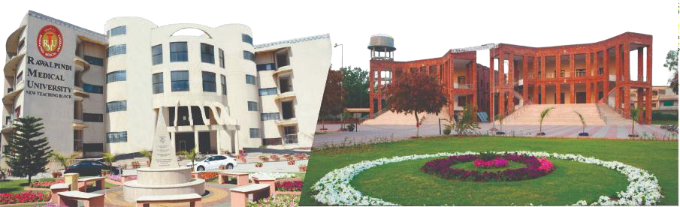

RAWALPINDI MEDICAL UNIVERSITY RAWALPINDI

## Dr. Zein El Aamir

### Head of Urology

##### PREFACE

The horizons of ***Medical Education*** are widening & there has been a steady rise of global interest in *Post Graduate Medical Education*, an increased awareness of the necessity for experience in education skills for all healthcare professionals and the need for some formal recognition of postgraduate training in Internal Medicine.

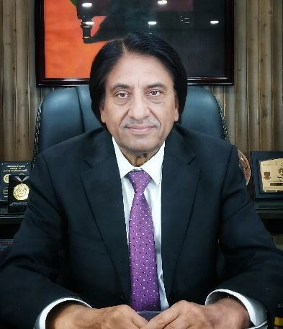

We are seeing a rise in the uptake of places on postgraduate courses in medical education, more

frequent issues of medical education journals and the further

development of e-journals and other new online resources. There is

therefore a need to provide active support in *Post Graduate Medical Education* for a larger, national group of colleagues in all specialties and at all stages of their personal professional development. If we were to formulate a statement of intent to explain the purpose of this logbook, we might simply say that our aim is to help clinical colleagues to teach and to help students to learn in a better and advanced way. This book is a **state-of-the-art**log book with representation of all activities of the **MD/MS Research Elective** program at RMU.A summary of the curriculum is incorporated in the logbook for convenience of supervisors and residents. It also allows the clinicians to gain an understanding of what goes into basic science discoveries and drug development. Translational **research** has an **important role** to play in **medical research**, and when used alongside basic science will lead to increased knowledge, discovery and treatment in **medicine**. A perfect monitoring system of a training program including monitoring of teaching and learning strategies, assessment and Research Activities cannot be denied so we at RMU have incorporated evaluation by ***Quality Assurance Cell*** and its comments in the logbook in addition to evaluation by ***University Training Monitoring Cell (URTMC)***. Reflection of the supervisor in each and every section of the logbook has been made sure to ensure transparency in the training program. The mission of Rawalpindi Medical University is to improve the health of the communities, and we serve through education, biomedical research and health care. As an integral part of this mission, importance of research culture and establishment of a comprehensive research structure and research curriculum for the residents has been formulated and a separate journal for research publications of residents is available.

[**PROF. MUHAMMAD UMAR**](https://www.rmur.edu.pk/)*(S.I, H.I)*

CONTRIBUTIONS

|  |  |  |
| --- | --- | --- |
| **SR.NO** | **NAME & DESIGNATION** | **CONTRIBUTIONS IN FORMULATION OF LOGBOOK and CURRICULUM OF MS UROLOGY** |
| 1 | **PROF DR. ZEIN-EL- AMIR**  **MBBS. FCPS**  Head & Professor of Department of Urology, Rawalpindi Medical University | Guidance regarding technical matters of Log Book of MS Urology.  Guidance regarding development of MS Urology Curriculum and its core competencies according to each year of postgraduate training.  Development of techniques for educational and skill level assessment of residents.  Also Proof reading & synthesis of final print version of Log Books of MS Urology and Rotations Log Book. |
| 2 | **DR. ZEESHAN QADEER MBBS, FCPS**  Associate Professor Department of Urology and Renal Transplant Rawalpindi Medical University | Supervised the research curriculum and assessment strategies for MS Urology trainees.  Actively involved in guidance of research , synopsis and thesis writing.  Also helped Prof. Dr. Zein in proof reading. |
| 3 | **DR UMER JAVED CHUGHTAI MBBS.FCPS**  Senior Registrar  Urology Department Benazir Bhutto Hospital Rawalpindi | Over all synthesis, structuring & over all write up of MS Urology Curriculum, and Log Book for MS Urology under guidance of Professor Dr. Zein-el-Amir |

Assistanc

Qadeer in computer

|  |  |  |  |  |
| --- | --- | --- | --- | --- |
| 4 | **DR RAMEEZ AHMED MBBS, FCPS, MRCS**  Senior Registrar Urology Department Benazir Bhutto Hospital Rawalpindi | | Assistance of Professor Dr. Zein-el-Amir and Dr. Umer Javed in compiling curriculum, designing the log book and computer work under their direct guidance & supervision. | |
| 5 |  | **DR. M. USAMA JAVID** e  Resident Urologist Urology Department Benazir Bhutto Hospital Rawalpindi | | of Professor Dr. Zein-el-Amir and Dr. Zeeshan compiling curriculum, designing the log book and work under their direct guidance & supervision. |
|  | |  | |

**TABLE OF CONTENTS**

|  |  |  |
| --- | --- | --- |
| S. No. | Title | Page No. |
| **Section I** | **Preamble** | **7** |
| 1 | Introduction | 7 |
| 2 | Mission Statement   * 1. RMU mission statement   2. Urology mission statement | 10 |
| 3 | Rules and regulations | 11 |
| 4 | General framework of MS Urology   * 1. Recognized training centers and supervisors.   2. Training pathway & duration of program.   3. Program personnel & Resources | 12 |
| 5 | Outcomes | 17 |
| 6 | Core Competencies | 20 |
| 7 | Rotations | 25 |
| 8 | Teaching strategies | 26 |
| 9 | Assessment Guidelines | 29 |
| **Section II** | **Competencies & Course Contents** | **33** |
| 1 | Competencies | 33 |
| 2 | Syllabus of the Course | 41 |
| **Section III** | **Research** | **66** |
| 1 | Submission of synopsis | 69 |
| 2 | Submission of thesis | 69 |
| 3 | E Log Book | 70 |
| **Section IV** | **Workshops** | **91** |
| 1 | Workshop details | 91 |
| **Section V** | **Life cycle of MS UROLOGY** | **96** |
| 1 | Milestones to be achieved by trainees   * 1. EPAs of Urology in RMU.   2. TOS of 1st year (general surgery) | 97  116  125 |
| **Section VI** | **Assessment strategies**   * 1. MTA, FTA, Thesis defense.   2. Table of specification in Urology   3. Table of specification unit wise.   4. Topic wise distribution of OSCE stations. | **128** |
| **Section VII** | **References** | **152** |

|  |  |  |
| --- | --- | --- |
| **Section VIII** | **Appendices** | **155** |

**SECTION I PREAMBLE**

###### Introduction

The curriculum provides the approved framework for the training of doctors to the level of independent, consultant practice Urology, addressing the requirements of patients, the population and the strategic health services.

**Definition of Speciality:**

Urology evaluates and treats patients with disorders of the genitourinary tract, including the adrenal gland and external genitalia. Specialists in this discipline demonstrate knowledge of the basic and clinical sciences related to the normal and diseased genitourinary system, as well as attendant skills in medical and surgical therapy. Residency programs educate physicians in the prevention and treatment of genitourinary disease, including the diagnosis, medical, and surgical management, and reconstruction of the genitourinary tract.

**Purpose of the curriculum:**

The purpose of the curriculum for Urology is to produce, at certification, competent doctors, able to deliver excellent outcomes for patients as consultant urologists. The curriculum will provide consultant Urologists with the generic professional and specialty-specific capabilities needed to manage patients presenting with the full range of acute and elective Urology conditions. Trainees will continue to develop their skills in the generality of Urology (both acute and elective such that they are competent to deal with 95% of cases presenting during an unselected emergency „take‟. Additionally, trainees will be expected to be competent to manage the full range of acute and elective conditions in the generality of their chosen special interest, including the operation. It is acknowledged that the

responsibility for patients in this specialist area will include care for patients up to, including and beyond the point of operation. Trainees will be entrusted to undertake the role of the Urology Postgraduate Resident (pgr) during training and will be qualified at certification to apply for consultant posts in Urology.

**Rationale and development of a new curriculum**

The curriculum has been developed with extensive input and representation from stakeholders including trainees, trainers, patient and lay representatives, education providers . Previous attempts at revising the Urology curriculum were centred on defining a series of core diagnostic and therapeutic capabilities in a five year training programme. The previous curriculum failed to equip trainees with those skills needed to deliver an unselected take in adult and paediatric emergency urology and to support colleagues from other specialities in the secondary care setting.

Additionally, the curriculum provides for areas of special interest in which trainees can develop areas of expertise which in turn have been proven to deliver better outcomes for patients. The curriculum framework articulates the standard required to work at the consultant level, and at key progression points during training, as well as encouraging the pursuit of excellence in all aspects of clinical and wider practice.

Service providers and patients benefit from consultant urologists who are trained in the generality of the specialty but who also have special interest skills to provide more specialist care. The curriculum ensures that trainees will, at certification, have both a special interest skill and full range of general emergency and elective skills.

###### Mission Statement

* 1. RMU Mission Statement:

To impart evidence based research oriented health professional education in order to provide best possible patient care and inculcate the values of mutual respect, ethical practice of healthcare and social accountability.

* 1. Mission Statement of Urology:

To provide exceptional education and training to develop highly skilled, knowledgeable, research oriented and compassionate Urologists.

###### Rules & Regulations

* 1. **Registration/Enrolment**
     + As per policy of Pakistan Medical & Dental Council, the number of PG Trainees/ Students per supervisor shall be maximum 04 per annum for all PG programs.
     + The beds to trainee ratio at the approved teaching site shall be at least 5 beds per trainee.
     + The University will approve supervisors for MS courses.
     + Candidates selected for the courses: after their enrollment at the relevant institutions shall be registered with RMU as per prescribed Registration Regulations.
  2. **Admission Criteria**

For admission in MS Urology course, the candidate shall have:

* + - MBBS degree
    - Completed one-year House Job
    - Registration with PMDC
    - Passed Entry Test conducted by the University & aptitude interview by the Institute concerned
    - Having up to the mark credentials as per RMU rules (no. of attempts in each professional, any gold medals or distinctions, relevant work experience, Rural/ Army services, research experience in a recognized institution, any research article published in a National or International Journal) may also be considered on case to case basis.

**Exemptions**: A candidate holding FCPS/FRCS/Diplomat/equivalent qualification in Urology shall be exempted from Part-I Examination and shall be directly admitted to Part-II Examinations, subject to fulfillment of requirements for the examination.

###### General Framework of MS Urology

MS Urology will be a 5-year program. Those candidates who will complete their training and other requirements will be awarded an MS (Urology) degree by the Rawalpindi Medical University.

**Table 1: Training Pathway MS Urology**

##### FRAMEWORK OF THE PROGRAMME:

**Below is the detailed framework of the MS Urology program at Rawalpindi Medical University**

|  |  |  |
| --- | --- | --- |
| **Component Details** | | |
| **Course Title** | MS UROLOGY | |
| **Training Center** | Department of UROLOGY, Rawalpindi Medical  University (RMU) | |
| **Duration of Course** | 5 years | |
| **Credit Hours** | 165 hours | |
| **Supervision** | Structured training under the guidance of an approved supervisor. | |
| **Induction Period** | * **Duration:** First 6 months in the Department of Urology * **Focus:** Orientation to UROLOGY and mandatory workshops | |
| **Basic Training (Part I)** | * **Duration:** 24 months * **Content:** Training in basic principles of Urology & General Surgery * **Research Requirement:** 2 DSR | |
| **Rotations (Part I)** | * Pediatric Surgery (2 months) * Plastic Surgery (2 months) * Radiology (2 months) | |
| **Assessment (Part I)** | Continuous internal assessment based on competency & Formative assessment:  **In-Training- Assessment Year-1 (at the end**  **of year 1)** | |
| **Mid Term Assessment**  **(MTA)** | At the end of 2 years, candidates will take the Mid Term Assessment (Summative) | |
| **Advanced Training (Part II)** | * **Duration:** 3rd, 4th , 5th years * **Focus:** UROLOGY , Research, and Thesis writing | |
| **Assessment (Part II)** | | Competency-based continuous internal assessment & Formative assessment:  **In-Training Assessment Year-3 (at the end of year 3)** |

|  |  |
| --- | --- |
|  | Competency-based continuous internal assessment & Formative assessment:  **In-Training Assessment Year-4 (at the end of year 4)** |
| **Final Term Assessment (FTA)** | At the end of five years, candidates will take the Final term Assessment  ( Summative) |
| **Research Component** | Research component aligned with the Research Cycle, including thesis writing and submission according to RMU guidelines |

4. 1 RECOGNIZED TRAINING CENTERS AND SUPERVISORS

Three hospitals attached with Rawalpindi Medical University (RMU) and Allied Teaching Hospitals will start with MS program, i.e.

* + - Department of Urology (Benazir Bhutto Hospital, Rawalpindi)

Teaching faculty with five or more than five years teaching experience in a PMDC recognized teaching hospital will be eligible to act as supervisors for MS program.

##### : THE TRAINING PATHWAY AND DURATION OF TRAINING

|  |  |  |
| --- | --- | --- |
| **Year** | **Departments** | **Duration** |
| **1st Year** | **Urology**  **General Surgery** | **6 Months**  **6 Months** |
| **2nd Year** | **General Surgery** | **6 Months** |
|  | **Plastic Surgery** | **2 Months** |
| **Radiology** | **2 Months** |
| **Pediatric Surgery** | **2 Months** |
| **3rd , 4th & 5th Year** | **Urology** | **3 Years** |

The duration of MS Urology course shall be five (5) years consisting of structured training in a recognized department under the guidance of an approved supervisor. The course is structured in two phases:

**Phase I** is structured for the 1st and 2nd calendar year. After the initial 1st Six months in Urology ,the resident will be rotated in Mandatory General Surgical Dept. Doctors entering this will require closely supervised training in basic examination methods and techniques and should rapidly be introduced to the elements of surgery and the management of general outpatients and accident and emergency Urological & General Surgery patients. In their second year, they will be expected to take a larger role in both theatre and outpatients, where they will benefit from special clinics. The training units should therefore provide a broad-based training in Urological surgery and exposure to the common subspecialties. The candidate shall undertake didactic and interactive training in Basic Medical and Surgical Sciences. At the end of 1st year an SEQ based examination will be conducted. After 1 year of General Surgical Rotation , he will attend mandatory rotations of Plastic Surgery, Pediatric Surgery & Radiology. At the end of 2nd year **mid-term examination** shall be held, comprising of 2 MCQ based question papers and Clinical OSCE.

**Phase II** is structured for 3rd, 4th& 5th calendar years in MS Urology. The trainee should see sufficient patients in a clinic to develop competency and fluency in managing patients in an outpatient setting but the number seen must not be excessive to the extent that training is impaired. The actual number of patients seen should be appropriate to the competency of the trainee and the complexity of the clinical condition of the patient. Surgical experience should develop as indicated by the learning outcomes in the curriculum. It is essential for the trainee to perform sufficient numbers of surgical cases (particularly cataract procedures) to experience a full range of clinical situations so that the trainee learns techniques to manage a range of cases and becomes competent in managing complications. At the end of 3rd & 4th year an SEQ based examination will be conducted.

The candidate will have to achieve sufficient clinical and research capability during this phase so as to qualify his **FTA** for the award of degree.

Program Personnel and Resources Program Director

The program director is the Head of Urology department of Rawalpindi Medical University.

Faculty

The faculty involved in the teaching process of the Urology, residents comprises of: Professor of Urology

Associate Professor of Urology Assistant Professor of Urology Senior Registrars

All the faculty members of the department are appointed as per the rules and regulations of PMC.

Resources:

**Out-patient Department**

The outpatient areas of the hospital have a well-equipped Ambulatory Learning Environment for residents who are supervised by Consultant Urologists. The patients are examined in detail in a methodic manner and cases are explained to the residents. The treatment strategies outlined by the residents is supervised by the senior faculty members. The trainees are also provided with ample opportunities of clinical clerkship with consultant Urologists.

Diagnostic Equipment Access

The residents have access to all the available diagnostic equipment e.g., Ultrasound machine, Cystoscope, Uroflowmetry etc.

Ambulatory learning

There is an adequate volume and variety of clinical Urological problems representing the entire spectrum of Urological diseases, which help the residents to develop diagnostic, therapeutic, and manual skills and judge the appropriateness of treatment. The in-patient department also has an examination room equipped with Diagnostic facilities.

Surgical Facilities

The surgical facilities include an operating room which is fully-equipped for Urological surgery, including Ultrasound machine, Cystoscope, URS , DVIU equipment, PCNL equipment etc.

###### Outcomes:

* 1. OUTCOME OF THE COURSE

The aim of the five-year MS Urology program is to train residents to acquire the competency of a specialist in the field of Urology so that they can become proficient teachers, researchers, and clinicians in their specialty after completion of their training.

The Objective of this course is to produce, competent doctors, able to deliver excellent outcomes for patients. Trainees will continue to develop their skills in the field of Urology for better patient care . Trainees will be entrusted to undertake the role of the Urology Postgraduate Resident during training and will be qualified as Consultant Urologist upon completion of course & passing the final exam.

Patient safety and competent practice are both essential and the program has been designed so that the learning experience itself should not affect patient safety, expected levels of performance, and levels of trainer supervision needed for safe and professional practice. Upon satisfactory completion of training programmes, we expect trainees to be able to work safely and competently in the defined area of practice and to be able to manage or mitigate relevant risks effectively. A feature of the training programme is that it promotes and encourages excellence through the setting of high-level outcomes , assessment and feedback, allowing trainees to progress at their own rate.

* 1. GOALS OF THE COURSE

The goal of this course is to produce a competent Urologist who is:

* + - Aware of the current concepts in quality care in Disorders related to Urology and also of diagnosis, therapeutic, medical and surgical management of Urological problems
    - Able to offer initial primary management of acute Urological emergencies
    - Aware of the limitations and refer readily to major centers for more qualified care of cases which warrant such referral
    - Aware of research methodology and be able to conduct research and publish the work done
    - Able to effectively communicate with patients, their family members, people and professional colleagues
    - Able to exercise empathy and a caring attitude and maintain high ethical standards
    - Able to continue taking keen interest in continuing education irrespective of whether he

/ she is in teaching institution or in clinical practice

* + - Dynamic, available at all times and proactive in the management of patients needing emergency care.
  1. OUTCOMES OF THE COURSE

At the end of MS course, the resident should be adept in the following domains:

* + - Skill to take a proper history for Urological disorders
    - Relevant Clinical examination.
    - Application of history & clinical findings in making an appropriate clinical diagnosis
    - Interpretation of investigations
    - Discussion of options of treatment and follow up rehabilitation for the diagnosis made
    - Have an in-depth theoretical knowledge of the syllabus with emphasis on current concepts
    - Learn basic skills in Urology by assisting or performing under supervision or perform independently as required.
    - Have basic knowledge of common disorders of the Urology.
    - Develop understanding of principles of Transplant surgery & adequate Skills related to it.

##### CORE COMPETENCIES

The curriculum MS Urology of Rawalpindi Medical University, Rawalpindi is derived from **Accreditation Council for Graduate Medical Education (ACGME)** which is competency / performance-based system competencies.

1. **Medical Knowledge ( 40%) both**
2. **Patient Care**
3. **Interpersonal & Communication Skills ( 40%) both**
4. **Professionalism**
5. **Practice Based Learning ( 10%) both**
6. **System Based Learning**
7. **Research (10%)**

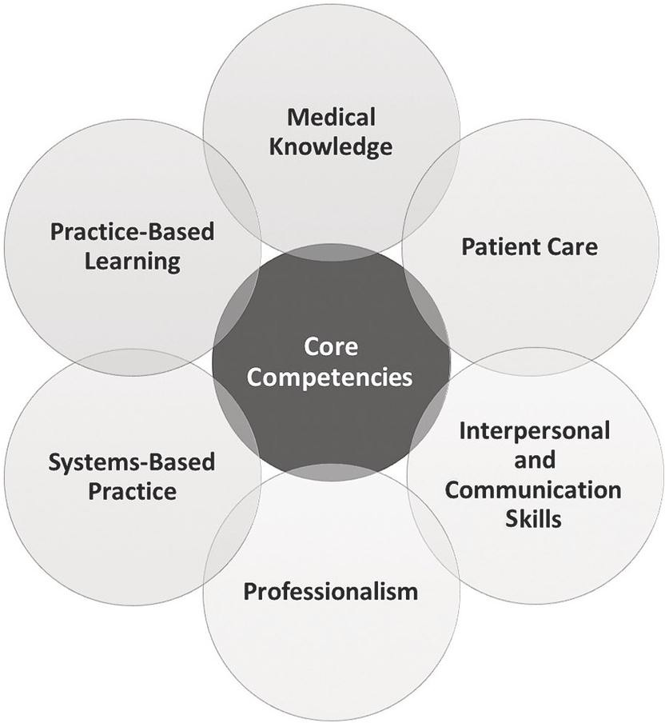



**Research**

7TH Core competence in RMU residents will be research

FIGURE 1: Core Competencies of MS UROLOGY

###### Medical Knowledge

* + Demonstrate a thorough understanding of biomedical, clinical, and cognate sciences and apply this knowledge to patient care.

###### Patient Care

* + Residents are expected to provide patient care compassionately, effectively for the promotion of health, prevention of illness, treatment of disease and end of life decisions.
  + Gather accurate, essential information from all sources, including interviews, physical examinations, medical records, and diagnostic/therapeutic procedures.
  + Make informed recommendations about preventive, diagnostic and therapeutic options, interventions based on clinical judgment, scientific evidence, and patient preference.
  + Develop, negotiate, and implement effective patient management plans and integration of patient care.
  + Perform competently the diagnostic and therapeutic procedures considered essential to the practice of general surgery.

###### Interpersonal and Communication Skills

* + Residents are expected to demonstrate interpersonal communication skills that enable them to establish and maintain professional relationships with patients, families, and other members of health care teams.
  + Provide effective and professional consultation to other physicians and health care professionals to deal with ethically professional relationships with patients, their families, and colleagues.
  + Use effective listening, nonverbal, questioning, narrative skills to communicate with patients and families.
  + Interact with consultants in a respectful, appropriate manner.
  + Maintain comprehensive, timely, and legible medical records.

###### Professionalism

* + Residents are expected to demonstrate behaviors that reflect a commitment to continuous professional developmental, ethical practice, an understanding and sensitivity to diversity and a responsible attitude toward their patients*,* their profession, and society.
  + Demonstrate respect, compassion, integrity, and altruism in relationships with patients, families, and colleagues.
  + Demonstrate sensitivity and responsiveness to the gender, age, culture, religion, sexual preference, socioeconomic status, beliefs, behavior and disabilities of patients and professional colleagues.
  + Adhere to principles of confidentiality, scientific/academic integrity, and informed consent.
  + Recognize and identify deficiencies in peer performance.
  + Understand and demonstrate the skill and art of end-of-life care.

###### Practice-Based Learning and Improvement

* + Residents are expected to be able to use scientific evidence, methods to investigate, evaluate, and improve patient care practices.
  + Identify areas for improvement and implement strategies to enhance knowledge, skills, attitudes, and processes of care.
  + Analyze and evaluate practice experiences and implement strategies to continually improve the quality of patient practice.
  + Develop and maintain a willingness to learn from errors and use errors to improve the system or processes of care.
  + Use information of technology or other available methodologies to access and manage information, support patient care decisions, and enhance both patient and physician education.
  + Develop error prevention skills and critical thinking leading to prevention of cognitive dispositions to respond.

###### Systems-Based Practice

* + Residents are expected to demonstrate both an understanding of the contexts and systems in which health care is provided, and the ability to apply this knowledge to improve and optimize health care.
  + Understands accesses and utilizes the resources, providers, and systems necessary to provide optimal care.
  + Understand the limitations and opportunities inherent in various practice types and delivery systems and develop strategies to optimize care for the individual patient.
  + Apply evidence-based, cost-conscious strategies to prevention, diagnosis, and disease management.
  + Collaborate with other members of the health care team to assist patients in dealing effectively with complex systems and to improve systematic processes of care.

##### ROTATIONS

MODULAR SYSTEM

The 5-year MS (Urology) training will comprise of:

|  |  |  |
| --- | --- | --- |
| **Year** | **Departments** | **Duration** |
| **1st Year** | **Urology**  **General Surgery** | **6 Months**  **6 Months** |
| **2nd Year** | **General Surgery** | **6 Months** |
|  | **Plastic Surgery** | **2 Months** |
| **Radiology** | **2 Months** |
| **Pediatric Surgery** | **2 Months** |
| **3rd , 4th & 5th Year** | **Urology** | **3 Years** |

* Credit hours will be awarded to the candidates after they have attended and cleared the Internal assessment of each module.
* MS (Urology) will comprise of 02 exams; one at the end of 1st year (conducted by the General Surgery Department), then at the end of 2nd year of training (MTA).

##### TEACHING STRATEGIES

* 1. TEACHING PROGRAM IN GENERAL SURGERY

1. General Principles
   * Acquisition of practical competencies being the keystone of postgraduate medical education, postgraduate training is skills oriented.
   * Learning in postgraduate program is essentially self-directed and primarily emanating from clinical and academic work. The formal sessions are merely meant to supplement this core effort.

***Inpatient Services:*** Urology residents will have work to in Surgery & allied for an initial 2 years and will appear in MTA Surgery. This training component will be according to RMU MS Urology initial 2 years’ curriculum. Afterwards, the resident will work in Urology during 3rd, 4th and 5th year of training.

***Outpatient Experiences:*** Residents should demonstrate expertise in diagnosis and management of patients in acute care clinics and gain experience in dealing with diagnosis of hernia, cholecystitis, acute abdomen, thyroid swelling, and breast lumps etc.

***Emergency services:*** Residents take an early active role in patient care and obtain decision-making roles quickly. Within the Emergency Department, residents direct the initial stabilization of all critical patients, manage airway interventions, and oversee all critical care being first responder, and be able to diagnose surgical emergency such as acute abdomen, blunt trauma abdomen/chest, penetrating injury, and be able to perform minor surgical procedures like chest intubation, central line catheterization, FAST scan etc.

***Electives / Specialty Rotations:*** Urology resident will do elective rotations in a variety of electives including General Surgery, pediatric surgery, plastic surgery & Radiology. Residents may also select electives at other institutions if the parent department does not offer the experiences they want.

***Mandatory Workshops:*** Residents achieve hands on training while participating in mandatory workshops of Basic surgical skills, Research Methodology, Advanced Life Support, Communication Skills, Computer & Internet, and Clinical Audit. Specific objectives are given in detail in the relevant section of Mandatory Workshops.

**Surgical / procedural competencies:** The clinical skills, which a urologist must have are, varied and complex. A complete list of the same necessary for residents and trainers is given below. Some examples, which are a sub sample of the whole, follow. These are to be taken as guidelines rather than definitive requirements. Key for assessing competencies:

1. Observer status.
2. Assistant status.
3. Performed under direct supervision.
4. Performed under indirect supervision.
   1. TEACHING PROGRAM IN UROLOGYS
      * Bedside teaching rounds
      * Journal club
      * Seminar
      * PG case discussion

Central session (held in hospital auditorium regarding various topics like CPC, guest lectures, student seminars, grand round, sessions on basic sciences, biostatistics, research methodology, teaching methodology, health economics, medical ethics and legal issues).

* 1. TEACHING SCHEDULE

In addition to bedside teaching rounds, in the department there will be daily hourly sessions of formal teaching per week. The suggested time distribution of each session for department’s teaching schedule as follows:

* + - Journal club Once a week
    - Seminar once a week
    - PG case discussion Once a week
    - Central session as per hospital schedule
    - Workshop – As per University Directions.

Note:

* + - All sessions are supervised by faculty members. It is mandatory for all residents to attend the sessions except those posted in emergency.
    - All the teaching sessions are assessed by the faculty members at the end of session and marks are given out of 10 and kept in the office for internal assessment.
    - Attendance of the residents at various sessions has to be at compulsory.

###### Assessment Guidelines



It will consist of action and professional growth oriented student-centered integrated assessment with an additional component of informal internal assessment, formative assessment and measurement-based summative assessment.

Student-Centered Integrated Assessment It views students as decision-makers in need of information about their own performance. Integrated Assessment is meant to give students responsibility for deciding what to evaluate, as well as how to evaluate. It encourages students to ‘own’ the evaluation and to use it as a basis for self-improvement. Therefore, it tends to be growth-oriented, student-controlled, collaborative, dynamic, contextualized, informal, flexible and action-oriented.



* Each student will be provided with a pre-designed self-assessment form to evaluate his/her level of comfort and competency in dealing with different relevant clinical situations. It will
* be the responsibility of the student to correctly identify his/her areas of weakness and to take appropriate measures to address those weaknesses.

360-DEGREE EVALUATION INSTRUMENT-MULTI-SOURCE FEEDBACK (MSF):

* The students will also be expected to evaluate their peers after the monthly small group meeting. These should be followed by constructive feedback according to prescribed

guidelines and should be nonjudgmental in nature. This will enable students to become good mentors in future.

* Paramedical staff.
* From Patients.
* From Supervisors.



INFORMAL INTERNAL ASSESSMENT BY THE FACULTY

* There will be no formal allocation of marks for the component of Internal Assessment so that students are willing to confront their weaknesses rather than hiding them from their instructors.
* It will include:
  + Punctuality
  + Ward work
  + Monthly assessment (written tests to indicate particular areas of weaknesses)
  + Participation in interactive sessions



* Will help to improve the existing instructional methods and the curriculum in use WPBA of Urology Resident in Rawalpindi Medical University

|  |  |
| --- | --- |
| Monthly Assessments in hospital | Online assessments on LMS |
| DOPS | 25 MCQs fortnightly |
| Mini-CEx |
| CBD |
| DOPS |
| Mini-CEx |
| CBD |
| 360-degree evaluation  LOG BOOK | |
| CBD DOPS Mini - CEX after every 03 months.  Fort nightly 25 MCQ on LMS | |

1. 360 Degree evaluation will be done at every 6 months by:
   1. Supervisor/consultant
   2. Paramedical staff
   3. Patients
   4. Self-assessment of postgraduate trainee by himself.
2. LOG BOOK will be maintained by the resident and counter signed by the supervisors.



FEEDBACK TO THE FACULTY BY THE STUDENTS:

* After every three months’ students will be providing a written feedback regarding their course components and teaching methods. This will help to identify strengths and weaknesses of the relevant course, faculty members and to ascertain areas for further improvement.

MINI-CLINICAL EVALUATION EXERCISE(MINI-CEX)

This tool evaluates a clinical encounter with a patient to provide an indication of competence in skills essential for good clinical care such as history taking, examination and clinical reasoning. The trainee receives immediate feedback to aid learning. They can be used at any time and in any setting when there is a trainee and patient interaction and an assessor is available.

DIRECT OBSERVATION OF PROCEDURAL SKILLS (DOPS)

A DOPS is an assessment tool designed to evaluate the performance of a trainee in undertaking a practical procedure, against a structured checklist. The trainee receives immediate feedback to identify strengths and areas for development.

CASE-BASED DISCUSSION (CBD)

The CBD assesses the performance of a trainee in their management of a patient to provide an indication of competence in areas such as clinical reasoning, decision-making and application of medical knowledge in relation to patient care. It also serves as a method to document conversations about, and presentations of, cases by trainees. The CBD should focus on a written record (such as written case notes, out-patient letter, and discharge summary). A typical encounter might be when presenting newly referred patients in the out- patient department.

AUDIT ASSESSMENT (AA)

The Audit Assessment tool is designed to assess a trainee’s competence in completing an audit. The Audit Assessment can be based on review of audit documentation OR on a presentation of the audit at a meeting. If possible, the trainee should be assessed on the same audit by more than one assessor.



It will be carried out at the end of the program to empirically evaluate cognitive, psychomotor and affective domains in order to award diplomas for successful completion of courses.

##### SECTION 2 COMPETENCIES:

All students are expected to reach a level of competence in different years of training after performing at least a said number of procedures at various levels of competence.

Students are initially observing with the supervisor performing, later they are directly involved for assistance.

Subsequently the skill acquisition level is raised with the student performing under direct supervision and later independently, when supervision is indirect.

Given here is a list of competencies that the student is supposed to achieve working with the supervisor in charge, peaking the graph at an achievable pace for the student.

The level of competency is denoted by a number, as mentioned, and the minimal number of cases listed.

Observer Status=1 Assistant status=2

Under Direct Supervision=3 Under Indirect Supervision=4

|  |  |  |  |  |  |  |  |  |  |
| --- | --- | --- | --- | --- | --- | --- | --- | --- | --- |
| Sr # | PROCEDURES / COMPETENCIES | PGY-1 | PGY-2 | PGY-3 | | PGY-4 | | PGY-5 | |
|  |  |  | EPA | No | EPA | No | EPA | No |
| **A** | **KIDNEY** |  |  |  |  |  |  |  |  |
| A1 | OPEN PROCEDURES |  |  |  |  |  |  |  |  |
| 1 | Simple Nephrectomy |  |  | 1 | 10 | 2 | 12 | 3 | 15 |
| 2 | Radical Nephrectomy |  |  | 1 | 10 | 2 | 12 | 2 | 15 |
| 3 | Pyelolithotomy |  |  | 1 | 10 | 2 | 12 | 3 | 15 |
| 4 | Pyeloplasty |  |  | 1 | 10 | 2 | 12 | 3 | 15 |
| 5 | Nephrosotomy |  |  | 1 | 15 | 3 | 20 | 3 | 30 |
| 6 | Renal Biopsy |  |  | 1 | 20 | 2 | 20 | 3 | 20 |
| 7 | Renal Transplantation |  |  | 1 | 6 | 2 | 8 | 2 | 8 |
| A2 | LAPAROSCOPIC |  |  |  |  |  |  |  |  |
| 1 | Nephrectomy |  |  | 1 | 12 | 2 | 12 | 2 | 4 |
| 2 | Pyeloplasty |  |  | 1 | 4 | 2 | 4 | 2 | 4 |
| A3 | PERCUTANEOUS |  |  |  |  |  |  |  |  |
| 1 | Nephrolithotomy |  |  | 1 | 6 | 2 | 8 | 2 | 8 |
| 2 | Nephrostomy |  |  | 1 | 23 | 2 | 14 | 3 | 16 |
| **B** | **URETER** |  |  |  |  |  |  |  |  |
| B1 | OPEN |  |  |  |  |  |  |  |  |
| 1 | Ureterolithotomy |  |  | 2 | 8 | 2 | 8 | 3 | 8 |
| 2 | Ureteric reimplantation |  |  | 1 | 4 | 1 | 4 | 2 | 4 |
| B2 | ENDOSCOPIC |  |  |  |  |  |  |  |  |
| 1 | Ureterorenoscopy (stones / tumor ) |  |  | 2 | 14 | 3 | 12 | 4 | 20 |
| **C** | **BLADDER** |  |  |  |  |  |  |  |  |
| C1 | OPEN |  |  |  |  |  |  |  |  |
| 1 | Vesicolithotomy |  |  | 1 | 12 | 2 | 17 | 3 | 11 |
| 2 | Vesicostomy |  |  | 1 | 12 | 2 | 8 | 3 | 8 |
| 3 | Suprapubic cystostomy |  |  | 2 | 20 | 3 | 12 | 4 | 12 |
| 4 | Simple cystectomy |  |  | 1 | 9 | 2 | 9 | 2 | 9 |
| 5 | Radical cystectomy |  |  | 1 | 11 | 2 | 15 | 2 | 20 |
| 6 | Repair of fistulae: VVF, UVF, Abdominal etc |  |  | 1 | 12 | 2 | 18 | 3 | 20 |
| 7 | Augmentation Cystoplasty |  |  | 1 | 7 | 2 | 4 | 2 | 6 |
| C2 | ENDOSCOPIC |  |  |  |  |  |  |  |  |
| 1 | Cystolitholapexy |  |  | 1 | 20 | 2 | 20 | 3 | 20 |
| 2 | Cystoscopy flexible |  |  | 2 | 50 | 3 | 60 | 4 | 40 |
| 3 | Cystoscopy rigid |  |  | 2 | 60 | 3 | 80 | 4 | 50 |
| 4 | TURBT |  |  | 1 | 20 | 2 | 20 | 3 | 20 |
| 5 | Insertion / removal of DJ stent |  |  | 2 | 20 | 3 | 20 | 4 | 20 |
| **D** | **PROSTATE** |  |  |  |  |  |  |  |  |
| D1 | OPEN |  |  |  |  |  |  |  |  |
| 1 | Simple prostatectomy |  |  | 1 | 8 | 2 | 8 | 3 | 8 |
| 2 | Radical prostatectomy |  |  | 1 | 12 | 2 | 14 | 2 | 12 |
| D2 | ENDOSCOPIC |  |  |  |  |  |  |  |  |
| 1 | TURP |  |  | 1 | 40 | 2 | 40 | 3 | 20 |
| **E** | **URETHRA** |  |  |  |  |  |  |  |  |
| 1 | Urethral catheterization |  |  | 2 | 40 | 3 | 40 | 4 | 20 |
| 2 | Urethral dilatation |  |  | 2 | 40 | 3 | 20 | 3 | 20 |
| E1 | OPEN |  |  |  |  |  |  |  |  |
| 1 | Urethroplasty |  |  | 1 | 20 | 2 | 30 | 3 | 30 |
| 2 | Hypospadias repair |  |  | 1 | 20 | 2 | 30 | 3 | 30 |
| 3 | Epispadias repair |  |  | 1 | 4 | 2 | 6 | 2 | 10 |
| E2 | ENDOSCOPIC |  |  |  |  |  |  |  |  |
| 1 | Optical urethrotomy / DVIU |  |  | 1 | 40 | 2 | 40 | 2 | 20 |
| 2 | Fulgration of posterior urethral valves |  |  | 1 | 18 | 2 | 20 | 3 | 12 |
| **F** | **PENIS** |  |  |  |  |  |  |  |  |
| 1 | Chordee correction |  |  | 1 | 5 | 2 | 5 | 2 | 5 |
| 2 | Priapism correction |  |  | 1 | 4 | 2 | 4 | 2 | 4 |
| 3 | Circumcision |  |  | 2 | 20 | 3 | 12 | 4 | 14 |
| **G** | **VAGINA** |  |  |  |  |  |  |  |  |
| 1 | Repair of VVF |  |  | 1 | 6 | 2 | 8 | 3 | 10 |
| **H** | **AMBIGUOUS GENITALIA** |  |  |  |  |  |  |  |  |
| 1 | Phalloplasty |  |  |  |  | 1 | 2 | 2 | 2 |
| **I** | **TESTIS** |  |  |  |  |  |  |  |  |
| I1 | OPEN |  |  |  |  |  |  |  |  |
| 1 | Testicular biopsy |  |  | 1 | 6 | 2 | 4 | 3 | 10 |
| 2 | Orchidopexy |  |  | 2 | 12 | 2 | 8 | 3 | 10 |
| 3 | Orchidectomy |  |  | 2 | 12 | 3 | 8 | 4 | 10 |
| 4 | Radical orchidectomy |  |  | 2 | 12 | 3 | 14 | 4 | 14 |
| I2 | LAPAROSCOPIC |  |  |  |  |  |  |  |  |
| 1 | Orchidopexy |  |  | 2 | 10 | 3 | 16 | 3 | 18 |
| **J** | **SCROTUM** |  |  |  |  |  |  |  |  |
| J1 | OPEN |  |  |  |  |  |  |  |  |
| 1 | Hydrocelectomy |  |  | 2 | 10 | 3 | 12 | 4 | 16 |
| 2 | Varicocelectomy |  |  | 2 | 10 | 3 | 12 | 4 | 16 |
| 3 | Excision of epididymal cyst |  |  | 2 | 10 | 3 | 12 | 4 | 16 |
| 4 | Vasectomy |  |  | 2 | 8 | 3 | 8 | 4 | 8 |
| J2 | LAPAROSCOPIC |  |  |  |  |  |  |  |  |
| 1 | Varicocele ligation |  |  | 2 | 10 | 3 | 8 | 4 | 8 |
| **K** | **RECONSTRUCTIVE PROCEDURES** |  |  |  |  |  |  |  |  |
| 1 | Ureterosigmoidostomy |  |  | 1 | 4 | 2 | 4 | 2 | 4 |
| 2 | Ileal conduit |  |  | 1 | 4 | 2 | 4 | 2 | 4 |
| **L** | **MISCELLANEOUS OPEN** |  |  |  |  |  |  |  |  |
| 1 | Inguinal hernia repair |  |  | 1 | 10 | 2 | 10 | 3 | 10 |
| 2 | Vasovasostomy |  |  | 1 | 10 | 2 | 10 | 3 | 10 |
| 3 | Adrenalectomy |  |  | 1 | 8 | 2 | 4 | 2 | 8 |
| **M** | **TRAUMA** |  |  |  |  |  |  |  |  |
| 1 | Nephrectomy |  |  | 1 | 12 | 2 | 8 | 3 | 4 |
| 2 | Repair of urinary tract injuries : ureter, bladder etc. |  |  | 1 | 4 | 2 | 12 | 3 | 14 |

Core Competencies for the Residents (Adapted from ACGME)

By the completion of training, Urological residents are expected to:

* **Patient Care:** Provide compassionate, appropriate, and effective care for health problems and promote health.
* **Medical Knowledge:** Demonstrate a thorough understanding of biomedical, clinical, and cognate sciences and apply this knowledge to patient care.
* **Practice-Based Learning and Improvement:** Investigate and evaluate patient care practices, appraise and assimilate scientific evidence, and continuously improve patient care based on self-evaluation and lifelong learning.
* **Interpersonal and Communication Skills:** Communicate effectively with patients, families, and the healthcare team.
* **Professionalism:** Commitment to carrying out professional responsibilities, adherence to ethical principles, and sensitivity to diverse patient populations.
* **Systems-Based Practice:** Demonstrate an understanding of and responsiveness to the larger context and system of healthcare, and the ability to effectively call on system resources to provide optimal care.
* Research

SYLLABUS OF THE COURSE

Student is expected to acquire comprehensive knowledge of Urogenital Anatomy, Physiology of Urogenital tract, its Pathology (Microbiology) and Pharmacology relevant to surgical practice appropriate for Urology

Anatomy Of Urogenital Tract

*Clinical and functional anatomy with pathological and operative relevance Surgical approaches to the renal and urinary structures*

*Embryology related to Urology*

Embryology

General Features of Human Development

Features of mitotic and meiotic modes of cell division. Genetic consequences of meiotic division.

Abnormal mitotic and meiotic divisions of clinical importance. Early Embryonic Development:

Cleavage, morula and blastocyst formation and implantation. Formation of the three primary germ layers.

List of the derivatives of the respective germ layers. Period of the Growing Fetus:

Various stages and salient features of the fetus development Extraembryonic Membranes:

Development, functions and anomalies of yolk sac, amnion, chorion, allantois, umbilical cord and placenta.

Development of kidney

Urogenital sinus & its transformation Origin of Mullerian system Development/ Descent of Testis

Endocrinological influences on male & female genitalia Development of adrenals

Embryology of extrophy, hypo / epispadias Teratogenesis:

Factors known to be involved in the development of congenital anomalies especially related to the urological system.

Concept of critical periods.

Anatomy:

Anterior abdominal wall and loin with reference to surgical incisions & hernia.

Anatomy & relations of kidneys & ureters and suprarenal glands. Anatomy of pelvic fascia & diaphragm.

Anatomy of perineum including perineal pouches. Urinary bladder ligaments & blood supply.

Prostate zones ,lobes & fascial sheaths.

Lymphatic drainage of pelvis and posterior abdominal wall.

Anatomy of urethra, penis, scrotum, testes, epididymis, vas deferens & seminal vesicles.

Anatomy and relation of female reproductive and genital tract.

Neuro anatomy/ nerves with reference to bladder, erectile and ejaculatory function.

1. Physiology Of Urogenital System

Functional anatomy of kidney, nephron-structure, parts, function, types. Juxtaglomerular apparatus: autoregulation, peculiarities, measurements. Renal circulation: Auto regulation, peculiarities, and measurement Glomerular filtration: filtration barrier, forces governing filtration, measurement.

Tubular functions: re-absorption, secretion, Tm values

Regulation of ECF-volume, osmolality and electrolytes Micturition

Renal function tests, renal clearance, abnormal constituents of urine Excretory functions of skin

Control of water balance & fluid compartments Acid base balance

Oedema & lymphatic function in renal disease Calcium metabolism

Testicular function Spermatogenesis & Endocrinology

Renal & Suprarenal Endocrines Physiology of Bladder-innervation Micturition reflex

Clinical and applied physiology

1. Pharmacology Relevant To Urogenital System

The evolution of medical drugs British pharmacopeia Introduction to pharmacology Receptors

Mechanisms of drug action Pharmacokinetic process Absorption

Distribution Metabolism

Desired plasma concentration Volume of distribution Elimination

Elimination rate constant and half life Creatinine clearance

Drug effect Beneficial responses Harmful responses Allergic responses

Drug dependence, addiction, abuse and tolerance Applied aspects related to pharmacokinetics

Drug therapies of renal failure ( including drug interactions) Commonly used drugs (antihypertensive, antidiabetic drugs, diuretics etc.)

Principals and use of anti microbial therapy Antiseptics

Drug interactions Dialysis

Drug use in pregnancy and in children Renal toxicity and medication

1. Pathology Of Urogenital Tract

Pathological alterations at cellular and structural level in infection, inflammation, ischemia, neoplasia and trauma affecting the ear, nose and upper respiratory tract

Cell Injury and adaptation Reversible and Irreversible Injury

Fatty change, Pathologic calcification Necrosis and Gangrene

Cellular adaptation Atrophy, Hypertrophy,

Hyperplasia, Metaplasia, Aplasia Inflammation

Acute inflammation

Cellular components and chemical mediators of acute inflammation Exudates and transudate

Sequelae of acute inflammation Chronic inflammation

Etiological factors and pathogenesis

Distinction between acute and chronic (duration) inflammation Histologic hallmarks

Types and causes of chronic inflammation, non-granulomatous & granulomatous,

Hemodynamic disorders

Etiology, pathogenesis, classification and morphological and clinical manifestations of Edema, Hemorrhage, Thrombosis, Embolism, Infarction & Hyperemia

Shock; classification etiology, and pathogenesis, manifestations. Compensatory mechanisms involved in shock

Pathogenesis and possible consequences of thrombosis Difference between arterial and venous emboli Neoplasia

Dysplasia and Neoplasia

Benign and malignant neoplasms Etiological factors for neoplasia Different modes of metastasis

Tumor staging system and tumor grade Immunity and Hypersensitivity Immunity

Immune response

Diagnostic procedures in a clinical Immunology laboratory Protective immunity to microbial diseases

Tumour immunology

Immunological tolerance, autoimmunity and autoimmune diseases. Transplantation immunology

Hypersensitivity Immunodeficiency disorders

Immuno prophylaxis & Immunotherapy

Related Microbiology

Role of microbes in various urological disorders Infection source

Nosocomial infections Bacterial growth and death Pathogenic bacteria Vegetative organisms Spores

Important viruses Important parasites

Surgically important microorganisms Sources of infection

Asepsis and antisepsis Sterilization and disinfection Infection prevention Immunization

Personnel protection from communicable diseases Use of investigation and procedures in laboratory Basics in allergy and immunology

**Special Pathology** Kidney and ureter Congenital lesions

Obstruction Calculus Infection Tumors

Cystic diseases Medical nephropathies Vascular

Renal transplantation Trauma

Bladder Congenital lesions Obstruction Inflammatory Tumors

Trauma

Incontinence & functional disorders Urinary diversion

Urethra Congenital lesions Strictures Diverticula Trauma

Prostate & Seminal Vesicles Congenital lesions

Benign prostatic hypertrophy Inflammatory

Tumors

Testis & scrotum

Congenital lesions Inflammatory Torsion

Tumors Adrenal Masses **Part II**

MS Urology

**Fundamental Principles of Surgery**

History of surgery

Preparing a patient for surgery

Principles of operative surgery: aseptic techniques, sterilization and antiseptics Surgical infections and antibiotics

Basic principles of anaesthesia and pain management Acute life support and critical care:

Pathophysiology and management of shock

Fluids and electrolyte balance/ acid base metabolism Hemostasis, blood transfusion

Trauma: assessment of polytrauma, triage, basic and advanced trauma Accident and emergency surgery

Wound healing and wound management Nutrition and metabolism

Principles of burn management Principles of surgical oncology Principles of laparoscopy and endoscopy Organ transplantation

Informed consent and medicolegal issues Molecular biology and genetics

Operative procedures for common surgical manifestations e.g cysts, sinuses, fistula, abscess, nodules, basic plastic and reconstructive surgery **Common Surgical Skills**

**Incision of skin and subcutaneous tissue**: Langer‟s lines

Healing mechanism Choice of instrument Safe practice

Closure of skin and subcutaneous tissue:

Options for closure Suture and needle choice Safe practice

Knot tying:

Choice of material Single handed Double handed Superficial

Deep

Tissue retraction:

Choice of instruments Placement of wound retractors Tissue forceps

**Use of drains:** Indications types

Insertion Fixation

Management/removal

**Incision of skin and subcutaneous tissue:** Ability to use scalpel, diathermy and scissors **Closure of skin and subcutaneous tissue:**

Accurate and tension free apposition of wound edges

Hemostasis:

Control of bleeding vessel (superficial) Diathermy

Suture ligation Clip application Plan investigations

Clinical decision making

Case work up and evaluation; risk management **Pre-operative assessment and management:** Cardiorespiratory physiology

Diabetes mellitus Renal failure

Pathophysiology of blood loss Pathophysiology of sepsis Risk factors for surgery Principles of day surgery Management of comorbidity **Intraoperative care:**

Safety in theatre Sharps safety Diathermy, laser use Infection risks Radiation use and risks Tourniquets

Principles of local, regional and general anesthesia

Post-operative care:

Monitoring f postoperative patient Postoperative analgesia

Fluid and electrolyte management Detection of impending organ failure Initial management of organ failure

Complications specific to particular operation Critical care

Blood products:

Components of blood

Alternatives to use of blood products

Management of the complications of blood product transfusion including children

Antibiotics:

Common pathogens in surgical patients Antibiotic sensitivities

Antibiotic side-effects

Principles of prophylaxis and treatment **Safely assess the multiply injured patient:** History and examination

Investigation

Resuscitation and early management

Referral to appropriate surgical subspecialties

Technical Skills

Central venous line insertion Chest drain insertion Diagnostic peritoneal lavage

Bleeding diathesis & corrective measures, e.g. warming, packing Clotting mechanism; Effect of surgery and trauma on coagulation Tests for thrombophilia and other disorders of coagulation Methods of investigation for suspected thromboembolic disease Anticoagulation, heparin and warfarin

Role of V/Q scanning, CT angiography and thrombolysis Place of pulmonary embolectomy

Awareness of symptoms and signs associated with pulmonary embolism and DVT

Role of duplex scanning, venography and d-dimer measurement Initiate and monitor treatment

Diagnosis and Management of Common Pediatric Surgical Conditions:

Child with abdominal pain Vomiting child

Trauma

Groin conditions Hernia Hydrocoele

Penile inflammatory conditions Undescended testis

Acute scrotum

Abdominal wall pathologies Urological conditions Abscess

In terms of general experience it is expected that trainees would have gained exposure to the following procedures and to be able to perform those marked (*) under direct supervision.

Elective Procedures Inguinal hernia

(not neo-natal) Orchidopexy Circumcision* Lymph node biopsy*

Abdominal wall hernia

Insertion of CV lines Emergency Procedures

Incision and drainage of abscess* Operation for testicular torsion* Insertion of suprapubic catheter* **Part III- MS Urology**

Clinical Component

Students should be familiar with typical clinical presentation, key physical findings, radiological findings and differential diagnosis, initial treatment, and referral indications for common urological diseases

GENERAL UROLOGY

Anatomy and embryology of genitourinary system

Urologic laboratory examination including renal function tests.. Radiology & radio nuclide imaging of urinary tract.

Vascular interventional radiology. Urodynamics.

Principles of chemo-, radio- & immunotherapy as applied to urologic practice.

Genetics as applied to genitourinary surgical conditions. Management of oliguria & acute renal failure.

Ch. Renal failure & dialysis, angioaccess Immunology, immune suppression, immune response

Pathophysiology of rejection., tissue typing & lymphocyte cross match

Congenital anomalies of kidney, ureter, bladder, urethra and genitalia, ambiguous genitalia

Infections of urinary tract, sexually transmitted diseases, specific urologic infections)

Disorders of kidneys, ureters, bladder, prostate, seminal vesicles and urethra

Pathophysiology of obstruction, stasis & reflux Pathophysiology of neurogenic bladder.

Pathophysiology of incontinence (neuromuscular dysfunction) Disorder of scrotum, testis, and spermatic cord

Skin disease of external genitalia Urolithiasis

Extracorporeal shockwave lithotripsy

Hypertension with reference to kidney & adrenals, secondary hypertension, malignant hypertension.

Principles of endourology, laparoscopic urology, lasers as applied to urology.

2. SPECIAL UROLOGY

Operative Urology

Urethral catheterization/ urethral dilatation Suprapubic cystostomy

Tumors of renal parenchyma Prostatectomy

for benign and malignant disease, principles of radical surgery

Principles of retroperitoneal surgery Radical cystectomy

Urethroplasty, principles of hypospadias surgery, anastomosis & substitution

Techniques in urethral stricture disease

Urinary diversion, ureterosigmoidostomy, orthotopic pouches & continent

Urinary diversion , resume of current technique in vogue

Principles of surgery in hydrocele, epididymal cysts & spermatoceles. Surgery for vesico-vaginal/ uterine fistulae

Pediatric urology: principles of orchidopexy, pyeloplasty , anti-reflux Procedures & scrotal swellings

Kidney transplantation

Endourology, retrograde catheterization, cystourethroscopy, ureterorenoscopy.

Endoscopic management of urethral, prostatic, bladder, ureteral & renal pathologies, retrograde instrumentation of ureter, laparoscopic urological surgery, percutaneous renal surgery.

Uro-Oncology

Diagnosis, management of renal tumors, bladder malignancies, other neoplasms of urothelium and prostatic carcinoma; testicular tumors; adrenal masses.

Carcinoma penis, metastatic tumors involving genitourinary tract

Genitourinary Trauma

Mode/ mechanics of renal, ureteric, bladder, urethral & scrotal injuries, clinical presentation, management & complications **Incontinence**

Classification; indication of surgical intervention, artificial

sphincters and bladder substitution

Neurogenic bladder, immediate as well as long term management

Female Urology

Urethral stenosis

Etiology, diagnosis and management of stress, urge, true incontinence and genitourinary fistulae

Pediatric Urology

Antenatal diagnosis, PUJ, vesicoureteric reflux, posterior urethral valves

Childhood tumors & disorders of penis and male urethra

Andrology

Male Infertility

Etiology, pathophysiology of erectile dysfunction

Clinical presentation, diagnosis and therapeutic modalities including drugs & prosthesis;

Management of priapism; Peyronie‟s disease

Kidney Transplantation:

Selection & preparation of donor & recipient for kidney transplantation

Immunosuppression, donor nephrectomy, transplantation, post op management and complications

Schedule

|  |  |  |  |  |  |  |
| --- | --- | --- | --- | --- | --- | --- |
| ***Yea***  ***r*** | **Category** | **Level I** | **Level II** | **Level III** | **Level IV** | **Level V** |
| I | Minor | - | 50 | 10 | 10 | 05 |
|  | Medium | 25 | 10 | 05 | - | - |
|  | Major | 25 | 10 | - | - | - |
|  | Extraordinar  y | 10 | 05 | - | - | - |
| I | Minor | - | - | 50 | 25 | 10 |
|  | Medium | - | 25 | 15 | 10 | - |
|  | Major | - | 25 | 10 | 05 | - |
|  | Extraordinar  y | 10 | 10 | 05 | - | - |
| III | Minor | - | -- | - | 25 | 25 |
|  | Medium | - | - | 50 | 25 | 15 |
|  | Major | - | - | 25 | 25 | 10 |
|  | Extraordinar  y | - | 10 | 10 | - | - |

***Operative procedures***

MINOR

Arterial Blood Sampling. Central Venous Cannulation. Lumbar Puncture.

E.T. intubation.

Pleural aspiration.

Peritoneal aspiration

Insertion of peritoneal catheter. (APD) (CAPD) Aspiration of scrotal cysts.

Urethral catheterization. Suprapubic cystostomy. Circumcision.

Retrograde cystourethrogram., MCU, Anti/Retrograde Pyelography. Prostatic Biopsy

Cystoscopy

MEDIUM

Retrograde catheterization (ureteric). PCN.

Orchiectomy. Vesicolithotomy. Litholapaxy.

Ureterolithotomy. Varicocelectomy.

Testicular Biopsy/ orchiectomy

Urethroscopy / D.J. removal / internal urethrotomy Check cystoscopy.

A.V. Fistula

MAJOR

Open Prostatectomy

Exposure of kidney / Pyelolithotomy. Recipient bed.

TURP. TURBT.

Colposuspension.

Exposure of urethra in urethroplasty. Pyeloplasty.

Hypospadias surgery.

Ureteroscopy / Intracorporeal Lithotripsy Orchidopexy.

PCNL

Laparoscopic Urological Surgery

Extraordinary

Radical prostatectomy

Radical cystectomy Radical nephrectomy RPLND

Donor Nephrectomy. Kidney Transplant

###### SECTION III Research

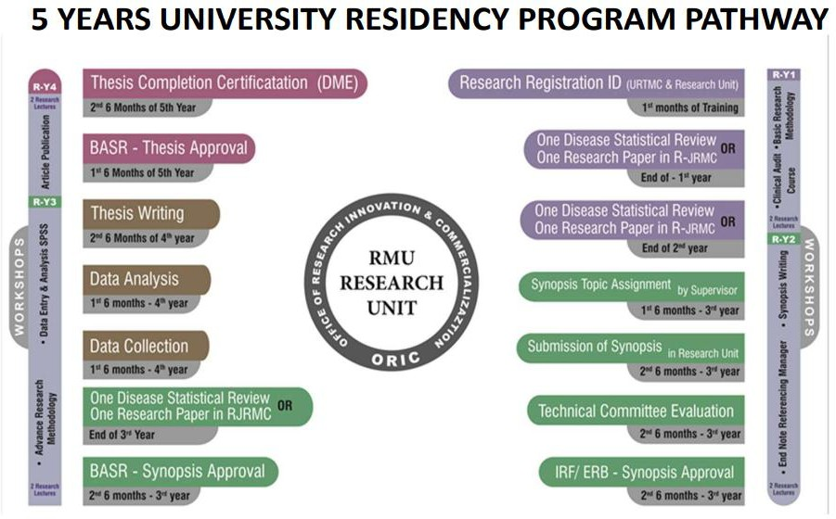

**Outline of research curriculum**

|  |  |
| --- | --- |
|  |  |
| **Clinical Audit /Disease Statistical Review** | **Y1** |
| **Basic Research Methodology** | **Y1** |
| **Research lectures** | **Y1** |
| **One disease statistical report is to be submitted for MTA** | **Y2** |
| **Research synopsis approval from ERB & BASR is mandatory for appearing in In-Training assessment 3rd year** | **Y3** |
| **Will do data collection** | **Y4** |
| **Thesis submission about 6 months before the completion of training is to be submitted for FTA** | **Y5** |

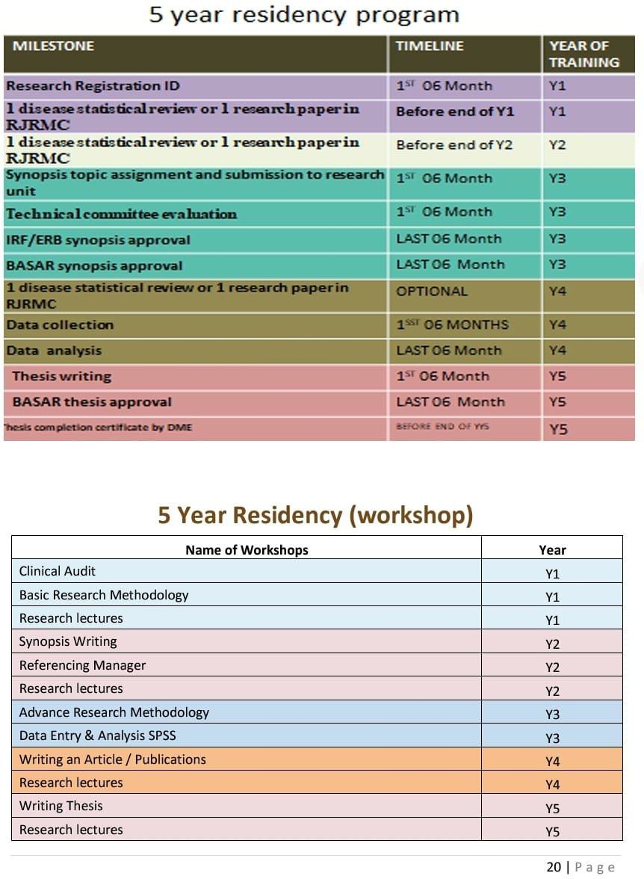

1. SUBMISSION OF SYNOPSIS
   1. The candidates shall prepare their synopsis as per guidelines provided by the Rawalpindi Medical University.
   2. The research topic in clinical subject should have 30% component related to basic sciences and 70% component related to applied clinical sciences. The research topic must consist of a reasonable sample size and sufficient numbers of variables to give training to the candidate to conduct research, to collect & analyze the data.
   3. Synopsis of research project shall be submitted by the end of the 3rdyear of MS program. The synopsis after review by an Institutional Review Committee shall be submitted to the University for Consideration by the Research Board, through the Principal / Dean

/Head of the institution.

* 1. **Or else**, if the candidate opts for 02 research publications in PMDC and HEC recognized journals, then he will have to submit 02 research topics along with their synopsis to the University Research Board for approval. He will undertake the study after approval from the board.

1. SUBMISSION OF THESIS

Thesis shall be submitted by the candidate duly recommended by the supervisor.

The minimum duration between approval of synopsis and submission of thesis shall be one year, but the thesis cannot be submitted later than 8 years of enrolment.

The research thesis must be compiled and bound in accordance with the thesis format guidelines approved by the university and available on website.

The research thesis will be submitted along with the fee prescribed by the university.

**Or else**, the candidate can submit copies of 02 research articles published in PMDC and HEC recognized journals which had previously been accepted in the university research board, at least 06 months prior to the examination.

1. E-LOG BOOK

The residents must maintain a log book and get it signed regula rly by the supervisor. A complete and duly certified log book should be part of the requirement to sit for MS examination. Log book should include adequate number of diagnostic and therapeutic procedures observed and performed , the indications for the procedure, any complications and the interpretation of the results, routine and emergency management of patients, case presentations in CPCs, journal club meetings and literature review.

INTRODUCTION TO RESEARCH FOR MS UROLOGY

**With advent of Evidence Based Practice over last two to three decades in medical science,** merging the best research **evidence** with good clinical expertise and patient values is inevitable in decision making process for patient care. Therefore, apart from receiving per excellence knowledge of the essential principles of medicine and necessary skills of clinical procedures, the trainees should also be well versed and skillful in research methodologies. The training in research being imperative is integrated longitudinally in all five year’s training tenure of the trainees.

The purpose of the research training is to provide optimal knowledge and skills regarding research methods and critical appraisal. The expected outcome of this training is to make trainees dexterous and proficient to practically conduct quality research through amalgamation of their knowledge, skills and practice in research methodologies.

ORIENTATION SESSION FOR POST GRADUATE TRAINEES:

1. At the beginning of the research course, an orientation session or an introductory session of one-hour duration will be held, organized by Director, Deputy Directors of ORIC (Office of Research Commercialization and Innovation) of RMU to make trainees acquainted to the research courses during five years post graduate training, the schedule of all scholarly and academic activities related to research and the assessment procedures.
2. Trainees will also be introduced to all the facilitators of the course, organizational structure of ORIC (Annexure 1) and the terms of references of corresponding authorities (Annexure 2) for any further information and facilitation.
3. All the curriculum details and materials for assistance and guidance will be provided to trainees during the orientation session.
4. The research model of RMU as given in Figure 1 and will be introduced to the newly inducted trainees of RMU.

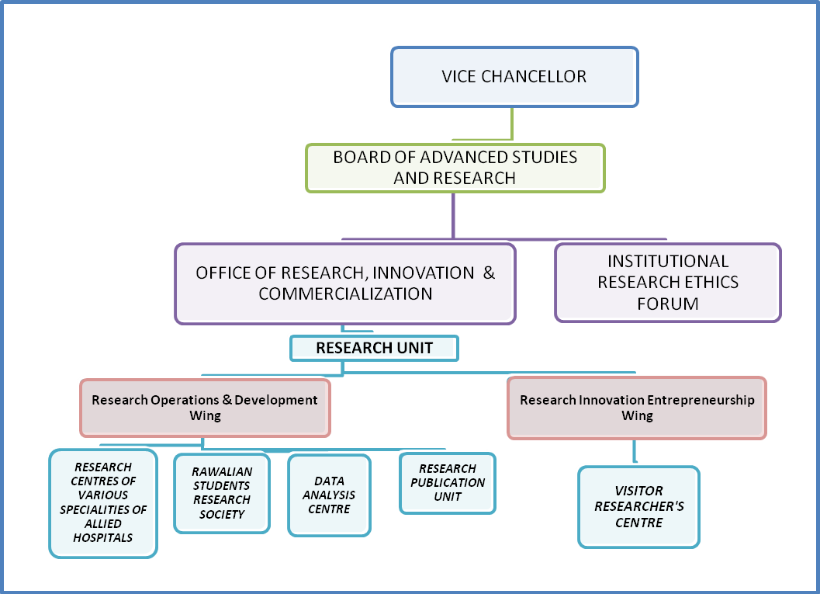

FIGURE 2: MODEL OF RESEARCH AT RAWALPINDI MEDICAL UNIVERSITY

The research training component for Post Graduate Trainees comprises of five years and the Distribution and curriculum for each year is mentioned as follows:

RESEARCH COURSE OF FIRST POST-GRADUATION TRAINING YEAR

#### PURPOSE OF RESEARCH-YEAR1 (RESEARCH COURSE)

The RESEARCH YEAR 1 or R-Y1 research course of the post graduate trainees intends to provide ample knowledge to trainees regarding the importance of research, its necessity and types. This course will provide them clarity of concepts that what are the priority problems that require research, how to sort them out and select topics for research. It will also teach them the best techniques for exploring existent & previous evidences in research through well-organized literature search and also how to critically appraise them. The course will not only provide them comprehensive knowledge but will also impart optimum skills on how to practical plan, design a research project by educating & coaching them about various research methodologies. The trainees will get familiarized to research ethics, concepts of protection of human study subjects, practice-based learning, evidence-based practice in addition to the standard ethical, institutional appraisal procedure by Board of Advanced Studies, Research Institutional & Ethics Research Forum of RMU.

LEARNING OUTCOMES OF R-Y1 RESEARCH COURSE

After completion of R-Y1 course the trainees should be efficiently able to:

* 1. Discuss the value of research in health service in helping to solve priority problems in a local context.
  2. Identify, analyze and describe a research problem
  3. Review relevant literature and other available information
  4. Formulate research question, aim, purpose and objectives
  5. Identify study variables and types
  6. Develop an appropriate research methodology
  7. Identify appropriate setting and site for a study
  8. Calculate minimally required sample size for a study.
  9. Identify sampling technique, inclusion and exclusion criteria
  10. Formulate appropriate data collection tools according to techniques
  11. Formulate data collection procedure according to techniques
  12. Pre-test data collection tools
  13. Identify appropriate plan for data analysis
  14. Prepare of a project plan for the study through work plans and Gantt charts
  15. Identify resources required for research and means of resources
  16. Prepare a realistic study budget in accordance with the work plan.
  17. Critically appraise a research paper of any national or international journal.
  18. Present research papers published in various national and international journals at journal club.
  19. Prepare a research proposal independently.
  20. Develop a strategy for dissemination and utilization of research results.
  21. Familiarization with application Performa for submission of a research proposal to BASR or IREF.
  22. Familiarization with format of presentations and procedure of presentation and defense of a research proposal to BASR or IREF.
  23. Familiarization with the supervisor, nominated by the Dean and to develop a harmonious rapport with supervisor.

**ACTIVITIE**

**ASSESSMEN**

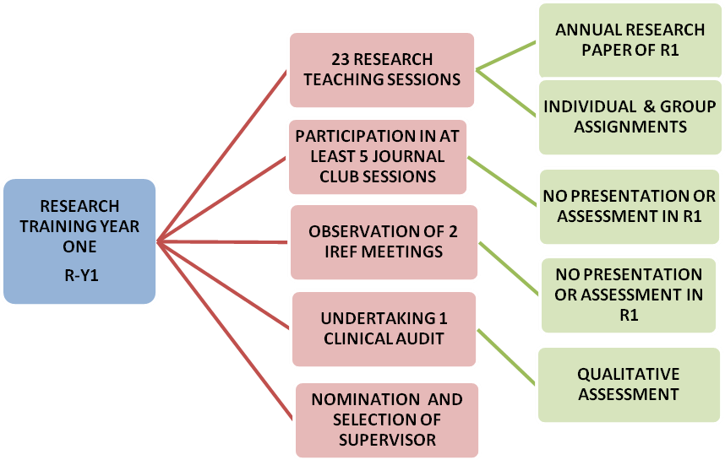

FIGURE 4: A FLOW CHART OF RESEARCH ACTIVITIES OF R-Y1 POST GRADUATE/MS TRAINEE OF RMU AND THEIR ASSESSMENT

**RESEARCH COURSE OF SECOND POST GRADUATION TRAINING YEAR**

#### PURPOSE OF R-Y2 RESEARCH COURSE:

The RESEARCH-YEAR 2-R2 research course of the post graduate trainees will provide optimum skills to trainees to actually formulate their individual research proposal of the research project/dissertation, prerequisite to their degrees, in perspective of the knowledge acquired during year one of the training i.e. R-Y1. This course will provide them clarity of basic epidemiological and biostatistics concepts that they essentially require to transform their data into substantial evidences, to answer their research questions for their individual research project/dissertation. The course will also make them proficient to follow the standard ethical and institutional appraisal procedures of Rawalpindi medical University by Board of Advanced Studies and Research and Institutional and Ethics Research Forum of RMU. It will also impart them expertise to explore evidences in research through well-organized literature search and also how to critically appraise them.

LEARNING OUTCOMES OF R-Y2 RESEARCH COURSE

After completion of R-Y2 course the trainees should be efficiently able to:

1. Identify and define the basic concepts of Epidemiological measures and biostatistics.
2. Formulate and pretest to finalize all the data collection tools for the research projects
3. Identify and execute proficiently all procedures required for data analysis and interpretation.
4. Analyze and interpret the data collected for a research project and draw conclusions related to the objectives of study.
5. Write a clear and concise research report (paper for a peer reviewed journal/dissertation) and a summary of the major findings and recommendations for each of the different parties interested in the results.
6. Present the major findings & the recommendations of a study to policy-makers managers & other stakeholders to finalize the recommendations.
7. Prepare a plan of action for the dissemination, communication and utilization of the findings and (if required) make recommendations for additional future research.
8. Critically appraise a research paper of any national or international journal.
9. Present research papers published in various national and international journals at journal club.
10. Prepare final draft of the research proposal of the Dissertation project, requisite to the post-graduation degree of trainee, under the guidance of the nominated supervisor.
11. Fill in an application Performa for submission of Dissertation’s research proposal to BASR or IREF.
12. Present and defend a research proposal to BASR or IREF.

**ACTIVITI**

**ASSESSMEN**

**16 RESEARCH TEACHING**

**SESSIONS**

**PARTICIPATION OF ATLEAST 6 JOURNAL CLUB SESSIONS**

**ANNUAL RESEARCH**

**PAPER**

**INDIVIDUAL & GROUP**

**ASSIGNMENTS**

**TWO PRESENTATION IN**

**JOURNAL CLUB SESSION**

**QUANTITATIVE**

**ASSESSMENT IN R1**

**RESEARCH**

**TRAINING YEAR TWO**

**R-Y2**

**PRESENTATION OF**

**ARTICLE/CLINICAL AUDIT TO INSTITUTIONAL RESEARCH ETHICS COMMITTEE (IREF) OF RMU**

**ASSESSMENT BY**

**SUPERVISOR**

**ASSESSMENT BY IREF**

**FOR APPRAISAL**

**PROVIDING ASSURANCE OF**

**FEASIBILITY & AVAILIBILITY**

**OF RESOURCES FOR QUALITATIVE**

**RESEARCH PROJECTS ASSESSMENT**

**SUBMISSION OF**

**ARTICLE/CLINICAL AUDIT TO RJ RMU/HOD**

**ASSESSMENT**

**BYBASR/CPSP**

FIGURE 5: A FLOW CHART OF RESEARCH ACTIVITIES OF R-Y2 POST GRADUATE/MD TRAINEE OF RMU AND THEIR ASSESSMENTS

RESEARCH COURSE OF THIRD POST GRADUATION TRAINING YEAR

PURPOSE OF R-Y3 RESEARCH COURSE:

Utilizing all the knowledge and skills in research, accrued during first two years, the post graduate trainees of RMU, will be dexterous enough to actually execute a research project and implement efficiently and proficiently all the activities of the research project that they will have planned during period of R-Y1 to R-Y2. During the third year of training post graduate trainees of MD Gastroenterology will select his/her thesis topic. This course will provide them an opportunity to revitalize and update their concepts, knowledge and skills in research methodologies.

LEARNING OUTCOMES OF R-Y3 RESEARCH COURSE

After completion of R-Y3 course the trainees should be efficiently able to:

* 1. Revise and rejuvenate all the basic concepts of Epidemiological measures and biostatistics.
  2. Collate the information gathered through an extensive literature review relevant to study topics finalized and formulate an extensive write up of literature for research project.
  3. Collect and store high quality information for their research project in an honest and unambiguous way.
  4. Utilize skills to enter, analyze and interpret the data collected for a research project
  5. Write a clear and concise research report (research paper for a peer reviewed journal/dissertation) and a summary of the major findings and recommendations for each of the different parties interested in the results.

**ACTIVITI**

**ASSESSMEN**

**16 RESEARCH TEACHING**

**SESSIONS**

**ANNUAL RESEARCH**

**PAPER**

**TWO PRESENTATIONS IN**

**JOURNAL CLUB SESSIONS**

**INDIVIDUAL & GROUP**

**ASSIGNMENTS**

**FORMULATION OF**

**RESEARCH PROPOSAL/S**

**QUANTITATIVE**

**ASSESSMENT IN R1**

**RESEARCH**

**TRAINING YEAR TWO**

**R-Y3**

**PRESENTATION OF**

**RESEARCH PROPOSAL/S TO INSTITUTIONAL RESEARCH ETHICS COMMITTEE (IREF) OF RMU**

**ASSESSMENT BY**

**SUPERVISOR**

**ASSESSMENT BY IREF**

**FOR APPRAISAL**

**PROVIDING ASSURANCE OF**

**FEASIBILITY & AVAILIBILITY**

**OF RESOURCES FOR QUALITATIVE**

**RESEARCH PROJECTS ASSESSMENT**

**SUBMISSION OF RESEARCH**

**PROPOSAL/S TO BASR OF RMU**

**ASSESSMENT BY BASR**

FIGURE 6: A FLOW CHART OF RESEARCH ACTIVITIES OF R-Y3 MD RESIDENTS OF RMU AND THEIR ASSESSMENTS

RESEARCH COURSE OF FOURTH POST GRADUATION TRAINING YEAR

#### RESEARCH-YEAR4

PURPOSE OF R-Y4 RESEARCH COURSE:

Utilizing all the knowledge and skills in research, accrued during first two years, the post graduate trainees of RMU, will be dexterous enough to actually execute a research project and implement efficiently and proficiently all the activities of the research project that they will have planned during period of R-Y1 to R-Y2. During the third year of training post graduate trainees will collect all the information and data and to explore answer to their research questions formulated for their individual research project/dissertation, prerequisite to their degrees. This course will provide them an opportunity to revitalize and update their concepts, knowledge and skills in research methodologies.

LEARNING OUTCOMES OF R-Y4 RESEARCH COURSE

After completion of R-Y4 course the trainees should be efficiently able to:

1. Revise and rejuvenate all the basic concepts of Epidemiological measures and biostatistics
2. Identify and execute proficiently all procedures required for data collection, data analysis and interpretation.
3. Analyze and interpret the data collected for a research project and draw conclusions related to the objectives of study.
4. Collate the information gathered through an extensive literature review relevant to study topics finalized and formulate an extensive write up of literature for research project.
5. Collect and store high quality information for their research project in an honest and unambiguous way

FIGURE 4 (A). A FLOW CHART OF RESEARCH ACTIVITIES AND ASSESSMENTS OF R-Y4

MD RESIDENTS OF RMU WHO WILL OPT FOR DISSERTATION WRITING

**ACTIVITIES**

**ASSESSMEN**

**10 ELECTIVE REFRESHER SHORT COURSES/WORKSHOPS**

**INDIVIDUAL & GROUP EXERCISES**

**RESEARCH TRAINING YEAR FOUR**

**R-Y4 (A) FOR DISSERTATION WRITING**

**PARTICIPATION IN ATLEAST 6 JOURNAL CLUB SESSIONS INCLUDING 1 PRESENTATION**

**DATA COLLECTION, ENTRY AND ANALYSIS OF RESEARCH PROJECT OF DISSERTATION**

**INITIATION OF WRITE UP OF LITERATURE REVIEW FOR**

**INDIVIDUAL ASSIGNMENTS**

**QUALITATIVE ASSESSMENT ONLY**

**ASSESSMENT BY SUPERVISOR & STATISTICIAN OF ORIC**

**DISSERTATION ASSESSMENT BY SUPERVISOR AND PUBLICATION INCHARGE**

**OF ORIC**

FIGURE 4 (B). A FLOW CHART OF RESEARCH ACTIVITIES AND RELEVANT ASSESSMENTS

OF R-Y4 MD RESIDENTS OF RMU OPTING FOR PUBLICATION OF TWO RESEARCH PAPERS AS REQUISITE TO MD DEGREE

Activities

**Assessment**

**10 ELECTIVE REFRESHER SHORT**

**COURSES/WORKSHOPS INDIVIDUAL & GROUP EXERCISES**

**RESEARCH TRAINING YEAR FOUR**

**R-Y4 (B) FOR AUTHORS OF 2 RESEARCH PAPERS**

**PARTICIPATION IN ATLEAST 6 JOURNAL CLUB SESSIONS INCLUDING 1 PRESENTATION**

**DATA COLLECTION, ENTRY AND ANALYSIS OF DATA FOR BOTH RESEARCH PAPERS**

**COMPLETION AND SUBMISSION OF TWO RESEARCH PAPERS TO JOURNALS**

**INDIVIDUAL ASSIGNMENTS**

**QUALITATIVE ASSESSMENT ONLY**

**ASSESSMENT BY SUPERVISOR & STATISTICIAN OF ORIC**

**ASSESSMENT BY SUPERVISOR, DEAN, HOD AND PUBLICATION INCHARGE OF ORIC**

COMPLETION OF RESEARCH PROJECT AND ITS WRITE UP AS A DISSERTATION

***This section A implies for MS scholars with option A i.e. writing dissertation***

1. The trainees writing dissertations should have completed their data collection, data analysis & interpretation in fourth year of training and will have also initiated write up literature view for the dissertation.
2. As soon as the year forth of training commence, these trainees should complete the introduction and literature review sections of their dissertations along with proper referencing during first three months of R-Y4. They will be continuously guided in this task by their supervisors, research associates and the publication in charge at the ORIC.
3. The trainees, In the meanwhile, will also seek continuous assistance of statisticians of Data analysis unit of ORIC for data analysis in statistical software. Trainees will be guided how to interpret the results, how to determine the statistical significances and how to write these results in textual, tabulated and graphical forms. They will have to complete their data analysis and write up of results till fourth month of year 4.
4. The supervisor and publication in charge at ORIC will also guide the trainee to write the section of “discussion” for their dissertations based on the comparison of the findings of their study with the previously available research nationally as well as internationally.
5. The trainees will also identify strengths and weaknesses of their study and should make recommendations with statement of final conclusion.
6. According to the required referencing systems the reference lists and in text citation will also be completed correctly.
7. After writing the abstract and cover pages and annexure of the dissertation, the trainee will submit his/her dissertation’s final draft to publication in charge ORIC for plagiarism detection through turn-it-in software. Any dissertation that will have originality score less than 90% or similarity index more than 10% will be returned back to trainees for rephrasing till the eligible scores will be reached.
8. Then the trainee should submit final draft of dissertation to the supervisor and head of department till end of fifth month of year for final modifications. Since the supervisor will be incessantly involved in every aspect of the project since the beginning and will

be persistently guiding the procedure, so he/she should not take more than 10 days to give final review to dissertation of the trainee with written feedback that will be entered in a structured Performa with recommendations for improvement or corrections. The Head of Department will also provide his feedback within 10-15 days.

1. Based on the feedback of the reviews, the trainee will make final editing and will get the dissertation printed and submitted to the degree awarding authority accordingly (BASR for MD trainees and CPSP for post graduate trainees of fellowship) for review for acceptance before third week of sixth month of year 4.
2. The trainee will also submit a copy of dissertation to head of department, the Dean, Director of ORIC and Chairperson of BASR that will be dealt as a confidential document in order to avoid potential risk of plagiarism.
3. While the dissertations will be under review by the degree awarding authority for acceptance, the trainees will be continuously guided by the supervisor and the research associates at ORIC regarding defense of their dissertation. They will be guided how to make effective presentations according to the format provided by the examination authorities and also how to successfully and confidently respond to the queries of examiners.
4. In case the dissertation is sent back with recommended corrections or modifications, the supervisor and research associates at ORIC will assist the trainee on urgent basis to get it rectified and resubmitted within at least 10 days’ time and not more than it.

RESUBMISSION OF RESEARCH PAPER/S IN CASE MODIFICATIONS ADVISED OR REJECTED FOR PUBLICATION BY A JOURNAL

***This section B implies only for MS Scholars who will be opt for two research paper and provided one or both of their research paper/s is/are sent back for modifications or rejected publication.***

1. In case the research paper/s is/are sent back with recommended corrections or modifications, the supervisor, publication in charge and concerned facilitators at ORIC will assist the trainee on urgent basis to get it rectified and resubmitted within next 10 days’ time.
2. In case any of the paper is refused publication by a journal even then the supervisor and publication unit at ORIC will assist the trainee on urgent basis, to get it rectified and resubmitted to another target journal of choice within next 10 days’ time without any delay.

SUBMISSION OF ACCEPTANCE LETTERS OF APPROVED RESEARCH PAPER/PAPERS AND SUBMISSION OF HARD AND SOFT COPIES OF PUBLISHED RESEARCH PAPER/S

***This section C implies only for the MS Scholars who will be opt for two research paper submission and provided their research paper/s is/are approved by journals and are published.***

1. In case the research paper/s is/are approved by the target journals, the trainee will submit the letter of acceptance/s copies to supervisor, HOD, Dean and Publication in charge of ORIC.
2. When the original article will be published in journal/s, then the trainee will submit hard and soft copies of the original journal with his/her published articles copies to supervisor, HOD, Dean and Publication in charge of ORIC and BASR.

FIGURE 5 (A). A FLOW CHART OF RESEARCH ACTIVITIES AND ASSESSMENTS

OF R-Y4 MS RESIDENT OF RMU WHO WILL OPT FOR DISSERTATION WRITING

**ACTIVITIES**

**Assessment**

**RESEARCH TRAINING YEAR**

**FIVE**

**R-Y4 (A) FOR DISSERTATION WRITERS**

**COMPLETION OF DATA ANALYSIS AND ITS WRITE UP TILL FOURTH MONTH OF R-Y4**

**COMPLETION OF DISSERTATION AND SUBMISSION TO SUPERVISOR & HOD FOR FINAL REVIEW TILL FIFTH MONTH OF R-Y4**

**ASSESSMENT BY SUPERVISOR & PUBLICATION INCHARGE OF ORIC**

**ASSESSMENT BY SUPERVISOR & STATISTICIAN OF ORIC**

**ASSESSMENT BY SUPERVISOR, PUBLICATION INCHARGE OF ORIC AND HOD**

**FINAL SUBMISSION OF DISSERTATION TO DEGREE AWARDING INSTITUTION TILL SIXTH MONTH OF R-Y4**

**FINAL EVALUATION BY EXAMINATION BODY**

**PARTICIPATION IN ATLEAST 5 JOURNAL CLUB SESSIONS**

**NO QUANTITATIVE ASSESSMENT**

**COMPLETION OF INTRODUCTION AND LITERATURE REVIEW OF DISSERTATION WITHIN FIRST 3 MONTHS OF R-Y4**

FIGURE 5 (B). A FLOW CHART OF RESEARCH ACTIVITIES AND ASSESSMENTS

OF R-Y4 MS RESIDENTS OF RMU WHO WILL OPT FOR 2 RESEARCH PAPERS AS REQUISITE TO MS DEGREE

**POSSIBILITY A:**

**JOURNAL/S ACCEPT THE RESEARCH PAPER/S AND ARE PUBLISHED**

**SUBMISSION OF ACCEPATANCE LETTERS AND ORIGINAL ARTICLES WITH COPIES TO SUPERVISOR, HOD, DEAN AND PUBLICATION IN CHARGE OF ORIC AND BASR.**

**RESEARCH TRAINING YEAR**

**R-Y4(B) FOR AUTHORS OF TWO RESEARCH PAPERS**

**POSSIBILITY B:**

**JOURNAL/S SEND BACK RESEARCH PAPER/S FOR MODIFICATIONS**

**POSSIBILITY C: JOURNAL/S REJECTS**

**PUBLICATION OF RESEARCH PAPER/S**

**PARTICIPATION IN ATLEAST 5 JOURNAL CLUB SESSIONS**

**UNDERTAKING MODIFICATIONS UNDER GUIDANCE OF SUPERVISOR, PUBLICATION INCHARGEOF ORIC AND HOD AND RESUBMISSION WITHIN 10 DAYS**

**RESUBMISSION TO NEW TARGET JOURNAL UNDER GUIDANCE OF SUPERVISOR,PUBLICATION INCHARGEOF ORIC AND HOD AND RESUBMISSION WITHIN 10 DAYS**

**NO QUANTITATIVE ASSESSMENT**

#### ANNEXURE 1: THE ORGANIZATION CHART OF ORIC RMU

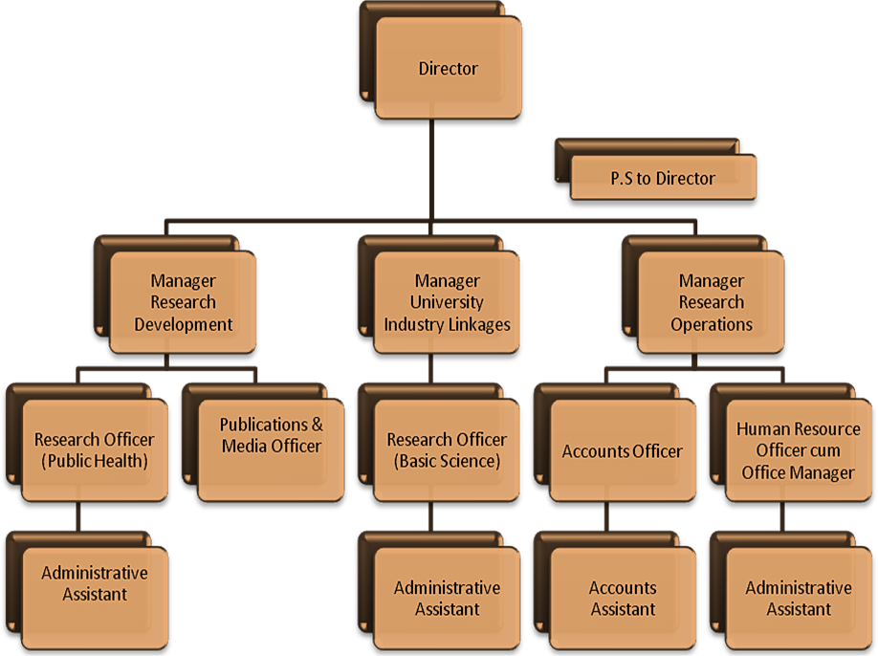

*Note: Managers of ORIC are also referred to as Deputy Directors in RMU*

##### SECTION IV WORKSHOPS

**Workshops (5 hours each for 3 days)**

|  |  |  |  |  |  |  |  |
| --- | --- | --- | --- | --- | --- | --- | --- |
|  | **S.NO** |  |  | **Name of the Workshop** |  | **Learning Objectives** | **Topics to be Covered** |
|  | | |
| **1.** | | | **Biostatistics & Research Methodology (2 days)** | | | * To understand the basics of Bio- Statistics * To critique why research is important? * To discuss the importance of Selecting a Field for Research * To prepare oneself for Participation in National and International Research * To prepare oneself for Participation in Pharmaceutical Company Research * To interpret the importance of research ideas & Criteria for a good research topic * To discuss Ethics in Health Research * To learn to write a Scientific Paper * To learn to make a Scientific Presentation * To learn to make a purposeful   literature search | 1. Introduction to Bio-Statistics 2. Introduction to Bio- Medical Research Why research is important? 3. What research to do?    1. Selecting a Field for Research    2. Drivers for Health Research    3. Participation in National and International Research    4. Participation in Pharmaceutical Company Research    5. Where do research ideas come from    6. Criteria for a good research topic Ethics in Health Research 4. Writing a Scientific Paper 5. Making a Scientific Presentation & Searching the Literature |
| **2.** | | | **Introduction to computer/ Information Technology &** | | | By the end of this workshop student should be able to:   * Appropriately | 1. Hardware and Software    * Understand the main components of a computer, including input and output devices.    * Understand the function of communication devices |

|  |  |  |  |
| --- | --- | --- | --- |
|  | **Software (2 days)** | start up and shut down your computer.   * Navigate the operating system and start applications. * Perform basic functions of file management. * Perform basic functions in a word processor and spreadsheet. * Manage print settings and print documents. * Receive and send email. * Use a web browser to navigate the Internet. * work with windows, toolbars, and command menus * perform basic word processing and graphic tasks * make a Power Point presentation * explore Web browsing basics * back up files * save, copy, and organize your work * to enter data accurately in software of Statistical Package for Social Sciences | such as smart phones and tablets.   * Understand the role of Operating Systems, programs and apps.  1. Windows    * Turning on the computer and logging on.    * The Windows screen.    * Running programs from the Start Menu.    * Minimizing, maximizing, moving, resizing and closing windows.    * Logging off and shutting down your computer. 2. Working with Programs    * Running multiple programs.    * Desktop icons and creating a desktop shortcut.    * Managing programs from the taskbar.    * Closing programs. 3. File Management    * Managing Windows Explorer.    * Creating, moving, renaming and deleting folders and files.    * Understandings file extensions.    * Viewing storage devices and network connections.    * Managing USB flash drives. 4. Word Processing    * Creating documents in Microsoft Word.    * Typing text, numbers and dates into a document.    * Easy formatting.    * Checking the spelling in your document.    * Making and saving changes to your document. 5. Power Point   Making Power Point presentation 7.Spreadsheets   * + Understanding spreadsheet functionality.   + Creating spreadsheets in Microsoft Excel.   + Typing text numbers and dates into a worksheet.   + Easy formulas.   + Easy formatting.   + Charting your data.   + Making and saving changes to your workbook.   + Printing a worksheet. 8.Printing   + Print preview.   + Print settings.   + Managing the print queue.   9.Using Email   * The Outlook mail screen elements. * Composing and sending an email message. * Managing the Inbox. 10.Accessing the Internet * Going to a specific website and bookmarking. * Understanding how to search/Google effectively. * Copy and paste Internet content into your documents and emails. * Stopping and refreshing pages. * Demystifying the Cloud. * Understanding social media platforms such as Face |

|  |  |  |  |
| --- | --- | --- | --- |
|  |  |  | book and Twitter.   * Computer security best practices. 11.Statistical Package for Social Sciences * general understanding for data entry |
| **3.** | **communication skills**  **(2 days)** | * To learn to use Non-Medicinal Interventions in Communication Skills of Clinical Practice * To discuss the importance of counseling * To role play as a counselor * To learn to manage a conflict resolution * To learn to break bad news * To discuss the importance of Medical Ethics, Professionalism and Doctor- Patient Relationship Hippocratic Oath * To learn to take an informed consent * To illustrate the importance of confidentiality * To summarize Ethical Dilemmas in a Doctor’s Life | 1. Use of Non-Medicinal Interventions in Clinical Practice Communication Skills 2. Counseling 3. Informational Skills 4. Crisis Intervention/Disaster 5. Management Conflict Resolution 6. Breaking Bad News 7. Medical Ethics, Professionalism and Doctor-Patient Relationship Hippocratic Oath 8. Four Pillars of Medical Ethics (Autonomy, Beneficence, Non-maleficence and Justice) 9. Informed Consent and Confidentiality 10. Ethical Dilemmas in a Doctor’s Life |
| **4.** | **Advanced trauma Life Support**  **(2 days)** | Upon successful completion of the workshop, the student will be able to:   * Recognize and initiate early management of pre-arrest conditions that   may result in | The workshop is designed to give students the opportunity to practice and demonstrate proficiency in the following skills used in resuscitation:   1. Systematic approach 2. High-quality BLS 3. Airway management 4. Rhythm recognition 5. Defibrillation 6. Intravenous (IV)/intraosseous (IO) access (information only) |

|  |  |  |  |
| --- | --- | --- | --- |
|  |  | cardiac arrest or complicate resuscitation outcome   * Demonstrate proficiency in providing BLS care, including prioritizing chest compressions and integrating automated external defibrillator (AED) use * Recognize and manage respiratory arrest * Recognize and manage cardiac arrest until termination of resuscitation or transfer of care, including immediate post- cardiac arrest care * Recognize and initiate early management of ACS, including appropriate disposition * Recognize and initiate early management of stroke, including appropriate disposition * Demonstrate effective communication as a member or leader of a resuscitation team and recognize the impact of team dynamics on overall team performance | 1. Use of medications 2. Cardio version 3. Transcutaneous pacing 4. Team dynamics 5. Reading and interpreting electrocardiograms (ECGs)    * Be able to identify—on a monitor and paper tracing—rhythms associated with bradycardia, tachycardia with adequate perfusion, tachycardia with poor perfusion, and pulseless arrest. These rhythms include but are not limited to:      + Normal sinus rhythm      + Sinus bradycardia      + Type I second-degree AV block      + Type II second-degree AV block      + Third-degree AV block      + Sinus tachycardia      + Supraventricular tachycardias      + Ventricular tachycardia      + Asystole      + Ventricular fibrillation      + Organized rhythm without a pulse 6. Basic understanding of the essential drugs used in:  * Cardiac arrest * Bradycardia * Tachycardia with adequate perfusion * Tachycardia with poor perfusion * Immediate post–cardiac arrest care |

**SECTION V LIFE CYCLE OF MS UROLOGY**

**Milestones to be Achieved by Trainees**

CLINICAL COMPETENCIES FOR 1ST, 2ND, 3RD,4TH AND 5TH YEAR MS UROLOGY SURGERY TRAINEES CLINICAL COMPETENCIES\SKILL\PROCEDURE

The clinical competencies, a specialist must have, are varied and complex. A complete list of the skills necessary for trainees and trainers is given below. The level of competence to be achieved each year is specified according to the key, as follows:

1. Observer status
2. Assistant status
3. Performed under supervision
4. Performed under indirect supervision

###### Charting the Road to Competence: Developmental Milestones for MS Urology Program atRawalpindi Medical University

Remember to celebrate for the milestones as you prepare for the road ahead Nelson

**Mandela.**

High-quality assessment of resident performance is needed to guide individual residents' development and ensure their preparedness to provide patient care. To facilitate this aim, reporting milestones are now required across all UROLOGY residency programs. Milestones promote competency-based training in General Surgery. Residency program directors may use them to track the progress of trainees in the 6 general competencies including ***patient care, Medical Knowledge, Practice-Based Learning and Improvement, Interpersonal and Communication Skills, Professionalism and Systems-Based Practice.*** Milestones inform decisions regarding promotion and readiness for independent practice. In addition, the milestones may guide curriculum development, suggest specific assessment strategies, provide benchmarks for resident self-directed assessment-seeking, assist remediation by facilitating identification of specific deficits, and provide a degree of national standardization in evaluation. Finally, by explicitly enumerating the profession‟s expectations for graduates, they may improve public accountability for

residency training.

|  |  |  |  |
| --- | --- | --- | --- |
| **Table-1** | **Developmental Milestones for UROLOGY Training—Patientcare** | | |
| **Competency** | **Developmental Milestones Informing Competencies** | **Approximate Time Frame Trainee Should Achieve**  **Stage(months)** | **General Evaluation Strategies Assessment Methods/Tools** |
| ***A. Clinical skills and reasoning*** | ***Historical data gathering*** | | |
| * Manage patients using clinical skills of interviewing and physical examination * Demonstrate competence in the performance of procedures * Appropriately use laboratory and imaging techniques | 1. Acquire accurate and relevant history from the patient in an efficiently customized, prioritized, and hypothesis  driven fashion | 8 | * Standardized patient * Direct observation |
| 2. Seek and obtain appropriate, verified, and prioritized data from secondary sources (eg,  family, records,  pharmacy) | 12 |
| 3. Obtain relevant historical subtleties that inform and prioritize both differential diagnoses and diagnostic plans, including sensitive, complicated, and detailed information that may not often  be volunteered by the patient | 24 |
|  | 4. Role model gathering subtle and reliable information from the patient for  junior members of the health care team | 40 |  |
|  | ***Performing a physical examination*** | | |
|  | 1. Perform an accurate physical examination that is appropriately targeted to the patient’s complaints and medical conditions. Identify pertinent abnormalities using  common maneuvers | 8 | * Standardized patient direct observation * Simulation |

|  |  |  |  |
| --- | --- | --- | --- |
|  | 2. Accurately track important changes in the physical examination over time in the outpatient and inpatient settings | 12 |  |
|  | 3. Demonstrate and teach how to elicit important physical findings for junior members of the health  care team | 24 |
|  | 4. Routinely identify subtle or  unusual physical  findings that may influence clinical decision making, using advanced maneuvers  where applicable | 40 |
| ***Clinical reasoning*** | | |
| 1. Synthesize all available  data, including interview, physical examination, and preliminary laboratory data, to define each patient’s central  clinical problem | 16 | * Chart-stimulated recall * Direct observation * Clinical vignettes |
| 2. Develop prioritized differential diagnoses, evidence- based diagnostic  and therapeutic plan for common inpatient and ambulatory  conditions | 32 |
| 3. Modify differential diagnosis and care plan based on clinical course and data as  appropriate | 32 |
| 4.Recognize disease presentations that deviate from common patterns and that  require com plex decision making | 48 |

|  |  |  |  |
| --- | --- | --- | --- |
|  | ***Invasive procedures*** | | |
| 1. Appropriately perform invasive procedures and provide post- procedure management for  common procedures | 24 | * Simulation * Direct observation |
|  | Diagnostic tests | | |
| ***B. Delivery of patient- centered clinical care***   * Manage patients with progressive   responsibility   * Manage patients across the spectrum of clinical diseases seen in the practice of Urological Surgery. * Manage patients in a variety of health care settings to include the inpatient ward, critical care units, the ambulatory setting, and the emergency setting * Manage undifferentiat ed acutely and severely ill patients * Manage patients in the prevention, counseling, detection, |
| 1. Make appropriate clinical decisions based on the results of common diagnostic testing, including but not limited to routine blood chemistries, hematologic studies, coagulation tests, ECG, chest radiographs, USG , Cystoscopic evaluation, CT-scan  MRI and Renal Scans | 16 | * Chart-stimulated recall * Standardized tests * Clinical vignettes |
| 2. Make appropriate clinical decision based on the results of more advanced diagnostic  tests | 24 |  |
| Patient management | | |
| 1. Recognize situations with a need for urgent or emergent medical care and/or surgical care. | 8 | * Simulation * Chart-stimulated recall * Multisource feedback * Direct observation * Chart audit |
| 2. Recognize when to seek additional guidance | 8 |
| 3. Provide appropriate preventive care and teach patient  regarding self-care | ` |
| 4. With supervision, manage patients with common clinical disorders seen in the practice of inpatient  department. | 16 |

|  |  |  |  |
| --- | --- | --- | --- |
| diagnosis, and treatment of gender- specific diseases Manage patients  as a consultant to other physician |  |  |  |
| 5. With minimal supervision, manage patients with common and complex clinical disorders seen in the practice. | 16 |
| 6. Initiate management and stabilize patients with emergent  conditions | 16 |
| 7. Manage patients with conditions that require  intensive care | 48 |
| 8. Independently manage patients with a broad spectrum of clinical disorders seen in the practice of  Urology. | 48 |
| 9. Manage complex or rare Urological conditions | 48 |
| 10. Customize care in the context of the patient’s preferences and overall  health | 48 |
| Consultative care | | |
| 1. Provide specific, responsive consultation to other  services | 32 | * Simulation * Chart-stimulated recall * Multisource feedback * Direct observation * Chart audit |
| 2. Provide Urological consultation for patients with more complex clinical problems requiring detailed  risk assessment | 48 |



**87 |** P a g e

|  |  |  |  |  |  |
| --- | --- | --- | --- | --- | --- |
| **Table-2 Developmental Milestones for Urology Training—Medical Knowledge** | | | | | |
| **Competency** | **Developmental Milestones Informing Competencies** | **Approxim ate TimeFram e Trainee Should Achieve**  **Stage(months)** | **General Evaluation Strategies Assessment Methods/To ols** | | |
| 1. Core knowledge of Urology    * Demonstrate a level of expertise in the knowledge of those areas appropriate for a Urologist.    * Demonstrate sufficient knowledge to treat Urological conditions commonly managed by internists, provide basic preventive care, and recognize and provide initial management of emergency problems | ***Knowledge of core content*** | | | | |
| 1. Understand the relevant pathophysiology and basic science for common conditions | | | 8 | •  • |
|  |  | | |  | • |

|  |  |  |  |
| --- | --- | --- | --- |
|  |  |  |  |
| 2. Demonstrate sufficient knowledge to diagnose and treat common conditions that require hospitalization | 16 | • |
| 3. Demonstrate sufficient knowledge to evaluate common  conditions | 24 |
| 4. Demonstrate sufficient knowledge to diagnose and treat undifferentiated and emergent conditions | 24 |
| 5. Demonstrate sufficient knowledge to provide  preventive care | 24 |
| 6. Demonstrate sufficient knowledge to identify and treat conditions that require intensive care | 32 |
| 7. Demonstrate sufficient knowledge to evaluate complex or rare conditions and multiple  coexistent conditions | 48 |
| 8. Understand the relevant pathophysiology and basic science for uncommon or  complex conditions | 48 |
| 9. Demonstrate sufficient knowledge of sociobehavioral sciences including but not limited to health care economics, medical ethics.  medical education | 48 |

|  |  |  |  |
| --- | --- | --- | --- |
| B. Common | Diagnostic tests | | |
| modalities used in the |
| 1. Understand indications for and basic interpretation of common diagnostic testing, including but not limited to routine blood chemistries, hematologic studies, coagulation tests, ECG, chest radiographs, USG, CT Scan ,  Cystoscopy, MRI & Renal Scan. | 16 | * Chart-stimulated recall * Standardized tests * Clinical vignettes |
| practice of |  |
| Urology & |  |
| Demonstrate |  |
| sufficient |  |
| knowledge to |  |
| interpret |  |
| basic clinical |  |
| tests and |  |
| images, use |  |
| common |  |
| pharmacothe |  |
| rapy, and |  |
| appropriately |  |
| use and |  |
| perform |  |
| diagnostic |  |
| and |  |
| therapeutic |  |
| procedures. |  |
|  | 2. Understand | 24 |  |
| indications |  |
| for and has basic skills |  |
| in interpreting more |  |
| advanced diagnostic |  |
| tests |  |
|  | 3. Understand prior | 24 |
| probability and test |  |
| performance |  |
| characteristics |  |

|  |  |  |  |
| --- | --- | --- | --- |
| **Table-3 Developmental Milestones for Urology Training—Practice-Based Learning and Improvement** | | | |
| **Competency** | **Developmental Milestones Informing Competencies** | **Approximate TimeFrame Trainee Should Achieve**  **Stage(months)** | **General Evaluation Strategies Assessment Methods/Tools** |
| **A. Learni** | ***Improve the quality of care for a panel of patients*** | | |
| **ng and** |
| **impro** | 1. Appreciate the responsibility to assess and improve care collectively for a  panel of patients |  | * Several elements of quality improvement project * Standardized tests |
| **ving via**  **audit** | 16 |
| **of** |  |
| **perfor** |  |
| **manc** |  |
| **e &** |  |
| **Syste** | 2. Perform or review audit of a panel of patients using standardized, disease- specific, and  evidence- based  criteria |  |
| **matic**  **ally** | 32 |
| **analy** |  |
| **ze** |  |
| **practi** |  |
| **ce** |  |
| **using** |  |
| **qualit** |  |
| **y** |  |
| **impro** |  |
| **veme** |
| 3. Reflect on audit compared with local or national benchmarks and explore possible explanations for deficiencies, including doctor- related, system-related, and  patient related factors |  |
| **nt** |  |
| **meth** |  |
| **ods,**  **and** | 32 |
| **imple** |  |
| **ment** |  |
| **chang** |  |
| **es** |  |
| **with** |  |
| **the** |  |
| **goal** |  |
| **of** |  |
| **practi** |  |
| **ce impro veme nt** |  |
| 4. Identify areas in resident’s own  practice and local | 48 |
|  | system that can be |  |
|  | changed to improve |  |
|  | effect of |  |
|  | the processes and |  |
|  | outcomes of care |  |
|  | 5. Engage in a quality | 48 |
|  | improvement |  |
|  | intervention |  |
| 1. **Learning and improvement via answering clinical questions from patient scenarios**    * Locate, appraise, and assimilate evidence from scientific studies | * Ask answerable questions for emerging information needs | | |
| 1. Identify learning |  | * Evidence-based medicine * evaluation instruments EBM mini-CEX * Chart-stimulated recall |
| needs (clinical | 16 |
| questions) as they |  |
| emerge in patient |  |
| care activities |  |
| 2. Classify and | 32 |
| precisely |  |
| articulate clinical |  |
| questions |  |

|  |  |  |  |
| --- | --- | --- | --- |
| related to their patients’ health problems;   * Use information | 3. Develop a system to track, pursue,  and reflect on clinical  questions | 32 |  |
| ***Acquiresthebestevidence*** | | |
| technology to |
| optimize learning | 1. Access medical information resources  to answer clinical | 16 | * Evidence-based medicine * evaluation instruments * EBM, mini-CEX, Chart-stimulated recall |
|  | questions and support |  |
|  | decision making |  |
|  | 2. Effectively and |  |
|  | efficiently search NLM  database for original | 16 |
|  | clinical research articles |  |
|  | 3. Effectively and |  |
|  | efficiently search  evidence- based | 32 |
|  | summary medical |  |
|  | information resources |  |
|  | 4. Appraise the quality |  |
|  | of medical information  resources and select | 48 |
|  | among them based on |  |
|  | the characteristics of |  |
|  | the clinical question |  |
|  | Appraises the evidence for validity and usefulness | | |
|  | 1. With assistance, |  | * Evidence-based medicine * evaluation instruments EBM mini-CEX * Chart-stimulated recall |
|  | appraise study design,  conduct, and statistical | 16 |
|  | analysis in clinical |  |
|  | research papers |  |
|  | 2. With assistance,  appraise clinical | 32 |
|  | guidelines |  |
|  | 3. Independently |  |
|  | appraise study design,  conduct, and statistical | 48 |
|  | analysis in clinical |  |
|  | research papers |  |
|  | 4. Independently, |  |  |
| appraise clinical  guideline | 48 |
| recommendations for |  |
| bias and cost-benefit |  |
| considerations |  |
| ***Appliestheevidencetodecision-makingforindividualpatients*** | | |
| 1. Determine if clinical |  | * Evidence-based medicine * evaluation instruments EBM mini-CEX * Chart-stimulated recall |
| evidence can be  generalized to | 16 |
| an individual patient |  |
| 2. Customize clinical  evidence for an | 32 |
| individual patient |  |
| 3. Communicate risks |  |
| and benefits of  alternatives to | 48 |
| patients |  |
| 4. Integrate clinical |  |
| evidence, clinical  context, and patient | 48 |
| preferences into |  |
| decision making |  |
| **C. Learning** | ***Improves via feedback*** | | |

|  |  |  |  |
| --- | --- | --- | --- |
| **and improvin g via feedback and self- assessme nt**   * Identify strengths, deficiencies, and limits in one’s knowledge and expertise * Set learning and improvement goals * Identify and perform appropriate learning activities * Incorporate formative evaluation feedback into daily practice * Participate in the education of patients, families, students, residents, and other health professionals | 1. Respond welcomingly and productively to feedback from all members of the health care team including faculty, peer residents, students, nurses, allied health workers, patients, and their  advocates | 16 | * Multisource feedback * Self-evaluation forms with action plans |
| 2. Actively seek feedback from all  members of the health  care team | 24 |
| 3. Calibrate self- assessment with feedback and other  external data | 32 |
| 4. Reflect on feedback in developing plans for  improvement | 32 |
| ***Improves via self-assessment*** | | |
| 1. Maintain awareness of the situation in the moment, and  respond to meet situational needs | 32 | * Multisource feedback * Reflective practice surveys |
| 2. Reflect (in action) when surprised, applies new insights to future clinical scenarios, and reflects (on action)  back on the process | 48 |
| ***Participates in the education of all members of the health*** | | |
|  | ***careteam*** | | |
|  | 1. Actively participate in | 16 | * OSCE with standardized learners Direct observation * Peer evaluations |
|  | teaching conferences |  |
|  | 2. Integrate teaching, feedback, and evaluation with supervision of  interns’  and students’ patient care | 32 |
|  | 3. Take a leadership role in the education of all members of the  healthcare team. | 48 |

|  |  |  |  |
| --- | --- | --- | --- |
| **Table-4 Developmental Milestones for UROLOGY Training—Interpersonal and Communication Skills** | | | |
| **Competen cy** | **Developmental Milestones Informing Competencies** | **Approximate TimeFrame Trainee Should Achieve**  **Stage(months)** | **General Evaluation Strategies Assessment Methods/Tools** |
| ***A.*** | ***Communicate effectively*** | | |

|  |  |  |  |
| --- | --- | --- | --- |
| ***Communic ate effectively:***   * Patients and family Communicat e effectively with patients, families, and the public,   as appropriate, across a broad range of socioecono mic and cultural background  s | 1. Provide timely and comprehensive verbal and written communication to  patients/advocates | 16 | * Multisource feedback * Patient surveys * Direct observation * Mentored self- reflection |
| 2. Effectively use verbal and nonverbal skills to create rapport with  patients/families | 16 |
| 3. Use communication skills to build a therapeutic  relationship |  |
| 4.Engage patients  /advocates in shared  decision making for uncomplicated diagnostic  and therapeutic scenarios | 32 |
| 5. Use patient-centered education strategies | 32 |
| 6. Engage patients  /advocates in shared decision making for difficult, ambiguous, or  controversial scenarios | 48 |
|  | 7. Appropriately counsel patients about the risks and benefits of tests and procedures, highlighting cost awareness and resource allocation | 48 |  |
| 8. Role model effective communication skills in challenging situations | 48 |
| ***Intercultural sensitivity*** | | |
| 1. Effectively use an interpreter to engage patients in the clinical setting, including  patient education | 8 | * Multisource feedback * Direct observation * Mentored self- reflection |
| 2. Demonstrate sensitivity to differences in patients including but not limited to race, culture, gender, sexual orientation, socioeconomic status, literacy, and religious beliefs | 16 |
| 3. Actively seek to understand patient differences and views and reflects this in respectful communication and shared decision-making with the patient and the healthcare  team | 40 |
| ***B. Physicians*** | ***Transitions of care*** | | |

|  |  |  |  |  |  |
| --- | --- | --- | --- | --- | --- |
| ***and other health care professional s***   * Communic ate effectively with physicians, other health professiona ls, and health- related agencies Work effectively as a member or leader of a health care team or other professiona l | 1. Effectively communicate with other caregivers in order to maintain appropriate continuity during  transitions of care | 16 | | | * Multisource feedback * Direct observation * Sign-out form ratings * Patient surveys |
| 2. Role model and teach effective communication with next caregivers during  transitions of care | 32 | | |
| ***Interprofessional team*** | | | | |
| group   * Act in a consult ative role to other physicia ns and health professi onals | 1. Deliver appropriate, succinct, hypothesis-driven oral presentations | | 8 | | * Multisource feedback |
| 2. Effectively communicate plan of care to all members of  the health care team | | 16 | |
| 3. Engage in collaborative communication with all members of the health care  team | | 40 | |
| ***Consultation*** | | | | |
| 1. Request consultative services in an effective manner | | | 8 | * Multisource feedback * Chart audit |
| 2. Clearly communicate the role of consultant to the patient, in support of the primary care relationship | | | 1  6 |
| 3. Communicate consultative recommendations to the referring team in an effective manner | | | 4  8 |
| ***C. Medical records***   * Maintain comprehensi   ve, timely, and legible medical records | ***Health records*** | | | | |
| 1. Provide legible, accurate  ,complete,and timely written communication  that is congruent with medical standards | 8 | | | * Chart audit |

|  |  |  |  |
| --- | --- | --- | --- |
|  | 2.Ensuresuccinct,r elevant,andpatient  -specificwritten  communication | 32 |  |

|  |  |  |  |
| --- | --- | --- | --- |
| **Table-5 Developmental Milestones for UROLOGY Training—Professionalism** | | | |
| **Compete ncy** | **Developmental Milestones Informing Competencies** | **Approximate TimeFrame Trainee Should Achieve**  **Stage(months)** | **General Evaluation Strategies Assessment Methods/Tools** |
| ***A.Physicianship*** Demonstrate compassion, integrity, and respect for others responsiveness to  patient needs that supersedes self- interest Accountability to patients, society, and the profession | ***Adhere to basic ethical principles*** | | |
| 1. Document and report clinical information  truthfully | 1.5 | * Multisource feedback |
| 2. Follow formal  policies | 1.5 |
| 3. Accept personal  errors and honestly  acknowledge them | 8 |
| 4. Uphold ethical expectations of  research and scholarly activity | 48 |
| ***Demonstrate compassion and respect to patients*** | | |
| 1. Demonstrate empathy and compassion to all  patients | 4 | * Multisource feedback |
| 2. Demonstrate a commitment to  relieve pain and suffering | 4 |
| 3. Provide support (physical, psychological, social, and spiritual) for dying patients  and their families | 32 |
| 4. Provide leadership for a team that respects  patient dignity and  autonomy | 32 |
| - | ***Provide timely***  ***,constructive feedback to colleagues*** | | |

|  |  |  |  |  |
| --- | --- | --- | --- | --- |
|  | 1. Communicate constructive  feedback to other members of the  health care team | 16 | | * Multisource feedback * Mentored self- reflection * Direct observation |
| 2. Recognize, respond to, and report impairment in colleagues or substandard  care via peer  review process | 24 | |
| Maintain accessibility | | | |
| 1. Respond promptly and appropriately to clinical responsibilities including but  not limited to calls and pages | 1.5 | | * Multisource feedback |
| 2. Carry out timely interactions with colleagues, patients, and  their designated  caregivers | 8 | |  |
| Recognize conflicts of interest | | | |
| 1. Recognize and manage obvious conflicts of interest, such as caring for family members and professional  associates as patients | 8 | | * Multisource feedback * Mentored self- reflection * Clinical vignettes |
| 2. Maintain ethical | 40 | |
| relationships with |  | |
| industry |  | |
| 3. Recognize and | 40 | |
| manage subtler |  | |
| conflicts of interest |  | |
| Demonstrate personal accountability | | | |
| 1. Dress and behave appropriately | | 1.5 | Multisource feedback Direct observation |
| 2. Maintain appropriate professional relationships with  patients, families,  and staff | | 1.5 |  |
| 3. Ensure prompt completion of clinical, administrative, and  curricular tasks | | 8 |  |
| 4. Recognize and address personal, psychological, and physical limitations that may affect professional  performance | | 16 |  |

|  |  |  |  |  |
| --- | --- | --- | --- | --- |
|  | 5. Recognize the scope of his/her abilities and ask for supervision and assistance  appropriately | | 16 |  |
| 6. Serve as a professional role model for more junior colleagues (eg, medical  students, interns) | | 40 |
| 7. Recognize the need to assist colleagues in the provision of duties | | 40 |
| ***Practice individual patient advocacy*** | | | |
| 1. Recognize when it is  necessary to advocate for individual patient  needs | 8 | | Multisource feedback Direct observation |
| 2. Effectively advocate for individual patient  needs | 40 | |
| ***Comply with public health policies*** | | | |
| 1. Recognize and take responsibility for situationswherepublich ealthsupersedesindivid ualhealth(eg,reportable  infectious diseases) | 32 | | * Multisource feedback |
| ***Patient- centeredness***   * Respec t for patient privacy and autonoy   Sensitivity and responsivenes to a diverse patient population  ,including but not limited to diversity in gender, age, culture, race  ,religion  ,disabilities, and sexual orientation | ***Respectthedignity,culture,beliefs,values,andopinionsofthepati ent*** | | | |
| 1.Treatpatientswithdig nity,civilityand respect,regardless of race, culture, gender,ethnicity,ag e,or  Socio-economic status | 1.5 | | Multisource feedback Direct observation |
| 2. Recognize and manage conflict when patient values | 40 | |
|  |  | |  |
| ***Confidentiality*** | | | |
| 1.Maintainpat ientconfiden tiality | | 1.5 | Multisource feedback Chart audits |
| 2.Educateandholdothers Accountable for  patient  confidentiality | | 24 |
| ***Recognize and address disparities in healthcare*** | | | |

|  |  |  |  |
| --- | --- | --- | --- |
|  | 1. Recognize that disparities exist in health care among populations and that they may impact care of the  patient | 16 | Multisource feedback Direct observation Mentored self-reflection |
| 2.Embracephysic ians’roleinassisti ngthepublicandp olicymakersin understanding and addressing causes of disparity in disease and  suffering | 40 |
| 3.Advocatesforappropriat e  Allocation of limited healthcare  resources. | 40 |

**References of Milestones** <https://www.acgme.org/Portals/0/PDFs/Milestones/InternalMedicineMilestones.pdf> <http://education.med.ufl.edu/files/2010/10/InternalMedicineMilestones.pdf> <http://www.upstate.edu/medresidency/current/competencies.php>

###### Entrustable Professional Activities (EPAs) :

* Entrustable Professional Activities (EPAs) for a five-year Urology residency program are essential in defining the specific tasks residents should be able to perform independently by the end of their training. These EPAs are aligned with clinical core competencies and are designed to ensure that residents progressively develop their skills and knowledge throughout their residency.
* Levels of EPA
* 1)Be present and observe or Assist
* 2)Direct pro-active Supervision: The supervisor is physically present with the resident and the patient.
* 3) Indirect re-active Supervision is broken down into two levels: Direct Supervision Immediately Available: The supervisor is physically within the hospital or other site of patient care and is immediately available to provide direct supervision. Direct Supervision not readily Available: The supervisor is not physically present within the hospital or other site of patient care, but is immediately available by means of telephonic and/or electronic modalities, and is available to provide direct supervision.
* 4) Can supervise other junior residents
* Below is a structured outline of EPAs in each domain based on ACGME core competencies
* Accountability and Transparency
* Fairness and Equity
* Stewardship and Service
* Engagement of Stakeholders
* Leadership and Collaboration

1. Conducting a Comprehensive Patient Evaluation and History Taking for Common Urological Presentations

**Key Features:**

* + Conduct comprehensive Urological history taking.
  + Identify and document chief complaints, HOPI, pertinent negatives and positives, medical history, and family history relevant to Urology care.

Assessment plan:

Case discussion after clinical encounter (At least 5 different presentations to 2 different assessors)

Milestones:

* Optimize the physical environment for patient comfort, dignity, and privacy
* Establish rapport and explain the purpose of the visit
* Gather a history relevant to the patient‟s presentation
* Conduct the interview in a patient-centered manner
* Apply an organized approach to history-gathering
* Identify other sources of information (e.g., family, medical record) that may assist in a patient‟s care

1. Performing Essential Urological Examinations.

**Key Features:**

* + This EPA focuses on performing a general Urological examination for adult patients to assess Abdomen & Ext. Genitalia examination.
  + It also includes identifying normal Urological structures.

Assessment plan:

Direct observation by supervisor, mentor or clinical fellow (Collect 3 observations of achievement. -

At

least 2 different services - At least 3 different assessors)

Milestones:

* Maintain rapport and explain the steps and purpose of the examination
* Optimize the physical environment for patient comfort, dignity, and privacy
* Position the patient and/or equipment to optimize comfort and ergonomics
* Apply knowledge of the normal anatomy of Urological structures
* Demonstrate appropriate technique in the use of instruments for clinical assessment
* Perform a basic Abdominal examination
* Apply an organized approach to the urological examination
* Identify and differentiate normal and abnormal findings
* Synthesize and organize information for clear and succinct presentation to a supervisor.

1. Recognizing Life- and Vision-Threatening Findings in Basic Urological Diagnostic Investigations

**Key Features:**

* + This EPA includes the following diagnostic tests: USG & Cystoscopic examination.
  + Interpret results from these examinations.

Assessment plan:

Review of results of Urological examination (Collect 8 observations of achievement - At least 2 of each diagnostic test - At least 1 normal result for each diagnostic test - At least 1 faculty assessor )

Milestones:

* Apply knowledge of anatomy, physiology, and pathophysiology
* Identify normal structures and anatomic landmarks
* Recognize findings that signify a potential vision- or life-threatening condition
* Interpret findings in the context of the patient‟s presentation

1. Developing an initial management plan for patients with an acute Urological condition or presentation

**Key Features:**

* + This EPA focuses on synthesizing findings from a clinical assessment to develop a differential diagnosis, determine the acuity of the problem and the urgency of investigation and/or treatment, and initiate management to stabilize acute life-threatening emergencies.
  + Know when to escalate care to a senior resident or attending physician.

Assessment plan:

Direct observation and/or case review by supervisor, mentor or clinical fellow (Collect 3 observations of achievement. - At least 3 different conditions/presentations)

Milestones:

* Synthesize and interpret information from the clinical assessment
* Propose a differential diagnosis
* Determine the acuity of the condition
* Respond appropriately to vision- or life-threatening conditions
* Develop and implement a plan for initial management

1. Performing basic Urological Procedures Key Features:

This EPA includes determining which procedure is necessary and appropriate to the situation and performing the technical skills of the procedure as well as providing immediate post-procedural care.

Procedures include: removal of an embedded foreign body, DJS placement & Removal , Cystoscopic evaluation , Incision & Drainage , debridement of Fourneriers gangrene.

Assessment plan:

Direct observation by supervisor or mentor or clinical fellow (Collect 4 observations of achievement).

Milestones:

1. Knowledge of procedure: Understand steps, potential risks, and the means to overcome them
2. Pre-operative plan: Assess clinical information to determine/confirm diagnosis and appropriateness of procedure
3. Case preparation: Position patient correctly, understand approach and required instruments, be prepared to deal with probable complications
4. Efficiency and flow: Demonstrate planned course of procedure, economy of movement and flow
5. Technical performance: Perform steps of procedure efficiently, avoiding pitfalls and respecting tissues
6. Visuospatial skills: Demonstrate 3D spatial orientation, position instruments where intended
7. Post-procedure plan: Establish an appropriate and complete post-procedure plan
8. Professional and effective communication/utilization of assistants
9. Provide information about the procedure and/or operative findings to the patient and/or family in a clear, accurate and timely manner
10. Effectively Communicating Clinical Findings and Management Plans to Patients Key Features:
    * This EPA focuses on the application of communication skills and medical expertise to convey information about a Urological diagnosis and engage the patient and family in shared decision making regarding the management plan.
    * Communicate effectively with patients and families, explaining diagnoses and treatment plans clearly.
    * Demonstrate professionalism and empathy in patient interactions.

Assessment plan:

Direct observation by supervisor, which may include feedback collected from patient/family (Collect 3 observations of achievement).

Milestones:

* Establish rapport with the patient and family
* Tailor the approach to communication to the needs of the patient and/or family
* Engage the patient in the discussion as appropriate for their age and/or developmental stage Provide accurate information about the condition and/or the management plan
* Use plain language and avoid medical jargon
* Solicit and answer questions from the patient and/or family
* Verify understanding of the information conveyed
* Use communication skills and strategies that help the patient and/or family make an informed decision
* Communicate in a manner that is respectful, non-judgmental and culturally aware

1. Performing EndoUrological Surgeries.

**Key Features:**

* + This EPA focuses on the resident having a sound plan and performing all aspects of the procedure, including obtaining informed consent, preoperative planning including preparation of the sterile field, Cystoscopic evaluation , identification of relevant anatomical structures identification and resection of enlarged prostatic lobes, adequate channeling,hemostasis and post op care.
  + The observation of this EPA is divided into two parts: direct observation of a procedure; a log of procedures to demonstrate the breadth of experience.
  + This EPA may be observed in simulation.

Assessment Plan:

Part A: Procedural skills Direct observation by supervisor, mentor or clinical fellow Setting: clinical; simulation

Case mix (select all that apply): TURP Complications: Hemorrhage, perforation, infection.

Collect 36 observations of achievement (items marked to with an asterisk may be achieved in simulation).

At least 80 standard cataract surgeries, in a clinical setting, with at least 3 different observers

Milestones:

* + Procedural skills
  + Knowledge of procedure: Understand steps, potential risks, and the means to overcome them
  + Pre-operative plan:
  + Assess clinical information to determine additional instruments, medications, modification of settings and/or approach, and appropriateness of procedure
  + Case preparation: Position patient correctly, understand approach and required instruments, be prepared to deal with probable complications
  + Efficiency and flow: Demonstrate planned course of procedure, economy of movement and flow, and appropriate positioning for use of foot pedals and ergonomics
  + Technical performance: Perform steps of procedure efficiently .
  + Visuospatial skills: Demonstrate 3D spatial orientation, position instruments where intended
  + Post-procedure plan: Establish an appropriate and complete post-procedure plan
  + Professional and effective communication/utilization of assistants and OR team
  + Provide information about the procedure and/or operative findings to the patient and/or family in a clear, accurate and timely manner

1. Performing TURBT

**Key Features:**

* + This EPA focuses on the resident having a sound plan and performing all aspects of the procedure.
  + Procedures include obtaining informed consent, preoperative planning including preparation of the sterile field, Cystoscopic evaluation , identification of relevant anatomical structures identification and resection of bladder tumor, adequate tumor resection,hemostasis and post op care.
  + The observation of this EPA is divided into two parts: direct observation of a procedure; a log of procedures to demonstrate the breadth of experience.

Assessment Plan:

Procedural skills: Direct observation of the procedure by supervisor or mentor or clinical fellow (Collect 8 observations of achievement)

Procedural experience: Submit logbook of procedures

Milestones:

* + Procedural skills
  + Knowledge of procedure: Understand steps, potential risks, and the means to overcome them
  + Pre-operative plan: Assess clinical information to determine/confirm diagnosis and appropriateness of procedure
  + Case preparation: Position patient correctly, understand approach and required instruments, be prepared to deal with probable complications
  + Efficiency and flow: Demonstrate planned course of procedure, economy of movement and flow
  + Technical performance: Perform steps of procedure efficiently, avoiding pitfalls and respecting tissues
  + Visuospatial skills: Demonstrate 3D spatial orientation, position instruments where intended
  + Post-procedure plan: Establish an appropriate and complete post-procedure plan Professional and effective communication/utilization of assistants
  + Provide information about the procedure and/or operative findings to the patient and/or family in a clear, accurate and timely manner

1. Managing Genito-Urinary trauma Key Features:
   * This EPA focuses on the resident having a sound plan and performing all aspects of the procedure.
   * Procedures include Suprapubic Cystostomy, Percutaneous nephrostomy , Ureter & Bladder repair & emergency Nephrectomy .
   * The observation of this EPA is divided into two parts: direct observation of a procedure; a log of procedures to demonstrate the breadth of experience.
   * This EPA may be observed in simulation. Assessment Plan:

Procedural skills: Direct observation of the procedure by supervisor or mentor or clinical fellow (Collect 4 observations of achievement).

Procedural experience: Submit logbook of procedures

Milestones:

* Procedural skills
* Knowledge of procedure: Understand steps, potential risks, and the means to overcome them
* Pre-operative plan: Assess clinical information to determine/confirm diagnosis and appropriateness of procedure
* Case preparation: Position patient correctly, understand approach and required instruments, be prepared to deal with probable complications
* Efficiency and flow: Demonstrate planned course of procedure, economy of movement and flow
* Technical performance: Perform steps of procedure efficiently, using appropriate technique, avoiding pitfalls and respecting tissues.
* Visuospatial skills: Demonstrate 3D spatial orientation, position instruments where intended
* Post-procedure plan: Establish an appropriate and complete post-procedure plan Professional and effective communication/utilization of assistants and OR team
* Provide information about the procedure and/or operative findings to the patient and/or family in a clear, accurate and timely manner



**108 |** P a g e

#### 2) TABLE OF SPECIFICATIONS FOR FIRST YEAR

IN GENERAL SURGERY

|  |  |  |  |
| --- | --- | --- | --- |
| **Topics To Be Taught** | **Learning Objective**  **Student should be able to know:** | **Teaching Methods** | **Assessme nt** |
| **1. History Taking (Knowledge)** | To progressively develop the ability to obtain a relevant focused history from increasingly complex patients & challenging circumstances  To record accurately and synthesize history with clinical examination & formulation of management plan according to likely clinical evolution Recognizes the importance of different elements of history  Recognizes the importance of clinical (particularly cognitive impairment), psychological, social, cultural and nutritional factors particularly those relating to ethnicity, race, cultural or religious beliefs and preferences, sexual orientation, gender and disability  Recognizes that patients do not present history in structured fashion and that the history may be influenced by the presence of acute and chronic medical conditions  Know causes and risk factors for conditions relevant to mode of presentation  Recognizes that history should inform examination, investigation & management. | Bedside teaching in wards and outpatient departments | mini-CEX MCQs |
| **2. History Taking (Skills)** | Identify and overcome possible barriers (eg cognitive impairment) to effective communication  Manage time and draw consultation to close appropriately. Supplement history with standardized instruments or questionnaires when relevant  Manage alternative and conflicting views from family, careers and friends  Assimilate history from the available information from patient and other sources  Recognize and interpret the use of nonverbal communication from patients and careers  Focus on relevant aspects of history\  Show respect and behave in accordance with Good Medical Practice | Bedside teaching in wards & outpatient Departments | mini-CEX |

|  |  |  |  |
| --- | --- | --- | --- |
| **3.Clinical Examination** (knowledge) | * To progressively develop the ability to perform focused and accurate clinical examination in increasingly complex patients and challenging circumstances * To relate physical findings to history in order to establish diagnosis and formulate a management plan * Understand the need for a valid clinical examination * Understand the basis for clinical signs and the relevance of positive and negative physical signs * Recognize constraints to performing physical examination and strategies that may be used to overcome them * Recognize the limitations of physical examination and the   need for adjunctive forms of assessment to confirm diagnosis | Bedside teaching in wards and outpatient departments | **CBD**  **mini-CEX ACAT** |
| **4. clinical Examination** (Skills) | * Perform an examination relevant to the presentation and risk factors that is valid, targeted and time efficient * Recognize the possibility of deliberate harm in vulnerable patients and report to appropriate agencies * Interpret findings from the history, physical examination and mental state examination, appreciating the importance of clinical, psychological, religious, social and cultural factors * Actively elicit important clinical findings * Perform relevant adjunctive examinations including cognitive examination such as Mini Mental state Examination (MMSE) and Abbreviated Mental Test Score   (AMTS) | Bedside teaching in wards and outpatient departments | **CBD**  **mini-CEX ACAT** |
| **5. Clinical Examination**  (Attitude) | * Show respect and behaves in accordance with Good Medical Practice | Bedside teaching  in wards & outpatient | **CBD, mini CEX**  **MSF** |
| **6. Time Management & Decision Making** | * To become increasingly able to prioritize and organize clinical and clerical duties in order to optimize patient care. To become increasingly able to make appropriate clinical and clerical decisions in order to optimize the effectiveness of the clinical team resource | Bedside teaching in wards and outpatient departments | **ACAT CBD** |
| **7. Decision Making & Clinical Reasoning** | * To progressively develop the ability to formulate a diagnostic and therapeutic plan for a patient according to the clinical information available * To progressively develop the ability to prioritize the diagnostic and therapeutic plan * To be able to communicate the diagnostic and therapeutic   plan appropriately | Bedside teaching in wards | **ACAT CBD**  **mini-CEX** |

###### SECTION VI Evaluation and Assessment Strategies Framework Of Assessment:

1

2

3

4

5

* At the End of 5th year
* **Final Term Summative Assessment (FTA)**
* At the End of 4th year
* **In training Formative assessment for fourth year**
* At the End of 3rd year
* **In training Formative assessment for Third year**
* at the end of second calendar year
* **Midterm Summative Assessment**
* At the End of 1st year
* **In training Formative assessment for first year**

**Continuous Internal Assessment**

Multi-Source Feedback(360

Degree Performas)

Direct Observation of

Procedural Skills (DOPS)

Workplace Based

Assessment

More information about these methods including guidance for trainees and assessors is available in the Portfolio. Workplace-based assessments will be entered in the trainee‟s e-portfolio. The workplace-based assessment methods include feedback opportunities as an integral part of the assessment process.

**In training assessment for first year (Formative)**

1. All candidates admitted in MS Urology course shall appear in an examination at the end of first calendar year.
2. The examination will be composed of SEQs and OSCE.
3. The pass percentage will be 60%.

**Midterm Assessment (Summative)**

1. All candidates admitted in MS Urology course shall appear in Midterm examination at the end of second calendar year.
2. The examination shall be held on biannual basis.
3. The candidate who fails to pass the examination in 3 consecutive attempts availed or un-availed, shall be dropped from the course.
4. The examination shall have two components:
   * Paper-I MCQs (Optics & Refraction) 75 Marks
   * Paper-II MCQs 75 Marks
   * TOACS 150 Marks (15 Interactive stations)
5. Subjects to be examined shall be General Surgery (Upper & Lower GIT Tract, plastics Surgery, Paeds. Surgery .etc.
6. Only those candidates, who pass in theory papers, will be eligible to appear in the TOACS.
7. The candidates, who have passed written examination but failed in TOACS, will re-appear only in TOACS.
8. The maximum number of attempts to re-appear in TOACS alone shall be Four, after which the candidate shall have to appear in both written and TOACS as a whole.
9. To be eligible to appear in midterm assessment the candidate must submit;
10. Duly filled, prescribed Admission Form to the Controller of Examinations duly recommended by the Principal/Head of the Institution in which he/she is enrolled.
11. A certificate by the Principal/Head of the Institution, that the candidate has attended at least 75% of the lectures, seminars, practical/clinical demonstrations.
12. Examination fee as prescribed by the University.
13. To be declared successful in midterm examination the candidate must secure 60% marks in each paper

**In training assessment for third year (Formative)**

1. All candidates admitted in MS Urology course shall appear in an examination at the end of third calendar year.
2. The examination will be composed of SEQs and clinical OSCE.
3. The pass percentage will be 60%.

**In training assessment for Fourth year (Formative)**

1. All candidates admitted in MS Urology course shall appear in an examination at the end of Fourth calendar year.
2. The examination will be composed of SEQs and clinical OSCE.
3. The pass percentage will be 60%.

**Final Term Assessment (FTA) (Summative)**

1. All candidates admitted in MS Urology course shall appear in FTA at the end of structured training program (end of 5th calendar year), and having passed MTA. However, a candidate holding FCPS Ophthalmology / FRCS Ophthalmology / Diplomat American Board shall be exempted from MTA and shall be directly admitted to FTA, subject to fulfillment of requirements for the examination.
2. The examination shall be held on biannual basis.
3. To be eligible to appear in FTA the candidate must submit;
   1. duly filled, prescribed Admission Form to the Controller of Examinations duly recommended by the Principal/Head of the Institution in which he/she is enrolled;
   2. a certificate by the Principal/Head of the Institution, that the candidate has attended at least 75% of the lectures, seminars, practical/clinical demonstrations;
   3. Original Log Book complete in all respect and duly signed by the Supervisor (for Oral & practical/clinical Examination);
   4. certificate of having passed the midterm examination;
   5. certificates of all the mandatory rotations;
   6. Examination fee as prescribed by the University.
4. The FTA shall have the following components:

* Written 200 marks
* OSCE 150 marks

1. The written paper shall comprise of;

* Paper-I MCQs (single best) 100 Marks
* Paper-II MCQs (single best) 100 Marks

1. Clinical examination shall have 450 marks for:
   1. OSCE 150 marks
      1. 15 stations of clinical UROLOGY
   2. 1 Long Case 100 marks
   3. 4 Short Cases 200 marks (50 marks each)
2. To be declared successful in Part-III examination the candidate must secure 60% marks in each component and 50% in each sub-component.
3. Only those candidates, who pass in theory papers, will be eligible to appear in the Oral & Practical/ Clinical Examination.
4. The candidates, who have passed written examination but failed in Clinical Examination, will re- appear only in four consecutive. Clinical examination after which the candidate shall have to appear in both written and clinical examinations as a whole.
5. The candidate with 80% or above marks shall be deemed to have passed with distinction.
6. Log Book/Assignments:
7. Throughout the length of the course, the work record of the candidate shall be entered on the Log Book.
8. The Supervisor shall certify every year that the Log Book is being maintained and signed regularly.
9. The performance of the candidate shall be evaluated on annual basis, e.g., 25 marks for each year in five years MS UROLOGY course. The internal assessment shall reflect the performance of the candidate on following parameters:
   1. Year wise record of the competence of skills.
   2. Year wise record of the assignments.
   3. Year wise record of the evaluation regarding attitude & behavior.
   4. Year wise record of journal club / lectures / presentations / clinico-pathologic conferences attended & / or made by the candidate.

CONTINUOUS INTERNAL ASSESSMENT:

The continuous internal Assessment is taken in the form of

* 1. Multi-Source Feedback(360 Degree Performas) : To be filled by Supervisor & other Senior faculty members 6 monthly.
* 2. Direct Observation of Procedural Skills (DOPS) : To be Observed by a Senior Faculty member 6 monthly.
* 3.Workplace Based Assessment : To be evaluated by both External & Internal Examiner 6 monthly.

TABLE OF SPECIFICATIONS

END OF 1st YEAR TRAINING EXAMINATION

|  |  |  |  |  |
| --- | --- | --- | --- | --- |
| **Year One In-Training Assessment- Total marks 200** | | | | |
| **Exam Component** | **No. of Questions** | **Marks Distribution** | **Total Marks** | **Passing Marks** |
| **Written (SEQ)** | 10 | 10 marks each | 100 | 60 |
| **Clinical - OSCE** | 10 | 10 marks each | 100 | 60 |

**Written component Table of Specifications**

Total SEQs- 10/ 10 marks each

|  |  |  |
| --- | --- | --- |
| **Sr. No.** | **Topics** | **No. of SEQ** |
| 1. | Upper GIT | 1 |
| 2. | Lower GIT | 1 |
| 3. | Hepatobiliary System | 1 |
| 4. | Trauma & Accident | 1 |
| 5. | Plastic Surgery | 1 |

|  |  |  |  |  |
| --- | --- | --- | --- | --- |
|  | 6. | Paeds. Surgery | 1 |  |
| 7. | Vascular | 1 |
| 8. | Orthopaedic Surgery | 1 |
| 9. | Neuro-Surgery | 1 |
| 10. | Urology | 1 |

* 10% of the questions may come from any topic.

**Clinical Component Table of Specifications**

OSCE stations- 05

Total marks- 100

Passing marks- 60

Time allowed per station- 10min Interactive stations- 05

**Topic Wise Distribution of OSCE Stations**

|  |  |  |
| --- | --- | --- |
| **Station No.** | **Station Description & Topics** | **Skill to be assessed** |
| 1. | Clinical Methods | To assess the candidate‟s ability to perform the given examination task on a patient/simulated subject |
| 2. | Clinical Methods | To assess the candidate‟s ability to perform the given examination task on a patient/simulated  subject. |
| 3. | Clinical Methods | To assess the candidate's ability to perform the given examination task on a patient/simulated subject. |
| 4. | Clinical Methods | To assess the candidate's ability to perform the given examination task on a patient/simulated  subject |
| 5. | Clinical Methods | To assess the candidate's ability to perform the given examination task on a patient/simulated  subject |

MIDTERM EXAMINATION

|  |  |  |  |  |
| --- | --- | --- | --- | --- |
| **MTA- Total marks 300** | | | | |
| **Exam Component** | **No. of Questions** | **Marks Distribution** | **Total Marks** | **Passing Marks** |
| **Written (MCQs)**  **Paper 1 : 75**  **Paper 2: 75** | 150  **Paper 1 : 75 Q**  **Paper 2: 75 Q** | 1 mark each | 150 | 90 |
| **Clinical - OSCE** | 15 | 10 marks each | 150 | 90 |

Written component Table of Specifications

Total MCQs 150

(**Paper 1 : 75 Q's**

**Paper 2: 75 Q's)**

PAPER 1:

**No. of MCQs : 75**

|  |  |  |
| --- | --- | --- |
| **Sr. No.** | **Topics** | **No. of MCQs** |
| 1. | Head & Neck including thyroid & parathyroid | 10 |
| 2. | Salivary gland disorders | 05 |
| 3. | Hepatobiliary System | 10 |
| 4. | Acute Abdomen | 05 |
| 5. | Breast disorder | 05 |
| 6. | Abd. wall Hernias | 05 |
| 7. | Upper GIT | 10 |
| 8. | Lower GIT | 10 |
| 9. | Arterial, venous & lymphatic disorder | 10 |

PAPER 2:

No. of MCQs : 75

|  |  |  |
| --- | --- | --- |
| **Sr. No.** | **Topics** | **No. of MCQs** |
| 1. | ATLS Principles & Shock management | 05 |
| 2. | Torso trauma | 10 |
| 3. | Surgical Site infection | 05 |
| 4. | Pre-operative & ICU care | 05 |
| 5. | Nutrition & Electrolytes disorder | 10 |
| 6. | Urology | 10 |
| 7. | Paeds/Plastic Surgery | 10 |
| 8. | NeuroSurgery | 10 |
| 9. | Orthopedics | 10 |

**Clinical Component Table of Specifications**

OSCE stations- 15

Total marks- 150

Passing marks- 90

Time allowed per station- 05mins Interactive stations- 15

Topic Wise Distribution of OSCE Stations

|  |  |
| --- | --- |
| **Station No.** | **Station Description & Topics** |
| 1. | BLS/ATLS |
| 2. | BLS/ATLS |
| 3. | Counselling |
| 4. | Surgical Skills |
| 5. | Surgical Skills |
| 6. | Clinical Examination |
| 7. | Clinical Examination |
| 8. | Log Book |
| 9. | Orthopedics |
| 10. | Neurosurgery |
| 11. | Plastic /Pediatric Suregery |
| 12. | Radiology |
| 13. | Radiology |
| 14. | Metabolic Disorder |
| 15. | Clinical Scenario, diagnosis & management |

**END OF 3rd YEAR In-TRAINING EXAMINATION**

Total SEQs- 10/ 10 marks each

|  |  |  |
| --- | --- | --- |
| **Sr. No.** | **Topics** | **No. of SEQs** |
| 1. | Bladder Outflow Obstruction | 1 |
| 2. | Urinary Incontinence | 1 |
| 3. | Infections & inflammatory Conditions | 1 |
| 4. | Bladder Cancer | 1 |
| 5. | Stone Disease | 1 |
| 6. | Upper Tract Obstruction( hydronephrosis) | 1 |
| 7. | Renal cell Carcinoma | 1 |
| 8. | Uro-genital Trauma | 1 |
| 9. | Pediatric Urology | 1 |
| 10. | Prostate Cancer | 1 |

**10% of the questions may come from any topic.**

CLINICAL COMPONENT TABLE OF SPECIFICATIONS

OSCE stations- 05

Total marks- 100

Passing marks- 60

Time allowed per station- 5min Interactive stations- 5

Topic Wise Distribution of Urology OSCE Stations

|  |  |  |
| --- | --- | --- |
| **No of Stations** | **Station Description & Topics** | **Competence to be assessed** |
| 2 | Urological Investigations  (CT Scan, MRI , Isotope Renal Scan) | To assess the ability of the candidate to interpret the investigation and answer the questions (Critical  thinking & Problem solving) |
| 1 | Clinical Methods  (Abd . examination+ digital rectal examination) | To assess the candidate‟s ability to perform the given examination task on a patient/simulated subject. |
| 1 | Clinical Methods (Genital examination) | To assess the candidate's ability to perform the given examination task on a patient/simulated subject. |
| 1 | Urological procedures ( USG) | Images/videos will be shown to the candidate with relevant clinical scenarios to assess the ability to interpret findings and discuss the management plan (Critical thinking & Problem solving) |

**END OF 4td YEAR In-TRAINING EXAMINATION**

Total SEQs- 10/ 10 marks each

|  |  |  |
| --- | --- | --- |
| **Sr. No.** | **Topics** | **No. of SEQs** |
| 1. | Bladder Outflow Obstruction | 1 |
| 2. | Urinary Incontinence | 1 |
| 3. | Infections & inflammatory Conditions | 1 |
| 4. | Bladder Cancer | 1 |

|  |  |  |  |  |
| --- | --- | --- | --- | --- |
|  | 5. | Stone Disease | 1 |  |
| 6. | Upper Tract Obstruction( hydronephrosis) | 1 |
| 7. | Renal cell Carcinoma | 1 |
| 8. | Uro-genital Trauma | 1 |
| 9. | Pediatric Urology | 1 |
| 10. | Prostate Cancer | 1 |

**10% of the questions may come from any topic.**

CLINICAL COMPONENT TABLE OF SPECIFICATIONS

OSCE stations- 10

Total marks- 100

Passing marks- 60

Time allowed per station- 5min Interactive stations- 5

**Topic Wise Distribution of Urology OSCE Stations**

|  |  |  |
| --- | --- | --- |
| **No of Stations** | **Station Description & Topics** | **Competence to be assessed** |
| 2 | Urological Investigations  (CT Scan, MRI , Isotope Renal Scan) | To assess the ability of the candidate to interpret the investigation and answer the questions (Critical  thinking & Problem solving) |
| 1 | Clinical Methods  (Abd . examination+ digital rectal examination) | To assess the candidate‟s ability to perform the given examination task on a patient/simulated subject. |
| 1 | Clinical Methods (Genital examination) | To assess the candidate's ability to perform the given examination task on a patient/simulated subject. |
| 1 | Urological procedures ( USG) | Images/videos will be shown to the candidate with relevant clinical scenarios to assess the ability to  interpret findings and discuss the |

|  |  |  |
| --- | --- | --- |
|  |  | management plan (Critical thinking & Problem solving) |

EXAMINATION TABLE OF SPECIFICATIONS

* **Discipline UROLOGY**
* **Level of exam (FTA)**
* **Paper (I)**
* **No. of items (100)**

|  |  |  |  |  |  |  |  |  |  |  |  |
| --- | --- | --- | --- | --- | --- | --- | --- | --- | --- | --- | --- |
| **S.**  **No** | **Topic** | **Presentation** | **Impact** | **Frequenc y** | **I × F** | **Weig ht** | **No of items** | **Diag nosis** | **Invest**  **igatio n** | **Treat ment** | **Basic knowledge** |
| **1** | **Prosta te** | Benign prostatic  Hyperplasia | 1 | 3 | 3 | 0.024 | 2.4=2 | 1 | 0 | 1 | 0 |
| Trans rectal USG guided prostate  biopsy | 2 | 2 | 4 | 0.03 | 3=3 | 1 | 1 | 1 | 0 |
| Bacterial infections of prostate | 1 | 3 | 3 | 0.024 | 2.4=2 | 1 | 0 | 1 | 0 |
| Acute Urinary Retention | 2 | 3 | 6 | 0.048 | 4.8=5 | 02 | 0 | 2 | 1 |
| **2** | **Infecti ons & Infla mmat ory condit ions** | Urinary tract infections | 1 | 3 | 3 | 0.024 | 2.40=2 | 0 | 1 | 1 | 0 |
| Fourniers Gangrene | 1 | 1 | 1 | 0.007 | 0.7=1 | 1 | 0 | 0 | 0 |
| Epididmo- orchitis | 2 | 3 | 6 | 0.048 | 4.8=5 | 0 | 2 | 3 | 0 |
| **3** | **Renal Trans plant** | Preoperative Preparation of  Transplant | 3 | 2 | 6 | 0.048 | 4.8=5 | 0 | 2 | 2 | 1 |
| Workup for  Renal Transplant | 2 | 2 | 4 | 0.03 | 3=3 | 1 | 1 | 1 | 0 |
| Complication s | 1 | 1 | 1 | 0.007 | 0.7=1 | 0 | 0 | 1 | 0 |

|  |  |  |  |  |  |  |  |  |  |  |  |
| --- | --- | --- | --- | --- | --- | --- | --- | --- | --- | --- | --- |
|  |  | Transplant Rejection | 1 | 1 | 1 | 0.007 | 0.7=1 | 0 | 0 | 1 | 0 |

|  |  |  |  |  |  |  |  |  |  |  |  |
| --- | --- | --- | --- | --- | --- | --- | --- | --- | --- | --- | --- |
| **4** | **Incontine nce Of**  **Urine** | Stress & Urge Incontinence | 2 | 3 | 6 | 0.048 | 4.8=5 | 1 | 2 | 2 | 0 |
| VesicoVaginal Fistula | 1 | 3 | 3 | 0.024 | 2.4=2 | 0 | 1 | 1 | 0 |
| **5** | **Testicular Tumors** | Diagnosis & Investigations | 1 | 3 | 3 | 0.024 | 2.40=2 | 0 | 1 | 1 | 0 |
| Management Of Testicular  Tumors | 1 | 2 | 2 | 0.016 | 1.60=2 | 0 | 1 | 1 | 0 |
| **6** | **Genito- Urinary Trauma** | Renal Trauma | 2 | 3 | 6 | 0.048 | 4.8=5 | 1 | 1 | 3 | 0 |
| Ureteric Trauma | 2 | 1 | 2 | 0.016 | 1.6=2 | 1 | 0 | 1 | 0 |
| Bladder Trauma | 2 | 1 | 2 | 0.016 | 1.6=2 | 1 | 0 | 1 | 0 |
| Urethral Trauma | 1 | 3 | 3 | 0.024 | 2.4=2 | 0 | 1 | 1 | 0 |
| Testicular trauma | 2 | 1 | 2 | 0.016 | 1.6=2 | 1 | 1 | 0 | 0 |
| Penile Trauma | 1 | 1 | 1 | 0.007 | 0.7=1 | 0 | 0 | 1 | 0 |
| **7** | **Urologiva l ailments in**  **Pregnanc**  **y** | UTI in Pregnancy | 2 | 2 | 4 | 0.03 | 3=3 | 0 | 1 | 2 | 0 |

|  |  |  |  |  |  |  |  |  |  |  |  |
| --- | --- | --- | --- | --- | --- | --- | --- | --- | --- | --- | --- |
|  |  | Hydronephrosis in pregnancy | 2 | 2 | 4 | 0.03 | 3=3 | 0 | 1 | 2 | 0 |
| **8** | **Urethral Stricture** | Causes & Investigations | 1 | 2 | 2 | 0.016 | 1.6=2 | 1 | 0 | 1 | 0 |
| Management | 1 | 1 | 1 | 0.007 | 0.7=1 | 1 | 0 | 0 | 0 |
| **9** | **Androlo gy** | Erectile Dysfunction | 2 | 2 | 4 | 0.03 | 3=3 | 1 | 0 | 2 | 0 |
| Premature ejaculation | 2 | 3 | 6 | 0.048 | 4.8=5 | 1 | 1 | 3 | 0 |
| Ambiguous Genitalia | 2 | 2 | 4 | 0.030 | 3.0=3 | 1 | 0 | 2 | 0 |
| **1**  **0** | **Stone Disease** | Renal Stone | 2 | 2 | 4 | 0.030 | 3.0=3 | 1 | 2 | 0 | 0 |
| Ureteric Stone | 2 | 3 | 6 | 0.048 | 4.8=5 | 0 | 2 | 3 | 0 |
| Bladder Stone | 2 | 2 | 4 | 0.03 | 3=3 | 1 | 1 | 1 | 0 |
| Urethral Stone | 1 | 2 | 2 | 0.016 | 1.6=2 | 1 | 0 | 1 | 0 |
| Metabolic Workup | 2 | 2 | 4 | 0.030 | 3.0=3 | 1 | 0 | 2 | 0 |
| Stone In Pediatric Workup | 1 | 2 | 2 | 0.016 | 1.60=2 | 1 | 0 | 1 | 0 |
|  |  | Obstructive Uropathy due  to Stone | 2 | 2 | 4 | 0.03 | 3.0=3 | 2 | 0 | 1 | 0 |
| Prevention Of urinary stone formation | 1 | 2 | 2 | 0.016 | 1.6=2 | 1 | 0 | 1 | 0 |
| Recent  Advances In treatment | 2 | 1 | 2 | 0.016 | 1.6=2 | 1 | 0 | 1 | 0 |

**Level of questions (according to Bloom’s taxonomy) C2 26**

C3 74

* **Discipline UROLOGY**
* **Level of exam (FTA)**
* **Paper (II)**
* **No. of items (100)**

|  |  |  |  |  |  |  |  |  |  |  |  |
| --- | --- | --- | --- | --- | --- | --- | --- | --- | --- | --- | --- |
| **S.**  **No** | **Topic** | **Presentatio n** | **Impact** | **Frequency** | **I**  **× F** | **Weight** | **No of items** | **Diagnosis** | **Investig ation** | **Tre atm**  **ent** | **Basic knowled**  **ge** |
| **1** | **Pediatric Urology** | PUJO | 2 | 3 | 6 | 0.042 | 4.2=4 | 2 | 2 | 2 | 0 |
| Post.  Urethral Valve | 2 | 1 | 2 | 0.014 | 1.4=1 | 0 | 0 | 1 | 0 |
| Exstrophy Of Bladder | 1 | 1 | 1 | 0.007 | 0.7=1 | 0 | 0 | 1 | 0 |
| Hypospadias | 1 | 1 | 1 | 0.007 | 0.7=1 | 0 | 0 | 1 | 0 |
| Megaureter | 1 | 1 | 1 | 0.007 | 0.7=1 | 0 | 0 | 1 | 0 |
| VesicoUreter ic Reflex | 1 | 1 | 1 | 0.007 | 0.7=1 | 0 | 0 | 1 | 0 |
| UDT | 1 | 1 | 1 | 0.007 | 0.7=1 | 1 | 0 | 2 | 0 |
| **2** | **Bladder Tumor** | Presentation | 1 | 2 | 2 | 0.014 | 1.4=1 | 0 | 0 | 1 | 0 |
| Diagnosis & Ivestigations | 1 | 1 | 1 | 0.007 | 0.7=1 | 1 | 1 | 2 | 0 |

|  |  |  |  |  |  |  |  |  |  |  |  |
| --- | --- | --- | --- | --- | --- | --- | --- | --- | --- | --- | --- |
|  |  | Staging & Grading | 1 | 1 | 1 | 0.007 | 0.7=1 | 0 | 0 | 1 | 0 |
| Treament OF Non muscle Invasive  tumor | 1 | 1 | 1 | 0.007 | 0.7=1 | 0 | 0 | 1 | 0 |
| Treament OF muscle Invasive  tumor | 1 | 1 | 1 | 0.007 | 0.7=1 | 1 | 0 | 0 | 0 |
| **3** | **CA**  **Prostate** | PSA | 3 | 2 | 6 | 0.042 | 4.2=4 | 0 | 2 | 2 | 0 |
| Screnning  For CA Prostate | 3 | 2 | 6 | 0.042 | 4.2=4 | 0 | 2 | 2 | 0 |
| Presentation & Diagnosis | 2 | 1 | 2 | 0.014 | 1.4=1 | 0 | 1 | 0 | 0 |
| Investigations | 1 | 1 | 1 | 0.007 | 0.7=1 | 1 | 2 | 2 | 0 |
| Management for ORgan confined  disease | 2 | 3 | 6 | 0.042 | 4.2=4 | 0 | 2 | 2 | 0 |
| Management of locally invasive  disease | 3 | 1 | 3 | 0.021 | 2.1=2 | 1 | 2 | 1 | 0 |
| Management of metastatic disease | 1 | 1 | 1 | 0.007 | 0.7=1 | 0 | 0 | 1 | 0 |
| Role of Hormone  Therapy | 1 | 1 | 1 | 0.007 | 0.7=1 | 0 | 0 | 1 | 0 |
| Robotic  Surgery In CA prostate | 1 | 1 | 1 | 0.007 | 0.7=1 | 1 | 0 | 0 | 0 |

|  |  |  |  |  |  |  |  |  |  |  |  |
| --- | --- | --- | --- | --- | --- | --- | --- | --- | --- | --- | --- |
|  |  | TRUS  Guided Biopsy | 1 | 1 | 1 | 0.007 | 0.7=1 | 0 | 0 | 1 | 0 |
| **4** | **Renal Cell Carcinom a** | Clinical  Presentatio n | 3 | 2 | 6 | 0.042 | 4.2=4 | 0 | 2 | 2 | 2 |
| Imaging | 2 | 2 | 4 | 0.028 | 2.8=3 | 0 | 1 | 2 | 0 |
| Manageme nt Of Organ Confined  Disease | 2 | 1 | 2 | 0.014 | 1.4=1 | 0 | 1 | 2 | 0 |
| Managemnt Of  metastaic disease | 1 | 2 | 2 | 0.014 | 1.4=1 | 0 | 0 | 1 | 0 |
| Paraneoplas tic Syndromes in RCC | 1 | 1 | 1 | 0.007 | 0.7=1 | 0 | 0 | 1 | 0 |
| Wilms Tumor | 1 | 2 | 2 | 0.014 | 1.4=1 | 0 | 0 | 1 | 0 |
| Benign  Renal Tumors | 1 | 1 | 1 | 0.007 | 0.7=1 | 0 | 0 | 1 | 0 |
| Hereditory Renal Tumors | 1 | 1 | 1 | 0.007 | 0.7=1 | 0 | 0 | 1 | 0 |
| Role Of Immune checkpoint inhibitors  in RCC | 1 | 1 | 1 | 0.007 | 0.7=1 | 0 | 0 | 1 | 0 |
| **5** | **Infertility** | Workup for infertile male | 1 | 2 | 2 | 0.014 | 1.4=1 | 1 | 0 | 0 | 0 |

|  |  |  |  |  |  |  |  |  |  |  |  |
| --- | --- | --- | --- | --- | --- | --- | --- | --- | --- | --- | --- |
|  |  | Impact of Varicocele on infertility | 1 | 2 | 2 | 0.014 | 1.4=1 | 0 | 1 | 0 | 0 |
| Management of infertility | 1 | 1 | 1 | 0.007 | 0.7=1 | 1 | 0 | 0 | 0 |
| **6** | **Neurogenic Bladder** | Causes of Neurogenic Bladder | 3 | 2 | 6 | 0.042 | 4.2=4 | 0 | 1 | 3 | 0 |
| Classification | 2 | 2 | 4 | 0.028 | 2.8=3 | 1 | 0 | 2 | 0 |
| Diagnosis & Investigations | 1 | 1 | 1 | 0.007 | 0.7=1 | 0 | 0 | 1 | 0 |
| Management of Neurogenic Bladder | 3 | 2 | 6 | 0.042 | 4.2=4 | 0 | 1 | 3 | 0 |
| **7** | **Testicular Swelling** | Hydrocele | 2 | 2 | 4 | 0.028 | 2.8=3 | 1 | 0 | 2 | 0 |
|  |  | Epididmal Cyst | 2 | 2 | 4 | 0.028 | 2.8=3 | 0 | 2 | 1 | 0 |
| **8** | **Sexually Transmited Infections** | Gonorrhea | 1 | 1 | 1 | 0.007 | 0.7=1 | 1 | 0 | 0 | 0 |
| Chlaymadia | 1 | 1 | 1 | 0.007 | 0.7=1 | 1 | 0 | 0 | 0 |
| Syphilis | 1 | 1 | 1 | 0.007 | 0.7=1 | 1 | 0 | 0 | 0 |
| **9** | **Miscellaneous** | Testicular Torsion | 1 | 2 | 2 | 0.014 | 1.4=1 | 0 | 2 | 1 | 0 |
| Varicocele | 2 | 2 | 4 | 0.028 | 2.8=3 | 0 | 1 | 2 | 0 |
| Priapisam | 2 | 2 | 4 | 0.028 | 2.8=3 | 0 | 1 | 2 | 0 |
| Phimosis & ParaPhimosis | 2 | 2 | 4 | 0.028 | 2.8=3 | 0 | 0 | 1 | 0 |

**Level of questions (according to Bloom’s taxonomy) C2 25**

C3 75

**CLINICAL COMPONENT TABLE OF SPECIFICATIONS**

**Exam : FTA Osce OSCE stations- 15**

**Total marks- 150**

**Passing marks- 90**

**Time allowed per station- 5min Interactive stations- 15**

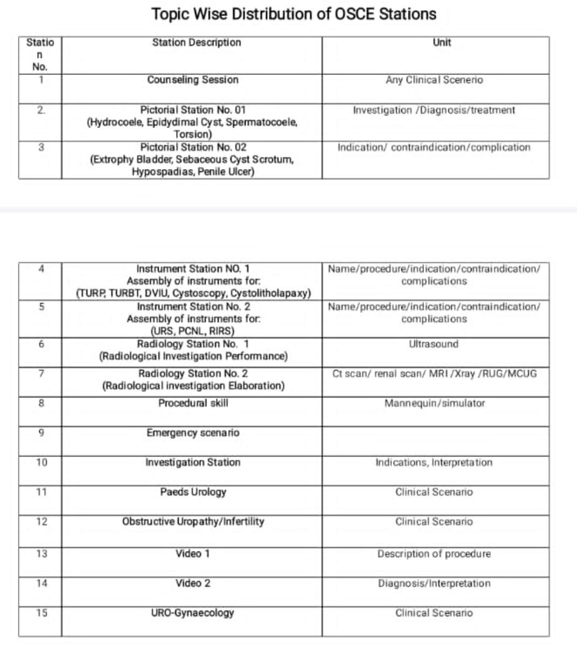

**Research Work Evaluation**

**Submission of Synopsis and Thesis**

1. The candidates shall prepare their synopsis as per guidelines provided by the Advanced Studies & Research Board, available on RMU website.
2. Synopsis of research project should be submitted and approved by the end of the 3rd year of MS program.
3. The minimum duration between approval of synopsis and submission of thesis shall be one year, but the thesis cannot be submitted later than 8 years of enrolment.
4. Thesis shall be submitted by the candidate duly recommended by the Supervisor.
5. The research thesis must be compiled and bound in accordance with the Thesis Format Guidelines approved by the University and available on website.
6. The research thesis will be submitted along with the fee prescribed by the University.
7. All candidates admitted in MS course shall appear in thesis evaluation component of the MTAafter completion of 5th years of their training course.

Thesis Defence

1. Only those candidates shall be eligible for thesis evaluation who have passed Midterm Examination and Oral & Practical/ Clinical component of Exit Examination.
2. The examination shall include thesis evaluation with defense.
3. The Vice Chancellor shall appoint three external examiners for thesis evaluation, preferably from other universities and from abroad, out of the panel of examiners approved by the Advanced Studies & Research Board. The examiners shall be appointed from respective specialty.
4. The thesis shall be sent to the external examiners for evaluation, well in time before the date of defense examination and should be approved by all the examiners.
5. After the approval of thesis by the evaluators, the thesis defense examination shall be held within the University on such date as may be notified by the Controller of Examinations. The Controller of Examinations shall make appropriate arrangements for the conduct of thesis defense examination in consultation with the supervisor, who will co-ordinate the defense examination.
6. The thesis defense examination shall be conducted by two External Examiners who shall submit a report on the suitability of the candidate for the award of degree. The supervisor shall act as coordinator.

SECTION VII References Teaching Methods

* + Kolb, D.ExperientialLearning.EnglewoodCliffs,NJ:PrenticeHall.1984
  + Maudsley.Doallmeanthe samethingby“PBL”?AcademicMedicine1999;74:178-85
  + HillW.LearningThruDiscussion2ndedition.London:SagePublications.1977.
  + CookD.Web-basedlearning:pros,consandcontroversies.ClinicalMedicine2007;7(1):37- 42.
  + GreenhalghT.Computerassistedlearninginundergraduatemedicaleducation.BMJ2001;32 2:40-4.
  + Chumley-Jones HS *et al* Web-based learning: Sound educational method or Hype?
  + A review of the evaluationliterature.AcademicMedicine2002;77(10):S86- S93.
  + SchonD.Educatingthereflectivepractitioner.SanFrancisco:JosseyBass.1984
  + LockyerJ*etal*Knowledgetranslation:theroleandpracticeofreflection.Journalof ContinuingEducation.2004;24:50-56

**Assessment methods**

* + VanderVleuten,CPMandSwanson,D.Assessmentofclinicalskillswithstand ardizedpatients:Stateoftheart.*Teach LearnMed*. 1990;2:58-76.
  + HaladynaTM.*Developingandvalidatingmultiple- choicetestitems*.Hillsdale,NewJersey:L.ErlbaumAssociates.199
  + CenterforCreativeLeadership,Greensboro,NorthCarolina([http://www.ccl.org](http://www.ccl.org/)).
  + ChallisM.AMEEmedicaleducationguideno.11(revised):Portfolio- basedlearningandassessmentinmedicaleducation.*MedTeach.*1999;21: 370-86.
  + Gray,J.Globalratingscalesinresidencyeducation.*AcadMed*.1996;71:S55-63.
  + HaladynaTM.*Developingandvalidatingmultiple- choicetestitems*.Hillsdale,NewJersey:L.ErlbaumAssociates.1994.
  + KaplanSH,WareJE.Thepatient‟sroleinhealthcareandqualityassessment.In:Goldfiel dNandNashD(eds).*Providingqualitycare(2nded):FutureChallenge.*AnnArbor,MI: HealthAdministrationPress,1995:25-52.
  + MatthewsDA,FeinsteinAR.Anewinstrumentforpatients‟ratingsofphysicianperform anceinthehospitalsetting.*JGenInternMed*.1989:4:14-22.
  + MancallEL,BashookPG.(eds.)*Assessingclinicalreasoning:theoralexaminationand alternativemethods*.Evanston,Illinois:AmericanBoardofMedicalSpecialties,1995.
  + Munger,BS.Oralexaminations.InMancallEL,BashookPG.(editors)*Recertification: newevaluationmethodsandstrategies*.Evanston,Illinois:AmericanBoardofMedical Specialties,1995:39-42.
  + NoelG,HerbersJE,CaplowMetal.HowwelldoInternalMedicinefacultymemberseval uatetheclinicalskillsofresidents?*AnnIntMed*.1992;117: 757-65.
  + Norman,Geoffrey.*EvaluationMethods:Aresourcehandbook*.Hamilton,Ontario,Can ada:ProgramforEducationalDevelopment,McMasterUniversity,1995: 71- 77.TekianA,McGuireCH,etal(eds.)*Innovativesimulationsforassessingprofessional competence*.Chicago,Illinois:Universityof IllinoisatChicago,Dept. Med. Educ.1999
  + TugwellP,Dok,C.Medicalrecordreview.In:NeufeldVandNormanG(ed).*Assessingcl inicalcompetence.*NewYork:SpringerPublishingCompany, 1985:142-82.
  + VanderVleuten,CPMandSwanson,D.Assessmentofclinicalskillswithstandardizedp atients:Stateoftheart.*TeachLearnMed*.1990;2:58-76.
  + WattsJ,FeldmanWB.Assessmentoftechnicalskills.In:NeufeldVandNormanG(ed).*A ssessingclinicalcompetence.*New York:SpringerPublishingCompany,1985,259- 74.
  + WinckelCP,ReznickRK,CohenR,TaylorB.Reliabilityandconstructvalidityofastruct uredtechnicalskillsassessmentform.*AmJSurg*. 1994;167: 423-27.

References of Milestones

* + - [https://www.acgme.org/Portals/0/PDFs/Milestones/Urology Milestones.pdf](https://www.acgme.org/Portals/0/PDFs/Milestones/Urology%20Milestones.pdf)
    - [http://education.med.ufl.edu/files/2010/10/Urology Milestones.pdf](http://education.med.ufl.edu/files/2010/10/Urology%20Milestones.pdf)
    - <http://www.upstate.edu/medresidency/current/competencies.php>

CORE BOOKS

* Smith’s Urology
* Campbell Book of Urology
* EAU Guidelines 2024
* AUA Guidelines 2024

**Section VIII Appendices**

360 EVALUATION, EVALUATION OF TRAINEES BY NURSING STAFF REGARDING CORE COMPETENCIES, WPBA, ANNUAL REPORT, EVALUATION OF FACULTY BY RESIDENT, PROGRAM EVALUATION

### ANNUAL PROGRAM EVALUATION (APE)

***Date of the APE meeting:***

#### MINUTES& ACTION PLAN

***Date; Minutes &Action Plan were reviewed and Approved by teaching faculty:***

Please attach the minutes of the meeting where the Minutes &Action Plan were reviewed and approved.

***Academic Year reviewed:***

Faculty Members of the PEC in attendance Other Members of the PEC in attendance: Areas reviewed:

1. Resident performance
   * Supporting documents:
2. Faculty development
   * Supporting documents:
3. Graduate performance
   * Supporting documents:
4. Program quality
   * Supporting documents:
5. Policies, Protocols &Procedures
   * Supporting documents:

# Appendices Documents

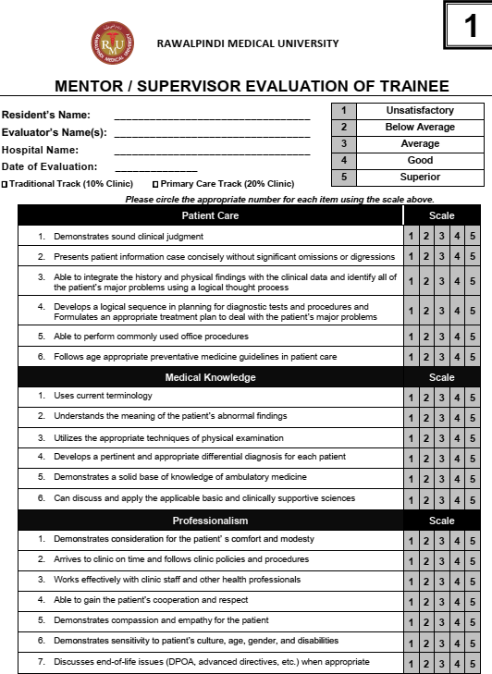

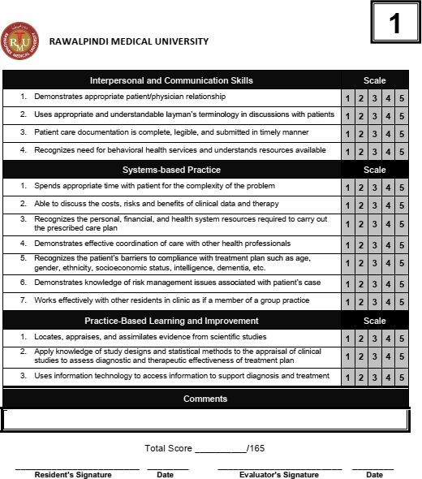

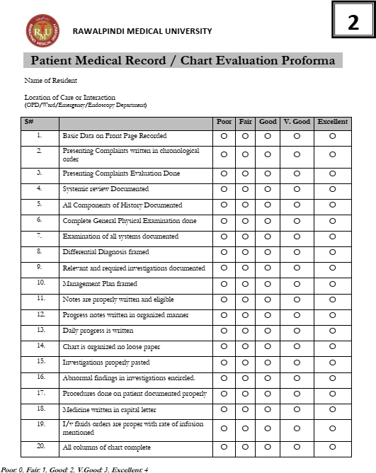

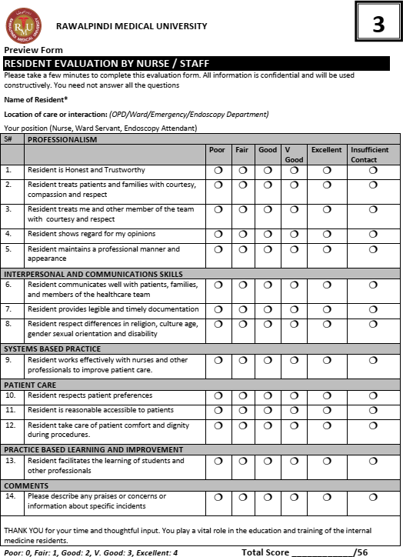

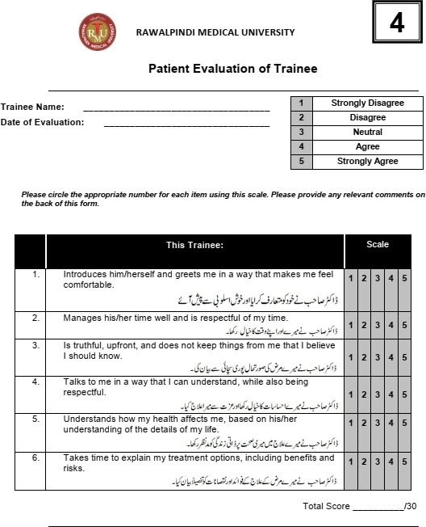

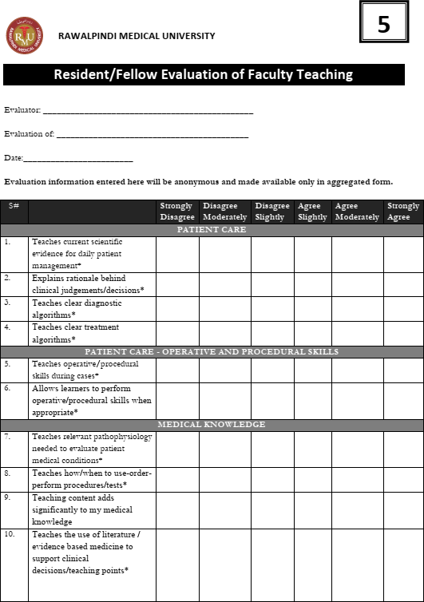

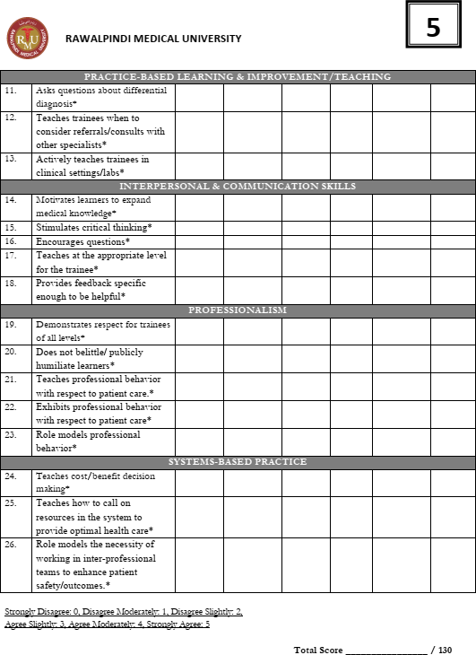

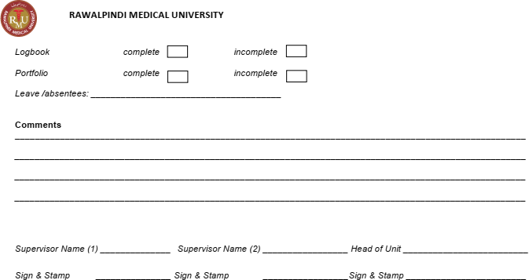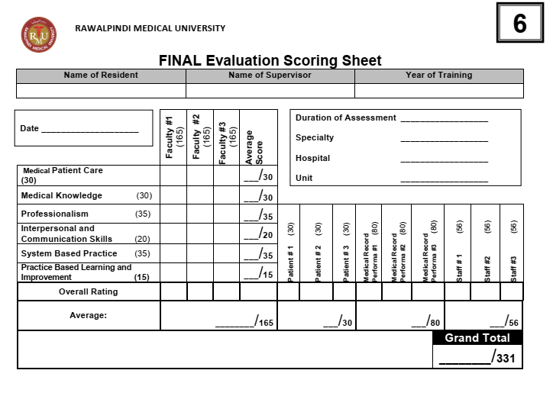

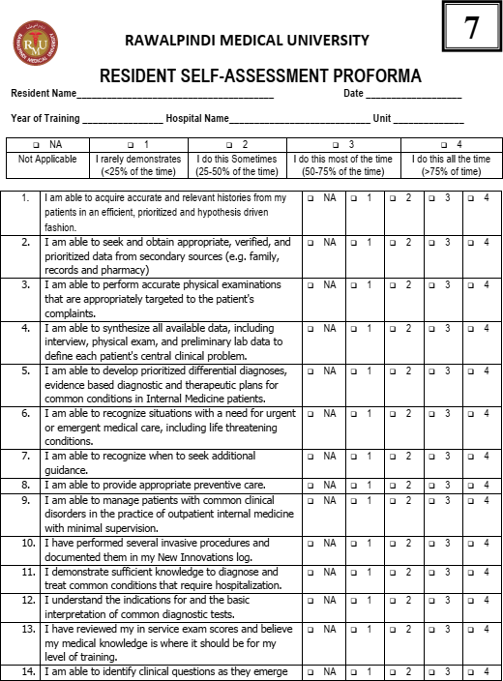

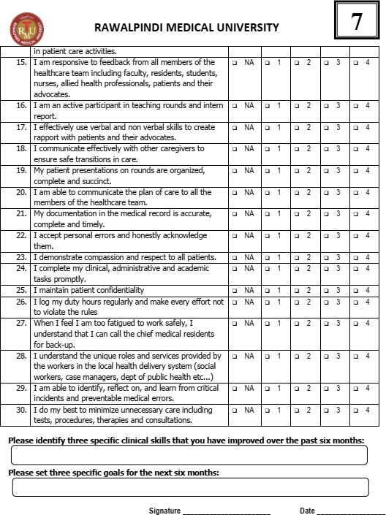

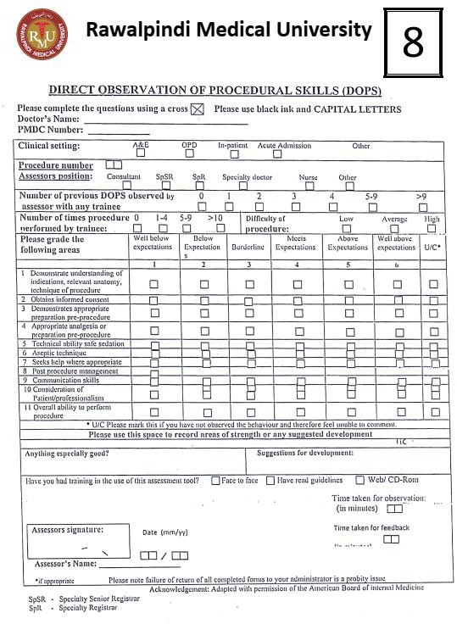

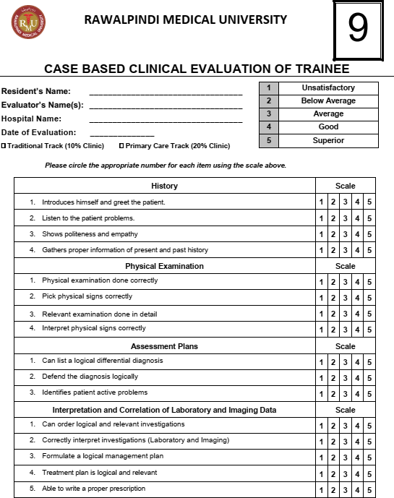

**Registration and Enrolment**

##### ENROLMENT DETAILS

Program of Admission

Session

Registration / Training Number

Name of Candidate

Father’s Name

Date of Birth / / CNIC No.

Present Address

Permanent Address

E-mail Address

Cell Phone

Date of Start of Training

Date of Completion of Training

Name of Supervisor

Designation of Supervisor

Qualification of Supervisor

Title of department / Unit