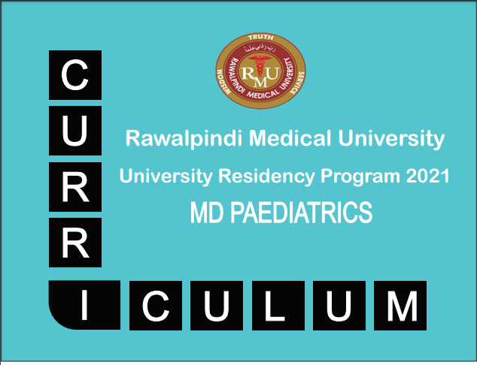
2025



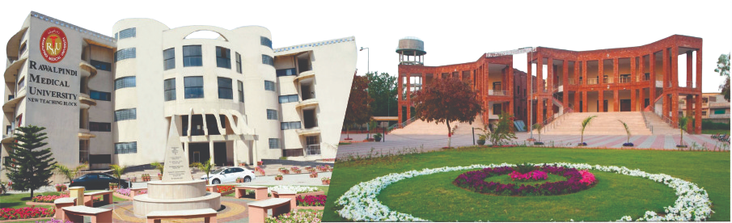
Curriculum MD Pediatric Medicine

Revised March 2025


PREFACE

The horizons of medical education are expanding, reflecting a global surge in interest in postgraduate medical education. There is an increasing recognition of the necessity for healthcare professionals to gain expertise in educational skills and the importance of formal acknowledgment of postgraduate training in Pediatric Medicine.
We are witnessing a significant rise in enrollment in postgraduate courses in medical education, more frequent publication of medical education journals, and the development of e-journals and other innovative online resources. Consequently, there is a pressing need to provide robust support in postgraduate medical education for a diverse, national group of colleagues across all specialties and at every stage of their professional development.
Our objective is succinct: to enhance the teaching capabilities of clinical colleagues and to facilitate advanced learning for students. This book represents the state-of- the-art activities of the MD Pediatric Medicine program at Rawalpindi Medical University (RMU). For the convenience of supervisors and residents, the curriculum is comprehensively incorporated into this book.

The MD curriculum is anchored on the six core competencies outlined by the Accreditation Council for Graduate Medical Education (ACGME), which include: Patient Care, Medical Knowledge, System Based Practice, Practice Based Learning, Professionalism, Interpersonal and Communication Skills. The mission of Rawalpindi Medical University is to enhance the health of the communities we serve through education, biomedical research, and healthcare. Integral to this mission is fostering a research culture and establishing a comprehensive research structure and curriculum for residents, which are detailed in this book.
This preface outlines the guiding principles and aims of the MD Pediatric Medicine program at RMU, underscoring our commitment to educational excellence and the continual advancement of medical knowledge and practice.
Prof. Muhammad Umar (Hilal-e-Imtiaz)
MBBS, MCPS, FCPS, FACG, FRCP (Lon), FRCP (Gla), AGAF
Vice Chancellor Rawalpindi Medical University & Allied Hospitals

REVISION CONTRIBUTORS

The field of pediatric medicine is constantly evolving, driven by new discoveries and advancements that demand continuous updates to educational curricula. It is with great pride that we present the revised and updated MD pediatric Medicine Curriculum at RMU. This comprehensive revision reflects our commitment to providing a robust and contemporary education that prepares our students for the challenges and opportunities of modern medical practice.
The revision process was a collaborative effort among our esteemed faculty members, each bringing their expertise and dedication to ensure the curriculum meets the highest standards of medical education. The curriculum sections were meticulously reviewed and updated to incorporate the latest medical knowledge and pedagogical practices.
1. Prof. Rai Muhammad Asghar (Dean of Paediatrics RMU)
2. Dr. Hina Sattar (Associate Professor, Pediatrics HFH)
3. Dr. Aqeela Ayub (Associate Professor, Pediatrics BBH)
4. Dr. Jawaria Zain (Assistant Professor, Pediatrics BBH)
5. Dr. Muhammad Asim (Senior Registrar, Pediatrics BBH)
This revised curriculum represents a significant milestone in our ongoing mission to provide an exceptional medical education. We are confident that these updates will greatly benefit our students, equipping them with the knowledge and skills necessary to excel in their medical careers and contribute meaningfully to the healthcare field. We extend our heartfelt thanks to all faculty members involved in this revision for their hard work and dedication. It is through their collective efforts that we continue to advance the standards of medical education at RMU.
Hoe to read this document
TABLE OF CONTENTS
S. No. | Content
 | SECTION – I Preamble
1. | Mission and Vision
2. | Aim of the Programme
3. | Framework of the programme
4. | Rules and Regulation
5. | Course Competencies of the Programme
6. | Programme Learning Outcomes
7. | Electives/Rotations
8. | Methods of Teaching & Learning during course conduction
9. | Tools of Assessment for the course
 | SECTION – II Core Curriculum
10. | Introduction
11. | Course Content for the first year
12. | Course Content for 2nd, 3rd, & 4th year
13. | Year wise Learning Outcomes for the Residents
 | SECTION – III Research & Thesis writing
14. | Details about Research component &Thesis writing
15. | Details Research Curriculum & Workshops Detail
SECTION – IV Elective Rotations
SECTION– V Developmental Milestones ( Resident’s life cycle)
16. | Charting the Road to Competence: Developmental Milestones for MD Pediatric Medicine Program at Rawalpindi Medical University
SECTION – VI Evaluation & Assessment strategies
17. | Evaluation & Assessment strategies a general overview
18. | Details of MD Pediatric Medicine Intermediate examination (written & clinical)
19. | Details of MD Pediatric Medicine Final examination (written & clinical)
20. | MD Pediatric Medicine Final thesis examination
SECTION—VII Entrust able Professional Activities
SECTION – VIII Logbook & Portfolio
21. | Logbook for Pediatric Medicine (Templates)
22. | Logbook for Research (Templates)
23. | Portfolio (Templates)
SECTION – IX References
SECTION – X Appendices (proformas/Forms)

SECTION-I
PREAMBLE

Rawalpindi Medical University
Rawalpindi Medical University is a public university located in Rawalpindi, Punjab, Pakistan. It is affiliated with four public sector teaching hospitals (HFH, BBH, RTH - Rawalpindi) for undergraduate and postgraduate medical education & training.
There are two campuses of Rawalpindi Medical University. Old teaching block is situated at Tipu Road, Rawalpindi while New Teaching Block is located at Satellite Town within the premises of Holy Family Hospital Rawalpindi which is one of the teaching hospitals affiliated with Rawalpindi Medical University.
This University is intended to impart evidence-based research oriented medical education, to promote ethical practice of medicine and hence to improve the healthcare of our nation. It is actively involved not only in undergraduate teaching of MBBS students, but also the training and clinical teaching of M.Phil. M.S, M.D, FCPS & MCPS postgraduate trainees in various disciplines. Apart from that, the college is also providing teaching facilities to nursing and Allied Health Sciences students.
Specialized and trained faculty along with support staff is available in well-equipped departments of both the campuses of RMU. In addition Department of Medical Education and splendid library with thousands of books on all medical subjects to facilitate the learning of undergraduate students and postgraduate trainees are also accessible separately in both teaching blocks.
Vision
To impart evidence-based research oriented health professional education in order to provide best possible patient care and inculcate the values of mutual respect, ethical practice of healthcare and social accountability.
Mission
Highly recognized and accredited center of excellence in Medical Education, using evidence-based training techniques for development of highly competent health professionals, who are lifelong experiential learner and are socially accountable.

MISSION & VISION of Pediatric Residency Program:

The mission & vision of the Pediatric Medicine Residency Program at Rawalpindi Medical University is to:
Mission Statement
“The MD Pediatric Medicine Residency Program at Rawalpindi Medical University is committed to training proficient, compassionate, and ethical pediatricians who deliver evidence-based, patient-centered care. We strive to create a dynamic learning environment that fosters clinical expertise, research acumen, and professional integrity. Through rigorous academic and clinical training, mentorship, and community engagement, we aim to produce pediatricians who are equipped to meet the healthcare needs of pediatric population with dedication and social accountability.”
Vision Statement
“To be a premier, internationally recognized center for Pediatric medicine education, cultivating leaders in clinical practice, medical research, and healthcare innovation. Our graduates will exemplify excellence in patient care, demonstrate leadership in advancing medical knowledge, and contribute meaningfully to the well-being of the communities they serve, both locally and globally.”
AIM OF THE PROGRAMME:
The MD Pediatric Medicine program at Rawalpindi Medical University aims to develop specialists with comprehensive medical knowledge, clinical excellence, and leadership skills. The program emphasizes evidence-based practice, proficiency in managing complex medical conditions, and readiness for subspecialty training. Trainees will cultivate research, critical thinking, and communication skills, enabling them to excel in both inpatient and outpatient settings. Professionalism, community engagement, and a commitment to lifelong learning are central, ensuring graduates provide compassionate, patient-centered care and contribute to the advancement of medical knowledge.
FRAMEWORK OF THE PROGRAMME:

Below is the detailed framework of the MD Pediatric Medicine program at Rawalpindi Medical University

Component | Details
Course Title | MD Pediatric Medicine
Training Center | Department of Pediatric Medicine, Rawalpindi Medical University (RMU)
Duration of Course | 4 years
Credit Hours | 132 hours
Supervision | Structured training under the guidance of an approved supervisor in a recognized Medical Unit.
Induction Period | - Duration: First 6 months in the Department of Pediatric Medicine  - Focus: Orientation to Pediatric Medicine and mandatory workshops
Basic Training (Part I) | - Duration: 18 months  - Content: Training in basic principles of Pediatric Medicine  - Research Requirement: Research synopsis approval by ERB and BASR
Rotations (Part I) | - Paeds OPD (3 months)  - Nursery (3 months)  - Infectious diseases (3 months)  - Nutrition and preventive pediatrics (3 months)  - Paeds emergency (3 months)  - Paeds HDU (3 months)
Assessment (Part I) | Continuous Pediatric assessment based on competency & Formative assessment:  In-Training- Assessment Year-1 (at the end of year 1)
Mid Term Assessment (MTA) | At the end of 2 years, candidates will take the  Mid Term Assessment (Summative)
Advanced Training (Part II) | - Duration: 3rd and 4th years  - Focus: Advanced Pediatric Medicine, Specialty rotations, Research, and Thesis writing
Rotations (Part II)  3rd year | - Pulmonology (3 month)  - Premature NICU (3 months)  - PICU (3 months)  - NICU (3 months)  - Nephrology/Neurology (3 months)  - Gastroenterology/Metabolic disorders (3 months)
4th year | - Endocrinology/ Rheumatology (3 month)  - Oncology/Hematology (3 month)  - 3 external rotations in any 2 of these(2 months each):  - Paeds surgery, Paeds cardiology. Rehabilitation medicine, dermatology, pediatric neurology, pediatric oncology, pediatric gastroenterology, pediatric nephrology, perinatology
Assessment (Part II) | Competency-based continuous Pediatric assessment & Formative assessment:  In-Training Assessment Year-3 (at the end of year 3)
Final Term Assessment (FTA) | At the end of four years, candidates will take the  Final term Assessment ( Summative)
Research Component | Research component aligned with the Research Cycle, including thesis writing and submission according to RMU guidelines

RULES AND REGULATIONS:
Admission Criteria:

Applications for admission to MD Training Programs will be invited through print and electronic media advertisements, specifying the application deadline and the Entry Examination date. At present induction is being done according to Punjab Health Departments Central Induction Policy.
Available at: http://prp.phf.gop.pk/
Eligibility: Applicants must meet the following criteria by the application deadline:

- Basic Medical Qualification: MBBS or equivalent, recognized by the Pakistan Medical & Dental Council (PMDC).
- House Job Experience: Certificate of one year's completed House Job experience in an institution recognized by the PMDC is essential at the time of interview.
- PMDC Registration: Valid permanent or provisional registration certificate from the PMDC.
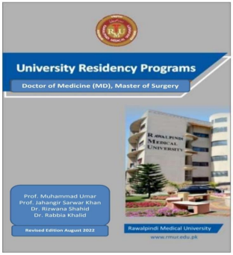

Registration and Enrollment:

Supervisor and Trainee Limits: In accordance with PMDC policy, the maximum number of postgraduate trainees per supervisor is five (5) per year across all postgraduate programs, including minor programs (if any).
Bed to Trainee Ratio: The approved teaching site must have a minimum of five (5) beds per trainee.

Supervisor Approval: RMU will approve supervisors for MD Medicine course.

University Registration: Selected candidates must register with RMU according to prescribed Registration Regulations after enrollment at the relevant institution.

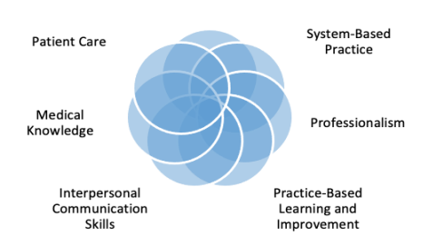
CORE COMPETENCIES OF THE PROGRAMME:
ACGME Competency Model At Rawalpindi Medical University (RMU), we are committed to training our residents according to the Accreditation Council for Graduate Medical Education (ACGME) competencies, incorporating six core domains: Patient Care, Medical Knowledge, Practice-Based Learning and Improvement, Interpersonal and Communication Skills, Professionalism, and Systems-Based Practice. Additionally, we emphasize research as a fundamental component of our training. RMU proudly leads as the first public sector university in Pakistan to implement an ACGME-aligned postgraduate curriculum, reflecting our dedication to producing competent, compassionate, and research-oriented clinicians prepared to excel in today’s dynamic healthcare landscape.

Figure 1: ACGME core competencies (Ref: https://sl.bing.net/hO8ZQtFeM1

The MD Pediatric Medicine curriculum at Rawalpindi Medical University, Rawalpindi, is structured based on the competency and performance-based framework of the Accreditation Council for Graduate Medical Education (ACGME). The curriculum emphasizes the following core competencies:
1: Medical Knowledge: Mastery of the fundamental biomedical sciences and clinical knowledge.
2: Patient Care: Proficiency in delivering patient-centered care that is compassionate, appropriate, and effective.
3: Interpersonal and Communication Skills: Development of skills necessary for effective information exchange and collaboration with patients, their families, and health professionals.
4: Professionalism: Commitment to professional responsibilities, adherence to ethical principles, and sensitivity to diverse patient populations.
5: Practice-Based Learning and Improvement: Ability to investigate and evaluate patient care practices, appraise and assimilate scientific evidence, and continuously improve patient care based on constant self-evaluation and life-long learning.
6: Systems-Based Practice: Understanding of and responsiveness to the larger context and system of health care, including the ability to effectively call on system resources to provide optimal care.
7: Research: Engagement in scholarly activities that contribute to the advancement of medical knowledge and practice through research and innovation.
This curriculum aims to produce physicians who are not only clinically proficient but also equipped with the skills necessary for continuous professional development and contribution to the medical field through research and system improvement.

PROGRAMME LEARNING OUTCOMES:
The MD Pediatric Medicine program aims to develop residents with the following competencies:
A. Medical Knowledge
1: Strong foundation in the core concepts and subspecialties of Pediatric Medicine.
2: Ability to diagnose, investigate, and manage common and complex medical conditions based on the latest scientific understanding.
3: Critical analysis and application of evidence-based medicine, including cost-effective treatment approaches.
4: Understanding of psychological, social, and ethical aspects of patient care.
5: Proficient interpretation of laboratory tests, diagnostic procedures, and relevant medical research.
B. Skills
1: Comprehensive history taking, physical examinations, and diagnostic reasoning.
2: Selection and effective use of diagnostic tests and procedures.
3: Safe and proficient performance of essential medical procedures.
4: Management of acute and chronic medical conditions, including emergencies, in both inpatient and outpatient settings.
5: Ability to lead multidisciplinary healthcare teams.
6: Effective communication with patients, families, and colleagues.
7: Research skills to advance medical knowledge and inform clinical practice.
C. Attitudes
1: Patient-centered approach, prioritizing empathy and respect.
2: Commitment to lifelong learning and professional development.
3: Understanding of cost-effective care and ethical decision-making.
4: Collaboration with specialists and other healthcare professionals.
5: Recognition of the role of teaching and research in advancing the field.

TEACHING AND LEARNING STRATEGIES:
Does:
Mini
-
CEX, DOPs, CBD, 360
Feedback
Shows How:
OSCE, Short Cases,
Long Case, E
-
Logbook, Portfolio,
& Reflective log
Knows & Knows How:
SAQ, SEQ,
Case Senario based MCQs, EMQ
The MD Pediatric Medicine curriculum at Rawalpindi Medical University emphasizes a diverse, evidence-based approach to learning, fostering the development of both clinical and academic excellence. Teaching strategies include hands-on clinical exposure, interactive case-based learning, and procedural training in various inpatient and outpatient settings. Residents are actively engaged in interdisciplinary collaboration and are provided opportunities to lead presentations and participate in problem-solving discussions. The program offers a broad range of elective rotations in subspecialties, allowing residents to tailor their training and gain expertise in specific areas, further supplemented by dedicated mentorship and research projects aimed at fostering critical thinking and lifelong learning.

ASSESSMENT AND EVALUATION METHODS:
The assessment of MD Pediatric Medicine residents at Rawalpindi Medical University will comprehensively evaluate their knowledge, skills, and attitudes through a combination of formative, summative, and workplace-based assessments (WPBA). These assessments are structured in accordance with Miller’s Pyramid of Clinical Competence, ensuring a progressive evaluation of residents' abilities from foundational knowledge to the application of clinical skills in real-world settings. A variety of methods will be employed to measure competence across all domains, aligning with the curriculum’s objectives to produce clinically proficient, research-oriented, and professionally ethical physicians.

SECTION-II
CONTENT OF THE CURRICULUM

INTRODUCTION:
The content of the MD Pediatric Medicine curriculum encompasses a comprehensive framework designed to equip postgraduate trainees with the necessary competencies in Pediatric Medicine. It includes theoretical knowledge, clinical skills, and professional attitudes essential for the diagnosis, management, and care of patients with a wide range of medical conditions. This content is structured to align with international standards such as the ACGME Core Competencies while ensuring relevance to the healthcare landscape of Pakistan.

This structured approach, adhering to ACGME Core Competencies, ensures that MD Pediatric Medicine graduates from RMU are fully equipped to meet the evolving challenges of Pediatric Medicine practice both locally and globally. The curriculum is based on the following components.

Domain | Details
Knowledge | The curriculum provides a robust foundation in the understanding of pathophysiology, clinical features, diagnostics, and therapeutic options across various Pediatric subspecialties, including cardiology, neurology, pulmonology, gastroenterology, endocrinology, nephrology, and infectious diseases. Emphasis is placed on evidence-based practice, interpretation of laboratory and imaging data, and the integration of clinical guidelines into patient care.
Skills | Skills emphasize hands-on clinical proficiency. Residents are trained in essential procedures such as central venous catheterization, mechanical ventilation, and advanced pediatric life support. They are also taught to perform comprehensive patient assessments, interpret diagnostic tests, and develop management plans. Clinical reasoning, problem-solving, and procedural competence are refined through ward rounds, case-based discussions, and simulated patient encounters.
Attitude | The curriculum aims to instill professionalism, ethical practice, and effective communication. Residents are trained to exhibit compassion, maintain patient confidentiality, and uphold a commitment to lifelong learning. In the Pakistani context, special attention is given to cultural sensitivity, resource management, and delivering high-quality care in resource-constrained settings.  Additionally, residents are expected to engage in teamwork and demonstrate leadership in multidisciplinary environments.

This section outlines the content to be covered during the four-year MD Pediatric Medicine residency program, along with the learning outcomes residents are expected to achieve by the end of each academic year. The curriculum is structured to progressively build the residents' knowledge, clinical skills, and professional competencies. Each year of training introduces more complex topics and responsibilities, ensuring that by the end of the program, residents are fully prepared to manage a broad range of Pediatric Medicine cases independently.

RMU Postgraduate Competency Model

The Rawalpindi Medical University (RMU) postgraduate Competency Model is designed to equip residents for the dynamic demands of modern healthcare. Rooted in ACGME core principles with research as an additional core competency, this model defines essential competencies for all RMU graduates, aligning them with both Pakistan’s healthcare priorities and global standards. This approach ensures RMU postgraduates emerge as skilled clinicians, ethical leaders, and compassionate problem-solvers. Complementing this, the RMU postgraduate Competency Model takes a holistic approach, mapping clear developmental pathways from foundational knowledge to advanced clinical practice. Through these competencies, RMU residents are prepared to thrive across diverse healthcare settings, adapt to rapid changes, and contribute meaningfully to society.
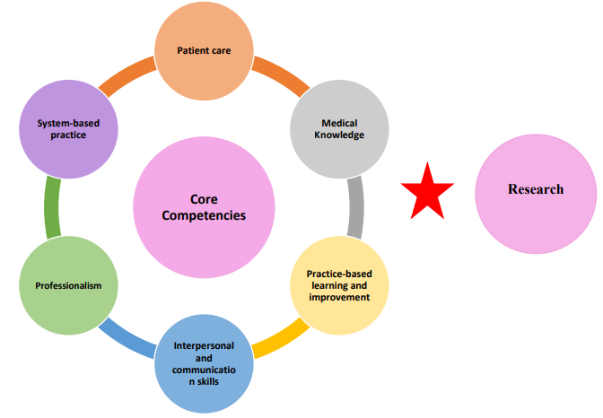
RMU Postgraduate Competency Model

RMU Postgraduate Competency Framework of Pediatric Medicine
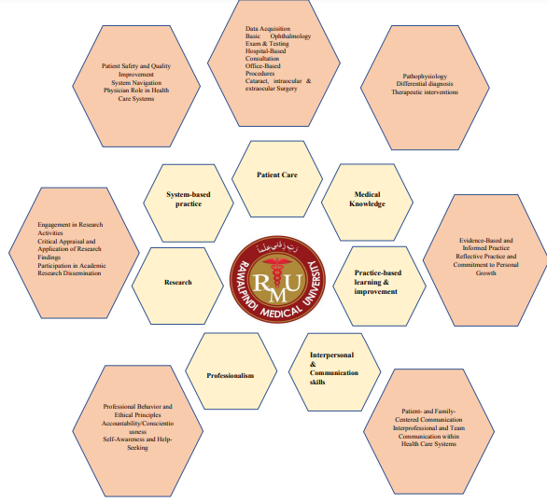

Credit Hours of MS Ophthalmology Program
According to the HEC criteria, 16 teaching/learning hours equate to 1 credit hour:
- For each training year:
  - 33 credit hours x 16 hours = 528 teaching/learning hours per year.
- For the 4-year program:
  - 528 hours x 4 years = 2,112 total teaching/learning hours for the entire program.
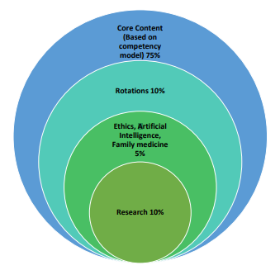
Therefore, the MD Pediatric Medicine training program comprises a total of 2,112 teaching/learning hours, equating to 132 credit hours over the four years. This extensive allocation aligns with HEC criteria and supports a robust foundation in clinical and academic training for ophthalmology residents.

Course Content for the First Year

TABLE OF CONTENTS OF FIRST YEAR MD MEDICINE

S NO. | CONTENT
1. | Basic Clinical Skills  History Taking (Knowledge)  History Taking (Skills)  History Taking (Behaviors)  Clinical examination (knowledge)  Clinical examination (skills)  Clinical examination (Behaviors)  Time management and decision making  Decision making and clinical reasoning
2. | Common Clinical Disorders  Acute pharyngitis  Acute Gastroenteritis  Pneumonia  Bronchiolitis  Asthma  Tuberculosis  Anemia  General Management of poisoning  Diabetes Mellitus  Nephrotic Syndrome
55

Theme: Basic Clinical Skills (Skill & Attitude)

TOPICS TO BE TAUGHT | LEARNING OBJECTIVES  Student should be able to know: | TEACHING METHOD | ASSESSMENT
1. History Taking  (Knowledge)  Competency: Medical Knowledge & Patient Care | - Progressively develop the ability to obtain relevant, focused histories from increasingly complex patients in challenging circumstances.  - Accurately record, synthesize history, and integrate clinical examination to formulate a management plan based on anticipated clinical evolution.  - Recognize the importance of various elements of patient history, including cognitive, psychological, social, cultural, and nutritional factors.  - Understand that patient histories may be unstructured and influenced by acute or chronic medical conditions.  - Identify likely causes and risk factors for presentations.  - Recognize that history should guide examination, investigation, and management. | Bedside teaching in wards and outpatient departments | Mini-CEX,  OSCE,  Long  Case
2. History Taking  (Skills)  Competency:  Interpersonal and  Communication Skills,  Patient Care | - Identify and overcome barriers to effective communication, including cognitive impairment.  - Manage time effectively and close consultations appropriately.  - Use standardized instruments or questionnaires to supplement history when relevant.  - Manage alternative or conflicting views from family, caregivers, or friends.  - Assimilate history from various sources, including patient and caregiver input.  - Recognize and interpret nonverbal communication cues.  - Focus on relevant aspects of history. | Bedside teaching in wards and outpatient | Mini-CEX,  OSCE, Long  Case
56
 |  |  | Departments
3. History Taking  (Behaviors)  Competency:  Professionalism | - Demonstrate respect and behave in accordance with ethical medical practices. |  | Bedside teaching in wards and outpatient departments | Mini-CEX,  OSCE, Long  Case
4. Clinical examination  (knowledge)  Competency: Medical  Knowledge, Patient Care | - To progressively develop the ability to perform focused and accurate clinical examination in increasingly complex patients and challenging circumstances  - To relate physical findings to history to establish diagnosis and formulate a management plan  - Understand the need for a valid clinical examination Understand the basis for clinical signs and the relevance of positive and negative physical signs  - Recognize constraints to performing physical examination and strategies that may be used to overcome them  - Recognize the limitations of physical examination and the need for adjunctive forms of assessment to confirm diagnosis |  | Bedside teaching in wards and outpatient departments | CbD, mini-CEX, OSCE
5. Clinical examination skills)  Competency: Patient Care | - Perform an examination relevant to the presentation and risk factors that is valid, targeted and time efficient Recognize the possibility of deliberate harm in vulnerable patients and report to appropriate agencies Interpret findings from the history, physical examination and mental state examination, appreciating the importance of clinical, psychological, religious, social and cultural factors  - Actively elicit important clinical findings  - Perform relevant adjunctive examinations including cognitive examination such as Mini Mental state Examination (MMSE) and Abbreviated Mental Test Score (AMTS) |  | Bedside teaching in wards and outpatient  departments | CbD mini-CEX, OSCE,
57
6. Clinical examination  (Behaviors)  Competency: Professionalism | - Demonstrate respect and behave according to ethical medical practice standards. | Bedside teaching in wards and outpatient departments | CbD, mini- CEX, 360degree Feedback
7. Time management and decision making  Competency: Practice Based Learning and Improvement, Systems Based Practice | - To become increasingly able to prioritize and organize clinical and clerical duties to optimize patient care.  - To become increasingly able to make appropriate clinical and clerical decisions to optimize the effectiveness of the clinical team resource. | Bedside teaching in wards and outpatient departments | Mini-CEX, CbD, 360degree Feedback
8. Decision making and clinical reasoning  Competency: Patient Care, Medical  Knowledge | - To progressively develop the ability to formulate a diagnostic and therapeutic plan for a patient according to the clinical information available  - To progressively develop the ability to prioritize the diagnostic and therapeutic plan  - To be able to communicate the diagnostic and therapeutic plan appropriately | Bedside teaching in wards | CbD,  Mini-CEX,  Long Case
Theme: Common Clinical Disorders (Knowledge)
TOPIC | LEARNING OBJECTIVES | TEACHING STRATEGIES | ASSESSME NT TOOL
1. Acute pharyngitis | - Define acute pharyngitis, and describe its various causes.  - Identify the investigations required for the diagnosis of acute pharyngitis, CBC, throat swab.  - Understand the epidemiology, incubation periods, transmission modes, and clinical features of acute pharyngitis.  - Recognize the complications of acute pharyngitis, such as acute rheumatic fever, and outline its management principles.  - Identify medications and toxins that can cause acute pharyngitis, and explain the associated clinical features, diagnostic approach, and management. | Large class format  (interactive lecture | MCQs, SEQ
2. Acute Gastroenteritis | - Define Acute Gastroenteritis, and differentiate it from chronic diarrhea based on duration and underlying mechanisms.  - Understand the epidemiology, pathophysiology, clinical features, and complications of Acute Gastroenteritis, including dehydration, AKI, Sepsis.  - Identify appropriate investigations for diagnosing Acute Gastroenteritis, including CBC, Serum Electrolytes, stool examination.  - Describe the management strategies for Acute Gastroenteritis, and outline the potential outcomes based on disease progression and treatment response. | Large class format  (interactive lecture | MCQs, SEQ
3. Pneumonia | - Define Pneumonia, describe its causes, and explain the underlying pathophysiology, particularly in relation to age, causative organism.  - Recognize the clinical features of Pneumonia, and identify key investigations used in its diagnosis, including CBC, Chest X-Ray.  - Outline the management strategies for Pneumonia based on its etiology, and describe potential complications such as Pleural effusion.  - Understand the outcome of Pneumonia, with a focus on prognosis depending on the underlying cause. | Case Based Learning | MCQs, SEQ
4. Bronchiolitis | - Define Bronchiolitis, describe its causes, and explain the underlying pathophysiology, particularly in relation to age, causative organism.  - Recognize the clinical features of Bronchiolitis, and identify key investigations used in its diagnosis, including CBC, Chest X-Ray.  - Outline the management strategies for Bronchiolitis based on its etiology, and describe potential complications such as respiratory failure.  - Understand the outcome of Bronchiolitis, with a focus on prognosis depending on the underlying cause. | Case  Based  Learning | MCQs, SEQ
5. Asthma | - Define asthma and describe its epidemiology, pathophysiology, and the different types of asthma, along with common aggravating factors.  - Recognize the clinical features of asthma, including characteristic symptoms (wheezing, dyspnea, etc.), and identify signs of severity for acute asthma exacerbations, as well as grading based on symptom control and frequency.  - Understand the investigations used in asthma diagnosis, including Pulmonary Function Tests (PFTs) and their interpretation, and develop a differential diagnosis to distinguish asthma from other respiratory conditions.  - Outline the treatment strategies for asthma, with an emphasis on the management of acute severe asthma (status asthamaticus) and the graded treatment approach for chronic asthma, including the use of bronchodilators, corticosteroids, and long-term control medications, and discuss potential complications and outcomes. | Large class format  (interactive lecture | MCQs, SEQ
6. Tuberculosis | - Differentiate between the pathophysiology of primary tuberculosis and reactivated tuberculosis, highlighting the mechanisms underlying initial infection and reactivation in immunocompromized or predisposed individuals.  - Discuss the global incidence of tuberculosis, including its epidemiological significance, and identify Mycobacterium tuberculosis as the causative agent.  - Explain the modes of transmission of tuberculosis, Emphasizing how the disease is spread via respiratory droplets and the role of environmental and social factors in transmission.  - Differentiate between Ghon focus and Ghon complex, outlining their formation and significance in the context of primary tuberculosis.  - Compare the causes, pathophysiology, clinical features, diagnosis, and treatment of primary and secondary tuberculosis, focusing on their distinctive presentations and management approaches.  - Outline the various treatment regimens for tuberculosis, detailing the pharmacological options for both drugsusceptible and drug-resistant strains.  - Discuss the complications associated with tuberculosis and strategies for its prevention, including the importance of vaccination (BCG), public health measures, and early detection to reduce transmission and morbidity. | Large class format  (interactive lecture | MCQs, SEQs
7. Anemia | - Define anemia and explain its significance in clinical practice, including the implications for patient health and management.  - Identify and differentiate between the various classifications of anemia.  - Discuss the causes associated with different types of anemias.  - Recognize the clinical features of anemia.  - Describe the specific features of various anemias, including characteristic laboratory findings and clinical presentations. Know the normal values for key hematological parameters and their relevance in diagnosing anemia.  - Outline the basic investigations utilized in the assessment of anemia, including complete blood count (CBC), reticulocyte count, and peripheral blood smear.  - Elaborate the specific investigations required for diagnosing different types of anemia, including iron studies, vitamin B12 and folate levels, and bone marrow biopsy when indicated.  - Evaluate the treatment options for various types of anemia, including iron supplementation, vitamin replacement, and management of underlying causes. | Case Based Learning | MCQs, SEQs
8. General Management of poisoning | - Define poisoning and categorize the various types of poisoning.  - Describe the general approach to managing poisoning, including triage and resuscitation, clinical assessment and investigations, and the components of general management.  - Outline the principles of gastrointestinal decontamination.  - Identify commonly used antidotes for specific poisons and discuss the various methods of poison removal, including their mechanisms of action and clinical applications.  - Explain the importance of psychiatric evaluation in the management of poisoning cases. | Large class format  (interactive lecture | MCQs, SEQs
9. Diabetes Mellitus | - Identify the etiology of diabetes mellitus.  - Explain the pathogenesis of diabetes.  - Classify the types of diabetes mellitus.  - Outline the criteria for diagnosing diabetes.  - Discuss the management strategies for diabetes. Recognize the complications of diabetes and their management.  - Describe management considerations in special situations related to diabetes. | Small group discussion | MCQs,  SEQs,
10. Nephrotic Syndrome | - Define Nephrotic Syndrome and describe its pathophysiology and causes  - Identify the clinical features and diagnostic criteria for Nephrotic Syndrome.  - Discuss the investigations necessary for diagnosing Nephrotic Syndrome  - Outline the management strategies for Nephrotic Syndrome , including daily abdominal girth monitoring , proteinuria monitoring, BP monitoring  - Describe dietary measures and medication use in the management of Nephrotic Syndrome  - Recognize potential complications of Nephrotic Syndrome and their treatment options, along with prognosis. | Case Based Learning | MCQs, SEQs

Content of the Curriculum
2nd, 3rd, and 4th Year
TABLE OF CONTENTS

NO. | CONTENT
A | General Pediatric Medicine
B | Pediatric ICU
C | Neonatology
D | Pediatric Cardiology
E | Pediatric Dermatology
F | Pediatric Endocrinology
G | Pediatric Gastroenterology
H | Pediatric Emergency medicine
I | Pediatric Neurology
J | Pediatric Psychiatry
K | Pediatric Radiology
M | Pediatric Hematology/ oncology
N | Pediatric Infectious diseases
O | Pediatric Nephrology
P | Pediatric Pulmonary
Q | Pediatric Rheumatology

64

DETAILS OF COURSE CONTENT:

A. GENERAL PEDIATRIC MEDICINE
Educational Purpose
The Pediatric Medicine Ward rotation is structured to provide PGTs with the fundamental knowledge base of Pediatric Medicine, the essential principles in the approach to Pediatric Medicine ward patients, the basic techniques of physical examination, the necessary skills in performing clinical procedures, and the capability to communicate clearly with children, their families and other members of the health care team.
Content of required knowledge:

System | Topics
Human Growth, Development, and Aging | Pediatric medicine  Aging and introduction to pediatric medicine  Management of common problems in the adolescents
Preventive Pediatric Medicine | Principles of preventive pediatrics  Immunization  Alcohol and substance abuse
Principle of Diagnosis and Management | Clinical approach to the patient  Clinical decision-making  Interpretation of laboratory data
Cardiovascular Diseases | Acyanotic heart diseases like VSD, ASD, AVSD, PDA  Cyanotic Heart Disease like TOF, TGA, Truncus arteriosus, TAPVR  Rheumatic Heart disease  Infective endocarditis  Arrhythmias  Myocarditis  Cardiomyopathies  Hypertension
Respiratory Diseases | Pneumonia  Bronchiolitis  cystic fibrosis  Asthma  Pleural effusion  Interpretation of pulmonary function tests
Renal Diseases | Disorders of electrolytes and acid-base  Acute renal failure  Chronic renal failure  Nephrotic Syndrome  Glomerulonephritis  Tubulointerstitial diseases
Diseases of the GIT, Liver and Hepatobilliary Tract | Viral hepatitis  Cirrhosis and portal hypertension  Hepatic failure  Wilson disease  Autoimmune hepatitis  Coeliac disease  IBD  Malabsorption syndrome
Hematologic Diseases | Anemia  Interpretation of the peripheral blood smear  Transfusion of blood and blood products  Neutropenia  Disorders of the platelets  Disorders of blood coagulation
Oncology | Acute leukemia  Oncologic emergencies  Lymphomas  Solid organ tumors
Nutritional Diseases | Malnutrition  Marasmus  Kwashiorkor  Micronutrient deficiency  Principles of nutritional support.
Endocrine Diseases | Diabetes mellitus  Diabetic ketoacidosis  Adrenal disorders  Thyroid diseases Osteoporosis
Musculoskeletal and Connective Tissue Diseases | Juvenile idiopathic Arthritis  Systemic lupus erythematosus (SLE)  Dermatomyositis  Vasculitis syndromes
Infectious Diseases | Pneumonia  Enteric Fever  Urinary tract infections (UTI)  Soft tissue infections  Osteomyelitis  Infective endocarditis  Bacterial meningitis  Leishmaniasis  Malaria  Diphtheria  Tetanus  Tuberculosis  Septic shock  Principles of antimicrobial therapy  Fungal infections  HIV infection  Treatment of AIDS and related disorders
Neurology | Febrile Fits  Epilepsy  Cerebral palsy  Neurometabolic disorders  Cerebrovascular accident (Stroke)  Autoimmune encephalitis

Teaching Strategies and Assessment tools:
Teaching Strategies | Assessment Tools
Bedside teaching during Grand Ward Rounds  Seminars  Small group discussions  Problem based learning  Case Based Discussion (CBD)  Didactic lectures  Self-directed learning  Follow up clinics  Skill teaching in ward settings  Clinic pathological conferences | MCQs, SEQs  Short Cases  Long Cases  OSCE  Mini- CEX  DOPs  CBD  360 Feedback

Evaluation/Feedback

- A 360-degree evaluation will be used to assess professionalism and ethical behavior.
- At the end of each rotation, a formal evaluation and verbal feedback session will be conducted with the postgraduate trainee (PGT). PGTs are encouraged to proactively discuss their learning experiences, challenges, or any conflicts with their supervisor, co-supervisor, and program director or Dean.
- Trainees will evaluate the training program's effectiveness and efficiency in providing the necessary skills, offering feedback for program improvement.
Required Competencies

Patient Care  - Obtain a complete history and recognize common abnormal physical findings.  - Construct a master problem list, a working diagnosis, and a group of differential diagnoses.  - Be familiar with different diagnostic tools such as the electronic thermometer, sphygmomanometer, ophthalmoscope, EKG machine, pulse oximetry, and defibrillator. Become familiar with the concept of pre-test and post-test probabilities of disease.  - Be able to perform various clinical procedures such as venipuncture, thoracentesis, paracentesis, lumbar puncture, arthrocentesis, skin punch- biopsy, endotracheal intubation, and central line placement.  - Residents should know indications of potential complications of each of these procedures.  - Understand how to improve patient/physician relationships in a professional way. Residents should be compassionate, but humble and honest, not only with their patients, but also with their co-workers.  - Residents are encouraged to develop leadership in teaching and supervising interns and medical students.  - Consideration of patient preferences in making therapeutic decisions.  - Completeness of medical charting | Evaluation of Patient Care  - Completeness and accuracy of medical interviews and physical examinations.  - Thoroughness of the review of the available medical data on each patient.  - Performance of appropriate maneuvers and procedures on patients.  - Accuracy and thoroughness of patient assessments  - Appropriateness of Diagnostic and therapeutic decisions.  - Soundness of medical judgment. | Professionalism  • The resident should continue to develop his/her ethical behavior, and must show the humanistic qualities of respect, compassion, integrity and honesty.  • The resident must be willing to acknowledge errors and determine how to avoid future similar mistakes.  • The resident must be responsible and reliable always. The resident must always consider the needs of patients, families, colleague s and support staff.  • The resident must always maintain a professional appearance. | Interpersonal and  Communication  Skills  • The resident should learn when to call a sub- specialist for evaluation and management of a patient.  • The resident should be able to clearly present a case to the attending staff in an organized and thorough manner.  • The resident must be able to establish rapport with a patient and listen to the patient’s complaints to promote the patient’s welfare. The resident should provide effective education and counseling for patients.  • The resident must write organized legible notes. The resident must  communic ate any patient problems to the attending staff in a timely fashion. | Practice Based  Learning  Improvement  - The resident should use feedback and self- evaluation in order to improve perform once.  - The resident should read pertine nt require d materia l and articles provided to enhance learning.  - The resident should use the medical literature search tools in library to find appropriate articles. | Evaluation of  Medical  Knowledge  - The resident’s ability to answer directed questions and to participate in attending rounds.  - The resident’s presentation of patient history and physical exam, where attention is given to differential diagnosis and pathophysiology.  - When time permits, residents may be assigned short topics to present at attending grounds. These will be examined for completeness , accuracy, organization and the residents understanding of the topic.  • The president’s ability to apply the information learned from attending round sessions to the patient care setting.  The residents interest level in learning.

    - PEDIATRIC INTENSIVE CARE UNIT – PICU)

Educational Purpose:

The goal of the Critical Care faculty is to train the general internist to evaluate and treat critically ill patients, use consultants and paramedical personnel effectively, and stress sensitive, compassionate management of patients and their families. Training in emergency medicine and critical care is crucial for pediatric internist. Recognition/prioritization medical emergencies is the basic knowledge that should be acquired by the internist. Important aspects of this training include identifying patients who are candidates for intensive care, the bedside approach to the critically ill patient, knowledge of algorithms for diagnosis and management of common problems in the ICU, death, resuscitation issues, and interaction with the families
Content of required knowledge:

Knowledge
Topic | Sub - Topics | Teaching Strategy | Assessment tool
Cardiovascular Hemodynamics | Pathophysiology and management of shock, heart failure, and hemodynamic monitoring. | LGIS, Bedside teaching, Case based discussion, Seminars, Case presentations, Journal Club | MCQs, SEQs, Literature Search Mini-CEX, CbD
Respiratory Management | Mechanisms of acute lung injury, principles of mechanical ventilation, and non-invasive ventilation.
Acid-Base Disorders | Understanding arterial blood gases and electrolyte disturbances.
Sepsis | Pathophysiology, management strategies, and the use of early goal directed therapy.
Renal Failure | Acute kidney injury and principles of renal replacement therapy.
Pharmacology | Use of vasoactive agents, antibiotics, and drug dosing adjustments in critically ill patients.
Neurologic Emergencies | Recognition and management of coma, seizures, and cerebrovascular accidents.
Infectious Diseases | Management of hospital-acquired infections, pneumonia, and sepsis.
Endocrine Emergencies | Diabetic ketoacidosis, adrenal crises, and thyrotoxicosis.
Nutrition in Critical Care | Enteral and parenteral nutrition guidelines
Fluid and Electrolyte Management | Resuscitation strategies, correction of imbalances.
Multisystem Organ Failure  Management | Approach to sepsis, shock, and MOF
Blood Loss | Fluid resuscitation and blood transfusion
Ethical Issues | End-of-life care, advanced directives, and decision-making in the ICU.
Skill
Airway Management | Endotracheal intubation, management of tracheostomy, and use of non-invasive ventilation. | Skill Lab, Stimulation based Learning | OSCE, DOPs
Mechanical Ventilation | Initiation, monitoring, troubleshooting, and weaning from invasive mechanical ventilation.
Hemodynamic Monitoring | Use of pulmonary artery catheters, central venous catheters, and arterial lines.
Procedural Skills | Insertion of central lines, arterial catheters, and chest tubes.
Advanced Cardiovascular Life Support (ACLS) | Leading and managing resuscitation efforts.
Bedside USG | Use in assessment of fluid status, cardiac function, and guiding procedures.
Attitude
Teamwork | Collaborative decision-making in a multidisciplinary team. | Bedside Teaching, ICU rotational training | 360-degree Feedback
Ethical Decision-Making | Consideration of patient autonomy and end-of-life issues.
Professionalism | Maintaining calm, clear communication in high-stress environments.
Patient-Centered Care | Respect for patient and family preferences, particularly in palliative care scenarios.
Adaptability | Flexibility in managing complex, evolving clinical situations.
Leadership | Leading resuscitation and crisis management teams with composure and effectiveness.

Competencies required

Patient Care | - Trainees will learn to obtain a logical, chronological history from critically ill patients and their families and to do an effective physical examination in this challenging milieu. Use of information from old charts and private physicians is stressed.  - Residents will learn to integrate physiological parameters and laboratory data with the clinical history and physical exam to make clinical diagnostic and management decisions.  - Residents will learn the appropriate use of daily progress notes in patient follow-up, and the need for frequent reevaluation of the unstable patient.
Practice Based Learning Improvement | - The resident should use feedback and self-evaluation to improve performance.  - The resident should read the required material and articles provided to enhance learning.  The resident should use the medical literature search tools in the library to find appropriate articles related to interesting cases.
Professionalism | The resident should continue to develop his/her ethical behavior and the humanistic qualities of respect, compassion, integrity, and honesty. In the ICU, these goals are met in several ways:  - Sensitive handling of a do-not resuscitate order.  - Respect and compassion for the depersonalized, intubated, non- communicative patient.  - Appropriate use of consultants and paramedical personnel.  - Compassionate handling of families and development of rapport with them.  - Residents should learn to ask permission for an autopsy in a forthright, non- threatening way and should be available to family members to discuss autopsy findings.  - The resident must be willing to acknowledge errors and determine how to avoid future similar mistakes.  - The resident must always be responsible and reliable.  - The resident must always consider the needs of patients, families, colleagues, and support staff.  - The resident must always maintain a professional appearance.

    - NEONATOLOGY

Educational Purpose

- To provide the resident guidance and supervision as they develop a timely clinical approach to the patient in the NICU setting. This would include the ability to formulate differential diagnoses based on the neonate's specific complaints, the art of effective and appropriate communication with parents and other members of the health care delivery team.
- To promote and teach the principles of neonatal Medicine, primary and secondary prevention in screening of asymptomatic neonates.

Training Protocol:
- Most of the teaching is done through experience of the PGTs at Well baby Nursery, Phototherapy NICU, Sick Baby NICU, and Premature NICU, mother’s room.
- The Urgent Care consist of patients that are referred for evaluation from the Gynecology department, walk- in patients in ER/OPD with various complaints who need timely attention. Occasionally, mothers are referred to these clinics for outpatient preoperative evaluation.
- The Sub Sections of neonatology that the residents will participate in include Well baby Nursery, Phototherapy NICU, Sick Baby NICU, and Premature NICU, mother’s room. All residents in these clinics are supervised by faculty.
.

Knowledge
Topic | Sub-Topic | Teaching Strategy | Assessment Tools
NNS | Classification,  pathogenesis, diagnosis,  management, comprehensive preventive care,  management and  identification of complications on neonatal sepsis | Supervised Training under senior faculty, Case- based Discussion,  LGIS, SNAPP, OMP, & SDL | MCQs, SEQ, Mini-CEX, CbD
NNJ | Diagnosis, classification. Identification of screening interventions for neonatal jaundice, management and pathogenesis.
Hypoxic Ischemic encephalopathy | Pathogenesis, diagnosis, screening, therapy and monitoring of hypoxic ischemic encephalopathy.
Prematurity | Pathogenesis, diagnosis, screening, therapy and monitoring of prematurity
Transient Tachypnea of Newborn | Pathogenesis, diagnosis, screening, therapy and monitoring of transient tachypnea of newborn
Congenital heart disease | Pathogenesis, classification, diagnosis, management of Congenital heart disease
Meningitis | Pathogenesis, diagnosis, causes of neonatal meningitis, and its management in accordance with National standards.
Twin pregnancy | Pathogenesis, diagnosis and management in accordance with National Standards.
TORCH infection | Pathogenesis, diagnosis and management of TORCH infection
SKILL
Clinical Assessment | Perform comprehensive history taking and physical  examinations of neonate | Skill lab, Observation and feedback, Case based learning | OSCE, Mini-CEX, DOPs
Neonatal resuscitation | Resuscitate newborn according to the latest NRP guidelines.
Procedural Skills | Perform common procedures e.g., exchange transfusion, ventricular tap, chest intubation, intraosseous infusion, arterial cannulation
Attitude
Communication Skills | Counsel parents about disease.  Deliver bad news and manage difficult conversations sensitively (  Effectively communicate management plans and follow-up instructions

Competencies required

Professionalism | The resident should continue to develop his/her ethical behavior and must show the humanistic qualities of respect, compassion, integrity, and honesty.  The resident must be willing to acknowledge errors and determine how to avoid future similar mistakes.  The resident must always be responsible and reliable.  The resident must always consider the needs of patients, families, colleagues, and support staff.  The resident must always maintain a professional appearance.
Patient-Centered Care | Demonstrate respect for patient autonomy, cultural values, and personal preferences during consultations.  Build long-term, trusting relationships with patients by showing empathy and active listening.  Display sensitivity to patients' cultural, socioeconomic, and religious backgrounds when developing treatment plans.  Adapt care strategies to accommodate diverse patient needs, particularly in the context of the public healthcare system in Pakistan.  Advocate for patients' access to necessary healthcare resources and social support systems.  Participate in community outreach programs for health promotion and disease prevention, especially in underserved populations.
Practice- based Learning | Stay updated with guidelines, research, and advancements relevant to ambulatory care.  Engage in continuous self-reflection and seek feedback for personal growth in outpatient practice.
Inter- personal and communication Skills | Work effectively in a multidisciplinary team, including nurses, pharmacists, and allied health professionals, for comprehensive patient care.  Collaborate with specialists when referring patients and ensure smooth coordination for continuity of care.

Evaluation/Feedback:
- 360 ⁰ evaluation of the resident to judge professionalism and ethics
- The faculty will fill out the standard evaluation forms for workplace-based evaluation of the resident.
- The residents will fill out an evaluation of the clinic rotation at the end of the month.
- Any constructive criticism, improvements, or suggestions to further enhance the training in general Pediatric Medicine is welcome at any time.
- The resident should receive frequent (generally daily) feedback regarding his or her performance during the ambulatory medicine rotation.
- The faculty is encouraged to use the “early concern” and “praise card” throughout the rotation.
- A formal evaluation and verbal discussion with the resident is to be done at the end of the rotation.

D. PEDIATRIC CARDIOLOGY
Educational Purpose
To give the PGTs formal intensive instruction, clinical experience, and the opportunity to acquire expertise in the evaluation and management of pediatric cardiovascular disorders.

  - The general pediatrician should be able to provide essential medical care and initially manage the full range of congenital heart disorders.
  - The need for additional competencies in congenital heart disorders will depend on the availability of a pediatric cardiologist in contact.
  - In some communities, the general pediatrician may be responsible for management of more complex cardiac procedures that require intensive monitoring and interventions (for example, defibrillation, prostaglandin infusion, pericardiocentsis) in the intensive care unit.
Content of required knowledge:

Knowledge
Topic | Specific Learning Objectives | Teaching Strategies | Assessment Tools
Acyanotic Heart Disease | Diagnose and manage patient of Acyanotic Heart Disease.  Diagnose and manage acute and chronic complications of Acyanotic Heart Disease.  Apply primary and secondary preventive measures to the patients of rheumatic heart disease. | Didactic lectures,  Outpatient evaluation at cardiology clinic,  bedside teaching rounds, learning through monitoring of the stress tests, Exposure to Echocardiograms,  Exposure to Nuclear cardiology studies, coach-and-pupil method for daily interpretation of ECGs, Didactic lectures, Seminars,  Problem based learning, Case based learning, Clinic pathological conferences | MCQs, SEQs, Mini- CEX, CbD
Cyanotic Heart Disease | Diagnose and manage patient of cyanotic Heart Disease.  Diagnose and manage acute and chronic complications of cyanotic Heart Disease.  Apply primary and secondary preventive measures to the patients of rheumatic heart disease.
Heart failure | Accurately diagnose and formulate a management plan for patients with acute and chronic heart failure based on clinical assessment and diagnostic findings.  Classify the severity of heart failure using echocardiographic parameters.  Identify and assess risk factors and underlying etiologies in patients presenting with chronic heart failure.  Diagnose and manage acute decompensated heart failure, including prompt stabilization, hemodynamic monitoring, and initiating appropriate pharmacologic and non-pharmacologic treatments.
Arrhythmias | Understand the pathophysiology of common cardiac arrhythmias.  Classify arrhythmias based on electrocardiographic (ECG) findings.  Identify risk factors and underlying etiologies of various arrhythmias.  Recognize clinical presentations and symptoms associated with different types of arrhythmias.  Know the indications and interpretation of diagnostic tests, including ECG, Holter monitoring, and electrophysiological studies.  Understand the pharmacologic and non-pharmacologic management strategies for arrhythmias, including antiarrhythmic drugs and electrical cardio version.  Recognize complications and long term management of recurrent or refractory arrhythmias.
Valvular heart diseases | Understand the pathophysiology and etiology of common valvular heart diseases.  Recognize clinical presentation and symptoms associated with different valvular heart diseases.  Diagnose and manage patient with valvular heart disease
Cardiomyopathies | Classify, diagnose, and manage cardiomyopathies.
Pericardial diseases | Understand pathophysiology, identify etiologies, and know the clinical presentation of different Pericardial diseases.  Identity and diagnose different pericardial diseases based on ECG,  2-D ECHO and Cardiac MRI findings.
Infections | Infective Endocarditis: Diagnosis and management of infective endocarditis.  Acute Rheumatic Fever: Diagnosis and management of Acute Rheumatic fever.  Myocarditis: Diagnosis and management of myocarditis.
Pulmonary HTN | Classify, diagnose, and manage Pulmonary HTN.
Skills
Clinical  Examination | Perform comprehensive history taking and physical examinations of cardiac patients. | Skill lab, Simulation based learning | OSCE, DOPs
Interpretation of clinical and laboratory Tests | Interpret findings of ECG, CXR, 2-D ECHO.
Procedural Skills | Perform ECG, Cardiopulmonary resuscitation, PALS, and pericardiocentesis.
Attitude
Communication  Skills | Keep the patient and family informed about clinical status and test results.  Maintain regular communication with the referring physician.  Review past medical records and extract relevant cardiovascular information.  Understand that patients have the right to accept or decline recommendations.  Educate the patient on their condition and treatment options. | Role play,  Standardized patient exposure | OSCE, 360-degree feedback

Competencies required:
Professionalism | The PGT should continue to develop his/her ethical behavior and the humanistic qualities of respect, compassion, integrity, and honesty.  The PGT must be willing to acknowledge errors and determine how to avoid future similar mistakes.  The PGT must always be responsible and reliable.  The PGT must always consider the needs of patients, families, colleagues, and support staff.  The PGT must always maintain a professional appearance
Interpersonal and  Communication Skills | The PGT should learn when to call a subspecialist for evaluation and management of a patient with a cardiovascular disease.  The PGT should be able to clearly present the consultation cases to the staff in an organized and thorough manner. The PGT must be able to establish a rapport with the patients and listen to the patient’s complaints to promote the patient’s welfare.  The PGT should provide effective education and counseling for patients.  The PGT must write organized and legible notes  The PGT must communicate any patient problems to the staff in a timely fashion.
Practice Based Learning  Improvement | The PGT should use feedback and self- evaluation to improve performance.  The PGT should read the required material and articles provided to enhance learning  The PGT should use the medical literature search tools in the library to find appropriate articles related to interesting cases.
Evaluation of Medical Knowledge | The PGT’s ability to answer directed questions and to participate in the didactic sessions.  The PGT’s presentation of assigned short topics. These will be examined for their competence s, accuracy, organization, and the PGTs’ understanding of the topic.  The PGT’s ability to apply the information learned in the didactic sessions to the patient care setting. The PGT’s interest level in learning.

E. PEDIATRIC DERMATOLOGY

Educational Purpose:

To give the residents formal intensive instruction, clinical experience, and the opportunity to acquire expertise in the evaluation and management of cutaneous disorders.

Content of required knowledge:

Specific Learning Objectives | Topics | Teaching Strategies | Assessment Tools
Knowledge
Understand the pathogenesis, differential diagnosis, and management of common skin, and mucosal disorders, including inflammatory, infectious, neoplastic, and congenital conditions.  Demonstrate competence in recognizing skin manifestations of systemic diseases, common skin malignancies, and benign growths, with proficiency in performing skin examinations and describing findings accurately.  Diagnose and manage a variety of common dermatological conditions, making appropriate referrals when necessary. | Principles of dermatologic therapy  Benign pigmented lesions  Malignant Melanoma  Squamous cell and Basal cell Carcinoma  Fungal infections of the skin, Mucocutaneous Candidiasis  Viral Infections (Herpes Simplex,  Herpes Zoster, HIV, Molluscum Contagiosum, Warts)  Bacterial Infections (Erysipelas, Cellulitis, Impetigo)  Parasitic infestation like Scabies  Inflammatory nodules (Erythema Nodosum)  Scaly disorders (Psoriasis, Seborrheic  Dermatitis, Lichen planus)  Skin Manifestations of systemic disorders | LGIS, Case based discussion, OPD and  Bedside teaching, Small group discussion, SDL, Clinicopathological  Conference, Journal Club | OSCE  MCQs  SEQs  Assignments  Case Presentations Mini-CEX
Vesicular & blistering dermatoses
(Contact Dermatitis, Pemphigus)
Acne Vulgaris
Steven Johnson Syndrome, TEN
Skills
Perform common office procedures and interpret histological test reports. | Application of chemical destructive  agents for skin lesions e.g., warts and molluscum, condyloma  Skin biopsy
 | Microscopic examination for Scabies  Interpretation skin biopsy test report findings. | Skill lab, Simulation based learning,  Observation and feedback | OSCE, DOPs

Competencies required

Professionalism | Interpersonal and Communication  Skills | Practice Based  Learning  Improvement | Evaluation of Medical Knowledge
The resident should continue to develop his/her ethical behavior and the humanistic qualities of respect, compassion, integrity, and honesty.  The resident must be willing to acknowledge errors and determine how to avoid future similar mistakes.  The resident must always be responsible and reliable.  The resident must always consider the needs of patients, families, colleagues, and support staff.  The resident must always maintain a professional appearance. | The resident should learn when to call a sub specialist for evaluation and management of a patient with a dermatologic disease.  The resident should be able to clearly present the consultation cases to the staff in an organized and thorough manner.  The resident must be able to establish a rapport with the patients and listen to the patient's complaints to promote the patient's welfare.  The resident should provide effective education and counseling for patients.  The resident must write organized and legible notes.  The resident must communicate any patient problems to the staff in a timely fashion. | The resident should use Feedback and self-evaluation to improve performance.  The resident should read the required material and articles provided to enhance learning.  The resident should use the medical literature search tools in the library to find appropriate articles related to interesting cases. | The resident's ability to answer directed questions and to participate in the didactic sessions.  The resident's presentation of assigned short topics. These will be examined for their completeness, accuracy, organization, and the resident's understanding of the topic.  The resident's ability to apply the information learned in the didactic sessions to the patient care setting.  The resident's interest level in learning. The resident will take a pre- and post-test written and color slide exam.  Improvement from one end of the rotation to the other should be realized.

Evaluation/Feedback:

- 360-degree evaluation to judge the professionalism, ethics
- The faculty will fill out the standard evaluation form using the criteria for evaluations of the resident in the required competencies related to dermatology.
- The residents will fill out an evaluation of the dermatology rotation at the end of the month. Any constructive criticism, improvements, or suggestions to further enhance the training in dermatology are welcome at any time.
- The resident should receive frequent (generally daily) feedback regarding his or her performance during the dermatology rotation.
- The resident will be informed about the results of the evaluation process, and input will be requested from the resident regarding his or her evaluation of the dermatology rotation.
- The faculty is encouraged to use the “early concern” and “praise card” throughout the rotation.
- A formal evaluation and verbal discussion with the resident is to be done at the end of the rotation.

F. PEDAITRIC ENDOCRINOLOGY

Educational Purpose:

To give the residents formal intensive instruction, clinical experience, and the opportunity to acquire expertise in the evaluation and management of endocrine disorders.
Content of required knowledge:

Knowledge
Topic | Learning Objectives | Teaching Strategies | Assessment Tool
Knowledge
Diabetes Mellitus | Recognize Type 1 from Type 2 DM  Plan dietary therapy, insulin therapy for all Type 1 DM patients diabetics, especially  Plan and advice recommendations according to weight  Understand the concept of tight control, standards of care and targets of control for Type 1 DM patients  Learn the management of acute  decompensation of diabetes, i.e. DKA, hyperosmolar state. | Bedside teaching, Diabetic and  Endocrinology OPD, Seminars, Case based discussion, Clinico-pathological  Conferences, Journal Club, SNAPP,  OMP | MCQs, SEQs, Case  Presentation, Assignments,  Long case, Mini-CEX, CbD
Thyroid Disorders | Learn to interpret thyroid function tests, thyroid imaging and to initiate and follow patients on thyroid hormone replacement therapy.  Diagnosis, evaluation, differential diagnosis and management of overt and subclinical hyperthyroidism and hypothyroidism, thyroid storm and low uptake versus high uptake thyrotoxicosis.  Approach to thyroid nodules and thyroid cancer.
Pituitary Gland Disorders | Evaluate and develop treatment strategies for Pituitary disorders – pituitary tumors and hypopituitarism, diagnosis, difference between the various etiologies and replacement hormonal therapies.
Adrenal Gland Disorders | Learning to approach adrenal diseases including CAH Cushing’s syndrome and adrenal insufficiency focuses on acute and chronic adrenal insufficiency – diagnosis and management.  Endocrine causes of secondary hypertension-  Cost efficient evaluation and management
Parathyroid gland disorders | Evaluation, D/D and management of Osteoporosis, Osteopenia, Vitamin D deficiency, Hypercalcemia (focus on primary hyperparathyroidism) and Hypocalcemia.
Reproductive system disorders | Learn to recognize and treat precocious puberty, delayed puberty, disorders of sexual differentiation.  Evaluate and treat male and female hypogonadism
Miscellaneous | Learn to recognize and treat Poly endocrine autoimmune syndromes.  Approach to endocrine incidentalomas – (pituitary, adrenal and thyroid with a focus on adrenal incidentalomas).  Evaluate and identify the endocrinologic implications of abnormal serum electrolytes, hypertension, fatigue, and other nonspecific presentations.  Diagnosis and Management of Endocrine  Emergencies
Skills
Clinical Skills | Perform focused clinical assessments of patients with endocrine disorders, including detailed history and examination.  Interpret laboratory and imaging results related to endocrine diseases accurately and integrate them into patient management plans. | Role play, Observation and Feedback,  Simulation based learning | OSCE, Long Case, Short cases,  DOPs
Attitude
Communication Skills | Exhibit empathy and effective communication when discussing chronic endocrine disorders with patients, ensuring their understanding and adherence to management plans.

Competencies Required:
Professionalism | The resident should continue to develop his/her ethical behavior and the humanistic qualities of respect, compassion, integrity, and honesty.  The resident must be willing to acknowledge errors and determine how to avoid future similar mistakes.  The resident must be responsible and reliable always.  The resident must always consider the needs of patients, families, colleagues, and support staff.  The resident must always maintain a professional appearance.
Interpersonal communication  Skills | The resident should learn when to call a subspecialist for evaluation and management of a patient with an endocrine disease.  The resident should be able to clearly present the consultation cases to the staff in an organized and thorough manner.  The resident must be able to establish a rapport with the patients and listen to the patient’s complaints to promote the patient’s welfare.  The resident should provide effective education on and counseling for patients.  The resident must write organized and legible notes.  The resident must communicate any patient problems to the staff in a timely fashion.
Practice based learning | The resident should use feedback and self- evaluation to improve performance.  The resident should read the required material and articles provided to enhance learning.  The resident should use the medical literature search tools in the library to find appropriate articles related to interesting cases.
Evaluation of Medical  Knowledge |  | The resident’s ability to answer directed questions and to participate in the teaching sessions.  The resident's presentation of assigned short topics will be evaluated based on the following criteria: completeness, accuracy, organization, and the resident's understanding of the topic.  The resident’s ability to apply the information learned in the teaching sessions to the patient care setting.  The resident’s interest level in learning.
.
Evaluation/Feedback:

- 360-degree evaluation to judge the professionalism, ethics.
- The faculty will fill out the standard evaluation form using the criteria for evaluations as delineated above to grade the resident in the required competencies as related to endocrinology.
- The residents will fill out an evaluation of the endocrine rotation at the end of the month.
- Any constructive criticism, improvements, or suggestions to further enhance the training in endocrinology are welcome at any time.
- The resident should receive frequent (generally daily) feedback about his or her performance during the endocrinology rotation. The resident will be informed about the results of the evaluation process, and input will be requested from the resident regarding his or her evaluation of the endocrinology rotation.
- The faculty is encouraged to use the “early concern” and “praise card” throughout the rotation.
- A formal evaluation and verbal discussion with the resident is to be done at the end of the rotation.

G. PEDIATRIC GASTROENTEROLOGY

Educational Purpose:

To give the residents formal instruction, clinical experience, and opportunities to acquire expertise in the evaluation and management of gastroenterological disorders.
Content of required knowledge:

Knowledge
Specific Learning Objectives | Topics | Teaching Strategies | Assessment Tools
Understand the pathophysiology, clinical presentation, and management of common gastrointestinal diseases.  Evaluate and manage patients with a wide variety of digestive disorders in an inpatient and outpatient setting.  Identify the causes, clinical features, and treatment strategies for liver diseases.  Recognize the diagnostic approaches and management options for gastrointestinal emergencies, such as bleeding.  Discuss the epidemiology, diagnosis, and treatment of pancreatic and functional gastrointestinal disorders.  Discuss nutritional deficiencies, screening and prevention, particularly for colorectal cancer.  Recognize the indications, contraindications, complications, limitations and alternatives for GI procedures. | Malabsorptive/Nutritional disorders  Coeliac Disease  Viral hepatitis  Chronic liver disease and Cirrhosis  Inflammatory Bowel Disease  Irritable Bowel Syndrome  Peptic Ulcer Diseases  Gastrointestinal Emergencies (UGIB,  LGID)  GI motility disorders  Biliary disorders  Pancreatic disorders
Clinical Skills
Perform a thorough clinical assessment and focused physical examination for gastrointestinal and hepatobiliary diseases.  Interpret diagnostic imaging and endoscopic findings, along with relevant laboratory data, to formulate a management plan. | GIT system examination and related general physical examination clinical signs.  History taking of GIT system disorders.  Interpret diagnostic imaging and endoscopic findings, along with relevant laboratory data, to formulate a management plan. | Role play, Standardized patient encounter, Case based discussion | OSCE, Long case, Short case, Mini-CEX, CbD
Procedural Skills
Execute essential procedural skills.  Interpret diagnostic imaging and endoscopic findings, along with relevant laboratory data, to formulate a management plan. | Diagnostic and Therapeutic Ascitic tap.  Liver Biopsy  Upper and lower GI endoscopy (Observation) | Simulation based learning, Skill lab | OSCE, DOPs
Attitude
Demonstrate empathy and professionalism when communicating with patients suffering from chronic and acute gastrointestinal conditions.  Collaborate effectively with the multidisciplinary team to provide holistic care for patients with gastrointestinal diseases.  Show commitment to ethical practice, respecting patient autonomy and ensuring informed  consent for invasive diagnostic and therapeutic procedures. | Professionalism, Communication  Skills, Ethical practice | Role play | OSCE, Long Case, 360- degree feedback, Mini-CEX
Competencies required:

Professionalism | Interpersonal and  Communication Skills | Practice Based Learning Improvement | Evaluation of Medical  Knowledge
- Respect for the risks and benefits of diagnostic and therapeutic procedures.  - Prudent, cost-effective and judicious use of special instruments, test and therapy in the diagnosis and management of gastroenterological disorders.  - Appropriate method of calling gastroenterology consults.  - Need for continually reading current literature on gastroenterology–liver diseases to stay current in terms of diagnosis and treatment of diseases | - The ability to ask gastroenterology consultants a precise and clear Question.  - The development of critical reading skills for the  Gastroenterology literature.  - Ability to give clear patient presentations to consultants and at conferences in gastroenterology. | - The resident should use feedback and self-evaluation to improve performance.  - The resident should read the required material and article provided to enhance learning.  - The resident should use the medical literature search tools in the library to find appropriate articles related to interesting cases. | - Consultations will be reviewed with the attending physicians.  - Patient presentations and conference presentations will be reviewed.  - Procedures done by the resident will be documented, giving the indications, outcomes, diagnoses, level of competence and assessment by the supervisor of the ability of the resident to perform it independently.  - Mid-rotation evaluation session with the faculty member working with the resident.  - The residents will also fill out an evaluation of the gastroenterology rotation at the end of the month.

Evaluation/Feedback:

- Resident Evaluation: The faculty will fill out the standard evaluation form using the criteria for required competencies related to gastroenterology.
- Program Evaluation
i. The residents will fill out an evaluation of the gastroenterology rotation at the end of the month.
ii. Any constructive criticism, improvements, or suggestions to further enhance the training in gastroenterology are welcome at any time.
- Residents will receive feedback with respect to achieving the desired level of proficiency and working out ways in which they can enhance their performance when the desired level of proficiency has not been achieved.
- The faculty is encouraged to use the “early concern” and “praise card” throughout the rotation.
- A formal evaluation and verbal discussion with the resident is to be done at the end of the rotation.

H: PEDIATRIC EMERGENCY

Educational Purpose:
A. To provide Pediatric Medicine residents with the required knowledge base, patient care skills, interpersonal and communication skills, professionalism training and practice-based learning skills to function effectively as a consultant to all other medical specialties.

B. To perform a comprehensive emergency evaluation and optimal OPD follow up of patients for non-admitted patients using a systematic approach based on clinical practice guidelines and other pertinent current literature

Content of required knowledge:

Topic | Learning Objectives | Teaching Strategies | Assessment Tools
Knowledge
TRIAGE  Emergency management  Resuscitation care  Clinical guidelines | Understand the principles of evaluation based on clinical practice guidelines for emergency children.  Recognize the complications in medical comorbidities and implement prevention strategies.  Apply evidence-based literature for optimal emergency care in pediatrics | Didactic lectures  Case-based discussions  Journal club | MCQs, SEQ  CbD, Mini-CEX
Skill
Comprehensive clinical evaluation | Perform a systematic | Bedside teaching | OSCE
Postoperative management | assessment in collaboration with other colleagues.  Identify and manage complications effectively.  Formulate and communicate a clear  consult plan to the referring physician. | Simulation-based training Ward rounds | Mini-CEX DOPs
Attitude
 | Demonstrate professionalism in interactions with consulting teams and patients.  Show effective communication with  the pediatric team and other consulting services.  Exhibit ethical practice in patient care, ensuring informed decision making and respecting patient autonomy. | Role-playing  Feedback sessions  Mentorship | 360-degree evaluation  OSCE

Competencies required:
Patient care  - Competently interview and examine patients about to undergo an operative procedure or referral by a non-Pediatric Medicine service for evaluation of a medical condition.  - Obtain all other necessary medical information by chart review and review of all other available data.  - Make informed recommendations about diagnostic and therapeutic options and interventions based on clinical judgment, scientific evidence, and patient preference.  - Competently and efficiently manage all perioperative and general medical problems as requested by the consulting physician. | Professionalism  - Establish a professional patient- physician, physician-family and physician- physician relationships. Respond  sensitively to gender, age,  culture, religion, socioeconomic status, and  beliefs of patients and professional colleagues.  - Follow HIPPA rules on confidentiality, scientific integrity, and informed consent.  - Providing clear medical record documentation is expected to avoid all chart conflicts.  - Clearly and respectfully communicate and explain recommendations and plan of care to consulting physician and staff. | Interpersonal and  Communication Skills  - Communicate  effectively with patients and families on the consultative service.  - Communicate  promptly, concisely, and respectfully both verbally and through the written record with all other physicians and providers involved in the care of the patient.  - Promptly and  professionally answer all  questions raised by the consulting physician.  - Encourage further consultation by eagerness, promptness, helpfulness, and competence.  - Assure smooth delegation of patient care responsibilities during outpatient clinic duties. | Practice Based Learning Improvement  - Define gaps in knowledge, skills, and attitudes about consultative medicine and use evidence- based  medicine to fill these gaps.  - Adult learning  principles of self- determination, goal oriented and respect are the preferred methods for competency and knowledge development during the medical consult service rotation.  - A biweekly review and discussion session will be held to cover a total of 10 selected articles in perioperative management.  - Residents and attending will actively seek current literature pertinent to patient care, problems consulted and overall perioperative practice

Evaluation/Feedback:

- 360-degree evaluation to judge the professionalism, ethics
- All Residents in the Department of Pediatric Medicine receive formal evaluation on standardized evaluation and feedback forms during the rotation
- Residents and faculty should schedule a face-to-face discussion of the learning experience on the consultation service.

I. PEDIATRIC NEUROLOGY

Educational Purpose:

To give residents formal instruction, clinical experience, and the opportunity to acquire expertise necessary to evaluate and manage pediatric neurological diseases.
Content of the required Knowledge:

Knowledge
Learning Objectives | Topics | Teaching Strategy | Assessment tool
Understand pathophysiology of neurological diseases.  Recognize and manage common neurological disorders.  Develop differential diagnoses for neurological conditions.  Understand neuroimaging and electrodiagnostic studies.  Interpret diagnostic data for neurological diseases.  Formulate investigation and management plans.  Assess prognosis in neurological disorders.  Recognize and respond to  neurological emergencies.  Identify neurological signs of systemic diseases. | Cerebral Palsy  Degenerative brain disease  Neuro metabolic disease  Epilepsy  TIA  Stroke  Cerebral Hemorrhage  SAH  Pseudotumor cereberi  Neurocutaneous diseases (Tuberous sclerosis, Neurofibromatosis)  Movement disorders  Dementia  Wernicke’s Encephalopathy  Multiple sclerosis  Motor neuron disease  Spinal cord diseases (Syringomyelia,  Subacute combined degeneration,  Myelopathy)  Neuropathies  GBS  Myopathies  CNS infections  Neurological emergencies (Status epilepticus, acute myasthenia crisis, spinal shock, head trauma) | Didactic lectures  Case based learning  Problem based learning  Interactive seminars  Small group discussion  Clinico- pathological conference  Neurology Grand Round  Bedside teaching  Journal club | MCQs, SEQs, Long Case, Case presentation,  Assignments, Mini-CEX,  CbD
Clinical Skills
Perform a comprehensive neurological examination  Accurately assess motor, sensory, cranial nerve, and reflex function in patients.  Accurately gather information about neurological disorders to reach diagnosis.  Interpret neurological diagnostic tests  Competently read and analyze neuroimaging (CT, MRI) and electrodiagnostic results (EEG, EMG). | History taking skills  Neurological Examination Techniques  Interpretation of Neuroimaging Interpretation of Neurodiagnostic Investigations. | Bedside teaching, Role play, Standardized patient encounters | OSCE, Short cases, Long Case, Mini-CEX
Procedural skills
Competently perform emergency and diagnostic procedures. | Performing lumbar puncture  Monitoring and managing of intracranial pressure. | Simulation based teaching | DOPs, OSCE
Attitude
Reporting and documenting neurological findings accurately | Communication and Documentation | Role play, Bedside teaching | OSCE, 360- degree feedback
Communicating neuroimaging and
test results to patients and team members

Competencies Required:
System based learning | Residents should gain insight into and appreciation of the psychosocial effects of chronic illness.  Residents should enhance their utilization of communication with many health services and professionals such as nutritionists, nurse clinicians, physician assistants, social workers podiatrist, ophthalmologist, physical therapist, surgeon, radiologist and nuclear medicine specialist.  Residents should learn the importance of preventive medicine in routine health care and specifically in neurological disease management.  Residents should be knowledgeable on the use of cost-effective medicine  Residents will assist in the development of systems of improvements to correct identified problems.
Professionalism | Development of ethical behavior and humanistic qualities of respect, compassion, integrity, and honesty. Willing to acknowledge errors and determine how to prevent them in the future.  Responsibility and reliability always.  Consideration of needs from patients, families, colleagues and support staff.  Professional appearance always.
Interpersonal and Communication Skills | Residents should be able to decide when to call another Specialist for Evaluation and management on a patient with a neurological disease.  Residents should be able to clearly present the problem to the consultant and ask a precise question to the consultant.  Residents should continue to develop their ethical behavior and the humanistic qualities of respect, compassion, empathy, and rapport with patients and family to promote the patient’s welfare.  Residents should provide effective education and counseling to patients.  Residents must write organized and legible notes.  Residents must communicate to the staff in a timely fashion any problem or conflict that arouse during interaction with the patients.
Practice Based Learning | Use feedback and self- evaluation to improve performance.  Read the required material from textbooks, journals and handouts.  Use medical literature search tools at the library and through on-line to find appropriate articles that apply to interesting cases.
Medical Knowledge Evaluation | Answer specific questions and participate in teaching sessions.  Properly present assigned topics (these will be examined for completeness, accuracy, organization, and resident’s understanding of the subject.  Apply the learned information on patients care setting.  Give more than their share and demonstrate ate interest, and enthusiasm in learning.

Evaluation/Feedback:

Residents Evaluation:
360-degree evaluation to judge the professionalism and ethics.
The Faculty will fill out the standard Evaluation Form using the criteria for evaluations to grade the residents’ performance in required competencies.

Program Evaluation:
The residents will fill out an evaluation of the Neurology rotation at the end of the month.
This will include constructive criticism for improvement; or suggestions to further enhance training.
J. PEDIATRIC PSYCHIATRY

Educational Purpose:

To give residents formal instruction, clinical experience, and the opportunity to acquire expertise necessary to evaluate and manage pediatric psychiatric diseases commonly seen in Pediatric Medicine patients and to know when to request consultation services.

Content of the required Knowledge:

Knowledge
Learning Objectives | Topic | Teaching Strategies | Assessment Tools
Describe the pathophysiology, clinical features, diagnosis, and treatment of mental disorders, emotional, behavioral, and stress related issues.  Recognize the importance of primary and secondary prevention in managing risk factors for mental disorders.  Identify the psychiatric comorbidities contributing to medical morbidity, particularly in hospitalized and ICU patients.  Describe the impact of psychiatric, psychological, and behavioral factors in the pathogenesis of medical disorders. | Psychiatric assessment of common psychiatric disorders.  Substance use disorders. Delirium, dementia and other cognitive disorders  Pediatric psychiatric disorders Psychiatric problems associated with hospitalization, medical, and surgical disorders Mood disorders  Anxiety disorders  Somatoform disorders  Schizophrenia  Personality disorders  Eating disorders  Malingering | Bedside teaching, Ward rounds, OPD Psychiatry Clinic, Case based discussion, Seminars, Workshops, Clinicopathological conference, Journal Club, LGIS | MCQs, SEQs,  Assignments, Topic presentation, Mini-CEX, CbD, Long case
Skill
Perform a focused psychiatric history, request appropriate diagnostic tests, formulate differential diagnoses, and devise treatment plans, including referrals.  Execute psychiatric consultations effectively, addressing the psychological aspects of medical and surgical patients.  Utilize non-pharmacologic interventions, such as brief psychotherapy, behavioral management, and family interventions.  Provide psychosocial guidance on the role of mental health in medical conditions and medication effects on psychiatric symptoms and their role in disease management. | History taking skills  Depression inventory  Mental status examination, including standardized cognitive examinations when indicated  Ordering and Understanding Tests  Electroencephalography  Neuropsychological evaluation | Bedside teaching, Role play, Standardized patient Encounters | OSCE, CbD, Mini-CEX
Attitude
Demonstrate professionalism and empathy when addressing psychiatric issues in medical and surgical patients.  Engage in liaison processes with non-psychiatrist staff to increase awareness of psychiatric concerns in the hospital setting.  Exhibit openness to specialty consultation for complex psychiatric cases requiring advanced psychotherapeutic interventions.  Foster a supportive environment for discussing psychosocial factors | Communication skills and interprofessional collaboration | Role play, real and standardized patient encounters | OSCE, 360- degree Feedback

Competencies required:
Patient care  - Residents should enhance their utilization of communication with many health services and professionals such as nutritionists, nurse clinicians, physician assistants, social workers podiatrist, ophthalmologist, physical therapist, surgeon, radiologist and nuclear medicine specialist.  - Residents should learn the importance of preventive medicine in routine health care and specifically in the area of psychiatric disease management.  - Residents should be knowledgeable on the use of cost-effective medicine.  - Residents will assist in development of systems of improvements to correct identified problems | System Based learning  - Development of ethical behavior and humanistic qualities of respect, compassion, integrity, and honesty  - Willing to acknowledge  errors and determine how to prevent them in the future  - Responsibility and reliability always consideration of needs from patients, families, colleagues and support staff Professional appearance always | Professionalism  - Residents must write organized and legible notes.  - Residents must communicate to the staff in a timely fashion any problem or conflict that arises during interaction with the patients. | Interpersonal and  Communication  Skills  - Use feedback and  self- Evaluation to improve performance  - Read the required material from textbook, journals  and handouts  - Use medical literature search tools at the library and through on- line to find appropriate articles that Apply to interesting cases. | Practice Based  Learning Improvement  - Answer  specific questions and to participate in didactic sessions  - Properly present assigned topics (these will be  examined for  completeness,  Accuracy, organization , and resident’s understandi ng of the subject).  Apply the learned information to patients care settings.

Evaluation/Feedback:

- Resident Evaluation:
    - 360 degree evaluation to judge the professionalism and ethics
    - The Faculty will fill out the standard Evaluation Form using the criteria for evaluations as delineated above to grade the residents’ performance in each category of competency.

- Program Evaluation: The resident will fill out an evaluation of the Psychiatry rotation at the end of the month. This will include constructive criticism for improvement; or suggestions to further enhance training.

- Residents should receive frequent (generally daily) feedback in regards to their performance during the rotation. Residents will be informed about the results of the evaluation process and input will be requested from residents in regards to their evaluation of the Psychiatry rotation.

- There will be a formal evaluation and verbal discussion with the resident at the end of therotation

Suggested readings:

  - Mandatory Reading:
Wise, MG, Rundell, JR: Clinical Manual of Psychosomatic Medicine: A Guide to Consultation-Liaison Psychiatry. American Psychiatric Publishing, Washington, DC. 2005.

  - Suggested Reading:
Stern, TA, Herman, JB, and Slavin, PL: Massachusetts General Hospital Guide to Primary Care Psychiatry, 2nd ed. McGraw-Hill Companies, Inc. New York. 2004.

K. PEDIATRIC RADIOLOGY

Educational Purpose:

To give residents formal, informal instruction and clinical experience in the evaluation and clinical correlation of the results of various imaging techniques utilized in a modern radiology department.
Content of the required Knowledge:

Knowledge & Skill
Learning Objectives | Topics | Teaching Strategies | Assessment Tool
Identify and interpret normal and abnormal chest radiographic findings.  Interpret plain abdominal radiographs to identify pathology in acute and chronic conditions.  Evaluate radiologic findings indicative of small bowel diseases, including obstruction and inflammatory conditions.  Identify musculoskeletal abnormalities and articulate differential diagnoses based on imaging.  Recognize common radiologic patterns in chest diseases such as pneumonia, COPD, and malignancies.  Describe imaging findings in liver and biliary diseases, including cirrhosis, hepatocellular carcinoma, and biliary obstruction.  Identify radiologic features of acute | Fundamentals of Chest Roentgenology  Radiology of Cardiac Disease  Plain Film Analysis of the Abdomen  Imaging of Small Bowel Disorders  Radiologic Differential Diagnoses in Gastrointestinal Disease  Radiologic Differential Diagnoses in  Musculoskeletal Disease  Radiological Findings in Pulmonary  Disorders  Radiological Assessment of Liver and Hepatobiliary Disorders  Imaging of Pancreatic Disease  Basic Radiologic Modalities and Their  Clinical Applications  Radiological Imaging of CNS Disorder Basics of CT scan, interpretation & diagnosis of common diseases Basics of MRI scan, interpretation & diagnosis of common diseases | Observation and feedback, Case presentation, Workshop, Journal club
and chronic pancreatitis, cystic lesions, and neoplasms of the pancreas.

Identify radiologic features of acute and chronic pancreatitis, cystic lesions, and neoplasms of the pancreas.

Understand the indications, advantages, and limitations of common imaging modalities, including CT, MRI, and ultrasound.

Understand imaging modalities for CNS disorders, including CT and MRI, and identify radiologic findings in common conditions such as stroke, intracranial hemorrhage, and CNS tumors.

Competency required

Patient care | System Based learning | Professionalism | Interpersonal and  Communication  Skills | Practice  Based  Learning  Improvement
- Recognizing appropriateness of various imaging procedures  - Correlating imaging procedures with clinical  findings  - Appreciate concerns with techniques for performing imaging  studies  - Recognizing abnormal  radiological findings of the commonly used imaging studies  - Proper interpretation of the imaging consultation report | - The resident should improve in the utilization of and communication with many health services professionals, such as technologists, sonographers and other support staff.  - The resident should improve in the prudent, cost-effective and judicious use of imaging studies and other diagnostic testing by recognizing the value and limitations of various imaging procedures.  - The resident should develop a systematic approach to utilize available imaging techniques to work-up the patients with various clinical findings.  - The resident will assist in determining the root cause of any error which is identified and methods for avoiding such problems in the future.  - The resident will assist in development of systems’ improvement if problems are identified | - The resident should continue to develop his/her ethical behavior and the humanistic qualities of respect, compassion, integrity, and honesty.  - The resident must be willing to acknowledge errors and determine how to avoid future similar mistakes.  - The resident must always be responsible and reliable.  - The resident must always consider the needs of patients, families, colleagues, and support staff.  - • The resident must maintain a professional appearance always. | - The proper role of  radiological consultation  - Obtaining appropriate  clinical  information  needed to  complete an imaging study  - Addressing patients’ concerns about radiation and imaging procedures  - Understanding technic al limitations of imaging procedures in certain settings | - Use feedback and self- evaluation in order to improve performance  - Read the required material and articles provided to enhance learning  - Use the medical literature search tools to find appropriate articles related to interesting cases.  - Develop capabilities in interpreting results of basic radiological studies.

Evaluation/Feedback

- 360 degree evaluation to judge the professionalism and ethics
- Attendance at the required morning X-ray film review
- Assigned case presentations and conference presentations will be evaluated
- Ability to interpret results of commonly used imaging studies
- Mid-rotation evaluation session between the resident and the consult service attending for that month
- Residents will receive feedback with respect to achieving the desired level of proficiency.
- Ways in which they can enhance their performance will be discussed when the desired level of proficiency has not been achieved.
- Evaluation and feedback will occur during the rotation.
- A formal evaluation and verbal discussion with the resident is to be done at the end of the rotation.
- Should be able to interpret CT and MRI scans for common diseases

M. PEDAITRIC HAEMATOLOGY-ONCOLOGY

Educational Purpose

To equip the postgraduate trainees with sufficient knowledge, clinical skills and proficiency for evaluating and managing hematologic disorders, emergencies and malignancies.

Content of Required Knowledge:

Knowledge
Learning Objectives | Topics | Teaching Strategies | Assessment Tools
Classify anemia, leukemia, lymphomas, and myeloproliferative disorders with emphasis on clinical features and diagnostic criteria.  Differentiate types of anemia and outline diagnostic approaches.  Explain hemostasis and identify diagnostic and management strategies for bleeding and thrombotic disorders.  Describe staging, prognosis, and diagnostic tools for leukemia, lymphomas, and myeloma.  Summarize principles, indications, and safety protocols in blood transfusion.  Recognize bone marrow failure syndromes and interpret bone marrow biopsy findings.  Explain genetic and acquired hemolytic anemia and outline key diagnostics and treatments.  Interpret CBC, peripheral smears, and  advanced hematologic tests.  Summarize the use and risks of anticoagulants, immunosuppressants, and targeted therapies.  Outline indications, types, and complications of stem cell transplantation. | Blood disorders  Anemias  Coagulation disorders  Haematological Malignancies  Transfusion Medicine  Bone marrow disorders  Haemoglobinopathies and hemolytic anemias Laboratory diagnostics  Pharmacology in hematology  Stem cell transplantation | Bedside teaching, Grand ward rounds, Case based discussion,  Seminars, Workshops, Journal Club,  Clinicopathological conference, LGIS | MCQs, SEQs, Assignments,  Logbook, Topic presentations,  Mini-CEX, CbD
Skills
Demonstrate proficiency in interpreting peripheral blood smears to guide diagnosis of hematologic conditions.  Demonstrate appropriate technique for bone marrow aspiration and biopsy under supervision.  Develop a transfusion plan for patients, identifying indications and managing complications.  Utilize hematologic tests to support diagnostic decision making in clinical cases.  Demonstrate proficiency in initiating, adjusting, and discontinuing anticoagulation based on clinical needs. | Peripheral film interpretation  Bone marrow aspiration and biopsy procedure  Blood transfusion management  Interpretation of hematological test  Anticoagulation monitoring and management  Focused history and clinical examination to diagnose hematological disorders | Bedside teaching, Observation and feedback, Standardized patient encounters, Case based discussions | OSCE, Long case, Mini-Cex,  DOPs
Attitude
Demonstrate a patient-centered | Communication Skill | Bedside teaching, Standardized | OSCE, 360-degree feedback
Approach by effectively communicating treatment plans with compassion.  Apply ethical principles in the decision-making process for transfusion practices.  Demonstrate effective teamwork and communication to optimize patient outcomes in complex hematologic cases. | Ethical practice in blood transfusion Interprofessional collaboration | patient encounters

Evaluation / Feedback

- 360 degree evaluation of the trainees to judge the professionalism, ethics, counseling & interpersonal communication skills
- Evaluation by formal discussion of trainees with supervisor, co-supervisor and program director by the end of rotation to rule out conflicts of interest and difficulties faced by trainees
- Evaluation of training program pertinent to effectiveness and efficiency of program in equipping trainees with necessary skills
- Trainees will frequently be provided with feedback for improvement of their performance.
Competencies required

Systems Based Learning | Attitudes, Values and Habits | Professionalism | Interpersonal and  Communication Skills | Practice Based  Learning  Improvement | Evaluation of  Medical Knowledge
- PGT should improve  in the utilization of and communication with many health services and professionals such as the radiologist, surgeon, and pathologist  - PGT should improve  in the use of cost- effective medicine  - PGT should assist in determining the root cause of any error which is identified and methods for avoiding such problems in the future  - PGT should recommend the  drugs available in hospital pharmacy  - Bed bureau should be informed for bed issue  - PGT must assist in development of systems’ improvement if problems are identified | - Keeping the patient and family informed on the clinical status of the patient, results of tests, etc.  - Frequent, direct  communication with the physician who requested the consultation  - Review of previous medical records and extraction of information relevant to the patient’s hematologic status. Other sources of information may be used, when pertinent Understanding that patients have the right to either accepts or decline recommendations made by the physician. | - PGT should understand the ethical conflict  between  care of an individual and welfare of the  community  - PGT should understand the ethical conflicts pertinent to antimicrobial therapy, vaccination and preventive measures  - PGT should acknowledge medical errors and should learn how to avoid mistakes in future be responsible and timely in consulting with staff & patients PGT should always have professional appearance. | - PGT should learn when to call a subspecialist to manage patient with hematologic /oncologic problem  - PGT should clearly present the cases to staff in organized way  - PGT should be able to establish rapport with patients  - PGT should listen to the patient’s complaints for patient’s welfare  - PGT should effectively educate & counsel patients  - PGT should not down all complaints of patients in organized manner  - PGT should timely communicate pt’s problem to the staff | - PGT should use feedback and self-evaluation  in order to improve performance.  - PGT should read the required material and articles provided to enhance learning.  - PGT should use the medical literature search tools in the library to find appropriate articles related to interesting cases | - PGT should  be able to answer directed questions & participate in case management  - PGT presentations on assigned short topics will be assessed for completeness, accuracy, organization  & understanding of topic  - Ability of PGT to apply the information to the patient care setting  - interest level of PGT in learning

Suggested Readings

- Hoffbrand’s Essential Haematology, 7th Edition. October 2015, ©2016, Wiley-Blackwell.
- Dacie and Lewis Practical Haematology, 12th Edition By Barbara J. Bain, Copyright 2017
- Harrison’s Principles of Pediatric Medicine, Latest Edition OR Cecil’s Textbook of Pediatric Medicine, Latest Edition 4. Hematologic diseases, part XIV (pages 958 – 1106) and Oncology, latest Edition part XV (pages 1108 – 1256).
- MKSAP latest edition – (Oncology & Hematology booklets).
- New England Journal of Medicine (www.nejm.org)
- Journal of Clinical Oncology (www.jco.org)
- National Comprehensive Cancer Network (www.nccn.org)
- Understanding the benefits of adjuvant chemotherapy in Breast, Colon and Lung cancer patients
(www.adjuvantonline.com)

N. PEDIATRIC INFECTIOUS DISEASES

Educational Purpose

To train the postgraduate trainees with provision of fundamental information, acquisition of clinical skills so that they are well versed in prevention, assessment and management of infectious diseases.

Content of required Knowledge

- PGT should Identify sign and symptoms and management of patients presenting with common infectious diseases
- PGT should recognize and interpret the importance of certain life styles and life events in the risk for specific infections, including intravenous drug abuse, sexual orientation or behavior, socioeconomic status, travel, animal exposure and environmental exposure
- PGT should recognize the role of pediatric age, diabetes mellitus, renal failure, malnutrition, and cardiovascular disease in development of infections
- PGT should be able to recommend appropriate antimicrobial therapy in a variety of infectious entities both in community acquired or nosocomial infections.
- PGT must recognize and understand the natural and pathogenesis of sepsis associated with infections at specific organ system
- PGT should be aware of microbial virulence factors, host defense mechanisms, epidemiology of infectious diseases and anti-infective therapy principles

Basic Concepts of Clinical Microbiology
- Appropriate collection and transport of specimen
- Sterilization and disinfection
- Microscopy
- Staining (Gram, AFB and others)
- Culture media and basic preparation
- Culture techniques (standard & automated)
- Bacterial and mycobacterial microbiology
- Sensitivity testing
- Parasitology
- Mycology
- Molecular diagnostics
- Virology
- Safety
- Quality assurance

Management of Major Infectious Clinical syndromes

- Fever evaluation
- Respiratory tract infections
- Cardiovascular infections
- CNS infections
- Skin and soft tissue infections
- Gastrointestinal infections, food poisoning and hepatitis
- Bone and joint infections
- Diseases of reproductive organs and STDs & AIDS
- Eye and ENT infections
- Infections in immune-compromised hosts and burns
- Transplant infections
- Nosocomial infections 13.Infections in special hosts
- Surgical & trauma related infections
- Zoonoses
- Viral, bacterial, chlamydial, rickettsial, protozoal and fungal infections

Special Topics

- Immunization
- Infection control
- Risk reduction
- Outbreak investigation
- Travel medicine
- Biological warfare

Procedural Skills

A. Bacteriology
      - Perform gram stain
      - Inoculation of culture plates
B. Mycobacteriology
• Perform AFB smear
C. Urine Analysis
• Perform urine dipstick
D. Mycology
• Identification of molds and yeasts
E. Serology
  - Perform RPR
  - Perform MP ICT
Interpretation of clinical and laboratory procedures

 | Interpret gram stains of blood, sterile fluids and sputum
 | Interpret culture plates
 | Interpret antimicrobial susceptibility testing (disc diffusion, MIC)
 | Interpret API
 | Interpret AFB smear
 | Interpret AFB cultures
 | Interpret serologies
 | Interpret RPR
 | Interpret MP ICT

Teaching strategies

 | Didactic lectures
 | Bed side teaching
 | Case based discussion
 | Problem based learning
 | Seminars
 | Conferences
 | Symposiums
 | Outpatient evaluation in clinical settings
 | Interactive sessions
Assessment
  - OSCE
  - MCQs
  - SEQs
  - Long case
  - Short case

*Assessment of the trainees will be followed by constructive feedback for improvement of attitude, performance and ability of the trainees

Evaluation / Feedback

 | 360 degree evaluation of the trainees to judge the professionalism, ethics, counseling & interpersonal communication skills.
 | Mid-rotation evaluation session between the resident and the infectious diseases staff will also be conducted
 | Evaluation by formal discussion of trainees with supervisor, co-supervisor and program director by the end of rotation to rule out conflicts of interest and difficulties faced by trainees. The faculty will complete a standard written evaluation form used by the department.
 | Evaluation of training program pertinent to effectiveness and efficiency of program in equipping trainees with necessary skills will also be carried out.
 | Trainees will frequently be provided with feedback for improvement of their performance.

Required Competencies:

Systems Based Learning | Attitudes, Values and Habits | Professionalism | Interpersonal and  Communication Skills | Practice Based  Learning  Improvement |  | Evaluation of  Medical Knowledge
- PGT recommend drugs easily available in hospital setting  - PGT should understand the issues implicated with the transmission of an infectious agent and the responsibility of the physician to protect uninfected individuals.  - PGT should apply evidence- based, cost- effective strategies for prevention, diagnosis and disease management  . | - Keeping the patient and family informed on the clinical status of the patient, results of tests, etc.  - Frequent, direct  communication with the physician who requested the consultation  - Review of previous  Medical records and extraction of information relevant to the patient’s infectious status. Other sources of information may be used, when pertinent  • Understanding that patients have the right to either accepts or decline recommendations made by the physician  - Education of the patient. | - PGT should develop ethical behavior  - Should  reflect humanistic qualities of respect, compassion, integrity, and honesty  - PGT should admit his errors and must learn how to avoid them in future  - PGT should always be responsible  & reliable  - PGT should  consider the needs of patients, families, colleagues, and  - PGT should always maintain a professional appearance  - PGT should understand how personal and cultural characteristics impact the efforts to control  spread of communicable diseases support staff | - PGT should communicate with lab staff to obtain relevant microbiologic data of patients’ samples  - PGT should appropriately call a subspecialist for evaluation and management of a patient with infectious disease  - PGT should ask precise questions from infectious diseases consultants  - PGT should arrange the elements of patient’s |  | - PGT should  identify parameters to monitor  care  - PGT should maintain currency with patient’s clinical progress  - PGT should keep up to date with medical literature related to interesting cases seen in consult service |  | - PGT should  be able to perform procedures and consult adequately the plan of  care  - PGT should be able to participate in didactic infectious diseases sessions  - PGT should apply the information learnt in didactic sessions in patient care setting

Suggested Readings
- Mandell, Douglas, and Bennett's Principles and Practice of Infectious Diseases: Expert Consult Premium Edition. Two Volumes, 7th Edition.

- Baron's Medical Microbiology / 4th ed.; 2000

- Best Practices in Infection Prevention and Control: An International Perspective, 2nd ed.; 2012.

- The Blue Book – Guidelines for the Control of Infectious Diseases / 2nd ed.; 2011.

- Cohen & Powderly: Infectious Diseases, 3rd ed.; 2010. --- Clinical Key

- Infectious Diseases section: The Merck Manual of Diagnosis and Therapy, 19th ed., 2011.

- Microbial Threats to Health: Emergence, Detection, and Response / edited by Mark S. Smolinski, Margaret A. Hamburg, and Joshua Lederberg, Board on Global Health; 2003.

O. PEDIATRIC NEPHROLOGY

Educational Purpose

To make postgraduate trainees competent in identification of the problem and provision of care to patients presenting with renal disorders.

Content of Required Knowledge

- PGT should be able to classify renal failure and stage chronic kidney diseases
- PGT should understand etiology, pathogenesis and competent enough to clinically present, diagnose and manage the cases of glomerulopathies, tubule-interstitial disorders
- PGT must be proficient in managing acid-base disorders and fluid / electrolyte imbalances
- PGT should know principles of dialysis procedure and its complications

Renal Disorders

- Nephrotic Syndrome
- Nephritic syndrome
- Acute renal failure
- Chronic renal failure
- Primary & secondary glomerulopathies
- Tubulo-interstitial disorders
- Obstructive nephropathy (acute & chronic)
- Hereditary nephropathy (Polycystic kidney disease, Alport’s syndrome)
- Primary and secondary hypertension
- Lupus nephritis
- Acid base disorders
- Fluid & electrolytes imbalances
- Urinalysis
- Kidney biopsy indications
- Acute and chronic dialysis
- Kidney transplantation

Procedural Skills

- placement of temporary hemodialysis catheters
- kidney biopsies
- placement of tunneled hemodialysis catheters
- ultrasonography
- hemodialysis access interventions
- Placement of peritoneal dialysis catheters

Interpretation of clinical and laboratory procedures
Renal Function Tests (RFTs)
Renal biopsy
Renal ultrasonography
Teaching strategies

- Didactic lectures
- Bed side teaching
- Case based discussion
- Problem based learning
- Seminars
- Conferences
- Symposiums
- Outpatient evaluation in clinical settings / dialysis clinic
- Interactive sessions

Assessment

- OSCE
- MCQs
- SEQs
- Long case
- Short case

*Assessment of the trainees will be followed by constructive feedback for improvement of their attitude, performance and competencies.
Evaluation / Feedback

- 360 degree evaluation of the trainees to judge the professionalism, ethics, counseling & interpersonal communication skills
- Evaluation by formal discussion of trainees with supervisor, co-supervisor and program director by the end of rotation to rule out conflicts of interest and difficulties faced by trainees
- Evaluation of training program pertinent to effectiveness and efficiency of program in equipping traineeswith necessary skills will also be done. • Trainees will frequently be provided with feedback for improvement of their performance.

Required Competencies:

Systems Based Learning | Attitudes, Values and Habits | Professionalism | Interpersonal and  Communication Skills | Practice Based  Learning  Improvement | Evaluation of  Medical Knowledge
- PGT recommend drugs easily available in hospital setting  - PGT should understand the issues implicated with the transmission of an infectious agent and the responsibility of the physician to protect uninfected individuals.  - PGT should apply evidence- based, cost- effective strategies for prevention, diagnosis and disease management  . | - Keeping the patient and family informed on the clinical status of the patient, results of tests, etc.  - Frequent, direct  communication with the physician who requested the consultation  - Review of previous  Medical records and extraction of information relevant to the patient’s infectious status. Other sources of information may be used, when pertinent  • Understanding that patients have the right to either accepts or decline recommendations made by the physician  - Education of the patient. | - PGT should develop ethical behavior  - Should  reflect humanistic qualities of respect, compassion, integrity, and honesty  - PGT should admit his errors and must learn how to avoid them in future  - PGT should always be responsible  & reliable  - PGT should  consider the needs of patients, families, colleagues, and  - PGT should always maintain a professional appearance  - PGT should understand how personal and cultural characteristics impact the efforts to control  spread of communicable diseases support staff | - PGT should communicate with lab staff to obtain relevant microbiologic data of patients’ samples  - PGT should appropriately call a subspecialist for evaluation and management of a patient with infectious disease  - PGT should ask precise questions from infectious diseases consultants  - PGT should arrange the elements of patient’s | - PGT should  identify parameters to monitor  care  - PGT should maintain currency with patient’s clinical progress  - PGT should keep up to date with medical literature related to interesting cases seen in consult service | - PGT should  be able to perform procedures and consult adequately the plan of  care  - PGT should be able to participate in didactic infectious diseases sessions  - PGT should apply the information learnt in didactic sessions in patient care setting

Suggested Readings

- Murray Longmore. Oxford Handbook of Clinical Medicine and Oxford Assess and Progress: Clinical MedicinePack. 2014.
- Douglas C.Eaton. John Pooler. Vanders Renal Physioloyg, 8th Edition. Lange.
- Michael J. Field, Carol Pollock, David Harris. The Renal System: Systems of the body series. 2nd Edition. Churchill Livingstone.
- Richard A. Preston. Acid Base, fluids and electrolytes made ridiculously simple. 2nd Edition. 2010.

P. PEDIATRIC PULMONOLOGY AND CRITICAL CARE MEDICINE

Educational Purpose

To give a broad view of pulmonary diseases to postgraduate trainees to facilitate them in diagnosing and managing acute and chronic pulmonary diseases and when to pursue pulmonary subspecialty consultations.

Content of Required Knowledge

- PGT should be able to recognize signs and symptoms, diagnose and manage all common pulmonary infections, Pneumonia, bronchiolitis, asthma, TB, cystic fibrosis.
- PGT should be proficient enough to diagnose and manage pulmonary vascular diseases and respiratory failure.
- PGT should seek pertinent physical exam, laboratory information, and radiographic studies to rule out malignancies of pleura and mediastinum including pneumothorax and empyema.
Pulmonary Disorders

 | Pulmonary infections, including fungal infections, and those in the immuno-compromised host
 | Tuberculosis
 | Obstructive lung diseases including asthma, bronchitis, emphysema and bronchiectasis
 | Malignant diseases of the lung, pleura and mediastinum, both primary and metastatic
 | Pulmonary vascular diseases (Pulmonary embolism)
 | Pleuro-pulmonary manifestations of systemic diseases
 | Respiratory failure (Respiratory Distress Syndrome)
 | Occupational and environmental lung disease
 | Diffuse interstitial lung disease
 Disorders of the pleura and mediastinum, including pneumothorax and empyema
 Sleep-induced disorders of breathing

Procedural Skills

 Thoracentesis
 Bronchoscopy
 Chest intubation
 Needle biopsy of pleura

Interpretation of clinical and laboratory procedures

 Pulmonary Function Tests
 Thoracentesis
 Needle biopsy of pleura
 Bronchoscopy
 Chest intubation

Teaching strategies

 | Didactic lectures
 | Bed side teaching
 | Case based discussion
 | Problem based learning
 | Seminars
 Conferences
 Symposiums
 Outpatient evaluation in pulmonary outpatient clinic / TB clinic
 Interactive sessions

Assessment

 | OSCE
 | MCQs
 | SEQs
 | Long case
 | Short case

*Assessment of the trainees will be followed by constructive feedback for improvement of their attitude, performance and competencies.
Evaluation / Feedback

 | 360 degree evaluation of the trainees to judge the professionalism, ethics, counseling & interpersonal communication skills
 | Evaluation by formal discussion of trainees with supervisor, co-supervisor and program director by the end of rotation to rule out conflicts of interest and difficulties faced by trainees
 | Evaluation of training program pertinent to effectiveness and efficiency of program in equipping trainees with necessary skills
 | Trainees will frequently be provided with feedback for improvement of their performance.

Required Competencies:

Systems Based Learning | Attitudes, Values and Habits | Professionalism | Interpersonal and  Communication Skills | Practice Based  Learning  Improvement | Evaluation of  Medical Knowledge
- PGT recommend drugs easily available in hospital setting  - PGT should understand the issues implicated with the transmission of an infectious agent and the responsibility of the physician to protect uninfected individuals.  - PGT should apply evidence- based, cost- effective strategies for prevention, diagnosis and disease management  . | - Keeping the patient and family informed on the clinical status of the patient, results of tests, etc.  - Frequent, direct  communication with the physician who requested the consultation  - Review of previous  Medical records and extraction of information relevant to the patient’s infectious status. Other sources of information may be used, when pertinent  • Understanding that patients have the right to either accepts or decline recommendations made by the physician  - Education of the patient. | - PGT should develop ethical behavior  - Should  reflect humanistic qualities of respect, compassion, integrity, and honesty  - PGT should admit his errors and must learn how to avoid them in future  - PGT should always be responsible  & reliable  - PGT should  consider the needs of patients, families, colleagues, and  - PGT should always maintain a professional appearance  - PGT should understand how personal and cultural characteristics impact the efforts to control  spread of communicable diseases support staff | - PGT should communicate with lab staff to obtain relevant microbiologic data of patients’ samples  - PGT should appropriately call a subspecialist for evaluation and management of a patient with infectious disease  - PGT should ask precise questions from infectious diseases consultants  - PGT should arrange the elements of patient’s | - PGT should  identify parameters to monitor  care  - PGT should maintain currency with patient’s clinical progress  - PGT should keep up to date with medical literature related to interesting cases seen in consult service | - PGT should  be able to perform procedures and consult adequately the plan of  care  - PGT should be able to participate in didactic infectious diseases sessions  - PGT should apply the information learnt in didactic sessions in patient care setting

Suggested Readings

- John B. West, Andrew M. Luks. West’s respiratory physiology: The Essentials. 10th Edition. WoltersKluver.
- Dinah Bradley. Foreword by Dr. Mike Thomas. Hyperventilation syndrome. Breathing Pattern Disorder. 2012. London. United Kingdom.
- Lynelle N.B. Pierce. Management of Mechanically Ventilated Patient. 2nd Edition. 2006. Elsevier.

Q. PEDIATRIC RHEUMATOLOGY

Educational Purpose

To provide the postgraduate trainees with intensive instruction, clinical experience, and the opportunity to be proficient in evaluation and management of rheumatologic disorders.
Content of Required Knowledge

- PGT should be able to recognize clinical manifestations, diagnose and manage cases of juvenile idiopathic arthritis, SLE, other inflammatory and metabolic myopathies.
- PGT should be competent enough to diagnose and manage scleroderma, fibromyalgia and soft tissue rheumatism.

Rheumatologic Diseases

 Juvenile idiopathic arthritis
 Systemic lupus erythematosus (SLE)
 Scleroderma
 Other inflammatory and metabolic myopathies
 Dermatomyositis
 HSP Vasculitis
Procedural Skills

 soft tissue and joint injections
 spinal injections for relief of back pain
 biopsy procedures such synovial or muscle biopsies
 musculoskeletal ultrasound
 synovial fluid aspirations
 synovial biopsy
 arthrocentesis
 trigger point injections
Interpretation of clinical and laboratory procedures

 X-ray and other imaging techniques
 Lab tests
 soft tissue and joint injections
 spinal injections for relief of back pain
 biopsy procedures such synovial or muscle biopsies
 musculoskeletal ultrasound
 synovial fluid aspirations
 synovial biopsy
Teaching strategies

 Didactic lectures
 Bed side teaching
 Case based discussion
 Problem based learning
 Seminars
 Conferences
 Symposiums
 Outpatient evaluation in clinical settings
 Interactive sessions
Assessment

 OSCE
 MCQs
 SEQs
 Long case
 Short case
*Assessment of the trainees will be followed by constructive feedback for improvement of their attitude, performance and competencies.
Evaluation / Feedback
 360 degree evaluation of the trainees to grade the trainees in each of the six competencies as related to rheumatology.
 Evaluation by formal discussion of trainees with supervisor, co-supervisor and program director by the end of rotation to rule out conflicts of interest and difficulties faced by trainees
 Evaluation of training program pertinent to effectiveness and efficiency of program in equipping trainees with necessary skills
 Trainees will frequently be provided with feedback for improvement of their performance.

Required Competencies:

Systems Based Learning | Attitudes, Values and Habits | Professionalism | Interpersonal and  Communication Skills | Practice Based  Learning  Improvement | Evaluation of  Medical Knowledge
- PGT recommend drugs easily available in hospital setting  - PGT should understand the issues implicated with the transmission of an infectious agent and the responsibility of the physician to protect uninfected individuals.  - PGT should apply evidence- based, cost- effective strategies for prevention, diagnosis and disease management  . | - Keeping the patient and family informed on the clinical status of the patient, results of tests, etc.  - Frequent, direct  communication with the physician who requested the consultation  - Review of previous  Medical records and extraction of information relevant to the patient’s infectious status. Other sources of information may be used, when pertinent  • Understanding that patients have the right to either accepts or decline recommendations made by the physician  - Education of the patient. | - PGT should develop ethical behavior  - Should  reflect humanistic qualities of respect, compassion, integrity, and honesty  - PGT should admit his errors and must learn how to avoid them in future  - PGT should always be responsible  & reliable  - PGT should  consider the needs of patients, families, colleagues, and  - PGT should always maintain a professional appearance  - PGT should understand how personal and cultural characteristics impact the efforts to control  spread of communicable diseases support staff | - PGT should communicate with lab staff to obtain relevant microbiologic data of patients’ samples  - PGT should appropriately call a subspecialist for evaluation and management of a patient with infectious disease  - PGT should ask precise questions from infectious diseases consultants  - PGT should arrange the elements of patient’s | - PGT should  identify parameters to monitor  care  - PGT should maintain currency with patient’s clinical progress  - PGT should keep up to date with medical literature related to interesting cases seen in consult service | - PGT should  be able to perform procedures and consult adequately the plan of  care  - PGT should be able to participate in didactic infectious diseases sessions  - PGT should apply the information learnt in didactic sessions in patient care setting

Suggested Readings

- Section on musculoskeletal disease in Harrison’s Principles of Pediatric Medicine, McGraw-Hill publisher.
- Section of Rheumatology in Cecil’s Textbook of Medicine, latest Edition WB Sanders Publisher.
- MKSAP booklet on Rheumatology.
- The textbook Primer on the Rheumatic Disease will also be provided which address all basic areasof rheumatology.

R. PEDIATRIC EMERGENCY MEDICINE

Educational Purpose

To learn practicing emergency medicine, prioritization of care and triage, interaction with ambulance and other emergency personnel and basic approach to common emergencies; traumatic, medical, in neonatal pediatric and adolescent age groups.
Content of Required Knowledge

- PGT should be able to obtain all pertinent historical data and correctly do physical examination and assessment in acute illness
- PGT should be competent enough to develop an appropriate diagnosis & care plan for Emergency patients
- PGT should be proficient in performing emergency procedures under universal precautions
- PGT should be adequately skilled to resuscitate a critically ill patient
Medical & Surgical Emergencies

  - Knowledge of pathological abnormalities, clinical manifestations and principles of management of medical and surgical emergencies
  - Understanding of routine investigations for proper management of patients
  - Ability to take decision regarding hospitalization or timely referral to other consultants / subspecialty
  - Competency in selecting correct drug combinations for different clinical problems keeping in view their pharmacological effect, side effects, interaction with other drugs
  - Proficiency in recommending preventive, restorative and rehabilitative aspects including those in elderly so as to counsel the patients correctly after recovery from acute or chronic illness.
General skills to be achieved for managing Emergencies

 History taking
 Planning initial management
 Simple airway maneuvers
 Bag mask ventilation
 LMA & multi-lumen esophageal airway insertion
 Oropharyngeal and nasopharyngeal airway
 Apply nasal prongs
 Administer nebulizer
 Arterial puncture
 Inline immobilization
 Application of cervical collar
 Oxygen therapy
 Cardio-pulmonary resuscitation
 Basics of ECG
 Rhythm recognition
 Defibrillation and cardio version
 Peripheral I/V access
 NG tube insertion
 Urinary catheter insertion
 Decompression of pneumothorax
 Examination of Ear, Nose and Throat
 Splinting
 Debridement
 Wound care
 Suturing
 P/R examination
 Lumbar puncture
 Basics of radiology

❖ Desired medical and surgical procedures which should be demonstrated after trainees have been imparted competencies
Medical Skills

 Advanced airway management
 Ventilator support
 Non-invasive ventilation
 Central vascular access
 CVP monitoring
 Trans cutaneous pacing
 Trans venous pacing
 Invasive hemodynamic monitoring
 Temporary pacemaker insertion and maintenance
 Pain relief
 Naso-jejunal tube placement
 Bronchoscopy
 Abdominal paracentesis
 Hemodialysis
Surgical Skills

 Percutaneous tracheostomy
 Cricothyroidotomy
 Surgical tracheostomy
 ICP measurement
 Venous cut down
 Thoracentesis
 ICD tube placement
 External fixation of pelvis
Hands on Training in Trauma Management & Assessment

- Needle thoracentesis
- Cricothyroidectomy
- Needle cricothyroidotomy
- Supra pubic catheterization
- Inter osseous nailing
- Central venous access
- Spine immobilization
- Splinting
- Invasive pressure monitoring
- Suturing technique
- ABG sampling
- Anterior and posterior nasal packing
- Foreign body removal
- Reducing dislocated joints
- Debridement
- Endotracheal insertion
- Insertion of Foley’s catheter
- Umbilical vein catheterization
- Emergency ultrasonography
- Nail bed hematoma removal
- Incision and Drainage
Interpretations of clinical and laboratory procedures

  - Reading trauma and surgical related CT
  - Reading trauma and surgical related MRI
  - Reading trauma and surgical related X-ray
  - Interpret results of specialized investigations like:
    - Ultrasonography
    - Biochemical, hemodynamic, electro-cardiographic, electro-physiological, pulmonary functional, hematological, immunological, nuclear isotope scanning and ABG analysis results
Teaching strategies

 Hands on training in trauma management workshops
 Didactic lectures
 Bed side teaching
 Case based discussion
 Problem based learning
 Seminars
 Conferences
 Symposiums
 Outpatient evaluation in clinical settings
 Interactive sessions
Assessment

 OSCE
 MCQs
 SEQs
 Long case
 Short case
*Assessment of the trainees will be followed by constructive feedback for improvement of their attitude, performance and competencies.
Evaluation / Feedback

 360 degree evaluation of the trainees to judge the professionalism, ethics, counseling & interpersonal communication skills
 Evaluation by formal discussion of trainees with supervisor, co-supervisor and program director by the end of rotation to rule out conflicts of interest and difficulties faced by trainees
 Evaluation of training program pertinent to effectiveness and efficiency of program in equipping trainees with necessary skills
 Trainees will frequently be provided with feedback for improvement of their performance.
Required Competencies:

Systems Based Learning | Attitudes, Values and Habits | Professionalism | Interpersonal and  Communication Skills | Practice Based  Learning  Improvement | Evaluation of  Medical Knowledge
- PGT recommend drugs easily available in hospital setting  - PGT should understand the issues implicated with the transmission of an infectious agent and the responsibility of the physician to protect uninfected individuals.  - PGT should apply evidence- based, cost- effective strategies for prevention, diagnosis and disease management  . | - Keeping the patient and family informed on the clinical status of the patient, results of tests, etc.  - Frequent, direct  communication with the physician who requested the consultation  - Review of previous  Medical records and extraction of information relevant to the patient’s infectious status. Other sources of information may be used, when pertinent  • Understanding that patients have the right to either accepts or decline recommendations made by the physician  - Education of the patient. | - PGT should develop ethical behavior  - Should  reflect humanistic qualities of respect, compassion, integrity, and honesty  - PGT should admit his errors and must learn how to avoid them in future  - PGT should always be responsible  & reliable  - PGT should  consider the needs of patients, families, colleagues, and  - PGT should always maintain a professional appearance  - PGT should understand how personal and cultural characteristics impact the efforts to control  spread of communicable diseases support staff | - PGT should communicate with lab staff to obtain relevant microbiologic data of patients’ samples  - PGT should appropriately call a subspecialist for evaluation and management of a patient with infectious disease  - PGT should ask precise questions from infectious diseases consultants  - PGT should arrange the elements of patient’s | - PGT should  identify parameters to monitor  care  - PGT should maintain currency with patient’s clinical progress  - PGT should keep up to date with medical literature related to interesting cases seen in consult service | - PGT should  be able to perform procedures and consult adequately the plan of  care  - PGT should be able to participate in didactic infectious diseases sessions  - PGT should apply the information learnt in didactic sessions in patient care setting

Suggested Readings

- Basic Life Support (BLS) Provider Manual by American Heart Association. 2016.
- Emergency Care and Transportation of the Sick and Injured (Book & Navigate 2 Essentials Access). 11th Edition. American Academy of Orthopaedic Surgeons (AAOS)
- Responding to Emergency: Comprehensive First Aid / CPR / AED.American Red Cross.1st Edition.
- John Tardiff, Paula Derr, Mike McEvoy. Emergency & Critical Care Pocket Guide 8th Edition. 2016.

THE EXPECTED LEARNING OUTCOMES OF RESIDENT YEARWISE.
The following outlines the expected learning outcomes for residents in each year of a four-year medical program

YEAR | LEARNING OUTCOMES |  | MODE OF TEACHING | ASSESSMENT
FIRST YEAR MD RESIDENT | - Act as primary physician for patients.  - Perform detailed history and physical exams.  - Contribute to patient plans under supervision.  - Understand pathophysiology of disease processes.  - Present patient cases during rounds.  - Perform procedures under supervision.  - Attend outpatient clinics under supervision of senior resident. |  | Bedside teachings in emergency, inpatient, and outpatient department. Workshops, seminars and conferences. Formal teaching sessions with the supervisors. Mock courses | Formative assessment workplace based assessments. (Mini-CXE. CBDs, DOPS, ACATs, MCQs and OSCE, 360- degree evaluation  Summative  assessment  First year in training exam
SECOND YEAR MD RESIDENT | - Work alongside first-year resident as a role model.  - Have increasing responsibilities on inpatient rotations.  - Attend outpatient clinics.  - Demonstrate understanding of pathophysiology and lab/radiology findings. Come up with a reasonable differential diagnosis and management plan. |  | Bedside teachings in emergency, inpatient and outpatient department. Workshops, seminars and conferences. Formal teaching sessions with the supervisors Mock courses | Formative assessment workplace based assessments (Mini-CXE. CBDs, DOPS, ACATs, MCQs and OSCE, 360- degree evaluation  Summative assessment  MTA
THIRD YEAR MD RESIDENT |  | Take on leadership and supervisory roles for first and second-year residents.  Demonstrate interpersonal and communication skills.  Understand literature on diagnosis, prognosis, and management of disease processes.  Teach junior residents. Articulate findings and plan systematically.  Conduct procedures with minimal supervision | Bedside teachings in emergency, inpatient and outpatient department. Workshops, seminars and conferences. Formal teaching sessions with the supervisors Mock courses | Formative assessment workplace-based assessments (Mini-CXE. CBDs, DOPS, ACATs, MCQs and OSCE, 360- degree evaluation  Summative  assessment  Third year in training exam
FOURTH YEAR MD RESIDENT | - • •  - • | Build on leadership, mentor, and supervisory role.  Be actively involved in teaching junior residents. Have a solid knowledge base of disease processes and management.  Be actively involved in outpatient clinic.  Carry out most procedures independently and supervise junior residents.  Analyze articles skillfully and present thesis. | Bedside teachings in emergency, inpatient and outpatient department. Workshops, seminars and conferences. Formal teaching sessions with the supervisors Mock courses | Formative assessment workplace-based assessments (Mini-CXE. CBDs, DOPS, ACATs, MCQs and OSCE, 360- degree evaluation  Summative assessment FTA exam

Our program is competency-based and outcome-driven, with a focus on providing a supportive learning environment for residents to develop their skills and knowledge and achieve their career goals.

SECTION NO. 3:
Research and Thesis Writing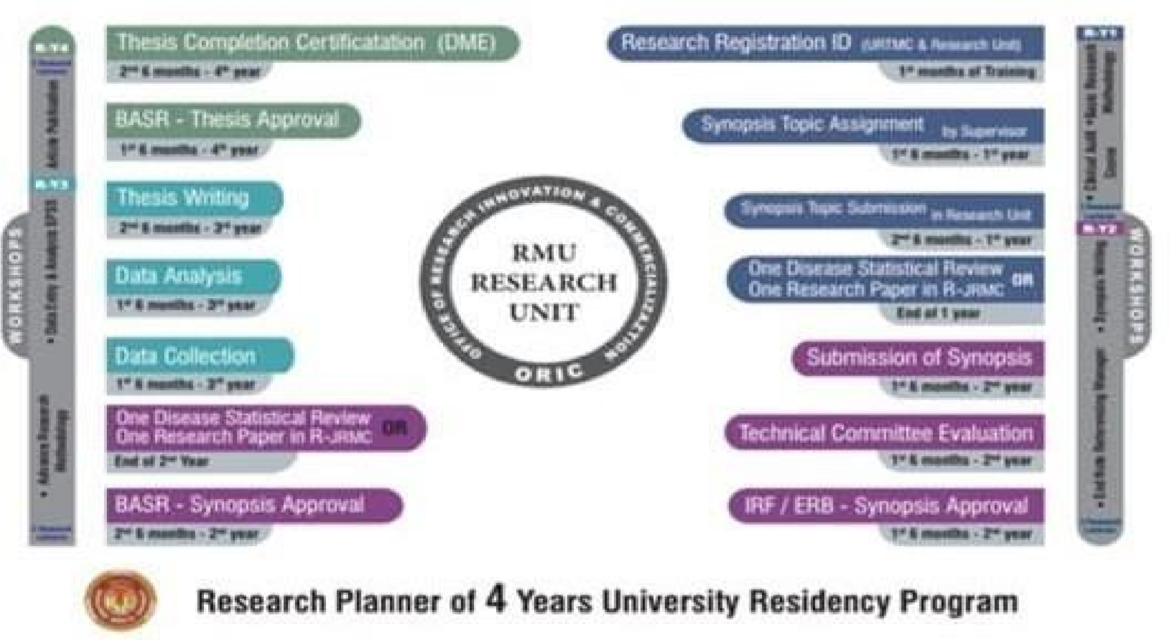

For residency program research work on synopsis and thesis writing starts from entry into university by getting registration ID number from the research unit. It has been structured in 06 monthly & annual time scale goals. Essential steps are included in eligibility criteria of yearly, midterm and final assessments. Compulsory workshops have been designed to train residents along the pathway of research conduction. The charts below show the structure and timeline description of the tasks required.
Outline of research curriculum
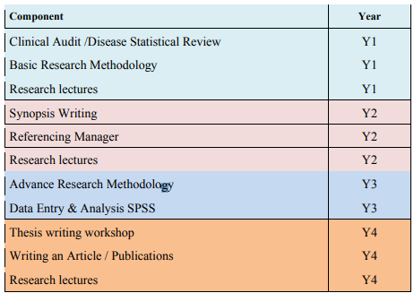

Year | Milestone | Training Components
Year 1 | - Research Registration ID (1st Month): Registration establishes an official record of the resident's research participation and aligns with institutional requirements.  - Synopsis Topic Assignment & Submission to Research Unit (1st 6 Months): Residents are assigned a research topic, ideally aligned with their clinical interests, which lays the foundation for their thesis.  - Single Disease Statistical Review or Research Paper (Before End of Year 1): Residents complete a statistical review or publish a research paper, introducing them to data interpretation and critical analysis | - Basic Research Methodology: A series of introductory lectures on research methodology, covering study designs, sample size calculation, and research ethics.  - Research Lectures: Regular sessions to familiarize residents with foundational research principles.  - Synopsis Writing & Referencing Manager Training: Workshops on writing a research synopsis and managing references using software like EndNote or Zotero.
Year 2 | - Submission of Synopsis (1st 6 Months): Residents submit a detailed research proposal outlining their study objectives, methodology, and expected outcomes.  - Technical Committee Evaluation, IRF/ERB Approval, and BASAR Synopsis Approval: These steps involve institutional and ethical approvals, ensuring the research project meets ethical standards and feasibility. | - Advanced Research Methodology: Building on the basics, this module covers complex statistical tests, bias minimization, and confounding variables.  - Research Lectures: Continued educational sessions to reinforce methodological rigor and address any challenges in the research process.
Year 3 | - Disease Statistical Review or 1 Research Paper (Optional): An optional review or paper to further enhance research skills.  - Data Collection (1st 6 Months): Residents begin gathering data for their thesis under guidance, focusing on data quality and integrity.  - Data Analysis (Last 6 Months): Residents learn to apply statistical techniques using software like SPSS, analyzing the data collected for meaningful insights. | - Data Entry & Analysis with SPSS: A workshop on using SPSS for data entry and performing essential statistical analyses, equipping residents with hands-on analytical skills.  - Research Lectures: Ongoing lectures addressing specific challenges in data management and analysis.
Year 4 | - Thesis writing (1st 6 Months): Residents draft their thesis with structured guidance on writing style, formatting, and scientific rigor.  - BASAR Thesis Approval (Last 6 Months): The thesis is submitted for approval, marking the completion of the primary research requirement.  - Thesis Completion Certificate by DME (Last 6 Months): Upon approval, the Department of Medical Education certifies the thesis completion, fulfilling the academic research requirement | - Thesis Writing Workshop: A dedicated session on organizing research findings, structuring a thesis, and using appropriate academic language.  - Writing an Article/Publications: Guidance on publishing research findings, including manuscript preparation, journal selection, and the peer-review process.  - Research Lectures: Concluding lectures covering advanced topics in publication ethics and responding to reviewer feedback.
Research milestones
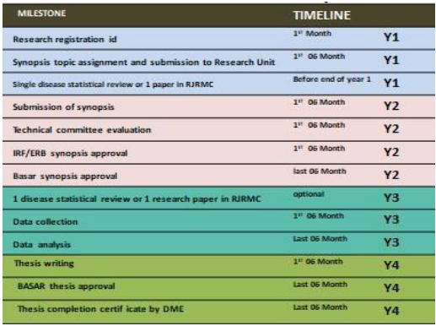

Research Work Assessment
Submission of Synopsis and Thesis
The candidates shall prepare their synopsis as per guidelines provided by the Advanced Studies & Research Board, available on RMU website.
Synopsis of research project should be submitted and approved by the end of the 1st year of MS/MD program.
The minimum duration between approval of synopsis and submission of thesis shall be one year, but the thesis cannot be submitted later than 8 years of enrolment.
Thesis shall be submitted by the candidate duly recommended by the Supervisor.
The research thesis must be compiled and bound in accordance with the Thesis Format
Guidelines approved by the University and available on website.
The research thesis will be submitted along with the fee prescribed by the University.
Thesis Assessment
All candidates admitted in MS/MD course shall appear in thesis evaluation component of the FTA after completion of 4th years of their training course.
Only those candidates shall be eligible for thesis evaluation who have passed Final term Examination and Oral & Practical/ Clinical component of Exit Examination.
The examination shall include thesis evaluation with defense.
The Vice Chancellor shall appoint three external examiners for thesis evaluation, preferably from other universities and from abroad, out of the panel of examiners approved by the Advanced Studies & Research Board. The examiners shall be appointed from respective specialty.
The thesis shall be sent to the external examiners for evaluation, well in time before the date of defense examination and should be approved by all the examiners.
After the approval of thesis by the evaluators, the thesis defense examination shall be held within the University on such date as may be notified by the Controller of Examinations. The Controller of Examinations shall make appropriate arrangements for the conduct of thesis defense examination in consultation with the supervisor, who will co-ordinate the defense examination.
The thesis defense examination shall be conducted by two External Examiners who shall submit a report on the suitability of the candidate for the award of degree. The supervisor shall act as coordinator.
Candidates and faculty interested in further details relating to research, please refer to the document on Research curriculum (also available on RMU website can be san through his QR code)


SECTION 4:
WORKSHOPS

INTRODUCTION

The workshops conducted for first- and second-year MD Pediatric Medicine residents at Rawalpindi Medical University aim to equip residents with essential skills and knowledge to enhance their clinical and academic proficiency. These workshops include:

- University Residency Program Orientation.
This workshop introduces residents to the structure, expectations, and resources of the residency program, helping them transition smoothly into their roles.

- Communication Skills
This session develops residents' interpersonal skills for effective patient communication and teamwork, essential for fostering therapeutic relationships and collaborative healthcare environments.

- Cardiac first response
Residents gain life-saving skills through ACLS training, covering the recognition and management of cardiac emergencies to enhance patient survival in critical situations.

- Biostatistics and Research Methodology
Designed to introduce the fundamentals of medical research, this workshop emphasizes data analysis, statistical interpretation, and research planning, preparing residents to conduct and evaluate research.

- Synopsis Writing
This workshop provides guidance on structuring and drafting a research synopsis, a key component for scholarly submissions and research projects.

- Introduction to Computers/ Information Technology and Software
Residents are introduced to essential IT skills, including medical software and digital tools that streamline clinical documentation, data management, and research activities.

These workshops are structured to develop both clinical and academic competencies, supporting residents in becoming skilled, informed, and confident healthcare professionals.

YEAR OF TRAINING | WORKSHOPS
FIRST YEAR MD Training | University Residency Program orientation  Communication skills  Cardiac first response
SECOND YEAR MD Training | Research methodology  Synopsis writing  IT (Information technology) skills

WORKSHOP DETAILS:
WORKSHOPS (3 hours each for 2-5 days)

S.NO | NAME OF THE WORKSHOP | LEARNING OBJECTIVES |  | TOPICS TO BE COVERED
1. | Biostatistics & Research  Methodology  (2 days) | - To understand the basics of Bio- Statistics  - To critique why research is important?  - To discuss the importance of Selecting a Field for Research  - To prepare oneself for Participation in National and International Research  - To prepare oneself for Participation in Pharmaceutical Company Research  - To interpret the importance of research ideas & Criteria for a good research topic  - To discuss Ethics in Health Research  - To learn to write a Scientific Paper  - To learn to make a Scientific Presentation  - To learn to make a purposeful literature search |  | - Introduction to Bio-Statistics  - Introduction to Bio- Medical Research Why research is important?  What research to do?  - Selecting a Field for Research  - Drivers for Health Research  - Participation in National and International Research  - Participation in Pharmaceutical  Company Research  - Where do research ideas come from  - Criteria for a good research topic Ethics in Health Research  - Writing a Scientific Paper  - Making a Scientific Presentation & Searching the Literature
2. | Introduction to computer/Information  Technology & Software  (3 days) | By the end of this workshop student should be able to:  Appropriately start up and shut  down your computer.  Navigate the operating system and start applications.  Perform basic functions of file management.  Perform basic functions in a word processor and spreadsheet. Manage print settings and print documents.  Receive and send email.  Use a web browser to navigate the Internet.  work with windows, toolbars, and command menus  perform basic word processing and graphic tasks make a Power Point presentation explore Web browsing basics  back up files save, copy, and organize your work to enter data accurately in software  of Statistical Package for Social  Sciences |  | 1. Hardware and Software  • Understand the main components of a computer, including input and output devices.  - Understand the function of communication devices such as smartphones and tablets.  - Understand the role of Operating Systems, programs and apps.  2. Windows  - Turning on the computer and logging on.  - The Windows screen.  - Running programs from the Start Menu.  - Minimising, maximising, moving, resizing and closing windows.  - Logging off and shutting down your computer.  3.Working with Programs  - Running multiple programs.  - Desktop icons and creating a desktop shortcut.  - Managing programs from the taskbar.  - Closing programs.  4.File Management  - Managing Windows Explorer.  - Creating, moving, renaming and deleting folders and files.  - Understandings file extensions.  - Viewing storage devices and network connections.  - Managing USB flash drives.  5.Word Processing  - Creating documents in Microsoft Word.  - Typing text, numbers and dates into a document.  - Easy formatting.  - Checking the spelling in your document.  - Making and saving changes to your document.  6. Power Point  - Making Power Point presentation  7.Spreadsheets  • Understanding spreadsheet functionality.  - Creating spreadsheets in Microsoft Excel.  - Typing text numbers and dates into a worksheet.  - Easy formulas.  - Easy formatting.  - Charting your data.  - Making and saving changes to your workbook.  - Printing a worksheet.  8.Printing  - Print preview.  - Print settings.  - Managing the print queue.  9.Using Email  - The Outlook mail screen elements.  - Composing and sending an email message.  - Managing the Inbox.  10.Accessing the Internet  - Going to a specific website and bookmarking.  - Understanding how to search/Google effectively.  - Copy and paste Internet content into your documents and emails.  - Stopping and refreshing pages.  - Demystifying the Cloud.  - Understanding social media platforms such as Facebook and Twitter.  - Computer security best practices.  11.Statistical Package for Social Sciences  - general understanding for data entry
3. | Communication skills  (2 days) | - To learn to use Non-medicinal Interventions in Communication Skills of Clinical Practice To discuss the importance of counseling  - To role play as a counselor  - To learn to manage a conflict  - resolution  - To learn to break a bad news  - To discuss the importance of Medical Ethics, Professionalism and Doctor-Patient Relationship Hippocratic Oath  - To learn to take an informed consent  - To illustrate the importance of confidentiality  - To summarize Ethical Dilemmas in a Doctor’s Life |  | - Use of Non-medicinal Interventions in Clinical Practice Communication Skills  - Counseling  - Informational Skills  - Crisis Intervention/Disaster  - Management Conflict Resolution  - Breaking Bad News  - Medical Ethics, Professionalism and Doctor-Patient Relationship Hippocratic Oath  - Four Pillars of Medical Ethics (Autonomy, Beneficence, Non-malficence and Justice)  - Informed Consent and Confidentiality  - Ethical Dilemmas in a Doctor’s Life
4. | Clinical Audit  (2 days)  (Workshop is specific for MD Pediatric Medicine only ) | Road Map for workshop:  - Step 1:Topic selection  - Step 2: Setting of criteria and standards  - Step 3: First data collection  - Step 4: Evaluation and comparison with criteria and standards  - Step 5: Implementation of change  - Step 6: Second data collection – evaluation of change  The following are factors that may affect your choice of audit topic:  - Strong impact on health  - Convincing evidence available about appropriate care  - Common condition which can be  clearly defined  - Good reasons of believing that current performance can be improved  - Readily accessible data which can be collected within a reasonable length  of time  • Consensus on the audit topic among the practice members |  | - To understand clinical audit process. To help clinicians decide exactly why they are doing a particular audit and what they want to achieve through carrying out the audit.  - To determine, how clinical audit relates to other activities related to accountability for the quality and safety of patient care.  - To select the right subject for audit.  - To use evidence of good practice in designing clinical audits.  - To help clinicians formulate measures of quality based on evidence of good practice, as the basis for data collection and also to develop data collection protocols and tools and advise on data collection for clinical audits.  - To help in understanding how to handle data protection issues related to clinical audit.  - To understand use of statistics for analyzing and presenting findings of data collection and thus help clinicians to analyze causes of problems that are affecting the quality of care. This helps in applying principles and strategies for taking action to achieve changes in clinical practice.  - To help clinicians manage review of clinical audit findings with their colleagues.  - To be able to prepare clinical audit reports.  - To recognize and handle ethics issues related to clinical audit.
5. | Cardiac first response  (2 days) | Upon successful completion of the workshop, the student will be able to:  - Recognize and initiate early management of pre-arrest conditions that may result in cardiac  arrest or complicate resuscitation outcome  - Demonstrate proficiency in providing BLS care, including prioritizing chest compressions and integrating automated external defibrillator (AED) use  - Recognize and manage respiratory arrest  - Recognize and manage cardiac arrest until termination of resuscitation or transfer of care, including immediate post-cardiac arrest care  - Recognize and initiate early management of ACS, including appropriate disposition  - Recognize and initiate early management of stroke, including appropriate disposition  - Demonstrate effective communication as a member or leader of a resuscitation team and recognize the impact of team dynamics on overall team  Performance |  | The workshop is designed to give students the opportunity to practice and demonstrate proficiency in the following skills used in resuscitation:  - Systematic approach  - High-quality BLS  - Airway management  - Rhythm recognition  - Defibrillation  - Intravenous (IV)/intraosseous (IO) access  (information only)  - Use of medications  - Cardioversion  - Transcutaneous pacing  - Team dynamics  - Reading and interpreting electrocardiograms (ECGs) - Be able to identify—on a monitor and paper tracing—rhythms associated with bradycardia, tachycardia with adequate perfusion, tachycardia with poor perfusion, and pulseless arrest. These rhythms include but are not limited to:  - Normal sinus rhythm o Sinus bradycardia o Type I second-degree AV block o Type II second-degree AV block o Third-degree AV block o Sinus tachycardia  - Supraventricular tachycardias o Ventricular tachycardia o Asystole  - Ventricular fibrillation  - Organized rhythm without a pulse  12. Basic understanding of the essential drugs used in: o Cardiac arrest o Bradycardia o Tachycardia with adequate perfusion o Tachycardia with poor perfusion o Immediate post–cardiac arrest care

SECTION – 5
Charting the Road to Competence: Developmental Milestones for MD Pediatric Medicine Program at Rawalpindi Medical University

Introduction to Milestones for the 4-Year MD Pediatric Medicine Program at Rawalpindi Medical University, Pakistan
The 4-year MD Pediatric Medicine Program at Rawalpindi Medical University, aligned with ACGME milestones, offers a structured framework for comprehensive training. This ensures the progressive development of clinical skills, medical knowledge, professionalism, practice-based learning, systems-based practice, and research capabilities.
Remember to celebrate the milestones as you prepare for the road ahead --- Nelson Mandela.

High-quality assessment of resident performance is needed to guide individual residents' development and ensure their preparedness to provide patient care. To facilitate this aim, reporting milestones are now required across all Pediatric Medicine (IM) residency programs. Milestones promote competency-based training in Pediatric Medicine. Residency program directors may use them to track the progress of trainees in the 6 general competencies including patient care, Medical Knowledge, Practice-Based Learning and Improvement, Interpersonal and Communication Skills, Professionalism and Systems-Based Practice. Milestones inform decisions regarding promotion and readiness for independent practice. In addition, the milestones may guide curriculum development, suggest specific assessment strategies, provide benchmarks for resident self-directed assessment-seeking, assist remediation by facilitating identification of specific deficits and provide a degree of national standardization in evaluation.
Finally, by explicitly enumerating the profession’s expectations for graduates, they may improve public accountability for residency training.

Developmental Milestones | Competency
PATIENT CARE | Clinical skills and reasoning | Approximate Time  Frame  Trainee Should  Achieve  Stage
Acquire accurate and relevant history from the patient in an efficiently customized, prioritized, and hypothesis driven fashion | Historical Data Gathering | 6 months
Seek and obtain appropriate, verified, and prioritized data from secondary sources (e.g. family, records, pharmacy) |  | 9 months
Obtain relevant historical subtleties that inform and prioritize both differential diagnoses and diagnostic plans, including sensitive, complicated, and detailed information that may not often be volunteered by the patient |  | 24 months
Role model gathering subtle and reliable information from the patient for junior members of the healthcare team |  | 38 months
Perform an accurate physical examination that is appropriately targeted to the patient’s complaints and medical conditions. Identify pertinent abnormalities using common maneuvers. | Performing a physical exam | 6 months
Accurately track important changes in the physical examination over time in the outpatient and inpatient settings |  | 12 months
Demonstrate and teach how to elicit important physical findings for junior members of the healthcare team |  | 24 months
Routinely identify subtle or unusual physical findings that may influence clinical decision making, using advanced maneuvers where applicable |  | 36 months
Synthesize all available data, including interview, physical examination, and preliminary laboratory data, to define each patient’s central clinical problem | Clinical Reasoning | 12 months
Develop prioritized differential diagnoses, evidence-based diagnostic and therapeutic plan for common inpatient and ambulatory conditions |  | 12 months
Modify differential diagnosis and care plan base on clinical course and data as appropriate |  | 24 months
Recognize disease presentations that deviate from common patterns and that require complex decision making |  | 36 months
Appropriately perform invasive procedures and provide post-procedure management for common procedures | Invasive procedures | 18 months
Make appropriate clinical decisions based on the results of common diagnostic testing, including but not limited to routine blood chemistries, hematologic studies, coagulations tests, arterial blood gases, ECG, chest radiographs, pulmonary function tests, urinalysis and other body fluids | Delivery of patient centered clinical care  (Diagnostic tests) | 12 months
Make appropriate clinical decisions based upon the results of more advanced diagnostic tests |  | 24 months
Recognize situations with a need for a need for urgent or emergent medical care, including life-threatening conditions | Patient Management | 6 months
Recognize when to seek additional guidance |  | 6 months
Provide appropriate preventive care and teach patient regarding self-care |  | 9 months
With minimal supervision, manage patients with common clinical disorders seen in the practice of inpatient and ambulatory general Pediatric Medicine |  | 12 months
With supervision, manage patients with common and complex clinical clinical disorders seen in the practice of inpatient and ambulatory general Pediatric Medicine |  | 18 months
Initiate management and stabilize patients with emergent medical conditions |  | 12 months
Manage patients with conditions that require intensive care |  | 36 months
Independently manage patient with a broad spectrum of clinical disorders seen in the practice of general Pediatric Medicine |  | 36 months
Manage complex or rare medical conditions |  | 40 months
Customize care in the context of the patient’s preferences and overall health |  | 36 months
Provide specific, responsive consultation to other services | Consultative care | 24 months
Provide Pediatric Medicine consultation for patients with more complex clinical problems require detailed risk assessment |  | 40 months

Developmental Milestones | Competency | Approximate Time  Frame  Trainee Should  Achieve  Stage
PRACTICE-BASED LEARNING & IMPROVEMENT | Learning and Improving via Audit of Performance
Appreciate the responsibility to assess and improve care collectively for a panel of patients | Improve the quality of care for a panel of patients | 12 months
Perform or review audit of a panel of patients using standardized, disease-specific, and evidence-based criteria |  | 24 months
Reflect on audit compared with local or national benchmarks and explore possible explanations for deficiencies, including doctor-related, system- related, and patient-related factors |  | 24 months
Identify areas in resident's own practice and local system that can be changed to improve the processes and outcomes of care |  | 36 months
Engage in a quality improvement intervention |  | 42 months
Identify learning needs (clinical questions) as they emerge in patient care activities | Learning and improvement via answering clinical questions from patient scenarios (self-regulation) | 12 months
Classify and precisely articulate clinical questions |  | 24 months
Develop a system to track, pursue, and reflect on clinical questions |  | 24 months
Access medical information resources to answer clinical questions and support decision making | Acquires the best evidence | 12 months
Effectively and efficiently search NLM databases for original clinical research articles |  | 12 months
Effectively and efficiently search evidence-based summary medical information resources |  | 24 months
Appraise the quality of medical information resources and select among them based on the characteristics of the clinical question |  | 36 months
With assistance, appraise study design, conduct, and statistical analysis in clinical research papers | Appraises the evidence for validity and usefulness | 12 months
With assistance, appraise clinical guideline recommendations for bias |  | 24 months
Independently appraise study design, conduct and statistical analysis in clinical research papers |  | 36 months
Independently appraise clincial guideline recommendations for bias and cost-benefit considerations |  | 36 months
Determine if clinical evidence can be generalized to an individual patient | Applies the evidence to decision-making for individual patients | 12 months
Customize clinical evidence for an individual patient |  | 24 months
Communicate risks and benefits to alternative to patients |  | 36 months
Integrate clinical evidence, clinical context, and patient preferences into decision-making |  | 36 months
Respond welcomingly and productively to feedback from all members of the health care team including faculty, peer residents, students, nurses,
allied health workers, patients and their advocates | Improves via feedback | 12 months
Actively seek feedback from all members of the health care team |  | 12 months
Calibrate self-assessment with feedback and other external data |  | 24 months
Reflect on feedback in developing plans for improvement |  | 24 months
Maintain awareness of the situation in the moment, and respond to meet situational needs | Improves via self-assessment | 24 months
Reflect (in action) when surprised, applies new insights to future clinical scenarios, and reflects (on action) back on the process |  | 36 months
Actively participate in teaching conferences | Participates in the education of all members of the  health care team | 12 months
Integrate teaching, feedback and evaluation with supervision of interns' and students' patient care |  | 36 months
Take a leadership role in the education of all members of the health care team |  | 42 months

Developmental Milestones | Competency | Approximate Time  Frame Trainee Should  Achieve Stage
INTERPERSONAL & COMMUNICATION SKILLS | Patients and Family
Provide timely and comprehensive verbal and written communication to patients/advocates | Communicate effectively | 12 months
Effectively use verbal and nonverbal skills to create rapport with patients/families |  | 12 months
Use communication skills to build a therapeutic relationship |  | 12 months
Engage patients/advocates in shared decision making for uncomplicated diagnostic and therapeutic scenarios |  | 24 months
Utilize patient centered educational strategies |  | 24 months
Engage patient/advocates in shared decision-making for difficult, ambiguous or controversial scenarios |  | 36 months
Appropriately counsel patients about the risks and benefits of tests and procedures highlighting cost awareness and resource allocation |  | 36 months
Role model effective communication skills in challenging situations |  | 36 months
Effectively use an interpreter to engage patient in the clinical setting, including patient education | Intercultural sensitivity | 6 months
Demonstrate sensitivity to differences in patients including but no limited to race, culture, gender, sexual orientation, socioeconomic status, literacy, and religious beliefs |  | 12 months
Actively seek to understand patient differences and views and reflects this in respectful communication and shared decision-making with the patient and the healthcare team |  | 30 months
Effectively communicate with other caregivers in order to maintain appropriate continuity during transitions of care | Physician and other healthcare professionals (Transition of care) | 12 months
Role model and teach effective communication with next caregivers during transitions of care |  | 24 months
Deliver appropriate, succinct, hypothesis-driven oral presentations | Interprofessional team | 6 months
Effectively communicate plan of care to all members of the health care team |  | 12 months
Engage in collaborative communication with all members of the health care team |  | 30 months
Request consultative services in an effective manner | Consultation | 6 months
Clearly communicate the role of consultant to the patient, in support of the primary care relationship |  | 12 months
Communicate consultative recommendations to the referring team in an effective manner |  | 36 months
Provide legible, accurate, complete, and timely written communication that is congruent with medical standards | Medical Records | 6 months
Ensure succint, relevant and patient-specific written communication |  | 24 months
Developmental Milestones  PROFESSIONALISM | Competency  Physician ship | Approximate Time  Frame Trainee Should Achieve Stage
Document and report clinical information truthfully | Adhere to basic ethical principles | 1 month
Follow formal policies |  | 1 months
Accept personal errors and honestly acknowledge them |  | 6 months
Uphold ethical expectations of research and scholarly activity |  | 36 months
Demonstrate empathy and compassion to all patients | Demonstrate compassion and respect to patients | 3 months
Demonstrate a commitment to relieve pain and suffering |  | 3 months
Provide support (physical, psychological, social and spiritual) for dying patients and their families |  | 24 months
Provide leadership for a team that respects patient dignity and autonomy |  | 30 months
Communicate constructive feedback to other members of the health care team | Provide timely, constructive feedback to colleague | 12 months
Recognize, respond to and report impairment in colleagues or substandard care via peer review process |  | 24 months
Respond promptly and appropriately to clinical responsibilities including but not limited to calls and pages | Maintain accessibility | 1 month
Carry out timely interactions with colleagues, patients, and their designated caregivers |  | 6 months
Recognize and manage obvious conflicts of interest, such as caring for family members and professional associates as patients | Recognize conflicts of interest | 6 months
Maintain ethical relationships with industry |  | 30 months
Recognize and manage subtler conflicts of interest |  | 34 months
Dress and behave appropriately | Demonstrate personal accountability | 1 month
Maintain appropriate professional relationships with patients, families and staff |  | 1 month
Ensure prompt completion of clinical, administrative and curricular tasks |  | 6 months
Recognize and address personal, psychological, and physical limitations that may affect professional performance |  | 12 months
Recognize the scope of his/her abilities and ask for supervision and assistance appropriately |  | 12 months
Serve as a professional role model for more junior colleagues (e.g. medical students, interns) |  | 30 months
Recognize the need to assist colleagues in the provision of duties |  | 30 months
Recognize when it is necessary to advocate for individual patient needs | Practice individual patient advocacy | 6 months
Effectively advocate for individual patient needs |  | 30 months
Recognize and take responsibility for situations where public health supersedes individual health (e.g. reportable infectious diseases) | Comply with public health policies | 24 months
Treat patients with dignity, civility and respect, regardless of race, culture, gender, ethnicity, age, or socioeconomic status | Patient centeredness (Respect the dignity, culture, beliefs, values and opinions of the patient) | 1 month
Recognize and manage conflict when patient values differ from their own |  | 24 months
Maintain patient confidentiality | Confidentiality | 1 month
Educate and hold others accountable for patient confidentiality |  | 18 months
Recognize that disparities exist in health care among populations and that they may impact care of the patient | Recognize and address disparities in health care | 12 months
Embrace physicians' role in assisting the public and policy makers in understanding and addressing causes of disparity in disease and suffering |  | 36 months
Advocates for appropriate allocation of limited health care resources |  | 42 months

Developmental Milestones | Competency | Approximate Time  Frame Trainee Should  Achieve Stage
SYSTEMS-BASED PRACTICE | Works effectively with other care providers and settings
Understand unique roles and services provided by local health care delivery systems | Works effectively within multiple health delivery systems | 12 months
Manage and coordinate care and care transitions across multiple delivery systems, including ambulatory, subacute, acute, rehabiliation and skilled  Nursing |  | 24 months
Negotiate patient-centered care among multiple care providers |  | 36 months
Appreciate roles of a variety of health care providers, including but not limited to consultants, therapists, nursed, home care workers, pharmacists,
and social workers | Works effectively within an interprofessional team | 6 months
Work effectively as a member within the interprofessional team to ensure safe patient care |  | 6 months
Consider alternative solutions provided by other teammates |  | 12 months
Demonstrate how to manage the team by utilizing the skills and coordinating the activities of interprofessional team members |  | 36 months
Recognize health system forces that increase the risk for error including barriers to optimal care | Improving health care delivery (Recognizes system error and advocates for system improvement) | 12 months
Identify, reflect on, and learn from critical incidents such as near misses and preventable medical errors |  | 12 months
Dialogue with care team members to identify risk for and prevention of medical error |  | 24 months
Understand the mechanisms for analysis and correction of systems errors |  | 24 months
Demonstrate ability to understand and engage in a system level quality improvement initiative |  | 36 months
Partner with other healthcare team professionals to identify, propose improvement opportunities within the system |  | 36 months
Reflect awareness of common socio-economic barriers that impact patient care | Cost-effective care for patients and populations (Identifies forces that impact the cost of health care and advocates for cost-effective care) | 12 months
Understand how cost-benefit analysis is applied to patient care (i.e. via principles of screening tests and the development of clinical guidelines |  | 12 months
Identify the role of various health care stakeholders including providers, suppliers, financiers, purchasers and consumers and their varied impact on the cost of and access to health care |  | 24 months
Understand coding and reimbursement principles |  | 24 months
Identify costs for common diagnostic or therapeutic tests | Practices cost-effective care | 6 months
Minimize unnecessary care including tests, procedures, therapies and ambulatory or hospital encounters |  | 6 months
Demonstrate the incorporation of cost-awareness principles into standard clinical judgments and decision-making |  | 18 months
Demonstrate the incorporation of cost-awareness principles into complex clinical scenarios |  | 36 months

These milestones provide a structured framework for assessing the development and progression of MD Pediatric Medicine postgraduate trainees, ensuring a comprehensive and rigorous educational experience.

References:

https://www.im.org/resources/ume-gme-program-resources/milestones/core-competencies

Section no. 6
Evaluation and assessment strategies
(MTA, FTA, & Thesis defense)

The assessment component of the MD Pediatric Medicine curriculum at Rawalpindi Medical University, structured in alignment with the Accreditation Council for Graduate Medical Education (ACGME) guidelines, serves as a foundational pillar in evaluating and ensuring the competence of residents.
The assessment system is designed to foster a comprehensive understanding of Pediatric Medicine through rigorous and multidimensional evaluation methods. These methods encompass formative and summative assessments, including direct observations, written exams, and 360-degree feedback, each of which provides critical insights into a resident's clinical knowledge, procedural skills, communication abilities, and professional behavior.
Assessments are pivotal in guiding teaching and learning, offering feedback that helps residents identify areas for improvement, advance their skills, and meet the standards of quality patient care. By maintaining robust assessment practices, the curriculum ensures that graduates are not only competent in their field but also embody the high standards of professionalism and patient-centered care central to medical practice.

Few definitions before we proceed further made to be clear:

- What Is Competency?
The ability to do something successfully or efficiently.

- What Is Competence?
Competency is described as what an individual is enable to do while performance should describe what an individual actually does in clinical practice.
The terms “performance” and “competency” are often used interchangeably.

- What is performance-based assessment of curriculum?
Performance based assessment measures students’ ability to apply the skills & knowledge learned from a unit of study.

- What is workplace based assessment of curriculum?
The apprenticeship model of medical training has existed for thousands of years: the apprentice learns from watching the master and the master in turn observe the apprentice’s performance & helps them improve. Performance assessment not therefore a new concept higher work in modern healthcare environment with its discourse of accountability, performance assessment increasing role In ensuring that professionals develop and maintain the knowledge and skills required for practice. However now it will be done in a structured manner.

- What is a Formative Assessment?
- Such an Assessment which creates learning itself, from one’s deficiencies.
- It is non-threatening for the students because it does not decide pass or fail.
- Provision of Feed back to the students is essential component of Formative Assessment

6. What is a Summative Assessment?
- Criteria Based High Stake Examinations
- Provision of Feedback to the students is not essential for Summative Examinations
7. What is continuous Internal Assessment?
- A collection of Formative Assessments is called Continuous Internal Assessment

What is the basis of curriculum and Assessment of MD Pediatric Medicine of Rawalpindi Medical University Rawalpindi?

The curriculum of MD Pediatric Medicine of Rawalpindi Medical University Rawalpindi is derived from Accreditation Council for Graduate Medical Education which is competency / performance based system depends upon six following competencies.
- Medical Knowledge
- Patient Care
- Interpersonal & Communication Skills
- Professionalism
- Practice Based Learning
- System Based Learning

Rawalpindi Medical University Rawalpindi has two incorporated one additional component in this basic structure of six core competencies 7. Research
Distribution of weightage (if we consider total marks as 100) among various desired competencies of RMU Pediatric Medicine MD curriculum:

1. Medical knowledge | 40% both
2. Patient care
3. Interpersonal & communication skills | 40% both
4. Professionalism
5. Practice based learning | 10% both
6. System based learning
7. Research | 10%

Continuous Internal Assessment:

Competencies included CIA | Phases of CIA | Time Line for end  of various phases of CIA | Weightage of CIA | Tools for Assessment of CIA
- Medical knowledge  - Patient care (40% both)  - Interpersonal & communication skills  - Professionalism (40% both)  - Practice based learning  - System based learning  (10% both)  - Research 10%) | Phase -1  - CIA Year 1  - CIA Year 2 | till end of Year 2 | Equal to or more than 75% of the total marks of all formative assessments/ 360⁰ Evaluations | - Multi source feedback/360 degree evaluation  - MCQs for knowledge  - Mini-CEX  - Case based discussion  - CPC presentations  - TOACS/OSCE  - Charts stimulated recall  - Teaching rounds  - Directly observed procedures  - Research activities
 | Phase -2  - CIA Year 3  - CIA Year 4 | till end of Year 4 | Equal to or more than 75% of the total marks of all formative assessments/  360⁰ Evaluations

Details about various competencies required for MD Pediatric Medicine along with brief details of Teaching Strategies, Type of Assessment, weightage given to the competency & Tools of Assessment:

Sr.  No | Competency to be assessed | Teaching & learning strategies | Type of Assessment for the competency to be assessed | % weightage of the competency | Tools of Assessment
1. | Medical knowledge | Case based discussion & problem based learning, large group interactive session, self-directed learning, teaching rounds, and literature search. | Formative Assessment leading to continue internal assessment and also summative assessment in high stake exams | 40% for both Medical  Knowledge and Patient Care both | MCQs, SEQs, Directly observe procedure, mini clinical examinations, charts, OSCE, teaching ward rounds, case discussion, seminars, topic presentation
2. | Patient care | Case based discussion, teaching rounds, morbidity & mortality meetings, 360⁰ feedback evaluation, DOPS, long case/ short case discussions OPDs, emergency indoor workshops, hands on trainings. | Formative assessment leading to continue internal assessment and also summative assessment in high stake exams |  | Teaching rounds, case base discussion, presentations, CPC participations, clinical management, problem base learning, peer assisted learning, dealing with paramedics  & patient attendants
3. | Professionalism | Teaching rounds, known conferences, workshops, hands on training, CPC, morbidity & mortality meetings, journal Club | Formative assessment leading to continue internal assessment | 40% for both professionalism  & interpersonal communication skills both | Working in OPDs, wards, emergency  DOPs, clinical case discussion, dealing with paramedics, meeting with supervisor & mentors, mini clinical examination
4. | Interpersonal &  communication  skills | Teaching rounds, hands on training, workshops related to research methodology, SPSS, data entry, LGIS, session with supervisor & mentors, session with research units, SDL, | Formative assessment leading to continuous internal assessment |  | Multi source & 360 degree evaluation.
5. | Practice based learning | Case based discussion, teaching rounds, known conferences, morbidity & mortality meetings, OPDs, emergency indoor workshops, hands on trainings. | Formative assessment leading to continuous internal assessment Multi source & 360 degree evaluation (Logbook & portfolio) | 10% both Practice Based Learning &  System Based Learning both | Working in OPDs, wards, emergency  DOPs, clinical case discussion, dealing with paramedics, meeting with supervisor & mentors, mini clinical examination
6. | System based learning | Working in wards, OPDs, Emergency | Formative assessment leading to continuous internal assessment Multi source & 360 degree evaluation (Logbook & portfolio) |  | Working in OPDs, wards, emergency  DOPs, clinical case discussion, dealing with paramedics, meeting with supervisor & mentors, mini clinical examination
7. | Research | Large group Interactive sessions on Research, hands on training & workshops, practical work of research including literature search, finding research question, synopsis writing, data collection, data analysis, thesis writing | Formative leading to continuous internal assessment Multi source & 360 degree evaluation (Logbook & portfolio)&also Summative assessment | 10% | Approval of research topic and synopsis & thesis from URTMC, Board of Advanced studies and Research and ethical review board,  Requirement of Completion certificate of research workshops as eligibility criteria  for examinations,  Defense of Thesis examination

Framework of Assessment Plan for MD Pediatric Medicine Training Program:

S.NO. | Year of  Examination | Name of Examination & type of Assessment | Competencies to be  Assessed with weightage | Eligibility criteria | Pass Marks required | Total No. of Assessments
1 | At the End of Year 1 | In Training -Assessment year1  (Formative Assessment) | - Medical knowledge  - Patient care (40% both)  - Interpersonal & communication skills  - Professionalism (40% both)  - Practice based learning  - System based learning  (10% both )  - Research (10%) | - 75% or above of CIA the total marks will be considered as eligible  - Submission of certificates of completion of the Following Mandatory workshops:  Communication skills ----- 3 days Computer & IT skills ------ 3  days  Synopsis writing ----------- 3 days  Basic Life Support -------- 2 days  - Submission of certificate of approval of Research Topic/Affidavit that if certificate of approval of Research Topic will not be provided within 30 days of submission of Application for in training examination no.1, the candidate will not be allowed to take examination.  - Publication of one article in Resident Research Journal (for five year training program only)  - OR Statistical report of one disease (for five year training program only)  - Completed and Duly signed Log Book for Year one  - Completed and duly signed Portfolio for Year one  - Submission of certificate of Continuous Internal Assessment for year one: Equal to or More than 75% (a cumulative score of the year one)  - Certificate of completion of First year Training duly signed by the  Supervisor  - Submission of evidence of payment of examination Fee for year-1 examination  - Submission of no dues certificate from all relevant departments including Library, Hostel, Cashier etc. for year one of training | Not applicable as it is a  Formative Assessment | 04 evaluations in one year (total evaluations in four years =16 )  02 Formative and 02  Summative Assessments in four years.
2 | At the end of Year-2 | Mid Training Assessment (Summative Assessment) |  | - 75% or above of CIA the total marks will be considered as eligible  - Submission of Pass Result of Examination of Year-1  - Submission of certificates of completion of the Following Mandatory workshops:  Research methodology &  Biostatistics----- -----3 days  Professionalism ----- 2 days  SPSS (Statistical Package for  Social Sciences)-------- 2 days  - Submission of certificate of approval of Research Protocol/Synopsis or undertaking /Affidavit that if approved synopsis will not be provided within 30 days of submission of Application for  Intermediate Module  Examination, the candidate will not be allowed to take examination.  - Publication of one article in Resident Research Journal (for five year training program only)  - OR Statistical report of one disease (for five year training program only)  - Completed and Duly signed Log Book for year one and two  - Completed and duly signed Portfolio for year one and two  - Submission of certificate of Continuous Internal Assessment for year one: Equal to or More than 75% (a cumulative score of the year one and two both)  - Certificate of completion of second year of Training duly signed b y the Supervisor  - Submission of evidence of payment of examination Fee for intermediate Module Examination: Examination Fee once deposited cannot be refunded/carried over the next examination under any circumstances  - Submission of no dues certificate from all relevant departments including Library, Hostel, Cashier etc. for year two of training | Details Described at the end  60% pass marks
3 | At the end of Year - 3 | In Training -Assessment year 3  (Formative Assessment) |  | - Submission of Pass result Mid Training Examination  - Submission of certificates of completion of the Following  Mandatory workshops  :Reference Manager (Endnote)--- 1 day  Mandalay 1 day  - Submission of certificate of verification of Data Collection or undertaking /Affidavit that if the certificate of verification of Data Collection will not be provided within 30 days of submission of Application for in training examination no.2, the candidate will not be allowed to take examination.  - Publication of one article in Resident Research Journal (for five year training program only)  - OR Statistical report of one disease (for five year training program only)  - Completed and Duly signed Log Book for year three  - Completed and duly signed Portfolio for year three  - Submission of certificate of Continuous Internal Assessment for year three: Equal to or More than 75% (a cumulative score of the year three)  - Certificate of completion of third year of Training duly signed by the Supervisor  - Submission of evidence of payment of examination Fee for in training examination no.2: Examination Fee once deposited cannot be refunded/carried over the next examination under any circumstances  - Submission of no dues certificate from all relevant departments including Library, Hostel, Cashier etc. For year three | Not applicable as it is a  Formative Assessment
4 | At the end of year-4 | Final Assessment for four year program  (Summative Assessment) |  | - 75% or above of CIA the total marks will be considered as eligible  - Submission of Pass result of In Examination year-3  - Submission of certificates of completion of the workshops:  - Can attend any required workshop optionally if He or She wants and can submit the certificate  - Submission of certificate of approval of Thesis or undertaking /Affidavit that if approved synopsis within 30 days of submission of  Application for Final  Examination, the candidate will not be allowed to take examination.  - Publication of one article in Resident Research Journal (for five year training program only) OR Statistical report of one disease (for five year training  program only)  - Completed and Duly signed Log Book for year three and four  - Completed and duly signed Portfolio for year three and four  - Submission of certificate of Continuous Internal Assessment for year three and four: Equal to or More than 75% (a cumulative score of the year three and four) 9. Certificate of completion of Fourth year of Training duly signed by the Supervisor  - Submission of evidence of payment of examination Fee for Final Examination: Examination Fee once deposited cannot be refunded/carried over the next examination under any circumstances  - Submission of no dues certificate from all relevant departments including Library, Hostel, Cashier etc. For year four only | Details Described at the end  60% Pass marks

TABLE OF SPECIFICATION & NOMENCLATURE
Details about Content, number of questions (MCQs) and Marks of various High Stake/ Summative Examinations

Name of examination | Content | Eligibility criteria | Questions  MCQs/SEQs/TOACS
In-Training- Assessment Year-1 (at the end of year 1) | - Cardiology, Nephrology, Gastroenterology, Respiratory  Medicine, Neurology, Emergency  Medicine/Poisoning, Endocrinology,  Dermatology, Critical Care, and  Infectious diseases related  - Basic principles of medicine  - Symptoms analysis  - Clinical methods/signs interpretation  - Differential diagnosis  - Basic investigations  - Counseling &ethics  - BLS/ACLS  - Management of common emergencies  - Principles of Antibiotic Therapy | i. Completion of 1 year training  ii. Workshops completion  - Communication skills ----------- 3days  - Computer &IT skills ------------ 3days  - Synopsis writing ---------------- 3days  - BLS/ACLS ----------------- 1 days  iii. Research  - Allotment of Thesis topic by supervisor  - Publication of one article in Resident Research Journal OR Statistical report of one disease iv. CIS- Minimum 75% marks- Certification by DME and Supervisor/s  Special note:  Students with less than 75% CIS, such cases will be referred to relevant academic review committee which will work under the umbrella of DME/ UTMC | A. Written Assessment for year -1 total marks 100 (100 MCQs)  (Pass percentage: 60%)  Table of Specification for written Assessment
 |  |  |  | No | Discipline | MCQs
 |  |  |  | 1. | Neonatology | 9
 |  |  |  | 2. | Infectious Diseases | 8
 |  |  |  | 3. | Nephrology | 8
 |  |  |  | 4. | Neurology | 8
 |  |  |  | 5. | Hematology/ Oncology | 8
 |  |  |  | 6. | Cardiology | 8
 |  |  |  | 7. | Gastroenterology | 8
 |  |  |  | 8. | Pediatric Emergency/ Critical Care | 8
 |  |  |  | 9. | Immunology/ Rheumatology/ Bone Disease | 7
 |  |  |  | 10. | Pulmonology | 7
 |  |  |  | 11. | Preventive Pediatrics/ Nutrition | 6
 |  |  |  | 12. | Endocrinology | 6
 |  |  |  | 13. | Developmental/ Genetics/ Metabolic | 3
 |  |  |  | 14. | Dermatology/Orthopedics | 3
 |  |  |  | 15 | Pediatric Surgery | 3
Up to 10% Questions may be from any topic
B- Clinical Assessment (100marks)
trainee will appear in practical exam consisting of 15 OSCE stations
Pass marks 60%.
• 15 interactive OSCE stations (ECG, X-Ray, CT-Scan, Procedure, Clinical scenario, Videos, short cases of Respiratory, CVS, Neurology, Gastroenterology, developmental assessment and
Clinical Medicine Scenario (each of 10 marks)

Mid Training  Assessment (MTA) at the end of year 2 | - Cardiology  - Gastroenterology  - Respiratory medicine  - Neurology  - Infectious diseases  - Nephrology  - Emergency medicine  - Hematology  - Rheumatology  - Psychiatry  - Endocrinology  - Critical care  - Dermatology | i- Completion of 2 year training  ii- Passed Year One examination  iii-Rotations completion  Three rotations (each of 2 months- to be completed in first two years)  - Cardiology  - Nephrology  - ICU  iv- Research:  - Formulation of research synopsis with approval of ERB & BASR by the end of 2nd year  - Certificate will be issued by UTMC  v- CIS- Minimum 75% marks minimum 75% marks- Certification by DME and Supervisor/s  Special note:  Students with less than 75% CIS, such cases will be  referred to relevant academic review committee which will work under the umbrella of DME/ UTMC | - – Mid Training Assessment( total marks = 300)  - - Written Assessment (150 marks)  Two papers of case based 75 MCQs ------ total marks 150  (Pass percentage = 60%)  C- Table of Specification for paper I & II PAPER-I
 |  |  |  | No | Discipline | MCQs
 |  |  |  | 1. | Infectious Diseases | 10
 |  |  |  | 2. | Nephrology | 10
 |  |  |  | 3. | Neurology | 15
 |  |  |  | 4. | Immunology/ Rheumatology/ Bone Disease | 10
 |  |  |  | 5. | Preventive Pediatrics/ Nutrition | 10
 |  |  |  | 6. | Hematology/ Oncology | 10
 |  |  |  | 7 | Developmental/ Genetics/ Metabolic | 05
 |  |  |  | 8 | Dermatology/Orthopedics | 05
 |  |  |  | PAPER -II
 |  |  |  | Sr.no | Discipline | MCQs
 |  |  |  | 1. | Cardiology | 10
 |  |  |  | 2. | Neonatology | 15
 |  |  |  | 3. | Gastroenterology | 12
 |  |  |  | 4. | Pediatric Emergency/ Critical Care | 15
 |  |  |  | 5. | Endocrinology | 08
 |  |  |  | 6. | Pulmonology | 10
 |  |  |  | 7. | Pediatric Surgery | 5
Up to 10% Questions may be from any topic
D- Clinical Assessment (OSCE 150 marks)
On passing the theory, trainee will be eligible to appear in OSCE comprising 15 Stations. (Pass percentage = 60%)

MTA MD PEDIATRIC MEDICINE CALGARY TOS

PAPER I:

MTA Paper 1 MD Pediatrics
No. | UNIT | Questions | No. | Topics | Impact | Frequency | I x F | Weight | No. of Items | Diagnosis | Investigations | Treatment | Basic Knowledge
1 | Infectious Diseases | 10 | 1 | Staphylococcus | 3 | 3 | 9 | 0.09375 | 0.9 | 2 | 3 | 3 | 2
 |  |  | 2 | Streptococcus Pneumoniae | 3 | 3 | 9 | 0.09375 | 0.9
 |  |  | 3 | Group A Streptococcus | 3 | 3 | 9 | 0.09375 | 0.9
 |  |  | 4 | Group B Streptococcus | 1 | 1 | 1 | 0.010416667 | 0.1
 |  |  | 5 | Diphtheria | 3 | 1 | 3 | 0.03125 | 0.3
 |  |  | 6 | Neisseria Meningitidis | 3 | 1 | 3 | 0.03125 | 0.3
 |  |  | 7 | Neisseria Gonorrhoeae | 1 | 1 | 1 | 0.010416667 | 0.1
 |  |  | 8 | Pertussis | 3 | 1 | 3 | 0.03125 | 0.3
 |  |  | 9 | Salmonella | 2 | 3 | 6 | 0.0625 | 0.6
 |  |  | 10 | Shigella | 1 | 1 | 1 | 0.010416667 | 0.1
 |  |  | 11 | Escherichia Coli | 1 | 3 | 3 | 0.03125 | 0.3
 |  |  | 12 | Cholera | 3 | 1 | 3 | 0.03125 | 0.3
 |  |  | 13 | Botulism | 1 | 1 | 1 | 0.010416667 | 0.1
 |  |  | 14 | Tetanus | 3 | 1 | 3 | 0.03125 | 0.3
 |  |  | 15 | Clostridium Difficile | 1 | 1 | 1 | 0.010416667 | 0.1
 |  |  | 16 | Mycobacterium Tuberculosis | 3 | 3 | 9 | 0.09375 | 0.9
 |  |  | 17 | Syphiis | 1 | 1 | 1 | 0.010416667 | 0.1
 |  |  | 18 | MMR | 3 | 3 | 9 | 0.09375 | 0.9
 |  |  | 19 | Polio | 1 | 1 | 1 | 0.010416667 | 0.1
 |  |  | 20 | Herpes Siplex, Varicella | 1 | 1 | 1 | 0.010416667 | 0.1
 |  |  | 21 | TORCH | 1 | 1 | 1 | 0.010416667 | 0.1
 |  |  | 22 | Dengue Fever | 3 | 2 | 6 | 0.0625 | 0.6
 |  |  | 23 | Rabies | 3 | 1 | 3 | 0.03125 | 0.3
 |  |  | 24 | HIV | 1 | 1 | 1 | 0.010416667 | 0.1
 |  |  | 25 | Giardiasis | 1 | 1 | 1 | 0.010416667 | 0.1
 |  |  | 26 | Amebiasis | 1 | 1 | 1 | 0.010416667 | 0.1
 |  |  | 27 | Leishmaniasis | 1 | 1 | 1 | 0.010416667 | 0.1
 |  |  | 28 | Malaria | 2 | 1 | 2 | 0.020833333 | 0.2
 |  |  | 29 | Ascariasis | 1 | 1 | 1 | 0.010416667 | 0.1
 |  |  | 30 | Hookworm | 1 | 1 | 1 | 0.010416667 | 0.1
 |  |  | 31 | Echinococcosis | 1 | 1 | 1 | 0.010416667 | 0.1
 |  |  |  | TOTAL |  |  | 96 | 1 | 10.0
2 | Nephrology | 10 | 1 | IgA Nephropathy | 1 | 1 | 1 | 0.012820513 | 0.1 | 3 | 3 | 2 | 2
 |  |  | 2 | Alport Syndrome | 1 | 1 | 1 | 0.012820513 | 0.1
 |  |  | 3 | PostStreptococcal Glomerulonephritis | 3 | 3 | 9 | 0.115384615 | 1.2
 |  |  | 4 | Lupus nephritis | 3 | 1 | 3 | 0.038461538 | 0.4
 |  |  | 5 | Goodpasture syndrome | 1 | 1 | 1 | 0.012820513 | 0.1
 |  |  | 6 | HUS | 1 | 1 | 1 | 0.012820513 | 0.1
 |  |  | 7 | AKI | 3 | 3 | 9 | 0.115384615 | 1.2
 |  |  | 8 | RVT | 1 | 1 | 1 | 0.012820513 | 0.1
 |  |  | 9 | ARPKD | 1 | 1 | 1 | 0.012820513 | 0.1
 |  |  | 10 | Nephrotic Syndrome | 3 | 3 | 9 | 0.115384615 | 1.2
 |  |  | 11 | RTA | 3 | 3 | 9 | 0.115384615 | 1.2
 |  |  | 12 | nDiabetes Insipidus | 1 | 1 | 1 | 0.012820513 | 0.1
 |  |  | 13 | Bartter Syndrome | 2 | 2 | 4 | 0.051282051 | 0.5
 |  |  | 14 | Gitelman Syndrome | 1 | 1 | 1 | 0.012820513 | 0.1
 |  |  | 15 | CKD | 3 | 3 | 9 | 0.115384615 | 1.2
 |  |  | 16 | UTI | 3 | 3 | 9 | 0.115384615 | 1.2
 |  |  | 17 | VUR | 2 | 2 | 4 | 0.051282051 | 0.5
 |  |  | 18 | Nocturnal Enuresis | 2 | 2 | 4 | 0.051282051 | 0.5
 |  |  | 19 | renal calculi | 1 | 1 | 1 | 0.012820513 | 0.1
 |  |  |  | TOTAL |  |  | 78 | 1 | 10.0
3 | Neurology | 15 | 1 | Epilepsy | 3 | 3 | 9 | 0.166666667 | 2.5 | 4 | 5 | 2 | 4
 |  |  | 2 | headache | 1 | 1 | 1 | 0.018518519 | 0.3
 |  |  | 3 | neurocutaneous syndrome | 1 | 1 | 1 | 0.018518519 | 0.3
 |  |  | 4 | ataxia, chorea, tremor, dystonia | 1 | 1 | 1 | 0.018518519 | 0.3
 |  |  | 5 | cerebral palsy | 3 | 3 | 9 | 0.166666667 | 2.5
 |  |  | 6 | mitochondrial encephalopathy | 1 | 1 | 1 | 0.018518519 | 0.3
 |  |  | 7 | autoimmune encephalitis | 1 | 1 | 1 | 0.018518519 | 0.3
 |  |  | 8 | neurodegenrative diseases | 2 | 1 | 2 | 0.037037037 | 0.6
 |  |  | 9 | demyelinating disorders (ADEM, Optic neuritis, transverse myellitis, multilplie sclerosis) | 1 | 1 | 1 | 0.018518519 | 0.3
 |  |  | 10 | stroke | 1 | 1 | 1 | 0.018518519 | 0.3
 |  |  | 11 | menigitis/ encephalitis | 3 | 3 | 9 | 0.166666667 | 2.5
 |  |  | 12 | cerebral abscess | 2 | 2 | 4 | 0.074074074 | 1.1
 |  |  | 13 | pseudotumor cerebri | 1 | 1 | 1 | 0.018518519 | 0.3
 |  |  | 14 | myopathy | 1 | 1 | 1 | 0.018518519 | 0.3
 |  |  | 15 | muscular dystrophy | 1 | 1 | 1 | 0.018518519 | 0.3
 |  |  | 16 | myasthenia gravis | 1 | 1 | 1 | 0.018518519 | 0.3
 |  |  | 17 | spinal muscular atrophy | 1 | 1 | 1 | 0.018518519 | 0.3
 |  |  | 18 | hereditary motor sensory neuropathy | 1 | 1 | 1 | 0.018518519 | 0.3
 |  |  | 19 | Guillain Barre syndrome | 3 | 2 | 6 | 0.111111111 | 1.7
 |  |  | 20 | bell palsy | 1 | 2 | 2 | 0.037037037 | 0.6
 |  |  |  | TOTAL |  |  | 54 | 1 | 15.0
4 | Immunology/ Rheumatology/ Bone Disease | 10 | 1 | SCID | 1 | 1 | 1 | 0.027777778 | 0.3 | 3 | 3 | 2 | 2
 |  |  | 2 | Wiskot adrich syndrome | 1 | 1 | 1 | 0.027777778 | 0.3
 |  |  | 3 | Chronic granulomatous disease | 1 | 1 | 1 | 0.027777778 | 0.3
 |  |  | 4 | leucocyte adhesion defect | 1 | 1 | 1 | 0.027777778 | 0.3
 |  |  | 5 | hematopoietic stem cell transplant | 1 | 1 | 1 | 0.027777778 | 0.3
 |  |  | 6 | JIA | 2 | 1 | 2 | 0.055555556 | 0.6
 |  |  | 7 | SLE | 2 | 1 | 2 | 0.055555556 | 0.6
 |  |  | 8 | Juvenile dermatomyositis | 1 | 1 | 1 | 0.027777778 | 0.3
 |  |  | 9 | Scleroderma | 1 | 1 | 1 | 0.027777778 | 0.3
 |  |  | 10 | Sjogren disease | 1 | 1 | 1 | 0.027777778 | 0.3
 |  |  | 11 | Amyloidosis | 1 | 1 | 1 | 0.027777778 | 0.3
 |  |  | 12 | Sarcoidosis | 1 | 1 | 1 | 0.027777778 | 0.3
 |  |  | 13 | Kawasaki disease | 2 | 2 | 4 | 0.111111111 | 1.1
 |  |  | 14 | HSP | 2 | 2 | 4 | 0.111111111 | 1.1
 |  |  | 15 | Takayasu Artetritis | 1 | 1 | 1 | 0.027777778 | 0.3
 |  |  | 16 | DDH | 2 | 1 | 2 | 0.055555556 | 0.6
 |  |  | 17 | septic arthritis | 2 | 1 | 2 | 0.055555556 | 0.6
 |  |  | 18 | osteomyelitis | 2 | 1 | 2 | 0.055555556 | 0.6
 |  |  | 19 | skeletal dysplasia | 1 | 1 | 1 | 0.027777778 | 0.3
 |  |  | 20 | osteopetrosis | 1 | 1 | 1 | 0.027777778 | 0.3
 |  |  | 21 | osteogenesis imperfecta | 1 | 1 | 1 | 0.027777778 | 0.3
 |  |  | 22 | rickets | 1 | 3 | 3 | 0.083333333 | 0.8
 |  |  | 23 | marfan syndrome | 1 | 1 | 1 | 0.027777778 | 0.3
 |  |  |  | TOTAL |  |  | 36 | 1 | 10.0
5 | Preventive Pediatrics/ Nutrition | 10 | 1 | Immunization (EPI and Other vaccines) | 3 | 1 | 3 | 0.06122449 | 0.6 | 3 | 2 | 1 | 4
 |  |  | 2 | Malntrition | 3 | 3 | 9 | 0.183673469 | 1.8
 |  |  | 3 | Marasmus, Kwashiorkor | 3 | 3 | 9 | 0.183673469 | 1.8
 |  |  | 4 | Vitamin deficiency | 3 | 3 | 9 | 0.183673469 | 1.8
 |  |  | 5 | iron deficiency | 3 | 3 | 9 | 0.183673469 | 1.8
 |  |  | 6 | Breastfeeding | 3 | 3 | 9 | 0.183673469 | 1.8
 |  |  | 7 | Over weight, obesity | 1 | 1 | 1 | 0.020408163 | 0.2
 |  |  |  | TOTAL |  |  | 49 | 1 | 10.0
6 | Hematology/ Oncology | 10 | 1 | Iron deficiency anemia | 1 | 3 | 3 | 0.052631579 | 0.5 | 3 | 3 | 2 | 2
 |  |  | 2 | Megaloblastic anemia | 1 | 3 | 3 | 0.052631579 | 0.5
 |  |  | 3 | CDA | 1 | 1 | 1 | 0.01754386 | 0.2
 |  |  | 4 | Thallasemia | 3 | 3 | 9 | 0.157894737 | 1.6
 |  |  | 5 | herediatry spherocytosis | 1 | 1 | 1 | 0.01754386 | 0.2
 |  |  | 6 | G6PD deficiency | 1 | 1 | 1 | 0.01754386 | 0.2
 |  |  | 7 | Autoimmmune hemolytic anemia | 1 | 1 | 1 | 0.01754386 | 0.2
 |  |  | 8 | sickle cell anemia | 1 | 1 | 1 | 0.01754386 | 0.2
 |  |  | 9 | methemoglobinemia | 1 | 1 | 1 | 0.01754386 | 0.2
 |  |  | 10 | apalstic anemia | 1 | 1 | 1 | 0.01754386 | 0.2
 |  |  | 11 | fanconi anemia | 1 | 1 | 1 | 0.01754386 | 0.2
 |  |  | 12 | hemophilia | 2 | 2 | 4 | 0.070175439 | 0.7
 |  |  | 13 | von willebrand | 2 | 2 | 4 | 0.070175439 | 0.7
 |  |  | 14 | ITP | 2 | 2 | 4 | 0.070175439 | 0.7
 |  |  | 15 | thrombotic condition | 1 | 1 | 1 | 0.01754386 | 0.2
 |  |  | 16 | anticoagulant and thrombolytic therapy | 1 | 1 | 1 | 0.01754386 | 0.2
 |  |  | 17 | DIC | 2 | 1 | 2 | 0.035087719 | 0.4
 |  |  | 18 | neonatal thrombocytopenia | 1 | 1 | 1 | 0.01754386 | 0.2
 |  |  | 19 | platelet function disorders | 1 | 1 | 1 | 0.01754386 | 0.2
 |  |  | 20 | leukemia | 3 | 1 | 3 | 0.052631579 | 0.5
 |  |  | 21 | lymphoma | 3 | 1 | 3 | 0.052631579 | 0.5
 |  |  | 22 | neuroblastoma | 1 | 1 | 1 | 0.01754386 | 0.2
 |  |  | 23 | nephroblastoma | 1 | 1 | 1 | 0.01754386 | 0.2
 |  |  | 24 | sarcoma | 1 | 1 | 1 | 0.01754386 | 0.2
 |  |  | 25 | retinoblastoma | 1 | 1 | 1 | 0.01754386 | 0.2
 |  |  | 26 | HLH | 1 | 1 | 1 | 0.01754386 | 0.2
 |  |  | 27 | brain tumor | 1 | 1 | 1 | 0.01754386 | 0.2
 |  |  | 28 | bone malignancy | 1 | 1 | 1 | 0.01754386 | 0.2
 |  |  | 29 | teratoma | 1 | 1 | 1 | 0.01754386 | 0.2
 |  |  | 30 | liver Neoplasm | 1 | 1 | 1 | 0.01754386 | 0.2
 |  |  | 31 | pheochromocytoma | 1 | 1 | 1 | 0.01754386 | 0.2
 |  |  |  | TOTAL |  |  | 57 | 1 | 10.0
7 | Developmental/ Genetics/ Metabolic | 5 | 1 | Inhritence patterns/ pedigree | 1 | 1 | 1 | 0.052631579 | 0.3 | 2 | 1 | 1 | 1
 |  |  | 2 | Down Syndrome | 1 | 3 | 3 | 0.157894737 | 0.8
 |  |  | 3 | Turner Syndrome | 1 | 1 | 1 | 0.052631579 | 0.3
 |  |  | 4 | prader willi Syndrome | 1 | 1 | 1 | 0.052631579 | 0.3
 |  |  | 5 | phenylketonuria | 1 | 1 | 1 | 0.052631579 | 0.3
 |  |  | 6 | tyrosenemia | 1 | 1 | 1 | 0.052631579 | 0.3
 |  |  | 7 | urea cycle disorder | 1 | 1 | 1 | 0.052631579 | 0.3
 |  |  | 8 | adrenolucodystrophy | 1 | 1 | 1 | 0.052631579 | 0.3
 |  |  | 9 | gaucher disease | 1 | 1 | 1 | 0.052631579 | 0.3
 |  |  | 10 | niemann pick disease | 1 | 1 | 1 | 0.052631579 | 0.3
 |  |  | 11 | Glycogen storage disease | 1 | 2 | 2 | 0.105263158 | 0.5
 |  |  | 12 | glactosemia | 1 | 2 | 2 | 0.105263158 | 0.5
 |  |  | 13 | mucoplysaccharidosis | 1 | 2 | 2 | 0.105263158 | 0.5
 |  |  | 14 | porphyria | 1 | 1 | 1 | 0.052631579 | 0.3
 |  |  |  | TOTAL |  |  | 19 | 1 | 5.0
7 | Dermatology/ Orthopedics | 5 | 1 | Acrodermatits enterpathica | 1 | 1 | 1 | 0.041666667 | 0.2 | 2 | 1 | 1 | 1
 |  |  | 2 | café au lait spots | 1 | 1 | 1 | 0.041666667 | 0.2
 |  |  | 3 | steven Johnson syndrome/TEN | 2 | 1 | 2 | 0.083333333 | 0.4
 |  |  | 4 | nappy rash | 1 | 1 | 1 | 0.041666667 | 0.2
 |  |  | 5 | seborrheic dermatitis | 1 | 1 | 1 | 0.041666667 | 0.2
 |  |  | 6 | collodion baby | 1 | 1 | 1 | 0.041666667 | 0.2
 |  |  | 7 | ehler danlos | 1 | 2 | 2 | 0.083333333 | 0.4
 |  |  | 8 | impetigo, cellulitis, fascitis | 1 | 1 | 1 | 0.041666667 | 0.2
 |  |  | 9 | Tinea | 1 | 1 | 1 | 0.041666667 | 0.2
 |  |  | 10 | candidiasis | 1 | 1 | 1 | 0.041666667 | 0.2
 |  |  | 11 | scabies | 1 | 3 | 3 | 0.125 | 0.6
 |  |  | 12 | DDH | 2 | 1 | 2 | 0.083333333 | 0.4
 |  |  | 13 | septic arthritis | 2 | 1 | 2 | 0.083333333 | 0.4
 |  |  | 14 | osteomyelitis | 2 | 1 | 2 | 0.083333333 | 0.4
 |  |  | 15 | skeletal dysplasia | 1 | 1 | 1 | 0.041666667 | 0.2
 |  |  | 16 | osteopetrosis | 1 | 1 | 1 | 0.041666667 | 0.2
 |  |  | 17 | osteogenesis imperfecta | 1 | 1 | 1 | 0.041666667 | 0.2
 |  |  |  | TOTAL |  |  | 24 | 1 | 5.0

PAPER II:

MTA Paper 2 MD Pediatrics
No. | Presentation | Questions | No. | Topics | Impact | Frequency | I x F | Weight | No. of Items | Diagnosis | Investigations | Treatment | Basic Knowledge
1 | Cardiology | 10 | 1 | VSD | 3 | 3 | 9 | 0.125 | 1.3 | 3 | 3 | 2 | 2
 |  |  | 2 | ASD | 1 | 1 | 1 | 0.0139 | 0.1
 |  |  | 3 | PDA | 3 | 3 | 9 | 0.125 | 1.3
 |  |  | 4 | TOF | 3 | 3 | 9 | 0.125 | 1.3
 |  |  | 5 | TGA | 2 | 2 | 4 | 0.0556 | 0.6
 |  |  | 6 | Truncus arteriosus | 1 | 1 | 1 | 0.0139 | 0.1
 |  |  | 7 | Coarctation of Aorta | 1 | 1 | 1 | 0.0139 | 0.1
 |  |  | 8 | TAPVR | 1 | 1 | 1 | 0.0139 | 0.1
 |  |  | 9 | Infective endocarditis | 1 | 1 | 1 | 0.0139 | 0.1
 |  |  | 10 | Rheumatic heart disease | 2 | 2 | 4 | 0.0556 | 0.6
 |  |  | 11 | myocarditis | 3 | 3 | 9 | 0.125 | 1.3
 |  |  | 12 | arrhythmias | 3 | 3 | 9 | 0.125 | 1.3
 |  |  | 13 | AVSD | 1 | 1 | 1 | 0.0139 | 0.1
 |  |  | 14 | Aortic stenosis | 1 | 1 | 1 | 0.0139 | 0.1
 |  |  | 15 | pulmonary stenosis | 1 | 1 | 1 | 0.0139 | 0.1
 |  |  | 16 | ebstein anomaly | 1 | 1 | 1 | 0.0139 | 0.1
 |  |  | 17 | Tricuspid atresia | 1 | 1 | 1 | 0.0139 | 0.1
 |  |  | 18 | hypoplastic left heart syndrome | 1 | 1 | 1 | 0.0139 | 0.1
 |  |  | 19 | ALCAPA | 1 | 1 | 1 | 0.0139 | 0.1
 |  |  | 20 | Pulmonary hypertension | 1 | 1 | 1 | 0.0139 | 0.1
 |  |  | 21 | HOCM | 1 | 1 | 1 | 0.0139 | 0.1
 |  |  | 22 | DCM | 1 | 1 | 1 | 0.0139 | 0.1
 |  |  | 23 | Hypertension | 2 | 2 | 4 | 0.0556 | 0.6
 |  |  |  | TOTAL |  |  | 72 | 1 | 10.0
2 | Neonatology | 15 | 1 | Low birth weight/ Pre-maturity/IUGR | 3 | 3 | 9 | 0.1364 | 2.0 | 4 | 5 | 2 | 4
 |  |  | 2 | Cardiac problems (Duct dependant cardiac lesions, PDA) | 3 | 1 | 3 | 0.0455 | 0.7
 |  |  | 3 | bleeding disorders (HDN, DIC, Neonatal Thrombocytopenia) | 2 | 1 | 2 | 0.0303 | 0.5
 |  |  | 4 | Resspiratory problems (Respiratory distress syndrom, TTN, MAS) | 2 | 3 | 6 | 0.0909 | 1.4
 |  |  | 5 | Apnea of prematurity | 1 | 1 | 1 | 0.0152 | 0.2
 |  |  | 6 | Infections (NNS, Meningitis, TORCH) | 3 | 3 | 9 | 0.1364 | 2.0
 |  |  | 7 | NNJ (Direct,Indirect, Hemolytic disease of newborn, Kernicterus) | 2 | 3 | 6 | 0.0909 | 1.4
 |  |  | 8 | Anemia in newborn | 1 | 1 | 1 | 0.0152 | 0.2
 |  |  | 9 | Birth Asphyxia/ HIE | 3 | 3 | 9 | 0.1364 | 2.0
 |  |  | 10 | NEC | 3 | 2 | 6 | 0.0909 | 1.4
 |  |  | 11 | Renal Failure | 2 | 1 | 2 | 0.0303 | 0.5
 |  |  | 12 | Congenital Malformations | 1 | 1 | 1 | 0.0152 | 0.2
 |  |  | 13 | Neonatal Resuscitation | 3 | 3 | 9 | 0.1364 | 2.0
 |  |  | 14 | Twin pregnancy | 1 | 1 | 1 | 0.0152 | 0.2
 |  |  | 15 | Endocine problems (IDM, Congeintal hypothyroidism, CAH) | 1 | 1 | 1 | 0.0152 | 0.2
 |  |  |  |  |  |  | 66 | 1 | 15.0
3 | Gastroenterology | 12 | 1 | GERD | 1 | 1 | 1 | 0.025 | 0.3 | 4 | 4 | 1 | 3
 |  |  | 2 | Pyloric stenosis | 1 | 1 | 1 | 0.025 | 0.3
 |  |  | 3 | pepetic ulcer | 1 | 1 | 1 | 0.025 | 0.3
 |  |  | 4 | IBD | 1 | 1 | 1 | 0.025 | 0.3
 |  |  | 5 | Coeliac disease | 3 | 3 | 9 | 0.225 | 2.7
 |  |  | 6 | Acute gastroenteritis | 3 | 3 | 9 | 0.225 | 2.7
 |  |  | 7 | Chronic diarhhea | 1 | 1 | 1 | 0.025 | 0.3
 |  |  | 8 | Pancreatitis | 1 | 1 | 1 | 0.025 | 0.3
 |  |  | 9 | Wilson disease | 1 | 1 | 1 | 0.025 | 0.3
 |  |  | 10 | Viral Hepatitis (A,B,C) | 2 | 2 | 4 | 0.1 | 1.2
 |  |  | 11 | Liver abscess | 3 | 1 | 3 | 0.075 | 0.9
 |  |  | 12 | Autoimmune hepatitis | 1 | 1 | 1 | 0.025 | 0.3
 |  |  | 13 | Chronic liver disease | 1 | 1 | 1 | 0.025 | 0.3
 |  |  | 14 | Acute liver Failure | 2 | 2 | 4 | 0.1 | 1.2
 |  |  | 15 | Portal Hypertension, Varices | 1 | 1 | 1 | 0.025 | 0.3
 |  |  | 16 | Peritonitis | 1 | 1 | 1 | 0.025 | 0.3
 |  |  |  |  |  |  | 40 | 1 | 12.0
4 | Pediatric Emergency/ Critical Care | 15 | 1 | BLS | 3 | 3 | 9 | 0.1343 | 2.0 | 5 | 4 | 3 | 3
 |  |  | 2 | PALS | 3 | 3 | 9 | 0.1343 | 2.0
 |  |  | 3 | Syncope | 3 | 1 | 3 | 0.0448 | 0.7
 |  |  | 4 | Anaphylaxis | 3 | 2 | 6 | 0.0896 | 1.3
 |  |  | 5 | Drowning | 3 | 1 | 3 | 0.0448 | 0.7
 |  |  | 6 | Shock | 3 | 2 | 6 | 0.0896 | 1.3
 |  |  | 7 | Poisoning | 3 | 2 | 6 | 0.0896 | 1.3
 |  |  | 8 | Respiratory failure | 3 | 2 | 6 | 0.0896 | 1.3
 |  |  | 9 | Acid Base Abnormalities | 3 | 3 | 9 | 0.1343 | 2.0
 |  |  | 10 | Oxygenation, ventilaton strategies | 3 | 3 | 9 | 0.1343 | 2.0
 |  |  | 11 | electrocution | 1 | 1 | 1 | 0.0149 | 0.2
 |  |  |  |  |  |  | 67 | 1 | 15.0
5 | Endocrinology | 8 | 1 | growth hormone deficiency | 1 | 1 | 1 | 0.0333 | 0.3 | 2 | 3 | 1 | 2
 |  |  | 2 | diabetes inspidus | 1 | 1 | 1 | 0.0333 | 0.3
 |  |  | 3 | precocious puberty | 1 | 1 | 1 | 0.0333 | 0.3
 |  |  | 4 | macCune albright syndrome | 1 | 1 | 1 | 0.0333 | 0.3
 |  |  | 5 | delayed puberty | 1 | 1 | 1 | 0.0333 | 0.3
 |  |  | 6 | hypothyridism | 1 | 2 | 2 | 0.0667 | 0.5
 |  |  | 7 | hyperthyroidism | 1 | 1 | 1 | 0.0333 | 0.3
 |  |  | 8 | hypoparathyroidism | 1 | 1 | 1 | 0.0333 | 0.3
 |  |  | 9 | hyperparathyroidism | 1 | 1 | 1 | 0.0333 | 0.3
 |  |  | 10 | CAH | 2 | 2 | 4 | 0.1333 | 1.1
 |  |  | 11 | Cushing syndrome | 2 | 2 | 4 | 0.1333 | 1.1
 |  |  | 12 | Addison disease | 1 | 1 | 1 | 0.0333 | 0.3
 |  |  | 13 | DSD | 1 | 1 | 1 | 0.0333 | 0.3
 |  |  | 14 | hypogonadism | 1 | 1 | 1 | 0.0333 | 0.3
 |  |  | 15 | diabetes Mellitus | 3 | 3 | 9 | 0.3 | 2.4
 |  |  |  | TOTAL |  |  | 30 | 1 | 8.0
6 | Pulmonology | 10 | 1 | Pneumonia | 3 | 3 | 9 | 0.2045 | 2.0 | 3 | 3 | 2 | 2
 |  |  | 2 | Bronchiolitis | 3 | 3 | 9 | 0.2045 | 2.0
 |  |  | 3 | Asthma | 3 | 3 | 9 | 0.2045 | 2.0
 |  |  | 4 | Croup | 1 | 1 | 1 | 0.0227 | 0.2
 |  |  | 5 | Pleural effusion | 1 | 1 | 1 | 0.0227 | 0.2
 |  |  | 6 | Cyctic fibrosis | 1 | 1 | 1 | 0.0227 | 0.2
 |  |  | 7 | Tonsillitis | 1 | 1 | 1 | 0.0227 | 0.2
 |  |  | 8 | emphysema | 1 | 1 | 1 | 0.0227 | 0.2
 |  |  | 9 | sarcoidosis | 1 | 1 | 1 | 0.0227 | 0.2
 |  |  | 10 | interstitial lung disease | 1 | 1 | 1 | 0.0227 | 0.2
 |  |  | 11 | pulmonary abscess | 1 | 1 | 1 | 0.0227 | 0.2
 |  |  | 12 | pulmonary embolism | 3 | 3 | 9 | 0.2045 | 2.0
 |  |  |  | TOTAL |  |  | 44 | 1 | 10.0
7 | Pediatric Surgery | 5 |  | DDH | 1 | 1 | 1 | 0.0556 | 0.3 | 1 | 2 | 1 | 1
 |  |  |  | Cleft Palate | 1 | 1 | 1 | 0.0556 | 0.3
 |  |  |  | Diaphragmatic Hernia | 3 | 1 | 3 | 0.1667 | 0.8
 |  |  |  | Anorectal Malformation | 2 | 1 | 2 | 0.1111 | 0.6
 |  |  |  | Tracheo-esophageal Fistula | 3 | 1 | 3 | 0.1667 | 0.8
 |  |  |  | Pyloric Stenosis | 2 | 2 | 4 | 0.2222 | 1.1
 |  |  |  | Dudenal Atresia | 1 | 1 | 1 | 0.0556 | 0.3
 |  |  |  | Biliary Atresia | 1 | 1 | 1 | 0.0556 | 0.3
 |  |  |  | Intessusception | 1 | 1 | 1 | 0.0556 | 0.3
 |  |  |  | Appendicitis | 1 | 1 | 1 | 0.0556 | 0.3
 |  |  |  | TOTAL |  |  | 18 | 1 | 5.0

In-Training Assessment Year-3 (at the end of year 3) | - Cardiology  - Gastroenterology  - Respiratory medicine  - Neurology  - Infectious diseases  - Nephrology  - Dermatology  - Critical care  - Emergency medicine  - Rheumatology  - Endocrinology  - Psychiatry  - Hematology | i. Completion of 3rd year training  ii. Passed Intermediate examination  iii. Workshops completion  - Reference Manager (Endnote)---1 day  iv. Research  - data collection  - data analysis & interpretation  - start writing thesis  - Publication of one article in resident research journal or statistical report of 1 disease(optional)  - CIS MINIMUM 75% marks minimum 75% marks certification by DME and Supervisors/s  Special note:  Students with less than 75% CIS, such cases will be referred to relevant academic review committee which will work under the umbrella of DME/ UTMC | - Written Assessment (100 marks)  100 MCQs -------- total marks 100  (100 clinical MCQs)  (Pass percentage = 50%)  Table of Specification
 |  |  | - | Sr.no | Discipline | MCQs
 |  |  |  | 1. | Neonatology | 10
 |  |  |  | 2. | Infectious Diseases | 10
 |  |  |  | 3. | Gastroenterology | 10
 |  |  |  | 4. | Cardiology | 10
 |  |  |  | 5. | Nephrology | 10
 |  |  |  | 6. | Neurology | 10
 |  |  |  | 7. | Pediatric Emergency/ Critical Care | 7
 |  |  |  | 8. | Hematology/ Oncology | 7
 |  |  |  | 9. | Preventive Pediatrics/ Nutrition | 5
 |  |  |  | 10. | Immunology/ Rheumatology/ Bone Disease | 5
 |  |  |  | 11. | Endocrinology | 5
 |  |  |  | 12. | Pulmonology | 5
 |  |  |  | 13. | Developmental/ Genetics/ Metabolic | 3
 |  |  |  | 14 | Dermatology/ Psychiatry | 3
Up to 10% Questions may be from any topic
Pass marks 60%.
Each trainee will appear in clinical assessment
B. Clinical Assessment 15 OSCE stations (150 marks)
C. Four short cases total 200 marks (each of 50 marks)
D. One long case 100 marks

Final Assessment (FTA) at the end of year 4 | - Cardiology  - Gastroenterology  - Respiratory medicine  - Neurology  - Infectious diseases  - Nephrology  - Dermatology  - Critical care  - Emergency medicine  - Rheumatology  - Endocrinology  - Hematology  - Psychiatry | i- Completion of 4th year training  ii-Passed 3rd year examination  iii-Research/Thesis  - Completion & submission of Thesis 6 months before completion of training  - Defense & Approval of Thesis in BASR  - Certificate will be issued by UTMC  iv- Rotations  03 External Rotations (2 months each) in any of following:-  - Paeds Surgery  - Paeds Cardiology  - Rehabilitation Medicine  - Dermatology  - Pediatric Neurology  - Pediatric Oncology  - Pediatric Gastroenterology  - Pediatric Nephrology  - Perinatology  v. CIS Minimum 75% marks- Certification by DME and Supervisor/s  Special note:  Students with less than 75% CIS, such cases will be referred to relevant academic review committee which will work under the umbrella of DME/ UTMC. | (Total Marks = 800)  A. Written Assessment (200 marks)  PAPER-I- Case Based 100 MCQs---(100 marks)  PAPER-II Case Based 100 MCQs---(100 marks)  Case Based Clinical MCQs of C3 level  Pass percentage = 60%  B- Table of Specification for paper I & II  PAPER-I
 |  |  |  | Sr.no | Discipline | MCQs
 |  |  |  | 1. | Neonatology | 20
 |  |  |  | 2. | Infectious Diseases | 20
 |  |  |  | 3. | Gastroenterology | 20
 |  |  |  | 4. | Pediatric Emergency/ Critical Care | 15
 |  |  |  | 5. | Preventive Pediatrics/ Nutrition | 10
 |  |  |  | 6. | Immunology/ Rheumatology/ Bone Disease | 10
 |  |  |  | 7. | Developmental/ Genetics/ Metabolic | 5
 |  |  |  | PAPER -II
 |  |  |  | Sr.no | Discipline | MCQs
 |  |  |  | 1. | Cardiology | 20
 |  |  |  | 2. | Nephrology | 20
 |  |  |  | 3. | Neurology | 20
 |  |  |  | 4. | Hematology/ Oncology | 15
 |  |  |  | 5. | Endocrinology | 10
 |  |  |  | 6. | Pulmonology | 10
 |  |  |  | 7. | Dermatology/ Psychiatry | 5
Up to 10% Questions may be from any topic
C. Clinical Assessment (500 marks)
On passing the theory, trainee will be eligible to appear in practical exam. Pass marks 60%.
  - OSCE (15 stations) ---------- 150 marks
  - Four short cases total 200 marks (each of 50 marks)
  - One long case150 marks
D. Defense of Thesis (100 marks)
  - Presentation: 30 marks
  - Discussion :70 marks
Pass percentage = 60%

MD PEDIATRIC MEDICINE FTA CALGARY TOS

PAPER I:

FTA Paper 1 MD Pediatrics
No. | UNIT | Questions | No. | Topics | Impact | Frequency | I x F | Weight | No. of Items | Diagnosis | Investigations | Treatment | Basic Knowledge
1 | Neonatology | 20 | 1 | Low birth weight/ Pre-maturity/IUGR | 3 | 3 | 9 | 0.136363636 | 2.7 | 3 | 5 | 10 | 2
 |  |  | 2 | Cardiac problems (Duct dependant cardiac lesions, PDA) | 3 | 1 | 3 | 0.045454545 | 0.9
 |  |  | 3 | bleeding disorders (HDN, DIC, Neonatal Thrombocytopenia) | 2 | 1 | 2 | 0.03030303 | 0.6
 |  |  | 4 | Resspiratory problems (Respiratory distress syndrom, TTN, MAS) | 2 | 3 | 6 | 0.090909091 | 1.8
 |  |  | 5 | Apnea of prematurity | 1 | 1 | 1 | 0.015151515 | 0.3
 |  |  | 6 | Infections (NNS, Meningitis, TORCH) | 3 | 3 | 9 | 0.136363636 | 2.7
 |  |  | 7 | NNJ (Direct, Indirect, Hemolytic disease of newborn, Kernicterus) | 2 | 3 | 6 | 0.090909091 | 1.8
 |  |  | 8 | Anemia in newborn | 1 | 1 | 1 | 0.015151515 | 0.3
 |  |  | 9 | Birth Asphyxia/ HIE | 3 | 3 | 9 | 0.136363636 | 2.7
 |  |  | 10 | NEC | 3 | 2 | 6 | 0.090909091 | 1.8
 |  |  | 11 | Renal Failure | 2 | 1 | 2 | 0.03030303 | 0.6
 |  |  | 12 | Congenital Malformations | 1 | 1 | 1 | 0.015151515 | 0.3
 |  |  | 13 | Neonatal Resuscitation | 3 | 3 | 9 | 0.136363636 | 2.7
 |  |  | 14 | Twin pregnancy | 1 | 1 | 1 | 0.015151515 | 0.3
 |  |  | 15 | Endocrine problems (IDM, Congenital hypothyroidism, CAH) | 1 | 1 | 1 | 0.015151515 | 0.3
 |  |  |  | TOTAL |  |  | 66 |  | 20.0
2 | Infectious Diseases | 20 | 1 | Staphylococcus | 3 | 3 | 9 | 0.09375 | 1.9 | 3 | 5 | 10 | 2
 |  |  | 2 | Streptococcus Pneumoniae | 3 | 3 | 9 | 0.09375 | 1.9
 |  |  | 3 | Group A Streptococcus | 3 | 3 | 9 | 0.09375 | 1.9
 |  |  | 4 | Group B Streptococcus | 1 | 1 | 1 | 0.010416667 | 0.2
 |  |  | 5 | Diphtheria | 3 | 1 | 3 | 0.03125 | 0.6
 |  |  | 6 | Neisseria Meningitidis | 3 | 1 | 3 | 0.03125 | 0.6
 |  |  | 7 | Neisseria Gonorrhoeae | 1 | 1 | 1 | 0.010416667 | 0.2
 |  |  | 8 | Pertussis | 3 | 1 | 3 | 0.03125 | 0.6
 |  |  | 9 | Salmonella | 2 | 3 | 6 | 0.0625 | 1.3
 |  |  | 10 | Shigella | 1 | 1 | 1 | 0.010416667 | 0.2
 |  |  | 11 | Escherichia Coli | 1 | 3 | 3 | 0.03125 | 0.6
 |  |  | 12 | Cholera | 3 | 1 | 3 | 0.03125 | 0.6
 |  |  | 13 | Botulism | 1 | 1 | 1 | 0.010416667 | 0.2
 |  |  | 14 | Tetanus | 3 | 1 | 3 | 0.03125 | 0.6
 |  |  | 15 | Clostridium Difficile | 1 | 1 | 1 | 0.010416667 | 0.2
 |  |  | 16 | Mycobacterium Tuberculosis | 3 | 3 | 9 | 0.09375 | 1.9
 |  |  | 17 | Syphiis | 1 | 1 | 1 | 0.010416667 | 0.2
 |  |  | 18 | MMR | 3 | 3 | 9 | 0.09375 | 1.9
 |  |  | 19 | Polio | 1 | 1 | 1 | 0.010416667 | 0.2
 |  |  | 20 | Herpes Simplex, Varicella | 1 | 1 | 1 | 0.010416667 | 0.2
 |  |  | 21 | TORCH | 1 | 1 | 1 | 0.010416667 | 0.2
 |  |  | 22 | Dengue Fever | 3 | 2 | 6 | 0.0625 | 1.3
 |  |  | 23 | Rabies | 3 | 1 | 3 | 0.03125 | 0.6
 |  |  | 24 | HIV | 1 | 1 | 1 | 0.010416667 | 0.2
 |  |  | 25 | Giardiasis | 1 | 1 | 1 | 0.010416667 | 0.2
 |  |  | 26 | Amebiasis | 1 | 1 | 1 | 0.010416667 | 0.2
 |  |  | 27 | Leishmaniasis | 1 | 1 | 1 | 0.010416667 | 0.2
 |  |  | 28 | Malaria | 2 | 1 | 2 | 0.020833333 | 0.4
 |  |  | 29 | Ascariasis | 1 | 1 | 1 | 0.010416667 | 0.2
 |  |  | 30 | Hookworm | 1 | 1 | 1 | 0.010416667 | 0.2
 |  |  | 31 | Echinococcosis | 1 | 1 | 1 | 0.010416667 | 0.2
 |  |  |  | TOTAL |  |  | 96 | 1 | 20.0
3 | Gastroenterology | 20 | 1 | GERD | 1 | 1 | 1 | 0.025 | 0.5 | 3 | 5 | 10 | 2
 |  |  | 2 | Pyloric stenosis | 1 | 1 | 1 | 0.025 | 0.5
 |  |  | 3 | pepetic ulcer | 1 | 1 | 1 | 0.025 | 0.5
 |  |  | 4 | IBD | 1 | 1 | 1 | 0.025 | 0.5
 |  |  | 5 | Coeliac disease | 3 | 3 | 9 | 0.225 | 4.5
 |  |  | 6 | Acute gastroenteritis | 3 | 3 | 9 | 0.225 | 4.5
 |  |  | 7 | Chronic diarhhea | 1 | 1 | 1 | 0.025 | 0.5
 |  |  | 8 | Pancreatitis | 1 | 1 | 1 | 0.025 | 0.5
 |  |  | 9 | Wilson disease | 1 | 1 | 1 | 0.025 | 0.5
 |  |  | 10 | Viral Hepatitis (A,B,C) | 2 | 2 | 4 | 0.1 | 2.0
 |  |  | 11 | Liver abscess | 3 | 1 | 3 | 0.075 | 1.5
 |  |  | 12 | Autoimmune hepatitis | 1 | 1 | 1 | 0.025 | 0.5
 |  |  | 13 | Chronic liver disease | 1 | 1 | 1 | 0.025 | 0.5
 |  |  | 14 | Acute liver Failure | 2 | 2 | 4 | 0.1 | 2.0
 |  |  | 15 | Portal Hypertension, Varices | 1 | 1 | 1 | 0.025 | 0.5
 |  |  | 16 | Peritonitis | 1 | 1 | 1 | 0.025 | 0.5
 |  |  |  | TOTAL |  |  | 40 | 1 | 20.0
4 | Pediatric Emergency/ Critical Care | 15 | 1 | BLS | 3 | 3 | 9 | 0.134328358 | 2.0 | 2 | 3 | 9 | 1
 |  |  | 2 | PALS | 3 | 3 | 9 | 0.134328358 | 2.0
 |  |  | 3 | Syncope | 3 | 1 | 3 | 0.044776119 | 0.7
 |  |  | 4 | Anaphylaxis | 3 | 2 | 6 | 0.089552239 | 1.3
 |  |  | 5 | Drowning | 3 | 1 | 3 | 0.044776119 | 0.7
 |  |  | 6 | Shock | 3 | 2 | 6 | 0.089552239 | 1.3
 |  |  | 7 | Poisoning | 3 | 2 | 6 | 0.089552239 | 1.3
 |  |  | 8 | Respiratory failure | 3 | 2 | 6 | 0.089552239 | 1.3
 |  |  | 9 | Acid Base Abnormalities | 3 | 3 | 9 | 0.134328358 | 2.0
 |  |  | 10 | Oxygenation, ventilaton strategies | 3 | 3 | 9 | 0.134328358 | 2.0
 |  |  | 11 | electrocution | 1 | 1 | 1 | 0.014925373 | 0.2
 |  |  |  | TOTAL |  |  | 67 | 1 | 15.0
5 | Preventive Pediatrics/ Nutrition | 10 | 1 | Immunization (EPI and Other vaccines) | 3 | 1 | 3 | 0.06122449 | 0.6 | 4 | 2 | 2 | 2
 |  |  | 2 | Malntrition | 3 | 3 | 9 | 0.183673469 | 1.8
 |  |  | 3 | Marasmus, Kwashiorkor | 3 | 3 | 9 | 0.183673469 | 1.8
 |  |  | 4 | Vitamin deficiency | 3 | 3 | 9 | 0.183673469 | 1.8
 |  |  | 5 | iron deficiency | 3 | 3 | 9 | 0.183673469 | 1.8
 |  |  | 6 | Breastfeeding | 3 | 3 | 9 | 0.183673469 | 1.8
 |  |  | 7 | Over weight, obesity | 1 | 1 | 1 | 0.020408163 | 0.2
 |  |  |  | TOTAL |  |  | 49 | 1 | 10.0
6 | Immunology/ Rheumatology/ Bone Disease | 10 | 1 | SCID | 1 | 1 | 1 | 0.027777778 | 0.3 | 2 | 2 | 5 | 1
 |  |  | 2 | Wiskot adrich syndrome | 1 | 1 | 1 | 0.027777778 | 0.3
 |  |  | 3 | Chronic granulomatous disease | 1 | 1 | 1 | 0.027777778 | 0.3
 |  |  | 4 | leucocyte adhesion defect | 1 | 1 | 1 | 0.027777778 | 0.3
 |  |  | 5 | hematopoietic stem cell transplant | 1 | 1 | 1 | 0.027777778 | 0.3
 |  |  | 6 | JIA | 2 | 1 | 2 | 0.055555556 | 0.6
 |  |  | 7 | SLE | 2 | 1 | 2 | 0.055555556 | 0.6
 |  |  | 8 | Juvenile dermatomyositis | 1 | 1 | 1 | 0.027777778 | 0.3
 |  |  | 9 | Scleroderma | 1 | 1 | 1 | 0.027777778 | 0.3
 |  |  | 10 | Sjogren disease | 1 | 1 | 1 | 0.027777778 | 0.3
 |  |  | 11 | Amyloidosis | 1 | 1 | 1 | 0.027777778 | 0.3
 |  |  | 12 | Sarcoidosis | 1 | 1 | 1 | 0.027777778 | 0.3
 |  |  | 13 | Kawasaki disease | 2 | 2 | 4 | 0.111111111 | 1.1
 |  |  | 14 | HSP | 2 | 2 | 4 | 0.111111111 | 1.1
 |  |  | 15 | Takayasu Artetritis | 1 | 1 | 1 | 0.027777778 | 0.3
 |  |  | 16 | DDH | 2 | 1 | 2 | 0.055555556 | 0.6
 |  |  | 17 | septic arthritis | 2 | 1 | 2 | 0.055555556 | 0.6
 |  |  | 18 | osteomyelitis | 2 | 1 | 2 | 0.055555556 | 0.6
 |  |  | 19 | skeletal dysplasia | 1 | 1 | 1 | 0.027777778 | 0.3
 |  |  | 20 | osteopetrosis | 1 | 1 | 1 | 0.027777778 | 0.3
 |  |  | 21 | osteogenesis imperfecta | 1 | 1 | 1 | 0.027777778 | 0.3
 |  |  | 22 | rickets | 1 | 3 | 3 | 0.083333333 | 0.8
 |  |  | 23 | marfan syndrome | 1 | 1 | 1 | 0.027777778 | 0.3
 |  |  |  | TOTAL |  |  | 36 | 1 | 10.0
7 | Developmental/ Genetics/ Metabolic | 5 | 1 | Inhritence patterns/ pedigree | 1 | 1 | 1 | 0.052631579 | 0.3 | 2 | 1 | 1 | 1
 |  |  | 2 | Down Syndrome | 1 | 3 | 3 | 0.157894737 | 0.8
 |  |  | 3 | Turner Syndrome | 1 | 1 | 1 | 0.052631579 | 0.3
 |  |  | 4 | prader willi Syndrome | 1 | 1 | 1 | 0.052631579 | 0.3
 |  |  | 5 | phenylketonuria | 1 | 1 | 1 | 0.052631579 | 0.3
 |  |  | 6 | tyrosenemia | 1 | 1 | 1 | 0.052631579 | 0.3
 |  |  | 7 | urea cycle disorder | 1 | 1 | 1 | 0.052631579 | 0.3
 |  |  | 8 | adrenolucodystrophy | 1 | 1 | 1 | 0.052631579 | 0.3
 |  |  | 9 | gaucher disease | 1 | 1 | 1 | 0.052631579 | 0.3
 |  |  | 10 | niemann pick disease | 1 | 1 | 1 | 0.052631579 | 0.3
 |  |  | 11 | Glycogen storage disease | 1 | 2 | 2 | 0.105263158 | 0.5
 |  |  | 12 | glactosemia | 1 | 2 | 2 | 0.105263158 | 0.5
 |  |  | 13 | mucoplysaccharidosis | 1 | 2 | 2 | 0.105263158 | 0.5
 |  |  | 14 | porphyria | 1 | 1 | 1 | 0.052631579 | 0.3
 |  |  |  | TOTAL |  |  | 19 | 1 | 5.0

PAPER II:

FTA Paper 2 MD Pediatrics
No. | Presentation | Qustions | No. | Topics | Impact | Frequency | I x F | Weight | No. of Items | Diagnosis | Investigations | Treatment | Basic Knowledge
1 | Cardiology | 20 | 1 | VSD | 3 | 3 | 9 | 0.125 | 2.5 | 5 | 3 | 10 | 2
 |  |  | 2 | ASD | 1 | 1 | 1 | 0.0139 | 0.3
 |  |  | 3 | PDA | 3 | 3 | 9 | 0.125 | 2.5
 |  |  | 4 | TOF | 3 | 3 | 9 | 0.125 | 2.5
 |  |  | 5 | TGA | 2 | 2 | 4 | 0.0556 | 1.1
 |  |  | 6 | Truncus arteriosus | 1 | 1 | 1 | 0.0139 | 0.3
 |  |  | 7 | Coarctation of Aorta | 1 | 1 | 1 | 0.0139 | 0.3
 |  |  | 8 | TAPVR | 1 | 1 | 1 | 0.0139 | 0.3
 |  |  | 9 | Infective endocarditis | 1 | 1 | 1 | 0.0139 | 0.3
 |  |  | 10 | Rheumatic heart disease | 2 | 2 | 4 | 0.0556 | 1.1
 |  |  | 11 | myocarditis | 3 | 3 | 9 | 0.125 | 2.5
 |  |  | 12 | arrhythmias | 3 | 3 | 9 | 0.125 | 2.5
 |  |  | 13 | AVSD | 1 | 1 | 1 | 0.0139 | 0.3
 |  |  | 14 | Aortic stenosis | 1 | 1 | 1 | 0.0139 | 0.3
 |  |  | 15 | pulmonary stenosis | 1 | 1 | 1 | 0.0139 | 0.3
 |  |  | 16 | ebstein anomaly | 1 | 1 | 1 | 0.0139 | 0.3
 |  |  | 17 | Tricuspid atresia | 1 | 1 | 1 | 0.0139 | 0.3
 |  |  | 18 | hypoplastic left heart syndrome | 1 | 1 | 1 | 0.0139 | 0.3
 |  |  | 19 | ALCAPA | 1 | 1 | 1 | 0.0139 | 0.3
 |  |  | 20 | Pulmonary hypertension | 1 | 1 | 1 | 0.0139 | 0.3
 |  |  | 21 | HOCM | 1 | 1 | 1 | 0.0139 | 0.3
 |  |  | 22 | DCM | 1 | 1 | 1 | 0.0139 | 0.3
 |  |  | 23 | Hypertension | 2 | 2 | 4 | 0.0556 | 1.1
 |  |  |  | TOTAL |  |  | 72 | 1 | 20.0
2 | Nephrology | 20 | 1 | IgA Nephropathy | 1 | 1 | 1 | 0.0128 | 0.3 | 4 | 4 | 10 | 2
 |  |  | 2 | Alport Syndrome | 1 | 1 | 1 | 0.0128 | 0.3
 |  |  | 3 | PostStreptococcal Glomerulonephritis | 3 | 3 | 9 | 0.1154 | 2.3
 |  |  | 4 | Lupus nephritis | 3 | 1 | 3 | 0.0385 | 0.8
 |  |  | 5 | Goodpasture syndrome | 1 | 1 | 1 | 0.0128 | 0.3
 |  |  | 6 | HUS | 1 | 1 | 1 | 0.0128 | 0.3
 |  |  | 7 | AKI | 3 | 3 | 9 | 0.1154 | 2.3
 |  |  | 8 | RVT | 1 | 1 | 1 | 0.0128 | 0.3
 |  |  | 9 | ARPKD | 1 | 1 | 1 | 0.0128 | 0.3
 |  |  | 10 | Nephrotic Syndrome | 3 | 3 | 9 | 0.1154 | 2.3
 |  |  | 11 | RTA | 3 | 3 | 9 | 0.1154 | 2.3
 |  |  | 12 | nDiabetes Insipidus | 1 | 1 | 1 | 0.0128 | 0.3
 |  |  | 13 | Bartter Syndrome | 2 | 2 | 4 | 0.0513 | 1.0
 |  |  | 14 | Gitelman Syndrome | 1 | 1 | 1 | 0.0128 | 0.3
 |  |  | 15 | CKD | 3 | 3 | 9 | 0.1154 | 2.3
 |  |  | 16 | UTI | 3 | 3 | 9 | 0.1154 | 2.3
 |  |  | 17 | VUR | 2 | 2 | 4 | 0.0513 | 1.0
 |  |  | 18 | Nocturnal Enuresis | 2 | 2 | 4 | 0.0513 | 1.0
 |  |  | 19 | renal calculi | 1 | 1 | 1 | 0.0128 | 0.3
 |  |  |  | TOTAL |  |  | 78 | 1 | 20.0
3 | Neurology | 20 | 1 | Epilepsy | 3 | 3 | 9 | 0.1667 | 3.3 | 8 | 2 | 8 | 2
 |  |  | 2 | headache | 1 | 1 | 1 | 0.0185 | 0.4
 |  |  | 3 | neurocutaneous syndrome | 1 | 1 | 1 | 0.0185 | 0.4
 |  |  | 4 | ataxia, chorea, tremor, dystonia | 1 | 1 | 1 | 0.0185 | 0.4
 |  |  | 5 | cerebral palsy | 3 | 3 | 9 | 0.1667 | 3.3
 |  |  | 6 | mitochondrial encephalopathy | 1 | 1 | 1 | 0.0185 | 0.4
 |  |  | 7 | autoimmune encephalitis | 1 | 1 | 1 | 0.0185 | 0.4
 |  |  | 8 | neurodegenerative diseases | 2 | 1 | 2 | 0.037 | 0.7
 |  |  | 9 | demyelinating disorders (ADEM, Optic neuritis, transverse myellitis, multiple sclerosis) | 1 | 1 | 1 | 0.0185 | 0.4
 |  |  | 10 | stroke | 1 | 1 | 1 | 0.0185 | 0.4
 |  |  | 11 | meningitis/ encephalitis | 3 | 3 | 9 | 0.1667 | 3.3
 |  |  | 12 | cerebral abscess | 2 | 2 | 4 | 0.0741 | 1.5
 |  |  | 13 | pseudotumor cerebri | 1 | 1 | 1 | 0.0185 | 0.4
 |  |  | 14 | myopathy | 1 | 1 | 1 | 0.0185 | 0.4
 |  |  | 15 | muscular dystrophy | 1 | 1 | 1 | 0.0185 | 0.4
 |  |  | 16 | myasthenia gravis | 1 | 1 | 1 | 0.0185 | 0.4
 |  |  | 17 | spinal muscular atrophy | 1 | 1 | 1 | 0.0185 | 0.4
 |  |  | 18 | hereditary motor sensory neuropathy | 1 | 1 | 1 | 0.0185 | 0.4
 |  |  | 19 | Guillain Barre syndrome | 3 | 2 | 6 | 0.1111 | 2.2
 |  |  | 20 | bell palsy | 1 | 2 | 2 | 0.037 | 0.7
 |  |  |  | TOTAL |  |  | 54 | 1 | 20.0
4 | Hematology/ Oncology | 15 | 1 | Iron deficiency anemia | 1 | 3 | 3 | 0.0526 | 0.8 | 8 | 4 | 7 | 1
 |  |  | 2 | Megaloblastic anemia | 1 | 3 | 3 | 0.0526 | 0.8
 |  |  | 3 | CDA | 1 | 1 | 1 | 0.0175 | 0.3
 |  |  | 4 | Thallasemia | 3 | 3 | 9 | 0.1579 | 2.4
 |  |  | 5 | herediatry spherocytosis | 1 | 1 | 1 | 0.0175 | 0.3
 |  |  | 6 | G6PD deficiency | 1 | 1 | 1 | 0.0175 | 0.3
 |  |  | 7 | Autoimmmune hemolytic anemia | 1 | 1 | 1 | 0.0175 | 0.3
 |  |  | 8 | sickle cell anemia | 1 | 1 | 1 | 0.0175 | 0.3
 |  |  | 9 | methemoglobinemia | 1 | 1 | 1 | 0.0175 | 0.3
 |  |  | 10 | apalstic anemia | 1 | 1 | 1 | 0.0175 | 0.3
 |  |  | 11 | fanconi anemia | 1 | 1 | 1 | 0.0175 | 0.3
 |  |  | 12 | hemophilia | 2 | 2 | 4 | 0.0702 | 1.1
 |  |  | 13 | von willebrand | 2 | 2 | 4 | 0.0702 | 1.1
 |  |  | 14 | ITP | 2 | 2 | 4 | 0.0702 | 1.1
 |  |  | 15 | thrombotic condition | 1 | 1 | 1 | 0.0175 | 0.3
 |  |  | 16 | anticoagulant and thrombolytic therapy | 1 | 1 | 1 | 0.0175 | 0.3
 |  |  | 17 | DIC | 2 | 1 | 2 | 0.0351 | 0.5
 |  |  | 18 | neonatal thrombocytopenia | 1 | 1 | 1 | 0.0175 | 0.3
 |  |  | 19 | platelet function disorders | 1 | 1 | 1 | 0.0175 | 0.3
 |  |  | 20 | leukemia | 3 | 1 | 3 | 0.0526 | 0.8
 |  |  | 21 | lymphoma | 3 | 1 | 3 | 0.0526 | 0.8
 |  |  | 22 | neuroblastoma | 1 | 1 | 1 | 0.0175 | 0.3
 |  |  | 23 | nephroblastoma | 1 | 1 | 1 | 0.0175 | 0.3
 |  |  | 24 | sarcoma | 1 | 1 | 1 | 0.0175 | 0.3
 |  |  | 25 | retinoblastoma | 1 | 1 | 1 | 0.0175 | 0.3
 |  |  | 26 | HLH | 1 | 1 | 1 | 0.0175 | 0.3
 |  |  | 27 | brain tumor | 1 | 1 | 1 | 0.0175 | 0.3
 |  |  | 28 | bone malignancy | 1 | 1 | 1 | 0.0175 | 0.3
 |  |  | 29 | teratoma | 1 | 1 | 1 | 0.0175 | 0.3
 |  |  | 30 | liver Neoplasm | 1 | 1 | 1 | 0.0175 | 0.3
 |  |  | 31 | pheochromocytoma | 1 | 1 | 1 | 0.0175 | 0.3
 |  |  |  | TOTAL |  |  | 57 | 1 | 15.0
5 | Endocrinology | 10 | 1 | growth hormone deficiency | 1 | 1 | 1 | 0.0333 | 0.3 | 2 | 3 | 4 | 1
 |  |  | 2 | diabetes inspidus | 1 | 1 | 1 | 0.0333 | 0.3
 |  |  | 3 | precocious puberty | 1 | 1 | 1 | 0.0333 | 0.3
 |  |  | 4 | macCune albright syndrome | 1 | 1 | 1 | 0.0333 | 0.3
 |  |  | 5 | delayed puberty | 1 | 1 | 1 | 0.0333 | 0.3
 |  |  | 6 | hypothyridism | 1 | 2 | 2 | 0.0667 | 0.7
 |  |  | 7 | hyperthyroidism | 1 | 1 | 1 | 0.0333 | 0.3
 |  |  | 8 | hypoparathyroidism | 1 | 1 | 1 | 0.0333 | 0.3
 |  |  | 9 | hyperparathyroidism | 1 | 1 | 1 | 0.0333 | 0.3
 |  |  | 10 | CAH | 2 | 2 | 4 | 0.1333 | 1.3
 |  |  | 11 | Cushing syndrome | 2 | 2 | 4 | 0.1333 | 1.3
 |  |  | 12 | Addison disease | 1 | 1 | 1 | 0.0333 | 0.3
 |  |  | 13 | DSD | 1 | 1 | 1 | 0.0333 | 0.3
 |  |  | 14 | hypogonadism | 1 | 1 | 1 | 0.0333 | 0.3
 |  |  | 15 | diabetes Mellitus | 3 | 3 | 9 | 0.3 | 3.0
 |  |  |  | TOTAL |  |  | 30 | 1 | 10.0
6 | Pulmonology | 10 | 1 | Pneumonia | 3 | 3 | 9 | 0.2045 | 2.0 | 3 | 3 | 3 | 1
 |  |  | 2 | Bronchiolitis | 3 | 3 | 9 | 0.2045 | 2.0
 |  |  | 3 | Asthma | 3 | 3 | 9 | 0.2045 | 2.0
 |  |  | 4 | Croup | 1 | 1 | 1 | 0.0227 | 0.2
 |  |  | 5 | Pleural effusion | 1 | 1 | 1 | 0.0227 | 0.2
 |  |  | 6 | Cyctic fibrosis | 1 | 1 | 1 | 0.0227 | 0.2
 |  |  | 7 | Tonsillitis | 1 | 1 | 1 | 0.0227 | 0.2
 |  |  | 8 | emphysema | 1 | 1 | 1 | 0.0227 | 0.2
 |  |  | 9 | sarcoidosis | 1 | 1 | 1 | 0.0227 | 0.2
 |  |  | 10 | interstitial lung disease | 1 | 1 | 1 | 0.0227 | 0.2
 |  |  | 11 | pulmonary abscess | 1 | 1 | 1 | 0.0227 | 0.2
 |  |  | 12 | pulmonary embolism | 3 | 3 | 9 | 0.2045 | 2.0
 |  |  |  | TOTAL |  |  | 44 | 1 | 10.0
7 | Dermatology/ Psychiatry | 5 | 1 | Acrodermatits enterpathica | 1 | 1 | 1 | 0.0417 | 0.2 | 2 | 1 | 1 | 1
 |  |  | 2 | café au lait spots | 1 | 1 | 1 | 0.0417 | 0.2
 |  |  | 3 | steven Johnson syndrome/TEN | 2 | 1 | 2 | 0.0833 | 0.4
 |  |  | 4 | nappy rash | 1 | 1 | 1 | 0.0417 | 0.2
 |  |  | 5 | seborrheic dermatitis | 1 | 1 | 1 | 0.0417 | 0.2
 |  |  | 6 | collodion baby | 1 | 1 | 1 | 0.0417 | 0.2
 |  |  | 7 | ehler danlos | 1 | 2 | 2 | 0.0833 | 0.4
 |  |  | 8 | impetigo, cellulitis, fascitis | 1 | 1 | 1 | 0.0417 | 0.2
 |  |  | 9 | Tinea | 1 | 1 | 1 | 0.0417 | 0.2
 |  |  | 10 | candidiasis | 1 | 1 | 1 | 0.0417 | 0.2
 |  |  | 11 | scabies | 1 | 3 | 3 | 0.125 | 0.6
 |  |  | 12 | Pica | 1 | 3 | 3 | 0.125 | 0.6
 |  |  | 13 | breath holding spell | 2 | 2 | 4 | 0.1667 | 0.8
 |  |  | 14 | autism | 1 | 1 | 1 | 0.0417 | 0.2
 |  |  | 15 | ADHD | 1 | 1 | 1 | 0.0417 | 0.2
 |  |  |  | TOTAL |  |  | 24 |  | 5.0

OSCE IN-TRAINING ASSESMENT YEAR 1

Total number of stations – 15 (all Interactive)
Time allocation for each station – 5 minutes
- Total marks 150
- Marks allocation for each station – 10 marks

Details of OSCE Stations

No. | Station Topic
1 | ECG
2 | X-ray: Chest or abdominal or limbs
3 | CT scan or MRI scan: Brain or abdomen or chest
4 | Radionuclide scan or contrast studies : IVU, HIDA scan, Barium studies, Meckel’s scan, DTPA renal scan, MAG-3renal scan, Thyroid scan, MCUG etc.  EEG or Pure tone audiometry or BERA
5 | Video/Audio: seizures, seizures like activities, Gowers’ sign, Syndromic features, movement disorders like ataxia, tremors, chorea, dysdiadochokinesia, pedigree chart, centile charts, skin lesions Murmur, breath sound, abnormal sounds like stridor, moaning, wheezing, grunting, autism, ADHD etc
6 | Video/Audio: seizures, seizures like activities, Gowers’ sign, Syndromic features, movement disorders like ataxia, tremors, chorea, dysdiadochokinesia, pedigree chart, centile charts, skin lesions Murmur, breath sound, abnormal sounds like stridor, moaning, wheezing, grunting, autism, ADHD etc
7 | Procedure: : lumbar puncture, Arterial sampling, CVP line insertion, Needle thoracotomy, BCG vaccination, bone marrow aspiration, chest intubation, liver biopsy, renal biopsy, surfactant administration, exchange transfusion, pleural tap, ascetic tap, ventricular tap, umbilical artery cannulation, peritoneal dialysis etc.
8 | Neonatal resuscitation / Pediatric resuscitation
9 | Clinical Scenario/ Emergency Scenario/ Laboratory investigations: DKA, Status epilepticus, status asthmaticus, hypoglycemia, electrolyte imbalance, head injury, shock, burn, ventilator settings, defibrillation settings etc.
10 | Short case (Developmental assessment)
11 | Short case (GPE)
12 | Short case (Abdomen)
13 | Short case (Respiratory)
14 | Short case (Cardiology)
15 | Short case (Neurology)

Year I Assessment- OSCE Short Cases Marking Details- Marks 20

Subject: Medicine | Candidates Name:
Hospital/Unit: | Date:
OSCE Station. | Diagnosis/System covered:
 | EXCELLENT  (100%) | GOOD  (80%) | ADEQUATE  (60%) | INADEQUATE  (<60%)
Clinical Examination Skills (3 Marks) • Observes professional manners.  • Performs proper and relevant clinical examination according to instructions given.  • Applies clinical methods systematically and appropriately | 3 | 2.4 | 1.8
Discussion (7 Marks)  • Gives correct findings with logical interpretation and conclusion. | 3 | 2.4 | 1.8
Justifies diagnosis | 2 | 1.6 | 1.2
• Suggests appropriate & relevant investigations and management | 2 | 1.7 | 1.2

*Write numbers in inadequate category. These should be less than adequate. The same will be clarified in pre-examination meeting and in relevant training sessions.
Additional Remarks (if any):

Name and Signature of Examiner:

OSCE- MID TERM ASSESSMENT

- number of stations – 15 (All Interactive)
- Time allocation for each station – 5 minutes
- Marks allocation for each station – 10 marks

Station No. | Topic | Sub-topic | Task | C | P | A
1 | Interpretation of ECG | Arrhythmias, Heart Blocks, ECGs of congenital and acquired cardiac defects, Electrolyte Imbalances etc. | Candidate will describe the given ECG and will give diagnosis and management plan | C3 | P3
2 | Interpretation of X-ray | Chest: Pneumonia, Pneumothorax, pleural effusion, asthma, bronchiolitis, bronchiectasis, foreign body, RDS, ARDS, MAS, ribs fracture/anomalies etc.  Abdominal: Intestinal Obstruction, Volvulus, Intussusception, Air under Diaphragm, NEC, Renal Calculi etc.  Limbs: Rickets, osteogenesis imperfecta, osteopetrosis, osteosarcoma etc.  Skull: hemolytic changes, fracture etc. | Candidate will describe the given X-Ray and will give diagnosis and management plan | C3 | P3
3 | Interpretation of CT scan or  MRI scan | Brain: Hydrocephalus, Calcification, basal enhancement, tuberculoma, cerebral edema, cerebral atrophy etc.  Abdomen: Abdominal TB, Abdominal Malignancy etc.  Limbs: Rickets, osteogenesis imperfecta, osteopetrosis, osteosarcoma, osteomyelitis etc.  Chest: Cystic fibrosis, pleural effusion etc. | Candidate will describe the given CT Scan / MRI Scan and will give diagnosis and management plan | C3 | P3
4 | Interpretation of Radionuclide scan or contrast studies, EEG or Pure tone audiometry | Renal: IVU, DTPA renal scan, MAG-3renal scan, MCUG etc.  GIT: HIDA scan, Barium studies, Meckel’s scan etc.  Thyroid: Thyroid scan etc.  EEG: Epileptiform discharges, Slow discharges etc.  PTA: Conductive/ Sensorineural Hearing loss etc. | Candidate will describe the given X-Ray/EEG/PTA and will give diagnosis and management plan | C3 | P3
5 | Video/Audio clip | Seizures, seizures like activities, Gowers’ sign, Syndromic features, movement disorders like ataxia, tremors, chorea, dysdiadochokinesia, pedigree chart, syndrome features, centile charts, skin lesions, Murmur, breath sound, abnormal sounds like stridor, moaning, wheezing, grunting, autism, ADHD etc. | Candidate will watch the video or hear the audio and will give diagnosis and management plan | C3 | P3
6 | Video/Audio clip | Seizures, seizures like activities, Gowers’ sign, Syndromic features, movement disorders like ataxia, tremors, chorea, dysdiadochokinesia pedigree chart, syndrome features, centile charts, skin lesions, Murmur, breath sound, abnormal sounds like stridor, moaning, wheezing, grunting, autism, ADHD etc. | Candidate will watch the video clip or hear the audio clip and will give diagnosis and management plan | C3 | P3
7 | Procedure | Lumbar puncture, Arterial sampling, CVP line insertion, Needle thoracotomy, BCG vaccination, bone marrow aspiration, chest intubation, liver biopsy, renal biopsy, surfactant administration, exchange transfusion, pleural tap, ascetic tap, ventricular tap, umbilical artery cannulation, peritoneal dialysis etc. | Candidate will perform all the steps of the procedure on mannequin or simulated patient and will describe indications and complication | C3 | P3 | A3
8 | Neonatal resuscitation / Pediatric resuscitation | Neonatal Resuscitation: NRP resuscitation scenarios like not breathing/crying newborn, bradycardiac neonate meconium aspiration syndrome, prematurity etc.  Pediatric Resuscitation: PALS Algorithms like Chocking, unconscious child, bradyarrythmias, tachyarrythmias, cardiac arrest etc. | Candidate will perform all the steps of neonatal/ pediatric resuscitation on mannequin and will describe management plan | C3 | P3 | A3
9 | Interpretation of Clinical Scenario/ Emergency Scenario/ Laboratory investigations | DKA, Status epilepticus, status asthmaticus, hypoglycemia, electrolyte imbalance, head injury, shock, burn, ventilator settings, defibrillation settings etc. | Candidate will interpret the data, will make diagnosis and will describe management plan.  Candidate will read the emergency scenario and will perform all the steps of defibrillation on Mannequin and will describe further management plan  Candidate will read the critical care scenario and will adjust the settings of ventilator and will describe further management plan | C3 | P3
10 | Short case of  General Physical Examination | Anemia, Jaundice, Cyanosis, clubbing, short stature, nephrotic syndrome, ITP etc. | Candidate will examine General Physical Examination of real patient and will describe positive findings and its interpretation along with diagnosis and management plan | C3 | P3 | A3
11 | Short case of Developmental assessment | Syndromic Baby, Storage disorders, neurodegenerative diseases, etc | Candidate will do Developmental Assessment of real patient and will describe positive findings and its interpretation along with diagnosis and management plan | C3 | P3 | A3
12 | Short case of Abdomen | CLD, Ascites, Thalassemia, Storage disorders, Hemolytic anemia, etc | Candidate will examine Abdomen of real patient and will describe positive findings and its interpretation along with diagnosis and management plan | C3 | P3 | A3
13 | Short case of Respiratory System | Pneumonia, Pneumothorax, Pleural Effusion, Bronchiectasis, Cystic Fibrosis, Asthma, Croup etc | Candidate will examine Respiratory System of real patient and will describe positive findings and its interpretation along with diagnosis and management plan | C3 | P3 | A3
14 | Short case of Cardiovascular System | VSD, ASD, PDA, TOF, TGA, Ebstein anomaly, Rheumatic Heart Disease, Infective Endocarditis etc | Candidate will examine Cardiovascular System of real patient and will describe positive findings and its interpretation along with diagnosis and management plan | C3 | P3 | A3
15 | Short case of  Central Nervous System | Meningitis, CP, Dystrophy, Hydrocephalus, Microcephaly, Neurocutaneous syndromes etc | Candidate will examine Central Nervous System of real patient and will describe positive findings and its interpretation along with diagnosis and management plan | C3 | P3 | A3

As a guideline 50% of the station will focus cognition, 40% psychomotor skills, and 10% on attitude. This can be varied however depending on scenario, station type, and examiners preference

OSCE Short Cases Stations MTA (10-15) Marking Details- 10 Marks

Subject: Medicine | Candidates Roll No:
Examiner Name: | Date:
OSCE Station. | Diagnosis/System covered:

 | Maximum Marks | Obtained Marks
Observes professional manners | 1
Use correct clinical methods | 3
Gives correct clinical findings | 3
Gives logical interpretation and differential diagnosis  Suggests appropriate & relevant investigations and management | 3
TOTAL MARKS | 10

Additional Remarks (if any):

Name and Signature of Examiner:

IN-TRAINING ASSESMENT YEAR-3 CLINICAL COMPONENT

- Total number of stations – 15 (All Interactive)
- Time allocation for each station – 5 minutes
- Marks allocation for each station – 10 marks

Topic Wise Distribution of OSCE Stations

No. | Station Description
1 | ECG
2 | X-ray Chest or abdominal
3 | CT scan or MRI scan or MRA/MRV Brain or abdomen or chest etc.
4 | Diagnostic investigations:  Radionuclide scan or contrast studies:  IVU, HIDA scan, Barium studies, Meckel’s scan, DTPA renal scan, MAG-3renal scan, Thyroid scan, MCUG etc.  EEG or Pure tone audiometry or BERA
5 | Lab Investigations, Data interpretation  Complete blood count, bleeding disorders, centile charts, bone marrow reports, Arterial Blood Gases etc
6 | Procedure: lumbar puncture, Arterial sampling, CVP line insertion, Needle thoracotomy, BCG vaccination, bone marrow aspiration, chest intubation, liver biopsy, renal biopsy, surfactant administration, exchange transfusion, pleural tap, ascetic tap, ventricular tap, umbilical artery cannulation, peritoneal dialysis etc.
7 | Procedure: lumbar puncture, Arterial sampling, CVP line insertion, Needle thoracotomy, BCG vaccination, bone marrow aspiration, chest intubation, liver biopsy, renal biopsy, surfactant administration, exchange transfusion, ascetic tap, pleural tap, ventricular tap, umbilical artery cannulation, peritoneal dialysis etc.
8 | Neonatal Resuscitation / Pediatric Resuscitation
9 | Ventilator or Defibrillation
10 | Clinical Scenario/ Emergency Scenario: DKA, Status epilepticus, status asthmaticus, hypoglycemia, electrolyte imbalance, head injury, shock, burn etc.
11 | Developmental Assessment
12 | Procedure: lumbar puncture, Arterial sampling, CVP line insertion, Needle thoracotomy, BCG vaccination, bone marrow aspiration, chest intubation, liver biopsy, renal biopsy, surfactant administration, exchange transfusion, ascetic tap, pleural tap, ventricular tap, umbilical artery cannulation, peritoneal dialysis etc.
13 | Video/Audio: seizures, seizures like activities, Gowers’ sign, Syndromic features, movement disorders like ataxia, tremors, chorea, dysdiadochokinesia, pedigree chart, centile charts, skin lesions Murmur, breath sound, abnormal sounds like stridor, moaning, wheezing, grunting, autism, ADHD etc
14 | Video/Audio: seizures, seizures like activities, Gowers’ sign, Syndromic features, movement disorders like ataxia, tremors, chorea, dysdiadochokinesia, pedigree chart, centile charts, skin lesions Murmur, breath sound, abnormal sounds like stridor, moaning, wheezing, grunting, autism, ADHD etc
15 | Video/Audio: seizures, seizures like activities, Gowers’ sign, Syndromic features, movement disorders like ataxia, tremors, chorea, dysdiadochokinesia, pedigree chart, centile charts, skin lesions Murmur, breath sound, abnormal sounds like stridor, moaning, wheezing, grunting, autism, ADHD etc

- 4 Short Cases – 50 marks each
Respiratory, CVS, GIT, and Neurology, GPE
Time allocation for each short case – 10 minutes
- 01 Long Case- 100 marks
Time allocation for each short case – 60 minutes
In training Assessment Year III- Short Cases Marking Details- 15 Marks

Subject: Medicine | Candidates Roll No:
Examiner Name: | Date:
OSCE Station. | Diagnosis/System covered:

 | Maximum Marks | Obtained Marks
Observes professional manners | 4
Use correct clinical methods | 17
Gives correct clinical findings | 12
Gives logical interpretation and differential diagnosis  Suggests appropriate & relevant investigations and management | 17
TOTAL MARKS | 50

Additional Remarks (if any):

Name and Signature of Examiner

In Training Assessment Year III- Long Case- Marking Details- 100 Marks

Subject: Medicine | Candidates Roll #: |  | Instructions to examiners:  Please enter your award on the performance against each item according to the rating scale
Station No; | Date:
Examiners Name; | Diagnosis of the case:
 |  | Excellent (100%) | Good (80%) | Adequate (60%) | Inadequate* (<60%)
History Taking Skills
Introduces self to patient, listens patiently and attentively, is polite, and obtains informed consent.
Communicates efficiently.
Asks necessary and relevant questions.  Assess patient's symptoms, identify potential risk factors, and establish a comprehensive understanding of health status to guide further diagnosis and treatment.  Focuses relevant components of history, including hospital course where relevant  Presents logically |  | 33 | 27 | 20
Clinical Examination
Uses correct clinical methods, is systemic and examines the patient as a whole. (including appropriate exposure and re-draping) Performs examinations of relevant system in detail. |  | 33 | 27 | 20
Case Presentation and Discussion
Presentation skills  Correctness of findings  Interpretation of findings  Diagnosis and differentia diagnosis  Management plan including multidisciplinary approach Counseling, recent advances, |  | 33 | 27 | 20
*Write numbers in inadequate category. These should be less than adequate. The same will be clarified in pre-examination meeting and in relevant training sessions.
Additional Remarks (if any):

Name and Signature of Examiner:

FTA CLINICAL/OSCE COMPONENTS MARKING
DETAILS

Components | Time allowed | Max. Marks | Min. Pass marks
OSCE  (15 interactive Stations) | 5 minutes per station | 150 | 90
Long case | 60 minutes  30 minutes for history taking and clinical  examination  30 minutes for discussion | 100 | 60
Short cases  (Four cases) | 40 minutes  (includes both examination and discussion) | 200 | 120

OSCE- FINAL TERM ASSESSMENT

- Total number of stations – 15 (all Interactive)
- Time allocation for each station – 5 minutes
- Marks allocation for each station – 10 marks

Details of OSCE Stations

- Total number of stations – 15 (All Interactive)
- Time allocation for each station – 5 minutes
- Marks allocation for each station – 10 marks

Station No. | Topic | Sub-topic | Task | C | P | A
1 | Interpretation of ECG | Arrhythmias, Heart Blocks, ECGs of congenital and acquired cardiac defects, Electrolyte Imbalances etc. | Candidate will describe the given ECG and will give diagnosis and management plan | C3 | P3
2 | Interpretation of  X-ray | Chest: Pneumonia, Pneumothorax, pleural effusion, asthma, bronchiolitis, bronchiectasis, foreign body, RDS, ARDS, MAS, ribs fracture/anomalies etc.  Abdominal: Intestinal Obstruction, Volvulus, Intussusception, Air under Diaphragm, NEC, Renal Calculi etc.  Limbs: Rickets, osteogenesis imperfecta, osteopetrosis, osteosarcoma etc.  Skull: hemolytic changes, fracture etc. | Candidate will describe the given X-Ray and will give diagnosis and management plan | C3 | P3
3 | Interpretation of  CT scan or  MRI scan | Brain: Hydrocephalus, Calcification, basal enhancement, tuberculoma, cerebral edema, cerebral atrophy etc.  Abdomen: Abdominal TB, Abdominal Malignancy etc.  Limbs: Rickets, osteogenesis imperfecta, osteopetrosis, osteosarcoma, osteomyelitis etc.  Chest: Cystic fibrosis, pleural effusion etc. | Candidate will describe the given CT Scan / MRI Scan and will give diagnosis and management plan | C3 | P3
4 | Interpretation of Radionuclide scan or contrast studies, EEG or Pure tone audiometry | Renal: IVU, DTPA renal scan, MAG-3renal scan, MCUG etc.  GIT: HIDA scan, Barium studies, Meckel’s scan etc.  Thyroid: Thyroid scan etc.  EEG: Epileptiform discharges, Slow discharges etc.  PTA: Conductive/Sensorineural Hearing loss etc. | Candidate will describe the given X-Ray/EEG/PTA and will give diagnosis and management plan | C3 | P3
5 | Interpretation of Laboratory investigations/ Data interpretation | Complete blood count, bleeding disorders, centile charts, bone marrow reports, Arterial Blood Gases etc | Candidate will interpret the data, will make diagnosis and will describe management plan. | C3 | P3
6 | Procedure | ABC:  Placement of Guedel airway, intraosseous line insertion, Arterial line insertion, umbilical artery and vein cannulation, CVP line insertion  CVS:  Pericardiocentesis, ECG, BP measurement, exchange transfusion | Candidate will perform all the steps of the procedure on mannequin or simulated patient and will describe indications and complication | C3 | P3 | A3
7 | Procedure | Respiratory:  Peak flow meter, thoracocentesis, chest tube intubation, surfactant administration  GIT:  NG tube insertion, Gastric lavage, Ascitic Tap, liver biopsy | Candidate will perform all the steps of the procedure on mannequin or simulated patient and will describe indications and complication | C3 | P3 | A3
8 | Neonatal resuscitation / Pediatric resuscitation | Neonatal Resuscitation: NRP resuscitation scenarios like not breathing/crying newborn, bradycardiac neonate meconium aspiration syndrome, prematurity etc.  Pediatric Resuscitation: PALS Algorithms like Chocking, unconscious child, bradyarrythmias, tachyarrythmias, cardiac arrest etc. | Candidate will perform all the steps of the neonatal/pediatric resuscitation on mannequin and will describe management plan | C3 | P3 | A3
9 | Critical Care  (Operation of Critical Care equipment) | Ventilator: Adjust settings: pressure mode, volume mode, PIP/PEEP, rate, FiO2 adjustment etc  Defibrillator: set settings: Automated External Defibrillation, Synchronized cardioversion etc  Infant Warmer: operate and adjust settings  ECG: how to apply leads and take ECG strip  CPAP: operate and adjust settings.  Cardiac monitor: operate and adjust settings.  Neonatal incubator: operate and adjust settings | Candidate will read the emergency/ critical care scenario and will perform all the steps of operation of the equipment and will adjust the settings according to given scenario. | C3 | P3 | A3
10 | Counselling and/or Interpretation of Clinical/ Emergency / Child Rights and Protection Scenario | DKA, Status epilepticus, status asthamaticus, hypoglycemia, electrolyte imbalance, head injury, shock, burn etc. | Candidate will counsel the parents and interpret the data, will make diagnosis and will describe steps of management plan. | C3 | P3 | A3
11 | Developmental assessment | Cerebral palsy, developmental delay child, Syndromic Baby, Storage disorders, neurodegenerative diseases, etc | Candidate will do Developmental Assessment of real patient and will describe positive findings and its interpretation along with diagnosis and management plan | C3 | P3 | A3
12 | Procedure | Genitourinary: Urethral cauterization, Suprapubic catheterization, renal biopsy, peritoneal dialysis  CNS: Lumbar puncture, ventricular tap  ENT & Eye: Otoscopic examination, Fundoscopy | Candidate will perform all the steps of the procedure on mannequin or simulated patient and will describe indications and complication | C3 | P3 | A3
13 | Video/Audio clip | CNS: Seizures, movement disorders like ataxia, tremors, chorea, Gower’s sign, dysdiadochokinesia etc.  CVS: Murmurs etc.  Respiratory: Abnormal breath sounds like stridor, grunting, wheeze, crepitations etc. | Candidate will watch the video or hear the audio and will give diagnosis and management plan | C3 | P3
14 | Video clip | Syndromic Babies: Down syndrome, turner syndrome, klinefelter syndrome, Noonan Syndrome, Russel silver Syndrome, Bardet-Biedl Syndrome Ehlers-Danlos Syndrome · Fragile X Syndrome · Marfan Syndrome, Edward syndrome, etc | Candidate will watch the video clip or hear the audio clip and will give diagnosis and management plan | C3 | P3
15 | Video clip | Dermatology: Skin lesions like neurocutanous syndrome, eczema, scabies etc.  Pathological conditions: Kwashiorkor, marasmus, nephrotic syndrome, rickets, thalassemia, achondroplasia, measles, chicken pox, HSP, TB, Asthma, etc. | Candidate will watch the video clip or hear the audio clip and will give diagnosis and management plan | C3 | P3

As a guideline 50% of the station will focus cognition, 40% psychomotor skills, and 10% on attitude. This can be varied however depending on scenario, station type, and examiners preference.

Short Cases FTA Marking Details- 50 Marks

Subject: Medicine | Candidates Roll No:
Examiner Name: | Date:
Diagnosis/System covered:

 | Excellent (100%) | Good (80%) | Adequate (60%) | Inadequate (<60%)*
Clinical Examination Skills (6 Marks)
• Observes professional manners(consent, hand hygiene, appropriate exposure and re-draping
Performs proper and focused clinical examination according to instructions given.  • Applies clinical methods systematically and appropriately | 30 | 24 | 18
Discussion (4 Marks)
- Gives correct findings with logical interpretation and conclusion. Justifies diagnosis  - Suggests appropriate & relevant investigations and management | 20 | 16 | 11

*Write numbers in inadequate category. These should be less than adequate. The same will be clarified in pre-examination meeting and in relevant training sessions.
Additional Remarks (if any):

Name and Signature of Examiner:

Long Case- Marking Details- 100 Marks

Subject: Medicine | Candidates Roll #: |  | Instructions to examiners:  Please enter your award on the performance against each item according to the rating scale
Station No; | Date:
Examiners Name; | Diagnosis of the case:
 |  | Excellent (100%) | Good (80%) | Adequate (60%) | Inadequate* (<60%)
History Taking Skills
Introduces self to patient, listens patiently and attentively, is polite, and obtains informed consent.
Communicates efficiently.
Asks necessary and relevant questions.  Assess patient's symptoms, identify potential risk factors, and establish a comprehensive understanding of health status to guide further diagnosis and treatment.  Focuses relevant components of history, including hospital course where relevant  Presents logically |  | 33 | 27 | 20
Clinical Examination
Uses correct clinical methods, is systemic and examines the patient as a whole. (including appropriate exposure and re-draping) Performs examinations of relevant system in detail. |  | 33 | 27 | 20
Case Presentation and Discussion
Presentation skills  Correctness of findings  Interpretation of findings  Diagnosis and differentia diagnosis  Management plan including multidisciplinary approach Counseling, recent advances, |  | 33 | 27 | 20
*Write numbers in inadequate category. These should be less than adequate. The same will be clarified in pre-examination meeting and in relevant training sessions.
Additional Remarks (if any):
Name and Signature of Examiner:

SECTION NO. 7
Entrust able Professional Activities
Entrustable Professional Activities (EPAs) for MD Pediatric Medicine Program of Rawalpindi Medical University:
Competency-based medical education (CBME) requires measures that reliably assess residents' performance when doing professional work. EPAs describe the core work of a discipline that physicians are trusted by society to deliver safely and competently. EPAs are units of concrete daily clinical tasks that trainee physicians should be able to handle with increasing autonomy during their postgraduate training. EPAs serve as a useful complement to CBME. They facilitate assessment processes because they are observable.
End-of-Training EPAs:
End-of-Training EPAs for Residents of the MD Medicine Program will constitute the following activities:
- EPA-1: Manage care of patients with acute common diseases across multiple care settings.
- EPA-2: Manage care of patients with acute complex diseases across multiple care settings.
- EPA-3: Manage care of patients with chronic diseases across multiple care settings.
- EPA-4: age-appropriate screening and preventative care.
- EPA-5: Resuscitate, stabilize, and care for unstable or critically ill patients.
- EPA-6: Provide perioperative assessment and care.
- EPA-7: Provide general Pediatric Medicine consultation to non-pediatric specialties.
- EPA-8: Manage transitions of care.
- EPA-9: Facilitate family meetings.
- EPA-10: Lead and work within interprofessional healthcare teams.
- EPA-11: Facilitate the learning of patients, families, and members of the interdisciplinary team.
- EPA-12: Enhance patient safety.
- EPA-13: Improve the quality of health care at both the individual and system levels.
- EPA- 14: Advocate for individual patients.
- EPA- 15: Demonstrate personal habits of lifelong learning.
- EPA-16: Demonstrate professional behavior.
Clinical Competency | PGY-1 | PGY-2 | PGY-3 | PGY-4
 | EPA No | EPA No | EPA No | EPA No
EPA-1: Manage care of patients with acute common diseases across multiple care settings. | 2 | 3 | 4 | 4
EPA-2: Manage care of patients with acute complex diseases across multiple care settings. | 1 | 2 | 3 | 4
EPA-3: Manage care of patients with chronic diseases across multiple care settings. | 1 | 2 | 3 | 4
EPA-4: Age-appropriate screening and preventative care. | 2 | 3 | 4 | 4
EPA-5: Resuscitate, stabilize, and care for unstable or critically ill patients. | 3 | 4 | 4 | 4
EPA-6: Provide perioperative assessment and care. | 1 | 2 | 3 | 4
EPA-7: Provide general Pediatric Medicine consultation to non-medical specialties. | 2 | 3 | 4 | 4
EPA-8: Manage transitions of care. | 2 | 3 | 4 | 4
EPA-9: Facilitate family meetings. | 2 | 3 | 4 | 4
EPA-10: Lead and work within interprofessional healthcare teams. | 1 | 2 | 3 | 4
EPA-11: Facilitate the learning of patients, families, and members of the interdisciplinary team. | 1 | 2 | 3 | 4
EPA-12: Enhance patient safety. | 2 | 3 | 4 | 4
EPA-13: Improve the quality of health care at both the individual and system levels. | 2 | 2 | 3 | 4
EPA- 14: Advocate for individual patients. | 2 | 3 | 4 | 4
EPA- 15: Demonstrate personal habits of lifelong learning. | 2 | 3 | 4 | 4
EPA-16: Demonstrate professional behavior. | 3 | 4 | 4 | 4

The EPAs-competencies matrix:
The end of training EPAs can be mapped onto the six core competencies of the MD Medicine residency program as follows:

Competency
 | EPA-1 | EPA-2 | EPA-3 | EPA-4 | EPA-5 | EPA-6 | EPA-7 | EPA-8 | EPA-9 | EPA-10 | EPA-11 | EPA-12 | EPA-13 | EPA-14 | EPA-15 | EPA-16
Patient Care | * | * | * | * | * | * | * | * |  |  |  | * |  | *
Medical Knowledge | * | * | * | * | * | * | *
Interpersonal and Communication Skills |  |  |  |  |  |  | * | * | * | * | * |  |  | *
Practice- based Learning and Improvement |  |  |  |  |  |  |  |  |  |  | * |  | * |  | *
Systems- based Practice | * | * | * | * | * | * |  | * |  |  |  | * | *
Professionalism |  |  |  |  |  |  | * | * | * | * |  | * |  | * | * | *

Entrustable Professional Activities
MD Pediatrics
Year 1 & 2 (MTA)
Key for assessing competencies:
1. Observer status
2. Assistant status
3. Performed under supervision
4. Performed independently

Competencies | 1st Year |  | 2nd Year
 | Level | cases | Level | cases
Basics
General Paediatrics  (Familiarity with Principles of General Paeds) | 3-4 | 40 | - | -
ER/ Emergency | 2-3 | 80 | 4 | 80
Neonatal Paediatrics (including perinatal care) | 2-3 | 80 | 4 | 80
PICU/Semi intensive | 1-2 | 20 | 3 | 20
Preventive/Ambulatory Care | 2-3 | 40 | 3 | 40
Paediatrics Surgery | - | - | 1 | 15
A: Patient management
History taking | 4 | 160 | 4 | 160
Physical Examination | 4 | 160 | 4 | 160
Ordering & Interpreting Investigations | 3-4 | 160 | 4 | 160
Deciding and implementing treatment | 3-4 | 160 | 3-4 | 160
Maintaining follow-up records | 4 | 160 | 4 | 160
Teaching/ Training/ Supervision of research (Acquisition of training in Research Methodology) | Milestones: Research Registration ID, Selection of topic for synopsis, One disease statistical report  Workshops: Clinical Audit, Basic research methodology, Research lectures |  | Milestones: Submission of synopsis, ERB approval. BASAR approval  Workshops: Synopsis writing, Referencing manager, Research lectures
B: Preventive Paediatrics
Nutrition, evaluation and management | 2-3 | 20 | 4 | 20
Assessment, monitoring and promotion of growth and development | 2-3 | 12 | 4 | 12
Vaccination | 3 | 12 | 4 | 12
Special education programs for handicapped and deprived children | - | - | 3-4 | 12
School health service | - | - | 3-4 | 12
Genetic counseling | 1-3 | 4 | 3-4 | 4
C: Procedures
Venous cannulation | 4 | 40 | 4 | 40
Venesection | 2 | 4 | 3-4 | 4
umbilical artery cannulation | 2 | 8 | 3-4 | 8
peripheral artery cannulation | 2-3 | 4 | 3-4 | 4
Lumbar puncture | 3-4 | 20 | 4 | 20
Subdural tap | 1-2 | 4 | 3-4 | 4
Pleural tap | 1-2 | 4 | 3-4 | 4
Pericardial tap | - | - | - | 1
Peritoneal tap | 1-2 | 4 | 3-4 | 4
Suprapubic aspirate | 2-3 | 4 | 4 | 4
Bone marrow aspirate | 1-2 | 4 | 2-3 | 4
Bone marrow trephine | 1-2 | 4 | 2-3 | 4
Direct laryngoscopy and endotracheal intubation | 2-3 | 12 | 4 | 12
Cardio pulmonary resuscitation CPR | 2-3 | 12 | 4 | 12
Mechanical ventilation | 1-2 | 4 | 3 | 4
Defibrillation | 1-2 | 4 | 3-4 | 4
Exchange transfusion | 2-3 | 8 | 3-4 | 8
Needle biopsy of liver | 2-3 | 4 | 3-4 | 4
Proctosigmoidoscopy | - | - | 1 | 1
Chest drain insertion (Pneumothorax/ Empyema) | 1-2 | 4 | 3 | 4
Emergency pneumothorax drainage (needle insertion) | 1-2 | 4 | 3-4 | 4
Peritoneal dialysis | 1-2 | 4 | 3-4 | 4
Gl endoscopy | 1-2 | 4 | 2 | 4
Renal Biopsy | 1-2 | 4 | 2 | 4
Common Paediatric Diseases
Malnutrition and micronutrient deficiencies | 2-3 | 20 | 4 | 20
Malaria | 2-3 | 4 | 4 | 4
A.R.I. | 2-3 | 20 | 4 | 20
Acute diarrhea | 2-3 | 60 | 4 | 60
Bronchial asthma | 2-3 | 20 | 4 | 20
Rheumatic fever | 2-3 | 8 | 4 | 8
Meningitis / Encephalitis | 2-3 | 20 | 4 | 20
Enteric fever | 2-3 | 8 | 4 | 8
Measles and other exanthemata | 2-3 | 8 | 4 | 8
Worm infestation | 2-3 | 4 | 4 | 4
Acute and chronic diarrhea | 2-3 | 8 | 4 | 8
Malabsorption syndromes | 2-3 | 4 | 4 | 4
Anemia including hemolytic Anemia | 2-3 | 12 | 4 | 12
Metabolic disorders | 2-3 | 8 | 3-4 | 8
Jaundice | 2-3 | 20 | 3-4 | 20
Sepsis | 2-3 | 18 | 3-4 | 20
Birth trauma /asphyxia | 2-3 | 8 | 3-4 | 8
Congenital malformation | 2-3 | 5 | 3-4 | 5
Congenital heart disease | 2-3 | 6 | 3-4 | 6
Respiratory distress | 2-3 | 12 | 3-4 | 12
Bleeding disorders | 2-3 | 4 | 3-4 | 4
Seizures | 2-3 | 8 | 3-4 | 8
Prematurity/low birth weight | 2-3 | 11 | 3-4 | 10
Antenatal screening | 2-3 | 4 | 3-4 | 4
Leukemia | 1-2 | 4 | 3-4 | 4
Hodgkin's disease | 1-2 | 4 | 3-4 | 4
UTI. | 2-3 | 8 | 4 | 8
AGN and Nephrotic Syndrome | 2-3 | 8 | 4 | 8
ARF and CRF | 2-3 | 8 | 4 | 8
Hypothyroidism | 2-3 | 4 | 4 | 4
Congenital adrenal hyperplasia | 2-3 | 6 | 4 | 8
Diabetes mellitus and diabetic ketoacidosis | 2-3 | 4 | 4 | 4
Seizure disorders | 2-3 | 8 | 4 | 8
Osteomyelitis and septic arthritis | 2-3 | 4 | 4 | 4
Common skin problems | 2-3 | 4 | 4 | 4
Metabolic and storage disorders | 1 | 2 | 3-4 | 4
Genetic disorders | 2-3 | 4 | 4 | 4
Management of emergencies
Shock | 2-3 | 7 | 3-4 | 8
Convulsions/status epilepticus | 2-3 | 7 | 3-4 | 8
Hyperpyrexia | 2-3 | 4 | 3-4 | 8
Poisoning | 2-3 | 4 | 3-4 | 4
Dehydration | 2-3 | 20 | 3-4 | 20
Coma | 2-3 | 8 | 3-4 | 8
Status asthamaticus | 2-3 | 10 | 3-4 | 10
Cardiac failure | 2-3 | 7 | 3-4 | 8
Renal failure | 2-3 | 4 | 3-4 | 4
Hepatic failure | 2-3 | 4 | 3-4 | 4
Respiratory failure | 2-3 | 4 | 3-4 | 4
Hypertensive conditions | 2-3 | 4 | 3-4 | 4

Entrustable Professional Activities
MD Pediatrics
Year 3 & 4 (FTA)
Key for assessing competencies:
1. Observer status
2. Assistant status
3. Performed under supervision
4. Performed independently

Competencies | 3rd Year |  | 4th Year
 | Level | cases | Level | cases
A: Patient management
History taking | 4 | 160 | 4 | 160
Physical Examination | 4 | 160 | 4 | 160
Ordering & Interpreting Investigations | 4 | 160 | 4 | 160
Deciding and implementing treatment | 4 | 160 | 4 | 160
Maintaining follow-up records | 4 | 160 | 4 | 160
Teaching/ Training/ Supervision of research (Acquisition of training in Research Methodology) | Milestones: Data collection, Data Analysis  Workshops: Advance Research methodology, Data Entry & SPSS |  | Milestones: Thesis writing, BASAR thesis approval, thesis completion certificate by DME  Workshops: Writing an Article/publication, Research lectures
B: Preventive Paediatrics
Nutrition, evaluation and management | 4 | 20 | 4 | 20
Assessment, monitoring and promotion of growth and development | 4 | 20 | 4 | 20
Vaccination | 4 | 20 | 4 | 20
Special education programs for handicapped and deprived children | 3 | 8 | 4 | 8
School health service | 3 | 4 | 4 | 4
Genetic counseling | 3 | 4 | 4 | 4
C: Procedures
Venous cannulation | 4 | 40 | 4 | 40
Venesection | 4 | 4 | 4 | 4
umbilical artery cannulation | 4 | 8 | 4 | 8
peripheral artery cannulation | 4 | 4 | 4 | 4
Lumbar puncture | 4 | 20 | 4 | 20
Subdural tap | 4 | 4 | 4 | 4
Pleural tap | 4 | 4 | 4 | 8
Pericardial tap | 3 | 4 | 4 | 4
Peritoneal tap | 4 | 4 | 4 | 4
Suprapubic aspirate | 3 | 4 | 4 | 4
Bone marrow aspirate | 3 | 4 | 4 | 4
Bone marrow trephine | 3 | 4 | 4 | 4
Direct laryngoscopy and endotracheal intubation | 4 | 12 | 4 | 12
Cardio pulmonary resuscitation CPR | 4 | 12 | 4 | 12
Neonatal resuscitation | 4 | 20 | 4 | 20
Mechanical ventilation | 4 | 4 | 4 | 4
Defibrillation | 3 | 4 | 4 | 4
Exchange transfusion | 4 | 12 | 4 | 12
Needle biopsy of liver | 4 | 4 | 4 | 4
Proctosigmoidoscopy | 3 | 4 | 4 | 4
Chest drain insertion (Pneumothorax/ Empyema) | 2 | 4 | 4 | 4
Emergency pneumothorax drainage (needle insertion) | 4 | 4 | 4 | 4
Peritoneal dialysis | 3 | 4 | 4 | 4
Gl endoscopy | 2 | 4 | 2 | 4
Renal Biopsy | 2 | 4 | 3 | 4
Colonoscopy | 1 | 4 | 2 | 4
Common Paediatric Diseases
Malnutrition and micronutrient deficiencies | 4 | 20 | 4 | 20
Malaria | 4 | 20 | 4 | 20
A.R.I. | 4 | 60 | 4 | 60
Acute diarrhea | 4 | 60 | 4 | 60
Bronchial asthma | 4 | 12 | 4 | 12
Rheumatic fever | 4 | 4 | 4 | 4
Meningitis / Encephalitis | 4 | 20 | 4 | 20
Enteric fever | 4 | 8 | 4 | 8
Measles and other exanthemata | 4 | 8 | 4 | 8
Worm infestation | 4 | 4 | 4 | 4
Hepatitis & Cirrhosis | 4 | 12 | 4 | 12
Malabsorption syndromes | 4 | 8 | 4 | 8
Congenital Heart Disease | 4 | 12 | 4 | 12
Anemia including hemolytic Anemia | 4 | 12 | 4 | 12
Leukemia | 4 | 8 | 4 | 8
Hodgkin's disease | 4 | 4 | 4 | 4
UTI. | 4 | 8 | 4 | 8
AGN and Nephrotic Syndrome | 4 | 8 | 4 | 8
ARF and CRF | 4 | 8 | 4 | 8
Hypothyroidism | 4 | 4 | 4 | 4
Congenital adrenal hyperplasia | 4 | 4 | 4 | 4
Diabetes mellitus and diabetic ketoacidosis | 4 | 8 | 4 | 8
Seizure disorders | 4 | 12 | 4 | 12
Osteomyelitis and septic arthritis | 4 | 4 | 4 | 4
Common skin problems | 4 | 8 | 4 | 8
Congenital Malformations | 3 | 4 | 3 | 4
Metabolic and storage disorders | 3 | 2 | 3 | 16
Genetic disorders | 3 | 4 | 3 | 4
Renal Tumor | 2-3 | 4 | 3-4 | 4
Obstructive Uropathy | 4 | 4 | 4 | 4
Brain Tumors | 3 | 4 | 4 | 4
Childhood stroke and degenerative brain disorder | 2-3 | 4 | 4 | 4
Management of emergencies
Shock | 4 | 12 | 4 | 12
Convulsions | 4 | 20 | 4 | 20
Hyperpyrexia | 4 | 12 | 4 | 12
Poisoning | 4 | 8 | 4 | 8
Dehydration | 4 | 20 | 4 | 20
Coma | 4 | 8 | 4 | 8
Cardiopulmonary arrest and resuscitation | 4 | 12 | 4 | 12
Status Epilepticus/Seizures | 4 | 8 | 4 | 8
Status asthamaticus | 4 | 8 | 4 | 8
Cardiac failure | 4 | 12 | 4 | 12
Renal failure | 4 | 8 | 4 | 8
Hepatic failure | 4 | 8 | 4 | 8
Croup/Epiglotittis | 4 | 8 | 4 | 8
Respiratory failure | 3 | 8 | 3 | 8
Hypertensive conditions | 4 | 8 | 4 | 8
Neonatology
Prematurity/low birth weight | 4 | 12 | 4 | 12
IUGR | 4 | 8 | 4 | 8
Jaundice | 4 | 20 | 4 | 20
Sepsis | 4 | 12 | 4 | 12
Birth trauma /asphyxia | 4 | 12 | 4 | 12
Congenital malformation | 4 | 4 | 4 | 4
Cyanosis | 4 | 8 | 4 | 8
Respiratory distress | 4 | 12 | 4 | 12
Bleeding disorders | 4 | 4 | 4 | 4
Seizures | 4 | 12 | 4 | 12
Inborn error of metabolism | 4 | 4 | 4 | 4
Fetal Medicine | 3-4 | 4 | 3-4 | 4

SECTION 8
LOGBOOKS



MD PEDIATRIC MEDICINE
RAWALPINDI MEDICAL UNIVERSITY RAWALPINDI

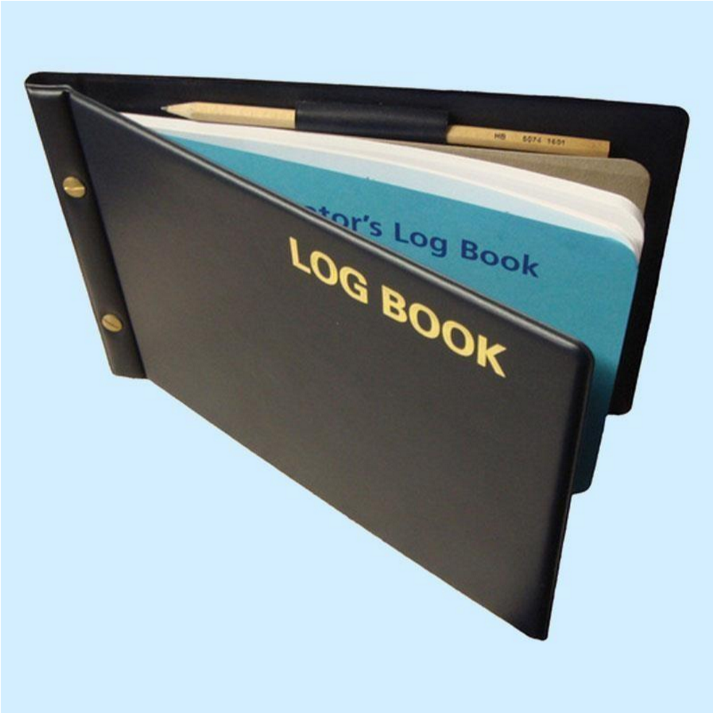
ENROLMENT DETAILS

Program of Admission

Session

Registration / Training Number

Name of Candidate

Father’s Name

Date of Birth / / CNIC No.

Present Address

Permanent Address

E-mail Address

Cell Phone

Date of Start of Training

Date of Completion of Training

Name of Supervisor

Designation of Supervisor

Qualification of Supervisor

Title of department / Unit

Name of Training Institute / Hospital
INTRODUCTION OF LOGBOOK:
A structured book in which certain types of educational activities and patient related information are recorded, usually by hand. Logbooks are used all over the world from undergraduate to postgraduate training, in human, veterinary and dental medicine, nursing schools and pharmacy, either in paper or electronic format.
Logbooks provide a clear setting of learning objectives and give trainees and clinical teachers a quick overview of the requirements of training and an idea of the learning progress. Logbooks are especially useful if different sites are involved in the training to set a (minimum) standard of training. Logbooks assist supervisors and trainees to see at one glance which learning objectives have not yet been accomplished and to set a learning plan. The analysis of logbooks can reveal weak points of training and can evaluate whether trainees have fulfilled the minimum requirements of training.
Logbooks facilitate communication between the trainee and clinical teacher. Logbooks help to structure and standardize learning in clinical settings. In contrast to portfolios, which focus on students’ documentation and self- reflection of their learning activities, logbooks set clear learning objectives and help to structure the learning process in clinical settings and to ease communication between trainee and clinical teacher. To implement logbooks in clinical training successfully, logbooks have to be an integrated part of the curriculum and the daily routine on the ward. Continuous measures of quality management are necessary.

Reference

Brauns KS,Narciss E, Schneyinck C, Böhme K, Brüstle P, Holzmann UM, etal. Twelve tips for successfully implementing logbooks in clinical training. Med Teach. 2016 Jun 2; 38(6): 564–569.

Name of Training Institute / Hospital

Sr. No Discipline
1. General Paediatrics
2. Emergency Paediatrics
3. Paediatric Intensive Care Unit (PICU)
4. Neonatal Intensive Care Unit
5. Paediatric Cardiology
6. Endocrinology
7. Paediatric Neurology
8. Infectious diseases
9. Paediatric Nephrology
10. Pulmonary and Critical Care Paediatrics
11. Gastroenterology & Diarrheal diseases
12. Dermatology
13. Paediatric Psychiatry
14. Radiology
15. Paediatric Hematology and Paediatric Oncology
16. Paediatric Rheumatology
17. Growth, Development and Nutrition
18. Ambulatory Paediatrics

MINIMUM LOG BOOK ENTERIES PER MONTH IN GENERAL

(This minimum number is being provided for uniformity of the training and convenience for monitoring of the resident’s performance by Quality Assurance Cell & University Research Training & Monitoring Cell of RMU but resident is encouraged to show performance above this minimum required number)

Serial number | Entry | Minimum cases/time duration
1. | Case presentation, topic presentation, journal club, mortality discussion | 15/ month  (at least 1/month each)
2. | CPC | 1/month during final year MBBS session
3. | Procedure documentation | 6-10/ month
4. | Indoor patient documentation | 15/ month
5. | Emergency documentation cases | 50/month  25/month in 2 month rotation  12/month in 1 month rotation
6. | OPD case documentation

Levels of supervision:

For all procedural skills, a trainee will be primarily evaluated to determine how much supervision s/he needs for a specified Entrustable Professional Activity, designated by four levels of supervision.
The following Entrustment Scale will be used to assess resident performance on an EPA:

- Observer Status: Not allowed to practice - Clinician in an observer role (1)
- Assistant Status: Direct active - full supervision by senior clinician, with prompting or verbal and actual guidance and help throughout (2)
- Performed under supervision: Indirect active - partial supervision by senior clinician, no prompting or help provided, direct line of vision or supervisor immediately available (3)
- Performed independently: Passive - full entrustment to carry out completely, no direct support provided (4)

LOGBOOK ENTRIES DISTRIBUTION FOR RESIDENTS OF MD PEDIATRICS PROGRAM
Topic | First Year | Second Year | Third Year | Forth Year
Neonatology | 150 | 120 | 80 | 50
Pediatric Emergency/ Critical Care | 150 | 120 | 80 | 50
Preventive Pediatrics/ Nutrition | 100 | 50 | 25 | 10
Infectious Diseases | 100 | 100 | 100 | 100
Gastroenterology | 40 | 50 | 60 | 70
Cardiology | 40 | 50 | 60 | 70
Nephrology | 30 | 50 | 60 | 70
Neurology | 40 | 50 | 60 | 70
Hematology/ Oncology | 25 | 40 | 50 | 60
Pulmonology | 30 | 40 | 50 | 60
Endocrinology | 15 | 30 | 40 | 40
Immunology/ Rheumatology/ Bone Disease | 10 | 20 | 30 | 40
Developmental/ Genetics/ Metabolic | 10 | 20 | 40 | 40
Dermatology/ Psychiatry | 10 | 10 | 15 | 20
Total | 750 | 750 | 750 | 750

LOGBOOK ENTRIES MAP- MD MEDICINE RESIDENTS
Table 1: Residency years 1 (PGY-1) & 2 (PGY-2):

No. of Procedures | PGY-1 | Level | PGY-2 | Level
Pleural Aspiration | 15 | 1,2 | 15 | 2,3
Peritoneal Aspiration | 15 | 1,2 | 15 | 2,3
Lumbar Puncture | 5 | 1,2 | 5 | 2,3
Nasogastric Intubation | 15 | 1,2 | 14 | 3,4
Urethral Catheterization | 15 | 1,2 | 14 | 3,4
Reading and Reporting ECG | 15 | 1,2 | 15 | 3,4
Endotracheal Intubation | 15 | 1,2 | 15 | 3,4
Cardiopulmonary Resuscitation (CPR) | 15 | 1,2 | 15 | 3,4
Arterial Puncture | 10 | 1,2 | 10 | 3,4
Joint Aspiration | - | - | 1 | 1,2
Bone Marrow Aspiration | - | - | 1 | 1
Abdominal Ultrasound | 5 | 1 | 5 | 1,2
CT for Head/ Thorax/Abdomen | 5 | 1,2 | 5 | 2,3
Total | 130 |  | 130

Table 2: Residency Years 3 (PGY-3) and 4 (PGY-4):

Procedures | 3RD YEAR | Level | 4TH YEAR | Level
Pleural Aspiration | 15 | 3,4 | 15 | 4
Peritoneal Aspiration | 15 | 3,4 | 15 | 4
Lumbar Puncture | 6 | 3,4 | 6 | 4
Nasogastric Intubation | 12 | 4 | 12 | 4
Urethral Catheterization | 12 | 4 | 12 | 4
Reading and Reporting ECG | 15 | 3,4 | 15 | 4
Endotracheal Intubation | 15 | 3,4 | 15 | 4
Cardiopulmonary Resuscitation (CPR) | 15 | 3,4 | 15 | 4
Arterial Puncture | 10 | 3,4 | 10 | 4
Joint Aspiration | 2 | 1,2 | 2 | 2,3,4
Bone Marrow Aspiration | 2 | 1,2 | 2 | 2,3,4
Abdominal Ultrasound | 5 | 2,3 | 5 | 3,4
CT for Head/ Thorax/Abdomen | 6 | 2,3 | 6 | 3,4
Total | 130 |  | 130

LOGBOOK ENTRIES (ROTATIONS)
Procedures | 10/month
Emergency cases | 12/month
OPD cases | 12/month
Indoor cases | 15/month

INTENSIVE CARE (2 months):

Procedure | Total Number |  | Level
Insertion of CVP line | 6 |  | 3,4
Mechanical ventilation | 7 |  | 3,4
Blood gases interpretation | 7 |  | 4
Total |  | 20
Indoor cases |  | 30

CARDIOLOGY (2 months):

Procedure | Total Number |  | Level
Management of arrhythmias - Drug  / Defibrillation | 7 |  | 3,4
ECG recordings & reporting | 8 |  | 4
Echocardiography | 4 |  | 1,2
Pericardiocentesis | 1 |  | 1,2
Total |  | 20
Emergency cases |  | 25
OPD cases |  | 25
Indoor cases |  | 30

NEPHROLOGY (2months):
Procedure | Total Number |  | Level
Haemodialysis | 8 |  | 1,2
Renal Biopsy | 4 |  | 3,4
Insertion of double lumen catheter | 8 |  | 1,2
Total |  | 20
OPD cases |  | 25
Indoor cases |  | 30

GASTROENTEROLOGY (2 months):

Procedure | Total Number |  | Level
Liver Biopsy | 6 |  | 1,2
Upper GI Endoscopy | 8 |  | 1,2
Colonoscopy / Sigmoidoscopy | 6 |  | 1,2
Total |  | 20
OPD cases |  | 25
Indoor cases |  | 30

NEUROLOGY (1 month):
Procedure

Total Number

Level

EEG

2

1
,
2

EMG/NCS

2

2
,
1

MRI Brain and Spine

6

2
,
3

,

Total

10

OPD cases

12

Indoor cases

15

PULMONOLOGY (1 month):
Procedure | Total Number |  | Level
Pleural Tap | 2 |  | 3,4
Chest intubation | 3 |  | 1.2
Bronchoscopy | 2 |  | 1,2
Lung function test | 3 |  | 1,2,3
Total |  | 10
OPD cases |  | 12
Indoor cases |  | 15

DERMATOLOGY (1 month):

Procedure | Total Number |  | Level
Skin biopsy | 2 |  | 1
Electrocautery | 2 |  | 1
CO2 laser | 2 |  | 1
Intralesional injection | 2 |  | 1
Phototherapy | 1 |  | 1
Cryotherapy | 1 |  | 1
TOTAL |  | 10
OPD cases |  | 12
Indoor cases |  | 15

PSYCHIATRY (2 weeks):

Procedure | Total Number |  | Level
Psychotherapy Sessions | 3 |  | 1
Electro convulsive therapy (ECT) | 2 |  | 1
Total |  | 5
OPD cases |  | 6
Indoor cases |  | 7

RADIOLOGY (2 weeks):
Procedure | Total Number |  | Level
Doppler Ultrasound of Limbs and Neck | 4 |  | 1,2
CT/MRI studies | 4 |  | 1,2
Contrast studies | 2 |  | 1,2
Total |  | 10
Emergency cases |  | 6
OPD cases |  | 6

Assessment tools for EPAs:
Multiple assessment tools will be used at regular intervals during the residency program to indicate progression toward unsupervised practice, suitability for entrustment decisions and to provide feedback to residents.
- Multisource feedback proformas
- Logbooks and e-portfolios
- Workplace-based assessments ( Mini-CEX, case-based discussions, DOPS)

References:
- Ten Cate, O., Chen, H. C., Hoff, R. G., Peters, H., Bok, H., & van der Schaaf, M. (2015). Curriculum development for the workplace using Entrustable Professional Activities (EPAs): AMEE Guide No. 99. Medical Teacher, 37(11), 983–1002.
https://doi.org/10.3109/0142159X.2015.1060308
- Milestones, EPAs, and NAS - AAIM. (2023). 2023 Alliance for Academic Pediatric Medicine. Retrieved June 24, 2024, from https://www.im.org/resources/ume-gme-program-resources/milestones/end-epas
- Taylor, D. R., Park, Y. S., Smith, C. A., Karpinski, J., Coke, W., & Tekian, A. (2018).
Creating entrustable professional activities to assess Pediatric Medicine residents in training. Annals of Pediatric Medicine, 168(10), 724.
https://doi.org/10.7326/m17-1680

INDEX OF LOG BOOK
- MORNING REPORT PRESENTATION/CASE PRESENTATION (LONG AND SHORT CASES)
- TOPIC PRESENTATION/SEMINAR
- DIDACTIC LECTURES/INTERACTIVE LECTURES
- JOURNAL CLUB
- PROBLEM CASE DISCUSSION
- EMERGENCY CASES
- INDOOR PATIENTS
- OPD AND CLINICS
- PROCEDURES (OBSERVED, ASSISTED,PERFORMED UNDER SUPERVISION &PERFORMED INDEPENDENTLY)
- MULTIDISCIPLINARY MEETINGS
- CLINICOPATHOLOGICAL CONFERENCE
- MORBIDITY/MORTALITY MEETINGS
- HANDS-ON TRAINING/WORKSHOPS
- PUBLICATIONS
- MAJOR RESEARCH PROJECT DURING MD TRAINING/ANY OTHER MAJOR RESEARCH PROJECT
- WRITTEN ASSESSMENT RECORD
- CLINICAL ASSESSMENT RECORD
- EVALUATION RECORD

SECTION-1
MORNING REPORT PRESENTATION/ CASE PRESENTATION (LONG AND SHORT CASES)

SR# | DATE | REG# OF PATIENT | DIAGNOSIS & BRIEF DESCRIPTION | Level of supervision (1 to 4) | SIGNATURES OF THE SUPERVISOR

SECTION-2
TOPIC PRESENTATION/SEMINAR
 | SR# | DATE | NAME OF THE TOPIC & BRIEF DETAILS  OF THE ASPECTS COVERED |  | Level of supervision (1 to 4) | SIGNATURES OF THE SUPERVISOR
SECTION-3
JOURNAL CLUB

SR# | DATE | TITLE OF THE ARTICLE | NAME OF JOURNAL | DATE OF PUBLICATION | SIGNATURES  OF THE  SUPERVISOR
SECTION-4

PROBLEM CASE DISCUSSION
SR # | DATE | REG.# OF THE  PATIENT  DISCUSSED | DIAGNOSIS | BRIEF  DESCRIPTION  OF THE CASE | Level of supervision (1 to 4) | SIGNATURES OF THE SUPERVISOR
SECTION-5
DIDACTIC LECTURE/INTERACTIVE LECTURES

 | SR # | DATE |  | TOPIC & BRIEF DESCRIPTION | NAME OF THE TEACHER | SIGNATURES OF THE SUPERVISOR
SECTION-6
RECORD OF TOTAL EMERGENCY CASES SEEN ON EMERGENCY CALL DAYS

 | SR.# | DATE |  | TOTAL NUMBER OF CASES ATTENDED | Level of supervision (1 to 4) | SIGNATURES OF THE SUPERVISOR
 | 1
 | 2
 | 3
 | 4
 | 5
 | 6
 | 7
 | 9
 | 10
 | 11
 | 12
 | 13
 | 14
 | 15
 | 16
 | 17
 | 18
 | 19
 | 20
 | 21
 | 22
 | 23
 | 24
 | 25
 | 26
 | 27
SECTION-6
EMERGENCY CASES (repetition of cases should be avoided)

 | SR# | DATE | REG # OF THE PATIENT |  | DIAGNOSIS | MANAGE MENT | PROCEDURES PERFORMED | Level of supervision (1 to 4) | SIGNATURES OF THE SUPERVISOR
SECTION-7
RECORD OF TOTAL INDOOR CASES SEEN ON CALL DAYS IN THE WARD

 | SR.# | DATE |  | TOTAL NUMBER OF CASES ATTENDED | Level of supervision (1 to 4) | SIGNATURES OF THE SUPERVISOR
 | 1
 | 2
 | 3
 | 4
 | 5
 | 6
 | 7
 | 9
 | 10
 | 11
 | 12
 | 13
 | 14
 | 15
 | 16
 | 17
 | 18
 | 19
 | 20
 | 21
 | 22
 | 23
 | 24
 | 25
 | 26
 | 27
 | 28
SECTION-7
INDOOR PATIENTS (repetition of cases should be avoided)

 | SR# | DATE | REG # OF  THE  PATIENT |  | DIAGNOSIS | MANAGEMENT | PROCE  DURES  PERFO  RMED | Level of supervision (1 to 4) | SIGNATURES  OF THE  SUPERVISOR
SECTION-8
RECORD OF TOTAL OPD/CLINIC CASES SEEN ON OPD CALL DAYS

SR.# | DATE | TOTAL NUMBER OF CASES ATTENDED | Level of supervision (1 to 4) | SIGNATURES OF THE SUPERVISOR
1
2
3
4
5
6
7
9
10
11
12
13
14
15
16
17
18
19
20
21
22
23
24
25
26
27

SECTION-9

OPD AND CLINICS (repetition of cases should be avoided)

SR# | DATE | REG # OF THE PATIENT | DIAGNOSIS | MANAGEMENT | Level of supervision (1 to 4) | SIGNATURES  OF THE  SUPERVISOR

SECTION-10
PROCEDURES

SR.# | DATE | REG NO. OF PATIENT | NAME OF PROCEDURE | Level of supervision (1 to 4) | PLACE OF PROCEDURE | SIGNATURES OF THE SUPERVISOR

SECTION-11
MULTI DICIPLINARY MEETINGS

 | SR# | DATE |  | BRIEF DESCRIPTION | SIGNATURES OF THE SUPERVISOR
SECTION-12
CLINICOPATHOLOGICAL CONFERENCE (CPC)

SR# | DATE | BRIEF DESCRIPTION OF THE TOPIC/CASE DISCUSSED | SIGNATURES OF THE SUPERVISOR

MORBIDITY/MORTALITY MEETINGS

SR# | DATE | REG. # OF THE  PATIENT DISCUSSED | BRIEF DESCRIPTION | COMMENTS/SUGGESTIONS | SIGNATURES OF THE SUPERVISOR

SECTION-14
HANDS ON TRAINING/WORKSHOPS

SR# | DATE | TITLE | VENUE | FACILITATOR | SIGNATURES OF THE SUPERVISOR

PUBLICATIONS

SNO. | NAME OF  PUBLICATION | TYPE OF PUBLICATION  ORIGINAL  ARTICLE/EDITORIAL/CASE  REPORT ETC | NAME OF JOURANL | DATE OF  PUBLICATION | PAGE NO. | SIGNATURES  OF THE  SUPERVISOR

SECTION-16
MAJOR RESEARCH PROJECT DURING MD TRAINING/ANY OTHER MAJOR RESEARCH PROJECT

SNO. | RESEARCH TOPIC | PLACE OF RESEARCH | NAME AND DESIGNATION  OF SUPERVISOR OTHER  THAN MD SUPERVISOR  UNDER WHOM RESEARCH  WAS CONDUCTED | BRIEF DETAILS | SIGNATURES OF THE SUPERVISOR

WRITTEN ASSESSMENT RECORD

 | SNO | TOPIC OF WRITTEN TEST/EXAMINATION |  | TYPE OF THE TEST  MCQS OR SEQS OR BOTH | TOTAL MARKS | MARKS OBTAINED | SIGNATURES OF THE SUPERVISOR
SECTION-18
CLINICAL ASSESSMENT RECORD

SR.# | TOPIC OF CLINICAL TEST/ EXAMINATION | TYPE OF THE TEST&  VENUE  OSPE, MINICEX, CHART  STIMULATED RECALL, DOPS, SIMULATED PATIENT, SKILL LAB  e.t.c | TOTAL MARKS | MARKS  OBTAINED | SIGNATURES OF THE SUPERVISOR

SECTION-19

EVALUATION RECORDS
(Photocopy of the consolidated evaluation record at the end of each block should be pasted here)
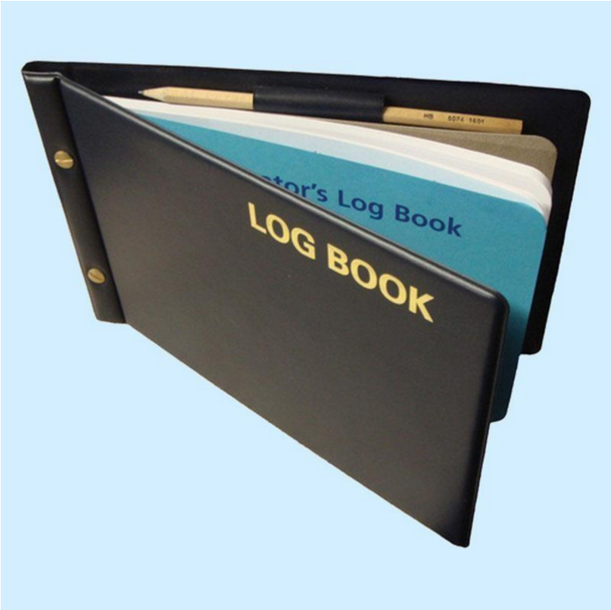
Log book of Research (Templates)

LOG BOOK OF RESEARCH

RAWALPINDI MEDICAL UNIVERSITY
RAWALPINDI

ENROLMENT DETAILS

Program of Admission

Session

Registration / Training Number

Name of Candidate

Father’s Name
/

/

CNIC

No.

Date of Birth

Present Address

Permanent Address

E-mail Address

Cell Phone

Date of Start of Training

Date of Completion of Training

Name of Supervisor

Designation of Supervisor

Qualification of Supervisor

Title of department / Unit

MOTO OF RAWALPINDI MEDICAL UNIVERSITY

Truth Wisdom & Service

MISSION STATEMENT

- To impart evidence based research oriented medical education.
- To provide best possible patient care.
- To inculcate the values of mutual respect and ethical practice of medicine.
- Highly recognized and accredited centre of excellence in Medical Education, using evidence-based training techniques for development of highly competent health professionals.

LOG OF RESEARCH ELECTIVE (RESEARCH ELECTIVE WOULD BE TAUGHT 08:00 AM TO 02:00 PM & RESIDENT WOULD PERFORM
THE DUTY OF EVENING CALLS AS PER ROTA). If required

Pediatric Medicine residents' outlook in research can be significantly improved using a research curriculum offered through a structured and dedicated research rotation. This is exemplified by the improvement noted in resident satisfaction, their participation in scholarly activities and resident research outcomes since the inception of the research rotation in our Pediatric Medicine training program. Residents' research lead to better clinical care, correlates with the pursuit of academic careers, increases numbers of clinician investigators, and is an asset to those applying for fellowships. We report our success in designing and implementing a “Structured Research Curriculum” incorporating basic principles within a research rotation to enhance participation and outcomes of our residents in scholarly activities within a busy residency training program setting.
REFERENCE:
https://bmcmededuc.biomedcentral.com/articles/10.1186/1472-6920-6-52
ROTATION CURRICULUM OF MD MEDICINE FOR RESEARCH

ORGANIZATIONAL STRUCTURE OF RESEARCH AT RAWALPINDI MEDICAL UNIVERSITY

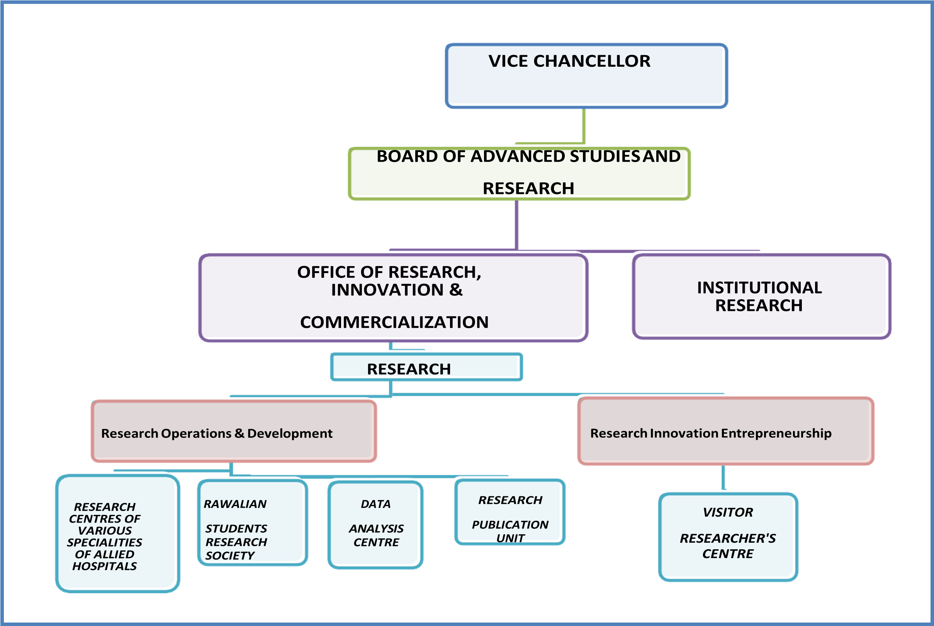

BASELINE PERFORMA TO BE FILLED IN BY RESIDENTS BEFORE ORIENTATION SESSION: RAWALPINDI MEDICAL UNIVERSITY
1.

Name of

Traine
e:

2.

Gender:

Male:

Female:

3.

Specialty:

4.

Unit/Department:

5.

Hospital:

6.

Date Of Commencement of

Training:

7.

Anticipated year of

Training:

- Registration No:
- Name of Supervisor:
- A. Have you ever attended any research methodology workshop/course/training: YES: NO:
- B If yes, please enters the details of the course/workshop (mention the last 5 workshops/courses in case of exceeding 5, starting from the latest as SR #1
SR # | Date/Month and year of training course/workshop | Title of training course/workshop | Organizing institution/company. | Duration of course in days | What was the main content/learning outcome of the research course?
1.
2.
3.
4.
5.

- A. Have you ever attended any workshop or course regarding synopsis development or research proposaldevelopment:
YES: NO:
- B. If yes please mention details of the course/workshop (mention the last 3 workshops/courses in case of exceeding 3, starting from the latest as SR # 01):

SR # | Date/Month and year of training course/workshop | Title of training course/workshop | Organizing institution/company. | Duration of course in days | What was the main content/learning outcome of the research course?
1.
2.
3.

11: C: Do you consider yourself proficient/skilled enough to write a research proposal independently with appropriatemethodology:
YES: NO: UNCERTAIN:

- A. Have you ever formulated a research proposal previously? Yes
B. If yes please mention the details of the synopsis/proposals developed by you (mention the last 3 synopsis/proposals in case of exceeding 3, starting from the latest as SR # 01):
SR # | Date/Month and year of formulating proposal | Title of Proposal | Did you formulate as a pre- requisite to any degree or funding? Please mention its purpose and | Was the proposal submitted anywhere for approval/acceptance? If yes, where? And was it approved or modified or accepted? | Did you pursue that synopsis and completed the research? Yes /No. Please mention reason for not completing the research after development of synopsis if answer is no.
1.
2.
3.

A. Have you ever written a research paper/manuscript previously: YES: NO:
13. B. If yes please mention the last five manuscripts in case of exceeding 5, startingfrom the latest as Sr # 1):

Sr # | Date/Month and year of formulating the manuscript/paper | Title of Paper | Was it an original article/short communication/case study/systematic review/meta analysis/editorial/any other academic writing in a journal? Please specify | Was the manuscript ever submitted any publication?  Yes or No.  If No give reason please. If yes to which journal/s and was it approved for publication or rejected? | If published please specify title of journal and edition and year of publication.
1.
2.
3.
4.
5.
14: Have you ever been involved in any of the following research activities during last 2 years? (Please tick in the appropriate boxes):

- Review of Medical literature
- Write up of literature review

- Vancouver/Harvard referencing

- Used any Plagiarism detection tool

- Formulated research methodology of a research project/synopsis

- Formulated any data collection tool/Performa /checklist/questionnaire for research project
- Collected data through Performa’s/interviews/observations/scales/Focus Group Discussions etc.

- Entered data in any computer based software e.g. SPSS, Epi-info, Microsoft Excel etc.
If yes mention name of soft ware:

- Analyzed quantitative or qualitative data in any computer based software

- Write up of results of study with formulation of tables or graphs

- Write up of discussion of a paper

- Ever submitted a manuscript to any journal

Title of research assigned to you by your supervisor you’re your MD/MS programme:

14. Please mention which of the following activities you already have performed regarding your research project/THESIS as requisite to MD/MS programme: (Please tick in the appropriate boxes):

a)

Topic selection

b)

Review of

literature

c)

Write up of literature

review

a)

Vancouver/Harvard

referencing

b)

Checked Plagiarism through detection

tool

c)

Formulated research methodology of a research

project/synopsis

- Formulated any data collection tool/Performa /checklist/questionnaire for your research
- Collected data through data collection tools/scales
- Entered data in any computer based software (e.g. SPSS, Epi info, Microsoft Excel etc.)
- Analyzed data in any computer based software
- Have formulated results of study with tables or graphs
- Formulated discussion of THESIS
- Written conclusion and abstract of your THESIS

- Submitted your THESIS to your supervisor

15. What are your expectations from this research course/module of MS/MD programme and any specific areas of training you want to be paid special
emphasis by the trainers:?

Thank you

Date of filling the

Performa:

Signatures of the

resident:

Signatures of the Director of ORIC, RMU: .
RESEARCH COURSE OF FIRST TRAINING YEAR-Y1

ACTIVITIES

ASSESSMENTS

2
RESEARCH
WORKSHOPS:

1.

BASIC

METHODOLOGY

2.

CLINICAL AUDIT

COURSE

QUANTITATIVE &
QUALITATIVE ASSESSMENT
OF INDIVIDUAL & GROUP
ASSIGNMENTS

RESEARCH
TRAINING
YEAR
ONE

R
-
Y1

PARTICIPATION IN AT
LEAST 5 JOURNAL CLUB
SESSIONS

OBSERVATION OF 2 IREF
MEETINGS

UNDERTAKING 1 CLINICAL
AUDIT

NOMINATION AND
SELECTION OF
SUPERVISOR

NO PRESENTATION
OR
ASSESSMENT IN

R1

NO PRESENTATION
OR
ASSESSMENT IN

R1

QUALITATIVE
ASSESSMENT

ONE WEEK ROTATION AT ORIC

3 DAYS -BASIC RESEARCH METHODOLOGY WORKSHOP DAY 1 OF WORKSHOP:

SECTION- 1
Date &Venue:

Modules of  Day 1 of  Workshop | TITLE OF MODULES OF DAY 1 | NAMES AND  SIGNATURES OF  FACILITATORS OF EACH  MODULE | FACILITATOR’S FEEDBACK REGARDING COMPLETION  AND PERFORMANCE OF RESIDENT IN ON SPOT  INDIVIDUAL OR GROUP ASSIGNMENTS OF THE  COURSE MODULE | SIGNATURE OF DIRECTOR  OF ORIC  (NAME/STAMP)
Module 1 | Introduction to health systems research  Identifying and Prioritizing  Research Problems
Module 2 | Analysis and statement of problem & Introduction to Literature review
Module 3 | Literature review  Referencing systems; Vancouver & Harvard referencing systems
Module 4 | Literature review  Referencing managing systems
Module 5 | Plagiarism
Module 6 | Formulation of research objectives
Module 7 | Formulation of Hypothesis for a research
Module 8 | Research methodology; Variables and Indicators
DAY 2 OF BASIC RESEARCH METHODOLOGY WORKSHOP:
Date &Venue:

Modules of Day 2 of Workshop | TITLE OF MODULES OF DAY 2 | NAMES AND SIGNATURES OF FACILITATORS OF EACH  MODULE | FACILITATOR’S FEEDBACK REGARDING COMPLETION AND PERFORMANCE OF RESIDENT IN ON SPOT INDIVIDUAL OR  GROUP ASSIGNMENTS OF THE COURSE MODULE | SIGNATURE OF  DIRECTOR OF ORIC  (NAME/STAMP)
Module 1 | Research methodology; Study types
Module 2 | Data collection techniques
Module 3 | Data collection tools
Module 4 | Sampling
Module 5 | Plan for Data Entry , storage and Statistical  Analysis
DAY 3 OF BASIC RESEARCH METHODOLOGY WORKSHOP:
Date &Venue:
 | Modules of Day 3 of Workshop | TITLE OF MODULES OF DAY 3 |  | NAMES AND SIGNATURES OF FACILITATORS OF EACH  MODULE | FACILITATOR’S FEEDBACK REGARDING COMPLETION AND PERFORMANCE OF RESIDENT IN ON SPOT INDIVIDUAL OR  GROUP ASSIGNMENTS OF THE COURSE MODULE | SIGNATURE OF  DIRECTOR OF ORIC  (NAME/STAMP)
 | Module 1 | Pilot and project planning
 | Module 2 | Budgeting for a study
 | Module 3 | Project administration
 | Module 4 | Plan for dissemination
 | Module 5 | Research ethics & concepts of protection of human study subjects
 | Module 6 | Differences between original articles, short communication, case reports, systematic reviews and meta- analysis
 | Module 7 | Writing a Case report
 | Module 8 | Critical Appraisal of a research paper
 | Module 9 | Making effective power-point presentations of a Research Project
 | Module 10 | Making effective poster presentations
SECTION- 2
INDIVIDUAL AND GROUP (HOME TASK) ASSIGNMENTS OF THE RESIDENTS REGARDING BASIC RESEARCH METHODOLOGY WORKSHOP

ASSIGNM  ENT’S  NUMBER | TITLE | DATE OF  SUBMISSION: | ORIGINALITY SCORE OF  ASSIGNMENT IN TURN-  IT–IN PLAGIARISM  DETECTION SOFT WARE | FACILITATOR’S REFLECTION ON  CORRECTNESS, COMPLETION AND  QUALITY OF INDIVIDUAL OR GROUP  ASSIGNMENTS OF THE WORKSHOP | SCORES  ATTAINED OUT  OF TOTAL  ATTAINABLE  SCORE | SIGNATURE OF  FACILITATORS | SIGNATURE OF  DIRECTOR OF  ORIC  (NAME/STAMP)

SECTION- 3
ONE DAY – WORKSHOP ON UNDERTAKING CLINICAL AUDIT
Date &Venue:
 | Modules of Day 1 of Workshop | TITLE OF MODULES OF DAY 1 |  | NAMES AND SIGNATURES OF FACILITATORS OF EACH  MODULE | FACILITATOR’S FEEDBACK REGARDING COMPLETION AND PERFORMANCE OF RESIDENT IN ON SPOT INDIVIDUAL OR  GROUP ASSIGNMENTS OF THE COURSE MODULE | SIGNATURE OF  DIRECTOR OF ORIC  (NAME/STAMP)
 | Module 1 | Introduction to a clinical audit and its  importance
 | Module 2 | Types of Clinical Audit
 | Module 3 | Process and steps of Clinical Audit
 | Module 4 | Methodology of Clinical Audit
 | Module 5 | Data Analysis of a Clinical Audit
 | Module 6 | Clinical Audit Report Writing
 | Module 7 | Dissemination of the report
SECTION- 4
JOURNAL CLUB MEETINGS ATTENDED BY RESIDENT AS AN OBSERVER DURING YR 1
 | JOURNAL  CLUB  MEETING # | DATE |  | TITLES OF THE ARTICLES  PRESENTED IN THE JOURNAL  CLUB MEETING | TITLE OF JOURNAL/ YEAR OF PUBLICATION | ANY QUESTION OR  COMMENT MADE ON THE  PRESENTATION BY THE  OBSERVER | SUPERVISOR’S SIGNATURE | HEAD OF DEPARTMENT’S  SIGNATURE  (NAME/STAMP)
 | 1. |  |  | A. | A. | A.
 |  |  |  | B. | B. | B.
 |  |  |  | C. | C. | C.
 | 2. |  |  | A. | A. | A.
 |  |  |  | B. | B. | B.
 |  |  |  | C. | C. | C.
 | 3. |  |  | A. | A. | A.
 |  |  |  | B. | B. | B.
 |  |  |  | C. | C. | C.
 | 4. |  |  | A. | A. | A.
 |  |  |  | B. | B. | B.
 |  |  |  | C. | C. | C.
 | 5. |  |  | A. | A. | A.
 |  |  |  | B. | B. | B.
 |  |  |  | C. | C. | C.
SECTION- 5
INSTITUTIONAL RESEARCH & ETHICS FORUM MEETINGS ATTENDED BY RESIDENT AS AN OBSERVER DURING YR 1

 | IREF MEETING # | DATE/VENUE |  | TITLES OF THE RESEARCH PROPOSALS PRESENTED IN THE IREF MEETING | ANY QUESTION OR COMMENT MADE ON THE PRESENTATIONS BY THE OBSERVER | SIGNATURE OF THE  CONVENER OF THE MEETING  (NAME/STAMP)
 | 1.
 | 2.
 | 3.
 | 4.
 | 5
SECTION- 6
UNDERTAKING A CLINICAL AUDITS UNDERTAKEN AS A GROUP MEMBER DURING YEAR 1

TITLE OF THE CLINICAL AUDIT | UNIT/DEPARTMENT WHERE  THE AUDIT WAS  CONDUCTED/NAME OF  SUPERVISOR | PERSON WHO CONDUCTED  THE AUDIT AND CONTENT  OF CONTRIBUTION IN THE  CLINICAL AUDIT | DISSEMINATION OF REPORT OF AUDIT:  (A. WAS CLINICAL AUDIT REPORT PUBLISHED AS ANNUAL AUDIT REPORT/IN A RESEARCH JOURNAL?  IF YES, DATE AND YEAR OF PUBLICATION AND NAME OF JOURNAL  B. WAS CLINICAL AUDIT PRESENTED IN CPC OF RMU? IF YES DATE AND VENUE) | SIGNATURE OF THE DEAN (NAME/STAMP)
1.
2.
3.
4.
5

SECTION- 7
RECORD OF FORTNIGHTLY MEETINGS OF THE RESIDENT WITH THE SUPERVISOR

 | Sr # | DATE/VENUE  /DURATION OF  MEETING |  | AGENDA AND OUTLINE OF THE MEETING  (IN TERMS OF CONTENT, DISCUSSION POINTS) | ACTION POINTS AND  SUPERVISOR’S REFLECTIONS | SUPERVISOR’S  SIGNATURE  (NAME/STAMP) | HEAD OF DEPARTMENT’S  SIGNATURE  (NAME/STAMP)
 | 1
 | 2
 | 3
 | 4
 | 5
 | 6
 | 7
SECTION- 8
RECORD OF RESIDENT’S ONE WEEK’S ROTATION AT ORIC

DAY # | DATE | ACTIVITY CARRIED OUT AT ORIC AND THE  RESEARCH ASSOCIATE/ DEPUTY DIRECTOR WHO SUPERVISED THE ACTIVITY | ORIC STAFF MEMBER’S  REFLECTIONS ON THE  PERFORMANCE OF THE ACTIVITY | THE RESEARCH ASSOCIATE/  DEPUTY DIRECTOR SIGNATURE (NAME/STAMP) | DIRECTOR ORIC’S SIGNATURE (NAME/STAMP)
1
2
3
4
5
6
7
8
SECTION- 9
ANY RESEARCH COURSE COURSE/WORKSHOP ATTENDED (ON OWN) BY THE RESIDENT DURING YEAR 1

 | Sr# | DATE/MONTH AND YEAR  OF TRAINING  COURSE/WORKSHOP |  | TITLE OF TRAINING COURSE/WORKSHOP | ORGANIZING  INSTITUTION/COMPANY | DURATION OF COURSE  IN DAYS/MODE OF COURSE (online or physically attended) | THE OBJECTIVES OR LEARNING OUTCOMES OF THE RESEARCH COURSE.
SECTION- 10
RECORD OF LITERATURE REVIEW CONDUCTED BY THE RESIDENT IN YEAR 1

SR # | TITLE OF THE LITERATURE REVIEWED | DATE/MONTH AND YEAR OF PUBLICATION | TITLE OF THE JOURNAL/BOOK | WAS IT AN ORIGINAL ARTICLE/SHORT  COMMUNICATION/CASE STUDY/SYSTEMATIC  REVIEW/META ANALYSIS/EDITORIAL/ANY  OTHER ACADEMIC WRITING (e.g. reports, books, conference papers, THESISs, Research and program reports- published/ unpublished)?PLEASE SPECIFY
1
2
3
4

SECTION-11 RECORD OF ANY MANUSCRIPT/RESEARCH PAPER FORMULATED BY THE RESIDENT IN YEAR 1

SL # | TITLE OF THE MANUSCRIPT | IF SUBMITTED FOR PUBLICATION,  DATE/MONTH AND YEAR OF  PUBLICATION, IF PUBLISHED | TITLE OF THE JOURNAL | WAS IT REVIWED, MODIFIED, ACCEPTED OR REJECTED.  PLEASE SPECIFY | DIRECTOR ORIC’S  SIGNATURE  (NAME/STAMP)
RESEARCH COURSE OF SECOND RESEARCH TRAINING YEAR (R-Y2)
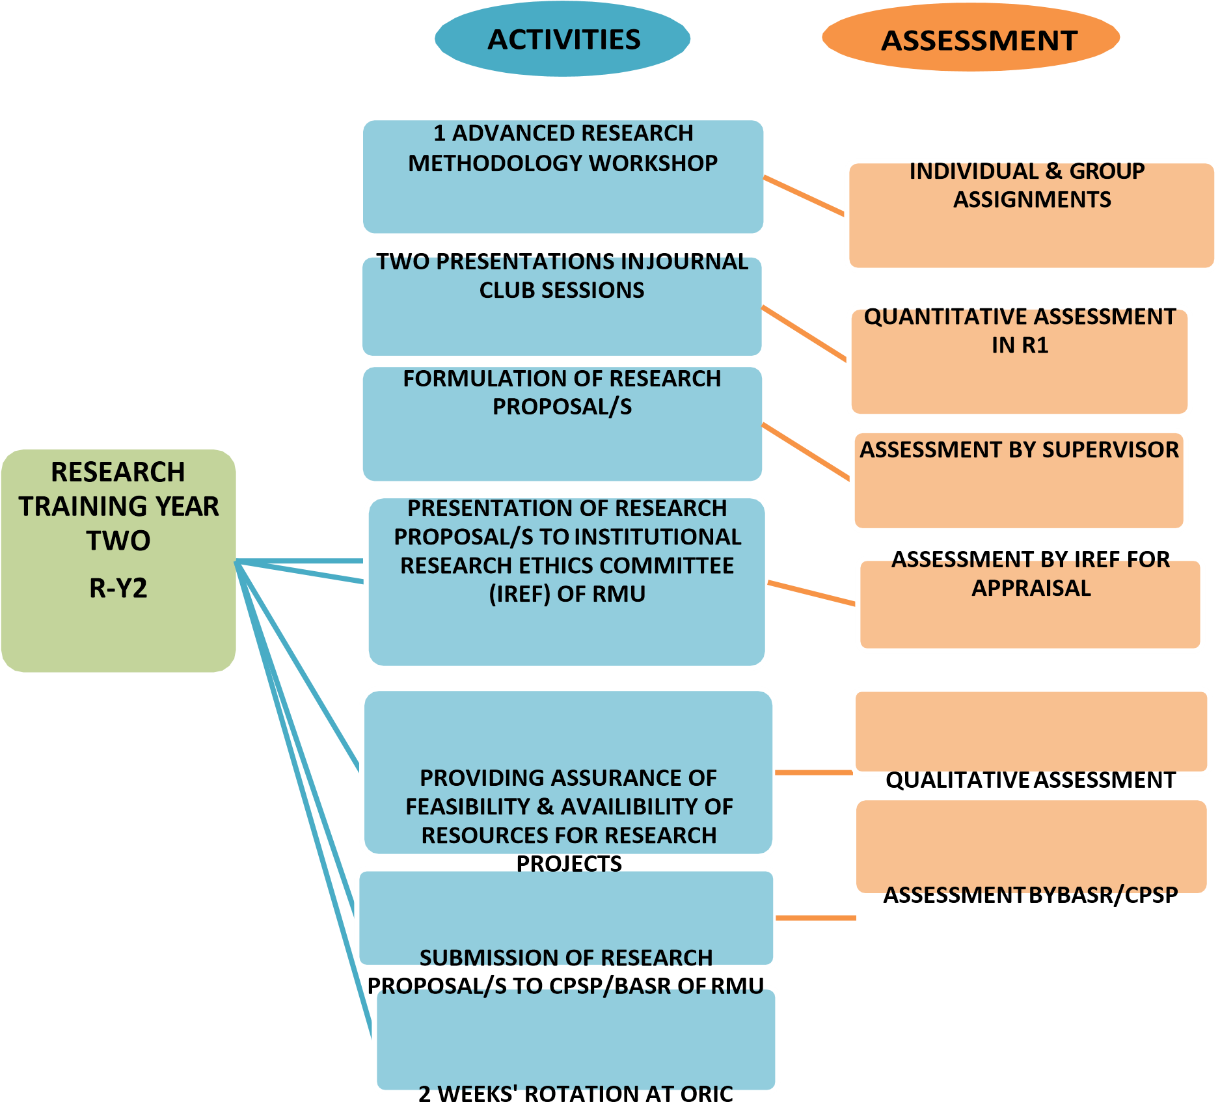
SECTION- 1
- DAYS –ADVANCED RESEARCH METHODOLOGY WORKSHOP DAY 1 OF WORKSHOP:
Date &Venue:
Modules of Day 1 of Workshop | TITLE OF MODULES OF DAY 1 | NAMES AND SIGNATURES OF FACILITATORS OF EACH  MODULE | FACILITATOR’S FEEDBACK REGARDING COMPLETION  AND PERFORMANCE OF RESIDENT IN ON SPOT  INDIVIDUAL OR GROUP ASSIGNMENTS OF THE COURSE MODULE | SIGNATURE OF DIRECTOR OF ORIC  (NAME/STAMP)
Module 1 | - Introduction to Biostatistics  - Description of Variables  Numerical methods of  Data summarization (Manual as well as through Statistical Package of Social Sciences)
Module 2 | Graphical presentation of data
Module 3 | • Cross-tabulation of quantitative data
Module 4 | Measures of Association based on risk
Module 5 | Confounding and methods to control confounding
Module 6 | Basic statistical concepts; Measure of dispersion and confidence Intervals

DAY 2 OF ADVANCED RESEARCH METHODOLOGY WORKSHOP:
Date &Venue:
Modules of Day 2 of Workshop | TITLE OF MODULES OF DAY 2 | NAMES AND SIGNATURES OF FACILITATORS OF EACH  MODULE | FACILITATOR’S FEEDBACK REGARDING COMPLETION AND  PERFORMANCE OF RESIDENT IN ON SPOT INDIVIDUAL OR  GROUP ASSIGNMENTS OF THE COURSE MODULE | SIGNATURE OF  DIRECTOR OF ORIC  (NAME/STAMP)
Module 1 | Hypothesis testing for a research
Module 2 | Tests of Significance
Module 3 | Determining difference between two groups- categorical data Paired & unpaired observations
Module 4 | Determining difference between two groups- numerical data  Paired & unpaired observations
Module 5 | Determining difference between more than two groups- numerical data  ANOVA (Analysis of  Variance)
DAY 3 OF ADVANCED RESEARCH METHODOLOGY WORKSHOP:
Date &Venue:
Modules of Day 3 of Workshop | TITLE OF MODULES OF DAY 3 | NAMES AND SIGNATURES OF FACILITATORS OF EACH  MODULE | FACILITATOR’S FEEDBACK REGARDING COMPLETION AND PERFORMANCE OF RESIDENT IN ON SPOT INDIVIDUAL OR  GROUP ASSIGNMENTS OF THE COURSE MODULE | SIGNATURE OF  DIRECTOR OF ORIC  (NAME/STAMP)
Module 1 | Determining  Correlation between variables
Module 2 | Regression Analysis
Module 3 | Diagnostic Accuracy of a test
Module 4 | Writing a research paper
Module 5 | Writing a THESIS

SECTION- 2
INDIVIDUAL AND GROUP (HOME TASK) ASSIGNMENTS OF THE RESIDENTS 3 REGARDING ADVANCED RESEARCH METHODOLOGY WORKSHOP

 | ASSIGNM  ENT’S  NUMBER | TITLE | DATE OF  SUBMISSION: |  | ORIGINALITY SCORE OF  ASSIGNMENT IN TURN- IT– IN PLAGIARISM DETECTION  SOFT WARE | FACILITATOR’S REFLECTION ON  CORRECTNESS, COMPLETION AND  QUALITY OF INDIVIDUAL OR  GROUP ASSIGNMENTS OF THE  WORKSHOP | SCORES  ATTAINED OUT  OF TOTAL  ATTAINABLE  SCORE | SIGNATURE OF  FACILITATORS | SIGNATURE OF  DIRECTOR OF  ORIC  (NAME/STAMP)
SECTION- 3

- JOURNAL CLUB MEETINGS ATTENDED BY RESIDENT AS AN OBSERVER DURING YR 2

JOURNAL CLUB MEETING # | DATE | TITLES OF THE ARTICLES PRESENTED IN THE  JOURNAL CLUB MEETING | TITLE OF JOURNAL/ YEAR OF PUBLICATION | ANY QUESTION OR  COMMENT MADE ON THE  PRESENTATION BY THE  OBSERVER | SUPERVISOR’S SIGNATURE | HEAD OF DEPARTMENT’S  SIGNATURE  (NAME/STAMP)
1. |  | A. | A. | A.
 |  | B. | B. | B.
 |  | C. | C. | C.
2. |  | A. | A. | A.
 |  | B. | B. | B.
 |  | C. | C. | C.
3. |  | A. | A. | A.
 |  | B. | B. | B.
 |  | C. | C. | C.
4. |  | A. | A. | A.
 |  | B. | B. | B.
 |  | C. | C. | C.
5 |  | A. | A. | A.
 |  | B. | B. | B.
 |  | C. | C. | C.

SECTION- 4
2 JOURNAL CLUB MEETINGS ATTENDED BY RESIDENT AS A PRESENTER DURING YR 2

Journal  Club  Meeting # | Date | Title Of The Article  Presented By Resident In  The Journal Club Meeting | Title Of Journal/ Year Of Publication | Reflection Of Two Senior Faculty Members On The  Presentation | Senior Faculty  Members  Signature | Reflection Of The HOD On  The Presentation And  Scores Given Out Of  Attainable Total Score Of 25 | Head Of  Department’s  Signature  (Name/Stamp)
1.
2.

SIGNATURE OF THE DEAN OF SPECIALITY:

SIGNATURE (NAME/STAMP):
SECTION_- - 5
APPROVAL OF TOPIC OF RESEARCH PROPOSAL/SYNOPSIS FOR THESIS FORMULATED BY RESIDENT DURING YR 2:

TOPIC OF THE RESEARCH PROPOSAL/SYNOPSIS FOR THESIS

APPROVAL OF THE TOPIC:

 | NAME OF THE PERSON APPROVING THE TOPIC OF SYNOPSIS |  | DESIGNATION OF THE PERSON APPROVING THE TOPIC OF SYNOPSIS | SIGNATURES | STAMP/DATE
 |  |  | SUPERVISOR
 |  |  | HEAD OF DEPARTMENT
 |  |  | DEAN OF SPECILAITY
 |  |  | DIRECTOR ORIC
CO- CHAIRPERSON OF THE BOARD
OF ADVANCED STUDIES &
RESEARCH OF RMU
SECTION- 6
COMPLETION OF RESEARCH PROPOSAL/SYNOPSIS FOR THESIS FORMULATED BY RESIDENT DURING YR 2 (TILL MONTH 8 OF YR 2):

TOPIC OF THE RESEARCH PROPOSAL/SYNOPSIS FOR THESIS:

SR # | DATE | ASPECTS OF THE SYNOPSIS/RESEARCH PROPOSAL REVIEWED | REFLECTION OF RESEARCH  ASSOCIATES/DEPUTY  DIRECTOR ORIC ON THE  CONTENT & QUALITY OF  THE PROPOSAL | RESEARCH  ASSOCIATES/DEPUTY  DIRECTOR’S  SIGNATURE | REFLECTION OF THE SUPERVISOR ON  THE CONTENT & QUALITY OF THE  PROPOSAL | SUPERVISOR’S  SIGNATURE  (NAME/STAMP)
1. |  | Introduction and rationale (with Vancouver/Harvard in text citations)
2. |  | Research aim, purpose and objectives
3 |  | Hypothesis, if required according to the study design.
4 |  | Operational Definitions
5A |  | Research Methodology:  Setting
5B |  | Research Methodology: Study Population
5C |  | Research Methodology: Study Duration
5D |  | Research Methodology: Study Design
5E |  | Research Methodology:  j) Sampling: (Sample size with statistical justifications, sampling technique, inclusion criteria & exclusion criteria)
5F |  | Research Methodology:  Data Collection technique/s
5G |  | Research Methodology: Data Collection tool/s
5H |  | Research Methodology: Data Collection procedure
6 |  | Plan for Data entry & Analysis
7 |  | Ethical Considerations
8 |  | Work plan/Gantt chart
9 |  | Budget with justifications
10 |  | Reference list according to the Vancouver referencing style
11 |  | Annexure (including data collection tool or Performa, consent form, official letters, scales, scoring systems and/or any other relevant material)

SECTION- 7
APPROVAL OF RESEARCH PROPOSAL/SYNOPSIS FOR THESIS FORMULATED BY RESIDENT DURING YR 2:

TOPIC OF THE RESEARCH PROPOSAL/SYNOPSIS FOR THESIS:

APPROVAL OF THE SYNOPSIS/PROPOSAL:

DATE ON WHICH  PROPOSAL WAS  PRESENTED | NAME OF THE PERSON APPROVING THE SYNOPSIS | DESIGNATION OF THE PERSON APPROVING THE SYNOPSIS | SIGNATURES | STAMP
 |  | SUPERVISOR
 |  | HEAD OF DEPARTMENT
 |  | DEAN OF SPECILAITY
 |  | DIRECTOR ORIC
CHAIRPERSON OF THE
INSTITUTIONAL RESEARCH AND ETHICS FORUM OF RMU
CO- CHAIRPERSON OF THE
BOARD OF ADVANCED STUDIES & RESEARCH OF RMU

SECTION- 8
RECORD OF FORTNIGHTLY MEETINGS OF THE RESIDENT WITH THE SUPERVISOR IN YEAR 2

SR # | DATE/VENUE  /DURATION OF  MEETING | AGENDA AND OUTLINE OF THE MEETING (IN TERMS OF CONTENT, DISCUSSION POINTS) | ACTION POINTS AND SUPERVISOR’S REFLECTIONS | SUPERVISOR’S  SIGNATURE  (NAME/STAMP) | HEAD OF  DEPARTMENT’S SIGNATURE  (NAME/STAMP)
1
2
3
4
5
6

SECTION- 9
RECORD OF RESIDENT’S TWO WEEK’S ROTATION AT ORIC DURING YR 2

 | DAY # | DATE | ACTIVITY CARRIED OUT AT ORIC AND THE  RESEARCH ASSOCIATE/ DEPUTY DIRECTOR WHO SUPERVISED THE ACTIVITY |  | ORIC STAFF MEMBER’S  REFLECTIONS ON THE  PERFORMANCE OF THE ACTIVITY | THE RESEARCH ASSOCIATE/  DEPUTY DIRECTOR SIGNATURE (NAME/STAMP) | DIRECTOR ORIC’S SIGNATURE (NAME/STAMP)
 | 1
 | 2
 | 3
 | 4
 | 5
 | 6
 | 7
 | 8
SECTION- 10
ANY RESEARCH COURSE/WORKSHOP ATTENDED (ON OWN) BY THE RESIDENT DURING YEAR 2

 | SR # | DATE/MONTH AND YEAR  OF TRAINING  COURSE/WORKSHOP |  | TITLE OF TRAINING COURSE/WORKSHOP | ORGANIZING  INSTITUTION/COMPANY | DURATION OF  COURSE IN  DAYS/MODE OF  COURSE (online or physically attended) | THE OBJECTIVES OR LEARNING OUTCOMES OF THE RESEARCH COURSE.
 | 1.
 | 2.
 | 3.
 | 4.
 | 5.
 | 6
SECTION- 11
RECORD OF LITERATURE REVIEW CONDUCTED BY THE RESIDENT IN YEAR 2

 | SL # | TITLE OF THE LITERATURE REVIEWED |  | DATE/MONTH AND YEAR OF PUBLICATION | TITLE OF THE  JOURNAL/BOOK | WAS IT AN ORIGINAL ARTICLE/SHORT  COMMUNICATION/CASE STUDY/SYSTEMATIC  REVIEW/META ANALYSIS/EDITORIAL/ANY OTHER  ACADEMIC (e.g. reports, books, conference papers, THESISs, Research and program reports- published/ unpublished)? PLEASE SPECIFY
 | 1.
 | 2.
 | 3.
 | 4.
 | 5.
 | 6.
 | 7.
SECTION- 12
RECORD OF ANY MANUSCRIPT/RESEARCH PAPER FORMULATED BY THE RESIDENT IN YEAR 2

SL # | TITLE OF THE MANUSCRIPT | IF SUBMITTED FOR PUBLICATION,  DATE/MONTH AND YEAR OF  PUBLICATION, IF PUBLISHED | TITLE OF THE JOURNAL | WAS IT REVIWED, MODIFIED, ACCEPTED OR REJECTED.  PLEASE SPECIFY | DIRECTOR ORIC’S  SIGNATURE  (NAME/STAMP)
1
2
3
4
5
6
SECTION- 13
OVERALL EVALUATION OF RESEARCH THESIS PROGRAM BY SUPERVISOR
SECTION- 13
OVERALL EVALUATION OF RESEARCH THESIS PROGRAM BY BASR (BOARD OF ADVANCED STUDIES AND RESEARCH)
SECTION- 13
OVERALL EVALUATION OF RESEARCH THESIS PROGRAM BY ORIC (OFFFICE OF RESEARCH INNOVATION AND COMMERCIALIZATION)
SECTION- 13
OVERALL EVALUATION OF RESEARCH THESIS PROGRAM BY DEPARTMENT OF MEDICAL EDUCATION (DME)

RESEARCH COURSE OF THIRD RESEARCH TRAINING YEAR

R-Y3

ACTIVITIE

ASSESSMEN

RESEARCH TRAINING

YEAR

THREE

ATTENDING ATLEAST 5 OF
TOTAL

OFFERED 10 ELECTIVE

PARTICIPATION IN
ATLEAST 5

JOURNAL

CLUB

SESSIONS

DATA COLLECTION, ENTRY
AND

ANALYSIS OF RESEARCH

INDIVIDUAL &

GROUP

INDIVIDUAL

QUALITATIVE
ASSESSMENT

ASSESSMENT BY

SUPERVISOR

&

STATISTICIAN OF
ORIC

INITIATION OF WRITE UP OF

LITERATURE REVIEW FOR
DISSERTATION

WEEK
1
ROTATION AT ORIC

ASSESSMENT
BY

SUPERVISOR AND

PUBLICATION INCHARGE

SECTION- 1
10 ELECTIVE RESEARCH WORKSHOPS TO BE OFFERED DURING YEAR 3

DATE & VENUE  & DURATION OF  WORKSHOP | TITLE OF ELECTIVE  WORKSHOPS ATTENDED | NAMES AND SIGNATURES OF FACILITATORS OF EACH  WORKSHOP | FACILITATOR’S FEEDBACK REGARDING COMPLETION AND PERFORMANCE OF RESIDENT IN ON SPOT INDIVIDUAL OR  GROUP ASSIGNMENTS OF THE COURSE MODULE | SIGNATURE OF  DIRECTOR OF ORIC  (NAME/STAMP)
 | End note referencing manager
 | Mendeley referencing manager
 | Effective write up of Literature review
Data entry in
Statistical Package of
Social Sciences
 | Graphical presentation of data in Microsoft Excel
Univariate, Bivariate and Multivariate analysis in Statistical
Package of Social
Sciences
 | Effectively writing up of a THESIS.
 | Research article write up
 | Critical appraisal of research
 | How to Present Research through power-point or posters

SECTION- 2
INDIVIDUAL AND GROUP (HOME TASK) ASSIGNMENTS OF THE RESIDENTS 3 REGARDING ADVANCED RESEARCH METHODOLOGY WORKSHOP

 | ASSIGN  MENT’S  NUMBER | TITLE OF  WORKSHOP | DATE OF  SUBMISSION: | ORIGINALITY SCORE OF  ASSIGNMENT IN TURN-IT–IN  PLAGIARISM DETECTION SOFT  WARE | FACILITATOR’S REFLECTION ON  CORRECTNESS, COMPLETION  AND QUALITY OF INDIVIDUAL  OR GROUP ASSIGNMENTS OF  THE WORKSHOP | SIGNATURE OF  FACILITATORS | SIGNATURE OF  DIRECTOR OF ORIC  (NAME/STAMP)
SECTION- 3
5 JOURNAL CLUB MEETINGS ATTENDED BY RESIDENT AS AN OBSERVER DURING YR 3

JOURNAL CLUB MEETING # | DATE | TITLES OF THE ARTICLES PRESENTED IN THE  JOURNAL CLUB MEETING | TITLE OF JOURNAL/ YEAR OF PUBLICATION | ANY QUESTION OR  COMMENT MADE ON THE  PRESENTATION BY THE  OBSERVER | SUPERVISOR’S SIGNATURE | HEAD OF DEPARTMENT’S  SIGNATURE  (NAME/STAMP)
1. |  | A. | A. | A.
 |  | B. | B. | B.
 |  | C. | C. | C.
2. |  | A. | A. | A.
 |  | B. | B. | B.
 |  | C. | C. | C.
3. |  | A. | A. | A.
 |  | B. | B. | B.
 |  | C. | C. | C.
4. |  | A. | A. | A.
 |  | B. | B. | B.
 |  | C. | C. | C.
5. |  | A. | A. | A.
 |  | B. | B. | B.
 |  | C. | C. | C.

SECTION- 4
1 JOURNAL CLUB MEETING ATTENDED BY RESIDENT AS AN PRESENTER DURING YR 3

JOURNAL CLUB  MEETING  # | DATE | TITLE OF THE ARTICLE  PRESENTED BY RESIDENT IN  THE JOURNAL CLUB MEETING | TITLE OF JOURNAL/ YEAR OF PUBLICATION | REFLECTION OF TWO  SENIOR FACULTY  MEMBERS ON THE  PRESENTATION | SENIOR FACULTY  MEMBERS  SIGNATURE | REFLECTION OF THE  HOD ON THE  PRESENTATION AND  SCORES GIVEN OUT OF  ATTAINABLE TOTAL  SCORE OF 25 | HEAD OF  DEPARTMENT’S  SIGNATURE  (NAME/STAMP)
1.

SIGNATURE OF THE DEAN OF SPECIALITY:

(NAME/STAMP):
SECTION- 5
CONFIRMATION OF COMPLETENESS OF DATA COLLECTION OF THE OF RESEARCH PROJECT FOR THESIS BY RESIDENT DURING YR 3:

TOPIC OF THE RESEARCH PROPOSAL/SYNOPSIS FOR THESIS:

CONFIRMATION OF COMPLETENESS OF DATACOLLECTION:

NAME OF THE PERSON CONFIRMING | DESIGNATION OF THE PERSON CONFIRMING | SIGNATURES | STAMP/DATE
 | SUPERVISOR
 | HEAD OF DEPARTMENT
 | STATISTICIAN AT ORIC
 | DIRECTOR ORIC

SECTION- 6
RECORD OF FORTNIGHTLY MEETINGS OF THE RESIDENT WITH THE SUPERVISOR IN YEAR 3

SR # | DATE/VENUE  /DURATION OF  MEETING | AGENDA AND OUTLINE OF THE MEETING  (IN TERMS OF CONTENT, DISCUSSION POINTS) | ACTION POINTS AND  SUPERVISOR’S REFLECTIONS | SUPERVISOR’S  SIGNATURE  (NAME/STAMP) | HEAD OF DEPARTMENT’S  SIGNATURE  (NAME/STAMP)
1.
2.
3.
4.
5.
6.
7.
8.

SECTION- 7
RECORD OF RESIDENT’S ONE WEEK’S ROTATION AT ORIC DURING YR 3

 | DAY # | DATE | ACTIVITY CARRIED OUT AT ORIC AND THE  RESEARCH ASSOCIATE/  STATISTICIAN/DEPUTY DIRECTOR WHO  SUPERVISED THE ACTIVITY |  | ORIC STAFF MEMBER’S  REFLECTIONS ON THE  PERFORMANCE OF THE ACTIVITY | THE RESEARCH ASSOCIATE/  DEPUTY DIRECTOR SIGNATURE  (NAME/STAMP) | DIRECTOR ORIC’S SIGNATURE (NAME/STAMP)
 | 1
 | 2
 | 3
 | 4
 | 5
 | 6
 | 7
SECTION- 8
ANY RESEARCH COURSE COURSE/WORKSHOP ATTENDED (ON OWN) BY THE RESIDENT DURING YEAR 3

SL # | DATE/MONTH AND  YEAR OF TRAINING  COURSE/WORKSHOP | TITLE OF TRAINING COURSE/WORKSHOP | ORGANIZING  INSTITUTION/COMPANY | DURATION OF  COURSE IN  DAYS/MODE OF COURSE (online or physically attended) | THE OBJECTIVES OR LEARNING OUTCOMES OF THE RESEARCH COURSE.
1.
2.
3.
4.
5

SECTION- 9
RECORD OF LITERATURE REVIEW CONDUCTED BY THE RESIDENT IN YEAR 3

SR # | TITLE OF THE LITERATURE REVIEWED | DATE/MONTH AND YEAR OF PUBLICATION | TITLE OF THE  JOURNAL/BOOK | WAS IT AN ORIGINAL ARTICLE/SHORT  COMMUNICATION/CASE STUDY/SYSTEMATIC  REVIEW/META ANALYSIS/EDITORIAL/ANY OTHER  ACADEMIC (e.g. reports, books, conference papers, THESISs,  Research and program reports- published/ unpublished)?  PLEASE SPECIFY
1.
2.
3.
4.
5.
6.

SECTION- 10
RECORD OF ANY MANUSCRIPT/RESEARCH PAPER FORMULATED BY THE RESIDENT IN YEAR 3

SR # | TITLE OF THE MANUSCRIPT | IF SUBMITTED FOR PUBLICATION,  DATE/MONTH AND YEAR OF  PUBLICATION, IF PUBLISHED | TITLE OF THE JOURNAL | WAS IT REVIWED, MODIFIED, ACCEPTED OR REJECTED.  PLEASE SPECIFY | DIRECTOR ORIC’S  SIGNATURE  (NAME/STAMP)
1
2
3
4
5
6
SECTION- 11
OVERALL EVALUATION OF RESEARCH THESIS PROGRAM BY SUPERVISOR
SECTION- 11
OVERALL EVALUATION OF RESEARCH THESIS PROGRAM BY BASR (BOARD OF ADVANCED STUDIES AND RESEARCH)
SECTION- 11
OVERALL EVALUATION OF RESEARCH THESIS PROGRAM BY ORIC (OFFFICE OF RESEARCH INNOVATION AND COMMERCIALIZATION)
SECTION- 11
OVERALL EVALUATION OF RESEARCH THESIS PROGRAM BY DEPARTMENT OF MEDICAL EDUCATION (DME)

RESEARCH COURSE OF FOURTH RESEARCH TRAINING YEAR

R-Y4

ACTIVITIES

ASSESSMENT

COMPLETION OF

INTRODUCTION
AND LITERATURE REVIEW OF
DISSERTATION WITHIN FIRST 3
MONTHS OF

R
-
Y4

ASSESSMENT BY
SUPERVISOR &

PUBLICATION
INCHARGE OF

ORIC

RESEARCH
TRAINING
YEAR
FOUR

R
-
Y4

(
A
)

COMPLETION OF DATA ANALYSIS
AND ITS WRITE UP TILL FOURTH
MONTH OF R
-
Y4

COMPLETION

OF

DISSERTATION

AND SUBMISSION TO

SUPERVISOR

& HOD FOR FINAL REVIEW TILL
FIFTH MONTH OF R
-
Y4

FINAL SUBMISSION OF
DISSERTATION TO DEGREE
AWARDING INSTITUTION TILL

SIXTH
MONTH OF

R
-
Y4

PARTICIPATION IN ATLEAST 5
JOURNAL CLUB SESSIONS

ASSESSMENT BY SUPERVISOR
& STATISTICIAN OF ORIC

ASSESSMENT BY
SUPERVISOR, PUBLICATION
INCHARGE OF ORIC AND

HOD

FINAL EVALUATION BY
EXAMINATION BODY

NO QUANTITATIVE
ASSESSMENT

ONE WEEK ROTATION
SECTION- 1
5 JOURNAL CLUB MEETINGS ATTENDED BY RESIDENT AS AN OBSERVER DURING YR 4

 | JOURNAL CLUB MEETING # | DATE |  | TITLES OF THE ARTICLES PRESENTED IN THE  JOURNAL CLUB MEETING | TITLE OF JOURNAL/ YEAR OF PUBLICATION | ANY QUESTION OR  COMMENT MADE ON THE  PRESENTATION BY THE  OBSERVER | SUPERVISOR’S SIGNATURE | HEAD OF DEPARTMENT’S  SIGNATURE  (NAME/STAMP)
 | 1. |  |  | A. | A. | A.
 |  |  |  | B. | B. | B.
 |  |  |  | C. | C. | C.
 | 2. |  |  | A. | A. | A.
 |  |  |  | B. | B. | B.
 |  |  |  | C. | C. | C.
 | 3. |  |  | A. | A. | A.
 |  |  |  | B. | B. | B.
 |  |  |  | C. | C. | C.
 | 4. |  |  | A. | A. | A.
 |  |  |  | B. | B. | B.
 |  |  |  | C. | C. | C.
 | 5. |  |  | A. | A. | A.
 |  |  |  | B. | B. | B.
 |  |  |  | C. | C. | C.
SECTION- 2

CONFIRMATION OF COMPLETENESS OF WRITE UP OF INTRODUCTION OF RESEARCH PROJECT FOR THESIS BY RESIDENT TILL
3RD MONTH OF YR 4:
TOPIC OF THE RESEARCH PROPOSAL/SYNOPSIS FOR THESIS:

CONFIRMATION OF COMPLETENESS OF INTRODUCTION OF RESEARCH PROJECT FOR THESIS BY RESIDENT TILL 3RD MONTH OF YR 4:

NAME OF THE PERSON CONFIRMING | DESIGNATION OF THE PERSON CONFIRMING | SIGNATURES | STAMP/DATE
 | SUPERVISOR
 | HEAD OF DEPARTMENT
 | RESEARCH ASSOCIATE/DEPUTY DIRECTOR AT ORIC
 | DIRECTOR ORIC

SECTION- 3

CONFIRMATION OF COMPLETENESS OF DATA ANALYSIS & WRITE UP OF RESULTS OF RESEARCH PROJECT FOR THESIS BY RESIDENT TILL 4THMONTH OF
YR 4:

TOPIC OF THE RESEARCH PROPOSAL/SYNOPSIS FOR THESIS:

CONFIRMATION OF COMPLETENESS OF DATA ANALYSIS & WRITE UP OF RESULTS OF RESEARCH PROJECT FOR THESIS BY RESIDENT TILL 4TH MONTH OF YR 4

NAME OF THE PERSON CONFIRMING | DESIGNATION OF THE PERSON CONFIRMING | SIGNATURES | STAMP/DATE
 | SUPERVISOR
 | HEAD OF DEPARTMENT
 | RESEARCH ASSOCIATE/DEPUTY DIRECTOR AT ORIC
 | STATISTICIAN AT ORIC
 | DIRECTOR ORIC

SECTION- 4

CONFIRMATIONS OF COMPLETENESS OF THESIS WRITE UP BY RESIDENT TILL 5TH MONTH OF YR 4:

TOPIC OF THE RESEARCH PROPOSAL/SYNOPSIS FOR THESIS:

NAME OF THE PERSON CONFIRMING | DESIGNATION OF THE PERSON CONFIRMING | SIGNATURES | STAMP/DATE
 | SUPERVISOR
 | HEAD OF DEPARTMENT
 | RESEARCH ASSOCIATE/DEPUTY DIRECTOR AT ORIC
 | STATISTICIAN AT ORIC
 | DIRECTOR ORIC

SECTION- 5

CONFIRMATION OF SUBMISSION OF COMPLETED THESIS BY RESIDENT TILL 6TH MONTH OF YR 4:

TOPIC OF THE RESEARCH PROPOSAL/SYNOPSIS FOR THESIS:

 | NAME OF THE PERSON CONFIRMING |  | DESIGNATION OF THE PERSON CONFIRMING | SIGNATURES | STAMP/DATE
 |  |  | SUPERVISOR
 |  |  | HEAD OF DEPARTMENT
 |  |  | RESEARCH ASSOCIATE/DEPUTY DIRECTOR AT ORIC
 |  |  | DIRECTOR ORIC
CHAIRPERSON OF BOARD OF
ADVANCED STUDIES & RESEARCH (BASR)OF RMU
SECTION- 6
RECORD OF FORTNIGHTLY MEETINGS OF THE RESIDENT WITH THE SUPERVISOR IN YEAR 4

 | SR # | DATE/VENUE  /DURATION OF  MEETING |  | AGENDA AND OUTLINE OF THE MEETING  (IN TERMS OF CONTENT, DISCUSSION POINTS) | ACTION POINTS AND  SUPERVISOR’S REFLECTIONS | SUPERVISOR’S  SIGNATURE  (NAME/STAMP) | HEAD OF DEPARTMENT’S  SIGNATURE  (NAME/STAMP)
 | 1.
 | 2.
 | 3.
 | 4.
 | 5.
 | 6.
 | 7.
SECTION- 7
RECORD OF RESIDENT’S ONE WEEK’S ROTATION AT ORIC DURING YR 4

 | DAY # | DATE | ACTIVITY CARRIED OUT AT ORIC AND THE  RESEARCH ASSOCIATE/  STATISTICIAN/DEPUTY DIRECTOR WHO  SUPERVISED THE ACTIVITY |  | ORIC STAFF MEMBER’S  REFLECTIONS ON THE  PERFORMANCE OF THE ACTIVITY | THE RESEARCH ASSOCIATE/  DEPUTY DIRECTOR SIGNATURE  (NAME/STAMP) | DIRECTOR ORIC’S SIGNATURE (NAME/STAMP)
 | 1
 | 2
 | 3
 | 4
 | 5
 | 6
SECTION- 8
ANY RESEARCH COURSE COURSE/WORKSHOP ATTENDED (ON OWN) BY THE RESIDENT DURING YEAR 4

SL # | DATE/MONTH AND YEAR  OF TRAINING  COURSE/WORKSHOP | TITLE OF TRAINING COURSE/WORKSHOP | ORGANIZING  INSTITUTION/COMPANY | DURATION OF COURSE IN  DAYS/MODE OF COURSE  (online or physically attended) | THE OBJECTIVES OR LEARNING OUTCOMES OF THE RESEARCH COURSE.
1.
2.
3.
4.
5.
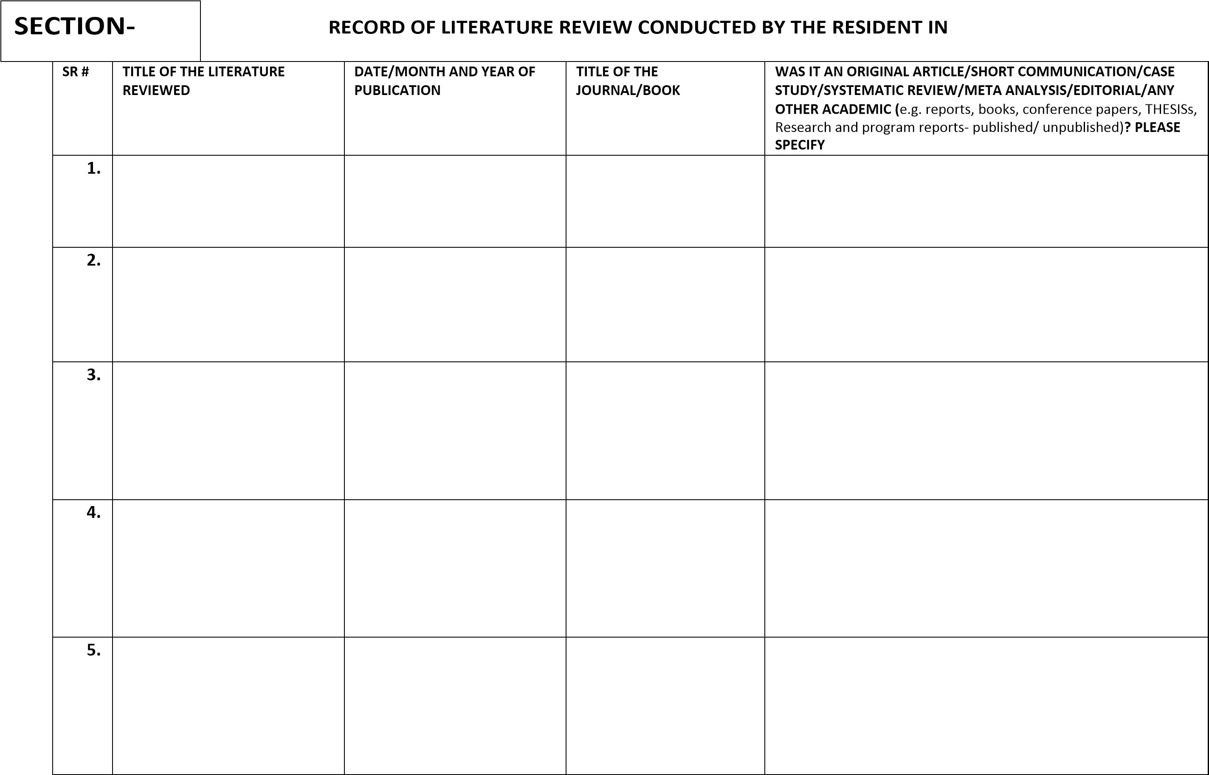

SECTION- 10
RECORD OF ANY MANUSCRIPT/RESEARCH PAPER FORMULATED BY THE RESIDENT IN YEAR 4

 | SR # | TITLE OF THE MANUSCRIPT |  | IF SUBMITTED FOR PUBLICATION,  DATE/MONTH AND YEAR OF  PUBLICATION, IF PUBLISHED | TITLE OF THE JOURNAL | WAS IT REVIWED, MODIFIED, ACCEPTED OR REJECTED.  PLEASE SPECIFY | DIRECTOR ORIC’S  SIGNATURE  (NAME/STAMP)
 | 1
 | 2
 | 3
 | 4
 | 5
SECTION- 11
OVERALL EVALUATION OF RESEARCH THESIS PROGRAM BY SUPERVISOR
SECTION- 11
OVERALL EVALUATION OF RESEARCH THESIS PROGRAM BY BASR (BOARD OF ADVANCED STUDIES AND RESEARCH)
SECTION- 11
OVERALL EVALUATION OF RESEARCH THESIS PROGRAM BY ORIC (OFFFICE OF RESEARCH INNOVATION AND COMMERCIALIZATION)
SECTION- 11
OVERALL EVALUATION OF RESEARCH THESIS PROGRAM BY DEPARTMENT OF MEDICAL EDUCATION (DME)

Portfolio (Templates)



RAWALPINDI MEDICAL UNIVERSITY
MD/MS RESIDENCY PROGRAMME



ENROLMENT DETAILS

Program of

Admission

Session

Registration / Training

Number

Name of

Candidate

Father’s

Name

Date

of

Birth

/

/

CNIC

No.

Present Address

Permanent Address

E-mail Address

Cell Phone

Date of Start of Training

Date of Completion of Training

Name of Supervisor

Designation of Supervisor

Qualification of Supervisor

Title of department / Unit

Name of Training Institute / Hospital

How to write reflections

In the following sections 2-12 ( case presentation, topic presentation, journal club, emergency, indoor, opd and clinics, procedural skills/directly observed procedures, multidisciplinary meetings, morbidity/mortality meetings, hands on training) reflect on the key activities that you have performed throughout the year in according to the 6 stages of Gibb’s reflective cycle.

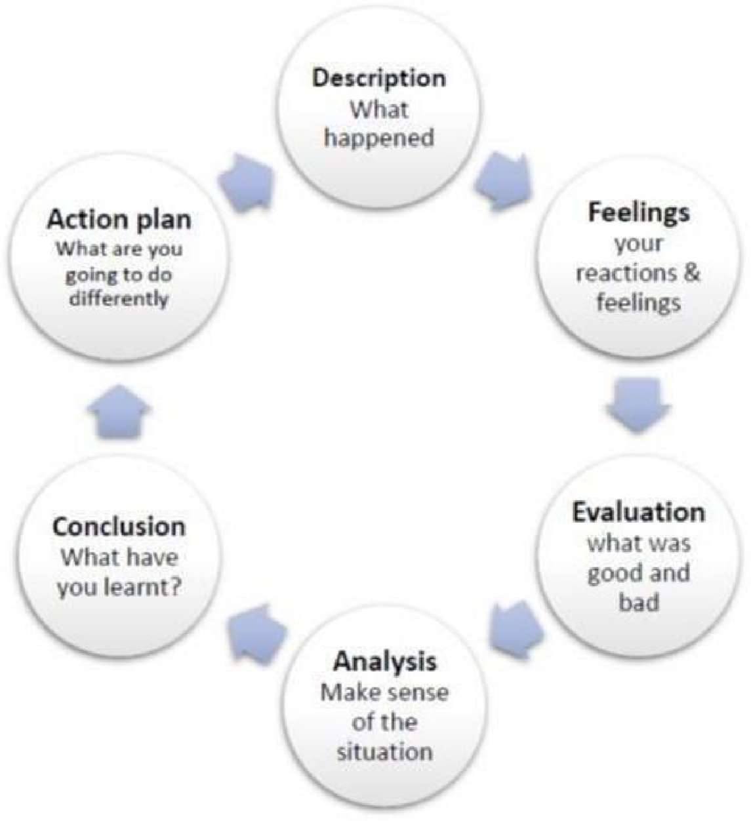
Gibb’s Reflective Cycle:

Stage 1- Description
Here you set the scene. What happened? When it occurred? Who was there? What did they do? What was the outcome?
Stage 2- Feelings
Discuss your feelings and thoughts about the experience. Consider questions such as:
How did you feel at the time? What did you think at the time? What impact did your emotions, beliefs and values have? What do you think other people were feeling? What did you think about the incident afterwards?

Stage 3- Evaluation
How did things go? Focus on the positive and negative even if it was primarily one or the other. What was good and what was bad about the experience? What went well? What didn’t? Were your contributions positive or negative. If you are writing about a difficult incident, did you feel that the situation was resolved afterwards?

Stage 4- Analysis
This is where you make sense of what happened, using the theory and wider context to develop understanding. Why did things go well? Badly? How can the theory explain what happened? How does my experience compare to the literature? What research/theories/models can help me make sense of this? Could I have responded in a different way? What might have helped or improved things?

Stage 5- Conclusion
What have you learnt? Generally, and specifically. What can I now do better? Could/should you have done anything differently? What skills would I need to handle this better?

Stage 6- Action plan
Action plans sum up anything you need to know and do to improve for next time.
How /where can I use my new knowledge and experience? How will I adapt my actions or improve my skills? If the same thing happened again, what would I do differently?
A Sample Reflection
This sample reflection is written from a Postgraduate medical student’s perspective. It will help you write reflections in your portfolio.

Topic: Journal Club Presentation on “xx-xx-xx” at “Conference Room Medical Unit 1”

Description

This was my first journal club presentation on the researchtitle “ ” published in “ ”. The paper was selected by my supervisor as it was a recent study and relevant to whatwe
practice in our unit. It took me 3 days (9 hours) to prepare for this presentation. For guidance I asked my SR
Dr. for help.
Feelings
During the presentation I felt quite nervous. As the presentation progressed, my tone of voice and command over the presentation improved.

Evaluation
The strengths of my presentation were my good grip on the topic.
My weaknesses were that I could not explain the statistical aspects of the study and had to rush through the tables.

Analysis
The Introduction went well because in addition to the paper I also read the topic from the text book and took guidance from my SR.
The methodology and results presentation were weak because I could not understand them myself.

Conclusion
I need to work on my presentation anxiety and need to understand interpretation on methodology and results. Action plan
I discussed with my supervisor and he informed me that I can self-learn these skills by reading up/attending courses online. However, I have come to know that DME department and Research Unit frequently conducts workshops on presentation skills and research methodology. I intent to register and attend them.
Introduction of portfolio

What is a portfolio?

A collection of a learner’s various documents and assessments throughout residency that reflect their professional development over time. May include referral letters and procedure logs (Rider et al., 2007).Portfolios also frequently include self-assessments, learning plans, and reflective essays (Epstein, 2007).

What should be included in a portfolio?

resident may include the following components in his or her portfolio:
  - Curriculum Vitae (CV)
  - Personal Publications
  - Research abstracts presented at professional conferences
  - Presentations at teaching units/departmental meetings and teaching sessions
  - Patient (case) presentations
  - Log of clinical procedures
  - Copies of written feedback received (direct observations, field notes, daily evaluations)
  - Quality improvement project plan and report of results
  - Summaries of ethical dilemmas (and how they were handled)
  - Chart notes of particular interest
  - Photographs and logs of medical procedures performed
  - Consult/referral letters of particular interest
  - Monthly faculty evaluations
  - 360-degree evaluations
  - Copies of written instructions for patients and families
  - Case presentations, lectures, logs of medical students mentored • Learning plans

  - Writing assignments, or case-based exercises assigned by program director
  - List of hospital/university committees served on
  - Documentation of managerial skills (e.g., schedules or minutes completed by resident)
  - Copies of billing sheets with explanations
  - Copies of written exams taken with answer sheets
  - In-training Evaluation Report (ITER) results
  - Format can be as simple as material collected in a three-ringed binder or as sophisticated as information stored in a handheld Pocket PC (PPC).
  - Patient confidentiality should be assured when any clinical material is included in the portfolio.
  - Should be resident-driven and include a space for residents to reflect on their learning experiences.
Why portfolio is required?
Can be used as a:
  - Formative learning tool: To help develop self-assessment and reflection skills.
  - Summative evaluation tool: To determine if a competency has been achieved.
  - Useful for evaluating competencies that are difficult to evaluate in more traditional ways such as:
    - Practice-based improvement
    - Use of scientific evidence in patient care o Professional behaviors (Rider et al., 2007)
  - Purpose is to highlight for the resident the need for ongoing learning and reflection to achieve and maintain competencies.
  - Enormous flexibility in using the portfolio as a learning tool: Portfolio may focus on one area (e.g., assessments pertaining to professionalism in a learner with attitudinal issues) without losing its effectiveness for the broader scope of competencies.
  - Number and frequency of entries may vary. Expectations, including minimum standards, should be defined with the resident from the outset.
  - Portfolios can be powerful tools for guided self-assessment and reflection (Holmboe & Carracio, 2008).

Evidence:
  - Evidence suggests that an assessment of skills is most valid when the tool used places the learner in an environment and/or situation that closely mimics that in which the learner will later practice the mastered skill (Wiggins et al., 1998). In that way, portfolios have the advantage of reflecting not just wharesidents can do in a controlled examination situation but what they actually do at work with real patients (Jackon et al., 2007).
  - As an evaluation tool, the reliability and validity of a portfolio are dependent on the psych ometric characteristics of the assessment and judging methods used in the portfolio process (Holmboe & Carracio, 2008).
  - Research is still needed to determine whether portfolios can be a catalyst for self-directed, lifelong learning
(O’Sullivan et al., 2002).

Practicality/Feasibility:

Portfolios can be time consuming for the resident to assemble and for the preceptor to assess.
References:

- Burch, V. C., & Seggie, J. L. (2008). Use of a structured interview to assess portfolio-based learning. Medical
Education, 42, 894-900.
- Challis M. (1999). AMEE medical education guide no. 11 (revised): Portfolio-based learnin g and assessment in medical education. Medical Teacher, 21, 370-86.
- Colbert, C.Y., Ownby, A.R., & Butler, P.M. (2008). A review of portfolio use in residency pro rams and considerations before implementation. Teaching and Learning in Medicine, 20(4), 340-345.
- Danner, E.F., & Henson, L.C. (2007). The portfolio approach to competency-based assessment at the Cleveland Clinic Lerner College of Medicine. Academic Medicine, 82(5), 493-502.
- David, M.F.B., Davis, M.H., Harden, R.M., Howie, P.W., Ker, J., & Pippard, M.J. (2001). AMEE Medical Education Guide No. 24: Portfolios as a method of student assessment. Medical Teacher, 23(6), 535-551.
- Davis, M.H., Ponnamperuma, G.G., & Ker, J.J. (2009). Student perceptions of a portfolio assessment process. Medical Education, 43(1), 89-98.
- Dekker, H., Driessen, E., Ter Braak, E., Scheele, F., Slaets, J., Van Der Molen, T., & Cohen-Schotanus, J. (2009). Mentoring portfolio use in undergraduate and postgraduate medical education. Medical Teacher, 31(10), 903- 909.
- Driessen, E., van Tartwijk, J., van der Vleuten, C., & Wass, V. (2007). Portfolios in medical education: Why do they meet with mixed success? A systematic review. Medical Education, 41(12), 1224-1233.
- Epstein, R.M. (2007). Assessment in medical education. New England Journal of Medicine, 356(4), 387-396.
- Gans, R. (2009). Mentoring with a formative portfolio: A case for reflection as a separate competency role. Medical Teacher, 31(10), 883-884.
- Gordon J. (2003). Assessing student' personal and professional development using portfolios and interviews. Medical Education, 37(4), 335-40.
- Holmboe, E.S. & Carracio, C. (2008). Portfolios. In E.S. Holmboe & R.E. Hawkins (Eds.), Practical Guide to the Evaluation of Clinical Competence (pp 86-101). Philadelphia: Mosby Elsevier.
- Jackson, N., Jamieson, A., & Khan, A. (2007). Assessment in medical education and training: A practical guide. Abingdon, UK: Radcliffe.
- Michels, N.R.M., Driessen, E.W., Muijtjens, A.M.M., Van Gaal, L.F., Bossaert, L.L., & De Winter, B.Y. (2009). Portfolio assessment during medical internships: How to obtain a reliable and feasible assessment procedure. Education for Health, 22(3), 313.
- O’Sullivan, P.S., Cogbill, K.K., McClain, T., Reckase, M.D., & Clardy, J.A. (2002). Portfolios as a novel approach for residency evaluation. Academic Psychiatry, 26(3), 173-9.
- Pitts J. (2007). Portfolios, personal development and reflective practice. Edinburgh: Association for the Study of Medical Education.
- Rider, E., Nawotniak, R., & Smith, G. (2007). A Practical Guide to Teaching and Assessing the ACGME Core Competencies. Marblehead, MA: HCPro Inc.
- Tochel, C., Haig, A., Hesketh, A., Cadzow, A., Beggs, K., Colthart, I., & Peacock, H. (2009). The effectiveness of portfolios for post-graduate assessment and education: BEME Guide No 12. Medical Teacher, 31(4), 299-318.
- Toolbox of Assessment Methods, Version 1.1. (2000). Accreditation Council for Graduate Medical Education (ACGME), & American Board of Medical Specialties (ABMS). Available online: http://www.acgme.org/Outcome/assess/Toolbox.pdf

- Van Tartwijk, J., & Driessen, E. (2009). Portfolios for assessment and learning: AMEE Guide no. 45. Medical Teacher, 31(9), 790-801.
- Wiggins, G. (1998). Educative Assessment: Designing Assessments to Inform and Improve Student Performance. San Francisco: Jossey-Bass.
INDEX:
- CURRICULUM VITAE (CV)
- CASE PRESENTATION
- TOPIC PRESENTATION
- JOURNAL CLUB
- EMERGENCY
- INDOOR
- OPD AND CLINICS
- PROCEDURAL SKILLS/DIRECTLY OBSERVED PROCEDURES
- MULTIDISCIPLINARY MEETINGS
- MORBIDITY/MORTALITY MEETINGS
- HANDS ON TRAINING
- RESEARCH PUBLICATIONS/MAJOR RESEARCH PROJECT/
ABSTRACT/SYNOPSIS/DISSERTATION/PAPER PRESENTATION
- ASSESSMENT RECORDS & EVALUATION PROFORMAS
- AWARDS/TESTIMONIALS/APPRECIATION LETTERS
- ANY OTHER SPECIFIC ACHIEVEMENTS
- FUTURE AIMS & OBJECTIVES
SECTION-1
CURRICULUM VITAE (CV)
Brief curriculum vitae encompassing all academic achievements & work experiences should be written or pasted here
SECTION-2
CASE PRESENTATION
Interesting and unique case presentations should be written in this section with your own opinion and comments of the supervisor

 | Title: |  | Date & Time:  Venue:
 | Description |  | Supervisor’s Comments:
 | Feelings
 | Evaluation
 | Analysis
 | Conclusion
 | Action plan
SECTION-3
TOPIC PRESENTATION
Details of the topic presentationswith the comments of the supervisor should be written here

 | Title: |  | Date & Time:  Venue:
 | Description |  | Supervisor’s Comments:
 | Feelings
 | Evaluation
 | Analysis
 | Conclusion
 | Action plan
SECTION-4
JOURNAL CLUB
Details of the selected critical appraisals of research articles discussed in journal club meetings should be written here

 | Title: |  | Date & Time:  Venue:
 | Description |  | Supervisor’s Comments:
 | Feelings
 | Evaluation
 | Analysis
 | Conclusion
 | Action plan
SECTION-5
EMERGENCY
Details of complicated and interesting emergency cases along with comments of the supervisor should written in this section

 | Title: |  | Date & Time:  Venue:
 | Description |  | Supervisor’s Comments:
 | Feelings
 | Evaluation
 | Analysis
 | Conclusion
 | Action plan
SECTION-6
INDOOR
Memorable cases seen in and managed in the medical ward along with comments of the supervisor should be mentioned in this section

 | Title: |  | Date & Time:  Venue:
 | Description |  | Supervisor’s Comments:
 | Feelings
 | Evaluation
 | Analysis
 | Conclusion
 | Action plan
SECTION-7
OPD AND CLINICS
Outpatient experiences along with supervisor’s comments should be written here

 | Title: |  | Date & Time:  Venue:
 | Description |  | Supervisor’s Comments:
 | Feelings
 | Evaluation
 | Analysis
 | Conclusion
 | Action plan
SECTION-8
PROCEDURAL SKILLS/DIRECTLY OBSERVED PROCEDURES
Experiences during learning of procedures and details of directly observed procedures should be written here along with comments of the supervisor

 | Title: |  | Date & Time:  Venue:
 | Description |  | Supervisor’s Comments:
 | Feelings
 | Evaluation
 | Analysis
 | Conclusion
 | Action plan
SECTION-9
MULTI DICIPLINARY MEETINGS
Details of Multidisciplinary meetings attended should be written here with comments of the supervisor

Title: | Date & Time:  Venue:
Description | Supervisor’s Comments:
Feelings
Evaluation
Analysis
Conclusion
Action plan

SECTION-10
MORBIDITY/MORTALITY MEETINGS
Details morbidity/mortality meetings attended should be written here with comments of the supervisor

 | Title: |  | Date & Time:  Venue:
 | Description |  | Supervisor’s Comments:
 | Feelings
 | Evaluation
 | Analysis
 | Conclusion
 | Action plan
SECTION-11
HANDS ON TRAINING
Brief description of learning outcomes achieved by workshops attended should be written here along with the reason of need to have a specific workshop and also get endorsed the comments of the supervisor for each workshop separately

 | Title: |  | Date & Time:  Venue:
 | Description |  | Supervisor’s Comments:
 | Feelings
 | Evaluation
 | Analysis
 | Conclusion
 | Action plan
SECTION-12
RESEARCH PUBLICATIONS/MAJOR RESEARCH PROJECT/
ABSTRACT/SYNOPSIS/DISSERTATION/PAPER PRESENTATION IN A CONFERENCE
All research experiences should be mentioned in this section along with comments of the supervisor

 | Title: |  | Date & Time:  Venue:
 | Description |  | Supervisor’s Comments:
 | Feelings
 | Evaluation
 | Analysis
 | Conclusion
 | Action plan
SECTION-13
ASSESSMENT RECORDS/EVALUATION PROFORMAS
Evidence of all available result cards and end of block (four months) evaluation record should mentioned in this section to have a reflection about resident’s Medical knowledge, patient care, Interpersonal and Communication Skills, system based learning, practice based learning and professionalism.
SECTION-14
AWARDS/TESTIMONIALS/ APPRECIATION LETTERS
Evidence of awards, testimonials and appreciation letters if any should be given in this section with comments of the supervisor

ANY OTHER SPECIFIC ACHIEVEMENT
SECTION-15
Evidence of any other specific achievement done under forceful circumstances as a compulsion or done by chance without any previous plan or done as a passion should be mentioned in this section along with comments of superviso
SECTION-16
FUTURE AIMS AND OBJECTIVES

Brief overview of the future aims and objectives should mentioned in this section
SECTION NO. 9

References
Teaching Methods

- Kolb, D. Experiential Learning. Englewood Cliffs, NJ: Prentice Hall. 1984
- Maudsley G. Do we all mean the same thing by “PBL”? Academic Medicine 1999; 74:178-85
- Koh G et al The effects of PBL during medical school on physician competency: a systemic review. CMAJ 2008 178(1) 34-41
- Hill W. Learning Thru Discussion 2nd edition. London: Sage Publications. 1977.
- Cook D. Web-based learning: pros, cons and controversies. Clinical Medicine 2007; 7(1):37-42.
- Greenhalgh T. Computer assisted learning in undergraduate medical education. BMJ 2001; 322:40-4.
- Chumley-Jones HS et al Web-based learning: Sound educational method or Hype? A review of the evaluation literature. Academic Medicine 2002;77(10):S86-S93.
- Schon D. Educating the reflective practitioner. San Francisco: Jossey Bass. 1984
- Lockyer J et al Knowledge translation: the role and practice of reflection. Journal of Continuing Education. 2004; 24:50-56.

Links for Electives/Rotations
- https://gme.uchc.edu/programs/im/electiveselective.html
- http://medicine.buffalo.edu/departments/medicine/education/internal- medicine/program/electives.html
- http://www.umm.edu/professionals/gme/programs/im-residency/electives-and-research
- https://internalmedicine.osu.edu/education/welcome/educational-career-development-programs/electives/

LINKS for curriculum
- https://elpaso.ttuhsc.edu/som/internal/IM_Curriculum_8-26-13.pdf
- http://www.hkcp.org/docs/TrainingGuidelines/HKCP%20GuideBooklet%202011updated%2021.8.2013.pdf
- https://www.jrcptb.org.uk/sites/default/files/2009%20GIM%20%28amendment%202012%29.pdf
- https://med.uth.edu/internalmedicine/files/2015/10/internal_medicine_curriculum_acgme.pdf
- http://www.uhs.edu.pk/downloads/MD%20Internal%20Medicine.pdf

Assessment methods
- Center for Creative Leadership, Greensboro, North Carolina (http://www.ccl.org).
- Munger, BS. Oral examinations. In Mancall EL, Bashook PG. (editors) Recertification: newevaluation methods and strategies. Evanston, Illinois: American Board of Medical Specialties,1995: 39-42
- Noel G, Herbers JE, Caplow M et al. How well do Pediatric Medicine faculty members evaluate the clinical skills of residents? Ann Int Med. 1992; 117: 757-65.
- Winckel CP, Reznick RK, Cohen R, Taylor B. Reliability and construct validity of a structured technical skills assessment form. Am J Surg. 1994; 167: 423-27.
- Norman, Geoffrey. Evaluation Methods: A resource handbook. Hamilton, Ontario, Canada: Program for Educational Development, McMaster University, 1995: 71-77.
- Watts J, Feldman WB. Assessment of technical skills. In: Neufeld V and Norman G (ed). Assessing clinical competence. New York: Springer Publishing Company, 1985: 259-74.
- Kaplan SH, Ware JE. The patient’s role in health care and quality assessment. In: Goldfield N and Nash D (eds). ▪ Providing quality care (2nded): Future Challenge. Ann Arbor, MI: Health Administration Press, 1995: 25-52.
- Matthews DA, Feinstein AR. A new instrument for patients’ ratings of physician performance in the hospital setting. J Gen Intern Med. 1989:4:14-22.
- Challis M. AMEE medical education guide no. 11 (revised): Portfolio-based learning and assessment in medical education. Med Teach. 1999; 21: 370-86.
- Tugwell P, Dok, C. Medical record review. In: Neufeld V and Norman G (ed). Assessingclinical competence. New York: Springer Publishing Company, 1985: 142-82.
- Tekian A, McGuire CH, et al (eds.) Innovative simulations for assessing professional competence. Chicago, Illinois: University of Illinois at Chicago, Dept. Med. Educ. 1999
- Mancall EL, Bashook PG. (eds.) Assessing clinical reasoning: the oral examination and alternativemethods. Evanston, Illinois: American Board of Medical Specialties, 1995.
- Van der Vleuten, CPM and Swanson, D. Assessment of clinical skills with standardized patients: State of the art. Teach Learn Med. 1990; 2: 58-76.

- Haladyna TM. Developing and validating multiple-choice test items. Hillsdale, New Jersey: L. Erlbaum Associates. 1994.
- Case SM, Swanson DB. Constructing written test questions for the basic and clinical sciences. Philadelphia, PA: National Board of Medical Examiners, 1996 (www.nbme.org)
- Case SM, Swanson DB. Constructing written test questions for the basic and clinical sciences. Philadelphia, PA: National Board of Medical Examiners, 1996 (www.nbme.org)
- Center for Creative Leadership, Greensboro, North Carolina (http://www.ccl.org).
- Challis M. AMEE medical education guide no. 11 (revised): Portfolio-based learning and assessment in medical education. Med Teach. 1999; 21: 370-86.
- Gray, J. Global rating scales in residency education. Acad Med. 1996; 71: S55-63.
- Haladyna TM. Developing and validating multiple-choice test items. Hillsdale, New Jersey: L. Erlbaum Associates. 1994.
- Kaplan SH, Ware JE. The patient’s role in health care and quality assessment. In: Goldfield N and Nash D (eds). ▪ Providing quality care (2nded): Future Challenge. Ann Arbor, MI: Health Administration Press, 1995: 25-52.
- Matthews DA, Feinstein AR. A new instrument for patients’ ratings of physician performance in the hospital setting. J Gen Intern Med. 1989:4:14-22.
- Mancall EL, Bashook PG. (eds.) Assessing clinical reasoning: the oral examination and alternative methods. Evanston, Illinois: American Board of Medical Specialties, 1995.
- Munger, BS. Oral examinations. In Mancall EL, Bashook PG. (editors) Recertification: new evaluation methods and strategies. Evanston, Illinois: American Board of Medical Specialties,1995: 39-42.
- Noel G, Herbers JE, Caplow M et al. How well do Pediatric Medicine faculty members evaluate the clinical skills of residents? Ann Int Med. 1992; 117: 757-65.
- Norman, Geoffrey. Evaluation Methods: A resource handbook. Hamilton, Ontario, Canada: Program for Educational Development, McMaster University, 1995: 71-77.
- Tekian A, McGuire CH, et al (eds.) Innovative simulations for assessing professional competence. Chicago, Illinois: University of Illinois at Chicago, Dept. Med. Educ. 1999
- Tugwell P, Dok, C. Medical record review. In: Neufeld V and Norman G (ed). Assessingclinical competence. New York: Springer Publishing Company, 1985: 142-82.
- Van der Vleuten, CPM and Swanson, D. Assessment of clinical skills with standardized patients: State of the art. Teach Learn Med. 1990; 2: 58-76.

- Watts J, Feldman WB. Assessment of technical skills. In: Neufeld V and Norman G (ed). Assessing clinical competence. New York: Springer Publishing Company, 1985, 259-74.
- Winckel CP, Reznick RK, Cohen R, Taylor B. Reliability and construct validity of a structured technical skills assessment form. Am J Surg. 1994; 167: 423-27.
References of Milestones
- https://www.acgme.org/Portals/0/PDFs/Milestones/InternalMedicineMilestones.pdf
- http://education.med.ufl.edu/files/2010/10/InternalMedicineMilestones.pdf ▪ http://www.upstate.edu/medresidency/current/competencies.php
References for EPAs :
- Ten Cate, O., Chen, H. C., Hoff, R. G., Peters, H., Bok, H., & van der Schaaf, M. (2015). Curriculum development for the workplace using Entrustable Professional Activities (EPAs): AMEE Guide No. 99. Medical Teacher, 37(11), 983–1002. https://doi.org/10.3109/0142159X.2015.1060308.
- Milestones, EPAs, and NAS - AAIM. (2023). 2023 Alliance for Academic Pediatric Medicine. Retrieved June 24, 2024, from https://www.im.org/resources/ume-gme-program-resources/milestones/end-epas
- 0Taylor, D. R., Park, Y. S., Smith, C. A., Karpinski, J., Coke, W., & Tekian, A. (2018). Creating entrustable professional activities to assess Pediatric Medicine residents in training. Annals of Pediatric Medicine, 168(10), 724. https://doi.org/10.7326/m17- 1680

SECTION NO. 10
Appendices (proformas/Forms)

List of Appendices

- Workplace Based Assessments-Multi source feedback proforma- 360⁰ evaluation ---------------------- Appendix “ A”
- Proforma for feedback by Nurse for core competencies of the resident --------------------------------- “Appendix B”
- Proforma for patient Medication Record------------------- “Appendix C”
- Workplace Based Assessments- guidelines for assessment of Generic & specialty specific Competencies ------
Appendix “ D”

- Supervisor’s Annual Review Report ---------------- Appendix “ E”
- Supervisors’ evaluation Proforma for continuous internal assessments .................. Appendix “ F”
- Evaluation of resident by the faculty ------------------------ Appendix “ G”
- Evaluation of faculty by the resident ------------------------ Appendix “ H”
- Evaluation of program by the faculty ------------------------ Appendix “ I”
- Evaluation of program by the resident ----------------------- Appendix “ J”
- Guidelines for program evaluation --------------------------- Appendix “ K”
- Evaluation of Project Director by the residents ------------ Appendix “ L”

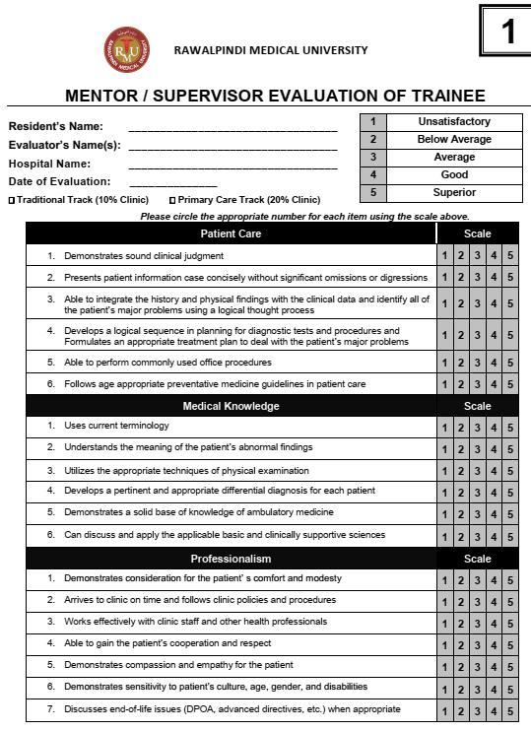
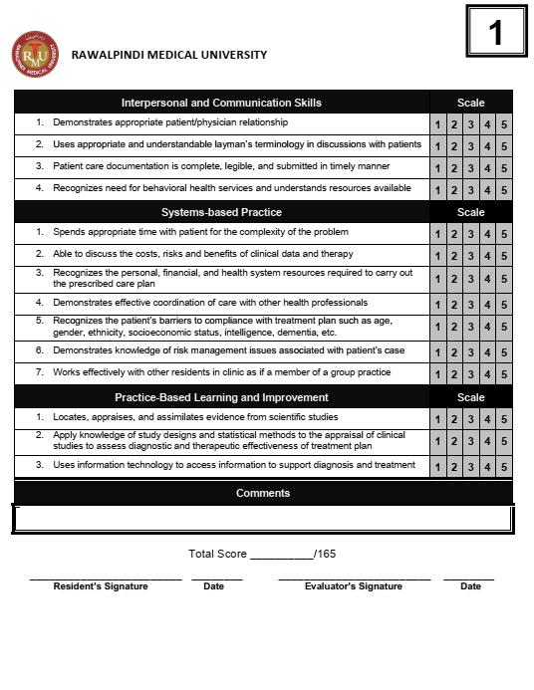
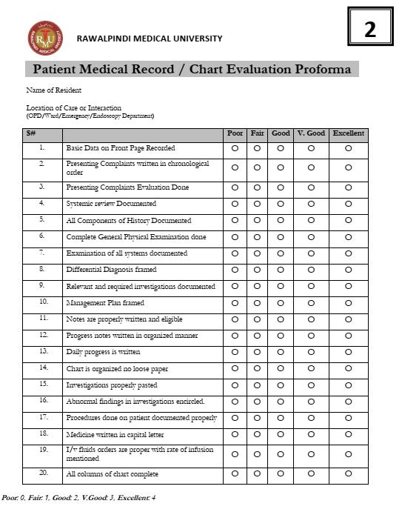
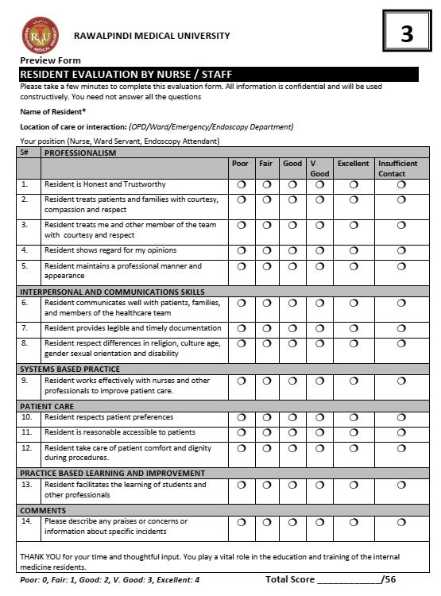
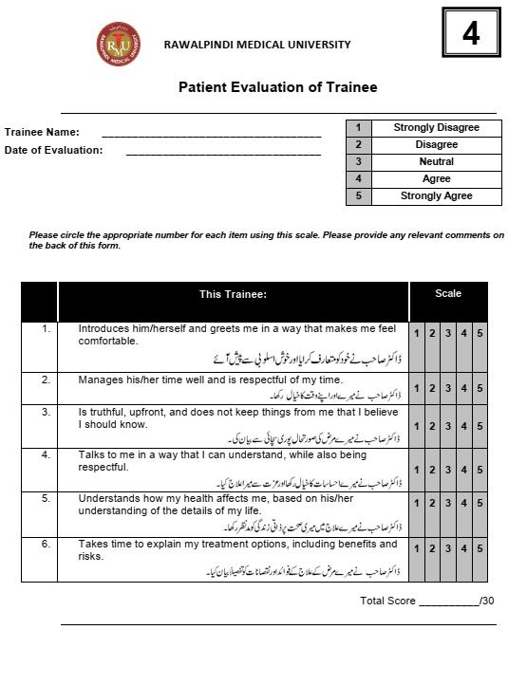
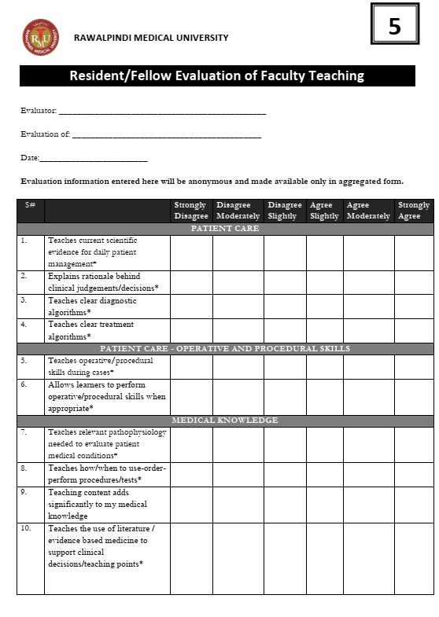
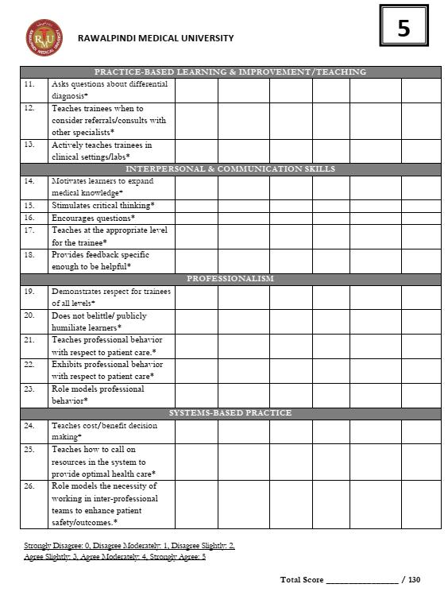
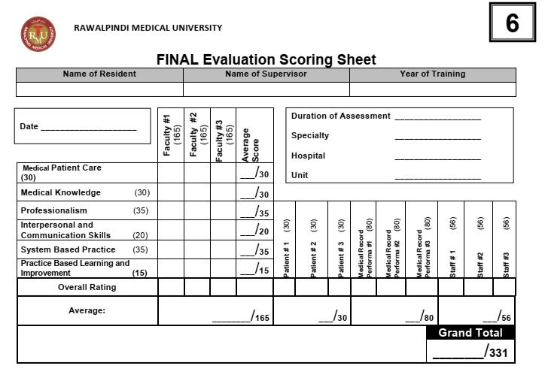
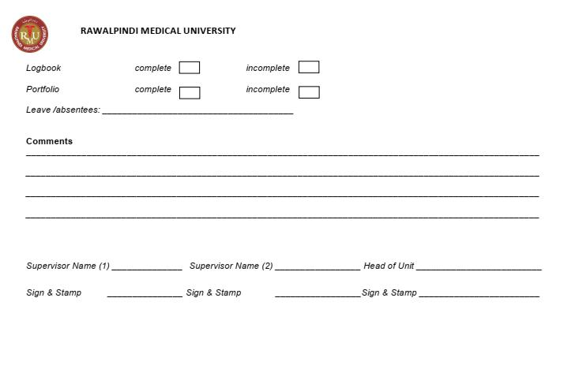
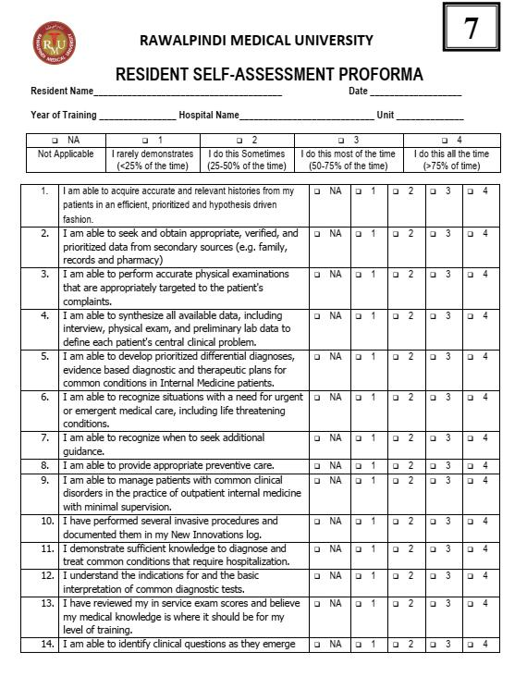
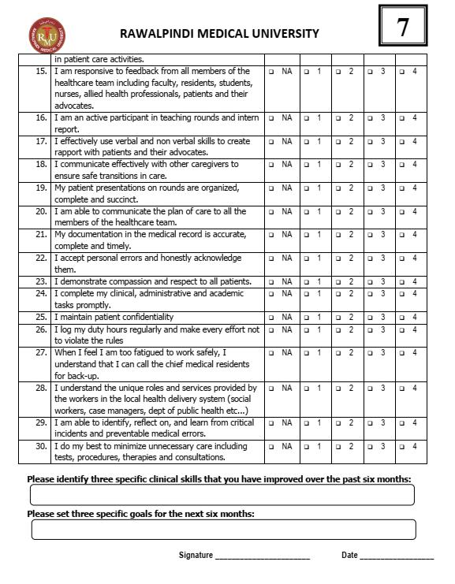
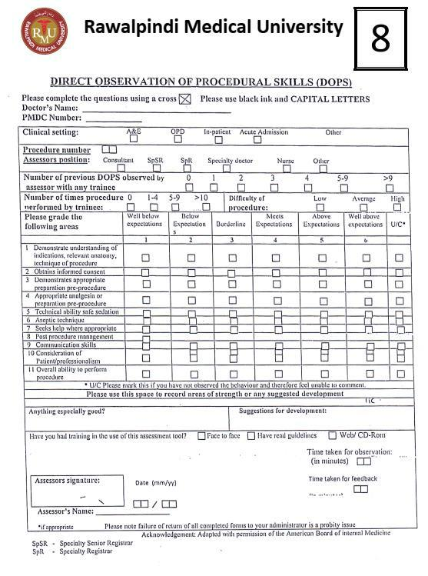
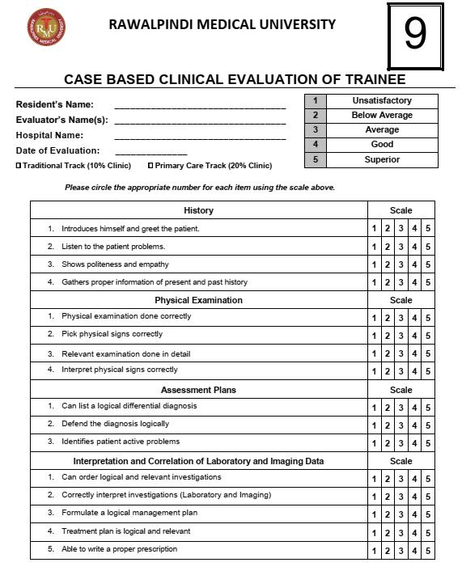

Workplace-Based Assessments - Guidelines for Supervisors for Assessment of Generic &
Specialty

Specific Competency
The Candidates of all MD programs will be trained and assessed in the following five generic competencies and also specialty specific competencies.
Generic Competencies:
A. Patient Care.
  - Patient Care competency will include skills of history taking, examination, diagnosis, counseling Plan care through ward teaching departmental conferences, morbidity and mortality meetings core curriculum lectures and training in procedures and operations.
  - The candidate shall learn patient care through ward teaching departmental conferences, morbidity and mortality meetings, care curriculum lectures and training in procedures and operations.
  - The Candidate will be assessed by the supervisor during presentation of cases on clinical ward rounds, scenario based discussions on patients management multisource feedback evaluation, Direct observation of Procedures (DOPS) and operating room assessments d. These methods of assessments will have equal weightage.

i. Medical knowledge and Research
- The candidate will learn basic factual knowledge of illnesses relevant to the specialty through lectures/discussions on topics selected from the syllabus, small group tutorials and bed side rounds
- The medical knowledge/skill will be assessed by the teacher during
- The candidate will be trained in designing research project, data collection data analysis and presentation of results by the supervisor.
- The acquisition of research skill will be assessed as per regulations governing thesis evaluation and its acceptance.
ii. Practice and System Based Learning
  - This competency will be learnt from journal clubs, review of literature policies and guidelines, audit projects medical error investigation, root cause analysis and awareness of health care facilities,.
  - The assessment methods will include case studies, personation in mobility and mortality review meetings and presentation of audit projects if any.
  - These methods of assessment shall have equal weight-age
- Communication Skills These will be learn it from role models, supervisor and workshops.
They will be assessed by direct observation of the candidate whilst interacting with the patients, relatives, colleagues and with multisource feedback evaluation.
- Professionalism as per Hippocratic oath
  - This competency is learnt from supervisor acting as a role model ethical case conferences and lectures on ethical issues such as confidentially informed consent end of life decisions, conflict of interest, harassment and use of human subjects in research.
  - The assessment of residents will be through multisource feedback evaluation according to preforms of evaluation and its scoring method.
B. Specialty Specific Competences.
i. The candidates will be trained in operative and procedural skills according to a quarterly based schedule. ii. The level of procedural Competency will be according to a competency table to be developed by each specialty iii. The following key will be used for assessing operative and procedural competencies:
- Level 1 Observer status The candidate physically present and observing the supervisor and senior colleagues
- Level 2 Assistant status The candidate assisting procedures and operations
- Level 3 Performed under supervision The candidate operating or performing aprocedure under direct supervision
- Level 4 Performed independently The candidate operating or performing aprocedure without any supervision v. Procedure Based Assessments (PBA)
- Procedural competency will assess the skill of consent taking, preoperative preparation and planning, intraoperative general and specific tasks and postoperative management
- Procedure Based assessments will be carried out during teaching and training of each procedure.
- The assessors may be supervisors, consultant colleagues and senior residents.
- The standardized forms will be filled in by the assessor after direct observation.
- The resident’s evaluation will be graded as satisfactory, deficient requiring further training and not assessed at all. f. Assessment report will be submitted
g. A satisfactory score will be required to be eligible for taking final examination.

Appendix “E”
Supervisor’s Annual Review Report.
This report will consist of the following components: -

  - Verification and validation of Log Book of operations & procedures according to the expected number of operations and procedures performed (as per levels of competence) determined by relevant board of studies.
  - A 90% attendance in academic activities is expected. The academic activities will include: Lectures, Workshops other than mandatory workshops, journal Clubs Morbidity & Mortality Review Meetings and Other presentations. III. Assessment report of presentations and lectures
IV. Compliance Report to meet timeline for completion of research project. V. Compliance report on personal Development Plan.
- Multisource Feedback Report, on relationship with colleagues, patients.
- Supervisor will produce an annual report based on assessments as per proforma in appendix-G and submit it to the Examination Department.
- 75% score will be required to pass the Continuous Internal Assessment on annual review.

Supervisor’s Evaluation of the Resident (Continuous Internal Assessment) Appendix “F”

1
2 | Below Average
3 | Average
4 | Good
5 | Superior

Resident’s

Name:

Evaluator’s

Name(s):

Hospital

Name:

Date

of

Evaluation:

Please circle the appropriate number for each item using the scale above.

 | Patient Care | Scale
1. | Demonstrates sound clinical judgment | 1 | 2 | 3 | 4 | 5
2. | Presents patient information case concisely without significant omissions or digressions | 1 | 2 | 3 | 4 | 5
3. | Able to integrate the history and physical findings with the clinical data and identify all of the patient’s major problems using a logical thought process | 1 | 2 | 3 | 4 | 5
4. | Develops a logical sequence in planning for diagnostic tests and procedures and Formulates an appropriate treatment plan to deal with the patient’s major problems | 1 | 2 | 3 | 4 | 5
5. | Able to perform commonly used office procedures | 1 | 2 | 3 | 4 | 5
6. | Follows age appropriate preventative medicine guidelines in patient care | 1 | 2 | 3 | 4 | 5
 | Medical Knowledge | Scale
1. | Uses current terminology | 1 | 2 | 3 | 4 | 5
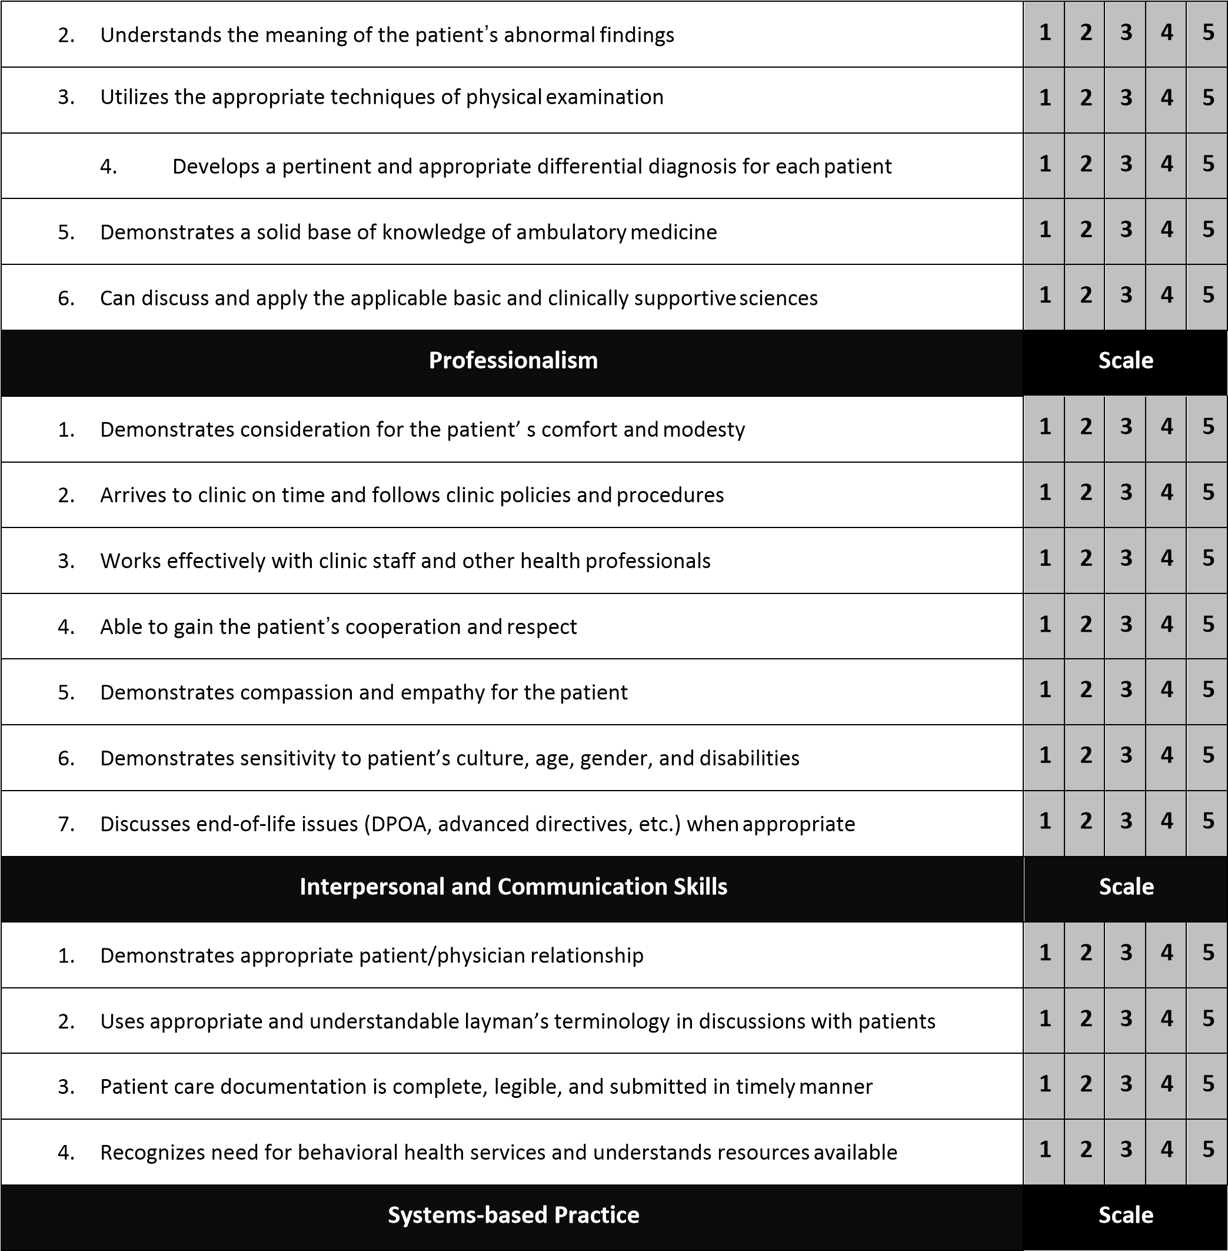
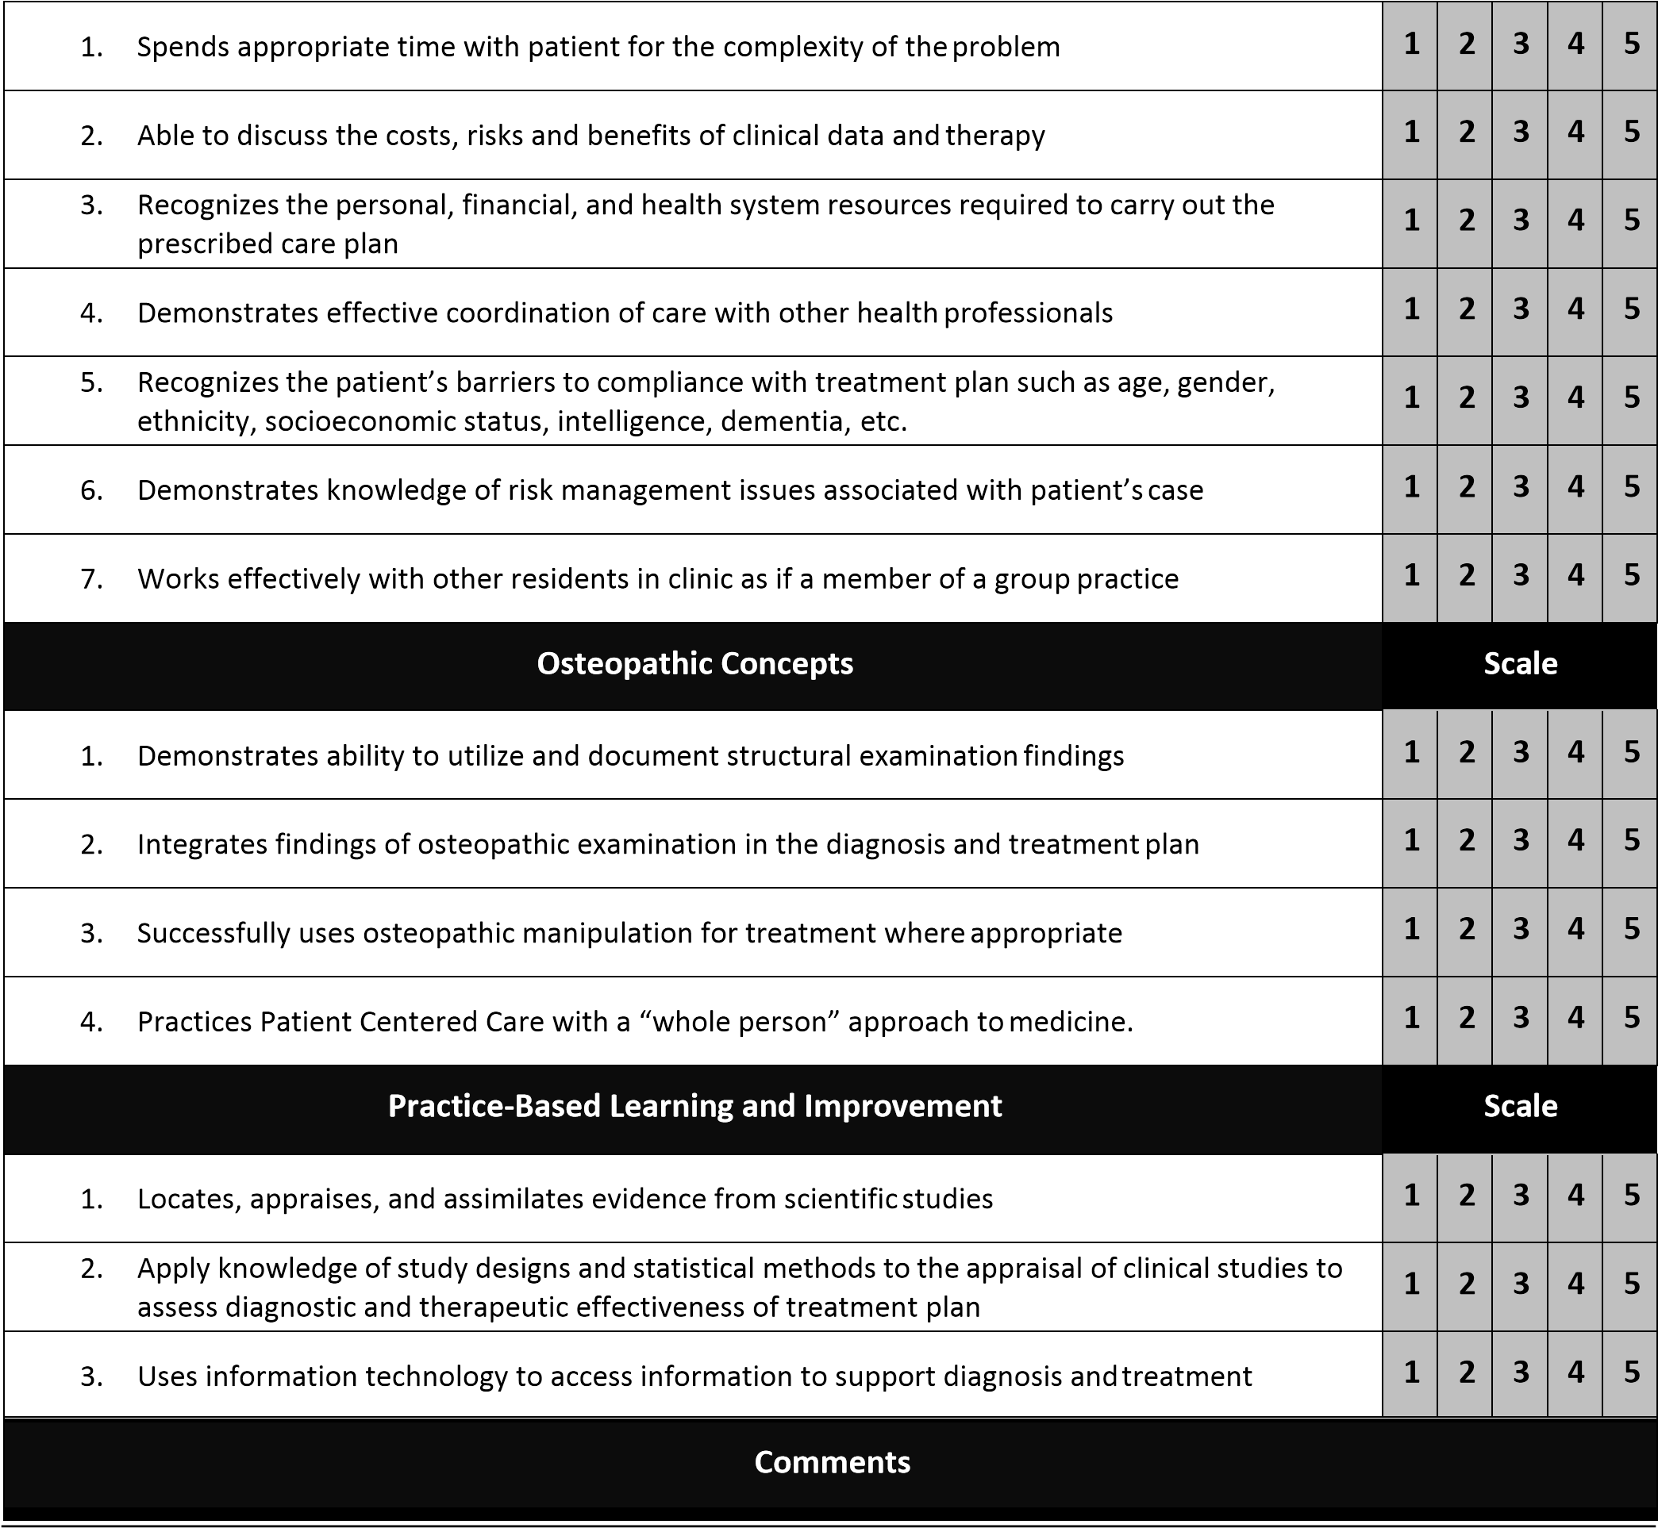

Resident’s Signature Date

Supervisor’s Signature Date
Appendix “G”

FACULTY EVALUATION OF RESIDENT
Abbreviations for six Core Competencies

- PC = Patient Care
- MK = Medical Knowledge
- ICS = Interpersonal / Communication Skills
- PBL = Practice-Based Learning and Improvement
- P = Professionalism
- SBP = Systems-Based Practice
Interpersonal and Communication Skills
Note content is appropriate and complete (ICS) (Question 1 of 24)

No  Interaction | Unsati |  | sfactory | Failing |  |  | Less  Marg | than inal |  | Below  Avera |  | ge | Avera |  | ge | Above  Avera |  | ge | Advan |  | ced | Outst |  | anding | Superior
0 | 1 |  |  | 2 |  |  | 3 |  |  | 4 |  |  | 5 |  |  | 6 |  |  | 7 |  |  | 8 |  |  | 9
Interpersonal skills with patients, families and staff is appropriate and skilled (ICS) (Question 2 of 24)

No  Interaction | Unsati |  | sfactory | Failing |  |  | Less  Marg | than inal |  | Below  Avera |  | ge | Avera |  | ge | Above  Avera |  | ge | Advan |  | ced | Outst |  | anding | Superior
0 |  |  |  |  |  |  | 3
 | 1 |  |  | 2 |  |  |  |  |  | 4 |  |  | 5 |  |  | 6 |  |  | 7 |  |  | 8 |  |  | 9
Presents cases in clear, concise manner (ICS) (Question 3 of 24)

No
Interaction

Unsatisfactory

Failing

Less than
Marginal

Below
Average

Average

Above
Average

Advanced

Outstanding

Superior

0 | 1 | 2 | 3 | 4 | 5 | 6 | 7 | 8 | 9

Medical Knowledge
Demonstrates understanding of clinical problems and their pathophysiology (MK) (Question 4 of 24)

No  Interaction | Unsati |  | sfactory | Failing |  |  | Less  Marg | than inal |  | Below  Avera |  | ge | Avera |  | ge | Above  Avera |  | ge | Advan |  | ced | Outst |  | anding | Superior
0 |  |  |  |  |  |  | 3
 | 1 |  |  | 2 |  |  |  |  |  | 4 |  |  | 5 |  |  | 6 |  |  | 7 |  |  | 8 |  |  | 9
Develops appropriate differential diagnosis (MK) (Question 5 of 24)

No  Interaction | Unsati |  | sfactory | Failing |  |  | Less  Marg | than inal |  | Below  Avera |  | ge | Avera |  | ge | Above  Avera |  | ge | Advan |  | ced | Outst |  | anding | Superior
0 |  |  |  |  |  |  | 3
 | 1 |  |  | 2 |  |  |  |  |  | 4 |  |  | 5 |  |  | 6 |  |  | 7 |  |  | 8 |  |  | 9
Evaluates scientific basis of diagnostic tests used (MK) (Question 6 of 24)

No  Interaction | Unsati |  | sfactory | Failing |  |  | Less  Marg | than inal |  | Below  Avera |  | ge | Avera |  | ge | Above  Avera |  | ge | Advan |  | ced | Outst |  | anding | Superior
0 |  |  |  |  |  |  | 3
 | 1 |  |  | 2 |  |  |  |  |  | 4 |  |  | 5 |  |  | 6 |  |  | 7 |  |  | 8 |  |  | 9
Reads service specific literature (MK) (Question 7 of 24)

No  Interaction | Unsati |  | sfactory | Failing |  |  | Less than  Marginal |  |  | Below  Avera |  | ge | Avera |  | ge | Above  Avera |  | ge | Advan |  | ced | Outst |  | anding | Superior
0
 | 1 |  |  | 2 |  |  | 3 |  |  | 4 |  |  | 5 |  |  | 6 |  |  | 7 |  |  | 8 |  |  | 9

Patient Care
Obtains accurate clinical history (PC) (Question 8 of 24)
No  Interaction | Unsati |  | sfactory | Failing |  |  | Less  Marg | than inal |  | Below  Avera |  | ge | Avera |  | ge | Above  Avera |  | ge | Advan |  | ced | Outst |  | anding | Superior
0 |  |  |  |  |  |  | 3
 | 1 |  |  | 2 |  |  |  |  |  | 4 |  |  | 5 |  |  | 6 |  |  | 7 |  |  | 8 |  |  | 9

Demonstrates appropriate physical exam (PC) (Question 9 of 24)

No  Interaction | Unsati |  | sfactory | Failing |  |  | Less  Marg | than inal |  | Below  Avera |  | ge | Avera |  | ge | Above  Avera |  | ge | Advan |  | ced | Outst |  | anding | Superior
0 |  |  |  |  |  |  | 3
 | 1 |  |  | 2 |  |  |  |  |  | 4 |  |  | 5 |  |  | 6 |  |  | 7 |  |  | 8 |  |  | 9

Identifies and reviews relevant existing patient data (PC) (Question 10 of 24)

No  Interaction | Unsati |  | sfactory | Failing |  |  | Less  Marg | than inal |  | Below  Avera |  | ge | Avera |  | ge | Above  Avera |  | ge | Advan |  | ced | Outst |  | anding | Superior
0 |  |  |  |  |  |  | 3
 | 1 |  |  | 2 |  |  |  |  |  | 4 |  |  | 5 |  |  | 6 |  |  | 7 |  |  | 8 |  |  | 9

Prioritizes problems and treatment plans appropriately (PC) (Question 11 of 24)

No  Interaction | Unsati |  | sfactory | Failing |  |  | Less  Marg | than inal |  | Below  Avera |  | ge | Avera |  | ge | Above  Avera |  | ge | Advan |  | ced | Outst |  | anding | Superior
0 | 1 |  |  | 2 |  |  | 3 |  |  | 4 |  |  | 5 |  |  | 6 |  |  | 7 |  |  | 8 |  |  | 9

Effectively uses consultation services (PC) (Question 12 of 24)
No  Interaction | Unsati |  | sfactory | Failin g |  |  | Less tha n |  |  | Below |  |  | Average |  |  | Above |  |  | Advanced |  |  | Outstanding |  |  | Superior
 |  |  |  |  |  |  | Marg |  |  | Av |  | ge |  |  |  | Av |  | ge
 |  |  |  |  |  |  |  | inal |  |  | era |  |  |  |  |  | era
0 | 1 |  |  | 2 |  |  | 3 |  |  | 4 |  |  | 5 |  |  | 6 |  |  | 7 |  |  | 8 |  |  | 9

Practice-based learning and improvement.
Identifies areas for improvement and applies it to practice PBL (Question 13 of 24)

No  Interaction | Unsati |  | sfactory | Failing |  |  | Less  Marg | than inal |  | Below  Avera |  | ge | Avera |  | ge | Above  Avera |  | ge | Advan |  | ced | Outst |  | anding | Superior
0 |  |  |  |  |  |  | 3
 | 1 |  |  | 2 |  |  |  |  |  | 4 |  |  | 5 |  |  | 6 |  |  | 7 |  |  | 8 |  |  | 9

Applies lessons learned from medical errors into practice PBL (question 14 of 24)

No  Interaction | Unsati |  | sfactory | Failing |  |  | Less  Marg | than inal |  | Below  Avera |  | ge | Avera |  | ge | Above  Avera |  | ge | Advan |  | ced | Outst |  | anding | Superior
0 |  |  |  |  |  |  | 3
 | 1 |  |  | 2 |  |  |  |  |  | 4 |  |  | 5 |  |  | 6 |  |  | 7 |  |  | 8 |  |  | 9
Shows Interest in learning from complex care issues PBL (Question 15 of 24)

No  Interaction | Unsatisfactory |  |  | Failing |  |  | Less than  Marginal |  |  | Below  Average |  |  | Average |  |  | Above  Average |  |  | Advanced |  |  | Outstanding |  |  | Superior
0
 | 1 |  |  | 2 |  |  | 3 |  |  | 4 |  |  | 5 |  |  | 6 |  |  | 7 |  |  | 8 |  |  | 9
Professionalism
Displays a professional attitude and demeanor (P) (Question 16 of 24)

No  Interaction | Unsati |  | sfactory | Failing |  |  | Less  Marg | than inal |  | Below  Avera |  | ge | Avera |  | ge | Above  Avera |  | ge | Advan |  | ced | Outst |  | anding | Superior
0 |  |  |  |  |  |  | 3
 | 1 |  |  | 2 |  |  |  |  |  | 4 |  |  | 5 |  |  | 6 |  |  | 7 |  |  | 8 |  |  | 9
Attends rounds on time. Handles criticism of self in pro-active way (P) (Question 17 of 24)

No  Interaction | Unsati |  | sfactory | Failing |  |  | Less  Marg | than inal |  | Below  Avera |  | ge | Avera |  | ge | Above  Avera |  | ge | Advan |  | ced | Outst |  | anding | Superior
0 |  |  |  |  |  |  | 3
 | 1 |  |  | 2 |  |  |  |  |  | 4 |  |  | 5 |  |  | 6 |  |  | 7 |  |  | 8 |  |  | 9
Cross-covers colleagues when necessary (P) (Question 18 of 24)

No  Interaction | Unsati |  | sfactory | Failing |  |  | Less  Marg | than inal |  | Below  Avera |  | ge | Avera |  | ge | Above  Avera |  | ge | Advan |  | ced | Outst |  | anding | Superior
0 |  |  |  |  |  |  | 3
 | 1 |  |  | 2 |  |  |  |  |  | 4 |  |  | 5 |  |  | 6 |  |  | 7 |  |  | 8 |  |  | 9

System-Based Practices
Understands the different types of medical practice and delivery systems, and alternative methods of controlling health care costs and allocatingresources (SBP) (Question 19 of 24)
No  Interaction | Unsatisfactory |  |  | Failing |  |  | Less than  Marginal |  |  | Below  Average |  |  | Average |  |  | Above  Average |  |  | Advanced |  |  | Outstanding |  |  | Superior
0
 | 1 |  |  | 2 |  |  | 3 |  |  | 4 |  |  | 5 |  |  | 6 |  |  | 7 |  |  | 8 |  |  | 9

Effectively Utilizes ancillary services SBP ( Questions 20 of 24)

No  Interaction | Unsati |  | sfactory | Failing |  |  | Less  Marg | than inal |  | Below  Avera |  | ge | Avera |  | ge | Above  Avera |  | ge | Advan |  | ced | Outst |  | anding | Superior
0 |  |  |  |  |  |  | 3
 | 1 |  |  | 2 |  |  |  |  |  | 4 |  |  | 5 |  |  | 6 |  |  | 7 |  |  | 8 |  |  | 9
Uses Patient care venues appropriately SBP (Questions 21 of 24)

No  Interaction | Unsati |  | sfactory | Failing |  |  | Less  Marg | than inal |  | Below  Avera |  | ge | Avera |  | ge | Above  Avera |  | ge | Advan |  | ced | Outst |  | anding | Superior
0 |  |  |  |  |  |  | 3
 | 1 |  |  | 2 |  |  |  |  |  | 4 |  |  | 5 |  |  | 6 |  |  | 7 |  |  | 8 |  |  | 9
Advocates for quality patient care and assists patients in dealing with system complexities SBP (Questions 22 of 24)

No  Interaction | Unsati |  | sfactory | Failing |  |  | Less  Marg | than inal |  | Below  Avera |  | ge | Avera |  | ge | Above  Avera |  | ge | Advan |  | ced | Outst |  | anding | Superior
0 |  |  |  |  |  |  | 3
 | 1 |  |  | 2 |  |  |  |  |  | 4 |  |  | 5 |  |  | 6 |  |  | 7 |  |  | 8 |  |  | 9
Overall / Summary
Did resident meet course objectives? (Questions 23 of 24)

No  Interaction | Unsati |  | sfactory | Failing |  |  | Less  Marg | than inal |  | Below  Avera |  | ge | Avera |  | ge | Above  Avera |  | ge | Advan |  | ced | Outst |  | anding | Superior
0 |  |  |  |  |  |  | 3
 | 1 |  |  | 2 |  |  |  |  |  | 4 |  |  | 5 |  |  | 6 |  |  | 7 |  |  | 8 |  |  | 9
Comments (Please provide Strengths, Weaknesses and Areas for Improvement) (Question 24 of 24)
No  Interaction | Unsati |  | sfactory | Failing |  |  | Less  Marg | than inal |  | Below  Avera |  | ge | Avera |  | ge | Above  Avera |  | ge | Advan |  | ced | Outst |  | anding | Superio  r
0 |  |  |  |  |  |  | 3
 | 1 |  |  | 2 |  |  |  |  |  | 4 |  |  | 5 |  |  | 6 |  |  | 7 |  |  | 8 |  |  | 9

RESIDENT EVALUATION OF FACULTY TEACHING SKILLS Appendix “H”

Faculty Member Department:

Period of Evaluation Location

Direction: please take a moment to assess the clinical faculty members teaching skills using this scale

1= Poor 2=Fair 3= Very Good 4= Excellent

- Leadership

Discussed expectations, duties and assignments for each 1 N/A team member and reviewed learning objectives and evaluation process
2

3

4

Treated each tea, member in a cutout and peaceful manner 1 N/A
2

3

4

2

3

4

2

3

4

Was usually prompt for teaching assignments and was always 1 N/A
Available and accessible as a supervisor
Showed respect for the physician in other specialties / 1 N/A
Subspecialties as well as for other health care professionals
Comments

- Role modeling

Demonstrated positive in interpersonal communication 1 N/A skills with patients, family members and staff
2

3

4

Enthusiasm and interest in teaching residents 1 N/A
2

3

4

Recognized own limitations and used these 1 N/A
2

3

4

Situation as opportunities to demonstrate how he / she learn

Used Medical / scientific literature to support clinical decisions 1 N/A
2

3

4

Comments

C. Patient Care /Teaching and & Feedback
Demonstrate how to handle “difficult” patients encounters 1 N/A
2

3

4

2

3

4

Demonstrated how to perform special physical exam 1 N/A techniques and / or procedures and observed me during my initials attempt
critical thinking skills and clinical judgment
Asked thought provoking questions to help me develop my 1 N/A
2

3

4

Share his/her own thought process when discussing patient 1 N/A workups and patients care decisions with the team
2

3

4

Highlighted important aspects of a patient case and often 1 N/A
2

3

4

generalized to boarder medical concepts and principles
Integrated social / ethical aspects of medical 1 N/A
2

3

4

(cost containment, patents right , humanism) into discussion of patient care
Provided guidance and specific “instructive feedback 1 N/A
2

3

4

to help me correct mistakes and / or increase my knowledge base

Comments:

- Didactic (Classroom) Instructions

Was usually prompt for teaching sessions, kept interruptions 1 N/A to minimum and kept discussion focused on case or topic
2

3

4

Gave lecture presentations that were well organized and 1 N/A
2

3

4

“Interactive” () i.e., and review pertinent topics

Provided references or other materials that stimulated me 1 N/A to road, research and review pertinent topics
2

3

4

Comments

- Evaluation

Reviewed my overall clinical performance at the end of the 1 2 3 4 N/A rotation pointed out my strengths and areas for improvement

Demonstrated “fairness” by adhering to established criteria, 1 2 3 4 N/A explaining reasons for the scores and following me to respond Comments

-

Overall, I would rate this faculty member’s clinical teaching skills as

POOR FAIR VERY EXCELLENT
GOOD

Would you recommend that faculty member continue to teach in this programm? Yes
NO

COMMENTS, COMMENDATIONS OR CONCERNS

RESIDENT EVALUATION OF FACULTY (FOR CORE COMPETENCIES) Appendix “I”
  - Interpersonal and Communication Skills
Interpersonal and Communication Skills (Question 1 of 22)

Asks question in a non-threatening manner

Cannot Evaluate | Unsatisfactory  (Comment  Required) | Marginal  (Comment  Required) | Satisfactory | Very Good | Excellent
0 | 1 | 2 | 3 | 4 | 5
Interpersonal and Communication Skills (Question 2 of 22)

Emphasizes problem-solving (thought processes leading to decisions)

Cannot Evaluate | Unsatisfactory  (Comment  Required) | Marginal  (Comment  Required) | Satisfactory | Very Good | Excellent
0 | 1 | 2 | 3 | 4 | 5
Interpersonal and Communication Skills (Question 4 of 22)

Effectively communicates knowledge

Cannot Evaluate | Unsatisfactory  (Comment  Required) | Marginal  (Comment  Required) | Satisfactory | Very Good | Excellent
0 | 1 | 2 | 3 | 4 | 5

  - Medical Knowledge
Medical Knowledge (Question 5 of 22)
Knowledge of specialty
Cannot Evaluate | Unsatisfactory  (Comment  Required) | Marginal  (Comment  Required) | Satisfactory | Very Good | Excellent
0 | 1 | 2 | 3 | 4 | 5
Medical Knowledge (Question 6 of 22)

Applies knowledge of specialty to patient problems

Cannot Evaluate | Unsatisfactory  (Comment  Required) | Marginal  (Comment  Required) | Satisfactory | Very Good | Excellent
0 | 1 | 2 | 3 | 4 | 5
Patient Care (Question 7 of 22)

Applies comprehensive high quality care

Cannot Evaluate | Unsatisfactory  (Comment  Required) | Marginal  (Comment  Required) | Satisfactory | Very Good | Excellent
0 | 1 | 2 | 3 | 4 | 5

  - Patient Care
Patient Care (Question 8 of 22)
Explains diagnostic decisions
Cannot Evaluate | Unsatisfactory  (Comment  Required) | Marginal  (Comment  Required) | Satisfactory | Very Good | Excellent
0 | 1 | 2 | 3 | 4 | 5
Patient Care (Question 9 of 22)

Clinical Judgment

Cannot Evaluate | Unsatisfactory  (Comment  Required) | Marginal  (Comment  Required) | Satisfactory | Very Good | Excellent
0 | 1 | 2 | 3 | 4 | 5

Patient Care (Question 10 of 22)

Clinical Skills

Cannot Evaluate | Unsatisfactory  (Comment Required) | Marginal  (Comment Required) | Satisfactory | Very Good | Excellent
0 | 1 | 2 | 3 | 4 | 5

  - Practice-Based Learning and Improvement
Practice-Based Learning and Improvement (Question 11 of 22)

Encourages self-education

Cannot Evaluate | Unsatisfactory  (Comment  Required) | Marginal  (Comment  Required) | Satisfactory | Very Good | Excellent
0 | 1 | 2 | 3 | 4 | 5
Practice-Based Learning and Improvement (Question 12 of 22)

Encourages evidence-based approaches to care

Cannot Evaluate | Unsatisfactory  (Comment  Required) | Marginal  (Comment  Required) | Satisfactory | Very Good | Excellent
0 | 1 | 2 | 3 | 4 | 5

  - Professionalism
Professionalism (Question 13 of 22)

Sensitive caring respectful attitude towards patients
Cannot Evaluate | Unsatisfactory  (Comment  Required) | Marginal  (Comment  Required) | Satisfactory | Very Good | Excellent
0 | 1 | 2 | 3 | 4 | 5
Professionalism (Question 14 of 22)

Uses time with patients and residents effectively

Cannot Evaluate | Unsatisfactory  (Comment  Required) | Marginal  (Comment  Required) | Satisfactory | Very Good | Excellent
0 | 1 | 2 | 3 | 4 | 5
Professionalism (Question 15 of 22)

Sufficient resident teaching on rounds/clinics

Cannot Evaluate | Unsatisfactory  (Comment  Required) | Marginal  (Comment  Required) | Satisfactory | Very Good | Excellent
0 | 1 | 2 | 3 | 4 | 5
Professionalism (Question 16 of 22)

Respects all members of the health care team
Cannot Evaluate | Unsatisfactory  (Comment  Required) | Marginal  (Comment  Required) | Satisfactory | Very Good | Excellent
0 | 1 | 2 | 3 | 4 | 5
Professionalism (Question 17 of 22)

Demonstrates Integrity
Cannot Evaluate | Unsatisfactory  (Comment  Required) | Marginal  (Comment  Required) | Satisfactory | Very Good | Excellent
0 | 1 | 2 | 3 | 4 | 5
Professionalism (Question 18 of 22)

Attains credibility and rapport with patients and their family

Cannot Evaluate | Unsatisfactory  (Comment  Required) | Marginal  (Comment  Required) | Satisfactory | Very Good | Excellent
0 | 1 | 2 | 3 | 4 | 5

F. Systems- Based Practice
Systems- Based Practice (Question 19 of 22)

Provides useful feedback including constructive criticism to team members

Cannot Evaluate | Unsatisfactory  (Comment  Required) | Marginal  (Comment  Required) | Satisfactory | Very Good | Excellent
0 | 1 | 2 | 3 | 4 | 5

System Base Practice (Question 20 of 22)
Discusses availability cost and utility of system resources in providing medical care.
Cannot Evaluate | Unsatisfactory  (Comment  Required) | Marginal  (Comment  Required) | Satisfactory | Very Good | Excellent
0 | 1 | 2 | 3 | 4 | 5

Overall/Summary (Question 21 of 22)
Overall contributions to your training

Cannot Evaluate | Unsatisfactory  (Comment  Required) | Marginal  (Comment  Required) | Satisfactory | Very Good | Excellent
0 | 1 | 2 | 3 | 4 | 5
Comments: (Question 22 of 22)

Faculty Evaluation of the Residency / Fellowship Program Appendix “J

Please use this scale to answer question1-10:

1 2 3 4 5

Strongly Disagree Disagree Neutral Agree Strongly Agree

- PATIENT/CASE VOLUME: There are a sufficient number and variety of patients/cases to facilitate high quality resident/fellow
education.

- CURRICULUM: The residency/fellowship program curriculum provides the appropriate education experiences for residents/fellows
to analyze investigate and improve patient care practices.

- PROGRAM DIRECTOR: The program director effectively communicates with program faculty members to understand their role in
resident/fellow education and development.

- ADMINISTRATIVE SUPPORT:There is adequate administrative support service to facilitate faculty participation in resident/fellow
education.

- SUPERVISION: The Program resident/fellow supervision policy has been clearly communicated to program faculty and is used by
the program.

- TRANSITION OF CARE: The program transition of care/hand-off policy and tools have been distributed to program faculty and
they are used.

- EVALUATION: Program faculty receives regular and timely feedback about their teaching and supervisors skills.

- FACULTY DEVELOPMENT: There are beneficial resources available for program faculty to improve their teaching and supervision
skills.
- SCHOLARLY ACTIVITY: Program faculties have the adequate resources to participate in scholarly activates.

- FACULTY: The program faculty provides the diversity of experience and expertise to accomplish the goals and objectives of the

program.

RESIDENT EVALUATION OF RESIDENCY PROGRAM Appendix “K

  - Program Goals and Objectives (Question 1 of 35)
The goals and objectives for each rotation are clearly communicated to residents.

Cannot Eva | luate |  | Unsatisfac  (Commen t | tory |  | Marginal  ( Comme | nt |  | Satisfacto | ry |  | Very Goo | d |  | Excellent
 |  |  | Required) |  |  | Required)
0 |  |  | 1 |  |  | 2 |  |  | 3 |  |  | 4 |  |  | 5
  - Evaluation (Question 2 of 35)
The evaluation process of the residents is constructive (computerized faculty evaluations of residents, daily clinical feedback to residents, yearly PRITE, and Director’s semi-annual resident meeting with resident).

Cannot Eva | luate |  | Unsatisfac  (Commen t  Required) | tory |  | Marginal  ( Comme  Required) | nt |  | Satisfactory |  | Very Good |  | Excellent
0 |  |  | 1 |  |  | 2 |  |  | 3 |  | 4 |  | 5
  - Research (Question 3 of 35)
Residents are provided ample opportunity to develop an interest an in research.

Cannot Evaluate |  |  | Unsatisfactory  (Comment  Required) |  |  | Marginal  (Comment  Required) |  |  | Satisfactory |  |  | Very Good |  |  | Excellent
0 |  |  | 1 |  |  | 2 |  |  | 3 |  |  | 4 |  |  | 5
Research (Question 4 of 35)
Residents are encouraged to participate in research.

Cannot Eva | luate |  | Unsatisfac  ( Comment  Required) | tory |  | Marginal  ( Comme  Required) | nt |  | Satisfacto | ry |  | Very Goo | d |  | Excellent
0 |  |  | 1 |  |  | 2 |  |  | 3 |  |  | 4 |  |  | 5

Research (Question 5 of 35)
Residents are provided the education to develop an understanding of research.

.

Cannot Eva | luate |  | Unsatisfac  ( Comment  Required) | tory |  | Marginal  ( Comme  Required) | nt |  | Satisfacto | ry |  | Very Goo | d |  | Excellent
0 |  |  | 1 |  |  | 2 |  |  | 3 |  |  | 4 |  |  | 5
  - Faculty (Question 6 of 35)
The size, diversification and availability of faculty is adequate for the training program.
.

Cannot Evaluate | Unsatisfactory  (Comment  Required) | Marginal  (Comment  Required) | Satisfactory | Very Good | Excellent
0 | 1 | 2 | 3 | 4 | 5

Cannot Evaluate | Unsatisfactory  (Comment | Marginal  (Comment | Satisfactory | Very Good | Excellent
  - Faculty (Question 7 of 35)
The Knowledge of the faculty is current and appropriate.

Cannot Eval | uate |  | Unsatisfac  (Comment | tory |  | Marginal  ( Comme | nt |  | Satisfacto | ry |  | Very Goo | d |  | Excellent
 |  |  | Required) |  |  | Required)
0 |  |  | 1 |  |  | 2 |  |  | 3 |  |  | 4 |  |  | 5
  - Facilities (Question 8 of 35)
The available resources necessary (library and computer) to obtain current medical information and scientific evidence are adequate and accessible.

.

Cannot Evaluate | Unsatisfactory  (Comment  Required) | Marginal  (Comment  Required) | Satisfactory | Very Good | Excellent
0 | 1 | 2 | 3 | 4 | 5

  - Facilities (Question 9 of 35)
On-call rooms, when needed, are adequate to ensure rest, safety, convenience and privacy.

Cannot Eva | luate |  | Unsatisfac  (Comment  Required) | tory |  | Marginal  ( Comme  Required) | nt |  | Satisfacto | ry |  | Very Goo | d |  | Excellent
0 |  |  | 1 |  |  | 2 |  |  | 3 |  |  | 4 |  |  | 5
  - Facilities (Question 10 of 35)
Cannot Evaluate | Unsatisfactory  (Comment | Marginal  (Comment | Satisfactory | Very Good | Excellent

The facilities are adequate with regard to support services (nurses, clinic aides) and space for teaching and patient care

Cannot Eval | uate |  | Unsatisfac  (Comment | tory |  | Marginal  ( Comme | nt |  | Satisfacto | ry |  | Very Goo | d |  | Excellent
 |  |  | Required) |  |  | Required)
0 |  |  | 1 |  |  | 2 |  |  | 3 |  |  | 4 |  |  | 5
  - Leadership and Logistics (Question 11 of 35)
The Program Director communicates effectively with residents.

Cannot Evaluate | Unsatisfactory  (Comment  Required) | Marginal  (Comment  Required) | Satisfactory |  | Very Good |  | Excellent
 |  |  | 3 |  | 4 |  | 5
0

1

2

  - Leadership and Logistics (Question 12 of 35)
The Associate Program Director communicates effectively with residents.

Cannot Eva | luate |  | Unsatisfac  ( Comment  Required) | tory |  | Marginal  ( Comme  Required) | nt |  | Satisfacto | ry |  | Very Goo | d |  | Excellent
0 |  |  | 1 |  |  | 2 |  |  | 3 |  |  | 4 |  |  | 5
  - Leadership and Logistics (Question 13 of 35)
The Chief Residents communicates effectively with residents.

Cannot Eva | luate |  | Unsatisfact  (Comment  Required) | ory |  | Marginal  ( Commen  Required) | t |  | Satisfactory |  |  | Very Good |  |  | Excellent
0 |  |  | 1 |  |  | 2 |  |  | 3 |  |  | 4 |  |  | 5
  - Leadership and Logistics (Question 14 of 35)

The Program Coordinator communicates effectively with residents.

Cannot Eva | luate |  | Unsatisfac  ( Comment  Required) | tory |  | Marginal  ( Comme  Required) | nt |  | Satisfacto | ry |  | Very Good |  | Excellent
0 |  |  | 1 |  |  | 2 |  |  | 3 |  |  | 4 |  | 5
  - Leadership and Logistics (Question 15 of 35)
The Program Director provides effective leadership of the residency.

Cannot Eva | luate |  | Unsatisfac  (Commen t  Required) | tory |  | Marginal  ( Comme  Required) | nt |  | Satisfacto | ry |  | Very Goo | d |  | Excellent
0 |  |  | 1 |  |  | 2 |  |  | 3 |  |  | 4 |  |  | 5
  - Leadership and Logistics (Question 16 of 35)
There is adequate departmental support for residency education.

Cannot Ev | aluate |  | Unsatisfac  ( Comment  Required) | tory |  | Marginal  ( Comme  Required) | nt |  | Satisfacto | ry |  | Very Goo | d |  | Excellent
0 |  |  | 1 |  |  | 2 |  |  | 3 |  |  | 4 |  |  | 5
  - Leadership and Logistics (Question 17 of 35)
There is adequate departmental support for residency education.

Cannot Eva | luate |  | Unsatisfac  (Commen t  Required) | tory |  | Marginal  ( Comme  Required) | nt |  | Satisfacto | ry |  | Very Good |  | Excellent
0 |  |  | 1 |  |  | 2 |  |  | 3 |  |  | 4 |  | 5
  - Leadership and Logistics (Question 18 of 35)
The program is responsive regarding scheduling, course materials and other logistical concerns.

Cannot Eva | luate |  | Unsatisfac  (Comment  Required) | tory |  | Marginal  ( Comme  Required) | nt |  | Satisfacto | ry |  | Very Goo | d |  | Excellent
0 |  |  | 1 |  |  | 2 |  |  | 3 |  |  | 4 |  |  | 5
  - Leadership and Logistics (Question 19 of 35)
The evaluation system (E-Value) is easy to use.

Cannot Eva | luate |  | Unsatisfac  (Commen t  Required) | tory |  | Marginal  ( Comme  Required) | nt |  | Satisfacto | ry |  | Very Goo | d |  | Excellent
0 |  |  | 1 |  |  | 2 |  |  | 3 |  |  | 4 |  |  | 5
  - Training (Question 20 of 35)
Faculty adequately supervises residents’ care of patients.

Cannot Eva | luate |  | Unsatisfac  (Commen t | tory |  | Marginal  ( Comme | nt |  | Satisfacto | ry |  | Very Goo | d |  | Excellent
 |  |  | Required) |  |  | Required)
0 |  |  | 1 |  |  | 2 |  |  | 3 |  |  | 4 |  |  | 5
  - Training (Question 21 of 35)

Training sites present a wide range of psychiatric clinical problems.

Cannot Evaluate

Unsatisfactory
Comment
(

Required)

Marginal
Comment
(

Required)

Satisfactory

Very Good

Excellent

0

1

2

3

4

5

T.

Training (Question 22 of

35)

Residents see an appropriate number of patients.

Cannot Eva | luate |  | Unsatisfac  (Comment  Required) | tory |  | Marginal  ( Comme  Required) | nt |  | Satisfacto | ry |  | Very Goo | d |  | Excellent
0 |  |  | 1 |  |  | 2 |  |  | 3 |  |  | 4 |  |  | 5
  - Training (Question 3 of 35)
Residents are given sufficient responsibility for decision-making and direct patient care.

Cannot Evaluate | Unsatisfactory  (Comment Required) | Marginal  (Comment Required) | Satisfactory | Very Good | Excellent
0 | 1 | 2 | 3 | 4 | 5

  - Training (Question 24 of 35)
Rounds and staffing are conducted professionally.

Cannot Eva | luate |  | Unsatisfac  ( Comment  Required) | tory |  | Marginal  ( Comme  Required) | nt |  | Satisfacto | ry |  | Very Good |  | Excellent
0 |  |  | 1 |  |  | 2 |  |  | 3 |  |  | 4 |  | 5
  - Training (Question 25 of 35)
Rounds and staffing are conducted efficiently.

Cannot Evalua |  | te | Unsatisfac  (Comment  Required) | tory |  | Marginal  ( Comme  Required) | nt |  | Satisfacto | ry |  | Very Goo | d |  | Excellent
0 |  |  | 1 |  |  | 2 |  |  | 3 |  |  | 4 |  |  | 5
  - Training (Question 26 of 35)
Faculty teaches and supervises in ways that facilitate learning.

Cannot Eva | luate |  | Unsatisfac  ( Comment  Required) | tory |  | Marginal  ( Comme  Required) | nt |  | Satisfacto | ry |  | Very Goo | d |  | Excellent
0 |  |  | 1 |  |  | 2 |  |  | 3 |  |  | 4 |  |  | 5
  - Training (Question 27 of 35)
The program is responsive to safety concems at training.
Cannot Eva | luate |  | Unsatisfac  (Commen t  Required) | tory |  | Marginal  ( Comme  Required) | nt |  | Satisfacto | ry |  | Very Good |  | Excellent
0 |  |  | 1 |  |  | 2 |  |  | 3 |  |  | 4
 |  |  |  |  |  |  |  |  |  |  |  |  |  | 5
  - Training (Question 28 of 35)
The program is responsive to feedback from residents.

Cannot Eva | luate |  | Unsatisfac  (Commen t  Required) | tory |  | Marginal  ( Comme  Required) | nt |  | Satisfacto | ry |  | Very Goo | d |  | Excellent
0 |  |  | 1 |  |  | 2 |  |  | 3 |  |  | 4 |  |  | 5
  - Training (Question 29 of 35)
Residents experience an appropriate balance of educational and clinical responsibilities.

Cannot Eva | luate |  | Unsatisfac  (Commen t  Required) | tory |  | Marginal  ( Comme  Required) | nt |  | Satisfacto | ry |  | Very Goo | d |  | Excellent
0 |  |  | 1 |  |  | 2 |  |  | 3 |  |  | 4 |  |  | 5
  - Training (Question 30 of 35)
The didactic sessions provide core knowledge of the field.
Cannot Eva | luate |  | Unsatisfac  (Commen t | tory |  | Marginal  ( Comme | nt |  | Satisfacto | ry |  | Very Goo | d |  | Excellent
 |  |  | Required) |  |  | Required)
0 |  |  | 1 |  |  | 2 |  |  | 3 |  |  | 4 |  |  | 5
  - Training (Question 31 of 35)
The morale of the residents is good.

Cannot Eva | luate |  | Unsatisfac  (Commen t  Required) | tory |  | Marginal  ( Comme  Required) | nt |  | Satisfacto | ry |  | Very Goo | d |  | Excellent
0 |  |  | 1 |  |  | 2 |  |  | 3 |  |  | 4 |  |  | 5
  - Training (Question 32 of 35)
The morale of the faculty is good.

Cannot Eva | luate |  | Unsatisfactory  (Comment  Required) |  |  | Marginal  ( Comment Required) |  |  | Satisfactory |  |  | Very Goo | d |  | Excellent
0 |  |  | 1 |  |  | 2 |  |  | 3 |  |  | 4 |  |  | 5
  - Training (Question 33 of 35)
Overall, I am very satisfied with the training our program provides.

Cannot Evaluate |  |  | Unsatisfactory |  |  | Marginal  ( Commen  Required) |  |  | Satisfactory |  |  | Very Good |  |  | Excellent
(Comment
Required)
 |  |  |  |  |  |  | t
0 |  |  | 1 |  |  | 2 |  |  | 3 |  |  | 4 |  |  | 5

  - Recommendations (Question 34 of 35)

What changes in the training program would you suggest to better prepare residents for their careers?

GG.Additional Comments (Question 35 of 35)

Guidelines for program Evaluation Appendix “L”

Program Evaluation Committee (PEC)

Background

The purpose of this committee is to conduct and document a formal, systematic evaluation of the program & curriculum on an annual basis.

Membership
The chair and membership of the committee are appointed by the Program Director. The membership of the committee consists of at least two members of the program faculty, and at least one resident/subspecialty resident.
Meeting Frequency The committee meets, at a minimum, annually.

Responsibilities of the PEC

- The PEC actively participates in planning, developing, implementing and evaluating the educational activities of the program.
- The PEC reviews and makes recommendations for revision of competency-based goals and objectives.
- Addresses areas of non-compliance with the standards; and reviews the program annually using written evaluations of faculty, residents, and others.
Required Documentation of PEC Activities

The PEC provides the GMEC with a written Annual Program Evaluation (APE) in the format that is appended to this document. This document details a written plan of action to document initiatives to improve performance based on monitoring of activities described below.

The APE document provides evidence that the PEC is monitoring the following areas, at a minimum:
  - Resident performance

  - Faculty development

  - Graduate performance, including performance of program graduates on the certifying examination

  - Assessment of program quality through:

. A n n u a l confidential and formal feedback from residents and faculty about the program quality;

b. A s s e s s m e n t of improvements needed based on program evaluation feedback from faculty, residents, and others

- Continuation of progress made on prior year’s action plan

- Prepare and submit a written plan of action to

  - document initiatives to improve performance in one of more of the areas identified,

  - D e l i n e a t e how they will be measured and monitored

  - Document continuation of progress made on the prior year’s action plan

Template for Documentation of Annual Program Evaluation and
Improvement
Date of annual program evaluation meeting:
Attendees:
i. Program Director: ii. Program Coordinator: iii. Associate/Assistant PD: iv. Faculty Members:
v. Residents:

 | Reviewed  √ | Discussion, Follow up, Action Plan
1. Current Program Requirements & Institutional Requirements
2. Most recent Internal Review Summary to ensure all recommendations are addressed
3. Review Curriculum

- effective mechanism in place to distribute Goals & Objectives (G&O) to residents and faculty

- overall program educational goals

- up-to-date competency-based G&O for each assignment

- up-to-date competency-based G&O for each level of training

- G&O contain delineation of resident responsibilities for patient care, progressive responsibility for patient management, and supervision of residents
4. Evaluation System
- Resident formative evaluation meets or exceeds program requirement

- Resident summative evaluation meets or exceeds program requirement

- Faculty evaluation meets or exceeds program requirement

- program evaluation meets or exceeds program requirement.
5. Didactic Curriculum

- includes recognizing the signs of fatigue and sleep deprivation

- the didactic curriculum meets program requirements

- the didactic curriculum meets residents needs
6. Clinical Curriculum – the effectiveness of in-patient and ambulatory teaching experience (structure, case mix, meets resident’s needs)
7. Volume and variety of patients and procedures (case log data) meets requirements and residents’ needs
8. Summary of written program evaluations completed by both faculty and residents
9. Resident supervision complies with Program Requirement
10. Recruiting results
11. Duty hour monitoring results
12. Track all research and scholarly activities of faculty and residents/fellows
13. Educational outcomes: is the program achieving its educational objectives? What aggregate data (residents as a group) can be used to show the program is achieving its objectives? Board scores, in-service training exam scores, graduate surveys, employer surveys, etc.
15. Clinical outcomes – specialty-specific metrics aligned with dept./division QI initiatives, disease outcomes, patient safety initiatives (describe resident involvement), QI projects (describe resident involvement)

Note:

If deficiencies are found during this process, the program should prepare a written plan of action to document initiatives to improve performance in the areasthat have been identified. The action plan should be reviewed and approved by the teaching faculty and documented in meeting minutes.

Annual Program Evaluation (APE)

Minutes & Action Plan
Date of the APE meeting:

Date; Minutes & Action Plan were reviewed and Approved by teaching faculty:

Please attach the minutes of the meeting where the Minutes & Action Plan were reviewed and approved.
Academic Year reviewed:

Faculty Members of the PEC in attendance Other Members of the
PEC in attendance: Areas reviewed:
- Resident performance
  - Supporting documents:
- Faculty development
  - Supporting documents:
- Graduate performance
  - Supporting documents:
- Program quality
  - Supporting documents: 5. Policies, Protocols & Procedures • Supporting documents:

SWOT Analysis
  - S: Strengths
  - W: Weaknesses
  - O: Opportunities
  - T: Threats
SOWT Analysis (Fishbone – Ishikawa Diagram)

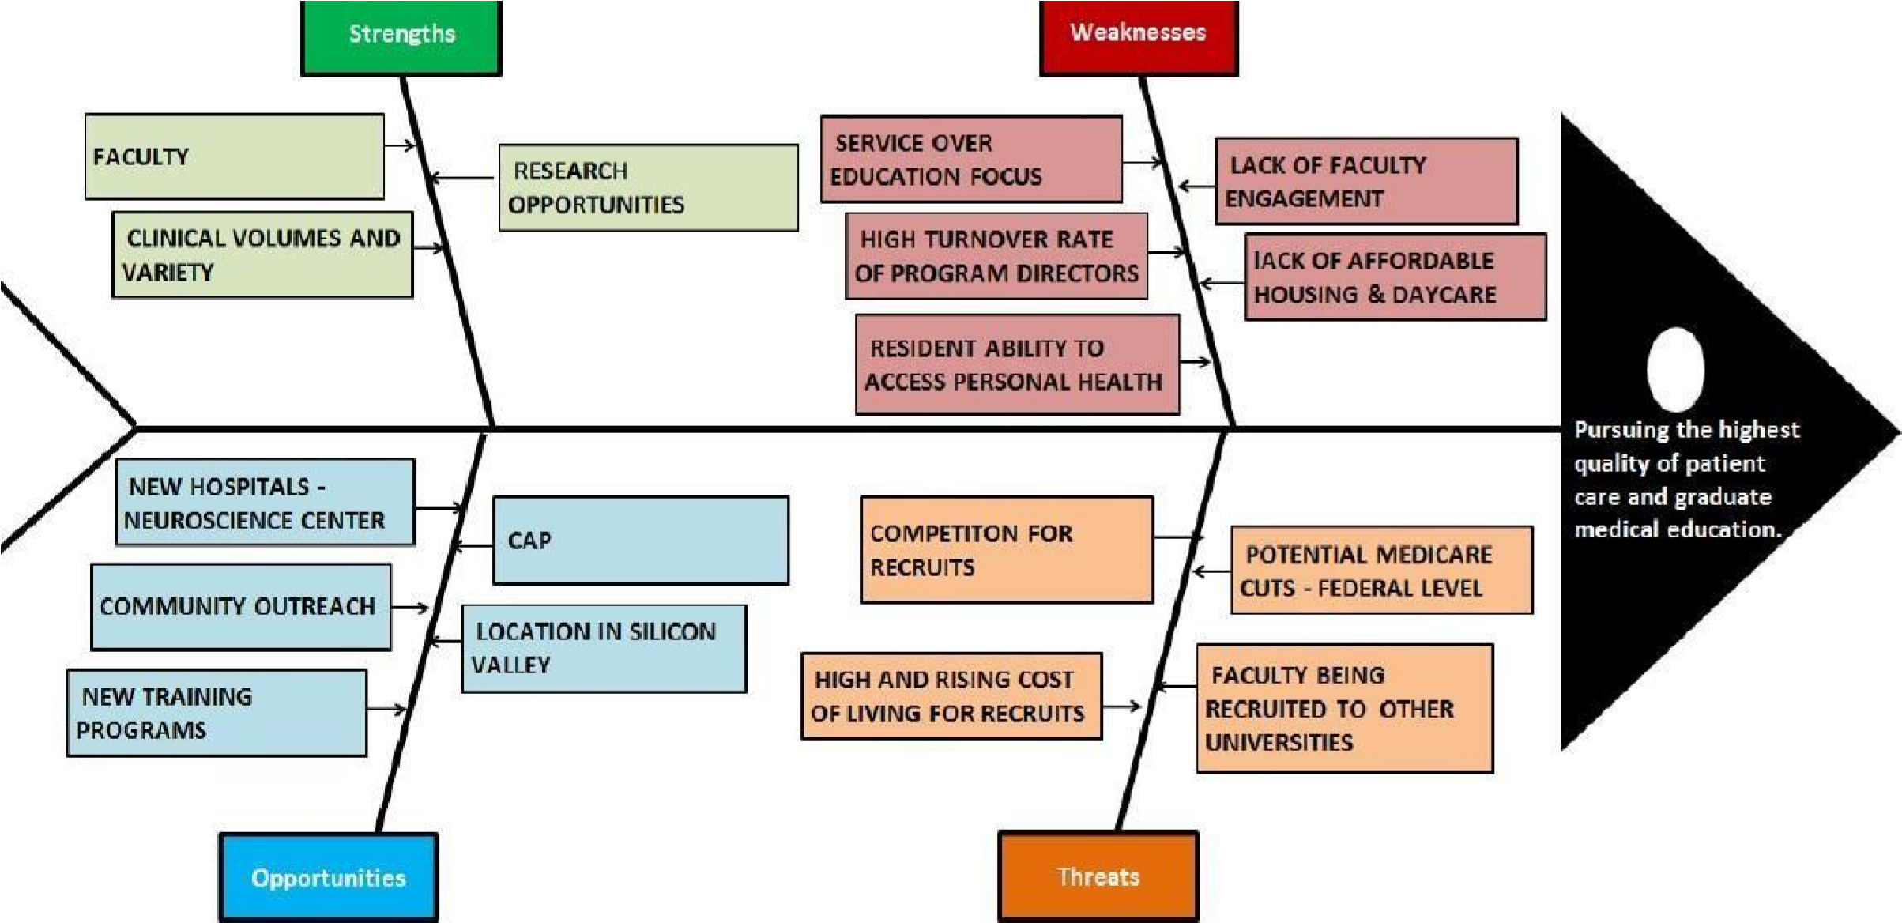
Action Plan

Item | Strategy | Resources | Timeline | Evaluation
Preservation Goals (Strengths)
Elimination Goals (Weaknesses)
Achievement Goals (Opportunities)
Avoidance Goals (Threats)

Name | Signatures
Dr. Aqeela Ayub
Associate Professor
Head of Paediatric Department
Benazir Bhutto Hospital Rawalpindi
Dr. Hina Sattar
Associate Professor
Head of Paediatric Department
Holy Family Hospital Rawalpindi
Prof Rai Muhammad Asghar
Dean of Paediatrics
Rawalpindi Medical University
Prof Muhammad Umer
Vice Chancellor
Rawalpindi Medical University

