Department of Paediatric Surgery Rawalpindi Medical University Rawalpindi

University Residency Program 2023

MS PAEDIATRIC SURGERY

Teaching Program and Training Assessment

#### PREFACE

The horizons of ***Medical Education*** are widening & there has been a steady rise of global interest in *Post Graduate Medical Education*, an increased awareness of the necessity for experience in education skills for all healthcare professionals and the need for some formal recognition of postgraduate training in Pediatric Surgery

We are seeing a rise in the uptake of places on postgraduate courses in medical education, more frequent issues of medical education journals and the further development of e-journals and other new online resources. There is therefore a need to provide active support in *Post Graduate Medical Education* for a larger, national group of colleagues in all specialties and at all stages of their personal professional development. If we were to formulate a statement of intent to explain the purpose of this log book, we might simply say that our aim is to help clinical colleagues to teach and to help students to learn in a better and advanced way. This book is a **state-of-the-art** log book with representation of all activities of the **MD/MS Research Elective** program at RMU.A summary of the curriculum is incorporated in the logbook for convenience of supervisors and residents. It also allows the clinicians to gain an understanding of what goes into basic science discoveries and drug development. Transitional **research** has an **important role** to play in **medical research**, and when used alongside basic science will lead to increased knowledge, discovery and treatment in **Pediatric Surgery**. A perfect monitoring system of a training program including monitoring of teaching and learning strategies, assessment and Research Activities cannot be denied so we at RMU have incorporated evaluation by ***Quality Assurance Cell*** and its comments in the logbook in addition to evaluation by ***University Training Monitoring Cell (URTMC)***. Reflection of the supervisor in each and every section of the logbook has been made sure to ensure transparency in the training program. **The mission of Rawalpindi Medical University** is to improve the health of the communities and we serve through education, biomedical research and health care. As an integral part of this mission, importance of research culture and establishment of a comprehensive research structure and research curriculum for the residents has been formulated and a separate journal for research publications of residents is available.

###### **[Prof. Muhammad Umar](https://www.rmur.edu.pk/)** *(S.I, H.I)*

# Table of CONTENTS

|  |  |  |
| --- | --- | --- |
| S. No. | Title | Page No. |
| **Section I** | **Preamble** | **6** |
| 1 | Introduction | 6 |
| 2 | Mission Statement  2.1) RMU mission statement  2.2) Pediatric Surgery mission statement | 7 |
| 3 | Rules and regulations | 8 |
| 4 | General framework of MS Pediatric Surgery  4.1) Recognized training centers and supervisors.  4.2) duration of program. | 9 |
| 5 | Objectives | 11 |
| 6 | Core Competencies | 13 |
| 7 | Rotations | 17 |
| 8 | Teaching strategies | 18 |
| 9 | Assessment Guidelines | 21 |
| **Section II** | **Course Contents** | **25** |
| 1 | Syllabus of the Course | 25 |
| 2 | Syllabus of MTA Examination | 31 |
| **Section III** | **Research** | **33** |
| 1 | Submission of synopsis | 33 |
| 2 | Submission of thesis | 34 |
| 3 | E Log Book | 34 |
| **Section IV** | **Workshops** | **54** |
| 1 | mandatory workshops | 54 |
| **Section V** | **Life cycle of MS Pediatric Surgery** | **60** |
| 1 | Milestones to be achieved by trainees  1.1 EPAs of pediatric surgery in RMU.  1.2 TOS of 3st year | 60  60  62 |
| **Section VI** | **Assessment strategies**   * 1. MTA, FTA, Thesis defense.   2. Table of specification in Pediatric Surgery   3. Table of specification unit wise.   4. Topic wise distribution of OSCE stations. | **64**  64  67  69  83 |
| **Section VII** | **References** | **86** |
| **Section VIII** | **Appendices** | **87** |

**SECTION I**

**PREAMBLE**

**Introduction**

The MS Pediatric Surgery program is a five (5) years course which will cover all aspect of Pediatric Surgery. The curriculum provides the approved framework for the training of doctors to the level of independent, consultant practice of Pediatric Surgery, addressing the requirements of patients, the population and the strategic health services.

Definition OF SPECIALTY

Pediatric surgery is a specialized branch of surgery focused on diagnosing, treating, and managing surgical conditions in fetuses, infants, children, and adolescents, including congenital anomalies, trauma, tumors, and other diseases requiring surgical intervention.

**Purpose of the curriculum:**

The purpose of the curriculum for Pediatric Surgery is to produce, at certification, competent doctors, able to deliver excellent outcomes for patients as consultant surgeons. The curriculum will provide consultant surgeons with the generic professional and specialty-specific capabilities needed to manage patients presenting with the full range of acute and elective Pediatric Surgery Procedures. Trainees will continue to develop their skills in the specialty of pediatric surgery (both acute and elective such that they are competent to deal with 95% of cases presenting during an unselected emergency ‘take’. Additionally, trainees will be expected to be competent to manage the full range of acute and elective conditions in the generality of their chosen special interest, including the operation. It is acknowledged that the responsibility for patients in this specialist area will include care for patients up to, including and beyond the point of operation. Trainees will be entrusted to undertake the role of the Pediatric Surgery Postgraduate Resident (PGR) during training and will be qualified at certification to apply for consultant posts in Pediatric Surgery.

**Rationale for development of a new curriculum**

The development of a new curriculum ensures alignment with current evidence-based practices, addresses evolving healthcare needs, integrates advancements in technology, and enhances competency-based training to produce well-rounded professionals equipped to meet modern challenges.

# Mission Statement

# RMU Mission Statement:

To impart evidence based research oriented health professional education in order to provide best possible patient care and inculcate the values of mutual respect, ethical practice of healthcare and social accountability

Mission Statement of Pediatric Surgery:

The mission of MS Pediatric Surgery Residency Program of Rawalpindi Medical University is:

1. To start awareness among patient and junior doctors and explain prevention is important to reduce burden of society.
2. To learn management of critical patient.
3. To impart knowledge and skills of Surgery to our trainees.
4. To support and contribute to the research mission of Pediatric Surgery department and the world by pursuing new knowledge, whether at the bench or bedside.
5. To promote the translation of the latest scientific knowledge to the bedside to improve our understanding of disease pathogenesis and ensure that all patients receive the most scientifically appropriate and up to date care.
6. To extend our talents outside the walls of our hospitals and clinics, to promote the health and well-being of communities, locally, nationally, and internationally.
7. To serve as proud ambassadors for the mission of the Rawalpindi Medical University MS Pediatric Surgery Program for the remainder of our professional lives.

The curriculum MS Pediatric Surgery of Rawalpindi Medical University, Rawalpindi is derived from **Accreditation Council for Graduate Medical Education (ACGME)** which is competency / performance-based system competencies.

1. **Knowledge**
2. **Patient Care**
3. **Interpersonal & Communication Skills**
4. **Professionalism**
5. **Practice Based Learning**
6. **System Based Learning**
7. **Research**

**Six ACGME Core Competencies**

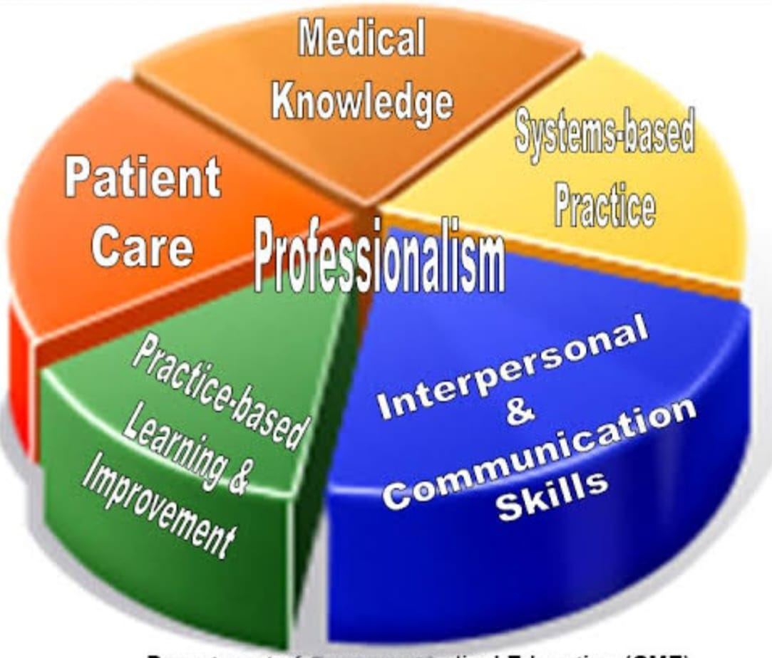

**Overview of Program**

The Rawalpindi Medical University (RMU) MS Pediatric Surgery Training Program is for 5-years. Five-year trainees will undergo Pediatric Surgery and Allied training according to MS Pediatric Surgery Curriculum, RMU. Trainees will work in inpatient, outpatient, and emergency Department and will do rotations in concerned Specialties/Sub-specialties.

During the inpatient rotations, trainees are expected to learn about inpatient evaluation and management of various diseases, their medical and surgical treatment and basic surgical skills as well as the appropriate transfer of patients to outpatient setting. A senior will supervise the trainee in all clinical encounters and is responsible for providing patient centered clinical teaching.

During the outpatient rotations, trainees are expected to learn about outpatient evaluation and management of various surgical disorders as well as delivering surgical care to patients in the outpatient setting, theoretical and practical knowledge related to surgery in general and to their specialty practice.

• Technical and operative skills

• Clinical skills and judgment

• Generic professional and leadership skills.

• An understanding and respect for the multi-professional nature of healthcare and their role in it.

# Rules & Regulations

# 

# Admission Criteria

Applications for admission to MS Pediatric Surgery Training Programs will be invited through advertisement in print and electronic media mentioning closing date of applications and date of Entry Examination by Health Department of Punjab.

**Eligibility:** The applicant on the last date of submission of applications for admission must possess the:

* Basic Medical Qualification of MBBS or equivalent medical qualification recognized by Pakistan Medical & Dental Council.
* Certificate of one-year House Job experience in institution recognized by Pakistan Medical & Dental Council Is essential at the time of interview. The applicant is required to submit the Hope Certificate from the concerned Medical Superintendent that the House Job shall be completed before the Interview.
* Valid certificate of permanent or provisional registration with Pakistan Medical & Dental Council.

**Registration and Enrolment**

* As per policy of Pakistan Medical & Dental Council, the number of PG Trainees/ Students per supervisor shall be maximum O5 per annum for all PG programs.
* The beds to trainee ratio at the approved teaching site shall be at least 5 beds per trainee.
* The University will approve supervisors for MS courses.
* Candidates selected for the courses: after their enrollment at the relevant institutions shall be registered with RMU as per prescribed Registration Regulations.

Exemptions:

A candidate holding FCPS/MRCS/Diplomat/equivalent qualification in Pediatric Surgery shall be exempted from Part I Examination and shall be directly admitted to Part-II Examinations, subject to fulfillment of requirements for the examination.

**General Framework of MS Pediatric Surgery**

|  |  |  |
| --- | --- | --- |
| **COURSE** | **COMPONENTS** | **EXAMINATION** |
|
| **FIRST YEAR** | 06 months in Pediatric Surgery department | Continuous / Formative internal assessment  First Year intra training assessment. Details in assessment section |
| 06 months in General Surgery department |
| Dept Mandatory workshops |
| One disease statistical review preparation and submission |
| **SECOND**  **YEAR** | 12 months rotation in General Surgery | Continuous internal / Formative assessment,  Midterm assessment MTA |
| RMU Mandatory workshops |
| Research Project designed and synopsis prepared and approved by IRB |
| Project Assignment on System related to Pediatric Surgery |
| **THIRD YEAR** | 06 months in Surgery and Allied departments (02 month in specified departments | Continuous internal assessment  In training assessment |
| Data collection and research work |
|  |
| Maturation of Project |
| **FOURTH**  **YEAR** | 12 Months rotation in Pediatric Surgery | Continuous internal/ Formative assessment |
| Article publication related to project |
| **FIFTH**  **YEAR** | 12 Months rotation in Pediatric Surgery | Continuous internal/ Formative assessment  Final Term exam FTA  Defense of thesis will be at the end of fifth year |
| Thesis writing must be completed and submitted at least 06 months before final exams. |

# Recognized Training Centers and supervisors

Three hospitals attached with Rawalpindi Medical University (RMU) and Allied Teaching Hospitals will start with MS program, i.e.

* Department of Pediatric Surgery (Holy Family Hospital, Rawalpindi)

Teaching faculty with five or more than five years teaching experience in a PMDC recognized teaching hospital will be eligible to act as supervisors for MS program.

# Duration of Program

The duration of MS Pediatric Surgery course shall be five (5) years. Rotations with structured training in a recognized department under the guidance of an approved supervisor.

The course is structured in two parts:

MTA is structured for the 1st and 2nd calendar years in MS Pediatric Surgery. The candidate shall undertake clinical training in fundamental concepts of General Surgery. At the end of 2nd year, examination shall be held in fundamental concepts of Surgery.by the end of first year the resident must write one disease statistical review (DSR).

FTA is structured for 3rd, 4th and 5th calendar years in MS Pediatric Surgery. It has two components: Clinical and Research. The candidate shall undergo clinical training to achieve educational objectives of MS (knowledge, skills & Attitude) along with rotation in relevant fields.

The clinical training shall be competency based. There shall be generic and specialty specific competencies and shall be assessed by continuous clinical Assessment and work place-based assessment including DOPS, CBD and Mini CEX.

Research Component and thesis writing shall be completed over five years’ duration of the course. Candidates will spend total time equivalent to one calendar year for research during the training. Research can be done as one block, or it can be done in the form of regular periodic rotation over four years if total research time is equivalent to one calendar year.

**Aims and Objectives of the Program:**

The aim of the five-years MS program in Pediatric Surgery is to train residents to acquire the competency so that they can become safe surgeons, researchers and skillful after completion of their training.

***General Objectives:***

1. To provide a broad experience in Pediatric Surgery with **multidisciplinary approach.**
2. To enhance medical knowledge, clinical reasoning, and competence in bedside diagnostic and therapeutic procedures.
3. To achieve the professional requirements to prepare for advance **training in** Pediatric Surgery**.**
4. To cultivate professional attitude and enhance communication skills towards patients, their families and other healthcare professionals.
5. To enhance sensitivity and responsiveness to community needs and the economics of health care delivery.
6. To enhance critical thinking, brain boosting, self-directed learning, and interest in research.
7. To cultivate the practice of evidence-based medicine and critical appraisal skills.
8. To inculcate a commitment to continuous medical education, surgical skills, and professional development.
9. To provide a broad training in surgery and in-depth training experience in Pediatric Surgery at a level for trainees to acquire competence and professionalism in the diagnosis, investigation, and treatment including pediatric surgical operations for various elective and emergency surgical problems towards the delivery of holistic patient care.
10. To acquire competence in managing emergencies and identifying problems in patients referred for primary care, timely identify which patient needs urgent surgical treatment and referral to another specialty if needed.
11. To manage patients in surgical units in regional/District hospitals; to be a leader in the health care delivery team and to work closely with networking units which provide convalescence, rehabilitation, and long-term care.
12. To encourage the development of skills in communication and collaboration with the community towards health care delivery.
13. To foster the development of skills in the critical appraisal of new methods of investigation and treatment.
14. To reinforce self-learning and commitment to continued updating in all aspects of Surgery.
15. To encourage contributions aiming at advancement of knowledge and innovation in surgery through basic surgical skills and clinical research and teaching of junior trainees and other health related professionals.
16. To acquire professional competence in training future trainees in Pediatric Surgery at Rawalpindi Medical University.

***Specific Objectives***

***Medical Knowledge (K)***

1. Understanding of basic core knowledge of pediatric surgery and other surgical specialties.
2. Etiology, pathophysiology, clinical manifestation, disease course, prognosis, investigation, and management of pediatric surgical diseases.
3. Scientific basis and recent advances in pathophysiology, diagnosis and management of diseases.
4. Spectrum of clinical manifestations and interaction of multiple medical and surgical diseases in the same patient.
5. Psychological and social aspects of medical illnesses.
6. Effective use and interpretation of investigations and special diagnostic & therapeutic procedures.
7. Critical analysis of the efficacy, cost-effectiveness, and cost-utility of treatment modalities.
8. Patient safety and risk management
9. Medical audit and quality assurance
10. Ethical principles and medico legal issues related to medical illnesses.
11. Updated knowledge on evidenced-based medicine and its implications for diagnosis and treatment of patients in a pediatric surgical unit.
12. Familiarity with different care approaches of health facilities towards the patients care with medical illnesses, including convalescence, rehabilitation, palliation, long term care, and medical ethics.
13. Knowledge of patient safety and clinical risk management.
14. Awareness and concern for the cost-effectiveness and risk-benefits of various advanced treatment modalities.
15. Familiarity with the concepts of administration, management, and overall forward planning for Pediatric Surgery.

***Skills (S)***

1. Ability to take a detailed history, gather relevant data from patients, and assimilate the information to develop diagnostic and management plan.
2. Trainees are expected to record an initial history, physical examination and follow-up notes as well as deliver comprehensive oral presentations to their team members based on written documents. Competence in eliciting abnormal physical signs and interpreting their significance.
3. Ability to relate clinical abnormalities with pathophysiologic states and diagnosis of diseases.
4. Ability to select relevant investigation and diagnostic and therapeutic procedures.
5. Residents should be able to interpret basic as well as advanced laboratory data as related to the disorder/disease.
6. Basic understanding of routine laboratory and ancillary tests accordingly. Trainees will understand the necessity of incorporating sensitivity, specificity, pre-test probability and Bayes laws/theorem in the ordering of evaluating patients’ signs and symptoms.
7. The formulation of a differential diagnosis with up-to-date scientific evidence, clinical judgment using history, physical examination, data, and the development of a prioritized problem list to select tests and make effective therapeutic decisions.
8. Assessing the risks, benefits, and costs of varying, effective treatment options; involving the patient in decision-making via open discussion; selecting drugs from within classes; and the design of basic treatment programs and using critical pathways when appropriate.
9. Residents must be able to assist and perform all general and laparoscopic surgical procedures based on their level and year of training.
10. Residents should be instructed in additional procedural skills that will be determined by the training environment, residents practice expectations, the availability of skilled teaching faculty, and privilege delineation.
11. Skills in performing important bedside diagnostic and therapeutic procedures and understanding of their indications. Trainees should acquire competence through supervised performance of the required number of each of the following procedures during the 1-year training period and should record them in the Trainee’s Logbook.
12. Ability to present clinical problems and literature review in grand rounds and seminars.
13. Good communication skills and interpersonal relationships with patients, families, medical colleagues, nursing, and allied health professionals.
14. Ability to mobilize appropriate resources for management of patients at different stages of illnesses, including critical care, consultation from other disciplines, ambulatory and rehabilitative services, and community resources.
15. Competence /Skills in the diagnosis and management of patients in surgical emergency, complex cases, unusual presentations, etc.
16. Ability to implement strategies for preventive care and early detection of diseases in collaboration with primary and community doctors.
17. Ability to understand medical statistics and critically appraise published work, clinical research on disease presentations and treatment outcomes. Experience in basic or clinical research within the training program should lead to publications and presentation in seminars or conferences.
18. Practice evidence-based learning with reference to research and scientific knowledge pertaining to their discipline through comprehensive training in Research Methodology
19. Ability to recognize and appreciate the importance of cost-effectiveness of treatment modalities.
20. The identification of key information resources and the utilization of medical literature to expand one’s knowledge base and to search for answers to medical problems. They will keep abreast of current literature and be able to integrate it to clinical practice.
21. ***Attitudes (P)***
22. The well-being and restoration of the health of patients must be of paramount consideration.
23. Empathy and good rapport with patients and Parents are essential attributes.
24. An aspiration to be the team-leader in total patient care involving nursing and allied health professionals should be developed.
25. The cost-effectiveness of various investigations and treatments in patient care should be recognized.
26. The privacy and confidentiality of patients and the sanctity of life must be respected.
27. The development of a functional understanding of informed consent, advanced directives, and the physician-patient relationship.
28. Ability to appreciate the importance of the effect of disease on the psychological and socio-economic aspects of individual patients and to understand patients’ psycho-social needs and rights, as well as the medical ethics involved in patient management.
29. To learn advances in Pediatric Medicine, MIS and other Specialties & timely refer patients for appropriate treatment.
30. The promotion of health via immunizations, periodic health screening, and risk factor assessment and modification.
31. Recognition that teaching and research are important activities for the advancement of the profession.
32. Adhere to the principles of sterilization and disinfection and proper operation theater techniques including scrubbing, draping and infection control practices during surgical procedures and bedside.
33. Develop and execute attitudes pertaining to effective team work during surgical procedures and while dealing with disaster like situations in emergency, wards and operation theaters.

***Other Required Core Competencies:***

* **Patient Care**
* Residents are expected to provide patient care compassionately, effectively for the promotion of health, prevention of illness, treatment of disease and end of life decisions.
* Gather accurate, essential information from all sources, including interviews, physical examinations, medical records, and diagnostic/therapeutic procedures.
* Make informed recommendations about preventive, diagnostic and therapeutic options, interventions based on clinical judgment, scientific evidence, and patient preference.
* Develop, negotiate, and implement effective patient management plans and integration of patient care.
* Perform competently the diagnostic and therapeutic procedures considered essential to the practice of Pediatric surgery.
* **Interpersonal and Communication Skills**
* Residents are expected to demonstrate interpersonal communication skills that enable them to establish and maintain professional relationships with patients, families, and other members of health care teams.
* Provide effective and professional consultation to other physicians and health care professionals to deal with ethically professional relationships with patients, their families, and colleagues.
* Use effective listening, nonverbal, questioning, narrative skills to communicate with patients and families.
* Interact with consultants in a respectful, appropriate manner.
* Maintain comprehensive, timely, and legible medical records.
* **Professionalism**
* Residents are expected to demonstrate behaviors that reflect a commitment to continuous professional developmental, ethical practice, an understanding and sensitivity to diversity and a responsible attitude toward their patients*,* their profession, and society.
* Demonstrate respect, compassion, integrity, and altruism in relationships with patients, families, and colleagues.
* Demonstrate sensitivity and responsiveness to the gender, age, culture, religion, sexual preference, socioeconomic status, beliefs, behavior and disabilities of patients and professional colleagues.
* Adhere to principles of confidentiality, scientific/academic integrity, and informed consent.
* Recognize and identify deficiencies in peer performance.
* Understand and demonstrate the skill and art of end-of-life care.
* **Practice-Based Learning and Improvement**
* Residents are expected to be able to use scientific evidence, methods to investigate, evaluate, and improve patient care practices.
* Identify areas for improvement and implement strategies to enhance knowledge, skills, attitudes, and processes of care.
* Analyze and evaluate practice experiences and implement strategies to continually improve the quality of patient practice.
* Develop and maintain a willingness to learn from errors and use errors to improve the system or processes of care.
* Use information of technology or other available methodologies to access and manage information, support patient care decisions, and enhance both patient and physician education.
* Develop error prevention skills and critical thinking leading to prevention of cognitive dispositions to respond.
* **Systems-Based Practice**
* Residents are expected to demonstrate both an understanding of the contexts and systems in which health care is provided, and the ability to apply this knowledge to improve and optimize health care.
* Understands accesses and utilizes the resources, providers, and systems necessary to provide optimal care.
* Understand the limitations and opportunities inherent in various practice types and delivery systems and develop strategies to optimize care for the individual patient.
* Apply evidence-based, cost-conscious strategies to prevention, diagnosis, and disease management.
* Collaborate with other members of the health care team to assist patients in dealing effectively with complex systems and to improve systematic processes of care.

**Methods of Teaching & Learning during course conduction**

***Inpatient Services:***

Pediatric Surgery residents will have work in surgery & allied for an initial 2 years and will appear in MTA Surgery. This training component will be according to RMU MS Surgery initial 2 years’ curriculum. Afterwards, the resident will work in Pediatric Surgery during 3rd ,4th year and 5th of training.

1. ***Outpatient Experiences:*** *Pediatric* Surgery residents should demonstrate expertise in diagnosis and management of patients in acute care clinics and gain experience in dealing with diagnosis of hernia, cholecystitis, acute abdomen, anorectal malformations, hirshsprung’s disease, hypertrophic pyloric stenosis and congenital malformations.

1. ***Emergency services:*** Residents take an early active role in patient care and obtain decision-making roles quickly. Within the Emergency Department, residents direct the initial stabilization of all critical patients, manage airway interventions, and oversee all critical care being first responder, and be able to diagnose surgical emergency such as acute abdomen, blunt trauma abdomen/chest, penetrating injury, and be able to perform minor surgical procedures like chest intubation, central line catheterization, FAST scan etc.

***3.Electives/Specialty Rotations:*** Pediatric Surgery resident will elective rotations in a variety of electives including orthopedic, neurosurgery, plastic surgery/cardiac surgery. Residents may also select electives at other institutions if the parent department does not offer the experiences they want.

***4.Mandatory Workshops:*** Residents achieve hands on training while participating in mandatory workshops of Basic surgical skills, Research Methodology, Communication Skills, Computer & Internet, and Clinical Audit. Specific objectives are given in detail in the relevant section of Mandatory Workshops.

***5.Introductory Lecture Series (ILS):*** Various introductory topics are presented by Pediatric surgery faculty to introduce interns to basic and essential topics in Pediatric surgical diseases.

***6.Long and Short Case Presentations:*** Giving an oral presentation on ward rounds is an important skill for residents to learn. Presenting complicated cases in MDM, learning newer surgical techniques based on literature and presenting in journal club and quarterly workplace-based assessment and DOPS.

***7.Seminar Presentation:*** Seminar is held in a conference format. Senior residents present an in-depth review of a surgical topic as well as their own research. Residents are formally critiqued by both the associate program director & their resident colleagues.

***8.Journal Club Meeting (JC):*** A resident will be assigned to present, in depth, a research article or topic of their choice of actual or potential broad interest and application. Two hours per month should be allocated to discussion of any current articles or topics introduced by any participant. Faculty or outside researchers will be invited to present outlines or results of current research activities. The article should be critically evaluated, and its applicable results should be highlighted, which can be incorporated in clinical practice. Record of all such articles should be maintained in the relevant department.

***9.Small Group Discussions/ Problem based learning/ Case based learning:*** Traditionally small groups consist of 8- 12 participants. Small groups can take on a variety of different tasks, including problem solving, role play, discussion, brainstorming, debate, workshops, and presentations. Generally, students prefer small group learning to other instructional methods. From the study of a problem students develop principles and rules and generalize their applicability to a variety of situations PBL is said to develop problem solving skills and an integrated body of knowledge. It is a student-centered approach to learning, in which students determine what and how they learn. Case studies help learners identify problems and solutions, compare options, and decide how to handle a real situation.

***10.Discussion/Debate:*** There are several types of discussion tasks which would be used as learning method for residents including: ***guided discussion*** ,in which the facility at or poses a discussion question to the group and learners offer responses or questions to each other's contributions as a means of broadening the discussion's scope; ***inquiry-based discussion***, in which learners are guided through a series of questions to discover some relationship or principle; ***exploratory discussion***, in which learners examine their personal opinions, suppositions or assumptions and then visualize alternatives to these assumptions; and ***debate*** in which students argue opposing sides of a controversial topic. With thoughtful and well-designed discussion tasks, learners can practice critical inquiry and reflection, developing their individual thinking, considering alternatives and negotiating meaning with other discussants to arrive at a shared understanding of the issues at hand.

***11.Case Conference (CC):*** These sessions are held three days each week; the focus of the discussion is selected by the presenting resident. For example, some cases may be presented to discuss a differential diagnosis, while others are presented to discuss specific management issues.

***12.Grand Rounds (GR)*:** The Department of Pediatric Surgery hosts Grand Rounds on a weekly basis. All residents on inpatient floor teams, as well as those on ambulatory block rotations and electives are expected to attend.

***13.Professionalism Curriculum (PC)*:** This is an organized series of recurring large and small group discussions focusing upon current issues and dilemmas in medical professionalism and ethics presented primarily by an associate program director.

***14.Evening Teaching Rounds:*** During these sign-out rounds, the inpatient senior Resident or registrar makes a brief educational presentation on a topic related to a patient currently on service, often related to the discussion from morning report. Serious cases are mainly focused during evening rounds.

***15.Clinico-Pathological Conferences:*** The clinic pathological conference, popularly known as CPC primarily relies on case method of teaching medicine. It is a teaching tool that illustrates the logical, measured consideration of a differential diagnosis used to evaluate patients. The process involves case presentation, diagnostic data, discussion of differential diagnosis, logically narrowing the list to few selected probable diagnoses and eventually reaching a final diagnosis and its brief discussion. The idea was first practiced in Boston, back in 1900 by a Harvard internist, Dr. Richard C. Cabot who practiced this as an informal discussion session in his private office. Dr. Cabot incepted this from a resident, who in turn had received the idea from a roommate, primarily a law student.

***16.Evidence Based Medicine (EBM)*:** Residents are presented a series of monthly lectures presented to allow residents to learn how to critically appraise journal articles, stay current on statistics, etc. The lectures are presented by the program director.

17.***Clinical Audit Based Learning:*** “Clinical audit is a quality improvement process that seeks to improve patient care and outcomes through systematic review of care against explicit criteria…Where indicated, changes are implemented…and further monitoring is used to confirm improvement in healthcare delivery.” *Principles for Best Practice in Clinical Audit (2002, NICE/CHI)*

***18.Peer Assisted Learning:*** Any situation where people learn from, or with, others of a similar level of training, background or other shared characteristic. Provides opportunities to reinforce and revise their learning. Encourages responsibility and increased self-confidence. Develops teaching and verbalization skills. Enhances communication skills, and empathy. Develops appraisal skills (of self and others) including the ability to give and receive appropriate feedback. Enhance organizational and team-working skills.

***19.Morbidity and Mortality Conference (MM)*:** The M&M Conference is held throughout the year. A case, with an adverse outcome, though not necessarily resulting in death, is discussed and thoroughly reviewed. Faculty members from various disciplines are invited to attend, especially if they were involved in the care of the patient. The discussion focuses on how care could have been improved.

***20.Clinical Case Conference***: Each resident, except when on vacation, will be responsible for at least one clinical case conference each month. The cases discussed may be those seen on either the consultation or clinic service or during rotations in specialty areas. The resident, with the advice of the Attending Physician on the Consultation Service, will prepare and present the case(s) and review the relevant literature

***21.SEQ as assignments on the content areas:*** SEQs assignments are given to the residents on regular basis to enhance their performance during written examinations.

***22.Skill teaching in ICU, emergency, ward settings& skill laboratory:*** Two hours twice a month should be assigned for learning and practicing clinical skills. List of skills to be learnt during these sessions is as follows:

1.Residents must develop a comprehensive understanding of the indications, contraindications, limitations, complications, techniques, and interpretation of results of those technical procedures integral to the discipline (mentioned in the Course outlines).

2. Residents must acquire knowledge of and skill in educating patients about the technique, rationale and ramifications of procedures and in obtaining procedure-specific informed consent. Faculty supervision of residents in their performance is required, and each resident's experience in such procedures must be documented by the program director

3.Residents must have instruction in the evaluation of medical literature, clinical epidemiology, clinical study design, relative and absolute risks of disease, medical statistics and decision-making.

4.Training must include cultural, social, family, behavioral and economic issues, such as confidentiality of information, indications for life support systems, and allocation of limited resources.

5.Residents must be taught the social and economic impact of their decisions on patients, the primary care physician and society. This can be achieved by attending the bioethics lectures and becoming familiar with Project Professionalism Manual such as that of the American Board of Internal Medicine.

6.Residents should have instruction and experience with patient counseling skills and community education.

7.This training should emphasize effective communication techniques for diverse populations, as well as organizational resources useful for patient and community education.

***23.Bed Side Teaching Rounds in Ward:*** *“To study the phenomenon of disease without books is to sail an uncharted sea whilst to study books without patients is not to go to sea at all” Sir William Osler 1849-1919.*Bedside teaching is regularly included in the ward rounds. Learning activities include the physical exam, a discussion of particular medical diseases, psychosocial and ethical themes, and management issues

***24.Directly Supervised Procedures - (DSP)*:** Residents learn procedures under the direct supervision of an attending or fellow during some rotations. For example, appendectomy, hernioplasty, cholecystectomy, exploratory laparotomy.

***25.Self-Directed Learning:*** self-directed learning residents have primary responsibility for planning, implementing, and evaluating their effort. It is an adult learning technique that assumes that the learner knows best what their educational needs are. The facilitator’s role in self-directed learning is to support learners in identifying their needs and goals for the program, to contribute to clarifying the learners' directions and objectives and to provide timely feedback. Self-directed learning can be highly motivating, especially if the learner is focusing on problems of the immediate present, a potential positive outcome is anticipated and obtained and they are not threatened by taking responsibility for their own learning.

***26.Follow Up Clinics:*** The main aims of our clinic for patients and relatives include .

(a) **Rehabilitation information and support:** We discuss with patients and relatives their individualized recovery from critical illness. This includes expectations, realistic goals, and change in family dynamics and coming to terms with life style changes.

(b)**Identifying physical, psychological or social problems** some of our patients have problems either as a result of their critical illness or because of other underlying conditions. The follow-up team will refer patients to various specialties, if appropriate.

(c)**Promoting a quality service**: By highlighting areas which require change in nursing and medical practice, we can improve the quality of patient and relatives care. Feedback from patients and relatives about their ICU & ward experience is invaluable. It has initiated various audits and advance clinical practice for the benefit of patients in the future.

***27.Core Curriculum Meeting:*** All the core topics of Pediatric Surgery should be thoroughly discussed during these sessions. The duration of each session should be at least two hours once a month. It should be chaired by the chief resident (elected by the residents of the relevant discipline). Each resident should be given an opportunity to brainstorm all topics included in the course and to generate new ideas regarding the improvement of the course structure

***28.Annual Grand Meeting*** Once a year all residents enrolled for MS Pediatric Surgery and other Specialties should be invited to the annual meeting at RMU. One full day will be allocated to this event. All the chief residents from affiliated institutes will present their annual reports. Issues and concerns related to their relevant courses will be discussed. Feedback should be collected and suggestions should be sought in order to involve residents in decision making. The research work done by residents and their literary work may be displayed. In the evening an informal gathering and dinner can be arranged. This will help in creating a sense of belonging and ownership among students and the faculty.

***29.Learning through Maintaining Log Book:*** *it is*sued to list the core clinical problems to be seen during the attachment and to document the student activity and learning achieved with each patient contact.

1. ***Learning Through Maintaining Portfolio:*** Personal Reflection is one of the most important adult educational tools available. Many theorists have argued that without reflection, knowledge translation and thus genuine “deep” learning cannot occur. One of the Individual reflection tools maintaining portfolios, Personal Reflection allows students to take inventory of their current knowledge skills and attitudes, to integrate concepts from various experiences, to transform current ideas and experiences into new knowledge and actions and to complete the experiential learning cycle.
2. ***Task-Based-Learning:*** A list of tasks is given to the students: participate in consultation with the attending staff, interview and examine patients, review a number of new radiographs with the radiologist.
3. ***Teaching in the Ambulatory Care Setting:*** A wide range of clinical conditions may be seen. There are large numbers of new and return patients. Students have the opportunity to experience a multi-professional approach to patient care. Unlike ward teaching, increased numbers of students can be accommodated without exhausting the limited No. of suitable patients.
4. ***Community Based Medical Education:*** CBME refers to medical education that is based outside a tertiary or large secondary level hospital. Learning in the fields of epidemiology, preventive health, public health principles, community development, and the social impact of illness and understanding how patients interact with the health care system. Also used for learning basic clinical skills, especially communication skills.
5. ***Audio Visual Laboratory:*** audio visual material for teaching skills to the residents is used specifically in Pediatric Surgery.

***30.* E-learning/Web-Based Education/Computer-Assisted instruction:** Computer technologies, including the Internet, can support a wide range of learning activities from dissemination of lectures and materials, access to live or recorded presentations, real-time discussions, self-instruction modules and virtual patient simulations. distance-independence, flexible scheduling, the creation of reusable learning materials that are easily shared and updated, the ability to individualize instruction through adaptive instruction technologies and automated record keeping for assessment purposes.

***31. Other teaching strategies specific for different specialties as mentioned in the relevant parts of the curriculum*** some of the other teaching strategies which are specific for certain domains of Pediatric Surgery are given along with relevant modules

***32.Learning through simulation and dry lab***

Athletes don’t train on the day of competition , all Pediatric surgical trainees are expected to practice and achieve proficiency in basic surgical skills in like instrument handling , Knotting , tissue handling and the art of assistance at surgery by spending adequate time in skill Lab and simulation labs , all Surgical units are required to establish an simulation and skill lab in their respective departments which would be regularly visited by the internal quality assurance department of RMU.

**33.Surgical / procedural competencies**

The clinical skills, which a surgeon must have are, varied and complex. A complete list of the same necessary for residents and trainers is given below. Some examples, which are a sub sample of the whole, follow. These are to be taken as guidelines rather than definitive requirements. Key for assessing competencies:

**1. Observer status.**

**2. Assistant status.**

**3. Performed under direct supervision.**

**4. Performed under indirect supervision.**

**5. Performed independently**

**Note: Levels 4 and 5 for practical purposes are almost synonymous**

### ROTATIONS

# Modular System

The duration of MS Pediatric Surgery course shall be five (5) years consisting of structured training in a recognized department under the guidance of an approved supervisor. The course is structured in two phases:

**Phase I** is structured for the 1st and 2nd calendar year.

|  |  |  |
| --- | --- | --- |
| **S. No** | **Discipline** | **Duration** |
|  | Pl Pediatric Surgery | 06 6 months **(Initial)** |
|  | G General Surgery | 01 2-year |
|  | Tr Trauma and Orthopedics | 02 03 months **(Mandatory)** |
|  | Dermatology | 02 months **(Mandatory)** |
|  | Surgical ICU | 02 02 months **(Mandatory)** |

**Phase II** is structured for 3rd,4th and 5th calendar years in MS paediatric surgery. The candidate shall undergo training to achieve the educational objectives of M.S paediatric surgery (knowledge and skills) along with rotations in the relevant fields. The training shall be competency based. There shall be generic and specialty specific competencies and shall be assessed by continuous Internal Assessment.

**Candidate will attend 03 mandatory rotations as listed below**

|  |  |  |
| --- | --- | --- |
| **S. No** | **Discipline** | **Duration** |
|  | paediatric surgery in another Department | 02 month |
|  | Maxilofacial | 02 month |
|  | Physical Rehabilitation/ Neuro Surgery | 02 month |

* Credit hours will be awarded to the candidates after they have attended and cleared the Internal assessment of each module.
* MS (paediatric surgery) will comprise of 03 exams; one at the end of 1st year (conducted by the General Surgery Department), then at the end of 2nd year of training (MTA) and then on completion of 5th year of training (FTA).

## A-3: Weekly academic activity Time Table

**A-4: Daily Training plan for all PGTs**

|  |  |
| --- | --- |
| Plan for all PGTs except those in OPD/ER & OT Groups | |
| Time | Activity |
| 8am to 9am | Morning Meeting  (Mondasy,Tuesday, Saturday ) |
| 9 am to 10.30am | Allocated Ward rounds |
| 10.30am -12.30 pm | SR / Consultant rounds & Bedside teaching |
| 12.30pm to 2pm | Round order Carrying out  (Deputed PGTs will go to teaching activity on specified days) |
| **Plan for PGTs in OPD/ER & OT Groups** | |
| 8am to 2pm | Work on deputed station and learn by bedside teaching and small group discussion. Acquire surgical skills by assistance and by working under supervision. |

## Research & Thesis writing

|  |  |  |  |  |  |
| --- | --- | --- | --- | --- | --- |
|  | 1st Year | 2nd year | 3rd year | 4th year | 5th year |
| First month | Research ID |  |  |  |  |
| 0-6 months | Synopsis topic selection | Synopsis submission, evaluation, DRB and ERB approval | Data collection and analysis | Data Collection and analysis | Thesis approval |
| 7th -12th month | Synopsis topic submission | Synopsis BASR approval | Thesis writing | Thesis writing | Certificate of thesis approval to be given |
| End of year | One disease statistical review |  |  |  |  |

# Section B: Syllabus

B-1: Summary of Syllabus

### Basic Principles of Surgery

* History of surgery
* Preparing a patient for surgery
* Principles of operative surgery: asepsis, sterilization and antiseptics
* Surgical infections and antibiotics
* Basic principles of anaesthesia and pain management
* Acute life support and critical care:
  + Pathophysiology and management of shock
  + Fluids and electrolyte balance/ acid base metabolism
  + Haemostasis, blood transfusion
* Trauma: assessment of polytrauma, triage, basic and advanced trauma
* Accident and emergency surgery
* Wound healing and wound management
* Nutrition and metabolism
* Principles of burn management
* Principles of surgical oncology
* Principles of laparoscopy and endoscopy
* Organ transplantation
* Informed consent and medico-legal issues
* Molecular biology and genetics
* Operative procedures for common surgical manifestations e.g cysts, sinuses, fistula, abscess, nodules, basic plastic and reconstructive surgery
* Principles of basic diagnostic and interventional radiography
* Principles and interpretation of conventional and advanced radiographic procedures

#### Common Surgical Skills Incision of skin and subcutaneous tissue:

* Langer’s lines
* Healing mechanism
* Choice of instrument
* Safe practice

#### Closure of skin and subcutaneous tissue:

* Options for closure
* Suture and needle choice
* Safe practice

#### Knot tying:

* Choice of material
* Single handed
* Double handed
* Superficial
* Deep

#### Tissue retraction:

* Choice of instruments
* Placement of wound retractors
* Tissue forceps

#### Use of drains:

* Indications
* Types
* Insertion
* Fixation
* Management/removal

#### Incision of skin and subcutaneous tissue:

* Ability to use scalpel, diathermy and scissors

#### Closure of skin and subcutaneous tissue:

* Accurate and tension free apposition of wound edges

#### Haemostasis:

* Control of bleeding vessel (superficial)
* Diathermy
* Suture ligation
* Tie ligation
* Clip application
* Plan investigations
* Clinical decision making
* Case work up and evaluation; risk management

#### Pre-operative assessment and management:

* Cardiorespiratory physiology
* Diabetes mellitus
* Renal failure
* Pathophysiology of blood loss
* Pathophysiology of sepsis
* Risk factors for surgery
* Principles of day surgery
* Management of comorbidity

#### Intraoperative care:

* Safety in theatre
* Sharps safety
* Diathermy, laser use
* Infection risks
* Radiation use and risks
* Tourniquets
* Principles of local, regional and general anesthesia

#### Post-operative care:

* Monitoring of postoperative patient
* Postoperative analgesia
* Fluid and electrolyte management
* Detection of impending organ failure
* Initial management of organ failure
* Complications specific to particular operation
* Critical care

#### Blood products:

* Components of blood
* Alternatives to use of blood products
* Management of the complications of blood product transfusion including children

#### Antibiotics:

* Common pathogens in surgical patients
* Antibiotic sensitivities
* Antibiotic side-effects
* Principles of prophylaxis and treatment

#### Safely assess the multiply injured patient:

* History and examination
* Investigation
* Resuscitation and early management
* Referral to appropriate surgical subspecialties

#### Technical Skills

* Central venous line insertion
* Chest drain insertion
* Diagnostic peritoneal lavage
* Bleeding diathesis & corrective measures, e.g. warming, packing
* Clotting mechanism; Effect of surgery and trauma on coagulation
* Tests for thrombophilia and other disorders of coagulation
* Methods of investigation for suspected thromboembolic disease
* Anticoagulation, heparin and warfarin
* Role of V/Q scanning, CT angiography and thrombolysis
* Place of pulmonary embolectomy
* Awareness of symptoms and signs associated with pulmonary embolism and DVT
* Role of duplex scanning, venography and d-dimer measurement
* Initiate and monitor treatment

#### Diagnosis and Management of Common Surgical Conditions:

* Child with abdominal pain
* Vomiting child
* Trauma
* Groin conditions
* Hernia
* Hydrocele
* Penile inflammatory conditions
* Undescended testis
* Acute scrotum
* Abdominal wall pathologies
* Urological conditions
* Constipation
* Head / neck swellings
* Intussusception
* Abscess
* In growing toenail

In terms of general experience, it is expected that trainees would have gained exposure to the following procedures and to be able to perform those marked (*) under direct supervision.

* Elective Procedures
* Inguinal hernia
* (not neo-natal)
* Orchidopexy
* Circumcision*
* Lymph node biopsy*
* Abdominal wall hernia
* Insertion of CV lines
* Management of in growing toenails*
* EUA rectum*
* Manual evacuation*
* Open rectal biopsy
* Excision of skin lesions*
* Emergency Procedures
* Appendicectomy
* Incision and drainage of abscess*
* Pyloromyotomy
* Operation for testicular torsion*
* Insertion of pleural drain*
* Insertion of suprapubic catheter*
* Reduction of intussusception

# MS PEDIATRIC SURGERY

## Clinical Component

Advanced Professional Education in Pediatric Surgery

The aim of this stage is to allow the trainee to continue to develop the advanced skills knowledge and attitude required to practice as consultant Pediatric Surgeon in Pakistan and Abroad.

Trainee will build on the basic skills and competences achieved in the initial stage of the program, gaining exposure to the more specialized areas of practice.

The goals as outlined in initial stages remain pertinent, as it is expected that the trainees will continue to build on their clinical experience and move beyond competent practice to the level of an advanced practitioner, in many of the areas.

The different sections will contain a mixture of information on relevant conditions, symptom patterns and associated surgical operations. This is in an attempt to represent the variety of clinical practice. Overall these goals

outlined are simply guides to progress and should be used by trainees, trainers and Program Directors to help plan rotational placements to ensure a full breadth; of training.

The difference surgical sections are:

* + Emergency surgery
  + Gastrointestinal surgery
  + Neonatal surgery
  + Urology
  + Thoracic surgery
  + Orthopedic Surgery
  + Neurosurgery
  + Surgical Oncology
  + Surgical Endocrinology
  + Research and Audit
  + Teaching and Training

By the end of the final stage of training trainees including those who are following an academic pathway will have:

* Achieved the level of an advanced practitioner in the management of the common surgical problems of childhood
* Acquired the skills to practice with integrity, respect and compassion
* Gained sufficient theoretical knowledge and practical experience to be able to enter for the examination in pediatric surgery as set by the Rawalpindi medical university in Pediatric Surgery.
* Increasing exposure to the more specialized areas of pediatric surgery to include clinical presentation, operative and non-operative management of cases within the different areas.
* Competence in further range of operations common to pediatric practice
* Developed skills and experience in areas of more specialized practice – with a view to developing a sub-specialty interest if appropriate.
* Achieved the level of advanced practitioner in operations common to

Pediatric practice, and be developing competence in procedures appropriate to sub-specialty training.

The operative skills outlined here are those relevant to this stage of surgical training. Many are related to the conditions outlined in the specialty modules.

Again, the curriculum is there to act as a guide to a minimum level of competence to be achieved by the end of 5th year. The operations detailed here are those it is reasonable to expect the trainee to be able to perform either independently or with consultant assistance available but not necessarily at the operating table.

Although this list is not exhaustive it gives an indication of those procedures that it is reasonable to expect a trainee by the end of 4th year to have been exposed to.

## Key to competency levels in clinical skills:

1. Observer status.
2. Assistant status.
3. Performed under supervision.
4. Performed independan
5. A candidate is expected to attain the laid down level of competence for the following procedures by the end of each year as given below: I. Procedures

## B-2: Year wise Specific Learning Objectives

* For details of clinical competencies and year wise level of various competencies, Please consult Section 1 of Main Log book,
* E Portal

E- Portal has been provided by RMU for replacement of paper Logbook as part of paperless working. Each Trainee has been given access through RMU site in this regard. Academic activities of the Trainees are approved by Supervisors through E-Portal.

|  |  |  |  |  |  |  |
| --- | --- | --- | --- | --- | --- | --- |
|  |  |  | | First Year | | TOTAL NO. OF CASES |
|  |  | 3months | | 6months | |  |
|  |  | Level | Cases | Level | Cases |  |
| **A:** | **Patient Management** |  |  |  |  |  |
| 1 | Elicit a pertinent history | 5 | 15 | 5 | 15 | 30 |
| 2 | Communicate effectively with patients, families and the health team. | 4 | 15 | 4 | 15 | 30 |
| 3 | Perform physical examination | 5 | 15 | 5 | 15 | 30 |
| 4 | Order appropriate investigations | 5 | 15 | 5 | 15 | 30 |
| 5 | Interpret the results of investigations | 3 | 15 | 4 | 15 | 30 |
| 6 | Assess fitness to undergo surgery | 3 | 15 | 3 | 15 | 30 |
| 7 | Decide and implement appropriate treatment | 3 | 15 | 4 | 15 | 30 |
| 8 | Postoperative management and monitoring | 3 | 15 | 3 | 15 | 30 |
| 9 | Maintain accurate and appropriate record | 3 | 15 | 3 | 15 | 30 |
| 10 | Surgical Audit | 3 | 15 | 4 | 15 | 30 |

|  |  |  |  |  |  |  |  |  |
| --- | --- | --- | --- | --- | --- | --- | --- | --- |
|  |  |  | | First Year |  | | | Totla No. of Cases |
|  |  | 6months | | | 12 months | | |  |
|  |  | Level | | Cases | Level | | Cases |  |
| S.NO | **A:Preoperative Preparation** |  |  | |  |  | |  |
| 1 | Use of aseptic technique | 3 | 3 | | 4 | 3 | | 06 |
| 2 | Positioning of patient for diagnostics and surgical procedures | 3 | 3 | | 4 | 3 | | 06 |
| 3 | Identification and use of surgical equipment | 3 | 3 | | 4 | 3 | | 06 |
| 4 | Suture material and appliances | 3 | 2 | | 4 | 2 | | 04 |
|  | **B: General Surgical Procedures** |  |  | |  |  | |  |
| 1 | Circumcision | 3 | 2 | | 3 | 2 | | 04 |
| 2 | Venesection | 3 | 3 | | 3 | 3 | | 06 |
| 4 | Tube thoracotomy | 2 | 3 | | 3 | 3 | | 06 |
| 5 | Management of empyema | 2 | 1 | | 3 | 1 | | 02 |
| 6 | Biopsy of lymph node | 2 | 3 | | 3 | 4 | | 07 |
| 7 | Biopsy of skin lesions, subcutaneous lumps or swelling | 2 | 3 | | 3 | 3 | | 06 |
| 8 | Excision of soft tissue tumors and cysts (surface surgery) | 2 | 2 | | 3 | 1 | | 03 |
| 9 | Cricothyroidotomy | 2 | 3 | | 3 | 1 | | 04 |
| 10 | Proctosigmoidoscoy | 2 | 3 | | 3 | 3 | | 06 |
| 11 | Proctoscopy and interpretation of finding | 2 | - | | 2 | - | | 00 |
| 12 | Percutaneous needle aspiration under ultrasound guidance/CT scan | 1 | 2 | | 2 | 2 | | 04 |
| 13 | Controlling hemorrhage | 2 | 3 | | 3 | 3 | | 06 |
| 14 | Debridement, wound excision, closure/suture of wounds | 2 | 5 | | 3 | 5 | | 10 |
| 15 | Uretheral catheterization | 3 | 3 | | 4 | 3 | | 06 |
| 16 | Suprapubic puncture | 1 | 3 | | 2 | 3 | | 06 |
| 17 | Meatomy | 1 | 3 | | 2 | 3 | | 06 |
|  | **C: Perioperative Care** |  |  | |  |  | |  |
| 1 | Use of ventilator | 1 | 1 | | 2 | 1 | | 02 |
| 2 | Wound healing and Peri-operative Complication | 2 | 2 | | 3 | 2 | | 04 |
| 3 | CPR | 2 | 2 | | 3 | 2 | | 04 |
| 4 | CV lines | 1 | 2 | | 2 | 2 | | 04 |
| 5 | Fluid and electrolyte balance | 2 | 2 | | 3 | 2 | | 04 |
| 6 | Monitoring devices | 2 | 3 | | 2 | 3 | | 06 |
| 7 | Inotropic agents | 1 | 2 | | 2 | 2 | | 04 |
| 8 | Care of unconscious patient | 1 | 2 | | 2 | 2 | | 04 |
| 9 | Replacement of nutrition | 2 | 1 | | 3 | 1 | | 02 |

|  |  |  |  |  |  |  |  |  |  |  |  |  |  |  |  |
| --- | --- | --- | --- | --- | --- | --- | --- | --- | --- | --- | --- | --- | --- | --- | --- |
|  |  | Second Year | | | | | | |  | | | | | | Total No. Of Cases |
|  |  | 3months | | | | 6months | | | 9months | | | 12months | | |  |
|  |  | Level | Cases | | | level | Cases | | level | Cases | | level | Cases | |  |
|  | **A: Abdominal Operations** |  | | | | | | |  | | | | | |  |
| 1 | Inguinal Hernia | 1 | | 3 | 2 | | | 3 | - | | - | - | | - | 06 |
| 2 | Rectal polyp | 1 | | 3 | 2 | | | 3 | - | | - | - | | - | 06 |
| 3 | Suprapubic cystostomy | 1 | | 2 | 2 | | | 2 | - | | - | - | | - | 04 |
| 4 | Vesicolithotomy | 1 | | 2 | 1 | | | 3 | - | | - | - | | - | 05 |
| 5 | Hemorrhoids, fissures, fistulae in ano | 2 | | 3 | 3 | | | 3 |  | |  |  | |  | 06 |
| 6 | Appendectomy | 2 | | 3 | 2 | | | 3 | - | | - | - | | - | 06 |
| 7 | Cholecystectomy | 2 | | 3 | 2 | | | 3 | - | | - | - | | - | 06 |
| 8 | Exploratory Laprotomy | 1 | | 2 | 2 | | | 2 | - | | - | - | | - | 04 |
| 9 | Oncological Surgery | 1 | | 2 | 1 | | | 2 | - | | - | - | | - | 04 |
| 10 | Laparoscopic / Endoscopic surgery (Principles and instrument handling | 1 | | 3 | 2 | | | 3 | - | | - | - | | - | 06 |
| 11 | Breast operations and benign lesion | 1 | | 2 | 2 | | | 2 | - | | - | - | | - | 04 |
|  | **B:Pediatric Medicine** |  | |  |  | | |  |  | |  |  | |  |  |
| 1 | Assesment of Newborn. |  | |  |  | | |  |  | |  |  | |  |  |
| 2 | Neonatal Recussitation |  | |  |  | | |  |  | |  |  | |  |  |
| 3 | Neonatal Fluid & Electrolyte balance |  | |  |  | | |  |  | |  |  | |  |  |
| **C:** | **Pathology** |  | |  |  | | |  |  | |  |  | |  |  |
| 1 | Hematological Sampling, and transportation |  | |  |  | | |  |  | |  |  | |  |  |
| 2 | Tissue Sampling and transportation |  | |  |  | | |  |  | |  |  | |  |  |
| 3 | Introduction to culture media. |  | |  |  | | |  |  | |  |  | |  |  |
| 4 | Frozen section Biopsy |  | |  |  | | |  |  | |  |  | |  |  |
| 5 | FNAC |  | |  |  | | |  |  | |  |  | |  |  |
| 6 | Introduction to clinical pathology |  | |  |  | | |  |  | |  |  | |  |  |
| 7 | Latest advancements in clinical pathology. |  | |  |  | | |  |  | |  |  | |  |  |
| **D:** |  |  | |  |  | | |  |  | |  |  | |  |  |

|  |  |  |  |  |  |  |  |  |  |  |
| --- | --- | --- | --- | --- | --- | --- | --- | --- | --- | --- |
|  | | **Third Year** | | | | | | | | **Total No. of**  **Cases** |
| **3 Months** | | **6 Months** | | **9 Months** | | **12 Months** | |
| **Level** | **Cases** | **Level** | **Cases** | **Level** | **Cases** | **Level** | **Cases** |
| **S. No.** | **A) Patient Management** | | | | | | | | | |
| 1. | Taking pertinent History (observing respect for dignity of patients and confidentiality) | 3 | 12 | 4 | 12 | 4 | 12 | 4 | 12 | 48 |
| 2. | Performing Physical Examination (including observing privacy) | 3 | 12 | 4 | 16 | 4 | 12 | 4 | 12 | 48 |
| 3. | Requesting Investigations | 3 | 12 | 4 | 12 | 4 | 12 | 3 | 12 | 48 |
| 4. | Interpreting Results | 2 | 12 | 3 | 12 | 3 | 12 | 3 | 12 | 48 |
| 5. | Planning Management | 1 | 12 | 2 | 12 | 3 | 12 | 3 | 12 | 48 |
| 6. | Maintaining Follow up | 3 | 12 | 4 | 12 | 4 | 12 | 4 | 12 | 48 |
| 7. | Obtaining informed  consent (Assent in older children as well) | 3 | 12 | 4 | 12 | 4 | 12 | 4 | 12 | 48 |
| 8. | Dealing with End of life issues (e.g. Withholding and Withdrawing | 1 | 2 | 2 | 2 | 2 | 2 | 3 | 2 | 48 |

|  |  |  |  |  |  |  |  |  |  |  |
| --- | --- | --- | --- | --- | --- | --- | --- | --- | --- | --- |
|  | Treatment) |  |  |  |  |  |  |  |  |  |
| 9. | Declaring Conflict of Interest (including relationship with  pharmaceutical industry) | 2 | 2 | 3 | 2 | 4 | 2 | 4 | 2 | 8 |
| 10. | Antenatal counseling for  congenital anomalies | 1 | 2 | 2 | 2 | 3 | 2 | 3 | 2 | 8 |
| **B) Head and Neck Procedure** | | | | | | | | | | |
| 11. | Excision of Thyroglossal  duct cyst and sinus | 2 | 1 | 2 | 1 | 2 | 1 | 2 | 1 | 4 |
| 12. | Excision of Branchial cyst  and sinus | 2 | 1 | 2 | 1 | 2 | 1 | 2 | 1 | 4 |
| 13. | Release of Torticollis | 2 | 1 | 2 | 1 | 2 | 1 | 2 | 1 | 4 |
| 14. | Prearicular sinus and cyst  excision | 2 | 1 | 2 | 1 | 2 | 1 | 2 | 1 | 4 |
| 15. | Thyroid surgery (excision of nodule /cyst, partial / completer thyroidectomy  etc) | - | - | - | - | - | - | 2 | 1 | 1 |
| 16. | Tracheostomy | - | - | - | - | 2 | 1 | 2 | 1 | 2 |
| **C) Plastic Surgery Procedures** | | | | | | | | | | |
| 17. | Repair of Cleft Lip | 2 | 1 | 2 | 1 | 2 | 1 | 2 | 1 | 3 |
| 18. | Repair of Cleft Palate | 2 | 1 | 2 | 1 | 2 | 1 | 2 | 1 | 3 |
| 19. | Skin Grafting /Flaps | 2 | 1 | 2 | 1 | 2 | 1 | 2 | 1 | 3 |
| 20. | Burns Contracture  Release | 2 | 1 | 2 | 1 | 2 | 1 | 2 | 1 | 3 |

|  |  |  |  |  |  |  |  |  |  |  |
| --- | --- | --- | --- | --- | --- | --- | --- | --- | --- | --- |
| 21. | Burns Wound Debridement | 2 | 2 | 2 | 2 | 3 | 2 | 4 | 2 | 8 |
| **D) Thoracic Surgery Procedures** | | | | | | | | | | |
| 22. | Repair of Esophageal Atresia (with or without Tracheoesophageal fistula) Including esophagostomy | 2 | 1 | 2 | 1 | 2 | 1 | 2 | 1 | 4 |
| 23. | Repair of Diaphragmatic  Hernia | - | - | - | - | 2 | 1 | 2 | 1 | 2 |
| 24. | Plication of Eventration of  Diaphragm | - | - | - | - | 2 | 1 | 2 | 1 | 2 |
| 25. | Pulmonary Lobectomy | - | - | - | - | 2 | 1 | 2 | 1 | 2 |
| 26. | Excision of Mediastinal  Masses | - | - | - | - | 2 | 1 | 2 | 1 | 2 |
| 27. | Decortication of Empyema | - | - | - | - | 2 | 1 | 2 | 1 | 2 |
| 28. | Esophageal Substitution | - | - | - | - | - | - | 2 | 1 | 1 |
| 29. | Tube Thoracostomy | 2 | 1 | 2 | 1 | 3 | 1 | 5 | 1 | 6 |
| **E) Abdominal Procedures** | | | | | | | | | | |
| 30. | Gastrostomy/Feeding  Jejunostomy | - | - | 2 | 1 | 2 | 1 | 2 | 1 | 3 |
| 31. | Ileostomy | - | - | 2 | 1 | 2 | 1 | 2 | 1 | 3 |
| 32. | Colostomy | 2 | 2 | 2 | 2 | 2 | 2 | 2 | 2 | 8 |
| 33. | Colostomy closure | 2 | 1 | 2 | 1 | 2 | 1 | 2 | 1 | 4 |
| 34. | Laparotomy for  Peritonitis, | 2 | 4 | 2 | 4 | 2 | 4 | 2 | 4 | 16 |

|  |  |  |  |  |  |  |  |  |  |  |
| --- | --- | --- | --- | --- | --- | --- | --- | --- | --- | --- |
|  | Intestinal perforation  Gangrene volvulous Gastrointestinal Obstruction  Small bowel atresia Meconium ileus Pyloromyotomy Intussusception Malrotation/Bands Meckel’s anomalies Duplication cyst  Mesenteric cyst |  |  |  |  |  |  |  |  |  |
| 35. | Bowel resection and  anastomosis | 2 | 1 | 2 | 1 | 2 | 1 | 2 | 1 | 4 |
| 36. | Appendectomy | 2 | 2 | 2 | 2 | 3 | 1 | 3 | 1 | 6 |
| 37. | Operation for Anorectal Malformations Anoplasty  PSARP/ASARP | 2 | 1 | 2 | 1 | 2 | 1 | 2 | 1 | 4 |
| 38. | Operation for Hirschprung’s Disease Rectal biopsy  Definitive procedure | 2 | 1 | 2 | 1 | 2 | 1 | 2 | 1 | 4 |
| 39. | Splenectomy | - | - | - | - | - | - | 2 | 1 | 1 |

|  |  |  |  |  |  |  |  |  |  |  |
| --- | --- | --- | --- | --- | --- | --- | --- | --- | --- | --- |
| 40. | Choledochal cyst | - | - | - | - | 2 | 1 | 2 | 1 | 2 |
| 41. | Cholecystectomy | - | - | - | - | 2 | 1 | 2 | 1 | 2 |
| 42. | Portoenterostomy | - | - | - | - | 2 | 1 | 2 | 1 | 2 |
| 43. | Hepatic cyst / abscesses  etc | - | - | - | - | 2 | 1 | 2 | 1 | 2 |
| 44. | Antireflux procedure (for  GERD & Achalasia Cardia) | - | - | - | - | 2 | 1 | 2 | 1 | 2 |
| 45. | Surgery on  Pancreas (pseudocyst etc) Adrental (cyst / adenoma excision) | - | - | - | - | 2 | 1 | 2 | 1 | 2 |
| 46. | Rectal Polypectomy | 2 | 2 | 3 | 2 | 4 | 2 | 4 | 2 | 8 |
| 47. | Injection sclerotherapy for  Rectal Prolapse | 2 | 2 | 3 | 2 | 4 | 2 | 4 | 2 | 8 |
| **F) Abdominal Wall / Inguinoscrotal Anomalies** | | | | | | | | | | |
| 48. | Repair of Omphalocele  and Gastroschisis | 2 | 1 | 2 | 1 | 2 | 1 | 2 | 1 | 4 |
| 49. | Umbilical anomalies repair | 2 | 2 | 2 | 2 | 3 | 1 | 3 | 1 | 6 |
| 50. | Inguinal Herniotomy | 2 | 2 | 2 | 2 | 3 | 1 | 3 | 1 | 6 |
| 51. | Ligation of PPV | 2 | 2 | 2 | 2 | 3 | 1 | 3 | 1 | 6 |
| **G) Genitourinary system** | | | | | | | | | | |
| 52. | Orchiopexy | 2 | 2 | 2 | 2 | 3 | 1 | 3 | 1 | 6 |
| 53. | Torsion Testis /  Appendages | - | - | - | - | 2 | 1 | 2 | 1 | 2 |
| 54. | Ovarian cyst extension | - | - | - | - | 2 | 1 | 2 | 1 | 2 |

|  |  |  |  |  |  |  |  |  |  |  |
| --- | --- | --- | --- | --- | --- | --- | --- | --- | --- | --- |
| 55. | Repair of Hypospadias (single or multi stages procedures including crippled hypospadias  repair) | 2 | 2 | 2 | 2 | 2 | 2 | 2 | 2 | 8 |
| 56. | Repair of Epispadias | - | - | - | - | 2 | 1 | 2 | 1 | 2 |
| 57. | Repair of Ectopia vesicae | - | - | - | - | 2 | 1 | 2 | 1 | 2 |
| 58. | Ureter Re implantation | - | - | - | - | - | - | 2 | 1 | 2 |
| 59. | Vesicostomy | - | - | - | - | 2 | 1 | 2 | 1 | 2 |
| 60. | Suprapubic cystostomy | 2 | 1 | 2 | 1 | 2 | 1 | 2 | 1 | 4 |
| 61. | Cystolithotomy | 2 | 1 | 2 | 1 | 2 | 1 | 2 | 1 | 4 |
| 62. | Pyelolithotomy | - | - | 2 | 1 | 2 | 1 | 2 | 1 | 3 |
| 63. | Ureterolithotomy | - | - | - | - | 2 | 1 | 2 | 1 | 2 |
| 64. | Pyeloplasty | - | - | 2 | 1 | 2 | 1 | 2 | 1 | 2 |
| 65. | Nephrectomy | - | - | - | - | 2 | 1 | 2 | 1 | 2 |
| 66. | Circumcission | 2 | 2 | 2 | 2 | 3 | 2 | 3 | 2 | 8 |
| 67. | Feminine Genitoplasty /  Urogenital sinus anomaly / vaginal atresia | - | - | - | - | 2 | 1 | 2 | 1 | 2 |
| **H) Endoscopic Procedures** | | | | | | | | | | |
| 68. | Bronchoscopy | 2 | 1 | 2 | 1 | 2 | 1 | 2 | 1 | 4 |
| 69. | Oesophagoscopy &  Dilatation | 2 | 1 | 2 | 1 | 2 | 1 | 2 | 1 | 4 |
| 70. | Sigmoidoscopy /  colonoscopy | 2 | 1 | 2 | 1 | 2 | 1 | 2 | 1 | 4 |
| 71. | Gastrodudenoscopy | 2 | 1 | 2 | 1 | 2 | 1 | 2 | 1 | 4 |

|  |  |  |  |  |  |  |  |  |  |  |
| --- | --- | --- | --- | --- | --- | --- | --- | --- | --- | --- |
| 72. | Cystoscopy including  Fulguration of PUV | 2 | 1 | 2 | 1 | 2 | 1 | 2 | 1 | 4 |
| **I)Surgical Oncology** | | | | | | | | | | |
| 73. | Wilim’s Tumor | 2 | 1 | 2 | 1 | 2 | 1 | 2 | 1 | 4 |
| 74. | Sacrococcygeal Teratoma | 2 | 1 | 2 | 1 | 2 | 1 | 2 | 1 | 4 |
| 75. | Neuroblastoma | 2 | 1 | 2 | 1 | 2 | 1 | 2 | 1 | 4 |
| 76. | Gonadal tumors | 2 | 1 | 2 | 1 | 2 | 1 | 2 | 1 | 4 |
| 77. | Rhabdomyosarcoma | 3 | 1 | 3 | 1 | 4 | 1 | 4 | 1 | 4 |
| 78. | Lymphomas | 2 | 1 | 2 | 1 | 2 | 1 | 2 | 1 | 4 |
| 79. | Hepatoblastoma | - | - | - | - | - | - | 2 | 1 | 1 |
| **J) Traumatology** | | | | | | | | | | |
| 80. | Management of Trauma  patients according to ATLS protocol | 2 | 2 | 2 | 2 | 2 | 2 | 2 | 2 | 8 |
| 81. | Laparotomy for  Penetrating trauma Blunt Trauma | 2 | 1 | 2 | 1 | 2 | 1 | 2 | 1 | 4 |
| **K) Minimally Invasive Surgery** | | | | | | | | | | |
| 82. | Laparoscopy | 2 | 2 | 2 | 2 | 2 | 2 | 2 | 2 | 8 |
| 83. | Thoracoscopy | - | - | - | - | 2 | 1 | 2 | 1 | 2 |
| **L) Neurosurgical Procedures** | | | | | | | | | | |
| 84. | Repair of Neural Tube Defects (Myelomeningocele,  Encephalocele) | 2 | 1 | 2 | 1 | 2 | 1 | 2 | 1 | 4 |
| 85. | VP shunt for | 2 | 1 | 2 | 1 | 2 | 1 | 2 | 1 | 4 |

|  |  |  |  |  |  |  |  |  |  |  |
| --- | --- | --- | --- | --- | --- | --- | --- | --- | --- | --- |
|  | Hydrocephalus |  |  |  |  |  |  |  |  |  |
| **M) Musculoskeletal Surgery** | | | | | | | | | | |
| 86. | Talipes Equinovarus  Surgery and Splint application | 2 | 1 | 2 | 1 | 2 | 1 | 2 | 1 | 4 |
| 87. | Arthorotomy / Drainage | 2 | 1 | 2 | 1 | 2 | 1 | 2 | 1 | 4 |
| 88. | Osteomyelitis drainage of  pus | 2 | 1 | 2 | 1 | 2 | 1 | 2 | 1 | 4 |
| 89. | Hip spica application | 2 | 1 | 2 | 1 | 2 | 1 | 2 | 1 | 2 |
| 90. | Application of POP cast  for Fractures | 2 | 2 | 2 | 2 | 2 | 2 | 2 | 2 | 8 |
| **N) Miscellaneous Procedures** | | | | | | | | | | |
| 91. | Excision of superficial  lumps | 2 | 1 | 2 | 1 | 3 | 1 | 3 | 1 | 4 |
| 92. | Drainage of deep  abscesses | 3 | 2 | 3 | 2 | 4 | 2 | 4 | 2 | 8 |
| 93. | Lymph node biopsy | 2 | 2 | 3 | 2 | 4 | 2 | 4 | 2 | 8 |
| 94. | Cystic Hygroma  (excision/sclerotherapy) | 2 | 1 | 2 | 1 | 2 | 1 | 2 | 1 | 4 |
| 95. | Haemangioma  (Sclerotherapy/Excision) | 2 | 1 | 2 | 1 | 2 | 1 | 2 | 1 | 4 |
| 96. | Central line insertion | 2 | 1 | 2 | 1 | 2 | 1 | 2 | 1 | 4 |

#### MS Pediatric Surgery

Competency Chart Year 4

|  |  |  |  |  |  |  |  |  |  |
| --- | --- | --- | --- | --- | --- | --- | --- | --- | --- |
|  | **Fourth Year** | | | | | | | | **Total**  **No. of Cases** |
| **15 Months** | | **18 Months** | | **21 Months** | | **24 Months** | |
| **Level** | **Cases** | **Level** | **Cases** | **Level** | **Cases** | **Level** | **Cases** |

|  |  |  |  |  |  |  |  |  |  |  |
| --- | --- | --- | --- | --- | --- | --- | --- | --- | --- | --- |
| **S.**  **No.** | **A) Patient Management** | | | | | | | | | |
| 1. | Taking pertinent History  (observing respect for  dignity of patients and confidentiality) | 4 | 12 | 4 | 12 | 4 | 12 | 4 | 12 | 48 |
| 2. | Performing Physical Examination (including  observing privacy) | 4 | 12 | 4 | 12 | 4 | 12 | 4 | 12 | 48 |
| 3. | Requesting  Investigations | 4 | 12 | 4 | 12 | 4 | 12 | 4 | 12 | 48 |
| 4. | Interpreting Results | 4 | 12 | 4 | 12 | 4 | 12 | 4 | 12 | 48 |
| 5. | Planning Management | 4 | 12 | 4 | 12 | 4 | 12 | 4 | 12 | 48 |
| 6. | Maintaining Follow up | 4 | 12 | 4 | 12 | 4 | 12 | 4 | 12 | 48 |
| 7. | Obtaining informed consent (Assent in older  children as well) | 4 | 12 | 4 | 12 | 4 | 12 | 4 | 12 | 48 |
| 8. | Dealing with End of life issues (e.g Withholding and Withdrawing  Treatment) | 4 | 2 | 4 | 2 | 4 | 2 | 4 | 2 | 8 |
| 9. | Declaring Conflict of Interest (including relationship with  pharmaceutical industry) | 4 | 2 | 4 | 2 | 4 | 2 | 4 | 2 | 8 |
| 10. | Antenatal counseling for  congenital anomalies | 4 | 2 | 4 | 2 | 4 | 2 | 4 | 2 | 8 |

|  |  |  |  |  |  |  |  |  |  |  |
| --- | --- | --- | --- | --- | --- | --- | --- | --- | --- | --- |
| **B) Head and Neck Procedure** | | | | | | | | | | |
| 11. | Excision of Thyroglossal  duct cyst and sinus | 2 | 1 | 2 | 1 | 3 | 1 | 3 | 1 | 4 |
| 12. | Excision of Branchial  cyst and sinus | 2 | 1 | 2 | 1 | 3 | 1 | 3 | 1 | 4 |
| 13. | Release of Torticollis | 2 | 1 | 2 | 1 | 3 | 1 | 3 | 1 | 4 |
| 14. | Prearicular sinus and  cyst excision | 2 | 1 | 2 | 1 | 3 | 1 | 3 | 1 | 4 |
| 15. | Thyroid surgery (excision of nodule /cyst, partial / completer  thyroidectomy etc) | 2 | 1 | 2 | 1 | 3 | 1 | 3 | 1 | 4 |
| 16. | Tracheostomy | 2 | 1 | 2 | 1 | 3 | 1 | 3 | 1 | 4 |
| **C) Plastic Surgery Procedures** | | | | | | | | | | |
| 17. | Repair of Cleft Lip | 2 | 1 | 2 | 1 | 2 | 1 | 3 | 1 | 4 |
| 18. | Repair of Cleft Palate | 2 | 1 | 2 | 1 | 2 | 1 | 3 | 1 | 4 |
| 19. | Skin Grafting /Flaps | 2 | 1 | 2 | 1 | 2 | 1 | 3 | 1 | 4 |
| 20. | Burns Contracture  Release | 2 | 1 | 2 | 1 | 2 | 1 | 3 | 1 | 4 |
| 21. | Burns Wound  Debridement | 3 | 2 | 4 | 2 | 4 | 2 | 4 | 2 | 8 |
| **D) Thoracic Surgery Procedures** | | | | | | | | | | |
| 22. | Repair of Oesophageal Atresia (with or without Tracheoesophageal  fistula) Inculding | 2 | 1 | 2 | 1 | 2 | 1 | 3 | 1 | 4 |

|  |  |  |  |  |  |  |  |  |  |  |
| --- | --- | --- | --- | --- | --- | --- | --- | --- | --- | --- |
|  | oesophagostomy |  |  |  |  |  |  |  |  |  |
| 23. | Repair of Diaphrgamatic  Hernia | 2 | 1 | 2 | 1 | 2 | 1 | 3 | 1 | 4 |
| 24. | Plication of Eventration  of Diaphragm | 2 | 1 | 2 | 1 | 2 | 1 | 3 | 1 | 4 |
| 25. | Pulmonary Lobectomy | 2 | 1 | 2 | 1 | 2 | 1 | 2 | 1 | 4 |
| 26. | Excision of Mediastinal  Masses | 2 | 1 | 2 | 1 | 2 | 1 | 3 | 1 | 4 |
| 27. | Decortication of  Empyema | 2 | 1 | 2 | 1 | 2 | 1 | 3 | 1 | 4 |
| 28. | Oesophageal  Subsitution | 2 | 1 | 2 | 1 | 2 | 1 | 2 | 1 | 4 |
| 29. | Tube Thoracostomy | 3 | 2 | 4 | 2 | 4 | 2 | 4 | 2 | 8 |
| **E) Abdominal Procedures** | | | | | | | | | | |
| 30. | Gastrostomy/Feeding  Jejunostomy | 2 | 1 | 3 | 1 | 3 | 1 | 4 | 1 | 4 |
| 31. | Ileostomy | 2 | 1 | 3 | 1 | 3 | 1 | 4 | 1 | 4 |
| 32. | Colostomy | 3 | 1 | 3 | 1 | 4 | 1 | 4 | 1 | 4 |
| 33. | Colostomy closure | 2 | 1 | 3 | 1 | 3 | 1 | 4 | 1 | 4 |
| 34. | Laparotomy for Peritonitis  Intestinal perforation  Gangrene /  volvulous Gastrointestinal | 3 | 3 | 3 | 3 | 4 | 2 | 4 | 2 | 10 |

|  |  |  |  |  |  |  |  |  |  |  |
| --- | --- | --- | --- | --- | --- | --- | --- | --- | --- | --- |
|  | Obstruction  Small bowel  atresia  Meconium ileus Pyloromyotomy Intussusception Malrotation/Bands Meckel’s  anomalies  Duplication cyst Mesenteric cyst |  |  |  |  |  |  |  |  |  |
| 35. | Bowel resection and  anastomosis | 2 | 1 | 3 | 1 | 3 | 1 | 3 | 1 | 4 |
| 36. | Appendectomy | 3 | 2 | 4 | 2 | 4 | 2 | 4 | 2 | 8 |
| 37. | Operation for Anorectal Malformations Anoplasty  PSARP/ASARP | 2 | 2 | 3 | 1 | 3 | 1 | 3 | 1 | 5 |
| 38. | Operation for Hirschprung’s Disease Rectal biopsy  Definitive procedure | 2 | 2 | 3 | 1 | 3 | 1 | 3 | 1 | 5 |
| 39. | Splenectomy | - | - | - | - | 2 | 1 | 2 | 1 | 2 |
| 40. | Choledochal cyst | 2 | 1 | 2 | 1 | 2 | 1 | 3 | 1 | 4 |
| 41. | Cholecystectomy | 2 | 1 | 3 | 1 | 3 | 1 | 3 | 1 | 4 |
| 42. | Portoenterostomy | 2 | 1 | 2 | 1 | 2 | 1 | 3 | 1 | 4 |

|  |  |  |  |  |  |  |  |  |  |  |
| --- | --- | --- | --- | --- | --- | --- | --- | --- | --- | --- |
| 43. | Hepatic cyst / abscesses  etc | 2 | 1 | 2 | 1 | 2 | 1 | 3 | 1 | 4 |
| 44. | Antireflux procedure (for GERD & Achalasia  Cardia) | 2 | 1 | 2 | 1 | 2 | 1 | 3 | 1 | 4 |
| 45. | Surgery on  Pancreas (pseudocyst etc)  Adrental (cyst /  adenoma excision) | 2 | 1 | 2 | 1 | 2 | 1 | 3 | 1 | 4 |
| 46. | Rectal Polypectomy | 4 | 2 | 4 | 2 | 4 | 2 | 4 | 2 | 8 |
| 47. | Injection sclerotherapy  for Rectal Prolapse | 4 | 2 | 4 | 2 | 4 | 2 | 4 | 2 | 8 |
| **F) Abdominal Wall / Inguinoscrotal Anomalies** | | | | | | | | | | |
| 48. | Repair of Omphalocele  and Gastroschisis | 2 | 1 | 3 | 1 | 3 | 1 | 4 | 1 | 4 |
| 49. | Umbilical anomalies  repair | 3 | 1 | 3 | 1 | 4 | 1 | 4 | 1 | 4 |
| 50. | Inguinal Herniotomy | 3 | 2 | 3 | 2 | 4 | 2 | 4 | 2 | 8 |
| 51. | Ligation of PPV | 3 | 2 | 3 | 2 | 4 | 2 | 4 | 2 | 8 |
| **G) Genitourinary system** | | | | | | | | | | |
| 52. | Orchiopexy | 3 | 2 | 3 | 2 | 4 | 2 | 4 | 2 | 8 |
| 53. | Torsion Testis /  Appendages | 3 | 1 | 3 | 1 | 4 | 1 | 4 | 1 | 4 |
| 54. | Ovarian cyst extension | 2 | 1 | 3 | 1 | 3 | 1 | 4 | 1 | 4 |
| 55. | Repair of Hypospadias | 2 | 1 | 3 | 1 | 3 | 1 | 4 | 1 | 4 |

|  |  |  |  |  |  |  |  |  |  |  |
| --- | --- | --- | --- | --- | --- | --- | --- | --- | --- | --- |
|  | (single or multi stages procedures including crippled hypospadias  repair) |  |  |  |  |  |  |  |  |  |
| 56. | Repair of Epispadias | 2 | 1 | 2 | 1 | 3 | 1 | 3 | 1 | 4 |
| 57. | Repair of Ectopia  vesicae | 2 | 1 | 2 | 1 | 2 | 1 | 3 | 1 | 4 |
| 58. | Ureter Re implantation | 2 | 1 | 2 | 1 | 2 | 1 | 3 | 1 | 4 |
| 59. | Vesicostomy | 3 | 1 | 3 | 1 | 4 | 1 | 4 | 1 | 4 |
| 60. | Suprapubic cystostomy | 3 | 1 | 3 | 1 | 4 | 1 | 4 | 1 | 4 |
| 61. | Cystolithotomy | 3 | 1 | 3 | 1 | 4 | 1 | 4 | 1 | 4 |
| 62. | Pyelolithotomy | 2 | 1 | 3 | 1 | 3 | 1 | 3 | 1 | 4 |
| 63. | Ureterolithotomy | 2 | 1 | 3 | 1 | 3 | 1 | 3 | 1 | 4 |
| 64. | Pyeloplasty | 2 | 1 | 3 | 1 | 3 | 1 | 3 | 1 | 4 |
| 65. | Nephrectomy | 2 | 1 | 3 | 1 | 3 | 1 | 3 | 1 | 4 |
| 66. | Circumcission | 4 | 2 | 4 | 2 | 4 | 2 | 4 | 2 | 8 |
| 67. | Feminine Genitoplasty /  Urogenital sinus  anomaly / vaginal atresia | 2 | 1 | 2 | 1 | 3 | 1 | 3 | 1 | 4 |
| **H) Endoscopic Procedures** | | | | | | | | | | |
| 68. | Bronchoscopy | 3 | 1 | 3 | 1 | 3 | 1 | 4 | 1 | 4 |
| 69. | Oesophagoscopy &  Dilatation | 3 | 1 | 3 | 1 | 3 | 1 | 4 | 1 | 4 |
| 70. | Sigmoidoscopy /  colonoscopy | 3 | 1 | 3 | 1 | 3 | 1 | 4 | 1 | 4 |

|  |  |  |  |  |  |  |  |  |  |  |
| --- | --- | --- | --- | --- | --- | --- | --- | --- | --- | --- |
| 71. | Gastrodudenoscopy | 3 | 1 | 3 | 1 | 3 | 1 | 4 | 1 | 4 |
| 72. | Cystoscopy including  Fulguration of PUV | 3 | 1 | 3 | 1 | 3 | 1 | 4 | 1 | 4 |
| **I)Surgical Oncology** | | | | | | | | | | |
| 73. | Wilim’s Tumor | 2 | 1 | 2 | 1 | 3 | 1 | 3 | 1 | 4 |
| 74. | Sacrococcygeal  Teratoma | 2 | 1 | 2 | 1 | 3 | 1 | 3 | 1 | 4 |
| 75. | Neuroblastoma | 2 | 1 | 2 | 1 | 3 | 1 | 3 | 1 | 4 |
| 76. | Gonadal tumors | 2 | 1 | 2 | 1 | 3 | 1 | 3 | 1 | 4 |
| 77. | Rhabdomyosarcoma | 2 | 1 | 2 | 1 | 3 | 1 | 3 | 1 | 4 |
| 78. | Lymphomas | 2 | 1 | 2 | 1 | 3 | 1 | 3 | 1 | 4 |
| 79. | Hepatoblastoma | 2 | 1 | 2 | 1 | 2 | 1 | 2 | 1 | 4 |
| **J) Traumatology** | | | | | | | | | | |
| 80. | Management of Trauma patients according to  ATLS protocol | 3 | 2 | 4 | 2 | 4 | 2 | 4 | 2 | 8 |
| 81. | Laparotomy for  Penetrating trauma & Blunt Trauma | 2 | 1 | 2 | 1 | 3 | 1 | 3 | 1 | 4 |
| **K) Minimally Invasive Surgery** | | | | | | | | | | |
| 82. | Laparoscopy | 2 | 1 | 2 | 1 | 3 | 1 | 3 | 1 | 4 |
| 83. | Thoracoscopy | 2 | 1 | 2 | 1 | 3 | 1 | 3 | 1 | 4 |
| **L) Neurosurgical Procedures** | | | | | | | | | | |
| 84. | Repair of Neural Tube Defects  (Myelomeningocele, | 3 | 1 | 3 | 1 | 3 | 1 | 3 | 1 | 4 |

|  |  |  |  |  |  |  |  |  |  |  |
| --- | --- | --- | --- | --- | --- | --- | --- | --- | --- | --- |
|  | Encephalocele) |  |  |  |  |  |  |  |  |  |
|  |  |  |  |  |  |  |  |  |  |  |
| 85. | VP shunt for  Hydrocephalus | 3 | 1 | 3 | 1 | 3 | 1 | 3 | 1 | 4 |
| **M) Musculoskeletal Surgery** | | | | | | | | | | |
| 86. | Talipes Equinovarus  Surgery and Splint application | 3 | 1 | 3 | 1 | 3 | 1 | 3 | 1 | 4 |
| 87. | Arthorotomy / Drainage | 3 | 1 | 3 | 1 | 3 | 1 | 3 | 1 | 4 |
| 88. | Osteomyelitis drainage  of pus | 3 | 1 | 3 | 1 | 3 | 1 | 3 | 1 | 4 |
| 89. | Hip spica application | 3 | 1 | 3 | 1 | 4 | 1 | 4 | 1 | 4 |
| 90. | Application of POP cast  for Fractures | 3 | 1 | 3 | 1 | 4 | 1 | 4 | 1 | 4 |
| **N) Miscellaneous Procedures** | | | | | | | | | | |
| 91. | Excision of superficial  lumps | 3 | 2 | 4 | 2 | 4 | 2 | 4 | 2 | 8 |
| 92. | Drainage of deep  abscesses | 4 | 2 | 4 | 2 | 4 | 2 | 4 | 2 | 8 |
| 93. | Lymph node biopsy | 4 | 2 | 4 | 2 | 4 | 2 | 4 | 2 | 8 |
|  | Cystic Hygroma  (excision/sclerotherapy) | 3 | 2 | 4 | 2 | 4 | 2 | 4 | 2 | 8 |
| 94. | Haemangioma  (Sclerotherapy/Excision) | 3 | 2 | 4 | 2 | 4 | 2 | 4 | 2 | 8 |
| 95. | Central line insertion | 3 | 2 | 4 | 2 | 4 | 2 | 4 | 2 | 8 |

#### MS Pediatric Surgery

Competency Chart Year 5

|  |  |  |  |  |  |  |  |  |  |  |
| --- | --- | --- | --- | --- | --- | --- | --- | --- | --- | --- |
|  | | **Fifth Year** | | | | | | | | **Total**  **No. of Cases** |
| **27 Months** | | **30 Months** | | **33 Months** | | **36 Months** | |
| **Level** | **Cases** | **Level** | **Cases** | **Level** | **Cases** | **Level** | **Cases** |
| **S.**  **No**  **.** | **A) Patient Management** | | | | | | | | | |
| 1. | Taking pertinent History  (observing respect for  dignity of patients and confidentiality) | 4 | 12 | 4 | 12 | 4 | 12 | 4 | 12 | 48 |
| 2. | Performing Physical  Examination (including observing privacy) | 4 | 12 | 4 | 12 | 4 | 12 | 4 | 12 | 48 |
| 3. | Requesting  Investigations | 4 | 12 | 4 | 12 | 4 | 12 | 4 | 12 | 48 |
| 4. | Interpreting Results | 4 | 12 | 4 | 12 | 4 | 12 | 4 | 12 | 48 |
| 5. | Planning Management | 4 | 12 | 4 | 12 | 4 | 12 | 4 | 12 | 48 |
| 6. | Maintaining Follow up | 4 | 12 | 4 | 12 | 4 | 12 | 4 | 12 | 48 |
| 7. | Obtaining informed  consent (Assent in older children as well) | 4 | 12 | 4 | 12 | 4 | 12 | 4 | 12 | 48 |
| 8. | Dealing with End of life issues (e.g Withholding and Withdrawing  Treatment) | 4 | 4 | 4 | 4 | 4 | 4 | 4 | 4 | 16 |
| 9. | Declaring Conflict of  Interest (including | 4 | 4 | 4 | 4 | 4 | 4 | 4 | 4 | 16 |

|  |  |  |  |  |  |  |  |  |  |  |
| --- | --- | --- | --- | --- | --- | --- | --- | --- | --- | --- |
|  | relationship with  pharmaceutical industry) |  |  |  |  |  |  |  |  |  |
| 10. | Antenatal counseling for  congenital anomalies | 4 | 4 | 4 | 4 | 4 | 4 | 4 | 4 | 16 |
| **B) Head and Neck Procedure** | | | | | | | | | | |
| 11. | Excision of Thyroglossal  duct cyst and sinus | 4 | 1 | 4 | 1 | 4 | 1 | 4 | 1 | 4 |
| 12. | Excision of Branchial  cyst and sinus | 4 | 1 | 4 | 1 | 4 | 1 | 4 | 1 | 4 |
| 13. | Release of Torticollis | 4 | 1 | 4 | 1 | 4 | 1 | 4 | 1 | 4 |
| 14. | Prearicular sinus and  cyst excision | 4 | 1 | 4 | 1 | 4 | 1 | 4 | 1 | 4 |
| 15. | Thyroid surgery (excision of nodule /cyst, partial / completer  thyroidectomy etc) | 3 | 1 | 3 | 1 | 3 | 1 | 4 | 1 | 4 |
| 16. | Tracheostomy | 4 | 1 | 4 | 1 | 4 | 1 | 4 | 1 | 4 |
| **C) Plastic Surgery Procedures** | | | | | | | | | | |
| 17. | Repair of Cleft Lip | 3 | 1 | 3 | 1 | 4 | 1 | 4 | 1 | 4 |
| 18. | Repair of Cleft Palate | 3 | 1 | 3 | 1 | 4 | 1 | 4 | 1 | 4 |
| 19. | Skin Grafting /Flaps | 3 | 1 | 3 | 1 | 4 | 1 | 4 | 1 | 4 |
| 20. | Burns Contracture  Release | 3 | 1 | 3 | 1 | 4 | 1 | 4 | 1 | 4 |
| 21. | Burns Wound  Debridement | 4 | 4 | 4 | 4 | 4 | 4 | 4 | 4 | 16 |
| **D) Thoracic Surgery Procedures** | | | | | | | | | | |

|  |  |  |  |  |  |  |  |  |  |  |
| --- | --- | --- | --- | --- | --- | --- | --- | --- | --- | --- |
| 22. | Repair of Oesophageal Atresia (with or without Tracheoesophageal fistula) Inculding  oesophagostomy | 3 | 1 | 3 | 1 | 4 | 1 | 4 | 1 | 4 |
| 23. | Repair of Diaphrgamatic  Hernia | 3 | 1 | 3 | 1 | 4 | 1 | 4 | 1 | 4 |
| 24. | Plication of Eventration  of Diaphragm | 3 | 1 | 3 | 1 | 4 | 1 | 4 | 1 | 4 |
| 25. | Pulmonary Lobectomy | 3 | 1 | 3 | 1 | 3 | 1 | 4 | 1 | 4 |
| 26. | Excision of Mediastinal  Masses | 3 | 1 | 3 | 1 | 3 | 1 | 4 | 1 | 4 |
| 27. | Decortication of  Empyema | 3 | 1 | 3 | 1 | 4 | 1 | 4 | 1 | 4 |
| 28. | Oesophageal  Subsitution | 2 | 1 | 2 | 1 | 2 | 1 | 3 | 1 | 4 |
| 29. | Tube Thoracostomy | 4 | 4 | 4 | 4 | 4 | 4 | 4 | 4 | 16 |
| **E) Abdominal Procedures** | | | | | | | | | | |
| 30. | Gastrostomy/Feeding  Jejunostomy | 3 | 1 | 4 | 1 | 4 | 1 | 4 | 1 | 4 |
| 31. | Ileostomy | 4 | 1 | 4 | 1 | 4 | 1 | 4 | 1 | 8 |
| 32. | Colostomy | 4 | 2 | 4 | 2 | 4 | 3 | 4 | 3 | 10 |
| 33. | Colostomy closure | 3 | 2 | 4 | 2 | 4 | 2 | 4 | 2 | 8 |
| 34. | Laparotomy for Peritonitis  Intestinal perforation | 4 | 4 | 4 | 4 | 4 | 4 | 4 | 4 | 16 |

|  |  |  |  |  |  |  |  |  |  |  |
| --- | --- | --- | --- | --- | --- | --- | --- | --- | --- | --- |
|  | Gangrene / volvulous Gastrointestinal Obstruction  Small bowel atresia Meconium ileus Pyloromyotomy Intussusception Malrotation/Bands Meckel’s anomalies Duplication cyst  Mesenteric cyst |  |  |  |  |  |  |  |  |  |
| 35. | Bowel resection and  anastomosis | 3 | 2 | 4 | 1 | 4 | 1 | 4 | 1 | 5 |
| 36. | Appendectomy | 4 | 2 | 4 | 2 | 4 | 2 | 4 | 2 | 8 |
| 37. | Operation for Anorectal Malformations Anoplasty  PSARP/ASARP | 3 | 2 | 4 | 1 | 4 | 1 | 4 | 1 | 5 |
| 38. | Operation for Hirschprung’s Disease Rectal biopsy  Definitive procedure | 3 | 1 | 3 | 1 | 4 | 1 | 4 | 1 | 4 |
| 39. | Splenectomy | 3 | 1 | 3 | 1 | 4 | 1 | 4 | 1 | 4 |
| 40. | Choledochal cyst | 2 | 1 | 3 | 1 | 3 | 1 | 4 | 1 | 4 |
| 41. | Cholecystectomy | 3 | 1 | 4 | 1 | 4 | 1 | 4 | 1 | 4 |
| 42. | Portoenterostomy | 2 | 1 | 3 | 1 | 3 | 1 | 4 | 1 | 4 |
| 43. | Hepatic cyst / abscesses | 3 | 1 | 4 | 1 | 4 | 1 | 4 | 1 | 4 |

|  |  |  |  |  |  |  |  |  |  |  |
| --- | --- | --- | --- | --- | --- | --- | --- | --- | --- | --- |
|  | etc |  |  |  |  |  |  |  |  |  |
| 44. | Antireflux procedure (for  GERD & Achalasia Cardia) | 3 | 1 | 4 | 1 | 4 | 1 | 4 | 1 | 4 |
| 45. | Surgery on  Pancreas (pseudocyst etc)  Adrental (cyst /  adenoma excision) | 3 | 1 | 4 | 1 | 4 | 1 | 4 | 1 | 4 |
| 46. | Rectal Polypectomy | 4 | 2 | 4 | 2 | 4 | 2 | 4 | 2 | 8 |
| 47. | Injection sclerotherapy  for Rectal Prolapse | 4 | 2 | 4 | 2 | 4 | 2 | 4 | 2 | 8 |
| **F) Abdominal Wall / Inguinoscrotal Anomalies** | | | | | | | | | | |
| 48. | Repair of Omphalocele  and Gastroschisis | 3 | 1 | 4 | 1 | 4 | 1 | 4 | 1 | 4 |
| 49. | Umbilical anomalies  repair | 4 | 1 | 4 | 1 | 4 | 1 | 4 | 1 | 4 |
| 50. | Inguinal Herniotomy | 4 | 2 | 4 | 2 | 4 | 2 | 4 | 2 | 8 |
| 51. | Ligation of PPV | 4 | 2 | 4 | 2 | 4 | 2 | 4 | 2 | 8 |
| **G) Genitourinary system** | | | | | | | | | | |
| 52. | Orchiopexy | 4 | 2 | 4 | 2 | 4 | 2 | 4 | 2 | 8 |
| 53. | Torsion Testis /  Appendages | 4 | 1 | 4 | 1 | 4 | 1 | 4 | 1 | 4 |
| 54. | Ovarian cyst extension | 3 | 1 | 4 | 1 | 4 | 1 | 4 | 1 | 4 |
| 55. | Repair of Hypospadias  (single or multi stages | 3 | 1 | 4 | 1 | 4 | 1 | 4 | 1 | 4 |

|  |  |  |  |  |  |  |  |  |  |  |
| --- | --- | --- | --- | --- | --- | --- | --- | --- | --- | --- |
|  | procedures including crippled hypospadias  repair) |  |  |  |  |  |  |  |  |  |
| 56. | Repair of Epispadias | 3 | 1 | 3 | 1 | 3 | 1 | 4 | 1 | 4 |
| 57. | Repair of Ectopia  vesicae |  |  |  |  |  |  |  |  |  |
| 58. | Ureter Re implantation | 3 | 1 | 3 | 1 | 3 | 1 | 4 | 1 | 4 |
| 59. | Vesicostomy | 3 | 1 | 3 | 1 | 3 | 1 | 4 | 1 | 4 |
| 60. | Suprapubic cystostomy | 4 | 2 | 4 | 2 | 4 | 2 | 4 | 2 | 8 |
| 61. | Cystolithotomy | 4 | 2 | 4 | 2 | 4 | 2 | 4 | 2 | 8 |
| 62. | Pyelolithotomy | 3 | 1 | 3 | 1 | 4 | 1 | 4 | 1 | 4 |
| 63. | Ureterolithotomy | 3 | 1 | 3 | 1 | 4 | 1 | 4 | 1 | 4 |
| 64. | Pyeloplasty | 3 | 1 | 3 | 1 | 4 | 1 | 4 | 1 | 4 |
| 65. | Nephrectomy | 3 | 1 | 3 | 1 | 4 | 1 | 4 | 1 | 4 |
| 66. | Circumcission | 4 | 2 | 4 | 2 | 4 | 2 | 4 | 2 | 8 |
| 67. | Feminine Genitoplasty / Urogenital sinus  anomaly / vaginal atresia | 3 | 1 | 3 | 1 | 4 | 1 | 4 | 1 | 4 |
| **H) Endoscopic Procedures** | | | | | | | | | | |
| 68. | Bronchoscopy | 3 | 2 | 4 | 2 | 4 | 2 | 4 | 2 | 8 |
| 69. | Oesophagoscopy &  Dilatation | 3 | 2 | 4 | 2 | 4 | 2 | 4 | 2 | 8 |
| 70. | Sigmoidoscopy /  colonoscopy | 3 | 2 | 4 | 2 | 4 | 2 | 4 | 2 | 8 |
| 71. | Gastrodudenoscopy | 3 | 2 | 4 | 2 | 4 | 2 | 4 | 2 | 8 |
| 72. | Cystoscopy including | 3 | 2 | 4 | 1 | 4 | 1 | 4 | 1 | 5 |

|  |  |  |  |  |  |  |  |  |  |  |
| --- | --- | --- | --- | --- | --- | --- | --- | --- | --- | --- |
|  | Fulguration of PUV |  |  |  |  |  |  |  |  |  |
| **I)Surgical Oncology** | | | | | | | | | | |
| 73. | Wilim’s Tumor | 3 | 1 | 4 | 1 | 4 | 1 | 4 | 1 | 4 |
| 74. | Sacrococcygeal  Teratoma | 3 | 1 | 4 | 1 | 4 | 1 | 4 | 1 | 4 |
| 75. | Neuroblastoma | 3 | 1 | 4 | 1 | 4 | 1 | 4 | 1 | 4 |
| 76. | Gonadal tumors | 3 | 1 | 4 | 1 | 4 | 1 | 4 | 1 | 4 |
| 77. | Rhabdomyosarcoma | 3 | 1 | 3 | 1 | 4 | 1 | 4 | 1 | 4 |
| 78. | Lymphomas | 3 | 1 | 4 | 1 | 4 | 1 | 4 | 1 | 4 |
| 79. | Hepatoblastoma | 2 | 1 | 2 | 1 | 3 | 1 | 3 | 1 | 4 |
| **J) Traumatology** | | | | | | | | | | |
| 80. | Management of Trauma  patients according to ATLS protocol | 4 | 3 | 4 | 3 | 4 | 3 | 4 | 3 | 12 |
| 81. | Laparotomy for  Penetrating trauma & Blunt Trauma | 4 | 1 | 4 | 1 | 4 | 1 | 4 | 1 | 4 |
| **K) Minimally Invasive Surgery** | | | | | | | | | | |
| 82. | Laparoscopy | 3 | 1 | 4 | 1 | 4 | 1 | 4 | 1 | 4 |
| 83. | Thoracoscopy | 3 | 1 | 3 | 1 | 4 | 1 | 4 | 1 | 4 |
| **L) Neurosurgical Procedures** | | | | | | | | | | |
| 84. | Repair of Neural Tube Defects (Myelomeningocele,  Encephalocele) | 4 | 1 | 4 | 1 | 4 | 4 | 4 | 1 | 4 |
| 85. | VP shunt for | 4 | 1 | 4 | 1 | 4 | 4 | 4 | 1 | 4 |

|  |  |  |  |  |  |  |  |  |  |  |
| --- | --- | --- | --- | --- | --- | --- | --- | --- | --- | --- |
|  | Hydrocephalus |  |  |  |  |  |  |  |  |  |
| **M) Musculoskeletal Surgery** | | | | | | | | | | |
| 86. | Talipes Equinovarus  Surgery and Splint application | 4 | 1 | 4 | 1 | 4 | 4 | 4 | 1 | 4 |
| 87. | Arthorotomy / Drainage | 4 | 1 | 4 | 1 | 4 | 4 | 4 | 1 | 4 |
| 88. | Osteomyelitis drainage  of pus | 4 | 1 | 4 | 1 | 4 | 4 | 4 | 1 | 4 |
| 89. | Hip spica application | 4 | 1 | 4 | 1 | 4 | 1 | 4 | 1 | 4 |
| 90. | Application of POP cast  for Fractures | 4 | 2 | 4 | 2 | 4 | 2 | 4 | 2 | 8 |
| **N) Miscellaneous Procedures** | | | | | | | | | | |
| 91. | Excision of superficial  lumps | 4 | 2 | 4 | 2 | 4 | 2 | 4 | 2 | 8 |
| 92. | Drainage of deep  abscesses | 4 | 2 | 4 | 2 | 4 | 2 | 4 | 2 | 8 |
| 93. | Lymph node biopsy | 4 | 2 | 4 | 2 | 4 | 2 | 4 | 2 | 8 |
| 94. | Cystic Hygroma  (excision/sclerotherapy) | 4 | 2 | 4 | 2 | 4 | 2 | 4 | 2 | 8 |
| 95. | Haemangioma  (Sclerotherapy/Excision) | 4 | 2 | 4 | 2 | 4 | 2 | 4 | 2 | 8 |
| 96. | Central line insertion |  |  |  |  |  |  |  |  |  |

**Methods of teaching and learning during course conductio****n**

**Log books** (Separate Main Log book, Long case log book, Rotation logbook, Research logbook are available in addition to E log)

**Portfolio**

**Long and short cases presentations**

**Seminars**

**Journal club meetings**

**Small group discussions**

**Case based learning**

**Case based discussions**

**Grand rounds**

**Clinopathological conference**

**Morbidity and mortality conference**

**Clinical audit based learning**

**Peer assisted learning**

**Self directed learning**

**Skill teaching in OPD, Wards,Emergency and operation theaters**

**Bed side teaching rounds**

**Directly supervised procedures**

**Task based learning**

**E- learning/web based medical education**

**Research based learning**

**Workshops (Year wise Detail below)**

**Details of Workshops**

**Mandatory Workshops**

|  |  |  |  |  |
| --- | --- | --- | --- | --- |
| **Date** | **Year of training** | **RMU mandatory Workshop for all residents** | **Facilitator** | **Sign by supervisor** |
|  |  | Communication skills |  |  |
|  |  | Computer skills and IT |  |  |
|  |  | Research methodology and biostatistics |  |  |
|  |  | Synopsis writing |  |  |
|  |  |  |  |  |

# SECTION - C: Assessment

## C-1: Formative Assessment Components

### C-1.1 – OSATS

##### 

##### OSATS (First Year)

|  |  |  |  |  |  |
| --- | --- | --- | --- | --- | --- |
| **Sr. No** | **OSATS to be assessed** | **Evaluation** | **Number of attempts** | **Remarks** | **Sign of supervisor** |
| 1. | Pediatric history taking and clinical examination |  |  |  |  |
| 2. | Urinary catheterization |  |  |  |  |
| 3. | Gloving, gowning scrubbing |  |  |  |  |
| 4. | Pediatrics and neonatal IV fluid management |  |  |  |  |
| 5. | Venous cut down |  |  |  |  |
| 6. | Skin opening and closure |  |  |  |  |
| 7. | Infected wound wash & dressing |  |  |  |  |
| 8 | BLS |  |  |  |  |
| 9 | Basic surgical skills |  |  |  |  |

##### OSATS (Second Year)

|  |  |  |  |  |  |
| --- | --- | --- | --- | --- | --- |
| **Sr. No** | **OSATS to be assessed** | **Evaluation** | **Number of attempts** | **Remarks** | **Sign of supervisor** |
| **GENERAL SURGERY** | | | | | |
| 1. | History taking |  |  |  |  |
| 2. | Clinical Examination |  |  |  |  |
| 3. | Abdominal wound opening and closure |  |  |  |  |
| 4. | Chest intubation |  |  |  |  |
| 5. | Wound Debridement |  |  |  |  |
| 6. | Basics of amputations |  |  |  |  |
| 1. | Appendicectomies |  |  |  |  |
| 2. | Trucut Biospy |  |  |  |  |
| 3. | Evacuation and curettage |  |  |  |  |
| 4. | VAC dressing application |  |  |  |  |

|  |  |  |  |  |  |
| --- | --- | --- | --- | --- | --- |
| **Plastic Surgery** | | | | | |
| 1. | Burn Care management |  |  |  |  |
| 2. | Post burn contractures release |  |  |  |  |
| 3. | Escharotomies and fasciotomies |  |  |  |  |
| 4. | CVP insertion |  |  |  |  |
| 5. | Flaps and Grafts |  |  |  |  |
| **ORTHOPEDIC SURGERY** | | | | | |
| 1. | MUA |  |  |  |  |
| 2. | Backslab |  |  |  |  |
| 3. | K-wire fxiation |  |  |  |  |
| 4. | POP |  |  |  |  |
| 5. | Skin Traction application |  |  |  |  |
| 6 | Pelvic binder application |  |  |  |  |
| 7 | Ponsetti casting |  |  |  |  |
| 8 | Hip spica Application |  |  |  |  |
| **NUEROSURGERY** | | | | | |
| 1 | Resuscitation of neurosurgical patients |  |  |  |  |
| 2 | ETT intubation of unconscious patients |  |  |  |  |
| 3 | Pediatric Nueroprotocol |  |  |  |  |
| 4 | Burr Hole |  |  |  |  |
| 5 | Counselling of Critical patients |  |  |  |  |

##### OSATS (Third Year)

|  |  |  |  |  |  |
| --- | --- | --- | --- | --- | --- |
| **Sr. No** | **OSATS to be assessed** | **Evaluation** | **Number of attempts** | **Remarks** | **Sign of supervisor** |
| **Pediatric Surgery** | | | | | |
| 1. 1. | History taking and examination |  |  |  |  |
| 1. 2. | Orchidopeexy |  |  |  |  |
| 1. 3. | PPV ligation |  |  |  |  |
| 1. 4. | Circumcision |  |  |  |  |
| 1. 5 | Ponsetti casting |  |  |  |  |
|  | Lymph node biopsies |  |  |  |  |
|  | Rectal Polypectomy |  |  |  |  |
|  | Laparotomy wound closure in layers |  |  |  |  |
|  | Injection sclerotherapy |  |  |  |  |
|  | Herniotomy( elective and emergencies) |  |  |  |  |

##### OSATS (Fourth Year)

|  |  |  |  |  |  |
| --- | --- | --- | --- | --- | --- |
| **Sr. No** | **OSATS to be assessed** | **Evaluation** | **Number of attempts** | **Remarks** | **Sign of supervisor** |
| **Pediatric Surgery** | | | | | |
| 1. | History taking and examination |  |  |  |  |
| 2. | Ladds procedure |  |  |  |  |
| 3. | Pyloromyotomy |  |  |  |  |
| 4. | Exp lap for emergency procedures like intessception , volvulus, perforated appendectomies, adhesive obstructions, Meckel’s diverticulum |  |  |  |  |
| 5 | Pelvic divided colostomy |  |  |  |  |

##### OSATS (Final Year)

|  |  |  |  |  |  |
| --- | --- | --- | --- | --- | --- |
| **Sr. No** | **OSATS to be assessed** | **Evaluation** | **Number of attempts** | **Remarks** | **Sign of supervisor** |
| **Pediatric Surgery** | | | | | |
| 1. | History taking and examination |  |  |  |  |
| 2. | Neonatal emergency surgeries ( meconium ileus, atresia, anorectal malformations, midgut volvolus |  |  |  |  |
| 3. | Assistance for TEF repair |  |  |  |  |
| 4. | Assistance in major hepatobiliary procedure( biliary atresia, choledochal cyst) |  |  |  |  |
| 5 | Head and Neck cyst and sinuses excision (brachial cyst excision) |  |  |  |  |
| 6 | Cleft lip and palate repair |  |  |  |  |
| 7 |  |  |  |  |  |

### C-1.2: Non Technical Skills for Surgeons (NOTSS)

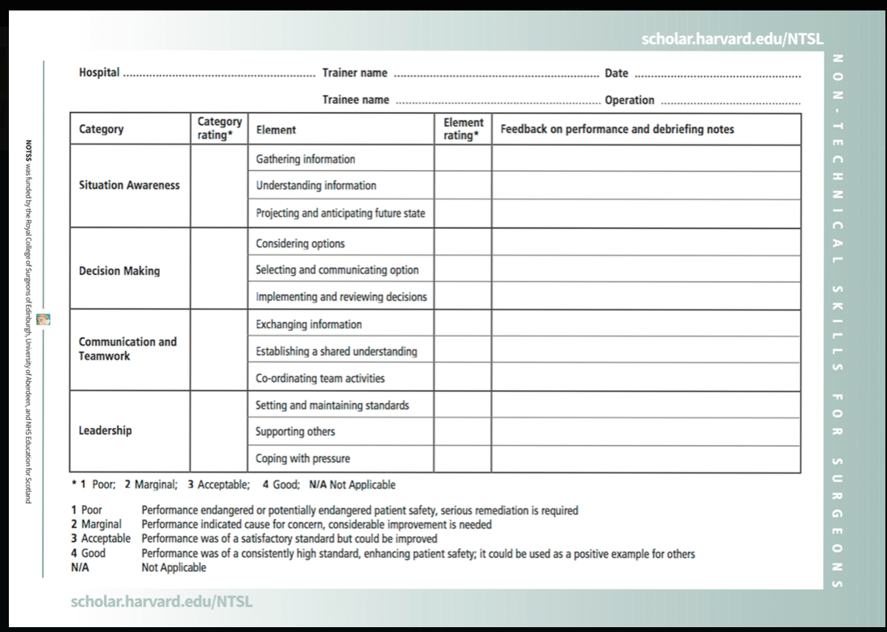

### C - 1.3: Mini-clinical Evaluation Exercise (Mini-CEX)

**DEFINITION:**

The Mini-CEX is a 10- to 20-minute direct observation assessment or “snapshot” of a trainee-patient interaction.

|  |  |  |  |  |
| --- | --- | --- | --- | --- |
| **Mini-CEX FORM** | | | | |
| Assessor’s Name and signature | | | | Date : _ _ / _ _ /_ _ _ _ |
| Student’s Name and signature | | | | Registration No: |
| Patient problem/diagnosis: | | | |  |
| Case Complexity: | • Low | • Moderate | • High |  |

Please rate the following areas (please circle one for each component of the exercise. All scores of 1 must be justified in the comments box. U/C if you have not observed the behavior and feel unable to comment

|  |  |  |  |  |
| --- | --- | --- | --- | --- |
|  | Below | Around | Above | U/C |
|  | Expectations | expectations | Expectations |  |
| History Taking: Elicits history and allows patient to elaborate |  |  |  |  |
| Asks relevant clinical questions | 1 | 2 | 3 | U/C |
| Current treatment, allergies |  |  |  |  |
| Past medical history and family history |  |  |  |  |
| Social history Inc. risk factors |  |  |  |  |
| Physical Examination: Obtains verbal consent for physical examination |  |  |  |  |
| Performs examination appropriately and competently | 1 | 2 | 3 | U/C |
| Uses relevant instruments in a competent manner |  |  |  |  |
| Communication Skills: Uses clear understandable language |  |  |  |  |
| Shows appropriate non verbal skills during the interview | 1 | 2 | 3 | U/C |
| Shows appropriate rapport/empathy |  |  |  |  |
| Clinical Judgement: Uses relevant details to confirm or refute working  Diagnoses  Sets up acute management plan and explains problem prioritization  Makes rational use of investigations to help identify pathophysiology  Utilizes drug therapy safely and rationally |  |  |  |  |
| 1 | 2 | 3 | U/C |
|  |  |  |  |
|  |  |  |  |
|  |  |  |  |
| Professionalism: Checks patient’s name and gives name  Responds appropriately to patient perspectives | 1 | 2 | 3 | U/C |
|  |
| Organization/Efficiency: Exhibits well organized approach |  |  |  |  |
| Sensible management of interview time and interaction | 1 | 2 | 3 | U/C |
|  |  |  |  |  |
| Overall Clinical Care: Makes appropriate long term management plan  including team working where appropriate | 1 | 2 | 3 | U/C |

Students Comments on Students Performance on this occasion

Assessors Comments on students’ performance on this occasion Tick if excellent

Agreed Actions

##### Mini-CEX (FIRST YEAR)

|  |  |  |  |  |  |
| --- | --- | --- | --- | --- | --- |
| **Sr .No** | **Mini-CEX to be assessed** | **Evaluation** | **Number of attempts** | **Remarks** | **Sign of supervisor** |
| 1. | Pediatric History Taking |  |  |  |  |
| 2. | General Physical Examination & systemic examination |  |  |  |  |
| 3. | IV fluid management |  |  |  |  |
| 4 | Documentation: Discharge slips,  operation notes, Delivery Notes, Blood transfusion notes, Call to other departments, Investigation slips. |  |  |  |  |
| 5 | Breastfeeding counseling |  |  |  |  |

##### Mini- CEX (2nd year)

|  |  |  |  |  |  |
| --- | --- | --- | --- | --- | --- |
| **Sr. No** | **Mini-CEX to be assessed** | **Evaluation** | **Number of attempts** | **Remarks** | **Sign of supervisor** |
| 1. | Pediatric history taking |  |  |  |  |
| 2. | General physical examination |  |  |  |  |
| 3. | Systemic examination |  |  |  |  |
| 4. | Abdominal examination of a mass abdomen |  |  |  |  |
| 5. | Proctoscopy |  |  |  |  |

##### Mini- CEX (3rd year)

|  |  |  |  |  |  |
| --- | --- | --- | --- | --- | --- |
| **S.NO** | **Mini-CEX to be assessed** | **Evaluation** | **Number of attempts** | **Remarks** | **Sign of supervisor** |
| 1. | Neonatal history and examination |  |  |  |  |
| 2. | Breaking the bad news in obstetrics e.g poor prognosis, anomalous baby |  |  |  |  |
| 3. | Interpretation of ultrasound and ct scans of pediatric patients |  |  |  |  |
| 4. | Excisional biopsies |  |  |  |  |
| 5. | Perineal examination |  |  |  |  |

##### Mini- CEX (4th year)

|  |  |  |  |  |  |
| --- | --- | --- | --- | --- | --- |
| **Sr.No** | **Mini-CEX to be assessed** | **Evaluation** | **Number of attempts** | **Remarks** | **Sign of supervisor** |
| 1. | History taking of a oncology cases |  |  |  |  |
| 2. | History taking of a case of Trauma patients |  |  |  |  |
| 3. | Radiological interpretation of surgical emergencies |  |  |  |  |
| 4. | How to examine a case of Fecal incontinence |  |  |  |  |
| 5. | Counseling of the case of malignancy |  |  |  |  |

##### Mini- CEX (5th year)

|  |  |  |  |  |  |
| --- | --- | --- | --- | --- | --- |
| **Sr.No** | **Mini-CEX to be assessed** | **Evaluation** | **Number of attempts** | **Remarks** | **Sign of supervisor** |
| 1. | Critical Care and End of life counselling |  |  |  |  |
| 2. | Bed Side Mannerism |  |  |  |  |
| 3. | Short case assessment |  |  |  |  |
| 4. | Long case assessment |  |  |  |  |

### 

### C - 1.4: MULTISOURCE FEEDBACK (360 DEGREE EVALUATION)

|  |  |
| --- | --- |
| Assessment Records/Evaluation Proformas  SHIFT TO MAIN LOG BOOK | Evidence of all available assessment records and six monthly 360 degree evaluation records should be mentioned in this section to have a reflection about resident’s medical knowledge, patient care, communication skills, system based learning, practice based learning and professionalism. Copies of the result cards/assessment records should be attached as evidence. |

**Proforma available on RMU website : www.rmu.com. pk and SECTION XI of curriculum MS pediatric Surgery**

### C- 1.5: Monthly Written Test MCQ

|  |  |
| --- | --- |
| **SR NO** | **TOPIC** |
| **1** | Pediatric history and examination |
| **2** | **Physiology of the newborn** |
| **3** | **Fluid and electrolyte management** |
| **4** | **Neonatal CDH** |
| **5** | **Esophageal atresia** |
| **6** | **CPAM** |
| **7** | **Chest wall anomalies** |
| **8** | **Acquired Lung and pleural diseases** |
| **9** | **Lung, chest wall and Soft tissue malignancies** |
| **10** | **Abdominal wall hernias** |
| **11** | **Abdominal wall defects( gastroschisis/ omphalocoele)** |
| **12** | **GERD** |
| **13** | **Intestinal atresias** |
| **14** | **Malrotation** |
| **15** | **Intessception** |
| **16** | **NEC** |
| **17** | **Appendix** |
| **18** | **IBD** |
| **19** | **HPD** |
| **20** | **Meckel’s diverticulum** |
| **21** | Alimentary tract duplication |
| **22** | Male anorectal malformation |
| **23** | Female anorectal malformation |
| **24** | Choledochal cyst |
| **25** | Biliary atresia |
| **26** | Splenic lesions |
| **27** | PUJ obstruction |
| **28** | VUJ obstruction |
| **29** | VUR |
| **30** | PUV |
| **31** | Hernias and hydrocoeles , undescended testis |
| **32** | DSD |
| **33** | Hypospadias |
| **34** | Abdominal and genitourinary malignancies |

### 

## C-2: Summative assessment:

### First year in training assessment

### Mid Term Assessment

### Third Year in training Assessment

### Final Term Assessment

Details of TOS for written and clinical exam in Curriculum.

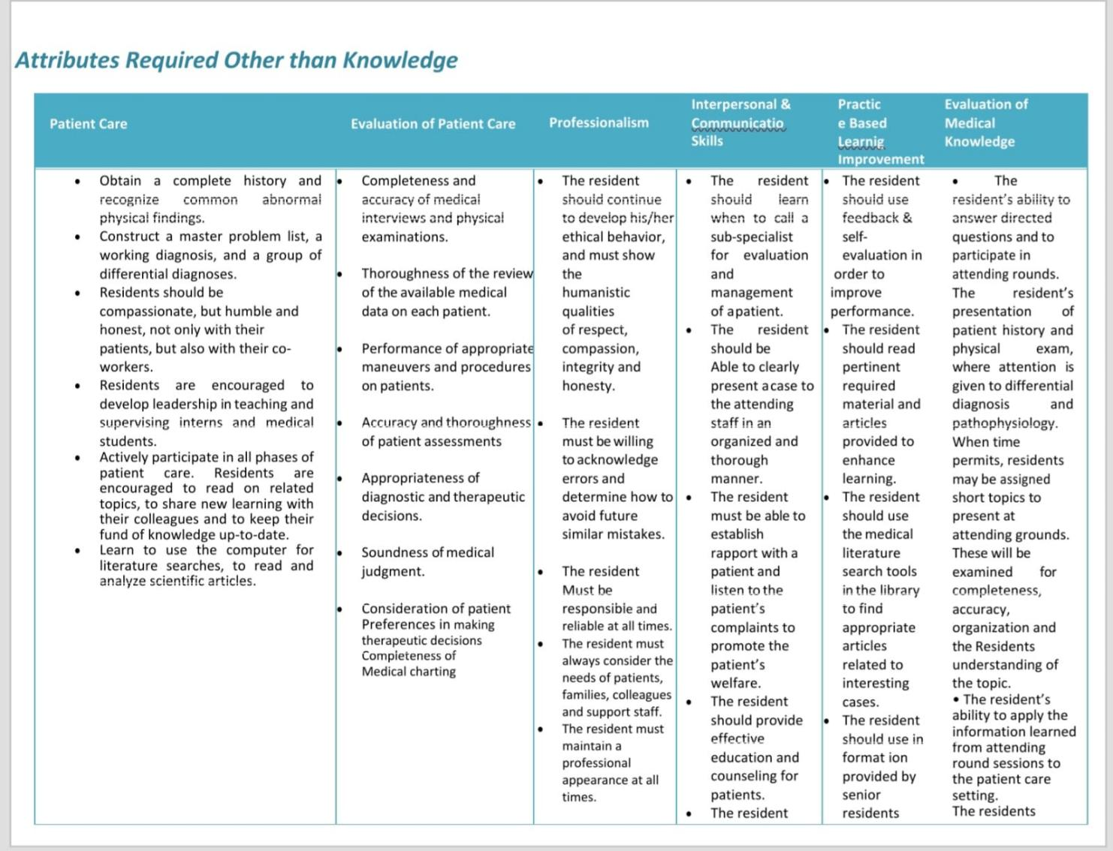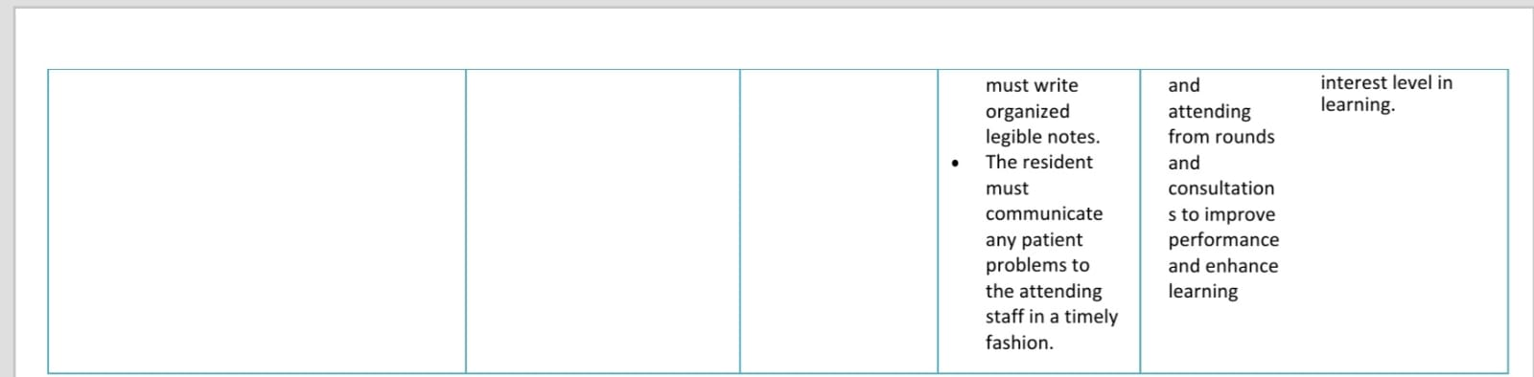

**Recommended learning resources**

1. Pediatric Surgery; 7th Edition by Arnold G Coran
2. Ashcraft’s pediatric surgery ;6th edition
3. Pearls and tricks in pediatric surgery; Martin Latcher
4. Essentials of pediatric urology ; Thomas and duffy 2nd Edition
5. Operative pediatric surgery ; 7th edition by Spitz and coran
6. Clinical pediatric surgery: A case based approach by Sheriff Emil
7. Pediatric Surgery diagnosis and management by Gupta
8. Pediatric surgery secrets by Glick , Pearl , Irish.

**RESEARCH CURRICULUMIntroduction**

**With advent of Evidence** **Based** **Practice over last two to three decades in medical science,** merging the best research **evidence** with good clinical expertise and patient values is inevitable in decision making process for patient care. Therefore, apart from receiving per excellence knowledge of the essential principles of medicine and necessary skills of clinical procedures, the trainees should also be well versed and skillful in research methodologies. The training in research being imperative is integrated longitudinally in all five year’s training tenure of the trainees.

The purpose of the research training is to provide optimal knowledge and skills regarding research methods and critical appraisal. The expected outcome of this training is to make trainees dexterous and proficient to practically conduct quality research through amalgamation of their knowledge, skills and practice in research methodologies.

Orientation Session for Post Graduate Trainees:

1. At the beginning of the research course, an orientation session or an introductory session of one-hour duration will be held, organized by Director, Deputy Directors of ORIC (Office of Research Commercialization and Innovation) of RMU to make trainees acquainted to the research courses during five years post graduate training, the schedule of all scholarly and academic activities related to research and the assessment procedures.
2. Trainees will also be introduced to all the facilitators of the course, organizational structure of ORIC (Annexure 1) and the terms of references of corresponding authorities (Annexure 2) for any further information and facilitation.
3. All the curriculum details and materials for assistance and guidance will be provided to trainees during the orientation session.
4. The research model of RMU as given in Figure 1 and will be introduced to the newly inducted trainees of RMU.

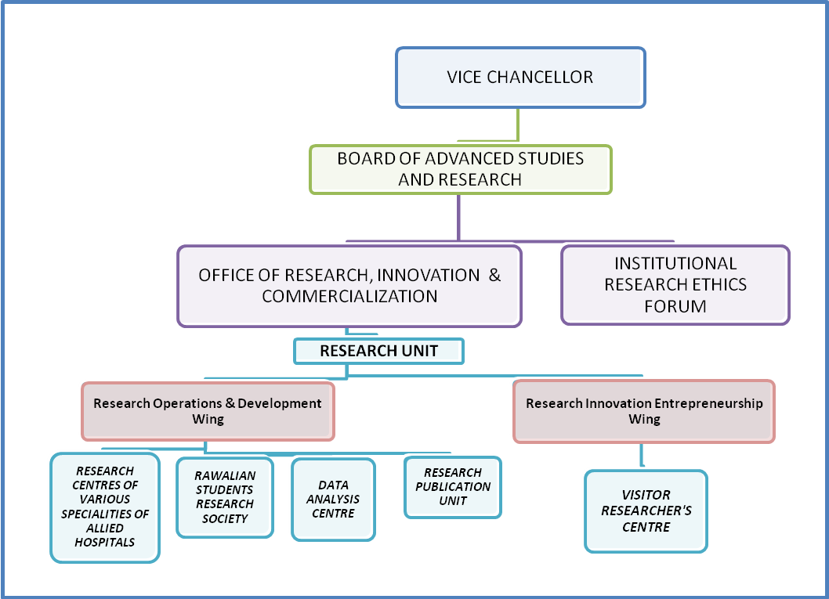

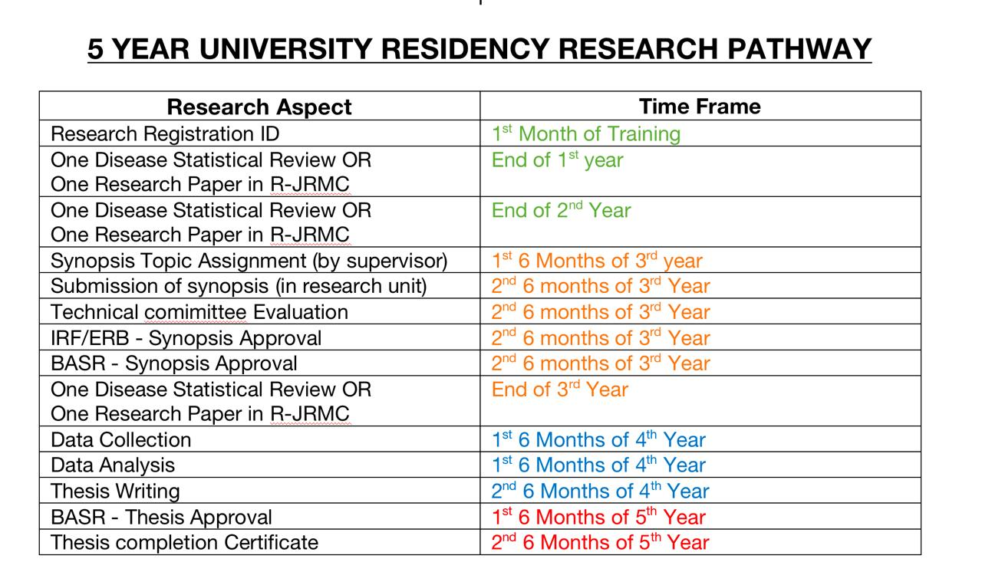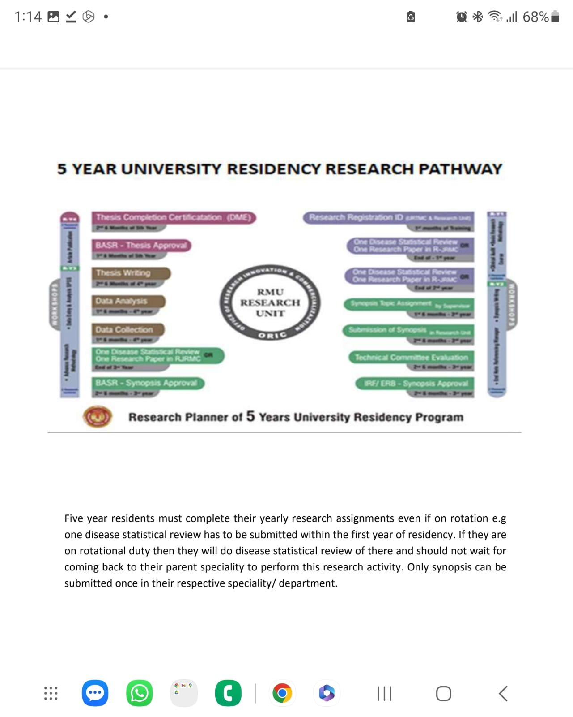

***Figure 3. A Flow Chart Of Research Activities Of R-Y1 Post Graduate/MD Trainee Of RMU And Their Assessment***

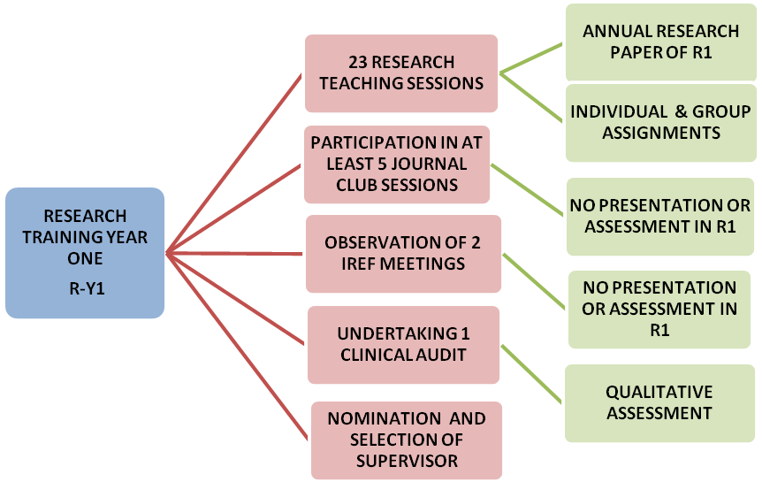

**A flow chart of research activities of R-Y2 post graduate/md trainee of RMU and their assessments**

**ASSESSMENTS**

**ACTIVITIES**

**A Flow Chart of Research Activities of R-Y3 MD Residents of RMU and Their Assessments**

**ASSESSMENTS**

**ACTIVITIESYES**

**A Flow Chart of Research Activities and Assessments of R-Y4 and R-Y5**

**MD Residents of RMU Who Will Opt for Dissertation Writing**

**ASSESSMENTSCTIVITIES**

**ACTIVITIES**

**ASSESSMENTSCTIVITIES**

**The organization chart of ORIC RMU**

