

**CURRICULUM, STATUTES & REGULATIONS**

**FOR**

**MS ANESTHESIA**

**(2024)**

RAWALPINDI MEDICAL UNIVERSITY



PREFACE

The horizons of Medical Education are widening & there has been a steady rise of global interest in Post Graduate Medical Education, an increased awareness of the necessity for experience in education skills for all healthcare professionals and the need for some formal recognition of postgraduate training in Internal Medicine. We are seeing a rise in the uptake of places on postgraduate courses in medical education, more frequent issues of medical education journals and the further development of e-journals and other new online resources. There is therefore a need to provide active support in Post Graduate Medical Education for a larger, national group of colleagues in all specialties and at all stages of their personal professional development. If we were to formulate a statement of intent to explain the purpose of this log book, we might simply say that our aim is to help clinical colleagues to teach and to help students to learn in a better and advanced way. This book is a state-of-the-art logbook with representation of all activities of the MS Anesthesia at RMU.A summary of the curriculum is incorporated in the logbook for convenience of supervisors and residents. MS curriculum is based on six Core Competencies of ACGME (Accreditation Council for Graduate Medical Education) including Patient Care, Medical Knowledge, System Based Practice, Practice Based Learning, Professionalism, Interpersonal and Communication Skills. A perfect monitoring system of a training program including monitoring of teaching and learning strategies, assessment and Research Activities cannot be denied so we at RMU have incorporated evaluation by Quality Assurance Cell and its comments in the logbook in addition to evaluation by University Training Monitoring Cell (URTMC). Reflection of the supervisor in each and every section of the logbook has been made sure to ensure transparency in the training program. The mission of Rawalpindi Medical University is to improve the health of the communities and we serve through education, biomedical research and health care. As an integral part of this mission, importance of research culture and establishment of a comprehensive research structure and research curriculum for the residents has been formulated and a separate journal for research publications of residents is available.

**Prof. Muhammad Umar**

**(Sitara-e-Imtiaz)**

(MBBS, MCPS, FCPS, FACG, FRCP (Lon), FRCP (Glasg), AGAF)

**Vice Chancellor Rawalpindi Medical University & Allied Hospitals**

**CONTRIBUTORS**

|  |
| --- |
| **PROF MUHAMMAD UMAR, *S. I*** |
| **MBBS, MCPS, FCPS (PAK), FACG (USA), FRCP (L), FRCP (G), ASGE-M(USA), AGAF (USA)** |
| Vice Chancellor & CEO |

**DR JAWAD ZAHIR**

**Associate Professor**

**MBBS, FCPS, M.Sc pain medicine**

**Dr. ANUM MALIK**

**Assistant Professor**

**MBBS, FCPS**

|  |  |
| --- | --- |
| S NO | CONTENT |
| SECTION - I | **PREAMBLE** |
| 1. | Mission and Vision of Rawalpindi Medical University |
| 2. | Introduction to MS Anesthesia |
| 3. | Overview |
| 4. | Registration and enrolment |
| 5. | General and specific objectives of course |
| 7. | Electives/rotations |
| 8. | Teaching and learning Strategies |
| 9. | Tools of assessment |
| SECTION – II | **CONTENT** |
| 10. | Details of curriculum of MS Anesthesia |
| 11. | First year curriculum |
| 12. | Second-year curriculum |
| 13. | Third and fourth-year curriculum |
| SECTION- III | **RESEARCH AND THESIS WRITING** |
| 14. | Details about the research component and Thesis writing |
| SECTION -IV | **Workshops** |
| 15. | Details of workshops |
| SECTION - V | **MILESTONES TO BE ACHIEVED BY THE RESIDENTS** |
| 16. | Charting the road to competence: developmental milestones for MS Anesthesia program at Rawalpindi Medical University |
| SECTION - VI | **EVALUATION AND ASSESSMENT STRATEGIES** |
| 17. | Evaluation and assessment strategies a general overview |
| 18 | Details of MS Anesthesia examination (written and clinical) |
| 19. | MS Anesthesia Final thesis examination |
| SECTION VII | **REFERENCES** |
| SECTION- VIII | **APPENDICIES** |
| 20. | Workplace Based Assessments-Multi source feedback Performa - 360⁰ evaluation ----Appendix “ A” |
| 21. | Performa for feedback by Nurse for core competencies of the resident -----------“Appendix B” |
| 22. | Performa for Patient Medication Record ------“Appendix C” |
| 23. | Workplace Based Assessments- guidelines for assessment of Generic & specialty specific Competencies -- Appendix “D” |
| 24. | Supervisor’s Annual Review Report------- Appendix “E” |
| 25. | Supervisor’s evaluation Performa for continuous internal assessments---------Appendix “F” |
| 26. | Evaluation of resident by the faculty---------- Appendix “G” |
| 27. | Evaluation of faculty by the resident------------ Appendix “H” |
| 28. | Evaluation of program by the faculty------------ Appendix “I” |
| 29. | Evaluation of program by the resident ------ Appendix “J” |
| 30 | Guidelines for program evaluation---- Appendix “K” |
| 31. | Evaluation of Project Director by the residents---- Appendix “L” |
| 32. | Log Book for Anesthesia (Templates) |
| 33. | Log Book for Research (Templates) |
| 34. | Portfolio (Templates) |
| 35. | SWOT Analysis |

**Section- I**

**Preamble**

**Mission and Vision of Rawalpindi Medical University**

**Mission**

Highly recognized and accredited center of excellence in Medical Education, using evidence-based training techniques for development of highly competent health professionals, who are lifelong experiential learner and are socially accountable

**Vision**

To impart evidence-based research oriented health professional education in order to provide best possible patient care and inculcate the values of mutual respect, ethical practice of healthcare and social accountability.

**MISION STATEMENT OF ANESTHESIA PROGRAM**

Our mission is to advance Anesthesiology through patient-centered care, innovative education, and cutting-edge research. We empower trainees to deliver critical, evidence-based care, raise awareness for prevention, and improve patient outcomes by translating the latest scientific knowledge to bedside practice. Committed to community health locally and globally, we proudly serve as lifelong ambassadors of the Rawalpindi Medical University MS Anesthesiology Program, dedicated to elevating healthcare standards.

**VISION**

Our vision is to build an ACGME-aligned MS Anesthesia program that champions clinical excellence, ethical practice, and compassionate patient care. Through rigorous training, we aim to develop skilled anesthesiologists who set the highest standards in patient safety, advance medical knowledge, and lead in improving healthcare outcomes. We are dedicated to cultivating future leaders who are committed to lifelong learning, innovation, and serving diverse communities with integrity and expertise

**Introduction**

**1.2.1: Definition and Scope of the Specialty**

The program of MS Anesthesiology of Rawalpindi Medical University is conducted with a goal to develop anesthesiologists who can provide quality peri-operative care to meet the needs of patients both now and in the future, and who can contribute to the field of anesthesiology through participation in research. Residency Curriculum provides essential intellectual and clinical information (the scope covers cognition, skills and attitudes) that are necessary for an anesthesiologist.

**1.2.2: Framework of Educational Program**

The duration of MS anesthesiology course shall be five (5) years consisting of structured training in a recognized department under the guidance of an approved supervisor. The course is structured in two phases:

**Phase I** is structured for the 1st and 2nd calendar year. Doctors entering this will require closely supervised training in basic assessment methods and techniques and should gradually be introduced to the pre-operative assessment and the management of ASA1 and ASA2 patients in elective theaters. In their second year, they will be expected to take a larger role in managing low-moderate risk patients. The training units should therefore provide comprehensive education in general anesthetic medicine and techniques, along with exposure to the most common anesthesia subspecialties. At the end of 1st year an MCQ based examination will be conducted. At the end of 2nd year **mid-term examination** shall be held, comprising of 2 MCQ based question papers and Clinical OSCE. ­

**Phase II** is structured for 3rd , 4th and 5th  calendar years in MS Anesthesiology. The trainee should see sufficient patients in a theater to develop competency and fluency in managing patients in an operation theater setting. During the inpatient rotations, Trainees are expected to learn about inpatient evaluation and management of various diseases, their medical and surgical treatment and basic anesthesia related skills as well as the appropriate transfer of patients to outpatient setting. During the inpatient rotations, Trainees are expected to learn about inpatient evaluation and management of various diseases, their medical and surgical treatment and basic anesthesia related skills as well as the appropriate transfer of patients to outpatient setting. A senior will supervise the Trainee in all clinical encounters and is responsible for providing patient centered clinical teaching.

During the outpatient rotations, Trainees are expected to learn about outpatient evaluation and management of various surgeries under anesthesia as well as delivering anesthesia related care to patients in the outpatient setting, Theoretical and practical knowledge related to anesthesia in general and to their specialty practice. At the end of 3rd year an MCQ based end of 3rd year examination will be conducted.

The candidate will have to achieve sufficient clinical and research capability during this phase so as to qualify his **FTA** for the award of degree.

**FRAME WORK OF ANESTHESIA TRIANING**

|  |  |
| --- | --- |
| **COMPONENTS** | **DETAILS** |
| **Course title** | MS Anesthesia |
| **Training center** | Anesthesia Department,RMU allied hospitals |
| **Duration of course** | 5 years |
| **Credit hours** | 165 hrs |
| **Supervision** | Structured training under the guidance of approved Supervisor by Rawalpindi Medical University |
| **Training year 1** | Training in basic Principles of Anesthesia  Research activity: One diseases statistical report or One research paper in R-JRMC  At the end of ist year ,Continuous Internal assessment |
| **Training year 2** | Advanced training in Anesthesia sub specialties’  Research activity: One diseases statistical report or One research paper in R-JRMC  Midterm Assessment |
| **Training year 3** | Advanced training in Anesthesia sub-specialties’  Research activity: Synopsis submission and approval by BASR  Continuous internal assessment |
| **Training year 4** | Advanced training in Anesthesia sub-specialties’  Research activity: Data collection, data analysis, thesis writing  Continuous internal assessment |
| **Training year 5** | Advanced training in Anesthesia sub-specialties’  Research activity: thesis approval by BASR and thesis completion certificate by DME  Final term assessment |

**1.2.3: Academic Body**

Rawalpindi Medical University

**1.2.4: Participating Sites**

Monthly case presentations, journal club meetings and academic tests will be held for all the residents at each participating site alternatively.

1. Holy Family Hospital, Rawalpindi
2. Benazir Bhutto Hospital, Rawalpindi
3. Rawalpindi teaching Hospital, Rawalpindi

**Program Personnel and Resources**

**1.2.5: Program Director**

The program director is the Chairman of Anesthesiology department of Rawalpindi Medical University.

**1.2.6: Faculty**

The faculty involved in the teaching process of the anesthesiology residents comprises of:

#### Associate Professor of Anesthesiology

#### Assistant Professor of Anesthesiology

#### Senior Registrars

All the faculty members of the department are appointed as per the rules and regulations of PMDC.

**1.2.8: Resources:**

1. **Outpatient Department**

The outpatient areas in both hospitals provide a well-equipped Ambulatory Learning Environment for anesthesia residents, where they are closely supervised by senior registrars. Residents conduct thorough pre-anesthetic assessments, discuss cases in detail, and develop anesthetic care plans under the guidance of senior faculty members. They are also given substantial opportunities for clinical clerkship with senior anesthesiology consultants, allowing for comprehensive hands-on experience.

1. **Diagnostic Anesthesia**

Residents have access to a full range of diagnostic and monitoring equipment, such as ultrasound for regional anesthesia, fiber optic scopes for airway management, advanced ventilatory monitoring systems, capnography, non-invasive and invasive hemodynamic monitors, and anesthesia workstations. They are also trained in the use of specialized tools for perioperative and critical care assessments, including bedside ultrasonography and echocardiography.

1. **Ambulatory Learning**

Given the large and diverse patient population served by these tertiary care hospitals, residents encounter a wide range of adult and pediatric cases spanning the entire spectrum of anesthetic needs. This enables them to develop diagnostic and therapeutic skills in anesthesia management across varied surgical and procedural contexts. The inpatient department is also equipped with dedicated preoperative assessment rooms and post-anesthesia care units for residents to refine patient evaluation and postoperative care skills.

1. **Surgical Facilities**

Each participating site offers fully equipped operating rooms suited for a variety of anesthesia-related procedures, including general, regional, and specialty anesthesia for surgeries in cardiovascular, orthopedic, neurosurgical, and pediatric disciplines. Residents' training is supported by teaching aids linked to the operating room equipment, with audiovisual systems streaming live procedures to a dedicated teaching room for group demonstrations. This setup enhances residents' understanding and skills in real-time procedural anesthesia and perioperative management.

**1.3: Admission criteria**

**Resident Appointments**

**1.3.1 Eligibility Criteria**

1. For admission in MS Anesthesia course, the candidate shall be required to have:

* MBBS degree
* Completed one-year House Job
* Registration with PMDC
* Passed Entry Test conducted by the University & aptitude interview by the Institute concerned
* Merit will be adhered to strictly for induction as per RMU rules.

1. Exemptions: A candidate holding FCPS Anesthesiology/FRCA anesthesiology/Diplomat American Board shall be exempted from Entrance and Midterm Examinations and shall be directly admitted for Exit Examination, subject to fulfillment of requirements for the examination.

**1.3.2 Number of Residents**

The minimum number of residents in an accredited four-year program is eight or two per year

**1.5: AIMS AND OBJECTIVES OF THE COURSE**

**AIM**

The five-year MS Anesthesiology program aims to train residents to become skilled and safe anesthetists, proficient researchers, and effective educators. By program completion, residents will have gained comprehensive competencies in anesthetic practice, empowering them to excel as clinical experts, teachers, and researchers within the field of anesthesia.

**GENERAL OBJECTIVES**

1. To provide a broad experience in Anesthesiology with **multidisciplinary approach.**
2. To enhance medical knowledge, clinical reasoning, and competence in bedside diagnostic and therapeutic procedures.
3. To achieve the professional requirements to prepare for Advance **Training in** Anesthesiology**.**
4. To cultivate professional attitude and enhance communication skills towards patients, their families and other healthcare professionals.
5. To enhance sensitivity and responsiveness to community needs and the economics of health care delivery.
6. To enhance critical thinking, brain boosting, self-directed learning, and interest in research.
7. To cultivate the practice of evidence-based medicine and critical appraisal skills.
8. To inculcate a commitment to continuous medical education, anesthesia related skills, and professional development.
9. To provide a broad training in Anesthesia and in-depth training experience in Anesthesiology at a level for trainees to acquire competence and professionalism in the diagnosis, investigation, and management during Anesthesia for various surgical operations elective and emergency and towards the delivery of holistic patient care.
10. To acquire competence in managing emergencies and identifying problems in patients referred for primary care,timely identify which patient needs urgent intensive care and consultations from another specialty as needed.
11. To manage patients in surgical care units in regional/District hospitals; to be a leader in the health care delivery team and to work closely with networking units which provide convalescence, rehabilitation, and long-term care.
12. To encourage the development of skills in communication and collaboration with the community towards health care delivery.
13. To foster the development of skills in the critical appraisal of new methods of investigation and treatment.
14. To reinforce self-learning and commitment to continued updating in all aspects of Anesthesiolgy.
15. To encourage contributions aiming at advancement of knowledge and innovation in anesthesia through basic anesthesia principles and clinical research and teaching of junior trainees and other health related professionals.
16. To acquire professional competence in training future trainees in Anesthesiology at Rawalpindi Medical University.

**SPECIFIC OBJECTIVES**

1. ***Medical Knowledge (K)***
2. Etiology, pathophysiology, clinical manifestation, disease course, prognosis, investigation, and management of surgical patients under anesthesia and in post –operative care unit.
3. Scientific basis and recent advances in pathophysiology, diagnosis and management of patients with co-morbid conditions under anesthesia.
4. Spectrum of clinical manifestations and interaction of multiple medical and surgical diseases in the same patient.
5. Psychological and social aspects of medical illnesses.
6. Effective use and interpretation of investigations and special diagnostic & therapeutic procedures.
7. Critical analysis of the efficacy, cost-effectiveness, and cost-utility of treatment modalities.
8. Patient safety and risk management
9. Medical audit and quality assurance
10. Ethical principles and medico legal issues related to medical illnesses.
11. Updated knowledge on evidenced-based medicine and its implications for diagnosis and treatment of patients in a surgical intensive unit.
12. Familiarity with different care approaches of health facilities towards the patients care with medical illnesses, including convalescence, rehabilitation, palliation, long term care, and medical ethics.
13. Knowledge of patient safety and clinical risk management.
14. Awareness and concern for the cost-effectiveness and risk-benefits of various advanced treatment modalities.
15. Familiarity with the concepts of administration, management, and overall forward planning for resuscitation and anesthetic management.
16. ***Skills (S)***

Trainee must be able to provide patient care that is compassionate, appropriate, and effective for the treatment of health problems and the promotion of health.

**(A). Residents must demonstrate competence in fundamental clinical skills of medicine, including:**

(i) obtaining a comprehensive medical history;

(ii) performing a comprehensive physical examination;

(iii) assessing a patient’s medical conditions;

(iv) making appropriate use of diagnostic studies and tests;

(v) integrating information to develop a differential diagnosis; and,

(vi) implementing a treatment plan.

**(B). Residents must demonstrate competence in anesthetic management, including care for:**

1. Patients younger than 12 years of age undergoing surgery or other procedures requiring anesthetics. This experience must involve care for 100 patients younger than 12 years of age.

Within this patient group, 20 children must be younger than three years of age, including five younger than three months of age.

2. Patients who are evaluated for management of acute, chronic, or cancer-related pain disorders. This experience must involve care for 20 patients presenting for initial evaluation of pain.

3.Residents must be familiar with the breadth of pain management, including clinical experience with interventional pain procedures.

4.Patients scheduled for evaluation prior to elective surgical procedures;

5.Patients immediately after anesthesia, including direct care of patients in the post-anesthesia-care unit, and responsibilities for management of pain, hemodynamic changes, and emergencies related to the post-anesthesia care unit and critically-ill patients.

6.Residents must achieve competence in the delivery of anesthetic care to:

7.Patients undergoing vaginal delivery. This experience must involve care for 40 patients.

8.Patients undergoing cesarean sections. This experience must involve care for 20 patients.

9.Patients undergoing cardiac surgery. This experience must involve care for 20 patients. The care provided to 10 of these patients must involve the use of cardiopulmonary bypass.

10.Patients undergoing open or endovascular procedures on major vessels, including carotid surgery, intrathoracic vascular surgery, intra-abdominal vascular surgery, or peripheral vascular surgery. This experience must involve care for 20 patients, not including surgery

11.For vascular access or repair of vascular access.

12.Patients undergoing non-cardiac intrathoracic surgery, including pulmonary surgery and surgery of the great vessels, esophagus, and the mediastinum and its structures. This experience must involve care for 20 patients.

13.Patients undergoing intra cerebral procedures, including those undergoing intra cerebral endo vascular procedures.This experience must involve care for 20 patients, the majority of which must involve an open cranium.

14.Patients for whom epidural anesthetics are used as part of the anesthetic technique or epidural catheters are placed for peri-operative analgesia.This experience must involve care for 40 patients.

15.Patients undergoing procedures for complex, immediate life-threatening pathology. This experience must involve care for 20 patients.

16.Patients undergoing surgical procedures, including cesarean sections, with spinal anesthetic. This experience must involve care for 40 patients.

17.Patients undergoing surgical procedures in whom peripheral nerve blocks are used as part of the anesthetic technique or peri-operative analgesic management. This experience must involve care for 40 patients.

18.Patients with acute post-operative pain, including those with patient-controlled intravenous techniques, neuraxial blockade, and other pain-control modalities.

19.Patients whose peri-operative care requires specialized techniques, including:

Broad spectrum of airway management techniques, to include laryngeal masks, fiberoptic intubation, and lung isolation techniques, such as double lumen endotracheal tube placement and endobronchial blockers;

Central vein and pulmonary artery catheter placement, and the use of transesophageal

Echocardiography and evoked potentials; use of electroencephalography (EEG) or processed EEG monitoring as part of the procedure, or adequate didactic instruction to ensure familiarity with EEG use and interpretation.

20.Patients undergoing a variety of diagnostic or therapeutic procedures outside the surgical suite. This must include competency in: using surface ultrasound and transesophageal and transthoracic echocardiography to guide the performance of invasive procedures and to evaluate organ function and pathology as related to anesthesia, critical care, and resuscitation;

21.Understanding the principles of ultrasound, including the physics of ultrasound transmission, ultrasound transducer construction, and transducer selection for specific applications, to include being able to obtain images with an understanding of limitations and artifacts; obtaining standard views of the heart and inferior vena cava with transthoracic echocardiography allowing the evaluation of myocardial function, estimation of central venous pressure, and gross pericardial/cardiac pathology (e.g., large pericardial effusion)

obtaining standard views of the heart with transesophageal echocardiography allowing the evaluation of mycardial function and gross pericardial/cardiac pathology (e.g., large pericardial effusion);

22.using transthoracic ultrasound for the detection of pneumothorax and pleural effusion.

23.using surface ultrasound to guide vascular access (both central and peripheral) and to guide regional anesthesia procedures; and describing techniques, views, and findings in standard language.

24.Residents must be able to perform all medical, diagnostic, and surgical procedures considered essential for the area of practice. This includes technical proficiency in taking informed consent, performing by using appropriate indications, contraindications, interpretations of findings and evaluating the results and handing the complications of the related procedures mentioned in the syllabus. Including but not limited to:

a. Cardiopulmonary resuscitation

b. Central venous cannulation

c. Epidural Catheter insertion

d. Abdominal paracentesis

e. Pleural tapping and biopsy

f. Endotracheal intubation

g. Lumbar puncture & Spinal Anesthesia

h. Chest drain insertion

i. Arterial Blood gases sampling and Arterial cannulation.

j. Intravenous Cannulation.

k. nasogastric and orogastric tube insertion

l. Peripheral nerve blocks

m. Tracheostomy.

25.Residents should be able to interpret basic laboratory data as related to the

disorder/disease.

4.Basic understanding of routine laboratory and ancillary tests including complete blood count,

chemistry panels, ECG, chest x-rays, pulmonary function tests, and body fluid cell counts.

5. Practice evidence—based learning with reference to research and scientific knowledge

pertaining to their discipline through comprehensive training in Research Methodology.

6. Ability to recognize and appreciate the importance of cost-effectiveness of treatment

modalities.

1. ***Attitudes (P)***
2. The well-being and restoration of the health of patients must be of paramount consideration.
3. Empathy and good rapport with patients and relatives are essential attributes.
4. An aspiration to be the team-leader in total patient care involving nursing and allied health professionals should be developed.
5. The cost-effectiveness of various investigations and treatments in patient care should be recognized. The privacy and confidentiality of patients and the sanctity of life must be respected.
6. The development of a functional understanding of informed consent, advanced directives, and the physician-patient relationship.
7. Ability to appreciate the importance of the effect of disease on the psychological and socio-economic aspects of individual patients and to understand patients’ psycho-social needs and rights, as well as the medical ethics involved in patient management.
8. To learn advances in Internal Medicine, Endocrinology and other Specialties & timely refer patients for appropriate treatment.
9. The promotion of health via adult immunizations, periodic health screening, and risk factor assessment and modification.
10. Recognition that teaching and research are important activities for the advancement of the profession.
11. Adhere to the principles of sterilization and disinfection and proper operation theater techniques including scrubbing, draping and infection control practices during surgical procedures and bedside.
12. Develop and execute attitudes pertaining to effective team work during anesthetic procedures and while dealing with disaster like situations in emergency, ICU and operation theaters.
13. Develop and execute attitudes pertaining to effective team work during anesthetic procedures and while dealing with disaster like situations in emergency, ICU and operation theaters.

**1.6: Core Competencies for the Residents (Adapted from ACGME)**

By the completion of training, anesthesia residents are expected to:

* **Patient Care:** Provide compassionate, appropriate, and effective care for health problems and promote health.
* **Medical Knowledge:** Demonstrate a thorough understanding of biomedical, clinical, and cognate sciences and apply this knowledge to patient care.
* **Practice-Based Learning and Improvement:** Investigate and evaluate patient care practices, appraise and assimilate scientific evidence, and continuously improve patient care based on self-evaluation and lifelong learning.
* **Interpersonal and Communication Skills:** Communicate effectively with patients, families, and the healthcare team.
* **Professionalism:** Commitment to carrying out professional responsibilities, adherence to ethical principles, and sensitivity to diverse patient populations.
* **Systems-Based Practice:** Demonstrate an understanding of and responsiveness to the larger context and system of healthcare, and the ability to effectively call on system resources to provide optimal care.
* **Research**

**ELECTIVES /ROTATIONS**

|  |  |
| --- | --- |
| **ROTATIONS** | **DURATION IN MONTHS** |
| Pre-anesthesia assessment clinic | 3 |
| Anesthesia for General Surgery | 10 |
| Anesthesia for Obstetrics & Gynecology | 10 |
| Anesthesia for Orthopedics Surgery & Trauma | 6 |
| Anesthesia for Urology | 1 |
| Post Anesthesia care unit | 2 |
| Intensive care unit | 6 |
| Anesthesia for Pediatric surgery | 4 |
| Anesthesia for Neurosurgery | 4 |
| Anesthesia for cardiothoracic surgery | 1 |
| Anesthesia for Burns & Plastic surgery | 3 |
| Anesthesia for ENT surgeries | 4 |
| Anesthesia for Eye | 2 |
| Anesthesia for emergency & trauma | 2 |
| Pain clinic | 2 |

**Teaching & Learning Strategies**

1. ***Workshops:*** Residents achieve hands on training while participating in mandatory workshops of Basic surgical skills, Research Methodology, Advanced Life Support, Communication Skills, Computer &Internet, and Clinical Audit. Specific objectives are given in detail in the relevant section of Mandatory Workshops.
2. ***Introductory Lecture Series (ILS):*** Various introductory topics are presented by subspecialty and general surgery faculty to introduce interns to basic and essential topics in surgical diseases.
3. ***Long and Short Case Presentations:*** –Giving an oral presentation on ward rounds is an important skill for residents to learn. Presenting complicated cases in MDM, learning newer surgical techniques based on literature and presenting in journal club and quarterly workplace-based assessment and DOPS.
4. ***Seminar Presentation:*** Seminar is held in a conference format. Senior residents present an in-depth review of a surgical topic as well as their own research. Residents are formally critiqued by both the associate program director & their resident colleagues.
5. ***Journal Club Meeting (JC):*** A resident will be assigned to present, in depth, a research article or topic of their choice of actual or potential broad interest and application. Two hours per month should be allocated to discussion of any current articles or topics introduced by any participant. Faculty or outside researchers will be invited to present outlines or results of current research activities. The article should be critically evaluated, and its applicable results should be highlighted, which can be incorporated in clinical practice. Record of all such articles should be maintained in the relevant department.
6. ***Small Group Discussions/ Problem based learning/ Case based learning:*** Traditionally small groups consist of 8- 12 participants. Small groups can take on a variety of different tasks, including problem solving, role play, discussion, brainstorming, debate, workshops, and presentations. Generally, students prefer small group learning to other instructional methods. From the study of a problem students develop principles and rules and generalize their applicability to a variety of situations PBL is said to develop problem solving skills and an integrated body of knowledge. It is a student-centered approach to learning, in which students determine what and how they learn. Case studies help learners identify problems and solutions, compare options, and decide how to handle a real situation.
7. ***Discussion/Debate:*** There are several types of discussion tasks which would be used as learning method for residents including: ***guided discussion*** ,in which the facility at or poses a discussion question to the group and learners offer responses or questions to each other's contributions as a means of broadening the discussion's scope; ***inquiry-based discussion***, in which learners are guided through a series of questions to discover some relationship or principle; ***exploratory discussion***, in which learners examine their personal opinions, suppositions or assumptions and then visualize alternatives to these assumptions; and ***debate*** in which students argue opposing sides of a controversial topic. With thoughtful and well-designed discussion tasks, learners can practice critical inquiry and reflection, developing their individual thinking, considering alternatives and negotiating meaning with other discussants to arrive at a shared understanding of the issues at hand.
8. ***Case Conference (CC):*** These sessions are held three days each week; the focus of the discussion is selected by the presenting resident. For example, some cases may be presented to discuss a differential diagnosis, while others are presented to discuss specific management issues.
9. ***Grand Rounds (GR)*:** The Department of Anesthesia hosts grand rounds on a monthly basis. Speakers from local, regional, and national anesthesia training programs are invited to present topics from the broad spectrum of General Surgery. All residents on inpatient floor teams, as well as those on ambulatory block rotations and electives are expected to attend.
10. ***Professionalism Curriculum (PC)*:** This is an organized series of recurring large and small group discussions focusing upon current issues and dilemmas in medical professionalism and ethics presented primarily by an associate program director.
11. ***Evening Teaching Rounds:*** During these sign-out rounds, the inpatient senior Resident or registrar makes a brief educational presentation on a topic related to a patient currently on service, often related to the discussion from morning report. Serious cases are mainly focused during evening rounds.
12. ***Clinical-Pathological Conferences:*** The clinic pathological conference, popularly known as CPC primarily relies on case method of teaching medicine. It is a teaching tool that illustrates the logical, measured consideration of a differential diagnosis used to evaluate patients. The process involves case presentation, diagnostic data, discussion of differential diagnosis, logically narrowing the list to few selected probable diagnoses and eventually reaching a final diagnosis and its brief discussion. The idea was first practiced in Boston, back in 1900 by a Harvard internist, Dr. Richard C. Cabot who practiced this as an informal discussion session in his private office. Dr. Cabot incepted this from a resident, who in turn had received the idea from a roommate, primarily a law student.
13. ***Evidence Based Medicine (EBM)*:** Residents are presented a series of monthly lectures presented to allow residents to learn how to critically appraise journal articles, stay current on statistics, etc. The lectures are presented by the program director.
14. ***Clinical Audit Based Learning:*** “Clinical audit is a quality improvement process that seeks to improve patient care and outcomes through systematic review of care against explicit criteria…Where indicated, changes are implemented…and further monitoring is used to confirm improvement in healthcare delivery.” *Principles for Best Practice in Clinical Audit (2002, NICE/CHI)*
15. ***Peer Assisted Learning:*** Any situation where people learn from, or with, others of a similar level of training, background or other shared characteristic. Provides opportunities to reinforce and revise their learning. Encourages responsibility and increased self-confidence. Develops teaching and verbalization skills. Enhances communication skills, and empathy. Develops appraisal skills (of self and others) including the ability to give and receive appropriate feedback. Enhance organizational and team-working skills.
16. ***Morbidity and Mortality Conference (MM)*:** The M&M Conference is held throughout the year. A case, with an adverse outcome, though not necessarily resulting in death, is discussed and thoroughly reviewed. Faculty members from various disciplines are invited to attend, especially if they were involved in the care of the patient. The discussion focuses on how care could have been improved.
17. ***Clinical Case Conference***: Each resident, except when on vacation, will be responsible for at least one clinical case conference each month. The cases discussed may be those seen on either the consultation or clinic service or during rotations in specialty areas. The resident, with the advice of the Attending Anesthetist on the Consultation Service, will prepare and present the case(s) and review the relevant literature

***SEQ as assignments on the content areas:*** SEQs assignments are given to the residents on regular basis to enhance their performance during written examinations.

1. ***Skill teaching in ICU, emergency, ward settings& skill laboratory:*** Two hours twice a month should be assigned for learning and practicing clinical skills. List of skills to be learnt during these sessions is as follows:
2. Residents must develop a comprehensive understanding of the indications, contraindications, limitations, complications, techniques, and interpretation of results of those technical procedures integral to the discipline (mentioned in the Course outlines)
3. Residents must acquire knowledge of and skill in educating patients about the technique, rationale and ramifications of procedures and in obtaining procedure-specific informed consent. Faculty supervision of residents in their performance is required, and each resident's experience in such procedures must be documented by the program director
4. Residents must have instruction in the evaluation of medical literature, clinical epidemiology, clinical study design, relative and absolute risks of disease, medical statistics and decision-making
5. Training must include cultural, social, family, behavioral and economic issues, such as confidentiality of information, indications for life support systems, and allocation of limited resources
6. Residents must be taught the social and economic impact of their decisions on patients, the primary care physician and society. This can be achieved by attending the bioethics lectures and becoming familiar with Project Professionalism Manual.
7. Residents should have instruction and experience with patient counseling skills and community education
8. This training should emphasize effective communication techniques for diverse populations, as well as organizational resources useful for patient and community education

***20.Bed Side Teaching Rounds in Ward:*** *“To study the phenomenon of disease without books is to sail an uncharted sea whilst to study books without patients is not to go to sea at all” Sir William Osler 1849-1919.*Bedside teaching is regularly included in the ward rounds. Learning activities include the physical exam, a discussion of particular medical diseases, psychosocial and ethical themes, and management issues

***21.Directly Supervised Procedures - (DSP)*:** Residents learn procedures under the direct supervision of an attending or fellow during some rotations. For example, administering spinal anaesthesia,airway management, central venous cannulation.

***22.Self-Directed Learning:*** self-directed learning residents have primary responsibility for planning, implementing, and evaluating their effort. It is an adult learning technique that assumes that the learner knows best what their educational needs are. The facilitator’s role in self-directed learning is to support learners in identifying their needs and goals for the program, to contribute to clarifying the learners' directions and objectives and to provide timely feedback. Self-directed learning can be highly motivating, especially if the learner is focusing on problems of the immediate present, a potential positive outcome is anticipated and obtained and they are not threatened by taking responsibility for their own learning.

***23.Follow Up Clinics:*** The main aims of our clinic for patients and relatives include

(a) **Explanation of patient's stay in ICU :** Many patients do not remember their ICU stay, and this lack of recall can lead to misconceptions, frustration and having unrealistic expectations of themselves during their recovery. It is therefore preferable for patients to be aware of how ill they have been and then they can understand why it is taking some time to recover. (b) **Rehabilitation information and support:** We discuss with patients and relatives their individualized recovery from critical illness. This includes expectations, realistic goals, and change in family

Dynamics and coming to terms with life style changes. (c)**Identifying physical, psychological or social problems** some of our patients have problems either as a result of their critical illness or because of other underlying conditions. The follow-up team will refer patients to various specialties, if appropriate. (d)**Promoting a quality service**: By highlighting areas which require change in nursing and medical practice, we can improve the quality of patient and relatives care. Feedback from patients and relatives about their ICU & ward experience is invaluable. It has initiated various audits and advance clinical practice for the benefit of patients in the future.

***24.Core Curriculum Meeting:*** All the core topics of General Surgery should be thoroughly discussed during these sessions. The duration of each session should be at least two hours once a month. It should be chaired by the chief resident (elected by the residents of the relevant discipline). Each resident should be given an opportunity to brainstorm all topics included in the course and to generate new ideas regarding the improvement of the course structure

***25.Annual Grand Meeting*** Once a year all residents enrolled for MSAnesthesia and Specialties should be invited to the annual meeting at RMU. One full day will be allocated to this event. All the chief residents from affiliated institutes will present their annual reports. Issues and concerns related to their relevant courses will be discussed. Feedback should be collected and suggestions should be sought in order to involve residents in decision making. The research work done by residents and their literary work may be displayed. In the evening an informal gathering and dinner can be arranged. This will help in creating a sense of belonging and ownership among students and the faculty.

***26.Learning through Maintaining Log Book:*** *it is*sued to list the core clinical problems to be seen during the attachment and to document the student activity and learning achieved with each patient contact.

1. ***Learning Through Maintaining Portfolio:*** Personal Reflection is one of the most important adult educational tools available. Many theorists have argued that without reflection, knowledge translation and thus genuine “deep” learning cannot occur. One of the Individual reflection tools maintaining portfolios, Personal Reflection allows students to take inventory of their current knowledge skills and attitudes, to integrate concepts from various experiences, to transform current ideas and experiences into new knowledge and actions and to complete the experiential learning cycle.
2. ***Task-Based-Learning:*** A list of tasks is given to the students: participate in consultation with the attending staff, interview and examine patients, review a number of new radiographs with the radiologist.
3. ***Teaching in the Ambulatory Care Setting:*** A wide range of clinical conditions may be seen. There are large numbers of new and return patients. Students have the opportunity to experience a multi-professional approach to patient care. Unlike ward teaching, increased numbers of students can be accommodated without exhausting the limited No. of suitable patients.
4. ***Community Based Medical Education:*** CBME refers to medical education that is based outside a tertiary or large secondary level hospital. Learning in the fields of epidemiology, preventive health, public health principles, community development, and the social impact of illness and understanding how patients interact with the health care system. Also used for learning basic clinical skills, especially communication skills.
5. ***Audio Visual Laboratory:*** audio visual material for teaching skills to the residents is used specifically in General Surgery.

***27.*E-learning/Web-BasedEducation/Computer-Assisted instruction:** Computer technologies, including the Internet, can support a wide range of learning activities from dissemination of lectures and materials, access to live or recorded presentations, real-time discussions, self-instruction modules and virtual patient simulations. distance-independence, flexible scheduling, the creation of reusable learning materials that are easily shared and updated, the ability to individualize instruction through adaptive instruction technologies and automated record keeping for assessment purposes.

***28.Research Based Learning:*** All residents in the categorical program are required to complete an academic outcomes-based research project during their training. This project can consist of original bench top laboratory research, clinical research or a combination of both. The research work shall be compiled in the form of a thesis which is to be submitted for evaluation by each resident before end of the training. The designated Faculty will organize and mentor the residents through the process, as well as journal clubs to teach critical appraisal of the literature.

***29.Other teaching strategies specific for different specialties as mentioned in the relevant parts of the curriculum*** some of the other teaching strategies which are specific for certain domains of General Surgery are given along with relevant modules

***30.Learning through simulation and dry lab***

***31*.Surgical / procedural competencies**

**Tools of Assessment:**

**A crisp detail about modern Tools of Assessment intended to be used for the course**

• **360-DEGREE EVALUATION INSTRUMENT-MULTI-SOURCE FEEDBACK (MSF):**

360-degree evaluations consist of measurement tools completed by multiple people in a person’s sphere of influence. Evaluators completing rating forms in a 360-degree review usually are superiors, peers, subordinates, and patients and families. A 360-degree evaluation can be used to assess interpersonal and communication skills, professional behavior, and some aspects of patient care and systems-based practice

**CHART-STIMULATED RECALL ORAL EXAMINATION (CSR)**

In a chart-stimulated recall (CSR) examination, patient cases of the examinee (resident) are assessed using a standardized oral examination. A trained and experienced physician examiner questions the examinee about the care provided, probing for reasons behind the work-up, diagnoses, interpretation of clinical findings, and treatment plans. The examiners rate the examinee using a well-established protocol and scoring procedure. Each patient case (test item) takes 5 to 10 minutes of inefficiently designed CSR oral exams. A typical CSR exam is two hours with one or two physicians as examiners per 30- or 60-minute session. These exams assess clinical decision-making and the application or use of medical knowledge with actual patients.

**CHECKLIST EVALUATION**

Checklists consist of essential or desired specific behaviors, activities, or steps that make up a more complex competency or competency component. Typical response options on these forms are a check (✓) or “yes” to indicate that the behavior occurred or options to indicate the completeness (complete, partial, or absent) or correctness (total, partial, or incorrect) of the action. The forms provide information about behaviors, but to judge the adequacy of the overall performance, standards need to be set that indicate, for example, pass/fail or excellent, good, fair, or poor performance. Checklists are useful for evaluating

any competency and competency component can be broken down into specific behaviors or actions.

**GLOBAL RATING OF LIVE OR RECORDED PERFORMANCE**

Global rating forms are distinguished from other rating forms in that (a) a rater judges general categories of ability (e.g., patient care skills, medical knowledge, interpersonal and communication skills) instead of specific skills, tasks, or behaviors and (b) the ratings are completed retrospectively based on general impressions collected over a period (e.g., end of a clinical rotation) derived from multiple sources of information (e.g., direct observations or interactions; input from other faculty, residents, or patients; review of work products or written materials). All rating forms contain scales that the evaluator uses to judge knowledge, skills, and behaviors listed on the form.

**OBJECTIVE STRUCTURED CLINICAL EXAMINATION (OSCE)**

In an objective structured clinical examination (OSCE), one or more assessment tools are administered at 12 to 20 separate standardized patient encounter stations, each station lasting 10 to 15 minutes. All candidates move from station to station in sequence on the same schedule. Standardized patients are the primary assessment tool used in OSCEs. Still, OSCEs have included other assessment tools, such as data interpretation exercises using clinical cases and scenarios with dummies, to assess technical skills.

**PATIENT SURVEYS**

Surveys of patients to assess satisfaction with hospital, clinic, or office visits typically include questions about the physician’s care. The questions often assess satisfaction with general aspects of the physician’s care (e.g., time spent with the patient, overall quality of care, physician competency (skills and knowledge), courtesy, and interest or empathy). More specific aspects of care can be assessed, including the physician’s explanations, listening skills, and provision of information about examination findings, treatment steps, and drug side effects.

**PORTFOLIOS**

A portfolio is a collection of products the resident prepares that provides evidence of learning and achievement related to a learning plan. A portfolio typically contains written documents but can include video or audio recordings, photographs, and other forms of information. Reflecting upon what has been learned is important to constructing a portfolio. In addition to products of learning, the portfolio can include statements about what has been learned, its application, remaining learning needs, and how they can be met in graduate medical education. Teaching experiences, morning reports, patient rounds, individualized studies, or research projects are learning experiences that lend themselves to using portfolios to assess residents.

**RECORD REVIEW**

Trained staff in an institution’s medical records department or clinical department review patients’ paper or electronic records. The staff uses a protocol and coding form based upon predefined criteria to abstract information from the records, such as medications, tests ordered, procedures performed, and patient outcomes. The patient record findings are summarized and compared to accepted patient care standards. Residents often confer with other clinical team members before documenting patient decisions. Therefore, the documented care may not be directly attributed to a single resident but to the clinical team.

**SIMULATIONS AND MODELS**

Simulations used to assess clinical performance closely resemble reality and attempt to imitate but not duplicate real clinical problems. Key attributes of simulations are that they incorporate a wide array of options resembling reality, allow examinees to reason through a clinical problem with little or no cueing, permit examinees to make life-threatening errors without hurting a real patient, provide instant feedback so examinees can correct a mistaken action, and rate examinees’ performance on clinical problems that are difficult or impossible to evaluate effectively in other circumstances.

**STANDARDIZED ORAL EXAMINATION**

The standardized oral examination is a performance assessment using realistic patient cases with a trained physician examiner questioning the examinee. The examiner begins by presenting a clinical problem in the form of a patient case scenario to the examinee and asks the examinee to manage the case. Questions probe the reasoning for requesting clinical findings, interpretation of findings, and treatment plans. Inefficiently designed exams, each case scenario takes three to five minutes. Exams last approximately 90 minutes to two and one-half hours with two to four separate 30 or 60-minute sessions.

**STANDARDIZED PATIENT EXAMINATION (SP)**

Standardized patients (SPs) are persons trained to simulate a medical condition in a standardized way or patients trained to present their condition in a standardized way. A standardized patient exam consists of multiple SPs presenting a different condition in a 10-12-minute patient encounter. The resident being evaluated examines the SP as if (s) he were a real patient, using a checklist or a rating form; a physician observer or the SPs assess the resident’s performance on appropriateness, correctness, and completeness of specific patient care tasks and expected behaviors.

**WRITTEN EXAMINATION (MCQ)**

A written or computer-based MCQ examination comprises multiple-choice questions (MCQ) selected to sample medical knowledge and understanding of a defined body of knowledge, not just factual or easily recalled information. Each question or test item contains an introductory statement followed by four or five options on a coded answer sheet. Only one option is keyed as the correct response. The introductory statement often presents a patient case and clinical findings or displays data graphically. A separate booklet can be used to display

pictures and other relevant clinical information. In computer-based examinations, the test items are displayed on a computer monitor one at a time, and photographs and graphical images are displayed directly on the monitor.

In a computer-adaptive test, fewer test questions are needed because test items are selected based on statistical rules programmed into the computer to measure the examinee’s ability quickly. MCQ examinations can measure medical knowledge and understanding.

**Mini-Clinical Evaluation Exercise (mini-CEX)**

This tool evaluates a clinical encounter with a patient to indicate competence in skills essential for good clinical care, such as history taking, examination, and clinical reasoning. The trainee receives immediate feedback to aid learning. They can be used at any time and in any setting when there is a trainee and patient interaction, and an assessor is available.

**Direct Observation of Procedural Skills (DOPS)**

A DOPS is an assessment tool designed to evaluate a trainee's performance in undertaking a practical procedure against a structured checklist. The trainee receives immediate feedback to identify strengths and areas for development.

**Case-based Discussion (CbD)**

The CBD assesses a trainee's performance in their patient management to indicate competence in areas such as clinical reasoning, decision-making, and application of medical knowledge about patient care. It also serves as a method to document conversations about and presentations of

cases by trainees. The CbD should focus on a written record (such as case notes, out-patient letters, and discharge summaries). A typical encounter might be when presenting newly referred patients in the outpatient department.

**Audit Assessment (AA)**

The Audit Assessment tool assesses a trainee’s competence in completing an audit. It can be based on reviewing audit documentation OR presenting the audit at a meeting. If possible, multiple assessors should assess the trainee on the same audit.

**Teaching Observation (TO)**

The Teaching Observation form is designed to provide structured, formative feedback to trainees on their teaching competence. The Form can be based on any formalized teaching by the trainee who has been observed by the assessor. The process should be trainee-led (identifying appropriate teaching sessions and assessors).

**Decisions on progress (ARCP)**

The Annual Review of Competence Progression (ARCP) is the formal method of monitoring and recording trainees' progression through their training program. It is not an assessment—it is the review of evidence of training and evaluation.

**SECTION II**

**The Course Content**

***A.* Anesthesiology (First two Years)**

**Educational Purpose**

The General Surgery operation theater rotation is structured to provide PGTs with the fundamental knowledge base ofthe essential principles in the approach to surgery ward patients, the basic techniques of physical examination, the necessary skills in performing surgical procedures, and the capability to communicate clearly with patients, their families and other members of the health care team.

**Content of Required Knowledge:**

|  |  |  |
| --- | --- | --- |
| **1.** | **Preoperative assessment** | Physical examination  Tests of respiratory, cardiac, renal and endocrine function  Electrocardiography and interpretation  Management of associated medical conditions, e.g. diabetes, respiratory disease, cardiovascular disease, malnutrition, anemia, jaundice, steroid, anticoagulant, immunosuppressant and other drug therapy, and drug treatment for psychiatric disorders  Patient information and documentation of informed consent  Prophylaxis of thromboembolic disease  Assessment of fitness for anesthesia and surgery  Premedication |
| **2.** | **Intraoperative Management** | Patient positioning  Prevention of nerve and other injuries in the anaesthetized patient  Principles of general and regional anesthesia  Care and monitoring of the anaesthetized patient |
| **3.** | **Postoperative Management** | Pain control  Post-operative monitoring  Post-operative complications  Prevention, recognition and management of complications  Techniques of venous access  Assessment and maintenance of fluid and electrolyte balance  Blood transfusion-indications, hazards, complications, plasma substitutes  Respiratory failure-recognition and treatment  Nutritional support-indications, techniques, total parenteral nutrition |
| **4.** | **Surgical Sepsis and its Prevention** | Hospital hygiene  Aseptic techniques  Sterilization  Principles of asepsis and antisepsis  Surgically important micro-organisms  The sources of surgical infection-prevention and control  Pathophysiology of the body’s response to infection  Septic Shock  Antibiotic prophylaxis and therapy of infections  Surgery in hepatitis and HIV carriers-special precaution |
| **5.** | **Principles of regional anesthesia** | Patients' counseling and consent  Patients positioning  Work station checklist and resuscitation drugs preparation  Skin preparation  Administration of drugs  Intra-operative monitoring and recovery in PACU |
| **6.** | **Principles of General Anesthesia** | **Preparation of workstation.**  **Assessment of airway and preparation.**  **Induction of anesthesia, maintenance and extubation.**  **Recovery** |
| **7.** | **Basic principles cannulation** | **Peripheral venous cannulation.**  **Indications and contraindications for central venous cannulation** |
| **8.** | **Miscellaneous** | Airway maneuvers  Supra-glottic airway devices  Nasogastric tube insertion  Guedels air way insertion  Saddle anesthesia  **Procedures**  **Subarachnoid block**  **Pre-operative assessment**  **Risk assessment and devising a plan**  Obtaining informed consent and counseling of patients and attendants |
|  |  |
| **10.** | **Critical care** | Cardiopulmonary and pharmacological resuscitation  Fluid replacement, infusion therapy and parenteral alimentation  Blood transfusion and serology  Blood coagulation disorders and substitution measures  Blood gas analysis and acid base balance  Derangements of electrolytes and acid-base management  Principles of damage control resuscitation  Principles of emergency airway management  **Conditions**  Hypovolemic shock  Septic, cardiogenic, anaphylactic and neurogenic shock  Coagulopathy  Neurologic dysfunction  Endocrine dysfunction  Pneumonia − hospital acquired  Single organ failure (heart, liver, kidney)  Multiple system organ failure (pathophysiology and treatment)  Respiratory failure-pulmonary edema “shock lung”, adult respiratory distress syndrome, lobar and pulmonary collapse  Acute necrotizing pancreatitis  Septic inflammatory response syndrome  Acute gastrointestinal hemorrhage  Acute renal failure in surgical patients  Hemofiltration, dialysis and plasmapheresis  Malignant hyperthermia  **Procedures**  Central venous catheterization  Catheterization of the pulmonary artery  Catheterization of the radial and femoral artery  Pulmonary artery catheter placement  Endotracheal intubation  Real-time ultrasound technique for vascular localization  Administration of oxygen and administrative devices  Airway management  Nasogastric tube placement  Urinary catheterization  Patient controlled analgesia and epidural analgesia  Use of monitors and interpretation  Defibrillation and cardioversion |
| **11.** | **Traumatology and Emergency Medicine** | Clinical assessment of critically ill and severely injured patients-scoring systems  Subsequent initial treatment and decision-making about referral to specialized center  Monitoring of vital functions in critically ill or severely injured patients  Maintenance of airway in severely injured and unconscious patients, endotracheal intubation, laryngotomy, tracheostomy  Cardiac arrest, resuscitation and hemodynamic support  **Conditions**  Management of the unconscious patient  Management of poly trauma patients  Hemorrhage and shock  Initial treatment in severe head and brain injury  Closed and penetrating head injury  Pneumo- and hemo-thorax  Pulmonary contusion and laceration  Myocardial contusion  Cardiac tamponade  Injuries of the diaphragm  Closed, blunt and penetrating abdominal injuries  Burn injury  Smoke inhalation injury  Carbon monoxide poisoning  Hypothermia and frostbite  Snake, spider and other animal bites  Human bites  Bee and wasp stings  Pediatric trauma  Geriatric trauma  Trauma in pregnancy  **Procedures**  Focused assessment with sonography and CT (FAST scan)  Placement of intracranial pressure monitor |
| **13** | **Hematopoietic and Lymph Reticular Systems** | The anatomy, physiology and pathology of the haemopoietic and lymph reticular systems appropriate to the understanding of clinical signs and special investigations.  **Conditions**  Heamo-globinopathies & coagulation disorders  **Procedures**  Anesthesia concerns in von Willi brand diseases, thalassemia disease, hemophilia, sickle cell anemia and other bleeding diathesis |
|  | **Musculo-skeletal System** | Musculo-skeletal anatomy, physiology and pathology relevant to the clinical examination of the locomotor system and to the understanding of disordered locomotor function with emphasis on the effects of trauma.  Common disorders of infancy and childhood  Metabolic and degenerative bone disease: osteoporosis and osteomalacia  Bone and joint infections including those related to prostheses  Principles of anesthesia considerations in joint replacement and Amputations |
|  | **Skin & Soft Tissue**  **Conditions** | Necrotizing fasciitis and ICU care  paronychia  diabetic foot, gangrenous toe , wet gangrene, Fournier’s gangrene |

**Teaching Strategy:**

* + Bedside teaching during grand ward rounds
  + Seminars
  + Small group discussions
  + Problem based learning
  + Didactic lectures
  + Case Based Discussion (CBD)
  + Self-directed learning
  + Follow up clinics
  + Skill teaching in ward settings
  + Clinico-pathological Conference

**Assessment:**

* + OSCE
  + MCQs
  + Long case
  + Short case

**Evaluation/Feedback**

* + 360-degree evaluation to judge the professionalism, ethics.
  + A formal evaluation and verbal discussion with the PGT are to be done at the end of the rotation / PGTs are encouraged to discuss with the supervisor, co- supervisor and program director/Dean their learning experiences, difficulties or conflicts.
  + Evaluation of training program by trainees pertinent to effectiveness and efficiency of program to equip trainees with necessary skills

***Attributes Required Other than Knowledge***

|  |  |  |  |  |  |
| --- | --- | --- | --- | --- | --- |
| Patient Care | Evaluation of Patient Care | Professionalism | Interpersonal & Communicatio  Skills | Practice Based Learnig  Improvement | Evaluation of Medical Knowledge |
| * Obtain a complete history and recognize common abnormal physical findings. * Construct a master problem list, a working diagnosis, and a group of differential diagnoses. * Residents should be compassionate, but humble and honest, not only with their patients, but also with their co-workers. * Residents are encouraged to develop leadership in teaching and supervising interns and medical students. * Actively participate in all phases of patient care. Residents are encouraged to read on related topics, to share new learning with their colleagues and to keep their fund of knowledge up-to-date. * Learn to use the computer for literature searches, to read and analyze scientific articles. | * Completeness and   accuracy of medical  interviews and physical examinations.   * Thoroughness of the review of the available medical data on each patient. * Performance of appropriate   maneuvers and procedures on patients.   * Accuracy and thoroughness of patient assessments * Appropriateness of diagnostic and therapeutic decisions. * Soundness of medical judgment. * Consideration of patient   Preferences in making  therapeutic decisions Completeness of  Medical charting | * The resident   should continue  to develop his/her  ethical behavior,  and must show the  humanistic qualities  of respect,  compassion,  integrity and  honesty.   * The resident   must be willing  to acknowledge  errors and  determine how to  avoid future  similar mistakes.   * The resident   Must be responsible and reliable at all times.   * The resident must   always consider the needs of patients,  families, colleagues  and support staff.   * The resident must   maintain a  professional  appearance at all  times. | * The resident should learn when to call a sub-specialist for evaluation and management   of a patient.   * The resident should be   Able to clearly present a case to the attending staff in an organized and thorough manner.   * The resident must be able to establish rapport with a patient and listen to the patient’s complaints to promote the patient’s welfare. * The resident should provide effective education and counseling for patients. * The resident must write organized legible notes. * The resident must communicate any patient problems to the attending staff in a timely fashion. | * The resident should use feedback &self-evaluation in   order to improve performance.   * The resident should read pertinent required material and articles provided to enhance learning. * The resident should use the medical literature search tools in the library to find appropriate articles related to interesting cases. * The resident should use in format ion provided by senior residents and attending from rounds and consultations to improve performance and enhance learning | * The resident’s ability to answer directed questions and to participate in attending rounds.   The resident’s presentation of patient history and physical exam, where attention is given to differential diagnosis and pathophysiology.  When time permits, residents may be assigned short topics to present at attending grounds. These will be examined for completeness, accuracy, organization and the Residents understanding of the topic.  • The resident’s ability to apply the information learned from attending round sessions to the patient care setting.  The residents interest level in learning. |

***Suggested Readings:***

1. Morgan and Mikhail’s clinical anesthesiology
2. The ICU book by Paul L Marino
3. Yao and Artusio’s anesthesiology. Problem oriented patient management.
4. Stoelting’s anesthesia and co existing disease.
5. Millar’s basics of Anesthesia.
6. Smith and Aitkenheads test book of anesthesia
7. The PGT is encouraged to read current literature particularly articles that pertain to current patient problems. Examples of appropriate current medical literature are the journal of anesthesia , Annals of anesthesia Recent Advances in anesthesia and online resources.

**ANESTHETIC EMERGENCY**

**Educational Purpose**

To learn practicing Anesthesia, prioritization of care and triage, interaction with ambulance and other emergency personnel and basic approach to common emergencies; traumatic, medical, pediatric and adult.

**Content of Required Knowledge**

1. PGT should be able to obtain pertinent historical data and correctly do physical examination and assessment in acute illness
2. PGT should be competent enough to develop an appropriate diagnosis & care plan for Emergency patients
3. PGT should be adequately skilled to resuscitate a critically ill patient

**Medical & Surgical Emergencies**

* + Knowledge of pathological abnormalities, clinical manifestations and principles of management of medical and surgical emergencies
  + Understanding of routine investigations for proper management of patients
  + Ability to take decision regarding hospitalization or timely referral to another consultants /subspecialty
  + Competency in selecting correct drug combinations for different clinical problems keeping in view their pharmacological effect, side effects, interaction with other drug

**General skills to be achieved for Managing Emergencies**

* History taking
* Planning initial management
* Simple airway maneuvers
* Bag mask ventilation
* LMA & multi-lumen esophageal airway insertion
* Oropharyngeal and nasopharyngeal airway
* Apply nasal prongs
* Administer nebulizer
* Arterial puncture
* Resuscitation
* Inline immobilization
* Application of cervical collar
* Oxygen therapy
* Cardio-pulmonary resuscitation
* Basics of ECG
* Rhythm recognition
* Defibrillation and cardioversion
* Peripheral I/V access
* NG tube insertion
* Urinary catheter insertion
* Decompression of pneumothorax
* Lumbar puncture
* Basics of radiology
* Basic trauma Life support
* Desired medical and surgical procedures which should be demonstrated after trainees have been imparted competencies

**Medical Skills**

* Advanced airway management
* Ventilator support
* Non-invasive ventilation
* Central vascular access
* CVP monitoring
* Invasive hemodynamic monitoring
* Pain relief
* Abdominal paracentesis

**Surgical Skills**

* Percutaneous tracheostomy
* Cricothyrotomy
* Surgical tracheostomy
* ICP measurement
* Venous cut down

**Hands on Training in Trauma Management & Assessment**

1. Needle thoracentesis
2. Cricothyrotomy
3. Needle Cricothyrotomy
4. Supra pubic catheterization
5. Central venous access
6. Cervical Spine immobilization
7. Invasive pressure monitoring
8. ABG sampling
9. Endo tracheal insertion
10. Insertion of Foley’ catheter
11. Umbilical vein catheterization
12. Nerve blocks
13. Abdominal compartment pressure monitoring

**Interpretations of Clinical and Laboratory Procedures**

* + Ultrasonography / FAST scan
  + CT scan including Ct angiography
  + MRI Including MRA
  + X-ray
  + Interpret results of specialized investigations like:
    - Biochemical, hemodynamic, electro-cardio graphic, electro-physiological, pulmonary functional, hematological, immunological and ABG analysis results
    - Vascular laboratory and Doppler scan interpretation and DSA

**Teaching Strategies**

* Hands on training in trauma management workshops
* Didactic lectures
* Bed side teaching
* Case based discussion
* Problem based learning
* Seminars
* Conferences
* Symposiums
* Outpatient evaluation in clinical settings
* Interactive sessions

**Assessment**

* OSCE
* MCQs, SEQs
* Long case
* Short case

*Assessment of the trainees will be followed by constructive feedback for improvement of their attitude, performance and competencies.

**Evaluation / Feedback**

* 360-degree evaluation of the trainees to judge the professionalism, ethics, counseling & interpersonal communication skills
* Evaluation by formal discussion of trainees with supervisor, co-supervisor and program director by the end of rotation to rule out conflicts of interest and difficulties faced by trainees
* Evaluation of training program pertinent to effectiveness and efficiency of program in equipping trainees with necessary skills

Trainees will frequently be provided with feedback for improvement of their performance

**ANESTHETIC EMERGENCY**

**Educational Purpose**

To learn practicing Anesthesia, prioritization of care and triage, interaction with ambulance and other emergency personnel and basic approach to common emergencies; traumatic, medical, pediatric and adult.

**Content of Required Knowledge**

1. PGT should be able to obtain pertinent historical data and correctly do physical examination and assessment in acute illness
2. PGT should be competent enough to develop an appropriate diagnosis & care plan for Emergency patients
3. PGT should be adequately skilled to resuscitate a critically ill patient

**Medical & Surgical Emergencies**

* + Knowledge of pathological abnormalities, clinical manifestations and principles of management of medical and surgical emergencies
  + Understanding of routine investigations for proper management of patients
  + Ability to take decision regarding hospitalization or timely referral to another consultants /subspecialty
  + Competency in selecting correct drug combinations for different clinical problems keeping in view their pharmacological effect, side effects, interaction with other drug

**General skills to be achieved for Managing Emergencies**

* History taking
* Planning initial management
* Simple airway maneuvers
* Bag mask ventilation
* LMA & multi-lumen esophageal airway insertion
* Oropharyngeal and nasopharyngeal airway
* Apply nasal prongs
* Administer nebulizer
* Arterial puncture
* Resuscitation
* Inline immobilization
* Application of cervical collar
* Oxygen therapy
* Cardio-pulmonary resuscitation
* Basics of ECG
* Rhythm recognition
* Defibrillation and cardioversion
* Peripheral I/V access
* NG tube insertion
* Urinary catheter insertion
* Decompression of pneumothorax
* Lumbar puncture
* Basics of radiology
* Basic trauma Life support
* Desired medical and surgical procedures which should be demonstrated after trainees have been imparted competencies

**Medical Skills**

* Advanced airway management
* Ventilator support
* Non-invasive ventilation
* Central vascular access
* CVP monitoring
* Invasive hemodynamic monitoring
* Pain relief
* Abdominal paracentesis

**Surgical Skills**

* Percutaneous tracheostomy
* Cricothyrotomy
* Surgical tracheostomy
* ICP measurement
* Venous cut down

**Hands on Training in Trauma Management & Assessment**

1. Needle thoracentesis
2. Cricothyrotomy
3. Needle Cricothyrotomy
4. Supra pubic catheterization
5. Central venous access
6. Cervical Spine immobilization
7. Invasive pressure monitoring
8. ABG sampling
9. Endo tracheal insertion
10. Insertion of Foley’ catheter
11. Umbilical vein catheterization
12. Nerve blocks
13. Abdominal compartment pressure monitoring

**Interpretations of Clinical and Laboratory Procedures**

* + Ultrasonography / FAST scan
  + CT scan including Ct angiography
  + MRI Including MRA
  + X-ray
  + Interpret results of specialized investigations like:
    - Biochemical, hemodynamic, electro-cardio graphic, electro-physiological, pulmonary functional, hematological, immunological and ABG analysis results
    - Vascular laboratory and Doppler scan interpretation and DSA

**Teaching Strategies**

* Hands on training in trauma management workshops
* Didactic lectures
* Bed side teaching
* Case based discussion
* Problem based learning
* Seminars
* Conferences
* Symposiums
* Outpatient evaluation in clinical settings
* Interactive sessions

**Assessment**

* OSCE
* MCQs
* Long case
* Short case

*Assessment of the trainees will be followed by constructive feedback for improvement of their attitude, performance and competencies.

**Evaluation / Feedback**

* 360-degree evaluation of the trainees to judge the professionalism, ethics, counseling & interpersonal communication skills
* Evaluation by formal discussion of trainees with supervisor, co-supervisor and program director by the end of rotation to rule out conflicts of interest and difficulties faced by trainees
* Evaluation of training program pertinent to effectiveness and efficiency of program in equipping trainees with necessary skills

Trainees will frequently be provided with feedback for improvement of their performance

**Surgical Critical Care Unit (Intensive Care Unit – ICU)**

**Educational Purpose:**

* + The goal of the Critical Care faculty is to train the resident to evaluate and treat critically ill patients, use consultants and paramedical personnel effectively, and stress sensitive, compassionate management of patients and their families.
  + Training in emergency and critical care is crucial. Recognition/prioritization surgical emergencies is the basic knowledge
  + Important aspects of this training include: identifying patients who are candidates for intensive care, the bedside approach to the critically-ill patient, knowledge of algorithms for diagnosis and management of common problems in the ICU, death and resuscitation issues, emergency surgery, interaction with families.

**Content of Required knowledge:**

* 1. Understand blood gases results and respond appropriately.
  2. Understand cardiovascular hemodynamics in a wide range of disease states.
  3. Management of congestive heart failure and cardiogenic shock.
  4. Basics of conventional mechanical ventilation.
  5. Initial Management of acute myocardial ischemia.
  6. Acute renal failure - diagnosis and treatment.
  7. Acute Endocrinological emergencies.
  8. Acute lung injury.
  9. Sepsis and the sepsis syndrome.
  10. Acute treatment of cardiac arrhythmias.
  11. Management of acute gastrointestinal bleeding.
  12. Management of common neurologic emergencies.
  13. Management and monitoring of vital functions in postoperative and trauma patients

**Skills and Procedures:**

* + Evaluation of chest pain
  + Evaluation of shortness of breath
  + Airway management/tracheostomy Barotrauma
  + Mechanical ventilation: indications, initial set-up.
  + Oxygen transport: physiology, alterations in the critically-ill
  + Arterial blood gases: approach to analysis, common alterations
  + Critical care pharmacology: vasopressors / inotropes, antibiotic dosing, drug dosing in ARF
  + Shock: pathophysiology, approach to resuscitation
  + Fluid and electrolyte disturbances: sodium, potassium, magnesium, calcium
  + Acute renal failure: approach differential diagnosis, management
  + Coma: pathophysiology, neurological exam, differential diagnosis
  + Multiple organ dysfunction syndrome
  + Acute CHF
  + Ethical issues in the ICU
  + Management of environmental emergencies
  + Basic toxicology principles
  + Sepsis prevention in the ICU
  + Arterial line insertion
  + Central venous catheterization
  + Assistance in endotracheal intubation
  + Cardiopulmonary resuscitation
  + Management of hypovolemia and central line guided fluid management
  + Management of surgical drains and tubes
  + Management of respiratory, renal and cardiovascular dysfunction in a surgical patient.

**Attributes Required Other Than Knowledge**

|  |  |  |
| --- | --- | --- |
| **Patient Care** | **Practice Based Learning Improvement** | **Professionalism** |
| * Trainees will learn to obtain a logical, chronological history from critically ill patients and their families and to do an effective physical examination in this challenging milieu. Use of information from old charts and private physicians is stressed. * Residents will learn to integrate physiological parameters and laboratory data with the clinical history and physical exam to make clinical diagnostic and management decisions. * Residents will learn the appropriate use of daily progress notes in patient follow-up, and the need for frequent reevaluation of the unstable patient. | * The resident should use feedback and self-evaluation in order to improve performance. * The resident should read the required material and articles provided to enhance learning. * The resident should use the medical literature search tools in the library to find appropriate articles related to interesting cases. | * The resident should continue to develop his/her ethical behavior and the humanistic qualities of respect, compassion, integrity, and honesty. In the ICU, these goals are met in sever always: * Sensitive handling of a do-not resuscitate order. * Respect and compassion for the depersonalized, intubated, non- communicative patient. * Appropriate use of consultants and paramedical personnel. * Compassionate handling of families and development of rapport with them. * Residents should learn to ask permission for an autopsy in a forthright, non- threatening way and should be available to family members to discuss autopsy findings. The resident must be willing to acknowledge errors and determine how to avoid future similar mistakes. * The resident must be responsible and reliable at all times. * The resident must always consider the needs of patients, families, colleagues, and support staff. * The resident must maintain a professional appearance at all times. |

**Suggested Readings**

1. Basic Life Support (BLS) Provider Manual by American Heart Association.2020.
2. Emergency Care and Transportation of the Sick and Injured (Book & Navigate 2 Essentials Access). 11th Edition. [American Academy of Orthopedic Surgeons(AAOS)](https://www.amazon.com/s/ref%3Ddp_byline_sr_book_1?ie=UTF8&text=American%2BAcademy%2Bof%2BOrthopaedic%2BSurgeons%2B%28AAOS%29&search-alias=books&field-author=American%2BAcademy%2Bof%2BOrthopaedic%2BSurgeons%2B%28AAOS%29&sort=relevancerank)
3. Responding to Emergency: Comprehensive First Aid / CPR / AED. American Red Cross. 1st Edition.
4. John Tardiff, Paula Derr, Mike McEvoy. Emergency & Critical Care Pocket Guide 8th Edition.2016.

**Surgical Critical Care Unit (Intensive Care Unit – ICU)**

**Educational Purpose:**

* + The goal of the Critical Care faculty is to train the resident to evaluate and treat critically ill patients, use consultants and paramedical personnel effectively, and stress sensitive, compassionate management of patients and their families.
  + Training in emergency and critical care is crucial. Recognition/prioritization surgical emergencies is the basic knowledge
  + Important aspects of this training include: identifying patients who are candidates for intensive care, the bedside approach to the critically-ill patient, knowledge of algorithms for diagnosis and management of common problems in the ICU, death and resuscitation issues, emergency surgery, interaction with families.

**Content of Required knowledge:**

* 1. Understand blood gases results and respond appropriately.
  2. Understand cardiovascular hemodynamics in a wide range of disease states.
  3. Management of congestive heart failure and cardiogenic shock.
  4. Basics of conventional mechanical ventilation.
  5. Initial Management of acute myocardial ischemia.
  6. Acute renal failure - diagnosis and treatment.
  7. Acute Endocrinological emergencies.
  8. Acute lung injury.
  9. Sepsis and the sepsis syndrome.
  10. Acute treatment of cardiac arrhythmias.
  11. Management of acute gastrointestinal bleeding.
  12. Management of common neurologic emergencies.
  13. Management and monitoring of vital functions in postoperative and trauma patients

**Skills and Procedures:**

* + Evaluation of chest pain
  + Evaluation of shortness of breath
  + Airway management/tracheostomy Barotrauma
  + Mechanical ventilation: indications, initial set-up.
  + Oxygen transport: physiology, alterations in the critically-ill
  + Arterial blood gases: approach to analysis, common alterations
  + Critical care pharmacology: vasopressors / inotropes, antibiotic dosing, drug dosing in ARF
  + Shock: pathophysiology, approach to resuscitation
  + Fluid and electrolyte disturbances: sodium, potassium, magnesium, calcium
  + Acute renal failure: approach differential diagnosis, management
  + Coma: pathophysiology, neurological exam, differential diagnosis
  + Multiple organ dysfunction syndrome
  + Acute CHF
  + Ethical issues in the ICU
  + Management of environmental emergencies
  + Basic toxicology principles
  + Sepsis prevention in the ICU
  + Arterial line insertion
  + Central venous catheterization
  + Assistance in endotracheal intubation
  + Cardiopulmonary resuscitation
  + Management of hypovolemia and central line guided fluid management
  + Management of surgical drains and tubes
  + Management of respiratory, renal and cardiovascular dysfunction in a surgical patient.

|  |  |  |
| --- | --- | --- |
| **Attributes Required Other Than Knowledge** | | |
| **Patient Care** | **Practice Based Learning Improvement** | **Professionalism** |
| * Trainees will learn to obtain a logical, chronological history from critically ill patients and their families and to do an effective physical examination in this challenging milieu. Use of information from old charts and private physicians is stressed. * Residents will learn to integrate physiological parameters and laboratory data with the clinical history and physical exam to make clinical diagnostic and management decisions. * Residents will learn the appropriate use of daily progress notes in patient follow-up, and the need for frequent reevaluation of the unstable patient. | * The resident should use feedback and self-evaluation in order to improve performance. * The resident should read the required material and articles provided to enhance learning. * The resident should use the medical literature search tools in the library to find appropriate articles related to interesting cases. | * The resident should continue to develop his/her ethical behavior and the humanistic qualities of respect, compassion, integrity, and honesty. In the ICU, these goals are met in sever always: * Sensitive handling of a do-not resuscitate order. * Respect and compassion for the depersonalized, intubated, non- communicative patient. * Appropriate use of consultants and paramedical personnel. * Compassionate handling of families and development of rapport with them. * Residents should learn to ask permission for an autopsy in a forthright, non- threatening way and should be available to family members to discuss autopsy findings. The resident must be willing to acknowledge errors and determine how to avoid future similar mistakes. * The resident must be responsible and reliable at all times. * The resident must always consider the needs of patients, families, colleagues, and support staff. * The resident must maintain a professional appearance at all times. |

**Teaching Strategies**

1. Formal presentation of the new admissions.
2. ICU Rounds
3. Diagnostic and treatment strategies are discussed at the bedside.
4. Didactic Lectures
5. Reading assignments
6. Literature searches
7. Skill teaching in ICU & emergency settings
8. Skill teaching in skill laboratory
9. Performing procedures under direct and indirect supervision.

**Evaluation/Feedback**

* + At the midway point of the rotation, residents are given feedback (informally) on their performance to date. Areas and methods of improvement are suggested. A formal evaluation and verbal discussion with the resident are to be done at the end of the rotation.
  + 360-degree evaluation to judge the professionalism, ethics
  + A formal evaluation and verbal discussion with the PGT are to be done at the end of the rotation / PGTs are encouraged to discuss with the supervisor, co- supervisor and program director/Dean their learning experiences, difficulties or conflicts.
  + Evaluation of training program by trainees pertinent to effectiveness and efficiency of program to equip trainees with necessary skills

***Anesthesia Equipment and Monitors***

***Educational Purpose:*** To give the residents formal instruction, clinical experience, and opportunities to acquire expertise in the understanding of airway equipment , work stations and breathing systems during Anesthesia .

**Content of Required Knowledge:**

The major objectives are as following

1. To provide Residents with opportunities to evaluate and manage patients with a wide variety of airways in an inpatient and outpatient setting. The Resident will act, under the supervision of the attending anesthetist to other clinical services.
2. To give Residents opportunities to learn about various aspects of a broad range of learning about operating room environment, medical gas system, electrical safety in operating room.
3. To provide Residents with opportunities to learn various breathing systems and anesthesia work stations broad range of learning about operating room environment, medical gas system, electrical safety in operating room.

To provide Residents with opportunities to learn various breathing systems and anesthesia work stations.

|  |  |  |  |
| --- | --- | --- | --- |
| **Professionalism** | **Interpersonal and Communication Skills** | **Practice Based Learning Improvement** | **Evaluation of Medical Knowledge** |
| * Respect for the risks and benefits of diagnostic and therapeutic Procedures. * Prudent, cost-effective and judicious use of special instruments, test * Appropriate method of calling HB consults. * Need for continually reading current literature on HB–liver diseases to stay current in terms of diagnosis and treatment of diseases | * The ability to ask a anesthesia consultant clear and precise question. * The development of critical reading skills for breathing systems. * Ability to give clear patient presentations to consultants and at conferences in anesthesia. | * The resident should use feedback and self-evaluation in order to improve performance. * The resident should read the required material and articles provided to enhance learning. * The resident should use the medical literature search tools in the library to find appropriate articles related to   interesting cases. | * Consults will be reviewed with the attending physicians. * Patient presentations and conference presentations will be reviewed. * Procedures done by the resident will be documented, giving the indications, outcomes, diagnoses, level of competence and assessment by the supervisor of the ability of the resident to perform it independently. * Mid-rotation evaluation session with the faculty member working with the resident. * The residents will also fill out an evaluation of the rotation at the end of the month. |

**Teaching Strategies:**

* Operating room dynamics are seen by residents during their surgery operating rooms rotations.
* Grand teaching rounds.
* Teaching skills in the procedure rooms and skill laboratory
* Didactic lectures
* Interactive Seminars
* Problem based learning
* Case based learning
* Clinic pathological conferences

**Assessment:**

* OSCE
* MCQs
* Long case
* Short case

**Evaluation/Feedback:**

* 1. **Resident Evaluation:** The faculty will fill out the standard evaluation form using the criteria for required competencies as related to operating room dynamics.

**SECTION IIB**

**Anesthesiology 3rd , 4th & 5th Year**

**Standards of depth of knowledge**

Standards for depth of knowledge during intermediate and final year’s anesthesia training

In the intermediate and final stages of anesthesia training the following methodology is used to define the relevant depth of knowledge required of the anesthesia trainee. Each topic within a stage has a competence level ascribed to it for knowledge ranging from 1 to 4 which indicates the depth of knowledge required:

1. knows of

2. knows basic concepts

3. knows generally

4. knows specifically and broadly

Standards for clinical and technical skills

The clinical skills, which a anesthetist must have are, varied and complex. A complete list of the same necessary for residents and trainers is given below. Some examples, which are a sub sample of the whole, follow. These are to be taken as guidelines rather than definitive requirements. Key for assessing competencies:

1. Observer status.

2. Assistant status.

3. Performed under direct supervision.

4. Performed under indirect supervision.

5. Performed independently

Note: Levels 4 and 5 for practical purposes are almost synonymous

**PREOPERATIVE ASSESSMENT, PREMEDICATION AND PERIOPERATIVE DOCUMENTATION**

|  |  |  |  |  |
| --- | --- | --- | --- | --- |
| **COMPETENCIES** | **PG1** | **PG2** | **PG3** | **PG4,PG5** |
|  |  |  |  |  |
| Able to obtain detailed history taking about co-morbid conditions |  |  |  |  |
| **OBJECTIVE** |  |  |  |  |
| Advice appropriate pre medication according to patient |  |  |  |  |
| Informed consent taking , counseling of patient and attendants |  |  |  |  |
| Devising an anesthetic plan , special monitors ,post op monitoring and recovery area |  |  |  |  |
| **KNOWLEDGE** |  |  |  |  |
| **Pre-operative assessment** |  |  |  |  |
| History taking | 1 | 2 | 3 | 4 |
| Co-morbid conditions | 1 | 2 | 3 | 4 |
| Physical examination | 1,2 | 3 | 4 | 4 |
| **Peri-operative anesthesia plan** |  |  |  |  |
| Mode of anesthesia | 1,2 | 3 | 4 | 4 |
| Standard and special monitors | 1,2 | 3 | 4 | 4 |
| Informed consent about anesthesia plan | 1,2 | 3 | 4 | 4 |
| Recovery in PACU | 1,2 | 3 | 3 | 4 |
| **Peri-operative documentation** |  |  |  |  |
| Pre op assessment  Antibiotic prophylaxis | 1,2 | 3 | 4 | 4 |
| Mode of anesthesia | 1,2 | 3 | 4 | 4 |
| Mode of analgesia including blocks | 1,2 | 3 | 3 | 4 |
| **CLINICAL SKILLS** | 1,2 | 3 |  |  |
| **Preoperative assessment** | 1,2 | 3 |  |  |
| Co-morbid ,compliance | 1,2 | 3 | 4 | 4 |
| Cardiac risk assessment | 1,2 | 3 | 2 | 3 |
| ASA classification | 1,2 | 3 | 4 | 4 |
| **TECHNICAL SKILLS** |  |  |  |  |
| Airway assessment | 1,2 | 3 | 4 | 4 |

|  |  |  |  |  |
| --- | --- | --- | --- | --- |
| Management plan | 1 | 2 | 3 | 4 |
| **ANESTHESIA FORPATIENTS WITH CARDIOVASCULAR DISEASE** |  |  |  |  |
| **OBJECTIVE** |  |  |  |  |
| Cardiovascular physiology and anesthesia |  |  |  |  |
| Anesthesia for patients with cardiovascular diseases |  |  |  |  |
| Anesthesia for cardiovascular surgery |  |  |  |  |
| **KNOWLEDGE** |  |  |  |  |
| Perioperative cardiovascular evaluation and preparation for non-cardiac surgery | 1,2 | 3 | 4 | 4 |
| Valvular heart diseases | 1,2 | 3 | 3 | 4 |
| Congenital heart disease | 1,2 | 3 | 3 | 4 |
| Physiological effects of cardiopulmonary bypass | 1,2 | 3 | 3 | 4 |
| **CLINICAL SKILLS** |  |  |  |  |
| Assessment of cardiovascular conditions and devising a appropriate plan | 1,2 | 2 | 3 | 4 |
| Arterial line insertion and interpretation | 1,2 | 2,3 | 3 | 4 |
| **Management plan for patient with co-existing cardiac conditions undergoing non cardiac surgery** | 1,2 | 2 | 3 | 4 |
| **RESPIRATORY SYSTEM** |  |  |  |  |
| **OBJECTIVE** |  |  |  |  |
| Knowledge of functional respiratory anatomy, mechanisms of breathing, lung volumes and capacities. |  |  |  |  |
| Ventilation –perfusion relationships |  |  |  |  |
| Mechanisms of hypoxemia  Transport of respiratory gases in blood  Control of breathing |  |  |  |  |
| Obstructive pulmonary diseases-assessment ,management and anesthesia concerns |  |  |  |  |
| Anesthesia and Sars CoV-19 |  |  |  |  |
| Restrictive pulmonary diseases, assessment and management plan for anesthetizing patients with these conditions |  |  |  |  |

|  |  |  |  |  |
| --- | --- | --- | --- | --- |
| **Anesthesia for thoracic surgery** |  |  |  |  |
| One lung ventilation |  |  |  |  |
| **KNOWLEDGE** |  |  |  |  |
| obstructive lung diseases | 1 | 2 | 3 | 4 |
| Restrictive lung diseases | 1 | 2 | 3 | 4 |
| Anesthesia for thoracic surgery | 1 | 2 | 3 | 4 |
| One lung ventilation | 1 | 2 | 3 | 4 |
| Anesthesia for sar co-V 19 | 1 | 2 | 3 | 4 |
| **CLINICAL SKILLS** |  |  |  |  |
| Assessment of pulmonary conditions in surgical patients | 1 | 2 | 3 | 4 |
| Anesthesia for bronchoscopy and VATS | 1 | 2 | 3 | 4 |
| Anesthesia for esophageal surgeries | 1 | 2 | 3 | 4 |
| **TECHNICAL SKILLS** |  |  |  |  |
| Double lumen tube insertion | 1 | 2 | 3 | 4 |
| Anesthesia for diagnostic and therapeutic bronchoscopies | 1 | 2 | 3 | 4 |
| **NEUROPHYSIOLOGY AND ANESTHESIA** |  |  |  |  |
| **OBJECTIVES** |  |  |  |  |
| Cerebral physiology and regulation of cerebral blood flow |  |  |  |  |
| Cerebral spinal fluid, formation, composition and regulation |  |  |  |  |
| Pathophysiology of cerebral ischemia |  |  |  |  |
| Intracranial hypertension |  |  |  |  |
| Anesthesia for craniotomies; posterior fossa surgery, |  |  |  |  |
| Anesthesia for cerebral aneurysm, Av malformations |  |  |  |  |
| Anesthesia for head trauma |  |  |  |  |

|  |  |  |  |  |
| --- | --- | --- | --- | --- |
| **ANESTHESIA FOR PATIENTS WITH KIDNEY DISEASES** |  |  |  |  |
| **KNOWLEDGE** |  |  |  |  |
| To be able to evaluate kidney function | 1,2 | 3 | 4 | 4 |
| To recognize altered kidney function and the effects of Anesthetic Agents | 1,2 | 2 | 4 | 4 |
| Anesthesia for patients with kidney failure | 1 | 2 | 3,4 | 5 |
| Anesthesia for patients with mild to moderate kidney impairment | 1 | 2 | 3 | 4 |
| Anesthesia for genitourinary surgery including trans urethral resection of prostate, surgery for urological malignancies | 1 | 2 | 3 | 4 |
| **CLINICAL SKILLS** | 1 | 2 | 3 |  |
| Pre-operative assessment for patients with deranged renal functions | 1 | 2 | 3 | 4 |
| Calculate creatnine clearance | 1 | 2 | 3 | 4 |
| Insertion of dialysis catheter | 1 | 2 | 3 | 4 |
| TURP peri-operative management | 1 | 2 | 3 | 4 |
| Management of TURP syndrome | 1 | 2 | 3 | 4 |
| Peri-operative management of radical nephrectomy | 1 | 2 | 3 | 4 | |
| **TECHNICAL SKILLS** | 1 | 2 | 3 |  | |
| Induction of anesthesia ,peri-operative monitoring,emergence | 1 | 2 | 3 | 4 | |
| Dialysis catheter insertion | 1 | 2 | 3 | 5 | |
| Acute renal failure | 1 | 2 | 3 | 4 | |
| Fluid therapy in patients of renal impairment | 1 | 2 | 3 | 4 | |
| Management of TURP syndrome | 1 | 2 | 3 | 5 | |
| **Anesthesia For Patients With Hepatic Impairment** |  |  |  |  | |
| **KNOWLEDGE** |  |  |  |  | |
| Hepatic functional anatomy | 1 | 2 | 3 | 4 | |
| Liver tests | 1 | 2 | 3 | 4 | |
| Effects of anesthesia on hepatiuc functions | 1 | 2 | 3 | 4 | |
| Hepatitis and pre-operative considerations | 1 | 2 | 3 | 4 | |
| **CLINICAL SKILLS** | 1 | 2 | 3 |  | |
| Interpretation of LFTs | 1 | 2 | 3 | 4 | |
| Anesthesia plan for patient with hepatitis | 1 | 2 | 3 | 5 | |
| Anesthesia plan for patients with CLD | 11 | 2 | 3 | 4 | |
| Anesthesia for hepatic surgery | 1 | 2 | 3 | 4 | |
| ICU care | 1 | 2 | 3 | 4 | |
| **Anesthesia For Patients With Endocrine Diseases** |  |  |  |  | |
| **Knowledge** |  |  |  |  | |
| Diabetes mellitus | 1 | 2 | 3 | 4 | |
| Hyperthyroidism | 1 | 2 | 3 | 4 | |
| Hypothyroidism | 1 | 2 | 3 | 4 | |
| Cushing disease | 1 | 2 | 3 | 3 | |
| SIADH | 1 | 2 | 3 | 4 | |
| Patients with glucocorticoid deficiency | 1 | 2 | 3 | 4 | |
| Pheochromocytoma | 1 | 2 | 3 | 4 | |
| Parathyroid conditions | 1 | 2 | 3 | 4 | |
| Obesity | 1 | 2 | 3 | 4 | |
| **CLINICAL SKILLS** |  |  |  |  | |
| Airway management and intravenous access | 1 | 2 | 3 | 5 | |
| Special monitor | 1,2 | 3 | 4 | 4 | |
| **Anesthesia For Ophthalmic Surgery** |  |  |  |  | |
| **Knowledge** |  |  |  |  | |
| Intra ocular pressure dynamics | 1,2 | 3 | 4 | 4 | |
| Systemic effects of ophthalmic drugs | 1,2 | 3 | 4 | 4 | |
| Oculocardiac reflex | 1,2 | 3 | 4 | 4 | |
| **CLINICAL SKILLS** |  |  |  |  | |
| General anesthesia for eye surgery | 1,2 | 2,3 | 4 | 4 | |
| Regional anesthesia and nerve blocks | 1,2 | 2,3 | 4 | 4 | |
| IV sedation | 1,2 | 2,3 | 4 | 4 | |
| **Anesthesia For Head And Neck Surgery** |  |  |  |  | |
| **Knowledge** |  |  |  |  | |
| Endoscopy and laser precaution | 1 | 2,3 | 3 | 4 | |
| Nasal and sinus surgery | 1 | 2 | 3 | 4 | |
| Head and neck cancer surgery | 1 | 2 | 3 | 4 | |
| Maxillofacial reconstruction | 1 | 2 | 3 | 4 | |
| Ear surgery | 1 | 2 | 3 | 4 | |
| **CLINICAL SKILLS** |  |  |  |  | |
| Peri operative plan and implementation | 1 | 2,3 | 3 | 4 | |
| Difficult airway management | 1 | 2,3 | 3 | 4 | |
| Effect of anesthetic drugs ;hypotensive anesthesia | 1 | 2 | 3 | 4 | |
| **Anesthesia For Orthopediac Surgery** |  |  |  |  | |
| **Knowledge** |  |  |  |  | |
| Fat embolism syndrome | 1 | 2 | 3 | 4 | |
| DVT and management | 1 | 2 | 3 | 4 | |
| Hip surgery; hip fracture and total hip arthoplasty | 1 | 2 | 3 | 4 | |
| Knee surgery; arthroscopy and arthroplasty | 1 | 2 | 3 | 4 | |
| Bone cement syndrome | 1 | 2 | 3 | 4 | |
| **CLINICAL SKILLS** |  |  |  |  | |
| Acute pain relief | 1 | 2 | 3 | 4 | |
| Management of embolism | 1 | 2 | 3 | 4 | |
| Management of polytrauma patients | 1 | 2 | 3 | 4 | |
| **ANESTHESIA FOR TRAUMA** |  |  |  |  | |
| **KNOWLEDGE** |  |  |  |  | |
| PRIMARY SURVEY AND RESUSCITATION | 1 | 2 | 3 | 4 | |
| Trauma induced coagulopathy | 1 | 2 | 3 | 4 | |
| Definitive trauma interventions, damage control surgry | 1 | 2 | 3 | 4 | |
| Traumatic brain injury | 1 | 2 | 3 | 4 | |
| Spinal cord injury | 1 | 2 | 3 | 4 | |
| Burns | 1 | 2 | 3 | 4 | |
| **CLINICAL SKILLS** |  |  |  |  | |
| Hemostatic resuscitation | 1 | 2 | 3 | 4 | |
| Management considerations for acute traumatic brain injury | 1 | 2 | 3 | 4 | |
| Burn management in ICU | 1 | 2 | 3 | 4 | |
| **ANESTHESISA FOR GYNAECOLOGY AND OBSTRETICS** |  |  |  |  | |
| **KNOWLEDGE** |  |  |  |  | |
| Physiological changes during pregnancy | 1 | 2 | 3 | 4 | |
| Physiology of normal labor | 1 | 2 | 3 | 4 | |
| General approach to obstetric patients | 1 | 2 | 4 | 5 | |
| Anesthesia for labor and vaginal delivery | 1 | 2 | 4 | 5 | |
| Anesthesia for c- section | 1 | 2,3 | 4 | 5 | |
| Anesthesia for complicated pregnancy | 1 | 2,3 | 4 | 5 | |
| Ante partum hemorrhage | 1 | 2,3 | 4 | 5 | |
| Hypertensive disorders | 1 | 2,3 | 4 | 5 | |
| Post partum hemorrhage | 1 | 2,3 | 4 | 5 | |
| Geriatric population | 1 | 2 | 3 | 4 | |
| Electives hysterectomy | 1 | 2 | 3 | 4 | |
| Gynecological oncology | 1 | 2 | 3 | 4 | |
| CLINICAL SKILLS |  |  |  |  | |
| Labor epidural | 1 | 2 | 3 | 4 | |
| Anesthesia for eclampsia | 1 | 2 | 3 | 4 | |
| Anesthesia in elective and emergency c-section | 1 | 2 | 3 | 5 | |
| Resuscitation in obstetric | 1 | 2 | 3 | 4 | |
| Amniotic fluid embolism | 1 | 2 | 3 | 4 | |
| Difficult intubation | 1 | 2 | 3 | 5 | |
| Valvular heart disease | 1 | 2 | 3 | 4 | |
| **PEADIATRIC ANESTHESIA** |  |  |  |  | |
| **KNOWLEDGE** |  |  |  |  | |
| ANATOMIC AND PHYSIOLOGICAL DEVELOPMENT | 1 | 2 | 3 | 4 | |
| PHARMACOLOGICAL DIFFERNCES | 1 | 2 | 3 | 4 | |
| ANESTHETIC TECHNIQUES | 1 | 2 | 3 | 4 | |
| **CLINICAL SKILLS** |  |  |  |  | |
| Pre operative assessment | 1 | 2 | 3 | 4 | |
| Fasting and pre medication | 1 | 2 | 3 | 4 | |
| Tracheal intubation | 1 | 2 | 3 | 4 | |
| Perioperative fluid management | 1 | 2 | 3 | 4 | |
| Consideration in intestinal malrotation | 1 | 2 | 3 | 4 | |
| Congenital diphrgmetic hernia | 1 | 2 | 3 | 3 | |
| Trachea esophageal fistula | 1 | 2 | 3 | 3 | |
| Hypertrophic pyloric stenosis | 1 | 2 | 3 | 3 | |
| Laryngo spasms | 1 | 2 | 3 | 4 | |
| Infectious croup, epiglotitis , foreign body aspiration | 1 | 2 | 3 | 5 | |
| **AMBULATORY AND NON OPERATIVE ROOM ANESTHESIA** |  |  |  |  | |
| **KNOWLEDGE** |  |  |  |  | |
| Candidates for ambulatory and office based anesthesia | 1 | 2 | 3 | 4 | |
| Post anesthesia recovery and discharge | 1 | 2 | 3 | 4 | |
| **CLINICAL SKILLS** | 1 | 2 | 3 | 4 | |
| Pre operative evaluation and optimization | 1 | 2 | 3 | 4 | |
| Stages of recovery | 1 | 2 | 3 | 4 | |
| Modified Aldrete scoring | 1 | 2 | 3 | 4 | |
| Discharge criteria | 1 | 2 | 3 | 4 | |
| Non operating room anesthesia | 1 | 2 | 3 | 3 | |
| **REGIONAL ANESTHESIA AND PAIN MANAGEMENT** |  |  |  |  | |
| **KNOWLEDGE** |  |  |  |  | |
| Spinal epidural and caudal blocks | 1 | 2 | 3 | 4 | |
| Neuraxial block in setting of anti coagulants and platelets | 1 | 2 | 3 | 4 | |
| Complications | 1 | 2 | 3 | 3 | |
| Peripheral nerve blocks | 1 | 2 | 3 | 3 | |
| Sono anatomy | 1 | 2 | 3 | 3 | |
| PAIN ; anatomy and physiology of nociception | 1 | 2 | 3 | 4 | |
| Systemic responses to pain | 1 | 2 | 3 | 4 | |
| Pain syndromes | 1 | 2 | 3 | 4 | |
| **CLINICAL SKILLS** |  |  |  |  | |
| Subarachnoid block, epidural block, caudal block | 1 | 2 | 3 | 4 | |
| Complication and management | 1 | 2 | 3 | 4 | |
| Block techniques;field block, nerve stimulation and ultrasound guided | 1 | 2 | 3 | 4 | |
| Fibromyalgia | 1 | 2 | 3 | 4 | |
| Myofacial pain | 1 | 2 | 3 | 3 | |
| Low back pain | 1 | 2 | 3 | 3 | |
| Neuropathic pain | 1 | 2 | 3 | 3 | |
| Vicera related pain | 1 | 2 | 3 | 3 | |
| **PERI OPERATIVE AND CITICAL CARE MEDICINE** |  |  |  |  | |
| **KNOWLEDGE** |  |  |  |  | |
| Fluid compartments | 1 | 2 | 3 | 4 | |
| Disorders of water balance | 1 | 2 | 3 | 4 | |
| Hyperosmolarity and hypernatremia | 1 | 2 | 3 | 4 | |
| Hyporosmolarity and hypornatremia | 1 | 2 | 3 | 4 | |
| Disorders of potassium , calcium ,phosphate, magnesium | 1 | 2 | 3 | 3 | |
| Acid base management | 1 | 2 | 3 | 3 | |
| Blood therapy | 1 | 2 | 3 | 3 | |
| Intravascular volume replacement | 1 | 2 | 3 | 3 | |
| Transfusion of blood products and complications | 1 | 2 | 3 | 4 | |
| Thermoregulations | 1 | 2 | 3 | 3 | |
| Malignant hyperthermia | 1 | 2 | 3 | 3 | |
| Nutrition in critical care | 1 | 2 | 3 | 3 | |
| **CLINICAL SKILLS** |  |  |  |  | |
| Calculations of plasma osmolarity | 1 | 2 | 3 | 3 | |
| Water deficit calculations and replacement | 1 | 2 | 3 | 3 | |
| Electrolyte deficit and management | 1 | 2 | 3 | 5 | |
| Treatment of acid base disorders | 1 | 2 | 3 | 4 | |
| Measurements of blood gas tensions | 1 | 2 | 3 | 4 | |
| Hemodynamic measurements | 1 | 2 | 3 | 4 | |
| Goal directed fluid therapy | 1 | 2 | 3 | 4 | |
| Emergency transfusions | 1 | 2 | 3 | 4 | |
| Massive transfusion protocol | 1 | 2 | 3 | 4 | |
| Protocol of immediate treatment of malignant hyperthermia | 1 | 2 | 3 | 3 | |
| Enteral and parentral nutrition calculation and administration | 1 | 2 | 3 | 4 | |
| **ANESTHESIA COMPLICATIONS** |  |  |  |  | |
| **KNOWLEDGE** |  |  |  |  | |
| Litigation | 1 | 2 | 3 | 4 | |
| Adverse anesthetic outcomes | 1 | 2 | 3 | 4 | |
| Mortality and brain injury | 1 | 2 | 3 | 4 | |
| Complications related to obstetric and peadiatric anesthesia | 1 | 2 | 3 | 5 | |
| Airway injury | 1 | 2 | 3 | 4 | |
| Peripheral nerve injury | 1 | 2 | 3 | 4 | |
| Awareness | 1 | 2 | 3 | 4 | |
| Eye injury and hearing loss | 1 | 2 | 3 | 4 | |
| Allergic reaction | 1 | 2 | 3 | 5 | |
| Occupational hazards | 1 | 2 | 3 | 4 | |
| **CLINICAL SKILLS** |  |  |  |  | |
| Counseling and informed consent | 1 | 2 | 3 | 5 | |
| Adverse event reporting | 1 | 2 | 3 | 5 | |
| Recognization of anesthetic complication and call for hrlp | 1 | 2 | 3 | 4 | |
| Quality management and audits | 1 | 2 | 3 | 4 | |
| **CARDIOPULMONARY RESUSCITATION** |  |  |  |  | |
| **KNOWLEDGE** |  |  |  |  | |
| Primary survey | 1 | 2 | 3 | 4 | |
| Circulation,airway breathing | 1 | 2 | 3 | 4 | |
| Code blue with in hospital setting | 1 | 2 | 3 | 5 | |
| Defibrillation | 1 | 2 | 3 | 5 | |
| Algorhithms for bradycardia, tachycardia,asystole | 1 | 2 | 3 | 5 | |
| **CLINICAL SKILLS** |  |  |  |  | |
| CPR | 1 | 2 | 3 | 5 | |
| Cardioversion and defibrillation | 1 | 2 | 3 | 5 | |
| Pre cordial thump | 1 | 2 | 3 | 4 | |
| **MECHANICAL VENTILATION** |  |  |  |  | |
| **KNOWLEDGE** |  |  |  |  | |
| Ambient oxygen therapy equipment | 1 | 2 | 3 | 5 | |
| Mechanical ventilation | 1 | 2 | 3 | 4 | |
| Weaning from mechanical ventilation | 1 | 2 | 3 | 5 | |
| Positive airway pressure airway therapy | 1 | 2 | 3 | 5 | |
| **CLINICAL SKILLS** |  |  |  |  | |
| Recognition of hypoxia | 1 | 2 | 3 | 4 | |
| Use of variable performance and fixed performance oxygen equipment | 1 | 2 | 3 | 5 | |
| Modes of ventilation | 1 | 2 | 3 | 5 | |
| Care of patients requiring mechanical ventilation | 1 | 2 | 3 | 4 | |
| Weaning criteria and trials | 1 | 2 | 3 | 4 | |
| Use of incentives parameters | 1 | 2 | 3 | 4 | |
| Flexible fiber-optic bronchoscopy | 1 | 2 | 3 | 4 | |

**SECTION – III**

**Research & Thesis Writing**

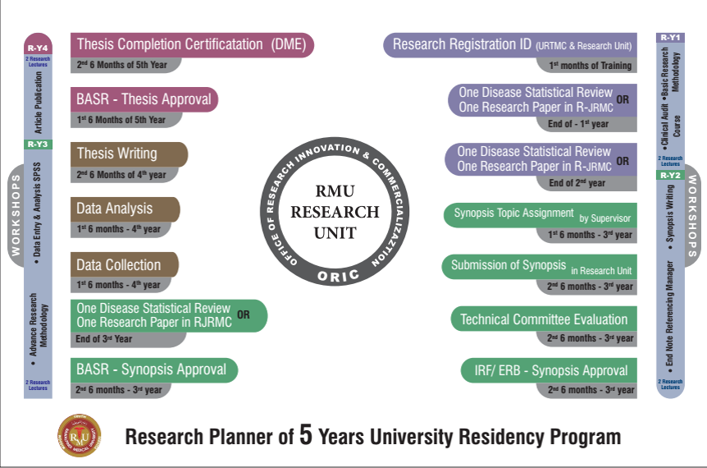

**Year 1**

* **Milestones**:
  + **Research Registration ID** (1st Month): Registration establishes an official record of the resident's research participation and aligns with institutional requirements.
  + **Synopsis Topic Assignment & Submission to Research Unit** (1st 6 Months): Residents are assigned a research topic, ideally aligned with their clinical interests, which lays the foundation for their thesis.
  + **Single Disease Statistical Review or Research Paper** (Before End of Year 1): Residents complete a statistical review or publish a research paper, introducing them to data interpretation and critical analysis.
* **Training Components**:
  + **Basic Research Methodology**: A series of introductory lectures on research methodology, covering study designs, sample size calculation, and research ethics.
  + **Research Lectures**: Regular sessions to familiarize residents with foundational research principles.
  + **Synopsis Writing & Referencing Manager Training**: Workshops on writing a research synopsis and managing references using software like EndNote or Zotero.

1. **Year 2**

* **Milestones**:
  + **Submission of Synopsis** (1st 6 Months): Residents submit a detailed research proposal outlining their study objectives, methodology, and expected outcomes.
  + **Technical Committee Evaluation, IRF/ERB Approval, and BASAR Synopsis Approval**: These steps involve institutional and ethical approvals, ensuring the research project meets ethical standards and feasibility.
* **Training Components**:
  + **Advanced Research Methodology**: Building on the basics, this module covers complex statistical tests, bias minimization, and confounding variables.
  + **Research Lectures**: Continued educational sessions to reinforce methodological rigor and address any challenges in the research process.

1. **Year 3**

* **Milestones**:
  + **1 Disease Statistical Review or 1 Research Paper** (Optional): An optional review or paper to further enhance research skills.
  + **Data Collection** (1st 6 Months): Residents begin gathering data for their thesis under guidance, focusing on data quality and integrity.
  + **Data Analysis** (Last 6 Months): Residents learn to apply statistical techniques using software like SPSS, analyzing the data collected for meaningful insights.
* **Training Components**:
  + **Data Entry & Analysis with SPSS**: A workshop on using SPSS for data entry and performing essential statistical analyses, equipping residents with hands-on analytical skills.
  + **Research Lectures**: Ongoing lectures addressing specific challenges in data management and analysis.

1. **Year 4 and 5**

* **Milestones**:
  + **Thesis Writing** (1st 6 Months): Residents draft their thesis with structured guidance on writing style, formatting, and scientific rigor.
  + **BASAR Thesis Approval** (Last 6 Months): The thesis is submitted for approval, marking the completion of the primary research requirement.
  + **Thesis Completion Certificate by DME** (Last 6 Months): Upon approval, the Department of Medical Education certifies the thesis completion, fulfilling the academic research requirement.
* **Training Components**:
  + **Thesis Writing Workshop**: A dedicated session on organizing research findings, structuring a thesis, and using appropriate academic language.
  + **Writing an Article/Publications**: Guidance on publishing research findings, including manuscript preparation, journal selection, and the peer-review process.

**Research Lectures**: Concluding lectures covering advanced topics in publication ethics and responding to reviewer feedback

**RESEARCH MILESTONES**

|  |  |
| --- | --- |
| **MILESTONE** | **TIMELINE** |
| Research registration ID | Year 1 |
| one disease statistical report | Year 1 |
| Synopsis topic assignment | Year 1 |
| One disease statistical report | Year 2 |
| Submission of synopsis | Year 3 |
| Technical committee evaluation | Year 3 |
| ERB approval | Year 3 |
| BASR approval | Year 3 |
| Data collection, data Analysis | Year 4 |
| Thesis writing | Year 4 |
| BASR thesis approval | Year 5 |
| Thesis completion certificate | Year 5 |

**Research Work Assessment**

**Submission of Synopsis and Thesis**

1. The candidates shall prepare their synopsis as per guidelines provided by the Advanced Studies & Research Board, available on RMU website.
2. Synopsis of research project should be submitted and approved by the end of the 1st year of MS program.
3. The minimum duration between approval of synopsis and submission of thesis shall be one year, but the thesis cannot be submitted later than 8 years of enrolment.
4. Thesis shall be submitted by the candidate duly recommended by the Supervisor.
5. The research thesis must be compiled and bound in accordance with the Thesis Format Guidelines approved by the University and available on website.
6. The research thesis will be submitted along with the fee prescribed by the University.

**Thesis Assessment**

1. All candidates admitted in MS course shall appear in thesis evaluation component of the MTA after completion of 4th years of their training course.
2. Only those candidates shall be eligible for thesis evaluation who have passed Midterm Examination and Oral & Practical/ Clinical component of Exit Examination.
3. The examination shall include thesis evaluation with defense.
4. The Vice Chancellor shall appoint three external examiners for thesis evaluation, preferably from other universities and from abroad, out of the panel of examiners approved by the Advanced Studies & Research Board. The examiners shall be appointed from respective specialty.
5. The thesis shall be sent to the external examiners for evaluation, well in time before the date of defense examination and should be approved by all the examiners.
6. After the approval of thesis by the evaluators, the thesis defense examination shall be held within the University on such date as may be notified by the Controller of Examinations. The Controller of Examinations shall make appropriate arrangements for the conduct of thesis defense examination in consultation with the supervisor, who will co-ordinate the defense examination.
7. The thesis defense examination shall be conducted by two External Examiners who shall submit a report on the suitability of the candidate for the award of degree. The supervisor shall act as coordinator.

***Candidates and faculty interested in further details relating to research, please refer to the document on Research curriculum (also available on RMU website***

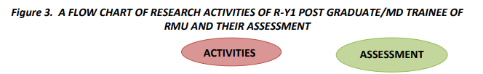

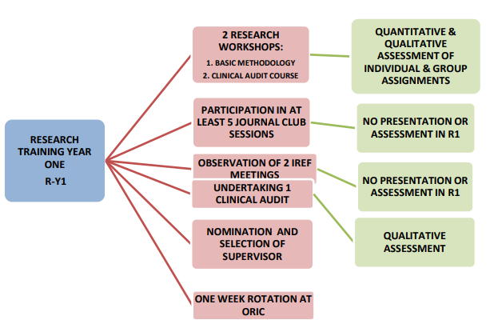

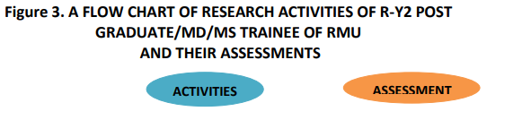

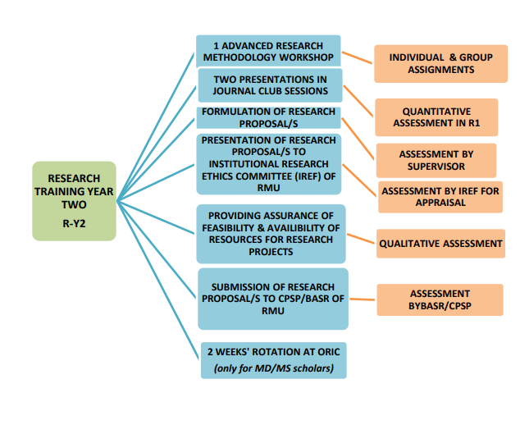

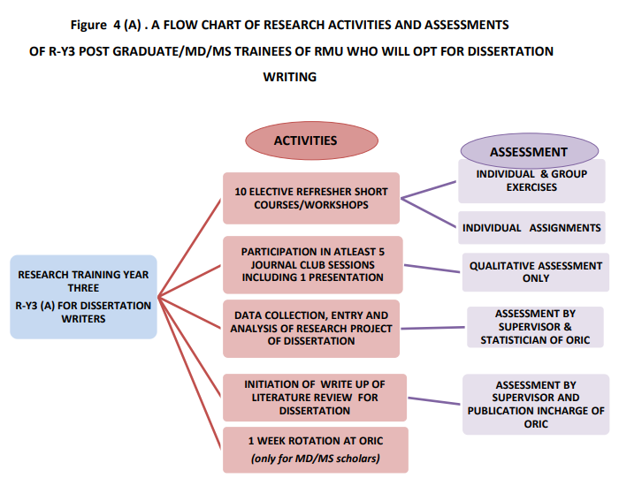

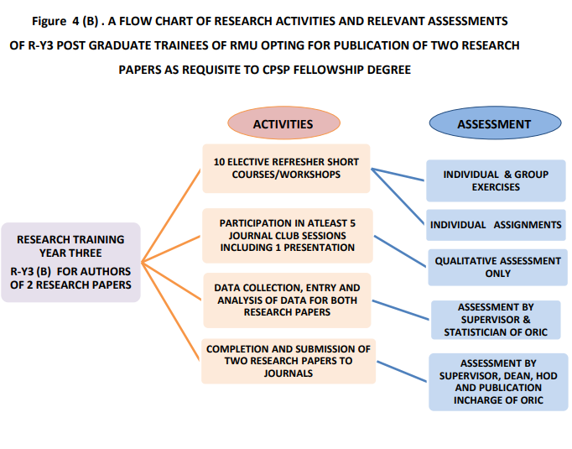



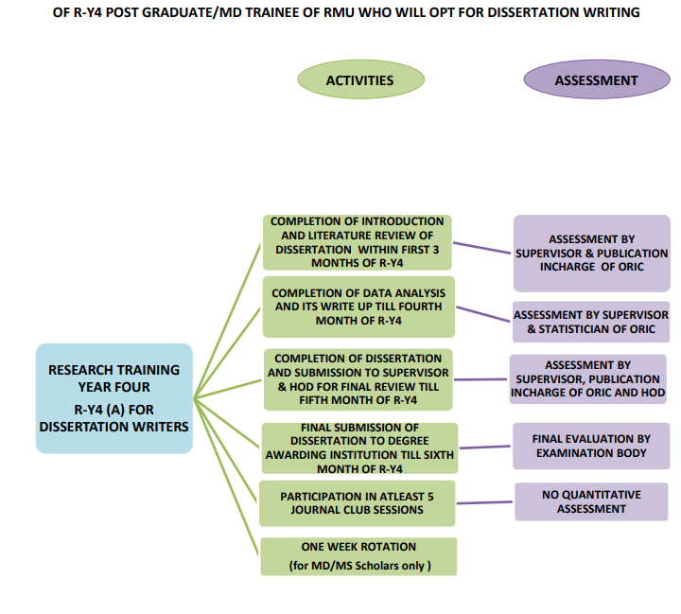

. .



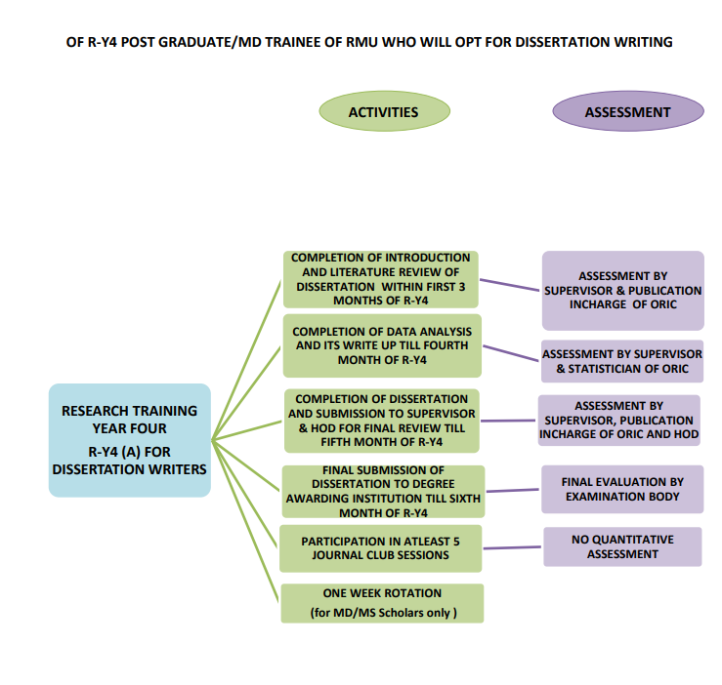

**SECTION – IV**

**RESEARCH CURRICULUM**

**&**

**MANDATORY WORKSHOPS**

**THE SUPERVISOR OF THE TRAINEE FOR THE DISSERTATION PROJECT**

1. The supervisor of the trainee must be nominated within first six months of the research training. The Dean of the specialty will decide the nomination of the supervisor for the post graduate trainee as well as MD scholars. In this regards a meeting will be held that will be attended by all heads of the departments and the Dean. The list of all the first year trainees and the available supervisors in each department will be presented by respective heads of each department in meeting. All of the eligible trainees and supervisors will also be around for briefs interviews during the meeting. The supervisor for the trainee will be nominated based the the level of performance, talent personality and temperament of both the trainees and the supervisors by the HOD. If the supervisor will also be willing to happily supervise the trainee, then the Dean will finally approve the nomination, apart from other requirements.

2. After finalization of nominations a letter of agreement of supervision will be submitted by the trainee to the office of Dean, including consent and endorsement of both trainee and the internal and/or external supervisor, with copies to HOD, ORIC and BASR.

3. The supervisor will be bound to meet with the trainee, on weekly basis exclusively for research activity and will document the activity performed during the meeting in the log book along with endorsement.

4. During ninth month of training year 1; R-Y1 the supervisor/s will supervise trainees together in groups and will undertake clinical audit on various aspects of the department as a project assignment, on one topic assigned to each group by the Dean and Heads of Departments. The contribution of the post graduate trainees’/ MD trainees in audits will be qualitatively assessed by the supervisors and the head of departments.

5. The supervisor will keep vigilant and continuous monitoring of all the research related academic activities of each trainee.

6. The supervisors will provide their feedback through structured and anonymous feedback forms/questionnaire, including closed and partially closed questions that will be regularly provided by them. They will provide their inputs and opinions regarding effectiveness of the course contents, curriculum, teaching methodologies, teaching aids and technologies, content and usefulness of the exercises and assessments etc.

7. One Focus group discussion of supervisors will also be organized by the ORIC to evaluate the research course, its benefits and weaknesses and scope for improvement, each year.

8. The supervisor will keep a close and continuous check on the Log books, Research portfolio of the trainee and will endorse it regularly. Based on his/her observations, the supervisor will evaluate the performance of the trainee and will discuss it in monthly meeting with the Head of Department or Dean of the specialty if required.

9. The supervisor will not only guide and facilitate the trainee in preparation of presentation of Journal Club but will also ensure that trainees should actively participate in question & answer session of the journal club meeting and will also ensure the attendance of the trainees in Journal club as per set requirements.

10. During these first three months of R-Y2, supervisor will guide and supervise the trainee to do extensive review of the literature, relevant to topic and finalize the research question/s and research topic/s with mutual understanding and will submit the selected topic to the Head of Department and Dean of specialty

11. The supervisor will facilitate the trainee at every step, the formal write up of research proposal/s in consultation with the research associates of ORIC for guidance in methodology. The research proposal should be completed in eighth month of R-Y2 and should also be reviewed and finalized by the Supervisor of the trainees.

12. The trainees should formulate all the data collection tools under guidance of supervisor and should also pretest to finalize all the data collection tools for their research projects.

13. The supervisors will also ensure that the duration of research project should be adequate and realistic so that trainees will be able to complete their project/s during third year of training leaving enough time for its write up during year 4 of training. The supervisor will also consult the Dean and HOD’s in ensuring the feasibility and availability of resources of a trainee during second year of training.

14. The supervisor will help the trainee to make a five to ten minutes’ presentation through power-point at Institutional Research Ethics Forum during 9-10 months of R-Y2. By the end of presentation, the supervisor will facilitate in defense of the proposal.

15. During first quarter of year 3, it will be mandatory for the trainees to initiate the data collection phase of their project/s under continuous guidance of their supervisors. In case the data collection will require more human resources, other than trainee himself/herself, the supervisor will ensure that the additional data collection staff will be adequate in number within

data within the time framework and should also make sure that they will be proficient enough to collect high quality and authentic data.

16. The data storage will also be finalized by trainee under the guidance of Supervisor and research center of specialty.

17. Whether the trainee is opting for dissertation writing or research paper publication, the supervisor will ensure that every step and procedure is being followed effectively and timely meeting all set requirements as per standard operational procedures.

18. The supervisor will actively assist the trainee in write up of dissertation/ research papers.

19. The trainee should submit final draft of dissertation to the supervisor till end of fifth month of year 4 for final modifications. Since the supervisor will be incessantly involved in every aspect of the project since the beginning and will be persistently guiding the procedure, so he/she should not take more than 10 days to give final review to dissertation of the trainee with written feedback that will be entered in a structured performa with recommendations for improvement or corrections.

20. In case the dissertation or research paper/s is/are sent back with recommended corrections or modifications, the supervisor will assist the trainee on urgent basis to get it rectified and resubmitted within next 10 days’ time. In case any of the paper is refused publication by a journal even then the supervisor will assist the trainee on urgent basis, to get it rectified and resubmitted to another target journal of choice within next 10 days’ time and not delaying it all.

21. In case the research paper/s is/are sent back with recommended corrections or modifications, the supervisor will assist the trainee on urgent basis to get it rectified and resubmitted within next 10 days’ time. In case any of the paper is refused publication by a journal even then the supervisor and publication unit at ORIC will assist the trainee on urgent basis, to get it rectified and resubmitted to another target journal of choice within next 10 days’ time and not delaying it all.

22. While the dissertations will be under review by the degree awarding authority for acceptance, the trainees will be continuously guided by the supervisor regarding defense of their dissertation. They will be guided how to make effective presentations according to the format provided by the examination authorities and also how to successfully and confidently respond to the queries of examiners.

***Candidates and faculty interested in further details relating to research, please refer to the document on Research curriculum (also available on RMU website***

**Framework of Workshops in MS Anesthesiology Program**

The MS Anesthesiology Residency Program includes a comprehensive workshop series designed to equip residents with critical skills in research methodology, computer literacy, communication, medical ethics, and emergency response. These workshops are integrated across the five-year residency to ensure incremental skill development and practical application. Each workshop has specific learning objectives and topics that address various aspects essential for clinical practice, patient interaction, research acumen, and emergency preparedness.

**Introduction to Computer/Information Technology & Software**

* **Learning Objectives**: Develop fundamental IT skills for clinical and research applications, including basic word processing, data management, and presentation creation.
* **Topics Covered**: Hardware, software basics, file management, word processing, PowerPoint, Excel, email, internet navigation, and introductory data entry in statistical software (SPSS).

**Biostatistics & Research Methodology**

* **Learning Objectives**: Grasp basic biostatistics, understand the importance of research, develop a research question, and engage in scientific presentations.
* **Topics Covered**: Introduction to biostatistics, biomedical research principles, selecting research fields, ethics, writing and presenting papers, and literature search techniques

**Communication Skills**

* **Learning Objectives**: Enhance clinical communication skills, improve counseling techniques, and understand ethical responsibilities.
* **Topics Covered**: Non-medical interventions, crisis intervention, conflict resolution, breaking bad news, informed consent, patient confidentiality, and professional ethics.

**Cardiac First Response (CFR)**

* **Learning Objectives:** Train in emergency cardiac care, including BLS, AED usage, and ALS fundamentals.
* **Topics Covered**: Cardiac emergency recognition, BLS principles, AED usage, ALS basics, scenario-based training, team dynamics, and advanced resuscitation techniques

**Synopsis Writing Workshop**

* **Learning Objectives**: Develop and structure a research synopsis, from research question formulation to reference management.
* **Topics Covered**: Synopsis components, research question development, literature review, methodology, timeline and budget planning, peer review, editing, and finalizing the synopsis.

**5 Year Residency Workshops**

|  |  |
| --- | --- |
| **Name of Workshops** | **Year** |

**WORKSHOPS**

**WORKSHOPS (3 hours each for 2-5 days)**

|  |  |  |  |
| --- | --- | --- | --- |
| **S.NO** | **NAME OF THE**  **WORKSHOP** | **LEARNING OBJECTIVES** | **TOPICS TO BE COVERED** |
| **1.** | **Biostatistics & Research Methodology**  **(4 days)** | * To understand the basics of Bio- Statistics * To critique why research is important? * To discuss the importance of Selecting a Field for Research * To prepare oneself for Participation in National and International Research * To prepare oneself for Participation in Pharmaceutical Company Research * To interpret the importance of research ideas & Criteria for a good research topic * To discuss Ethics in Health Research * To learn to write a Scientific Paper * To learn to make a Scientific Presentation * To learn to make a purposeful literature   search | 1. Introduction to Bio-Statistics 2. Introduction to Bio- Medical Research Why research is important? 3. What research to do?    1. Selecting a Field for Research    2. Drivers for Health Research    3. Participation in National and International Research    4. Participation in Pharmaceutical Company Research    5. Where do research ideas come from    6. Criteria for a good research topic Ethics in Health Research 4. Writing a Scientific Paper 5. Making a Scientific Presentation & Searching the Literature |
| **2.** | **Introduction to computer/Information Technology & Software (5 days)** | By the end of this workshop student should be able to:   * Appropriately start up and shut down your computer. * Navigate the operating system and start applications. * Perform basic functions of file management. * Perform basic functions in a word processor and spreadsheet. * Manage print settings and print documents. * Receive and send email. * Use a web browser to navigate the Internet. * work with windows, toolbars, and command menus * perform basic word processing and graphic tasks * make a Power Point presentation * explore Web browsing basics * back up files * save, copy, and organize your work * to enter data accurately in software of Statistical Package for Social Sciences | 1. Hardware and Software    * Understand the main components of a computer, including input and output devices.    * Understand the function of communication devices such as smartphones and tablets.    * Understand the role of Operating Systems, programs and apps. 2. Windows    * Turning on the computer and logging on.    * The Windows screen.    * Running programs from the Start Menu.    * Minimising, maximising, moving, resizing and closing windows.    * Logging off and shutting down your computer. 3.Working with Programs    * Running multiple programs.    * Desktop icons and creating a desktop shortcut.    * Managing programs from the taskbar.    * Closing programs. 4.File Managemnt    * Managing Windows Explorer.    * Creating, moving, renaming and deleting folders and files.    * Understandings file extensions.    * Viewing storage devices and network connections.    * Managing USB flash drives. 5.Word Processing    * Creating documents in Microsoft Word.    * Typing text, numbers and dates into a document.    * Easy formatting.    * Checking the spelling in your document.    * Making and saving changes to your document.   6.Power Point  Making Power Point presentation 7.Spreadsheets |
|  |  |  | * Understanding spreadsheet functionality. * Creating spreadsheets in Microsoft Excel. * Typing text numbers and dates into a worksheet. * Easy formulas. * Easy formatting. * Charting your data. * Making and saving changes to your workbook. * Printing a worksheet. 8.Printing * Print preview. * Print settings. * Managing the print queue. 9.Using Email * The Outlook mail screen elements. * Composing and sending an email message. * Managing the Inbox. 10.Accessing the Internet * Going to a specific website and bookmarking. * Understanding how to search/Google effectively. * Copy and paste Internet content into your documents and emails. * Stopping and refreshing pages. * Demystifying the Cloud. * Understanding social media platforms such as Facebook and Twitter. * Computer security best practices. 11.Statistical Package for Social Sciences * general understanding for data entry   • |
| **3.** | **communication skills**  **(3 days)** | * To learn to use Non-medicinal Interventions in Communication Skills of Clinical Practice * To discuss the importance of counseling * To role play as a counselor | 1. Use of Non-medicinal Interventions in Clinical Practice Communication Skills 2. Counseling 3. Informational Skills 4. Crisis Intervention/Disaster 5. Management Conflict Resolution |
|  |  | * To learn to manage a conflict resolution * To learn to break a bad news * To discuss the importance of Medical Ethics, Professionalism and Doctor-Patient Relationship Hippocratic Oath * To learn to take an informed consent * To illustrate the importance of confidentiality * To summarize Ethical Dilemmas in a   Doctor’s Life | 1. Breaking Bad News 2. Medical Ethics, Professionalism and Doctor-Patient Relationship Hippocratic Oath 3. Four Pillars of Medical Ethics (Autonomy, Beneficence, Non-malficence and Justice) 4. Informed Consent and Confidentiality 5. Ethical Dilemmas in a Doctor’s Life |
|  | **Synopses Writing** | * Introduction to Synopsis Writing and Research Question Development * Understand the purpose and structure of a research synopsis. * Learn to develop a clear and concise research question. * Literature Review and Methodology * Master techniques for conducting a literature review. * Understand how to design a robust research methodology * Writing the Synopsis and Managing References * Learn to write each section of a research synopsis. * Understand the importance of proper citation and reference management. * Peer Review and Finalizing the Synopsis * Learn the peer-review process and its importance. * Finalize and polish the research synopsis. | Introduction to Synopsis Writing:   * + Definition and importance of a research synopsis.   + Key components of a synopsis: title, abstract, introduction, objectives, methodology, and timeline.   + Differences between a synopsis, proposal, and full research paper.   Developing a Research Question:   * + Characteristics of a good research question: clarity, specificity, and feasibility.   + Techniques for formulating research questions: PICOT framework, FINER criteria.   + Refining and narrowing down research questions.   Conducting a Literature Review:   * + Purpose and scope of a literature review.   + Strategies for searching academic databases and identifying relevant literature.   + Synthesizing information and identifying research gaps.   + Referencing and citation management.   Designing the Research Methodology:   * + Types of research designs: qualitative, quantitative, and mixed methods.   + Selection of appropriate study design based on the research question.   + Sampling techniques, data collection methods, and data analysis plans.   + Ethical considerations in research design.   Writing the Synopsis:   * + Title and Abstract:     - Crafting a clear and informative title.     - Writing a concise abstract that summarizes the research.   + Introduction:     - Background and rationale for the study.     - Stating the research problem and objectives.   + Methodology:     - Detailed description of the research design, data collection, and analysis.   + Timeline and Budget:     - Creating a realistic timeline for the research.     - Estimating and justifying the research budget.   + References:     - Citing sources accurately and compiling a reference list.   Reference Management:   * + Tools for managing references (e.g., EndNote, Mendeley, Zotero).   + Proper citation styles (e.g., APA, MLA, Vancouver).   Peer Review Process:   * + Importance of peer review in research.   + How to provide constructive feedback.   + Reviewing and critiquing peer synopses.   + Incorporating feedback to improve the synopsis.   Finalizing the Synopsis:   * + Editing and proofreading techniques.   + Ensuring clarity, coherence, and conciseness in writing.   + Checking for completeness and adherence to guidelines.   + Preparing the final document for submission. |
|  | **Cardiac First**  **Response** | * Introduction to Cardiac Emergencies and Basic Life Support (BLS) * Understand the types and signs of cardiac emergencies. * Learn the fundamentals of Basic Life Support (BLS). * Automated External Defibrillator (AED) Use and Advanced Life Support (ALS) * Gain proficiency in the use of an Automated External Defibrillator (AED). * Understand the basics of Advanced Life Support (ALS). * Scenario-Based Training and Team Dynamics * Apply knowledge and skills in realistic, scenario-based training. * Understand the importance of effective team dynamics during a cardiac emergency. * Advanced Skills and Final Assessment * Learn advanced skills for managing cardiac emergencies. * Demonstrate competency through a final assessment. | 1. Introduction to Cardiac Emergencies:    * Overview of cardiac emergencies: heart attack, cardiac arrest, angina, and arrhythmias.    * Recognizing symptoms and risk factors.    * The importance of timely intervention and the concept of the "golden hour." 2. Basic Life Support (BLS):    * Principles of BLS: ensuring scene safety, assessing responsiveness, and calling for help.    * Steps of BLS: airway, breathing, and circulation (ABC).    * Hands-on practice: chest compressions, rescue breaths, and using a barrier device. 3. Automated External Defibrillator (AED):    * Function and importance of an AED in cardiac emergencies.    * Step-by-step instructions on how to use an AED.    * Safety precautions and troubleshooting common issues.    * Hands-on practice with AED simulators. 4. Introduction to Advanced Life Support (ALS):    * Overview of ALS and its components.    * The role of medications and advanced airway management.    * Introduction to ECG interpretation for identifying cardiac rhythms.    * Coordination and communication in a resuscitation team. 5. Scenario-Based Training:    * Simulated cardiac emergencies with real-time response.    * Role-playing various scenarios: out-of-hospital cardiac arrest, in-hospital cardiac arrest, and post-resuscitation care.    * Debriefing and feedback sessions to identify strengths and areas for improvement. 6. Team Dynamics in Cardiac Emergencies:    * Importance of teamwork and clear communication.    * Roles and responsibilities of team members during a resuscitation effort.    * Strategies for effective leadership and coordination.    * Hands-on practice with team drills and role assignments. 7. Advanced Skills:    * Advanced airway management: intubation and supraglottic airway devices.    * Intravenous (IV) access and medication administration.    * Post-resuscitation care: monitoring and stabilizing the patient.    * Review of ACLS algorithms and protocols. 8. Final Assessment:    * Practical exam: simulated cardiac emergency scenarios to assess BLS, AED, and ALS skills.    * Written exam: testing knowledge of cardiac emergency management, BLS, and ALS protocols.    * Feedback and discussion on performance.    * Certification for participants who meet competency standards. |

**THE SUPERVISOR OF THE TRAINEE FOR THE DISSERTATION PROJECT**

1. The supervisor of the trainee must be nominated within first six months of the research training. The Dean of the specialty will decide the nomination of the supervisor for the post graduate trainee as well as MD scholars. In this regards a meeting will be held that will be attended by all heads of the departments and the Dean. The list of all the first year trainees and the available supervisors in each department will be presented by respective heads of each department in meeting. All of the eligible trainees and supervisors will also be around for briefs interviews during the meeting. The supervisor for the trainee will be nominated based the the level of performance, talent personality and temperament of both the trainees and the supervisors by the HOD. If the supervisor will also be willing to happily supervise the trainee, then the Dean will finally approve the nomination, apart from other requirements.

2. After finalization of nominations a letter of agreement of supervision will be submitted by the trainee to the office of Dean, including consent and endorsement of both trainee and the internal and/or external supervisor, with copies to HOD, ORIC and BASR.

3. The supervisor will be bound to meet with the trainee, on weekly basis exclusively for research activity and will document the activity performed during the meeting in the log book along with endorsement.

4. During ninth month of training year 1; R-Y1 the supervisor/s will supervise trainees together in groups and will undertake clinical audit on various aspects of the department as a project assignment, on one topic assigned to each group by the Dean and Heads of Departments. The contribution of the post graduate trainees’/ MD trainees in audits will be qualitatively assessed by the supervisors and the head of departments.

5. The supervisor will keep vigilant and continuous monitoring of all the research related academic activities of each trainee.

6. The supervisors will provide their feedback through structured and anonymous feedback forms/questionnaire, including closed and partially closed questions that will be regularly provided by them. They will provide their inputs and opinions regarding effectiveness of the course contents, curriculum, teaching methodologies, teaching aids and technologies, content and usefulness of the exercises and assessments etc.

7. One Focus group discussion of supervisors will also be organized by the ORIC to evaluate the research course, its benefits and weaknesses and scope for improvement, each year.

8. The supervisor will keep a close and continuous check on the Log books, Research portfolio of the trainee and will endorse it regularly. Based on his/her observations, the supervisor will evaluate the performance of the trainee and will discuss it in monthly meeting with the Head of Department or Dean of the specialty if required.

9. The supervisor will not only guide and facilitate the trainee in preparation of presentation of Journal Club but will also ensure that trainees should actively participate in question & answer session of the journal club meeting and will also ensure the attendance of the trainees in Journal club as per set requirements.

10. During these first three months of R-Y2, supervisor will guide and supervise the trainee to do extensive review of the literature, relevant to topic and finalize the research question/s and research topic/s with mutual understanding and will submit the selected topic to the Head of Department and Dean of specialty

11. The supervisor will facilitate the trainee at every step, the formal write up of research proposal/s in consultation with the research associates of ORIC for guidance in methodology. The research proposal should be completed in eighth month of R-Y2 and should also be reviewed and finalized by the Supervisor of the trainees.

12. The trainees should formulate all the data collection tools under guidance of supervisor and should also pretest to finalize all the data collection tools for their research projects.

13. The supervisors will also ensure that the duration of research project should be adequate and realistic so that trainees will be able to complete their project/s during third year of training leaving enough time for its write up during year 4 of training. The supervisor will also consult the Dean and HOD’s in ensuring the feasibility and availability of resources of a trainee during second year of training.

14. The supervisor will help the trainee to make a five to ten minutes’ presentation through power-point at Institutional Research Ethics Forum during 9-10 months of R-Y2. By the end of presentation, the supervisor will facilitate in defense of the proposal.

15. During first quarter of year 3, it will be mandatory for the trainees to initiate the data collection phase of their project/s under continuous guidance of their supervisors. In case the data collection will require more human resources, other than trainee himself/herself, the supervisor will ensure that the additional data collection staff will be adequate in number within

data within the time framework and should also make sure that they will be proficient enough to collect high quality and authentic data.

16. The data storage will also be finalized by trainee under the guidance of Supervisor and research center of specialty.

17. Whether the trainee is opting for dissertation writing or research paper publication, the supervisor will ensure that every step and procedure is being followed effectively and timely meeting all set requirements as per standard operational procedures.

18. The supervisor will actively assist the trainee in write up of dissertation/ research papers.

19. The trainee should submit final draft of dissertation to the supervisor till end of fifth month of year 4 for final modifications. Since the supervisor will be incessantly involved in every aspect of the project since the beginning and will be persistently guiding the procedure, so he/she should not take more than 10 days to give final review to dissertation of the trainee with written feedback that will be entered in a structured performa with recommendations for improvement or corrections.

20. In case the dissertation or research paper/s is/are sent back with recommended corrections or modifications, the supervisor will assist the trainee on urgent basis to get it rectified and resubmitted within next 10 days’ time. In case any of the paper is refused publication by a journal even then the supervisor will assist the trainee on urgent basis, to get it rectified and resubmitted to another target journal of choice within next 10 days’ time and not delaying it all.

21. In case the research paper/s is/are sent back with recommended corrections or modifications, the supervisor will assist the trainee on urgent basis to get it rectified and resubmitted within next 10 days’ time. In case any of the paper is refused publication by a journal even then the supervisor and publication unit at ORIC will assist the trainee on urgent basis, to get it rectified and resubmitted to another target journal of choice within next 10 days’ time and not delaying it all.

22. While the dissertations will be under review by the degree awarding authority for acceptance, the trainees will be continuously guided by the supervisor regarding defense of their dissertation. They will be guided how to make effective presentations according to the format provided by the examination authorities and also how to successfully and confidently respond to the queries of examiners.

**SECTION V**

**MILESTONES AND EPA**

**Charting the Road to Competence: Developmental Milestones for MS Anesthesiology , Rawalpindi Medical University**

**Remember to celebrate for the milestones as you prepare for the road ahead----Nelson Mandela.**

High-quality assessment of resident performance is needed to guide individual residents' development and ensure their preparedness to provide patient care. To facilitate this aim, reporting milestones are now required across all Anesthesiology residency programs. Milestones promote competency-based training in internal medicine. Residency program directors may use them to track the progress of trainees in the 6 general competencies including ***patient care, Medical Knowledge, Practice-Based Learning and Improvement, Interpersonal and Communication Skills, Professionalism and Systems-Based Practice.*** Mile stones inform decisions regarding promotion and readiness for independent practice. In addition, the milestones may guide curriculum development, suggest specific assessment strategies, provide benchmarks for resident self-directed assessment-seeking, assist remediation by facilitating identification of specific deficits, and provide a degree of national standardization in evaluation. Finally, by explicitly enumerating the profession’s expectations for graduates, they may improve public accountability for residents training.

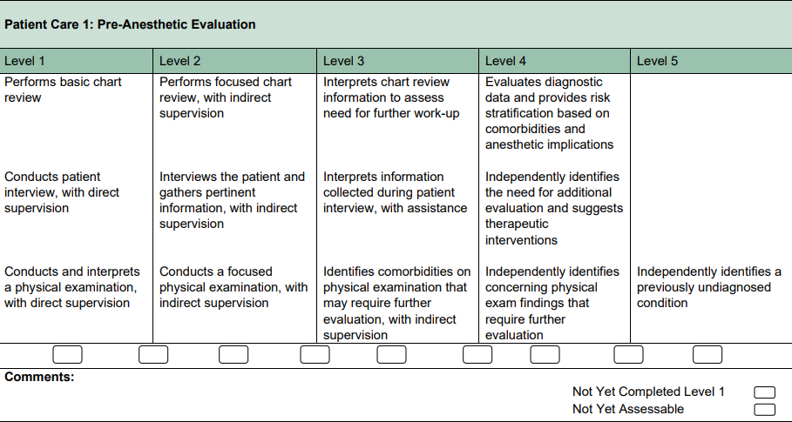

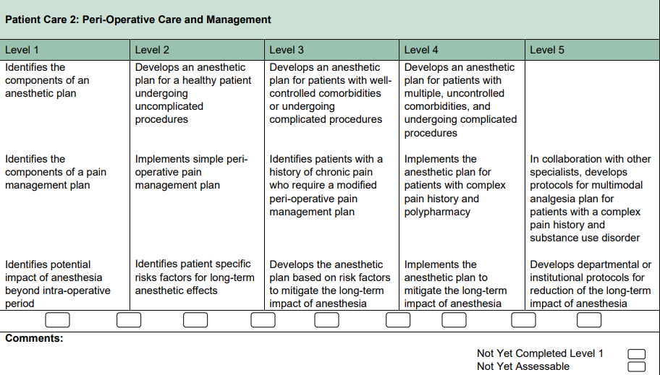

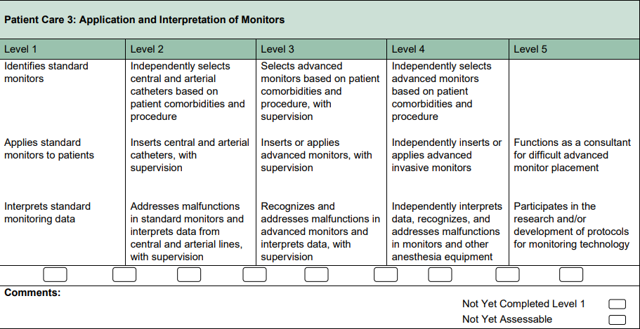

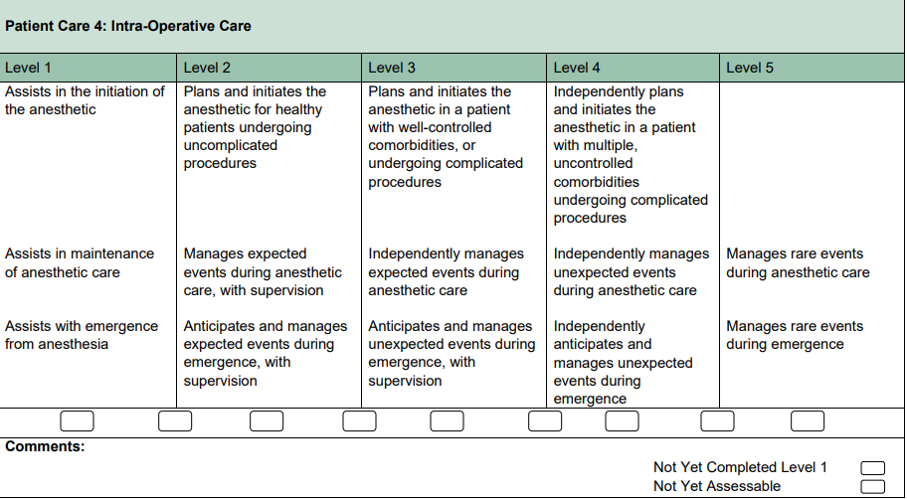

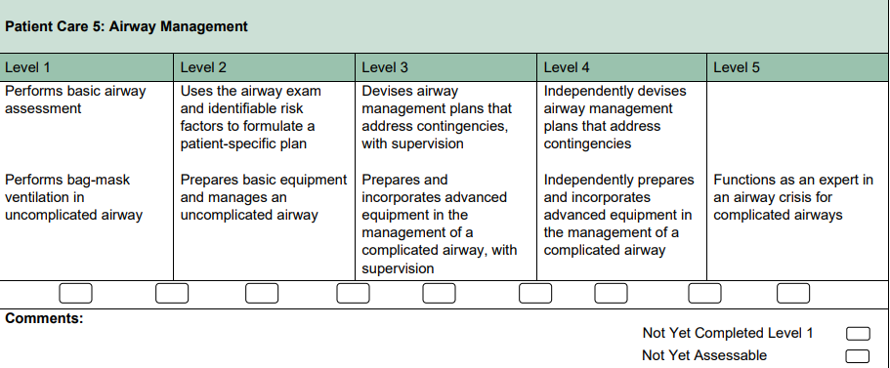

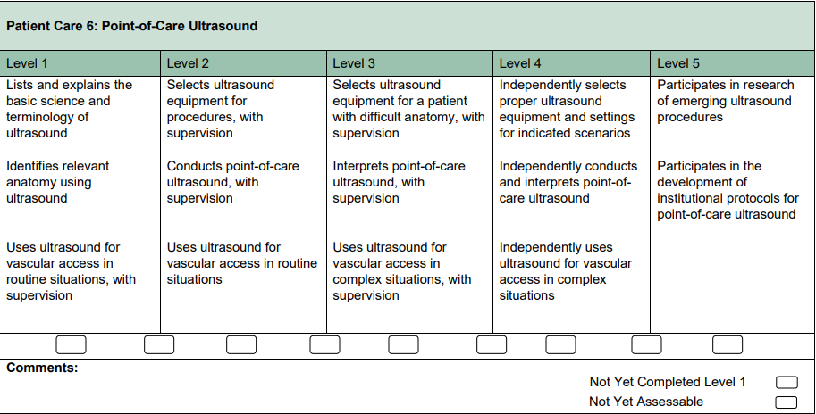

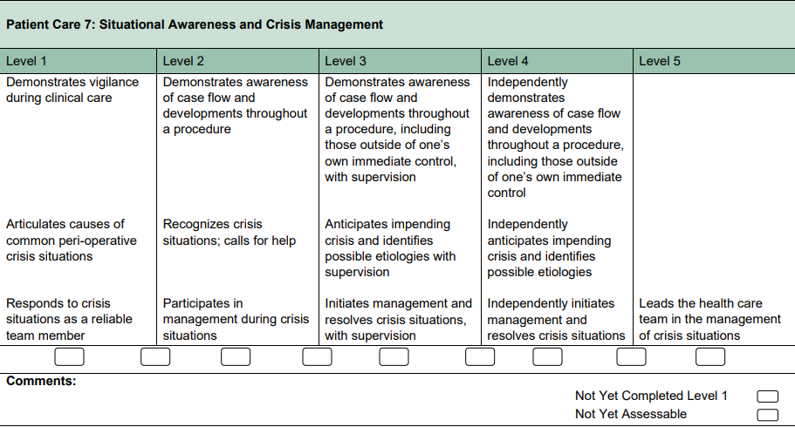

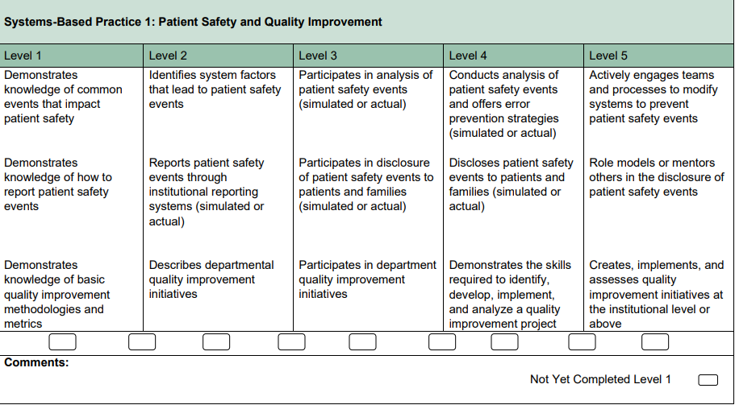

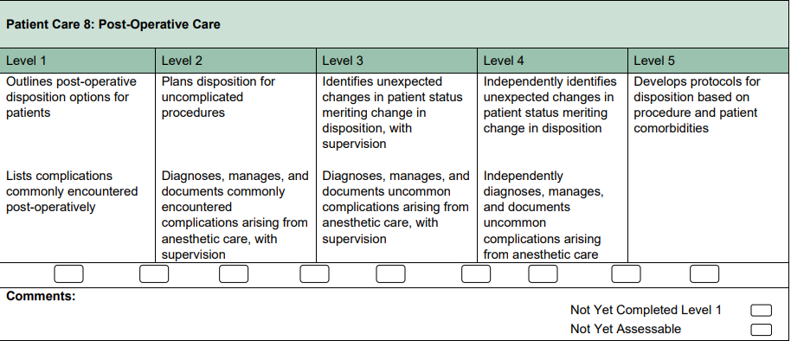

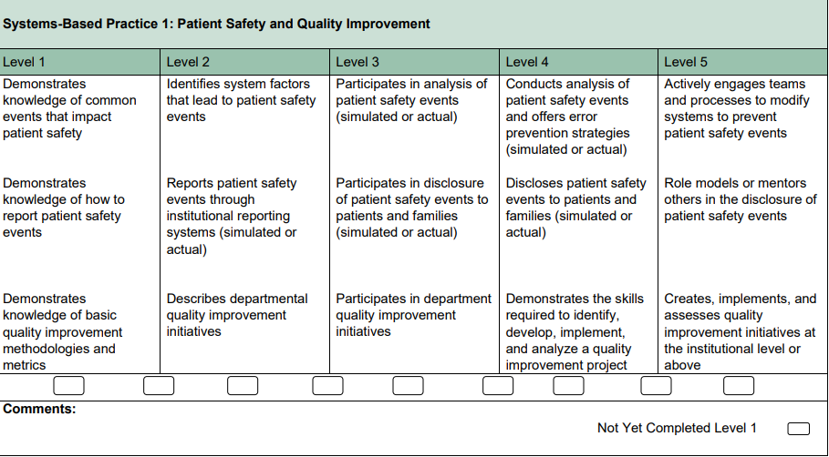

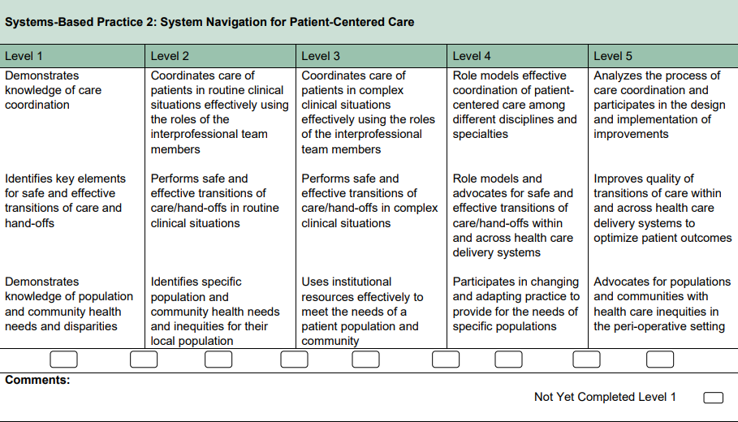

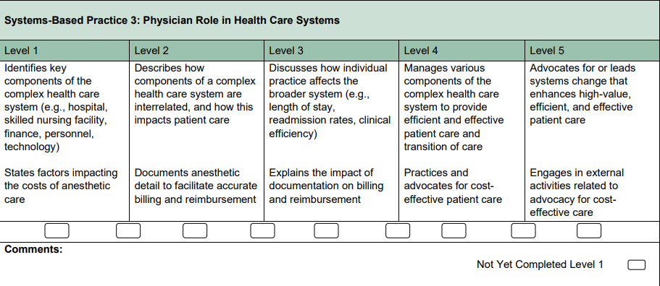

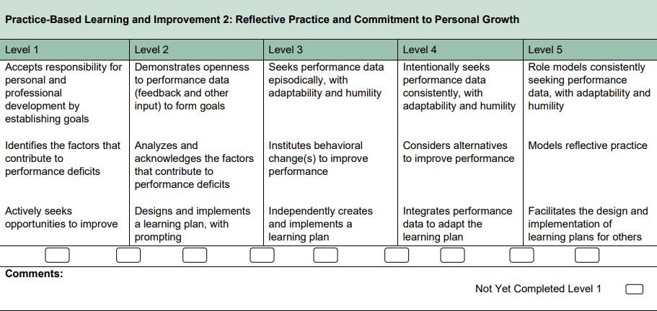

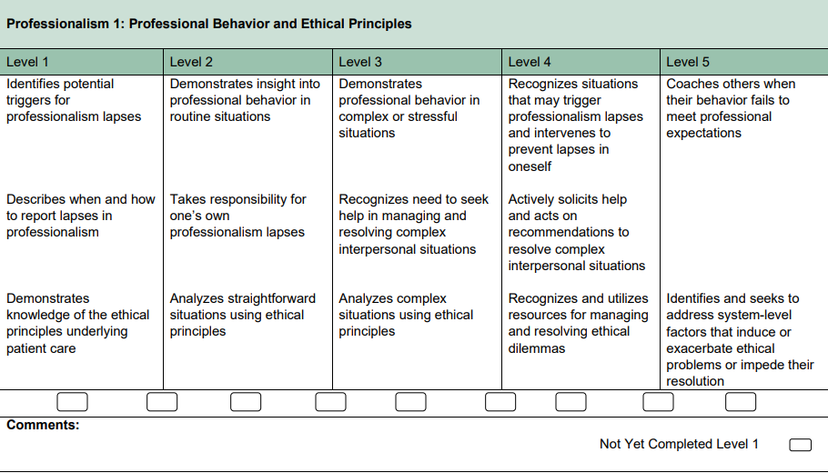

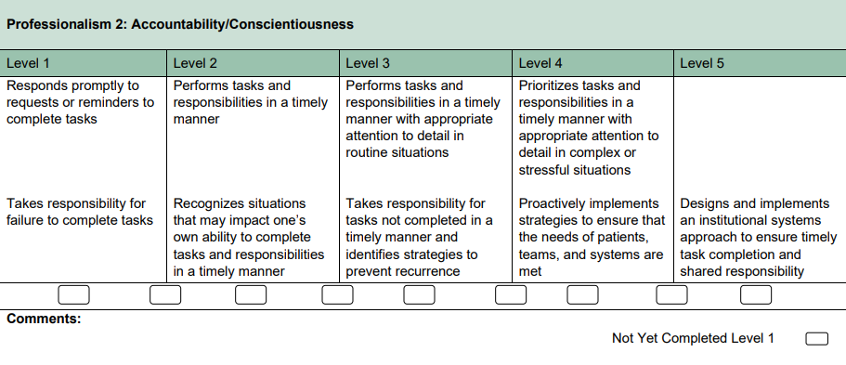

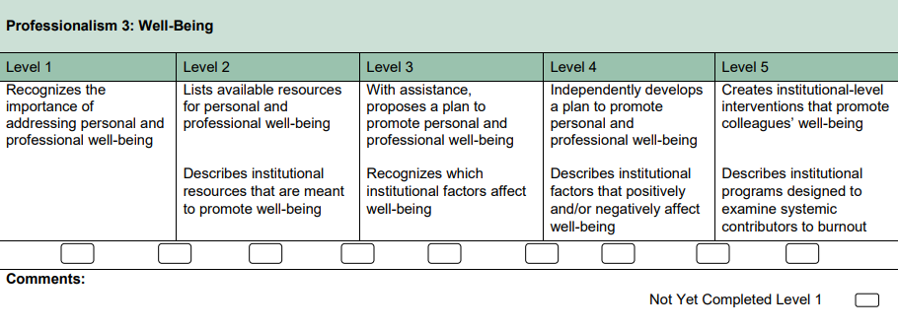

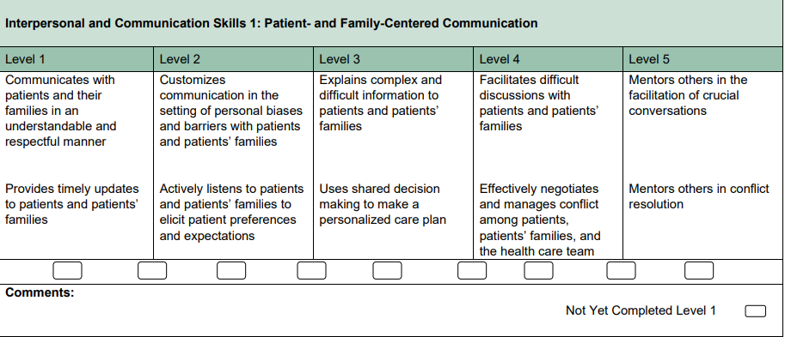

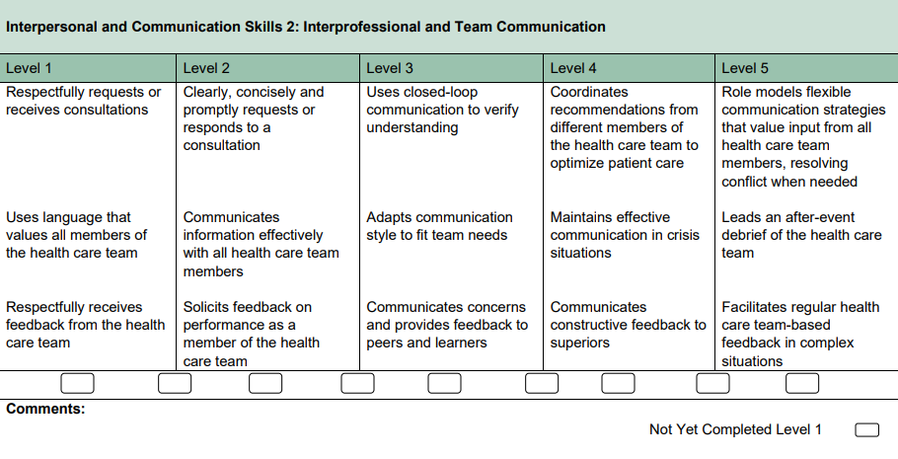

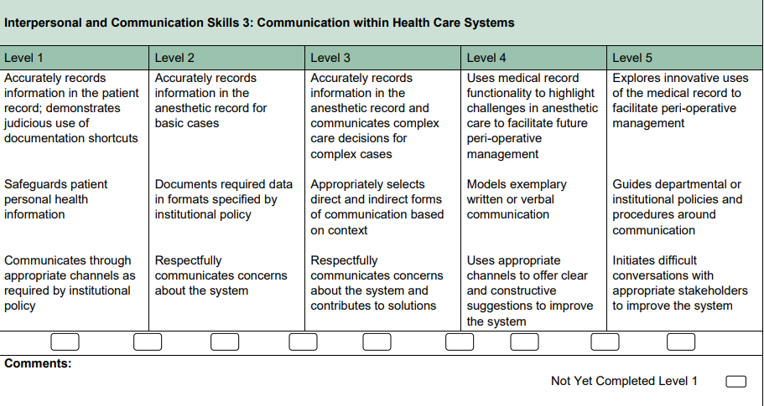

**ENTRUSTABLE PROFESSIONAL ACTIVITY FRAMEWORK**

|  |  |  |  |
| --- | --- | --- | --- |
| **s.no.** | **EPA** | **KEY FEATURES** | **Assessment plan – recommendations** |
| 1. | Performing preoperative assessments for healthy adult patients who will be undergoing a non-complex scheduled surgical procedure | 1) Establishing rapport with the patient who is scheduled for a non-complex surgery  2) Effectively gathering the data required for safe conduct of anesthesia  3) Organizing information appropriately in the anesthetic chart  4) Recognizing when to seek help in providing clear explanations to the patient | Direct observation or chart/case review by supervisor  Logbook |
| 2. | Monitoring adult patients undergoing non-complex surgical procedures, under general or regional anesthesia | 1)Preparing the operating room for non-complex surgical procedures including appropriate equipment checks, monitor selection/application and basic medication preparation  2) Recording physiologic values at appropriate intervals in the anesthetic chart 3)Identifying vital sign/monitoring abnormalities and initiating management/calling for help when needed | Direct observation by supervisor |
| 3. | Performing the postoperative transfer of care of healthy adult patients following anon-complex surgical procedure, including postoperative orders | 1)This EPA focuses on safe patient handover to the PACU team.  2) This includes providing necessary information to the receiving nurse in PACU, such as procedure performed, relevant comorbidities, medications used, complications, blood loss, fluids administered, analgesics and antiemetic’s given, and postoperative analgesia plan.  3)It also includes providing clear orders for postoperative care and ensuring the patient is in stable condition for PACU care. | Direct observation and review of order set by supervisor |
| 4. | Using the anesthetic assessment to generate the anesthetic considerations and management plan including postoperative disposition, and obtaining informed consent, for non-complex patients and non-complex surgery | interpretation of clinical data to identify and prioritize anesthetic considerations related to patient and surgical issues, and subsequent proposal of an anesthetic management plan encompassing preoperative, intraoperative and postoperative phases of care. | Direct (for consent) or indirect observation (case and chart review) by supervisor |
| 5. | Providing perioperative anesthetic management for non-complex cases in adult patients | This includes preoperative assessment, investigation/optimization if needed, informed consent, anesthetic management, postoperative management and determination of postoperative disposition. | Anesthetic management Direct observation and/or indirect observation by supervisor  Multisource feedback |
| 6. | Performing the non-airway basic procedures of Anesthesiology | This EPA includes:  1) selecting appropriate patients and techniques for the procedure  2) obtaining informed consent  3)performing the technical aspects of the procedure o appropriate documentation  4) managing post-procedure complications - Basic procedures include: spinal, arterial line, central line insertion. | Direct observation by supervisor  Log Book |
| 7. | Identifying patients presenting with an anticipated difficult airway and preparing for management options | 1)Identifying patients with an anticipated difficult airway ▪ 4 categories of anticipated difficulties: bag mask ventilation, intubation, supraglottic airway, front of neck access (FONA)  2)Discussing risks with the patient and obtaining informed consent  3) Planning management options; this must include plans for ventilation and oxygenation, and anticipated plans for safe extubation and postoperative management.It should also include having at least plan A and plan B. 4) Preparation of the operating room and equipment | Direct observation |
| 8. | Managing and coordinating patient positioning during anesthesia care and preventing and recognizing related complications | 1)Performing optimal positioning for a surgery  2) Coordinating the team during positioning  3) Applying knowledge of the risks of complications associated with suboptimal positioning 4)Recognizing a potential complication related to patient positioning and planning its management | Direct observation by supervisor |
| 9. | Assessing the indications for transfusion of blood products and managing side effects and complications | This EPA covers the more commonly used blood products: red blood cells (RBCs), frozen plasma (FP), platelets, cryoprecipitate, and prothrombin complex concentrate (PCC). Other products used less commonly, such as activated Factor VII or fibrinogen, are more appropriately covered in the relevant Core EPAs. | Direct observation and case review and debrief by supervisor |
| 10. | Diagnosing and managing common issues in the post-anesthesia care unit (PACU), or the surgical ward | Examples of common issues include: pain, nausea and/or vomiting, hypotension, hypertension, arrhythmias, cardiac ischemia, hypoxemia, respiratory depression, bronchospasm, pulmonary edema, deep venous thrombosis, delirium, slow awakening, decreased urine output. | Direct observation, or case and/or chart review with debrief, by supervisor |
| 11. | Initiating resuscitation and diagnosis of patients with life-threatening conditions in a time-appropriate manner | This EPA includes recognizing a life-threatening situation and beginning basic resuscitation (e.g., assess the ABCs, begin bag mask ventilation, bolus fluids, start pressors/inotropes). | Direct observation and/or case review and debrief by supervisor |
| 12. | Assessing pregnant patients and providing routine obstetric care or initial medical management for acute medical, surgical or obstetric conditions | This EPA focuses on assessing the pregnant patient, for routine care or for an acute problem, and proposing management plans that incorporate the wellbeing of both baby and mom. This EPA includes routine prenatal assessments, initial assessments during labour, common problems of pregnancy and acute/emergent medical, surgical or obstetric conditions. | Direct observation or chart review and/or case discussion by supervisor |
| 13. | Assessing and providing labour analgesia for healthy parturients with an uncomplicated pregnancy, including the management of common complications of labour analgesia | This EPA may include any of the following complications: inadequate control of pain, hypotension, bradycardia, fetal bradycardia and decelerations, respiratory depression, unilateral block, high block and/or inadvertent subarachnoid block | Direct observation by supervisor |
| 14. | Providing anesthesia for patients undergoing non-complex cesarean section | This EPA is focuses on providing anesthesia for non-complex obstetric patients undergoing cesarean section, regardless whether it is scheduled or not (“urgent” cesarean section where there is no immediate threat of life of woman or fetus, but early delivery is required) | Direct observation by supervisor |
| 15. | Providing perioperative anesthetic management for non-complex cases in pediatric patients | This EPA includes preoperative assessment, investigation and optimization if needed, as well as informed consent from parents/caregivers, anesthetic management and determination of postoperative disposition. | Direct observation by supervisor |
| 16. | Managing pediatric patients with common postoperative complications in the post anesthesia care unit or ward | This EPA may include the following complications: pain, nausea, vomiting, tachycardia, bradycardia, hypotension, hypoxemia, respiratory depression, laryngospasm, post op stridor, postoperative bleeding and delirium | Direct observation or case review and debriefing by supervisor |
| 17. | Using the anesthetic assessment to generate the anesthetic considerations and management plan, including prioritization and optimization, for patients with complex medical issues or surgeries | Interpretation of clinical data to identify and prioritize anesthetic considerations related to patient and surgical issues, and subsequent proposal of an anesthetic management plan encompassing preoperative, intraoperative and postoperative phases of care | Direct or indirect observation by supervisor |
| 18. | Providing anesthetic management for patients with defined critical illness | This EPA focuses on the anesthetic care of the patient who is critically ill, defined as needing some form of critical life support, with emphasis on mitigating risk and adapting the anesthetic plan to the patient’s underlying condition and stability, and to the required surgery | Direct observation and review of clinical documentation by supervisor |
| 19. | Providing perioperative anesthetic management for patients with significant cardiac disease | management of patients with significant cardiac disease throughout the perioperative period | Direct observation by supervisor |
| 20. | Managing patients presenting with a difficult airway, including developing plans for extubation | This EPA builds on the skills of Foundations related to discussing the assessment and plans for anticipated difficult airway | Direct observation by supervisor |
| 21. | Initiating and leading resuscitation for unstable patients in the perioperative period. | This EPA focuses on initiating resuscitation for unstable patients, during the perioperative period, following the principles of crisis resource management | Direct observation by supervisor |
| 22. | Providing peripartum anesthetic management for high-risk parturients | This EPA includes all complex cases of labour analgesia and cesarean | Direct or indirect observation by supervisor |
| 23. | Providing perioperative anesthetic management incorporating a peripheral nerve block technique | This EPA focuses on the management of all aspects of care including preoperative assessment, investigation/optimization if needed, appropriate patient selection, determination of surgical procedure compatibility, selection of anesthesia/analgesia technique, discussion of risks and benefits (informed consent), performance of the regional anesthetic technique and monitoring of the patient throughout the procedure. | Direct observation by supervisor |
| 24. | Diagnosing and providing management for patients with complications of regional anesthesia | This EPA focuses on diagnosis, assessment and management of complications related to regional anesthesia | Direct observation or case and/or chart review with debrief by supervisor |
| 25. | Providing anesthetic management for patients undergoing procedures outside the usual environment of the operating room | This EPA includes considerations and safety issues related to the specific environment. | Direct observation and review of clinical documentation by supervisor |
| 26. | Providing perioperative management for patients requiring airway diagnostic and therapeutic procedures | This EPA focuses on providing anesthetic management for procedures involving the upper and lower airway | Direct observation by supervisor |
| 27. | Providing perioperative anesthetic management for patients undergoing vascular surgery | Anesthetic planning & management of vascular surgeries includes knowledge & management of aortic cross-clamping, renal protection, spinal cord protection, hemodynamic support, cerebral monitoring & appropriate use of blood, blood products, heparin and protamine | Direct observation by supervisor |
| 28. | Providing perioperative anesthetic management for patients undergoing intracranial procedures | focus of this EPA is mastery of neuroprotective strategies. | Direct observation by supervisor |
| 29. | Providing perioperative anesthetic management for patients undergoing thoracic surgery | This EPA focuses on strategies for lung isolation and lung protection as well as perioperative pain management strategies especially in the context of thoracotomy (e.g. epidural or paravertebral block) | Direct observation by supervisor |
| 30. | Assessing, diagnosing and formulating management options for patients with common chronic pain disorders | This EPA focuses on management of common chronic pain disorders | Direct observation or case review and debrief by supervisor |
| 31. | Providing comprehensive ongoing management of critically ill patients in an intensive care setting | This EPA focuses on routine ICU care, including evaluating, stabilizing, admitting and providing day-to-day management for patients with common critical illness. | Direct or indirect observation by supervisor |
| 32. | Managing goals of care discussions with patients and families, including perioperative care plans | It also includes discussions surrounding the explicit interpretation of perioperative do-not-resuscitate (DNR)/no-CPR orders and the level of care wished by the patient and family (CPR, shock, intubation, postop ICU, etc.) | Direct observation by supervisor |

**Section 9**

**Assessment & Evaluation (MTA, FTA, Thesis defense)**

**FRAMEWORK OF ASSESSMENT**

**Continuous Internal Assessment**

The continuous internal Assessment is taken in the form of

1. Multi-Source Feedback (360 Degree Performa’s): To be filled by Supervisor & other Senior faculty members 6 monthly.

2. Direct Observation of Procedural Skills (DOPS): To be Observed by a Senior Faculty member 6 monthly.

3. Workplace Based Assessment: To be evaluated by both External & Internal Examiner 6 monthly.

**In training assessment for first year**

1. All candidates admitted in MS Anesthesiology course shall appear in an examination at the end of first calendar year.
2. The examination will be composed of MCQS and OSCE.
3. The pass percentage will be 60%.

**Midterm Assessment**

1. All candidates admitted in MS Anesthesiology course shall appear in Midterm examination at the end of second calendar year.
2. The examination shall be held on biannual basis.
3. The candidate who fails to pass the examination in 3 consecutive attempts availed or un-availed, shall be dropped from the course.
4. The examination shall have two components:

* Paper-I MCQs 75 Marks
* Paper-II MCQs 75 Marks
* TOACS 150 Marks (15 Interactive stations)

1. Subjects to be examined are mentioned in table of specification.
2. Only those candidates, who pass in theory papers, will be eligible to appear in the TOACS.
3. The candidates, who have passed written examination but failed in TOACS, will re-appear only in TOACS.
4. The maximum number of attempts to re-appear in TOACS alone shall be Four, after which the candidate shall have to appear in both written and TOACS as a whole.
5. To be eligible to appear in midterm assessment the candidate must submit;
   1. Duly filled, prescribed Admission Form to the Controller of Examinations duly recommended by the Principal/Head of the Institution in which he/she is enrolled.
   2. A certificate by the Principal/Head of the Institution, that the candidate has attended at least 75% of the lectures, seminars, practical/clinical demonstrations.
   3. Examination fee as prescribed by the University.
6. To be declared successful in midterm examination the candidate must secure 60% marks in each paper

**In training assessment for third year**

1. All candidates admitted in MS Anesthesiology course shall appear in an examination at the end of third calendar year.
2. The examination will be composed of MCQs and clinical OSCE.
3. The pass percentage will be 60%.

**In training assessment for Fourth year**

1. All candidates admitted in MS Anesthesiology course shall appear in an examination at the end of Fourth calendar year.
2. The examination will be composed of MCQs and clinical OSCE.
3. The pass percentage will be 60%.

**Final Term Assessment (FTA)**

1. All candidates admitted in MS Anesthesiology course shall appear in FTA at the end of structured training program (end of 5th calendar year), and having passed MTA. However, a candidate holding FCPS Anesthesiology / FRCA Anesthesiology / Diplomat American Board shall be exempted from MTA and shall be directly admitted to FTA, subject to fulfillment of requirements for the examination.
2. The examination shall be held on biannual basis.
3. To be eligible to appear in FTA the candidate must submit;
   1. duly filled, prescribed Admission Form to the Controller of Examinations duly recommended by the Principal/Head of the Institution in which he/she is enrolled;
   2. a certificate by the Principal/Head of the Institution, that the candidate has attended at least 75% of the lectures, seminars, practical/clinical demonstrations;
   3. Original Log Book complete in all respect and duly signed by the Supervisor (for Oral & practical/clinical Examination);
   4. certificate of having passed the midterm examination;
   5. certificates of all the mandatory rotations;
   6. Examination fee as prescribed by the University.
4. The FTA shall have the following components:

* Written 200 marks
* OSCE 150 marks

1. The written paper shall comprise of;

* Paper-I MCQs (single best) 100 Marks
* Paper-II MCQs (single best) 100 Marks

1. Clinical examination shall have 450 marks for:
   1. OSCE 150 marks

(15 stations of clinical Anesthesia)

* 1. 1 Long Case 150 marks
  2. 2 Table vivas 100 marks (50 marks each)
  3. Thesis 100 marks

1. To be declared successful in Part-II examination the candidate must secure 60% marks in each component and 50% in each sub-component.
2. Only those candidates, who pass in theory papers, will be eligible to appear in the Oral & Practical/ Clinical Examination.
3. The candidates, who have passed written examination but failed in Clinical Examination, will re-appear only in four consecutive. Clinical examination after which the candidate shall have to appear in both written and clinical examinations as a whole.
4. The candidate with 80% or above marks shall be deemed to have passed with distinction.
5. Log Book/Assignments:
6. Throughout the length of the course, the work record of the candidate shall be entered on the Log Book.
7. The Supervisor shall certify every year that the Log Book is being maintained and signed regularly.
8. The performance of the candidate shall be evaluated on annual basis, e.g., 25 marks for each year in five years MS Anesthesiology course. The internal assessment shall reflect the performance of the candidate on following parameters:
   1. Year wise record of the competence of skills.
   2. Year wise record of the assignments.
   3. Year wise record of the evaluation regarding attitude & behavior.
   4. Year wise record of journal club / lectures / presentations /clinico-pathologic conferences attended & / or made by the candidate.

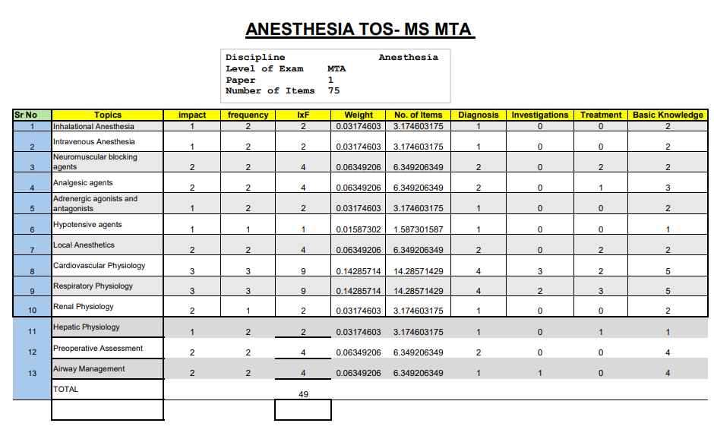

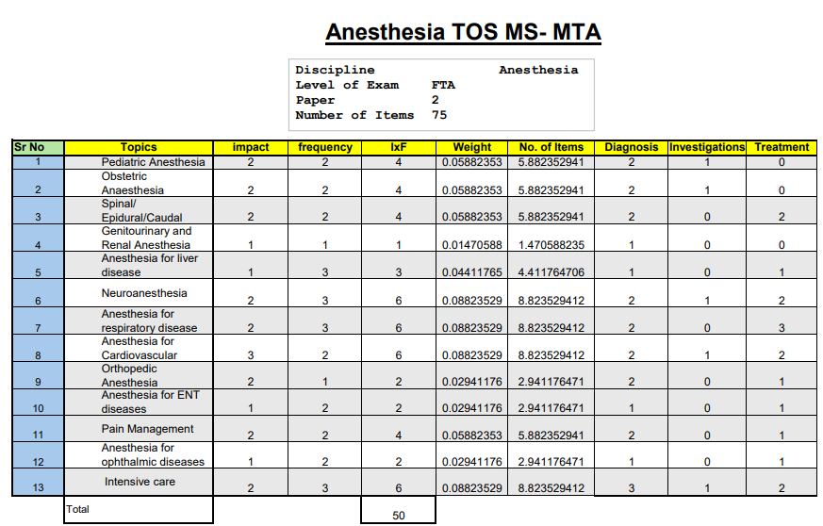

OSCE- MID TERM ASSESSMENT

5. Total number of stations – 15 (all Interactive)

6. Time allocation for each station – 5minutes

7. Marks allocation for each station – 10marks

Details of OSCE Stations

|  |  |  |  |
| --- | --- | --- | --- |
| S.no. | TOPIC | SUB-TOPIC | TASK |
| 1. | ECG | Arrhythmias, heart blocks, electrolyte imbalance, ECG of MI etc. | Candidate will identify the condition and give its management plan |
| 2. | Equipment | Vaporizer, anesthesia work station, breathing circuits, | Identify the equipment ,working principle , usage ,limitations |
| 3. | Acid base Analysis | Respiratory acidosis ,Alkalosis, metabolic disorders | Candidate will identify and state management plan |
| 4. | Counselling | Risk stratification , counselling of patient and attendants about benefits vs risk of anesthesia | Counselling of simulated patient regarding preexisting disease conditions and associated anesthesia plan |
| 5. | BLS/ACLS | Adult and pediatric resuscitation | Candidate will perform resuscitation on mannequins |
| 6. | Monitoring | Pulse oximeter, capnometer, invasive and noninvasive b.p monitoring, Cvp | Candidate will state use of monitor ,working principle and interpretation |
| 7. | Physics/ Laws | Laws of fluids, boyle’s law, charlie’s law, ideal gas law | Candidate will define law and state its clinical implications |
| 8. | Counselling | Anesthetic adverse effects ,prognosis of critically ill patients | Candidates will explain adverse events from tooth breakage to life threatening conditions to simulated patient |
| 9. | Clinical scenario | Perioperative plan for patient with cardiopulmonary conditions | Candidate will take brief history , interpretation of labs and management plan |
| 10. | Clinical scenario | Perioperative plan for patients ASA1,ASA2 | Candidate will devise a management plan |
| 11. | Peripheral nerve block | Blocks of upper and lower limbs | Candidate will identify area of interest on a simulated patient using ultrasound modality |
| 12. | Pharmacology related to anesthesia | Sedatives, hypnotics, inhalational agents, muscle relaxants, opioids etc | Candidate will be asked about pharmacodynamics and pharmacokinetics of drug |
| 13. | Procedure | Air way assessment, examination of CVS, examination of respiratory system | Candidate will perform the task on simulated patient |
| 14. | Interpretation of x-ray | Pneumothorax, hem thorax, central line , ng identification on xray etc | Candidate will identify condition and give its management plan |
| 15. | Anesthesia emergency | Laryngospasm , circuit disconnect, local anesthetic toxicity, | Candidate will identify the condition and state its management plan |

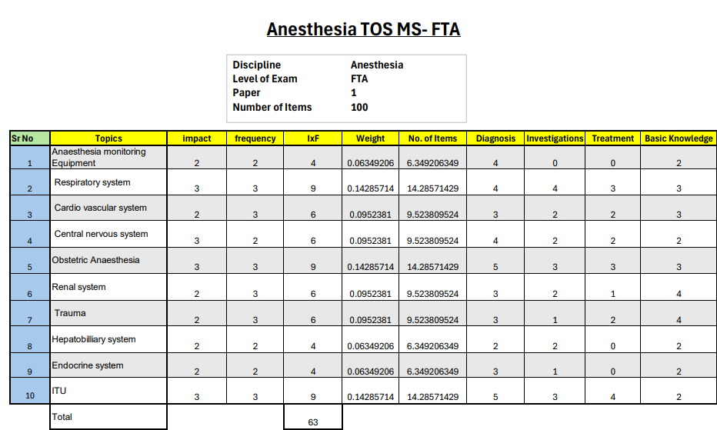

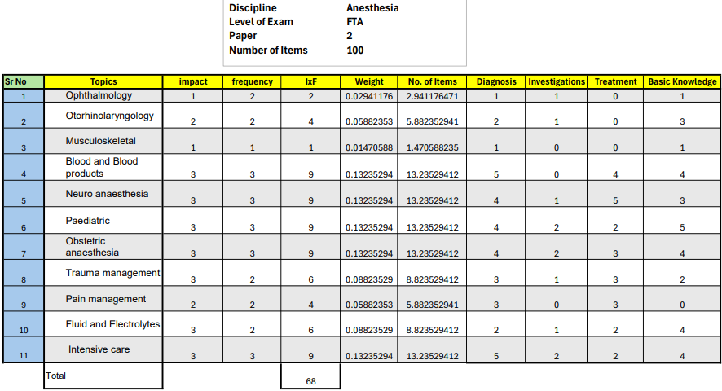

OSCE- FINAL TERM ASSESSMENT

5. Total number of stations – 15 (all Interactive)

6. Time allocation for each station – 5minutes

7. Marks allocation for each station – 10marks

Details of OSCE Stations

|  |  |  |  |
| --- | --- | --- | --- |
| S.no. | TOPIC | SUB-TOPIC | TASK |
| 1. | ECG | Arrhythmias, heart blocks, electrolyte imbalance, ECG of MI etc. | Candidate will identify the condition and give its management plan |
| 2. | Equipment | Vaporizer, anesthesia work station, breathing circuits, BIS monitor ,EEG | Identify the equipment ,working principle , usage ,limitations |
| 3. | Metabolic conditions and homeostatic disorders | Respiratory acidosis ,Alkalosis, metabolic disorders, disorders of electrolytes ,oxygen content | Candidate will identify and state management plan |
| 4. | Counselling | Risk stratification , counselling of patient and attendants about benefits vs risk of anesthesia in high risk population | Counselling of simulated patient regarding preexisting disease conditions and associated anesthesia plan |
| 5. | BLS/ACLS | Adult and pediatric resuscitation | Candidate will perform resuscitation on mannequins |
| 6. | Monitoring | Pulse oximeter, capnometer, invasive and noninvasive b.p monitoring, Cvp, monitoring for icu patients | Candidate will state use of monitor ,working principle and interpretation |
| 7. | Physics/ Laws | Laws of fluids, oxygen dissociation curve etc | Candidate will define law and state its clinical implications |
| 8. | Counselling | Anesthetic adverse effects ,prognosis of critically ill patients in ICU setup | Candidates will explain adverse events from tooth breakage to life threatening conditions to simulated patient |
| 9. | Clinical scenario | Perioperative plan for patient with cardiopulmonary conditions, hepato renal co-morbid, neurological disorders etc | Candidate will take brief history , interpretation of labs and management plan |
| 10. | Clinical scenario | Perioperative plan for patients ASA 3 and above | Candidate will devise a management plan |
| 11. | Peripheral nerve block | Blocks of upper and lower limbs, chronic pain conditions | Candidate will identify area of interest on a simulated patient using ultrasound modality |
| 12. | Pharmacology related to anesthesia | Sedatives, hypnotics, inhalational agents, muscle relaxants, opioids etc | Candidate will be asked about pharmacodynamics and pharmacokinetics of drug |
| 13. | Procedure | Air way assessment, examination of CVS, examination of respiratory system, neurological examination, spine assessment | Candidate will perform the task on simulated patient |
| 14. | Interpretation of x-ray | Pneumothorax, hem thorax, central line , ng pacemaker, ARDS ,aspiration identification on x-ray etc | Candidate will identify condition and give its management plan |
| 15. | Anesthesia emergency | Laryngospasm , circuit disconnect, local anesthetic toxicity, massive transfusion , cardiac arrest scenarios etc | Candidate will identify the condition and state its management plan |

**Appendices**

**List of Appendices**

1. Workplace Based Assessments-Multi source feedback profoma- 360⁰ evaluation---------------Appendix “ A”
2. Proforma for feedback by Nurse for core competencies of the resident “Appendix B”
3. Proforma for patient Medication Record “Appendix C”
4. Workplace Based Assessments- guidelines for assessment of Generic & specialty specific Competencies ------ Appendix “ D”
5. Supervisor’s Annual Review Report Appendix “ E”
6. Supervisors evaluation Proforma for continuous internal assessments Appendix “ F”
7. Evaluation of resident by the faculty Appendix “ G”
8. Evaluation of faculty by the resident Appendix “ H”
9. Evaluation of program by the faculty Appendix “ I”
10. Evaluation of program by the resident Appendix “ J”
11. Guidelines for program evaluation------Appendix “ K”
12. Evaluation of Project Director by the residents----------------------Appendix “ L”

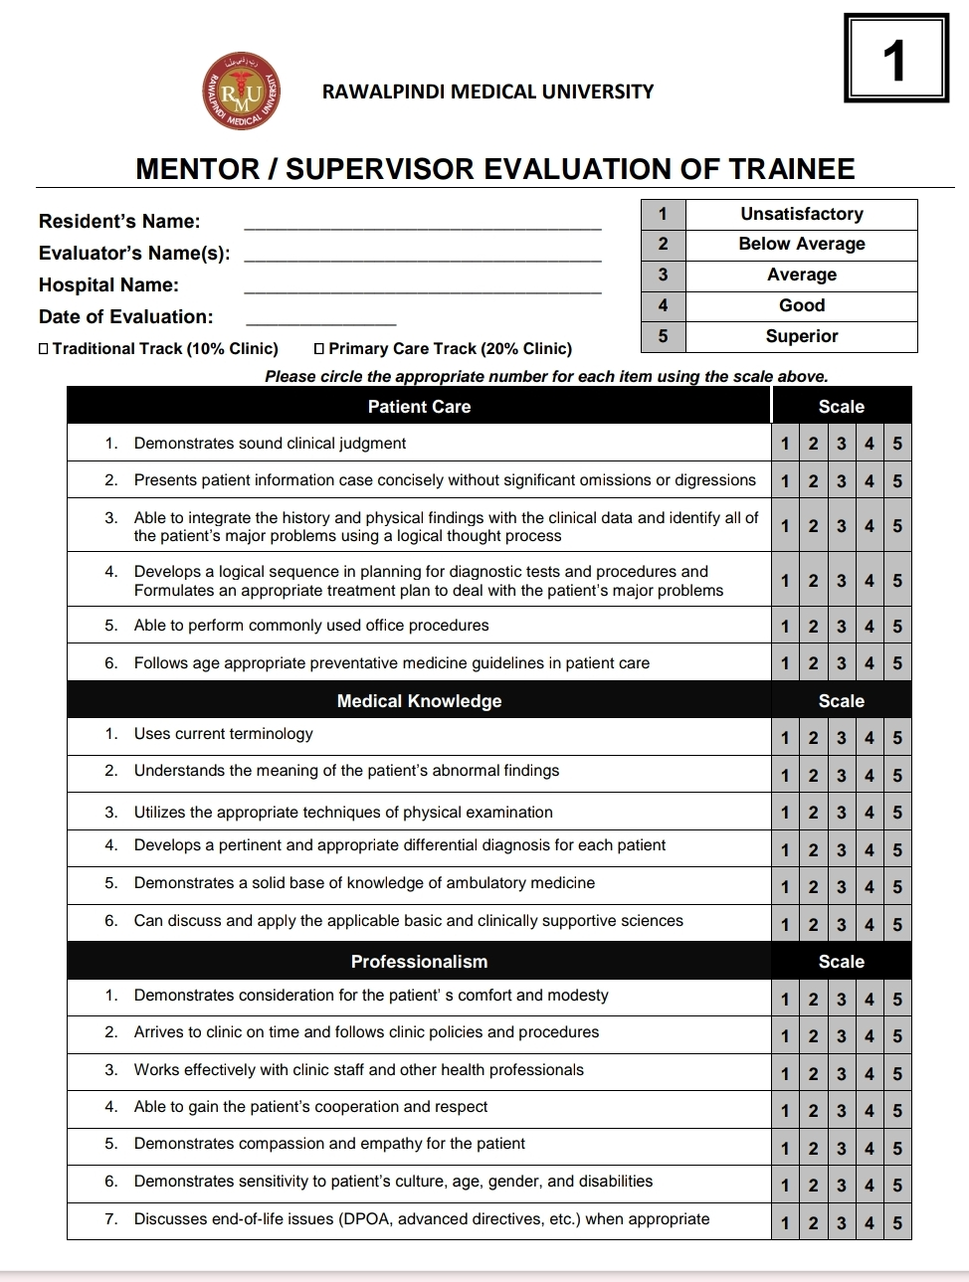

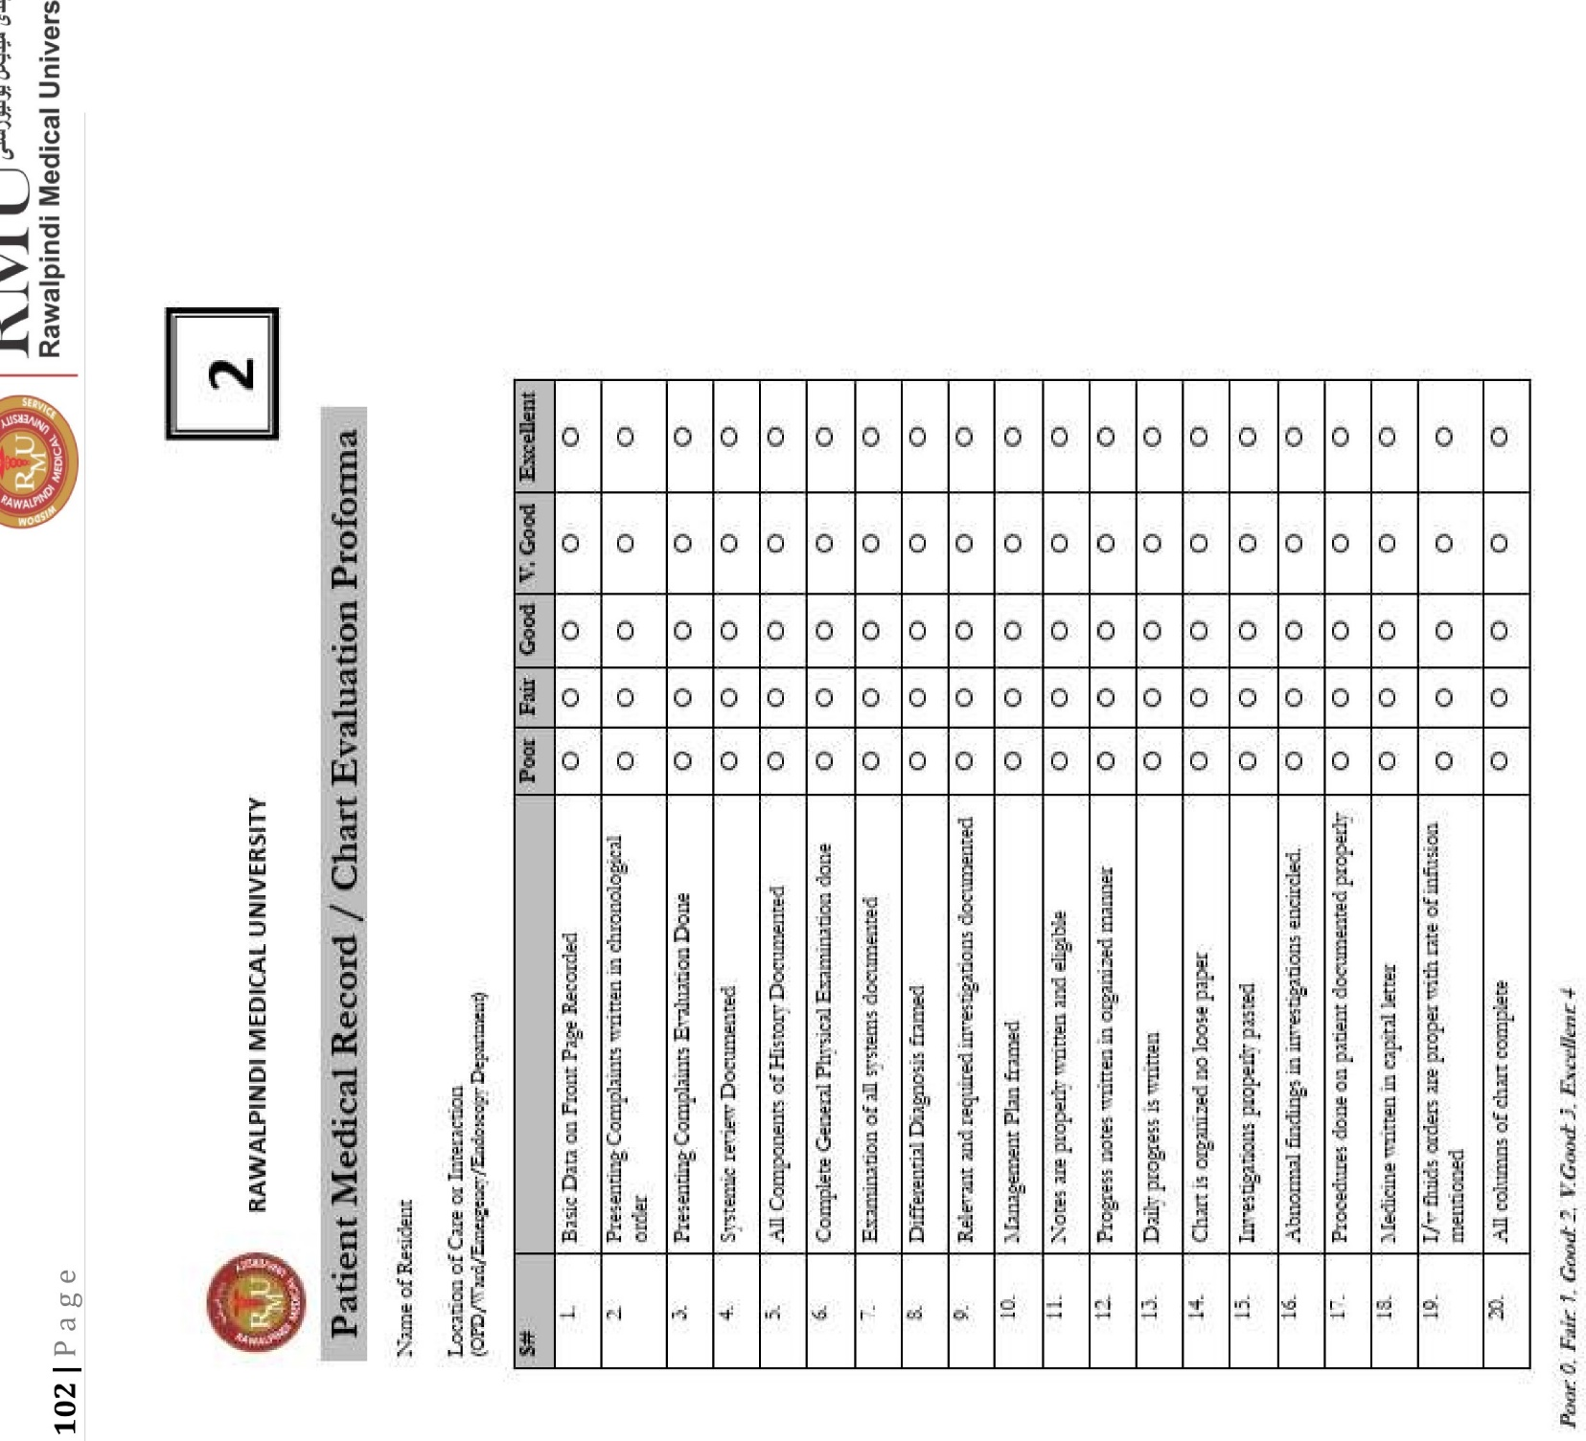

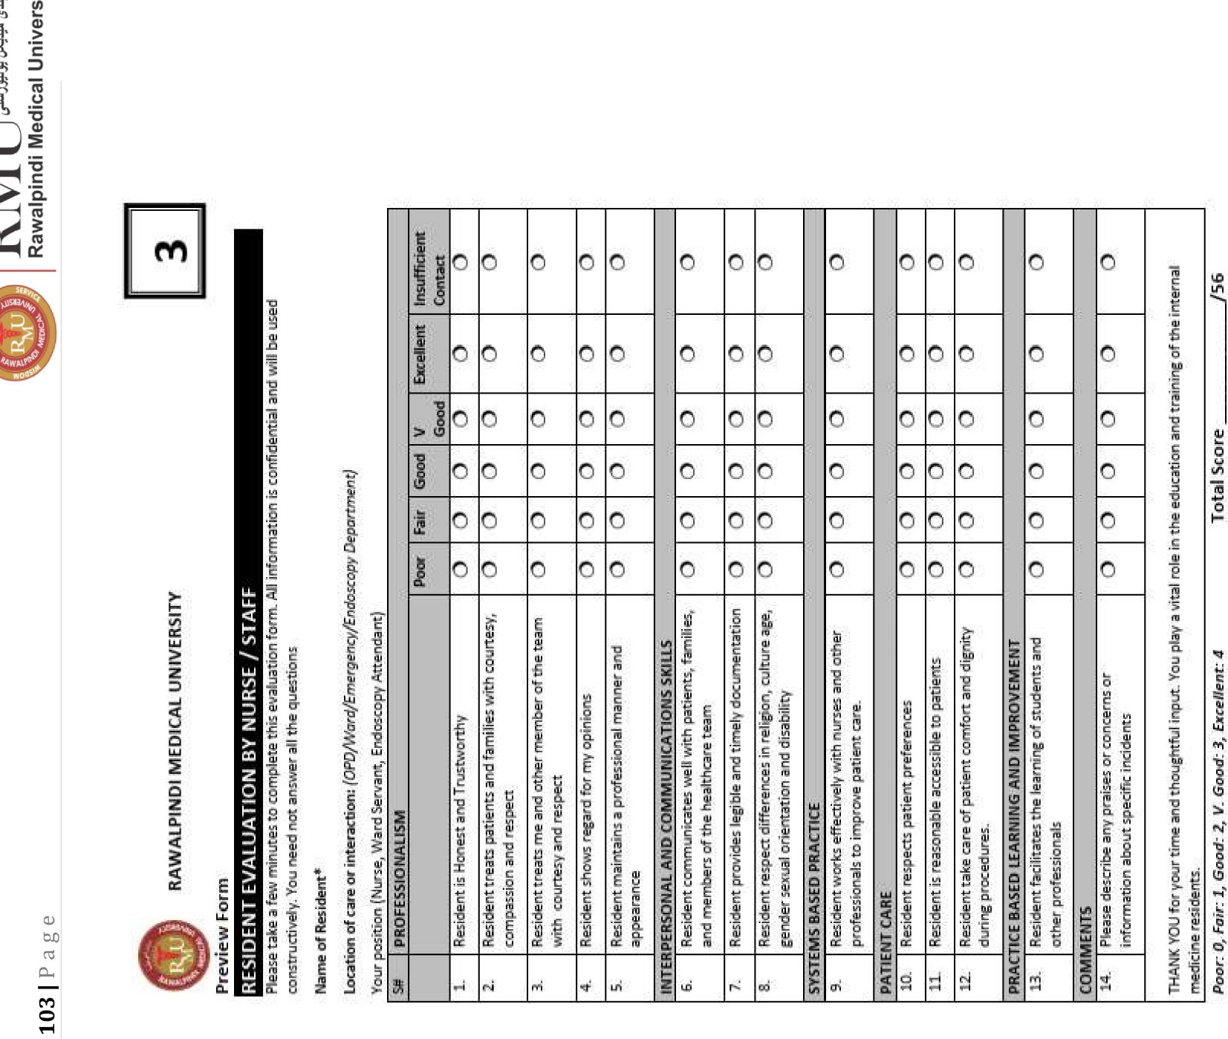

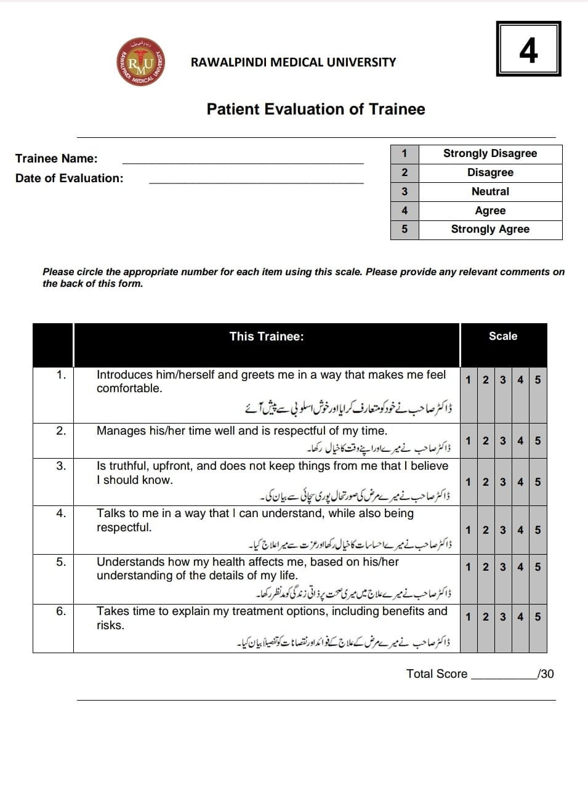

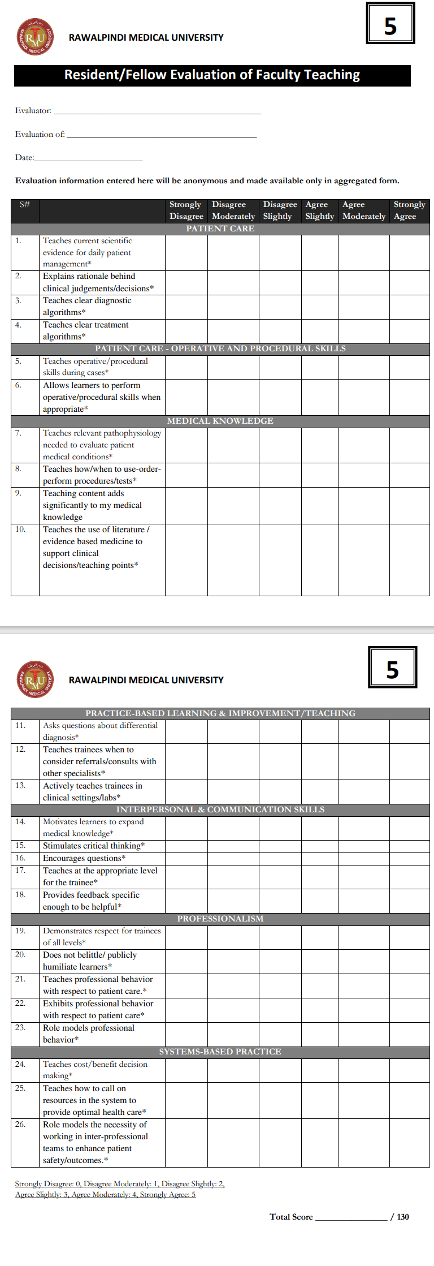

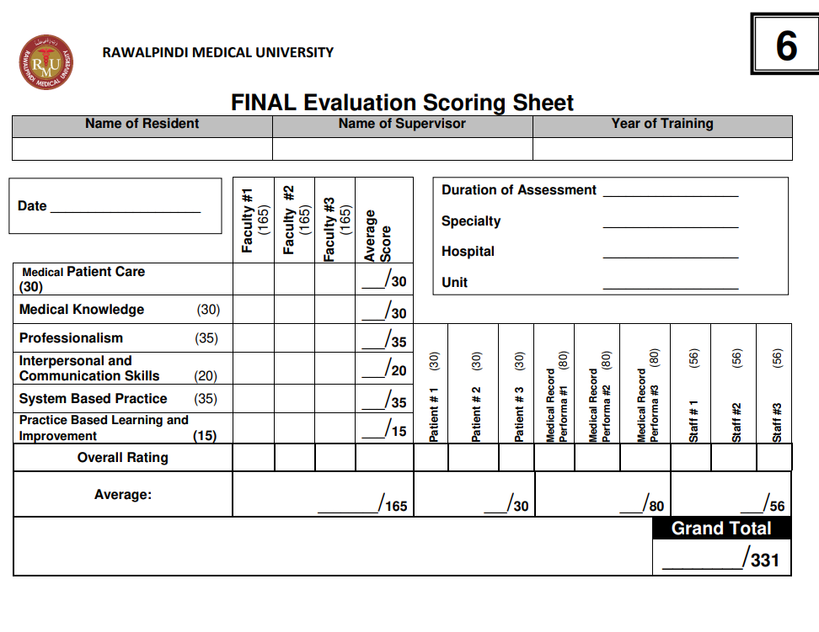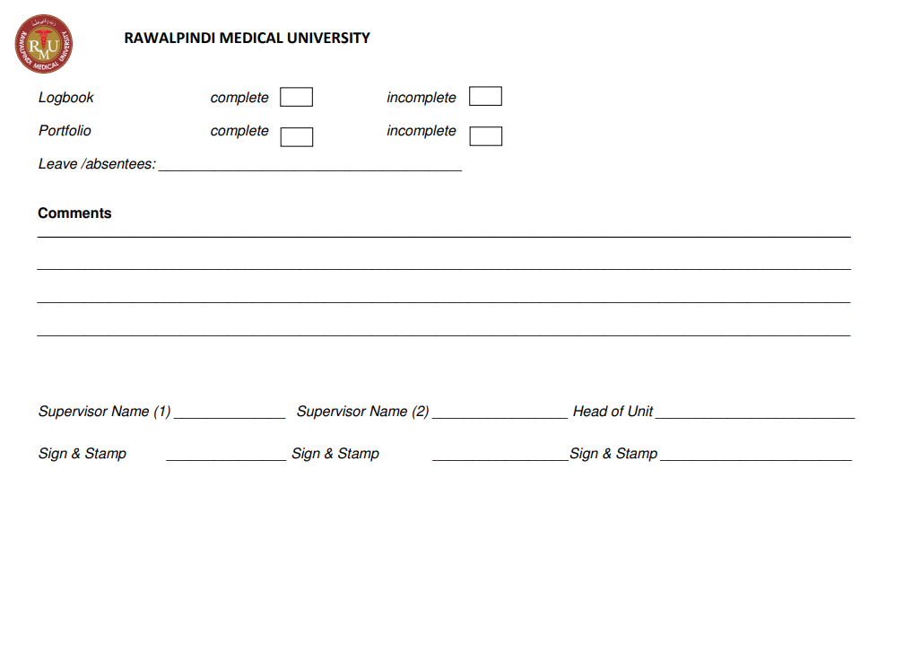

**6**

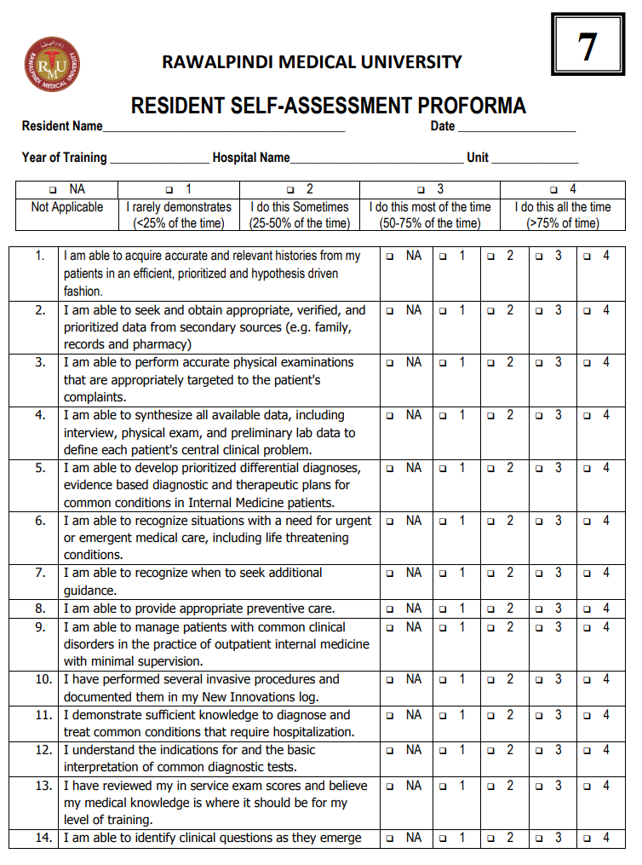

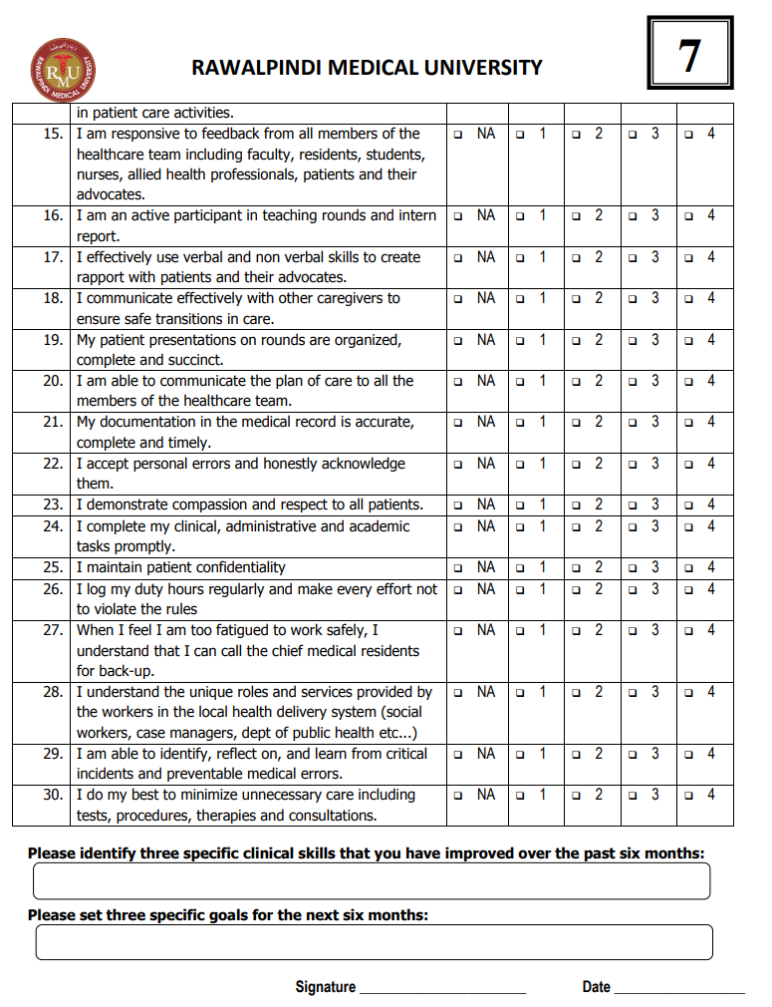

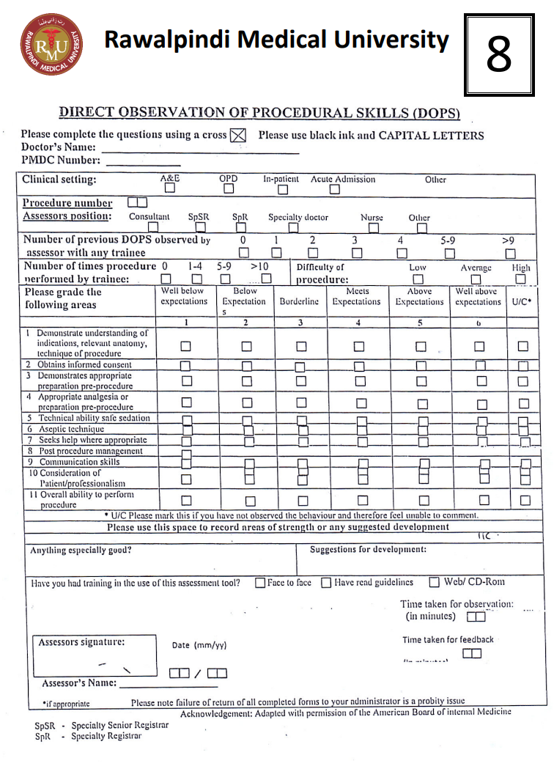

**Registration and Enrolment**

**ENROLLMENT DETAILS**

Program of Admission _____________________________

Session _________________________________________

Registration / Training Number ______________________

Name of Candidate __________________________________________________

Father’s Name ______________________________________________________

Date of Birth ___ / ___ / ____ CNIC No.__________________________________

Present Address _____________________________________________________

___________________________________________________________________

Permanent Address __________________________________________________

___________________________________________________________________

E-mail Address ______________________________________________________

Cell Phone __________________________________________________________

Date of Start of Training _____________________________________________

Date of Completion of Training_________________________________________

Name of Supervisor __________________________________________________

Designation of Supervisor _____________________________________________

Qualification of Supervisor _____________________________________________

Title of department / Unit _____________________________________________