**RAWALPINDI MEDICAL UNIVERSITY, RAWALPINIDI**

**STUDENT’S LOGBOOK**

**Community oriented Clerikship module**

4th year MBBS

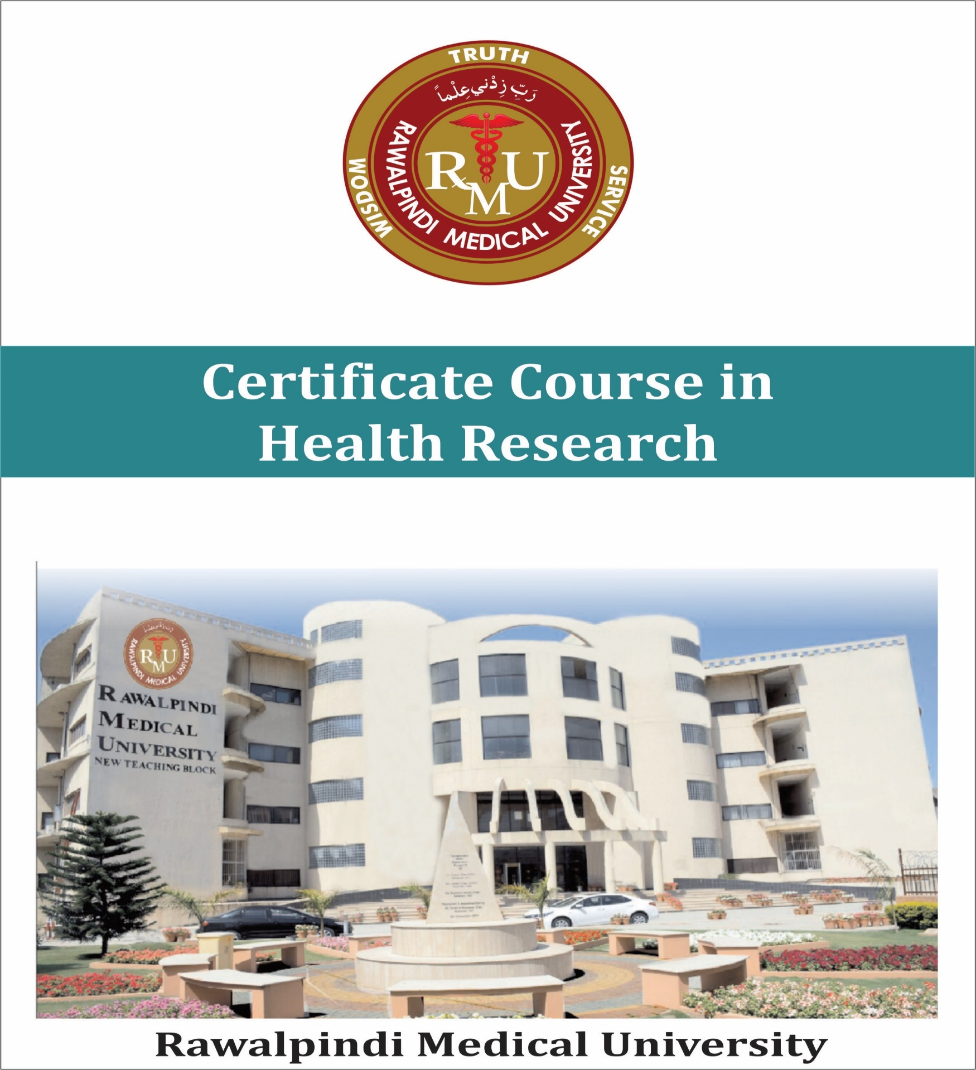Department of community medicine & public Health

**STUDENT’S PROFILE**

**STUDENT’S PROFILE**

**Space for Photo**

***University 4th Prof Exam Roll No .***

***Name of The Students: __________________________________***

***Class Roll No: ___________________________________________***

***Batch Name: _____________________________________________***

***Academic Session ________ Admission Session. _____________***

***University Reg. No: ________________________***

***Name Of Batch Incharge _____________________________***

***-------------------------- SIGNATURE OF STUDENT***

***Sig. Batch In charge_______________***

***Record Supervision***

***Department of Medical Education NTB / Student Section NTB RMU***

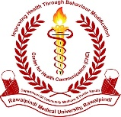

**Community oriented Clerikship module**

4th year MBBS **(Rev-2023)**

Department of community medicine & public Health RMU

**Theme (aim):**

1. The primary purpose of this module is to educate students in those areas of the subject of Community Medicine which are learnt better by onsite presence of the students at certain sites, processes, agencies which have public health relevance and in general community setting.
2. Interactive teachings in small group help students in domains of data analysis & report writing skills, contraceptive use skills, vaccination skills, etc are also covered during this rotation.
3. Batch rotation is dedicated for health education communication practices as Health awareness work and other social work.

**Learning outcomes (LOs):**

at the end of this learning module students are expectedto achieve following Public health Competencies as will be able to:

1. Undertake a population-based health survey (HHS)
2. Appreciate working of First level Care Facility (Public Sector)
3. Perform Community Immunization / EPI vaccinations.
4. Develop Hospital waste management plans.
5. Develop Community based health awareness message.
6. Communicate for Health awareness in community settings.
7. Commemorate International public health days.
8. Develop Hospital administration Plans.
9. Undertake Preventive healthcare inquiries and NCDs Risk Factors Surveillance
10. Counsel for the contraceptive devices to the community

**Module outline:**

1. A batch comprising 20-22 students is posted in the department for a period of 2weeks **(Monday to Thursday-04 hrs. /day & for 32hrs in total**). This schedule is run over the whole academic year, till all students of 4th year MBBS class passes through this rotation.
2. Batch formation and schedules of rotation for whole class as notified by the DME / Student’s section will be followed accordingly.
3. At commencement of the academic year overall batch learning module coordinator, nomination of batch in-charges, senior faculty in charges and calendar schedule of batch rotation for all batches over the whole academic year will be notified by the Department.

**SOPs of Learning & Assessments:**

1. Active participation will be graded by the batch in charge (under a check list) during the activity / session and grades/marks will be O5 Max Marks for health message development and Health awareness work.
2. Assessment will be done by OSPE **at** the end of each module and credit will be objectively recorded for the purpose of internal assessment. (Max mark 10)
3. Students are required to report / write the relevant work in Logbook on daily basis.

**SOP’s for filling the logbook**

1. All students should wear white coat during field visits
2. All students should wear their ID badges during the field visits
3. 75 % attendance is mandatory for every student
4. Students are required to submit leave application in principal office in case of illness or family emergencies
5. Students will not be permitted to makeup time missed without a leave application
6. Students time schedule for clerkship rotation will be set in the time table
7. Student reporting time in the department is 10:00 am.
8. Students are expected at all times to maintain a professional behavior.
9. Assessment (OSPE) at the end of clinical clerkship is mandatory.
10. Internal assessment is based on Assessment, Attendance and Behavior.
11. Student should keep a photocopy of this logbook so it can be replaced if lost.

## **Core Planner of Community Oriented Clerkship in the subject of Community Medicine** (2 weeks batch rotation)

[Calendar schedule as notified by DME will be followed accordingly]

|  |  |  |  |  |  |  |  |  |  |  |
| --- | --- | --- | --- | --- | --- | --- | --- | --- | --- | --- |
| **Day** | **Activity -I**  **10.30 – 11.00** | **Activity – II**  **11.00- 11.30am** | | **Activity -III**  **11.30- 01.00pm** | | **Act-V**  **01.00 – 2.00pm** | | **Sites of teaching-learning** | **Assessment** | **Session outcome (level of learning)** |
|  | Session topic | Session topic | | Session topic | | Session topic | |
| 1st day | instructing / demonstration on Practical Manual based Assignments | * Visit to CHC * SGIS on Health days commemoration work, Display material, PPT. | | * SGIS on HM-DTD practicum. Topic finalization, CHC-Message draft outlines finalization. | | * PPT based Demo on How to conduct & report HHS. * Guidelines on PHI work to be done during clinical rotations / ward duties | | * Demonstration / lec -Hall 3 * CHC -Dept CM NTB RMU. | * 1-2 OSPE in end of clerkship exam (credit will part of IA) * Assessment of HHS -Report (Max marks:5 part practical /viva exam 4th Prof MBBS) | * Construct a health message. (C6) * Prepare Health days commemoration stuff, Display material, PPT, (P) * Undertake a health survey. (HHS) (C3) |
| 2nd day | Follow up session on.  - HM-DTD work  - HHS work  - health days commemoration work | SGIS/ Briefing / PPT based guidelines on field visit of the day ( EPI services center HFH) | | FV to the EPI center HFH | | Health awareness work (HAW) | | * Demo Room, * EPI Center HFH * OPD, hospital shelters sites for health awareness work (HAW) | * 1-2 OSPE in end of clerkship exam (credit will part of IA) * Grade of performance in EPI visit reporting. * Credit of HAW | * Explain cold chain component at EPI center * Vaccinate (EPI) vaccines to the clients . * Comprehend EPI system |
| 3rd day | Follow up session on HM-DTD work & HHS | SGIS / Briefing / PPT based guidelines on FV to MCH & FP Services Center HFH | | FV to the MCH services & FP center HFH | | Health awareness work (HAW) | | * FP Center HFH * OPD, hospital shelters sites for HAW | * 1-2 OSPE in end of clerkship exam (credit will part of IA) * Grade of performance in EPI visit reporting. * Credit of HAW | * Identify CP devices available at MHC FP center * Counsel clients for use of a contraception method * Place CP devices to client (P) |
| 4th day | Follow up session on HM-DTD work & HHS | Briefing / guidelines on FV Hospital waste disposal system in hospitals | | * FV to the hospital waste disposal system & relevant sites / Incinerator | | Health awareness work (HAW) | | * FP Center HFH   OPD, hospital shelters sites for HAW | * End of module OSPE * Grade of performance in visits to sites | * Explain hospital waste disposal system * Develop a hospital waste management plan * Explains various domains of hospital management (C2) |
| 5th day (week 2) | SGIS / PPT based briefing on Hospital management & administration | Visit to Hospital management & administration (HFH) office | | | | Health awareness work (HAW | | HHF | * End of module OSPE * Grade of performance in visits to sites |
| 6th day | SGIS / PPT based briefing on visit to First level of health care facility (FLCF) BHU/RHC | Field visit to RHC Khyaban Sir-Syed (RHC) or BHU | | | | * Demo room / lec Hall 3 NTB / CPC-Hall . * RHC / BHU | | Health awareness work (HAW at site visited | * End of module OSPE * Report credit in PJ | * Explain working of FLCF * Appreciate PHC elements at FLCF. (C2) |
| 7th day | Health days commemoration ( walk/ seminar/ presentation/ CHC-message dissemination work  (10.30 – 12.00pm) | | | | 12.00 – 2.00pm   * Completion & assessment of relevant Practical Journal work, * HHS-report book, * Logbook etc. * Feedback discussion on PHI | | | | * Communication skills * Comprehend frequency Preventable RFs of NCDs in the real population (RF surveillance) * Undertake a preventive Healthcare inquiry | |
| 8th day | Museum learning module (MLM) / visit to departmental Museum  10.30- 12.30 | | * Endo of module OSPE (12.30 – 2.00pm) * OPSE conduction (10 stations video assisted OPSE / OSPE) for 40 total marks . | | | | Plus  Completion of any remaining work journal assessment  HHS report assessment  Students feedback etc | | | |
|  | **Community based / Field Visits**   * Each batch perform filed visits of sites of Public health importance outside the institutions under available opportunities and logistics. Following sites may be considered for the purpose | | | | | | **Health Message Dissemination** | | | |
|  | * RHC Khayaban-e-Sir-Syed Rawalpindi / DHO * Family planning center RMU * Hospital waste management RMU * Vaccination center RMU * Department of infectious diseases RMU * Hospital administration RMU | | | | | | OPDs & indoors of allied hospitals of RMU (to at least 30 Patients and/or attendants)  RHC Khayaban-e-Sir-Syed Rawalpindi | | | |

Department of Community Medicine.

Rawalpindi Medical University – 2025

**Section-1: Filed Visit**

Filed visits to the selected places of public health importance (4thyear MBBS)

Name of Batch In charge: _____________________________ Batch: ______________

|  |  |  |  |  |  |  |  |  |
| --- | --- | --- | --- | --- | --- | --- | --- | --- |
| # | Title & Site of the Filed Visit | Date | Level of parti.a | FV Repo.  Writing | Assess-  - ment | Sig BIc | Sig RFd | Sig DME |
| 1 |  |  |  |  | 1-2 OSPE/ MCQs in End of clerkship Exam |  |  |  |
| 2 |  |  |  |  | 1-2 OSPE/ MCQs in End of clerkship Exam |  |  |  |
| 3 |  |  |  |  | 1-2 OSPE/ MCQs in End of clerkship Exam |  |  |  |
| 4 |  |  |  |  | 1-2 OSPE/ MCQs in End of clerkship Exam |  |  |  |

a. A: active / raised rational query (1mark) B: no questioning (0 mark) b. FV Report Writing: student is required submit report of the FV on the prescribed Performa in practical manual at the end of FV c: batch in charge d: RF: remote facilitator . DME nominated person will supervise / sign

**Section-1: Filed Visit**

Filed visits to the selected places of public health importance (4thyear MBBS)

Name of Batch In charge: _____________________________ Batch: ______________

|  |  |  |  |  |  |  |  |  |
| --- | --- | --- | --- | --- | --- | --- | --- | --- |
| # | Title & Site of the Filed Visit | Date | Level of parti.a | FV Repo.  Writing | Assess-  - ment | Sig BIc | Sig RFd | Sig DME |
| 5 |  |  |  |  | 1-2 OSPE/ MCQs in End of clerkship Exam |  |  |  |
| 6 |  |  |  |  | 1-2 OSPE/ MCQs in End of clerkship Exam |  |  |  |
| 7 |  |  |  |  | 1-2 OSPE/ MCQs in End of clerkship Exam |  |  |  |
| 8 |  |  |  |  | 1-2 OSPE/ MCQs in End of clerkship Exam |  |  |  |

a. A: active / raised rational query (1mark) B: no questioning (0 mark) b. FV Report Writing: student is required submit report of the FV on the prescribed Performa in practical manual at the end of FV c: batch in charge d: RF: remote facilitator . DME nominated person will supervise / sign

**Section-2: Public Health Days Commemoration Work Module**

Name of Batch In charge: _____________________________ Batch: ______________

(Max Credit: 5marks)

|  |  |  |  |  |  |  |
| --- | --- | --- | --- | --- | --- | --- |
| # | Title / Topic / Theme of the Public Health Day Commemorated | Date | Level of parti.a | Assess-  - ment | Sig BIc | Sig Sen Faculty |
| 1 | 1. Public Health day topic: _______________________________________________________________________________________________ 2. Theme of the subject for the given year: ______________   -----------------------------------------------------------------------------------------------------------------------------------------------------------------------------------------------------------------------------------------------------------------------------------------------------------------------------------------------------------------------------------------------------------------------------------------------------------------------------------------------------------------------------------------------------------------------------------------------------------------------------------------------------------------------------------------------------------------------------------------------------------------------------------------------------------------------------------------------------------------------------------------------------------------------------------------------------------------------------------------------------------------------------------------------------------------------------------------------------------------------------------------------------------------------------------------------------------------   1. Health day commemoration strategy adopted    1. Seminar in institutional settings.   If yes, write the setting… …………………………………………………………………………   * 1. Seminar in community settings .   If yes, write the setting… …………………………………………………………………………   * 1. Health awareness walk .   If yes, write the setting… ………………………………………………………………………… |  |  | 1. 02 OSPE/ MCQs in End of the clerkship Exam |  |  |

A: health message development, B; presentation / talk, C: participation

**Section-3:Health Message Dissemination Work**  **Performa** (community awareness work) (Credit of work max marks:5)

|  |  |  |  |  |  |  |  |
| --- | --- | --- | --- | --- | --- | --- | --- |
| ## | Date | TITLE OF HEALTH MESSAGE IN URDU | Site of health awareness work | Ref of client* | Gender & age of client | Client Agreed to usefulness of H-Message (Y/N) | Remarks/Any issues faced by student |
|  |  |  |  |  |  |  |
|  |  |  |  |  |  |  |
|  |  |  |  |  |  |  |
|  |  |  |  |  |  |  |
|  |  |  |  |  |  |  |
|  |  |  |  |  |  |  |
|  |  |  |  |  |  |  |
|  |  |  |  |  |  |  |
|  |  |  |  |  |  |  |
|  |  |  |  |  |  |  |
|  |  |  |  |  |  |  |
|  |  |  |  |  |  |  |
|  |  |  |  |  |  |  |
|  |  |  |  |  |  |  |
|  |  |  |  |  |  |  |

*Ref. of client: OPD No./CNIC/Cell #/OPD # of patient if client was attendant

Roll No. _______________Batch______________ Sig of BI ___________________ dated: ________

|  |  |  |  |  |  |  |  |  |
| --- | --- | --- | --- | --- | --- | --- | --- | --- |
| ## | Date | TITLE OF HEALTH MESSAGE IN URDU |  | Site of health awareness work | Ref of client* | Gender & age of client | Agreed to usefulness of H-Message (Y/N) | Remarks/Any issues faced by student |
|  |  |  |  |  |  |  |  |
|  |  |  |  |  |  |  |  |
|  |  |  |  |  |  |  |  |
|  |  |  |  |  |  |  |  |
|  |  |  |  |  |  |  |  |
|  |  |  |  |  |  |  |  |
|  |  |  |  |  |  |  |  |
|  |  |  |  |  |  |  |  |
|  |  |  |  |  |  |  |  |
|  |  |  |  |  |  |  |  |
|  |  |  |  |  |  |  |  |
|  |  |  |  |  |  |  |  |
|  |  |  |  |  |  |  |  |
|  |  |  |  |  |  |  |  |
|  |  |  |  |  |  |  |  |

*Ref. of client: OPD No./CNIC/Cell #/OPD # of patient if client was attendant

Roll No. _______________Batch______________ Sig of BI ___________________ dated: ___________ **Assessment:**

|  |  |  |  |  |
| --- | --- | --- | --- | --- |
| Assessment mode | 100% covered | > 100% -80% covered | Sig of BI | Sig HOD |
| Number of people aware / delivered Health Edu | A (5marks) | B (4 marks) |  |  |

**Section-4: Museum Learning Module** (MLM) **- 4thyear MBBS**

Name of Batch In charge: _____________________________ Batch: ______________

|  |  |  |  |  |  |
| --- | --- | --- | --- | --- | --- |
| # | Names of the Model / specimen / major areas covered during the MLM-day | Date | Assess- | Sig BIc | Sig Sen. faculty |
| 1 | 1.  2.  3.  4.  5.  6.  7.  8.  9.  10. |  | 1-2 SOPE in End of clerkship exam |  |  |

a. A: invol in discussion / raised rational query (1mark) B: no questioning (0 mark) b.: batch in charge d: RF: remote facilitator / Dr. in charge Museum

**Assessment : Section 1, 2, & 4 ( End of clerkship Examination )**

|  |  |  |  |  |  |  |
| --- | --- | --- | --- | --- | --- | --- |
| Assessment mode | Max marks | Marks obtained | Marks in % | Sig of BI | Sig Sen faculty | DME supervision |
| OSPE / MCQs test |  |  |  |  |  |  |

Remarks: _______________________________________________________

Sig: HOD _______________________________________________________

**Section-5: IUGRC Component -IV** (4thyear MBBS) **Contact Sessions Log**

Name of Batch In charge: _____________________________ Batch: ______________

|  |  |  |  |  |  |  |  |
| --- | --- | --- | --- | --- | --- | --- | --- |
| # | Topic & LOs of the IUGRC Contact Session covered during the session (PAL) | Individual *Level of participation | | | Date | Sig BI | Sig Sen Faculty |
| A. Literature search | B. sharing ideas | C. Peer discussion |  |  |  |
| CS-1 |  |  |  |  |  |  |  |
| CS-2 |  |  |  |  |  |  |  |
| CS-3 |  |  |  |  |  |  |  |
| CS-4 |  |  |  |  |  |  |  |
| CS-5 |  |  |  |  |  |  |  |

**Section-5: IUGRC Component -IV** (4thyear MBBS) **Contact Sessions Log**

Name of Batch In charge: _____________________________ Batch: ______________

|  |  |  |  |  |  |  |  |
| --- | --- | --- | --- | --- | --- | --- | --- |
| # | Topic & LOs of the IUGRC Contact Session covered during the session (PAL) | Individual *Level of participation | | | Date | Sig BI | Sig Sen Faculty |
| A. Literature search | B. sharing ideas | C. Peer discussion |  |  |  |
| CS-6 |  |  |  |  |  |  |  |
| CS-7 |  |  |  |  |  |  |  |
| CS-8 |  |  |  |  |  |  |  |
| CS-9 |  |  |  |  |  |  |  |
| CS-10  CS-10 |  |  |  |  |  |  |  |

**Assessment Record (IUGRC-IV) Section-5**

|  |  |  |  |  |  |  |
| --- | --- | --- | --- | --- | --- | --- |
| Assessment mode | Max marks | Marks of obtained | Marks % | Sig BI | Sig Sen Faculty | Supervision DME |
| End of the session HRM (SGRPs) based viva voce examination |  |  |  |  |  |  |

Remarks: _______________________________________________________

Sig: HOD _____________________________________________________

* Sean Demo