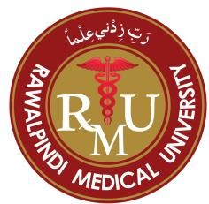

**Rawalpindi Medical University Rawalpindi**

**Department of Pathology**

**Curriculum of Learning Management System**

**Fourth Year MBBS 2025**

# Preamble

As current era of globalization and digitalization has significantly transformed the landscape of education. On one hand, it has introduced new challenges for institutions, teachers, and students. On the other hand, it has fostered innovation and inspired a renewed commitment to delivering quality education.

This manual has been developed to ensure that online learning is standardized across the five years of medical education and four years of dental education while maintaining a high standard of quality. It serves as a comprehensive policy guideline for online teaching and learning. The document provides detailed information on the learning management system (LMS), curricular framework, online assessment policy, student support services, quality assurance mechanisms, and QEC proformas for feedback. Additionally, it includes a faculty training plan designed to make online teaching more interactive and effective.

The development of a learning management system (LMS) tailored to the needs of RMU students and faculty highlights the institution’s commitment to delivering quality education during these challenging times. The LMS has been designed in accordance with the standards and guidelines set by the Higher Education Commission (HEC) and Pakistan Medical and Dental Council (PMDC) . Along with course materials, the system includes an integrated mechanism for tracking student progress through quizzes and assignments. Moreover, the online assessment component ensures adherence to the academic calendar in both letter and spirit. These assessments are primarily formative in nature. In future it is planned to include evaluation proformas have also been incorporated into the LMS to facilitate regular and periodic feedback from key stakeholders, embedding a culture of monitoring and continuous quality improvement.

We sincerely hope and pray that our dedicated efforts to safeguard our students’ valuable time will yield positive outcomes, reflected in stakeholder satisfaction. We aspire for this initiative to become a significant milestone in further enhancing the established credibility of the institution.

# The Vision

As current era of globalization and digitalization has significantly transformed the landscape of education. On one hand, it has introduced new challenges for institutions, teachers, and students. On the other hand, it has fostered innovation and inspired a renewed commitment to delivering quality education.

This manual has been developed to ensure that online learning is standardized across the five years of medical education and four years of dental education while maintaining a high standard of quality. It serves as a comprehensive policy guideline for online teaching and learning. The document provides detailed information on the learning management system (LMS), curricular framework, online assessment policy, student support services, quality assurance mechanisms, and QEC proformas for feedback. Additionally, it includes a faculty training plan designed to make online teaching more interactive and effective.

The development of a learning management system (LMS) tailored to the needs of RMU students and faculty highlights the institution’s commitment to delivering quality education during these challenging times. The LMS has been designed in accordance with the standards and guidelines set by the Higher Education Commission (HEC) and Pakistan Medical and Dental Council (PMDC) . Along with course materials, the system includes an integrated mechanism for tracking student progress through quizzes and assignments. Moreover, the online assessment component ensures adherence to the academic calendar in both letter and spirit.

TABLE OF CONTENTS

Preamble 2

The Vision 3

LEARNING MANAGEMENT SYSTEM RMU 5

Framework for LMS Assessment for Undergraduate Medical Students 6

TOS for LMS Department of Pathology: 12

LMS ASSESSMENT CONTENT 4TH YR MBBS 2025 14

Endocrinology Module XXIII 14

Reproductive Health & Population Medicine module XXIV 16

Renal Module XXV 19

CNS & Psychiatry Module XXVI 21

# LEARNING MANAGEMENT SYSTEM RMU

* A campus management system is being utilized as a learning resource.
* Faculty members from all disciplines, both basic and clinical, have been actively involved and trained in using these systems to deliver lectures effectively.
* The faculty is responsible for uploading lectures, assignments, and weekly assessments.
* Each student has been provided with a unique login to access the lectures and resources on the LMS.
  + - * Attendance for each academic activity—lectures, interactive sessions, quizzes, and assignments—is recorded separately.

Faculty members are required to mark attendance immediately after each lecture

**Objectives of a Learning Management System (LMS) for Undergraduate Medical Students**

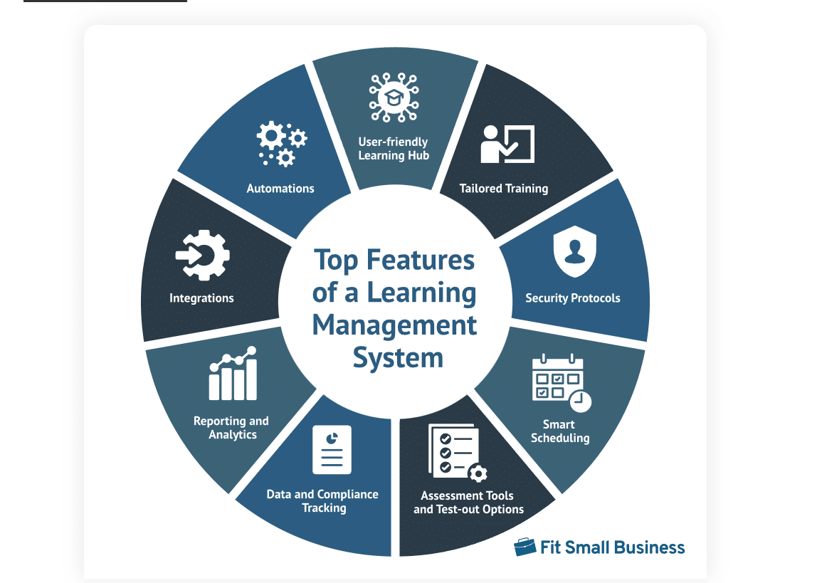The primary objective of a Learning Management System (LMS) for undergraduate medical students is to enhance the quality of medical education by providing a comprehensive, interactive, and accessible digital platform that facilitates:

* **Efficient Delivery of Educational Content:**

To enable faculty to upload and organize lectures, assignments, assessments, and other learning resources systematically.

* **Student-Centered Learning:**

To promote self-paced, flexible learning by granting students 24/7 access to educational materials tailored to their curriculum.

* **Interactive and Engaging Learning:**

To foster active engagement through features like discussion forums, quizzes, and virtual interactive sessions.

* **Streamlined Academic Monitoring:**

To track student attendance, performance, and progress through automated attendance marking, assessments, and progress dashboards.

* **Standardization and Quality Assurance:**

To ensure uniformity in educational delivery across various disciplines and compliance with institutional and accreditation standards.

* **Feedback and Continuous Improvement:**

To integrate feedback mechanisms that involve students, faculty, and other stakeholders, driving continuous quality improvement.

* **Integration of Technology in Medical Education:**

To familiarize students with digital tools and resources essential for modern medical practice and research.

By achieving these objectives, the LMS supports the holistic development of medical students, ensuring they are well-prepared for clinical practice and lifelong learning.

# 

# Framework for LMS Assessment for Undergraduate Medical Students

An effective Learning Management System (LMS) assessment framework for undergraduate medical students should be structured to evaluate knowledge, skills, and attitudes systematically. It should also align with educational objectives, regulatory standards, and the specific needs of medical education. Below is a comprehensive framework:

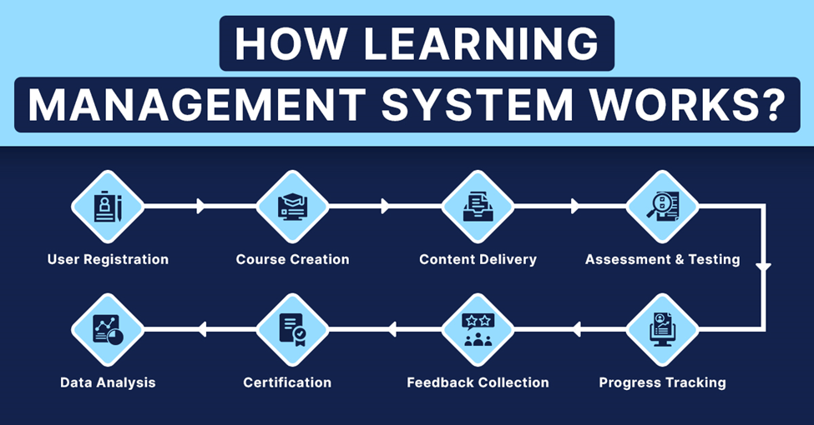

**1. Goals and Objectives of Assessment**

* **Knowledge:** Evaluate understanding of basic and clinical sciences.
* **Skills:** Assess critical thinking, clinical reasoning, and procedural skills.
* **Attitudes:** Foster professionalism, ethical decision-making, and communication skills.
* **Feedback:** Provide timely, constructive feedback to support learning and growth.

**2. Components of LMS-Based Assessment**

**a. Formative Assessments**

* **Purpose:** Monitor ongoing learning and identify areas needing improvement. It includes
  + Online quizzes (MCQs, EMQs)
  + Short assignments or reflections
  + Case-based discussions
  + Interactive polls during live sessions
* **Schedule :** Weekly or module-specific

**b. Practical/Skill-Based Assessments**

* **Purpose:** Assess clinical skills, diagnostic reasoning, and procedural competence. Practical/skill based assessments can be taught through
  + Virtual simulations (e.g., diagnostic procedures, patient management)
  + Video submissions demonstrating skills (e.g., history-taking, physical examination)
  + Peer assessment of clinical skills via uploaded videos

**c. Attendance and Participation.**

Its purpose is to encourage consistent engagement in academic activities. Student’s attendance is actively monitored through LMS via

* + Attendance tracking for lectures, discussions, and interactive sessions.
  + Participation metrics (e.g., activity in discussion forums, live Q&A sessions).

**d. Feedback Mechanisms:** Its purpose is toenhance learning and improve course delivery. Feedback monitoring can be done by following mechanisms:

* + Embedded feedback forms after each session or activity.
  + Peer and faculty reviews of assignments and projects.
  + Self-assessment tools for reflection on progress.

**3. Assessment Tools and Formats**

* **MCQs/EMQs:** Test foundational knowledge and application.
* **OSCE Simulations:** Evaluate clinical reasoning and procedural skills.
* **Interactive Tools:** Use polls, chat, and breakout rooms for real-time engagement.
* **Assignments:** Assess understanding through essays, case reports, or reflections.
* **Group Projects:** Foster teamwork and problem-solving skills.

**4. Implementation Strategies**

* **Faculty Training:** Equip faculty with skills to design and deliver online assessments.
* **Student Orientation:** Familiarize students with LMS tools and expectations.
* **Tech Infrastructure:** Ensure robust LMS functionality and technical support.
* **Accessibility:** Provide accommodations for students with disabilities or limited resources

**5. Quality Assurance and Continuous Improvement**

* **Evaluation Proformas:** Gather periodic feedback from students and faculty.
* **Data Analytics:** Use LMS analytics to track student performance and participation.
* **Audit Mechanisms:** Regularly review and update the assessment framework.
* **Stakeholder Input:** Incorporate suggestions from students, faculty, and external reviewers.

**6. Compliance with Regulatory Standards**

Launching of LMS in RMU is in alignment with regulatory bodies . Digital learning at RMU aims at

* Alignment assessments with accreditation and medical council guidelines (e.g., HEC, WFME).
* Ensure assessments address core competencies, including knowledge, skills, and professionalism.

This LMS assessment framework integrates diverse evaluation methods to ensure holistic learning and competency development in undergraduate medical students. It fosters an interactive, adaptive, and equitable learning environment, preparing students for the demands of modern medical practice.

A **Learning Management System (LMS)** is a software application or platform used to deliver, manage, and track educational content and training programs. It helps organizations, institutions, or businesses deliver learning experiences to learners in an organized, scalable, and accessible way.

**1. Course Creation & Management:**

* Allows instructors or administrators to create and organize courses, modules, lessons, and assessments.
* Supports multimedia content such as videos, quizzes, PDFs, and presentations.

**2. User Management:**

• Facilitates the creation of user profiles for learners, instructors, and administrators. • Allows tracking of individual progress, achievements, and performance.

**3. Assessment & Testing:**

• Includes features for creating and administering quizzes, assignments, and exams. • Provides automated grading and feedback to learners.

**4. Reporting & Analytics:**

* Tracks learner performance, course completion rates, and engagement levels.
* Provides insights to instructors and administrators for informed decision-making.

**5. Communication Tools:**

* Integrates discussion boards, chat features, and email to facilitate communication between learners and instructors.
* Supports notifications and announcements.

**6. Scalability & Flexibility:**

* Can accommodate a growing number of learners or users.
* Supports a variety of learning styles, including synchronous (live) and asynchronous (self-paced) learning.

**7. Mobile Access:**

• Many LMS platforms are mobile-friendly or offer mobile apps to support learning on the go.

**Implementation of LMS:**

To ensure the effective implementation of the Learning Management System (LMS), the following steps will be undertaken:

1. **Infrastructure Setup:**

The LMS will be hosted on a well-equipped platform capable of handling multiple users simultaneously, ensuring reliability and performance during peak usage times.

1. **IT Department Support:**

A dedicated IT department will be responsible for managing the system, providing technical support, and ensuring smooth operation.

1. **User Credentials:**

Unique IDs and passwords will be issued to each student by the IT department, granting secure access to the LMS. Students will be guided on how to use the platform effectively.

1. **Exam Scheduling:**

Dates and times for exams will be pre-set within the LMS, allowing students to prepare accordingly. The scheduling system will ensure timely availability of test materials and instructions.

1. **Automated Notifications:**

Automated messages will be sent to students to inform them of upcoming exams, deadlines, or important updates. These notifications will ensure students remain informed and prepared.

1. **Test Notices:**

Detailed test notices, including exam guidelines, formats, and schedules, will be shared with students through the LMS to ensure clarity and readiness.

This structured implementation plan will enable the LMS to function effectively, fostering a productive and organized learning environment for both students and faculty.

# TOS for LMS Department of Pathology:

Type of assessments are Summative. During each module every week ONLINE assessments are conducted in the evening.

At the end of block, an on-Campus assessment is conducted, comprises of component of all modules included in block.

(Single best answer with Scenario based Questions)

**Table 1: Frequency of Assessments & Distribution of MCQs in LMS:**

|  |  |  |  |  |  |
| --- | --- | --- | --- | --- | --- |
| Sr. #. | N | nomenclature of Exam | | Type of Assessment | No of  MCQs |
| 1. | During module (Weekly) | LMS Test | Every Tuesday evening | Summative | 20 |
| 3. | End of Block | LMS Test | After Completion of 2 Modules | Summative | 100 |

**Table 2: Distribution of Questions According to Level of Cognition:**

|  |  |  |
| --- | --- | --- |
| Sr.# | Level of Cognition | %age Distribution of  Questions |
| 1. | C1(Recall) | 20% |
| 2. | C2(Interpretation) | 60% |
| 3. | C3(Problem Solving) | 20% |

**Table 3: Distribution of Questions According to Integration of Subjects:**

|  |  |  |
| --- | --- | --- |
| Sr.# | %age Distribution of  Questions | Type of Integration |
| 1. | 20% | Horizontal Integration |
| 2. | 60% | Core Concept of Pathology |
| 3. | 20% | Vertical and longitudinal integration |

**Table 4: Implementation of Calgary Model of Categorization of Questions for LMS assessments:**

|  |  |  |  |  |
| --- | --- | --- | --- | --- |
| **Sr. No** | **Type of Assessment** | **Calgary Model** | | |
| Must Know (A) | Should know  (B) | Nice to know (C) |
| 1. | Summative weekly | 70% | | 30% |
| 2. | Summative end of block | 70% | | 30% |

# LMS ASSESSMENT CONTENT 4TH YR MBBS 2025

**Reproductive Health & Population Medicine Block XII**

## Endocrinology Module XXIII

**Pathology content**

| **Sr #** | **Wks.** | **Topics of LGIS SGD CBL & SKILL\*** | **Topics Of SDL** | **Learning Objectives of SDL** | **Learning Resources** | **Mode Of Assessment** |
| --- | --- | --- | --- | --- | --- | --- |
| **1.** | Wk. 1 | * Hypothyroidism and Thyroid Tumors * Hyperthyroidism * Disorders of Post-Pituitary Hormones * Thyroiditis,   Multinodular goiter Skill | contributions of the endocrine system to homeostasis | * Describe the effects of endocrine system on homeostasis. C2 * Describe the effects of derangements in hypothalamus pituitary axis C2 | Robin Basic Pathology 10th Edition  Chapter Endocrine System  Page: 749 -754 | LMS Based MCQS |
| **2.** | Wk. 2 | * Pancreatic tumors * Diabetics mellitus * Adrenal Gland/ Hyperadrenalism * Chronic pancreatitis & pancreatic carcinoma skill * Complications of Diabetes Mellitus CBL | Summarize the site of production, regulation, thyroid gland | * Discuss steps of production and regulation of Thyroid hormone C3 | Robin Basic Pathology 10th Edition  Chapter Endocrine System Page: 755 – 756 | LMS Based MCQS |
| **3.** | Wk. 3 | * Hypoadrenalism and adrenal tumors * Adrenal Gland/Hyperadrenalism * Complications of Diabetes Mellitus * Pineal Gland Pathologies * Parathyroid adenoma/carcinoma skill * Pineal gland CBL | Investigations of a case of goiter | * Know basic laboratory investigations of a case of Goiter C2 * Summarize and appraise the key points of the article regarding metabolic syndrome and thyroid disorders C3 | Robin Basic Pathology 10th Edition  Chapter Endocrine System Page: 762 – 763  Alwan, H., Ribero, V.A., Efthimiou, O. et al. A systematic review and meta-analysis investigating the relationship between metabolic syndrome and the incidence of thyroid diseases. Endocrine 84, 320–327 (2024). https://doi.org/10.1007/s12020-023-03503-7 | LMS Based MCQS |

*For LOS of LGIS SGD CBL & SKILL Ref To Study Guide Of Module XXIII Endocrine II

## Reproductive Health & Population Medicine module XXIV

**Pathology Content**

| **Sr #** | **Wks.** | **Topics of LGIS SGD CBL & SKILL\*** | **Topics Of SDL** | **Learning Objectives of SDL** | **Learning Resources** | **Mode Of Assessment** |
| --- | --- | --- | --- | --- | --- | --- |
| **1.** | Wk. 1 | * Pathology of early pregnancy complication & non neoplastic placental pathologies * Malignant diseases of cervix. * Benign Diseases of Uterus * Rh Incompatibility, Anemia & Diseases in Pregnancy CBL * Ovarian tumors and hydatidiform mole SKILL | Diseases of Penis | * Describe the Abnormalities /Malformations of Penis * Describe briefly about inflammatory diseases of Penis * Explain Neoplastic lesion of Penis | Robbins Basic Pathology 10th Edition  Chapter 21 male genital system  Pg 963 | LMS Based MCQS |
| **2.** | Wk. 2 | * Benign & premalignant conditions of cervix * Benign diseases of ovary * Cervical carcinoma and screening through cervical smears SKILL | Prostatitis | * Categorize different types of prostatitis * Explain etiology * clinically presentation of prostatitis diagnosis of prostatitis | Robbins Basic Pathology 10th Edition  Chapter 21 male genital system  Pg 975 | LMS Based MCQS |
| **3.** | Wk. 3 | * Diseases of lower urinary tract * Testicular Tumors * Rh incompatibility * Testicular tumors SKILL | Fibrocystic changes of Breast | * explain fibrocystic changes of breast * explain briefly types of changes * describe the morphology * how the fibrocystic changes are related to breast carcinomas | Robbins Basic Pathology 10th Edition  Chapter 23 Breast  Pg 1042 | LMS Based MCQS |
| **4.** | Wk. 4 | * Malignant diseases of ovary * Malignant neoplasm of breast * GTD & Choriocarcinoma | Polycystic ovarian disease | * Define PCOD * What is conical presentation of PCOD * Investigation of PCOD * Morphological changes of PCOD | Robbins Basic Pathology 10th Edition  Chapter 22 female genital system  Pg 1016 | LMS Based MCQS |
| **5.** | Wk. 5 | * Malignant diseases of cervix * Dysfunctional Uterine Bleeding * Testicular Atrophy, Cryptorchidism CBL * Proliferative lesions of Endometrium and Myometrium * Benign and malignant diseases of the uterus SKILL | Disorders of uterus | * Define Endometriosis * Etiology and clinical features of endometriosis * Morphology of endometriosis * Describe adenomyosis | Robbins Basic Pathology 10th Edition  Chapter 22 Female genital system  Pg 1001-1004 | LMS Based MCQS |
| **6.** | Wk. 6 | * Endometritis, Adenomyosis, Endometriosis * Pathology of Vulva & Vagina CBL * Tumours of the breast SKILL | Epidemiology and risk factors of breast carcinoma | * Epidemiology and Risk factors related to breast cancer * Summarize the article about epidemiology and early detection of breast cancer in Asia | Robbins Basic Pathology 10th Edition  Chapter 23 Breast Pg 1044-1046  Lim, Yu Xian, Zi Lin Lim, Peh Joo Ho, and Jingmei Li. 2022. "Breast Cancer in Asia: Incidence, Mortality, Early Detection, Mammography Programs, and Risk-Based Screening Initiatives" Cancers 14, no. 17: 4218. https://doi.org/10.3390/cancers14174218 | LMS Based MCQS |
| **7.** | Wk. 7 | - | Classification of sexually transmitted diseases | * Classify important STDs according to the pathogens * Appraise and summarize the given article | Robbins Basic Pathology 10th Edition  Chapter 22 female genital system  Caruso, Giorgia, Anna Giammanco, Roberta Virruso, and Teresa Fasciana. 2021. "Current and Future Trends in the Laboratory Diagnosis of Sexually Transmitted Infections" International Journal of Environmental Research and Public Health 18, no. 3: 1038. https://doi.org/10.3390/ijerph18031038  Pg 986-988 | LMS Based MCQS |

*For LOS of LGIS & SGD Ref To Study Guide Of Reproductive Health & Population Medicine Block

**CNS & Psychiatry Block-XIII**

## Renal Module XXV

**Pathology content**

| **Sr #** | **Wks.** | **Topics of LGIS SGD CBL & SKILL\*** | **Topics Of SDL** | **Learning Objectives of SDL** | **Learning Resources** | **Mode Of Assessment** |
| --- | --- | --- | --- | --- | --- | --- |
| **1.** | Wk. 1 | * Mechanism Of Glomerular Injury, Nephritic Syndrome(Post Streptococcal Glomerulonephritis) * Chronic pyelonephritis Urine Routine Examination SKILL * Diseases Causing Nephritic Syndrome * Pathologic Basis Of Nephrotic Syndrome (Primary Glomerular Diseases) * Nephrotic Syndrome In Systemic Diseases | Pathogenesis & morphology of primary Glomerular diseases. | * Describe the morphological features and pathogenesis of primary glomerular diseases | Robbins Basic Pathology 10th Edition Chapter 20 pg 906 -922 | LMS Based MCQS |
| **2.** | Wk. 2 | * Renal Vascular Diseases * Tubulointerstitial Diseases * Urinary Tract Infections CBL * Renal Cell carcinoma and Transitional Cell carcinoma SKILL | •Pathogenesis &morphology of secondary Glomerular diseases. | * Describe the morphological features and pathogenesis of secondary glomerular diseases | Robbins Basic Pathology 10th Edition Chapter 20 pg 923 | LMS Based MCQS |
| **3.** | Wk. 3 | * Renal Tumors * Renal Cystic Diseases * Wilms Tumor SKILL | •Diabetic Nephropathy | * Know causes , morphology & basic laboratory investigations of Diabetic Nephropathy * Summarize and appraise the key points of the article regarding artificial intelligence in renal disease | Robbins Basic Pathology 10th Edition Chapter 20 pg 922-923  D. Pawuś, T. Porażko and S. Paszkiel, "Automation and Decision Support in the Area of Nephrology Using Numerical Algorithms, Artificial Intelligence, and Expert Approach: Review of the Current State of Knowledge," in IEEE Access, vol. 12, pp. 86043-86066, 2024, doi: 10.1109/ACCESS.2024.3413595. | LMS Based MCQS |

*For LOS of LGIS & SGD Ref To Study Guide Of Renal Module XXV

## CNS & Psychiatry Module XXVI

**Pathology content**

|  |  |  |  |  |  |  |
| --- | --- | --- | --- | --- | --- | --- |
| **Sr #** | **Wks.** | **Topics of LGIS SGD CBL & SKILL\*** | **Topics Of SDL** | **Learning Objectives of SDL** | **Learning Resources** | **Mode Of Assessment** |
| **1.** | Wk. 1 | * Infectious diseases of CNS * Neuropathies * Brain tumors and CNS infections CSF Analysis SKILL | Genetic Metabolic Diseases of CNS | The student should be able to:   * Describes the types of Genetic Metabolic Diseases and their effects of brain and spinal cord | Robin Cotran Pathologic basis of disease 10th Edition Chapter The Central Nervous System page 1289-1290 | LMS Based MCQS |
| **2.** | Wk. 2 | * - | Toxic and Acquired Metabolic Diseases of CNS | * Describe the pathogenesis and morphological changes occurring due to toxic and acquired metabolic diseases in CNS | Robin Cotran Pathologic basis of disease 10th Edition Chapter The Central Nervous System page 1290-1293 | LMS Based MCQS |
| **3.** | Wk. 3 | * Physical traumatic head injury * Tumours of CNS | Inherited Diseases of Skeletal Muscle | * Describe the pathogenesis and genetic defects of various muscle dystrophies and myopathies | Robin Cotran Pathologic basis of disease 10th Edition Chapter Peripheral Nerves and  Skeletal Muscles page 1231-1234 | LMS Based MCQS |
| **4.** | Wk. 4 | * Diseases of myelin and neurodegenerative diseases * Soft tissue tumors and tumor-like lesions CBL * Soft tissue tumors practical | Peripheral Nerve Sheath Tumors | * Describe the morphology and pathogenesis of various peripheral nerve sheath tumors. | Robin Cotran Pathologic basis of disease 10th Edition Chapter Peripheral Nerves and  Skeletal Muscles page 1236-1239 | LMS Based MCQS |
| **5.** | Wk. 5 | * Bone Infections And Fractures * Metabolic diseases of bone * Bone Tumours And Tumour-Like * Inflammatory & Degenerative Joint Diseases * Arthritis * Bone Infections And Fractures * Arthritis CBL * Tumors of bones SKILL | Infectious Arthritis | * Describe the etiology pathogenesis and morphology of infectious arthritis * Summarize the article and appraise the key importance of artificial intelligence in care of arthritis | Robin Cotran Pathologic basis of disease 10th Edition Chapter Bones, Joints, and Soft  Tissue Tumors pages; 1203-1204  Afrazeh, Fatemeh, and Mostafa Shomalzadeh. "Revolutionizing Arthritis Care with Artificial Intelligence: A Comprehensive Review of Diagnostic, Prognostic, and Treatment Innovations." International Journal of Applied Data Science in Engineering and Health 1, no. 2 (2024): 7-17. | LMS Based MCQS |
| **6.** | Wk. 6 | * Diseases of skeletal muscles & myopathies * Tumours Of Adipose Tissue * Tumors of Adipose Tissue CBL * Soft Tissue Tumors * Tumours of skin * Dermatosis & Infections of Skin * Skin tumors SKILL | Infections of skin | * Describe the pathogenesis and morphological features of various bacterial and viral skin infections | Robin Cotran Pathologic basis of disease 10th Edition Chapter The skin pages; 1166-1169 | LMS Based MCQS |

*For LOS of LGIS & SGD Ref To Study Guide Of CNS& Psychiatry Module XXVI

Head / Professor of Pathology

Rawalpindi Medical University

Rawalpindi