Library Clearness Form
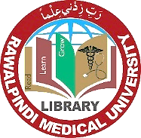
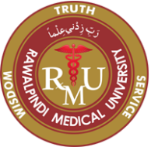
Rawalpindi Medical University
New Teaching Block Library Rawalpindi.

New Teaching Block / Main Campus__
Please tick only one

Student

Dated:______________

Name ___________________________________ Roll No: ________________________________________

Class___________________________________ Session: _______________________________________

Remarks : ______________________________________________________________________________

Signature of Library Assistant : Signature of Librarian:

