Library Clearness Form
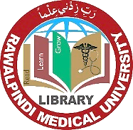
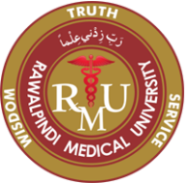
Rawalpindi Medical University

New Teaching Block / Main Campus__
Please tick only one

Faculty & Others

Dated:

Name ___________________________________ Designation ____________________________________

Department _____________________________ Place of Duty __________________________________

Remarks : ______________________________________________________________________________

Signature of Library Assistant : Signature of Librarian:

