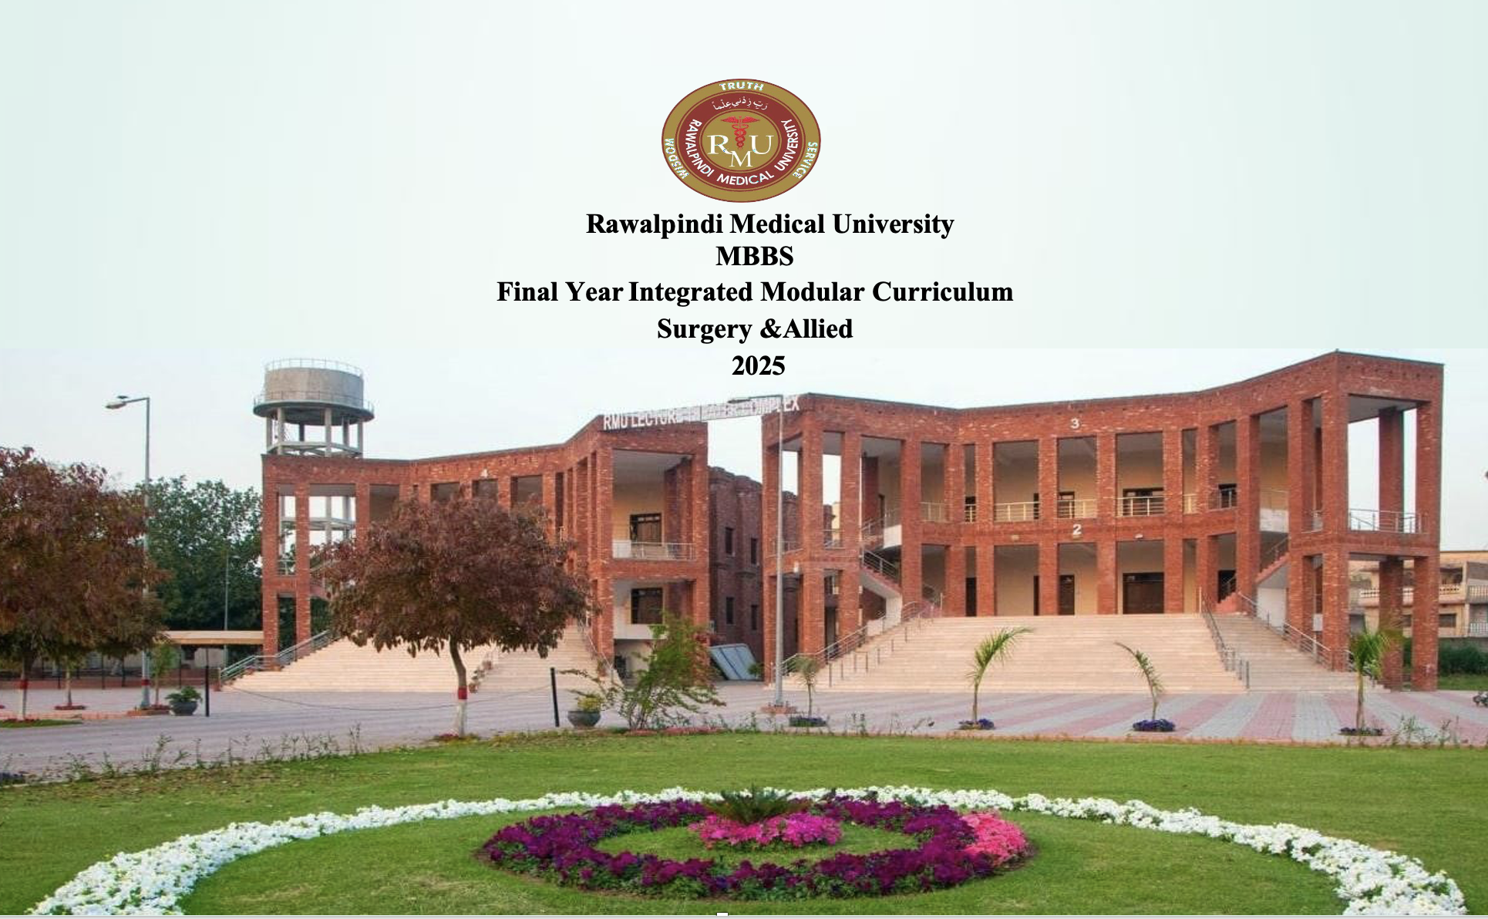

**Dedicated to Prophet Muhammad (SAW)**

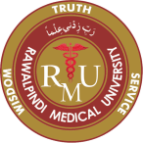

**MBBS**

Modular Integrated Curriculum

2025

#### MBBS FINAL YEAR

#### Surgery &Allied

**Quote by Quaid-e-Azam Muhammad Ali Jinnah**

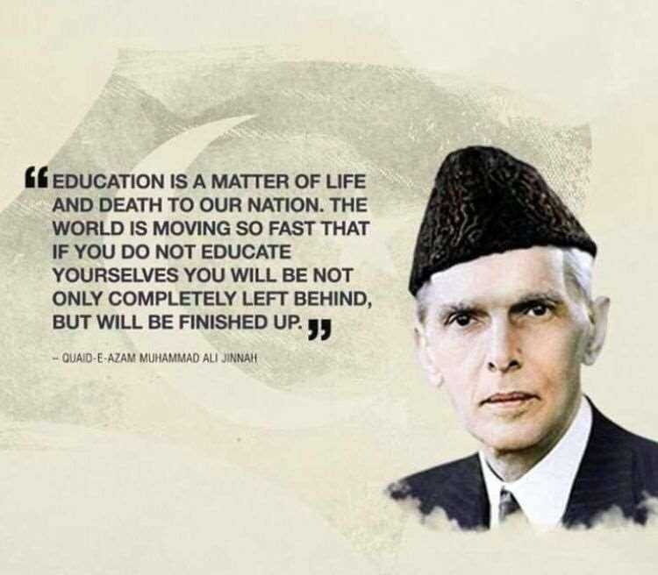

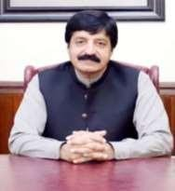

**Sardar Saleem Haider Khan**

 **Governor Punjab**

It is with great pleasure that I extend my congratulations to Rawalpindi Medical University on the introduction of its Integrated Curriculum. This progressive step

reflects the university’s commitment to shaping the future of medical education inPakistan, ensuring that our future healthcare professionals are equipped with the skills and

knowledge needed to meet the evolving demands of healthcare, both locally and globally.

The integrated curriculum represents a significant shift in how medical education is delivered, focusing on the interconnection between various disciplines and emphasizing

patient-centered care. By blending theoretical knowledge with practical application from the early stages of their education, students are better prepared to understand the

complexities of human health and the diverse challenges they will face in their medical careers. This holistic approach is critical in nurturing well-rounded professionals

who are not only adept clinicians but also compassionate caregivers.

Rawalpindi Medical University has always been at the forefront of medical education, and this curriculum reflects its visionary leadership in preparing graduates who are ready

to confront the future of healthcare with confidence and competence. I am confident that this initiative will greatly contribute to the advancement of healthcare in Punjab and

beyond, ensuring that our doctors are not only skilled but also compassionate and ethical leaders in their field.

**Mr. Khawaja Salman Rafique**

**Minister, Specialized Healthcare & Medical Education Department**

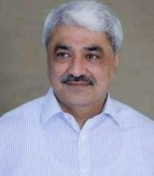



The Rawalpindi Medial University, Rawalpindi has consistently evolved and adapted to support its learners, uphold academic standards, and maintain its status as a globally recognized institution.

The launch of the ‘Modular Curriculum 2024 marks a significant step forward in advancing public health and addressing future healthcare needs. By embracing this curriculum, students and professionals alike

will gain the tools to turn knowledge into practical expertise, positioning themselves as leaders in research, public service, sustainable healthcare, and accessible medical care.

A curriculum’s success hinges on the dedication of those who implement it. The true impact of this program will be realized through the joint efforts of educators and learners. I am confident that this

integrated educational framework will equip our future doctors to confront global health challenges, including emerging disease trends, healthcare equity, and solutions for underserved communities.

###### 

###### 

###### **Prof. Dr. Muhammad Umar. Prof Jahangir Sarwar Khan**

**Vice Chancellor RMU**  **Principal RMC**



There is no subject which will require more careful consideration in the settlement of the educational details of the University of which RMU is to be the center than that of the choice and arrangement of the curriculum to be required for the degree in medicine. An exceptional opportunity presents itself, you have, within certain limits, a tabula rasa, and it behooves the authorities of the future university to mark it in the manner best calculated to promote the advance of medical science and the efficiency of medical teaching. If, from an experience acquired as a teacher and examiner in various universities during a period of more than a quarter of a century, I can help in the promotion of these objects, by pointing out virtues which may be emulated here,and failings which may be avoided there. I shall at least feel I have done something to assist in the modelling of what will, we all hope, become one of the great centers of learning of Pakistan.

There is no subject which will require more careful consideration in the settlement of the educational details of the University of which RMU is to be the center than that of the choice and arrangement of the curriculum to be required for the degree in medicine. An exceptional opportunity presents itself, you have, within certain limits, a tabula rasa, and it behooves the authorities of the future university to mark it in the manner best calculated to promote the advance of medical science and the efficiency of medical teaching. If, from an experience acquired as a teacher and examiner in various universities during a period of more than a quarter of a century, I can help in the promotion of these objects, by pointing out virtues which may be emulated here,and failings which may be avoided there. I shall at least feel I have done something to assist in the modelling of what will, we all hope, become one of the great centers of learning of Pakistan.

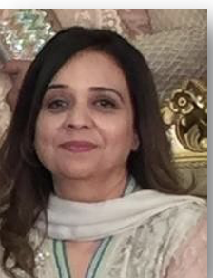

**Prof Dr. Ifra Saeed**

**Professor of Anatomy Director DME**



This is a great prospect for RMU and curriculum committee to formulate the modular curriculum of Final Year MBBS. It is a task, well meant for its contribution in medical education. Hopefully it will go a long way in training the medical graduates, as per required national and international standards of medical education. The Modular teaching is likely to give a fresh and varied approach to learning process and at the end optimizing maximum learning outcomes. This entails coordination, patience, commitment and diligence from all those who are on board, either the faculty or the students. All this seems to be encouraging, yet limited resources, inadequate manpower, and difficulty in breaking traditional shackles are tangible obstacles.

The preparation and implementation of modular curriculum provides the faculty an opportunity to design and re orientate and re-conceptualize health –illness process. Transforming academic stakeholders’ learning perspectives and then to translate it in students’ development as an effective force of society, well versed with modern day problems, is an uphill task. This is a humble effort in this regard. Still there is lot to distill, crystallize and narrate. Hopefully from this marathon, the curiosity will emerge like a fresh breeze, from here the character will arise in the horizon, as all this at the end is meant to serve the ailing humanity and to accomplish the dream of a healthy At the end, it will be great injustice not to acknowledge the unwavering and untiring support of Prof Dr Muhammad Umar, Vice Chancellor RMU, who is an ardent supporter and promoter of anything which givesfreshimpetus to medical education and practice. It’s all because of his continuous input and persuasion, that the modular curriculum achieved fruition.

**Dr. Omaima Asif**

Assistant Director DME/ Editor

As we begin this exciting new chapter with the Integrated Modular Curriculum, I want to take a moment to share my enthusiasm for the opportunities it brings to both our students and faculty. This forward-thinking curriculum is crafted to enrich the educational journey while better preparing our future healthcare professionals to tackle the intricacies of patient care.

In today's fast-changing medical environment, it is essential that our educational approach reflects the interconnectedness of healthcare. The Integrated Modular Curriculum dismantles conventional barriers, allowing students to experience a comprehensive view of medicine, where foundational sciences, clinical skills, and patient interactions come together seamlessly.

Our focus on active learning and collaborative approaches will empower students to think critically, adapt to new challenges, and develop the empathy vital in our profession. By emphasizing a patient-centered methodology and incorporating real-world experiences, we aim to foster a profound understanding of the impact of medical practice on individuals and communities.

I am thrilled about the potential this curriculum holds and deeply appreciate the commitment of our faculty and staff in bringing it to fruition. Together, we will cultivate a new generation of medical professionals who are not only well-informed but also compassionate, ready to make a positive impact on their patients' lives.

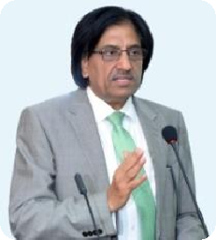

Authors Co-Authors.

**Prof. Muhammad Umar Professor Faryal Azhar**

Vice Chancellor Head of Department Surgery, RTH

Rawalpindi Medical University & Allied Hospitals

|  |  |
| --- | --- |
| **University Moto, Vision, Values & Goals**  **RMU Motto** | **Vision and Values**  Highly recognized and accredited center of excellence in Medical Education, using evidence-based training techniques for development of highly competent health professionals, who are critical thinkers, experiential self-directed lifelong learners and are socially accountable  **Mission Statement**  To impart evidence-based research-oriented health professional education in order to provide best possible patient care and inculcate the values of mutual respect, ethical practice of healthcare and social accountability.  **Outcomes of the Undergraduate Integrated Modular Curriculum**  The Undergraduate Integrated Learning Program is geared to provide you with quality medical education in an environment designed to:   * Provide thorough grounding in the basic theoretical concepts underpinning the practice of medicine. * Develop and polish the skills required for providing medical services at all levels of the health care delivery system. * Help you attain and maintain the highest possible levels of ethical and professional conduct in your future life. * Kindle a spirit of inquiry and acquisition of evidence-based knowledge to help you attain personal and professional growth & excellence. |

## 

## RMU ISO Certification

|  |  |  |  |  |
| --- | --- | --- | --- | --- |
| Final RMU logo | **Rawalpindi Medical University** | | | |
| **Doc. Title: Procedure For Control of Documented Information** | | | |
| **Document #:** RMU-MR-SOP-70 | **Rev. #:** 05 | **Issue #:** 01 | **Issue Date:** 24-10-2024 |

**Procedure For Control of Documented Information**

In-Compliance with **ISO 9001:2015 Clause 7.5** The copyright of this procedure, together with all confidential information contained herein is the sole property of Rawalpindi Medical University. It may be copied in full or in parts only by the Management/personnel and only for Company-related activities. Disclosure of any information contained within this procedure to any person (s) outside the employee of the institute without written permission of the Vice Chancellor or Principal or ISO Committee Head is strictly prohibited.

**Document Information**

|  |  |
| --- | --- |
| **Category** | **Competency based clinically oriented integrated modular curriculum** |
| Document | Procedure for Control of Documented Information |
| Issue | 1 |
| Rev | 05 |
| Identifier | RMU-MR-SOP-70 |
| Status | Final Document |
| Author(s) | Director Medical Education, Asst. Director Medical Education, |
| Reviewer(s) | Curriculum Committee. |
| Approver(s) | Vice Chancellor |
| Creation Date | 16-09-2024 |
| Effective Date | 16-09-2024 |
| Control Status | **Controlled** |
| Distribution | VC, Principal, ISO Committee |
| Disclaimer | This document contains confidential information. Do not distribute this document without prior approval from higher management of **Rawalpindi Medical University.** |

|  |  |  |  |  |
| --- | --- | --- | --- | --- |
| Final RMU logo | **Rawalpindi Medical University** | | | |
| **Doc. Title: Procedure For Control of Documented Information** | | | |
| **Document #:** RMU-MR-SOP-70 | **Rev. #:** 05 | **Issue #:** 01 | **Issue Date:** 24-10-2024 |

**Document Revision History**

**Document Approval**

|  |  |  |  |
| --- | --- | --- | --- |
| **Author(s)** | **Date** | **Version** | **Description** |
| Professor Naeem Zia | 2022-  2023 | 1st | Developed for Final year MBBS  Learning Objectives added. |
| Professor Faryal Azhar | 2024 | 2nd | Developed for Final Year MBBS  Learning Objectives updated.  Assessment added |
| Professor Faryal Azhar | 2025 | 3rd | Developed for Final Year MBBS.  Horizontally and vertically integrated  Research curriculum incorporated  Introduction changed, EPA added . |

|  |  |  |
| --- | --- | --- |
| **Prepared By** | **Reviewed By** | **Approved By** |
| Director Medical Education, Asst. Director Medical Education, | Curriculum Committee | Vice Chancellor |

**List of Copy Holders**

|  |  |  |  |  |
| --- | --- | --- | --- | --- |
| **Document Code** | **Issue #**  **/Rev.#** | **Copy #** | **Copy**  **Holders** | **Distribution**  **Mode** |
| **RMU-MR-SOP-70**  **RMU-MR-SOP-70 RMU-MR-SOP-70** | **01/00**  **01/00**  **01/00** | **01**  **02**  **03** | **V.C**  **HODs IC** | **Email**  **Email Hard Copy** |

## Table of Contents

# SECTION-I

## Contributors

## &

**Developing Team**

##### Members of Syndicate

|  |  |
| --- | --- |
| **Sr. No** | **Members** |
| **1.** | The Minister for SHC & ME Department, Punjab / Pro Chancellor, Rawalpindi Medical University, Rawalpindi. |
| **2.** | The Secretary to Government of the Punjab, SHC & ME Department, Lahore |
| **3.** | The Secretary to Government of the Punjab, Finance Department, Lahore |
| **4.** | The Secretary to Government of the Punjab, Higher Education Department, Lahore |
| **5.** | The Secretary to Government of the Punjab, Law & Parliamentary Affairs Department, Lahore |
| **6.** | The Chairman Higher Education Commission, Sector H-9, Islamabad |
| **7.** | Prof. Fareed Minhas, Ex, Professor of Psychiatry, RMC, Rawalpindi. |
| **8.** | Prof. Syed Irfan Ahmed, Ex-Professor of Medicine, RMC, Rawalpindi |
| **9.** | Syed Bakhtiyar Kazmi, Partner KPMG Taseer Hadi & Co |
| **10.** | Dr. Muhammad Saqib Abbasi, Rawalian Alumini |
| **11.** | The Medical Superintendent, Holy Family Hospital, Rawalpindi |
| **12.** | The Principal, College of Nursing Holy Family Hospital, Rawalpindi |
| **13.** | The Vice Chancellor Pir Mehr Ali Shah Arid Agriculture University, Rawalpindi |
| **14.** | The Vice Chancellor National University of Science & Technology (NUST), Islamabad |

##### Deans of Faculties & Professors

|  |  |  |  |  |  |  |  |  |
| --- | --- | --- | --- | --- | --- | --- | --- | --- |
| **Sr. No** | **Name** | **Department** | **Sr. No** | **Name** | **Department** | **Sr. No** | **Name** | **Department** |
| **1.** | Prof. Dr. Muhammad Umar | Vice Chancellor | **19.** | Prof. Dr. Asad Tameez-ud-Din | Psychiatry | **37.** | Dr. Hasnain Khan | Plastic Surgery |
| **2.** | Prof. Dr. Jahangir Sarwar Khan | Principal | **20.** | Prof. Dr. Zein El Aamir | Urology | **38.** | Dr. Obaid ur Rehman | Orthopedics |
| **3.** | Prof. Dr. Muhammad Khurram | Medicine | **21.** | Prof. Dr. Wafa Omer | Pathology | **39.** | Dr. Muhammad Mujeeb Khan | Infection Disease |
| **4.** | Prof. Akram Randhawa | Pharmacology | **22.** | Dr. Jawad Zaheer | Anesthesia | **40.** | Dr. Aneela Jamil | Biochemistry |
| **5.** | Prof. Rai Muhammad Ashgar | Peads | **23.** | Dr. Ashraf Mehmood | Neurosurgery | **41.** | Dr. Muhammad Asad | Cardiology |
| **6.** | Prof. Shagufta Saeed | Gynae/Obs | **24.** | Dr. Ahmed Hassan | ENT | **42.** | Dr. Shawana Sharif | Dermatology |
| **7.** | Prof. Riaz Ahmed Sheikh | Orthopedic Surgery | **25.** | Dr. Sadia Chaudhry | ENT | **43.** | Dr. Faran Maqbool | , Medicine |
| **8.** | Prof. Dr. Mobina Ahsan Dodhy | Pathology | **26.** | Dr. Muhammad Shahzad Manzoor | , Medicine | **44.** | Dr. Abeera Zareen | Anesthesia |
| **9.** | Prof. Dr. Naeem Akhtar | Pathology | **27.** | Dr. Faryal Azhar | Surgery | **45.** | Dr. Hina Sattar | Peads |
| **10.** | Prof. Dr. Samia Sarwar | Physiology | **28.** | Dr. Usman Qureshi | Surgery | **46.** | Dr. Raja Asif Masood | Nephrology |
| **11.** | Prof. Dr. Nousheen Qureshi | ENT | **29.** | Dr. Saima Ambreen | Medicine | **47.** | Dr. Sadia Azam Khan | Family Medicine |
| **12.** | Prof. Dr. Naveed Akhtar Malik | Surgery | **30.** | Dr. Sadia Khan | Gynae | **48.** | Dr. Rehman Rasool | , Orthopedics |
| **13.** | Prof. Dr. Waqas Raza | Surgery | **31.** | Dr. Rubaba Abid | Gynae | **49.** | Dr. Saad Riaz | Orthopedics |
| **14.** | Prof. Dr. Tallat Farkhanda | Gynae /Obs | **32.** | Dr. Humera Noreen | Gynae | **50.** | Dr. Israr Liaquat | Peads |
| **15.** | Prof. Dr. Nasir Khan | Radiology | **33.** | Dr. Tanveer Husain | Gastroenterology | **51.** | Dr. Arshad Rabbani | Medicine |
| **16.** | Prof. Dr. Ayesha Yousaf | Anatomy | **34.** | Dr. Hasnain Khan | Plastic Surgery | **52.** | Dr. Hasnain Khan | Plastic Surgery |
| **17.** | Prof. Dr. Ifra Saeed | Anatomy/DME | **35.** | Dr. Mudassar Faiz Gondal | Peads Surgery | **53.** | Dr. Obaid ur Rehman | Orthopedics |
| **18.** | Prof. Dr. Fuad Ahmad Khan Niazi | , Ophthalmology | **36.** | Dr. Asma Khan | Pharmacology | **54.** | Dr. Muhammad Mujeeb Khan | Infection Disease |

##### Contributors

|  |  |  |
| --- | --- | --- |
| **Department of Medicine** | **Department of Surgery** | **Department of Plastic Surgery** |
| Prof. Muhammad Umar Vice Chancellor | Professor. Dr. Jahangir Sarwar Khan (Principal) | Assistant Prof. Dr. Husnain Khan |
| Professor. Dr. Muhammad Khurram | Professor. Dr. M. Waqas Raza | **Department of Gastroenterology** |
| Associate Prof. Dr. Shahzad Manzoor | Professor. Dr. Anis Ahmed | Associate. Prof. Dr. Tanveer Hussain |
| Associate Prof. Dr. Saima Ambreen | Associate. Prof. Dr Usman Qureshi | Assistant. Prof. Sadia Ahmed |
| Associate Prof. Dr. Muhammad Arif | Associate Prof. Dr. Gohar Rasheed | **Department of Cardiology** |
| Associate. Prof. Dr. Lubna Meraj | Associate Prof. Dr. Faryal Azhar | Assistant. Prof. Dr. Muhammad Asad |
| Assistant Dr. Mujeeb Khan | Associate Prof. Dr M. Zafar Iqbal | **Department of Obs/Gynae** |
| Assistant. Prof. Dr. Faran Maqbool | Assistant. Prof. Dr. Muhammad Atif | Professor. Dr. Tallat Farkhanda |
| Assistant Prof. Nida Anjum | Assistant. Prof. Dr Huma Sabir Khan | Associate. Prof. Dr Sadia Khan |
| **Department of ENT** | Assistant Prof. Dr. Syed Rahat Hassan | Associate. Prof. Dr. Humera Noreen |
| Professor. Dr. Nousheen Qureshi | Assistant Prof. Dr. Asifa Dian | Associate. Prof. Dr. Rubaba Abid Naqvi |
| Associate Prof. Dr. Ahmad Hassan Ashfaq | **Department of Pediatrics Surgery** | Associate Prof. Dr Sobia Nawaz |
| Associate Prof. Dr. Sadia Chaudhry | Associate Prof. Dr. Mudasser Faiz Gondal | Assistant. Prof. Dr. Humaira Bilqis |
| Assistant. Prof. Dr. Haitham Akaash | Assistant Prof. Dr. Mahwish Khan | Assistant. Prof. Dr. Saima Bibi |
| Assistant. Prof. Dr. Muhammad Arshad | **Department of Pediatrics** | Assistant. Prof. Dr Maliha Sadaf |
| Assistant Prof. Dr. Ashar Alamgir | Assistant Prof. Dr. Hina Sattar | Assistant. Prof. Dr Khansa Iqbal |
| Assistant Prof. Dr. Tabassum Aziz | Assistant Prof. Dr. Aqeela Ayub | Assistant Prof. Dr. Amara Arooj |
| Assistant Prof. Dr. Nida Riaz | Assistant Prof. Dr. Jawaria Zain | Assistant. Prof. Dr. Shama Bashir |
| **Department of Psychiatry** | Assistant Prof. Dr. Asad Shabbir | Assistant Prof. Dr. Aqsa Ikram |
| Prof. Dr. Asad Tamis ud Din | Assistant Prof. Dr. Israr Liaqat | Assistant. Prof. Dr. Nighat Naheed |
| Associate Prof. Dr. Muhammad Kashif | **Department of Urology** | Assistant. Prof. Dr. Farah Deeba |
| Assistant Prof. Dr. Mahmood Ali Khan Jafri | Associate Prof. Dr. Zain-ul-Aamir | Dr. Ismat Batool S.R BBH |

|  |  |  |
| --- | --- | --- |
| Assistant Prof. Dr. Sadia Majid | Associate Prof. Dr. Zeeshan Qadeer | **Department of Orthopedics** |
| Assistant Prof. Dr. Qurat ul Ain | **Department of Dermatology** | Associate Prof. Dr. Obaid-Ur-Rahman |
| Assistant Prof. Dr. Azeem Khan | Assistant Prof. Dr. Shawana Sharif | Assistant Prof. Dr. Rehman Rasool Akhtar |
| **Department of Neurosurgery** | **Department of Pathology** | Assistant Prof. Dr. Saad Riaz |
| Associate Prof. Dr. Ashraf Mahmood | Professor. Dr. Naeem Akhtar | Assistant Prof. Dr. Muhammad Hassan |
| Assistant Prof. Dr. Soban Sarwar Gondal | Professor. Dr. Mobina Ahsan Dodhy | **Department of Anesthesiology** |
| **Department of Radiology** | Associate Prof. Dr. Mudassira Zahid | Associate Prof. Dr. Jawad Zahir |
| Professor Dr. Nasir Khan | Assistant Prof. kiran Fatima | Assistant Prof. Dr. Abeera Zareen |
| Associate Prof. Dr. Hina Hanif Mughal | Assistant Prof Fatima Tuz Zahra | Assistant. Prof. Dr. Waqas Anjum |
| Assistant Prof. Dr. Anum Zahoor | Assistant Prof. Dr. Rabbia Khalid Latif | Assistant Prof. Dr. Anum Malik |
| Assistant Prof. Dr. Faisal Mehmood | Dr. Abid Hassan APMO | Assistant Prof. Dr. Ayesha Mansoor |
| Assistant Prof. Dr. Hina Hafeez Abbasi | Dr. Uzma Zaffar APWMO | **Department of Pharmacology** |
| Assistant Prof. Dr. Beenish Nadeem | Dr. Jaweriya Qaiser APWMO | Prof. Dr. Akram Randhawa |
| Assistant Prof. Dr. Riffat Raja | Dr. Faiza Zafar S.W.D | Associate Prof. Dr. Asma Khan |
| Dr. Aniqa Saleem S.R, HFH | Dr. Syed Iqbal Haider S.D | Assistant Prof. Dr. Attiya Munir |
| Dr. Saba Binte Kashmir S.R HFH | Dr. Syed M. Ali S.D | Assistant Prof. Dr. Zunera Hakim |
| Dr. Jehangir Khan | Dr. Mehreen Fatima DEMO | Assistant Prof. Dr. Sfanila Akhter |
| Dr.Sana Yaqoob S.R | Dr. Nida Fatima Syed DEMO | Dr. Arsheen Arshad DEMO |
| Dr. Nadiha Maryam S.R BBH | Dr. Sara Rafi DEMO | DR. Muhammad Zaheer shaikh DEMO |
| **Department of Physiology** | Dr Syeda Aisha DEMO | Dr. Omaima Asif DEMO |
| Professor Dr. Samia Sarwar | Dr. Muhammad Shabih Haider Demo | Dr. Zoofashan Fatima Demo |
| Associate Dr. Faizania Shabbir | Dr. Unaiza Aslam S.W.D | Dr. Memuna Kanwal Demo |
| Assistant Prof. Dr. Sidra Hamid | Dr. Kiran Ahmad S.D | Dr. Haseeba Talat DEMO |
| Associate Prof. Faizania Shabir | Dr. Rabia Anjum | Dr. Rubina Kauser S.D |
| Dr. Sheena Tariq APMO | Dr. Saroor-e-Syma DEMO | Dr. Uzma Umar S.D |

|  |  |  |
| --- | --- | --- |
| Dr. Fareed Ullah Khan S.D | Dr. Faiza Sahar SWMO | Dr. Ayesha Anwar |
| Dr. Kamil Tahir S.D | Dr. Tahira Jabeen | Qurat-ul-Ain |
| Dr. Uzma Kiani S.W.D | Dr. Mahjabeen | Dr. Saba Sarfaraz |
| Dr. Fahad Anwar Demonstrator | Dr. Laraib Khatoon | **Department of Biochemistry** |
| Dr. Jawad Hasan Demo | Dr. Saira Karim | Assistant Prof. Dr. Aneela Jamil |
| Dr. Nazia Mumtaz Demo | Dr. Khuzeema Tanveer | Dr. Rahat Afzal APWMO |
| Dr. Aneela Yasmeen S.D | **Department of Anatomy** | Dr. Kashif Rauf S.D |
| Dr. Shazia Nosheen S.D | Professor Dr. Ayesha Yousaf | Dr Nayab Ramzan S.W.D |
| Dr. Uzma Kiani DEMO | Professor Dr. Ifra Saeed | Dr. Romessa Naeem DEMO |
| Dr. Najamul Sehar Javed | Associate Prof. Dr. Mohtasham Hina | Dr. Almas Ajaz S.D |
| **Department of Eye.** | Assistant Prof. Dr. Arsalan Manzoor Mughal | Dr. Uzma Zafar |
| Prof. Dr. Fauad Ahmad Khan Naizi | Assistant Prof. Dr. Maria Tasleem | Dr. Rohina Khalid |
| Assistant Prof. Dr. Ambreen Gul | Dr. Gaiti Ara Saeed APWMO | Dr. Sana Latif |
| Assistant Prof. Dr. Sidra Jabeen | Dr. Saadia Baqir APWMO | **Department of Nephrology** |
| **Department of Community Medicine** | DR. ALI RAZA, S.D | Assistant Prof. Dr. Sana Kifayat |
| Prof. Dr. Arshad Sabir | Dr. Muhammad Tariq Furqan S.D | Assistant Prof. Dr. Noman Butt |
| Associate Prof. Dr. Khola Noreen | Dr. Sajjad Hussain S.D | Assistant Prof. Dr. Asmara Asrar |
| Associate Prof. Dr. Sana Bilal | Dr. Kashif Ashraf S.D | **Department of Forensic Medicine** |
| Assistant Prof. Dr. Rizwana Shahid | Dr. Qurat ul Ain Sharif S.W.D | Associate Prof. Dr. Romana Malik |
| Assistant Prof. Dr. Afifa Kulsoom | Dr. Saira Aijaz S.W.D | Assistant Prof. Dr. Filza Ali |
| Assistant Prof M. Imran Younas | Dr. Minahil Haq Demo | Dr. Shahida Bashir APWMO |
| Assistant Prof. Gul Mehar Javaid | Dr. Urooj Shah DEMO | DR. Gulzaib Pervaiz APWMO |
| Assistant Prof. Dr. Farrah Pervaiz | Dr. Zeneara Saqib DEMO | Dr. Naila Batool APWMO |

|  |  |  |
| --- | --- | --- |
| Assistant Prof. Dr. Mehwish Riaz | **Department of Medical Education** | Dr. Syeda Fatima |
| Dr. Farhan Hassan S.D | Prof. Dr. Ifra Saeed (Director DME) | Dr. Shahrukh Khan S.D |
| Dr. Abdul Qudoos S.D | Asso. Dr. Arsalan Manzoor Mughal (Additional Director of Assessments) | Dr. Urooj Shah DEMO |
| Dr. Asif Maqbool Butt Demo | Dr. Farzana Fatima (Assistant Director DME OTB) | Dr. Roohina Saeed |
| Dr. Imrana Saeed S.D | Dr. Omaima Asif (Assistant Director DME NTB) | **Department of Critical Care** |
| Dr. Narjis zaidi S,D | Dr. Maryam S.W.M.O | Associate Prof. Dr. Abrar Akbar |
| Dr. Moniba Iqbal PGT | Dr Saira Aijaz Demonstrator | **Department of Family Medicine** |
| Dr. Bushra Farooq PGR |  | Assistant Prof. Dr. Sadia Azam Khan |
| Dr. Zaira Azhar PGR | **Department of Neurology** |
| Dr. Saba Maryam PGR | Assistant Prof. Dr. Waqas Ahmed |
| Dr. Ayesha zujaja PGR | **Department of Pulmonology** |
| Dr. Maria Jabeen PGR | Assistant Prof. Dr. Zaid Umar |
| Dr. Mehreen Noor PGR |  | |



# SECTION

## Preamble

## Modular Integrate Curriculum

Welcome to the Clinically Oriented Integrated Modular Curriculum for the MBBS students at Rawalpindi Medical University. This revised version is tailored to integrate clinical insights from the very beginning, ensuring a more practical and application-focused approach to the fundamental medical sciences. At Rawalpindi Medical University, we are committed to providing a curriculum that not only covers the essential theoretical knowledge but also emphasizes the development of critical clinical skills necessary for future medical professionals. This curriculum is designed to foster a deep understanding of human biology and the pathophysiological processes, combined with hands-on clinical experiences that contextualize theoretical knowledge in real-world medical settings.

curriculum incorporates the latest advancements in medical education and reflects changes in the medical landscape, ensuring our students are well-prepared to meet the challenges of modern healthcare environments. With a focus on interdisciplinary learning and ethical practice, we aim to equip our students with the competence and compassion required to excel in their future careers.

We trust that this curriculum will inspire and challenge you to reach new heights in medical education and beyond. Welcome to a journey of learning that promises to be as rewarding as it is demanding.

###### **What is curriculum?**

According to definition curriculum can be classified into five categories:

1. Curriculum as a product - program, document, electronic media, or multimedia.
2. Curriculum as a program of study - usually courses offered, curriculum sequences of study in standards as benchmarks, gateways,
3. Curriculum as intended learnings - goals, content, concepts, generalizations, outcomes.
4. Curriculum as experiences of the learner - activities, planned and unplanned.
5. Hidden curriculum - what students learn that isn't planned - unless you plan for this - or is it possible?

###### Diagram presenting the concept of a fully or spirally integrated... | Download Scientific Diagram**What is Integrated Medical Curriculum**?

Shoemaker defines an integrated curriculum as “education that is organized in such a way that it cuts across subject matter lines, bringing together

various aspects of the curriculum into meaningful association to focus upon broad areas of study.” There is an ongoing discussion about whether

medical curriculum should be discipline based or integrated. Most curricula for medical education have been integrated horizontally and vertically–-

vertically between basic and clinical sciences. The Flexnerian curriculum has disappeared to permit integration between basic sciences and clinical sciences,

which are taught throughout the curriculum. We have proposed a different form of integration where the horizontal axis represents the defined learning outcomes

and the vertical axis represents the teaching of the sciences throughout the courses. We believe that a mere integration of basic and clinical sciences is not enough

because it is necessary to emphasize the importance of humanism as well as health population sciences in medicine. It is necessary to integrate basic and clinical sciences,

humanism,and health population in the vertical axis, not only in the early years but also throughout the curriculum, presupposing the use of active teaching methods based

on problems or cases in small groups.

The method of teaching medicine, since Flexner's days, implies that students should first learn basic and biomedical

sciences and then move to clinical sciences; however, this is not how patients are presented. A common criticism of this

approach is that students will not see the relevance of basic and biomedical sciences applied to clinical practice, and it

is preferable to encourage students to think as doctors from the day they enter medical school.

Integration is therefore of key importance for medical education because basic science learning is placed in the context

of clinical and professional practice and is considered by students to be more meaningful and relevant. In the vast majority

of curriculum reforms, vertical integration combines basic and clinical sciences, early clinical experience, clinician–scientist

partnerships, and incorporation of sciences in the later years of the course. This is undoubtedly an advantage, but is based on

a biologist's vision of the health-illness process

###### **Curriculum Integration in Medical Education: A Theoretical Review | Semantic ScholarLevels of Integration**

At Rawalpindi Medical University, our curriculum for the MBBS program adheres to the sophisticated model of Correlation, recognized as level 7 on Harden’s scale of integration. This approach is foundational throughout the initial four years of the medical education journey. Our emphasis predominantly remains on discipline-specific education, where courses focused on individual subjects constitute the majority of the curriculum. This traditional structure ensures a robust foundation in the core medical sciences.

Within this discipline-oriented framework, we introduce an innovative element—an integrated teaching session. These sessions are strategically designed to bridge various subjects by identifying and connecting areas of mutual relevance. This method facilitates a holistic learning experience by correlating distinct disciplines and embedding them within a clinical context. This integration enhances the students' understanding and application of medical concepts, making the learning process both comprehensive and applicable to real-world scenarios.

As our students progress through their education, the degree of clinical teaching intensifies. This gradual increase is deliberate, ensuring that by the time our students reach their final year, they are well-prepared to engage in extensive clerkships. Year V is exclusively devoted to these clerkships, offering students hands-on, practical experience in a variety of clinical settings. This exposure is crucial for the development of competent and empathetic future physicians who are equipped to meet the diverse needs of their patients and the healthcare system at large.

###### **PMDC Seven Star Doctor Competencies**

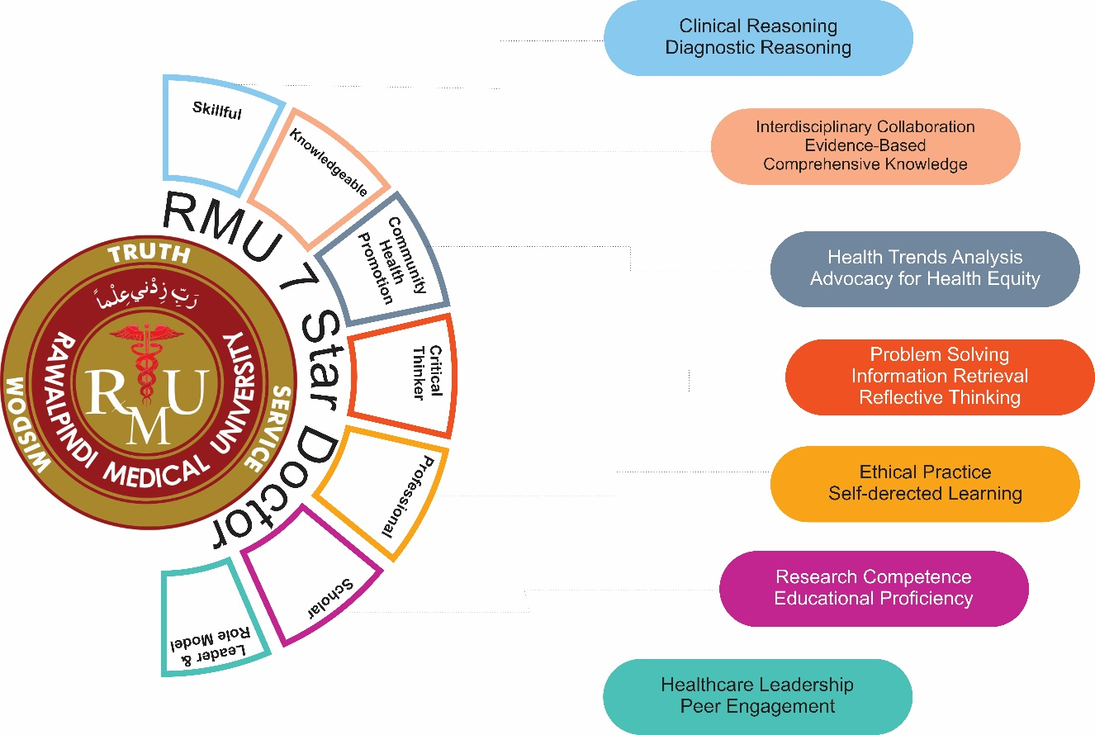

At RMU we aim to produce seven-star doctor according to PMDC Competencies having the generic competencies of “Skill, Knowledge, Community Health Promoter, Critical Thinker, Professional, Scholar, Leader and Role Model”, Rawalpindi Medical University has introduced modular integrated undergraduate curriculum as being first public sector university. These competencies are further outlined by various enabling traits specifying knowledge, skills, and attitude.  
Several key features have been integrated into Curriculum 2K23 for all three training domains, following discussions and an iterative process involving subject experts, medical educators, and university leaders. These features include:

|  |
| --- |
| Horizontal Integration |
| Cognitive Domain |
| The Curriculum 2K23 framework consists of 44 modules distributed over five years. It features a modular design that allows various foundational disciplines to address themes concurrently. Each module is organized to represent all key disciplines according to their content weight. The assessment framework also incorporates applied and clinical elements into the learner's conceptual development, ensuring that clinical relevance and context remain central to the education process. |
| Clinical Relevance:  Each module's objectives are introduced with the relevant themes and clinical significance. This approach is based on the module's rationale, guiding the learning process toward a practical professional perspective. However, institutions have the flexibility to adopt alternative thematic approaches as long as the program outcomes are met effectively. |
| Integration:  The spiral arrangement of modules within the framework facilitates a revisiting of basic sciences. Initially, the applied and clinical learning objectives guide the learner, while the recurring modules align with clinical rotations, all framed by the foundational sciences. In the final year of clerkship, students have their last opportunity to integrate their learning, which is primarily workplace-based and combines elements from all three domains. |
| Clinical Clerkship |
| Psychomotor |
| Clinical Skills follow a spiral which is entirely skills dominant. This spiral is the core of psychomotor training. The rotations in different wards will be based on foundational developmental already commenced in previous years. . Community oriented practices and family medicine will also be broadening the element of systems thinking and diversity of practice for a healthcare leader of tomorrow. Finally, Clinical Clerkships are aimed to be entirely facilitated in workplace environments. The clerkship model will involve the delegation of duties thus adding to the acquisition of professional accountability as a competency. The psychomotor training and skills acquisition will be the maximum in the year of clerkship. The entire process of C-FRC will be endorsed in a logbook which would be the training base of the learner for future references and exam evaluations. |
| Spiral Integration |
| Affective Domain |
| **ALPHA Model:**  Affective training has been formally integrated into the curricular framework through the ALPHA model, which aims to produce doctors with strong, resilient, and ethically grounded character. ALPHA stands for Artificial Intelligence, Leadership, Professionalism, Humanities & Arts , encompassing professional development for the effective application of acquired knowledge and skills. To ensure that professionals are socially accountable and capable of taking on healthcare leadership roles—such as advocacy, equity, and resource access—formal training is essential.  This training is structured through a categorical approach that includes assessing competencies and developing portfolios. The ALPHA framework will be implemented year-round through portfolio development, which promotes student-centered learning. The self-reflection involved in portfolio creation allows learners to identify and address their own educational needs.  The Medical Education department will directly oversee the ALPHA spiral, but teaching sessions and mentoring can be facilitated by other disciplines. For instance, communication skills may involve input from Family Medicine faculty, while Community Medicine and Public Health can support research training. Ethics education can be jointly provided by the Bioethics and Behavioral Sciences departments. Leadership training will benefit from the involvement of institutional leaders and successful alumni.  The Faculty of Medical Education will manage the entire process and contribute to teaching as needed. The academic council, in collaboration with the Medical Education department, should define the types of evidence, activities, and learning situations required for competency acquisition in the portfolios. A 'mentoring platform' can embody the spirit of affective learning within the ALPHA framework, leading to the recommendation for developing a mentorship program at each institution. |

RMU Competency Framework

The focus of this curriculum is on the roles of a general physician, as identified by the PMDC. These roles include being skillful, knowledgeable, a community health promoter, a critical thinker, a professional and role model, a researcher, and a leader. The competencies emphasized in the first and second years align with these roles.

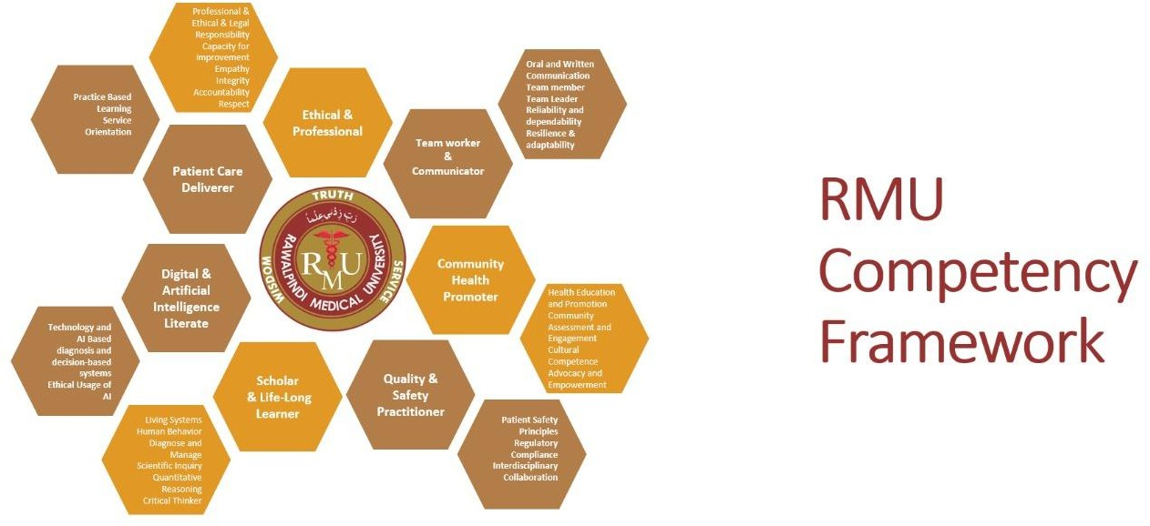

##### RMU Undergraduate Competency Model

The Rawalpindi Medical University (RMU) Undergraduate Competency Model is designed to prepare medical students to meet the evolving challenges of modern healthcare. Grounded in the principles of patient-centered care, ethical practice, and community engagement, this model outlines the core competencies that every RMU graduate must attain. These competencies are carefully aligned with the needs of Pakistan's healthcare system and the broader global context, ensuring that RMU graduates are not only skilled clinicians but also ethical leaders, compassionate caregivers, and innovative problem-solvers.

The RMU Undergraduate Competency Model emphasizes a holistic approach to medical education, integrating scientific knowledge with practical skills, critical thinking, and a deep commitment to lifelong learning. Each competency is complemented by specific sub competencies that provide a clear roadmap for students' development, guiding them from foundational knowledge to advanced clinical practice.

Through this competency-based framework, RMU aims to cultivate graduates who are capable of delivering high-quality, safe, and effective care, while also advancing the health and well-being of the communities they serve. By adhering to these competencies, RMU students will be equipped to excel in diverse medical environments, adapt to the rapidly changing landscape of healthcare, and contribute positively to the society they serve.

**Competency 1: Patient Care Deliverer**

The "Patient Care Deliverer" competency focuses on the practical aspects of delivering patient care. It emphasizes the importance of applying clinical skills, knowledge, and compassion in providing high-quality healthcare to patients. Students are expected to develop a strong foundation in patient-centered care, practice-based learning, and a commitment to continuous improvement in their clinical practice.

* Practice-Based Learning: Students should engage in continuous learning through practical experience, applying evidence-based medicine and reflecting on their clinical practice to improve patient care.
  + Apply evidence-based medicine in clinical practice.
  + Reflect on clinical experiences to improve patient care.
  + Engage in self-directed learning to enhance clinical skills.
* Service Orientation: A commitment to serving others is fundamental to the practice of medicine. Students should prioritize the well-being of patients and the community, demonstrating a strong dedication to providing compassionate and effective care.
  + Demonstrate a commitment to patient-centered care.
  + Engage in community service activities.
  + Reflect on the role of service in medical practice.

**Competency 2: Ethical & Professional**

The "Ethical & Professional" competency encompasses the foundational principles of medical ethics and professional behavior. It requires students to uphold the highest standards of legal and ethical responsibility in their practice. They must demonstrate empathy, integrity, and accountability, treating all individuals with respect and maintaining a commitment to continuous improvement.

* Professional & Ethical & Legal Responsibility: Students are expected to understand and apply ethical principles and legal requirements in medical practice. They should be able to identify and analyze ethical dilemmas in healthcare settings and make decisions that prioritize patient well-being.
  + Explain ethical frameworks in medical decision-making.
  + Apply legal standards in patient care.
  + Demonstrate professionalism in all interactions.
* Capacity for Improvement: Students should continuously strive to improve their clinical skills, knowledge, and patient care practices through self-assessment and reflective learning.
  + Assess personal strengths and weaknesses.
  + Implement strategies for self-improvement.
  + Seek feedback from peers and mentors.
* Empathy: Understanding and sharing the feelings of patients is crucial for building trust and providing compassionate care. Students must develop the ability to empathize with patients from diverse backgrounds.
  + Demonstrate empathy in patient interactions.
  + Reflect on the emotional and psychological aspects of patient care.
  + Integrate empathy into clinical practice.
* Integrity: Students must practice medicine with honesty and adhere to moral and ethical principles, ensuring that their actions align with the values of the medical profession.
  + Maintain honesty in patient interactions.
  + Uphold ethical standards in clinical decision-making.
  + Demonstrate transparency in communication with patients and colleagues.
* Accountability: Medical students must be accountable for their actions, taking responsibility for their decisions and outcomes in patient care.
  + Take responsibility for clinical decisions.
  + Reflect on the outcomes of patient care.
  + Ensure accountability in teamwork.
* Respect: Respect for patients, colleagues, and the broader healthcare team is fundamental. Students should treat everyone with dignity and consideration, regardless of differences in background or beliefs.
  + Demonstrate respect in patient interactions.
  + Collaborate respectfully with team members.
  + Address cultural differences in a respectful manner.

**Competency 3: Scholar & Life-Long Learner**

The "Scholar & Life-Long Learner" competency highlights the importance of continuous learning and scholarly inquiry in medical practice. Students are encouraged to engage in scientific research, develop critical thinking skills, and commit to lifelong learning to stay current in their field and contribute to the advancement of medical knowledge.

* Living Systems: Students should have a deep understanding of living systems and their functions, enabling them to apply this knowledge to patient care.
  + Explain the principles of living systems.
  + Apply knowledge of living systems to clinical practice.
  + Evaluate the impact of living systems on health and disease.
* Human Behavior: Understanding human behavior is crucial for effective patient care and communication. Students should be able to analyze behavioral factors that influence health and apply this understanding in clinical settings.
  + Analyze the impact of behavior on health outcomes.
  + Apply behavioral principles in patient care.
  + Reflect on the role of behavior in health and disease.
* Diagnose and Manage: Students must be proficient in diagnosing and managing medical conditions, using evidence-based approaches to ensure the best possible outcomes for patients.
  + Diagnose medical conditions accurately.
  + Develop management plans for patient care.
  + Evaluate the effectiveness of treatment interventions.
* Scientific Inquiry: Engaging in scientific inquiry is essential for advancing medical knowledge. Students should be able to conduct research, critically appraise evidence, and contribute to the scientific community.
  + Conduct research on medical topics.
  + Critically appraise scientific literature.
  + Disseminate research findings effectively.
* Quantitative Reasoning: Quantitative reasoning skills are necessary for interpreting data and making informed decisions in medical practice. Students should be able to analyze and apply quantitative data in clinical settings.
  + Interpret quantitative data in clinical practice.
  + Apply statistical methods to medical research.
  + Reflect on the role of quantitative reasoning in decision-making.
* Critical Thinker: Developing critical thinking skills is vital for solving complex medical problems. Students should be able to analyze information, evaluate evidence, and make reasoned decisions in patient care.
  + Analyze clinical scenarios critically.
  + Evaluate evidence in medical practice.
  + Make informed decisions based on critical thinking.

**Competency 4: Team Worker & Communicator**

The "Team Worker & Communicator" competency emphasizes the importance of effective communication and teamwork in healthcare settings. Students are expected to develop strong oral and written communication skills, work collaboratively as part of a healthcare team, and demonstrate leadership when necessary. Reliability, adaptability, and resilience are key qualities that support their ability to function effectively in diverse and dynamic clinical environments.

* Oral and Written Communication: Students must be able to convey medical information clearly and effectively, both verbally and in writing, to patients, families, and colleagues.
  + Communicate medical information clearly.
  + Develop patient-centered communication strategies.
  + Write accurate and comprehensive patient records.
* Team Member: Students should actively participate as members of the healthcare team, contributing to collective problem-solving and decision-making processes.
  + Collaborate effectively with team members.
  + Participate in interdisciplinary case discussions.
  + Contribute to team-based patient care.
* Team Leader: When required, students should be able to take on leadership roles within the healthcare team, guiding and coordinating the efforts of others.
  + Lead a healthcare team in clinical settings.
  + Make decisions as a team leader.
  + Facilitate effective team communication.
* Reliability and Dependability: Students must consistently demonstrate reliability and dependability in fulfilling their clinical responsibilities, ensuring that they are trusted members of the healthcare team.
  + Fulfill clinical duties reliably.
  + Demonstrate dependability in patient care.
  + Maintain consistency in performance under pressure.
* Resilience & Adaptability: Students need to develop resilience to cope with the challenges of medical practice and adapt to changes in clinical settings.
  + Demonstrate resilience in stressful situations.
  + Adapt to changes in clinical practice.
  + Reflect on challenges and adapt strategies accordingly.

**Competency 5: Community Health Promoter**

The "Community Health Promoter" competency focuses on the role of medical students in promoting health within the community. It involves educating and empowering communities, conducting assessments, and engaging with diverse populations to address public health challenges. Cultural competence and advocacy are essential in promoting health equity and improving community health outcomes.

* Health Education and Promotion: Students should be able to design and implement health education programs that address the specific needs of the community.
  + Develop health education materials.
  + Implement community health promotion activities.
  + Evaluate the effectiveness of health education programs.
* Community Assessment and Engagement: Students must be capable of assessing the health needs of communities and engaging with community members to identify and address public health issues.
  + Conduct community health assessments.
  + Engage with community stakeholders.
  + Identify public health priorities based on community needs.
* Cultural Competence: Understanding and respecting cultural differences is crucial in providing effective community health promotion. Students should be able to work with diverse populations and tailor health interventions accordingly.
  + Demonstrate cultural sensitivity in community interactions.
  + Adapt health interventions to cultural contexts.
  + Reflect on cultural influences in health behaviors.
* Advocacy and Empowerment: Students should advocate for policies and practices that promote community health and empower individuals and communities to take control of their health.
  + Advocate for community health initiatives.
  + Empower individuals to make informed health decisions.
  + Promote policies that address social determinants of health.

**Competency 6: Quality & Safety Practitioner**

The "Quality & Safety Practitioner" competency emphasizes the importance of patient safety and quality improvement in healthcare. Students are trained to understand and apply patient safety principles, comply with regulatory requirements, and collaborate with interdisciplinary teams to ensure the highest standards of care.

* Patient Safety Principles: Students must understand and apply patient safety principles to prevent medical errors and enhance the quality of care.
  + Identify potential safety risks in clinical practice.
  + Implement strategies to prevent medical errors.
  + Evaluate the effectiveness of patient safety interventions.
* Regulatory Compliance: Knowledge of and adherence to regulatory standards is essential in maintaining patient safety and quality care. Students must be familiar with relevant regulations and ensure compliance in their practice.
  + Understand and apply healthcare regulations.
  + Ensure compliance with legal and regulatory standards.
  + Reflect on the impact of regulations on patient safety.
* Interdisciplinary Collaboration: Effective collaboration with professionals from various disciplines is necessary to achieve optimal patient outcomes. Students should develop skills in working within interdisciplinary teams to enhance patient care.
  + Collaborate with interdisciplinary teams in patient care.
  + Contribute to interdisciplinary case discussions.
  + Reflect on the impact of interdisciplinary collaboration on patient outcomes.

**Competency 7: Digital & Artificial Intelligence Literate**

The "Digital & Artificial Intelligence Literate" competency prepares students to navigate the rapidly evolving landscape of digital health and artificial intelligence. Students are trained to use AI-based systems ethically and effectively in diagnosis and decision-making, ensuring that technological advancements are integrated into patient care responsibly.

* Technology and AI-Based Diagnosis and Decision-Based Systems: Students should be proficient in using technology and AI tools for diagnosis and decision-making, ensuring that these tools enhance patient care.
  + Use AI-based tools for diagnosis.
  + Evaluate the effectiveness of technology in clinical decision-making.
  + Integrate digital tools into patient care responsibly.
* Ethical Usage of AI: Ethical considerations are paramount when using AI in healthcare. Students must understand the ethical implications of AI and ensure that its application respects patient rights and autonomy.
  + Identify ethical issues in AI usage.
  + Apply ethical principles to AI-based decisions.
  + Reflect on the impact of AI on patient care.

This framework ensures that undergraduate medical students at Rawalpindi Medical University are well-prepared to excel as competent, ethical, and compassionate healthcare professionals. By meeting these competencies and their corresponding learning objectives, students will be equipped to navigate the complexities of modern medical practice and contribute meaningfully to patient care and community health.

###### Outcomes

**Outcomes of the Undergraduate Integrated Modular Curriculum**

The Undergraduate Integrated Learning Program is geared to provide you with quality medical education in an environment designed to:

* Provide thorough grounding in the basic theoretical concepts underpinning the practice of medicine.
* Develop and polish the skills required for providing medical services at all levels of the Health care delivery system.
* Help you attain and maintain the highest possible levels of ethical and professional conduct in your future life.
* Kindle a spirit of inquiry and acquisition of knowledge to help you attain personal and professional growth & excellence.

###### **Contextualization in the curriculum**

It involves incorporating both local needs and global standards. This ensures the curriculum's relevance to the local community while adhering to international benchmarks. For health professionals, this is crucial as it equips students to effectively serve diverse populations in real- world healthcare settings.

Content identification, contextualization, and validation during curriculum development require a balanced consideration of local and global requirements, overseen by relevant leaders and experts. To this end, Rawalpindi Medical University has engaged subject experts and medical educationists, planning to incorporate feedback from local stakeholders to address the current needs effectively.

In Pakistan, the shift towards contextualization is essential, particularly due to the country's unique healthcare challenges like infectious diseases, malnutrition, and maternal and child mortality, compounded by socioeconomic factors. The prevalence of various diseases, limited healthcare resources, and cultural diversity necessitate a customized approach to medical education.

Contextualizing the curriculum is expected to positively influence graduate performance. By blending basic and clinical subjects, introducing early clinical exposure, and emphasizing practical, context-aware learning, graduates will be better equipped to tackle health challenges in their communities, enhancing their competence, confidence, and ability to deliver high-quality healthcare.

###### **Context Facets of Curriculum 2024 at Rawalpindi Medical University**

Rawalpindi Medical University adheres to globally recognized best practices in curriculum development. The Department of Medical Education at RMU has structured the process of syllabi identification, thematic structuring, content validation, and contextualization. This process integrates existing teaching and learning practices with global recommendations for change.

Key perspectives for the context of change include:

•The exponential growth in course content due to educational advancements, technological innovations, and scientific discoveries requires prioritization, removal of outdated concepts, and modern information transfer methods.

•Evolving societal expectations of healthcare workers necessitate balancing patient satisfaction with health system responsiveness. The curriculum should address societal needs, healthcare access, resource equity, and system awareness.

•The post-pandemic era's shift towards hybrid learning and online methodologies necessitates a curriculum that accommodates these new educational paradigms.

•The curriculum revision is aligned with global standards of Basic Medical Education and conforms to national regulations, ensuring international recognition and employability.

The curriculum incorporates training in the affective domain to address societal expectations, legal awareness, and community interaction. This includes a dedicated ‘spiral’ for affective training, with assessments for the ‘PERLs’ domain.

•Student-centered approaches, such as Problem-Based Learning, electives, self-directed learning, and portfolio development, empower students in their educational journey.

###### **Process of Curriculum Development**

The curriculum development process at Rawalpindi Medical University was an intricate and well- orchestrated endeavor, meticulously designed to create an advanced and relevant curriculum. This process maintained a strong linkage with existing educational norms and professional practices while introducing innovative elements. Here's a more detailed breakdown of the process:

1. Syllabi Development and Expert Consultation: The first stage involved the formation of subject- specific advisory committees, engaging over 34 experts. Each committee focused on curating and refining the syllabi for their respective subjects. Their primary task was to incorporate all critical elements pertinent to each subject while discarding any obsolete or irrelevant content.
2. Curricular Committee Review: The next phase brought together a 26-member Curricular Steering Committee, consisting of medical educationists This committee played a pivotal role in scrutinizing and endorsing the overarching structure for a 'Modular Integrated Curriculum' spanning five years. Their focus areas included the identification and placement of modules, clerkship planning, and ensuring that the curriculum aligned seamlessly with various assessment techniques.
3. Theme Identification and Modular Design: In this phase, 18 medical educators engaged in a dynamic and collaborative exercise. They meticulously arranged syllabi elements into specific modules according to these themes. This step was crucial in determining the topics for each learning objective and allocating appropriate hours for each curriculum component.
4. Finalization of Modules: A select group comprising Lead Medical Educationists and members from the Department of Medical Education undertook the final step of module finalization. This involved setting the structure, themes, time allocation, syllabi content, and emphasizing clinical relevance for each module.
5. 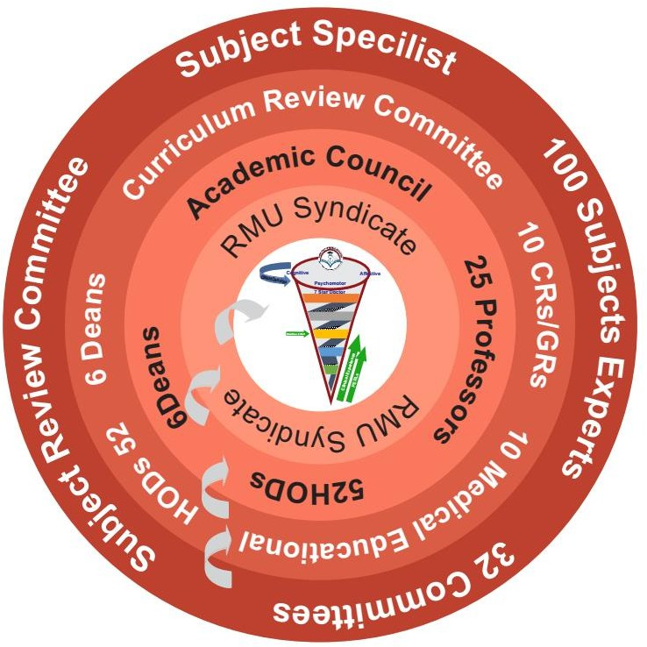Statutory Approval and Integration: The finalized modules and their associated assessment policies underwent a rigorous approval process through the Academic Council, and the Syndicate. Feedback and recommendations gathered during this statutory process were meticulously integrated into the curriculum guidelines.

Curriculum Development Process

1. Adaptive and Feedback-Oriented Approach: Recognizing the importance of adaptability and continuous improvement, the university incorporated a system for regular feedback and curricular evaluations. This system ensures that the curriculum remains dynamic, accommodating necessary updates and refinements as needed.
2. Curriculum 2024 - A Modular Integrated Outcome-Based Approach: The developed Curriculum is a testament to a comprehensive, outcome-based educational strategy. This strategy enables affiliated colleges to implement the curriculum effectively, respecting each institution's unique identity and vision, despite variations in available resources.
3. 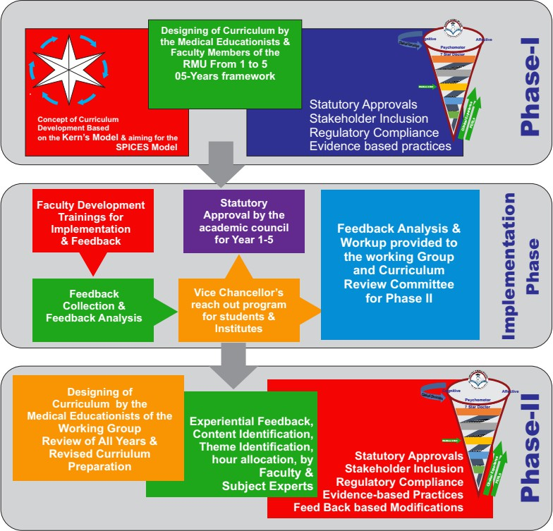Integrative and Contemporary Educational Strategies: The curriculum emphasizes both horizontal integration across various disciplines and vertical integration throughout different educational stages. This integrative approach is in line with modern educational theories, like Meizrow’s concept of transformative learning and strategies for early clinical exposure. Such an approach is aimed at promoting professional growth and practical knowledge application among students.

In essence, the curriculum development at Rawalpindi Medical University was a detailed, step-by-step process involving extensive expert input, iterative refinement, and a focus on adaptability and modern educational practices

###### **Curricular Organization and Structure**

RMU will follow the Correlation approach, corresponding to level 7 of Harden’s levels of integration. The emphasis remains on disciplines or subjects, with subject-based courses occupying most of the curriculum time. Within this framework, an integrated teaching session or course is introduced, in addition to the subject-based teaching. This session brings together areas of interest common to each of the subjects. Although the teaching is discipline-based, topics are correlated and taught within a clinical context for better understanding and application of concepts. However, clinical teaching increases gradually with advancing years. The fifth year of the MBBS program is dedicated to clerkships.

###### **Integrated Curriculum Design of RMU MBBS Program**

Two designs of the MBBS curriculum are acceptable by PMDC. System Based (Preferred) with horizontal and vertical integration. The curriculum of each Clinical Discipline must emphasize―Health Promotion and Disease Prevention‖, besides Curative Health Care. RMU has opted for system based modular curriculum.

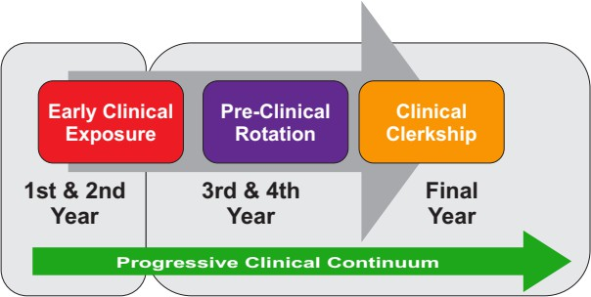

The Module: Module is the smallest unit of Curriculum both in the System- Based and Subject-Base (topic-based) Curricula. Modules are taught as a continuous block or as a longitudinal theme and assessments is carried out at the end of each module. The System-Based Curriculum made up of ―Modules, where each module is based upon organ-system(s) of the body. In each module, the Basic and Clinical Sciences are taught and learned in an integrated fashion in RMU we are following the system-based curriculum.

**The Module should explicit makes:**

Title of Module of a System 2) Learning Objectives, 3) Allocated Time in weeks/Hours and Credit Hours, 4) the name of the Coordinator, 5) Teaching Faculty (regular/visiting) 6) Learning Sites, 8) Modes of Information Transfer, 9) List of the Recommended Books, 10) Assessment strategies, and 11) Strategies for Monitoring and Improvement.

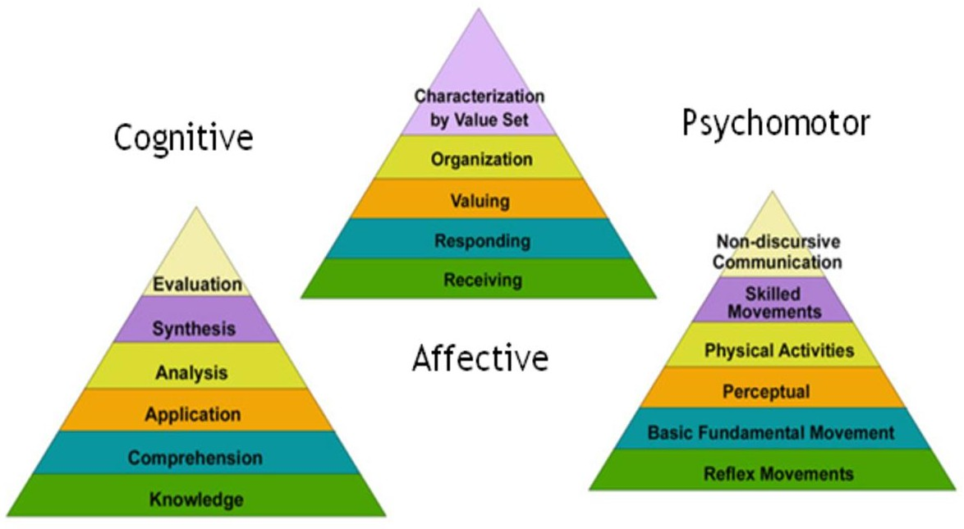Learning Objectives: Learning Objectives are defined for each module. They are Specific, Measurable, Achievable, Relevant to the desired competencies (Outcomes) of the PMDC Curriculum and Time bound (SMART), related to level of the learner and the three main domains.

Level of the Learner: While developing the curriculum, the learning objectives are according to the desired level of the learner, and the assessment systems must assess the knowledge, skills and attitudes to be achieved for that level.

1. The RMU MBBS curriculum in the first four years will be delivered in a System-Based Modular Format with clinical relevance and early clinical Exposure. However, in the third and fourth years, students will gain clinical exposure through rotations in the wards and outpatient departments (OPDs), and in the fifth year through clerkships.
2. The curriculum will be delivered by modular teams consisting of multidisciplinary basic science faculty and relevant clinical faculty.
3. The planning and delivery will be coordinated by Module Team who will guide module coordinators of their respective modules for efficient implementation.
4. The Modular Coordinator will be responsible for teaching and assessment during each module. The coordinator will be appointed by the Heads of Departments (HODs) in coordination with the Health Professions Education (HPE) team.
5. The Clinical Coordinator will be responsible for placement, teaching, and assessment during clinical rotations

##### The Theoretical Frameworks Shaping the RMU Integrated Modular Curriculum

###### **The Changing concept of Curriculum in Medical Education**

The way medical curricula are structured and taught has undergone significant changes in recent decades. New approaches to education have resulted in a more cohesive curriculum that emphasizes the teacher's role as a facilitator of learning rather than a source of information. Students are now seen as active participants in the learning process rather than mere recipients of knowledge. The responsibility for curriculum planning has shifted from individual departments to committees representing different stakeholders. Key issues that need to be addressed include the mission of the medical school, learning outcomes, curriculum content, course sequence, educational strategies, teaching and learning methods, assessment procedures, educational environment, communication about the curriculum, and management of the process. The SPICES model describes a range of educational strategies that move from student-centered to teacher-centered, problem-based to information-centered, integrated to discipline-based, community-based to hospital-based, and from electives to uniform and systematic to

opportunistic. (Figure-1) Spices Model of Educational Strategies

*(Essential Skills For A Medical Teacher, Second Edition, Ronald M. Harden)*

###### **Creating an Authentic Curriculum**

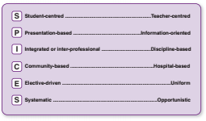The concept of an authentic curriculum in medical education is gaining importance worldwide. In line with this, Rawalpindi Medical University has also made efforts to create a curriculum that is relevant and responsive to the needs of society and the healthcare system. The university has recognized the need for medical education to keep pace with the changing healthcare landscape, and has adopted an outcome- or competency-based approach to education. This means that the curriculum is designed to produce graduates who are not only knowledgeable but also equipped with essential clinical skills, communication skills, and professionalism. To achieve this, the university has incorporated learning outcomes such as Leadership, Professionalism, Communication skills, Research skills and Bioethics in addition core objectives. Regular Case Based and Problem based learning sessions developed with a local context develops the ability of translating theory to practice since undergraduate years. By adopting an authentic curriculum, Rawalpindi Medical University aims to ensure that its graduates are well-prepared to practice effectively for the benefit of their patients and the community at large.

###### **Collaborative Activities in the Curriculum**

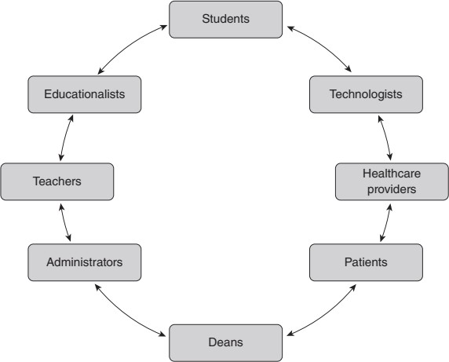Rawalpindi Medical University recognizes the importance of collaboration in enhancing medical education. In order to achieve this, the university has established a collaborative approach among different stakeholders, including students, faculty, healthcare professionals, and the community.

One of the ways that Rawalpindi Medical University fosters collaboration is by implementing horizontal and vertical integration in the medical curriculum on the continuum of the integration ladder. (Figure 2) By integrating subjects that are normally taught in the same phase of the curriculum, such as anatomy, physiology, biochemistry, surgery, paediatrics, obstetrics, and gynecology, students gain a more comprehensive understanding of medical concepts. Moreover, students are introduced to patients from the first year of the curriculum, allowing them to apply their knowledge in clinical settings.

In addition, the university believes that collaboration should extend beyond the different subject experts working together to deliver an integrated program. All stakeholders, including students, faculty, healthcare

professionals, and the community, should work together in the planning and implementing of a curriculum. (Figure 3) They collaborate in specifying learning outcomes, planning the approaches to teaching, learning, and assessment, and evaluating the effectiveness of the program.

The stakeholders in curriculum development. *(Mennin, Stewart, and Ronald Harden. Routledge international handbook of medical education., 2016. Pg 120)*

Furthermore, Rawalpindi Medical University recognizes that collaboration is necessary across the different phases of education, including undergraduate, postgraduate, and continuing education. By breaking down silos and fostering communication between these different phases, the university ensures a higher level of collaboration and progress. This collaborative approach to medical education ensures that students graduate with the necessary skills and knowledge to meet the changing needs of the community.

**The Involved Student**

In Rawalpindi Medical University, students play a crucial role in the curriculum. There has been a shift in the perception of the student's role, where they are no longer seen as mere products of the education system, but as active partners in the learning process. The focus is on student-centered learning, where the emphasis is on what the students learn rather than what the teachers teach.

To facilitate this, the university provides study guides and clear statements of the expected learning outcomes, encouraging students to take responsibility for their own learning. The university also supports personalized adaptive learning, recognizing that each student is different in terms of their abilities, previous experiences, learning styles, and aspirations.

The university has implemented various strategies, including problem-based learning, case-based learning, peer-to-peer learning and flipped classrooms, to support student-centered learning. Students are also actively engaged in the educational program, serving on committees, participating in policy decisions, and shaping the teaching and learning experience.

In Rawalpindi Medical University, students have the opportunity to engage in the research program, representing the school and contributing to national and international education seminars. They may also be involved in the delivery of the teaching program as peer teachers or developers of learning resources. Overall, students in Rawalpindi Medical University are valued partners in the learning process, actively engaged in shaping their educational experience.

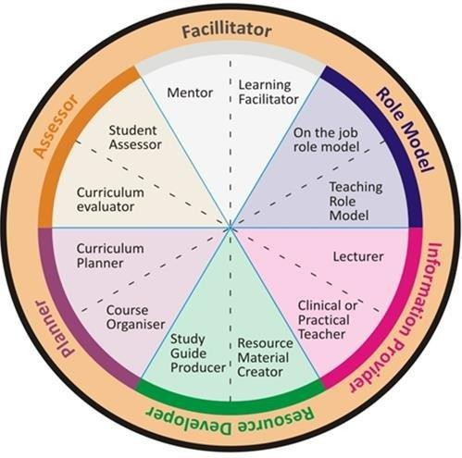**A broader role of Teachers**

Rawalpindi Medical University places great importance on the role of the teacher in the success of a curriculum. We understand that the input of the teacher is as significant, if not more significant, than the design of the curriculum itself. Therefore, we prioritize the training and development of our faculty through a regular faculty development program to ensure that they are equipped with the necessary knowledge and skills to effectively teach our students.

Our teachers play multiple roles in the curriculum, including that of information provider, role model, facilitator of learning, assessor of student progress, and curriculum planner. (Figure 4) They are not simply lecturers, but rather mentors and guides who help our students navigate the complex world of medicine. They work tirelessly to create an educational environment that supports the learning of our students and encourages appropriate learning behavior.

Our teachers also serve as facilitators of learning, guiding our students to access, select, and evaluate a wide range of resources that will help them achieve their learning outcomes. They work with individual students to support, motivate, and inspire them, promoting a sense of ownership of the course and their studies.

12 Roles of a Medical Teacher *(adapted from Harden, R.M., Crosby, J.R., 2000. AMEE Educational Guide No. 20)*

As assessors of student progress, our teachers monitor the progression of our students through the curriculum, identifying any problems related to their progress and guiding their studies to meet their individual needs. They provide feedback and support to students who may require remedial teaching, as well as guidance to those who have mastered a topic and are ready to explore more advanced areas.

Finally, our teachers are integral to the development of our authentic curriculum, which mirrors the mission of our medical school and relates to the needs of our community. They work collaboratively to ensure that our curriculum is up-to-date, relevant, and responsive to the changing landscape of healthcare.

At Rawalpindi Medical University, we recognize the critical role that our teachers play in the success of our curriculum and, ultimately, in the success of our students. We are committed to providing them with the training, resources, and support they need to continue to be effective mentors, guides, and role models for our future medical professionals.

SECTION-



## Teaching and Learning Methodologies / Strategies

**Large Group Interactive Session (LGIS)**

##### Case Based Learning (CBL)

**Skill Labs/Practical (SKL)**

**Bed side teaching**

**Teaching and Learning Methodologies / Strategies**

###### **Large Group Interactive Session (LGIS)**

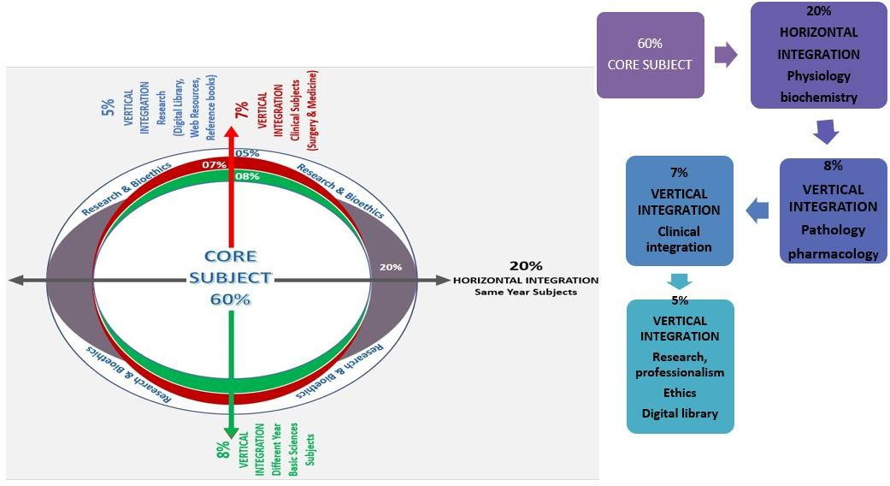

10%

Horizontal

Integration

10 %

The large group interactive session is structured format of Prof Umar Model of Integrated lecture.

It will the followed for delivery of all LGIS. The lecturer will introduce a topic or common clinical

condition and explains the underlying phenomena through questions, pictures, videos of

patients, interviews, and exercises, etc. Students are actively involved in the learning process.

**Prof Umar’s Model of Integrated Lecture**

###### **Table 2. Standardization of teaching content in Small Group Discussions. Table 3. Steps of Implementation of Small Group Discussions**

**Case Based Learning (CBL)**

**Practical Sessions/Skill Lab (SKL)**

|  |  |
| --- | --- |
| Demonstration/ power point presentation 4-5 slide | 10-15 minutes |
| Practical work | 25-30 minutes |
| Write/ draw and get it checked by teacher | 20-25 minutes |
| 05 mcqs at the end of the practical | 10 minutes |
| At the end of module practical copy will be signed by head of  department | |
| At the end of block the practical copy will be signed by  Head of Department, Dean, Medical education department, QEC | |

It’s a learner centered model which engages students in discussion of specific scenarios that typically resemble real world examples.

* Case scenario will be given to the students
* Will engage students in discussion of specific scenarios that resemble or typically are real-world examples.
* Learning objectives will be given to the students and will be based on
  1. To provide students with a relevant opportunity to see theory in practice
  2. Require students to analyze data in order to reach a conclusion.
  3. Develop analytic, communicative, and collaborative skills along with content knowledge.

**BED SIDE TEACHING (BST)**

Bedside teaching is a fundamental component of clinical training and an essential tool in the creation of a competent physician. It allows the students to

learn clinical skills, clinical reasoning, physician-patient communication, empathy, and professionalism.

cases are allocated to students at the start of their ward rotation.

They prepare their cases according to the schedule under supervision of senior registrar of wards.

They present the cases in consultant class.

**SECTION**

**Structured Framework of**

**Clinically Oriented Integrated Modular Curriculum 2025**

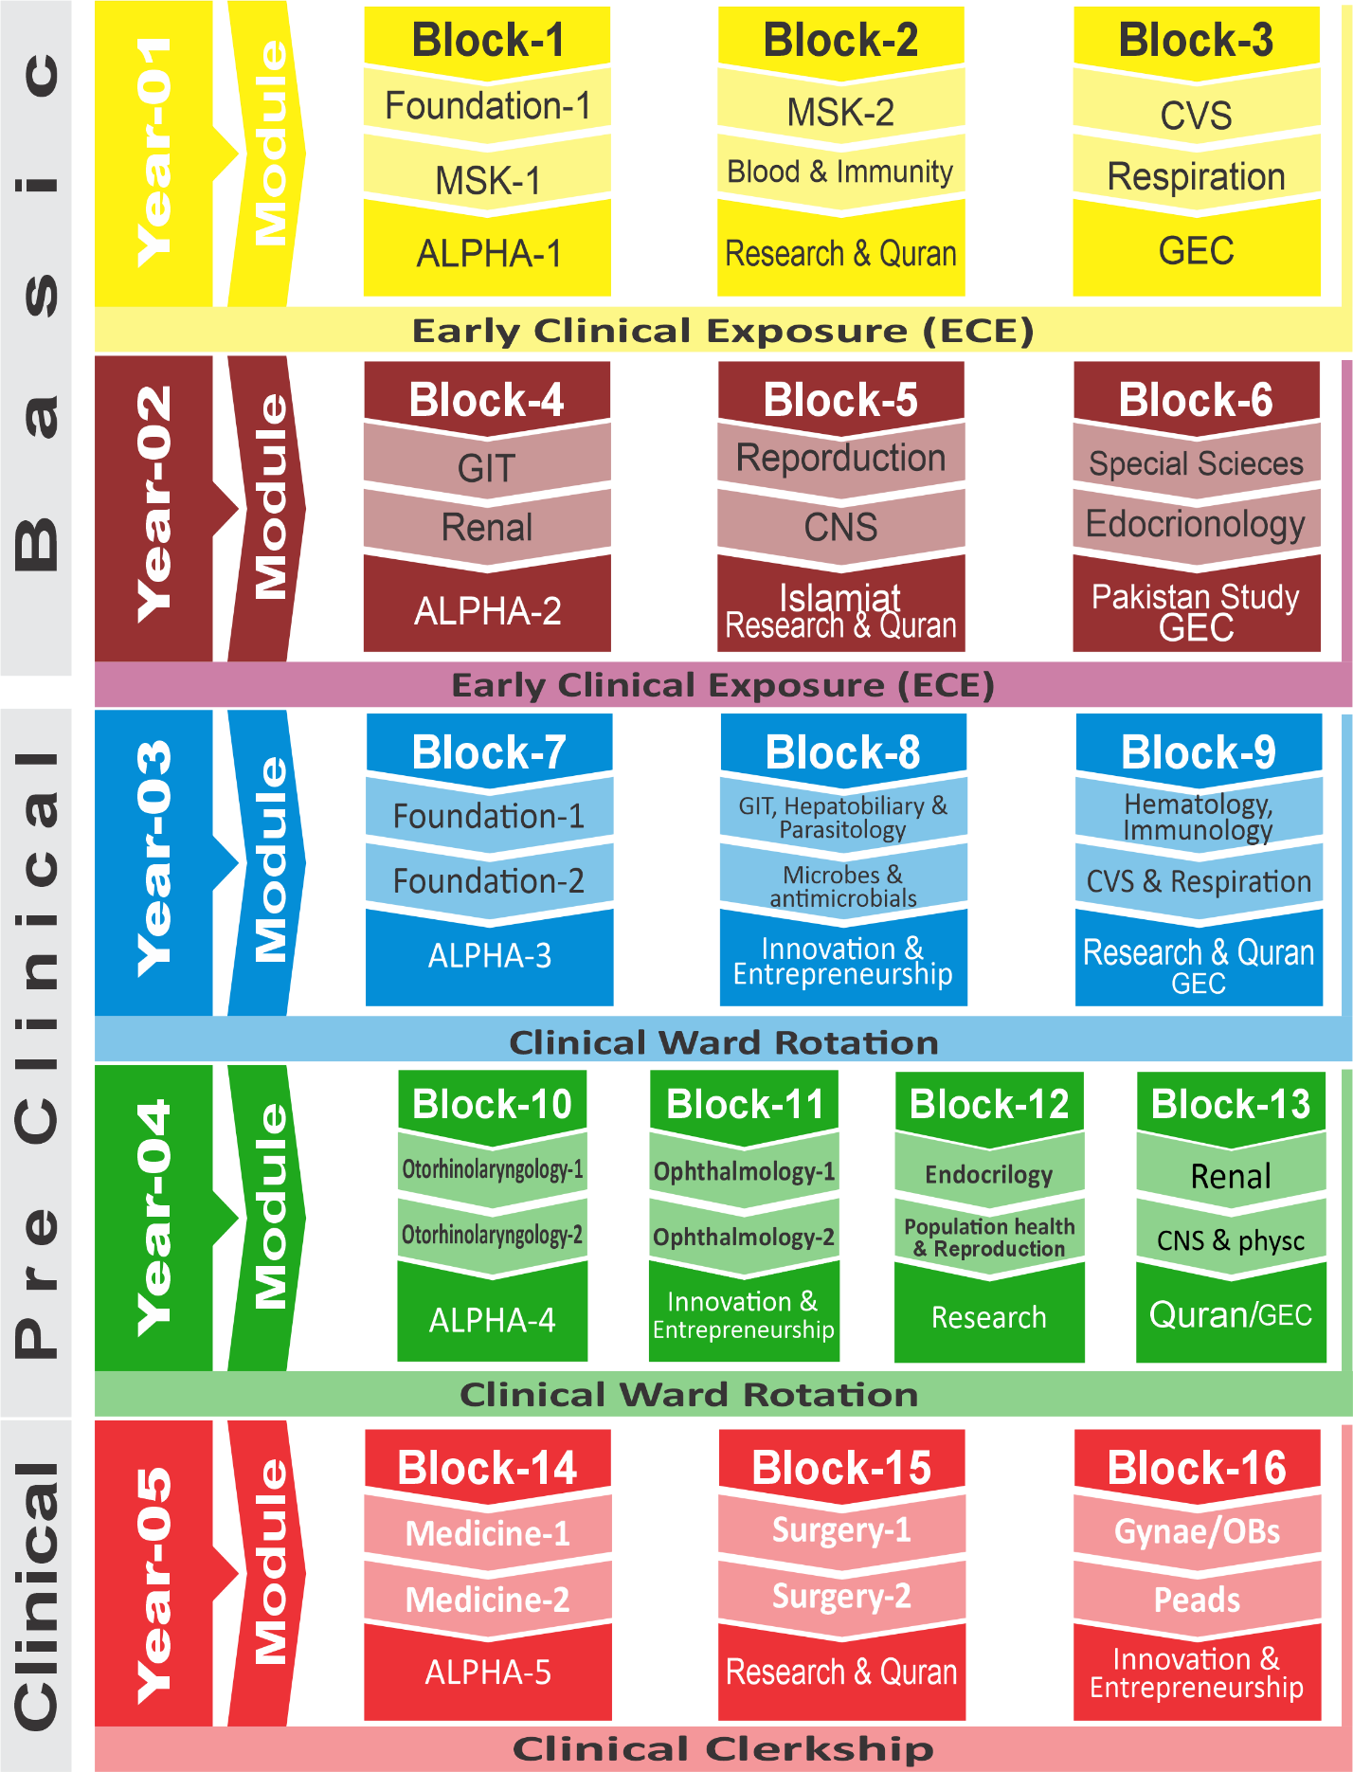

Structured Framework for Five Year of MBBS

|  |  |  |  |  |
| --- | --- | --- | --- | --- |
| **Sr. No** | **Class** | **Module** | **Duration** | **Block** |
| **1.** | **First Year MBBS** | Foundation Module | 6 weeks | Block-I |
| MSK-I Module | 5 weeks |
| MSK-II Module | 5 weeks | Block -II |
| Blood & immunity Module | 5 weeks |
| CVS Module | 6 weeks | Block -III |
| Respiration Module | 5 weeks |
| General Education Cluster Module | 1 week |
| **2.** | **Second Year MBBS** | Gastrointestinal tract Module | 5 weeks | Block-IV |
| Renal module | 5 weeks |
| Reproduction Module | 4 weeks | Block -V |
| Central nervous system module | 6 weeks |
| Special Senses Module | 4 weeks | Block -VI |
| Endocrinology Module | 5 weeks |
| **3.** | **Third Year MBBS** | Foundation 1 | 4 weeks | Block- VII |
| Foundation II | 4 weeks |
| GIT, Hepatobiliary & Parasitology | 5 weeks | Block - VIII |
| Microbes & Antimicrobials | 7 weeks |
| Hematology, Immunology & Research | 5 weeks | Block - IX |
| CVS & Respiration | 5 weeks |
| **4.** | **Fourth Year MBBS** | Otorhinolaryngology 1 | 2.5 weeks | Block- X |
| Otorhinolaryngology II | 3 weeks |
| Ophthalmology I | 2.5 weeks | Block - XI |
| Ophthalmology II | 3 weeks |
| Endocrinology | 5 weeks | Block -XII |
| Population Health & Reproduction | 6 weeks |
| Renal | 4 weeks | Block – XIII |
| CNS & Psychiatry | 6 weeks |
| **5.** | **Final Year MBBS** | Medicine & Allied | 12 weeks | Block- XIV |
| Surgery & Allied | 12 weeks | Block- XV |
| Gynae & Peads | 12 weeks | Block- XVI |

**Structured Framework of Clinically**

**Oriented Integrated Modular Curriculum 2025**

**Final Year Contact Hours Surgery and Allied**

**Teaching hours – Surgery**

**Total 600 Hours across five years**

|  |  |  |
| --- | --- | --- |
| Session | Year | Contact Hours |
| 2020-2021 | I | 08 |
| 2021-2022 | II | 10 |
| 2022-2023 | III | 14 |
| 2023-2024 | IV | 105 |
| 2024-2025 | V | 174 |



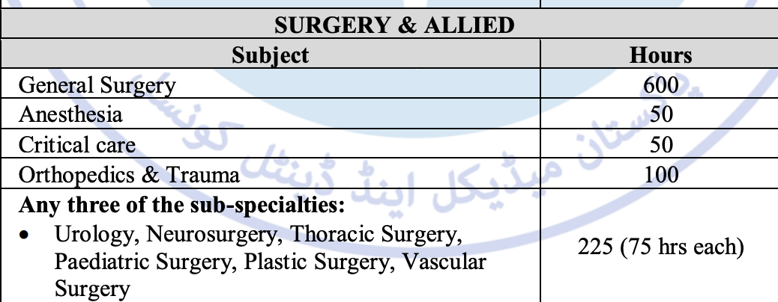

**Contact Hour Distribution for Surgery and Allied**

**Final Year MBBS**

|  |  |  |  |  |  |  |  |
| --- | --- | --- | --- | --- | --- | --- | --- |
| Teaching Hours Final Year MBBS | | | | | | | |
| **Blocks** | **Modules** | **LGIS** | **CPC** | **CLINICAL CLERKSHIP** | **EVENING CLINICAL CLERKSHIP** | **Total Hours** | **Percentage** |
| Surgery |  | 24 | 12 | 114 | 24 | 174 |  |
| Total Hours Per Subject | |  |  |  |  |  |  |
| Percentage | |  |  |  |  |  |  |

1. Overview

The final year of the MBBS program, including allied disciplines, represents a pivotal stage in medical education, serving as a crucial transition from theoretical knowledge to practical clinical expertise. Our comprehensive curriculum integrates interactive learning sessions (LGIS), a variety of clinical placements, and continuous assessments, all designed to develop well-rounded, competent, and compassionate healthcare professionals. This document outlines the gives details of Final Year MBBS Medicine and Allied curriculum. Our dedicated faculty members serve as committed mentors, guiding students through this intensive year of training. At the same time, students are encouraged to actively engage in their learning journey, taking full advantage of the opportunities for hands-on experience and knowledge application. We share a collective responsibility to maintain and uphold the highest standards of medical education. Together, let's work towards equipping our graduates with the necessary skills and knowledge to excel as junior doctors and allied healthcare professionals, making a significant positive impact on the communities they serve.

# Context

Surgery is a comprehensive specialty focused on delivering both primary and specialized care to adult patients. As such, it is a fundamental component of the undergraduate curriculum at Rawalpindi Medical University, woven throughout the five-year MBBS program with an intensified focus during the final three years. The primary objective of our curriculum is to equip students with the essential knowledge, skills, and professional attitudes required for the effective practice of medicine at the primary care level. Additionally, it prepares students to pursue advanced postgraduate studies in clinical practice, medical education, and research, fostering a commitment to lifelong learning and professional development.

# Mission

Our mission is to make highly recognized and accredited centre of excellence in Medical Education, using evidence-based training techniques for development of highly competent health professionals, who are lifelong experiential learner and are socially accountable.

# The objectives of the program

The program objective is to establish a foundation for independent practice after graduation as a general practitioner and involves the principal aspects of health improvement, preventive medicine, and acute and chronic care in the domain of medical disorders.

a)Knowledge

1) Acquisition of the knowledge and the ability to apply it in approach to the common complaints and symptoms in medical diseases.

2) Knowledge of common medical diseases and the ability to apply it to primary medical care of the patients within the limits of general practitioner’s duties.

3) Acquisition of the knowledge of simple procedures in outpatient setting that general practitioner must be able to do.

## b) Skill:

1)  Ability to take clinical history and do accurate clinical examination in the surgical patients

2)  Ability to do basic surgical techniques

3)  Ability to interpret results of common laboratory tests and imaging techniques in surgery.

## c)Competencies

* 1. Communication skills
  2. Critical thinking
  3. Problem solving
  4. Clinical skills
  5. Examination skills
  6. Procedural skills

1. Learning Outcome

At the end of final year, student will be able to:

1. Diagnose common Surgical problems, suggest and interpret appropriate investigation, rationalize treatment plan and if appropriate, refer patient for specialist opinion management.
2. Suggest preventive measure for the common Public Health Problem in the community
3. Perform relevant procedures
4. Convey relevant information and explanations accurately to patients, families, colleagues and other professionals .
5. Understand medical ethics and its application pertaining to surgery and maintain the confidentiality of the patient.
6. Adapt research findings appropriately to the individual patient situation or relevant patient population .
7. Teaching Hours- Surgery

|  |  |  |  |
| --- | --- | --- | --- |
|  | **Schedule Duration**  **Weekly** | | **Hours** |
| Interactive LGIS | 1 hour, 2/week= 2/week | | 40 hours |
| Clinical Clerkship in Wards | 8-1030 am, 4 days a week= 10  hour/week  Surgery (10 week),  anesthesia 1 week,  Skill Lab (1  week),   peads surgery 1 week ,  plastic surgery 1 week | | 180 |
| Current weeks  13 hrz | Suggested weeks  14 hrz |
| Evenings in Ward and Emergency | 3 hours, twice a week= 6 | | 108 hours |
| Self-Directed Study | 1 hours, 4 times week= 4  hours/week | | 72 hours |
|  |  | | 400 hours |

**1.  Teaching hours – Surgery and Allied Details of 3rd Year**

|  |  |  |  |
| --- | --- | --- | --- |
|  | **Schedule Duration**  **Weekly** | | **Hours** |
| Interactive LGIS | 1 hour, 2/week= 2/week | | 50 hours |
| Clinical Clerkship in Wards | **10:30-02:00pm, 4 days a week= 14**  **hour/week**  orthopediacs (2 week), neurosurgery (2  week), Critical Care (1 week),  urology (1week), | | 84 hours |
| Current weeks  04 | Suggested weeks  06 |
| Evenings in Ward and Emergency | 3 hours, twice a week= 6 | | 54 hours |
| Self-Directed Study | 1 hours, 2 times week= 2  hours/week | | 18 hours |
|  |  | | 206 hours |

**2.  Teaching hours – Surgery and Allied Details of 4th Year**

|  |  |  |
| --- | --- | --- |
| **3.  Teaching hours – Surgery  and Allied Details of Final Year** | **Schedule Duration**  **4 Weeks** | **Schedule Duration**  **12 Weeks** |
| Interactive LGIS | 8-9am, 5 days a  week= 5 hours/week=20 hours | 60 hours |
| CPC | 8-9am, once a week= 1  hours/week= 4 hour | 12 hours |
| Clinical Clerkship in Wards | 9am-2pm, 5 days a week= 25  hours/week= 100 hours  9am-12pm Friday= 3 hours/week=  12hours  4 Weeks x 2 surgical Units = 8  1 Week  orthopediacs  1 Week emergency  1 Week  critical care | 300 hours  36 hours |
| Shadowing Resident in  Emergency/Ward- Evening hours | 3 hours, 3 times a  week= 9 hours/week= 36 hours | 108 hours |
| Self-Directed Study | 2 hours, 6 times week= 12  hours/week= 48 hours | 144 hours |
|  |  | 660 hours |

|  |  |
| --- | --- |
| PLASTICS | **37.5hrs** |
| PEADS | **37. hrs** |
| ORTHOPEDIACS | **100hrs** |
| ANESTHESIA | **50hrs** |
| UROLOGY | **75 hrs** |
| GEN SURGERY | **600hrs** |
| NEUROSURGERY | **75hrs** |
| GYNAE | **300hrs** |
| CRITICAL CARE | **50 hrs** |
| ENT | **150 hrs** |
| EYE | **150 hrs** |

1. PMDC minimum requirement for Final Year MBBS 360 hours

|  |  |  |
| --- | --- | --- |
| **Sessions** | **YEARS** | **CONTACT HOURS** |
| 2023-2024 | V | 600 |
| 2022-2023 | IV | 206 |
| 2021-2022 | III | 400 |
| 2020-2021 | II |  |
| 2019-2020 | I |  |

1. Learning Strategies &Situations

A variety of pedagogies are used in this course, including didactic teaching, team-based and evidence-based learning in class rooms and patient side environment. Students are encouraged to adopt and inculcate self-learning strategies during the course

1. Learning Opportunities
   1. Teaching Ward Rounds
   2. Case presentations
   3. Case based Discussion
   4. Short cases in OPD
   5. Bedside Discussion
   6. Small Group Discussion
   7. Workshops
   8. Self-learning Activities
   9. Skill Lab Activity
   10. Observation of operations in OT
2. Venues for learning opportunities
3. Outpatient clinic
4. Emergency room
5. Inpatient ward
6. Tutorial room
7. Libraries including audio-visuals
8. Operation Theatres
9. Specific Learning Outcomes

Learning outcomes specific to the surgery course have been tabulated below in the table of specification and matched with educational strategies.

1. Implementation of curriculum

*The university will give details of all content including learning outcomes and table of specifications, distribution of which across the five years and rotations is upon the discretion of the medical college/institute.

1. Attendance & Discipline:
2. A record of attendance of medical students, /test results, end of module/rotation test result, workshop marks should be updated regularly.
3. Each Head of unit would keep a log of all clinical activities
4. Attendance of each student would be endorsed in his logbook as well.
5. Overall 85% attendance is mandatory to appear in final professional examination
6. Assessment

# INTRODUCTION

The final year MBBS Surgery and Allied Block at Rawalpindi Medical University represents the culmination of undergraduate medical education. It spans 12 weeks and integrates theoretical knowledge with practical clinical skills, preparing students for the professional demands of medical practice. This program is structured into three modules, each lasting four weeks. The first two modules focus on clinical placements in different medical units, allowing students to gain hands-on experience in managing patients. The third module

exposes students to specialized areas For one week in Urology, Orthopedic Surgery, Plastic Surgery, Pediatric Surgery, Neurosurgery and Vascular Surgery, respectively such as with each specialty receiving focused

training for one week.

The assessment approach for this block is rigorous, ensuring that students demonstrate proficiency in both theory and clinical skills. The theoretical component consists of multiple-choice questions (MCQs) and structured short-answer questions (SAQs) that test a broad range of topics, from respiratory and cardiovascular medicine to emergency medicine and endocrinology. In addition, clinical skills are assessed through the Clinically Integrated Observed Structured Clinical Examination (Ci-OSCE) and the Audio-Visual OSCE (Av-OSCE), which simulate real-world medical scenarios. This comprehensive system ensures that students are well-prepared for the final professional medicine and allied assessments, which will take place during the End Block assessment.

# SUMMARY

The 12-week final year MBBS Surgery and Allied Block at Rawalpindi Medical University is designed to offer a blend of theoretical knowledge and clinical practice. Divided into three modules, each lasting four weeks, the program covers a broad spectrum of clinical training and specialization. Modules I and II are dedicated to clinical placements in various medical units, while Module III focuses on specialized fields like Urology, Orthopedic Surgery, Plastic Surgery, Pediatric Surgery, Neurosurgery and Vascular Surgery. Each of these specialties is taught intensively over a one-week period. Assessments are conducted at the end of each module and include both theoretical and clinical components. Theory assessments consist of MCQs and SAQs, with topics covering essential areas such as trauma, Endocrinology, GIT, Hepatobiliary and vascular system. Clinical assessments involve Ci-OSCE and Av-OSCE exams, which test students' abilities in patient care, life support, counselling, and ethical decision-making. The End Block assessment is particularly comprehensive, with a total of 7 hours allocated for theory and clinical exams. This includes two separate theory papers, each covering multiple disciplines and featuring 60 MCQs, SEQs, SAQs, and EMQs. Clinical skills are tested through long and short cases, along with OSCE stations that evaluate critical clinical judgment and procedural skills. This structure ensures that graduating students have a well-rounded clinical education and are equipped with the necessary competencies for their medical careers.

# FINAL YEAR - SURGERY BLOCK

AV OSCE 20 slides =100 marks

Ci OSCE Long case 1=30 marks short cases 4=60 skill stations 2

s

END BLOCK EXAMINATION

Theory Paper 1 and 2

MCQ 60 each SEQ 5 each

SAQ 5 each EMQ 1

## 

**TRAINING DURATION AND ASSESSMENT HOURS COMPARISON (480:22=5.6%)**

Block Duration

Block

## Final Year Assessment

# MODULE I ASSESSMENT

# Theory Paper 1

|  |  |  |  |  |
| --- | --- | --- | --- | --- |
| Components | MCQ | SEQ | SAQ | EMQ |
| Questions | 20 | 3 | 3 | 1 |
| Marks | 20 | 15 (5 each) | 15 (5 each) | 10 |
| Time | 60 min | Total Marks: 60 |  |  |

# Theory paper 2

## Topic distribution

|  |  |  |  |  |  |
| --- | --- | --- | --- | --- | --- |
|  | Topic distribution | MCQ 20 | SEQ | SAQ | EMQ |
| 1. | Endocrinology | 5 | 1 |  | 1 |
| 2. | Vascular system | 5 |  | 1 |  |
| 3. | Acute abdomen | 7 | 1 | 1 |  |
| 4. | Breast | 3 | 1 | 1 |  |

# Clinical

|  |  |  |  |  |
| --- | --- | --- | --- | --- |
| Short cases | Ci-OSCE* | | | Total |
|  | Surgical skill | Counselling | Ethics |  |
| 4 | 1 | 1 | 0 | 6 |
| 15 marks each/60 marks | 10 marks | 10 marks |  | 80 |
| 15 minutes each and  total 60 min | 10 minutes each | 10 minutes each |  | 1 Hours 20 minutes |
| AV-OSCE** | | | | |
| Stems/Station | Marks | Time | | Total |
| 5 | 50 | 3min/slide | | 30 min |

*CI-OSCE: Clinically Integrated Observed Structured Clinical Examination.**Av-OSCE: Audio-visual Observed Structured Clinical Examination. AV-OSCE according to EBA AV-OSCE scheme

# MODULE II ASSESSMENT

# Theory Paper 1

|  |  |  |  |  |
| --- | --- | --- | --- | --- |
| Components | MCQ | SEQ | SAQ | EMQ |
| Questions | 20 | 3 | 3 | 1 |
| Marks | 20 | 15 (5 each) | 15 (5 each) | 10 |
| Time | 60 min | Total Marks: 60 |  |  |

# Theory Paper 2

|  |  |  |  |  |  |
| --- | --- | --- | --- | --- | --- |
|  | Topics of distribution | MCQs20 | SEQ 3 | SAQ 3 | EMQ1 |
| 1. | Lower GI | 5 | 1 | 1 |  |
| 2. | Trauma | 10 | 1 | 1 | 1 |
| 3. | Inguinoscrotal swellings | 3 |  | 1 |  |
| 4. | Diabetic foot | 2 | 1 |  |  |

# Clinical

|  |  |  |  |  |
| --- | --- | --- | --- | --- |
| Short cases | Ci-OSCE* | | | Total |
|  | Surgical skill | Counselling | Ethics |  |
| 4 | 1 | 1 | 0 | 6 |
| 15 marks each/60 marks | 10 marks | 10 marks |  | 80 |
| 15 minutes each and  total 60 min | 10 minutes each | 10 minutes each |  | 1 Hours 20 minutes |
| AV-OSCE** | | | | |
| Stems/Station | Marks | Time | | Total |
| 5 | 50 | 3min/slide | | 30 min |

*CI-OSCE: Clinically Integrated Observed Structured Clinical Examination

**Av-OSCE: Audio-visual Observed Structured Clinical Examination. AV-OSCE according to EBA AV-OSCE scheme

## MODULE III ASSESSMENT

Pattern for each of orthopaedic, urology, Anaesthesiology and ICU.

## Theory Paper

|  |  |  |  |  |
| --- | --- | --- | --- | --- |
| Components | MCQs | SEQ | SAQ | EMQ |
| Questions | 20 | 3 | 3 | 1 |
| Marks | 20 |  |  |  |
| Time | 60 min |  |  |  |

## Clinical

|  |  |  |  |  |
| --- | --- | --- | --- | --- |
| Short cases | Ci-OSCE* | | | Total |
|  | Surgical skill | Counselling | Ethics |  |
| 4 | 1 | 1 | 0 | 6 |
| 15 marks each/60 marks | 10 marks | 10 marks |  | 80 |
| 15 minutes each and  total 60 min | 10 minutes each | 10 minutes each |  | 1 Hours 20 minutes |
| AV-OSCE** | | | | |
| Stems/Station | Marks | Time | | Total |
| 5 | 50 | 3min/slide | | 30 min |

*CI-OSCE: Clinically Integrated Observed Structured Clinical Examination

**Av-OSCE: Audio-visual Observed Structured Clinical Examination. AV-OSCE according to EBA AV-OSCE scheme

# Final Year End Block Assessment

# END BLOCK ASSESSMENT FINAL YEAR MBBS SURGERY AND ALLIED BLOCK

## THEORY

|  |  |  |  |
| --- | --- | --- | --- |
| Component | Details |  | Marks |
| Theory Papers | **Paper 1**  - 60 Multiple Choice Questions (MCQs) per paper - 5 Short Essay Questions (SEQs) per paper - 5 Short Answer Questions (SAQs) per paper - 1 Extended Matching Question (EMQ) per paper | **Paper 2**  - 60 Multiple Choice Questions (MCQs) per paper - 5 Short Essay Questions (SEQs) per paper - 5 Short Answer Questions (SAQs) per paper - 1 Extended Matching Question (EMQ) per paper | **60**  **15**  **15**  **10**  **Total:100*2+200** |

# Clinical

|  |  |  |
| --- | --- | --- |
| Ci-OSCE Objective Structured Clinical Examination (OSCE) | Long Case - 1 Long Case - Duration: 30 minutes  Short Cases - 4 Short Cases - Duration: 15 minutes each  60 min total | 50  15 each  Total: 110 |
| Skill Stations | - Series of clinical and procedural skill stations - Each station assesses specific skills  Duration: 10 min each  20 min total. | **10 marks per station**  **20**  **Total: 130** |
| Video-Based Objective Structured Practical Examination (OSPE)  AVOSPE | - 20 slides presented - 5 stems per slide - 3 minutes per slide - Each slide assesses clinical reasoning and decision-making | **5 marks per slide** **Total: 100 marks** |
| Examination Timing | - Theory papers and OSCEs scheduled over consecutive days - Punctuality and preparedness are required | **Theory:2 hrs 40 min**  **OSCE: 130 min** |

### Table of Specification (TOS)

### End-Block Examination, Final Year MBBS

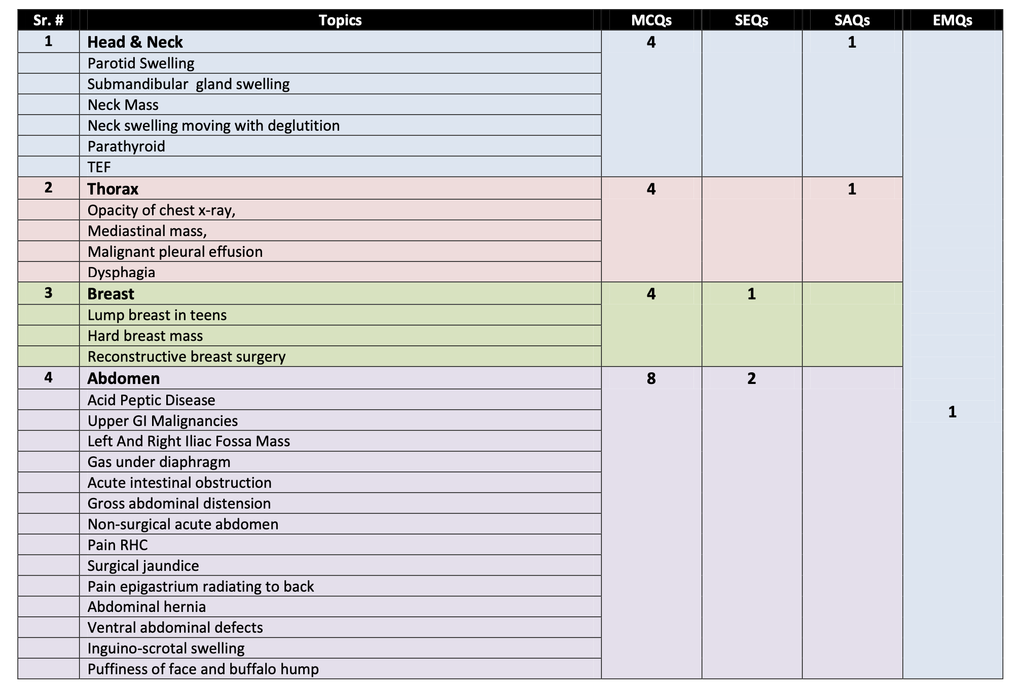

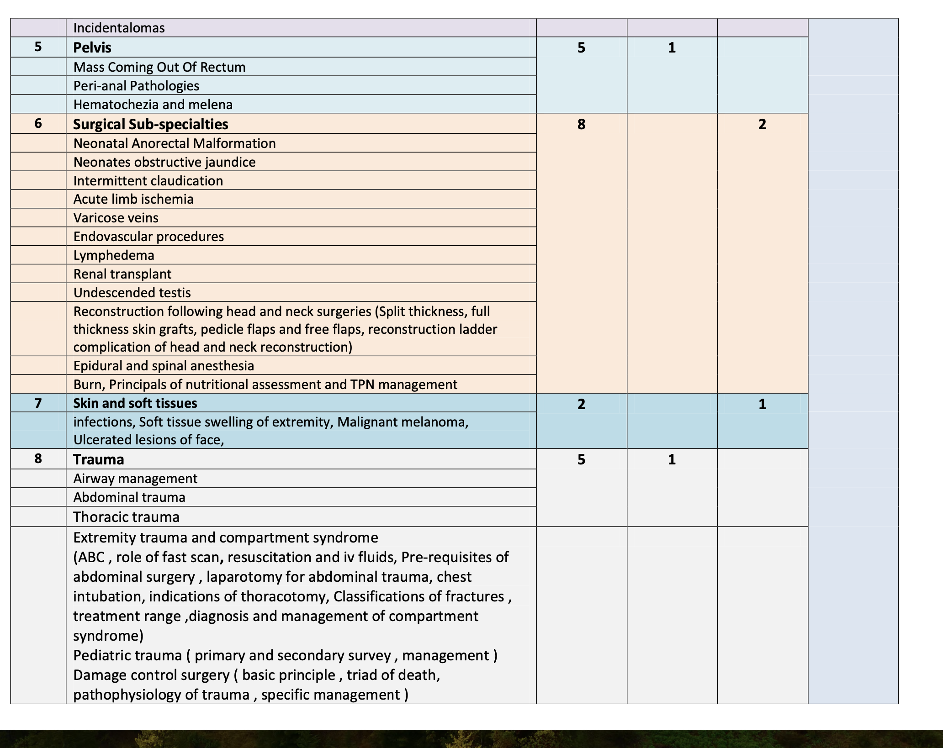

Assessment is an important aspect of any training program which not only includes assessment of students but also of the training program itself. The performance of each student would be marked and counted towards final internal assessment. The following tools/ methods would be used for this purpose:

## XV. Theory

1)Periodical class tests- Learning Management System (LMS) based.

2)End of block/Rotation Exams: At the end of each block/clinical rotation, a theory

exam would be held concurrently for the entire class from the syllabus covered

during this period.

b) Practical

1) Logbook: Each student would complete his logbook and get it countersigned

from HOD at the end of each rotation. Logbook is maintained during the rotation.

2) Workbook: Each student would complete his Workbook and get it

countersigned from HOD at the end of each rotation. Workbook is maintained

during the rotation.

3) End Block Assessment: At the end of each clinical rotation, the whole

group would have a clinical exam.

4) BLS/ACLS workshop (only attendance is required to get marks).

c) **Continuous** Internal assessment. There will be 30% internal assessment.

d) Professional exam. Professional exam of Surgery will be held in final year. There will

be 140 marks theory paper and 210 marks of practical. Student must pass theory and

practical separately with minimum 60 % marks. However, in clinical subjects, student

should pass in clinical exams (long Case, Short Cases, and OSCE). All three clinical

assessment sections must be passed separately

## **XVI.Evaluation of the Course**

a) Student portfolio should be maintained in the department in which students should give

their feedback either by name or anonymously.

b) Faculty suggestions for improvement of training may be incorporated in the next rotation.

## XVII.Recommended Readings

* 1. Bailey & Love Short Practice of Surgery
  2. Browse Introduction to the Symptoms & Signs of Surgical Disease
  3. Apley's Concise System of orthopedics & Fractures

# Table of Specification (Themes/Topics/Learning outcomes/Educational Strategies/ Weightings) Annex A

|  |  |  |  |  |  |  |
| --- | --- | --- | --- | --- | --- | --- |
| **SURGERY & ALLIED** | | | | | | |
|  |  | **At the end of each module, student will be able to:** | | |  |  |
| S.No | **Theme/Topic** | **Course Content** | **Learning Outcomes** | | **Instructional strategies** | **Assessm ent Tools** |
| **Knowledge** | **Skill/Attitude** |  |  |
| **I. Basic Principles of Surgery** | | | | | | |
| 1 | **Metabolic** | * Normal physiology, water loss & intoxication * Physiology of fluids and electrolytes * Pathophysiology of fluids and electrolytes derangements * Acid base balance * ECF loss & Excess, Hyponatremia, Hypernatremia, Hypermagnesiumemia, Hypomagnesiumemia   + Clinical diagnosis   + Lab diagnosis * Management * Fluid loss reference to: * diarrhea and vomiting | * Describe the major fluid compartments of | Assess the volume of | Lecture/SDL | MCQ/SE  Q/SAQ/ OSPE/Lo  ng case/ short case |
|  | **response to** | the body, the effect of osmolality | body fluid depletion, |  |
|  | **injury** | * Explain what may happen in common |  |  |
|  |  | conditions (eg acute blood loss, dehydration, | Administer fluids |  |
|  |  | excessive fluid replacement). | according to age and |  |
|  |  | * Recognize the different types of fluid used | comorbids. |  |
|  |  | for optimization, especially Hartmann’s, |  |  |
|  |  | Normal 0.9% Saline and Dextrose. |  |  |
|  |  |  | Calculate the correct |  |
|  |  |  | volume and rate of |  |
|  |  |  | administration |  |
|  |  |  | Monitor the progression |  |
|  |  |  | of fluid optimization |  |

|  |  |  |  |  |  |  |
| --- | --- | --- | --- | --- | --- | --- |
|  |  | * immobile / debilitated * elderly patients with reduced renal function  * drugs that lower renal fluid exchange functions * low BMI patients |  |  |  |  |
| **Nutrition**   * Enteral feeding (Oral, gastrostomy, jejunotomy) Different modes of enteral feeding   Its Advantages and Complications   * Parenteral nutrition and its complications * Malnutrition in surgical patients * Definition * Assessment * Lab diagnosis * Correction of malnutrition especially pertaining to BMI, serum albumin, frailty or triceps skin fold thickness. | List the physiological effects of protein–calorie malnutrition.   * Identify the different types of nutritional support – oral, nasogastric, gastro/jejunotomy and parenteral. * Describe what total parenteral nutrition (TPN) entails, its associated risks, and   the additional and parameters of care for these patients. | Identify patients in need of nutritional optimization. | Lecture/SDL | MCQ/SE  Q/SAQ/ OSPE/Lo  ng case/ short case |
| 2 | **Perioperative Care** | **Pre – operative optimization of surgical patients with systemic diseases**   * Types of medical diseases * Assessment of patients | * Rationalize routine intravenous fluid replacement in surgical patients * Identify the commonly prescribed intravenous fluids. | * Counsel the patient about the prognosis of the disease * Manage post – op complications | Lecture/SDL | MCQ/SE  Q/SAQ/ OSPE/Lo  ng case/ short case |

|  |  |  |  |  |  |  |
| --- | --- | --- | --- | --- | --- | --- |
|  |  | * Subject specialist consultation (Importance) * Optimization  * Assessment of risk of surgery | * Optimize management of co morbid. * Describe important complications of common operations |  |  |  |
| **Post- operative care**   * Daily assessment of patient * Day to day patient care * Recognition of potential complications * Diagnosis of complications * Management of post – op complications * Rehabilitation | Lecture  /CBL/SDL | MCQ/SE  Q/SAQ/ OSPE/Lo  ng case/ short case |
| 3 | **Shock & Blood transfusion** | Shock/Classification Hypovolemic Shock Hemorrhage  Blood transfusion | * Discuss the protocols of blood transfusion * Elaborate principles of blood transfusion of a surgical patient | * Clinically assess hypovolemia * Identify patients in need of fluid optimization/blood   transfusion | Lecture  /CBL/SDL | MCQ/SE  Q/SAQ/ OSPE/Lo  ng case/ short case |
| 4 | **Wound, healing and tissue repair** | * Wound classification, Mechanism of healing * Factors affecting wound healing * Complications of wound * Hypertrophic scars, keloid | * Describe the process and stages of wound healing. * State primary, secondary and tertiary wound healing. * Justify the reasons for conducting a wound assessment. * Summarize pressure ulcer classification. * State the need to assess pain in wound | * Identify wound bed tissue types. * Describe the skin surrounding the wound reference to underlying disease and the effectiveness of   current treatment. | Lecture/SDL | MCQ/SE  Q/SAQ/ OSPE/Lo  ng case/ short case |

|  |  |  |  |  |  |  |
| --- | --- | --- | --- | --- | --- | --- |
|  |  |  | care.   * Explain extrinsic and intrinsic factors which impact on wound healing eg nutrition.  * State the basic principles of wound dressing. * Identify patients at risk of pressure sore development | * Measure a wound. |  |  |
| 5 | **Surgical infections** | Bacteremia, Septicemia, Pyemia, SIRS, Sepsis, MOFS Severe Sepsis & Septic shock.   * Definitions * Pathophysiology * Diagnosis * Investigations * Management principles   Sepsis 6 (BUFALO) recommendations within the first hour to reduce mortality   * **B – blood cultures** * **U – urine output** * **F – fluid** * **A – antibiotics** * **L -lactate (and hemoglobin)** * **O – oxygen** | * Define the following terms: systemic inflammatory response syndrome (SIRS), sepsis, severe sepsis, septic shock, MOFS and acute respiratory distress syndrome(ARDS). * Differentiate between SIRS, sepsis, severe sepsis and septic shock on the basis of signs, symptoms, vital signs, hemodynamic measures and laboratory tests * Explain the seriousness of sepsis * Describe the microbiological causes of sepsis. * Describe the pathophysiology and mechanism of sepsis. * Prioritize for treatment of sepsis. * Explain the role of vasoactive agents in supporting the physiological function of a patient with sepsis. * Select appropriate agent, given details of a patient’s condition. * Develop an appropriate monitoring program for patients with sepsis. * List the principles of diagnosis and | * Take proper history of patient with sepsis * Perform clinical examination of patient with sepsis * Determine appropriate fluid resuscitation for sepsis with colloids or crystalloids. * Recommend an appropriate antibiotic regimen for treatment of sepsis based on patient characteristics and site of primary infection. * Carry out Sepsis 6 (BUFALO)   recommendations | CBL/SDL | MCQ/SE  Q/SAQ/ OSPE/Lo  ng case/ short case |

|  |  |  |  |  |  |  |
| --- | --- | --- | --- | --- | --- | --- |
|  |  |  | management of sepsis.   * State when to involve the infection control team.   State when to take appropriate microbiological specimens. | within the first hour to reduce mortality   * Prescribe antibiotic following local guidelines/protocols |  |  |
| **II. Skin & Subcutaneous tissue** | | | | | | |
| 6 | **Skin swellings and lumps** | Cyst, Dermoid, Papilloma, Fibroma, Bursae, ganglion, Neurofibroma, Schwannoma and Basal Cell Carcinoma   * Classification * Clinical features * Diagnosis * Management | * Classify lumps in skin & subcutaneous tissue * Differentiate between benign and malignant tumors * List the principles of diagnosis and management of lumps in skin & subcutaneous tissue. | * Take proper history of patient presenting with skin swelling * Perform clinical examination of patient presenting with skin swelling | Lecture/ CBL/SDL | MCQ/SE  Q/SAQ/ OSPE/Lo  ng case/ short case |
| 7 | **Sinuses and fistulas** | * Classification * Causes * Clinical features * Diagnosis * Management principles | * List the principles of diagnosis and management of sinuses and fistula on the basis of its etiology. | * Take proper history of patient presenting with sinuses and fistula * Perform clinical examination of patient presenting with sinuses and   fistula | Lecture  /CBL/SDL | MCQ/SE  Q/SAQ/ OSPE/Lo  ng case/ short case |
| 8 | **Burn** | * Types of burns * Pathophysiology * Complications * Acute management * Reconstruction | * Apply basic concepts of burn injury and pathophysiology to the evaluation, resuscitation, clinical management and rehabilitation of the burned patient. * Evaluate a burned patient | Assess the appearance of the burn wound in relation to its depth, bacteriologic condition, healing potential and | Lecture& bedside teaching/SDL | MCQ/SE  Q/SAQ/ OSPE/Lo  ng case/ short case |

|  |  |  |  |  |  |  |
| --- | --- | --- | --- | --- | --- | --- |
|  |  |  | * Develop an initial treatment plan for   stabilization and fluid replacement using basic principles of burn management. | requirement for intervention. |  |  |
| 9 | **Ulcer Classification and Management** | * Definition of ulcers  * Classification of ulcers * Pathophysiology of ulcers * Definitive diagnosis * Treatment plan | * List the principles of diagnosis and management of ulcers on the basis of its pathophysiology. | * Take proper history of patient presenting with ulcer * Perform clinical examination of patient presenting   with ulcer | Lecture  /CBL/SDL | MCQ/SE  Q/SAQ/ OSPE/Lo  ng case/ short case |
| **III. Trauma** | | | | | | |
| 10 | **Trauma and tissue response** | * Types of trauma * SIRS * Pathophysiology * Immediate management * Definitive management * Complications * Rapid primary survey, concurrent resuscitation, secondary survey, continued re-evaluation and monitoring, investigation and definitive care. | * Describe the physiological response to injury. * State the principles of surgical treatment in a multi-injured patient. * Assess priorities during all phases of management following *ATLS* principles. * Justify the importance of re-assessment of the patient with regards to earlier interventions. * Emphasize the significance of a patient with polytrauma. * Discuss issue of missed injuries, management and documentation. * Differentiate between primary and secondary survey. * Define triage and its importance. * State the importance of analgesia in the | * Take proper history of patient presenting with trauma (AMPLE) * Perform clinical examination of patient presenting with trauma * Provide emergency care with the patient of poly- trauma as per ABCDE protocol | Primary trauma care course (PTCC) /SDL | lectures/ clinical training |

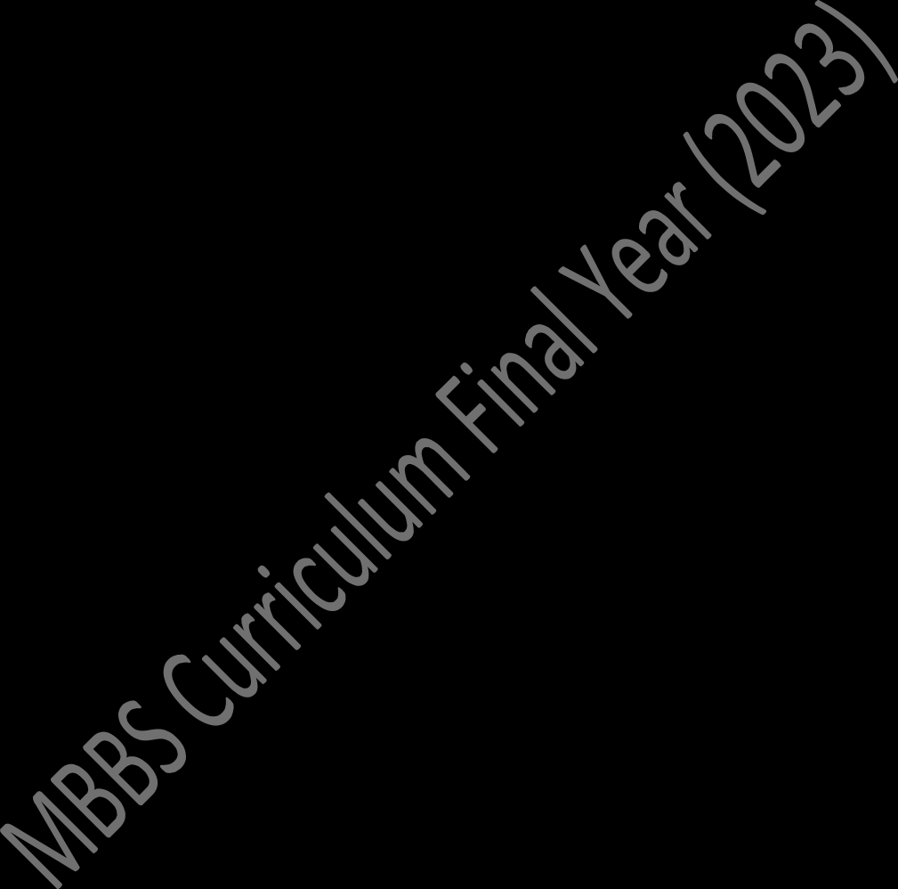

|  |  |  |  |  |  |  |
| --- | --- | --- | --- | --- | --- | --- |
|  |  |  | management of these patients.   * Differentiate between blunt, penetrating, crush, blast injuries on the basis of mechanisms of trauma * List the interventions that may be required for head injury. * Explain the importance of nerve or vessel injury in trauma. * Elaborate the importance of a continuum of care for the injured patient by a multidisciplinary team * Explain the importance of the *ATLS* strategy and systematic approach. * Explain the role of radiological investigations (eg CT scanning) and interventions. * Identify the role of investigation and   treatment dependent on the hemodynamic status of the patient. |  |  |  |
| 11 | **Trauma to regions** | Chest Trauma Broken ribs Pneumothorax | * Differentiate between different types of chest injuries based on mechanism of pathophysiology findings, and management. | * Take proper history of patient presenting with chest trauma. * Perform clinical examination of patient presenting   with chest trauma. | CBL &  Bedside teaching PTCC/SDL | MCQ/SE  Q/SAQ/ OSPE/Lo  ng case/ short case |

|  |  |  |  |  |  |  |
| --- | --- | --- | --- | --- | --- | --- |
|  |  | Abdominal Injury | * Elaborate upon abdominal/ genitourinary injuries reference to causes, signs, symptoms diagnosis, management predisposing factor, complications and preventions * Discuss various causes of abdominal injury/ genitourinary trauma * Enumerate the most susceptible visceral organs in Abdominal Injury/ genitourinary trauma | * Take proper history of patient presenting with abdominal/ genitourinary injury * Perform clinical examination of patient presenting with abdominal injury/ genitourinary   trauma | CPC/ PTCC/SDL |  |
| Genitourinary Trauma |
| **IV. Radiological Investigations and Diagnosis** | | | | | | |
| 12 | **Conventional Radiology Advanced techniques** | **X-ray Chest**  Normal and different pathological conditions like pleural effusion, Pneumothorax, Bronchitis, cardiomegaly, Mitral valve disease, left to right shunts, differentiating pulmonary arterial from pulmonary  venous hypertension. | * Demonstrate knowledge, clinical and technical skills and decision-making capabilities with respect to diagnostic imaging pertinent to the practice of General Surgery * State the basic principles of radiation protection and law in relation to use of ionizing radiation * Justify use of relevant imaging techniques in various clinical scenarios reference to advantages and disadvantages. | Differentiate between normal and pathological findings on CXRay | Lecture/CBLs  /SDL | MCQ/SE  Q/SAQ/ OSPE/Lo  ng case/ short case |
| **X-Ray Abdomen**  free air under the diaphragm. Intestinal obstruction.  Barium studies: barium swallow, meal, follow through, enema.  Normal gut pattern on plain  film and barium studies | Differentiate between normal and different pathological conditions on X Ray Abdomen | Lecture/CBLs  /SDL | MCQ/SE  Q/SAQ/ OSPE/Lo  ng case/ short case |

|  |  |  |  |  |  |  |
| --- | --- | --- | --- | --- | --- | --- |
|  |  | **Genito Urinary Tract**  IVU technique, Different phases of IVU. Interpretation of normal IVU. Basic pathologies as obstructive uropathy Hysterosalpingography: technique Normal uterus and fallopian tubes, Abnormal tubes as tubal blockage. |  | * Differentiate between normal and different pathological conditions as renal calculi, bladder calculi * Interpret IVU * Interpret   Hysterosalpingogram hy | Lecture/CBLs  /SDL | MCQ/SE  Q/SAQ/ OSPE/Lo  ng case/ short case |
| **Skull X Ray** | * Differentiate between normal and abnormal Skull lesions as lytic and sclerotic Calcifications * Identify Pituitary   fossa | Lecture/CBLs  /SDL | MCQ/SE  Q/SAQ/ OSPE/Lo  ng case/ short case |
| **Spine X-Ray**  Imaging modalities, X Ray projections of spine. Plain X Ray anatomy of spine | Identify X Ray projections of spine. Plain X Ray anatomy of spine | Lecture/CBLs  /SDL | MCQ/SE  Q/SAQ/ OSPE/Lo  ng case/ short case |
| **Bones**  Modalities for bone imaging Projections. Plain x rays of bones for pathologies as rickets, fractures, neoplastic  lesions and how to describe | Differentiate between normal and different pathological conditions as rickets, fractures, neoplastic lesions and  how to describe them. | Lecture/CBLs  /SDL | MCQ/SE  Q/SAQ/ OSPE/Lo  ng case/ short case |

|  |  |  |  |  |  |  |
| --- | --- | --- | --- | --- | --- | --- |
|  |  | them. Lytic and sclerotic  lesions. |  | Lytic and sclerotic  lesions. |  |  |
| 13 | **CT scan & MRI** | * Compare the benefits and limitations of different radiologic modalities including CT and MRI * List risks associated with radiation exposure * Describe the impact of patient age on radiation sensitivity * Compare the relative radiation dose delivered by different imaging modalities * Discuss the potential complications of intravenous contrast administration for CT and MR exams and identify predisposing   risk factors |  | Lecture/CBLs  /SDL |  |
| **V. Paediatric Surgery** | | | | | | |
| 14 | **Congenital Deformities** | * Cleft Lip & palate * Reconstructive Surgery | * Relate embryological formation of face/ lip and palate to congenital anomalies * Detail signs, symptoms, treatment options, complications and management of Cleft Lip & palate | * Take history of a patient with Cleft Lip & palate/CTEV * Perform clinical examination of a patient with Cleft Lip & palate/DTEV/ Dysplasia of hip joint | Lecture/SDL | MCQ/SE  Q/SAQ/ OSPE/Lo  ng case/ short case |
| * CTEV * Dysplasia of hip joint | * Relate embryological formation of hip joint, foot and palate to congenital anomalies * Detail signs, symptoms, treatment options, complications and management of CTEV   and Dysplasia of hip joint |
| 15 | **Congenital anomalies- Skull/Meninges** | Hydrocephalus & Meningocoele | * Describe the common symptoms, signs and management of hydrocephalus and meningocele. | * Take history of a patient with Hydrocephalus & Meningocele | Lecture/SDL | MCQ/SE  Q/SAQ/ OSPE/Lo  ng case/ short case |

|  |  |  |  |  |  |  |
| --- | --- | --- | --- | --- | --- | --- |
|  |  |  |  | * Perform clinical examination of a patient with Hydrocephalus &   Meningocele |  |  |
| 16 | **Congenital anomalies- upper GI** | * Esophageal atresia pyloric stenosis, Hirschsprung’s Disease  * Biliary Atresia | * Correlate the embryological origin of upper GI tract with Pathophysiology of Esophageal atresia, pyloric stenosis, Hirschsprung’s Disease * Differentiate between the Clinical presentation of Esophageal atresia, pyloric stenosis, Hirschsprung’s Disease, biliary atresia * Propose diagnostic investigations and treatment options in Esophageal atresia, pyloric stenosis, Hirschsprung’s Disease, biliary atresia * Develop management plan for   Complications Esophageal atresia, pyloric stenosis, Hirschsprung’s Disease | * Take history of a patient with esophageal atresia * Perform clinical examination of a patient with esophageal atresia | Lecture & bedside teaching/SDL | MCQ/SE  Q/SAQ/ OSPE/Lo  ng case/ short case |
| 17 | **Congenital anomalies- lower GI** | * Neonatal intestinal obstruction * Meconium ileus intestinal atresia intussusceptions | * Correlate defects in embryologic developments to the causes, types and clinical features, radiological findings of neonatal intestinal obstruction. * illustrate the contribution of different imaging modalities in diagnosis of neonatal intestinal obstruction. * Develop an approach to the management   of neonatal obstruction involving clinical and imaging data. | * Take history of a patient with neonatal intestinal obstruction * Perform clinical examination of a patient with neonatal intestinal obstruction | CBL&  bedside teaching/SDL | MCQ/SE  Q/SAQ/ OSPE/Lo  ng case/ short case |

|  |  |  |  |  |  |  |
| --- | --- | --- | --- | --- | --- | --- |
|  |  |  | * Identify the surgical intervention and post-   surgical complications for neonatal intestinal obstruction. |  |  |  |
| Imperforate anus | * identify embryological defect that leads to imperforate anus. * Demonstrate approach to diagnosis of imperforate anus. * Develop a treatment plan for Imperforate anus based on diagnostic classification and clinical presentation. | * Take history of a patient with anal malformations * Perform clinical examination of a patient with anal malformations * Educate patient\adults about feeding newborns   and children with GIT problems | CBL&  bedside teaching/SDL | MCQ/SE  Q/SAQ/ OSPE/Lo  ng case/ short case |
| 18 | **Congenital anomalies- Urogenital system** | * Undescended testis * Hypospadias | * Correlate defects in the embryological origin of testes to classification of Undescended testis and its clinical presentation. * Suggest Diagnostic investigations and treatment options of Undescended testis * Elaborate management plan for possible complications of Undescended testis | * Take history of a patient with Undescended testis/hypospadias * Perform clinical examination of a patient with Undescended   testis/hypospadias. | Lecture & bedside teaching/SDL | MCQ/SE  Q/SAQ/ OSPE/Lo  ng case/ short case |
| VI. **Orthopedic Surgery** | | | | | | |
| 19 | **Injuries of Upper limb** | Injuries of shoulder and arm Injuries of forearm and hand | * Identify anatomical features of bones and joints of upper and lower limbs * State the general principles of fracture management. | * Take history of a patient with fracture | Lecture & bedside teaching  /PTCC/SDL | MCQ/SE  Q/SAQ/ OSPE/Lo  ng case/ short case |

|  |  |  |  |  |  |  |
| --- | --- | --- | --- | --- | --- | --- |
| 20 | **Injuries of Lower limb** | Injuries of pelvis and femur Fracture Neck of Femur Injuries below knee joint | * Classify different types of fractures. * State radiological principles in fracture diagnosis. * List complications from fractures. * Describe the basic surgical management of fractures, including femoral neck fractures. | * Perform clinical examination of a patient with fracture | Lecture/ PTCC/SDL | MCQ/SE  Q/SAQ/ OSPE/Lo  ng case/ short case |
| 21 | **Open Fracture** | Open Fracture | Justify the management of open fractures and soft-tissue injury through surgery | * Take history of a patient with open fracture * Perform clinical examination of a patient with open   fracture | Lecture/ PTCC/SDL | MCQ/SE  Q/SAQ/ OSPE/Lo  ng case/ short case |
| 22 | **Fractures without Displacement** | Supracondylar Fracture in children  Stress fractures | * Describe the cellular process of fracture healing. * State the principles of general management of a fracture. * Differentiate the differences between different types of displaced fractures * Summarize the concept of ‘stability’ of a fracture * Describe the soft tissue component of a fracture * Identify risk factors for fractures * Classify fractures using different methods including Garland classification | * Take history of a patient with fracture * Perform clinical examination of a patient with fracture | Lecture/ PTCC/SDL | MCQ/SE  Q/SAQ/ OSPE/Lo  ng case/ short case |

|  |  |  |  |  |  |  |
| --- | --- | --- | --- | --- | --- | --- |
|  |  |  | * Identify the clinical features requiring emergency management * Suggest appropriate investigations  * Elaborate principles of management through open and closed reduction including follow up plan * List potential complications associated with   supracondylar fracture |  |  |  |
| 23 | **Joints- Abnormalities** | Dislocation of Joints | * Describe the management of a dislocated joint | * Take history of a patient with dislocated joint * Perform clinical examination of a patient with   dislocated joint | Lecture/ PTCC | MCQ/SE  Q/SAQ/ OSPE/Lo  ng case/ short case |
| 24 | **Infections – bone & joint**  **/Soft tissue** | Osteomyelitis Pathophysiology. Signs and symptoms.  Medical treatment Surgical treatment | * Classify pathophysiology signs & symptoms, medical and surgical types of infections of bones and soft joint tissues of Osteomyelitis * Discuss the clinical presentation of osteomyelitis * List the diagnostic and treatment modalities for osteomyelitis. | * Take history of a patient with Osteomyelitis * Perform clinical examination of a patient with Osteomyelitis | Lecture/ CPC/SDL | MCQ/SE  Q/SAQ/ OSPE/Lo  ng case/ short case |
| 25 | **Tumors** | Bone tumours | * classify benign and malignant tumors and soft tissue sarcomas * Choose best diagnostic strategies for appropriate treatment. * Elaborate the surgical interventions for   bone tumors and soft tissue sarcomas. | * Take history of a patient with bone tumours * Perform clinical examination of a | Lecture/SDL | MCQ/SE  Q/SAQ/ OSPE/Lo  ng case/ short case |

|  |  |  |  |  |  |  |
| --- | --- | --- | --- | --- | --- | --- |
|  |  |  |  | patient with bone  tumours |  |  |
| **VII. Spine Surgery** | | | | | | |
| 26 | **Backache** | Acute Lumbago  Patient’s medical work up, referral and physical therapy evaluation | * Relate functional anatomy to mechanisms for pain production. * Differentiate between different types of low back pain based on signs and symptoms * Develop management plan for a patient with a Lower back pain. * Justify physical therapy as management   option. | * Take history of a patient with backache * Perform clinical examination of a patient with backache * Offer recommendations for prophylaxis to patients in acute LBP and when in periods of recovery. * Educate patient about compliance & importance of physical therapy. | CBL/SDL | MCQ/SE  Q/SAQ/ OSPE/Lo  ng case/ short case |
| Degenerative Spine Disease | * Describe the pathogenesis and natural history of degenerative disease of spine. * Select appropriate diagnostic tools to interpret the results * Identify the patient problems using appropriate clinical examination and radiological studies. * Apply evidence based decision making for the management of the patient. * Manage post injury and post-operative complications | Lecture/SDL | MCQ/SE  Q/SAQ/ OSPE/Lo  ng case/ short case |
| TB spine | * Describe the etiology, epidemiology and pathophysiology of inflammatory infectious conditions of the spinal column. * Suggest appropriate investigations and   laboratory work up to establish case based differential diagnosis. | Lecture/SDL | MCQ/SE  Q/SAQ/ OSPE/Lo  ng case/ short case |

|  |  |  |  |  |  |  |
| --- | --- | --- | --- | --- | --- | --- |
|  |  |  | * Formulate appropriate evidence based medical and surgical management strategies for inflammatory and infectious disorders of the spinal column, including indication and techniques for urgent surgical intervention.  * Describe spinal TB its causes,   pathophysiology, investigations and treatment options |  |  |  |
| Spinal Tumour | * Differentiate between various types of spinal tumors. * Assess the patient clinically for accurate treatment and about Post-surgical   complications. | Lecture/SDL | MCQ/SE  Q/SAQ/ OSPE/Lo  ng case/ short case |
| **VIII. Neurosurgery** | | | | | | |
| 27 | **Tumours brain** | SOL Brain & Brain Tumour  Brain tumors in the following locations: Cerebellum, Brainstem and Pituitary etc.  Brain abscess | * State relative incidence and location of the major types of primary and secondary brain tumors and space occupying lesions * Differentiate between clinical presentations of brain tumors based on their locations: Cerebellum, Brainstem and Pituitary etc. * Describe the surgical indications for the most common benign and malignant tumors and also space occupying lesions of brain. * List the major differences between the   diagnosis and management of brain tumors and abscesses. | * Take history of a patient with brain tumours * Perform clinical examination of a patient with brain tumours | Lecture/CBC/ SDL | MCQ/SE  Q/SAQ/ OSPE/Lo  ng case/ short case |



|  |  |  |  |  |  |  |
| --- | --- | --- | --- | --- | --- | --- |
| 28 | **Injuries**  Hydrocephalus Myelo- meningocele Vascular anomalies | Head Injury | * List the interventions that may be required for head injury. * Explain the importance of nerve or vessel injury in trauma. * Correlate types of head injury to their pathophysiology. * Review the GLASSGOW COMA SCALE * Recognize signs in neurologically deteriorating patient. * Demonstrate the ABCDE approach and its relation to the avoidance of secondary neurological damage after head injury. * Discuss the surgical treatment and   complications | * Take history of a patient with head injury * Perform clinical examination of a patient with injury | Lecture& bedside teaching/SDL | MCQ/SE  Q/SAQ/ OSPE/Lo  ng case/ short case |
| Peripheral Nerve Injuries | * Differentiate between compression and laceration in nerve injury on the basis of pathology presentation * Identify historical and current concepts of sensibility retraining in nerve injury. Identify common nerve palsies, rehabilitation phases, treatment approaches and associated problems. * Discuss common nerve compression syndromes, anatomical features, provocative tests, differential diagnosis and   therapeutic interventions | * Perform examination of peripheral nerves * Take history of a patient with backache * Perform clinical examination of a patient with backache | Lecture& bedside teaching/SDL | MCQ/SE  Q/SAQ/ OSPE/Lo  ng case/ short case |

|  |  |  |  |  |  |  |
| --- | --- | --- | --- | --- | --- | --- |
| **IX. Vascular Surgery** | | | | | | |
| 29 | **Ischaemia** | Acute limb Ischaemia | * Identify clinical manifestations and etiology of acute limb ischemia * Relate the major risk factors to the etiology and pathophysiology of acute limb ischemia. * Elaborate differential diagnosis of acute limb ischemia. * Suggest appropriate investigations to make the diagnosis. * Discuss the medical and surgical management of acute limb ischemia. * Plan appropriate nursing care for the   patient of acute limb ischemia. | * Take history of a patient with ischaemia * Perform clinical examination of a patient with ischemia | Lecture/SDL | MCQ/SE  Q/SAQ/ OSPE/Lo  ng case/ short case |
| 30 | Chronic limb ischemia & DVT including but not limited to spiral CT, V/Q, lower extremity Doppler’s, D-dimer.  including appropriate use and monitoring of heparin and warfarin. | * List risk factors for the development of a Deep Vein Thrombosis (DVT)/chronic limb ischemia. * Recognize the signs and symptoms of DVT and chronic limb ischemia. * Generate a prioritized differential diagnosis of DVT/based on specific physical findings using pre-test probability tools * Justify utility of various diagnostic tests based on their interpretation * Develop an appropriate management plan for DVT/CLI. * Develop prophylaxis plan of deep vein   thrombosis prophylaxis where indicated. | * Take history of a patient with ischaemia and with swelling of one leg * Perform clinical examination of a patient with swelling of one leg | Lecture & bedside teaching/SDL | MCQ/SE  Q/SAQ/ OSPE/Lo  ng case/ short case |

|  |  |  |  |  |  |  |
| --- | --- | --- | --- | --- | --- | --- |
| 31 | **Peripheral Vascular Disease** | Varicose Veins | * Elaborate clinical presentation, etiology and pathophysiology of varicose veins. * Suggest differential diagnosis based on assessment of patient. * Classify varicose veins. * Rule out the diagnosis of DVT using appropriate investigations. * Suggest conservative or surgical management of varicose veins where   indicated. | * Take history of a patient with varicose veins * Perform clinical examination of a patient with varicose veins | CBL &  Bedside teaching/SDL | MCQ/SE  Q/SAQ/ OSPE/Lo  ng case/ short case |
| Surgical Complications of DM  Diabetic foot ulcer in terms of wound infection, associated soft tissue, or bone involvement, along with the systemic features of sepsis | * Elaborate significance of Baseline glycemic control required for surgical procedure * Discuss the complications of DM in Surgical Patient * Identify the Signs and Symptoms of uncontrolled DM in patients * Develop pre-op, and post-op management plan for a diabetic patient. | * Counsel a diabetic patient about foot care * assess the severity of Diabetic foot ulcer * Suggest antibiotic and local treatment for simple ulcers. * Suggest newer and advanced modalities used for management of   diabetic foot ulcers | CBL &  Bedside teaching/SDL | MCQ/SE  Q/SAQ/ OSPE/Lo  ng case/ short case |
| 32 |  | Gangrene   * Definition * Types * Pathophysiology * Clinical features * Diagnosis | * Differentiate between dry and wet gangrene * List the principles of diagnosis and its management | * Take history of a patient with gangrene * Perform clinical examination of a | CBL &  Bedside teaching/SDL | MCQ/SE  Q/SAQ/ OSPE/Lo  ng case/ short case |

|  |  |  |  |  |  |  |
| --- | --- | --- | --- | --- | --- | --- |
|  |  | * Management principles |  | patient with  gangrene |  |  |
| **X. Thoracic Surgery** | | | | | | |
| 33 | **Infection** | Empyema Thoracic | * differentiate between types of para pneumonic abscess on the basis of etiology. * Generate differential diagnosis of empyema thoracic * Understand the role of radiographic, endoscopic and laboratory evaluation in the diagnosis * Devise a proper management plan including pharmacotherapy and need for surgical intervention * Discuss the complications of disease and of surgical procedures for empyema thoracic * Propose postoperative follow up plan for the patient | * Take history of a patient with empyema thoracic * Perform clinical examination of a patient with empyema thoracic | Lecture & bedside teaching/SDL | MCQ/SE  Q/SAQ/ OSPE/Lo  ng case/ short case |
| 34 | **SOLs –**  **Mediastinum** | Mediastinal masses | * Generate differential diagnosis of mediastinal mass based on signs and symptoms * Devise a management plan for the treatment and diagnosis of mediastinal mass. | * Take history of a patient with mediastinal masses * Perform clinical examination of a patient with mediastinal masses * Counsel the patient about the prognosis   and follow up. | CBL/SDL | MCQ/SE  Q/SAQ/ OSPE/Lo  ng case/ short case |

|  |  |  |  |  |  |  |
| --- | --- | --- | --- | --- | --- | --- |
| 35 | **Oesophagus** | Dysphagia  theoretical and practical components of dysphagia management impacting prevention, compensation, and rehabilitation | * Identify factors in the patient history that are useful in diagnosing the etiology of dysphagia. * List symptoms that suggest oropharyngeal dysfunction. * List valuable tests in the diagnostic evaluation of dysphagia. * Specify diagnostic tools for dysphagia * Describe the * Suggest common food and liquid modification practices in dysphagia management. * Apply basic concepts to propose management for dysphagia * Explain the intended application/benefit for various swallowing maneuvers and postural adjustments employed in traditional dysphagia management. * Demonstrate understanding of basic   exercise principles as applied to dysphagia management. | * Take history of a patient with dysphagia * Perform clinical examination of a patient with dysphagia | CBL/SDL | MCQ/SE  Q/SAQ/ OSPE/Lo  ng case/ short case |
| Ca Oesophagus | * Relate cause, risk factors to pathophysiology of Ca Oesophagus. * Classify ca esophagus using TNM classification * Understand the role of grading and staging in assessment of patient * Discuss the role of medical history, clinical evaluation, radiographic procedures, | * Take history of a patient with ca esophagus * Perform clinical examination of a patient with ca esophagus * Counsel the patient about the poor | Lecture & bedside teaching/SDL | MCQ/SE  Q/SAQ/ OSPE/Lo  ng case/ short case |

|  |  |  |  |  |  |  |
| --- | --- | --- | --- | --- | --- | --- |
|  |  |  | endoscopic and laboratory evaluation in the diagnosis   * Formulate a proper management plan for patient based on stage and grade of cancer  * Describe the various treatment options for patients with esophageal cancer, including pre- and post-operative chemo radiation. | prognosis of the diseases |  |  |
| Oesophageal motility disorders | * Relate abnormalities of anatomy and physiology of esophagus to etiology and types of motility disorders * generate differential diagnosis of motility disorders based on signs and symptoms. * Propose diagnostic and management plan of patient using conventional and newer   treatment modalities | * Take history of a patient with motility disorders * Perform clinical examination of a patient with motility disorders | Lecture/SDL | MCQ/SE  Q/SAQ/ OSPE/Lo  ng case/ short case |
| 36 | **Tumors lungs** | Ca Lung  Modalities of treatment including radiotherapy, chemotherapy, surgical and neo adjuvant therapy | * identify the causes and risk factors for lung cancer * Advocate measures and guidelines to decrease risk for developing lung cancer and its screening * Discuss the prognostic factors of Ca lung. * Classify tumors based on types, staging and grading * justify the role of radiographic, endoscopic and laboratory evaluation in the diagnosis * Formulate a management plan using   various modalities. | Take history of a patient with Ca lung  Perform clinical examination of a patient with Ca lung | Lecture & bedside teaching/SDL | MCQ/SE  Q/SAQ/ OSPE/Lo  ng case/ short case |



|  |  |  |  |  |  |  |
| --- | --- | --- | --- | --- | --- | --- |
|  |  |  | * Discuss the complications of disease and its treatment |  |  |  |
| XI. **Anesthesia** | | | | | | |
| 37 | **General Anaesthesia** | General Anaesthesia | * Differentiate between different techniques of anesthesia and airway maintenance * Elaborate the methods of providing pain relief * Devise a plan for management of chronic   pain and pain from malignant disease | Monitor the patient under general anesthesia | Lecture/ Demo/SDL | MCQ/SE  Q/SAQ/ OSPE/Lo  ng case/ short case |
| 38 | **Regional & Spinal Anaesthesia** | Regional & Spinal Anaesthesia | * Discuss the local and regional anesthesia techniques * List the various techniques for regional anesthesia administration * Choose appropriate type of anesthesia for various surgical procedures * Discuss the pre-anesthesia workup required for regional/spinal anesthesia * list the complications resulting from   regional/spinal anesthesia | Monitor the patient under regional/spinal anesthesia | Lecture/ Demo/SDL | MCQ/SE  Q/SAQ/ OSPE/Lo  ng case/ short case |
| 39 | **Pain Relief** | Pain Relief in benign and malignant diseases | * Relate different types of pain to its pathophysiology. * Outline various methods for pain relief in benign and malignant diseases * Discuss the various methods used for pain relief in different diseases | * Take history of a patient with pain * Perform clinical examination of a patient with pain * Counsel the patient with pain | Lecture/ Demo/SDL | MCQ/SE  Q/SAQ/ OSPE/Lo  ng case/ short case |

|  |  |  |  |  |  |  |
| --- | --- | --- | --- | --- | --- | --- |
| **XII. Head & neck** | | | | | | |
| 40 | **Disorders of salivary glands** | Infections, obstruction, benign and malignant neoplasms of the salivary glands. | * Recognize the clinical features of infections of the salivary glands. * List the relevant information to be elicited during history taking from patients with salivary gland disorders. * differentiate on clinical grounds between infection, obstruction, benign and malignant neoplasms of the salivary glands. * Suggest relevant investigations to help in the diagnosis of salivary gland disorders. * Evaluate the results of the investigations done for disorders of the salivary glands. * Describe treatment procedures and their indications and potential complications of   treatment procedures. | * Take history of a patient with swelling on sites of salivary glands * Perform clinical examination of a patient with swelling relevant to salivary gland | Lecture/SDL | MCQ/SE  Q/SAQ/ OSPE/Lo  ng case/ short case |
| 41 | **Mass neck** | Evaluation of mass neck neoplastic, inflammatory, congenital | * Devise a systematic plan to evaluate a patient with a neck mass * Classify neck masses, according to etiology * Diagnose neck mass based on history, clinical examination basic laboratory tests and radiologic examinations. * Suggest special examinations of the nasopharynx and larynx where required * Develop an appropriate differential diagnosis and provisional diagnosis * Justify the role of surgery for adult neck   mass | * Take history of a patient with a neck mass * Perform clinical examination of a patient with a neck mass | CPC/SDL | MCQ/SE  Q/SAQ/ OSPE/Lo  ng case/ short case |

|  |  |  |  |  |  |  |
| --- | --- | --- | --- | --- | --- | --- |
| **XIII. Breast and Endocrine** | | | | | | |
| 42 | **Breast Lump** | Benign Breast Disease | * Classify Benign Breast Disease * Diagnose Benign breast disease based on history and clinical presentation * Enumerate the Diagnostic investigations of Benign Breast Diseases * Design management plan for Benign   Breast Disease and its complication | * Take history of a patient with breast lump * Perform clinical examination of a patient with breast lump * Counsel the patient about the importance of completion of treatment | Lecture & bedside teaching  /CBL/SDL | MCQ/SE  Q/SAQ/ OSPE/Lo  ng case/ short case |
| Ca Breast | * Suggest management plan for Ca breast and its complications applying basic concepts of anatomy and lymphatic drainage of the area. * Diagnose Ca Breast based on signs and symptoms and investigations |
| 43 | **Thyroid swelling** | Simple Goiter Toxic Goiter/ Thyrotoxicosis | * Corelate the clinical presentation of simple and toxic goiter to anatomical and physiological basis of thyroid gland * Suggest the diagnostic investigations needed to rule out other thyroid conditions * Enumerate the Treatment options for goiter * Propose management plan for goitre and   its complications. | * Take history of a patient with neck   /thyroid swelling   * Perform clinical examination of a patient with neck   /Thyroid swelling   * Counsel the patient about the progression of disease | Lecture & bedside teaching/SDL | MCQ/SE  Q/SAQ/ OSPE/Lo  ng case/ short case |
| Ca Thyroid | * Diagnose Ca thyroid based on clinical presentation and investigations * Classify Ca Thyroid * List tumor markers for Ca Thyroid | Lecture/CBL/ SDL | MCQ/SE  Q/SAQ/ OSPE/Lo  ng case/ short case |

|  |  |  |  |  |  |  |
| --- | --- | --- | --- | --- | --- | --- |
|  |  |  | * Develop management plan for Ca Thyroid and its Complications |  |  |  |
| 44 | **Parathyroid glands** | Disorders of Parathyroid glands | * Diagnose disorders of parathyroid based on clinical presentation and investigations * Develop management plan | * Take history of a patient * Perform clinical   examination of a patient | Lecture/CBL/ SDL | MCQ/SE  Q/SAQ/ OSPE/Lo  ng case/ short case |
| 45 | **Adrenal glands** | Disorders of Adrenal glands | * Diagnose disorders of adrenal glands based on clinical presentation and investigations * Develop management plan | * Take history of a patient * Perform clinical examination of a   patient | Lecture/CBL/ SDL | MCQ/SE  Q/SAQ/ OSPE/Lo  ng case/ short case |
| **XVI. Abdomen** | | | | | | |
| 46 | **Acute Abdomen** | * Acute intestinal obstruction * Acute peritonitis * Acute Appendicitis * Acute Cholecystitis * Intestinal perforation * Abdominal aortic aneurysm * Acute Diverticulitis. * Duodenal ulcer perforation   **Radiological diagnosis**   * complications that can result from small bowel obstruction including: ischaemia, perforation and biochemical derangement. | * Describe the symptoms, signs, and differential diagnosis for patients presenting with an acute abdomen. * Discuss the investigations and management of patients with acute abdominal pain * Choose the appropriate imaging in the investigation of acute abdominal pain * Generate differential diagnoses for small bowel obstruction. * Summarize complications that can result from small bowel obstruction * Describe the pre-and postoperative   management of an acutely unwell patient | * Take history of a patient with acute abdomen * Perform clinical examination of a patient with acute abdomen | Lecture/CBL & bedside teaching/SDL | MCQ/SE  Q/SAQ/ OSPE/Lo  ng case/ short case |

|  |  |  |  |  |  |  |
| --- | --- | --- | --- | --- | --- | --- |
|  |  | * Difficulties with fluid management and electrolyte derangements, including oliguria and acute kidney injury. | who requires emergency surgery.   * evaluate the difficulties with fluid management and electrolyte derangements * Demonstrate understanding of pathological basis of appendicitis, acute pancreatitis, acute cholecystitis, abdominal aortic aneurysm and diverticular disease. * Assess the indications for surgery and other   treatment options |  |  |  |
| 47 | **Chronic abdomen** | Mass Abdomen | * outline relevant investigations for abdominal swelling due to various pathological causes. * Describe the aetiology, presentation and management of intestinal obstruction. * Generate differential diagnosis, and management of patients presenting with a left iliac fossa mass. * provide the pathophysiological basis of a swelling in the epigastrium * Justify the need for emergency care * Evaluate the role of surgery in patient with mass abdomen | * Take history of a patient with mass abdomen * Perform clinical examination of a patient with mass abdomen | CBL &  Bedside teaching/SDL | MCQ/SE  Q/SAQ/ OSPE/Lo  ng case/ short case |
| Colorectal Carcinoma | * Discus the pathological basis of Ca colon * Elaborate specific Tumor markers * Elaborate the staging of ca colon | Take history of a patient with colorectal cancer | CBL &  Bedside teaching/SDL | MCQ/SE  Q/SAQ/ OSPE/Lo  ng case/ short case |

|  |  |  |  |  |  |  |
| --- | --- | --- | --- | --- | --- | --- |
|  |  |  | * Diagnose Ca colon and chronic abdomen based on clinical presentation * Develop management and prevention of   Ca Colon and chronic abdomen and their associated complications plan for | Perform clinical examination of a patient with colorectal cancer |  |  |
| Intestinal tuberculosis | * Explain the Pathophysiological basis of abdominal TB * Diagnose TB based on clinical features and investigations * Formulate a differential diagnosis * evaluate the role of anti-tuberculous therapy in patient management * Justify the use of appropriate surgical procedures in management of this disease. * Formulate management plan for   complications | Take history of a patient with Intestinal tuberculosis  Perform clinical examination of a patient with Intestinal tuberculosis | CBL &  Bedside teaching/SDL | MCQ/SE  Q/SAQ/ OSPE/Lo  ng case/ short case |
| 48 | **Abdominal Wall, Hernias** | * Inguinal Hernia * Femoral hernia * Ventral Hernias | * Differentiate between direct, indirect, incarcerated and strangulated hernias * Develop a differential diagnosis in a case of a mass in the inguinal or femoral region, or in the scrotum, making reference to those features which may distinguish hernias from other soft tissue masses. * Discuss the various investigations that help in diagnosis * Describe the principles of a surgical repair of a direct and indirect inguinal hernia * Describe the complications of untreated   abdominal wall defects | * Take history of a patient with mass in the inguinal or femoral region, or in the scrotum * Perform clinical examination of a patient with mass in the inguinal or femoral region, or in the scrotum | CBL &  Bedside teaching/SDL | MCQ/SE  Q/SAQ/ OSPE/Lo  ng case/ short case |

|  |  |  |  |  |  |  |
| --- | --- | --- | --- | --- | --- | --- |
| **XIV. Hepatobiliary Surgery** | | | | | | |
| 49 | **Liver – SOL liver** | Amoebic liver, Hydatid disease & Liver Carcinoma | * Generate differential diagnosis of SOL Liver * Develop plan for diagnosis, treatment and   prevention of SOL liver and its complications | Take history of a patient with SOL liver  Perform clinical examination of a patient with SOL liver | Lecture/SDL | MCQ/SE  Q/SAQ/ OSPE/Lo  ng case/ short case |
| 50 | **Stones in biliary tract** | Cholelithiasis | * Discuss the Etiology of Cholelithiasis with relevance to anatomical and pathological basis * Understand the Clinical presentation of Cholelithiasis * Elaborate the clinical significance of Charcot triangle * Diagnose cholelithiasis based on clinical presentation and investigations * Manage cholelithiasis and its complications | Take history of a patient with cholelithiasis Perform clinical examination of a patient with cholelithiasis  Counsel the patient about planning surgery before it leads to complications | Lecture & bedside teaching/SDL | MCQ/SE  Q/SAQ/ OSPE/Lo  ng case/ short case |
| Obstructive jaundice | * provide physiological and anatomical basis of different types of jaundice * Diagnose obstructive jaundice on the basis of clinical presentation and diagnostic tests * Plan management of obstructive jaundice   and its complications | Take history of a patient with obstructive jaundice  Perform clinical examination of a patient with obstructive jaundice | Lecture & bedside teaching/SDL | MCQ/SE  Q/SAQ/ OSPE/Lo  ng case/ short case |
| 51 | **Inflammation** | Acute and Ch Cholecystitis | * Discuss causes of Cholecystitis * Relate structural anomalies and pathological changes to predisposition to cholecystitis | * Take history of a patient with chronic cholecystitis * Perform clinical   examination of a | CBL &  Bedside teaching/SDL | MCQ/SE  Q/SAQ/ OSPE/Lo  ng case/ short case |

|  |  |  |  |  |  |  |
| --- | --- | --- | --- | --- | --- | --- |
|  |  |  | * Discuss the Signs and Symptoms * Discuss the diagnosis and management * Discuss the emergency and elective approach to management of Cholecystitis,   and its complications. | patient with chronic cholecystitis |  |  |
| 52 | **Surgical intervention- Laparoscopic Surgery** | Principles of Laparoscopic Surgery | List the general principles of laparoscopic surgery and its complications |  | Lecture/ Demo/SDL | MCQ/SE  Q/SAQ/ OSPE/Lo  ng case/ short case |
| XV. **Upper Gl Surgery – Stomach/Intestine/Pancreas** | | | | | | |
| 53 | **Upper GI bleed/ Hematemesis** | Differential diagnosis with management of Upper GI bleed   * duodenal ulcer, gastric ulcer, gastric erosions, esophageal varices, Mallory Weiss tear and esophagogastric cancer. | * State the pathophysiological basis of common causes of upper GI bleeding * Discuss the Immediate Management of Upper GI Bleed * Enumerate the Criteria for admission of Upper GI Bleed * Discuss the fluid resuscitation of Upper GI Bleed * Diagnose Upper GI Bleed * Elaborate the preventive methods of Upper GI Bleed * Elaborate the Complications of and their   management | * Take history of a patient with Hematemesis * Perform clinical examination of a patient with Hematemesis | Lecture  /CPC/SDL | MCQ/SE  Q/SAQ/ OSPE/Lo  ng case/ short case |
| 54 | **Tumors** | Ca stomach | * Discuss the causes of Ca stomach * Discuss the warning signs which lead to the diagnosis of Ca stomach | Take history of a patient with Ca stomach | Lecture & bedside teaching  /CBL/SDL | MCQ/SE  Q/SAQ/ OSPE/Lo |

|  |  |  |  |  |  |  |
| --- | --- | --- | --- | --- | --- | --- |
|  |  |  | * Discuss the presenting complaints of Ca stomach * list the investigations needed to diagnose the case  * Describe the staging and grading of cancer. * Describe the management plan for a   patient with Ca stomach | Perform clinical examination of a patient with Ca stomach |  | ng case/ short case |
| Ca Pancreas | * Discuss the etiology of Ca Pancreas * Discuss the Clinical Presentation of Ca Pancreas * Enumerate the Signs and symptoms of Ca pancreas * Discuss diagnostic criteria for Ca Pancreas * stage the cancer * Plan the treatment of Ca Pancreas and its complications | Take history of a patient with Ca Pancreas  Perform clinical examination of a patient with Ca Pancreas | Lecture/CBL/ SDL | MCQ/SE  Q/SAQ/ OSPE/Lo  ng case/ short case |
| 55 | **Inflammation** | Acute and Ch Pancreatitis | * Diagnose pancreatitis using Ranson and Glasgow criteria * Enumerate causes of pancreatitis and its predisposing factors * Elaborate the Diagnosis of pancreatitis based on its signs and symptoms * Manage pancreatitis and its complications | Take history of a patient with Ca lung  Perform clinical examination of a patient with chronic pancreatitis | CBL &  Bedside teaching/SDL | MCQ/SE  Q/SAQ/ OSPE/Lo  ng case/ short case |
| XVI. **Lower Gl Surgery – Appendix/Colon/Rectum/Anal Canal** | | | | | | |
| 56 | **Change in bowel habit / rectal bleeding** | colorectal cancer, diverticular disease, hemorrhoids, anal fissures and inflammatory bowel disease | * Explain the etiopathology of the common causes of rectal bleeding. * List the common causes of diarrhea and   constipation. | * Take history of a patient with change in bowel habit / rectal bleeding | Lecture & bedside teaching/CBL  /SDL | MCQ/SE  Q/SAQ/ OSPE/Lo |

|  |  |  |  |  |  |  |
| --- | --- | --- | --- | --- | --- | --- |
|  |  |  | * Relate the signs and symptoms for colorectal cancer and its underlying pathology * Explain the management for rectal bleeding, including relevant investigations and the indications for surgical   intervention. | * Perform clinical examination of a patient with change in bowel habit / rectal bleeding |  | ng case/ short case |
| 57 | **Abscess/Fissure** | Perianal Abscess Anal fissure | * Corelate the etiology and pathophysiology of perianal abscess/ fissure to its clinical presentation * make an appropriate differential diagnosis on the basis of clinical presentation * Review the surgical anatomy of anal region and classification of anal abscess/ fissure * Develop a plan for work up, management and postop care of a patient with perianal   abscess. | Take history of a patient with perianal abscess Perform clinical examination of a patient with abscess/ fissure | Lecture & bedside teaching/SDL | MCQ/SE  Q/SAQ/ OSPE/Lo  ng case/ short case |
| 58 | **Fistula** | Fistula in ano | * Explain the etiology and pathophysiology of anal fistula * make an appropriate differential diagnosis based on patient presentation * Develop a plan for work up, management and postop care of a patient with fistula in ano | * Take history of a patient with anal fistula * Perform clinical examination of a patient with anal fistula | Lecture & bedside teaching/SDL | MCQ/SE  Q/SAQ/ OSPE/Lo  ng case/ short case |
| XVII. **Urology** | | | | | | |
| 59 | **Haematuria** | Haematuria originating at different levels of urinary tract | * Identify basis for diagnosing hematuria. * Recognize those pigments that may discolor the urine, mimicking hematuria. | * Take history of a   patient with hematuria | Lecture & bedside  teaching/SDL | MCQ/SE  Q/SAQ/ OSPE/Lo |



|  |  |  |  |  |  |  |
| --- | --- | --- | --- | --- | --- | --- |
|  |  |  | * Give a differential diagnosis for hematuria originating in the different anatomical parts of the urinary tract. * justify the significance of the information gathered from the palpation of the prostate rectally. * List the radiological investigations available for the assessment of the urinary tract * Manage the patient with visible and non-   visible hematuria. | * Perform clinical examination of a patient presenting with hematuria |  | ng case/ short case |
| 60 | **Urinary Obstruction and Urological emergencies** | * Diagnostic modalities * Levels of obstruction * Acute uretheral obstruction * Bladder Outlet Obstruction * Urolithiasis | * Differentiate between obstruction at different levels of the urinary tract based on history, Clinical features and diagnostic modalities * Discuss the presenting features, signs and symptoms of urological emergencies * Generate a prioritized differential of the most important and likely causes of a patient’s emergency * Study the classification of urological emergencies based on etiology * Discuss the appropriate investigations leading to a definite diagnosis * Devise a management plan according to clinical presentation | * Take History of a patient with hematuria * Perform clinical and examination of a patient with hematuria * Take history of a patient and perform clinical examination of a patient acute uretheral obstruction/urolithi asis. | Lecture/CBL/ Demo/SDL | MCQ/SE  Q/SAQ/ OSPE/Lo  ng case/ short case |



|  |  |  |  |  |  |  |
| --- | --- | --- | --- | --- | --- | --- |
| 61 | **Tumours** | * Renal cell carcinoma and * Transitional cell carcinoma * Basal cell carcinoma | * Review the epidemiology and causes * List the risk factors for carcinoma of urinary tract * Outline the initial diagnostic workup for patients suspected of having carcinoma of urinary system * Discuss the grading and staging of carcinoma of urinary tract * Plan the general management and pre- operative workup of patient * Suggest the potential options for treatment of carcinoma of urinary tract * Implement effective treatment options for advanced and metastatic basal cell carcinoma (BCC) based on efficacy data and current guidelines. | * Take history of a patient with carcinoma of urinary tract * Perform clinical examination of a patient with carcinoma of urinary tract * Counsel the patient about the completion of treatment and prognosis of disease | Lecture/ CBL/SDL | MCQ/SE  Q/SAQ/ OSPE/Lo  ng case/ short case |

# Procedural Skills - Learning Outcomes

Following need to be focused:

* 1. Explaining the need for a procedure
  2. Explaining the details of a procedure to the patient or his/her attendant
  3. Planning necessary pre-procedure work-up
  4. Preparing the patient for the procedure
  5. Assisting the procedure
  6. Performing the procedure independently
  7. Managing the complications or post-procedure problems
  8. Surgical graduates should be able to perform and/or provide:
     + Basic Life-support.
     + Primary trauma care
     + Inject I/V, I/M, S/C, intradermal injections
     + Insert and maintain I/V lines.
     + Administer Blood transfusion (know the indications, contraindications, and complications of blood transfusions).
     + Treatment for pneumothorax
     + Maintain airway, breathing, and circulation i.e. ABCDE
     + Care of cervical spine
     + Treatment for acute pulmonary edema and anti-platelet therapy
     + Oxygen therapy: should know the indications, complications, different modes of Oxygen delivery
     + Nebulization
     + Educate the patient regarding correct care of diabetic foot
     + Should be able to perform DRE and proctoscopy: should be able to appreciate rectal growth and BPH
     + Urinary catheterization and collect urine samples
     + Large bowel enema.
  9. **Procedures to be observed/assisted:** Preferably on simulators first and then on patients but videos can be an alternative (including the indications, contraindications, steps of the procedure, and complications)

|  |  |  |  |  |  |
| --- | --- | --- | --- | --- | --- |
| **S.no** | **Procedures** | **Observed** | **Assisted** | **Done under supervision** | **Number of procedures** |
| **1.** | Passing the N/G Tube, and feeding, suction and stomach wash | **1** | **1** | **1** | **3** |
| **2.** | Pass foleys catheter | **1** | **1** | **1** | **3** |
| **3.** | Placing airway and its maintenance. | **1** | **1** | **1** | **3** |
| **4.** | Endotracheal tube placement | **2** |  |  | **2** |
| **5.** | Endotracheal suction/maintenance of airway/nursing on side etc. | **1** | **1** |  | **2** |
| **6.** | Insert Chest tube | **1** | **1** |  | **2** |
| **7.** | Tracheostomy tube insertion and care | **1** | **1** |  |  |
| **8.** | Giving intramuscular/intravenous injections | **1** | **1** | **3** | **5** |
| **9.** | IV cannula insertion | **1** | **1** | **3** | **5** |
| **10.** | Application of skin stitches | **1** | **1** | **1** | **3** |
| **11.** | Measuring CVP pressure | **1** | **1** |  | **2** |
| **12.** | Applying POP | **1** | **1** |  | **2** |

## XVIIII.Graduation Competencies/Program Learning Outcomes

The competency framework document was developed with a process of students, faculty and staff, drawing form the 2015 Can MEDS framework used in all Canadian medical education

**1.0 Medical Expert**

Medical Expert, the central physician competency integrating with all other competencies, represents the cornerstone of physician identity, defines scope of practice and encompasses the knowledge, skills, values and attitudes for a clinical decision maker providing high quality and safe patient-centered care. Medical Expert involves integration of the foundational sciences and other knowledge into patient and family centered care.

**1. Practice medicine within the scope of generalism as an undifferentiated generalist physician.**

1.1 Demonstrate commitment to quality patient care.

1.2 Apply knowledge from the clinical, biomedical and social/behavioral sciences in acute and chronic health challenges across the age spectrum.

1.3 Provide all care in the context of each patient’s determinants of health.

1.4 Perform safe, sensitive and timely clinical assessments with recommendations presented in an organized manner.

1.5 Deliver clinical responsibilities in the face of competing demands.

1.6 Recognize and respond appropriately to the complexity, uncertainty, and change in medicine.

1.7 Demonstrate an understanding of longitudinal care to patients and families in the management of their health challenges.

**2. Perform a patient and family-centered clinical assessment, formulate a diagnosis, create and implement a management plan.**

2.1 Identify and prioritize issues to be addressed in each encounter.

2.2 Elicit a relevant, concise history and perform a complete or focused accurate physical and/or mental health examination as appropriate to the patient context and clinical presentation.

2.3 Deliver a prioritized relevant differential diagnosis for each patient clinical presentation.

2.4 Select and interpret appropriate cost-effective interventions for the management, prevention and health promotion in patient care.

2.5 Establish goals of care in collaboration with other health professionals, patients and their families to optimize outcomes.

2.6 Develop an effective and appropriate patient-centered management plan.

2.7 Participate effectively in patient and family-centered care, valuing each patient’s and family’s unique needs.

**3. Plan and perform procedures and therapies for the purpose of patient management.**

3.1 Determine appropriate procedures or therapies for a patient’s care.

3.2 Participate in obtaining and documenting informed consent (including risks, benefits and rationale) for a proposed procedure or therapy.

3.3 Discuss and participate in prioritizing a procedure or therapy, considering clinical urgency and available resources.

3.4 Perform a designated procedure in a skillful and safe manner at the level of an undifferentiated physician, adapting to findings and changing clinical circumstances.

3.5 Demonstrate effective documentation of a procedure or therapy recommended or delivered to a patient.

**4. Formulate and implement plans for ongoing patient care and when appropriate seek timely consultation.**

4.1 Formulate and assist in implementing a comprehensive patient-centered care plan.

4.2 Perform timely follow-up on all inquiries, investigations, outcomes and suggest consultation or intervention where appropriate.

**5. Actively contribute as a member of a team providing care, to the continuous improvement of health care quality and patient safety.**

5.1 Recognize and respond to patient safety incidents arising in health care.

5.2 Understand the principles of and contribute to patient safety and quality improvement through human and system factors.

5.3 Participate in a disclosure of adverse events to patients, families, caregivers with other health professionals.

**2.0 Communicator**

Communicators form relationships with patients, families, communities, colleagues and members of interprofessional teams to facilitate gathering and sharing essential knowledge and create plans for effective care. Communicator involves all verbal and non-verbal actions in encounters. As Communicators, learners invoke a professional approach to all discussions using verbal and non-verbal skills, written text, and illustrations to convey information, including social and electronic media.

**1. Develop and recognize the essential skills of a communicator.**

1.1 Engage in patient-centred care that supports autonomy in decision-making and establishes trust while demonstrating empathy, respect and compassion.

1.2 Demonstrate effective verbal and non-verbal communication in all contexts of care.

1.3 Demonstrate effective communication to optimize care outcomes and minimize errors.

1.4 Effectively communicate respecting the diversity and background of patients, families, communities and colleagues.

1.5 Ensure an appropriate physical location for all discussions while understanding the context and supporting patient safety, comfort, dignity, privacy and diversity.

1.6 Deliver information to the patient and family in a humane manner that is clearly understood, encourages discussion and supports full participation in decision-making.

1.7 Demonstrate skills and methods in the disclosure of adverse outcomes in a timely and complete manner.

**2. Develop a common understanding on issues, problems and plans with patients, families, colleagues and other professionals to develop a shared plan of care.**

2.1 Develop rapport, trust and ethical relationships with patients, families, communities, colleagues and healthcare providers.

2.2 Enable patient-centered active communication in exploring patient symptoms and experience.

2.3 Understand the patient and family’s beliefs, values, gender, culture, knowledge, preferences and perspective on care.

2.4 Integrate social, economic, medical, family, life stage, demographic, work/school, and other relevant history factors in the clinical encounter.

2.5 Participate in shared decision-making through common ground for diverse patient and community values including, but not limited to gender, religion and cultural beliefs to address patient health goals.

2.6 Participate in obtaining informed patient consent.

2.7 Demonstrate an approach to managing physical, verbal and emotionally challenging scenarios.

**3. Develop practices for documenting and sharing written and electronic information on the encounter to optimize clinical decision-making, patient safety, confidentiality and privacy.**

3.1 Document clear, accurate and appropriate written and/or electronic records.

3.2 Effectively report clinical encounters and treatment plans to patients, families, and health professionals.

3.3 Demonstrate effective reporting of encounters and treatment during transitions of care.

3.4 Demonstrate professionalism in all communication.

3.5 Demonstrate privacy, data security and confidentiality in written, verbal, social media and electronic communication.

[(top)](https://www.schulich.uwo.ca/cbme/undergraduate/graduation_competencies/index.html#top)

**3.0 Collaborator**

Collaborators work cohesively with health-care professionals, community partners, system leaders and stakeholders, colleagues, patients and families to develop, provide, promote, evaluate and improve on quality and efficient patient care. Collaborator is grounded in the team skills of mutual trust, respect, and sharing knowledge in decision-making while respecting diversity across the continuum of care. Through collaboration, physicians participate in effective shared decisions of medical care, education, administration, and scholarship. Collaboration extends as a life skill into the professional’s professional, personal and community life.

**1. Work effectively and appropriately within an interprofessional health care team.**

1.1 Demonstrate an understanding of the integrated responsibilities and skillsets of health care team members.

1.2 Demonstrate the ability to identify, develop, research and communicate new knowledge in care with the health care team.

1.3 Work effectively and respectfully with patients, families and health professionals to provide patient and family-centered care.

1.4 Participate in shared decision-making with patients, families, and other health professionals.

1.5 Demonstrate the verbal and written skills necessary to safely handover care to health care team members in all clinical contexts.

**2. Contribute to a positive professional work and care environment.**

2.1 Demonstrate respect for patients, families and all health professionals.

2.2 Demonstrate how to navigate interpersonal differences, misunderstandings, and limitations of dialogue to foster a positive collaborative professional culture.

[(top)](https://www.schulich.uwo.ca/cbme/undergraduate/graduation_competencies/index.html#top)

**4.0 Leader**

As leaders, physicians engage with members of the health care team and other system partners in the creation, delivery, review and continuous improvement of patient care and system function. Leaders demonstrate actions through collaboration, communication, engagement, empowerment and continual improvement while balancing personal, clinical, scholarly and educational roles. Leaders frame all decisions in local, national and global contexts.

**1. Contribute to the improvement of health care delivery in teams, organizations and systems.**

1.1 Apply the science of quality improvement to improving patient safety and systems of care.

1.2 Analyze and address patient safety incidents to enhance care.

1.3 Utilize health informatics to improve the quality of care and optimize patient safety.

1.4 Demonstrate an understanding of the governance and financial operations of the Canadian healthcare system.

**2. Demonstrate the ability to utilize resources for cost-effective health care.**

2.1 Understand how care is impacted by healthcare resources.

2.2 Apply evidence-based processes to deliver cost-appropriate care across all patient care contexts.

2.3 Describe how public health and health policy shape the delivery of our healthcare system.

**3. Demonstrate key elements of leadership in your role as an individual, professional, team contributor and a member of the community.**

3.1 Apply the principles of change management to enhance healthcare outcomes.

3.2 Set priorities and manage time in professional responsibilities and personal life.

3.3 Implement processes to ensure personal and professional continuous improvement.

3.4 Participate in teams with other health professionals in respectful and effective decisionmaking.

3.5 Demonstrate an approach to managing professional and personal finances.

[(top)](https://www.schulich.uwo.ca/cbme/undergraduate/graduation_competencies/index.html#top)

**5.0 Health Advocate**

Health advocacy is integral to advancing the health and well-being of patients and families, communities and populations. Advocates deliver on their social accountability mandate for improving local, national and global health care. Advocates focus attention on and communicate for and support effective change on behalf of, or with: patients and families, health care partners and system leaders and stakeholders.

**1. Identify and respond in a socially accountable manner to the health care needs of patients and families by advocating for and with them in promoting healthy behavior and disease prevention.**

1.1 Utilize determinants of health including environmental, social, behavioral and health system perspectives when improving access to care.

1.2 Work with patients and families to adopt healthy behaviours.

1.3 Demonstrate skills that advance health promotion and surveillance to positively influence the health of patients and their families.

**2. Identify and respond in a socially accountable way to the health care needs of communities or populations served by advocating for system-level change that promotes healthy outcomes and disease prevention.**

2.1 Engage with communities and/or populations to identify and address determinants of health including environmental, social, behavioral and system policies that impact their health.

2.2 Advance patient care by health promotion, disease prevention and health surveillance in the communities served.

2.3 Apply health knowledge to a quality improvement process that positively improves the health of the communities and populations served.

[(top)](https://www.schulich.uwo.ca/cbme/undergraduate/graduation_competencies/index.html#top)

**6.0 Scholar**

Scholars demonstrate a lifelong commitment to excellence through lifelong learning, teaching and modelling, evaluating evidence in decision making, and contributing to expanding the science of medicine. In acting as a Scholar, students commit to the application, dissemination, translation, and creation of knowledge and practices applicable to advancing health care.

Learners acquire scholarly abilities by continually evaluating the processes and outcomes of their daily work and actively seeking feedback in the interest of quality improvement and patient safety. Scholars formulate questions to address knowledge gaps and arrive at decisions informed by evidence. Scholars identify pertinent evidence, evaluate it using criteria, and apply it in practice and scholarly activities while including patient values and preferences.

**1. Engage in life-long learning.**

1.1 Identify personal learning needs and create a plan of action.

1.2 Identify opportunities for learning and improvement by regularly assessing performance using internal and external data.

1.3 Engage in collaborative learning with colleagues and other health professionals.

1.4 Review outcomes using quality improvement processes to identify items for analysis.

**2. Participate actively in the education of self and others.**

2.1 Recognize and address role modelling and impact of the informal or hidden curriculum.

2.2 Promote a safe learning environment for all.

2.3 Plan and deliver personal, other professional and community lifelong learning activities.

2.4 Provide meaningful feedback for improvement to peers, mentors and programs.

2.5 Evaluate peers, teachers, and education programs using relevant tools and practices.

**3. Integrate best available evidence into learning and decision-making.**

3.1 Recognize personal and system knowledge gaps in patient care.

3.2 Generate focused questions that address gaps.

3.3 Critically evaluate the integrity, reliability and applicability of research literature.

3.4 Integrate evidence into clinical decision-making.

3.5 Formulate well-structured questions and consult scholarly resources in confronting a patient care problem.

3.6 Discuss selecting the most appropriate action in the absence of evidence.

3.7 Interpret qualitative and quantitative knowledge using standardized practices that address bias, validity, barriers, and relevance to care.

3.8 Apply new knowledge and evaluate the impact on patient care.

**4. Contribute to the creation and dissemination of knowledge applicable to health care.**

4.1 Demonstrate an understanding of the scientific principles of research and the role of evidence and research in health care.

4.2 Identify ethical principles for research and incorporate them into obtaining informed consent, while considering potential harms, benefits and needs of vulnerable populations.

4.3 Pose questions for inquiry, select methods to address them and share results.

4.4 Communicate findings of relevant research and scholarly research to peers, other health professionals, communities, patients and families.

4.5 Generate original scholarly work for dissemination to broad or specific communities.

[(top)](https://www.schulich.uwo.ca/cbme/undergraduate/graduation_competencies/index.html#top)

**7.0 Professional**

As health professionals, students work to develop a professional identity acknowledging a commitment to the health and well-being of patients, families, society and their colleagues. Embracing ethical patient care, high personal standards, accountability to the profession, society and the educational program while maintaining personal health, students evolve as professionals. Professionals commit to competence through ongoing professional development, promotion of the public good, meeting the values of integrity, honesty, altruism, and humility, respecting diversity, and full transparency in any or all potential conflicts of interest.

**1. Demonstrate a commitment to the needs of patients and families by applying integrity, honesty, altruism, respect, and best practices while adhering to high ethical standards.**

1.1 Demonstrate appropriate professional behaviours and relationships in all patient care while respecting diversity, and maintaining confidentiality.

1.2 Demonstrate a commitment to excellence in all aspects of patient and family centred care

1.3 Recognize and develop an approach to ethical dilemmas as they present.

1.4 Recognize and manage all conflicts of interest.

1.5 Demonstrate professional behaviours in the use of technology-enabled communication.

1.6 Respect autonomy of individual patients regardless of age, sex, gender, ethnic origin or religious beliefs consistent with the Canadian Charter of Rights and Freedoms.

**2. Demonstrate a commitment to society by applying integrity, honesty, altruism, and respect in recognizing and responding to community expectations in health care.**

2.1 Demonstrate accountability to patients and families, society, the community you serve and our profession in responding to expectations.

2.2 Demonstrate commitment to patient safety and quality improvement.

**3. Demonstrate a commitment to the profession by applying integrity, honesty, altruism, and respect in adhering to accepted standards.**

3.1 Understand and adhere to the professional and ethical codes, expectations and requirements of our school, program and profession.

3.2 Recognize and respond to address any and all unprofessional and unethical behaviours in colleagues, teachers, mentors, patients and families, communities and other professionals.

3.3 Contribute regularly to meaningful peer assessment.

**4. Demonstrate a commitment to personal health and well-being.**

4.1 Exhibit self-awareness and address all influences on personal well-being and professional performance.

4.2 Promote a culture that recognizes, supports, and responds effectively to colleagues in need.

4.3 Develop and maintain sustainable personal heath, work and learning habits.

* 1. Demonstrate skill in reflective practice and individual improvement to seek excellence in performance.

## Entrustable Professional Activities

**EPA LEVELS:**

|  |  |
| --- | --- |
| 1 | Not allowed to practice independently,observe only. |
| 2 | Direct active full supervision by senior clinician with prompting/verbal and actual guidance and help throughout. |
| 3 | Indirect active partial supervision by senior clinician,no prompting or help provided, direct line of vision or supervisor is immediately available. |
| 4 | Passive full entrusment to carry out competance, no senior support provided. |

Entrustability with the 12 EPAs is essential for quality patient care while ensuring successful transitions for our graduates moving onto the next stage of learning.

The twelve **AFMC EPAs** for final year are:

|  |  |  |  |  |  |
| --- | --- | --- | --- | --- | --- |
| No. | EPA | Level1 | Level 2 | Level 3 | Level 4 |
| 1 | Obtain a history and perform a physical examination adapted to the patient’s clinical situation. |  |  |  |  |
| 2 | Formulate and justify a prioritized differential diagnosis |  |  |  |  |
| 3 | Formulate an initial plan of investigation based on the diagnostic hypotheses |  |  |  |  |
| 4 | Interpret and communicate results of common diagnostic and screening tests |  |  |  |  |
| 5 | Formulate, communicate and implement management plans |  |  |  |  |
| 6 | Present oral and written reports that document a clinical encounter |  |  |  |  |
| 7 | Provide and receive the handover in transitions of care |  |  |  |  |
| 8 | Recognize a patient requiring urgent or emergent care, provide initial management and seek help |  |  |  |  |
| 9 | Communicate in difficult situations |  |  |  |  |
| 10 | Participate in health quality improvement initiatives |  |  |  |  |
| 11 | Perform general procedures of a physician |  |  |  |  |
| 12 | Educate patients on disease management, health promotion and preventive medicine |  |  |  |  |

## Quality Assurance Cel:

1. Paper is assessed at various levels by Deans, VC, Principal, Directorate of assessment and examination cel.
2. Onsite paper assessment is done.
3. Post exam analysis is mandatory and difficulty index is calculated.

## Acknowledgement

We acknowledge that the MBBS Final Year Medicine and Allied curriculum has been adopted from the National University of Medical Sciences (NUMS), Pakistan and Canadian university of medical education.