# C:\Users\dell\Downloads\Cover page Clean and green.jpg

# MESSAGES

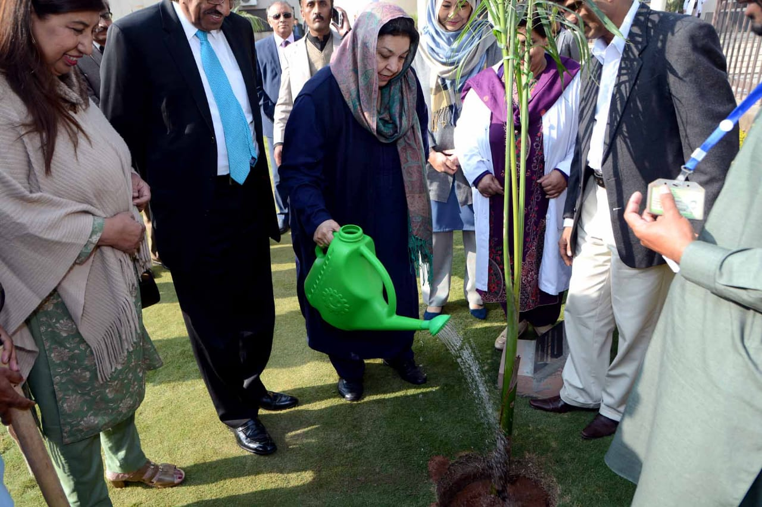Trees play a critical role to our existence on earth. They provide us with numerous products that we utilize in our daily lives, from food to furniture, paper to cosmetics and a host of products in between. Their aesthetic appeal is universal, and they make our world a much more beautiful space.

With ever growing zeal and zest, the Government of Pakistan has started National Planation Campaign according to vision of honorable Prime Minister Mr. Imran Khan. And I am particularly pleased that this year, Rawalpindi Medical University is focusing on the role of trees in mitigating the negative effects of climate change.

Sustainable development is a catchword that we all need to become acquainted with, and to practice, so that all our children and their children for generations to come, can reap the benefits of this beautiful land we call home.

Indeed, the trees we plant, once properly maintained, will benefit our country tomorrow. May they thrive, and provide both hope and shade for many years to come.

**VICE CHANCELLOR RMU / ALLIED HOSPITALS**

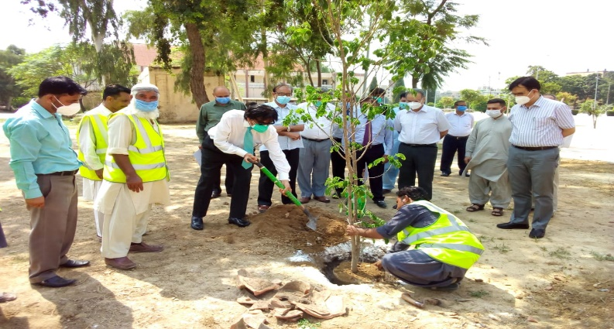It gives great pleasure to write this message for Clean and Green Initiative, of Rawalpindi Medical University. RMU is showing its excellence not ONLY just in the field of education & patient care but also in horticulture.

In the wake of National Plantation Campaign initiated by Prime Minister Mr. Imran Khan, RMU establish Green Task Force to ensure lush green outfields, and planting hundreds of trees. The Global Climate Risk Index has placed Pakistan on the fifth spot on the list of countries most vulnerable to climate change in its annual report for 2020. RMU is playing its parts by conducting plantation campaigns, with zealous involvement of students & faculty. All allied hospitals, medical college, RMU colony are decorated with different varieties of plants.

**PROF. MUHAMMAD UMAR**

**PRESEDENT GREEN & CLEAN INITIATIVE (NEW GREEN TASK FORCE)**

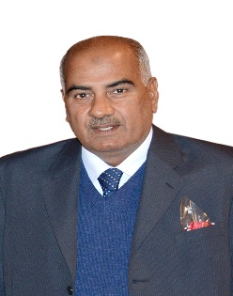"The true meaning of life is to plant trees; under whose shade you do not expect to sit."Being a Rawalian Myself and Chairman of Green task Force, gives me great pleasure to be able to communicate and write on the importance of a topic that can change our Country and coming generations.

I will be sharing with you 6 Lessons and words of wisdom spread across centuries that will enable you to grasp the significance and importance of Planting Trees.

**Lesson 1:** Our Prophet told us to:

The Messenger of Allah, Muhammad (PBUH), has ordered us to plant trees even as the world comes to an end, “If the end of the world approaches and one of you has a seedling (or plant) in his hand, if he can plant it before the end comes, let him do it.” He also says, “If a Muslim plant a tree or sow’s seeds, and then a bird, a person or an animal eats from it, it is regarded as a charitable gift for him until the Day of Judgment.”

**Lesson 2:** Any Time is the Best time to Plant a Tree

"The best time to plant a tree was 20 years ago. The second-best time is now.”

**Lesson 3:** It is the best Service we can do for our Nation

"A nation that destroys its soils destroys itself. Forests are the lungs of our land, purifying the air and giving fresh strength to our people."

**Lesson 4:** Planting A Tree means you are a Man of Action not of Talk, planting a Tree teaches you to go out of your way to make it happen.

"Until you dig a hole, you plant a tree, you water it and make it survive, you haven't done a thing. You are just talking."

**Lesson 5:** It is our Gift to the Next Generation

“A man doesn’t plant a tree for himself. He plants it for coming Generation.”

**Lesson 6:** Trees teach us a lot of lessons including Serving others, having deep roots, reaching for sky and much more

“We can learn a lot from trees: they’re always grounded but never stop reaching the sky.”

And with these words I will again recommend you to plant a tree whenever you can, it is going to be a source of everlasting constant Sadqa Jaria for you.

**PROF. MUHAMMAD ASLAM CHAUDRY**

**SECRETARY GREEN & CLEAN INITIATIVE (NEW GREEN TASK FORCE)**

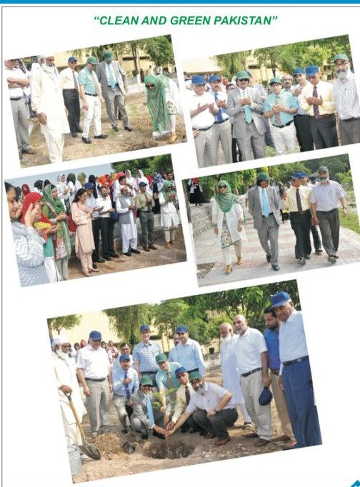I have been involved in tree plantation at RMU & Allied Hospitals for last two decades. Our aim was to provide a healthy environment to patients as well as doctors. For last seven years, under the leadership of worthy Vice Chancellor, we are working with new zeal and enthusiasm. In Monsoon 2020 alone, we planted about 200 plants. I hope in future, we can contribute positively to Prime Minister initiative of Clean and Cream Pakistan.

**PROF. JAHANGIR SARWAR KHAN**

**AIMS & OBJECTIVES**

1. Availability of clean drinking water at highest priority.
2. Conservation of water and energy
3. Clean energy adoption
4. Clean environment and plantation

# 

# CLEAN & GREEN RMU

**Task 01: Clean Drinking Water**

* In Pakistan, 40% illnesses are related to use of unsafe water
* Impurities in water: Bacteria, Viruses, Protozoan
* Dissolved salts, heavy matter and fluoride
* Chlorination, Reverse osmosis, ultra-filtration and nano-filtration are the methods of water purification
* Single filtration plant having capacity 2000L/h can provide water to 2000-3000 people

**Task 01.a: Cost of Filtration Plants**

|  |  |
| --- | --- |
| **Plant with capacity** | **Cost** |
| Chlorination/dechlorination system (2m3/hr) | 0.5 Million +taxes |
| Reverse osmosis(2m3/hr) | 1.5Million +taxes |
| Ultrafiltration (UF) (2m3/hr) | 1.5Million + taxes |
| Ionization for Arsenic Removal (2m3/hr) | 0.5Million + taxes |

**Task 02: Water Conservation for Campuses**

* Declining availability of water, a major concern among developing countries.
* Effective strategy/technology through which water can be conserve.
  + Tube Well Automation
  + Wudu water reuse

**Task 02.a: Tube Well Automation**

* Conserve water which otherwise be wasted in manual operation.
* Tube well automation was implemented by UET Lahore.
* ***Results***: ~ save 30kW of load and 0.5M gallons of water per year.

**Task 02.b: Wudu water reuse**

* 01 person uses 12L of water per prayer
* Average 700 person use water for Wudu in a mosque
* Approximately daily water consumption for Wudu is: 700x12L=8400L per mosque /day
* Greywater
* Compose of high amount of easily degradable organic matters
* Safe to reuse to irrigate both food and non-food producing plants.

**Task 03: Energy Conservation**

* Energy crisis a Challenging Issue.
* Adversely affect country’s economy.
* Efficient and effective management of consumption demand (immediate solution).

**Task 03.a: Energy Conservation Strategy by CERAD UET in Collaboration with PEECA**

Main Aim:

* Lowering net energy demand by
* Solar energy feasibility
* Energy saving strategies

Execution Process:

* Walk through audits and retrofitting recommendation for various institutes and commercial sector buildings.

**Task 03.a: Energy Saving Potential & Energy Conservation Retrofits**

|  |  |  |  |  |  |
| --- | --- | --- | --- | --- | --- |
| **Fast return Retrofits** | **Percent total load** | **Percentage reduction of total land** | **Payback (years)** | **Expected product life (years)** | |
| Lighting | -17% | -9.5% | <2 years | -5 years |  |
| Fan | -15% | -6.8% | <3 years | -10 years |  |
| CRTs | -0.65% | -0.4% | <1.5 years | -10 years |  |
| Traditional ACs | -30% | -15% | <7 years | -10 years |  |

**Task 04: Solar Energy**

* Renewable, free and inexhaustible energy resource.
* Reduced dependence on fossil fuels.
* Environmental Advantages
* Utilization of solar energy by *Solar PV System Installation.*
* **Sample Design:**

Solar PV system of capacity 100kWp each is installed in multiple institutes.

* **Outcome:**
* Accumulative capacity of PV systems installed in multiple institutes is ~1.8 MW.
* Generation is ~2.9 million kWhs per annum.
* **Possible modes of execution for Solar PV Installation:**
* Power purchase agreement
* Build operate and transfer

**Task 04: Plantation Drive**

* Encourage tree plantation.
* Organize plantation campaign.

**Benefits:**

* Prevent soil erosion.
* Lessen global warming effects.
* Maintain ecological balance.

**CLEAN AND GREEN PLANTATION DAY**

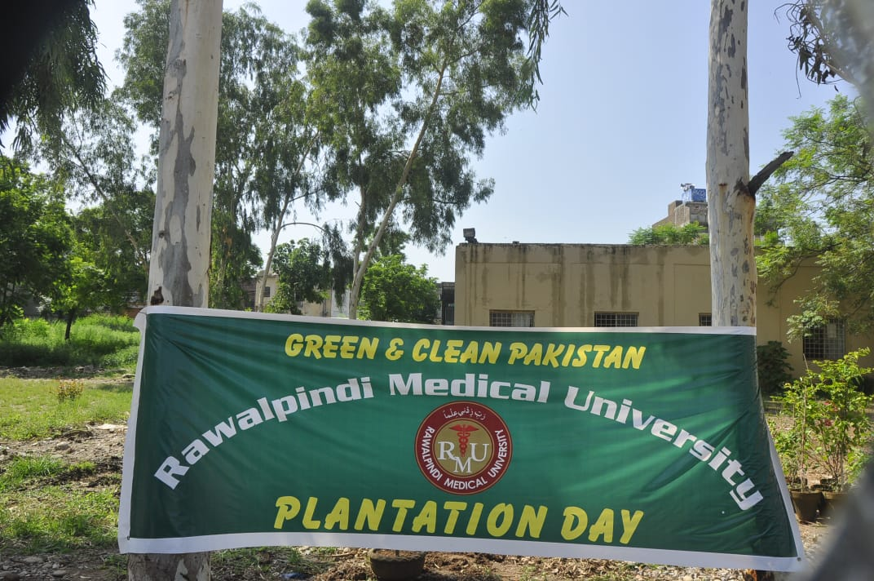

|  |  |
| --- | --- |
|  |  |
| G:\New pics\IMG-20200820-WA0006.jpg |  |
| G:\New pics\IMG-20200820-WA0003.jpg |  |



**PLANTATION COMPAIGN**

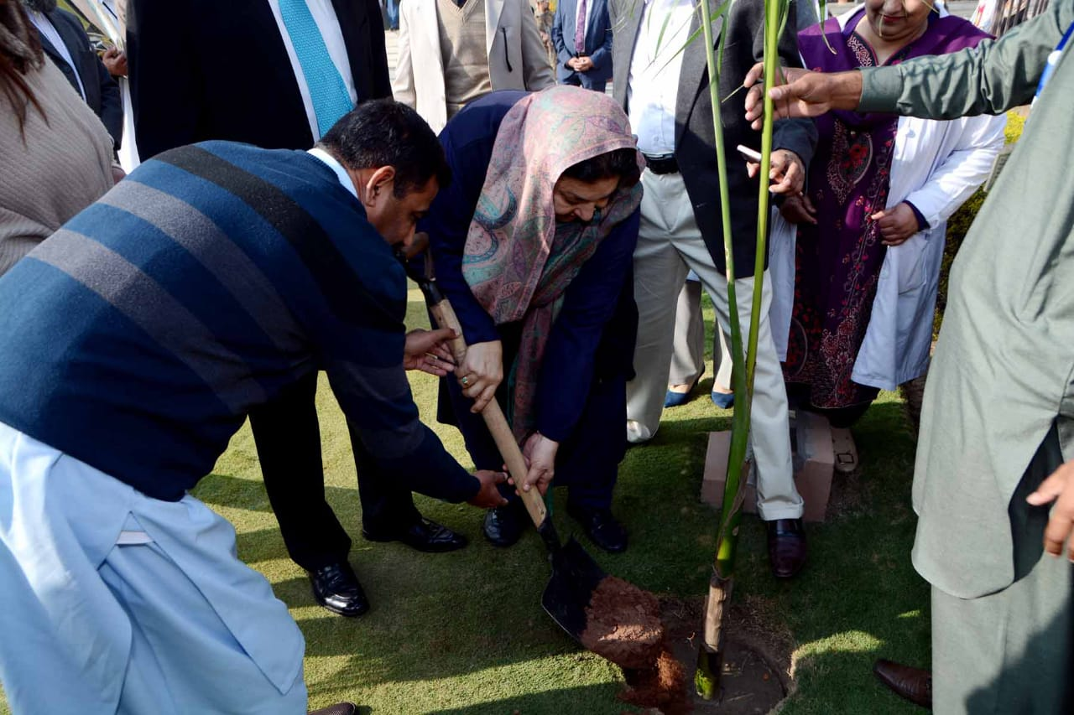



**PROFESSOR YASMIN RASHEED**

MINISTER OF HEALTH PUNJAB

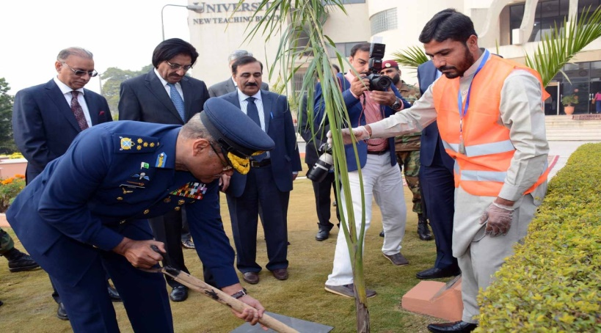

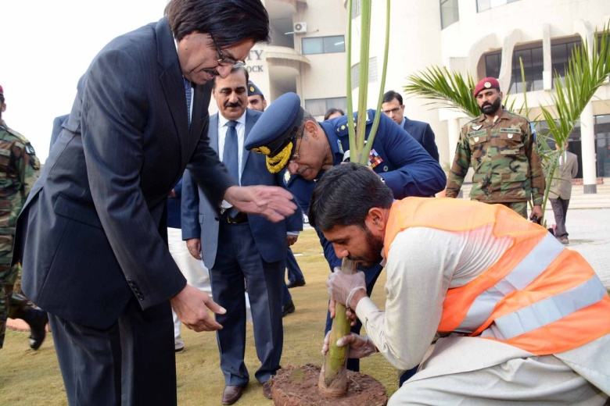

**SOHAIL AMMAN**

AIR CHIEF MARSHAL PAKISTAN

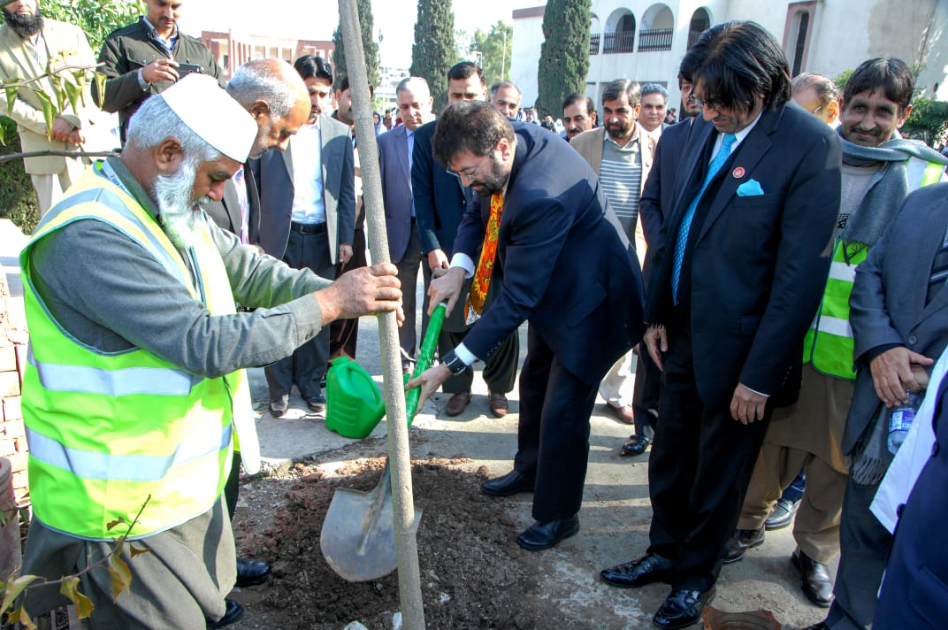

**Prof. Tariq Banuri**

CHAIRMAN HIGHER EDUCATION COMMISION

**DETAILS OF PLANTS IN RMU & ALLIED HOSPITALS**

|  |  |  |
| --- | --- | --- |
| **S.NO.** | **DEPARTMENT** | **TOTAL** |
| **1** | RMU Old Campus | 351 |
| **2** | RMU New Campus | 28 |
| **3** | Holy Family Hospital | 875 |
| **4** | Benazir Bhutto Hospital | 654 |
| **5** | District Headquarter Hospital | 344 |
| **6** | RMU staff colony & Girls Hostels | 695 |

|  |  |  |  |  |  |  |  |  |  |  |  |
| --- | --- | --- | --- | --- | --- | --- | --- | --- | --- | --- | --- |
| C:\Documents and Settings\Muhammad Afzal\Desktop\Trees Pictures\bottle-palm-tree-.jpg  **BOTTLE PALM**   |  |  | | --- | --- | | **OTB 17** | **NTB 08** | | C:\Documents and Settings\Muhammad Afzal\Desktop\Trees Pictures\Jacranda.jpg  **JACORANDA**   |  |  | | --- | --- | | **OTB 26** | **HFH 07** | |  |  | | **SILVER ROSE PLQANT**   |  |  |  | | --- | --- | --- | | **Silver Rose Plant** | **OTB 09** | **DHQ 06** | |
| C:\Documents and Settings\Muhammad Afzal\Desktop\Trees Pictures\Apple.jpg  **APPLE**   |  |  | | --- | --- | | **OTB 01** | **BBQ 01** | |  |  | | **BARRI**   |  |  | | --- | --- | | **HFH 07** | **Colony/Hostel 07** | | C:\Documents and Settings\Muhammad Afzal\Desktop\Trees Pictures\Fagus.jpg  **FAGUS**   |  |  | | --- | --- | | **HFH 181** | **BBH 82** | |
|  |  |  |
| C:\Documents and Settings\Muhammad Afzal\Desktop\Trees Pictures\Cheer.jpg  **CHEER**   |  |  | | --- | --- | | **HFH 09** | **BBH 26** | |  |  | | C:\Documents and Settings\Muhammad Afzal\Desktop\Trees Pictures\Kali March.jpg  **KALI MARCH**   |  |  |  | | --- | --- | --- | | **HFH 07** | **Colony/Hostel 01** | | |  | |  | | C:\Documents and Settings\Muhammad Afzal\Desktop\Trees Pictures\Anaar.jpg  **ANAAR**   |  |  | | --- | --- | | **BBH 03** | **DHQ 03** | |
|  |  |  |
| C:\Documents and Settings\Muhammad Afzal\Desktop\Trees Pictures\Amaltas.jpg  **AMALTAS**   |  |  |  |  | | --- | --- | --- | --- | | **OTB 32** | | **Colony/Hostel 06** | | |  |  | |  | | C:\Documents and Settings\Muhammad Afzal\Desktop\Trees Pictures\palm.png  **PALM**   |  |  | | --- | --- | | **HFH 38** | **BBH 06** | |  |  | | C:\Documents and Settings\Muhammad Afzal\Desktop\Trees Pictures\orange.jpg  **ORANGE**   |  |  | | --- | --- | | **BBH 03** | **Colony/Hostel 20** | |
| C:\Documents and Settings\Muhammad Afzal\Desktop\Trees Pictures\lokaat.jpg  **LOKAAT**   |  |  | | --- | --- | | **BBH 02** | **Colony/Hotel 25** | | C:\Documents and Settings\Muhammad Afzal\Local Settings\Temporary Internet Files\Content.Word\lastunia.jpg  **LASTUNIA**   |  |  | | --- | --- | | **HFH 68** | **BBH 165** | |  |  | | C:\Documents and Settings\Muhammad Afzal\Desktop\trees\Lsgestonia.jpg  **LAJISTUNIA**   |  |  |  | | --- | --- | --- | | **HFH 57** | **BBH 69** | | |  | |  | |
| C:\Documents and Settings\Muhammad Afzal\Desktop\Trees Pictures\Ficus.jpg  **FICUS**   |  |  | | --- | --- | |  | **OTB 23** | |  |  | | C:\Documents and Settings\Muhammad Afzal\Desktop\Trees Pictures\Arjun.jpg   |  |  | | --- | --- | |  | **HFH 12** | | C:\Documents and Settings\Muhammad Afzal\Desktop\Trees Pictures\khatti.jpg  **KHATTI**   |  |  | | --- | --- | |  | **HFH 07** | |
| C:\Documents and Settings\Muhammad Afzal\Desktop\Trees Pictures\lemon.jpg  **LEMON**   |  |  | | --- | --- | |  | **BBH 01** | | **RAAT KI RANI**   |  |  | | --- | --- | |  | **BBH 01** | |  |  | | C:\Documents and Settings\Muhammad Afzal\Desktop\Trees Pictures\Din ka raja.jpg  **DIN KA RAJA**   |  |  | | --- | --- | |  | **BBH 04** | |
| C:\Documents and Settings\Muhammad Afzal\Desktop\Trees Pictures\table palm tree.JPG  **TABLE PALM**   |  |  |  | | --- | --- | --- | |  | **OTB 23** | | |  |  |  | | C:\Documents and Settings\Muhammad Afzal\Desktop\Trees Pictures\Injeer.jpg  **INJEER**   |  |  | | --- | --- | |  | **BBH 07** | | C:\Documents and Settings\Muhammad Afzal\Desktop\Trees Pictures\Bugambilia.jpg  **BUGAMBILIA**   |  |  | | --- | --- | |  | **BBH 55** | |
| C:\Documents and Settings\Muhammad Afzal\Desktop\Trees Pictures\motia.jpg  **MOTIA**   |  |  | | --- | --- | |  | **BBH 04** | | C:\Documents and Settings\Muhammad Afzal\Desktop\Trees Pictures\neem.jpg  **NEEM**   |  |  | | --- | --- | |  | **DHQ 02** | | C:\Documents and Settings\Muhammad Afzal\Desktop\Trees Pictures\Zaitoon.jpg  **ZAITOON**   |  |  | | --- | --- | |  | **Colony/Hostel 03** | |  |  | |
| C:\Documents and Settings\Muhammad Afzal\Desktop\Trees Pictures\chanar.jpg  **CHANAR**   |  |  | | --- | --- | |  | **Colony/Hostel 05** | |  |  | | C:\Documents and Settings\Muhammad Afzal\Desktop\Trees Pictures\Peach.jpg  **ARROO(PEACH)**   |  |  | | --- | --- | |  | **DHQ 05** | | C:\Documents and Settings\Muhammad Afzal\Desktop\Trees Pictures\almound.jpg  **BADAM(ALMOND)**   |  |  | | --- | --- | |  | **DHQ 05** | |
| C:\Documents and Settings\Muhammad Afzal\Desktop\trees\pila taqoma.jpg  **PILA TAQUMA**   |  |  | | --- | --- | |  | **HFH 31** | |  |  | | C:\Documents and Settings\Muhammad Afzal\Desktop\trees\Taun Tree.jpg  **TAON**   |  |  | | --- | --- | |  | **OTB 09** | | C:\Documents and Settings\Muhammad Afzal\Desktop\Trees Pictures\Nashpati.jpg  **NASHPATI**   |  |  | | --- | --- | |  | **Colony/Hostel 06** | |
| C:\Documents and Settings\Muhammad Afzal\Local Settings\Temporary Internet Files\Content.Word\Alstonia plant.jpg  **ALSTONIA**   |  |  | | --- | --- | | **OTB 98** | **MTB 02** | | **Colony/Hostel** | **02** | | C:\Documents and Settings\Muhammad Afzal\Desktop\Trees Pictures\Bohar.jpg  **BOHAR**   |  |  | | --- | --- | | **OTB 01** | **HFH 01** | | C:\Documents and Settings\Muhammad Afzal\Desktop\Trees Pictures\Marva.jpg  **MARVA**   |  |  |  | | --- | --- | --- | | **OTB 01** | **HFH 36** | **DHQ 27** | |
| C:\Documents and Settings\Muhammad Afzal\Desktop\Trees Pictures\Peeple.jpg  **PIPAL**   |  |  |  | | --- | --- | --- | | **HFH 03** | **BBH 03** | **DHQ 01** | |  |  |  | |  |  |  | | C:\Documents and Settings\Muhammad Afzal\Desktop\Trees Pictures\Cheer.jpg  **CHEER**   |  |  | | --- | --- | | **HFH 09** | **BBH 09** | | **Colony/Hospital** | **26** | | C:\Documents and Settings\Muhammad Afzal\Desktop\Trees Pictures\Khajoor.jpg  **KHAJOOR**   |  |  |  | | --- | --- | --- | | **HFH 02** | **BBH 02** | **DHQ 04** | |
| C:\Documents and Settings\Muhammad Afzal\Desktop\Trees Pictures\Amloc.jpg  **JANGLI AMLOC**   |  |  |  | | --- | --- | --- | | **HFH 04** | **BBH 01** | **DHQ 01** | | C:\Documents and Settings\Muhammad Afzal\Desktop\Trees Pictures\rubber plant.jpg  **RUBBER PLANT**   |  |  |  | | --- | --- | --- | | **BBH 04** | **DHQ 04** | **Colony/Hospital 01** | | C:\Documents and Settings\Muhammad Afzal\Desktop\Trees Pictures\Aerokeria.jpg  **AEROKERIA**   |  |  |  |  | | --- | --- | --- | --- | | **MTB 04** | **HFH 04** | | **BBH 2** | | **Colony/Hospital 03** | |  | | |
| C:\Documents and Settings\Muhammad Afzal\Desktop\Trees Pictures\bottel brush.jpg  **BOTTLE BRUSH**   |  |  | | --- | --- | | **MTB 23** | **HFH 09** | | **BBH 02** | **Colony/Hospital 82** | | C:\Documents and Settings\Muhammad Afzal\Desktop\Trees Pictures\Saroo.jpg  **SAROO**   |  |  |  |  |  | | --- | --- | --- | --- | --- | | **MTB 09** | **HFH 17** | | **BBH 09** | | | **Colony/Hospital** | | **13** | |  | | C:\Documents and Settings\Muhammad Afzal\Desktop\Trees Pictures\Jaman.jpg  **JAMAN**   |  |  |  |  |  | | --- | --- | --- | --- | --- | | **MTB 05** | **HFH 09** | | **BBH 18** | | | **Colony/Hospital** | | **09** | |  | |
| C:\Documents and Settings\Muhammad Afzal\Desktop\Trees Pictures\Kachnar.jpg  **KHCHNAR**   |  |  |  | | --- | --- | --- | | **HFH 02** | **DHQ 02** | | | **Colony/Hospital 04** | |  | | C:\Documents and Settings\Muhammad Afzal\Desktop\Trees Pictures\popular.jpg  **POPULAR**   |  |  |  |  |  | | --- | --- | --- | --- | --- | | **MTB 04** | **HFH 04** | | **BBH 02** | | | **Colony/Hospital** | | **03** | |  | | C:\Documents and Settings\Muhammad Afzal\Desktop\Trees Pictures\sumbal.jpg  **SUMBAL**   |  |  |  |  | | --- | --- | --- | --- | | **OTB 02** | **HFH 02** | **BBH 04** | | | **DHQ 06** | **Colony/Hospital** | | **7** | |
| C:\Documents and Settings\Muhammad Afzal\Desktop\Trees Pictures\Drake.jpg  **DARAKE**   |  |  |  |  | | --- | --- | --- | --- | | **OTB 06** | **HFH 68** | **BBH 42** | | | **DHQ 49** | **Colony/Hospital** | | **06** | | C:\Documents and Settings\Muhammad Afzal\Desktop\Trees Pictures\Sukhchain.jpg  **SUKHCHAIN**   |  |  |  |  | | --- | --- | --- | --- | | **OTB 22** | **HFH 132** | | **BBH 20** | | **Colony/Hospital** | | **100** | **DHQ 15** | | C:\Documents and Settings\Muhammad Afzal\Desktop\Trees Pictures\Mango.jpg  **MANGO**   |  |  |  |  |  | | --- | --- | --- | --- | --- | | **OTB 01** | **HFH 03** | | **BBH 23** | | | **Colony/Hospital** | | **16** | |  | |
| C:\Documents and Settings\Muhammad Afzal\Desktop\Trees Pictures\Sufaida.jpg  **SAFEDA**   |  |  |  |  |  | | --- | --- | --- | --- | --- | | **OTB 70** | **HFH 70** | | **DHQ 26** | | | **Colony/Hospital** | | **110** | |  | | C:\Documents and Settings\Muhammad Afzal\Desktop\Trees Pictures\Shahtoot.jpg  **SHAHOOT**   |  |  |  |  |  | | --- | --- | --- | --- | --- | | **OTB 26** | **HFH 26** | | **BBH 07** | | | **Colony/Hospital** | | **42** | |  | | C:\Documents and Settings\Muhammad Afzal\Desktop\Trees Pictures\Gauva.jpg  **GUAVA**   |  |  |  |  |  | | --- | --- | --- | --- | --- | | **OTB 01** | **HFH 02** | | **BBH 10** | | | **Colony/Hospital** | | **02** | |  | |

**PLANTS** **DETAILS AT HOLY FAMILY HOSPITAL**

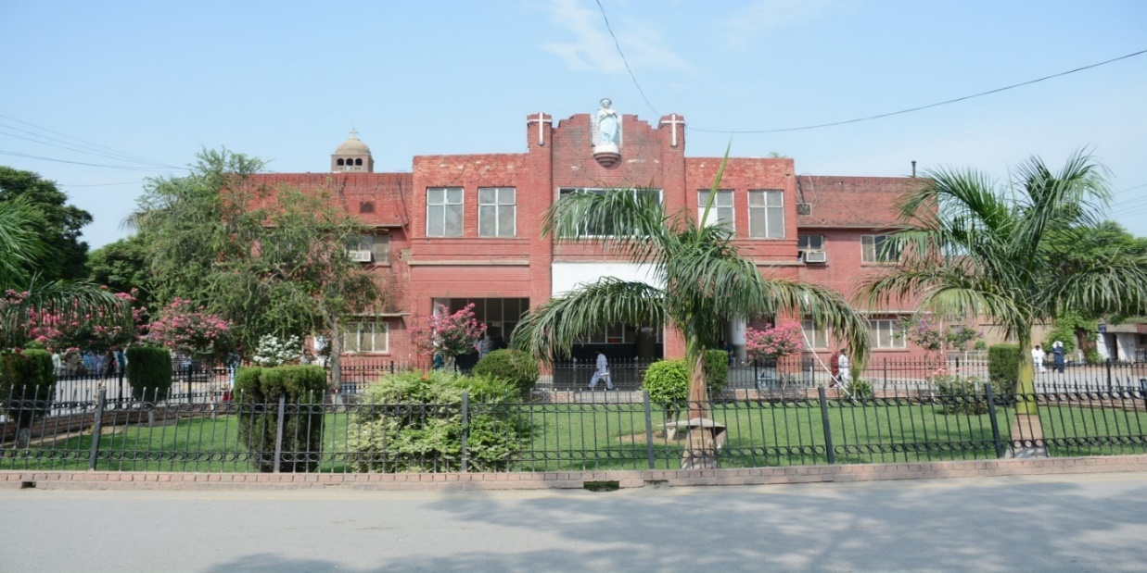

|  |  |  |  |  |  |
| --- | --- | --- | --- | --- | --- |
| **S. No.** | **Plant Name** | **Numbers** | **S. No.** | **Plant Name** | **Numbers** |
|  | Palkan | 30 | 19. | Shatooat | 31 |
|  | Lastunia | 68 | 20. | Jangli Amlok | 04 |
|  | Lajastunia | 57 | 21. | Hi Bax | 09 |
|  | Sukh Chain | 132 | 22. | Lokatch | 02 |
|  | Barri | 07 | 23. | Papli | 02 |
|  | Taali | 34 | 24. | Jangli Ratha | 10 |
|  | Arjun | 12 | 25. | Jaman | 05 |
|  | Fayqas | 181 | 26. | Pipal | 03 |
|  | Paam | 38 | 27. | Cheer | 09 |
|  | Safyda | 24 | 28. | Khajoor | 02 |
|  | Papular | 12 | 29. | Bour | 01 |
|  | Daryk | 68 | 30. | Khachnar | 01 |
|  | Marva | 36 | 31. | Aam | 03 |
|  | Chqranda | 07 | 32. | Aro Karia | 04 |
|  | Batel Burash | 23 | 33. | Amrood | 02 |
|  | Saroo | 09 | 34. | Kali Marach | 07 |
|  | Pila Taquma | 31 | 35. | Khati | 07 |
|  | Sumbal | 04 |  | **Total** | **823** |

|  |  |
| --- | --- |
| D:\HFH Garden\HFH HolyFamilyGarden\DSC_2049.JPG | D:\HFH Garden\HFH HolyFamilyGarden\DSC_2057.JPG |
| D:\HFH Garden\HFH Garden\DSC_3993.JPG | D:\PICSSS\WhatsApp Image 2020-09-12 at 10.02.49 AM.jpeg |
| D:\PICSSS\WhatsApp Image 2020-09-12 at 10.02.25 AM.jpeg | D:\PICSSS\WhatsApp Image 2020-09-12 at 10.02.27 AM.jpeg |

**PLANTS DETAIL AT** **BENAZIR BHUTTO HOSPITAL**

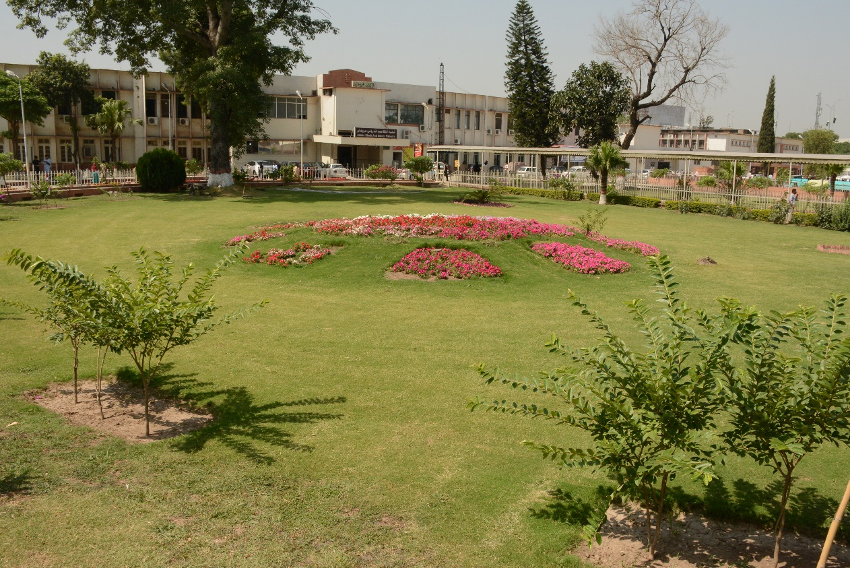

|  |  |  |  |  |  |
| --- | --- | --- | --- | --- | --- |
| **Sr. No.** | **Plant Name** | **Quantity** | **Sr. No.** | **Plant Name** | **Quantity** |
| **1.** | Palkan | 40 | 18. | Bour | 01 |
| **2.** | Lastonia | 165 | 19. | Aam | 23 |
| **3.** | Lajistonia | 69 | 20. | Amrood | 10 |
| **4.** | Sukh Chain | 20 | 21. | Shahtoot | 07 |
| **5.** | Tali | 13 | 22. | Jangli Amlok | 01 |
| **6.** | Faygus | 82 | 23. | Bugam Belia | 55 |
| **7.** | Palm | 06 | 24. | Rubber Plant | 10 |
| **8.** | Sufaida | 13 | 25. | Din ka Raja | 04 |
| **9.** | Popular | 06 | 26. | Raat ke Rani | 01 |
| **10.** | Darekh | 42 | 27. | Anaar | 03 |
| **11.** | Batel Burash | 09 | 28. | Injeer | 01 |
| **12.** | Saroo | 17 | 29. | Motia | 04 |
| **13.** | Sumbal | 04 | 30. | Lemon | 01 |
| **14.** | Jaman | 09 | 31. | Malta | 03 |
| **15.** | Pipal | 04 | 32. | Apple | 01 |
| **16.** | Cheerh | 26 | 33. | Lokaat | 02 |
| **17.** | Khajoor | 02 |  | **Total** |  |

|  |  |
| --- | --- |
| C:\Users\RMU Data Cell\Desktop\front\BBH\DSC_0819.JPG |  |
|  |  |
|  |  |

**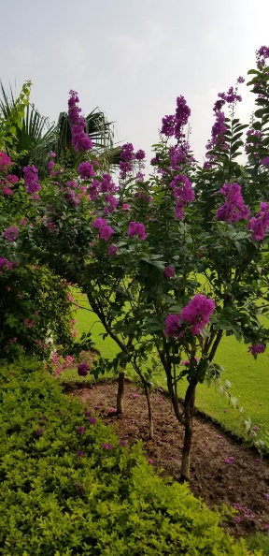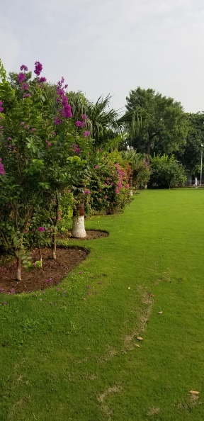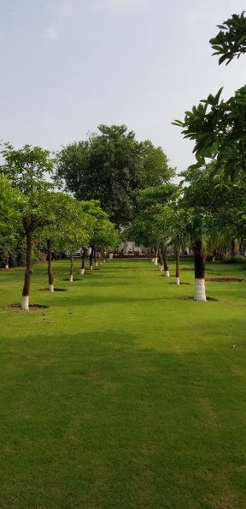**

**PLANTS DETAIL ATDISTRICT HEAT QUARTER HOSPITAL**

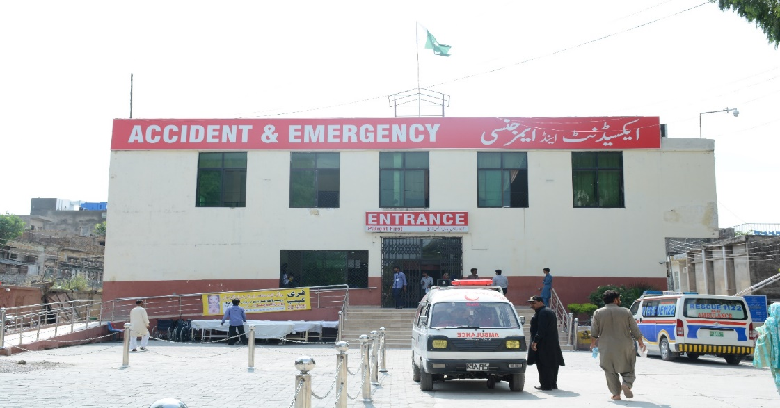

|  |  |  |  |  |  |
| --- | --- | --- | --- | --- | --- |
| **Sr. No.** | **Plant Name** | **Quantity** | **Sr. No.** | **Plant Name** | **Quantity** |
|  | Dareek | 49 | 16. | Badaam | 1 |
|  | Toot | 21 | 17. | Bottle barsh | 2 |
|  | Silver Plant | 6 | 18. | Amlook | 2 |
|  | Mango | 19 | 19. | Amrade | 10 |
|  | Sukh Chain | 15 | 20. | Neeam | 2 |
|  | Jaman | 18 | 21. | Papolur | 8 |
|  | Lasoodha | 1 | 22. | Anar | 3 |
|  | Rubber Plant | 6 | 23. | Saroo | 1 |
|  | Khajoor | 4 | 24. | Peepal | 1 |
|  | Sombal | 6 | 25. |  | 1 |
|  | Tali | 4 | 26. |  | 4 |
|  | Kachnar | 1 | 27. |  | 2 |
|  | Safeeda | 26 | 28. | Adhoo | 1 |
|  | Shafleera | 3 |  | **Total** | **217** |

|  |  |
| --- | --- |
| D:\PICSSS\WhatsApp Image 2020-09-12 at 10.02.17 AM.jpeg | D:\PICSSS\WhatsApp Image 2020-09-12 at 10.02.25 AM.jpeg |
| D:\PICSSS\WhatsApp Image 2020-09-12 at 10.02.46 AM.jpeg | D:\PICSSS\WhatsApp Image 2020-09-12 at 10.03.02 AM (2).jpeg |
| D:\PICSSS\WhatsApp Image 2020-09-12 at 10.02.27 AM.jpeg | D:\PICSSS\WhatsApp Image 2020-09-12 at 10.02.13 AM.jpeg |

**DETAIL OF PLANTS** **RMU NEW TEACHING BLOCK**

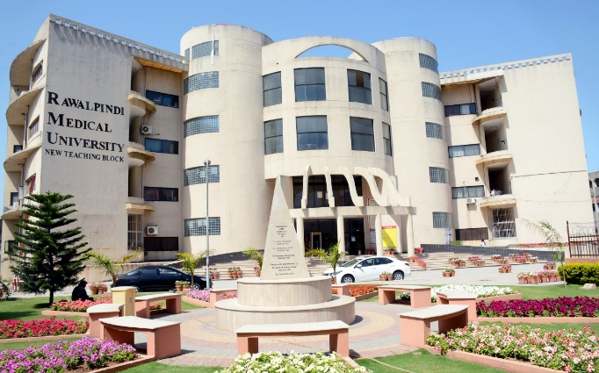

|  |  |  |  |  |  |
| --- | --- | --- | --- | --- | --- |
| **Sr. No.** | **Plant Name** | **Quantity** | **Sr. No.** | **Plant Name** | **Quantity** |
|  | Bottle Palm | 08 |  | Felkum | 01 |
|  | Aerokeria | 04 |  | Tehli | 01 |
|  | Aestrokolia | 06 |  | Ficus | 05 |
|  | Eistunia | 02 |  | **Total** | **27** |

|  |  |
| --- | --- |
|  |  |
|  |  |

**PLANTS DETAIL AT RMU OLD TEACHING BLOCK**

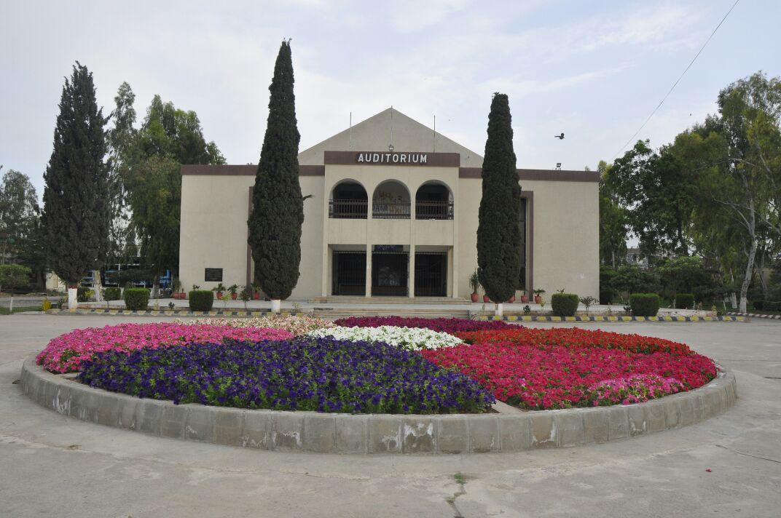

|  |  |  |  |  |  |
| --- | --- | --- | --- | --- | --- |
| **Sr. No.** | **Plant Name** | **Quantity** | **Sr. No.** | **Plant Name** | **Quantity** |
|  | Bottel Palm | 17 | 12. | Alstonia | 22 |
|  | Table Palm | 23 | 13. | Sukhchain | 1 |
|  | Sumbal | 3 | 14. | Bohar | 1 |
|  | Decorative | 26 | 15. | ango | 1 |
|  | Jecoranda | 9 | 16. | Apple | 1 |
|  | Silver Roge | 9 | 17. | Safeda | 70 |
|  | Toun | 32 | 18. | Marva | 1 |
|  | Amaltas | 3 | 19. | Tahli | 1 |
|  | Gule Chaina | 6 | 20. | Shahtoot | 26 |
|  | Darke | 98 |  | **Total** | **350** |

|  |  |
| --- | --- |
|  |  |
|  |  |
|  |  |