DATA CENTER DEVELOPMENT
R&D Department RMU

Acknowledgement

Prof. Dr. Muhammad Umar
Vice Chancellor
Rawalpindi Medical University, Rawalpindi

Management Team

Dr. Farrah Pervaiz
Additional Director R&D
Rawalpindi Medical University, Rawalpindi

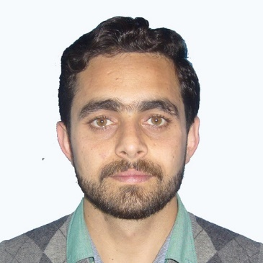
Dr. Haq Nawaz
Coordinator Research and Development
Rawalpindi Medical University, Rawalpindi

RMU DATA CENTER

Vision:
To become the cornerstone of innovation and efficiency in healthcare data management, propelling Rawalpindi Medical University towards pioneering research, seamless patient care, and transformative medical education.

Mission:
Our mission at Rawalpindi Medical University Data Centre is to harness the power of data to enhance medical research, education, and patient outcomes. Through cutting-edge technologies, rigorous data governance, and collaborative partnerships, we strive to centralize, secure, and analyze healthcare data, empowering healthcare professionals with actionable insights and facilitating the advancement of medical knowledge and practice.

Purpose:
The policy aims to:
• Ensure compliance with ethical, regulatory, and funding guidelines concerning personal and medical information, research data, and data handling.
• Empower staff, faculty, and researchers to proficiently and securely manage various types of data.
• Verify and exhibit the integrity of research findings.
• Preserve eligible data for future use.
• Educate and ensure that Rawalpindi Medical University faculty, staff, and researchers comprehend and fulfill their duties regarding research data governance.
• Clearly articulate the university's obligations concerning research data management.
• Establish exemplary research data management standards for all researchers affiliated with Rawalpindi Medical University.
• Foster accountability for research data management by facilitating the development of research data management plans.

Data collection and Validation flowchart

Verification of data from focal person for competence and accuracy
Received data of the disease from concerned department

Revision of data as per suggestions of clinical experts
Verification report submitted to the clinical experts of concerned department

Validated and accurate data stored in data bank
Verification and validation of revised data

Data collected for diseases

- Hepatitis C
- Dengue
- ICU Infections
- Radiology
- Oncology
- Covid-19
- Diabetes

Count of patients

