

**MD NEUROLOGY RAWALPINDI MEDICAL UNIVERSITY RAWALPINDI**

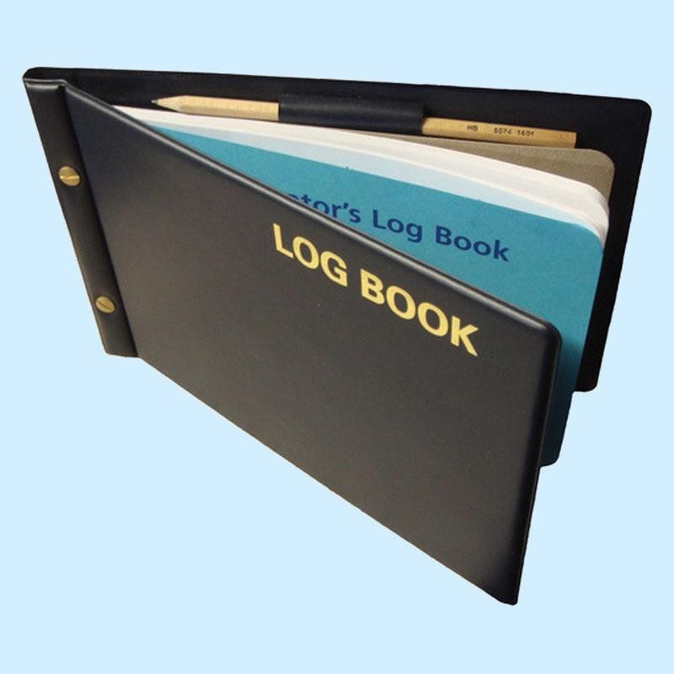

ENROLMENT DETAILS

Program of Admission

Session

Registration / Training Number

Name of Candidate

Father’s Name

Date of Birth / / CNIC No.

Present Address

Permanent Address

E-mail Address

Cell Phone

Date of Start of Training

Date of Completion of Training

Name of Supervisor

Designation of Supervisor

Qualification of Supervisor

Title of department / Unit

Name of Training Institute / Hospital

**INTRODUCTION OF LOGBOOK:**

A structured book in which certain types of educational activities and patient related information is recorded, usually by hand. Logbooks are used all over the world from undergraduate to postgraduate training, in human, veterinary and dental medicine, nursing schools and pharmacy, either in paper or electronic format .

Logbooks provide a clear setting of learning objectives and give trainees and clinical teachers a quick overview of the requirements of training and an idea of the learning progress. Logbooks are especially useful if different sites are involved in the training to set a (minimum) standard of training. Logbooks assist supervisors and trainees to see at one glance which learning objectives have not yet been accomplished and to set a learning plan.The analysis of logbooks can reveal weak points of training and can evaluate whether trainees have fulfilled the minimum requirements of training.

Logbooks facilitate communication between the trainee and clinical teacher. Logbooks help to structure and standardize learning in clinical settings. In contrast to portfolios, which focus on students’ documentation and self- reflection of their learning activities, logbooks set clear learning objectives and help to structure the learning process in clinical settings and to ease communication between trainee and clinical teacher. To implement logbooks in clinical training successfully, logbooks have to be an integrated part of the curriculum and the daily routine on the ward.

Continuous measures of quality management are necessary.

**Reference**

[*Brauns*](https://www.ncbi.nlm.nih.gov/pubmed/?term=Sch%26%23x000fc%3Bttpelz-Brauns%20K%5BAuthor%5D&cauthor=true&cauthor_uid=26841068) *KS,*[*Narciss*](https://www.ncbi.nlm.nih.gov/pubmed/?term=Narciss%20E%5BAuthor%5D&cauthor=true&cauthor_uid=26841068) *E,* [*Schneyinck*](https://www.ncbi.nlm.nih.gov/pubmed/?term=Schneyinck%20C%5BAuthor%5D&cauthor=true&cauthor_uid=26841068) *C,* [*Böhme*](https://www.ncbi.nlm.nih.gov/pubmed/?term=B%26%23x000f6%3Bhme%20K%5BAuthor%5D&cauthor=true&cauthor_uid=26841068) *K,* [*Brüstle*](https://www.ncbi.nlm.nih.gov/pubmed/?term=Br%26%23x000fc%3Bstle%20P%5BAuthor%5D&cauthor=true&cauthor_uid=26841068) *P,* [*Holzmann*](https://www.ncbi.nlm.nih.gov/pubmed/?term=Mau-Holzmann%20U%5BAuthor%5D&cauthor=true&cauthor_uid=26841068) *UM, etal. Twelve tips for successfully implementing logbooks in clinical training. Med Teach. 2016 Jun 2; 38(6): 564–569.*

**INDEX:*LOG OF***

1. **MORNING REPORT PRESENTATION/CASE PRESENTATION (LONG AND SHORT CASES)**
2. **TOPIC PRESENTATION/SEMINAR**
3. **DIDACTIC LECTURES/INTERACTIVE LECTURES**
4. **JOURNAL CLUB**
5. **PROBLEM CASE DISCUSSION**
6. **EMERGENCY CASES**
7. **INDOOR PATIENTS**
8. **OPD AND CLINICS**
9. **PROCEDURES (OBSERVED, ASSISTED,PERFORMED UNDER SUPERVISION & PERFORMED INDEPENDENTLY)**
10. **MULTIDISCIPLINARY MEETINGS**
11. **CLINICOPATHOLOGICAL CONFERENCE**
12. **MORBIDITY/MORTALITY MEETINGS**
13. **HANDS ON TRAINING/WORKSHOPS**
14. **PUBLICATIONS**
15. **MAJOR RESEARCH PROJECT DURING MD TRAINING/ANY OTHER MAJOR RESEARCH PROJECT**
16. **WRITTEN ASSESMENT RECORD**
17. **CLINICAL ASSESMENT RECORD**
18. **EVALUATION RECORD**

SECTION-1

**MORNING REPORT PRESENTATION/ CASE PRESENTATION (LONG AND SHORT CASES)**

|  |  |  |  |  |
| --- | --- | --- | --- | --- |
| **SR#** | **DATE** | **REG# OF**  **PATIENT** | **DIAGNOSIS & BRIEF DESCRIPTION** | **SIGNATURES OF THE**  **SUPERVISOR** |
|  |  |  |  |  |
|  |  |  |  |  |
|  |  |  |  |  |
|  |  |  |  |  |
|  |  |  |  |  |

**TOPIC PRESENTATION/SEMINAR**

SECTION-2

|  |  |  |  |
| --- | --- | --- | --- |
| **SR#** | **DATE** | **NAME OF THE TOPIC & BRIEF DETAILS OF THE ASPECTS COVERED** | **SIGNATURES OF THE SUPERVISOR** |
|  |  |  |  |
|  |  |  |  |
|  |  |  |  |
|  |  |  |  |
|  |  |  |  |

**JOURNAL CLUB**

SECTION-3

|  |  |  |  |  |  |
| --- | --- | --- | --- | --- | --- |
| **SR#** | **DATE** | **TITLE OF THE ARTICLE** | **NAME OF JOURNAL** | **DATE OF PUBLICATION** | **SIGNATURES OF THE SUPERVISOR** |
|  |  |  |  |  |  |
|  |  |  |  |  |  |
|  |  |  |  |  |  |
|  |  |  |  |  |  |
|  |  |  |  |  |  |

**PROBLEM CASE DISCUSSION**

SECTION-4

|  |  |  |  |  |  |
| --- | --- | --- | --- | --- | --- |
| **SR #** | **DATE** | **REG.# OF THE PATIENT DISCUSSED** | **DIAGNOSIS** | **BRIEF DESCRIPTION OF THE CASE** | **SIGNATURES OF THE SUPERVISOR** |
|  |  |  |  |  |  |
|  |  |  |  |  |  |
|  |  |  |  |  |  |
|  |  |  |  |  |  |
|  |  |  |  |  |  |

**DIDACTIC LECTURE/INTERACTIVE LECTURES**

SECTION-5

|  |  |  |  |  |
| --- | --- | --- | --- | --- |
| **SR #** | **DATE** | **TOPIC & BRIEF DESCRIPTION** | **NAME OF THE TEACHER** | **SIGNATURES OF THE SUPERVISOR** |
|  |  |  |  |  |
|  |  |  |  |  |
|  |  |  |  |  |
|  |  |  |  |  |

**RECORD OF TOTAL EMERGENCY CASES SEEN ON EMERGENCY CALL DAYS**

SECTION-6

|  |  |  |  |
| --- | --- | --- | --- |
| **SR.#** | **DATE** | **TOTAL NUMBER OF CASES ATTENDED** | **SIGNATURES OF THE SUPERVISOR** |
| **1** |  |  |  |
| **2** |  |  |  |
| **3** |  |  |  |
| **4** |  |  |  |
| **5** |  |  |  |
| **6** |  |  |  |
| **7** |  |  |  |
| **9** |  |  |  |
| **10** |  |  |  |
| **11** |  |  |  |
| **12** |  |  |  |
| **13** |  |  |  |
| **14** |  |  |  |

|  |  |  |  |
| --- | --- | --- | --- |
| **15** |  |  |  |
| **16** |  |  |  |
| **17** |  |  |  |
| **18** |  |  |  |
| **19** |  |  |  |
| **20** |  |  |  |
| **21** |  |  |  |
| **22** |  |  |  |
| **23** |  |  |  |
| **24** |  |  |  |
| **25** |  |  |  |
| **26** |  |  |  |
| **27** |  |  |  |

SECTION-6

**EMERGENCY CASES(repetition of cases should be avoided)**

|  |  |  |  |  |  |  |
| --- | --- | --- | --- | --- | --- | --- |
| **SR#** | **DATE** | **REG # OF THE PATIENT** | **DIAGNOSIS** | **MANAGEMENT** | **PROCEDURES PERFORMED** | **SIGNATURES OF THE SUPERVISOR** |
|  |  |  |  |  |  |  |
|  |  |  |  |  |  |  |
|  |  |  |  |  |  |  |
|  |  |  |  |  |  |  |
|  |  |  |  |  |  |  |

**RECORD OF TOTAL INDOOR CASES SEEN ON CALL DAYS IN THE WARD**

SECTION-7

|  |  |  |  |
| --- | --- | --- | --- |
| **SR.#** | **DATE** | **TOTAL NUMBER OF CASES ATTENDED** | **SIGNATURES OF THE SUPERVISOR** |
| **1** |  |  |  |
| **2** |  |  |  |
| **3** |  |  |  |
| **4** |  |  |  |
| **5** |  |  |  |
| **6** |  |  |  |
| **7** |  |  |  |
| **9** |  |  |  |
| **10** |  |  |  |
| **11** |  |  |  |
| **12** |  |  |  |
| **13** |  |  |  |
| **14** |  |  |  |

|  |  |  |  |
| --- | --- | --- | --- |
| **15** |  |  |  |
| **16** |  |  |  |
| **17** |  |  |  |
| **18** |  |  |  |
| **19** |  |  |  |
| **20** |  |  |  |
| **21** |  |  |  |
| **22** |  |  |  |
| **23** |  |  |  |
| **24** |  |  |  |
| **25** |  |  |  |
| **26** |  |  |  |
| **27** |  |  |  |
| **28** |  |  |  |

**INDOOR PATIENTS (repetition of cases should be avoided)**

SECTION-7

|  |  |  |  |  |  |  |
| --- | --- | --- | --- | --- | --- | --- |
| **SR#** | **DATE** | **REG # OF THE PATIENT** | **DIAGNOSIS** | **MANAGEMENT** | **PROCEDURES PERFORMED** | **SIGNATURES OF THE SUPERVISOR** |
|  |  |  |  |  |  |  |
|  |  |  |  |  |  |  |
|  |  |  |  |  |  |  |
|  |  |  |  |  |  |  |
|  |  |  |  |  |  |  |

**RECORD OF TOTAL OPD/CLINIC CASES SEEN ON OPD CALL DAYS**

SECTION-8

|  |  |  |  |
| --- | --- | --- | --- |
| **SR.#** | **DATE** | **TOTAL NUMBER OF CASES ATTENDED** | **SIGNATURES OF THE SUPERVISOR** |
| **1** |  |  |  |
| **2** |  |  |  |
| **3** |  |  |  |
| **4** |  |  |  |
| **5** |  |  |  |
| **6** |  |  |  |
| **7** |  |  |  |
| **9** |  |  |  |
| **10** |  |  |  |
| **11** |  |  |  |
| **12** |  |  |  |
| **13** |  |  |  |
| **14** |  |  |  |

|  |  |  |  |
| --- | --- | --- | --- |
| **15** |  |  |  |
| **16** |  |  |  |
| **17** |  |  |  |
| **18** |  |  |  |
| **19** |  |  |  |
| **20** |  |  |  |
| **21** |  |  |  |
| **22** |  |  |  |
| **23** |  |  |  |
| **24** |  |  |  |
| **25** |  |  |  |
| **26** |  |  |  |
| **27** |  |  |  |
| **28** |  |  |  |

**OPD AND CLINICS (repetition of cases should be avoided)**

SECTION-8

|  |  |  |  |  |  |
| --- | --- | --- | --- | --- | --- |
| **SR#** | **DATE** | **REG # OF THE PATIENT** | **DIAGNOSIS** | **MANAGEMENT** | **SIGNATURES OF THE SUPERVISOR** |
|  |  |  |  |  |  |
|  |  |  |  |  |  |
|  |  |  |  |  |  |
|  |  |  |  |  |  |
|  |  |  |  |  |  |

**PROCEDURES**

SECTION-9

|  |  |  |  |  |  |  |
| --- | --- | --- | --- | --- | --- | --- |
| **SR.#** | **DATE** | **REG NO. OF PATIENT** | **NAME OF PROCEDURE** | **OBSERVED/ASSISTED/PERFORMED UNDER SUPERVISION/PERFORMED**  **INDEPENDENTLY** | **PLACE OF PROCEDURE** | **SIGNATURES OF THE SUPERVISOR** |
|  |  |  |  |  |  |  |
|  |  |  |  |  |  |  |
|  |  |  |  |  |  |  |
|  |  |  |  |  |  |  |
|  |  |  |  |  |  |  |

**MULTI DICIPLINARY MEETINGS**

**SECTION-10**

|  |  |  |  |
| --- | --- | --- | --- |
| **SR#** | **DATE** | **BRIEF DESCRIPTION** | **SIGNATURES OF THE SUPERVISOR** |
|  |  |  |  |
|  |  |  |  |
|  |  |  |  |
|  |  |  |  |
|  |  |  |  |

**SECTION-**

**CLINICOPATHOLOGICAL CONFERENCE (CPC)**

|  |  |  |  |
| --- | --- | --- | --- |
| **SR#** | **DATE** | **BRIEF DESCRIPTION OF THE TOPIC/CASE DISCUSSED** | **SIGNATURES OF THE SUPERVISOR** |
|  |  |  |  |
|  |  |  |  |
|  |  |  |  |
|  |  |  |  |
|  |  |  |  |

**MORBIDITY/MORTALITY MEETINGS**

**SECTION-12**

|  |  |  |  |  |  |
| --- | --- | --- | --- | --- | --- |
| **SR#** | **DATE** | **REG. # OF THE PATIENT DISCUSSED** | **BRIEF DESCRIPTION** | **COMMENTS/SUGGESTIONS** | **SIGNATURES OF THE SUPERVISOR** |
|  |  |  |  |  |  |
|  |  |  |  |  |  |
|  |  |  |  |  |  |
|  |  |  |  |  |  |
|  |  |  |  |  |  |

**HANDS ON TRAINING/WORKSHOPS**

**SECTION-13**

|  |  |  |  |  |  |
| --- | --- | --- | --- | --- | --- |
| **SR#** | **DATE** | **TITLE** | **VENUE** | **FACILITATOR** | **SIGNATURES OF THE SUPERVISOR** |
|  |  |  |  |  |  |
|  |  |  |  |  |  |
|  |  |  |  |  |  |
|  |  |  |  |  |  |
|  |  |  |  |  |  |

**PUBLICATIONS**

**SECTION-14**

|  |  |  |  |  |  |  |
| --- | --- | --- | --- | --- | --- | --- |
| **SNO.** | **NAME OF PUBLICATION** | **TYPE OF PUBLICATION ORIGINAL ARTICLE/EDITORIAL/CASE**  **REPORT ETC** | **NAME OF JOURANL** | **DATE OF PUBLICATION** | **PAGE NO.** | **SIGNATURES OF THE SUPERVISOR** |
|  |  |  |  |  |  |  |
|  |  |  |  |  |  |  |
|  |  |  |  |  |  |  |
|  |  |  |  |  |  |  |
|  |  |  |  |  |  |  |

**MAJOR RESEARCH PROJECT DURING MD TRAINING/ANY OTHER MAJOR RESEARCH PROJECT**

**SECTION-15**

|  |  |  |  |  |  |
| --- | --- | --- | --- | --- | --- |
| **SNO.** | **RESEARCH TOPIC** | **PLACE OF RESEARCH** | **NAME AND DESIGNATION OF SUPERVISOR OTHER THAN MD SUPERVISOR UNDER WHOM RESEARCH**  **WAS CONDUCTED** | **BRIEF DETAILS** | **SIGNATURES OF THE SUPERVISOR** |
|  |  |  |  |  |  |
|  |  |  |  |  |  |
|  |  |  |  |  |  |
|  |  |  |  |  |  |

**WRITTEN ASSESSMENT RECORD**

**SECTION-16**

|  |  |  |  |  |  |
| --- | --- | --- | --- | --- | --- |
| **SNO** | **TOPIC OF WRITTEN TEST/EXAMINATION** | **TYPE OF THE TEST MCQS OR SEQS OR**  **BOTH** | **TOTAL MARKS** | **MARKS OBTAINED** | **SIGNATURES OF THE SUPERVISOR** |
|  |  |  |  |  |  |
|  |  |  |  |  |  |
|  |  |  |  |  |  |
|  |  |  |  |  |  |
|  |  |  |  |  |  |
|  |  |  |  |  |  |
|  |  |  |  |  |  |

**SECTION-17**

**CLINICAL ASSESSMENT RECORD**

|  |  |  |  |  |  |
| --- | --- | --- | --- | --- | --- |
| **SR.#** | **TOPIC OF CLINICAL TEST/ EXAMINATION** | **TYPE OF THE TEST& VENUE**  **OSPE, MINICEX, CHART STIMULATED RECALL, DOPS, SIMULATED PATIENT, SKILL LAB**  **e.t.c** | **TOTAL MARKS** | **MARKS OBTAINED** | **SIGNATURES OF THE SUPERVISOR** |
|  |  |  |  |  |  |
|  |  |  |  |  |  |
|  |  |  |  |  |  |
|  |  |  |  |  |  |
|  |  |  |  |  |  |
|  |  |  |  |  |  |

**SECTION-18**

EVALUATION RECORDS

(Photocopy of consolidated evaluation record at the end of each block should be pasted here)