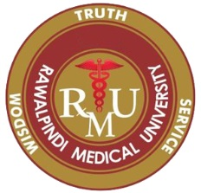
APPLICATION FORM
Certificate Course in Family Medicine
Photograph
Name: _______________________________S/D: ________________________________________
 |  |  |  |  | - |  |  |  |  |  |  |  | -

CNIC No.
 |  | - |  |  | -

Age:- ____ Gender:- Male Female Date of Birth.

Email: - _____________________________ Contact # _____________________________

Temporary Address: ___________________________________________________________________________

Permanent Address: __________________________________________________________________________________

Current Working Details
- Position Held: ____________________________________________________________
- Institution:_______________________________________________________________
- Experience:_________________________________________________________
PMC Reg. No. ___________________ Date of Expiry:- _________________________

Professional Qualifications

Sr.# | Qualification | College / University | Year of Passing | Obtained Marks | Total Marks | Marks % | Experience Year
 | Matric/ A Level
 | FSC/ O Level
 | MBBS

Objectives for Enrollment in this Program

Sr.#
1
2
3
4
5

_______________
Signature of Candidate Date: ____/___/2023

CHECKLIST FOR APPLICATION:

- Attested Copy of CNIC.
- Four Passport Size Photographs with Blue Background all pic attested three pic back and one Pic front attested.
- Attested Matric/A Level degree.
- Attested F.sc/O Level Degree.
- Attested MBBS Degree/Transcript.
- Attested Domicile.
- Attested Experience Letter if any.
- Attested Valid PMC Certificate.
- Application Fee (bank draft in the favor of Vice Chancellor, RMU).
- Application is duly signed and all columns are filled.

