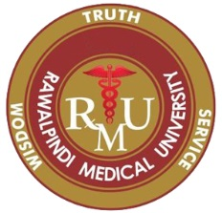
EMERGENCY MEDICINE FOUNDATION PROGRAM
APPLICATION FORM (Batch 2021-22)
Photograph

Name …………………………………………………………………. S/D/W ………………………………………………………….
 |  |  |  |  | - |  |  |  |  |  |  |  | -

CNIC No.

Age …………………… Gender: Male Female

Temporary Address …………………………………………………………………………………………………………………………………
………………………………………………………………………………………………………………………………………………………………..
Permanent Address …………………………………………………………………………………………………………………………………
………………………………………………………………………………………………………………………………………………………………..
Email …………………………………………………….. Contact # ……………………………………………………

Current Working Details
- Position held ……………………………………………………………………………………………………………………
- Institution ……………………………………………………………………………………………………………………….
- Experience ………………………………………………………………………………………………………………………

PM&DC Reg. No. …………………………………………….. Date of Expiry ………………………………

Professional Qualifications
Sr.# | Qualification | College / University | Year of Passing | Grade / Division

Objectives for enrollment in this program

……………………………………… ……………………………
Signature of Candidate Date

CHECKLIST FOR APPLICATION

- Copy of CNIC.
- Two passport size Photographs with blue/white background.

- Valid PMDC certificate.

- Application is duly signed and all columns are filled.

