GRANT DISPERSAL POLICY
(RMU-ORIC)

In order to support and systematically organize research and commercialization activities in the universities, Higher Education Commission (HEC) of Pakistan has introduced and established the concept of Offices of Research Innovation & Commercialization (ORIC) in the universities (1). Researchers and academicians are envisioned to remain engaged with their research through ORIC by communicating with their respective funding bodies at national and international levels to get research funding opportunities. ORIC will assist and facilitate the departments in getting grants, its dispersal as well as sponsoring and organizing seminars/presentations on a specific subject. ORIC will going to arrange the capacity building initiatives for faculty in areas to Research, Technology, Innovation, and Academics.

RMU-ORIC Policy for Dispersal of Funds:
Research grants/fund/scholarship/fellowship allocated to Rawalpindi Medical University to support research related activities will be processed under the auspices of ORIC.
- ORIC will be responsible for further dispersal of grants to various departments for certain aspects of research and related activities on priority basis.
- The research funds will be distributed on the recommendations of ORIC, and quality of research will be assessed periodically. The funds will be allocated to the Principal Investigators (Deans, HODs and Faculty members) of the allocated departments to support research and innovation.
- As per HEC rules, 5-15%, of the grants, out of total amount will be dispersed directly into the ORIC official account which in turn will be utilized to facilitate research activities either research projects, up-gradation of laboratories, conference or maintenance of equipment.
- All faculty of the university is eligible for submitting their application for financial assistance to ORIC. All proposals will be reviewed by the ORIC Committee including Deans and finally approved by worthy Vice Chancellor.
- To degree programs (Level of students undergraduate, MD / M. Phil, PhD) to prioritize relevance to laboratory needs and requirements and to enhance equitable access for students in research workshops/conferences/training in collaborative institute.
- Basic framework for dispersal fund will be
- Base Grant 65%
- Need Grant 20%
- Performance Grant 15%. Grants will be deposited in ORIC amount and will be further utilized through ORIC and after approval of VC of the university as per HEC rules.

- Approved funds by the funding agency may be released in 2 to 3 installments. First installment of approved funds may be released within 2 to 3 weeks after submission of legal agreement. In case of international funding agency, it may take more time. However, all funds shall be released by any funding/donor agency in favor of the VC or Treasurer. If funds are released in favor of P.I, he/she is required to report/intimate ORIC immediately for further necessary action and completion of required formalities. Under no circumstances, funds received for any type of research grant be operated through personal bank account, violation may lead to legal action according to university rules.
- Finance section, RMU shall send a copy of Funds Release Letter along with copy of cheque to ORIC, RMU for file record, reference and for future correspondence with funding agency.
- Quarterly and annual financial statement of the project account shall be shared with ORIC and placed in the case file in ORIC for monitoring, reporting and record.
- After receiving of funds in the university, P.I shall initiate a request to ORIC for opening of joint project account in the concerned bank and to be operated by P.I and treasurer.
- Any fund available for indirect overhead cost in the external funded projects shall be utilized for ORIC operational expenses only (to meet the office support, utilities etc.) as per funding agency policy. In this regard, a separate bank account shall be opened in the concerned bank to be operated by Director/Head (ORIC) or his nominee and Treasurer or his nominee.
- On completion of each phase/installment of the project, funds utilization report duly signed by the Director, ORIC, PI and university auditor shall be submitted to concerned funding agency.
- In case of delay in release of funds (2nd& 3rdInstallments), finance section of RMU shall make sure the availability of funds and release an advance (adjustable) from research fund/or any other budget head of RMU in lieu of 2nd& 3rd Installments so that ongoing project activities should neither be hampered nor stopped.
- After completion of external funded project, balance amount if any, shall be reimbursed to the funding agency or prior approval from concerned funding agency shall be obtained for utilization of balance funds in the same project to enhance the project scope or compensate for the inflationary premium.

DETAILS OF UNIVERSITY OVERHEADS:

Higher education institution allows three levels of university overheads or institutional costs, as a percent of the total direct cost of the project: 5%, 10%, and 15% mentioned in detail as:

Basic 5% | Extra 10% | Performance 15%
Basic cost covers projects that do not require allocation of dedicated office space or dedicated secretarial or support staff. It covers the basic research support services, i.e., accounts management, project reporting, auditing, office supplies (e.g., pens, staplers, or stationery), and monitoring and evaluation. Researchers are expected to use their own offices and regular university facilities. | The higher education Institution is responsible to provide support staff (daily wage clerical or manual labor, secretariat staff), campus expenses (e.g., use of dedicated office, unit, or building), utility costs, cost of access to digital resources (e.g., Digital Library), maintenance of scientific equipment, and/or access to laboratories. | The HEI may demonstrate superior performance on behalf of the ORICs or other research management institutions

POLICY POINTS
KEY OBJECTIVES OF THE ORIC:

The core objectives of the ORIC in accordance with ORIC Policy 2022 include:
- Professional research support system to enable their Principal Investigators/faculty members to attract research funding.
- Enhance research quality, relevance, and competitiveness, and promote innovation and commercialization at HEIs.
- Capacity building activities.
- Sustain university-based research through strategic planning, rationalization of internal processes, organizing resources for research, promulgation of research achievements, identification of collaborations, and development of affiliations with key external associates.

FUNDING OBJECTIVES:

Keeping in view the above core strategic objectives, the research funds will be distributed on the recommendations of Research and Development (R & D) division of university, and quality of research will be assessed periodically.
When the funding body provides a grant to the ORIC of the university to support a research project, it is typically divisible into direct cost and indirect cost which is called as administrative cost.

Direct Cost:
Out of total cost, 67-75% of the funds are distributed directly to the researcher/Principal Investigator (Deans, HODs and Faculty members). This “direct costs” portion supports

- Researcher salaries,
- Degree programs (Level of students undergraduate, MD / M. Phil, PhD) to prioritize relevance to laboratory needs and requirements
- Support and enhance equitable access for students in research training in collaborative institute by providing monthly stipend
- Laboratory equipment and supplies

Indirect/ Administrative Cost:
Out of total, 25-33 percent covers necessary research infrastructure that the university provides to support the research. These research infrastructure costs officially called as facilities and administrative costs, which support research expenses including:
- State of the art research laboratories
- High-speed data processing
- Support all biosafety levels of containments (BSL-1-BSL4)
- Patient safety (e.g., human subjects protections)
- Personnel required to support essential administrative and regulatory compliance work, maintenance laboratory and staff

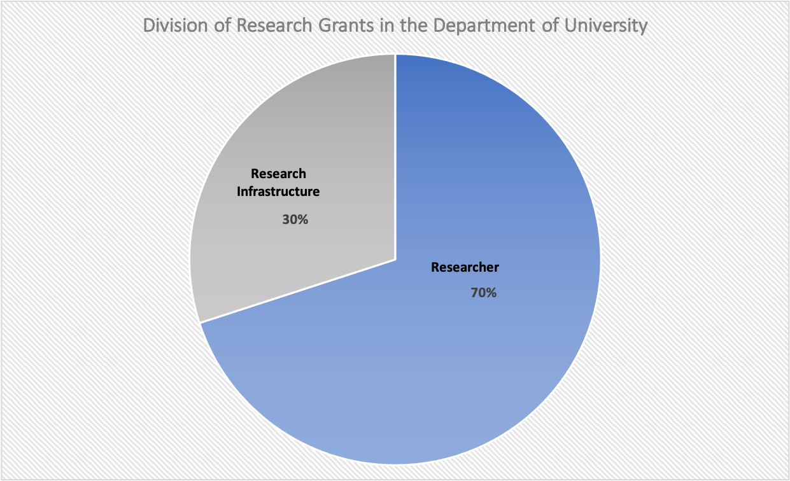

Allowance of Direct and Indirect Cost Expenditures and Limitations

The following general conditions apply to the provision of personnel costs and limitations by Higher Education Commission (4):

Sr # | Name of a Personnel | Expenditures Costs | Limitations
1. | Principal Investigator (HODs, Deans and faculty members) | Time cost of researcher calculated on the basis of their gross salary (i.e., basic pay, admissible allowances), multiplied by the time committed to the project. For example, if a faculty member contributes 2 months to a project, and she/ he has a gross salary of Rs. 200,000 per month, the project will be able to charge Rs. 400,000 for their time. | Faculty members may allocate a maximum of 25% of their time to research projects. Personnel costs billed against a faculty member's time may be paid to them as project honorarium, provided that the total honorarium received in any year is no more than 25% of their gross salary. If a faculty member wishes to allocate more than 25% of their time to research projects, the university will have to certify in writing that their teaching duties have been reduced proportionately, and that the corresponding amount has been deducted from their salary
2. | Students/Trainees | University students may be engaged as Research Assistants at the following scales:  ∙ PhD students: Rs. 80,000 per month, full time equivalent (FTE), times the time committed to the project.  ∙ MD/ MPhil Students: Rs. 80,000 FTE per month, subject to maximum time cap of 20% (i.e., an average of one day per week). ∙Undergraduate students: Rs. 60,000 FTE per month, subject to maximum time cap of 20% | Subject to approval of their supervisors, and based on their course load, PhD students at the thesis stage will be allowed to allocate between up to 80% of their time to research projects; those who have to take courses may allocate up to 20%. MD/ MPhil/ students may allocate only up to 20%. However, PhD students with course loads may, with the consent of their supervisors, allocate up to 40%, provided they reduce their course load by a quarter, thereby extending the duration of the degree programs. Only the university's own students can be included. The university, in its discretion, may provide a tuition waiver to students engaged as research assistants
3. | Other project personnel | Regardless of the actual amounts paid to project staff, the billed amount would be based on normal university salaries, e.g.  ∙ Research Assistants: (BS/ MS/MPhil) equivalent to lecturer.  ∙ Research Associate: (fresh PhD), equivalent to Asstt. Prof.  ∙ Research Fellow: (PhD with 9 years' experience) equivalent to Assoc. Prof.  ∙ Senior Fellow (PhD with 15 years' experience) equivalent to Professor. | The billed amount would be the multiple of the permitted gross salary, multiplied by the time allocated for the project (as per cent of FTE). Each person appointed to project should receive a formal contract, specifying all the terms of employment, including salary, benefits, and the duration of engagement. Project employment should not create an entitlement or expectation of full-time regular employment.

The following general conditions apply to the provision of equipment, consumables and services costs:
Sr # | Items | Description
1. | Equipment | ∙ Scientific lab Equipment: tools and equipment used in laboratories for research work relevant to the project. Some examples are DNA sequencers, electrometers, or spectrometers.  ∙ IT equipment: E.g, servers, network equipment, routers, or communication equipment.  ∙ Office Equipment: laptops, desktops, scanners, printers.  ∙ Specialized Software/ IT Applications: e.g., LabView, AutoCAD, MATLAB.
2. | Consumables | ∙ Lab Chemicals: e.g., chlorates, persulfates, peroxides, oxidizing acids, methanol, ethanol, or reagents.  ∙ Glassware: e.g., beakers, flasks, or test tubes.  ∙ Plastic wares: e.g., pipettes.  ∙ Expendable supplies: e.g., preserving and cleaning material, fuel, medicines, personal protective equipment, i.e., gloves, masks, or surgical caps.  ∙ Accessories: small accessories used routinely in labs, e.g., kits, PCR plates, ladders, sealers, magnetic stands
3. | Services  - Travel Cost | Access to scientific equipment: cost of access to sophisticated lab or research equipment not available in host institution.  ∙ Service contract for repair/ maintenance of purchased scientific equipment: The service cost should not exceed 25% of the cost of current price of the similar model  ∙ Subscription to open access journals or publications:  ∙ Management Cost for organizing national level conferences, workshops, or seminars: in cases, where such dissemination of research results are outsourced to external professional bodies.  Travel Cost covers expenses of project team (faculty and students) related to field work, participation in project meetings, attending national or international conferences or workshops to present research results from the project.  a. Prior authorization must be obtained for each project-related travel.  b. Travel budget must be justified by providing purpose of visit, the city, the country, the number of travelers, and estimated costs per visit.

REFERENCES:

- file:///Users/Huma/Downloads/Vit%20D/Funding-policy-HEIs.pdf
- https://adminguide.stanford.edu/chapter-3/subchapter-1/policy-3-1-2
- https://finance.princeton.edu/budgeting-financial-management/budgeting-and-planning/budgeting-academic-departments
- https://www.hec.gov.pk/english/services/faculty/LCF/Documents/Financial%20Rules%20for%20HEC%20Competitive%20Research%20Grants.pdf
- https://www.ucop.edu/research-policy-analysis-coordination/policies-guidance/indirect-cost-recovery/Costs-of-Research-FAQ-AAU.pdf
- Kesselheim, A.S., Robertson, C.T., Myers, J.A., Rose, S.L., Gillet, V., Ross, K.M., Glynn, R.J., Joffe, S. and Avorn, J., 2012.New England Journal of Medicine, 367(12), pp.1119-1127.

