Annual Audit Report 2020
SURGICAL UNIT 1
BENAZIR BHUTTO HOSPITAL
RAWALPINDI
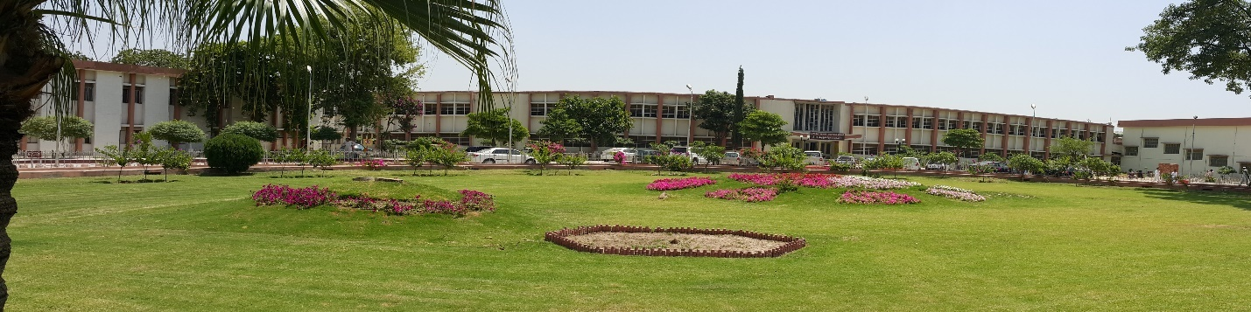

COMPILED BY
DR. SARMAD ANSARI
POST GRADUATE TRAINEE
Surgical Unit-I
BBH, Rawalpindi

CONTENTS
INTRODUCTION 4
MESSAGE FROM DEPARTMENT HEAD 5
COMMITTEE STRUCTURE 6,7,8
MEET US 9
WARD AUDIT 10-16
ICU AUDIT 17
OPD AUDIT 20
COT AUDIT 20-25
MOT AUDIT 28-34
ENDOSCOPY ROOM AUDIT Error! Bookmark not defined.
WORKSHOP AUDIT 36,37
ONGOING PROJECTS 38,39

INTRODUCTION
Department of Surgery shares the spirit, and is connected by our dedication to the purity of creating a place where any patient can come at any time to receive the best treatment possible. By small triumphs or major leaps; the product of teamwork or individual incentive; each act that moves us closer to this ideal is important, and energized by passion. Surgical unit I is a true General Surgical Unit because we deal with Hepato-biliary, GIT, Vascular, Endocrine , Thoracic, Breast diseases & Trauma and because of lack of specialized units of Plastic surgery, Pediatrics Surgery, Thoracic surgery in Allied Hospitals, we also deal with these cases.

Total No. of beds in Surgical wards | 41
Male Surgical Ward | 20
Female Surgical Ward | 17
Number Of beds in HDU | 06
No. of beds in ICU | Shared 08 beds
No. of Beds in Private Block | Shared 13 beds
No. of Beds in ER | 24 beds

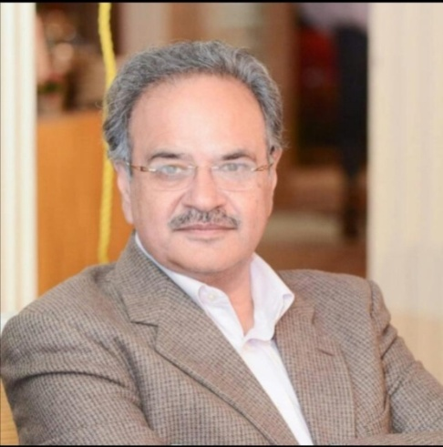

MESSAGE FROM DEPARTMENT HEAD

Practice of medicine is in a continuous state of evolution. Mankind has seen tremendous changes in different treatment modalities. The last two decades were remarkable as we witnessed in enormous change in technology and treatment protocols with improved outcomes.
The present era is of specialized work with emergence of sub specialties. Our country is also following this trend of specialization but with a very slow pace.
This annual report indicates the effort of our unit in keeping up with the pace of this evolution. It is obvious from this report that there is a heavy work load of patients who need sub specialty care, but are being managed in General Surgery. This will help in improving our treatment protocols and patient care.

LIST OF FACULTY MEMBERS OF SURGICAL UNIT-I

Prof. Dr. Naeem Zia
MBBS, FCPS, FRCS, FACS
Professor of Surgery RMU
Surgical unit-I
Benazir Bhutto Hospital, Rawalpindi
PMDC No. 14554-P

Dr. Anis Ahmed
MBBS, FCPS, MRCS (Glasgow), MHPE (KMU)
Associate Professor Surgery RMU
Surgical Unit-I
Benazir Bhutto Hospital, Rawalpindi
PMDC No. 28154-P

Dr. Muhammad Iqbal
MBBS, MCPS, FCPS,
Assistant Professor Surgery RMU
Surgical unit-I,
Benazir Bhutto Hospital, Rawalpindi
PMDC No. 38519-P

Dr. Asifa Dian Khan
FCPS, MRCS, MCPS
Senior Registrar
Surgical unit-I, Benazir Bhutto Hospital, Rawalpindi
PMDC No. 39239-P

Dr. Syed Rahat Hassan
FCPS, MRCPS
Senior Registrar
Surgical unit-I, Benazir Bhutto Hospital, Rawalpindi
PMDC No. 47963-P

Dr. Tahir Ashraf Awan
FCPS, MRCS
Senior Registrar, Surgical Unit-I
Benazir Bhutto Hospital, Rawalpindi
PMDC No. 54859-S

Dr. Muhammad Usman Ghani
FCPS
Senior Registrar, Surgical Unit-I
Benazir Bhutto Hospital, Rawalpindi
PMDC No. 62478-P

MEET US

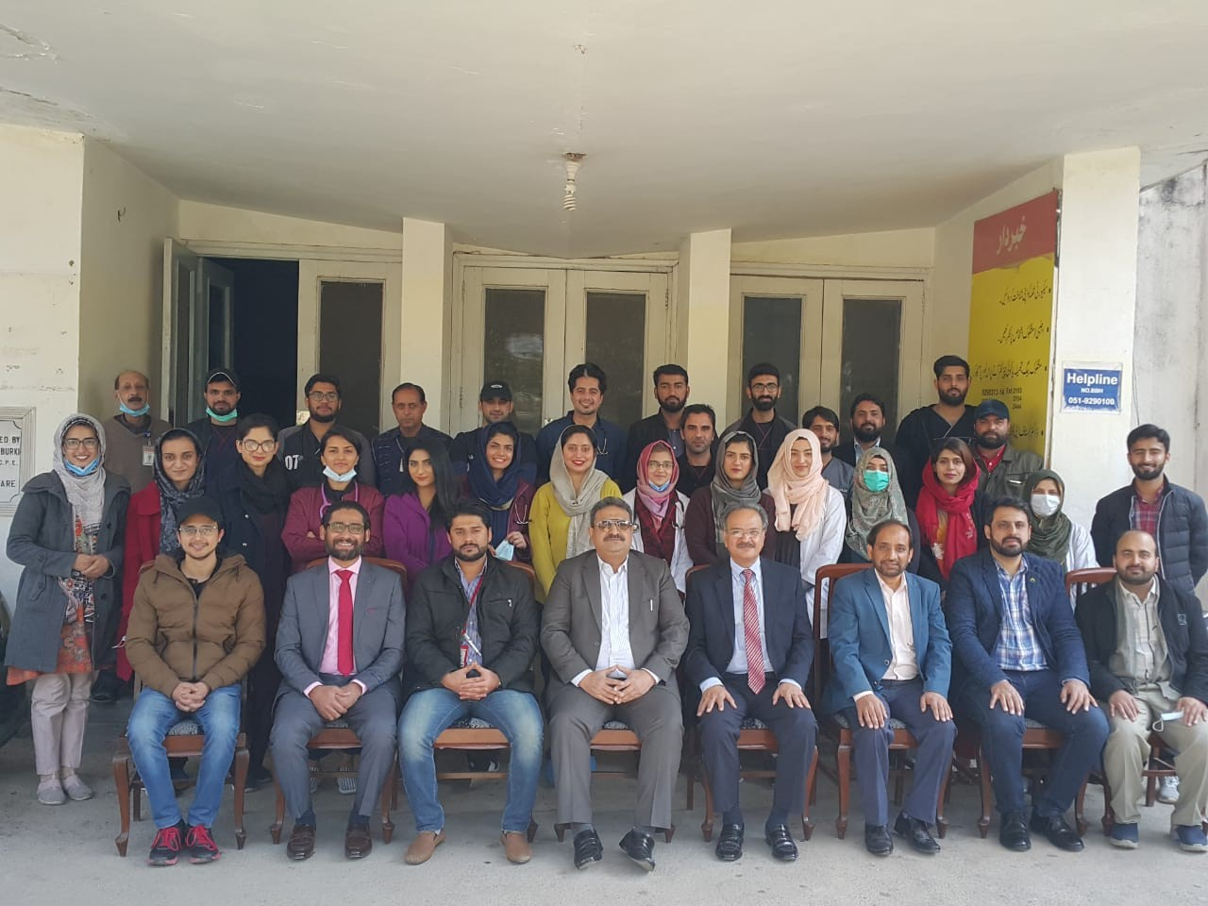

ANNUAL REPORTS

WARD AUDIT
TOTAL ADMISSIONS IN SU-1
 | Male 2019 | Male 2020 | Female 2019 | Female 2020 | Total 2019 | Total 2020
ER | 1245 | 778 | 504 | 478 | 1749 | 1256
OPD | 249 | 228 | 556 | 299 | 805 | 527
Total | 1494 | 1006 | 1060 | 787 | 2554 | 1793

WARD ADMISSIONS
Ward 9/HDU 2019 | Ward 9/HDU 2020 | Ward 10 2019 | Ward 10 2020 | ICU 2019 | ICU 2020 | Total 2019 | Total 2020
1410 | 1006 | 1047 | 787 | 53 | 72 | 2510 | 1865

MONTHLY WARD WISE ADMISSIONS
MONTH | WARD 9/HDU 2019 | WARD 9 /HDU 2020 | WARD 10 2019 | WARD 10 2020 | ICU 2019 | ICU 2020 | TOTAL 2019 | TOTAL 2020
January | 110 | 120 | 96 | 98 | 07 | 07 | 213 | 225
February | 111 | 118 | 97 | 111 | 08 | 10 | 216 | 239
March | 113 | 84 | 69 | 92 | 06 | 08 | 188 | 184
April | 134 | 36 | 93 | 24 | 04 | 08 | 231 | 68
May | 105 | 51 | 76 | 35 | 02 | 05 | 183 | 91
June | 126 | 10 | 84 | 09 | 03 | 0 | 213 | 19
July | 134 | 33 | 119 | 07 | 06 | 01 | 259 | 41
August | 135 | 80 | 81 | 62 | 02 | 07 | 218 | 149
September | 111 | 116 | 60 | 102 | 04 | 08 | 175 | 226
October | 100 | 113 | 74 | 102 | 01 | 11 | 175 | 226
November | 130 | 126 | 103 | 74 | 04 | 01 | 237 | 201
December | 101 | 119 | 95 | 71 | 06 | 06 | 202 | 186
Total | 1410 | 996 |  | 787 | 53 | 72 | 2510 | 1855

MONTH WISE AND GENDER WISE MORTALITY
MONTH | TOTAL MORTALITY 2019 | TOTAL MORTALITY 2020 | MALE 2019 | MALE 2020 | FEMALE 2019 | FEMALE 2020
JAN | 09 | 03 | 04 | 02 | 05 | 01
FEB | 04 | 03 | 02 | 03 | 02 | 0
MARCH | 04 | 04 | 01 | 04 | 03 | 0
APRIL | 05 | 04 | 03 | 02 | 02 | 02
MAY | 09 | 03 | 05 | 01 | 04 | 02
JUNE | 05 | 0 | 03 | 0 | 02 | 0
JULY | 05 | 02 | 03 | 01 | 02 | 01
AUGUST | 04 | 02 | 03 | 02 | 01 | 0
SEPT | 03 | 04 | 02 | 03 | 01 | 01
OCT | 04 | 09 | 00 | 06 | 04 | 03
NOV | 03 | 03 | 02 | 02 | 01 | 01
DEC | 02 | 05 | 02 | 04 | 00 | 01
TOTAL | 57 | 42 | 30 | 30 | 27 | 12

AGE WISE DISTRIBUTION IN WARD 9
MONTH | <20 yrs | 20 -40 yrs | 40-60 yrs | >60 yrs | TOTAL
January | 12 | 33 | 55 | 20 | 120
February | 14 | 44 | 44 | 16 | 118
March | 06 | 28 | 38 | 12 | 84
April | 02 | 18 | 10 | 06 | 36
May | 01 | 18 | 22 | 10 | 51
June | 00 | 05 | 04 | 01 | 10
July | 06 | 10 | 10 | 07 | 33
August | 10 | 30 | 28 | 12 | 80
September | 18 | 42 | 38 | 18 | 116
October | 19 | 42 | 35 | 17 | 113
November | 14 | 52 | 42 | 18 | 126
December | 15 | 43 | 46 | 14 | 119
TOTAL | 117 | 365 | 373 | 151 | 1006

AGE WISE DISTRIBUTION IN WARD 10
MONTH | <20 yrs | 20 -40 yrs | 40-60 yrs | >60 yrs | TOTAL
January | 08 | 36 | 48 | 06 | 98
February | 11 | 44 | 48 | 08 | 111
March | 02 | 43 | 40 | 07 | 92
April | 01 | 10 | 11 | 02 | 24
May | 02 | 16 | 14 | 03 | 35
June | 00 | 02 | 07 | 00 | 09
July | 00 | 02 | 05 | 00 | 07
August | 04 | 20 | 32 | 06 | 62
September | 12 | 58 | 20 | 12 | 102
October | 17 | 20 | 58 | 07 | 102
November | 12 | 22 | 32 | 06 | 74
December | 15 | 30 | 25 | 01 | 71
TOTAL | 84 | 303 | 342 | 58 | 787

OUTCOME OF ALL ADMITTED PATIENTS
MONTH | DISCHARGED 2019 | DISCHARGED 2020 | EXPIRED 2019 | EXPIRED 2020
JAN | 256 | 216 | 13 | 03
FEB | 218 | 214 | 09 | 03
MARCH | 241 | 200 | 06 | 04
APRIL | 251 | 51 | 06 | 04
MAY | 238 | 76 | 09 | 03
JUNE | 200 | 22 | 06 | 00
JULY | 204 | 41 | 08 | 02
AUGUST | 203 | 130 | 05 | 02
SEPT | 217 | 220 | 07 | 04
OCT | 206 | 189 | 05 | 09
NOV | 202 | 166 | 04 | 03
DEC | 173 | 153 | 03 | 06
TOTAL | 2409 | 1678 | 81 | 43

MONTH | ADMISSIONS 2019 | ADMISSIONS 2020 | SHIFTED TO WARD 2019 | SHIFTED TO WARD 2020 | EXPIRIES 2019 | EXPIRED 2020
January | 07 | 07 | 03 | 02 | 04 | 04
February | 08 | 10 | 03 | 03 | 05 | 06
March | 06 | 08 | 04 | 04 | 02 | 04
April | 04 | 08 | 03 | 04 | 01 | 04
May | 02 | 05 | 02 | 02 | 00 | 03
June | 03 | 00 | 02 | 00 | 01 | 00
July | 06 | 01 | 03 | 00 | 03 | 01
August | 02 | 07 | 01 | 02 | 01 | 05
September | 04 | 08 | 00 | 04 | 04 | 04
October | 01 | 11 | 00 | 02 | 01 | 09
November | 04 | 01 | 01 | 00 | 03 | 01
December | 06 | 06 | 05 | 03 | 01 | 03
Total | 53 | 72 | 27 | 26 | 26 | 43

ICU AUDIT

OPD AUDIT

Month | Male 2019 | Male 2020 | Female 2019 | Female2020 | Total 2019 | Total 2020
January | 899 | 1133 | 1009 | 1129 | 1908 | 2262
February | 973 | 979 | 1026 | 1103 | 1999 | 2082
March | 1188 | 863 | 1137 | 902 | 2325 | 1765
April | 1162 | 382 | 1208 | 293 | 2370 | 675
May | 848 | 297 | 754 | 262 | 1602 | 559
June | 952 | 90 | 958 | 95 | 1910 | 185
July | 1450 | 237 | 1371 | 175 | 2821 | 412
August | 1058 | 638 | 962 | 502 | 2020 | 1140
September | 1323 | 1262 | 1161 | 1083 | 2484 | 2345
October | 562 | 1044 | 529 | 1156 | 1091 | 2200
November | 953 | 943 | 913 | 949 | 1866 | 1892
December | 945 | 987 | 990 | 1003 | 1935 | 1990
Total | 12313 | 8855 | 12017 | 8652 | 24330 | 17507

 |  | CASES DEALT IN EMERGENCY ROOM AND TOTAL ER ADMISSIONS
MONTH | TOTAL 2019 |  | TOTAL 2020 | MALE 2019 | MALE 2020 | FEMALE 2019 | FEMALE 2020 | ADMISSION 2019 | ADMISSIONS 2020
JANUARY | 4551 |  | 5869 | 3000 | 3783 | 1551 | 2086 | 115 | 135
FEBRURY | 5068 |  | 6347 | 3294 | 1421 | 1774 | 2276 | 170 | 133
MARCH | 5844 |  | 5019 | 3788 | 3106 | 2056 | 1913 | 106 | 119
APRIL | 5931 |  | 3240 | 3953 | 2133 | 1978 | 1107 | 117 | 59
MAY | 6464 |  | 4131 | 4397 | 2815 | 2067 | 1316 | 134 | 86
JUNE | 7216 |  | 2181 | 4778 | 1547 | 2438 | 634 | 145 | 19
JULY | 8220 |  | 3358 | 5348 | 2337 | 2872 | 981 | 123 | 39
AUGUST | 6088 |  | 4948 | 4103 | 3394 | 1985 | 1554 | 152 | 108
SEPTEMBER | 4518 |  | 5224 | 2624 | 3552 | 1394 | 1672 | 104 | 149
OCTOBER | 1692 |  | 6990 | 1128 | 4703 | 564 | 2287 | 89 | 140
NOVEMBER | 4721 |  | 4869 | 3095 | 3324 | 1626 | 1545 | 140 | 145
DECEMBER | 3846 |  | 5099 | 2588 | 3293 | 1258 | 1806 | 125 | 124
TOTAL | 63659 |  | 56341 | 42096 | 35408 | 21563 | 20933 | 1520 | 1256

NO OF ACCIDENT CASES ATTENDED AT ER
MONTH | TOTAL 2019 | TOTAL 2020 | MALE 2019 | MALE 2020 | FEMALE 2019 | FEMALE 2020
JANUARY | 1645 | 1545 | 1189 | 1089 | 556 | 456
FEBRURY | 1925 | 1725 | 1360 | 1260 | 565 | 465
MARCH | 1652 | 1552 | 1091 | 991 | 661 | 561
APRIL | 1560 | 1460 | 1065 | 965 | 595 | 495
MAY | 1670 | 1570 | 1194 | 1094 | 576 | 476
JUNE | 1456 | 1356 | 1116 | 1016 | 540 | 440
JULY | 1640 | 1340 | 1054 | 954 | 586 | 386
AUGUST | 1660 | 1560 | 1265 | 1165 | 495 | 395
SEPTEMBER | 1586 | 1386 | 1045 | 945 | 541 | 441
OCTOBER | 1628 | 1428 | 1088 | 988 | 594 | 494
NOVEMBER | 1957 | 1757 | 1389 | 1289 | 568 | 468
DECEMBER | 1845 | 1645 | 1301 | 1201 | 544 | 444
Total | 28024 | 18324 | 14157 | 12957 | 6721 | 5421

COT AUDIT
COT OPERATED CASES
Month | Total | Major | Minor | Consultant | Trainees
January | 77 | 66 | 11 | 16 | 61
February | 68 | 60 | 08 | 09 | 59
March | 62 | 57 | 05 | 11 | 51
April | 46 | 42 | 04 | 9 | 37
May | 53 | 41 | 12 | 8 | 45
June | 1 | 1 | 0 | 0 | 1
July | 9 | 8 | 1 | 3 | 6
August | 39 | 28 | 11 | 13 | 26
September | 79 | 69 | 10 | 8 | 71
October | 87 | 75 | 12 | 12 | 75
November | 82 | 64 | 18 | 2 | 80
December | 126 | 75 | 51 | 18 | 108
TOTAL | 729 | 586 | 143 | 109 | 620

DETAIL OF COT OPERATED CASES
TOTAL | 1130  Year 2019 | 729  Year 2020
Abdominal Surgery
Open Appendectomy | 382 | 273
Laproscopic Appendix | 19 | 20
Open Cholecystectomy | 00 | 2
Diagnostic Laparotomy | 02 | 0
Exploratory Laparotomy | 170 | 46
Feeding jejunostomy | 3 | 6
Stoma refashioning | 2 | 10
Perforated duodenal ulcer | 56 | 29
Typhoid perforation | 34 | 2
Tuberculous perforation | 14 | 0
Perforated appendix | 45 | 20
Other Gut perforation | 12 | 8
Intussusception | 01 | 0
Pseudomyxoma peritonitis | 0 | 0
Blunt Trauma Abdomen | 24 | 10
Penetrating Trauma abdomen | 6 | 3
FAI | 14 | 20
Stab Abdomen | 15 | 9
Obstructed Inguinal Hernia | 13 | 9
Obstructed PUH | 12 | 9
Mesenteric Ischemia | O1 | 4
Burst abdomen | 02 | 8
Pancreatitis (Necrosectomy) | 0 | 2
Intraabdominal / Pelvic collection | 01 | 5
Mass / CA | 2 | 4
Re-laparotomy | 02 | 16
Baggota Bag Application | 02 | 08
Hemorrhoidectomy | 02 | 3
Perianal abscess | 05 | 14
Pilonidal Sinus | 00 | 0
Vascular Surgery | 18 | 24
Fasciotomy | 35 | 31
Above Knee Amputation | 15 | 15
Below Knee Amputation | 26 | 25
Ray amputation | 67 | 47
Above elbow amputation | 04 | 10
Thoracotomy | 05 | 3
Chest intubation | 67 | 11
Tracheostomy | 05 | 2
Neck exploration | 17 | 8
Incision & Drainage | 67 | 46
Debridement & Dressing | 98 | 30
Carbuncle deroofing | 16 | 7
Orchidectomy | 00 | 1
Amputation Stump refashioning | 05 | 5
Rectal polypectomy | 0 | 0
Rectal Biopsy | 05 | 2
Diversion Colostomy |  | 4

NO OF CASES OPERATED 2020 in MOT
(CATEGORY & ANESTHESIA WISE)

Month | Total | Major | Minor | GA | SA | LA
January | 92 | 64 | 28 | 50 | 22 | 20
February | 86 | 51 | 35 | 49 | 11 | 26
March | 63 | 38 | 25 | 32 | 11 | 20
April | 0 | 0 | 0 | 0 | 0 | 0
May | 0 | 0 | 0 | 0 | 0 | 0
June | 0 | 0 | 0 | 0 | 0 | 0
July | 0 | 0 | 0 | 0 | 0 | 0
August | 36 | 21 | 15 | 03 | 23 | 10
September | 99 | 58 | 41 | 43 | 19 | 37
October | 103 | 69 | 34 | 56 | 16 | 31
November | 66 | 46 | 20 | 36 | 09 | 21
December | 77 | 60 | 17 | 49 | 14 | 14
TOTAL | 622 | 407 | 215 | 318 | 125 | 179

NO OF CASES OPERATED 2019 in MOT
(CATEGORY & ANESTHESIA WISE)
Month | Total | Major | Minor | GA | SA | LA
January | 107 | 79 | 28 | 56 | 23 | 28
February | 118 | 89 | 29 | 66 | 23 | 29
March | 116 | 88 | 28 | 70 | 18 | 28
April | 114 | 85 | 29 | 59 | 26 | 29
May | 79 | 49 | 30 | 39 | 10 | 49
June | 90 | 59 | 31 | 29 | 30 | 59
July | 118 | 89 | 29 | 69 | 20 | 29
August | 95 | 57 | 38 | 45 | 12 | 38
September | 96 | 56 | 40 | 43 | 13 | 40
October | 91 | 55 | 36 | 40 | 15 | 36
November | 96 | 54 | 42 | 43 | 11 | 42
December | 90 | 56 | 34 | 42 | 14 | 34
TOTAL | 1210 | 816 | 394 | 601 | 215 | 394

MOT CASES OPERATED BY (2020)
Month | Total | HOD | Associate Prof | Asst. Prof | SR | PGT/HO
January | 92 | 04 | 13 | 05 | 29 | 41
February | 86 | 10 | 08 | 04 | 17 | 47
March | 63 | 01 | 08 | 04 | 12 | 38
April | 0 | 0 | 0 | 0 | 0 | 0
May | 0 | 0 | 0 | 0 | 0 | 0
June | 0 | 0 | 0 | 0 | 0 | 0
July | 0 | 0 | 0 | 0 | 0 | 0
August | 36 | 05 | 05 | 02 | 07 | 17
September | 99 | 07 | 08 | 07 | 25 | 52
October | 103 | 04 | 08 | 12 | 27 | 52
November | 66 | 04 | 08 | 04 | 15 | 43
December | 77 | 06 | 06 | 04 | 13 | 48
MOT CASES OPERATED BY (2019)
Month | TOTAL | HOD | Asso. Prof | Asst. Prof | SR | PGT | HO
January | 167 | 08 | 17 | 00 | 32 | 106 | 4
February | 165 | 07 | 16 | 00 | 31 | 108 | 3
March | 168 | 07 | 13 | 06 | 39 | 101 | 2
April | 166 | 08 | 12 | 08 | 42 | 92 | 4
May | 135 | 08 | 15 | 07 | 45 | 56 | 4
June | 129 | 06 | 20 | 08 | 48 | 45 | 2
July | 145 | 09 | 15 | 08 | 44 | 65 | 4
August | 91 | 05 | 07 | 01 | 21 | 55 | 2
September | 101 | 07 | 08 | 05 | 22 | 56 | 3
October | 102 | 06 | 09 | 05 | 23 | 55 | 4
November | 88 | 05 | 07 | 06 | 20 | 48 | 2
December | 80 | 04 | 07 | 00 | 20 | 47 | 2

GENDER WISE DISTRIBUTION (2020)
Month | Total | Male | Female
January | 92 | 44 | 48
February | 86 | 42 | 44
March | 63 | 30 | 33
April | 0 | 0 | 0
May | 0 | 0 | 0
June | 0 | 0 | 0
July | 0 | 0 | 0
August | 36 | 12 | 24
September | 99 | 41 | 58
October | 103 | 45 | 58
November | 66 | 40 | 26
December | 77 | 43 | 34

GENDER WISE DISTRIBUTION (2019)
Month | Total | Male | Female
January | 105 | 44 | 71
February | 103 | 47 | 56
March | 116 | 67 | 59
April | 101 | 52 | 49
May | 90 | 51 | 39
June | 95 | 47 | 48
July | 124 | 57 | 67
August | 77 | 34 | 43
September | 122 | 60 | 62
October | 104 | 45 | 49
November | 103 | 47 | 56
December | 72 | 34 | 38

DETAILS OF OPERATED CASES
ABDOMINAL SURGERIES | Year 2019 | Year 2020
Diagnostic Laparoscopy | 03 | 05
Incisional Hernia repair | 27 | 12
TEP | 06 | 02
Diaphragmatic hernia Repair | 44 | 01
PUH Repair | 012 | 34
Umbilical hernia | 125 | 02
Inguinal hernioplasty | 13 | 53
Inguinal herniotomy & Desarda | 07 | 14
Epigastric hernia repair | 00 | 07
Needle herniotomy | 01 | 2
Pancreaticojejenostomy | 01 | 01
Jejunostomy reversal | 03 | 02
Jaboley’s procedure | 00 | 02
Lap Cystectomy | 01 | 01
Median sternotomy | 03 | 0
Rectopexy | 02 | 0
TAPP | 01 | 0
Femoral hernia repair | 01 | 0
Hiatal hernia repair | 01 | 01
LAR | 00 | 0
Whipple procedure | 286 | 0
Lap. Cholecystectomy | 24 | 165
Open cholecystectomy | 24 | 12
Stoma repair | 01 | 00
Exploratory laprotomy & necrosectomy | 02 | 01
Choledochoduodenostomy | 14 | 00
Exploratory Laparotomy | 04 | 11
CBD exploration | 00 | 03
Triple bypass | 00 | 0
Exploration & Biopsy of mass pancreatic region | 02 | 00
Cysto-gastrostomy | 01 | 03
Splenectomy | 00 | 02
Partial Cholecystectomy | 01 | 03
Radical nephrectomy | 00 | 0
Gastro-jejunostomy | 02 | 01
Colostomy | 18 | 02
Ileostomy reversal | 03 | 7
Ileostomy | 02 | 0
Feeding jejunostomy | 08 | 02
Colostomy reversal | 00 | 02
Lap assisted Pan colectomy | 02 | 00
Lap assisted Hemicolectomy | 03 | 00
Ramstad’s pyloromyotomy | 04 | 0
Anal fissure- sphincterotomy | 12 | 05
Fistulectomy | 03 | 20
Rectopexy | 05 | 0
Inj Sclerotherapy for rectal prolapse | 06 | 00
Lap Varicocele | 05 | 00
Exploration of RIF mass | 01 | 01
Haemorrhoidectomy | 06 | 08
Band ligation | 37 | 0
Abdominoperineal resection | 08 | 01
Anterior Resection | 01 | 0
Adrenelectomy | 01 | 01
Laparoscopic Heller’s Myotomy | 01 | 03
Transhiatalesophagectomy | 01 | 00
Lap Orchidectomy | 00 | 02
Sleeve Gastrectomy | 01 | 00
Rigid Sigmoidoscopy | 00 | 11
Incisional Biopsy |  | 08

BREAST SURGERIES
 | Year 2020 | Year 2019
Fibroadenoma excision | 11 | 18
MRM | 05 | 09
MRM & TRAM | 0 | 01
Tru-cut biopsy | 08 | 18
Subcutaneous Mastectomy | 03 | 01

HEAD AND NECK SURGERIES
 | Year 2020 | Year 2019
Thyroid Surgery | 22 | 18
Sistrunk Operation | 01 | 09
Tracheostomy | 02 | 01
Lymph node biopsy | 10 | 18
Parotidectomy | 06 | 01
Submandibular gland excision | 02 | 01

THORACIC SURGERIES
 | Year 2020 | Year 2019
Thorocotomy | 11 | 04
VATS | 02 | 01
Lobectomy | 02 | 03
Pneumonectomy | 01 | 01
Decortication | 07 | 02
Rib Resection | 05 | 05
Chest tube insertion / readjustment | 08 | 01

VASCULAR SURGERIES
 | Year 2020 | Year 2019
Striping & flush ligation | 12 | 25
Hemangioma | 00 | 00
Pseudo-aneurysm ligation | 0 | 00
Injection sclerotherapy | 03 | 00
Ligation | 00 | 00
Thrombectomy | 0 | 01

PAEDIATRIC SURGERIES
 | Year 2020 | Year 2019
Radical Nephrectomy | 00 | 00
Ramsted’s pyloromyotomy | 00 | 03
Herniotomy | 02 | 02
Ileostomy reversal | 00 | 00
Exploratory laparotomy | 00 | 00
Tongue tie | 00 | 00
Orchidopexy | 03 | 01
Orchidectomy | 07 | 07
Circumcision | 38 | 76
Polypectomy | 00 | 00

PLASTIC SURGERIES
 | Year 2020 | Year 2019
Rhomboid Flap | 07 | 13
Z Plasty | 00 | 01
Reconstruction Flap | 00 | 01
SCC excision and flap | 01 | 00
Debridements | 10 | ---
VAC dressings | 05 | ---
Lipoma Excision | 13 | 21
Wide local excision | 07 | ---

ENDOSCOPY ROOM AUDIT 2020
MONTH | UPPER GI ENDOSCOPY | COLONOSCOPY | BRONCHOSCOPY
January | 00 | 02 | 0
February | 0 | 0 | 0
March | 0 | 02 | 0
April | 0 | 0 | 0
May | 0 | 0 | 0
June | 0 | 0 | 0
July | 0 | 0 | 0
August | 0 | 0 | 0
September | 0 | 0 | 0
0ctober | 0 | 0 | 0
November | 0 | 0 | 0
December | 0 | 0 | 0
Total | 0 | 04 | 0
ENDOSCOPY ROOM AUDIT 2019
MONTH | UPPER GI ENDOSCOPY | COLONOSCOPY | BRONCHOSCOPY
January | 02 | 02 | 00
February | 02 | 02 | 00
March | 03 | 04 | 00
April | 01 | 02 | 00
May | 02 | 04 | 00
June | 01 | 03 | 00
July | 02 | 02 | 00
August | 03 | 04 | 00
September | 01 | 03 | 00
October | 02 | 03 | 00
November | 01 | 02 | 00
December | 05 | 02 | 01

WORKSHOPS REPORT
Annual Resident Research Forum 2020 was well attended by PGTs and Faculty members. Poster presentations, research presentations and case presentations were done by PGTs and Faculty members.
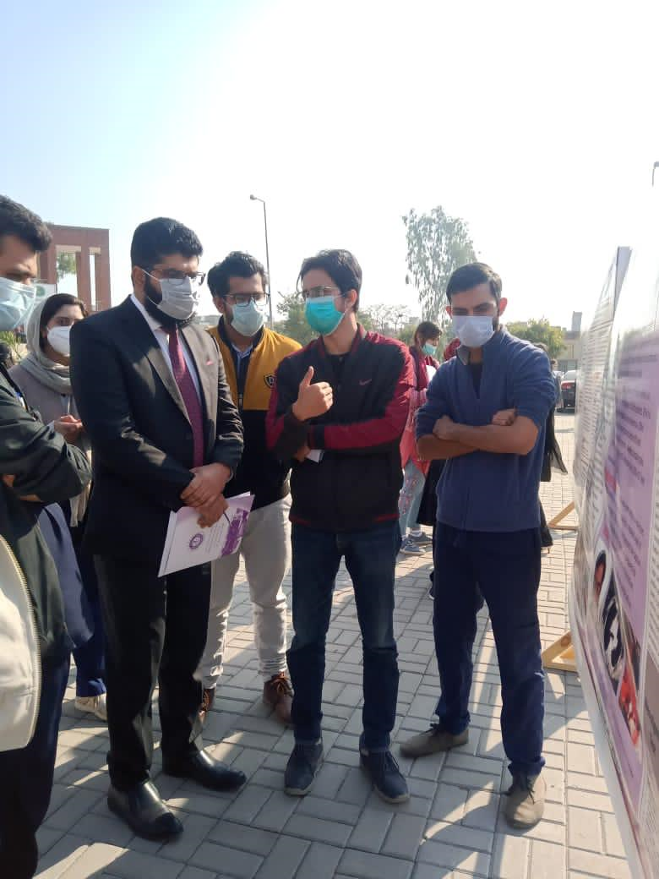

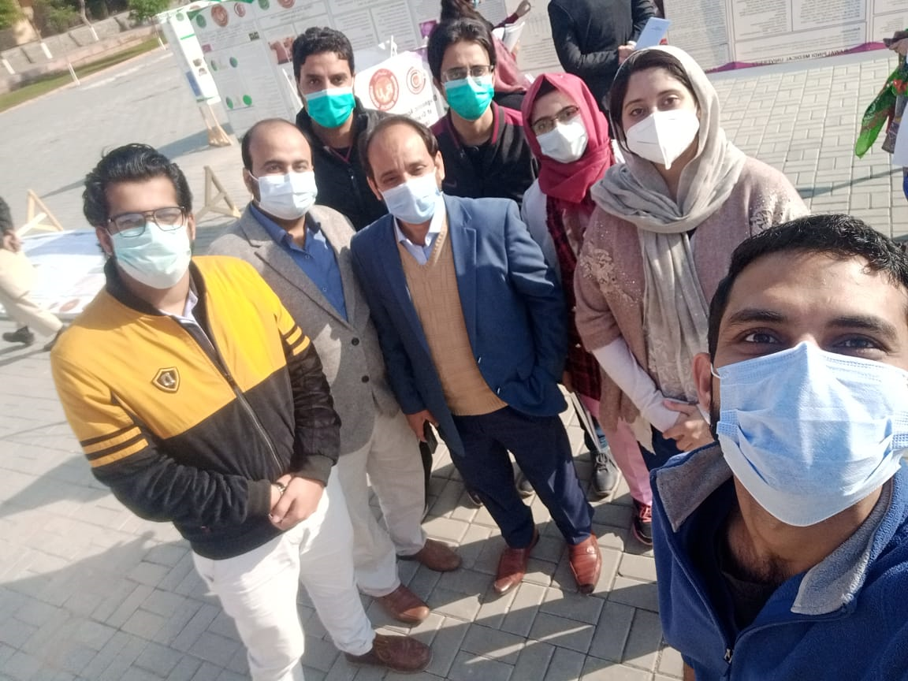
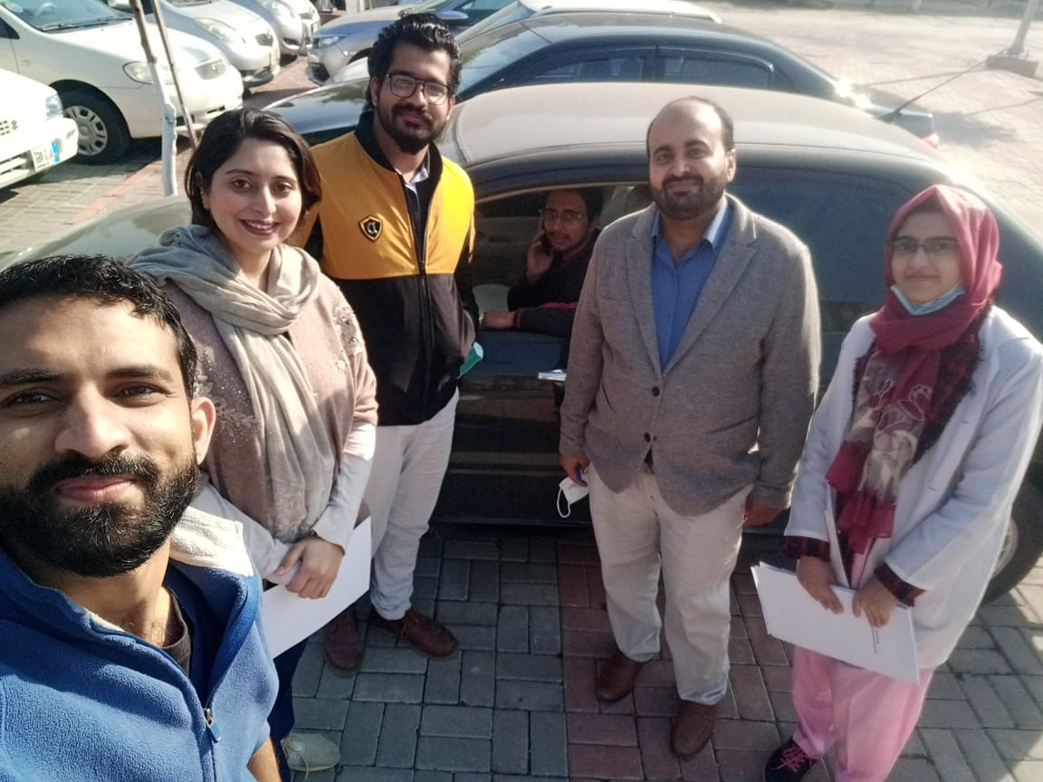

ONGOING PROJECTS
TELEMEDICINE & MDM
Neither a surgeon nor an oncologist alone can treat a cancer patient. It is the multimodality approach involving different specialties including surgery, oncology, pathology, diagnostic radiology, gynecology, psychiatry & nutrition. One of the biggest achievement of the year 2016 was in the field of Telemedicine.
We continued having our liaison with Nuclear Medicine Oncology and Radiotherapy Institute (NORI), Islamabad. We have weekly sessions on every Friday from 8:00AM to 9:00 am. In every session 2-3 cases are discussed regarding their management and further plan. More than 400 patients have been discussed so far. This not only improves patient care and saves the time but also provide a better insight of the disease process. A number of patients have been referred to NORI for Radio-chemotherapy and vice-versa, to SU-I for surgery. Common malignancies discussed were CA Breast, CA thyroid, Skin & Soft tissue tumors and GIT malignancies. Our Future plans are to ensure the involvement of Radiologists and Pathologists in the session.
BREAST CLINIC
It was established in March 2014. The timings are 10 am to 12 pm every Wednesday in OPD Room 39.
Our goals are to develop, implement and promote best practice, patient focused multi-disciplinary breast care, to facilitate the early detection and diagnosis of breast cancer & to monitor breast cancer outcomes through data collection and analysis.
Breast clinic at BBH provides value care for the patients having breast cancer or other breast related issues such as changes in breast skin, nipple discharge, breast infection and breast pain. Patients are examined by very skillful and learned female surgeons Mammography, ultrasound, ultrasound-guided breast biopsy services are available here at very low cost. Tru-cut biopsy facility is available on OPD basis to avoid multiple visits.
Weekly MDM sessions are held with NORI (Oncology) for better insight of disease on individual patient basis.
ESTABLISHMENT OF LAPROCOPIC SKILL LAB
Laparoscopic surgery, also called minimally invasive surgery (MIS), band aid surgery, or keyhole surgery, is a modern surgical technique in which operations are performed far from their location through small incisions (usually 0.5–1.5 cm) elsewhere in the body. Laparoscopic surgery is the demand of recent times so our great Prof Dr Naeem Zia keeping in view this demand put his greatest effort in establishment of laparoscopic skill labs for post graduate trainees of surgical unit I. He advocated a room for it from its renovation till completion of it from all resources of himself without any assistance of hospital funds.
It is great achievement and it is greatly helpful in learning different techniques for trainees as well as improving their expertise for senior registrar of surgical floor.

