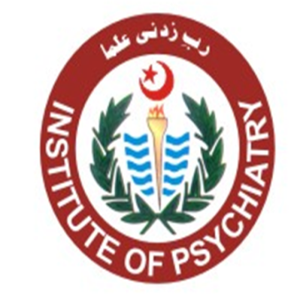
Annual Report 2020

Institute of Psychiatry
Rawalpindi Medical University
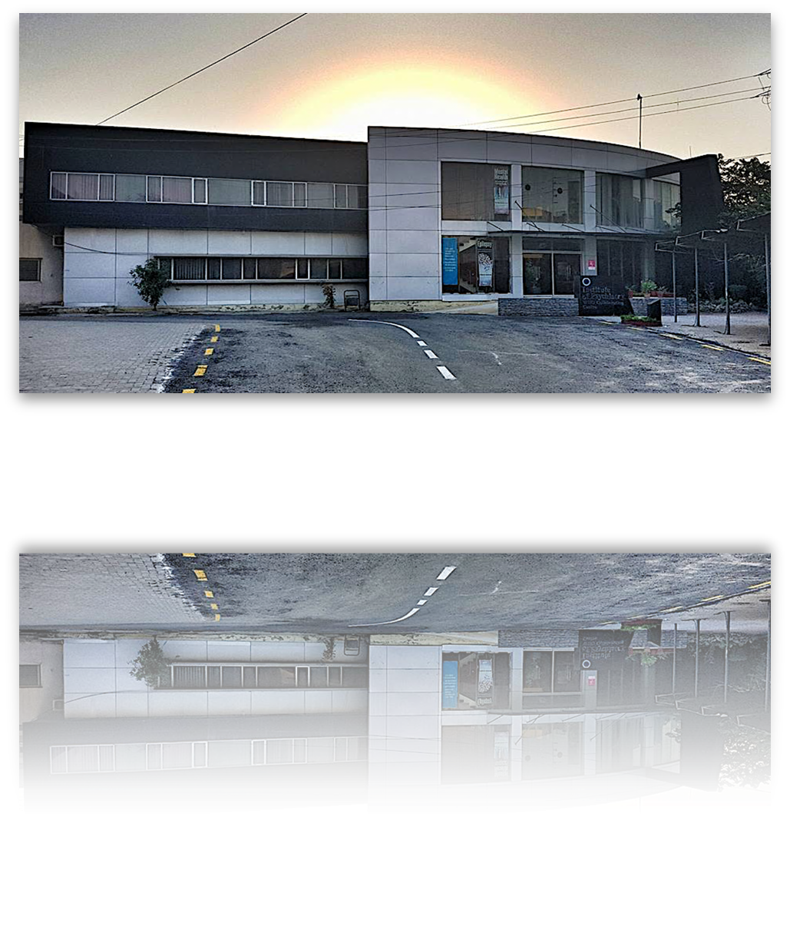

Table of Contents

Historical Perspective
Chairman’s words
Mission, Vision and values
Faculty Staff | 3
Postgraduate Trainees, Psychologists, Social Workers and House Officers | 3
General Adult Out Patient Department and Statistics | 4
Child Psychiatry Department and Statistics | 5
Patients Admitted in Ward in Year 2020 | 7
Psychotherapies in Outpatient Department In 2020 | 9
Electro convulsive Therapy | 10
Liaison Psychiatry | 11
Investing in Mental Health – The COVID Story | 12
Institute of Psychiatry Research Wing | 15

Historical Perspective
Institute of Psychiatry has been a historical place being one of the country’s largest mental health facility. It was established under the supervision of Prof Malik HussainMubashar, who laid the foundation of the department of psychiatry. Later, with the continued efforts and expansion, the department was elevated to the pedestal of Institute.
The Institute of Psychiatry is the academic unit of Rawalpindi Medical University and WHO Collaborating Centre for Mental Health Research & Training for whole of the Eastern Mediterranean Region (EMRO).

It is the hub of mental health activities at local, national and international level encompassing the policy planning, mental health legislation, development of mental health services and developing mental health professionals, teaching at undergraduate and postgraduate levels, and research and evaluation. In addition today it is considered as a centre of excellence for postgraduate training in psychiatry in the country and has the honour to claim that majority of fellows of CPSP have been trained at one time or the other in the corridors of the Institute of Psychiatry.

The Community mental health program launched by the Institute of Psychiatry brought about a revolution in mental health care in the country. It was later on adopted and reproduced by other countries of the World.

The Institute took the initiative of organizing a meeting in collaboration with WHO and formulated the National Mental Health Program for Pakistan. This was the first program developed in East Mediterranean region. This program was later adapted by Government of Pakistan and is implemented in its 7th, 8th, 9th five-year plans.

The Institute was given the additional responsibility of substance abuse treatment and rehabilitation by WHOin 1997 and that has been looked after since then.
The President of Pakistan in 2001 announced the New Mental Health Ordinance of 2001 at concluding ceremony of the 13th International Psychiatric Conference. This ordinance was prepared with the major contribution of the Institute.

The Institute was also designated as the collaborator and advisor for mental health services & policy on behalf of the National Action Plan for Non Communicable Diseases incorporating mental health as one of the priority non communicable disorders.

The Institute of Psychiatry was also designated as the focal point for developing health systems research & development at Rawalpindi Medical College through a LINK programme between Higher education Commission and the British Council, Islamabad. The efforts culminated in developing a research link between Rawalpindi Medical College and the Nuffield Institute of Health management

Chairman’s words
Prof Asad Tamizuddin Nizami
It is my great pride and honor to work as the chair of the great institution which is rich in terms of its unique history and culture. I owe the responsibility of a man who himself has been an authority in mental health not only at national level but also internationally. The great idea and contribution of the Institute is not only to treat the patients as per standard protocols but also to train the post graduate residents as at the best possible standards so that the chain of competiveness and care may get along with contribution in the society. We focus on the areas of research and medical education as per standardized protocols and hence the responsibility of facilitating and coordinating the activities is immense which we cherish. I wish and pray that my efforts may add to the values and culture for the progress of this great institute.

Mission
The Institute of Psychiatry is determined to provide comprehensive nationwide services to the patients and training the experts in mental health and hence facilitating them to resume their roles towards the healthy society.
Vision
By providing the standardized mental health preventive care and training, we are determined to transform the society because of comprehensive mental health care.

Values
Empathy, Confidentiality, Competitiveness and safety

Teaching Faculty
Prof Asad Tamizuddin Nizami
Head of Department Institute of Psychiatry
Dr Muhammad Munir Ahmed
Associate Professor, Institute of Psychiatry
DrMuhammad Kashif
Assistant Professor, Institute of Psychiatry
DrMahmood Ali Khan
Assistant Professor, Institute of Psychiatry
Dr Muhammad AzeemRao
Senior Registrar, Institute of Psychiatry
DrSadiaYasir
Senior Registrar, Institute of Psychiatry
DrZarnain Umar
Senior Registrar, Institute of Psychiatry
Dr Abdul Ghafoor
Consultant Psychiatrist, Institute of Psychiatry
DrMehboob Ali Shah
Consultant Psychiatrist, Institute of Psychiatry

Post Graduate Trainees
1. DrRabeeaIesar
2. DrIbadulHaq
3. DrZonaTahir
4. DrQasim Malik
5. DrAnam Fatima
6. DrHinaAsif
7. Dr Ayesha Jamil
8. Dr Sara Afzal
9. DrHaris Kamran
10. DrAzfarMaqsood
11. DrZahidHanif (MD)
12. DrAamirSuhail (MD)
13. DrBahjatNajeeb
14. DrSairaBano
15. DrLiaquatKhan
16. DrSaadUllah
17. DrSaneeaShahzad
18. DrNaimaGul
19. DrAneelaIshaq
20. Dr Faisal amir (MD)
21. Dr Ayesha Ejaz (MD)

Psychologists and Social Workers
MstGhulam Fatima
MstAmnaLiaqat
Mr Sarmad Ali

House Officers
Around 6-8 House officers work in Institute of Psychiatry in each Rotation.

Clinical Services
Medical Education
Psychological Services
Liaison Services

General Adult Out Patient Department

During the year 2020, total of 32691 patients visited the Institute of Psychiatry which is less than usual load of emergency department possibly due to COIVD-19 pandemic. The chart defines the load of patients in psychiatry department moves inversely proportional to COVID-19 situation of country. When COVID hits hard, number of cases in the department goes down and vice versa.

4 days a week
Daily about 200 to 250 patients are checked, prescribed medicines and provided with behavioral and psychological treatment.
Patients admitted
Behavioral techniques done in rehabilitation center.
Students Teaching
Annual statistics Adult Psychiatry
January – December 2020
OPD-32691 cases
Total Admissions.. 446

Total number of patients visited: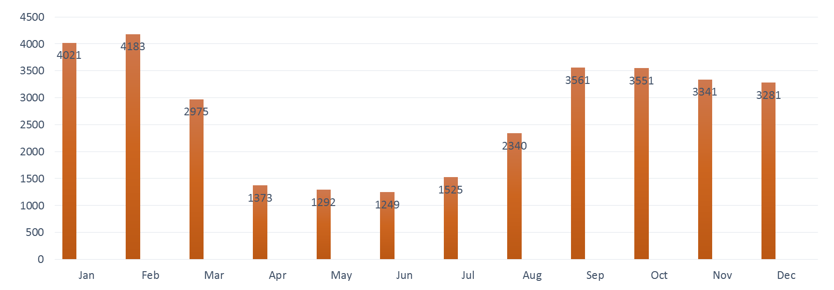

Ward Admissions by Month
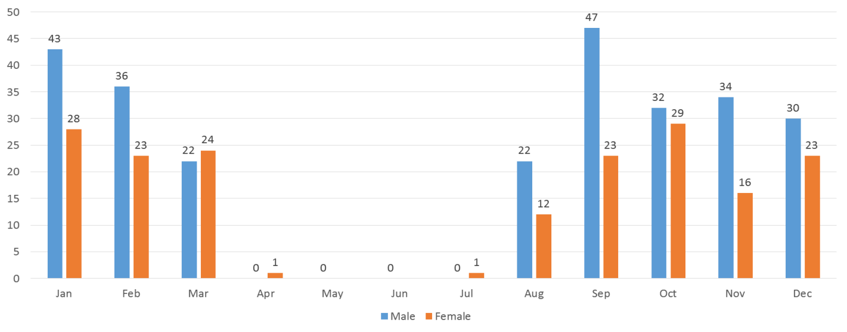

Department of Child & Adolescent Mental Health
The establishment of department of child psychiatry has been very challenging because of the increasing number of children presenting at the opd with different disorders and no facility was available. Keeping in view the needs, it was started under the supervision of Prof AtidRehman, who is Professor of child psychiatry at the University ofLiverpool, UK who started training existing faculty in year. Now, the situation of the department and services is very satisfactory as follows.
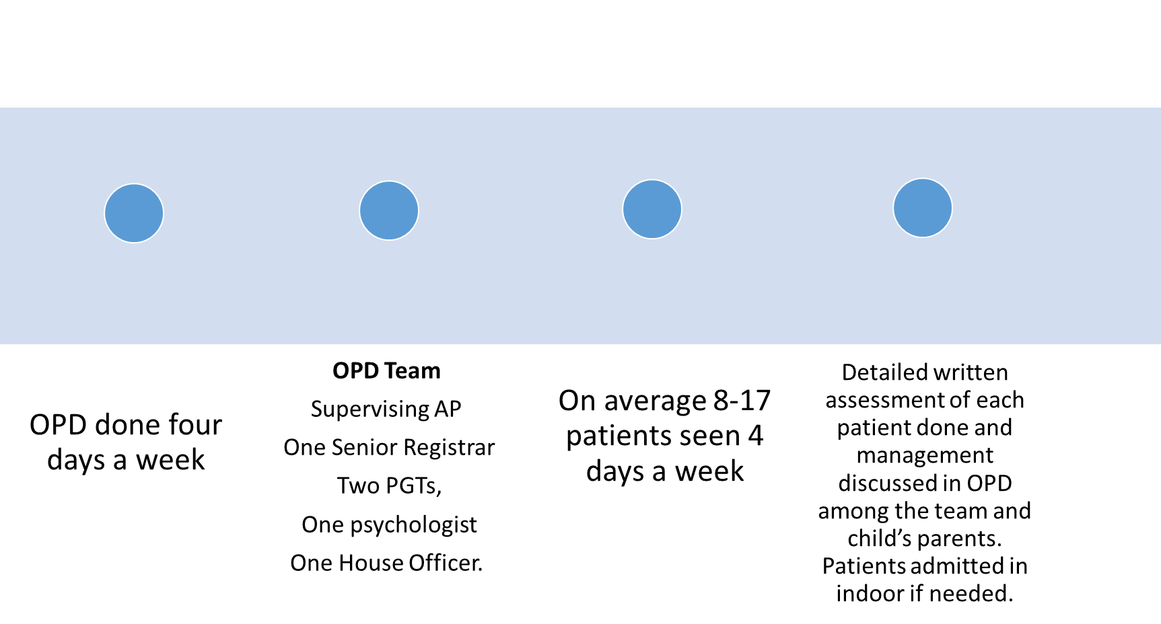
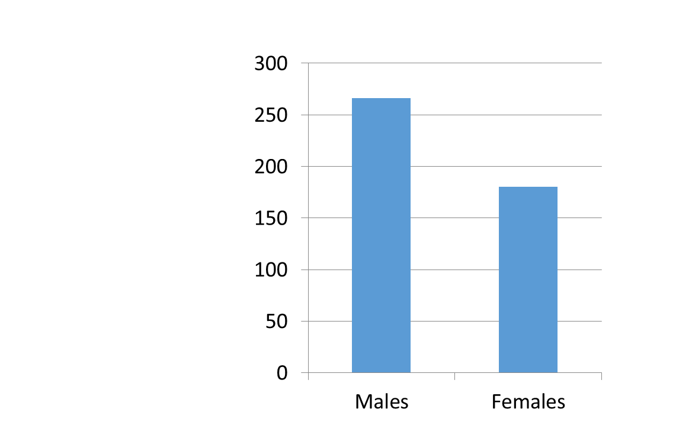

Child Psychiatry Statistics

Patients Admitted in Ward in Year 2020

Psychological work
The provision of psychological services is one of the important services which IOP caters. Those patients who need this work are generally assessed by residents and supervising consultants who refer to intern psychologist for the work. The number of sessions generally 4-6 vary according to the needs of the patients. Following were the areas for psychological work.
Total patients
CBT Sessions
Relaxation Exercises
Counseling sessions
Behavioral Techniques
Stress and anger management techniques

Psychotherapies in Outpatient Department In 2020
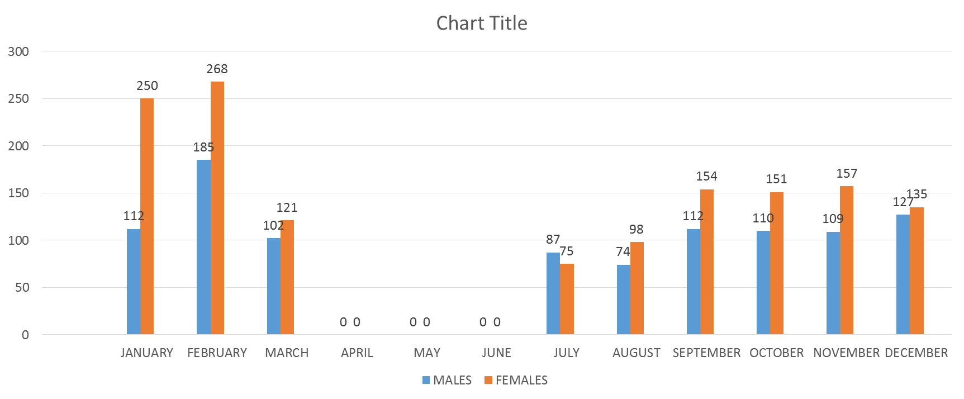

Electro convulsive Therapy ECT
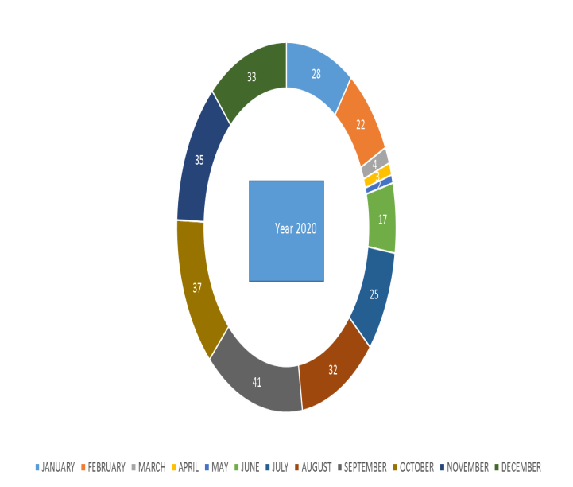
The ECT is performed in those patients who do not respond to the usual treatment or need acute relief. Moreover, it is used for the patients who stop eating and dehydrated. It is the drug of choice for many psychiatric disorders.
Following is the data for ECTs at IOP.

ECT sessions on each patient………………. 6-8
Total number of ECTs given during the year 2020……….279.

ECTs in 2020
Gender Wise Distribution

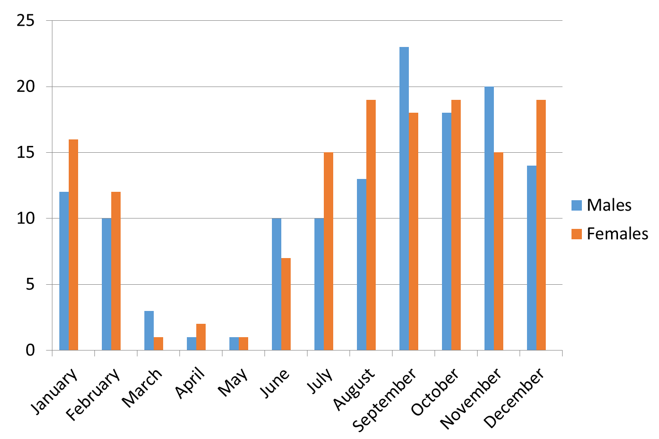

Liaison Psychiatry
The liaison services is one of the institute’s major contribution for allied hospitals. The protocols and data to address the services is kept very stringent and discussed with the supervising consultant at the time of consultation and next day the report is presented to the next consultant. Following is the data for year 2020.
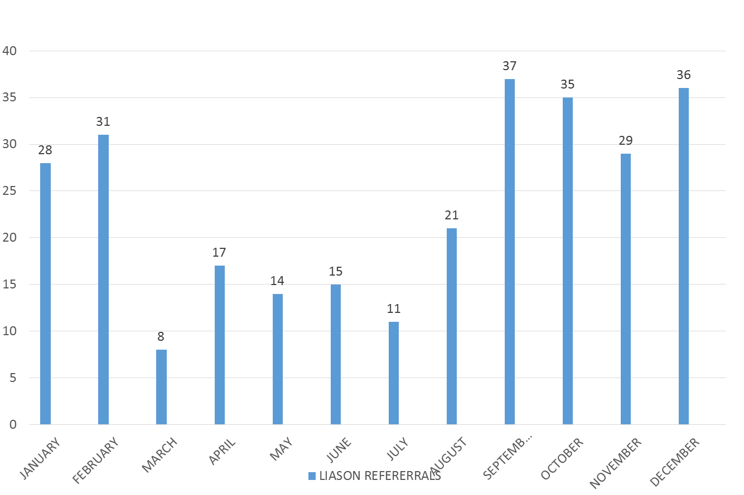

Medical Education and COVID Pandemic
The institute of Psychiatry has played a vital role in dealing with COVID Pandemic. The shifting of the clinical teaching on the online services was an enormous task which we did successfully by involving the faculty and staff. The challenges of online teaching and OPD services was challenging which we did during the pandemic with patience and understanding. The online patient assessment and google tools were used to optimize the patient care and services.
Following is the list
- Online students classes
- Online patient assessment and services
- Psychological services
Helpline Number: 0336-550-5759
Due to prevailing situations of COVID-19, online assessments and treatment is started to facilitate the patients and families from far off area.
Investing in Mental Health – The COVID Story
Institute of Psychiatry
During COVID, it was observed that medical students and doctors were with patients are emotionally and psychologically very upset. In order to take care of them, IOP designed talks with them to address the stress and management. Prof Asad Nizami and Dr Muhammad AzeemRao played a vital role by doing a series of workshops.
Medical student and Faculty Lecture Prof Asad Tamizuddin
Series of Stress Management workshops in Allied Hospital Dr Muhammad AzeemRao
Rawalpindi Medical University
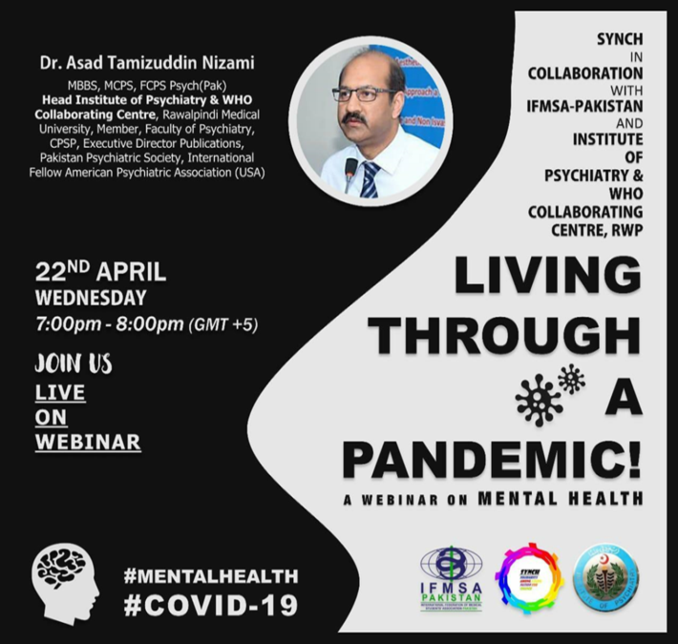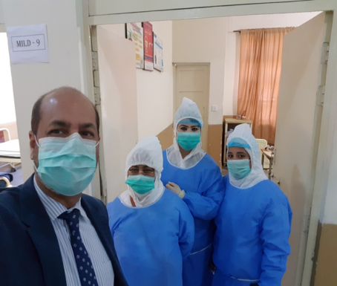

Stress Management Workshops
Workshop at Rawalpindi Institute of Urology with Doctors and Paramedical Staff
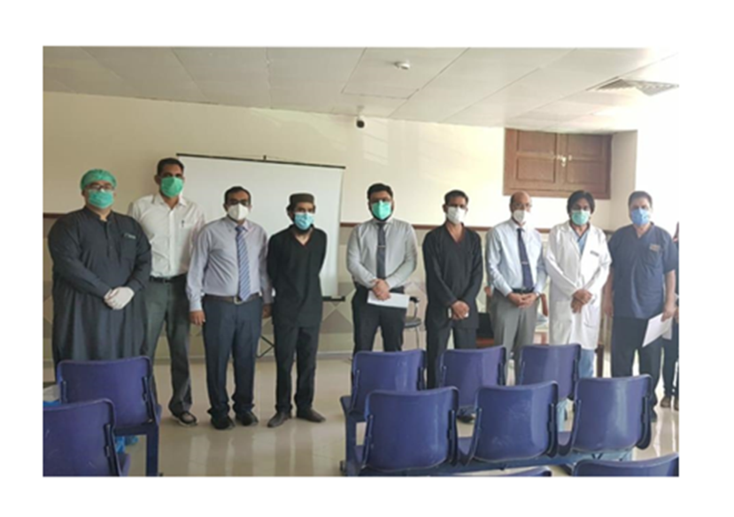
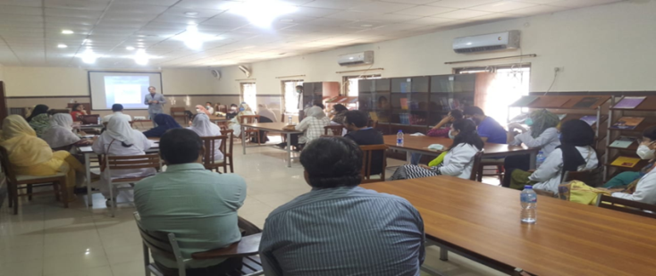
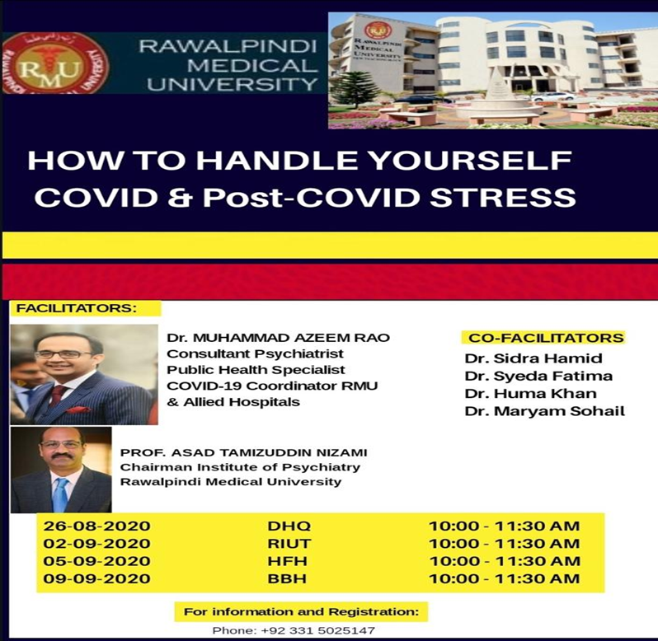

Hospital Readiness in Pandemic

Coordinator:
Dr Muhammad AzeemRao

Assessment of the current state and implementation of WHO guidelines for Hospital Readiness in Pandemic.The deficient areas were identified and protocols were discussed to improve and work as per WHO guidelines.
.

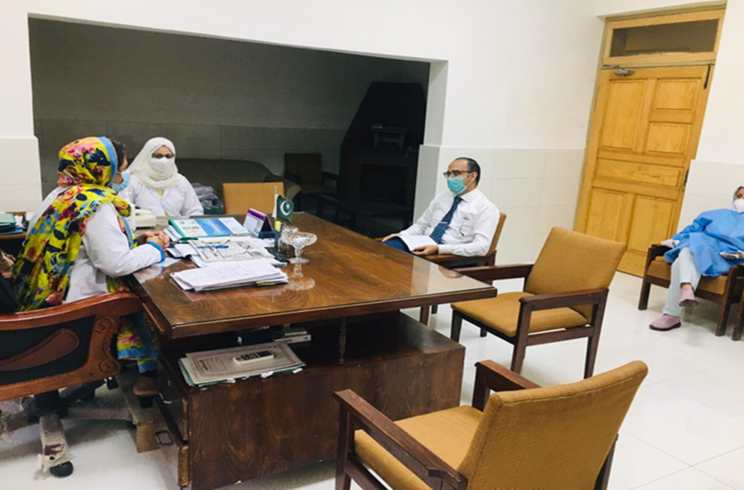

IOP Research Wing
Below are the research programmes at IOP.
Title/Acronym of Research study | Status
IMPACT: SMI survey | Halted due to pandemic
IMPACT: SMI-COVID survey | Data analysis and write-up
IMPACT: 4S study | Modification of protocol to hybrid delivery
IMPACT: CCD-Hepatitis study | Obtaining ethical approval
IMPACT: COSMOS | Participant interviews and systematic review underway
IMPACT: TBMM | Policy practice newsletter circulated
DiaDeM | Information material development underway
IMPACT: BEACON | Completed (Oct ’18- Dec’ 19)

Programme 1: Investigating Physical Health in Patients with Severe Mental Illness in India, Pakistan and Bangladesh: IMPACT
This study was funded with grant from National Institute of Health Research (NIHR). (Grant Ref: 17/63/130) The grant was awarded to University of York with title “NIHR Global Health Research Group: Improving Outcomes in Mental and Physical Multimorbidity and Developing Research Capacity (IMPACT) in South Asia”. Partners in the Global Health Research Group include:
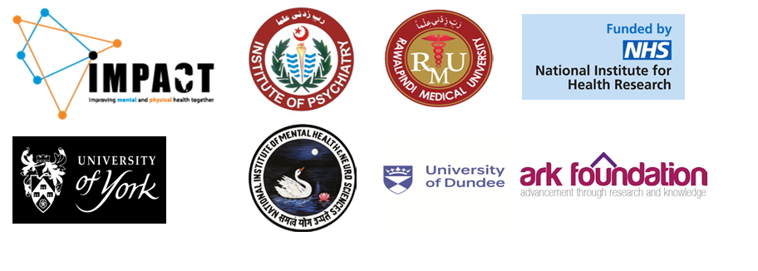
IMPACT OBJECTIVES:
6-MONTH: ACHIEVED:
- Established working relationships and communication, and contracts in place.
- Rapid syntheses summarizing evidence on burden and determinants of multimorbidity.
- Clarification of plans for building capacity; agreed plan for capacity assessments and measuring capacity strengthening.
- Clarification of research priorities and proposed intervention
- Community Advisory Panels established.
- Regional meeting of partners/collaborators including researchers, health professionals and policymakers.
3-YEAR PROGRAMME:
1. Carry out preliminary research to inform definitive studies and research grant applications
2. Build research capacity in global mental and physical health multimorbidity research
3. Establish the basis for a regional research hub in South Asia
A. For people with SMI:
- A cross-sectional survey to estimate the prevalence of chronic physical conditions, health risk behaviors and service utilization.
- Design a package of behavior change interventions targeting the key modifiable health risk behaviors (tobacco, physical activity, alcohol, diet). Interventions to incorporate a motivational interviewing approach.

B. For people with chronic non-communicable disease (NCD):
- Design a package to integrate the detection and treatment of depression/anxiety with the WHO Package of Essential Non-communicable (PEN) Disease Interventions for Primary Health Care. To identify and focus on the two most common NCDs for each country, for which PEN interventions are currently being rolled out. The depression/anxiety intervention to use a psychosocial approach (e.g. behavioral activation (BA)).

LONG-TERM:
1. Reduce morbidity and mortality associated with physical illness in people with SMI in South Asia.
2. Reduce depression/anxiety in people with chronic physical conditions in South Asia.

The IMPACT programme has the following on-going projects:
1) SMI survey 2) SMI covid-19 survey 3) IMPACT 4S trial 4) CCD-Hepatitis project 5) Cosmos study 6) TBMM
One study (BEACON) has been completed

- SMI survey:
Aims:
- Primary aim: Determine the prevalence of physical disorders and lifestyle health-risk behaviors in people with severe mental illness (SMI) in South Asia
- Secondary aims:
  - Determine the prevalence of physical disorders and lifestyle health-risk behaviors in people with SMI and compare these findings with those established in the general population
  - Determine the association between physical disorders, lifestyle health-risk behaviors, health-related quality of life and various demographic, behavioral, cognitive, psychological and social variables in people with SMI
  - Identify lifestyle advice that has been offered for this SMI population
  - Support SMI clinical trial readiness by providing evidence-based findings regarding outcome measures and procedures relevant for clinical trials design
Investigators and sites:
- UK, University of York: Prof Dr. Najma Siddiqi is the Principal investigator from University of York. Prof. Kamran Siddiqi, Prof. Catherine Hewitt are co-investigators and Dr. Gerardo Zavala is study lead.
- Pakistan, IOP: Prof. Asad Nizami is the principal investigator and Dr. Faiza Aslam is co-investigator and Ms Humaira Khalid is the study lead.
- Bangladesh: Prof. Rumana Huque as a principal investigator and Mr. Asiful Haidar as a study lead from Bangladesh
- India: Prof. Pratima Murthy is principal investigators and Prof. Santosh Kumar Chaturvedi Dr. Krishna Prasad are co investigators and Dr. Sukanya Rajan is study lead

Ethical approval:
Formal ethics review and approvals were obtained from National Bioethics Committee Pakistan (NBC Approval Ref: No.4-87/NBC-413/Ext-Y2/20/611). Trial registration number is ISRCTN88485933.
Timeframe:
Pilot survey was conducted Feb – Mar 2019. The main study started from July 1ST, 2019. In March 2020 recruitments for the SMI survey were halted due to the global coronavirus pandemic. In October 2020, survey was resumed but due to high risk to participants and researchers, the survey was halted again. As of December 2020 recruitments remained halted due to coronavirus pandemic. The timeline to resume recruitments depends on the pandemic situation. The team is involved in writing the pre-print material of the collected SMI survey data
Methodology:
The study population was People with severe mental illness (SMI) (i.e. schizophrenia, schizoaffective disorder, bipolar affective disorder, severe depression with psychosis). Estimated sample size is 1500 and by December 2020, 922 participants have been recruited

We are conducting an online survey to collect information about: physical health and related risk factors (WHO STEPs); severity of common mental disorders (PHQ-9 and GAD-7); and health-related quality of life (EQ-5D-5L). Physical measurements were also taken.
Outputs:
- The protocol of the study was published in BMJ open in Oct 2020 (https://pubmed.ncbi.nlm.nih.gov/33040004/)

Dissemination plan:
We plan to publish 3 papers once recruitment and analysis is complete

- Investigating the Impact of COVID-19 and its Response on People with Severe Mental Illness in South Asia: (SMI COVID-19 Survey)
The aim of this study is to investigate the impact of the COVID-19 pandemic and its response (e.g. health promotion messaging, lockdown and social distancing) on mental illness, well-being, health risk behaviors, socioeconomic parameters, quality of life and use of healthcare for people with SMI, and to compare findings with people without SMI.
Investigators and sites:
- UK, University of York: Prof Dr. Najma Siddiqi is the Principal investigators from University of York Prof. Kamran Siddiqi, Prof. Catherine Hewitt are co investigators and Dr. Gerardo Zavala is study lead.
- Pakistan, IOP: Prof. Asad Nizami is the principal investigator and Dr. Faiza Aslam is co-investigator and Ms Humaira Khalid is the study lead.
- Bangladesh: Prof. Rumana Huque as a principal investigator and Mr. Asiful Haidar as a study lead from Bangladesh
- India: Prof. Pratima Murthy is principal investigators and Prof. Santosh Kumar Chaturvedi Dr. Krishna Prasad are co investigators and Dr. Sukanya Rajan is study lead
Ethical approval:
In Pakistan, the study received approval from NBC on 22nd April 2020 (Ref: No.4-87/NBC-480-COVID19-10/20/)
Timeframe:
The study commenced on 16 May, 2020. Research Assistants obtained verbal consent and administered the survey by telephone and recorded responses directly into Qualtrics software using tablets. In wave 1 we collected data from 454 participants; in wave 2 we did follow up of 642 participants and in wave three, 706 participants were interviewed. Currently data analysis and write-up of paper is underway
Methodology:
This is a longitudinal cohort study, with regular follow up, to explore changes since the pandemic outbreak. We provisionally planned three follow-ups at approximately 2 monthly intervals, with each wave completed during a 3-weeks window. Consenting adults are aged 18 years and above with severe mental illness.
Dissemination plan:
- We will prepare summaries and policy briefs soon, and share these with stakeholders
- Lay summaries will also be prepared and disseminated via channels such as press releases and websites.

- IMPACT smoking cessation support for people with severe mental illness in South Asia (IMPACT 4S):
The aim of the study is to adapt an evidence based, combined behavioral and pharmacological support intervention for smoking cessation among people with severe mental illness; and test the feasibility and acceptability of delivering and evaluating it in India and Pakistan
Investigators and sites:
- Pakistan: At IOP, Prof Dr Asad Tamizuddin Nizami is the principal investigator. Dr Faiza Aslam is research fellow and program manager, Mr. Baha ul Haq is responsible for process evaluation
- India: Prof Pratima Murthy is principal investigator.
- UK: Professor Simon Gilbody is the principal investigator at University of York
Ethical Approvals:
Ethical approvals were obtained in Pakistan from NBC (NBC Ref No. 4-87/NBC-434/21/23), as well as from IRF at RMU (IRF Ref. No. R-48/RMU)
Timeline:
January 2019 to March 2022. As of December 2020, we are conducting amendments to the protocol to modify for the pandemic from face-to-face intervention delivery to hybrid mode of delivery.
Methodology:
Study design: IMPACT 4S is a parallel open label randomised, controlled pilot and feasibility trial.
Study population is adults with severe mental illness (i.e. schizophrenia, schizoaffective disorder, bipolar affective disorder, psychosis, severe depression with psychosis) who are regular smokers and are willing to quit smoking.
Intervention delivery: comprised originally of up to 10 structured face-to-face counseling session but this needs to undergo relevant adaptation with regard to the mode of delivery following the Covid-19 pandemic. The IMPACT 4S intervention at present is being designed to fit the hybrid mode of delivery, which includes either face-to-face or remote sessions or combination of both, adjusting to feasibility and client’s preferences.
A total of 172 participants will be included in IMPACT 4S study: 86 from Pakistan and 86 from India. There are three phases in IMPACT 4S study,
- Phase 1: To culturally adapt and finalize smoking cessation intervention through an iterative co-design approach. Intervention manuals and materials are being developed (e.g., informational leaflets, posters, advisor record book, flip books, participant’s information sheet etc.). We are currently in Phase 1
- Phase 2: Pilot and feasibility trial. Participants will be recruited, randomised and allocated in either one of the two study arms: Brief Advice (control) arm or IMACT 4S intervention arm.
- Phase 3: IMPACT 4S study will be process evaluation regarding the implementation, mechanisms of impact and context, using questionnaires and interviews embedded within the feasibility phase.

Outputs:
We conducted a Community Advisory Panel (CAP) workshop in October 2019

- INTEGRATING DEPRESSION CARE IN CHRONIC HEPATITIS SERVICES IN SOUTH ASIA: CCD-Hepatitis Project
The CCD-Hepatitis Project is planned to be conducted at selected sites within tertiary healthcare facilities of Bangladesh and Pakistan offering chronic hepatitis care (for HBV and/or HCV) patients.
Aims:
- Improve depression and hepatitis outcomes for people living with this multi-morbidity, by developing and evaluating an evidence-based intervention to deliver depression care integrated into hepatitis services.
- Carry out preliminary work to inform a future trial evaluation of the interventions
- Understand facilitators and barriers to integrating care for depression in hepatitis services,
- Develop culture and context appropriate approaches to case finding and treatment of depression integrated with hepatitis care that can be delivered by non-mental health specialists.
- Test feasibility of case finding for depression in chronic hepatitis services in terms of coverage, acceptability to patients and healthcare staff
- Develop a protocol for a randomized controlled trial to evaluate the ‘Chronic hepatitis -Depression’ intervention

Ethical approval:
Ethical approval for CCD Project was obtained from Institutional Research Forum (IRF) at RMU (Ref No. 239/IREF\RMU\2020)

Timeline:
We have obtained ethical approval. Study project will be formally started from Mar 2021
Methodology:
We will divide the study into three complementary workstreams as follows;
Workstream 1: Stakeholder workshops to find out the facilitators and barriers for integrating depression case finding and treatment within chronic hepatitis services in South Asia (Bangladesh and Pakistan). Facilitated workshop discussions will be used to explore experiences of delivering or receiving care, and the facilitators and barriers of integrating depression with chronic hepatitis care.
Workstream 2: A series of co-design workshops with patients, families and healthcare staff will be conducted to develop culturally appropriate pathways and materials for depression case finding and treatment that can be integrated with chronic hepatitis services.
Workstream 3: Screening and case finding for depression in chronic hepatitis services at pre-selected study sites. We will collect data via a service audit on rates of screening, and screen-positive and diagnosed depression.
Public and Patient Involvement:
Community Panels comprising patient, family and community representatives will be involved in all stages. There will be at least 2 community advisory meetings with a gap of 6 months

Way forward
The study will engage non-mental health specialists, health provider staff and chronic hepatitis patients and caregivers through workshops. Outputs will be disseminated via community events, policy briefs, and published in academic journals to reach a wide audience and will inform a trial protocol for evaluating integrated depression care with chronic hepatitis services

- Development of a core outcome set for multimorbidity studies in low- and middle-income countries (COSMOS)
The research aim is to study multi-morbidity (in adults with SMI illness co-existing with other illnesses)
The study rationale is to develop the core outcome set for people living with multimorbidity in low middle income countries. The development of "core outcome sets" is an approach that addresses these challenges by involving stakeholders from research and practice.
Investigators and Sites
- UK: Principal investigator at University of York are Prof. Najma Siddiqi and Dr. Jan boehnke at University of Dundee
- Pakistan: Team lead at IOP is Ms Rusham Rana
- There are 10 LMIC sites: Nepal, Ghana, Mexico, Peru, Suriname, Pakistan, Afghanistan, Nigeria, Bangladesh and Burkina Fasu
Ethical approvals:
Pakistan ethical approval was obtained from IRF at RMU (IRF NO 247/IREF/RMU/2020 dated 04-12-2020).
Timeframe:
The Cosmos study started during the time frame of June 2020, the study was halted due to COVID pandemic and as of December 2020, interviews are being conducted from participants (patients with SMI).
Methodology:
Study consists of 3 phases:
- Phase 1 which comprises of interviews and systematic review. We are currently in Phase 1 and are developing interview guides, consent forms and patient information sheets.
- Phase 2 will consist of Delphi survey.
- Phase 3 will have consensus meetings.

Outputs: Study protocol is in pre-publishing stage. Systematic reviews are underway

- Identifying and addressing mental and physical multimorbidity in people with TB in high Burden Countries: Reviews, secondary data analysis, network development and capacity-building. (TBMM: Tuberculosis Multimorbidity)

Project Partners:
- Yan Lin, Senior Advisor at The UNION
- The NIHR IMPALA Unit, with 20 TB and lung health organisations in 9 African countries.
- Dr Achakzai HIV Programme Manager at Common Management Unit, TB, HIV/AIDS, malaria, Pakistan
- National Diabetes Task Force and Pakistan Endocrine Society and Pakistan Psychiatric Society
- Prof Huque, Director at ARK Foundation and ?Dr Baral, Director at HERD International two leading NGOs in TB control in Bangladesh and Nepal respectively.
- Centre for Injury Prevention Research, Bangladesh.
- Global Public Health Division, Public Health England.

Investigators and Sites:
- UK, University of York: Prof Najma Siddiqi (joint-P), the co-director of IMPACT, University of York) and Prof Kamran Siddiqi
- Pak, IOP: Prof Asad Tamizuddin Nizami (PI, the chairman of Institute of Psychiatry), Dr Fazia Aslam (Facilitator, IMPACT/ DiaDeM Program Manager) and Ms. Humaira Khalid (Facilitator, IMPACT Research Fellow)
- Pak, KMU: Prof Dost Muhammad

Aim:

To estimate the prevalence, patterns and impact of NCD, mental illness and CCD multimorbidity in people with TB, including identifying clusters of diseases that contribute most to disease burden and their modifiable risk factors in low- and middle-income countries (LMIC)

This project focuses on multimorbidity (including non-communicable diseases, mental disorders and chronic communicable diseases in people with TB (‘TB multimorbidity’) specifically to : (i) define multimorbidity clusters that contribute the highest disease burden in people with TB, (ii) identify interventions to prevent, screen and manage non-communicable diseases (NCD), mental disorders and chronic communicable diseases (CCD), which can be integrated within TB programmes for patients in these clusters and (iii) build a network and strengthen capacity to plan a future research programme on TB multimorbidity.

Methodology:

This project undertakes 4 workstreams (WS):

WS1: Review of published literature and analysis of World Health Survey data to estimate prevalence, patterns, risk factors and disease burden associated with TB multimorbidity.

WS2: Review to identify candidate interventions to prevent, screen and treat the cluster(s) of diseases, which contribute most to TB multimorbidity disease burden.

WS3: Establish a global TB Multimorbidity Network, agree priority TB multimorbidity clusters and collate an inventory of candidate interventions for a TB multimorbidity ‘package’ to be developed and evaluated in future work.

WS4: Build capacity in research, leadership, finance, governance and policy.

Progress:

Multiple webinar and Meetings on TB and Diabetes: changing policy and practice were conducted during 2020. Newsletters titled “Tuberculosis and Multimorbidity” were produced and circulated in November, 2020. Plans for secondary data analysis has been shared with the team.

Outputs from this seed work (evidence on clusters/interventions, a global TB Multimorbidity Network and strengthened capacity) will inform a future research programme (and associated capacity-building), to develop and evaluate a TB multimorbidity intervention package.

Programme 2: Developing and evaluating an adapted behavioral activation intervention for people with depression and diabetes in South Asia (DiaDeM)
DiaDeM is a global, National Institute of Health Research (NIHR) (Ref: Global Health Research NIHR 200806) funded 4 years program which aims to
- Reduce depression in people with diabetes,
- Improve health and reduce deaths associated with depression and diabetes,
- Build research capacity in applied health research on mental and physical multi-morbidity.

Partners and Sites:
- UK:
  - Department of Health Sciences, University of York is Lead Partner of DiaDeM
  - University of Leeds, and University of Southampton are also centers in the study
- Pakistan:
  - Institute of Psychiatry is eminent collaborator
  - Khyber Medical University, Peshawar is also a center in the study
- Bangladesh:
  - ARK Foundation, Dhaka, Bangladesh
  - BADAS, Dhaka, Bangladesh

Investigators:
- Dr Najma Siddiqi is Principal Investigator from University of York
- In Pakistan, IOP, Prof Dr. Asad Tamizuddin Nizami is Principal Investigator and Dr. Faiza Aslam is Program Manager.
- Ms. Anum Naz is a research fellow.

Ethics Approval:
From Pakistan, approval was obtained from Institutional Research Forum, RMU, Reference Number (Ref.No 242./IREF/RMU/2020) as well as from National Bioethics Committee (NBC) (Ref: No.4-87/NBC-578/20/ 1101)

Timeline:
As of December 2020, the topic guide in collaboration with all partner sites is being formulated. Workstream 1 meetings are underway. Information sheet, terms of reference documents, consent forms, with translations are being developed.

Completed Project: Part of the IMPACT programme
Behavioural activation for depression in people with non-communicable disease in low- and middle-income countries in South Asia: Protocol for intervention design and randomised controlled feasibility trial (BEACON Study)
Aim:
The Behavioral Activation for Comorbid Depression in Non-communicable Disease (BEACON) study explored the acceptability and feasibility of integrating a brief depression intervention (behavioral activation, BA) into NCD services in healthcare facilities in Bangladesh and Pakistan.
Investigators and Sites:
- Pakistan: At IOP at BBH, principal investigator was Prof Dr. Asad Tamizuddin Nizami
  - BEACON lead: Dr. Siham Sikandar
  - Project coordinator: Dr. Faiza Aslam
  - Study lead: Rusham Rana Zahra
  - THQ Taxila
- UK : University of York
- Bangladesh
- India
Timeline:
Oct’ 18 to Dec’19
Methodology:
The study was conducted in the following phases:
- Phase 1: Situation Analysis and Qualitative Interviews (with patients, healthcare workers, health managers, policy makers) 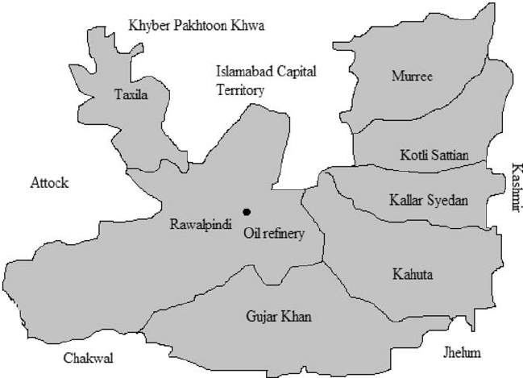

- Phase 2: Randomized controlled feasibility trial
  - This included feasibility trial, process evaluation & focus group interviews, fidelity interviews and feasibility of economic evaluation
  - In both the intervention and control groups, participants received ‘enhanced usual care.’ This included a leaflet, developed by the team, describing depression and its treatment.
  - In the intervention group only, participants will in addition receive the BEACON intervention, delivered by trained non-mental health specialists (BA counsellors) based in NCD services. BA counsellors will be supervised by a mental health specialist.
Output:
Wright, J., Mazumdar, P., Barua, D. et al. Integrating depression care within NCD provision in Bangladesh and Pakistan: a qualitative study. Int J Ment Health Syst 14, 63 (2020). https://doi.org/10.1186/s13033-020-00399-y

