**Welcome RCEM (UK) Faculty Emergency Medicine Foundation Program Rawalpindi Medical University**

RMU Faculty

RCEM Faculty

# PROF. JAHANGIR SARWAR KHAN

Principal

RAWALPINDI MEDICAL COLLEGE

# PROF. MUHAMMAD UMAR

VICE CHANCELLOR RAWALPINDI MEDICAL UNIVERSITY

# DR. ADRIAN BOYLE

PRESIDENT RCEM ADDENBROOKE’S HOSPITAL CAMBRIDGE, UK

**DR. AYAZ ABBASI** CONSULTANT EMERGENCY MEDICINE ROYAL ALBERT EDWARD INFIRMARY, UK

# DR. USMAN QURESHI

LEAD EDUCATIONAL SUPERVISOR EMFP, RMU

**DR. SAIMA AMBREEN** EDUCATIONAL SUPERVISOR EMFP, RMU

**JASON LONG** CONSULTANT EMERGENCY MEDICINE QUEEN ELIZABETH UNIVERSITY, UK

# DR. ASIM IJAZ

CONSULTANT EMERGENCY MEDICINE UNIVERSITY HOSPITALS OF MORECAMBE, UK

**DR. AIMEN MALIK** EDUCATIONAL SUPERVISOR & COORDINATOR EMFP,RMU

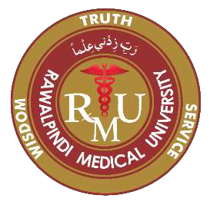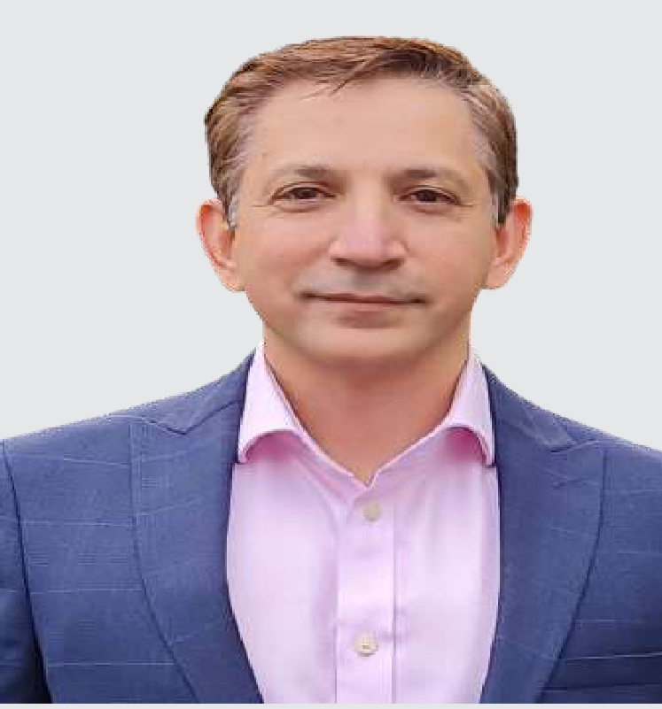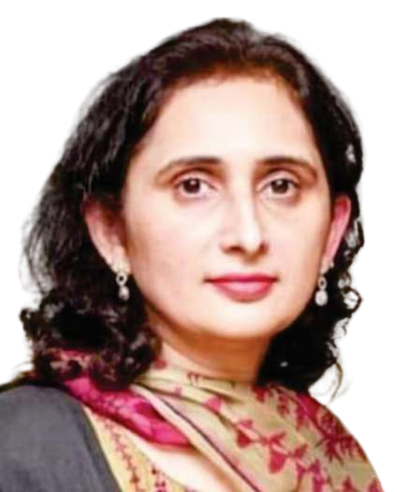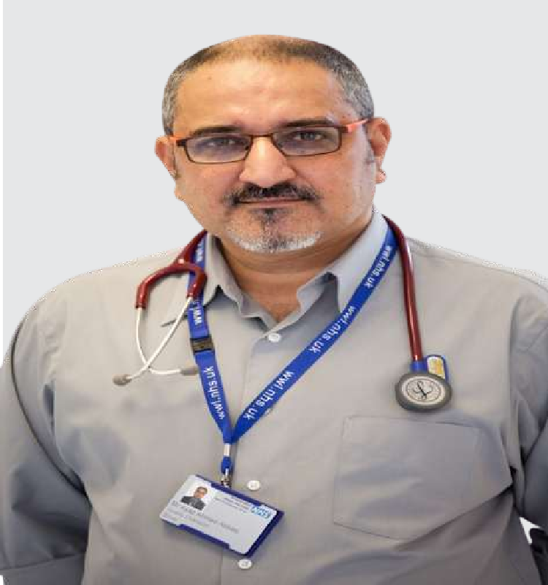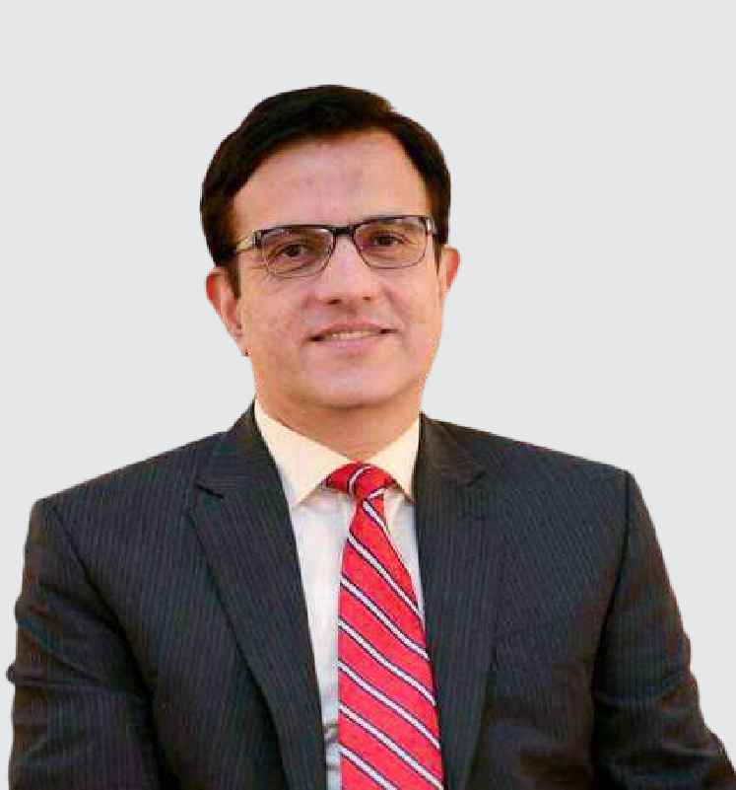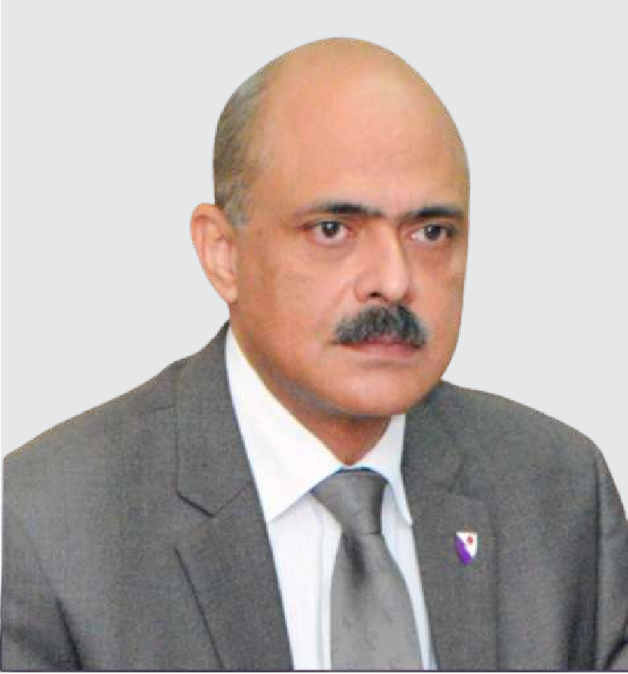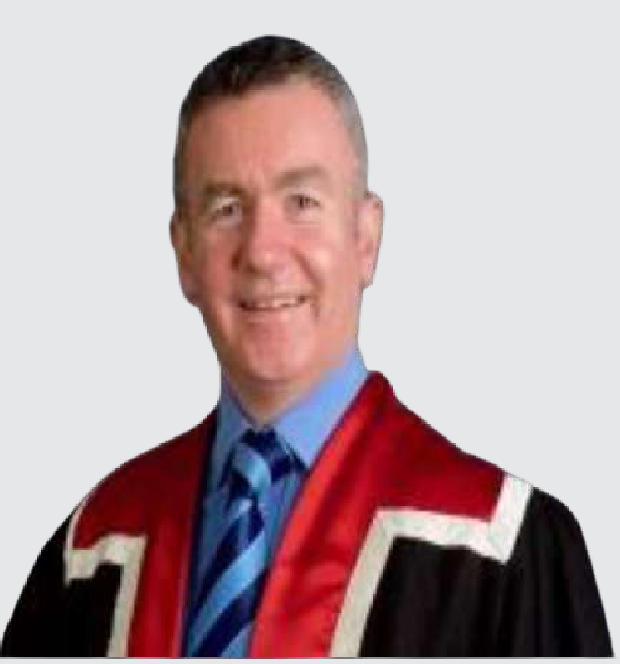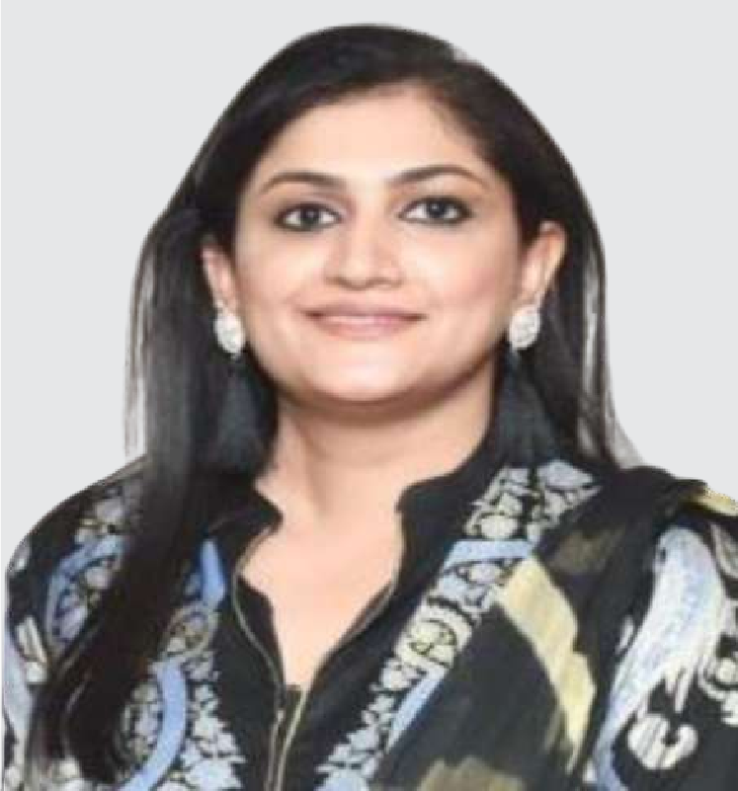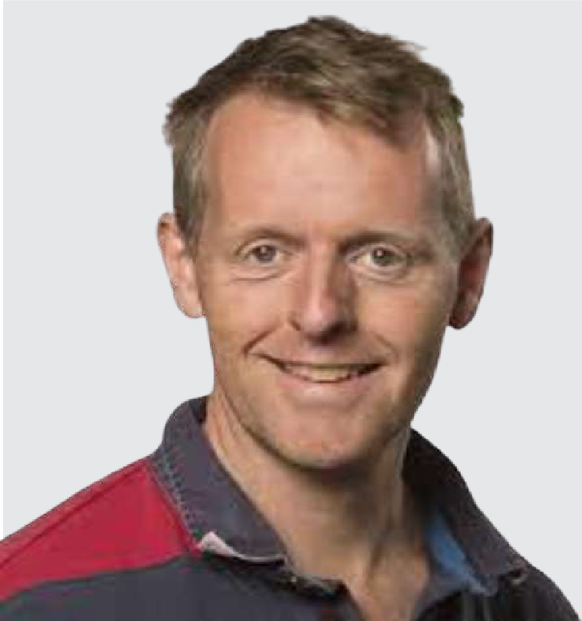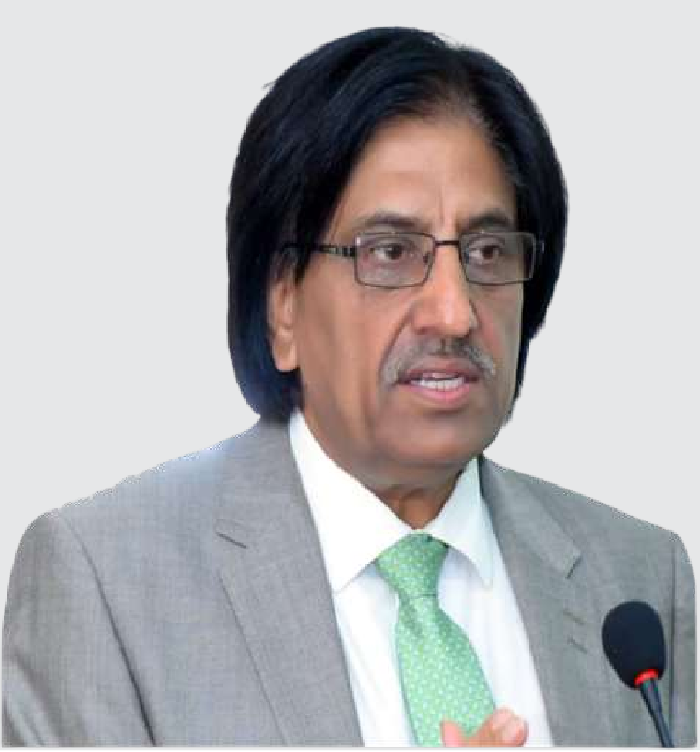

**ANDREW FRYER** INTERNATIONAL MANAGER RCEM, UK



**Welcome RCEM (UK) Delegation Emergency Medicine Foundation Program**

**Rawalpindi Medical University**