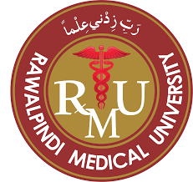

ANNUAL REPORT 2020
DEPARTMENT OF
OBSTETRICS & GYNAECOLOGY, UNIT II
HOLY FAMILY HOSPITAL, RAWALPINDI
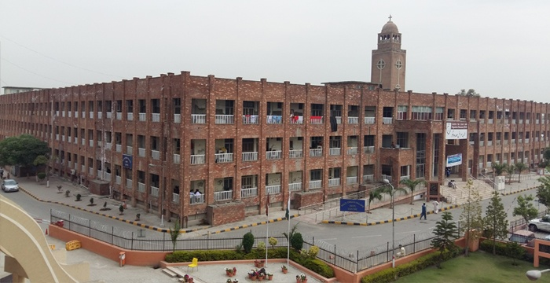
HOLY FAMILY HOSPITAL, RAWALPINDI
PREFACE

It is important to consistently look back and reflect to redefine ourselves for future. This emphasizes the need of annual reports and audit organization, so as to improve the working and service standards.
Gynae Unit-II has been regularly preparing the annual reports and clinical audits for past many years. Annual report 2020 is the continuation of the same process. This is a brief but comprehensive account of clinical services, academics, achievements and research activities of Gynae Unit-II in past one year as well as brief introduction of department and staff members.

MISSION STATEMENT

- To promote the slogan of “healthy mother and healthy baby”.
- To provide the highest quality service to our patients.
- To continuously evaluate the results of our efforts to meet the needs of our patients.
- To promote the involvement of all levels of faculty and staff in the identification and solution of problems.
- To support and contribute to the research mission of our center by pursuing new knowledge.
- To be enthusiastic and to think positively.
DEPARTMENT OF OBS/GYNAE
HOLY FAMILY HOSPITAL, RAWALPINDI

Holy Family Hospital is 962 bedded tertiary care teaching hospital which is attached to Rawalpindi Medical University. Gynae Unit-II is a 125 bedded maternity unit providing clinical services not only to surrounding districts of Punjab but also to patients from Azad Kashmir and KPK. It is recognized for internship and postgraduate training programs like FCPS, MS and MRCOG.
ANNUAL REPORT 2020
STAFF MEMBERS
FACULTY MEMBERS:
- Professor: Dr. Nabeela Waheed FCPS
- Assistant Professor: Dr. Khansa Iqbal FCPS, CHPE
- Assistant Professor: Dr. Maliha Sadaf MCPS, FCPS, ICMT/CHPE
Senior Registrars:
- Dr. Aqsa Ikram
- Dr. Saira Ahmed
- Dr. Shama Bashir
- Dr. Saima Khurshid
- Dr. Alia Malik
- Dr. Amna Abbasi
- Dr. Sabeen Ashraf
- Dr. Asia Sharif
Medical Officers:
- Dr. Nadia Sadiq
- Dr. Saba Yousaf

POSTGRADUATE TRAINEES
Total No of Postgraduate Trainees: 31
- Completed training in 2020 02
- New Inductions in 2020
FCPS: 03
MS : 02
INTERNEES

Total No. of internees 50
RMU Graduates completing Internship: 36
Other Institution Graduates completing Internship: 14

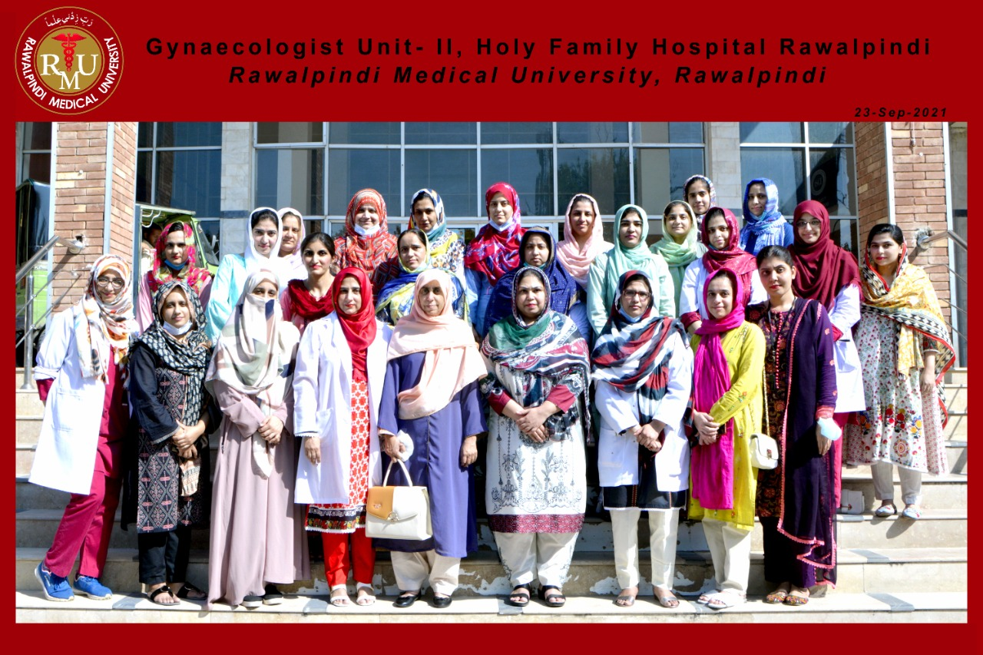

ANNUAL REPORT 2020
SCOPE OF SERVICES

  - Upgraded Family Planning services
  - Oncology services in collaboration with NORI Hospital
  - Upgraded Subfertility management services
  - Blood transfusion services in collaboration with Bood Bank Unit
  - Operative Laparoscopic facilities
  - Operative Hysteroscopic facilities
  - Colposcopy Facility
  - Day care center for babies of working doctors
  - Lactation management facility
  - Development of concept of Day care for patients requiring admission

ANNUAL REPORT 2020
TRAINING AND TEACHING AIDS

  - Hands- On Skill Departmental Library
  - Conference room with multimedia and Microsoft Teams facility for online video meeting and online teaching
  - Three Computers with internet facility
  - Computer Operator for data entry

STATISTICS

ANNUAL REPORT 2020
HOSPITAL STATISTICS

- Total No. of Admissions 12854
- Total No. of Deliveries 11405
  - Vaginal deliveries 7077
  - LSCS 4328
  - Caesarean Section Rate 37%
- Total No. of patients attended in ER 21150
- Total No. of patients attended in OPD 60052
- Gynaecological Surgeries 688
  - Major Cases 289*
  - Minor Cases 399*
- Total No. of Near Missed Cases 195
- Total No. of Covid-19 Positive patients 37
- Perinatal Mortality Rate 65/1000 live births
- Maternal Mortality Ratio 401/100,000 Maternities

* Reduced Number of surgeries due to COVID-19 pandemic
ANNUAL REPORT 2020
OPD SERVICES DATA

Gynae Unit-II provides outpatient services three days a week i.e Tuesday, Thursday & Saturday. A consultant and two senior registrars with a team of postgraduate trainees and house surgeons are responsible for OPD services. OPD is organized to provide clinical services to new and follow up patients in separately allocated rooms. Specialized clinics deal with high risk pregnancies, subfertility, oncology and menstrual disorders.
ANNUAL REPORT 2020
OPD

Total Patients Seen | 60052
General OPD | 45213
Consultant OPD | 14839
Ultrasound Room | 15623
Patients admitted through OPD | 4005

ANNUAL REPORT 2020
EMERGENCY SERVICES DATA

Gynae Unit-II provides emergency services on Tuesday, Thursday & Saturday every week and alternate Sundays every month. Postgraduate trainees and house surgeon under supervision of senior registrar are responsible for services in emergency. A consultant is available round the clock for emergency cover as and when required.
Total Patients Seen | 21150
Total patients admitted through ER | 7039

ANNUAL REPORT 2020
TOTAL ADMISSIONS

Total patients admitted through ER | 7039
Total patients admitted in labour room | 8448
Total patients admitted in Antenatal ward | 3958
Total patients admitted in Gynae ward | 448

ANNUAL REPORT 2020
GYNAE WARD 2020
Miscarriages | 108
Menstrual Disorders  - Menorrhagia  - Irregular PV Bleeding  - PMB | 95  60  24  16
U. V. Prolapse | 14
Ectopic Pregnancy | 73
Molar Pregnancy | 27
Cervical Cerclage | 09
Uterine Fibroids | 08

ANNUAL REPORT 2020
GYNAE WARD 2020
Primary Amenorrhea | 01
Primary Subfertility | 04
Lost IUCD | 02
Secondary Subfertility | 01
Cervical Pathologies | 06
Ovarian Pathologies  - Benign Tumors  - Malignant Tumors | 15  11  04

ANNUAL REPORT 2020
ANTENATAL WARD 2020

PIH | 313
Preterm | 142
Anaemia | 308
Chronic Hypertension | 147
PIH + IUGR | 146
Placenta Previa | 161
Multiple Pregnancy | 71
Diabetes Mellitus | 223
Post dates | 224
ANNUAL REPORT 2020
ANTENATAL WARD 2020

Previous I L.S.C.S | 194
Previous II LSCS | 245
Previous III L.S.C.S | 182
Previous IV L.S.C.S | 21
Pregnancy With Fibroid | 36
Infections (UTI) | 126
Oligohydramnios | 158
Polyhydramnios | 99
PPROM | 277
False Labour Pains | 94
Pregnancy with thyroid Disorders | 16
Precious Pregnancy | 78
Breech Presentation | 42

ANNUAL REPORT 2020
COVID-19 (PCR Positive Cases)

Total admitted patients | 37
Vaginal Deliveries | 07
LSCS | 30
IUD | 04
ENND | 03
Maternal Deaths | 03

ANNUAL REPORT 2020
OPERATION THEATRE 2020
MAJOR OPERATIONS

Total No. of Procedures | 237
Abdominal Hysterectomy  - TAH  - TAH + BSO | 41  21  20
Vaginal Hysterectomy | 08
Myomectomy | 08
Manchester Repair | 03
Operative Laparoscopy | 19
Diagnostic Laparoscopy | 05

ANNUAL REPORT 2020
OPERATION THEATRE 2020
MAJOR OPERATIONS
Operations
Laparotomy  - Staging Laparotomy  - Emergency Laparotomy  - Ruptured Ectopic pregnancy  - Ruptured uterus  - Adherent Placenta  - Pack Removal  - Exploratory Laparotomy  - Pregnancy with ovarian cyst  - Adnexal Mass  - Abdominal Pregnancy | 153  17  118  82  24  05  07  18  08  08  02
ANNUAL REPORT 2020
MINOR OPERATIONS 2020
Total Procedures | 508
ERPC | 391
Suction Evacuation | 27
Diagnostic D & C | 16
Cervical Cerclage | 05
Polypectomy | 12
Perineal Tear Repair | 06
Wound Debridement | 28
Cervical Biopsy | 09
Mirena Insertion | 06
Post Coital Tear Repair | 08

ANNUAL REPORT 2020
LSCS – 2020

 | Total
Total LSCS | 4328
Elective LSCS | 1020
Emergency LSCS | 3308
Peripartum Hysterectomies | 47

ANNUAL REPORT 2020
MATERNAL DEATHS – 2020

Causes of Maternal Deaths | 45
Eclampsia | 11
Primary PPH | 07
Pulmonary Embolism | 08
Puerperal Sepsis | 03
Acute Fulminant Hepatic Failure | 03
DIC | 04
Peripartum Cardiomyopathy | 03
Ruptured Uterus | 03
Covid-19 | 03

ANNUAL REPORT 2020
PATIENTS SEEN IN OPD – 2020

ANNUAL REPORT 2020
MONTH WISE MATERNITIES - 2020

ANNUAL REPORT 2020
EMERGENCY VS ELECTIVE LSCS - 2020

ANNUAL REPORT 2020
GYNAECOLOGICAL PROCEDURES - 2020

EDUCATIONAL PROGRAMS

UNDERGRADUATE TEACHING PROGRAM

FOURTH YEAR
Lecture conducted once a week in university premises by departmental faculty.
FINAL YEAR
Lecture conducted once a week in university premises by departmental faculty.

Clinical Rotation Schedule Followed*
FOURTH YEAR
Two weeks rotation of 4-5 student batches (four days a week).
FINAL YEAR
Four weeks rotation of 15-18 students batches (six days a week).

Hybrid model of education adopted during COVID-19 pandemic *

Rotation Schedule Followed For Undergraduate Students
- From 10 am to 12 pm students are rotated at different stations like emergency, OPD and wards.
- From 12 to 2 pm students attend a clinical class by teaching faculty.
- Students are also assigned maternity duties from 2pm to 5pm
- At the end of clinical rotation of each batch there is a ward test comprising of OSPE and Long cases
Observed
- Spontaneous vaginal delivery
- Lower segment C section
- Delivery of placenta By Brandt- Andrews Maneuver
- Repairing of mediolateral episiotomy
- Resuscitation of newborn baby
- Resuscitation of collapsed patients
- Management of PPH, Eclampsia
Drills on Mannequins
- Vacuum extraction
- Outlet forceps delivery
- Shoulder dystocia
- Breech delivery
- Fetal dimensions and pelvic diameters on examination model

Schedule followed
INTERNSHIP PROGRAM

- Clinical class by SR / week
- A presentation / week by H.O supervised by SR/ AP
- Daily morning meeting participation

UNIVERSITY RESIDENCY TRAINING PROGRAM

Schedule followed

- 4 year program with one year rotation
- Morning meeting/ station rounds, Log book, DOPs, Portfolios
- Audit Report, CBD, Journal Club
- Monthly Rotations in OPD, ER, OT, ANW, PNW, Gynae Ward, LR

FELLOWSHIP TRAINING PROGRAM

Schedule followed

  - 4 year program with six months rotation
  - Morning meeting/station rounds
  - Audit report preparation, CBD, DOPs, Journal Club
  - Monthly Rotations in OPD, ER, OT, ANW, PNW, Gynae Ward, LR

ACADEMIC ACTIVITIES

WORKSHOPS ATTENDED

Postgraduate Trainees | Senior Registrars | Consultants
09 | 06 | 03

WORKSHOPS CONDUCTED / FACILITATED

- Hands on workshop on “Long acting reversible contraception (LARC)”, 2020
- Workshop on “Awareness of Covid-19 in pregnancy”, 2020

PUBLICATIONS 2020

Department | Ongoing Projects / Researches | Total number of Published Articles | National Publications
GU-II | 09 | 05 | 05

PUBLICATIONS 2020

- A Case Report: Once-in a life time diagnosis, Uterine Torsion. Journal of Society of Obstetric & Gynaecology Pakistan 2020: Vol 10 No. 3.
- Comparison of Blood loss in Manual and Spontaneous Removal of Placenta in Caesarean section. JRMC; 2020;24(1):80-84.
- 40 weeks of gestation is as high risk gestation as 41 weeks in low risk pregnancy. JRMC: 2020;24(4):358-362.
- Perinatal outcome in term pregnancies with isolated oligohydramnios. Med. Forum; Sep. 2020; Vol 33; No. 9.
- Frequency & severity of primary dysmenorrhea in adolescent females. PJMHS; Vol. 14, No. 4, Oct-Dec. 2020.
ON GOING RESEARCH / PROJECTS

- Happy mother, healthy baby (HmHb) – an anxiety-focused early prenatal intervention for prevention of common mental disorder in Pakistan(In progress)
- Vitamin D deficiency in second trimester of pregnancy and risk of pre-eclampsia
- Comparison of the effectiveness of daily versus weekly oral iron supplementation in preventing anemia during pregnancy
- Incidence of primary PPH in spontaneous versus induced labour in primigravidae
- Comparison of oral estrogen versus parenteral estrogen in threatened miscarriage
- Role of calcium supplementation commenced before 20 weeks of gestation in reducing risk of pre-eclampsia
- Comparison between intravenous iron sucrose versus oral iron therapy for anemia during second trimester of pregnancy
- Ultrasound measurement of fetal kidney length and its correlation with gestational age
- Frequency of pregnancy induced hypertension and its association with raised serum ßHCG during mid trimester of pregnancy
- Comparison of IM MgSO₄ with low dose I/V regime in treatment of eclampsia

ACHIEVEMENTS

Second Faculty Research Forum Conference in RMU  Research Paper Presentations | Dr. Aqsa Ikram  Dr. Shama Bashir
Resident Research Forum Conference  Paper Presentations | Dr. Ulfat Naseem  Dr. Saman Habib (3rd Prize)
Resident Research Forum Conference  Paper Presentations | Dr. Maliha Sadaf (Judge)
Research Poster Presentations | Prof. Nabeela Waheed  Dr. Khansa Iqbal  Dr. Maliha Sadaf  Dr. Aqsa Ikram  Dr. Shama Bashir  Dr. Sabeen Ashraf
Post Graduation Exam Passed by Trainees | 4
Medical Education Certification by Faculty | 2

CONFERENCES AND WORKSHOPS ATTENDED

 | UFDP workshops  - Advanced Research Workshop | Prof. Nabeela Waheed
 | Supervisor Mandatory Workshops | Dr. Alia Malik  Dr. Amina Abbasi  Dr. Saira Ahmed  Dr. Aqsa Ikram
 | CHPE sessions | Dr. Khansa Iqbal  Dr. Maliha Sadaf
Zoom online Webinar on COVID-19 pandemic |  | All Department
IRF meetings |  | Dr. Saira Ahmed
House Officers Interviews |  | Prof. Nabeela Waheed
4th Year integrated curriculum meeting |  | Dr. Maliha Sadaf

EVENTS OF 2020

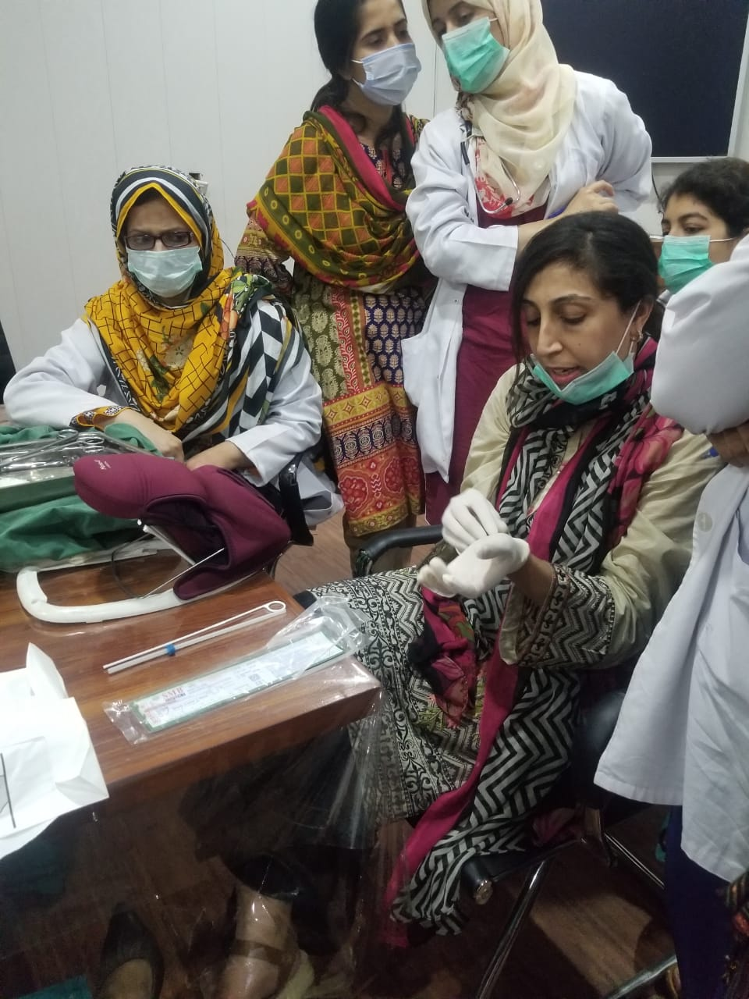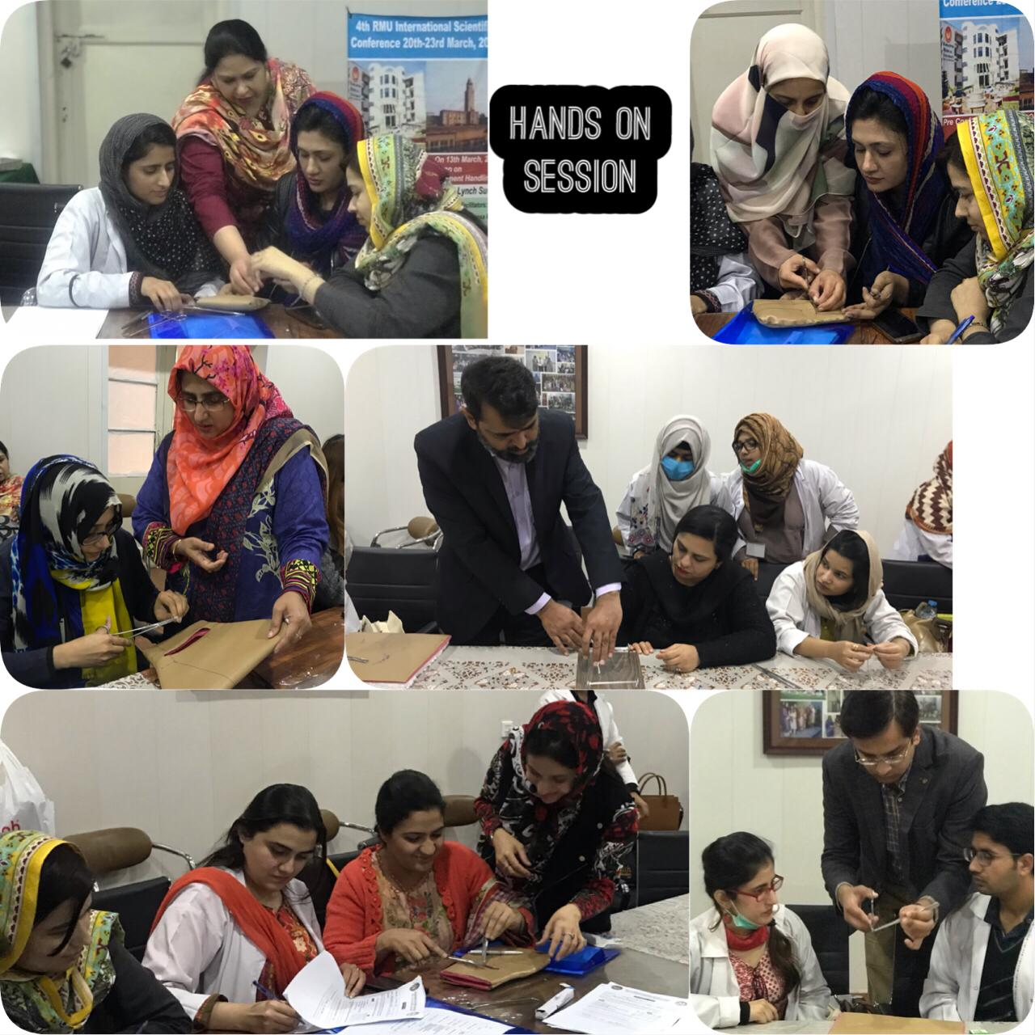

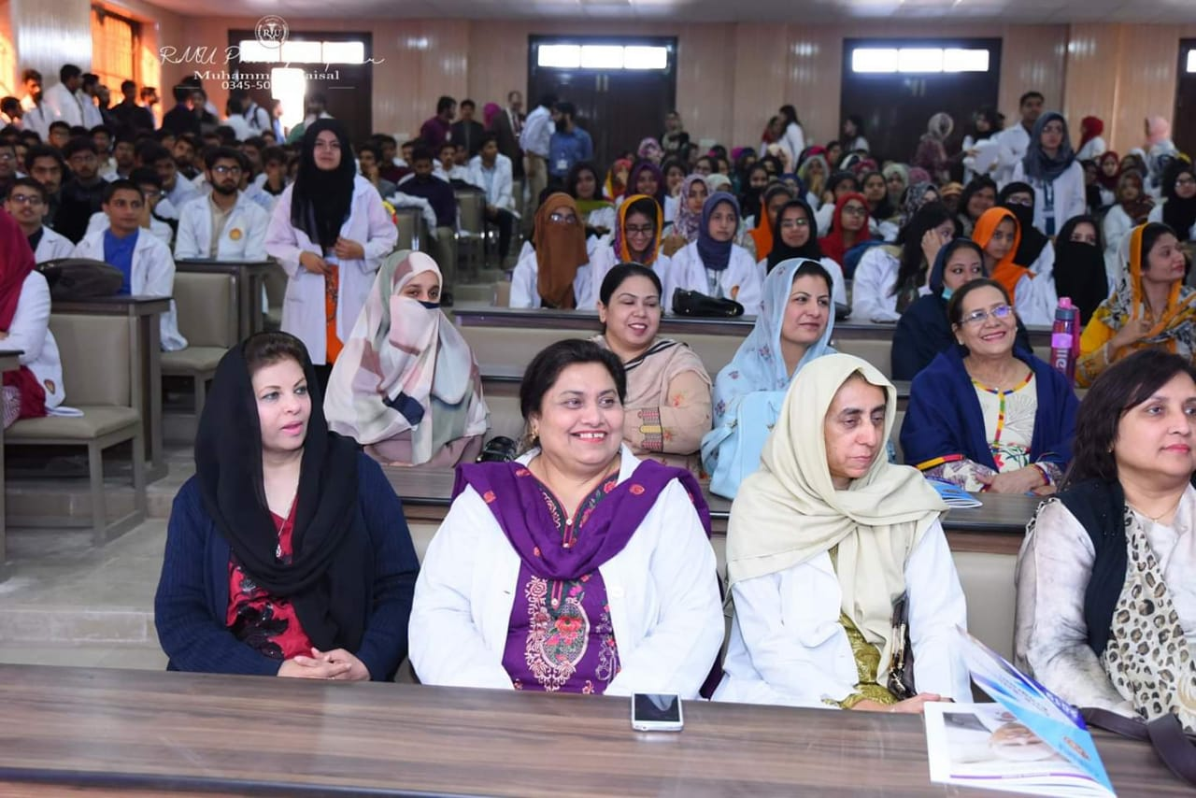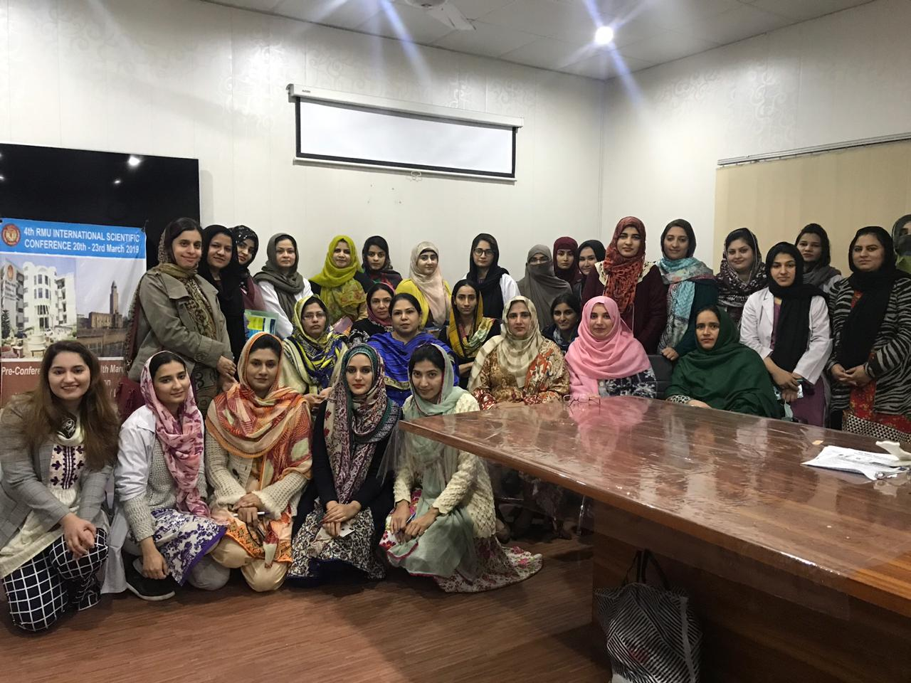
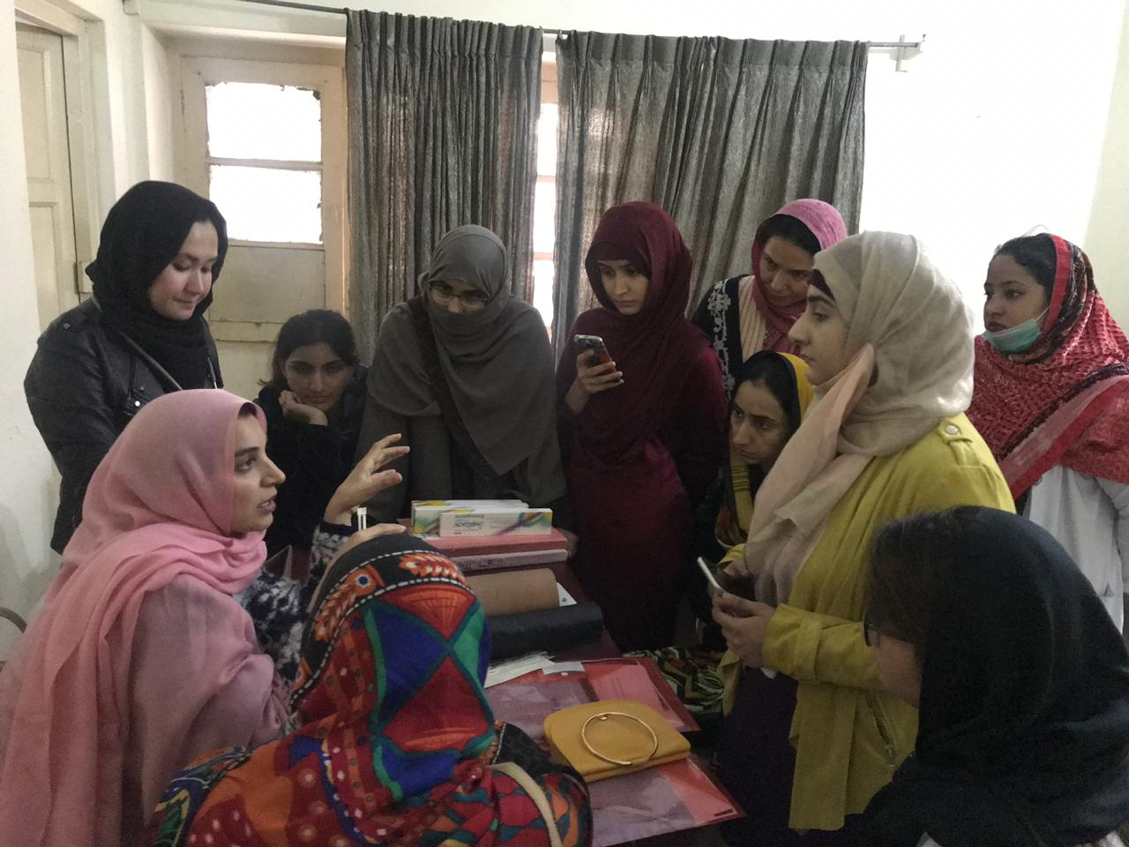
FUTURE AIMS

  - Development of subspecialties of sub-fertility, gynaecological oncology, urogynaecology and fetal medicine.
- Development of integrated oncology services (radiotherapy and chemotherapy)
- Upgradation of subfertility management services
- Improvement of blood transfusion services
- Advancement in hysteroscopy and laparoscopic services
- Initiation of mother crap classes
- Establishment of day care center for babies of working doctors
- Development of lactation management facility
- Development of daycare services for patients requiring admission
- Development of concept of ambulatory gynaecology
- Development of early pregnancy assessment unit

THANK YOU

