ANNUAL REPORT 2020
DEPARTMENT OF OBSTETRICS AND GYNAECOLOGY
BENAZIR BHUTTO TEACHING HOSPITAL RAWALPINDI

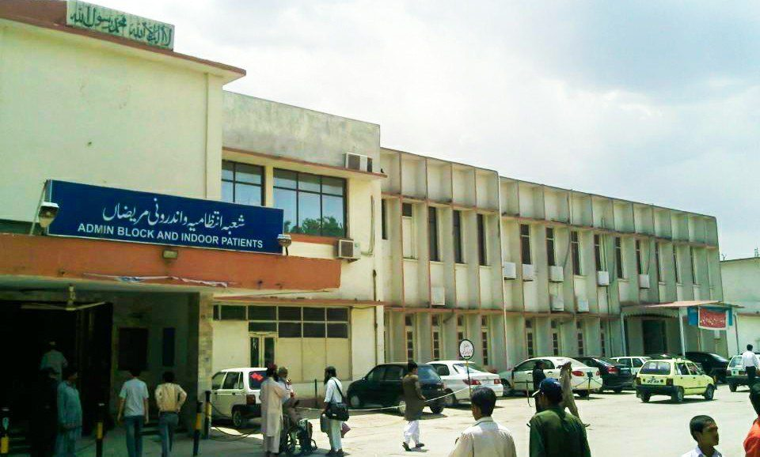
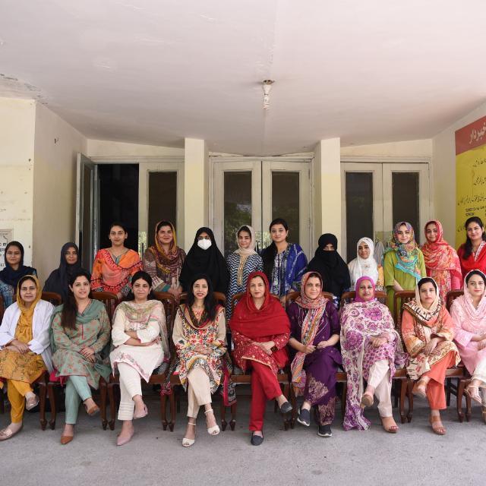

CONTENTS
Mission & vision | 03
Scope of Services | 04
Faculty Of Department | 05
Statistic | 06
Events of department | 23
Conferences and workshops | 27
Research & Activities | 28
Academic activities | 31
Equipments & Furniture | 36

Mission
Our mission is to serve the patients coming to us and improve their health regarding Gynecological and obstetrical problems. Our mission is to deal the patients in a polite and humble way and to make them understand their diseases and their management at the hospital and at their homes as well. This mission is accomplished by training and development of medical students, Nurses, Community midwives, undergraduates and postgraduates as safe health care providers and to advance the field of Obstetrics and Gynaecology through translational research. We work towards the mission by integrating education and research with clinical services to all women attending Obstetrics and Gynaecology Department of BBH.
We achieve this through advancement of knowledge, encouragement and conduct of research, application of latest skills and appropriate attitude towards patients.
We are responsive towards needs of our consumers including colleagues and students and we are committed to monitoring and improving our performance. In order to achieve our aims, we provide a productive and satisfying working environment for our staff.
The Department of Obstetrics and Gynaecology is committed to the integration of service, teaching and research functions. Education, Research and best possible health care services are important components of our mission.

Vision
In order to provide the best possible care of patients and to train undergraduate and graduates along with innovative research, the department carefully balances the strengths of sub specialization and general practice. All faculty is committed to teaching and scholarly pursuits, as well as high quality patient care.

ANNUAL REPORT 2020

Scope of Services
Subspecialties of subfertility, Gynaecological Oncology and Urogynaecology have been developed in the department. Other special services are:
- Upgraded Family Planning services
- Oncology services (Radiotherapy and Chemotherapy)
- Upgraded Subfertility management services (IUI center)
- Advanced Blood transfusion services
- Advanced diagnostic facilities (Fluoroscopic imaging)
- Advanced Laparoscopic facilities (Operative)
- Advanced Hysteroscopic facilities (Operative)
- Colposcopy Facility
- Mother craft classes
- Day care center for babies of working doctors
- Lactation management facility
- Development of concept of Day care for patients requiring admission
- Development of Early pregnancy assessment unit

Training and Teaching Aid
- Mannequins of pelvis and fetus
- Hands- On Skill Lab
- Departmental Library
- Conference room with multimedia and Skype facility for online video meeting
- Four Computers with internet
- Computer Operator for data entry

__________________________________________

ANNUAL REPORT 2020

DEPARTMENT OF OBSTETRICS AND GYNAECOLOGY
BENAZIR BHUTTO HOSPITAL RAWALPINDI

Benazir Bhutto hospital is a 750 bedded teaching hospital, affiliated with Rawalpindi medical university Rawalpindi. The department of Gynae/Obs has bed strength of 108 and besides providing clinical services it is recognized for different Postgraduate training programs like FCPS, MS/MD and MRCOG.

TEACHING FACULTY OF DEPARTMENT

Head of Department  Prof.Dr.Shazia Syed  (MBBS,FCPS,ICMT/CHPE)  Assistant Professors  Dr.Humera Noreen  (MBBS,MCPS,FCPS,CHPE)  Dr.Ismat Batool  (MBBS,FCPS,CHPE) | Consultant Gynaecologists  Dr.Samina Shafqat (MCPS)  Dr.Samina Shabir (MCPS)  Senior Registrar  Dr.Hina Gul (FCPS,CHPE)  Dr.Nighat Naheed (FCPS,CHPE)  Dr.Humaira Masood (FCPS)  Dr.Asima Khan (FCPS)  Dr.Ayesha Zulfiqar (FCPS)  Dr.Nazia Fakhar (FCPS)  Dr.Shumaila Hamid (FCPS)

Medical Officers | 10
Post Graduate Trainees (PGTs) | 20
House Officers | 19

ANNUAL REPORT 2020

STATISTICS
January 2020 to December 2020
Overview
Total no of patients seen in OPD | 57268
Total no of Patients seen in ER | 10205
Total Admissions | 12475
Admissions through OPD | 8911
Admissions through ER | 3564
Bed occupancy rate | 112%
Total maternities | 7381
Cesarean sections | 2685
Vaginal deliveries | 4696
C-Section rate | 36.3%
Total Gynecological surgeries | 224
Major surgeries | 63
Minor surgeries | 161
Maternal mortality ratio | 18 (243/100000 live births)
Perinatal mortality | 30(4.06/1000 live births)

ANNUAL REPORT 2020

STATISTICS
OPD

Total Patients Seen | 57268
General OPD | 34286
Consultant OPD | 22982
Ultrasound Room | 14283
Patients admitted through OPD | 8911

EMERGENCY WARD

Total Patients Seen | 10,205
Total patients admitted in ER | 6620
Near miss | 12

ANNUAL REPORT 2020

TOTAL ADMISSIONS (12475)

Total patients admitted in ER | 6620
Total patients admitted in labour room | 3167
Total patients admitted in High risk ward | 2283
Total patients admitted in Gynae ward | 405
Total patients admitted in Postnatal ward | 2713

High Risk Ward (Total Patients Admitted) (2283)

Diseases | Number
Anemia | 352
Scarred Uterus | 756
Hypertensive Disorders in Pregnancy | 425
Oligohydramnios | 551
Diabetes mellitus | 426
Mal presentation | 55
Polyhydramnios | 129
Placenta previa | 61
Multiple pregnancy | 40
Precious Pregnancy | 45
Cardiac Disease | 08
Thyroid Disease | 38
Liver disorder | 92
Epilepsy | 03
Post dates | 61
IUGR | 125
PPROM | 83
Preterm labour | 37
Congenital Anomalies | 20
Pregnancy with Adnexal cyst | 01
Rh Incompatibility | 14
NOTE: *One Patient can present with more than one factor so the total may not match with the grand total.

ANNUAL REPORT 2020

Labour Room (Total Patients Admitted) (3167)

Labouring Patients | 2918
Non Labouring Patients | 249

Postnatal Ward (Total Patients Admitted) (2713)

Post op Caesarean Sections | 2669
Post Natal Vaginal Deliveries | 44

Gynae Ward (Total Patients Admitted) (405)

Diseases |  | No.
Fibroid Uterus |  | 72
Adnexal Mass |  | 59
UV Prolapse |  | 25
Miscarriages |  | 15
Carcinomas(07) | Ovary | 02
 | Cervix | 02
 | Endometrium | 02
 | Vulva | 01
Polyp |  | 04
Molar Pregnancy |  | 14
DUB |  | 00
Chronic Ectopic |  | 04
Bartholin’s Cyst/Abscess |  | 01
Cervical Cerclage |  | `18
Perineal tear |  | 08
Misplaced IUCD |  | 03
Postmenopausal bleeding |  | 13
Septic induced abortion |  | 00
Hematocolpos |  | 00
Dermoid Cyst |  | 01
Post Op, Ruptured Ectopic |  | 14
Referred to NORI |  | 07
Primary Amenorrhea for EUA |  | 02
Post Op Cases |  | 41

ANNUAL REPORT 2020

EARLY PREGNANCY LOSS (653)

Miscarriages | 621
Ectopic pregnancy | 18
Molar pregnancy | 14

COVID-19 (PCR positive cases)

Total admitted patients | 18 (0.24%)
Vaginal deliveries | 06
VBAC’s | 01
LSCS | 11
IUD | 04
Early Neonatal death | 02
Maternal death | 01

ANNUAL REPORT 2020

Gynecological Surgeries (224)
Major procedures (63)
TAH | 15
TAH+BSO | 02
Staging Laprotomy | 03
Laprotomy | 09
Emergency laparotomy | 23
Myomectomy | 09
Sacrohysteropexy | 02

Intermediate and Minor procedures (161)
Polypectomy | 06
Cervical cerclage | 03
EUA | 33
Removal of IUCD | 01
Pipelle biopsy | 01
ERPC | 89
STOP | 06
Laparoscopy | 01
Hysteroscopy | 17
Cystoscopy+Proctoscopy | 04

Obstetrical surgeries (2700)
LSCS | 2685
Elective Caesarean section | 480
Emergency Caesarean section | 2197
Emergency hysterotomy | 08
Peripartum Hysterectomies | 13
Correction of Uterine Inversion | 02

Anesthesia
General anesthesia | 79
Spinal anesthesia | 2811
Local anesthesia | 34

ANNUAL REPORT 2020

MATERNAL MORTALITY RATIO ( MMR=243/100,000 live births)

Total deaths | 18
Disease
Primary PPH | 09
Pulmonary Embolism | 03
Hepatic encephalitis+Covid-19 | 01
Ruptured Uterus | 02
Blood Transfusion Reaction | 03

PERINATAL MORTALITY
PNMR=4.06/1000 live births

Total Perinatal deaths | 30
Mode of delivery
SVD | 12
LSCS | 18
Disease
Prematurity (Birth weight 1.2 kg to 2.2 kg | 07
Neonatal sepsis | 07
Birth asphyxia | 05
Meconium aspiration | 02
CHD | 02
HIE III | 01
Dandy walker malformation | 01

ANNUAL REPORT 2020

CONSULTATIONS FROM OTHER DEPARTMENTS

Total | 5,938
Department
1.Anaesthesia department | 2290
2. Radiology department | 1169
3. Medical department | 959
4. Surgical department | 22
5.Cardiology department | 30
6.Psychiatry department | 04
7.Dermatology department | 02
8.Oncology department (NORI) | 04
9.Paediatric department | 1458

SPECIAL INVESTIGATIONS
CT Scan | 52
MR I | 06

ANNUAL REPORT 2020

Special Services
Subfertility clinic
Total No. of Patients | 68
Primary Subfertility | 37
Secondary Subfertility | 22
Tubal Factor | 00
Ovarian Factor | 33
Male Factor | 08
Raised Prolactin level | 02
Endometrioses | 02
Unexplained | 00
Uterine Factor | 00
Ovulation induction given | 33
Admitted for Diagnostics Laparoscopy | 02
No. of Patients Conceived | 00
Workup not complete | 32

*One Patient can present with more than one factor so the total may not match with the grand total.

ANNUAL REPORT 2020

Special Services

Urogynaecology Clinic
Total Number Of Patients | 279
Age Group
> 50 years | 108
Between 40 to 50 years | 124
< 40 years | 47
Socioeconomic Status
Low | 89
Middle | 169
High | 21
Urinary Symptoms with Pelvic Organ Prolapse | 151
UV Prolapse with stress incontinence | 92
Cystocele with stress incontinence | 59
Urinary Symptoms without Pelvic Organ Prolapse | 128
Urge incontinence | 05
UTI | 91
Stress incontinence | 24
Mixed incontinence | 06
Urinary retention due to fibroid | 02
Vesicovaginal fistula | 00

ANNUAL REPORT 2020

COVID – 19 (PCR positive cases)
BBH was declared as COVID-19 hospital from 06-06-2020
Total Patients admitted | 18
Booked patients | 01
Non-Booked | 17
Referral cases | 06
LSCS | 11
SVDs | 06
VBAC | 01
Maternal mortality | 01
ENND | 02
IUD | 04
Symptomatic patients | 06
Asymptomatic patients | 12
Covid – 19 + Medical problems | 11
Anemia | 05
Diabetes mellitus | 02
PIH | 03
Sepsis (Typhi dot +ve) | 01
Indication of C-Sections
Previous 01 scar | 01
Previous II scars | 03
Previous III scars | 01
Chorioamnionitis | 02
Precious pregnancy | 01
Eclampsia | 01
Decreased fetal movement | 01
CPD | 01

ANNUAL REPORT 2020

Patients seen in OPD
N=71551
14,283
34286
22982

ANNUAL REPORT 2020

Total patients seen in EMERGENCY and WARD
N=8,596

ANNUAL REPORT 2020

Total Maternities
N=7373

ANNUAL REPORT 2020

Month wise maternities in 2020

ANNUAL REPORT 2020

YEAR WISE MATERNITIES

ANNUAL REPORT 2020

ANNUAL REPORT 2020

EVENTS OF THE DEPARTMENT OF OBSTETRICS AND GYNAECOLOGY
BENAZIR BHUTTO HOSPITAL.RWP
2020

ANNUAL REPORT 2020

ACHIEVEMENTS
Research Papers Presentation on national level | - COVID-19 and Pregnancy Outcome: An Experience in ‘COVID-19 Management Designated’ Tertiary Care Hospital, Rawalpindi, Pakistan  (presented by Prof. Dr. Shazia Syed in 2nd Annual Faculty Research conference RMU and SOGP Local chapter meeting)  - Partial hydatidiform mole with co-existing live fetus presented by Dr.Samina Shafqat in 2nd Annual Faculty Research conference RMU  - Study on Basal FSH and Antral Follicle Count in prediction of ovarian reserve among subfertile women presented by Dr Aisha Ishtiaq (PGT) in 3rd Annual resident Research Conference RMU. (She won the competition).  - Comparison of the effect of myoinositol and metformin on biochemical profile in women with PCOs presented by Wajiha Khanum (PGT) in 3rd Annual resident Research Conference RMU
National Poster presentation | - Dilemma of large vesical calculus complicating pregnancy presented by Dr.Sawera Sadique (PGT) 2nd Annual Faculty Research conference RMU

ANNUAL REPORT 2020

Sr. | Date | Topic
1 | 07-03-2020 | Women’s Day  Venue: OPD BBH | 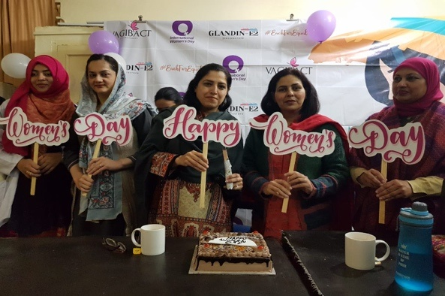
2 | 25-09-2020 | World Contraception Day SOGP Rwp/Isb Chapter Workshop on LARC  Venue: Skill Lab BBH | 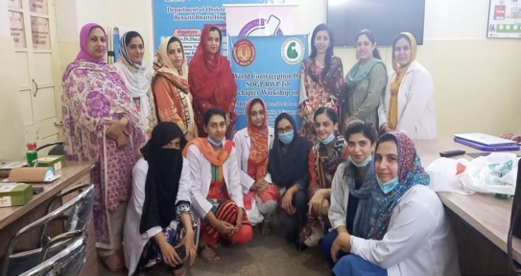
3 | 27-10-2020 | Workshop on Clinical Management of COVID-19 during Pregnancy  Venue: BBH library | 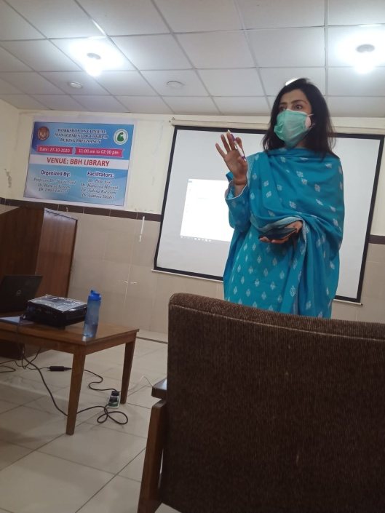  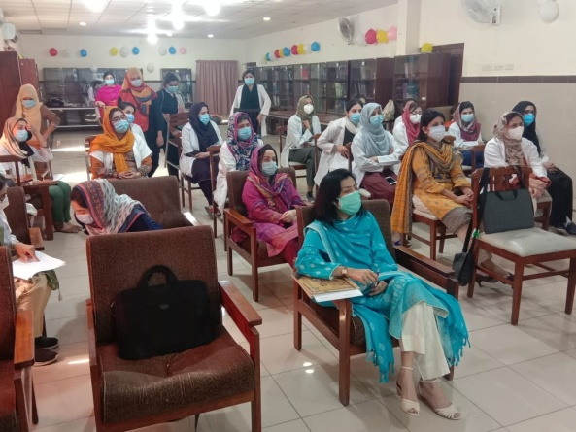
4 | 15-12-2020 | 2nd Annual Faculty Research Conference RMU | 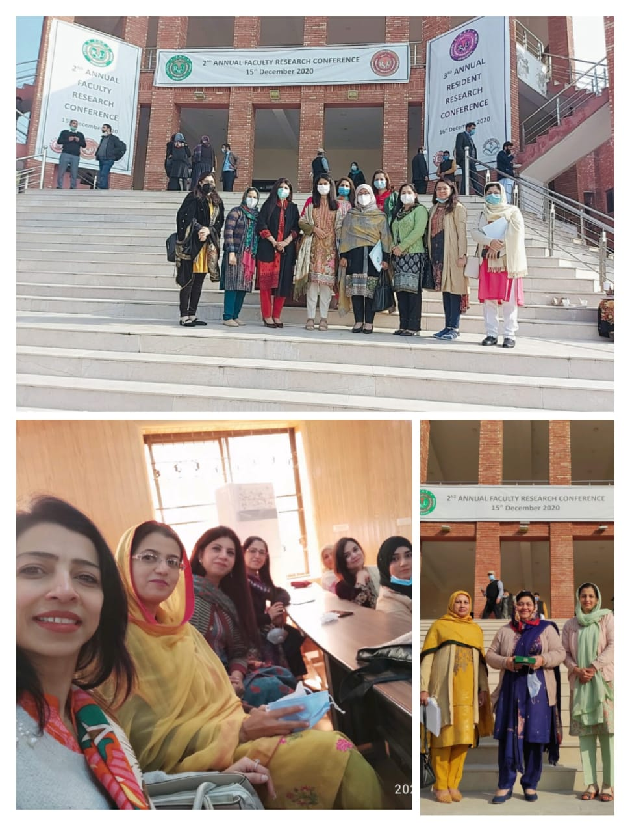
5 | 16-12-2020 | 3rd Annual Resident Research Conference RMU | 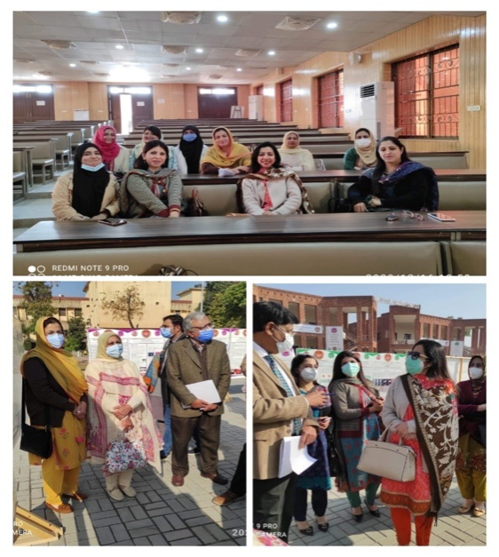

ANNUAL REPORT 2020

Conferences and Workshops Attended by Faculty of Department of Obstetrics and Gynaecology, Benazir Bhutto Hospital, Rawalpindi

- First Mechanical Hysteroscopic Workshop Attended by Prof.Dr.Shazia Syed at Shifa Tamer-e-Millat University on 7th March, 2020
- Urogynaecology and Reproductive Health. 17th International Bhurban Conference on Applied Sciences and Technology Attended by Prof.Dr.Shazia Syed at NESCOM on 16th January, 2020
- Training of District gynaecologist on HIV treatment PPTCT and Pediatric care guidelines organized by Punjab AIDS control program in collaboration with UNICEF Attended by Dr.Samina Shafqat at Flatties Grand Hotel, Gulberg III, Lahore on 30th January, 2020
- Training on clinical management of COVID-19 during pregnancy attended by Dr. Humaira Masood at PIMS, Islamabad on 27th August, 2020
- Workshop on urodynamics attended by Dr. Rehana Kauser at NESCOM Hospital Islamabad on 17th January, 2020
- Workshop on b-lynch suture attended by Dr.Rehana Kauser at NESCOM Hospital Islamabad on January, 2020
- Workshop on Fundamental Biostatistics for researchers using SPSS organized by Indus Pharma attended by Dr.Asima Khan at Benazir Bhutto Hospital, Rawalpindi in 2020.

ANNUAL REPORT 2020

RESEARCH ACTIVITIES

A-RESEARCH PUBLISHED

Original Research Articles in PM&DC/HEC approved Journals

- “COVID-19 and Pregnancy Outcome: An Experience in ‘COVID-19 Management Designated’ Tertiary Care Hospital, Rawalpindi, Pakistan published in Journal of Rawalpindi Medical College (JRMC) Vol 24 No-Supp-1 (2020)”
Shazia Syed, Humera Noreen,Humaira Masood, IsmatBatool,Hina Gul, Nighat Naheed

B- ONGOING RESEARCH PROJECT OF FACULTY

- National Research Project;
Optimisation of Caesarean section rate using ROBSON’s 10 Group classification system’

- International Research Project;
Investigating Efficacy of Tranexamic acid in management of Postpartum-haemorrhage. (Women Trial II)

ANNUAL REPORT 2020

C- ONGOING RESEARCH PROJECT OF FCPS PGTs

Name of PGT | Title/Topic
Dr.Sawera Sadique | Study of umbilical cord blood ph and its relationship with clinical fetal distress and APGAR score
Dr.Sumaira Bibi | Association of maternal uric acid level with fetal outcome in patient with pre eclampsia
Dr.Sadia Ejaz | Association between obesity and gestational diabetes mellitus
Dr.Irum Baig | Screening and prevention of preeclampsia in 1st trimester
Dr.Qudsia Khan | Accuracy of estimated fetal weight sonologically in prediction of actual birth weight in term pregnancies
Dr.Aima Ather | Comparison of diagnostic acccurancy of ADNEX and RMI model in predicting the nature of ovarian tumor
Dr.Wajiha Khanum | Predictive value of SFH in detection of FGR by taking ultrasound as a standard
Dr.Shamin Fazal | Comparison of induction- delivery interval between prostaglanding passry and ICF
Dr.Mehmooda Mehdi | Palm-COEIN classification system of FIGO vs the classic terminology in ots with abnormal uterine bleeding

ANNUAL REPORT 2020

D- ONGOING RESEARCH PROJECT OF MS PGTs

Name of PGT | Title/Topic
Dr.Aisha Ishtiaq | Comparison of fetomaternal outcome in patient with pre-labour rupture of membrane at term-immediate verses expected management
Dr.Unsa Malik | Comparison of ovulation induction response in obes verses non obes patients presented with PCOS
Dr.Zahida Saeed | Comparison of obstetric complications after previous one elective vs planned C-Section
Dr.Sumaira Mubashir | Frequency of postpartum hemoprhhage in spontaneous VS prostaglandin induced labour
Dr.Aiman Shahid | Diagnostic accuracy of transabdominal ultrasound in diagnosis of placenta accrete spectrum in comparison with per operative findings
Dr.Sidra Kiyani | Early pregnancy serum lipid profile as a predictor of hypertensive disorder of pregnancy
Dr.Tabassum Jahangir | Maternal outcome of membrane sweeping for vaginal birth after c- section
Dr.Maryum Iqbal | Diagnostic accuracy of transvaginal Ultrasound in detection of Postmenopausal pathology in comparison with histopathology
Dr.Zeeshan Ahmed | Hypoproteinemia as a parameter of poor perinatal/neonatal outcomes in women with preeclampsia diagnosed as hypertension plus proteinuria

ANNUAL REPORT 2020

ACADEMIC ACTIVITIES OF THE DEPARTMENT OF OBSTETRICS AND GYNAECOLOGY
BENAZIR BHUTTO HOSPITAL.RWP

ANNUAL REPORT 2020

UNDER GRADUATES TEACHING PROGRAM
LECTURE SCHEDULE
FOURTH YEAR
- Lecture conducted once a week in university premises by departmental faculty.
FINAL YEAR
- Lecture conducted once a week in university premises by departmental faculty.

CLINICAL ROTATAION SCHEDULE

FOURTH YEAR
- Two weeks rotation in divided batches of 4-5 students (four days a week).
FINAL YEAR
- Four weeks rotation in divided batches of 15-18 students (six days a week).

ANNUAL REPORT 2020

ROTATION PLAN FOR UNDERGRADUATE STUDENTS

- From 10am to 12pm students are rotated at different stations like emergency, OPD and wards.
- From 12 to 2pm students attend a clinical class by teaching faculty.
- Students are also assigned maternity duties from 2pm to 5pm
- At the end of clinical rotation of each batch there is a ward test comprising of OSPE and Long case

TRAINING PROGRAM OF UNDERGRADUATE STUDENTS
INDEPENDANT
- History Taking
- General Physical Examination
- Abdominal examination of antenatal patient.
- Tracing out CTG
- Post Op care of patients.
DIRECTLY SUPERVISED /ASSISTED
- Maintaining IV line
- Urinary catheterization
- PAP smear
- Taking high vaginal swab

ANNUAL REPORT 2020

TRAINING PROGRAM OF UNDERGRADUATE STUDENTS
OBSERVED
- Spontaneous vaginal delivery
- Lower segment C section
- Delivery of placenta By Brands Andrew technique
- Repairing of mediolateral episiotomy
- Resuscitation of newborn baby
- Resuscitation of collapsed patients
- Management of PPH, eclampsia, PROM

DRILLS ON MENEQUIN

- Vacuum extraction
- Outlet forceps delivery
- Shoulder dystocia
- Breech delivery
- Fetal dimentions and pelvic diameters on examination model

ANNUAL REPORT 2020

TRAINING PROGRAM OF POSTGRADUATE STUDENTS

FCPS

- 4-years program with six months rotation
- Affiliated with CPSP

MS/MD
- 4-years program with one year rotation
- Affiliated with RMU/ UHS

SCHEDULE OF POSTGRADUATE STUDENTS

- Post graduate trainings are rotated monthly on different stations with 1/3 calls for first two years and 1/4 calls for next two years.
- Morning meeting is conducted 4-days a week.
- Long case presentation once a week.
- Journal club meeting once a month.
- Maternal mortality meeting once a month.
- Statistical meeting once a month.

ANNUAL REPORT 2020
Equipment and furniture required for the Department:
- Cardiotocography monitors 12
- Ultrasound machines with abdominal and Vaginal probes 04
- Doppler Ultrasound 01
- Pulse Oximeters 06
- ECG Machines 02
- Glucometer with strips 02
- HDU vital signs monitors 06
- Infusion pumps/Diaflow 06
- Adjustable Hydraulic beds (for all indoor patients in OBS/GYNAE)
- Adjustable Hydraulic Delivery tables 06
- Eclampsia beds 02
- Baby resuscitation trolleys 02
- Baby portable incubators 2
- Mock resuscitation trainer for babies
- Sonic aids 06
- HCG diagnostic kits
- Microscope for Subfertility clinic 01
- Drinking water and washroom facilities for patients and doctors
- Seating arrangements (waiting area for pregnant ladies in OPD and ER)
- Air conditioning facilities (Cold and warm) for patients, doctors and for durability of ultrasound machines
- Office chairs16
- Large office table for ER room 27
- Screens for wards (8)
- Demands for doctors:(SRs/MO/HO)
- Microwave Ovens 02
- Refrigerator 02
- Room chairs 06
- Wooden tables 02
- Wooden beds with room mattresses 05
- AC for SR room
Note: For implementation of above-mentioned services and training and for utilization of equipment additional medical and para medical staff and support staff is required along with provision of additional space and infrastructure.

THANK YOU

ANNUAL REPORT 2020
DEPARTMENT OF OBSTETRICS AND GYNAECOLOGY
BENAZIR BHUTTO TEACHING HOSPITAL
RAWALPINDI MEDICAL UNIVERSITY AND ALLIED HOSPITAL

