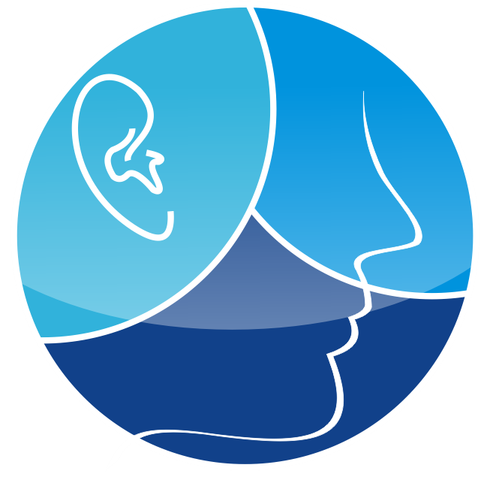
ANNUAL PROGRESS REPORT 2020-2021
DEPARTMENT OF OTORHINOLARYNGOLOGY
DISTRICT HEADQUARTERS HOSPITAL RAWALPINDI

INTRODUCTION:
The Department of ENT at DHQ hospital is a multidisciplinary department consisting of Otology, Rhinology, Laryngology and Audiology sections. The department is providing services round the clock to emergency patients of the hospital. ENT department is providing 4 days a week OPD services to outdoor patients as well as 2 days a week elective services to patients of DHQ Hospital, Rawalpindi. All the services to OPD, emergency and elective are provided free of cost.
The department is equipped with routine ENT equipment in OPD section. In OT we have facilities for microsopic and endoscopic surgery system. We are also equipped with Bronchoscope and Esophagoscope in Operation Theatre. In our ward we have 12 beds, 1 side room, 1 class room, 2 consultant room and a Mini OT as well as we have central oxygen supply. ENT department is providing services to 200 plus OPD patients in every 4 days of OPD weekly and about 25,000 plus yearly as well as 150 plus Emergency cases and 40 plus Elective cases monthly. The staff is committed to provide high quality, efficient, reliable services. 10 post graduate resident are getting training in ENT department.

QUALITY ASSURANCE:
- All our services are supported daily by internal Quality Assurance (Controls), thus ensuring reliability and confidence.
- Punjab Healthcare Commission (PHC) indicators are being displayed in every section and they are being strictly implemented.
DIFFERENT SERVICES AVAILABLE IN DIFFERENT SECTIONS

1. OTOLOGY:
All routine Otology cases includes ear wax, acute otitis externa, ASOM, CSOM, furuncle, perichondritis, otomycosis, tinnitus and vertigo etc. are dealt in OPD.
- For Ear Wax suction machine is available in OPD and also in ward.
- Foreign body ear, trauma to temporal bone is dealt on emergency basis.

2. RHINOLOGY:
It include both nose and paranasal sinuses problems. All routine cases e.g. , acute viral rhinosinusitis, allergic rhinitis , epistaxis, deviated nasal septum and Nasal polyp are dealt by the experienced, dedicated and well trained team.
Foreign body nose is dealt on emergency basis.
Polyp and other cases such carcinoma are operated on Wednesday and Friday lists.

Newly renovated OPD section with all routine ENT equipment in DHQ Hospital, Rawalpindi

3. LARYNGOLOGY:
All routine cases such as acute laryngitis etc are carried out in this section. All benign and malignant diseases of larynx are dealt with. Tracheostomy is done in emergency and on elective basis.

4. AUDIOLOGY:
Routine Audiology cases are dealt in OPD.
Disability certificate is given to disabled two days a week after thoroughly examining and co-relating investigation of patients.

Thyroidectomy done in operation theatre of DHQ Hospital, Rawalpindi

- The recent ongoing renovation process in the department and the prevailing pandemic influenced the per annum work load, due to similarity of sign and symptoms of COVID - 19. Every effort was made to provide uninterrupted services to the hospital and patients.

- The detailed description of the OPD, emergency cases, elective cases per month can be shared on demand as hard copies.

- Following is the summary of ALL cases in different sections of ENT department DHQ hospital Rawalpindi from July 2020 to June 2021.

Sr no | Sections | July 20 | Aug 20 | Sep 20 | Oct 20 | Nov 20 | Dec 20 | Jan 21 | Feb 21 | Mar 21 | Apr 21 | May 21 | June 21 | Total
1 | OPD | 2968 | 2877 | 2776 | 2974 | 2884 | 2798 | 2897 | 2802 | 2965 | 2873 | 2975 | 2785 | 28824
2 | Emergency | 152 | 163 | 145 | 134 | 137 | 136 | 147 | 156 | 159 | 162 | 161 | 153 | 1805
3 | Elective | 38 | 41 | 40 | 39 | 38 | 37 | 42 | 44 | 37 | 36 | 43 | 44 | 479
 | Total |  |  |  |  |  |  |  |  |  |  |  |  | 85108

TEACHING ACTIVITIES:
- Undergraduate teaching of 4th year M.B.B.S students in ENT is in the form of small group, wards rotation in DHQ hosp. Regular demonstration and classes at continuous pace are carried out for these students throughout the year.

- Department also participate in conducting regular seminars/ training sessions as part of continued medical education in collaboration with other departments of Hospital.
- Department is also conducting weekly test of PGT's and journals club.
ACTIVITIES DURING COVID19 PANDEMIC
- ENT department is more exposed to Covid - 19 due to similarity of symptoms and sign, despite this fact our department is giving services with all precautionary measures and following SOP's of Covid-19.
- Urgent tracheostomies done in covid-19 patients when needed.

RESEARCH ACTIVITIES.
- Department is actively engaged in research activities. Regular journal club is done on weekly basis in which latest research articles related to ENT from international journals are discussed.
- Presently all trainers are doing research projects in different stages of data collection.
- Faculty of department is involved in inculcating research attitude and guiding them in their research projects.

