Faculty of Community Medicine

& Public Health
ANNUAL REPORT 2019-20

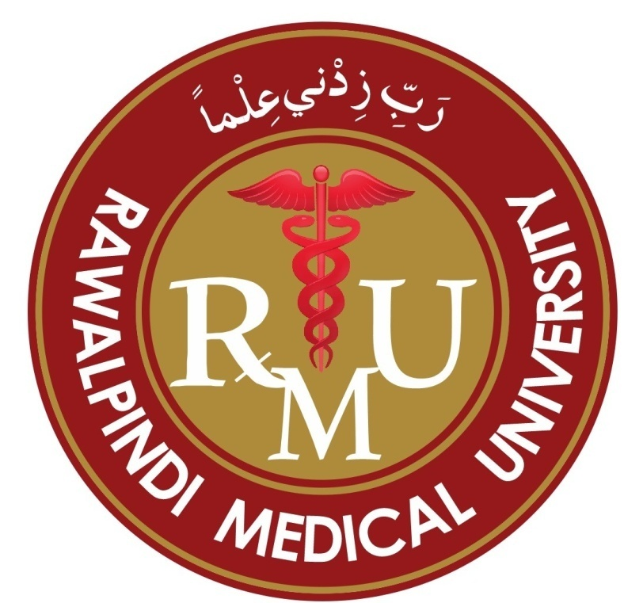

Rawalpindi Medical University
Rawalpindi
New Teaching Block HFH Rawalpindi
Ph. 051-9290693, 051-9290775 Ext.345

Foreword
This report contains an outline of all important the academic and extra-academic work done by the faculty & staff of the Department of Community Medicine & Public Health over the year 2019-20. This report has been produced under the need of the office of Vice Chancellor Rawalpindi Medical University.

Chairman
Faculty of Community Medicine & Public Health
Rawalpindi Medical University Rawalpindi

Mission Statement

To impart subject based updated & community oriented medical education to the students of MBBS degree so they could learn and practice their roles in preventing diseases, protecting & promoting human health & well being of the communities they are supposed to serve in future.

This Document Contains following item

# | CONTENTS
 | Foreword
 | Mission statement
 | Faculty introduction
 | Report of 4thyear MBBS Academic work – Community Medicine 2019-20
 | Report of 1st – 3rd MBBS Academic work – Community Medicine 2019-20
 | Report of IUGRC 1st to 3rd Years components.
 | Report of Student’s Research Projects 4thyear MBBS – CM – 2019-20
 | Report of Center for Health Communication activities - 2019-20
 | Report of Museum Learning Module -CM- 2019-20
 | Report of faculty & staff workshare in running Telemedicine Center-RMU during Covid-19 Pandemic during year 2020.

FACULTY OF COMMUNITY MEDICINE &PUBLIC HEALTH
2019-20

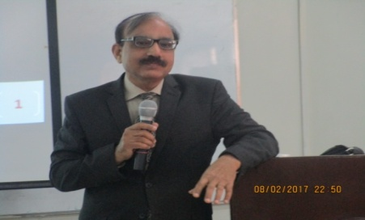

Head of the Department
Prof Dr. Syed Arshad Sabir
MBBS FCPS, MCPS, DCH, CRCP

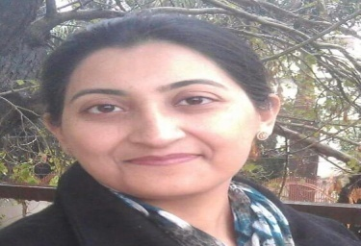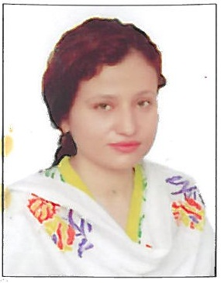 |  |  | 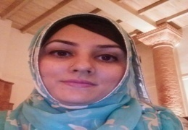
Dr.Sana Bilal MBBS, FCPS AP Dr khola Noreen MBBS,M.Phil AP |  |  | Dr.Rizwana Shahid AP Dr.Afifa Kulsoom MBBS,FCPS AP  FCPS,MBBS,MHPE
 |  | 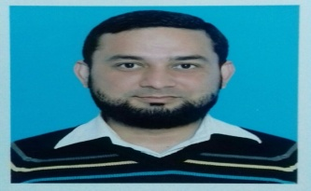 | 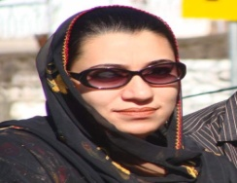 | 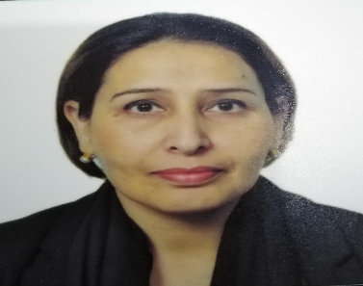
Dr.Abdur Rehman  MBBS,FCPS1 |  | Dr.Farhan Hassan  MBBS,FCPS1 | Dr.Mahjabeen Qureshi MCPS,MBBS | Dr. Narjis Zaidi  MBBS MSPH
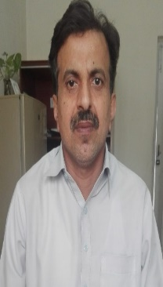 | 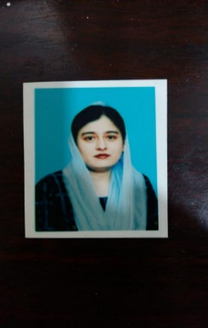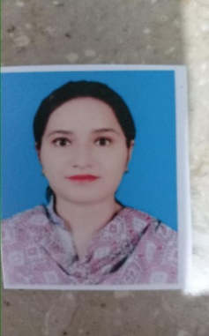 |  | 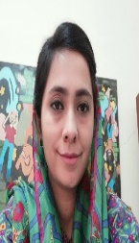 |  | 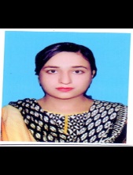
Dr.AbduLlqaddus MBBS,MPH  Dr.Maimoona Saleem MBBS, MCPS  Dr. Gulzaib Pervaiz MBBS , FCPS part1 |  |  | Dr. Anum Abdullah MBBS, FCPS-ii PGT  Dr Umaira Ali MBBS, FCPS-II PGT  Dr. Muniba Iqbal MBBS,FCPs-II PGT

Report core academics of 4thyear MBBS session 2019-20 in the subject of community medicine

(subject teachings & Assessments)

Rawalpindi Medical University
- Commencement of the Session 9th December 2019
BREAK UP OF SCHEDULE, MODE OF DELIVERANCE & HRs OF THE CURRICULUM

CLASS-ROOM TEACHING
# | PERIOD | No OF LGISs | Mode of teaching | Remarks
1 | 9th December 2019 to 14th March 2020 | 65 | On campus teachings | Formal start of the session
2 | 6th April 2020 to 15th May, 2020 | 54 | Uploaded Recorded lectures (LSM) | Start of covid-19 pandemic
3 | 16th May 2020 to 15th September, 2020 | 61 | Online teachings  MS teams | Closure of institutional teachings – covid-19
4 | 16th September,2020 to 14th November,2020 | 38 | On campus teachings | Formal session resumed
Total LGIS = 218
On campus= 103 hrs.
Online teachings = 115hrs

BATCH TEACHINGS BREAKUP

- Whole class is taught in batches of 20-22 students, posted in the department of community medicine on rotation basis over the whole academic year.
- Total batches: 15
- Period of rotation: 2weeks
- Teaching hrs.: 28hrs each rotation
- Batch teachings comprise, class -room teachings, students research projects, field visits and CHC training program.

ASSESSMENT WORK REPORT

Assessment activity | Schedule followed | Mode of Assessment | Result (pass %age)
Formative assessment
1st class test | 17th February, 2020 | SEQs (on campus) | 47%
2nd class test | 28th September,2020 | MCQs (on campus) | 70%
3rd class test | 9th&10th October, 2020 | OSPE (on campus) | 70%
4th class test | 6th & 7th November,2020 | VIVA (on campus) | 85%
Sendup exam | 20th November, 2020 | MCQs (online) | 98%
Summative (University) assessment
Professional  (theory exam)  Professional  (Practical exam) | 26th February, 2021  10th March to 21st March (12 Days) | MCQs & SEQs  (On campus)  OSPE & VIVA | 97%

Report section prepared by:
- Dr Mahjabeen Qurashi (Sen Demo)
- Dr Farhan Hassan (Sen Demo)
Supervised by:
Dr Sana Bilal AP

Report of Integrated Modular Curriculum 1st to 3rd Year MBBS shared by the subject of Community Medicine during Academic Session 2019-20
Since the beginning of integration across five years of MBBS at Rawalpindi Medical University, the subject of community medicine is also being taught right from first year of MBBS. Relevant content is being delivered according to the system-based modules in first year, second year and third year.
The objective is to inculcate required competencies of community medicine and public health to the undergraduate medical students in accordance with the various curricular subjects taught in each year of MBBS course under the need of integrated modular curriculum.
The outline or report of contents of the subject of community medicine delivered under various modules form 1st to 3rd year is as under:
First year MBBS
DEPARTMENTAL TEAM
Team lead | PROF. DR. SYED ARSHAD SABIR  DEAN PUBLIC HEALTH AND COMMUNITY MEDICINE RMU
Senior Supervising faculty  Teaching faculty | DR AFIFA KULSOOM Assistant Professor  DR. MAIMOONA  DR. GULZAIB  DR. MUNEEBA

Foundation Module
CM Curriculum delivered | Teaching strategy | Remarks
Healthcare  Health For All  Primary Health Care  Health Determinants  Evolution Of Public Health | LGIS
Epidemiology of Genetic health disorder  Genetic Screening & counselling | LGIS
BLOOD AND IMMUNOLOGY MODULE
Host Defence mechanisms and immunology | LGIS
RESPIRATORY MODULE
Air and ventilation  Environmental Degradation | LGIS
Smoking | LGIS
Tuberculosis – Public Health Problem | LGIS
CARDIOVASCULAR MODULE
Non-communicable health problems of the community | LGIS
CHDs | LGIS
MUSCULOSKELETAL MODULE
Roadside Accidents | LGIS

2nd year MBBS
Teaching Faculty
- DR. FARHAN
- DR. MEHJABEEN
- DR. UMAIRA ALI
REPRODUCTION MODULE
CM Curriculum delivered | Learning strategy | Remarks
Epidemiology & Control of Sexually Transmitted Diseases | LGIS
BLOOD AND IMMUNOLOGY MODULE
Host Defence mechanisms and immunology | LGIS
HIV AIDS | LGIS
ENDOCRINE MODULE
Descriptive Statistics-I | LGIS
Descriptive Statistics-II | LGIS
Descriptive Statistics-III | LGIS
GASTROINTESTINAL MODULE
Concept of Health & Disease | LGIS
Infectious disease epidemiology-intro | LGIS
Water borne disease of in community | LGIS

3rd year MBBS
Teaching Faculty
- DR. ABDULQUDDOOS
- DR. ABDURREHMAN
- DR. NARGIS
- DR. ANUM
FOUNDATION MODULE
CM Curriculum delivered | Learning strategy | Remarks
Environment & Human Health- water | LGIS
Water distribution-conservation – purification | LGIS
Air- pollution – I | LGIS
Air-Pollution-II | LGIS
HAEMATOLOGY IMMUNOLOGY AND RESEARCH MODULE
Inferential Statistics-I & HRM | LGIS
Inferential Statistics-II & HRM | LGIS
Inferential Statistics-III & HRM | LGIS
Inferential Statistics-IV & HRM | LGIS
Inferential Statistics-V & HRM | LGIS
MICROBES AND ANTIMICROBIALS MODULE
Disposal of Waste | LGIS
Climate & Human Health | LGIS
Housing & Human Health | LGIS
Light & Noise Pollution | LGIS
Dengue Fever- Control & prevention in the community | LGIS | Seminar
GI & RESPIRATORY MODULE
Community Nutrition-I | LGIS
Community Nutrition-II | LGIS
Community Nutrition-III | LGIS
Community Nutrition-IV | LGIS

Section Report prepared by: Dr Afifa Kulsoom Assistant Professor

Report IUGRC 1st to 3rdyear subject deliverance (2019-20) Report
(Report Section prepared by Dr Khoula Nourren AP)
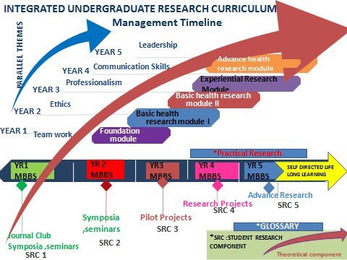
Fig 1: Integrated Under Graduate Research Curriculum
(Theoretical component (IUGRC1-V) (Student Research component SRC 1-V)
Integrated Undergraduate Research Curriculum (IUGRC)

First Year MBBS
- Theoretical sessions
- 4 sessions are conducted
- Details of the sessions are as under
- Introduction to Health research
- Characteristics of Health Research
- Health Research Cycle
- Ethics in Health Research

- Practical Session (3 Sessions)

Evidence Based Medicine –1
- Introduction to EBM Process
- 5As of EBM Cycle

Evidence Based Medicine –2
- Framing a Proper, Pertinent, Focused and Answerable Question
Dates on which practical session were conducted ( one session was replaced by LGIS)
Second year MBBS
3 LGIS conducted
- Descriptive statistics 1
- Descriptive statistics 2
- Descriptive statistics 3

3rd year MBBS
6 LGIS scheduled as follows
    - Inferential Statistics-I / HRM-I
    - Inferential Statistics-II / HRM-II
    - Inferential Statistics-III / HRM-III
    - Inferential Statistics-IV / HRM-IV
    - Inferential Statistics-V / HRM-V
    - Inferential Statistics-VI / HRM-VI

ANNUAL REPORT OF STUDENTS RESEARCH PROJECTS
4th Year MBBS

Faculty of Community Medicine & Public Health

Session 2019-2020

Rawalpindi Medical University NTB Rawalpindi
(Report Section Prepared by Dr Umaira Ali PGT-FCPS-II, Supervised by Dr Sana Bilal AP)

INDEX
# | Batch name | Title of the research Project | Batch In charge
 | e | personality traits of medical students: a cross sectional study: | Dr. Abdul Qudoos
 | n | epidemiological information, analysis of data available on internet about covid -19 in united states of America | Dr. Abdul Qudoos
 | b | Levels of emotional intelligence among students of public medical colleges of Pakistan amidst the crisis of covid-19 pandemic | Dr. Umaira Ali
 | k | a review and analysis of pooled epidemiological data available on internet about covid-19 outbreak in Wuhan, China | Dr. Anum Abdullah
 | j | Factors which determine grand multi parity and associated health consequences. | Dr. Sidrah Nasim
 | a | assessment of level of awareness of preventive measures against corona disease among educated people (non-medical). | Dr. Farhan
 | c | perception and acceptance by a section of youth of premarital screening as health measure to control some genetic, perinatally and sexually transmitted diseases prevalent in community. A cross-sectional survey. | Dr. Gulzaib Pervaiz
 | d | Frequency of self-medication and its determinants in a section of adult population of Rawalpindi | Dr. Mehjabeen Qureshi
 | o | Pattern of health problems during last 3 months of covid pandemic (1st year) as reported by the general physicians. | Dr. Mehjabeen Qureshi
 | h | knowledge & perception of social factors affecting eating habits in youth of Rawalpindi & Islamabad settings | Dr. Narjis Zaidi
 | l | Frequency & pattern of symptoms of premenstrual syndrome  in female mbbs students | Dr. Gulzaib Pervaiz
 | g | Level of knowledge of cough etiquettes in medical students, doctors, and non-medical staff. A descriptive study | Dr. Farhan
 | m | Pattern of eating habits of medical students of a public sector medical teaching institution. | Dr. Abdur Rehman

Abstracts of the students research projects (SRP)undertaken during academic year 2019-20
SRP 1
PERSONALITY TRAITS OF MEDICAL STUDENTS: A CROSS SECTIONAL SURVEY:
Students of Batch E. Batch in charge: Dr. Abdul Qudoos
Abstract
Introduction The aim of the study was to access the personality traits of medical students in Rawalpindi medical university. Material and methods This cross sectional study was done as part of batch research program in Rawalpindi medical university we used validated big five inventory to measure students personality traits. Undergraduate MBBS students from all classes were included in the study. The questionnaires were distributed among the students. We used convenience sampling to collect data. The data was analyzed using SPSS version 20. Results The students scored highest on openness to experience 35.60 ± 7.06 and agreeableness 33.52 ± 5.14. While lowest score was in extroversion 25.11 ± 5.99. Independent t test shows that there was no significant difference between male and female participants on all five personality traits. Further analysis showed that 76 (82.6%) students scored high on agreeableness while 82 (89.1%) students on openness. 77 (83.7%) students were low on extroversion which was highest low on any category. Conclusion Openness to experience and agreeableness were highest observed personality traits among medical students. Which corresponds for inventiveness, intellectual curiosity and compassionate, and cooperative. Indicates ones trusting and helpful nature. While students were low on extroversion, neuroticism and Conscientiousness.
Keywords : Medical students, personality traits, extroverts,

SRP 2

Epidemiological information, analysis of data available on internet about COVID -19 in United States of America
Students of Batch N. Batch in charge: Dr. Abdul Qudoos
Abstract:
Introduction: Coronavirus disease 2019 (COVID-19) is a novel infectious disease caused by severe acute respiratory syndrome coronavirus 2 (SARS-CoV-2). The first confirmed case of local transmission in United States was recorded in January after which there is tremendous increases in cases as well as spike in death rates: study objectives were to analyse data available on internet of covid 19 in United States of America which can help us understand epidemiology of this disease.3Material and methods This study was conducted during locked down period as part of batch research of 4th year community medicine Rawalpindi medical university: online data available on different sources about covid 19, its epidemiology distribution, trends in cases during study months and overall mortality was analysed. As we relied on data available on internet, so case definition of covid 19, and related mortality were same as adopted by the local authorities: Results: Community transmission of coronavirus disease 2019(COVID-19) was first detected in the United States in February 2020. Data showed ethnicity/ race related variations in cases non-Hispanic had highest number of cases 1,193,100 (43.2%) followed by Hispanic/Latino 802,908 (29.1%). Asian, Non-Hispanic 92,184 (3.3%).gender distribution shows 23.7% cases were of 18-29 years and 20.6% cases in 50-64 years of age. Children below 18 were roughly 8%. Females have slightly more cases 51.7%. Highest mortality was seen in white, Non-Hispanic 52.4% followed by Black Non-Hispanic 20.9%. Mortality data shows tremendous increase in death rates in older age group.21.1% in 65-74 years, 26.4% in 75-84 years and 31.7% in 85 years above. Children under 18 years have less than 1 percent mortality Conclusion Covid 19 shows race, gender related variation in cases. The paediatric population is relative at lower risk both for number of cases and mortality. The elderly population is at particular risk for high mortality and needs special care for prevention and treatment
KEY WORDS: Covid 19, pandemic mortality epidemiology united states
SRP 3

Levels of Emotional Intelligence among Students of Public Medical College of Pakistan amidst the Crisis of Covid-19 Pandemic
Student’s Batch B. Batch incharge: Dr. Umaira Ali
ABSTRACT
Introduction: Emotional intelligence describes an ability to monitor your own emotions as well as the emotions of others, to distinguish between and label different emotions correctly, and to use emotional intelligence to guide your thinking and behaviour and influence that of others (1,2).Emotional intelligence can contribute to individual cognitive based performance equal or may be better than Intelligence quotient (3,4).
Results of a study conducted at the University of Alberta, Canada showed a higher level of stress and depression among medical students (5). The aim of the study is to signify the importance of enhancing emotional intelligence and help in future to initiate steps towards betterment in future and further Open Avenue to master the art of dealing catastrophes with emotional intelligence. Objective: To determine the frequency of emotional intelligence among students of RMU Rawalpindi. Methodology: It is a cross-sectional study in which an online questionnaire was distributed among the target population to evaluate perceived emotional intelligence. Each portion had 5 questions each with Likert-type five point answer scale: 0 (never), 1(rarely), 2(sometimes), 3(often), and 4 (always). The study was conducted in the month of May over a period of 14 days. Sample size was 139. Only medical students of Rawalpindi Medical University, from any year of medical training (1st year to final year) , both male and female, were eligible to be taken as a sample for this study. Results: Average value of emotional awareness among the participants was 65.15% ±12.6 SD, average value of emotional management was found to be 51.12% ±12.12 SD, average value of social awareness was 48.4% ±17.39 SD and average of value of emotional intelligence was 54.34% ±13.89 SD.
Key words: emotional intelligence , pandemic, covid 19

SRP 4

A REVIEW AND ANALYSIS OF POOLED EPIDEMIOLOGICAL DATA AVAILABLE ON INTERNET ABOUT COVID-19 OUTBREAK IN WUHAN, CHINA
Students of Batch K. Batch in charge: Dr. Anum Abdullah
ABSTRACT:
INTRODUCTION: A pandemic is a disease outbreak that spreads across countries or continents. An outbreak of SARS was first reported in China in 2002 which quickly spread globally with a mortality rate of 11%. In 2012an outbreak of MERS was reported with a fatality rate of 37%.It was first reported In Saudi Arabia cluster of pneumonia cases, an epidemic, was reported in December 2019 in Wuhan, China. It is caused by severe respiratory syndrome coronavirus-2 and is named as Coronavirus disease-2019(Covid 19) . SARS-COV-2 is a positively enveloped single stranded RNA virus that was discovered in 1960. Covid 19 is a droplet infection which can be transmitted through close contact and through respiratory droplets while sneezing and coughing from person to person . A precise review of the literature and current worldwide scenario reveals that covid-19 is spreading very fast because of its highly contagious nature and this study is taken up to assess the very updated epidemiology and statistics of covid 19 in china so that very accurate measurements could be adopted to deal with this situation in our country for our betterment. OBJECTIVES To analyze the epidemiological characteristics of COVID-19 in Wuhan, China. MATERIALS AND METHADOLOGY; In order to analyze the epidemiological characteristics of COVID-19 spread in China, we have gone through articles from Google Scholar, PubMed and other authentic sites like WHO, CDC and few references from J.E Park. This analysis will help us to make comparisons and draw inferences in our country. This analysis can help us with an overview of preventive actions, resources of our country. RESULTS ; The average percentage (ꭓ̅) for fever and cough came out to be 75.025% and 65.625% respectively. The average percentage (ꭓ̅) for Hypertension, Diabetes and cardiovascular diseases came out to be 26.99%, 15.69% and 12.95% respectively. The most susceptible age group is from 70-80+ years. The average percentage (ꭓ̅) for 70-79 years age group came out to be 8.186% and the average percentage (ꭓ̅) for 80+ years age group came out to be 14.233%. The average percentage (ꭓ̅) for Males came out to be 58.533% while that of Females came out to be 40.466%. The average percentage (ꭓ̅) for the residents of Wuhan came out to be 45.45% . The average percentage (ꭓ̅) for the people who had Wet Market exposure came out to be 1.45%. The average percentage (ꭓ̅) for the people who recently visited Wuhan came out to be 24.15%. The average percentage (ꭓ̅) for the people who has contact with Wuhan Residents came out to be 72.65%.
Key words: outbreak, pandemic, contagious
SRP 5

REASONS FOR GRAND MULTI PARITY IN A DEVELOPING COUNTRY AND ITS CONSEQUENCES.
Students Batch-J. Batch In charge: Dr. Sidrah Nasim
ABSTRACT:
Introduction: Grand Multipara refers to a woman who has had 5≥5 births (live or stillborn) at ≥20 weeks of gestation. It poses a great risk of antenatal, postnatal and maternal complications such as anemia, diabetes mellitus, and hypertension, increased rate of cesarean section, postpartum hemorrhage and intra-uterine deaths and is associated with an increased prevalence of maternal and neonatal complications. The most eminent reasons are desire for another child, unwanted pregnancy, lack of contraceptive awareness, requiring a large family, gender desirability, death of the previous child. Objectives: To find out reasons and consequences of grand multiparity on physical health of mother and fetus. Methods: A descriptive cross-sectional study was conducted on 100 participants at Allied Hospitals of Rawalpindi Medical University during 9th to 22nd March 2020. Data was collected by convenience sampling from mothers with 5 or more children, excluding mothers who have given birth to 5 or more at a time, as well as mothers with any pre-morbid before conceiving child. Fetal outcomes were considered in 5th and further pregnancies. A self-designed questionnaire was used to collect data, which was then analyzed using SPSS version 22.
Results: 73% respondents had contraceptive awareness, but only 31% use them, mostly IUCDs and injectables (20%). 23% participants underwent caesarean section, but mostly delivered normally (54%). 49% of the fetal outcomes were normal, and about 40% resulted in fetal macrosomia and NICU.
Conclusion: The most common reasons for grand multiparity are unwanted pregnancies, couple desire, and desire of male child. Despite high awareness of modern contraceptive methods, there is low use prevalence among respondents. Grand multiparity remains a risk in pregnancy and is associated with an increased prevalence of maternal and neonatal complications.
Keywords: multiparity, antenatal, postnatal

SRP 6

Assessment of level of preventive measures against corona disease among educated people (non-medical).
Students of Batch: A. Batch in charge: Dr. Farhan Hassan
ABSTRACT:
Introduction: In late 2019, a novel coronavirus, now designated as SARSCoV-2, was identified as the cause of an outbreak of acute respiratory illness in Wuhan, a city in the Hubei province of China. In February 2020, the World Health Organization (WHO) designated the disease COVID-19, which stands for coronavirus disease 2019.¹ The clinical presentation of 2019-nCoV infection ranges from asymptomatic to very severe pneumonia with acute respiratory distress syndrome, septic shock and multi-organ failure, which may result in death¹. In March 2020, this disease was declared as pandemic by WHO².
SARS-CoV-2 uses the angiotensin-converting enzyme II (ACE-2) as the cellular entry receptor³. While the virus can infect individuals of any age, to date, most of the severe cases have been described in those >55 years of age and with significant comorbidities, such as COPD^{4 .} Objective: To assess the level of preventive measures against corona virus among educated people (non-medical). Methods:A cross-sectional study was conducted among non-medical educated people in Punjab from June 22nd , 2020 to June 25th , 2020. Data from 200 participants were collected using convenient sampling from Non-medical educated people from the Urban Areas of Punjab. Whereas, people belonging to medical profession such as doctors, nurses, etc. were excluded. A self-designed questionnaire was used to collect data which was analyzed using SPSS version 25. Results: Majority 99% (n=198) said that they have heard of corona disease. Majority 92.5% (n=185) consider it as disease caused by corona virus that can be lethal sometimes. 98.5% (n=197) considered fever, fatigue and dry cough as main clinical symptoms of covid-19. 92% (n=184) people consider early symptomatic and supportive treatment to be affective to treat a covid patient. 97% (n=194) considered isolation and treatment of infected ones to prevent the spread of virus. 63% (n=126) considered covid mainly affects elderly persons. 87.5% (n=175) people considered that patient with premorbid illnesses develop more complicated disease. 94% (n=188) considered repetitive hand washing can prevent transmission. 89.5% (n=179) considered hand washing for 20 seconds to be effective. 84.5% (n=169) use hand sanitizers.82% (n=164) think disposable gloves can prevent transmission. 97% (n=194) wear masks at public places and 96.5% (n=193) know to cover both nose and mouth with mask.
Keywords: noval coronavirus, septic shock, respiratory distress
SRP 7

Perception and Acceptance by youth of Premarital Screening as health measure to control some genetic, perinatally and sexually transmitted diseases prevalent in community. A cross-sectional survey.
Students of Batch L. Batch In charge: Dr. Gulzaib Pervaiz.
ABSTRACT
INTRODUCTION: Pre-marital screening can be defined as the examination and testing of individuals before marriage for the detection of any genetic or infectious disease. In Pakistan, 5.4% people are carrier of thalassemia.^{[1]} About 0.5 to 1% of the Pakistani population carries hemoglobin S or hemoglobin E ^{[2]}, indicating prevalence of sickle cell anemia in Pakistan. In addition, some other diseases result from premarital infections by certain microorganisms like hepatitis B virus or rubella during pregnancy.^{[3]} Pakistan has the world’s second highest prevalence of hepatitis C. ^{[4]} STIs also demand special attention in regards to premarital screening. Cervical cancer caused by HPV is ranked the 3rd major contributing source of deaths among women in Pakistan.^{[5]} This study is aimed to determine the knowledge, perception and acceptance of students regarding pre-marital screening. OBJECTIVE: To determine level of perception & acceptance for pre-marital screening in a section of educated youth of Rawalpindi to control genetic, perinatally & sexually transmitted diseases prevalent in community. METHODOLOGY: A cross-sectional study as carried out on medical students aged 18-27 years by convenient sampling over a period of 2 weeks. The data was collected on a structured questionnaire approved by batch in-charge. Data was analyzed on computer using SPSS version 22.
Keywords: premarital screening, hemoglobin, perception
SRP 8

Frequency & pattern of Self-medication in section of adult population of Rawalpindi.
Students of Batch D. Batch in charge: Dr. Mehjabeen Qureshi
Introduction: Self-medication is defined as the selection and use of medicines without prescription by an individuals' personal responsibility as a cure of self-identified disease. Its rationale, type and extent may differ from culture to culture ¹. So, self-medication is basically obtaining drugs without the advice of a physician. It is a fact that drugs have to be used with caution because of the multiple side effects and various drug interactions. There are many problems that may arise from self-medication like multi-drug resistance, drug dependence and addiction, masking of malignant diseases, misdiagnoses, problems related to under or over dosage, drug interactions and side-effects of specific drugs.²
Our study is trying to determine and assess the relationship between education, financial status, distance of health care facility and accessibility of pharmacy to the practice of self-medication. While we are also looking at factors like previous experience with self-medication and frequently used medicines in this practice by the inhabitants of Rawalpindi. Objectives: To analyze Self Medication practice, its prevalence, and associated determinants among the adult population of Rawalpindi. Methodology: In our study, total 330 targeted individuals were evaluated for self-medication by convenient sampling technique. Study duration was of 2 weeks and data was analyzed by SPSS version 22. People taking medicines without any prescription by doctors were given the title of self-medication practitioners. the independent variables were: Demographic details, Socioeconomic details, distance of health care facility, accessibility, peer pressure and exposure to self-medication. The study included data analyzing self-medication for common health problems like fever headache cough diarrhea blood pressure abdominal pain chest pain flu body aches joint pain burning gastritis and micturation. Results: Out of 330 participants, 63.78% were involved in self-medication practice. Females were observed as majority in self-medication practice. The total population that was targeted, n=330 mostly were female(54.2%), age mostly 18-24 years(75.8%),mostly students(80%), mostly living in urban area(61.2%), education mostly diploma and above(53%), number of family members mostly 5 and above(70.9%) that are mostly child(68.2%), living less than one hour from health care facility(80.6%),Most of targeted population don't have health professionals in their family(55.2%), having facility of medication at home(82.4%), mostly having experience of self-medication practice(56.1%), only 24% of targeted population do SMP under peer pressure
Keywords: self-medication, multidrug resistance, malignancy
SRP 9

Pattern of health problems during last 3 months of COVID pandemic (Year one) as reported by the General physician of the city.
Students Batch O. Batch in charge: Dr. Mehjabeen Qureshi
ABSTRACT
Introduction: PATTERN OF HEALTH PROBLEMS varies with different regions and in different seasons. It depends on various factors amongst host agent and environment but there are certain studies which suggest pandemics like COVID-19 also affect patterns of health problem ¹In last 3 months the evolving corona virus disease (COVID-19) pandemic has led shockwaves through the healthcare system of Pakistan, disrupting care facility with high rates of morbidity and mortality nationwide.² Several aspects of COVID-19 including epidemiology, clinical presentation, impact on mental health and health pattern are under study. The studies conducted on health pattern in Europe showed a surge in the wave of serious COVID-19 patients in emergencies and a major decrease of other patients in emergency and outpatient departments. It is important to study the change in health patterns seen in Pakistan during the past few months. Objective: To determine the change in pattern of health problems during the last three months of the Covid19 pandemic. Methodology: This was a descriptive cross-sectional study conducted on convenient sample of general practitioners working currently during COVID-19. Those GPs who could be contacted through email and were willing to participate in study were included. GPs that were not working currently in OPDs and could not be reached were excluded from study. Study was performed in the hospitals of Punjab. Study duration was of 2 weeks. An online questionnaire was designed and approved by batch in charge. Results: Of the General Practitioners involved in the study, mean age was found to be 31 years (SD +/- 8.16). Out of 50 participants, 36 were female while 14 were male. 22 of the General Practitioners were Postgraduate trainees. 35 of them were working in an urban setting, while 14 worked in rural areas. Types of clinic included OPD (24%), Indoor (26%), those having OT Facility (12%) and those having ED (38%).
Keywords: pattern, host agent, pandemic

SRP 10

Knowledge & Perception of Social factors affecting eating habits in youth of Rawalpindi & Islamabad settings
Students Batch H. Batch in charge: Dr. Narjis Zaidi
ABSTRACT
Introduction: Poor eating habits is a major public health concern among young adults who experienced transition from adolescence to young adulthood [1], during which they are exposed to stress and lack of time [2, 3].Not only is the presence of obesity and unhealthy lifestyle characteristics at this life stage associated with increased chronic disease risk, but this also may be a critical time during which young people establish independence and adopt lasting health behavior patterns. [1]. These food habits are considered temporary, as part of youth; unhealthy habits picked up at this age generally persist in older adult life [4]. Rapid changes in physical growth and psychosocial development have placed these young adults as nutritionally vulnerable groups with poor eating habits that fails to meet dietary requirements [5–7]. OBJECTIVE: To assess the pattern of eating habits and its associated social factors among youth of Rawalpindi and Islamabad settings Methods: A cross sectional study was conducted among 114 participants who were young adults between ages of 18-24 years. A self-administered interview based questionnaire was used which included questions on socio-demography, eating habits and social factors. Results ; Mean (±SD) age of the respondents was 21.27 (±1.65) years and (the age) ranged from 18 to 24 years. Less than half had regular meals and more than half had breakfast (49.1% &, 58.8% respectively). Majority (54.4%) consumed fruits less than three times per week, 61.4% had rice preference infrequently and 53.5% infrequent intake of milk which is the basic source of calcium in young adults. Eating habits score was significantly low among younger students (18–22 years) who were not living with their families. (p<0.05).Young adults consumed more tea and beverages in a day (p<0.11).
Keywords: eating habits, chronic disease, growth
SRP 11

Frequency of various symptoms of Premenstrual Syndrome in female MBBS students
Students Batch L. Batch in charge: Dr. Gulzaib Pervaiz
ABSTRACT
Objective: To access the Frequency of various symptoms of Premenstrual Syndrome in female MBBS students of 3rd, 4th and Final year. Study design: A cross-sectional study: Place & Duration of study: Rawalpindi medical university, for 2 weeks. Methodology: Unmarried medical students aged 18-25 years with regular menstrual period for the last 06 months were recruited by convenience sampling. PMS-related data was collected on a structures questionnaire approved by batch in charge. Data was analyzed on computer using SPSS version 22.Results: Study participants (n=145) had mean age of 20.9 ± 1.7 years. Among them, 100 (695) had PMS. The results of our study revealed that out of 145 respondents, 104 student showed anxiety (71.72%), 85 students showed depressed mood (58.6%), 93 students showed mood changes (64.1 %) and 60 showed sleep problems (41.37%). According to our study social withdrawal was 42.72% i.e. has impaired interaction with their friends. Conclusion: The most common symptoms of PMS were irritability and anger outbursts followed by depression and skin problems. 48 % of these females had their normal routines disturbed due to symptoms of PMS.
Keywords: premenstrual, syndrome, anxiety
SRP 12

Level Of Knowledge of Cough Etiquettes In Medical Students, Doctors And Non-Medical Staff. A Descriptive Study.
Students Batch: G, Batch in charge: Dr. Farhan Hassan
ABSTRACT
Introduction : Cough is a reflex action involving sudden, audible expulsion of air from the lungs. Though it is a protective response that plays an important role in clearing of respiratory passages and preventing aspiration of foreign materials but the violent expulsion of air during cough generates aerosol particles which is involved in transmission of infectious diseases.¹ Cough is one of the most frequent reason for visits to primary care physicians, accounting for around 8% of all consultations. ² The prevalence of acute cough caused by upper airway infection fluctuates between 9% and 64%. Whereas, prevalence of chronic cough is >10%, ranging from 7.2%-33%. ³ Many common infections that are transmitted by respiratory aerosol includes Novel Coronavirus, Tuberculosis, Influenza, Pneumonia, Pertusis, Diphtheria, Measles, etc. Respiratory infections are quite virulent in nature and are easily transmitted. Prevention of the spread of disease is the most important step in disease management in a population. Use of standard precautions, appropriate respiratory and hand hygiene by patients and health care professionals have the potential to significantly reduce morbidity/mortality associated with disease, manage its spread as well as reduce the financial burden associated with the disease. ⁴Objective: To determine knowledge of cough etiquette in medical students, doctors and non-medical staff. Methods: A cross-sectional study was conducted on 90 people in Rawalpindi Medical University and allied hospitals during 27th January to 4th February, 2020. Data was collected by convenient sampling from medical students, doctors and non-medical staff who didn’t belong to infection control department or recently attended a seminar on infectious diseases. A self-designed questionnaire was used to collect data which was analysed using SPSS version 25. Based on number of questions answered correctly regarding cough etiquette, a scale was generated to assess level of knowledge among participants. P-value less than 0.05 was considered statistically significant. Results: About 94% participants believed that following cough etiquette could prevent disease transmission. Around 89% were aware of cough etiquette and 84.4% practiced it. Most of participants (62.2%) had moderate knowledge about it. Only 18.9% had adequate knowledge with majority being doctors. However, there was no significant difference (p-value = 0.095) in knowledge about cough etiquette with the occupation of participants. Out of 90 participants, 48.9% (n=44) were males and 51.1% (n=46) were females having mean age of 31.08 ± 12.39. Majority of them were non-smokers (91.1%).
Keywords: reflux, expulsion, foreign body
SRP 13

Factors determining Eating Habits of Medical students of a Medical Teaching Institution.
Students Batch F. Batch in charge: DR. ABDUR RAHMAN

ABSTRACT
Introduction: Medical students especially those who stay in hostels away from their home are susceptible to irregular dietary habits, lack of exercise and addiction. They have also been shown to exhibit early risk factors for chronic diseases. The biggest deterrent to exercise and healthy eating habits was lack of time (36%)". In a cross sectional survey in UAE, a large percentage of medical students were found to be either underweight or obese and they have insufficient activity, high stress levels and unhealthy diet. Similarly Agha Khan University showed that majority (>90%) of the students had been stressed at one time or another which affected not only their academic performance but also all aspects of health. This study excavates medical students of Rawalpindi Medical University for their dietary habits, practices of healthy lifestyle and to get themselves aware of the need to modify their usual dietary practices. Methodology: A descriptive cross-sectional study carried out on 100 randomly selected medical students of Rawalpindi Medical University during 12 to 21 January, through a structured questionnaire collecting information on number of meals, type, their timing, special diet, food supplements and missed meals. Data was analyzed on SPSS version 20. Conclusion: Eating habits and practices are better in Rawalpindi Medical University
Keywords: eating habits, exercise, addiction

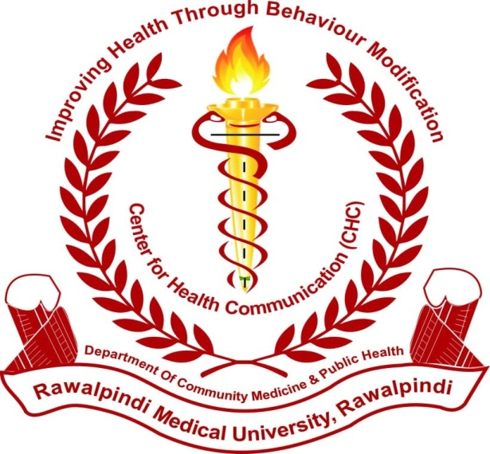

REPORT (2019-20)

OF CENTER FOR HEALTH COMMUNICATION (CHC)
Department of Community Medicine & Public Health

RAWALPINDI MEDICAL UNIVERSITY

Table of Content
Content PAGE
Work Moto of CHC i
Work 4th year MBBS ii
Health message development to dissemination iii
Work detail during 2019-20 iv
List of tables of 4th year work v
List of table of faculty work vi

CHC theme
Health communication is the study and use of communication strategies to inform and influence choices people make about their health. Health information technology includes digital tools and services used to enhance patients’ self-care, assist in patient-provider communication, inform health behaviors and decisions, prevent health complications, and promote health equity. Messages are shared directly by the students and the faculty in every possible opportunity including community settings, Hospitals OPDs, attendants of patients in wards and resting areas, public health conferences & seminars, health walks etc. Health communication and health information technology enables health professionals and the public to search for, understand, and use health information to significantly impact their health decisions and actions.
Communication alone can do:
• Increase the intended audience’s knowledge and awareness of a health issue, problem, or solution
• Influence perceptions, beliefs, and attitudes that may change social norms
• Prompt action
• Demonstrate or illustrate healthy skills
• Reinforce knowledge, attitudes, or behaviour
• Show the benefit of behaviour change
• Advocate a position on a health issue or policy
• Increase demand or support for health services
• Refute myths and misconceptions
• Strengthen organizational relationships

Health Message Development to dissemination work sopS
- Batch in charge two days prior to commencement of the batch meet HOD/Senior faculty to discuss and finalize Topic for Health Message.
- We conduct a batch tour to CHC Room to initiate and motivate about work ahead.
- We conduct a Health Message development session in CHC Room under HOD/senior faculty
- Initial draft of Health Message is prepared.
- Health Message is finalized by the HOD/senior faculty.
- Health Communication/ Health Message deliverance firstly discussed with HOD/senior faculty (site / community, method of deliverance).
- Whole record of the Health Message Development by the batch is kept and handed over to in charge CHC Dr. Sana and Dr. Narjis coordinator-CHC.
- Colored copies of Health Message (4-6).
- Pics/videos of the whole activity (Process of development and communication to the community)

HEALTH MESSAGE COMMUNICATION, SOP’s FOR STUDENTS
- Each student will communicate at least 05 persons for the given message
- Students will keep record of this health communication (recipient detail, name, age gender).
- Students will submit original record to the batch in charge in written form.
- Health Message Communication activity will be carried out under supervision of batch in charge.

Health Message Development to Dissemination(HMDTD) brief2019-20
During 2019-20, most of the batches of 4th year MBBS were on line and others were on campus. HMDTD work was done under the on campus teaching & training opportunity
Sr.No | Batch Name | Batch In Charge | Duration Of Batch | Epidemiological research Work Done By Batch | Remarks
1 | D | Dr. Mahjabeen Qureshi | 9/12/19 To 22/12/19 | Self-Medication And Determinants Of Adult Population Of Rawalpindi | On Campus
2 | E | Dr. Abdul Qadoos | 23/12/19 To 12/01/20 | PERSONALITY TRAITS OF MEDICAL STUDENTS: A CROSS SECTIONAL STUDY | On Campus
3 | F | Dr. Abdul Rehman | 13/01/20 To 26/01/20 | A Description Of Eating Habits Of Medical Students Of Rawalpindi Medical University | On Campus
4 | G | Dr. Farhan Hassan | 27/01/20 To 09/02/20 | KNOWLEDGE OF COUGH ETIQUETTES IN MEDICAL STUDENTS, DOCTORS AND NON-MEDICAL STAFF | On Campus
5 | H | Dr. Narjis Zaidi | 10/02/20 To 23/02/20 | Knowledge & Perception Of Social Factors Affecting Eating Habits In Youth Of Rawalpindi & Islamabad Settings | On Campus
6 | I | Dr Umaria Ali | 24/02/20 To 08/03/20 | Assessment Of Levels Of Emotional Intelligence Among Students Of Public Medical College Of Pakistan Amidst The Crisis Of Covid-19 Pandemic | On Campus
7 | J | Dr. Sidra Nasim | 03/08/20 | REASONS FOR GRAND MULTI PARITY IN A DEVELOPING COUNTRY AND ITS CONSEQUENCES. | On Line
8 | K | Dr. Anum Abdullah | 06/04/20 To 16/04/20 | A REVIEW AND ANALYSIS OF POOLED EPIDEMIOLOGICAL DATA AVAILABLE ON INTERNET ABOUT COVID-19 OUTBREAK IN WUHAN, CHINA | On Line
9 | L | Dr. Gulzeb Pervaiz | 31/08/20 To 13/09/20 | Frequency Of Various Symptoms Of Premenstrual Syndrome  In Female MBBS Students | On Line
10 | M | Dr.Abdul Rehman | 25/05/20 To 04/06/20 | A Description Of Eating Habits Of Medical Students Of Rawalpindi Medical University | On Line
11 | N | Dr. Abdul Qadoos | 01/10/20 To 14/10/20 | Epidemiological Information, Analysis Of Data Available On Internet About COVID -19 In United States Of America | On Line
12 | O | Dr. Mahjabeen Qureshi | 15/10/20 To28/10/20 | Pattern Of Health Problems During Last 3 Months Of COVID Pandemic As Reported By The General Physician (GP) | On Line
13 | A | Dr. Farhan Hassan | 22/06/20 To25/06/20 | Assessment Of Level Of Preventive Measures Against Corona Disease Among Educated People (Non-Medical). | On Line
14 | B | Dr. Umaria Ali | 03/08/20 To 16/08/20 | - | On Line
15 | C | Dr Gulzaib Pervaiz | 13/07/20 To 25/07/20 | Perception And Acceptance By A Section Of Youth Of PREMARITAL SCREENING As Health Measure To Control Some Genetic, Perinatally And Sexually Transmitted Diseases Prevalent In Community | On Line

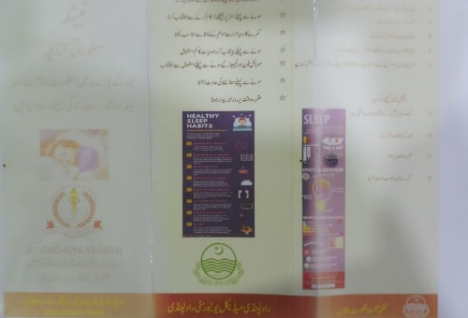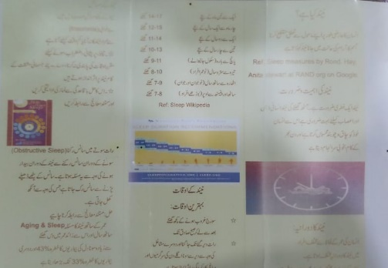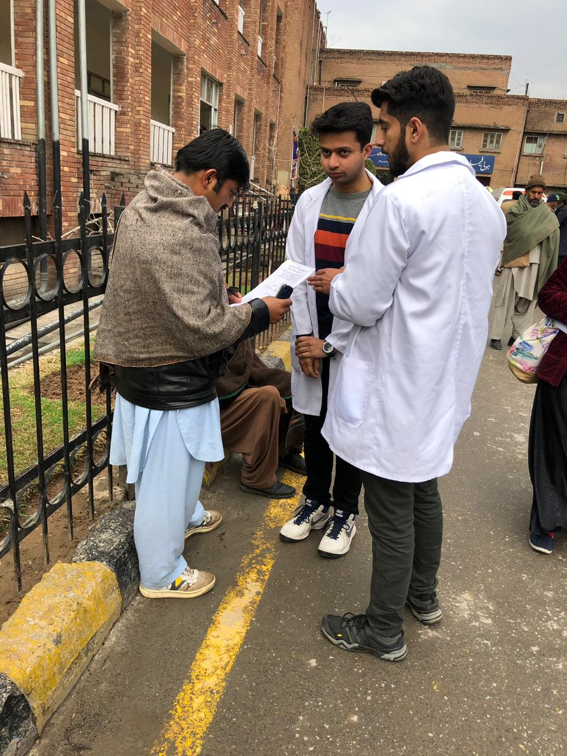
Glimpses of the CHC “ HMDTD work/ Community awareness work done under CHC

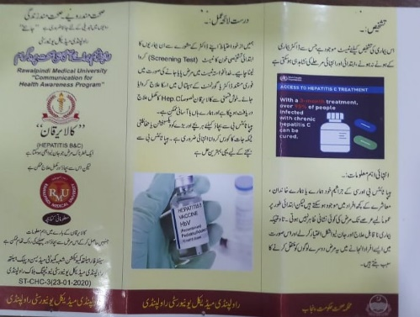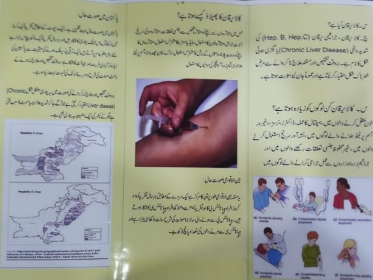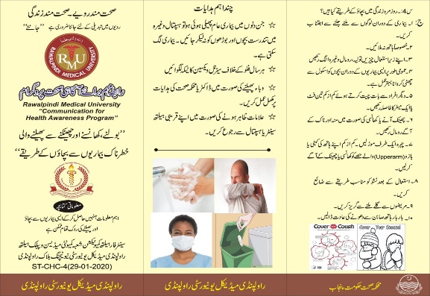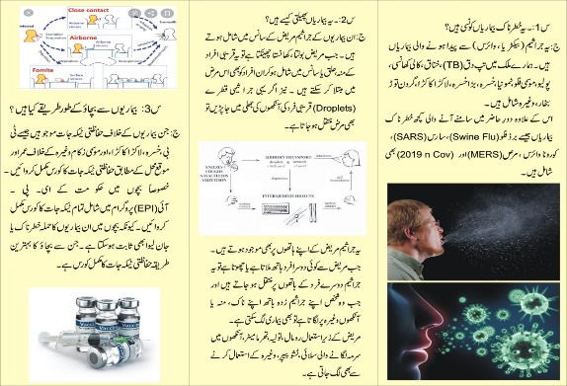
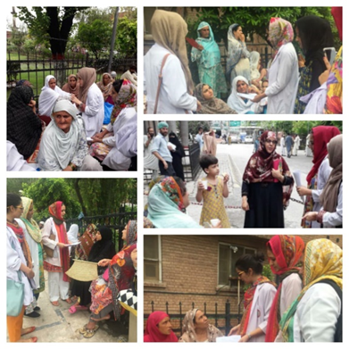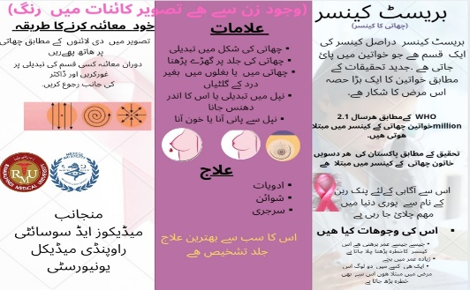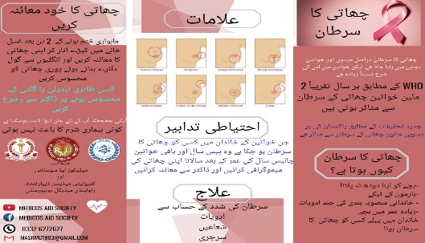
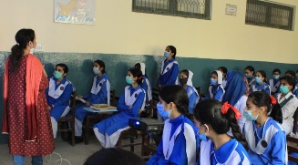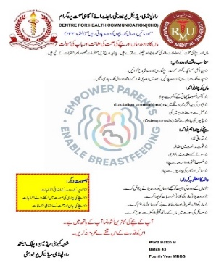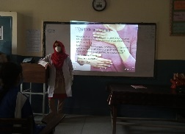

Faculty CHC Activities Brief during year 2019-20
- 1/ March 7th 2019 Hepatitis C Screening Awareness campaign At Govt. and Private secondary schools of Rata Amral.
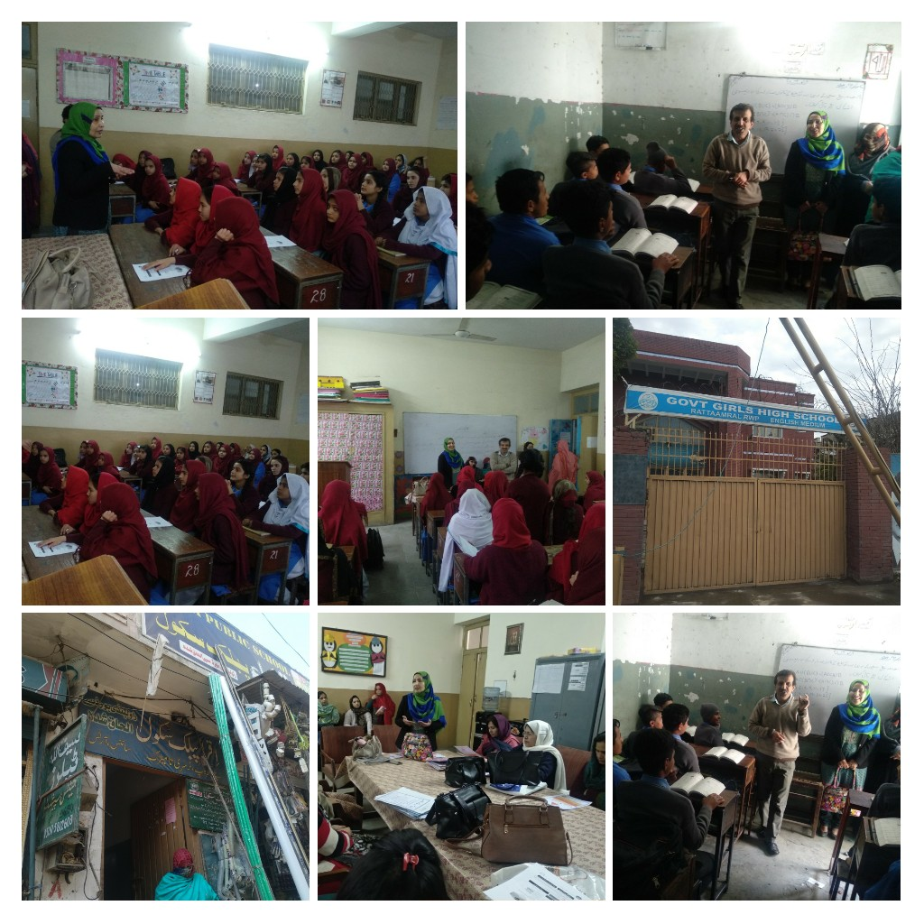
- 2/ Influenza seminar On “Seasonal influenza (H1N1) control strategies”15th march 2019
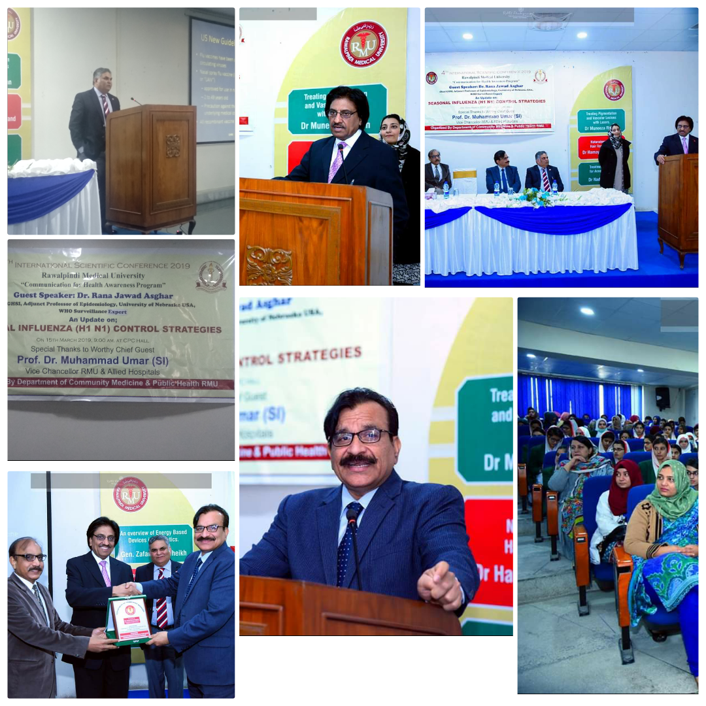
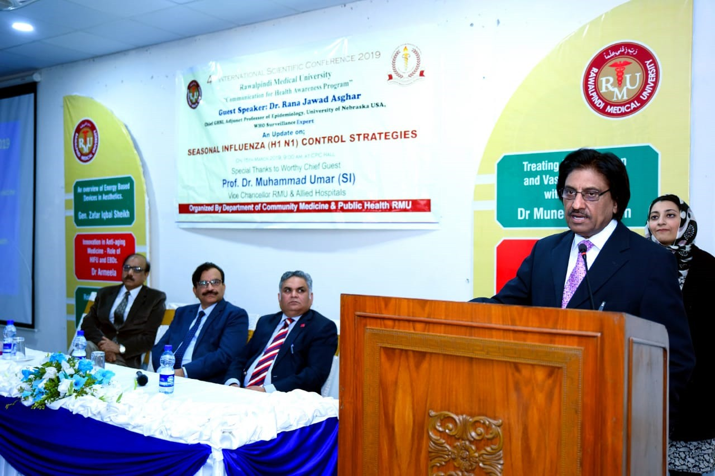
- / Dengue awareness campaign in union council 1
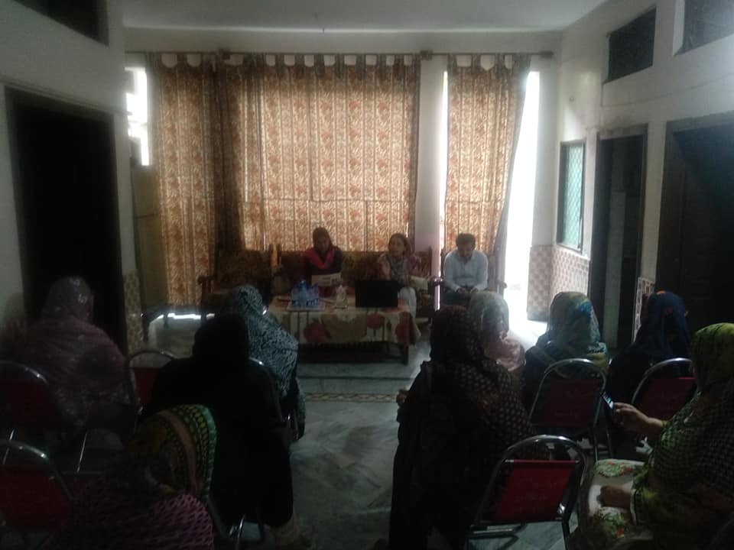
- SEMINAR ON “RAPID POPULATION GROWTH AND ITS IMPLICATIONS” in collaboration with Torque ( Marking Company) and Greenstar on 9th January,2020
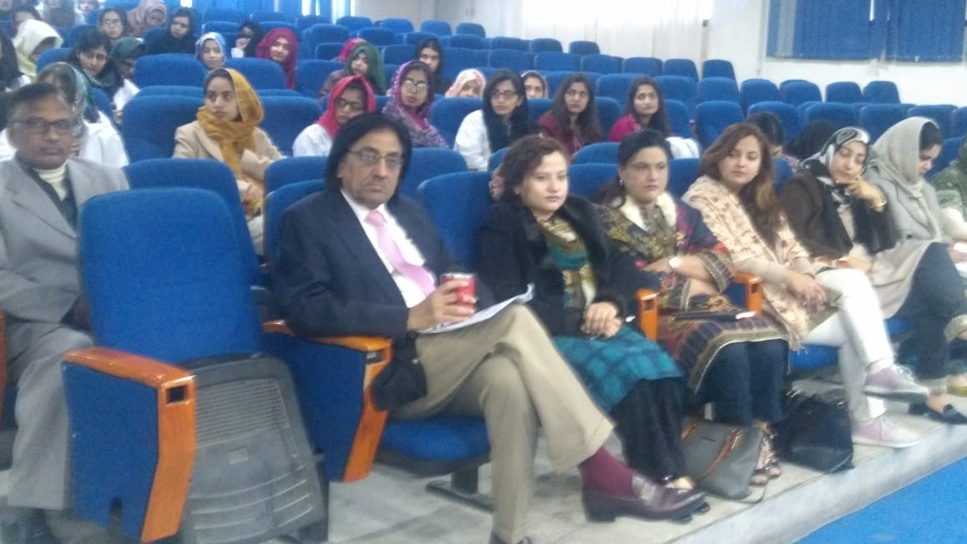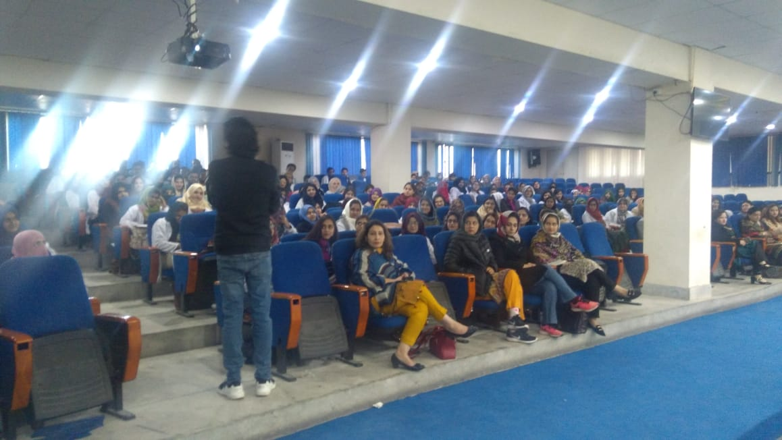
- Corona virus (2019nCoV) Epidemic threat in Pakistan: Alert & Awareness: Seminar on: “Infection control in Community & Healthcare settings ”. Jan 29, 2020
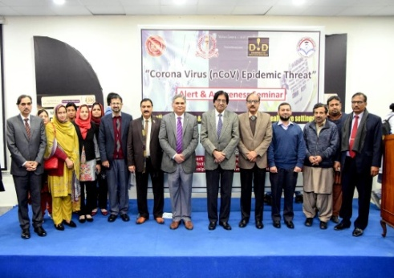
- Public health message in free medical Camp in SAROBA, CHAKRI District Rawalpindi 23 Februray2020 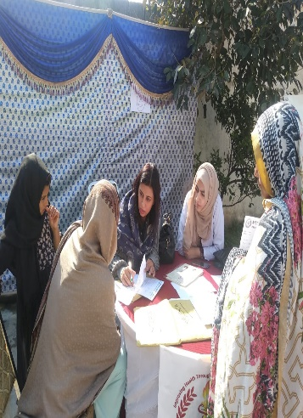
- Centre for Health Communications ( CHC ) RMU conducted on 3rd March 2020 public health seminar in Govt. Girls high school B- block satellite town Rawalpindi on Corona Virus (nCovid-19 ) “ Not panic ,be aware and behave right “
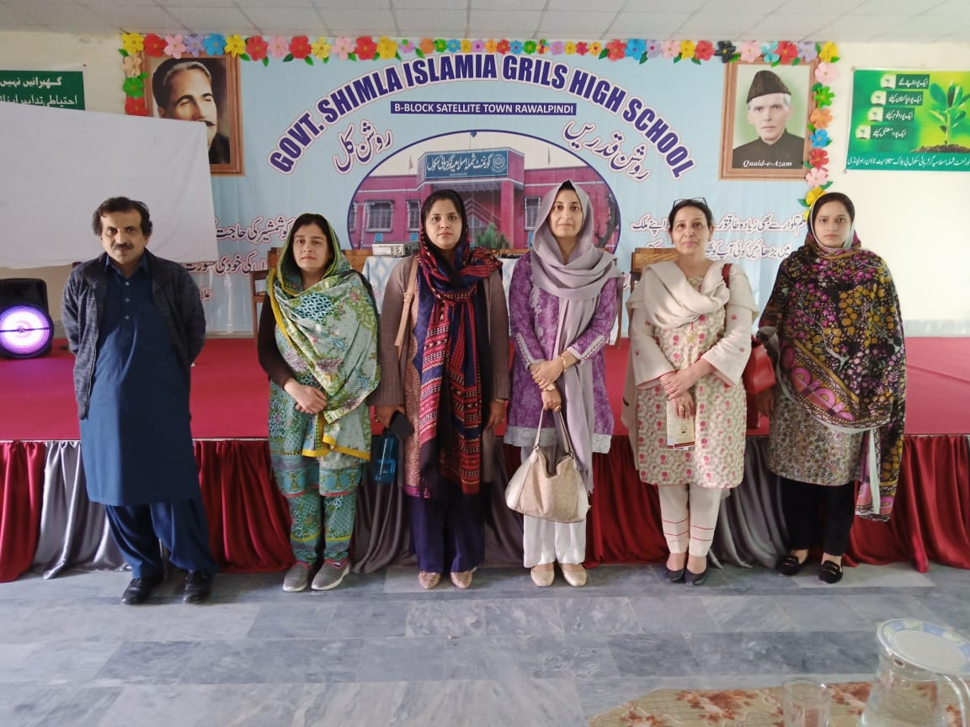

- Corona virus Epidemic threat in Pakistan: Alert & Awareness: Seminar on: “Infection control in Community & Healthcare settings” on 12th March 2020, Venue: Pak Turk School Satillite Town

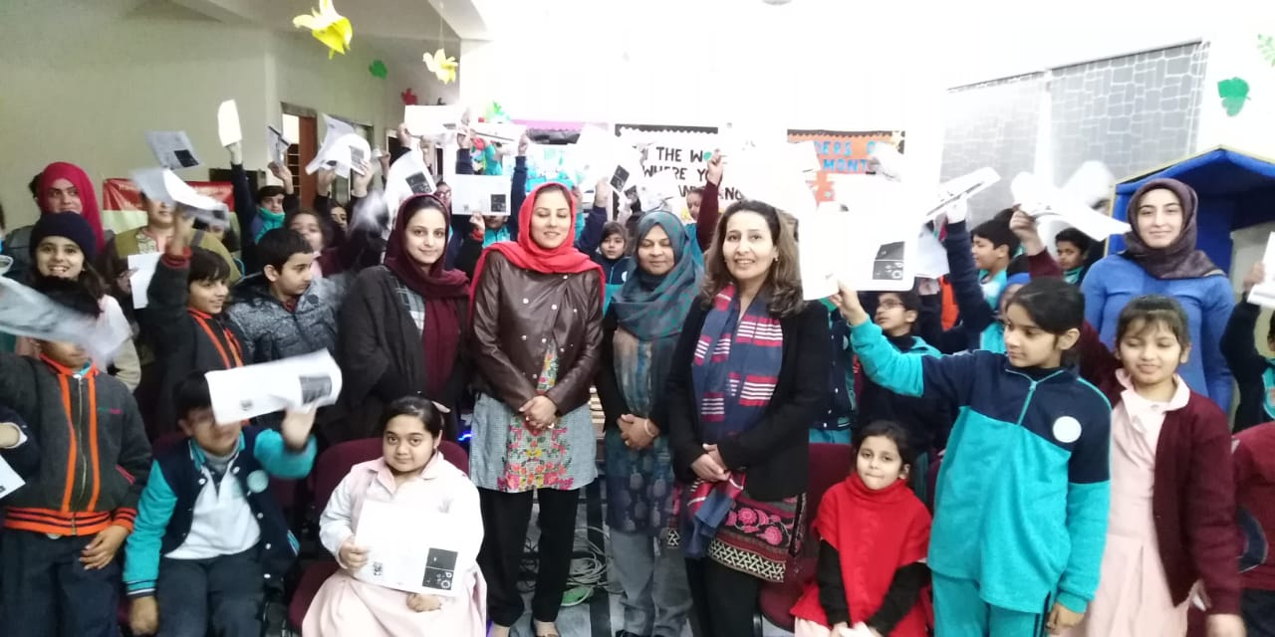

- Breast Cancer Awareness Day In Pakistan: Alert & Awareness Seminar on “LET’S DEFEAT BREAST CANCER TOGETHER”
- Oct.28th , 2020 in Govt. Khadija Girls High School District Rawalpindi
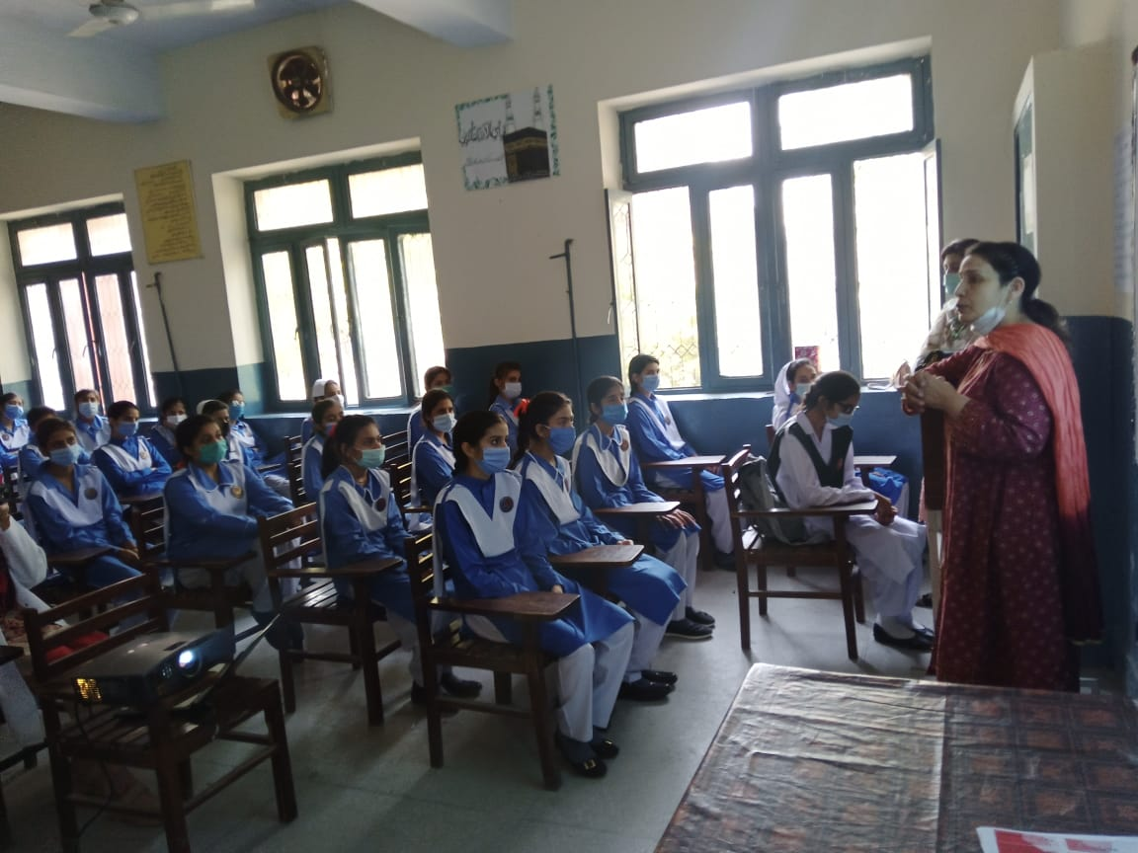
CHTP SITE SELECTION 2020
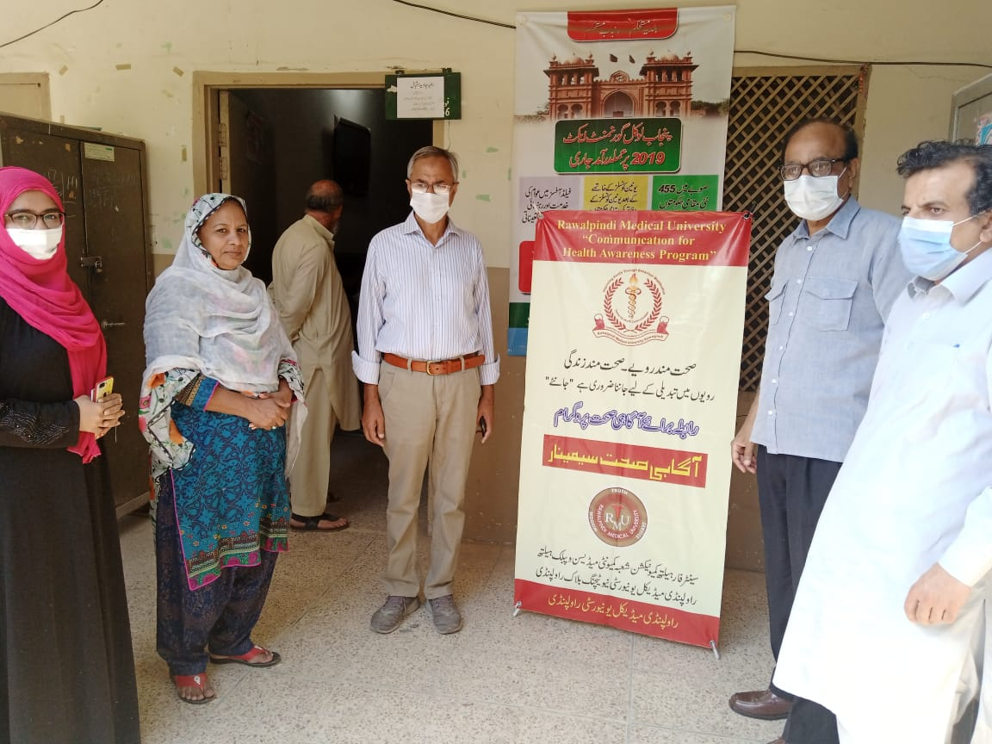

Report of “Museum Learning Module” (MLM) of 4thyear MBBS during year 2019-20

Department of community medicine & public health

Rawalpindi Medical University, NTB Rawalpindi
Forward: Museum of community medicine comprises models, specimen, and sketches of public health importance. One section includes simple gadgets like BP apparatus, anthropometric measurements tools commonly used in population-based surveys or research. There are twelve sections of the museum, containing 42items in total while 3 items are outside the cupboards (45). All these items are used for clarity of concepts and better deliverance of the relevant subject matter to the 4thyear MBBS students during their teaching & training in the discipline of community medicine & public health.
Approximately 350 students of MBBS class are educated over the year through “Museum learning program”. All students are rotated for community medicine learning in batches of 20-22 students for period of two weeks over the academic year. One day of the rotation is reserved for MLM. Students supervised by their dedicated batch in charge visit museum during the scheduled hours. Students have short introductory tour of whole museum in all areas. Students’ queries are addressed side by side. Then one pre-scheduled area/section of the museum is explained in detail for pertinent public health knowledge by the Museum in charge tutor. This work is executed under MLM-SOPs and on a specified proforma (annexure-A) record is kept accordingly. The report of the MLM schedule run over year 2019-20 is hereby given below.
Theme: learning explained with clarity on purposely build models, sketches and other such relevant gadgets add to better understanding of the subject to the learner.
Learning outcomes: after visiting all sections of the museum and having interactive small group learning session on a specific section/topic students have clear concept of the subject taught.

MLM Deliverance Report 4th Year MBBS session 2019-20
# | Batch specification | Batch in charge name | MLM schedule | Section / topic of the Museum discussed in detail | MLM Supervising tutor
 | A | Dr.Farhan Hassan | 23-6-20 | Life cycle of aedes aegypti- DF | Dr Maimoona Saleem
 | B | Dr.Umaira Ali | 4-8-20 | Contraceptive devices – Family Planning
 | C | Dr.Gulzeb Pervaiz | 14-7-20 | Life cycle of Ancylostoma duodenale-  Worms infestation
 | D | Dr.Mahjabeen  Qureshi | 10-12-20 | Guinee worm disease - step wells – disease eradication
 | E | Dr.Abdul Qaddos | 24-12-19 | School health services
 | F | Dr.Abdul Rehman | 14-1-20 | Immunization / EPI
 | G | Dr Farhan Hassan | 28-1-20
 | H | Dr.Narjis Zaidi | 11-2-20 | Marasmus & Kwashiorkor (PEM)
 | I | Dr.Umaira Ali | 25-2-20 | Barrier Nursing- Equipment of barrier nursing (PPEs)
 | J | Dr.Sidra Naseem | 4-8-20 | Rainwater harvesting – Water Scarcity
 | K | Dr.Anum Abdullah | 7-4-20 | Global warming – environmental degradation
 | L | Dr.Gulzeb Pervaiz | 1-9-20 | Endemic goiter – IDDs
 | M | Dr.Abdul Rahman | 26-5-20 | Poliomyelitis – Polio eradication
 | N | Dr.Abdul Qaddos | 2-10-20 | Research gadgets
 | O | Dr.Mahjabeen  Qureshi | 16-10-20 | Iceberg phenomenon of diseases- Screening
Covid- 19: as the schedule of academic year 2019-20 was affected due to covid-19 pandemic, some of the museum learning module sessions were taken online and others on campus under official schedule of the university / DME.

MLM Work reporting Performa (record)
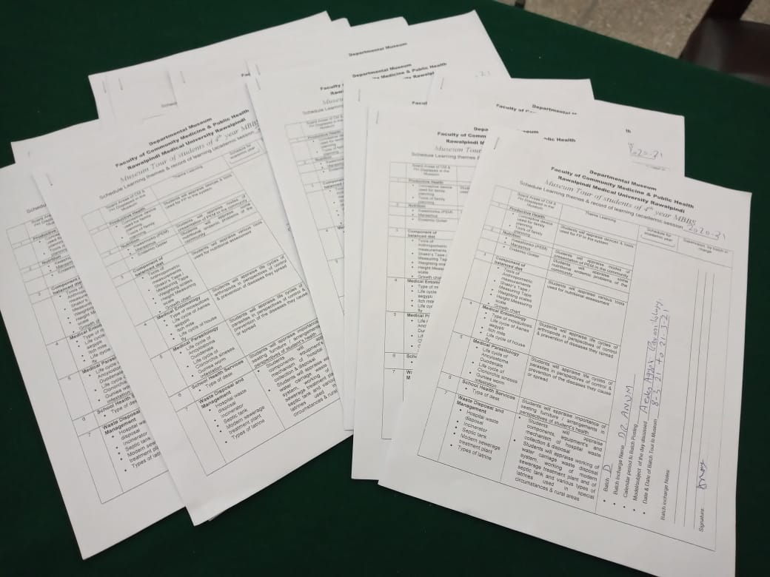
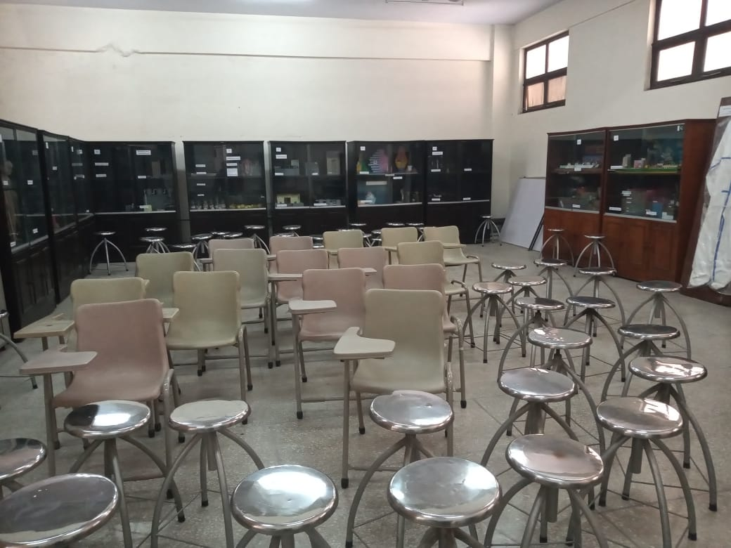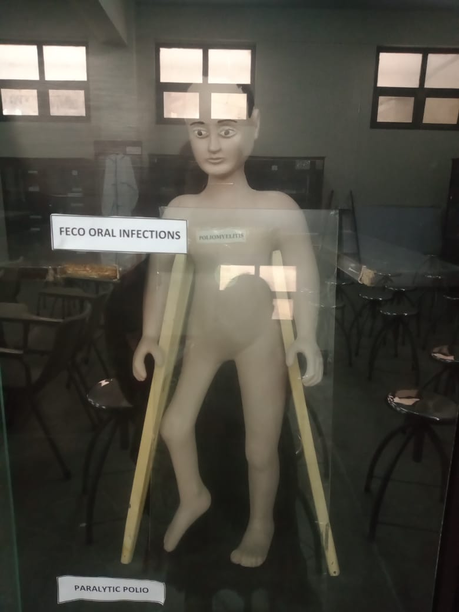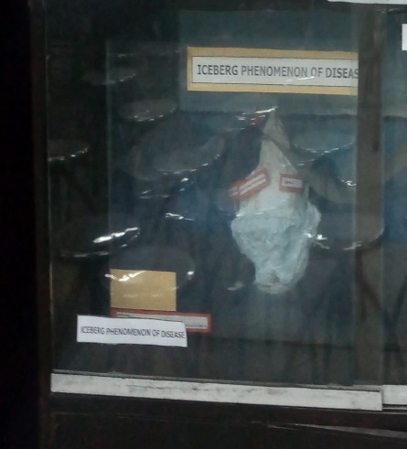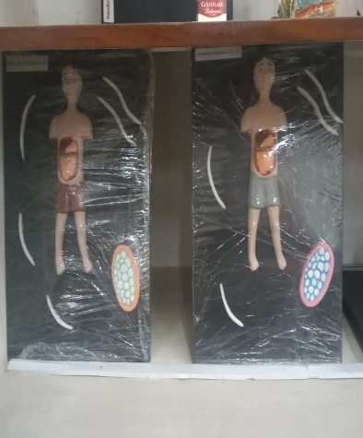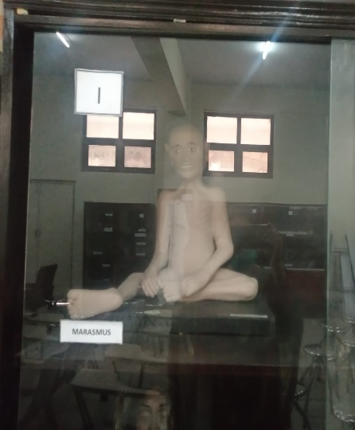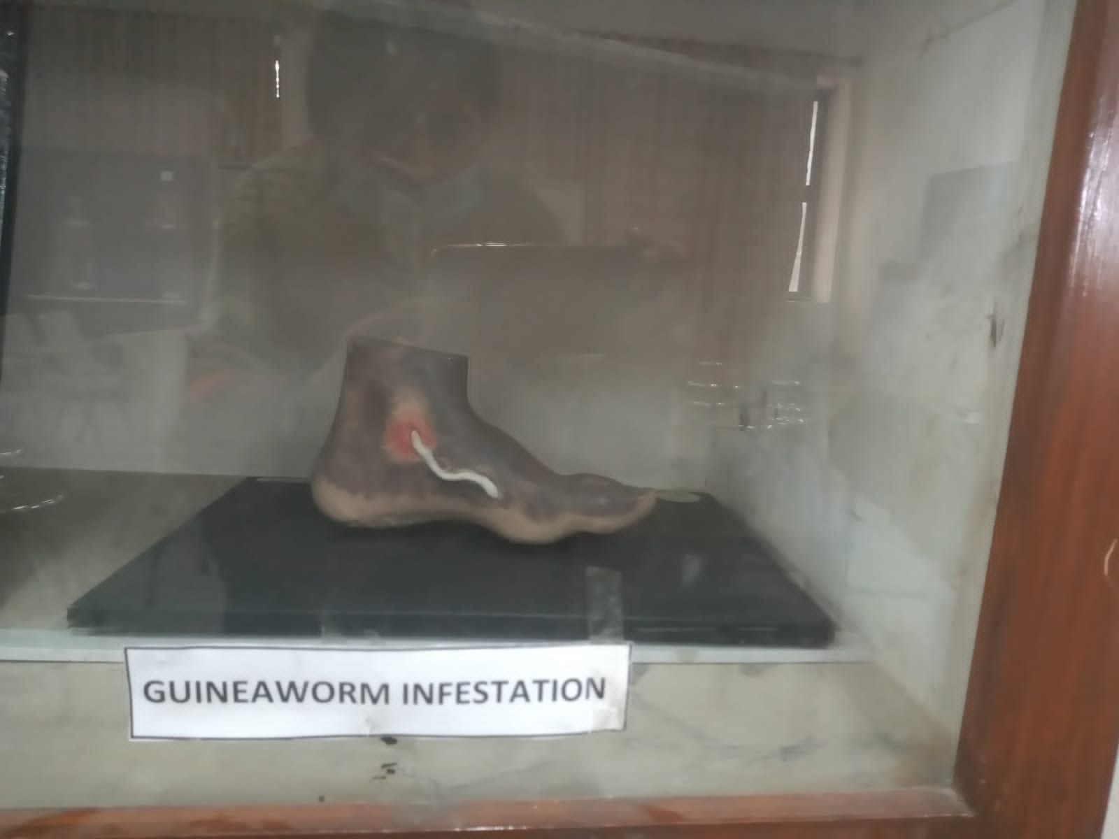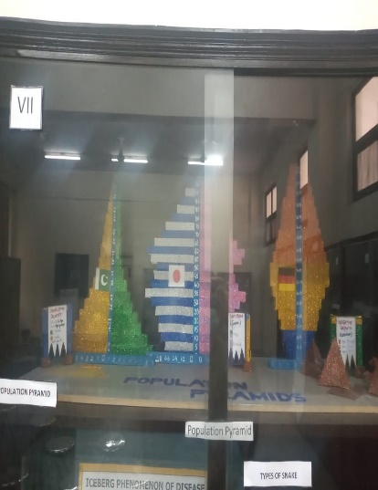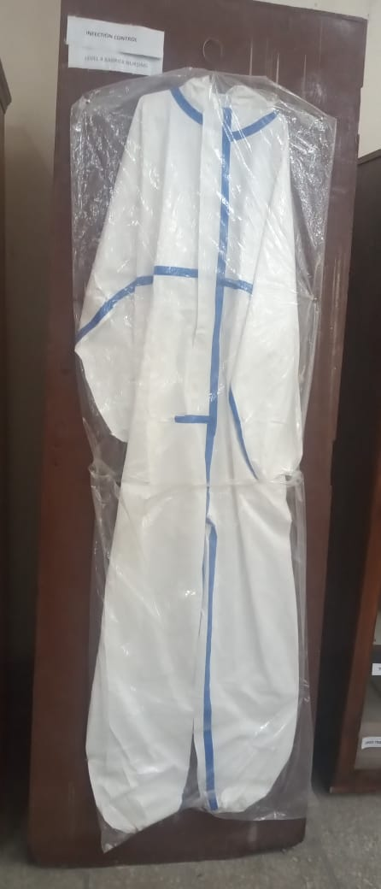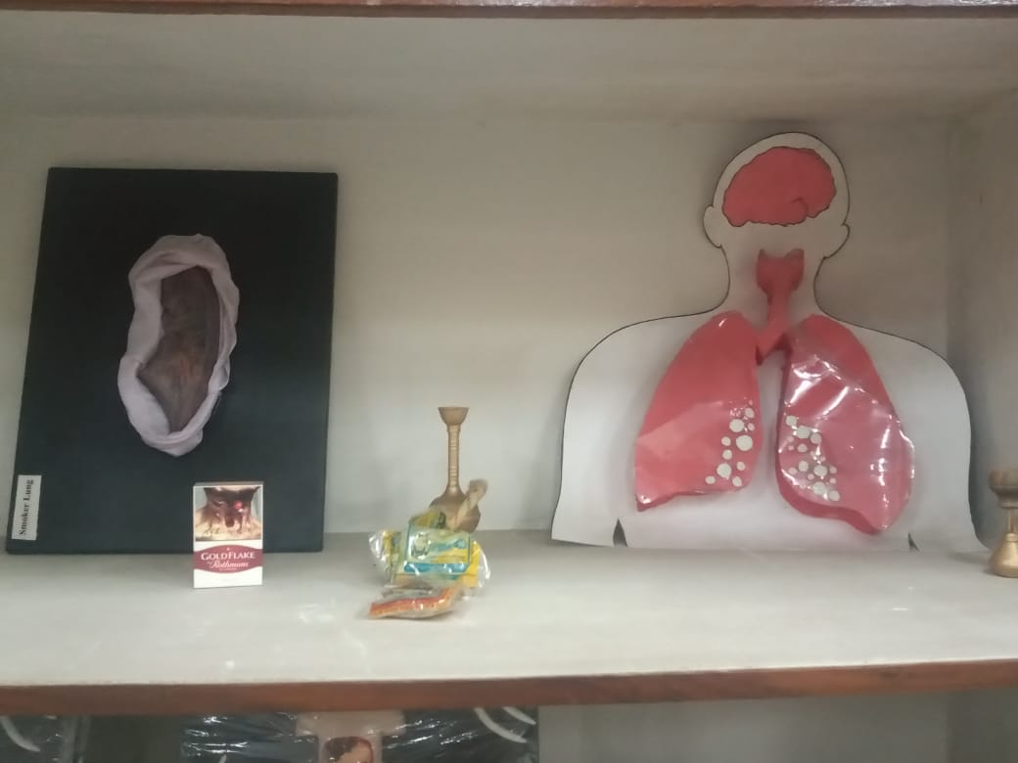

Report prepared by:
Dr Maimoona Saleem
Senior Demo / Museum Tutor In charge
Sep 10th 2021

Role of Community Medicine Department in Telemedicine Services Provided At RMU During

COVID-19 Pandemic
(This section of report was prepared by Dr Farhan Hassan Sen Demo & Mr A.Whab PA)
As always, the Department of Community Medicine has also played its dynamic role in provision of telemedicine services at Telemedicine Centre of Rawalpindi Medical University.

In response to the Telemedicine initiative of the Government of Punjab, Vice Chancellor of Rawalpindi Medical University, Prof. Dr. Muhammad Umar launched the Telemedicine Centre (TMC) at the New Teaching Block of Rawalpindi Medical University on 27th March 2020. The Telemedicine Centre has been providing round the clock services by qualified doctors providing online consultation facility to the public free of cost in line with Government directions.

Telemedicine is a unique concept of providing medical care to the patients over digital platforms used for communication like voice calls, video consultations etc., in situations where the patient may be present at a distant location, avoiding the need of patient presenting himself to the doctor.

Under the leadership of Prof. Dr. Syed Arshad Sabir, Department of Community Medicine presented its entire qualified medical faculty for this noble cause. Faculty of Community Medicine provided telemedicine services 24/7 along with other departments of University as per duty roster shown below in morning, evening and night shifts. Department of Community Medicine also provided its support staff for maintaining services at the Telemedicine Centre.

The telemedicine services are being provided through the connectivity provided via the mobile phone to the patients. All the patients anywhere in the country can access the telemedicine center through the Toll Free Number 0304-1112101.

The Department of Community Medicine along with its team of dedicated doctors and support staff has played its vital role in all ways possible for alleviating human sufferings during this pandemic. The faculty of Community Medicine Department provided the consultation not only for Corona infection related concerns of the public including its identification, prevention and care of suspected patients; but also addressed other health related problems of numerous patients of Rawalpindi, Islamabad, urban & rural localities and other adjacent cities under laid down standard operating procedures of RMU Telemedicine Centre administration and provided all relevant record to the administration under protocols in this regard for ready reference.

The Department of Community Medicine has a strong commitment to serve the nation in any situation and shall always progress its mission for welfare of community at large.

Duty performed / Roster Of Community Medicine Faculty & Staff In Telemedicine Centre

Sr. No | Name of Doctor | Number of days / period served
1 | Dr. Sana Bilal Assistant Professor  24-04-2020, to 15-06-2020 18 spotted days work as shift in charge
2 | Dr. Khola Noreen Assistant Professor  21-04-2020 to 28-6-2020 18 spotted days work as shift in charge
3 | Dr. Rizwana Shahid Assistant Professor  23-04-2020 work as shift in charge
4 | Dr. Afifa Kulsoom Assistant Professor  20-04-2020 to 27-06-2020 18 spotted days work as shift in charge
5 | Dr. Abdul Rehman APMO / Sen Demo  25-04-2020 to 24-06-2020 13 spotted days work as shift in charge
6 | Dr. Mehjabeen Qureshi Senior Demonstrator  22-04-2020 to 24-12-2020 11 spotted days work as telemedicine officer
7 | Dr. Narjis Zaidi Senior Demonstrator  Worked as Telemedicine Coordinator for period of 62days
8 | Dr. Maimoona Saleem Senior Demonstrator  21-04-2020 to 29-12-2020 13 spotted days worked as telemedicine officer
9 | Dr. Gulzaib Pervaiz Sen Demo  20-04-2020 to 23-12-2020 13 spotted days worked as telemedicine officer
10 | Dr. Abdul Qudoos Sen Demo  20-04-2020 to 10-08-2020 11 spotted days worked as telemedicine officer
11 | Sheikh Abdul Wahab PA/ Junior Clerk  20-04-2020 to 04-08-2020 for 26 spotted days worked as Data compilation clerk
12 | Rehmat Ali (Chowkidar)  17-03-2020 to 03-08-2020 26 spotted days worked as shift N/Qasid

