Mission Statement

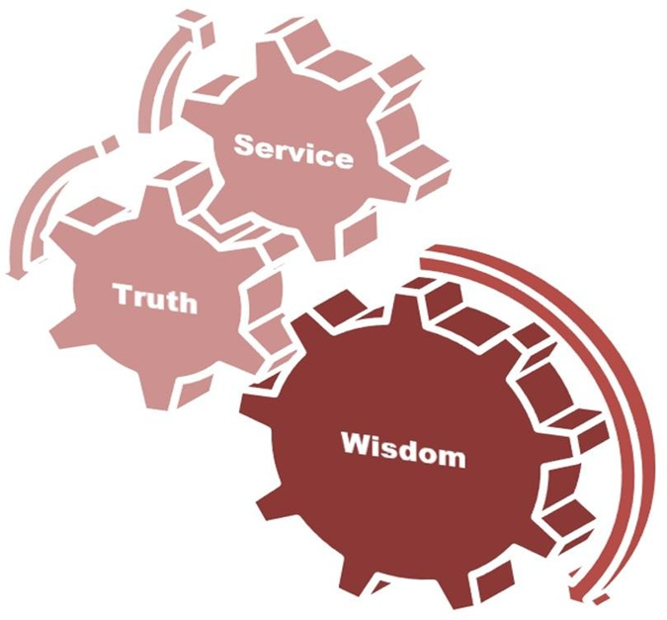
Vision

- To Impart Evidence Based Research Oriented Medical Education.
- To Provide Best Possible Patient Care.
- To Inculcate the Values of Mutual Respect & Ethical Practice of Medicine.

 | Prof. Dr. Muhammad Umar, Sitara-i-Imtiaz  MBBS, MCPS, FCPS, FRCP (Glasg), FRCP (London),  FACG (USA), AGAF (USA)  Vice Chancellor & Chief Executive  Rawalpindi Medical University / Allied Hospitals Rawalpindi  Chairperson & Professor of Medicine, Rawalpindi Medical College  Chief Gastroenterology &Hepatology Division, Holy Family Hospital  Chairman AsiaHepPakistan  Governor American College of Gastroenterology (ACG) Past President Past Society of Gastroenterology President, Pakistan Society of Hepatology  President Rawalians’ Research Forum
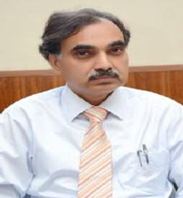 | Prof. Rai Muhammad Asghar  MBBS, MCPS, FCPS  Professor of Pediatric Director, DME  Rawalpindi Medical University, Rawalpindi
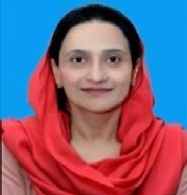 | Dr. Shazia Zeb  MBBS, MPH, DCPS-HCSM, MHPE  Deputy Director Department of Medical Education Rawalpindi Medical University, Rawalpindi
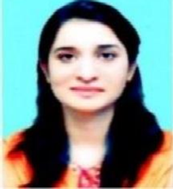 | Dr. Sumaira Yasmeen  MBBS, Demonstrator  Department of MedicalEducation  Rawalpindi Medical University, Rawalpindi
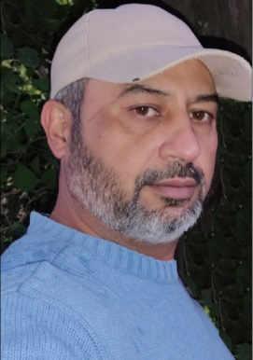 | KhurramShahzad  IT Expert  Department of MedicalEducation  Rawalpindi Medical University, Rawalpindi

Preamble

Due to COVID-19 pandemic and subsequent country-wide lockdown from 24th Mar 2020, Rawalpindi Medical University immediately switched over to online education for continuation of academic activities. On closure of educational institutions as per directives of government, it became imperative to digitalize educational proceedings. Untiring efforts of worthy Vice Chancellor Prof. Muhammad Umar and his dedicated team pertinent to commencement of e-learning are worth mentioning
E-learning at Rawalpindi Medical University was customized to meet the educational needs of our students. Technological assistance was provided to all stakeholders including students, teachers and parents for its successful execution. Orientation sessions of University faculty as well as clerks were conducted for audio recording and uploading of lectures. Later on orientation sessions were carried out for working on Microsoft Teams to make lectures interactive and facilitate clinical teachings.
To acquire the students’ experience regarding existing online education system being imparted to them, Quality Enhancement Cell (QEC) of RMU gathered feedback of the medical students as well as faculty about the modalities introduced for e-learning.

The strenuous efforts of faculty members, IT team, students and Department of Medical Education to cope up with e-learning modalities in response to COVID-19 pandemic are really admirable. I congratulate all for continuation of educational activities during worldwide critical scenario another successful milestone at RMU.

Prof. Rai Muhammad Asghar
Director DME
Rawalpindi Medical University Rawalpindi

Introduction
Online learning is education that takes place over the internet, often referred as e-learning it is just onetype of distance learning. The “under e-learning umbrella” any teaching that takes place across distance and not in a traditionalclassroom.

What is onlineteaching?

Earlier there was only one option of teaching or learning that is to go to school but now days we have an option of online teaching. This is the modern and newest way of teaching from distance. Online teaching is the worldwide most popular type of teaching now a days and its trend is increasing day by day.E-Learning is an innovation in the current Era and good solution to create an active platform for learning. Online teaching is an education that takes place with the help of Internet. E-learning or Online teaching is that which were not conducted in traditional class rooms, Different type of software’s, online portal, custom made software and websites etc. are used for online teaching.

Aims and Objectives

- Enhance the quality of learning andteaching.
- Meet the learning needs ofstudents.
- Improve user accessibility and time flexibility to engage learner in the learningprocess.
- To help students earn education no matter where they arelocated.
- Low cost education because no travelingrequired.
- self-paced coursework

Online software platforms adopted for e-learning at RMU

Online teaching is conducted with the help of following software.

- Learning Management System(LMS).
- Microsoft office 365 (MSTeams)
- Zoom

Need for Online Teaching

- Due to Global Pandemic COVID 19 which needs social distancing, Students and teachers need to communicate through internet at different geographicLocations.
- Higher Education Commission (HEC) for CME has directed all universities and accredited institutions with sufficient resources to start online classes. Due to outbreak of Coronavirus (COVID-19) inPakistan.
- It’s also a requirement of Students and stakeholders of RMU to arrange some safe and reliable mode of studies during this pandemicoutbreak.
- Teachers and students need to set online learning enables to study or teach from anywhere in theworld.

Following types of software’s platform adopted during e-learning at RMU.

Learning Management System was started at Rawalpindi Medical University on 15th April 2020 in response to COVID-19 pandemic to automate all educational endeavors. Login and password of the faculty members were made to ensure access to the software for this purpose. This was based on software application for digitalization of medical education. Strenuous efforts of Prof. Muhammad Umar, Vice Chancellor of RMU and his dedicated team made digitalization of medical education possible. The records and databases of all educational proceedings including student/teacher’s files and course summaries were properly maintained.
Microsoft Office 365 was introduced to the faculty and clerks of RMU to facilitate interaction between students and teachers during lectures and clinical sessions. Versatile applications in this software aided in content delivery and assessment. Teachers can share their presentations, samples, models or X-ray films during teaching through this collaborative tool. Teamwork of IT experts, Department of Medical Education and institutional faculty made its conquering implementation possible.

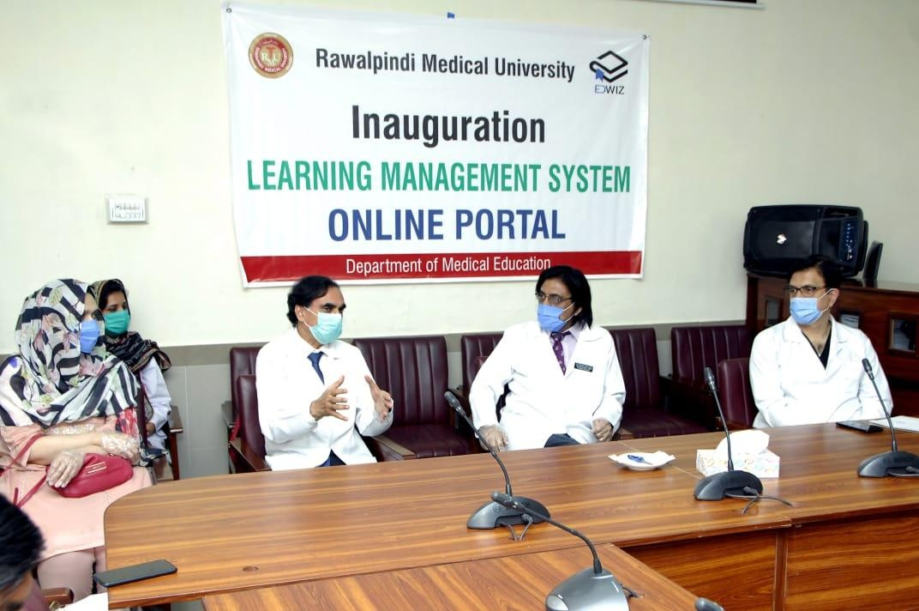

Launching Ceremony

Challenges
- Shortage of manpower due to current pandemic most of the faculty members are COVID-19 Positive and were in Isolation.
- The students are from far flung areas of Pakistan, Jammu Kashmir, Gilgit and Balochistan.Where there is no internet connectivity or very low internetconnectivity.
- Underdeveloped IT setup at University.
- Faculty and supporting staff is not trained for onlineteaching.

Solutions
Worthy Vice Chancellor Prof. Muhammad Umar Invest time and money for High Speed Internet connection.

PERN Connectivity Merits
- High Speedinternet
- DigitalLibrary
- ResearchWork
- Cloud
- VideoLink
- Free License (MS office 365, Windows etc.)

Director Medical Education

Infrastructure Development

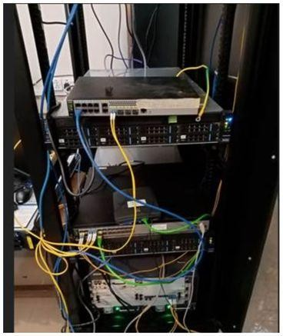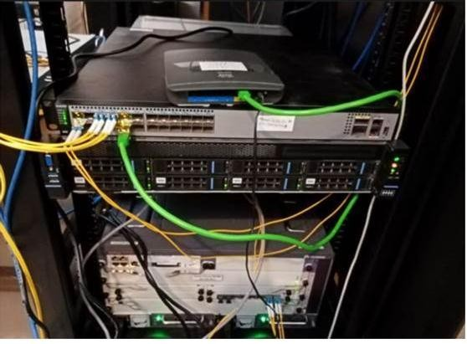

From: Kamran Abid [mailto:kabid@hec.gov.pk]
Sent: Tuesday, August 25, 2020 10:59 AM
To: Zain Khan <zain.rehman@dwp.com.pk>; info@rmur.edu.pk
Cc: Naveed Tahir <ntahir@hec.gov.pk>; Jawad Raza <jraza@hec.gov.pk>; 'Zubair Aziz/Datacom Engineer- ISB/PERN/Huawei' <zubair.aziz@pern.edu.pk>; Zahid Riaz <zahid.riaz@huawei.com>; 'Ahsan Javied'
<ajavied@pern.edu.pk>; Pern2 NOC <pern2noc@hec.gov.pk>; SUSCNOC <suscnoc@hec.gov.pk>; 'Muhammad Imaad Tariq' <muhammad.immad@dwp.com.pk>; 'Saqib Wahab' <saqib.wahab@dwp.com.pk>; 'Mr. Bilawal Shah'
<bilawal@pern.edu.pk>
Subject: RE: Tesng scheduled in RMU(HollyFamily), Rawalpindi on Monday 24th August, 2020

+ Mr. Khurrum & Mr. Farooq

Pleasefindbelowthetechnicalanalysisofthecoreswitchwhichcurrentlynotsuitable/capableofhandlingthe required bandwidth. Submied for necessary acon,please.
Regards, Kamran Abid

From: Zain Khan [mailto:zain.rehman@dwp.com.pk]
Sent: Tuesday, August 25, 2020 12:12 AM
To: Kamran Abid <kabid@hec.gov.pk>
Cc: Naveed Tahir <ntahir@hec.gov.pk>; Jawad Raza <jraza@hec.gov.pk>; 'Zubair Aziz/Datacom Engineer- ISB/PERN/Huawei' <zubair.aziz@pern.edu.pk>; Zahid Riaz <zahid.riaz@huawei.com>; 'Ahsan Javied'
<ajavied@pern.edu.pk>; Pern2 NOC <pern2noc@hec.gov.pk>; SUSCNOC <suscnoc@hec.gov.pk>; 'Muhammad Imaad Tariq' <muhammad.immad@dwp.com.pk>; 'Saqib Wahab' <saqib.wahab@dwp.com.pk>; 'Mr. Bilawal Shah'
<bilawal@pern.edu.pk>
Subject: RE: Tesng scheduled in RMU(HollyFamily), Rawalpindi on Monday 24th August, 2020

Dear Sir,
As per Today Visit at RMU Rawalpindi we configured the workaround exactly as menoned below scenario. We are
geng the Speed of 346.37Mbps on LAN while 51-60Mpbs over wireless. There is no lose on PERN link end to end connecvityisPerfectandsmooth.Thedownloadspeedfromdierentsiteswasaround45-50Mbps(overwifidirectlypublic given toAP)

ThoughRMUcoreswitchisofBrand3iSysvendorwhichisaTaiwanbasevendorhasveryleastHardwareresourcewhich doesnotmeetthecampusrequirement.ThisswitchhasMaximumThroughputcapacityof42Mbpswhenthereisnostreaming or mulcast tra c. RMU Core Switch is not capable for forwarding high BW load/roung and forwarding tra c of modern applicaonbasetrac,IthasleastROMandRAMwhichexhaustedathighBWload.ThereforeRMUmusthavetoreplacethe Coreswitchwhichcanbeconsiderascoreinsteadofexinglimitedresourcenonmanageableswitch.

Regards Zain

From: Saqib Wahab [mailto:saqib.wahab@dwp.com.pk]
Sent: Friday, August 21, 2020 3:37 PM
To: 'Kamran Abid' <kabid@hec.gov.pk>; 'Zahid Riaz' <zahid.riaz@huawei.com>; 'Zain Khan' <zain.rehman@dwp.com.pk>Cc: 'Naveed Tahir' <ntahir@hec.gov.pk>; 'Jawad Raza' <jraza@hec.gov.pk>; 'Zubair Aziz/Datacom Engineer- ISB/PERN/Huawei' <zubair.aziz@pern.edu.pk>; 'Ahsan Javied' <ajavied@pern.edu.pk>; 'Pern2 NOC'
<pern2noc@hec.gov.pk>; 'SUSCNOC' <suscnoc@hec.gov.pk>; 'Muhammad Imaad Tariq'
<muhammad.immad@dwp.com.pk>
Subject: RE: Tesng scheduled in RMU(HollyFamily), Rawalpindi on Monday 24th August, 2020 Sure kamran Bhai
Dear Zain

Kindly do the needful.

Regards
SaqibWahabProject Manager
From: Kamran Abid<kabid@hec.gov.pk>
Sent: Friday, August 21, 2020 12:43 PM
To: Zahid Riaz <zahid.riaz@huawei.com>; Saqib Wahab <saqib.wahab@dwp.com.pk>
Cc: Naveed Tahir <ntahir@hec.gov.pk>; Jawad Raza <jraza@hec.gov.pk>; 'Zubair Aziz/Datacom Engineer- ISB/PERN/Huawei' <zubair.aziz@pern.edu.pk>; 'Ahsan Javied' <ajavied@pern.edu.pk>; Pern2 NOC
<pern2noc@hec.gov.pk>; SUSCNOC <suscnoc@hec.gov.pk>; 'Muhammad Imaad Tariq'
<muhammad.immad@dwp.com.pk>
Subject: Tesng scheduled in RMU(HollyFamily), Rawalpindi on Monday 24th August, 2020
Importance: High

Dear Zahid Sb & Saqib Sb,

AsperthemeetingwiththeRMUdelegaontodayinHEC,pleasedeputeoneresourcefromPERNandSMART eachforconfiguraonofoneAccessPointwiththePERNpublicIPdirectlywiththecoreswitchonseparate

VLANin th
RMU(HollyFamily),RawalpindionMonday24

August, 2020 at 10AM. The team has to conduct 2 hour

longtesngofMSteamsvideocallwithHECIslamabad/Lahore/Khi/Quea/etc.Thetesnghastobeconducted in the conferencehall
nd
on 2 floor aached with the server room directly (No intermediate hops allowed).
MakesurethereisnohopsbetweentheAP(cisco)andcoreswitchandAPisconfiguredwithpublicIPandis not in vlan-1 on coreswitch.

Alsothecableprovidedinconferencehallisinseparatevlan,aswellasitmustbeconnecteddirectlyoncore switch.
The system/pc used for tesng must be configured with PERN public IP.

ThereisonegigabitlinkinRMU(HollyFamily)andsessionsonMSTeamswithmulpletesngparcipantsfrom HEC-Isb,Lhr,Khi,quea,etcmustbesmooth&stableduring2hoursession,takerecordingofthesessionand all technical tesng for recordpurposes.

Regards,

Kamran Abid
Deputy Director (Networks), Higher Educaon Commission, H-9, Islamabad.
051-90402226, 0321-5553410

Monitoring of Online Classes
One doctor designated for each class for smooth conduction of OnlineTeaching. Dr.FarzanaFatima 1st Year MBBS and 2nd YearMBBS
Dr.OmaimaAsif 3rd Year MBBS Dr.SumairaYasmeen 4th Year MBBS Dr.Maryam Batul Final Year MBBS

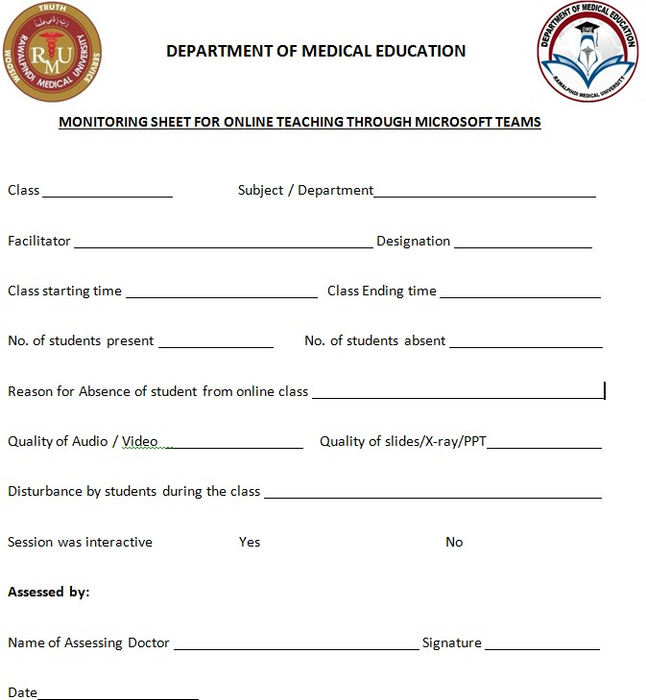

RMU has started online teaching or e learning through Learning Management System The system is custom-made to RMU’s specific needs and the system structure has been tailored to our needs. The project has two Phases

  - Short Term: virtual education solution to tackle the currentsituation.

    - Students & Teachers Portal login andPasswords.
    - Virtualclasses
    - Video RecordedLectures
    - Online Assignments, Quizzes, Homework Submissions, Checking and Feedback.
    - File Sharing (Books, Notes, Digital lectures and otherresources)
    - Teachersannouncements
    - Students virtualattendance
    - Access to Online Library andGamification.

  - Long term plan to digitalize educational processes at DME to assist Management, Teachers andStudents.
    - Equipment for smart class rooms (camera, micro tripod andscreen

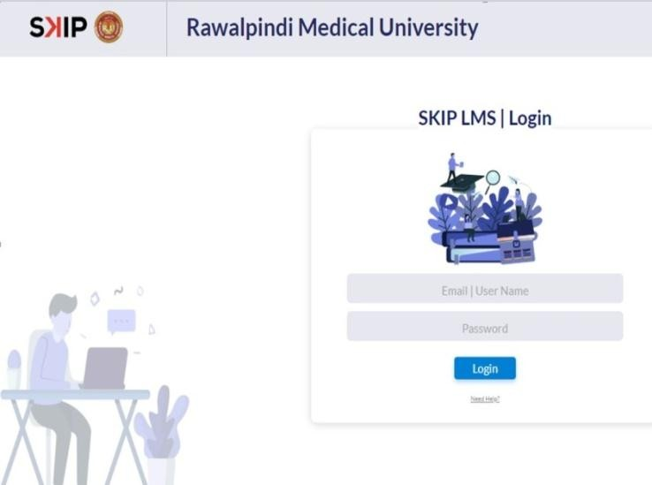

Orientation/ Training
Hands on training were given to Teaching faculty and supporting staff were given for smooth running of LMS and quires and problems addressed or arising during the orientation/ training session were solved immediately.

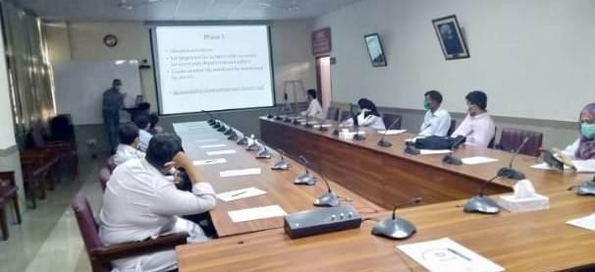
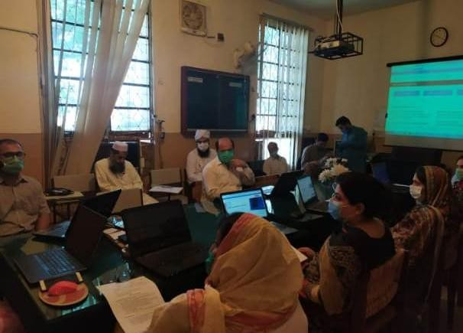
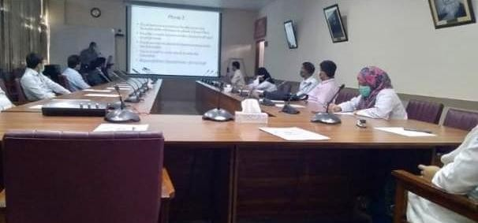

Shifting from LMS to Microsoft Teams
On 22nd June 2020 RMU shifted its online classes from LMS to Microsoft Teams on the Instruction of Higher Education Commission of Pakistan (HEC). Immediately on the instructions of Vice Chancellor RMU Orientation and training were given to the Faculty and supporting staff for implementation and smooth running of Microsoft teams.

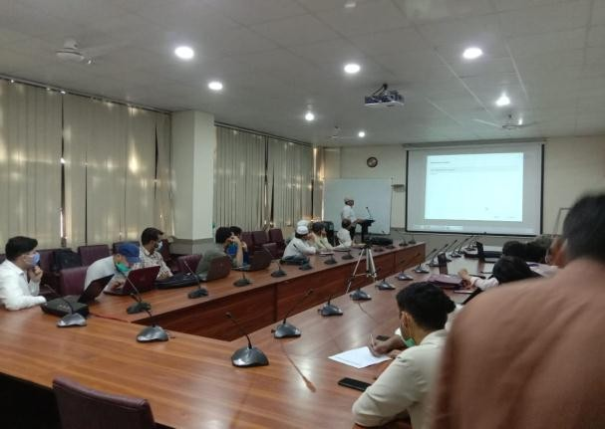
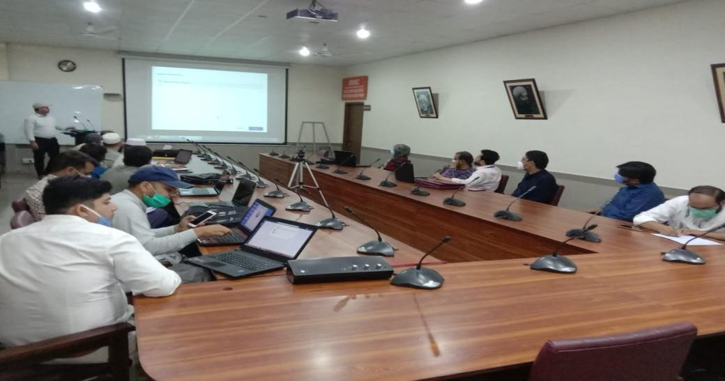
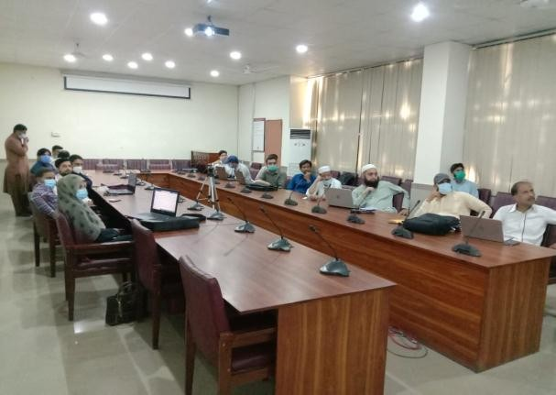

Online Classes

- HD Audio-VideoMeeting
- 350 participants permeeting
- ScreenSharing
- Recording
- Chat Box for Question/ Answers
- MuteParticipant
- RemoveParticipant

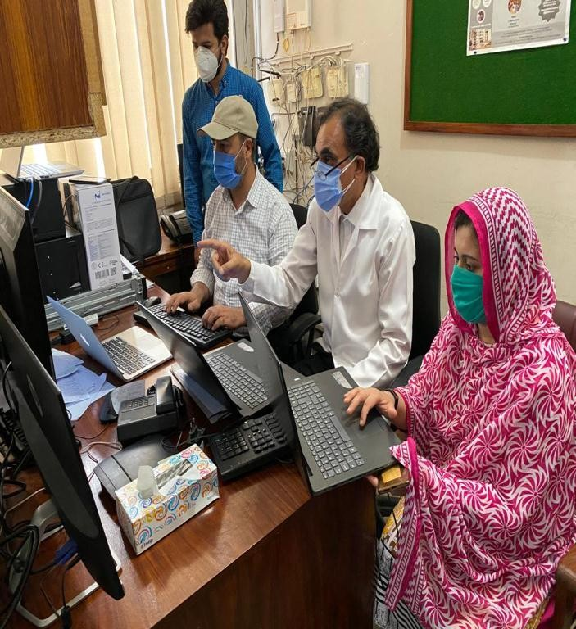
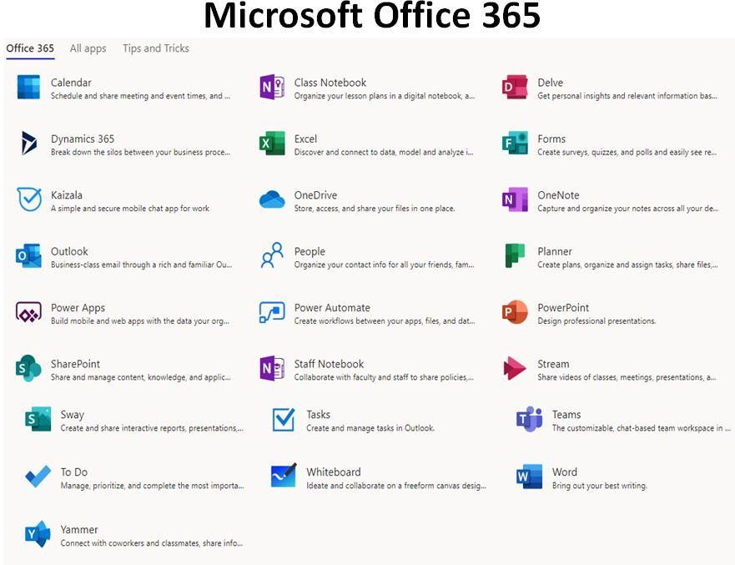

Online Assessment Tools

- MicrosoftForms
- AutomatedAssessment
- Multiple ChoiceQuestion
- Short AnswerAssignment

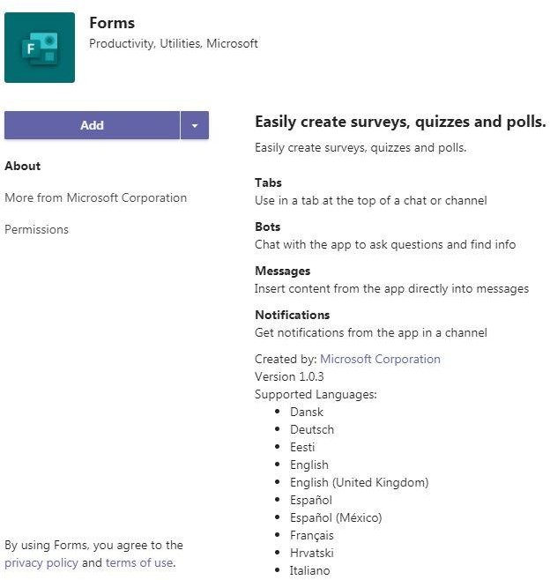

Timetable for
1st Prof MBBS
24 Classes Per Week
(Lectures+ Practical+ Tutorial)

2nd Prof MBBS
24 Classes Per Week
(Lectures+ Practical+ Tutorial)
3rd Prof MBBS
27 Classes Per Week
(Lectures+ Clinical Batches at Wards)

4th Prof MBBS
34 Classes per Week
(Lectures+ Clinical Batches at Wards)

Final Prof MBBS
35 Classes per Week
(Lectures+ Clinical Batches at Wards)
Online classes
(144 Classes/ Week)

Steps to Improve Quality of Teaching
Facilitators are briefed about “Ganges nine events of instructions” to improve quality monitored by QEC Department
- GainingAttention
- Informing Learners of theObjective
- Stimulating Recall of PriorLearning
- Presenting the Stimulus (NewContent)
- Providing Learning Guidance
- ElicitingPerformance
- ProvidingFeedback
- Assessingperformance
- Enhancing retention andtransfer

Student Feedback Report
In response to COVID19 Pandemic E-Learning was commenced at RMU as per instructions of Government with the objective to continue undergraduates and postgraduates academics.
This was initiated through LMS on 14 March, 2020.

Later it was replaced by MS Teams on 22nd June. Department of Medical Education and IT experts worked tremendously to make this initiative feasible and successful. Strenuous efforts put by VC and his team in this regards reallyacknowledgeable.

Feedback Time Duration: 1 week (10-17 July 2020)
Target Audience: 1st MBBS-Final year MBBS Students of RMU
1st Year MBBS | 350
2nd Year MBBS | 300
3rd Year MBBS | 320
4th Year MBBS | 336
Final Year MBBS | 318
Total | 1624
Objectives:
- To assess our onlinesystem.
- To improve our onlineteaching.
- To check students satisfaction level regarding onlineteaching.

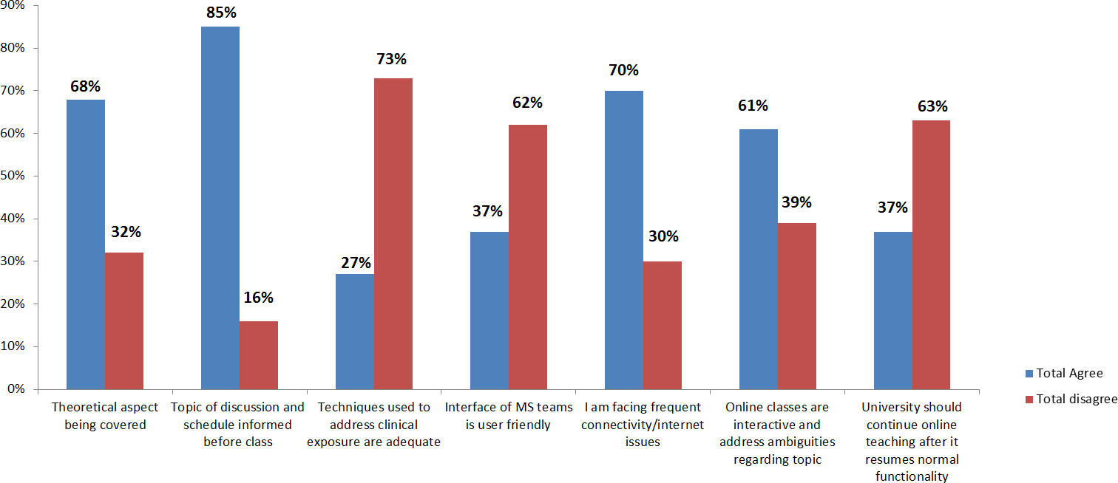

Faculty Feedback Report

Feedback Time Duration: 21-23 July 2020
Target Audience: RMU Faculty (Professor, Associate Professor, AP, SR, Demonstrator)

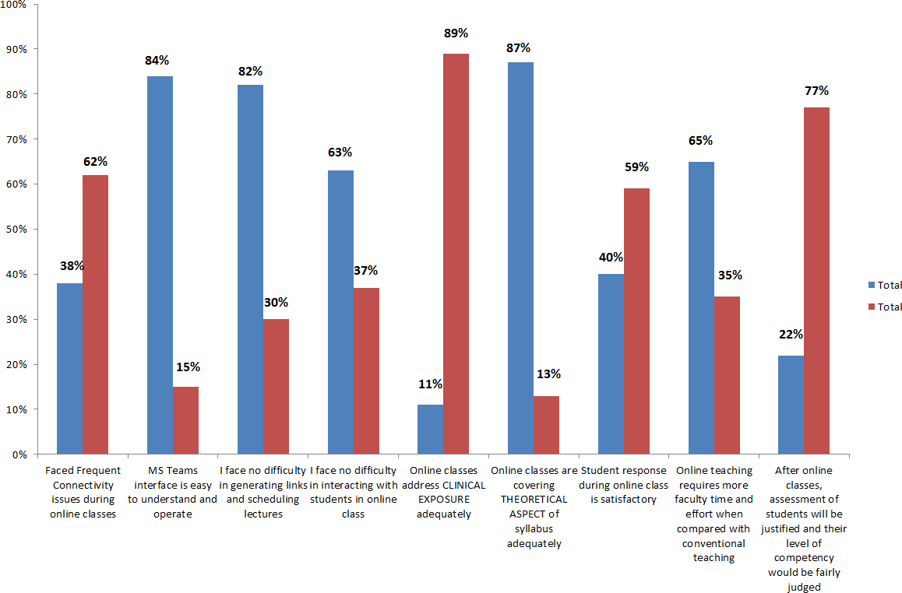

Guide to Use Software (All Pictures)

SIGNING IN TO MICROSOFT
1. Start Microsoft
Open windows browser (Google Chrome, Internet Explorer, Opera, Firefox, Safari, etc) Type “login.microsoftonline.com”

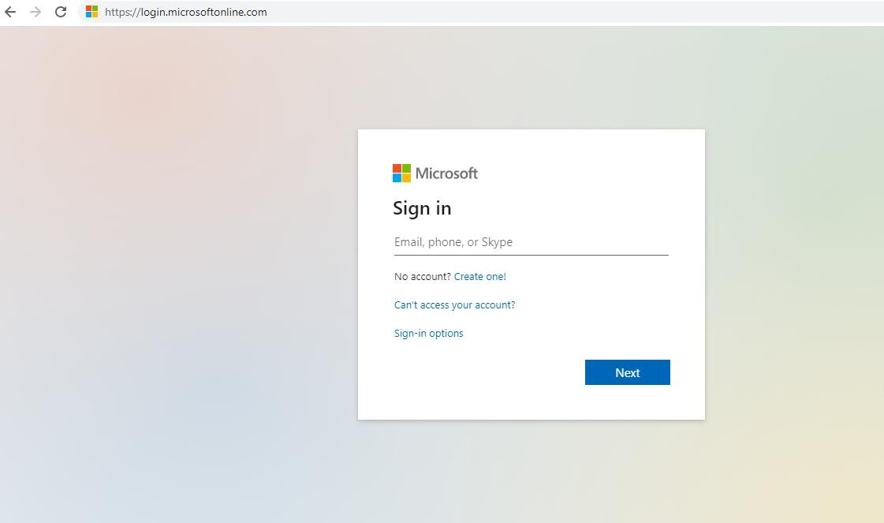
Enter University Provided Email address

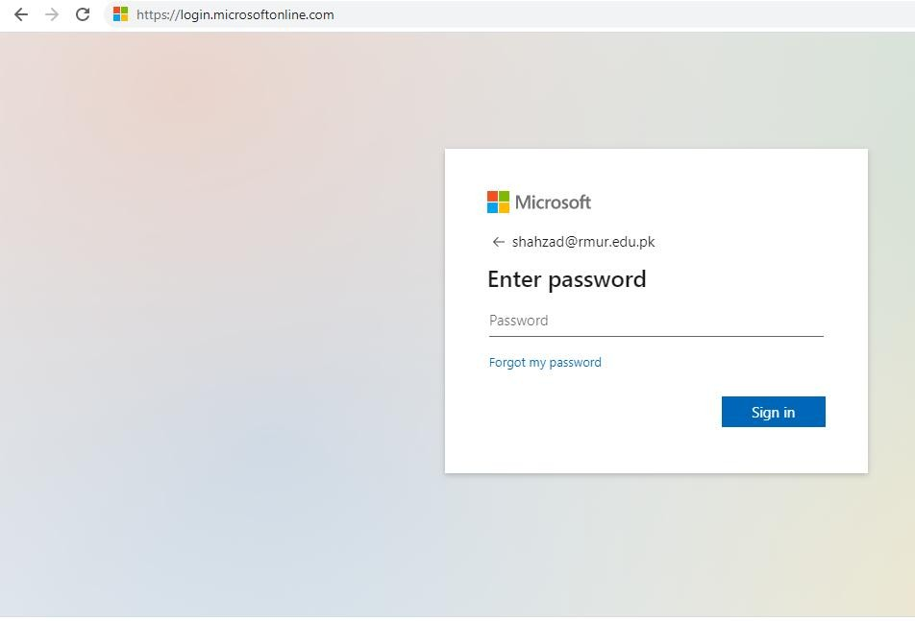
Enter University provided Password and click on sign in

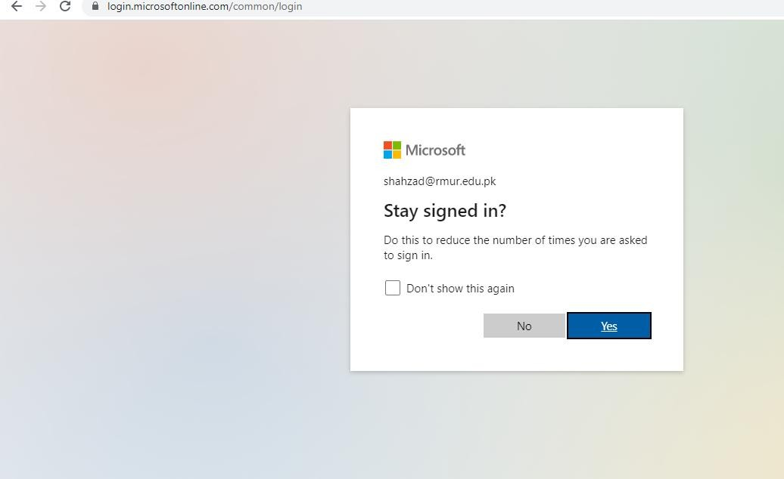
Click on Yes

- For mobile users, tap on the Teams software icon
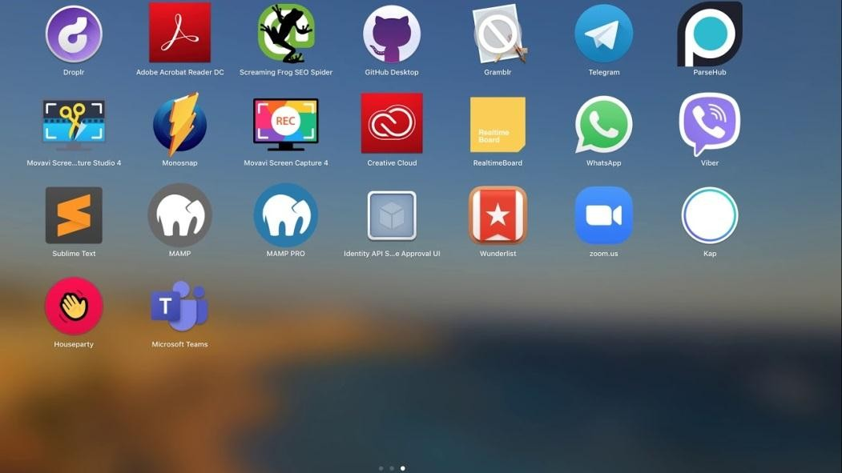

Click on Teams Icon
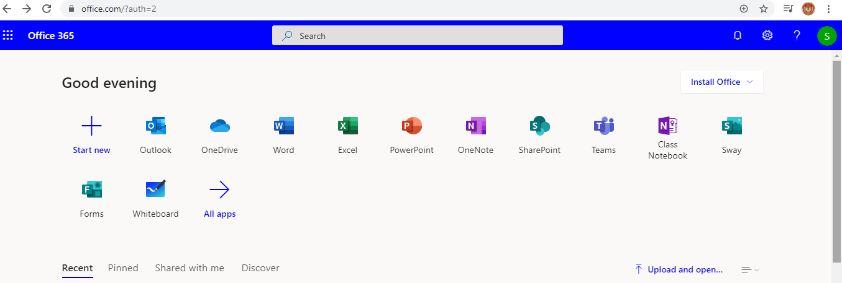
Click on Teams

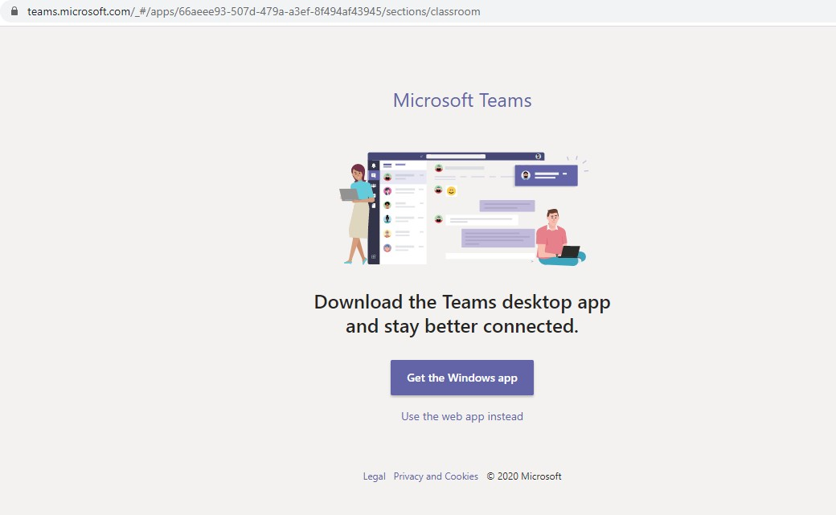
otherwise click here
If you have Microsoft Teams Software Than

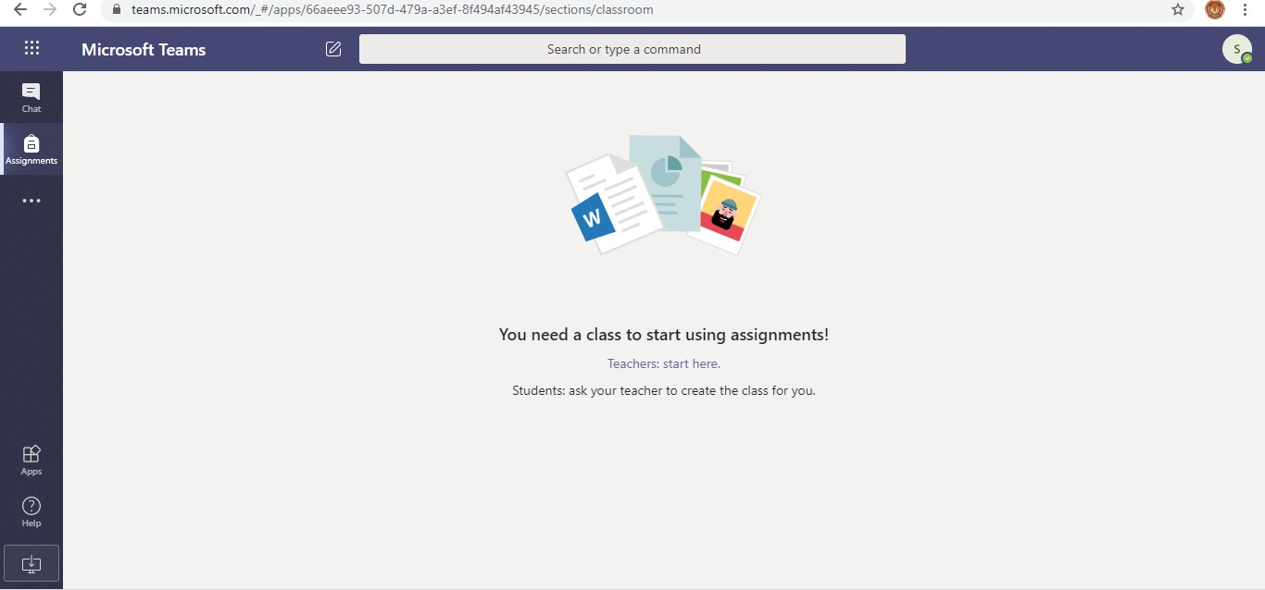
Click on 3 dots

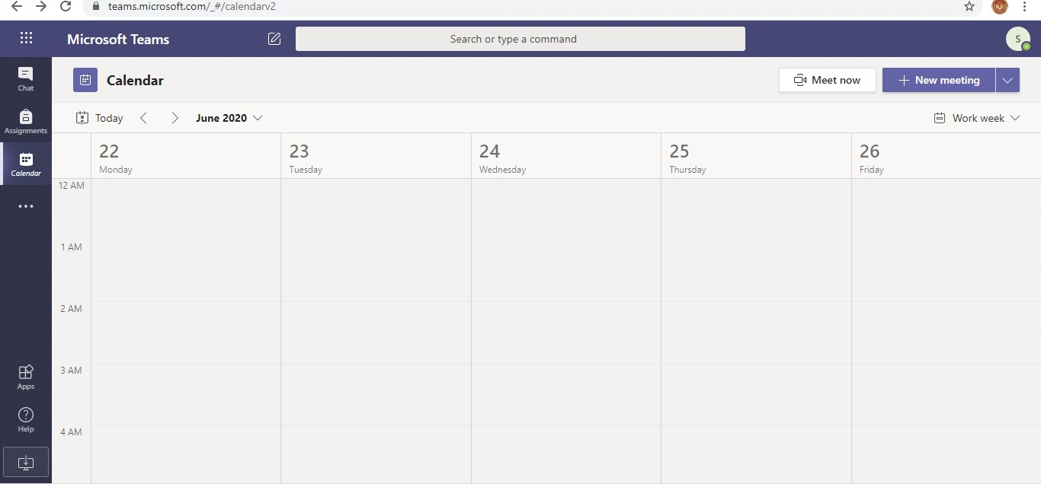
Click onNew
MeetingIcon
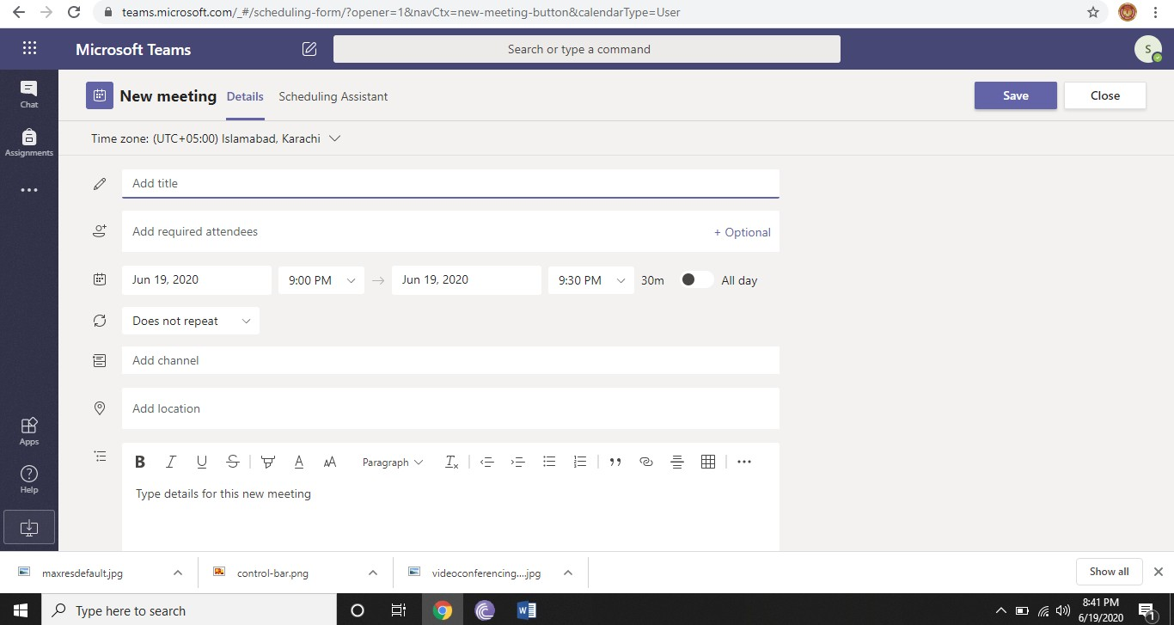
Ensure Microsoft
Teams and Your Computer /Laptop Time zoneand
Date aresame

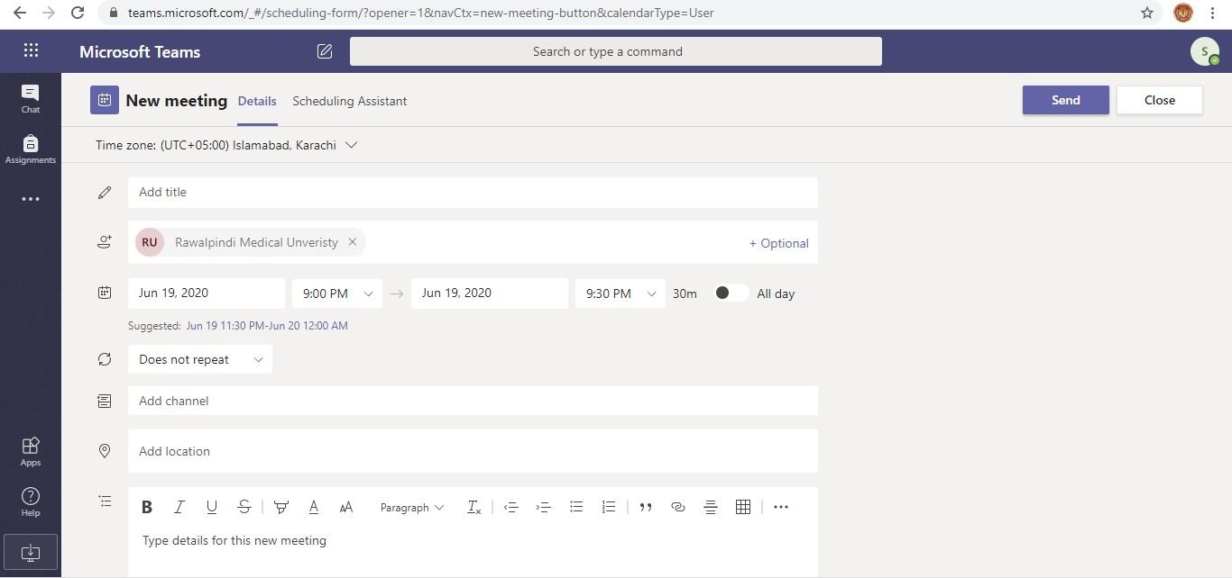
Enter Meeting Name
Enter email address and admin shahzad@rmur.edu.pk
If you already create Class
than Select and Add
Meeting Note or Detail (Optional)
Add location (Optional)
Start Timing
Date
End Time
Start Date
fill all fields than save/send/update meeting

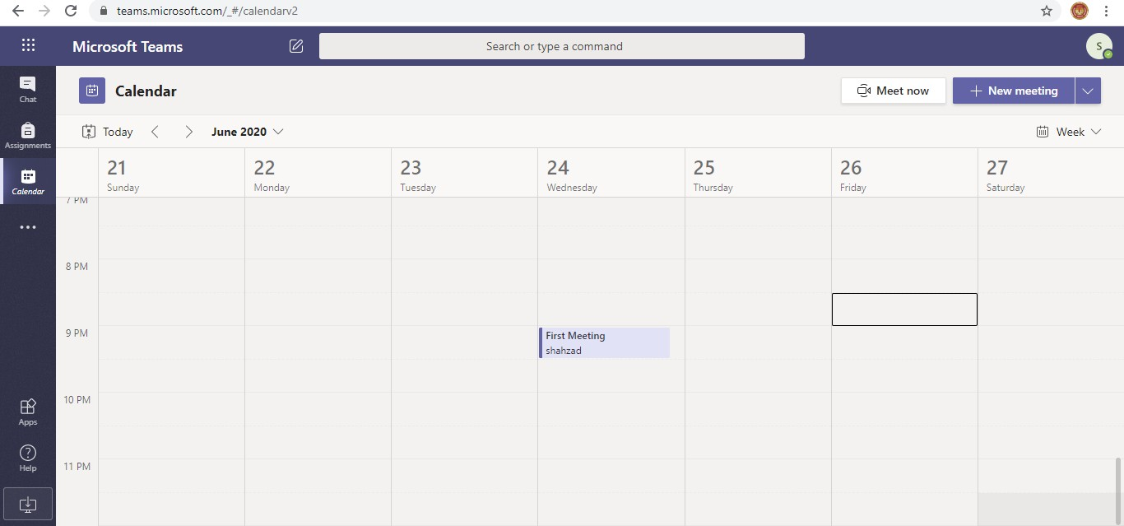
You show this icon on your Teams calendar its mean your schedule meeting is ready
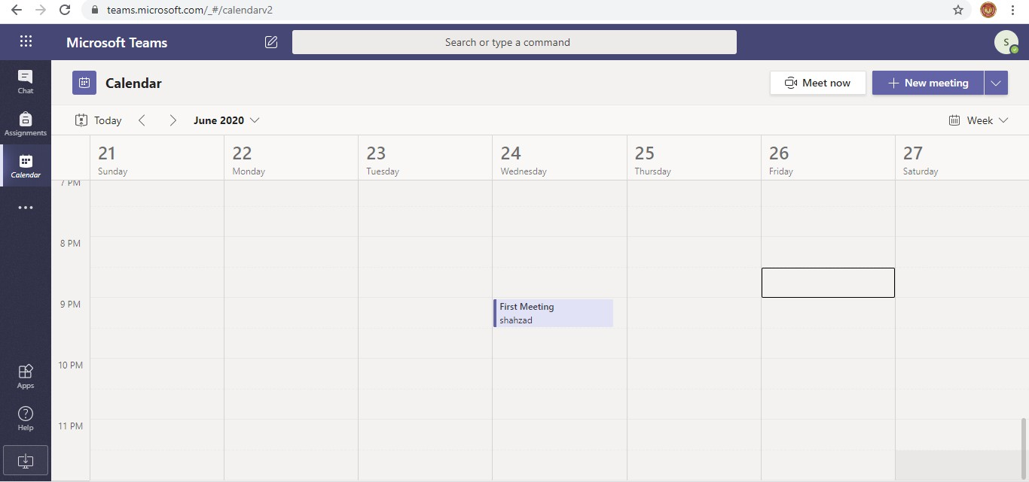
You want join to meeting click on this

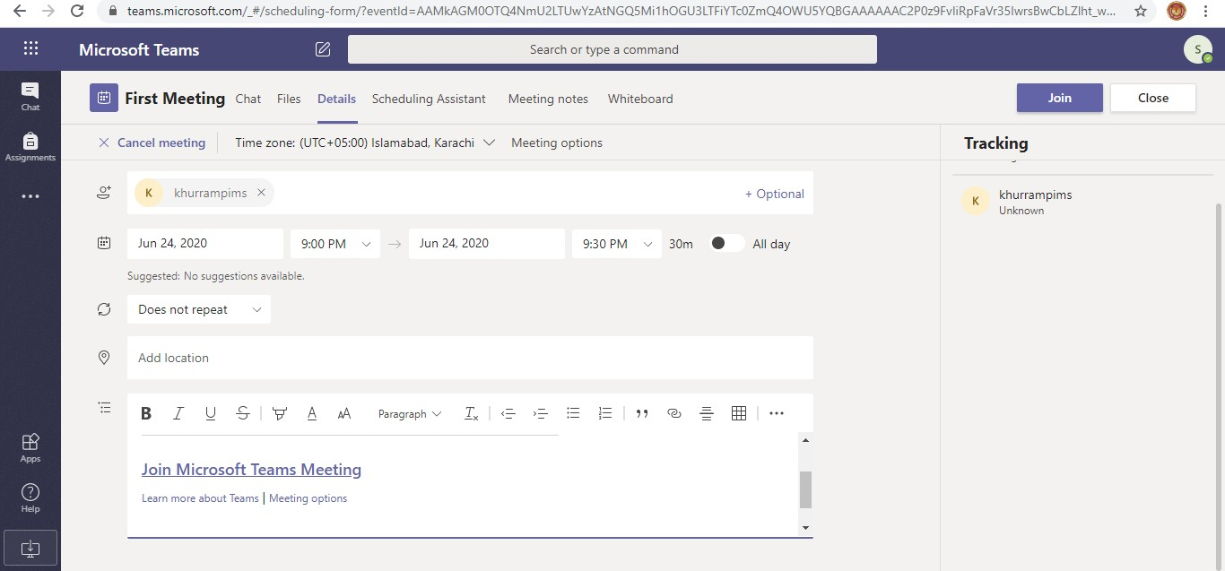
Start Meeting Click on Join
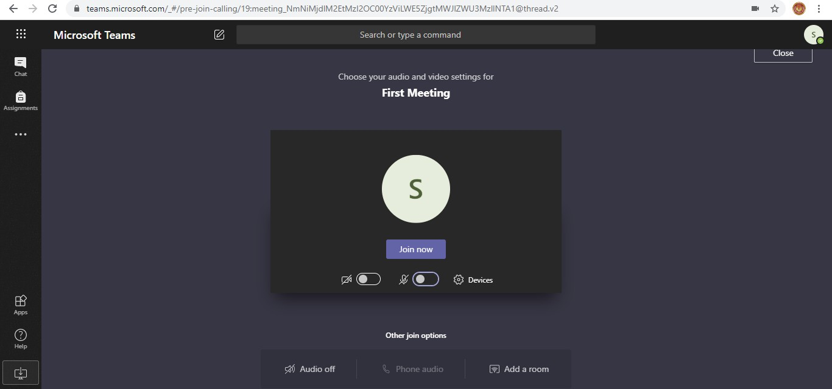
Check Camera and Mic and click here

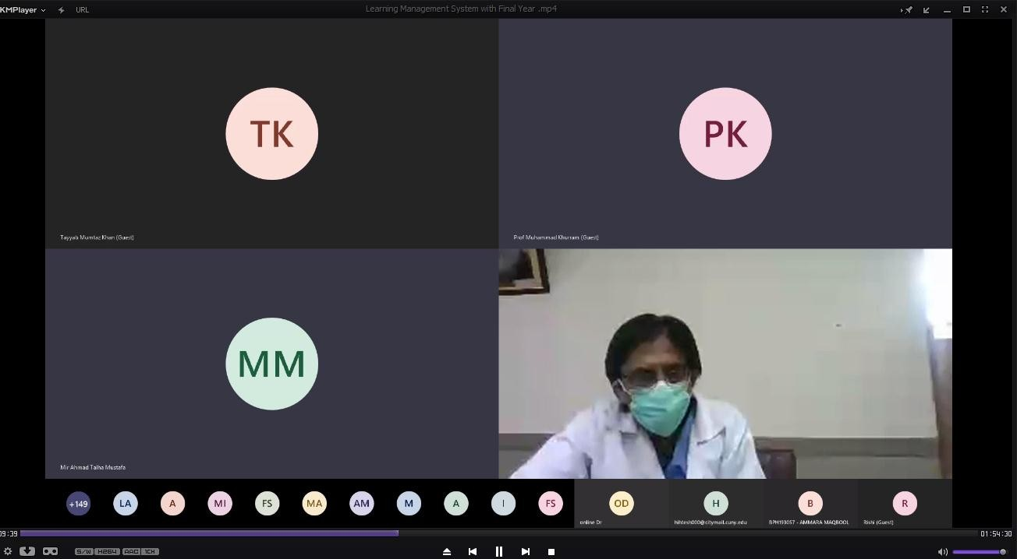

After join meeting you shown this dashboard
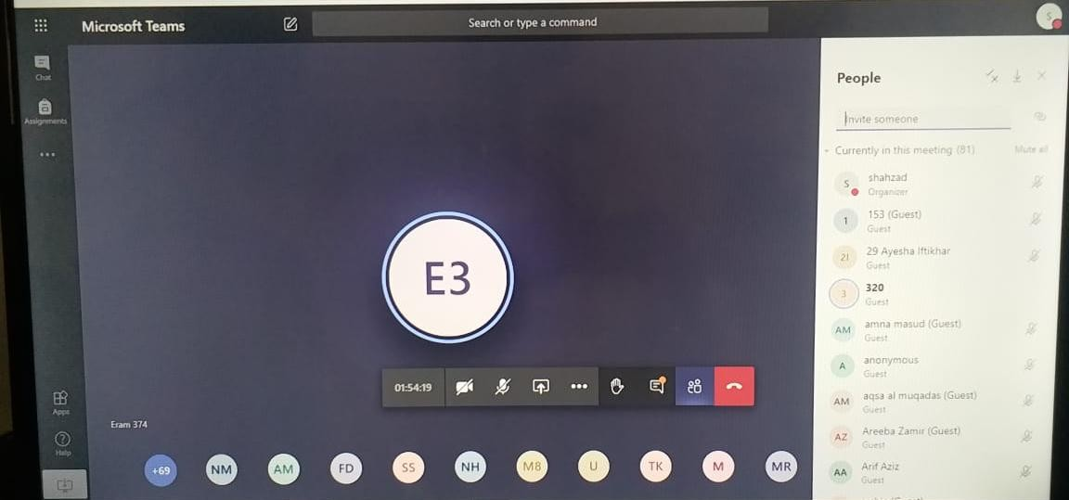
Click on the icon show chat list
Mute or un Mute Participats
Show Participants
Download Attendance List
Joined Participants

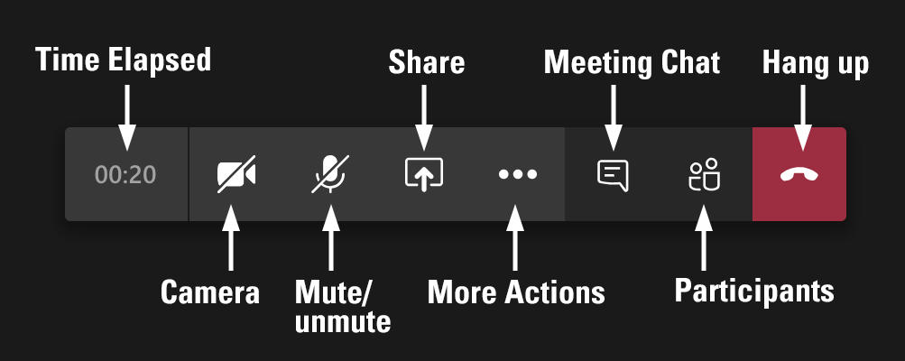

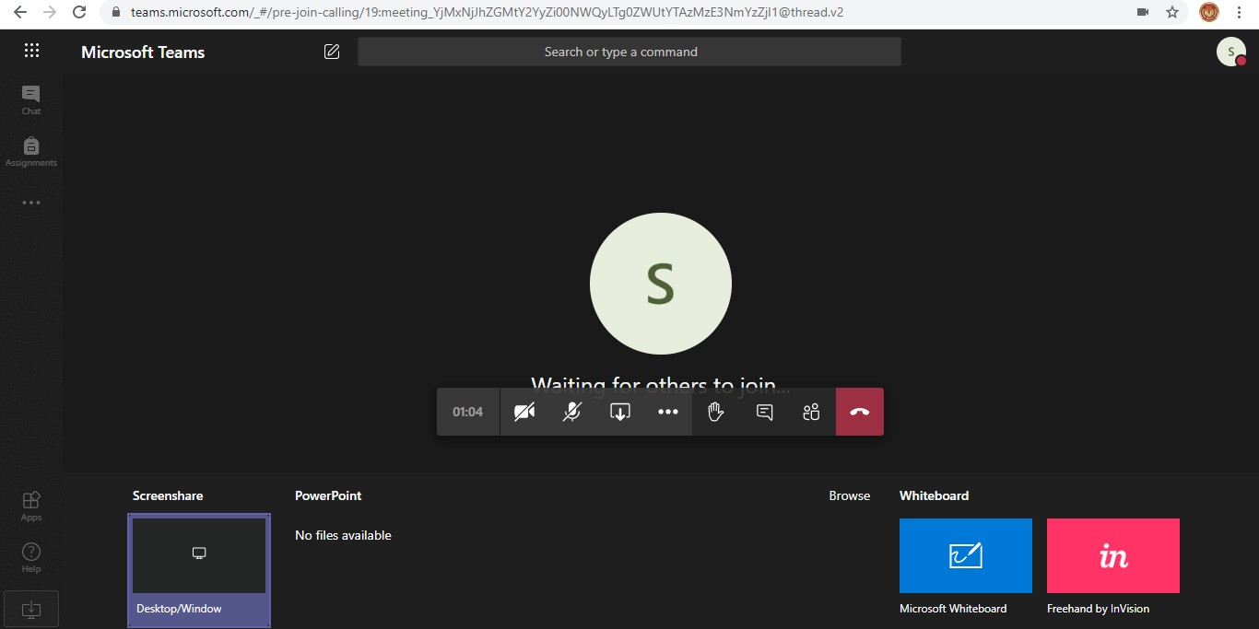
Use White board so please click on here
Share Screen click here
Share Power Point click on power point

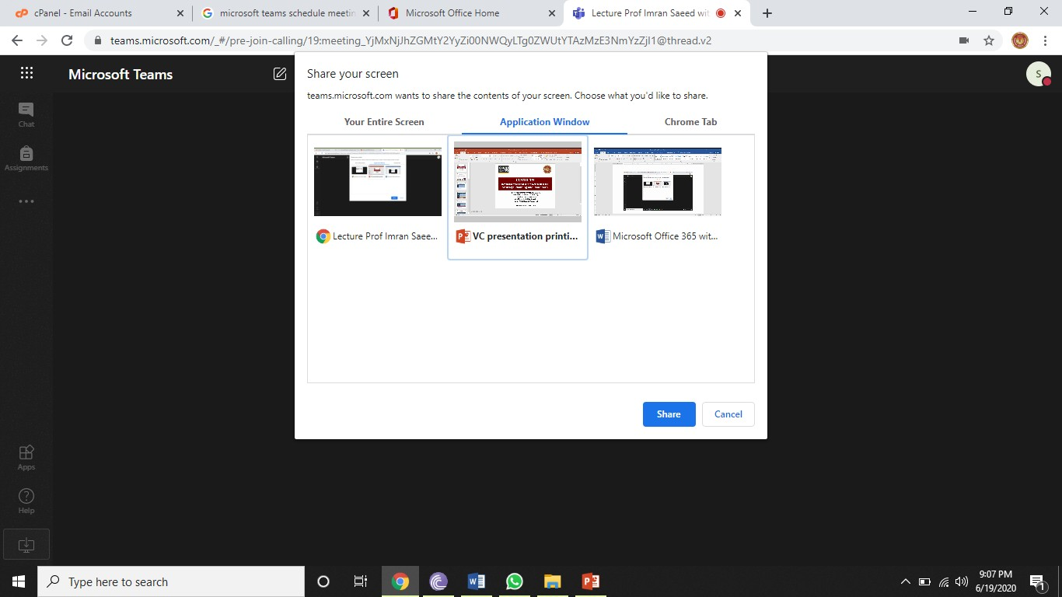
After selecting power point presentation Press share

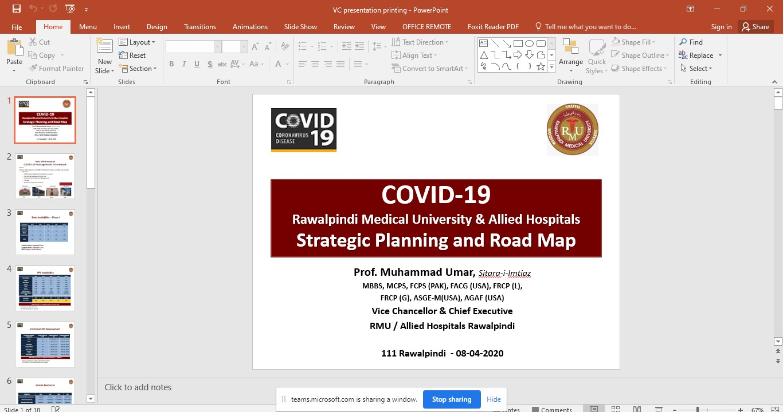
If you want stop sharing, click on here

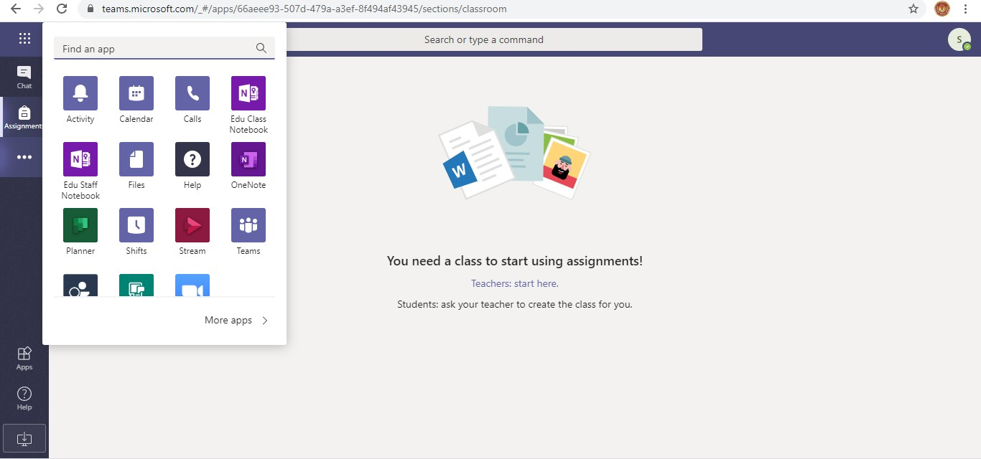
And select Calendar Icon

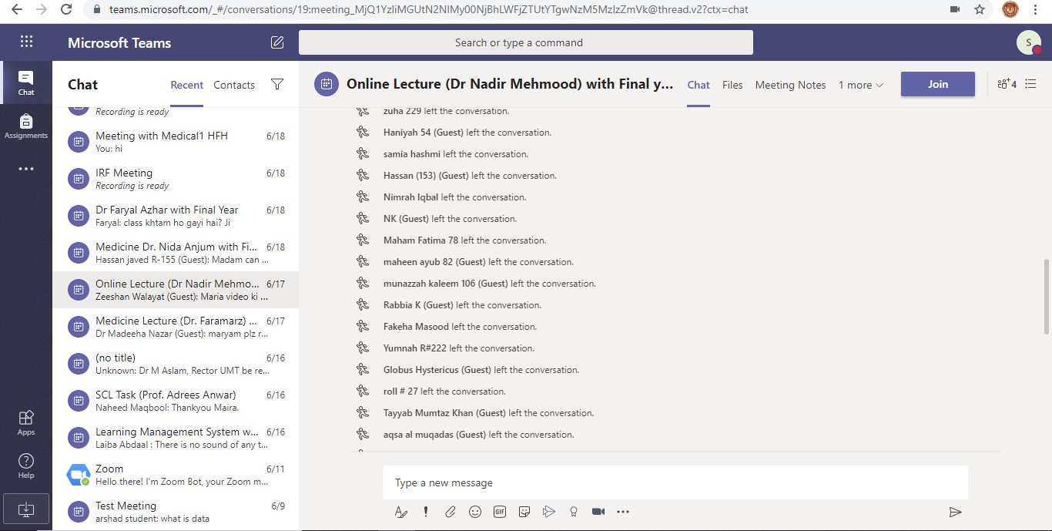
Show Meeting participants/
After meeting click on chat option

Webinar Session on COVID-19

