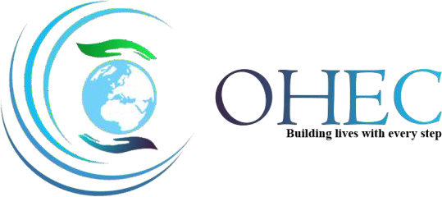

ORGANIZATION OF HEALTH AND ECONOMIC COLLABORATION

“Building lives with every step”

“THE YOUTH OF TODAY ARE THE LEADERS OF TOMORROW.”
~ Nelson Mandela

Founded on 23rd March 2021

OUR VISION

- To close the gap between Medical and economical sectors; the major requirement of the upcoming era to keep pace with the intellectual community.
- To introduce innovation in medicine and medicinal tools and techniques in Pakistan, via research publications to ensure that we provide standard healthcare, that is up to the international mark.

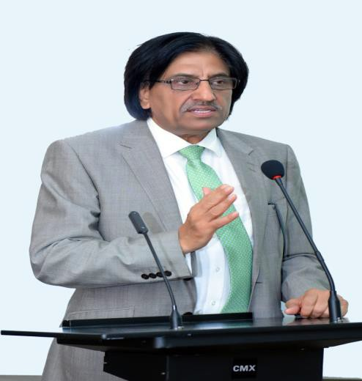

PATRON-IN-CHIEF OHEC PROF. DR. MUHAMMAD UMAR (SI)
VC RMU
‘Putting The Patient First’

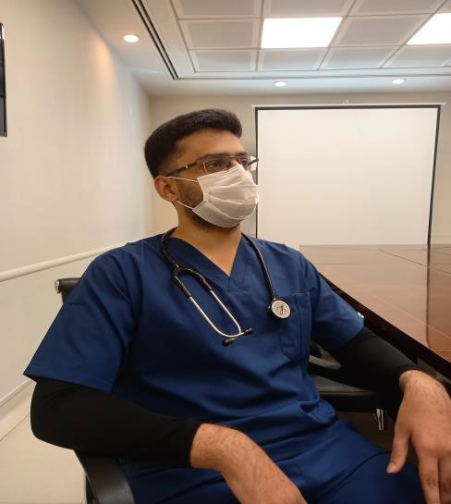

CEO/FOUNDER PRESIDENT OHEC~DANISH ALI

Pain Today, Pride Tomorrow is the executive principle of success. Nothing in this world is impossible but with consistency, perseverance, and humbleness.

Every Chapter of life contains good and bad in it and strangely, it has always been those unnerving moments that give birth to excellency.

For us, OHEC is the outcome of motivation from such critical times and is heading its way to revive dying spirits and commands.

ADVISORY PANEL OHEC

Dr. Sohail Aman (Head) | RMU Alumni USA/Ex-President RMCAANA
Dr. Usman Sheikh | General Physican UK
Dr. Sidra Hamid | Assistant Director DME RMU
Dr. Nuzhat | Demo. Anatomy dept, RMU
Miss. Sana Amin | Member Rawalpindi Female chamber of commerce

OUR TEAMS

TEAM RMU
Founder President | Danish Ali
Vice President | Kashmala Azam Heraza Naseer
General Secretary | Fatima Hassan
Information Secretary | Manahil Asmat

TEAM KEMU
President | Abdullah Haseeb
Vice President | Hamza Chaudry Zunaira Mukhtar
General Secretary | Laiba Sarfaraz
Information Secretary | Hamid Mahmood

TEAM HBSM&DC
President | Muhammad Fawad Tahir
Vice President | Khunsha Kamran
General Secretary | Muhammad Nehyan
Information Secretary | Anila Amin Khattak

TEAM IIMC
President | Iqra Muqaddas
Vice President | Wajiha Riaz
General Secretary | Asia Yasmin
Information Secretary | Fatima Bashir

TEAM FMC
President | Sabahat Hafeez
Vice President | Ifra Eeman Ahmed
General Secretary | Qareeha Rehman
Information Secretary | Rabia Irfan

ACHIEVEMENTS

- DEVELOPMENT OF WEBSITE at https://orghec.com within a short span of less than 2
months.
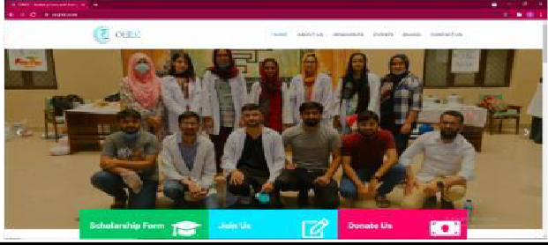

- OHDC is the first ever digital health project in collaboration with ATP (American Tele Physicians) and Shifa4u which:
  - Aims to Digitalize Health
  - Provide Online Services to patients

  - On-ground Outreach and Campaigns
  - Health Care IT services
  - EMR Training Courses

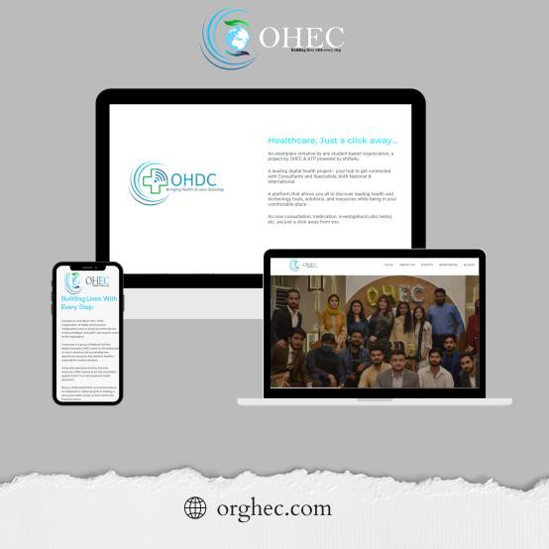

- Free of cost access to USMLE and PLAB data & subscriptions worth Rs. 15 Lac tofacilitate and ease the financial burden of USMLE and PLAB Aspirants.

- Medical related stuff in a completely categorized way for all years from 1st Year

to final year MBBS including Relevant Video Lectures, LMS lectures, Notes, PDFs, Past papers, Dissection videos, OSPE, and Viva stuff.
- Successfully Conducted OHEC USMLE KAPLAN PREPARATION SESSION with 74Registered members which comprised of Data provision, proper Schedule, discipline wise assessments as per USMLE standard.
- OHEC Research Series 2021 aiming to provide step wise complete guidance to the Beginners, two WEBINARS of the series titled:

- Introduction to Research and its importance for beginners
- Selection of Topic for Research

GUIDANCE WEBINARS
conducted either on Zoom or OHEC Facebook Page including:

  - USMLE Guidance
  - UGRAD Guidance
  - Webinar for First Year Students
  - Webinar for MDCAT Guidance
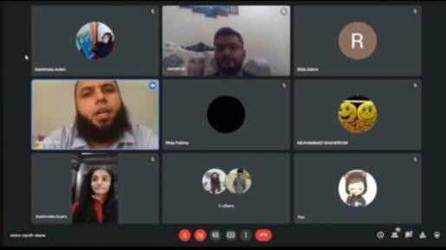

- OHEC Scholarship Program facilitating the youth by providing need and merit-based scholarships to assure equal opportunities for brilliant minds to excel and minimize the hindrances in their ways.
- Organized Charity based Food Fest an ice breaking project after Covid-19 and Quarantine, at Rawalpindi Medical University-NTB. A total of Rs, 64,000/- were collected

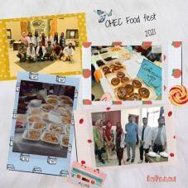

- BUSINESS EXPO: OHEC participated in Business EXPO 2022 to raise funds for Oncology Centre-HFH. A total of Rs, 23,000/- were collected and donated to Oncology Centre, HFH.

- FLOOD RELIEF CAMPAIGN: OHEC played a praise-worthy role in Floods 2022:
  - First to reach flood affected sites
  - Covered TAUNSA and BALUCHISTAN by on-site work
  - Arranged 12 MEDICAL CAMPS in which 6000 patients were examined and Free Medicines were distributed
  - Ration was distributed among 200 families
  - Processed food was distributed
  - Clothes Distribution Drive in which 200 CLOTH pairs were distributed.
  - Building OHEC Flood Relief Zone for Rehabilitation of flood affectees

- CANCER UNIT-HFH established in collaboration with RMU for cancer patients to manage the disease easily:
  - To help poor people and reduce the burden
  - To provide better facilities

WELFARE VISITS to
- Old Homes
- Welfare Trusts
- APNA Orphanage
- Thalassemia Centre
- In OHEC EID Drive at " Mera Apna Orphanage ", we spent quality time with the little innocent souls for involving them in our celebrations, inculcating happiness in their lives, and distributing gifts among them so that they never feel left out.

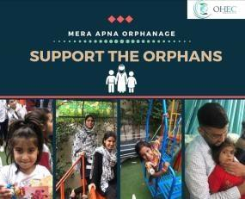

- Arranged a MEDICAL CAMP in Rawalpindi in which 2000 patients were examined, and Free Medicines were distributed.

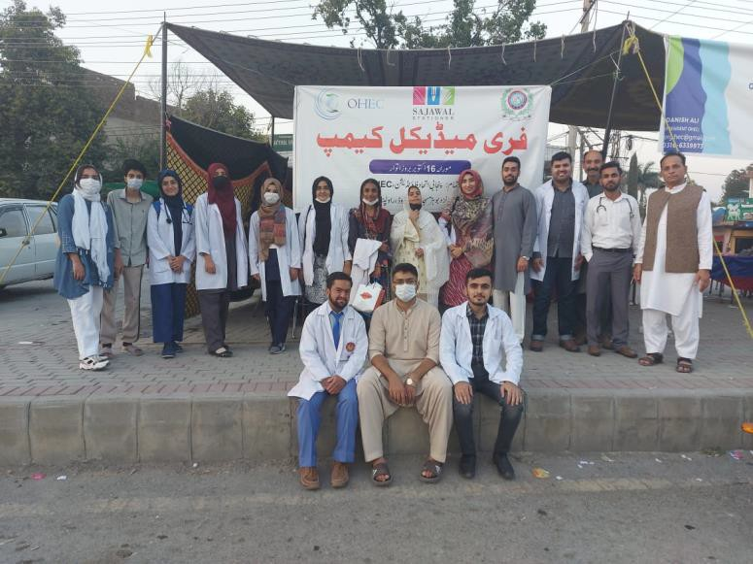

TAUNSA Rehabilitation Project :
OHEC is the 1st RMU based society to start rehabilitation process in TAUNSA- South Punjab, initially beginning with construction of 2 homes, aiming to exceed it to a greater level

CHARITY EVENTS:

- Provision of financial support to the needy ones via OHEC Charity Department after proper verification.
- Ration Drives
- Winter Drive 2022: OHEC visited slum areas near RMU and distributed clothes and goodie packs among the deserving
- Provided necessary stuff worth more than Rs. 1Lac for the marriage of the daughter of a widow who works at RMU Girls hostel.
- Student's Fee

- Qarz-e-Hasana
- Fund Raiser Food Stalls
- Conduction of Ramadan Drive 2021 worth 1 lac 18 thousand rupees in which we provided ration packages to more than 55 deserving families in Rawalpindi and Multan.
- OHEC ANNUAL CARNIVAL was arranged and many INTER-UNIVERSITIES COMPETITONS were held to ensure better interactions and providing a means of relaxation to break monotony and stress of studies. Competitions included Qirat, Hamd, Naat, Calligraphy, Ghazal Gaiki, Writings, Online Games, Photography, and Sketching.

- AWARENESS POSTS AND POSTERS: Awareness of all important Days, either National or International, is ensured via videos, posters, and articles. Some examples include:
- RAMADAN DAILY REMINDER SERIES

- Videos regarding THALASSEMIA Day, Labor Day, Alzheimer’s Day, World Humanitarian Day
- Celebrations and campaigns regarding important national Days like Pakistan Day, World earth day, World malaria day, we stand with the Palestine campaign, Women rights awareness campaign, World suicide prevention day, Thalassemia prevention campaign.

AWARENESS WEBINARS AND WALKS:
- Mental Health Awareness
- Say no to drugs campaign

- Self-Care
- Stress Management
- Nosocomial Infections
- Videos for Viral Diseases
- Healthy diet
- Visit to Peads Ward: Awareness and distribution of food items and gifts among the children.

- Webinar on International Self Care Day: To highlight the importance of mental health, a session delivered by Dr Tayyab, Patron in charge OHDC.

- Vocational Training centers: Established 2 Vocational Training centers for Special children in collaboration with Rotary International and Prudents.

- Special Children Day: Organized International Special Children Day at Ayub National Park in collaboration with Rotary International

- Independence Day of Kazakhstan: Celebrated Independence Day of Kazakhstan in collaboration with Kazakhstan Embassy

- Saws Camp: Visited Saws Camp, arranged activities, distributed goodie packs, stationary items among children

- Free Medical Camp: Team OHEC attended a Free Medical Camp in Mirpur, Azad Kashmir where more than 450 patients were checked, and free medicine was provided

- Mera Apna orphanage Visit: Visited Mera Apna orphanage along with Hope Emporium distributed KFC meals among children, donated a Refrigerator, arranged interactive activities

OHEC FINANCIAL REPORT ON FIELD PROJECTS

EVENTS | DATES | AMOUNT
USMLE Project 1  USMLE Project 2 | 12.April.2021 11. March.2021 | Rs 38000
Ration Drive in Rawalpindi, Islamabad, Multan | September 2021 | Rs 118,000 approx.
USMLE Preparation Session Phase Kaplan  USMLE prep phase first aid, B&B  USMLE data purchase and distribution | September 2021 | Rs 15,00,000 approx.
OHEC Website Development | 25.April.2021 | Hosting Rs 8,500  Drive Rs 18,000  WordPress + Theme Rs 5000 Plug-in + Support Rs 1,500 Total Rs 33,000
Marriage case at girls' hostel RMU | October 2021 | Rs 63,000
Ramadan Ration Distribution | 2022 | Rs. 193,000 approx.
Food stall at RMU NTB | 10.July.2021 | Rs 64,000
Research Quiz 2021 | September 2021 | Rs 1,500
Free Medical Camp | October 2022 | Rs 1,00,000
OHEC research series | June-September 2021 | Rs 1800
Scholarships |  | Rs 53000
Flood Relief Campaign | August-September 2022 | Rs 1300000

FUTURE PROJECTS

- BLS PROGRAM: Basic life Support helps save lives at time of medical emergencies. A proper program will be conducted very soon, with the help of trained teachers, in the locality of RMU.
- SELF DEFFENCE SESSIONS: We aim to conduct self-defense workshops, with the help of trained staff that will teach the basic self-defense techniques. Separate sessions for women will be conducted contributing towards the task of women empowerment.
- CLINICAL SET UP IN PERIPHERY: Work is in progress for setting up a clinic that will provide the basic measures to non-affording people belonging to backward areas.
- CANCER AWARENESS CAMPAIGNS: OHEC has conducted different campaigns that fall under OHDC, such campaigns for general public awareness will be conducted in future as well. Starting with Breast Cancer awareness campaign in collaboration with Shoukat Khanum by the end of October 2022.
- CME CREDITED EMR TRAINING COURSE: Such courses are aimed at being conducted to benefit our young graduates and undergraduates.
- CLIMATE FRIENDLY PROJECTS WITH GWCN: Such projects will be launched, that will be eco-friendly.
- SPECIAL CHILDREN WELFARE PROJECTS: Such projects are already being carried out in the form of if vocational center for special kids. OHEC will keep on making efforts in this regard.
- FREE MEDICAL CAMPS: Successfully conducted free medical camp in Rawalpindi. A free medical camp is going to be organized in Nov in KPK, Hazara.
- RESEARCH WORKSHOPS: A series of workshops will be conducted to benefit undergraduate, as well as graduates on basics of Research, promoting the research culture among our students.
- WOMEN EMPOWERMENT: Women form a most important part of our society comprising of more than half of our population. Steps will be taken in this regard, to empower women, as their role in society cannot be denied by any means.
- OHEC BOOK BANK: This step is going to be taken soon, to provide non-affordable students with books and also with the idea of recycling used books.
- OHEC APP: OHEC is soon going to launch its app, where you can assess all the services and information regarding human welfare projects at a single click.

- Plantation Drive: Plantation drive in collaboration with Ministry of climate change with a target of 1000-5000 plants.

GALLERY:

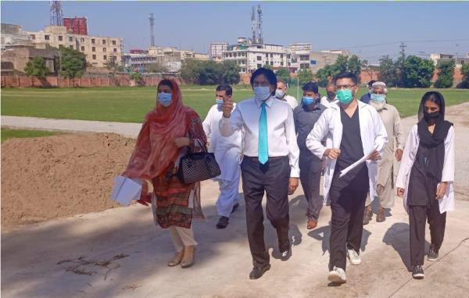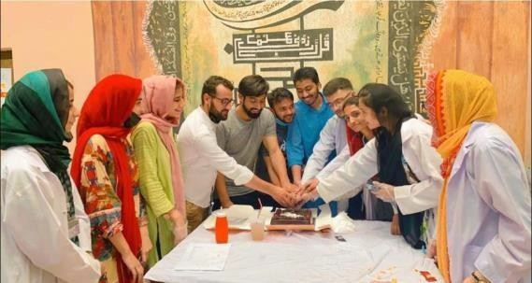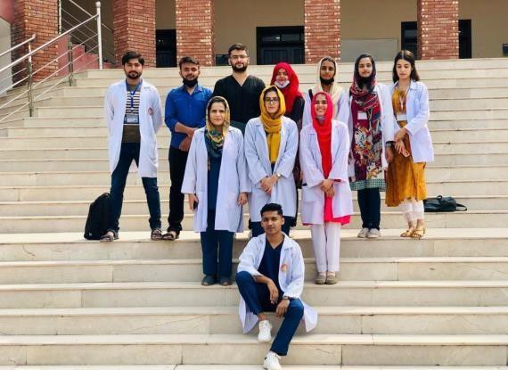

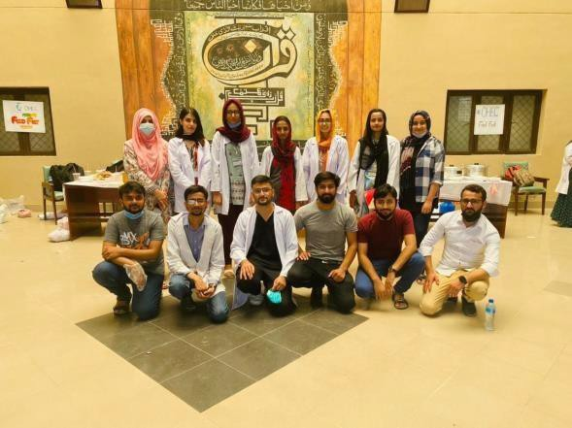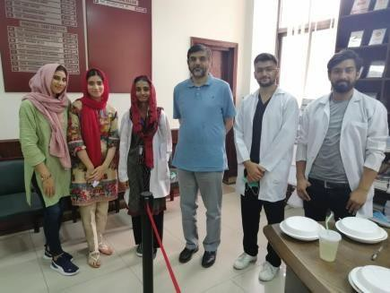

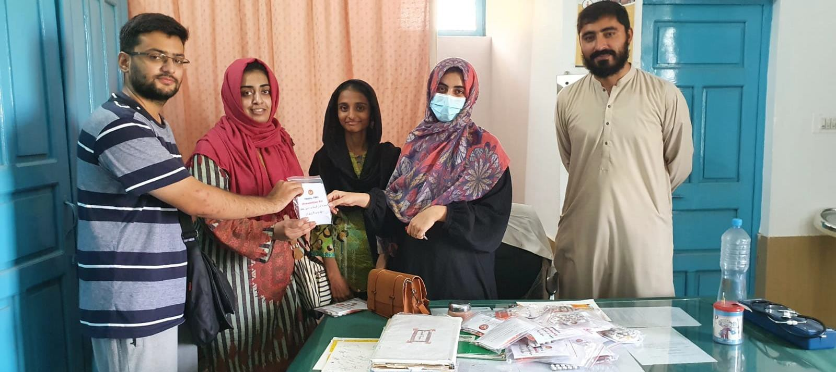

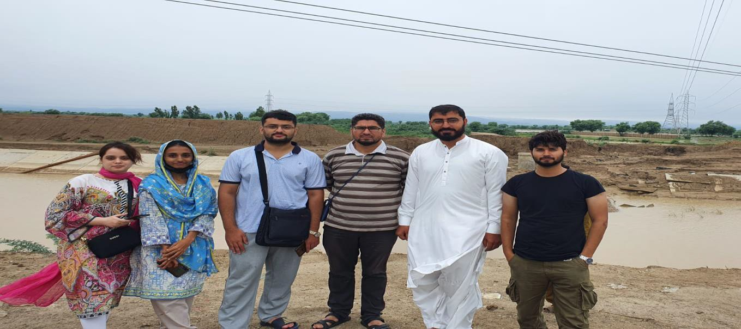

TIME SPAN

Just a period of 1.5 years Number of projects Accomplished: 65+

CONTACT US:

https://www.facebook.com/org.hec/
https://instagram.com/ohec_21
http://www.orghec.com https://twitter.com/orghec?s=09
https://www.youtube.com/channel/UC8lJu4lS8cPguE59ZsQh2Lw
https://www.linkedin.com/company/organization-of-health-and-economic-collaboration/ https://wa.me/<+923166339973>

BUILDING LIVES WITH EVERY STEP THANK YOU

