APPLICATION FORM
Diploma in Health and Hospital Management
Photograph
Name …………………………………………………………………. S/D/W ………………………………………………………….
 |  |  |  |  | - |  |  |  |  |  |  |  | -
CNIC No.

Age …………………… Gender Male Female
Temporary Address …………………………………………………………………………………………………………………………………
………………………………………………………………………………………………………………………………………………………………..
Permanent Address …………………………………………………………………………………………………………………………………
………………………………………………………………………………………………………………………………………………………………..
Email ……………………………………………………. Contact # ……………………………………………………
Current Working Details
- Position held ……………………………………………………………………………………………………………………
- Institution ……………………………………………………………………………………………………………………….
- Experience ………………………………………………………………………………………………………………………
PMC Reg. No. ……………………………………………. Date of Expiry ………………………………
Professional Qualifications
Sr.# | Qualification | College / University | Year of Passing | Grade / Division

Objectives for enrollment in this program

……………………………………… ……………………………
Signature of Candidate Date

CHECKLIST FOR APPLICATION

- Copy of CNIC.
- Two passport size Photographs with blue/white background.

- Matric/A Level degree

- F.sc/O level Degree

- MBBS Degree/Transcript

- Domicile

- Experience Letter if any

- Valid PMC certificate.

- Fee (bank draft in the favor of Vice Chancellor, RMU)

- Application is duly signed and all columns are filled.

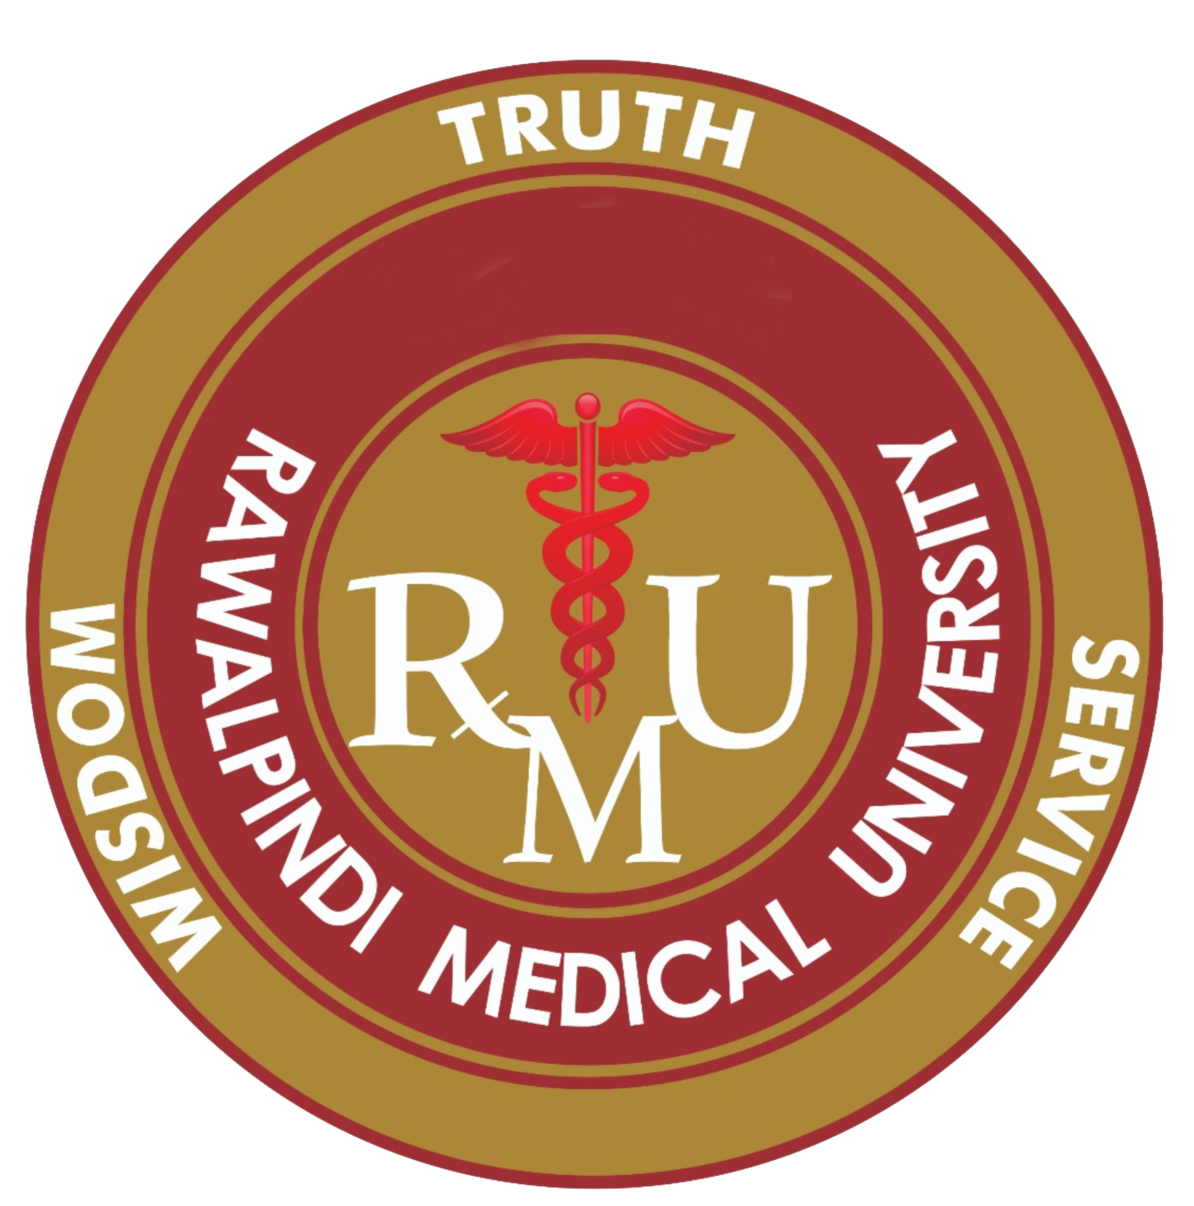 | Rawalpindi Medical University Rawalpindi |  |  | Roll No: _______
 |  |  |  | (Office use only)
ADMITTANCE CARD
(FOR CANDIDATE)
Examination: _____________________________________________
Name: | _____________________________________________ |  |  | Please Paste
Father’s Name: ___________________________________________
 |  |  |  | photograph here
Name of Institution: ________________________________________ |  |  |  | attested from Back
 |  |  |  | side (3X3 cm)
Subjects / Specialty in which to be examined: ____________________
 |  |  |  | with blue background
________________________________________________________
________________________________________________________
 |  |  | Controller of Examinations
________________________________________________________

Note: Cell/Mobile Phones, Palm Tops, Minicomputers and any other electronic equipment likely to help the candidates are completely prohibited in the Examination centers. Moreover Cell/Mobile Phones shall not be collected by the centre superintendent or University administration at examination centre.

_________________________

Signature of the Candidate

……………………………………………………………………………………………………………………………………………………
 | Rawalpindi Medical University Rawalpindi |  |  | Roll No: _______
 |  |  |  | (Office use only)
ADMITTANCE CARD
(FOR SUPERINTENDENT)
Examination: _____________________________________________
Name: | _____________________________________________ |  |  | Please Paste
Father’s Name: ___________________________________________
 |  |  |  | photograph here
Name of Institution: ________________________________________ |  |  |  | attested from Back
 |  |  |  | side (3X3 cm)
Subjects / Specialty in which to be examined: ____________________
 |  |  |  | with blue background
________________________________________________________
________________________________________________________
 |  |  | Controller of Examinations
________________________________________________________

Note: Cell/Mobile Phones, Palm Tops, Minicomputers and any other electronic equipment likely to help the candidates are completely prohibited in the Examination centers. Moreover Cell/Mobile Phones shall not be collected by the centre superintendent or University administration at examination centre.

_________________________

Signature of the Candidate

