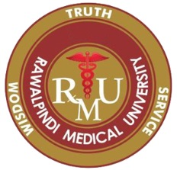
APPLICATION FORM
CERTIFICATE COURSE IN CT TECHNOLOGY
Photograph
Name …………………………………………………………………. S/D/W ………………………………………………………….
 |  |  |  |  | - |  |  |  |  |  |  |  | -
CNIC No.

Age …………………… Gender Male Female
Temporary Address …………………………………………………………………………………………………………………………………
………………………………………………………………………………………………………………………………………………………………..
Permanent Address …………………………………………………………………………………………………………………………………
………………………………………………………………………………………………………………………………………………………………..
Email …………………………………………………….. Contact # ……………………………………………………
Current Working Details
- Position held ……………………………………………………………………………………………………………………
- Institution ……………………………………………………………………………………………………………………….
- Experience ………………………………………………………………………………………………………………………
PM&DC Reg. No. …………………………………………….. Date of Expiry ………………………………
Professional Qualifications
Sr.# | Qualification | College / University | Year of Passing | Grade / Division

Objectives for enrollment in this program

……………………………………… ……………………………
Signature of Candidate Date

CHECKLIST FOR APPLICATION

- Copy of CNIC.
- Two passport size Photographs with blue/white background.

- Valid PMDC certificate.

- Fee (bank draft in the favour of Vice Chancellor, RMU)

- Application is duly signed and all columns are filled.

