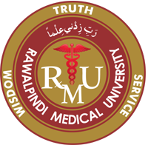
RMU
Rawalpindi Medical University
Table of Specifications
PhD Health Sciences Program (Biochemistry)
Enterance Exam
S. No. | Topics | Marks %age
Biochemistry Section
1. | Cell and Cell Signalling | 07
2. | Carbhohydrates and Carbohydrate metabolism | 14
3. | Lipids and Lipid metabolism | 12
4. | Proteins and Protien metabolism | 14
5. | Enzymes (Enzymology) | 06
6. | Biochemistry of Nutrition | 07
Molecular Biology Section
7. | Molecular Biology of Genome | 15
8. | Molecular Biology of Manipulation of Genetic Material | 05
9. | Molecular Biology of Mutations and Repair | 08
10 | Molecular Techniques | 12
Postgraduate Department RMU

